|  |  |  |
| --- | --- | --- |
| Macintosh HD:Users:bilodeau:Desktop:logos:template 2017:un.emf | Macintosh HD:Users:bilodeau:Desktop:logos:template 2017:unep-old.emf | **CBD** |
| Macintosh HD:Users:bilodeau:Desktop:logos:template 2017:cbd.emf | | Distr.  GENERAL  CBD/ABS/CC/2/3  5 April 2018  ENGLISH ONLY |

COMPLIANCE COMMITTEE UNDER THE NAGOYA PROTOCOL

Second meeting

Montreal, Canada, 24-26 April 2018

Item 4 of the provisional agenda[1]*

**First assessment and review of the Nagoya Protocol and general issues of compliance**

*Note by the Executive Secretary*

# Introduction

1. Article 31 of the Nagoya Protocol addresses “assessment and review” and provides that the meeting of the Parties to the Protocol shall undertake an evaluation of the effectiveness of the Protocol four years after its entry into force. In decision [NP-2/4](https://www.cbd.int/doc/decisions/np-mop-02/np-mop-02-dec-04-en.pdf), the meeting of the Parties decided on the process for the first assessment and review of the Protocol and the elements to be included in the first assessment and review. As part of this, it requested the Compliance Committee to provide inputs in the form of information and findings on general issues of compliance and recommendations to assist in addressing challenges to the implementation of the Protocol (para. 5).
2. In preparation for the consideration of the first assessment and review of the Protocol by the Subsidiary Body on Implementation, the Secretariat has prepared two documents: (a) an analysis of information contained in the interim national reports and information published in the Access and Benefit‑sharing Clearing-House; and (b) a statistical overview of the answers provided in the interim national reports. These documents are issued for the information of the Compliance Committee as CBD/ABS/CC/2/INF/1 and CBD/ABS/CC/2/INF/2, respectively.
3. On the basis of the information contained in these documents, the Secretariat has identified possible general issues of compliance to facilitate the work of the Committee.
4. The present document contains, in section II, information on the rate of submission of the interim national reports. Section III presents some possible general issues of compliance, and section IV of the note suggests issues for the consideration of the Committee.

# Rate of submission of the interim national report

1. Article 29 of the Protocol requires Parties to monitor the implementation of their obligations under this Protocol and to report to the Conference of the Parties serving as the meeting of the Parties to the Protocol (COP-MOP) on measures that it has taken to implement the Protocol.
2. In decision [NP-1/3](https://www.cbd.int/doc/decisions/np-mop-01/np-mop-01-dec-03-en.pdf), the Parties to the Protocol, agreed on the format and guidelines for submission of an interim national report on the implementation of the Nagoya Protocol and requested Parties to the Protocol to submit the report 12 months prior to the third meeting of the Parties to the Protocol. The Parties also welcomed submissions of relevant information by non-Parties. Interim national reports were due to be submitted by 1 November 2017.
3. Taking into account that the submission of the national reports is a key obligation for Parties to the Protocol and enables Parties to take decisions to promote compliance and effective implementation of the Protocol, the rate of compliance with this obligation is herein examined.
4. A total of 100 Parties to the Convention were Parties to the Nagoya Protocol by the reporting deadline of 1 November 2017. An additional five Parties[2] to the Convention had ratified the Protocol but were not Parties to the Protocol by 1 November 2017[3] and, therefore, did not have the obligation to submit the interim national report. A list of countries that submitted the interim national report can be found in CBD/ABS/CC/2/INF/2, annex I.
5. As of 22 February 2018, 69 Parties to the Nagoya Protocol had submitted a report. Of these 69 Parties, 39 had submitted the report by the deadline.
6. The distribution of these reports among United Nations regional groups is as follows:
   1. Africa: 27 reports received (69% of 47 Parties from that region);
   2. Asia and the Pacific: 13 reports received (50% of 26 Parties from that region);
   3. Latin America and the Caribbean (GRULAC): 8 reports received (67% of 13 Parties from that region);
   4. Central and Eastern Europe (CEE): 7 reports (88% of 8 Parties from that region);
   5. Western Europe and Others Group (WEOG): 14 reports (93% of 15 Parties from that region).
7. In addition, six non-Parties submitted interim national reports.
8. With respect to financial support for the preparation of the national report, the Conference of the Parties at its thirteenth meeting[4] invited the Global Environment Facility (GEF) to provide support to eligible Parties.
9. The Executive Secretary informed all Parties to the Nagoya Protocol that the United Nations Environment Programme (UNEP) was preparing a project for funding by GEF to assist eligible Parties in the preparation of their report and invited eligible Parties to contact UNEP to access the funds. [5] A GEF project was approved in August 2017 covering 65 eligible Parties, 42 of which have submitted their report. Given the short amount of time between the approval of the project and the due date for the interim national report, it is expected that additional Parties will submit their reports in the following months.
10. All interim national reports received are available online on the ABS Clearing-House at the following link: <https://absch.cbd.int/reports>, with the exception of one report that was submitted offline. The ABS Clearing-House also hosts a report analyser tool that enables the analysis of information contained in the interim national report by question, country/ies or region.

# General issues of compliance

1. On the basis of the analysis described in CBD/ABS/CC/2/INF/1, some general issues affecting the compliance of a number of Parties with respect to their obligations under the Protocol are identified herein.
2. In order to make the Protocol operational, Parties need, as first step, to put the necessary access and benefit-sharing legislative, administrative and policy measures in place, and to establish institutional arrangements to implement them (i.e. a national focal point, one or more competent national authorities and one or more checkpoints). The publication of mandatory information in the ABS Clearing-House (including information on the permits or their equivalent issued at the time of access) is also essential for the implementation of the Protocol.
3. Promoting compliance with these core elements is key for the operationalization of the Protocol, and, therefore, it is proposed that these elements be further examined by the Committee as possible general issues of compliance.
4. These general issues of compliance should be understood within the limitations of the analysis itself as pointed out in section II of the analysis document (CBD/ABS/CC/2/INF/1). Furthermore, while the analysis document includes information from both Parties and non-Parties to the Protocol, the present document only considers information from Parties. Accordingly, the discussion below is based on information from the 105 Parties to the Convention on Biological Diversity that had ratified the Protocol by 22 February 2018.[6]
5. The information provided on general issues of compliance is also to be considered within the broader context of general challenges in implementing the Protocol and taking into account the fact that many Parties are at early stages in the implementation of the Protocol. In this regard, subsection A below provides a summary of challenges and difficulties identified by Parties in their interim national reports that may be of relevance for the consideration of possible general issues of compliance.
6. Against this background, and on the basis of the analysis contained in the analysis document, subsection B below provides the following information for each general issue of compliance:
   1. A brief overview of progress in implementation by Parties with respect to the obligations for which a general issue of compliance has been identified. The overview takes into account information provided in the interim national reports and the ABS Clearing-House. For those Parties that did not submit an interim national report, information provided through the national biodiversity strategies and action plans (NBSAPs)  and the fifth national reports on the implementation of the Convention has been considered;
   2. A short summary of main difficulties and challenges as provided in the interim national reports.

## General considerations and challenges and difficulties in implementing the Protocol

1. In their reports, many Parties highlighted the fact that the Nagoya Protocol was a new instrument, especially for those that had just recently ratified it, and that they were still in the process of establishing access and benefit‑sharing (ABS) measures and appropriate institutional arrangements.
2. Many Parties highlighted the cross-cutting nature of the Protocol, which is relevant to many sectors, and the need to involve many actors as an important challenge for the adoption of measures and progress towards implementation. A number of Parties recognized that this created challenges in implementation at two levels: first, in ensuring participation in ABS processes of indigenous peoples and local communities and relevant stakeholders; and second, at the institutional level, many highlighted the need for better coordination among different institutions and relevant agencies and ministries. Some also reported a lack of clear division of competencies between institutions, and either having gaps or overlaps in mandates on issues related to ABS.
3. Although a number of capacity-building and development initiatives are currently supporting ratification and implementation of the Nagoya Protocol, many Parties reported lacking the necessary capacity and financial resources to make the Protocol operational. Capacity-building and development support continue to be essential in order to make progress in the implementation of the Protocol, in particular for developing country Parties and Parties with economies in transition.
4. The lack of human resources working on ABS and the Nagoya Protocol also seems to be a challenge for many Parties. Many Parties indicated having limited human resources working on Nagoya Protocol implementation and that available staff is either temporary or has other responsibilities.
5. Many highlighted the need for building capacity and raising awareness of the Protocol of all actors involved, including institutions, indigenous peoples and local communities and relevant stakeholders (for example, the business and scientific communities).
6. Many Parties considered that the difficulties mentioned above were hindering progress in adopting legislative, administrative and policy measures (ABS measures) and establishing institutional arrangements to implement the Protocol, with the exception of the designation of the national focal point where Parties generally felt that there were no challenges to report.
7. The lack of ABS measures and/or institutional arrangements was considered by many as the main reason for not having made progress in the publication of mandatory information in the ABS Clearing-House, including in the constitution of the internationally recognized certificates of compliance.

## Possible general issues of compliance

*Legislative, administrative or policy measures on ABS*

1. A number of provisions of the Protocol require Parties to adopt legislative, administrative or policy measures on ABS. The format of the interim national report endeavours to collect information on the progress Parties are making towards fulfilment of these obligations through a number of questions on access, benefit-sharing, compliance with domestic legislation or regulatory requirements on ABS, monitoring the utilization of genetic resources, and compliance with mutually agreed terms, as well as the questions on the provisions related to indigenous peoples and local communities.
2. For the purposes of examining general issues of compliance, information provided by Parties in response to question 3 of the report[7] is presented below, and, as part of the challenges and difficulties, the provisions of the Protocol that Parties are having more difficulty implementing are examined.

(a) *Status*

1. The following provides an overview of the progress made in adopting ABS measures based on the information provided in response to question 3 of the report and information published in the ABS Clearing‑House. In addition, for Parties that have not submitted an interim national report, information provided through NBSAPs and the fifth national reports under the Convention is presented for the information of the Committee.
2. According to the information that is available, as of 22 February 2018, 75 Parties (62%) had published measures in the ABS Clearing-House or reported having some ABS measures established in the interim national report, NBSAP or fifth national report.
3. The ABS measures reported vary in the degree of specificity and comprehensiveness and many were adopted prior to the adoption of the Nagoya Protocol. Some Parties reported having general legislation which relates to ABS (for example, general environmental legislation, or measures dealing with animal husbandry, forests), while others have adopted specific ABS measures to implement the Protocol. Of these 75 Parties, 44 indicated that they are currently revising existing or developing new ABS measures to implement the Protocol, and 10 Parties are planning to develop additional ABS measures.
4. A total of 25 Parties reported not having ABS measures in place and did not have measures published in the ABS Clearing-House. Based on the available information, 2 of these Parties are currently developing measures, and 13 Parties are planning to develop ABS measures.

**Figure 1. Status of progress by Parties that have ABS measures in place (as of 22 February 2018)**

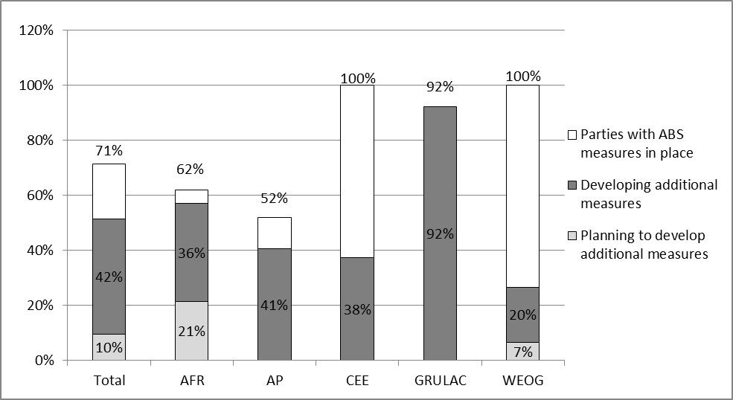

**Figure 2. Status of progress by Parties that do not have ABS measures in place (as of 22 February 2018)**

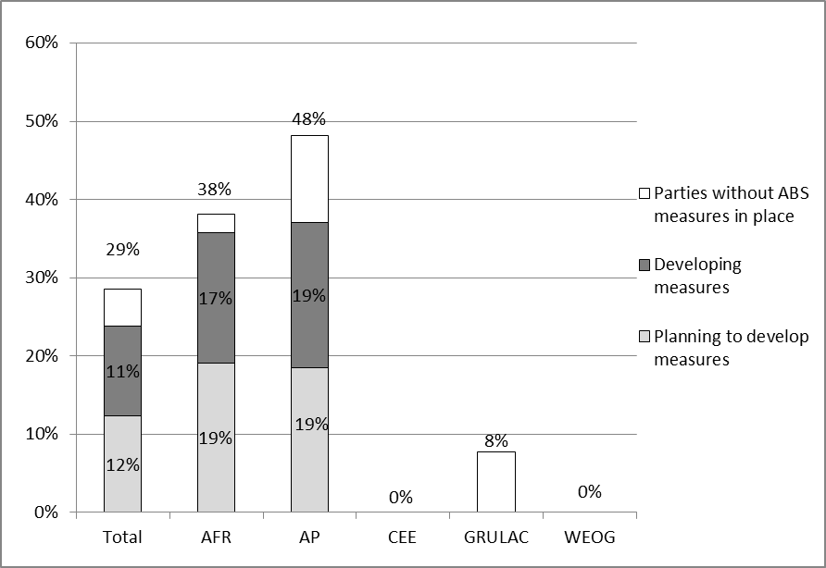

(b) *Challenges and difficulties*

1. In addition to the general challenges referred to in subsection A above, some Parties explained in their reports the difficulties they had experienced in developing ABS measures that took into account many different considerations (for example, many sectors and actors, or the different articles of the Nagoya Protocol), while at the same time adopting measures that are balanced, promote benefit-sharing and legal certainty, and avoid complexity, delays and increased burden and costs on users.
2. Some Parties noted that the process for adopting ABS measures and making progress in implementation of the Protocol was more time consuming and slower than expected.
3. Implementing some of the new elements of the Protocol, namely the provisions on compliance with domestic measures, monitoring the utilization of genetic resources and the obligations related to indigenous peoples and local communities, presented a particular challenge for many Parties. These are therefore examined in further detail below.
4. *Compliance with domestic measures*. Approximately half of the Parties indicated that they had taken measures to implement Article 15 (compliance with domestic legislation or regulatory requirements on ABS) and Article 16 of the Protocol (compliance with domestic legislation or regulatory requirements on ABS for traditional knowledge associated with genetic resources). Although many have adopted measures to provide that genetic resources and associated traditional knowledge utilized within their jurisdiction has been accessed in accordance with the requirements of another Party, a number of others reported on measures that would address cases of non-compliance with their own domestic ABS legislation.
5. *Monitoring the utilization of genetic resources*.From the analysis of the content of the reports, it can be concluded that many Parties have not yet implemented the obligations related to the designation and functioning of checkpoints as provided for in Article 17. Overall, the main difficulty in implementing this obligation is identified as the absence of ABS measures in place or the need to further develop or review measures so that they are in line with the Nagoya Protocol. The need for capacity-building on this aspect was noted by many Parties.
6. *Provisions related to indigenous peoples and local communities*. In their reports, 47 Parties indicated that there were either indigenous peoples, local communities or both indigenous peoples and local communities in their country. Approximately half of those Parties reported having taken measures to implement Articles 6, 7 and 12 of the Protocol. In different parts of the report, many Parties identified challenges in implementing the provisions of the Protocol related to indigenous peoples and local communities.
7. Some Parties reported challenges in clarifying what the term “indigenous peoples and local communities” meant in their national context, including providing clarity on the ownership of indigenous peoples and local communities over genetic resources and/or traditional knowledge associated with genetic resources. Many Parties experienced difficulties in identifying the different groups of indigenous peoples and local communities, understanding the way they are organized, and being able to link traditional knowledge with the holder/s of such knowledge.
8. Many Parties considered the need to build capacity at the institutional level on issues related to traditional knowledge associated with genetic resources and indigenous peoples and local communities. The difficulty of developing measures to ensure that all indigenous peoples and local communities issues in the Protocol are dealt with appropriately was raised, and some noted the lack of experience or examples that could be used.
9. Many Parties highlighted the need for capacity-building and awareness-raising about ABS for indigenous peoples and local communities.

*Institutional arrangements*

1. Article 13 of the Protocol requires Parties to designate a national focal point on ABS (para. 1) and one or more competent national authorities (para. 2). In addition, Article 17 requires Parties to take measures to support compliance, including through the designation of one or more checkpoints (para. 1).

(a) *Status*

1. *National focal points.* The designation of national focal points is not considered a general issue of compliance as Parties have made good progress on this aspect of their institutional arrangements. It has nonetheless been included here to give a better picture of the overall state of implementation of institutional arrangements. A total of 103 Parties to the Protocol (98%) have a national focal point for ABS (as of 22 February 2018). Given the key role of national focal points under Article 13, paragraph 1, of the Protocol, it is encouraging to see that this is an area where good progress has been made.
2. *Competent national authorities*. As of 22 February 2018, 57 Parties (54%) had designated one or more competent national authorities, according to information available in the interim national report, the ABS Clearing-House, the NBSAP or the fifth national report. In addition, 9 Parties reported on work under way towards the designation of one or more competent national authorities; and another 5 Parties indicated that they were planning to do so.
3. Finally, 34 Parties did not report on progress towards designating one or more competent national authorities, and therefore there is no information available for these Parties.

**Figure 3. Status of progress in the designation of one or more competent national authorities (as of 22 February 2018)**

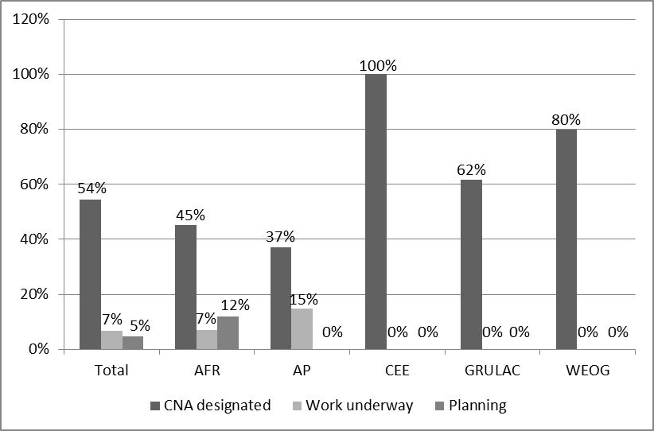

1. *Checkpoints.* As of 22 February 2018, 29 Parties had designated one or more checkpoints (27%) according to information available in the interim national report, the ABS Clearing-House, the NBSAP or the fifth national report. In addition, 18 Parties reported on work under way to designate one or more checkpoints; and 11 Parties indicated that they were planning to do so.
2. Finally, 47 Parties did not report on progress towards designating one or more competent national authorities, and, therefore, no information is available for these Parties.

**Figure 4. Status of progress in the designation of one or more checkpoints (as of 22 February 2018)**

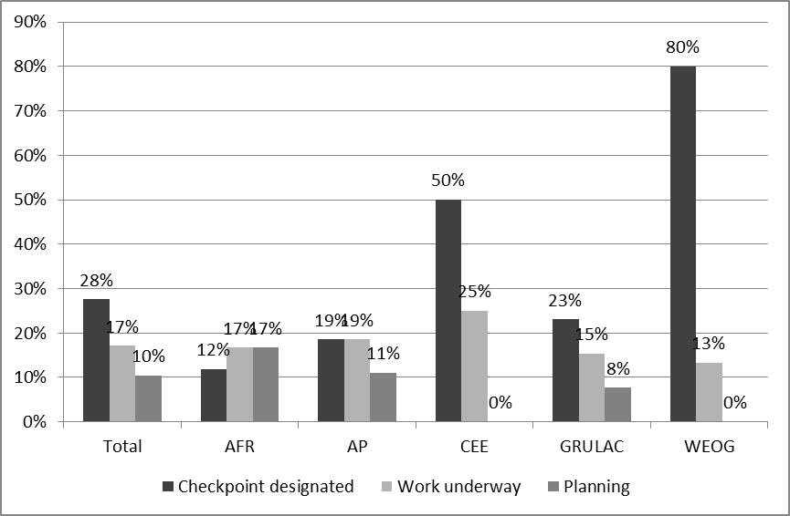

(b) *Challenges and difficulties*

1. In general, for many Parties, progress in establishing competent national authorities and checkpoints is tied to progress in adopting the necessary ABS measures. Some measures adopted prior to the existence of the Nagoya Protocol include the designation of one or more competent national authorities. However, the designation of checkpoints and the compliance provisions in general are some of the innovations of the Protocol, and, therefore, many Parties still need to adopt or review ABS measures to incorporate these elements.
2. In addition to general difficulties in terms of resources and capacity, the most common challenges mentioned in designating one or more competent national authorities relate to clarifying mandates between institutions and agencies, ensuring coordination among competent national authorities as well as between the competent national authority and other national institutions. However, some Parties reported not having experienced major difficulties in establishing competent national authorities.
3. With regard to checkpoints, some Parties identified the need for further analysis or studies as well as capacity-building to implement the compliance related provisions of the Protocol. A number of Parties, in defining checkpoints, considered it challenging to strike a balance between having effective checkpoints covering the full range of relevant ABS activities and avoiding the creation of unnecessary administrative burdens.

*Publication of information in the ABS Clearing-House*

1. Article 14 of the Protocol requires Parties to make available to the ABS Clearing-House the following information: (a) legislative, administrative and policy measures on access and benefit-sharing; (b) information on the national focal point and competent national authority/ies; and (c) permits or their equivalent issued at the time of access as evidence of the decision to grant prior informed consent and of the establishment of mutually agreed terms.
2. For the purpose of assessing the status of progress in publishing information in the ABS Clearing-House, the information on the national focal point has not been included in the analysis, as this information is not made available by Parties through the ABS Clearing-Hosue but through official letters to the Secretariat. However, the publication of information on checkpoints has been considered, as this is a key institution for the operationalization of the Protocol.

(a) *Status*

1. The following table summarizes the information made available to the ABS Clearing-House by Parties as of 22 February 2018.

**Table 1. Number of national records made available in the ABS Clearing-House (as of 22 February 2018)**

|  |  |  |
| --- | --- | --- |
| *Type of information* | *Number of records published* | *Number of Parties that published records* |
| Competent national authorities | 60 | 45 |
| ABS measures | 195 | 45 |
| Checkpoints | 44 | 20 |
| Permits or their equivalent constituting an internationally recognized certificate of compliance | 146 | 12 |

1. As of 22 February 2018, 54 Parties (51%) had published ABS measures, competent national authorities, checkpoints or internationally recognized certificates of compliance in the ABS Clearing-House.
2. A total of 46 Parties indicated in the interim national report, NBSAP or fifth national report having ABS measures, competent national authorities, checkpoints or permits or their equivalents that had not yet been made available to the ABS Clearing-House.[8] With regard to permits, 11 Parties indicated that they had permits to make available to the ABS Clearing-House.[9]

**Figure 5. Status of progress in publishing information in the ABS Clearing-House (as of 22 February 2018)**

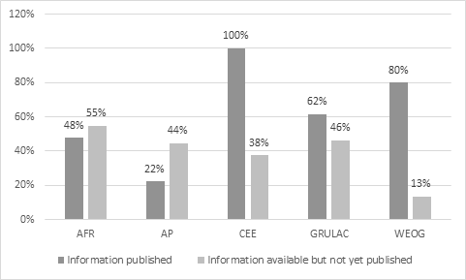

(b) *Challenges and difficulties*

1. Some Parties reported that there were no perceived challenges in making information available in the ABS Clearing-House. Some of the difficulties and challenges identified by other Parties are the following: (a) delays in the designation of the publishing authority; (b) frequent changes in responsible authorities; (c) the need for translation of the ABS Clearing-House into other languages; (d) the need for capacity to use the ABS Clearing-House; and (e) technical difficulties.
2. With respect to the internationally recognized certificates of compliance, Parties that reported having issued permits or their equivalent identified the following constraints for publishing this information in the ABS Clearing-House: (a) the need to adopt ABS measures; (b) technical problems in accessing the ABS Clearing-House; (c) the need to streamline the process for making permits available to the ABS Clearing-House; (d) lack of human resources; (e) the need for capacity-building; and (f) delays in the designation of publishing authorities.

# Suggested issues for consideration

1. The Committee may wish to consider the rate of submission of the interim national reports described in section II above.
2. As a contribution to the first assessment and review of the Protocol, the Committee is invited to consider the progress made by Parties in implementing the Protocol and to examine the possible general issues of compliance, as well as difficulties and challenges identified in section II above, with a view to providing inputs in the form of information and findings on general issues of compliance for the second meeting of the Subsidiary Body on Implementation. The Committee may also wish to provide recommendations to the Subsidiary Body on Implementation to assist in addressing challenges to the implementation of the Protocol.
3. Finally, the Committee may wish to discuss how its findings on general issues of compliance and recommendations to assist in addressing challenges to the implementation of the Protocol may be relevant to the development of the [post-2020 biodiversity framework](https://www.cbd.int/post2020/), for example by identifying key priorities for advancing the implementation of the Nagoya Protocol. It may also wish to consider what role it could play in the process towards the development of the post-2020 biodiversity framework. The Committee may further wish to make recommendations on these matters to the Conference of the Parties serving as the meeting of the Parties to the Protocol at its third meeting, as appropriate.

__________

1. * [CBD/ABS/CC/2/1](https://www.cbd.int/doc/c/0b2c/2720/e624bbebb1a093b90db3d1ce/abs-cc-02-01-en.pdf).
2. Chad, Ecuador, Lebanon, United Republic of Tanzania and Zimbabwe.
3. As the Protocol had not yet entered into force for the country following the 90-day period set out in Article 33.2 of the Protocol.
4. In decision XIII/21, paragraph 38.
5. Through notification 2017-032 of 23 February 2017.
6. For the purpose of the present document, the term “Parties” includes those that had ratified the Nagoya Protocol by 22 February but for which the Protocol has not yet entered into force following the 90-day period set out in Article 33.2 of the Protocol.
7. “Has your country taken legislative, administrative and policy measures on ABS?”
8. Some of these Parties have published some information in the ABS Clearing-House and indicated that they had information available that had not yet been published.
9. Of these 11 Parties, 4 have already published some permits constituting internationally recognized certificates of compliance in the ABS Clearing-House but indicated that they also had additional permits to publish.