|  |  |  |
| --- | --- | --- |
| Macintosh HD:Users:bilodeau:Desktop:logos:template 2017:un.emf |  | **CBD** |

|  |  |
| --- | --- |
| Macintosh HD:Users:bilodeau:Desktop:logos:template 2017:cbd.emf | Distr.  GENERAL  CBD/SBI/3/3/Add.1  17 August 2020  ORIGINAL: ENGLISH |

Subsidiary Body on Implementation

Third meeting

Venue and dates to be determined

Item 4 of the provisional agenda[1]*

Analysis of information for the assessment and review of the effectiveness of the Cartagena Protocol on Biosafety and final evaluation of the Strategic Plan for the Cartagena Protocol for the period 2011-2020

*Note by the Executive Secretary*

1. **INTRODUCTION**
2. Article 35 of the Cartagena Protocol on Biosafety requires that the Conference of the Parties serving as the meeting of the Parties to the Protocol undertake, five years after the entry into force of the Protocol and at least every five years thereafter, an evaluation of the effectiveness of the Protocol, including an assessment of its procedures and annexes.
3. The Strategic Plan for the Cartagena Protocol on Biosafety for the period 2011-2020 (Strategic Plan) was adopted by the Conference of the Parties serving as the meeting of the Parties in 2010 through its [decision BS‑V/16](http://bch.cbd.int/protocol/decisions/?decisionID=12329). The mid-term evaluation of the Strategic Plan as carried out in conjunction with the third assessment and review of the effectiveness of the Protocol and considered by the Conference of the Parties serving as the meeting of the Parties to the Protocol, at its eighth meeting (decision [CP-VIII/15](https://www.cbd.int/doc/decisions/mop-08/mop-08-dec-15-en.pdf)).
4. The Conference of the Parties serving as the meeting of the Parties to the Protocol, at its ninth meeting, through decision [CP-9/6](https://www.cbd.int/doc/decisions/cp-mop-09/cp-mop-09-dec-06-en.pdf), decided that the fourth assessment and review of the Cartagena Protocol would be combined with the final evaluation of the Strategic Plan for the Cartagena Protocol and outlined a process in this regard, involving contributions from the Liaison Group on the Cartagena Protocol on Biosafety and the Compliance Committee, consideration by the Subsidiary Body on Implementation at its third meeting, and the Conference of the Parties serving as the meeting of the Parties to the Protocol, at its tenth meeting.
5. The Conference of the Parties serving as the meeting of the Parties to the Protocol requested the Executive Secretary to analyse and synthesize information on the implementation of the Protocol, using, inter alia, the fourth national reports as a primary source,[2] the Biosafety Clearing-House (BCH) and experience from capacity-building projects and the Compliance Committee, where appropriate, to facilitate the fourth assessment and review of the Protocol in conjunction with the final evaluation of the Strategic Plan, and make this information available to the Liaison Group and, as appropriate, the Compliance Committee.
6. The present note presents the analysis and synthesis of information for the fourth assessment and review of the effectiveness of the Protocol and the final evaluation of the Strategic Plan. A preliminary version of this document was made available to the Compliance Committee at its seventeenth meeting and the Liaison Group at its fourteenth meeting.[3]
7. Section II describes the methodology used for the preparation of the analysis of information. Section III provides an analysis and synthesis of information on progress made towards reaching the operational objectives of the Strategic Plan and on the status and trends in the implementation of the Cartagena Protocol on Biosafety.
8. **METHODOLOGY**
9. Pursuant to decision CP-9/6, paragraph 3(b), this document analyses and synthesizes information on the implementation of the Protocol related to the fourth reporting cycle, as compared to the baseline.
10. The information for the present analysis was obtained from the fourth national reports that had been submitted by 15 January 2020,[4] information from the BCH and experience from capacity-building projects and the Compliance Committee.[5]
11. The baseline used for measuring progress was established through decision BS-VI/15. The baseline comprises information from primarily the second national reports, the BCH and a dedicated survey to gather information corresponding to indicators in the Strategic Plan that could not be obtained from the second national reports or though other existing mechanisms (referred to below as the “Survey”).[6]
12. The information provided in the fourth national reports was compared with information from the baseline. The comparison of these data was obtained making use of the online national report analyser tool.[7] Information from the BCH relating to the fourth reporting cycle was compared with similar information from the baseline. For each indicator, the source of information used is provided in the matrix on sources of information.[8]
13. Furthermore, the analysis is based on data of only those Parties that submitted their fourth national report by 15 January 2020 which had also provided corresponding data at the baseline. This approach is intended to enable a consistent and comparable review of progress over time and follows the approach taken for the third assessment and review of the Protocol and mid-term evaluation of the Strategic Plan.[9]
14. Of the 99 Parties that had submitted a complete fourth national report by 15 January 2020, a total of 94 of these Parties had also submitted a second national report and 71 had responded to the Survey. Not all Parties provided answers to all questions in the national reports and in the Survey so as a result, the total number of Parties to which reference is made in the analysis varies for the different indicators.
15. The present note provides an analysis of information obtained in the fourth reporting cycle (current status) and of reported changes since the baseline. Changes are presented as “increase” (“(+x%)”) or “decrease” (“(-x%)”) and reflect net changes, not those changes reported by individual Parties.[10]
16. In addition to providing information on the current status and changes from the baseline globally, regional breakdowns are provided for a number of indicators to help clarify the status reported or changes from the baseline at the global level. As the number of Parties in some regional groups is limited, small changes may result in large differences, when expressed in percentages.
17. The analysis covers each of the operational objectives of the Strategic Plan and uses the respective indicators to assess the progress made towards the achievements of the operational objectives.[11] Some indicators refer to the “percentage of Parties”, while others refer to the “number of Parties”. In keeping with the analysis prepared for the third assessment and review of the Protocol and mid-term evaluation of the Strategic Plan, the present analysis refers to percentages and also provides the number of Parties within brackets for the figures at the global level. For the regional breakdowns and trends, only percentages are provided.
18. **Analysis of the status and trends in the IMPLEMENTATION OF THE CARTAGENA PROTOCOL ON BIOSAFETY**
19. This section presents a comparative analysis of the status and trends in the implementation of the Cartagena Protocol on Biosafety.
20. In order to facilitate an integrated assessment of the emerging trends in the implementation of the Cartagena Protocol on Biosafety and to avoid a duplication of information, related operational objectives of the Strategic Plan are analysed and discussed under 12 broad areas, namely: national biosafety frameworks; coordination and support; risk assessment and risk management; living modified organisms (LMOs) or traits that may have adverse effects; liability and redress; handling, transport, packaging and identification; socioeconomic considerations; transit, contained use, unintentional transboundary movements and emergency measures; information sharing; compliance and review; public awareness and participation, biosafety education and training; and outreach and cooperation.
21. Based on the analysis below, a brief summary of progress in each of these areas is included in document CBD/SBI/3/3.
22. **National biosafety frameworks (operational objectives 1.1 and 2.1)**

**Operational objective 1.1: National biosafety frameworks**

1. The focus of operational objective 1.1 is to enable all Parties to have operational national biosafety frameworks in place for the implementation of the Protocol. Five indicators were set out to measure progress towards the achievement of this operational objective.
2. With regard to **indicator 1.1.1** (the number of Parties, in particular in centres of origin, that have in place national biosafety legislation and implementing guidelines not more than six years after accession to/ratification of the Protocol), 55% of Parties (51 Parties) reported having fully introduced the necessary legal, administrative and other measures for the implementation of the Protocol, which is an increase of 8% (7 Parties) from the baseline. There are substantial regional differences. Measures were reported to be fully in place by: all Parties within the Western Europe and Others region (WEOG) (+6%); 81% of Parties in Central and Eastern European region (CEE) (+6%); 63% of Parties in the Asia-Pacific region (+6%); 30% of the Parties in the African region (+10%) and 8% of the Parties in Latin America and the Caribbean (GRULAC) (+8%).
3. A total of 39% of Parties (36 Parties) reported that national measures are partially in place, a decrease of 1% from the baseline. At the regional level, measures were reported to be partially in place by 77% of the Parties in the GRULAC region (+8%), 57% of the Parties in Africa (no change from the baseline), 38% of the Parties in Asia and the Pacific (-6%), 19% of the Parties in CEE (no change from the baseline), and none of the Parties in WEOG (-6%). More detailed information is provided under area J (compliance), in the context of indicator 3.1.2, including through figure 8.
4. **Indicator 1.1.1** concerns Parties having in place measures not more than six years after becoming a Party to the Protocol. Since December 2013, a total of four countries became Party to the Protocol.[12] One other State deposited its instrument of accession to the Protocol and became a party on 23 January 2020.[13] The comparative analysis does not reflect data provided by these Parties.[14]
5. Among the Parties that have reported that they have fully or partially introduced the necessary legal, administrative and other measures for the implementation of the Protocol, 24 fall within centres of origin (no change from the baseline).[15] A total of 13 of these Parties reported having in place measures fully in place, an increase of 1 Party, as compared to the baseline.
6. With respect to the specific kinds of instruments that Parties have reported having in place for the implementation of the Protocol, 80 Parties reported having in place one or more biosafety laws, regulations or guidelines. As compared to the baseline, 10 more Parties reported having one or more biosafety laws, 12 more Parties reported having one or more biosafety regulations and 12 more Parties reported having one or more sets of biosafety guidelines.[16] A total of 55 Parties reported that other laws, regulations or guidelines that indirectly apply to biosafety are in place (1 Party less than at the baseline). A total of 5 Parties reported no instrument is in place, which represents no change from the baseline. Many Parties that reported having biosafety specific instruments also reported that other instruments that indirectly apply to biosafety are in place.
7. In their written contributions, a number of Parties explained the difficulties they face with respect to adopting legal, administrative and other measures to implement the Protocol. Several Parties indicated that legal instruments are being developed or have been developed but are pending adoption. Some of these Parties indicated that the adoption of these instruments is expected to strengthen institutional structures and improve the availability of resources. Some Parties mentioned the importance of biosafety mainstreaming across a variety of sectoral and cross-sectoral policy and legal instruments. Some Parties reported having effectively addressed biosafety in sectoral or cross-sectoral policies or laws. A number of Parties indicated that the lack of resources and capacities has negatively affected the implementation of the Protocol.
8. With respect to **indicator 1.1.2** (the percentage of Parties that have in place administrative rules and procedures for handling notifications and requests for approval of imports of LMOs intended for direct use as food or feed, or for processing (LMOs-FFP); contained use and for introduction into the environment), a total of 83% of Parties (77 Parties) reported having laws, regulations or administrative measures for decision-making regarding the import of LMOs for direct use as food, feed or for processing, which constitutes an increase of 13% from the baseline. Increases were reported in all regions (GRULAC +31%; Asia and the Pacific +19%; WEOG +11%; Africa +7%; CEE +6%).
9. A total of 80% of Parties (74 Parties) reported regulating contained use, a 7% increase from the baseline. Increases were reported in Asia and the Pacific (+19%), CEE (+13%) and GRULAC (+7%), while no change from the baseline was reported in Africa and WEOG.
10. Furthermore, 66% of Parties (61 Parties) reported having established legal requirements for exporters under their domestic framework to notify in writing the competent national authority of the Party of import prior to the intentional transboundary movement of an LMO that falls within the scope of the advance informed agreement (AIA) procedure, an increase of 5% from the baseline. In addition, 10% of Parties (9 Parties) reported having established such legal requirements for exporters to some extent.[17] Taken together, 76% of Parties reported having established such legal requirements, an increase of 14%[18] from the baseline (with regional changes as follows: Asia and the Pacific +38%; GRULAC +31%; Africa +7%; WEOG +6%; CEE no change from the baseline). A total of 25% of Parties (23 Parties) reported not having established such legal requirements, a decrease of 14%.
11. With regard to **indicator 1.1.3** (the percentage of Parties that have designated national focal points and competent national authorities), 98% of all Parties to the Protocol (168 of 171 Parties) have designated their national focal point for the Cartagena Protocol. This represents a decrease of 1% from the baseline, when it was 99% (159 of the 161 Parties at the time); A total of 99% of all Parties to the Protocol (169 Parties) have designated their focal point for the BCH. This is unchanged from the baseline, when it was 99% (160 of the 161 Parties at the time). A total of 89% of all Parties to the Protocol (152 Parties) have designated one or more competent national authorities. This represents an increase of 1% from the baseline, when it was 88% (142 of the 161 Parties at the time). Furthermore, a total of 78% of all Parties to the Protocol (133 Parties) have made available to the BCH information concerning their point of contact for receiving notifications under Article 17. This represents an increase of 34% from the baseline when it was 44% (71 of the 161 Parties at the time).
12. In relation to **indicator 1.1.4** (the percentage of Parties that have received notifications in accordance with Article 8 of the Protocol or the appropriate domestic legislation), 21% of the Parties (19 Parties) reported having received a notification regarding the intentional transboundary movements of LMOs for intentional introduction into the environment, which is a decrease of 13% from the baseline (with changes per region as follows: WEOG -44%; CEE -19%; GRULAC -8%; Africa and Asia and the Pacific: no change from the baseline). Some of these changes may be related to the revision of the question in the format for the fourth national report, which was restricted to the reporting period, while it was open-ended in the second national report.
13. Finally, with respect to **indicator 1.1.5** (the percentage of Parties that have made import decisions in accordance with Article 10 of the Protocol or the appropriate domestic legislation) 19% of the Parties (15 Parties) reported having taken decisions in response to a notification regarding intentional transboundary movements of LMOs for intentional introduction during this reporting cycle, a decrease of 14% (with regional differences as follows: WEOG -41%; CEE -20%; GRULAC -10%; Asia and the Pacific -8%; Africa, no change from the baseline). A total of 7 Parties having taken such a decision reported that the decision related to the approval of import with conditions, while 2 Parties reported that the decisions related to approval without conditions. A further 2 Parties reported that the decision related to a prohibition of import.

**Operational objective 2.1: National biosafety frameworks**

1. Under operational objective 2.1, the Parties aim to further support the development and implementation of national regulatory and administrative systems. Information on **indicator 2.1.1** (number of Parties with operational regulatory frameworks) is presented above in the context of operational objective 1.1.
2. With regard to **indicator 2.1.2** (the number of Parties with functional administrative arrangements), the fourth national reporting format contains a number of relevant questions,[19] although none of these questions directly address the functionality of administrative arrangements.
3. A total of 58% of Parties (53 Parties) reported that a mechanism has been established for budget allocations for the operation of their national biosafety measures (a decrease of 10% from the baseline), while 23% of Parties (21 Parties) reported having done so to some extent. Taken together, this constitutes an increase of 13% (12 Parties), as compared to the baseline (with regional changes, as follows: Asia and the Pacific +25%; CEE +24%; Africa +13%; GRULAC -1%; WEOG no change).[20]
4. A total of 94% of Parties (87 Parties) reported having permanent staff to administer functions related to biosafety, an increase of 8% from the baseline (with regional changes, as follows: Africa +17%; GRULAC +7%; CEE +6%; Asia and the Pacific and WEOG: no change from the baseline). In their fourth national reports, a total of 47% of Parties reported that the number of staff was adequate.[21]
5. A total of 65% of Parties (60 Parties) reported having established adequate institutional capacity to enable the competent authority to perform the administrative functions required by the Cartagena Protocol (an increase of 20% from the baseline), while a total of 26% of Parties (24 Parties) reporting that adequate institutional capacity had been established to some extent (a decrease of 14% from the baseline).
6. In their written contributions, a number of countries indicated that although institutional frameworks have been established, the necessary capacities and staffing levels are still insufficient. Some Parties indicated that inter-agency cooperation needs to be improved. Some Parties mentioned that further strengthening of mandates through legislation is required.
7. **Coordination and support (operational objective 1.2)**
8. Operational objective 1.2 focuses on putting in place effective mechanisms for establishing biosafety systems with the necessary coordination, financing and monitoring support. Eight indicators were developed to measure progress towards the achievement of this operational objective.
9. With respect to **indicator 1.2.1** (the number of Parties that have assessed their capacity-building needs, including training and institutional needs, and submitted the information to the BCH), 45% of Parties (42 Parties) reported that they carried out a capacity-building needs assessment, which represents a decrease of 4% from the baseline. At the regional level, these figures are as follows: 69% in Asia and the Pacific (+19%); 63% in Africa (+7%); 54% in GRULAC (-8%); 19% in CEE (-44%); WEOG 11% (-6%).
10. Regarding **indicator 1.2.2** (the percentage of the Parties that have developed national biosafety capacity-building action plans for implementing the Protocol), 33% of Parties (31 Parties) reported having developed a capacity-building strategy or action plan, an increase of 2% from the baseline. At the regional level, the figures are as follows: Asia and the Pacific: 75% (+31%); Africa: 33% (+3%); CEE: 13% (-25%). The percentages reported in GRULAC (38%) and WEOG (11%) constitute no change from the baseline.
11. With respect to **indicator 1.2.3** (the percentage of Parties that have in place training programmes for personnel dealing with biosafety issues and for long-term training of biosafety professionals), the fourth national report does not contain a question specific to this indicator. However, 86% of the Parties (61 Parties) reported that academic institutions in their country offer biosafety education and training courses and programmes, which is an increase of 11% from the baseline. In their written contributions a number of Parties indicated that in addition, seminars and training workshops for policymakers, experts and relevant personnel had been organized.
12. As regards **indicator 1.2.4** (the percentage of Parties that have in place national coordination mechanisms for biosafety capacity-building initiatives), 44% of Parties (31 Parties) reported having a functional national mechanism for coordinating biosafety capacity-building initiatives, which is a decrease of 10% from the baseline. The figures at the regional level are as follows: Africa: 42% (+5%); Asia and the Pacific: 78% (+22%); CEE: 43% (+7%); WEOG: 38% (-31%); GRULAC: 31% (-46%). A number of Parties indicated in their written contributions that their competent national authorities are responsible for coordinating and implementing biosafety capacity-building initiatives at the national level.
13. In respect of **indicator 1.2.5** (the amount of new and additional financial resources mobilized for the implementation of the Protocol) 31 Parties reported having mobilized additional financial resources beyond their regular national budgetary allocation, a decrease of 13 Parties, as compared to the baseline. Of these Parties, 35% reported having received between US$ 5,000 and 49,999; 16% between US$ 50,000 and 99,999; 23% between US$ 100,000 and US$ 499,999; and 23% more than US$ 500,000. As further set out in the information provided for **indicator 3.1.8**, below, decreases in the amounts received as compared to the baseline were reported.
14. In relation to **indicator 1.2.6** (the number of Parties that have predictable and reliable funding for strengthening their capacity in implementing the Protocol), 35% of Parties (25 Parties) reported having predictable and reliable funding (a decrease of 7% from the baseline), while 14% of Parties (10 Parties) reported that they have predictable and reliable funding to some extent (an increase of 14% from the baseline). Considered together, 49% of the Parties (35 Parties) reported having predictable and reliable funding at least to some extent, an increase of 7% from the baseline. At the regional level, increases are reported for Africa (+21%), Asia and the Pacific (+11%) and GRULAC (+8%). Decreases are reported for CEE (‑7%) and no change from the baseline is reported in WEOG. To some extent, the reported changes since the baseline may be related to a change in the reporting format for the fourth national report.[22]
15. With regard to **indicator 1.2.7** (the number of Parties reporting that their capacity‑building needs have been met), 20% of Parties (19 Parties) reported having no capacity-building needs, a slight increase of 2%. While 83% of Parties in the WEOG region reported that their capacity-building needs had been met (-4%), in other regions, the percentages were much lower. No change from the baseline was reported in three regions, where percentages remained as follows: Africa 0%; GRULAC 0%; Asia and the Pacific 13%. CEE was the only region where there was a positive trend in the number of Parties reporting that their capacity‑building needs had been met, with an increase of 13%, bringing the percentage for this region to 13%.
16. In their free text contributions, a number of Parties indicated that funds for capacity-building are often limited and insufficient to address all their capacity-needs. Many Parties indicated that they had benefited from funds provided by the Global Environment Facility (GEF). A number of these Parties indicated that these funds were hard to access and that project preparation times were long and complex. Other Parties indicated that they had not been able to access GEF funds for biosafety-related activities. Several Parties mentioned that they are in receipt of funding from their government or that their government provides co-funding for biosafety capacity-building projects. A few Parties mentioned that bilateral and multilateral channels were also means used to secure external financial and technical support to strengthen capacity in implementing the Protocol.
17. With regard to **indicator 1.2.8** (the number of cooperative arrangements reported involving LMO exporting and importing Parties), the fourth national report and the BCH do not provide information related to cooperative arrangements specifically involving LMO-exporting and -importing Parties. However, information is provided on bilateral, regional and multilateral agreements or arrangements relevant to biosafety. A total of 27% of Parties (20 Parties) reported having entered into one or more such agreements or arrangements, an increase of 6% from the baseline. Regional changes since the baseline are reported as follows: Asia and the Pacific +33%; GRULAC +16%; Africa +13%; CEE -2%; WEOG -21%. Of these Parties, 18 reported having entered into between 1 and 4 agreements or arrangements; 1 Party reported having entered into between 5 and 9, while 1 Party reported having entered into 10 or more agreements or arrangements.
18. **Risk assessment and risk management (operational objectives 1.3 and 2.2)**

**Operational objective 1.3: Risk assessment and risk management**

1. Operational objective 1.3 focuses on further developing and supporting the implementation of scientific tools on common approaches to risk assessment and risk management. Four indicators were set out to measure progress towards the achievement of this operational objective.
2. Concerning **indicator 1.3.1(a)** (percentage of Parties adopting and using guidance documents for the purpose of performing their own risk assessment and risk management) and **indicator 1.3.1(b)** (percentage of Parties adopting and using guidance documents for the purpose of evaluating risk assessment reports submitted by notifiers), the information available from the national reports does not enable distinguishing between guidance for performing risk assessments and guidance for evaluating risk assessments submitted by notifiers. The information in the fourth national reports includes some relevant information that can help towards measuring these indicators, as summarized in the following two paragraphs.[23]
3. As regards, risk assessment, a total of 72% of Parties (51 Parties) reported that they had adopted or used guidance documents for the purpose of conducting risk assessment, or for evaluating risk assessment reports submitted by notifiers. This represents a modest 4% increase from the baseline. At the regional level, considerable variation is visible: WEOG 100%; Asia and the Pacific: 89%; CEE 86%; Africa: 58%; GRULAC: 31%. Changes were reported in two regions: Africa (+11%); CEE (+7%).
4. As regards risk management, a total of 71% of Parties (50 Parties), reported that they had adopted or used guidance documents for the purpose of conducting risk management, representing a +5% increase from the baseline. At the regional level, considerable variation is visible: WEOG 100%; Asia and the Pacific: 88%; CEE 86%; Africa: 58%; GRULAC: 31%. The breakdown in regional increases is as follows: Asia and the Pacific (+13%), Africa (+11%), CEE (+7%). (See figure 1).
5. From the Parties that reported having adopted or used guidance documents on risk assessment or risk management, 41% (29 Parties) indicated to be using the “Guidance on Risk Assessment of LMOs” (developed by the Online Forum and the AHTEG on Risk Assessment and Risk Management). This represents an increase of 5% (35 Parties) compared to the mid-term evaluation.[24] The biggest change was reported in the African region (+28%), followed by Asia and the Pacific (-6%) and CEE (-8%), while no change from the baseline was reported in GRULAC and WEOG.
6. For **indicator 1.3.2** (percentage of Parties adopting common approaches to risk assessment and risk management), 58% (41 Parties) reported having adopted common approaches or methodologies to risk assessment in coordination with other countries, an increase of 13% from the baseline. All regions reported an increase, which was most pronounced in GRULAC (+23%), followed by CEE (+14%), WEOG (+13%); Asia and the Pacific (+11%) and Africa (+5%).
7. In relation to **indicator 1.3.3** (percentage of Parties that undertake actual risk assessments pursuant to the Protocol), 61% of Parties (43 Parties) reported having undertaken risk assessment of LMOs pursuant to the Protocol in the current reporting period. This represents an increase of 9% from the baseline. At the regional level, increases were reported in CEE (+36%); Asia and the Pacific (+22%) and WEOG (+6%). The GRULAC region showed a decrease (-15%), while the African region showed no change from the baseline. Of those who indicated having undertaken a risk assessment, 25% reported that they undertook 100 or more risk assessments in this reporting cycle; 15% reported having conducted between 50-99 risk assessments; 31% reported having conducted between 10 to 49 risk assessments; and 29% reported having conducted 1-9 risk assessments.[25]

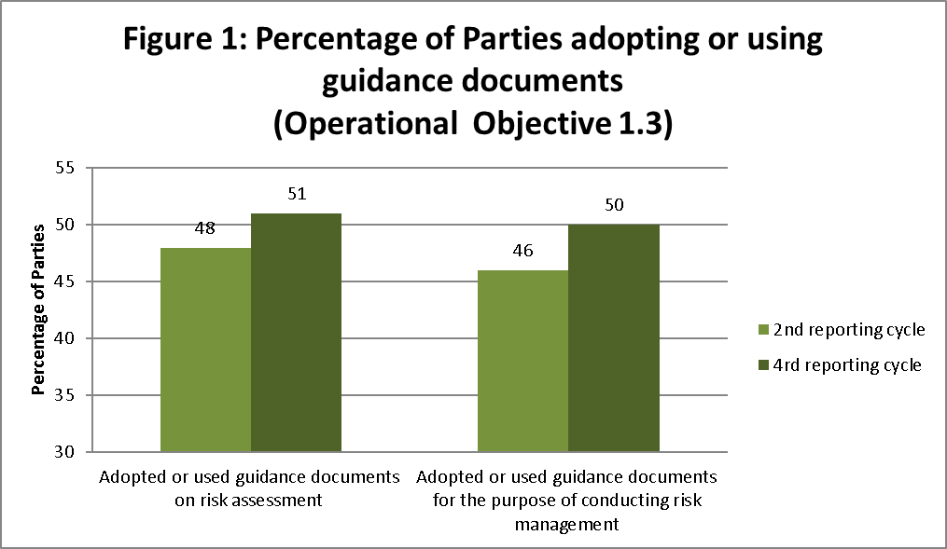

**Operational objective 2.2: Risk assessment and risk management**

1. Within focal area 2 on “Capacity-building”, operational objective 2.2 is aimed at enabling Parties to evaluate, apply, share and carry out risk assessments, as well as establish local science-based capacities to regulate, manage, monitor and control risks of LMOs. Six indicators are provided under this operational objective to measure progress (Figure 2).
2. Concerning **indicator 2.2.1** (the ratio of risk assessment summary reports as against number of decisions on LMOs on the BCH), the ratio between risk assessment reports and the number of decisions on LMOs[26] in the BCH has increased from 79% (514 risk assessments to 650 decisions) in January 2012; and 92% (1,198 risk assessments to 1,299 decisions) in January 2016; to 96% (2,055 risk assessments to 2,134 decisions) in January 2020. From the baseline, this represents a 17% increase.[27]
3. For **indicator** **2.2.3** (number of people trained on risk assessment, as well as in monitoring, management and control of LMOs), Parties reported on the number of people in their country trained in risk assessment, risk management and monitoring of LMOs, as follows:
4. People trained in risk assessment: 93% of Parties reported that people had been trained in their country on risk assessment. A total of:
   1. 31% of Parties (22 Parties) reported between 1 to 9 people (no change from baseline);
   2. 35% of Parties (25 Parties) reported between 10 to 49 people (+4%);
   3. 14% of Parties (10 Parties) reported 50 to 99 people (-10%);
   4. 13% (9 Parties) reported 100 or more people had been trained on risk assessment (+4%);
   5. A total of 7% of Parties (5 Parties) reported that none had been trained (+1%);
5. People trained in risk management: 90% of Parties reported that people had been trained in their country on risk management. A total of:
   1. 38% (27 Parties) reported between 1 to 9 people (+8%);
   2. 28% (20 Parties) reported between 10 to 49 people (-3%);
   3. 13% (9 Parties) reported between 50 to 99 people (-10%);
   4. 11% (8 Parties) reported 100 or more people had been trained on risk management (+ 3%);
   5. 10% (7 Parties) reported none had been trained (+2%);
6. People trained in monitoring of LMOs: 87% of Parties reported that people had been trained in their country on monitoring of LMOs. A total of:
   1. 41% (29 Parties) reported between 1 to 9 people (+14%);
   2. 28% (20 Parties) reported between 10 to 49 people (-10%);
   3. 11% (8 Parties) reported between 50 to 99 people (-6%);
   4. 7% (5 Parties) reported that 100 or more people had been trained on monitoring of LMOs (+1%);
   5. 13% (9 Parties) reported none had been trained (no change from the baseline).
7. Concerning **indicator 2.2.4** (number of Parties that have infrastructure, including laboratories for monitoring, management and control), 77% of Parties (55 Parties) reported having the necessary infrastructure for monitoring or managing LMOs. There was no change from the baseline. Within the regions, changes were reported in Africa (+5%) and in GRULAC (-8%) in Parties that reported having infrastructure for monitoring and control. In their written contributions, several Parties highlighted the continuous need for support in establishing the necessary infrastructure. Some Parties indicated that they benefit from capacity-building activities in this area, including projects supported by UNEP-GEF.
8. Concerning **indicator 2.2.5** (number of Parties that are using the developed training materials and technical guidance), 77% of Parties (55 Parties) reported using training material and/or technical guidance for training in risk assessment and risk management of LMOs. This represents an increase of 1% from the baseline. Of these Parties, 50% reported to be using the “Manual on Risk Assessment of LMOs” (developed by the CBD Secretariat), and 49% reported to be using the “Guidance on Risk Assessment of LMOs” (developed by the Online Forum and the AHTEG on Risk Assessment and Risk Management). In both cases, the African region had the highest percentage of Parties who reported using the Manual and the Guidance (78%). In comparison to the mid-term evaluation, there has been an increase in the percentage of Parties using the Guidance on Risk Assessment (+4%), while no change was reported since the mid-term evaluation in the use of the Manual.[28]
9. For **indicator 2.2.6** (number of Parties that are of the opinion that the training materials and technical guidance are sufficient and effective), 65% of Parties (64 Parties)[29] indicated that their country has specific needs for further guidance on specific topics of risk assessment of LMOs. At the regional level, the percentage of Parties reporting to have specific needs for further guidance are as follows: Africa: 97%; GRULAC: 87%; Asia and the Pacific: 56%; CEE: 44%; WEOG: 21%.
10. Figure 2 provides an overview of information related to various indicators under operational objective 2.2, such as training on assessment, management and monitoring of LMOs, as well laboratory infrastructure and the use of training materials and guidance.

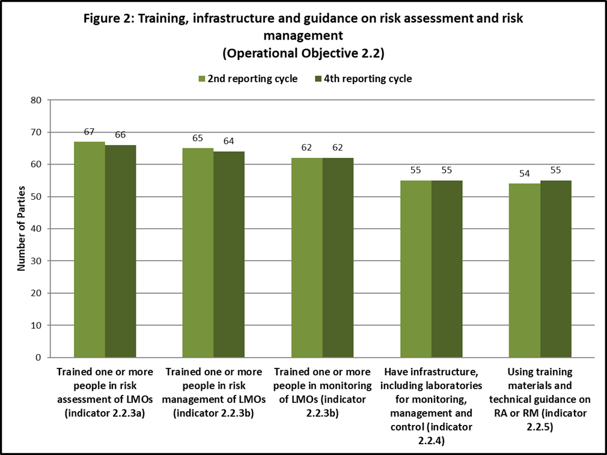

1. **LMOs or traits that may have adverse effects (operational objective 1.4)**
2. Operational objective 1.4 focuses on the development of modalities for cooperation and guidance in identifying LMOs or specific traits that may have adverse effects on the conservation and sustainable use of biological diversity, taking also into account risks to human health. Two indicators are provided in the Strategic Plan to measure progress towards this operational objective.
3. Concerning **indicator 1.4.1** (guidance on living modified organisms or specific traits that may have adverse effects on the conservation and sustainable use of biological diversity, taking also into account risks to human health, developed by Parties and available), no information is available specifically relating to this indicator. However, some information on cooperation in this field is provided in the fourth national report.[30] A total of 43% of Parties (40 Parties) reported having cooperated with other Parties with a view to identifying LMOs or specific traits that may have adverse effects on the conservation and sustainable use of biological diversity. From the baseline, there has been a 6% increase with, at the regional level, the following changes: CEE (+19%), Asia and the Pacific (+13%), Africa (+7%), WEOG (+6%), GRULAC (-15%).
4. Concerning **indicator 1.4.2** (the number of Parties that have the capacity to detect, identify, assess, and monitor LMOs or specific traits that may have adverse effects on the conservation and sustainable use of biological diversity, taking into account risks to human health), Parties reported the following (see also figure 3 for (b)-(d)):
5. 79% of Parties (78 Parties) reported that they have the capacity to detect such LMOs. No baseline data is available related to detection, however this is an increase of 1% since the third reporting cycle reporting cycle;
6. 77% (55 Parties) reported having the capacity to identify such LMOs, which represents a 6% decrease;
7. 77% (54 Parties) reported having the capacity to assess such LMOs, which represents no change from the baseline;
8. 71% (50 Parties) reported having the capacity to monitor such LMOs, an increase of 5% from the baseline.
9. More Parties in the WEOG and CEE regions than in any other region reported having the capacity for detecting, assessing and monitoring in this area (between 85% and 100%). WEOG and Asia and the Pacific are the two regions with the highest capacities for identification (respectively 100% and 89%), followed by CEE (86%). Overall percentages for GRULAC and Africa are lower (between 56% and 68% in Africa, between 46% and 62% in GRULAC).

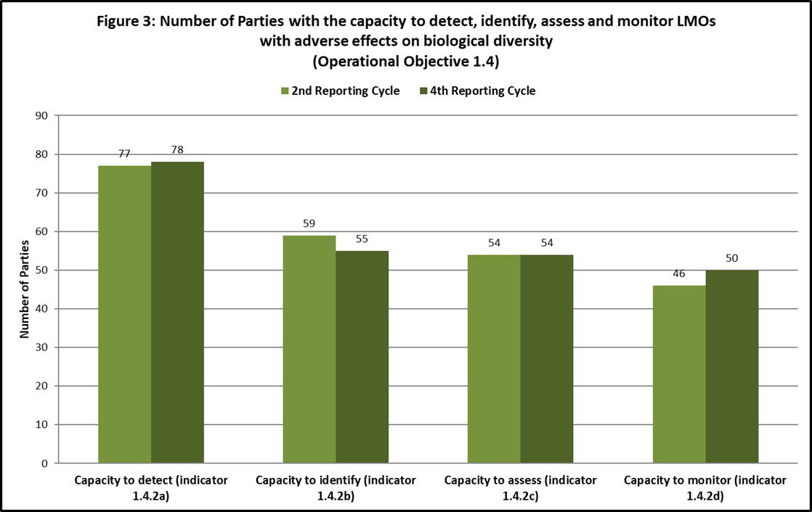

1. **Liability and redress (operational objectives 1.5 and 2.4)**

**Operational objectives 1.5 and 2.4: Liability and redress**

1. During the third assessment and review of the Protocol and the mid-term evaluation of the Strategic Plan in 2016, the Nagoya-Kuala Lumpur Supplementary Protocol on Liability and Redress to the Cartagena Protocol on Biosafety had not yet entered into force. The Supplementary Protocol required 40 ratifications to enter into force; 34 ratifications had been received by 1 March 2016. **Indicator 1.5.1** (entry into force of the Nagoya-Kuala Lumpur Supplementary Protocol on Liability and Redress to the Cartagena Protocol on Biosafety prior to the seventh meeting of the Conference of the Parties serving as the meeting of the Parties to the Protocol (2014)) was therefore not met.
2. The Supplementary Protocol entered into force on 5 March 2018. As of 16 January 2020, there were 47 Parties to the Supplementary Protocol, an increase of 38% since the third assessment and review. Of the 13 new ratifications received between 17 February 2016 and 16 January 2020, 5 (38%) were from countries in Africa and 8 were from countries of other regions, divided equally in 2 ratifications (15%) per region.
3. In the fourth national report, 57% of Parties (32 Parties) to the Cartagena Protocol that have not yet ratified the Supplementary Protocol indicated that they have a national process in place towards becoming a Party to the Supplementary Protocol.
4. As regards **indicator 1.5.2** (the percentage of Parties to the Supplementary Protocol having in place national administrative and legal frameworks incorporating rules and procedures on liability and redress for damage caused by LMOs), of the Parties to the Supplementary Protocol, 60% (23 Parties) reported having measures fully in place for the implementation of the Supplementary Protocol and 15% (6 Parties) reported that national measures are partially in place. A total of 13% of Parties (5 Parties) reported that only draft measures exist and another 13% (5 Parties) reported that no measures have yet been taken.[31]
5. In addition, information was provided on the implementation of the Supplementary Protocol and on liability and redress by countries that are Parties to the Cartagena Protocol but have not yet ratified the Supplementary Protocol. Information provided by these Parties and by Parties to the Supplementary Protocol in their fourth national reports is summarized below.
6. A total of 67% of Parties (66 Parties) reported having administrative or legal instruments that require response measures to be taken in case of damage resulting from LMOs. This represents a 3% decrease from the baseline. A total of 62% of Parties (61 Parties) reported having administrative or legal instruments that require response measures to be taken in case there is sufficient likelihood that damage will result if response measures are not taken.[32]
7. In addition, 55% of Parties (54 Parties) reported having identified a competent authority for carrying out the functions set out in the Supplementary Protocol while 45% (44 Parties) reported that they had not identified a competent authority.
8. Concerning **indicator 2.4.1** (number of eligible Parties that received capacity-building support in the area of liability and redress involving living modified organisms), a total of 17 Parties reported that in the current reporting period, activities had been carried out for the development and/or strengthening of human resources and institutional capacities in the field of liability and redress. In comparison to the third reporting cycle, wherein 12 Parties reported having received financial and/or technical assistance for capacity‑building in the area of liability and redress relating to LMOs, this constitutes an increase of 5 Parties, with an increase reported especially in the African region.
9. Information in relation to **indicator 2.4.2** (number of domestic administrative or legal instruments identified, amended or newly enacted that fulfil the objective of the international rules and procedures in the field of liability and redress) is not available, and reference should be made to the related **indicator 1.5.2** above.
10. **Handling, transport, packaging and identification (operational objectives 1.6 and 2.3)**

**Operational objective 1.6: Handling, transport, packaging and identification**

1. With regard to **indicator 1.6.1** (the percentage of Parties that have put in place documentation requirements for LMOs intended for direct use as food or feed, or for processing),55% of Parties (51 Parties) reported having taken measures to require that documentation accompanying LMOs-FFP, in cases where the identity of the LMOs is not known, clearly identifies that they may contain LMOs and are not intended for intentional introduction into the environment. This represents an increase of 11% from the baseline (with regional changes as follows: Africa +23%; GRULAC +8%; Asia and the Pacific +6%; CEE +6%; WEOG: no change from the baseline). In addition, 16% of Parties (15 Parties) reported that they had these measures in place to some extent (no change from the baseline).
2. A total of 62% of Parties (58 Parties) reported having taken measures requiring that documentation accompanying LMOs-FFP, in cases where the identity of the LMOs is known, clearly identifies that they contain LMOs and are not intended for intentional introduction into the environment, as well as a contact point for further information. This represents an increase of 15% from the baseline (with regional changes as follows: Africa +30%; GRULAC +23%; CEE +13%; Asia and the Pacific and WEOG: no change from the baseline). A further 16% of Parties (15 Parties) reported having taken such measures to some extent, a decrease of 1% (see figure 4).
3. Concerning **indicator 1.6.2** (the percentage of Parties that have put in place documentation requirements for LMOs for contained use and for intentional introduction into the environment), 63% of Parties (59 Parties) reported having taken measures to require that documentation accompanying LMOs that are destined for contained use clearly identifies them as LMOs and specifies any requirements for the safe handling, storage, transport and use, the contact point for further information, including the name and address of the individual and institution to whom the LMOs are consigned. This represents an increase of 9% from the baseline (with regional changes as follows: Africa +27%; CEE +19%; Asia and the Pacific +6%; WEOG no change from the baseline; GRULAC -23%). A total of 13% of Parties (12 Parties) reported having taken such measures to some extent, a decrease of 5% from the baseline (see figure 4).

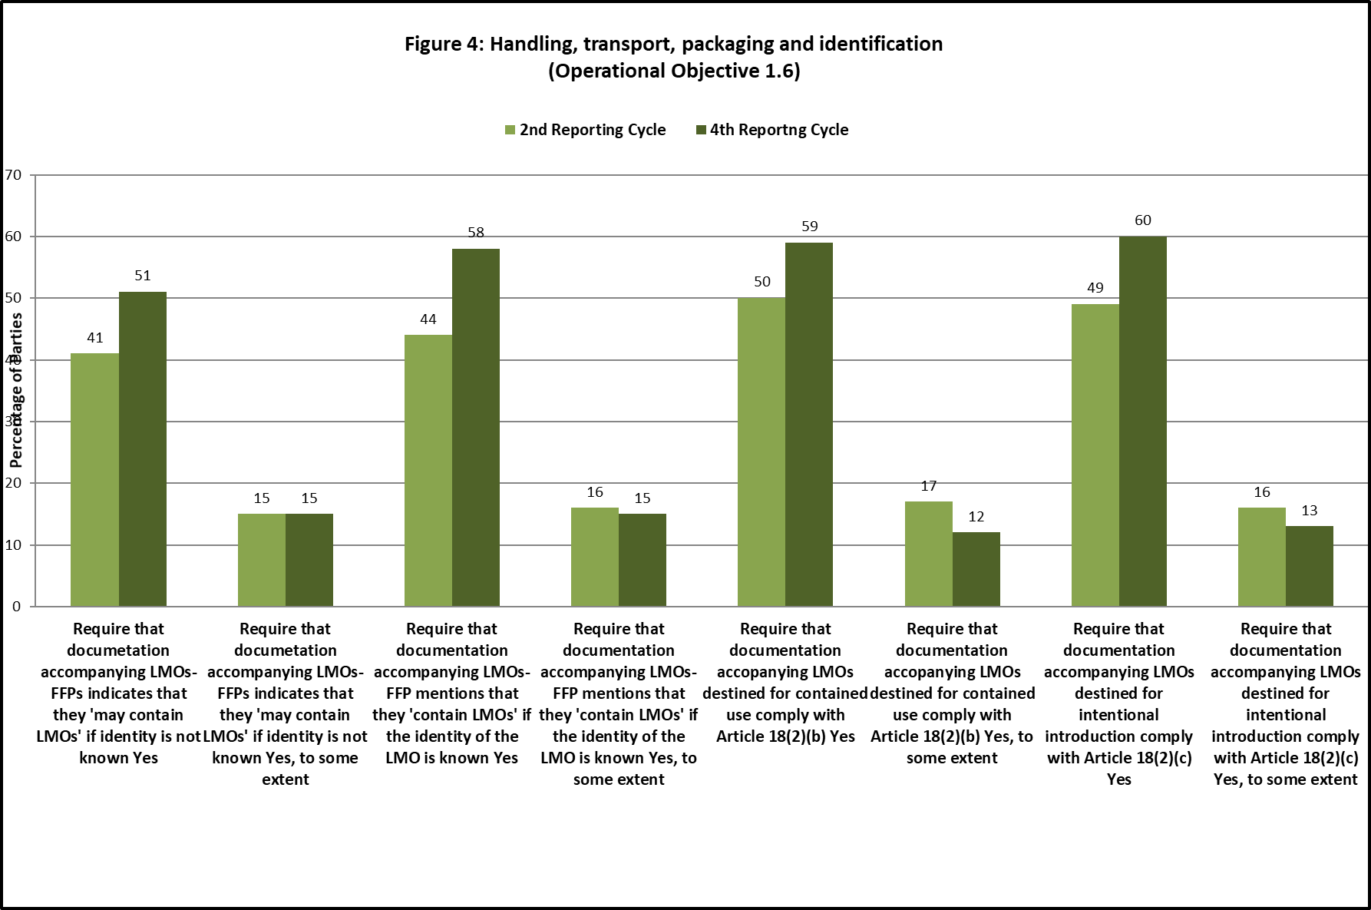

1. For **indicator 1.6.3** (the number of Parties with access to tools that are capable of detecting unauthorized LMOs), the closest information available to measure progress is related to Parties having established procedures for the sampling and detection of LMOs. A total of 56% of Parties (52 Parties) reported having established such procedures, an increase of 21% from the baseline (with regional changes as follows: Asia and the Pacific +50%; Africa +20%; WEOG +17%; GRULAC +8%; CEE +6%;). A total of 19% of Parties (18 Parties) reported having established such procedures to some extent, a decrease of 9%. (See also **indicator 1.4.2 (a)** above).
2. For **indicator 1.6.4** (the number of Parties using guidance developed for the handling, transport and packaging of LMOs), 69% of Parties (49 Parties) reported having guidance for the purpose of ensuring the safe handling, transport, and packaging of living modified organisms. This represents an increase of 7%. Changes at the regional level were reported in Africa (+4%) and Asia and the Pacific (+3%), while in the other regions no changes from the baseline was reported.

**Operational objective 2.3: Handling, transport, packaging and identification**

1. With respect to **indicator 2.3.1** (the number of customs officers and laboratory personnel trained) 59% of Parties (42 Parties) reported having trained customs officers, which represents a 6% increase from the baseline. The majority of these Parties (23 Parties) reported having trained up to 10 customs officers (55% of that group), an increase of 2% from the baseline. The number of Parties that reported having trained 100 or more customs officers increased by 7% to 6 Parties (14% of the Parties reporting to have trained customs officers), arising from increases in Asia and the Pacific and WEOG. Almost half of the Parties (41%) reported not having trained customs officers, a decrease of 6% from the baseline.
2. A total of 96% of Parties (68 Parties) reported that laboratory personnel received training on LMO detection, an increase of 9% from the baseline. The increase is mainly related to an increase of 12% from the baseline in the number of Parties that reported that up to 10 laboratory personnel had been trained (35 Parties in total).
3. In relation to **indicator 2.3.2** (percentage of Parties that have established or have reliable access to detection laboratories), 87% of the Parties reported having reliable access to laboratory facilities, which is an increase of 10% from the baseline, with a regional breakdown as follows: Africa: 79% (+11%); Asia and the Pacific: 89% (+11%); CEE: 100% (+14%); GRULAC: 69% (+15%); WEOG: 100% (no change from the baseline).
4. Concerning **indicator 2.3.3** (the number of national and regional laboratories certified with the capacity to detect LMOs), the national reports provide information on the number Parties reporting that laboratories exist in their country that are certified for LMO detection. A total of 68% of Parties (48 Parties) reported that one or more laboratories in their country are certified for LMO detection, 2 Parties more than at the baseline, which represents an increase of 3%, which is mostly attributable to the regions of Asia and the Pacific (+22%) and CEE (+7%).
5. Concerning **indicator 2.3.4** (the number of certified laboratories in operation), of those Parties that reported that laboratories certified for LMO detection exist in their country, 96% reported (46 Parties) that these laboratories are currently operating in the detection of LMOs. This represents a 10% increase from the baseline, attributable to the African (+33%) and CEE (+15%) regions.

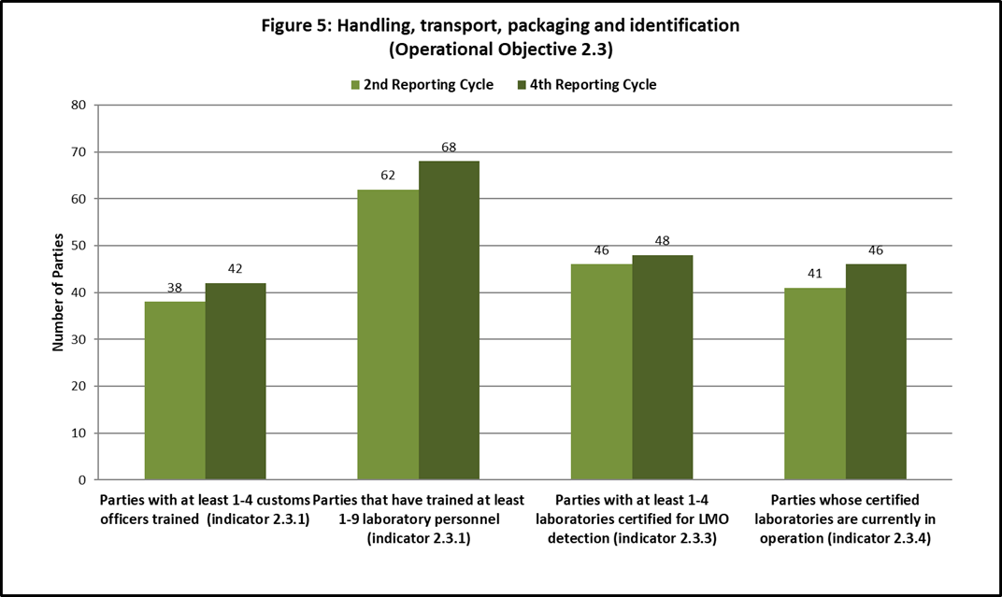

1. In their free text contribution, a number of Parties listed a variety of laboratories, as well as national networks, established within their jurisdiction. Several Parties mentioned the recent establishment of national laboratories. Parties from the European Union reported their participation in networks of laboratories that focus on the detection and identification of LMOs. A few Parties mentioned that they access and use international or foreign laboratories for their detection activities. In addition, a number of Parties indicated that capacity development is being undertaken to establish laboratories specific for LMO detection and/or to obtain international certification. Several recent or forthcoming training courses for customs officers and relevant legislation were also listed.
2. Other Parties mentioned that they were unable to undertake detection and identification of LMOs. Some Parties cited a lack of laboratories, personnel, equipment, certification and/or capacity to conduct LMO detection activities. A few Parties lacked the necessary biosafety regulations to regulate LMO detection but stated that they were in the process of developing such instruments. A few Parties mentioned that customs officers were not specifically trained on LMO detection and could benefit from further training. Some Parties mentioned that reinforcement at the personnel and laboratory levels are also required to improve capacity in this area. One Party mentioned that training courses are important and required to ensure capacity is maintained.
3. **Socioeconomic considerations (operational objective 1.7)**
4. The focus of operational objective 1.7 is to provide, on the basis of relevant research and information exchange, guidance on socio-economic considerations that may be taken into account in reaching decisions on the import of living modified organisms. Parties agreed on outcomes that include the development and use of guidelines and the application of socio-economic considerations, as appropriate. Four indicators were set out to measure progress towards the achievement of this operational objective.
5. Concerning **indicator 1.7.1** (the number of peer-reviewed research papers published, made available and used by Parties in considering socio-economic impacts of LMOs), 34% of Parties (24 Parties) reported that they had used peer reviewed materials for the purpose of elaborating or determining national actions with regard to socio-economic considerations, which constitutes a decrease of 8% from the baseline. A total of 14% of Parties reported having used 50 or more peer reviewed materials (+4%); 6% reported having used between 10 and 49 of such materials (-1%); 3% reported having used between 5 and 9 materials (no change from the baseline); 11% of Parties reported having used between 1 and 4 materials (-11%). All Parties that reported using 50 or more materials in the reporting period are from the CEE and WEOG regions. A total of 63% of Parties (17 Parties) reported in their fourth national reports that they considered the number of peer-reviewed published materials used to have been adequate.
6. With regard to **indicator 1.7.2** (the number of Parties reporting on their approaches to taking socio-economic considerations into account), 52% of Parties (37 Parties) reported having specific approaches or requirements that facilitate how socioeconomic considerations should be taken into account in LMO decision-making, an increase of 10% from the baseline. At the regional level, the data show pronounced variations, both in total numbers and in changes reported since the baseline: Africa: 63% (+32%); Asia and the Pacific: 44% (+22%); CEE: 50% (no change from the baseline); GRULAC: 8% (-15%); WEOG: 81% (+6).
7. In relation to **indicator 1.7.3** (number of Parties reporting on their experiences in taking socio-economic considerations into account in reaching decisions on the import of living modified organisms), 60 Parties (65%) reported having taken decisions on LMOs in this context during the reporting period.[33] Of these 60 Parties, 27% reported having always taken socio-economic considerations arising from the impact of LMOs into account in these decisions; 38% of these Parties reported having done so only in some cases; and 35% reported that they did not do so. From among those 60 Parties that reported having taken decisions on LMOs, this represents a 14% increase in the percentage of Parties that report having always or in some cases taken into account socio-economic considerations in their decision making on LMOs.
8. For **indicator 1.7.4** (number of Parties using guidelines on socio-economic considerations), no specific information is available. In the absence of specific information on the use of guidelines, some information is provided on activities that have taken place since the establishment of a baseline towards the fulfilment of operational objective 1.7 of the Strategic Plan on the development by Parties of guidance regarding socio-economic considerations of living modified organisms.
9. An Ad Hoc Technical Expert Group (AHTEG) on socio-economic considerations was established through decision BS-VI/13 to develop conceptual clarity in the context of paragraph 1 of Article 26. It met for the first time in Seoul, Republic of Korea in February 2014 and agreed to a list of elements of a framework for conceptual clarity on socio-economic considerations. At its seventh meeting, the Conference of the Parties serving as the meeting of the Parties to the Protocol extended the AHTEG to work on the further development of conceptual clarity and on developing an outline for guidance with a view to making progress towards achieving operational objective 1.7 of the Strategic Plan and its outcomes. The AHTEG continued its work online and agreed on a revised Framework for Conceptual Clarity, which was considered by the Conference of the Parties serving as the meeting of the Parties, at its eighth meeting. The meeting of the Parties, through decision CP-VIII/13, extended the AHTEG to allow it to meet face-to-face to work on the guidelines envisaged under the outcomes of operational objective 1.7 of the Strategic Plan. The AHTEG met in Ljubljana in October 2017. It developed a draft “Guidance on the assessment of socio-economic considerations in the context of Article 26 of the Cartagena Protocol on Biosafety”. The Guidance provides an operational definition, identifies principles and sets out a step-wise approach for an overall assessment process throughout which the principles identified would apply. The Conference of the Parties serving as the meeting of the Parties to the Protocol took note of the Guidance in decision CP-9/14. Work to supplement the Guidance on the basis of preliminary experience with its use as well as examples of methodologies and applications of socio-economic considerations continued in the 2019-2020 inter-sessional period.
10. The written contributions made in the fourth national reports, showed that a number of Parties take socio-economic considerations into account, yet to different degrees. Some Parties reported that their domestic legislation regarding LMOs requires that socio-economic considerations be fully taken into account in the decision-making process and provided further explanations, including, in some cases, the text of the relevant legislation or an account of the decision-making process or domestic context involving socio-economic considerations. Other Parties reported that socio-economic considerations are taken into account for field trials or for commercial releases only.
11. In terms of challenges, Parties highlighted in their written contributions the scarcity of data as a big issue, emphasized the need for local studies to be conducted and for more research to be done so that a methodological framework can be built-up to define appropriate socio-economic indicators and rules for data collection. Some Parties reported that they are currently conducting studies on factoring socio-economic considerations into LMO policy- and decision-making. Some Parties noted that they would benefit from the on-going discussions under the Cartagena Protocol towards developing guidelines on socio-economic considerations in order to operationalize the integration of socio-economic considerations in the national decision-making process. Other Parties indicated that they were already in the process of adapting their mechanisms to integrate the Guidance developed thus far. One Party also noted that assistance would be required to build the necessary capacities to carry out socio-economic assessments.
12. Finally, a number of Parties indicated in their free-text contributions that legislation regarding socio-economic considerations is under development.
13. **Transit, contained use, unintentional transboundary movements and emergency measures (operational objective 1.8)**
14. Operational objective 1.8 relates to the development of tools and guidance that facilitate the implementation of the Protocol’s provisions on transit, contained use, unintentional transboundary movements and emergency measures. Three indicators are available to measure progress on this operational objective.
15. With regard to **indicator 1.8.1** (the percentage of Parties that have in place measures to manage LMOs in transit) 70% of Parties (64 Parties) reported that they regulate the transit of LMOs, an increase of 7% from the baseline. In addition, 7% of Parties (6 Parties) reported having regulated transit of LMOs to some extent. Considered together, a total of 77% of Parties reported having at least to some extent regulated transit of LMOs, an increase of 14% from the baseline. At the regional level, the combined data reported are as follows: Africa: 57 (+7%); Asia and the Pacific: 73% (+40%); CEE: 94% (+6%); GRULAC: 69% (+23%); WEOG: 100% (no change from the baseline) (see figure 6).
16. Concerning **indicator 1.8.2** (the percentage of Parties having in place measures for contained use), 80% of Parties (74 Parties) reported having measures in place to regulate the contained use of LMOs, an increase of 7%. At the regional level, the data are as follows: Africa: 53% (no change from the baseline); Asia and the Pacific: 94% (+19%); CEE: 100% (+13%); GRULAC: 69% (+8%); WEOG: 100% (no change from the baseline).
17. Finally, for **indicator 1.8.3** (the percentage of Parties using the guidance to detect occurrence of unintentional releases of living modified organisms and being able to take appropriate response measures), no information is available on the use by Parties of guidance to detect the occurrence of unintentional releases of living modified organisms. Experts from the Network of Laboratories for the Detection and Identification of Living Modified Organisms have produced a draft training manual on the detection and identification of living modified organisms, which is expected to be finalized and published on the BCH during 2020. The fourth national reports, however, do provide information on the capacity for taking response measures in case of unintentional transboundary movements. A total of 70% of Parties reported having the capacity to take appropriate response measures in response to unintentional transboundary movements, an increase of 4% from the baseline. At the regional level, the data are as follows: Africa: 53% (+16%); Asia and the Pacific: 67% (no change from the baseline); CEE: 93% (+7%); GRULAC: 38% (-8%); WEOG: 100% (no change from the baseline).

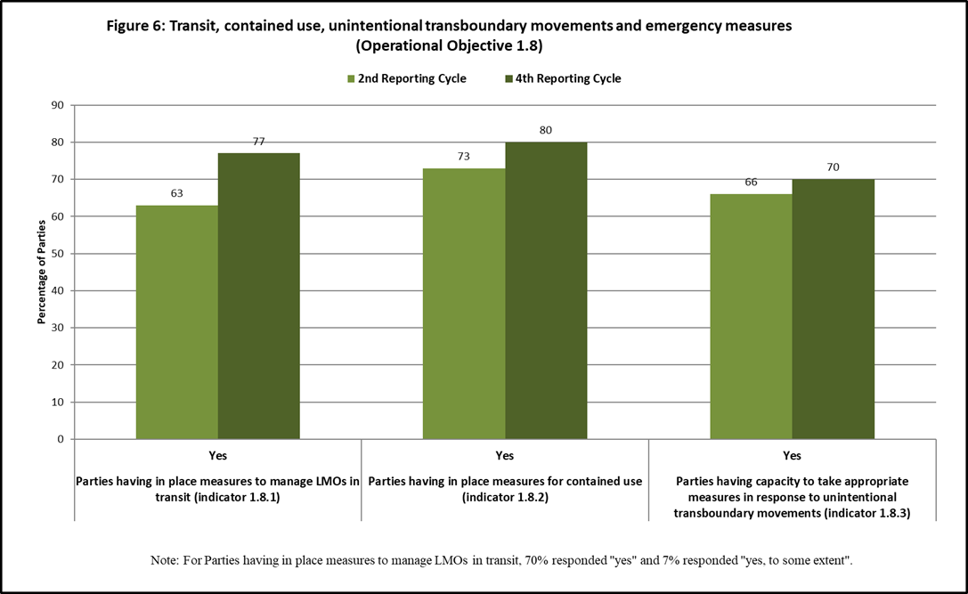

1. **Information sharing (operational objectives 2.6, 4.1 and 4.2)**

**Operational objective 2.6: Information sharing**

1. Operational objective 2.6 aims at ensuring that the Biosafety Clearing House (BCH) is easily accessed by all established stakeholders, in particular in developing countries and countries with economies in transition. Two indicators were established to measure progress towards this operational objective. Results obtained from the BCH at the end of the fourth reporting cycle when compared with the baseline indicate the following.
2. Concerning **indicator 2.6.1** (number of submissions to the BCH from developing countries and countries with economies in transition), the number of submissions of national records to the BCH from developing countries and countries with economies in transition increased from 1,445 measured on 1 January 2012, to 4,438 on 1 January 2020. At the baseline, submissions from developing countries and economies in transition constituted 51% of all submissions. This had increased to 66% by 1 January 2020, which represents a rise in the rate of submission of national records by developing countries and economies in transition by 15%.
3. With respect to **indicator 2.6.2** (amount of traffic (annual average across the reporting periods) in the BCH by users from developing countries and countries with economies in transition), the amount of traffic (annual average across the reporting periods) in the BCH by users from developing countries and countries with economies in transition increased from 65,327 visits and 39,275 unique visitors annually to 106,996 visits and 68,832 unique visitors annually, representing a large increase of 64% in the number of visits and 75% in the number of unique visitors from developing countries and countries with economies in transition.[34]

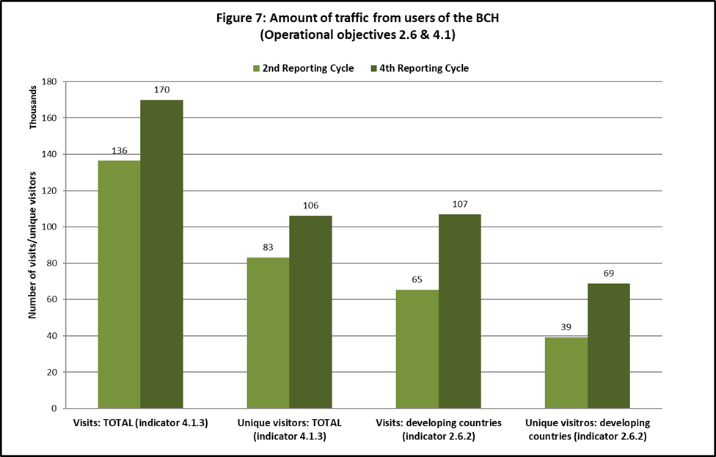

**Operational objective 4.1: BCH effectiveness**

1. Operational objective 4.1 on the effectiveness of BCH aims at increasing the amount and quality of information submitted to and retrieved from the BCH. Eight indicators are provided in the Strategic Plan to measure progress towards this operational objective. Data obtained during the fourth reporting cycle compared with the baseline show the following.
2. With regard to **indicator 4.1.1** (ratio of risk assessment summary reports as against number of decisions on LMOs), the ratio between risk assessment reports and the number of decisions on LMOs[35] in the BCH has increased from 79% (514 risk assessments to 650 decisions) in January 2012; 92% (1,198 risk assessments to 1,299 decisions) in January 2016; to 96% (2,055 risk assessments to 2,134 decisions) as of January 2020. From the baseline, this represents a 17% increase.
3. With regard to **indicator 4.1.2** (number of publications contained in the Biosafety Information Resource Centre (BIRC)), the number of publications contained in the BIRC increased from 1,223 in December 2012 to 1,527 in January 2020, representing a 25% increase from the baseline;
4. With regard to **indicator 4.1.3** (amount of traffic (annual average across the reporting periods) from users to the BCH (measured globally)), in the second reporting cycle the annual average of visits was 136,450 and the annual average of unique visitors was 83,159. In the fourth reporting cycle these annual averages increased to 169,864 visits and 106,184 unique visitors. This represents an increase in visits and unique visitors of 24% and 28% from the baseline, respectively. (see figure 7 above).
5. With regard to **indicator 4.1.4** (number of references to the BCH), information related to referrals through social networks were analysed. The number of visitors who arrived at the BCH by clicking on links on social networks increased from 1,458 in the second reporting cycle to 3,791 visits in the fourth reporting cycle. This represents an overall 160% increase from the baseline. Most of these referrals came through Facebook (69%), followed by Twitter (22%).
6. With regard to **indicator 4.1.5 (**the number of countries with focal points registered on the BCH), the following information is provided:[36]
7. Cartagena Protocol Focal Point: As of 1 January 2020, 181 countries (92% of countries) had designated their focal point for the Protocol. In January 2012, 176 countries (91% of countries) had designated their focal point for the Protocol. This represents an increase of 1% from the baseline;
8. BCH Focal Point: In January 2020, 191 countries (97% of countries) had designated their BCH focal point. In January 2012, 192 countries (98% of countries) had done so. This represents a decrease of 1% from the baseline;
9. Emergency Measures (Article 17) Contact Point: A total of 133 countries (68% of countries) had designated a contact point for receiving notifications under Article 17. At the baseline, 72 countries had registered a point of contact for receiving notifications under Article 17. This constitutes an important increase of 31% from the baseline.
10. With regard to **indicator 4.1.6** (number of countries having published biosafety laws and/or regulations on the BCH), as of January 2020, 161 countries had published biosafety laws and/or regulations on the BCH. In January 2012, 155 countries had done so. This represents an increase of 4%.[37]
11. With respect to **indicator 4.1.7** (number of AIA/domestic decisions available through the BCH), as of January 2020, a total of 2,428 decisions were available through the BCH, including decisions by both Parties and other Governments. In January 2012, 876 AIA/domestic decisions were available through the BCH. [38] The change between January 2012 and January 2020 represents a 177% increase. When considering decisions by Parties only, the increase would be 228% (from 650 decisions in January 2012 to 2,134 decisions in January 2020).
12. With respect to **indicator** **4.1.8** (number of users of the BCH requesting improvement on accuracy, completeness or timeliness of information), no information is available for the comparison.

**Operational objective** **4.2: BCH as a tool for online discussions and conferences**

1. Operational objective 4.2 aims to establish the BCH as a fully functional and effective platform for assisting countries in the implementation of the Protocol, and to increase the amount and quality of information submitted to and retrieved from the BCH.
2. Three indicators are provided in the Strategic Plan to measure progress towards this operational objective. Data obtained from the BCH during 2016-2019 in comparison with data obtained during the period 2010-2012, which serves as the baseline[39] for this operational objective, show the following.
3. For **indicator 4.2.1** (percentage of Parties participating in online discussions and real-time conferences on the BCH), the average percentage of Parties that nominated participants to open-ended forums held on the BCH increased from 18% (29 of 161 Parties) at the baseline to 27% of (46 of 171 Parties) in the fourth reporting cycle (see table 1). It is noted that the reference period for the fourth reporting cycle is one year longer, which may have affected the results of the analysis on this indicator.

Table 1  
**Number of Parties that nominated participants to open-ended forums held on the Biosafety Clearing-House**

| *Topic* | *Baseline*  *(2010-2012)* | *Fourth reporting cycle (2016-2019)* |
| --- | --- | --- |
| Risk assessment | 50 | 60 |
| Detection and identification | 18 | 46 |
| Customs officers | 15 | N/A |
| Socioeconomic | 34 | 30 |
| Synthetic biology | N/A | 53 |
| Post-2020 implementation plan | N/A | 29 |
| Public awareness | N/A | 57 |
| **Average number Parties having nominated participants to each forum** | **29** | **46** |

*Note*: For topics where more than one nomination process took place, the average number of Parties nominating is provided.

1. For **indicator 4.2.2** (number of participants in online discussions and conferences, their diversity and background), 428 participants took part in open-ended online forums held through the BCH from 2010 to 2012, while 875 took part during the fourth reporting cycle, representing an increase of 104% (See Table 2). It is noted that during the fourth reporting cycle, two forums were held for each of the following topics: risk assessment; detection and identification, synthetic biology and public awareness.

Table 2  
**Number of participants registered in open-ended online forums held on the Biosafety Clearing-House**

| *Topic* | *Second reporting cycle (2010-2012)* | *Fourth reporting cycle (2016-2019)* |
| --- | --- | --- |
| Risk assessment | 281 | 185 |
| Detection and identification | 34 | 121 |
| Customs officers | 21 | N/A |
| Socioeconomics | 92 | 75 |
| Synthetic biology | N/A | 205 |
| Post-2020 Implementation Plan | N/A | 109 |
| Public awareness | N/A | 180 |
| **Total** | **428** | **875** |

*Note*: For topics where more than one forum took place, the average number of participants in each forum is provided.

1. Finally, with respect to **indicator 4.2.3** (number of capacity-building activities aimed to increase the transparency, inclusiveness and equity of participation in the BCH), there were two online forums (“BCH on BCH Forum” and “UNEP-GEF BCH Forum”) during the second reporting cycle. Two new forums (“FAO-CBD-OECD Biosafety Databases Forum” and “BCH Informal Advisory Committee”) were added during the third reporting cycle. In the fourth reporting cycle, there was no increase in online forums. Furthermore, only the “BCH on BCH Forum” was active during the cycle and remains ongoing.
2. In collaboration with and with the support of the UNEP-GEF BCH Project, the Secretariat of the Convention on Biological Diversity convened two BCH training workshops, on the margins of the fifth (2010) and sixth (2012) meetings of the Conference of the Parties serving as the meeting of the Parties to the Protocol. During the fourth reporting cycle (2016 to 2019), two BCH training workshops were organized, on the margins of the eighth and ninth meetings of the Conference of the Parties serving as the meeting of the Parties to the Protocol. In addition, beginning in 2016, the UNEP-GEF BCH III project has been undertaking numerous capacity-building activities on the BCH in countries. Information on these activities is regularly shared through the “BCH News”.[40]
3. **Compliance and review (operational objective 3.1 and 3.2)**

**Operational objective 3.1: Compliance with the Protocol**

1. With respect to **indicator 3.1.1** (the number of Parties that have identified and addressed their non-compliance issues), the experience from the Compliance Committee in reviewing compliance by Parties with their obligations under the Protocol and with taking measures to promote compliance and addressing cases of non-compliance may be taken into consideration.
2. Pursuant to the Procedures and Mechanisms on Compliance under the Cartagena Protocol on Biosafety, as contained in the annex of decision BS-I/7, the Compliance Committee may receive a submission relating to compliance from a Party with respect to itself or from a Party with respect to another Party and on that basis take a number of measures to address the issue. The experience under this procedure would likely constitute the most pertinent basis for reviewing progress on **indicator 3.1.1**. To date, however, no receivable submissions have been made.
3. In decision BS-V/1, following consideration of how the supportive role of the Compliance Committee could be improved, the Conference of the Parties serving as the meeting of the Parties to the Protocol decided that the Committee could also take measures in a situation where a Party fails to submit its national report, or information has been received through a national report or the Secretariat, based on information from the BCH, that shows that the Party concerned is faced with difficulties complying with its obligations under the Protocol. For these reasons, experience gained through other activities by the Compliance Committee is provided below.
4. The Committee has focused its activities to a large extent on considering general issues of compliance and individual cases of non-compliance, reviewing compliance by Parties with a number of key obligations under the Protocol, in particular the obligation to report on the implementation of the Protocol in accordance with Article 33 of the Protocol, the obligation to take the necessary measures to implement the Protocol in accordance with Article 2, paragraph 1 of the Protocol, and the obligation to make certain types of information available to the BCH, in accordance with Article 20, paragraph 3, and other provisions of the Protocol.
5. In this context, the Committee has reviewed compliance by Parties with the obligation to submit their second and third national reports and has taken a range of incremental follow-up measures in this regard. The Committee noted the positive effects of its continuous efforts to support Parties in preparing and submitting their national report, including through the actions taken in respect of Parties that had not submitted national reports over multiple reporting cycles.[41]
6. The Committee also reviewed and followed-up on compliance issues in relation to completeness of information on the BCH, as set out in the information provided under indicator 3.1.5 below. In this context, the Conference of the Parties serving as the meeting of the Parties to the Protocol, at its ninth meeting, noted with appreciation the efforts made by Parties to comply with their obligations under the Protocol to make information available to the BCH (decision CP-9/1). The Committee furthermore reviewed compliance with the obligation to take the necessary measures to implement the Protocol and, following the third assessment and review and mid-term evaluation, it followed up with individual Parties in this respect.
7. The Committee’s supportive role, pursuant to decision BS-V/1,[42] has been welcomed by the Conference of the Parties serving as the meeting of the Parties to the Protocol as a contribution to the progress reported in the context of the third assessment and review of the Protocol and mid-term evaluation of the Strategic Plan (decision CP-VIII/15).
8. A more detailed description of the experience of the Committee in supporting Parties to comply with their obligations under the Protocol with relevance to the indicators of the Strategic Plan is available in CBD/CP/CC/17/3.
9. With regard to **indicator 3.1.2** (the number of Parties having approved and functional national legal, administrative and other measures to implement the Protocol), 55% of Parties (51 Parties) reported that measures to implement the Protocol are fully in place, an increase of 8% from the baseline. A total of 39% of Parties (36 Parties) reported that national measures are partially in place, a decrease of 1% from the baseline. One Party, representing 1% of Parties, reported that only temporary measures have been introduced, a decrease of 2 Parties since the baseline (-2%). Five Parties reported that only draft measures had been taken, a decrease of 1 Party (-1%). None of the Parties reported that no measures had been taken, a decrease of 3 Parties since the baseline (-3%) (see Figure 8) (see also **indicators 1.1.1** and **2.1.2** above).
10. A total of 58% of Parties (53 Parties) reported having established a mechanism for budget allocations for the operation of their national biosafety measures, a decrease of 10%. A total of 23% of Parties (21 Parties) reported that such a mechanism had been established to some extent, an increase of 23%.[43] Considered together, 74 Parties (81%) reported that a mechanism is in place or is in place to some extent, which represents an increase of 13% from the baseline (with combined changes within each region as follows: Asia and the Pacific +25%; CEE +24%; Africa +13%; GRULAC -1%; WEOG no difference).
11. A total of 94% of Parties (87 Parties) reported having permanent staff to administer functions directly related to biosafety, an increase of 8% (with regional changes as follows: Africa +17%; GRULAC +8%; CEE +6%; Asia and the Pacific and WEOG no change in respect of the baseline). While no data are available to compare changes since the baseline, a total of 47% of Parties reported that the number of staff was adequate, with important regional differences (WEOG 87%; CEE 71%; Asia and the Pacific 44%; GRULAC 27%; Africa 20%).[44]
12. Several Parties indicated in their free-text contributions that legal instruments are being developed or are pending adoption. Some of these Parties indicated that the adoption of these instruments is expected to have beneficial effects on the institutional structures and availability of resources. Some Parties mentioned the importance of biosafety mainstreaming across a variety of sectoral and cross-sectoral policy and legal instruments. Some reported having effectively addressed biosafety in sectoral and cross-sectoral policies or laws. A number of Parties indicated that the lack of resources and capacities has negatively affected the implementation of the Protocol.

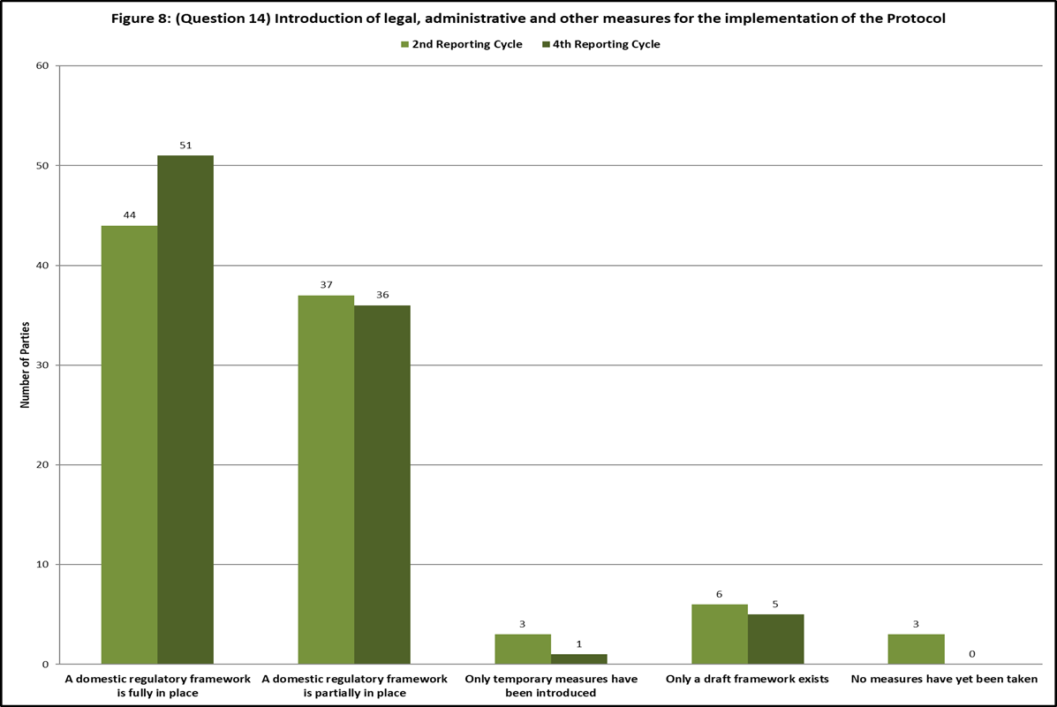

1. For **indicator 3.1.3** (the percentage of Parties that designated all national focal points), 98% of all Parties to the Protocol (168 Parties) have designated their national focal point for the Cartagena Protocol. This represents a decrease of 1% from the baseline, when it was 99% (159 of the 161 Parties at the time). A total of 99% of all Parties to the Protocol (169 Parties) have designated their focal point for the BCH. This represents no change from the baseline, when it was 99% (160 of the 161 Parties at the time); a total of 89% of all Parties to the Protocol (152 Parties) have designated one or more competent national authorities. This represents an increase of 1% from the baseline, when it was 88% (142 of the 161 Parties at the time). Furthermore, a total of 78% of all Parties to the Protocol (133 Parties) have made available to the BCH information concerning their point of contact for receiving notifications under Article 17. This represents an increase of 34% from the baseline when it was 44% (71 of the 161 Parties at the time).
2. Concerning **indicator 3.1.4** (number of Parties having in place a system for handling requests including for Advance Informed Agreement), 66% of Parties (61 Parties) reported having established legal requirements for exporters under their domestic framework to notify in writing the competent national authority of the Party of import prior to the intentional transboundary movement of an LMO that falls within the scope of the advance informed agreement (AIA) procedure, an increase of 5% from the baseline. In addition, 10% of Parties (9 Parties) reported having established such legal requirements for exporters to some extent.[45] Taken together, 76% of Parties reported having established such legal requirements, an increase of 14%[46] from the baseline (with regional changes as follows: Asia and the Pacific +38%; GRULAC +31%; Africa +7%; WEOG +6%; CEE no change from the baseline). A total of 25% of Parties (23 Parties) reported not having established such legal requirements, a decrease of 14%.
3. A total of 21% of the Parties (19 Parties) reported having received a notification regarding the intentional transboundary movements of LMOs for intentional introduction into the environment, which is a decrease of 13% from the baseline (with changes per region as follows: WEOG -45%; CEE -19%; GRULAC -8%; Africa and Asia and the Pacific: no change from the baseline).[47]
4. A total of 19% of the Parties (15 Parties) reported having taken decisions in response to the notification regarding intentional transboundary movements of LMOs for intentional introduction during this reporting cycle, a decrease of 15% (with regional differences as follows: WEOG -41%; CEE -20%; GRULAC -10%; Asia and the Pacific -8%; Africa: no change from the baseline).[48] A total of 7 Parties having taken such a decision reported that the decision related to the approval of import with conditions, while 2 Parties reported that the decisions related to approval without conditions. A further 2 Parties reported that the decision related to a prohibition of import. Of the Parties that reported having taken such a decision, 10 reported that national measures to implement the Protocol are fully in place, while 5 of these Parties reported that national measures to implement the Protocol are partially in place.
5. A total of 84% of Parties (78 Parties) reported having laws, regulations or administrative measures for decision making regarding domestic use, including placing on the market of LMOs for direct use as food, feed or for processing, which constitutes an increase of 15% from the baseline. Increases were reported in three regions: Asia and the Pacific (+31%); GRULAC (+23%); Africa (+20%). No changes from the baseline were reported in CEE and WEOG.
6. A total of 70% of Parties (21 Parties) reported having taken decisions regarding domestic use, including placing on the market, of LMOs that may be subject to transboundary movement for direct use as food or feed, or for processing.[49] This represents a decrease of 3% from the baseline.
7. A total of 83% of Parties (77 Parties) reported having laws, regulations or administrative measures for decision-making regarding the import of LMOs for direct use as food, feed, or for processing, which constitutes an increase of 13% from the baseline. Increases were reported in all regions (GRULAC +31%; Asia and the Pacific +19%; WEOG +11%; Africa +7%; CEE +6%).
8. In their fourth national reports, a total of 70% of Parties (21 Parties) reported having taken decisions regarding the import of LMOs for direct use as food or feed, or for processing.[50] This constitutes a decrease of 6% from the baseline.
9. In relation to the number of Parties having systems in place for handling requests, including for advance informed agreement, the majority of Parties reported that regulatory frameworks are in place for taking decisions regarding domestic use, including placing on the market of LMOs destined for direct use as food or feed, or for processing (84%), and for the import of LMOs-FFP (83%). All Parties that reported having taken decisions on domestic use, including placing on the market and all Parties that reported having taken decisions regarding the importation of LMOs-FFP have measures in place for taking these decisions. Of the Parties that reported having received notifications regarding intentional transboundary movement of LMOs destined for intentional introduction into the environment, 79% of these Parties reported having taken a decision in this regard. Two thirds of the Parties that reported having taken such a decision reported that measures to implement the Protocol are fully in place, while one third of these Parties reported that measures are partially in place.
10. As regards **indicator 3.1.5** (the percentage of Parties that published all mandatory information via the BCH), 78% of Parties (73 Parties) reported that they have submitted information related to legislation, regulations and guidelines for implementing the Protocol, as well as information required by Parties for AIA procedures to the BCH, which constitutes an increase of 21% from the baseline (with regional changes as follows: Africa +37%; GRULAC +23%; Asia and the Pacific +13%; CEE +13%, WEOG +11%). With respect to legislation**,** regulations and guidelines applicable to the import of LMOs intended for direct use as food or feed, or for processing, 71% of Parties (66 Parties) reported that this information has been submitted to the BCH, an increase of 18% from the baseline (with regional changes as follows: Africa +27%; GRULAC +23%; Asia and the Pacific +19%; WEOG +11%; CEE +6%).
11. With respect to the status of mandatory information submitted to the BCH regarding bilateral, multilateral and regional agreements and arrangements, of those Parties that reported that the information was available (28%, 26 Parties), 54% (14 Parties) reported that the information had also been submitted to the BCH, an increase of 15%.
12. Of those Parties that reported that information concerning cases of illegal transboundary movements of LMOs was available (16%, 15 Parties), 33% (5 Parties) reported that the information had been submitted to the BCH, a decrease of 17% from the baseline.
13. Of those Parties that reported that decisions regarding the importation of LMOs for intentional introduction into the environment were available (40%, 37 Parties), 73% (27 Parties) reported that the information had been submitted to the BCH, an increase of 19% from the baseline.
14. Of those Parties that reported that decisions regarding the domestic use of LMOs that may be subject to transboundary movement for direct use as food or feed, or for processing were available (45%), 83% reported that the information had been submitted to the BCH, an increase of 14%.
15. Of those Parties that reported that the decisions regarding the import of LMOs intended for direct use as food or feed, or for processing that are taken under domestic regulatory frameworks (Article 11, paragraph 4) or in accordance with Annex III to the Protocol (Article 11, para. 6) were available (47%, 44 Parties), 82% (36 Parties) reported that the information had been submitted to the BCH, an increase of 15%.
16. Of those Parties that reported that summaries of risk assessments or environmental reviews of LMOs generated by regulatory processes and relevant information regarding products thereof were available (55%, 51 Parties), 69% (35 Parties) reported that the information had been submitted to the BCH, an increase of 19%. The information in the BCH at the time of preparation of this note showed that risk assessment summary reports are missing in respect of a total of 78 decisions of a total of 6 Parties.[51]
17. In their free text contributions, many Parties indicated that many types of information are not available in their country and that for this reason the information was not submitted. Some Parties refer to the lack of capacities and resources for making certain information available.
18. In terms of **indicator 3.1.6** (the number of Parties that have in place a monitoring and enforcement system), 77% of Parties (53 Parties) reported having in place a system to monitor and enforce the implementation of the Cartagena Protocol, which is an increase of 7% from the baseline (with regional changes as follows: Asia and the Pacific +22%; Africa +17%, CEE +7%; GRULAC no change; WEOG -7%).[52]
19. **Indicator 3.1.7** is related to the number of national reports received under each reporting cycle. As of 15 January 2020, 99 Parties had submitted their complete fourth national report out of 171 Parties to the Protocol that had an obligation to do so.[53] This represents a submission rate of 58%. At a comparable point in time after the submission deadline for the second national reports, the submission rate was 89%.[54]
20. With respect to **indicator 3.1.8** (number of Parties able to access financial resources to fulfil their obligations under the Protocol), 35% of Parties (25 Parties) reported having access to predictable and reliable funding for building capacity for the effective implementation of the Protocol, while 14% of Parties (10 Parties) reported having access to such funding to some extent. Taken together, this represents an increase of 7% from the baseline (with combined regional differences as follows: Africa +21%; Asia and the Pacific +11%; GRULAC +8%; WEOG no change; CEE -7%).[55] (See also the information provided under **indicator 1.2.6**, above).
21. A total of 70% of Parties (31 Parties) reported having mobilized funding in addition to the regular budget allocation to support the implementation of the Cartagena Protocol, which is 13 Parties less than at the baseline.[56] Differences are reported in the amounts received in comparison to the baseline. A decrease of 11% is reported in amounts up to US$ 50,000. A decrease of 14% was reported in amounts received between US$ 100,000 and US$ 500,000. A decrease of 7% was reported in amounts received over US$ 500,000. The contribution to the decrease seems to be divided relatively evenly among Parties across the regions. (See also the information provided under **indicator 1.2.5** above).

**Operational objective 3.2: Assessment and review**

1. Concerning **indicator 3.2.1** (the number of assessment reports submitted, and reviews published), as of 15 January 2020, 99 Parties (58%) had submitted a complete fourth national report, of the 171 Parties that had an obligation to do so. At a similar point in time following the submission deadline of second national reports, the submission rate was 89%, while the submission rate of third national reports was 62%, at a comparable point in time after the submission deadline.
2. While for the second national reports, the availability of funding from GEF for the preparation of national reports as well as the capacity-building and awareness-raising activities carried out by the Secretariat in this regard were factors that were considered to have contributed to the high submission rate by the Compliance Committee,[57] the Committee noted that administrative changes within the United Nations had created systems challenges that resulted in delays for a number of eligible Parties in accessing funding and noted that this had caused difficulties for a number of Parties in fulfilling their obligations under the Protocol, for example as regards the submission of their third national reports.[58]
3. At its seventeenth meeting, the Compliance Committee reviewed compliance by Parties with their obligation to report. It considered a number of possible factors that might have contributed to the low number of fourth national reports submitted, including delayed access to financial support, lack of dedicated human resources at the national level, as well as a lack of priority for and awareness of biosafety issues.[59]
4. Concerning **indicator 3.2.2. (**the number of Parties modifying their national biosafety frameworks to correspond with amendments to the Protocol adopted to address new challenges), it is noted that there have not been any amendments to the Protocol to date.
5. **Public awareness and participation, biosafety education and training  
   (operational objectives 2.5, 2.7 and 4.3)**
6. The programme of work on Article 23 was adopted by the Conference of the Parties serving as the meeting of the Parties to the Protocol in 2010, through decision BS-V/13, and was extended until 2020 through decision CP-VIII/18. The programme of work includes a number of indicators, many of which are shared with the Strategic Plan for the Cartagena Protocol for the period 2011-2020. The fourth national report and the BCH provide the necessary information for measuring progress in this regard.
7. For those indicators of the programme of work on Article 23 on which insufficient information was available through the fourth national reports and the BCH, a survey was developed to supplement the information base – the *survey on key indicators of the programme of work on public awareness, education and participation concerning the safe transfer, handling and use of living modified organisms* (survey on the programme of work on Article 23).[60] Through notification 2019-92, dated 21 October 2019, Parties were invited to respond to the Survey on the programme of work on Article 23. A total of 56 respondents filled out the survey on the programme of work, of which 38 were national focal points for the Protocol or the BCH. The information provided by these Parties has been reflected in subsections K and L of the present document.

**Operational objective 2.5: Public awareness, education and participation**

1. Operational objective 2.5 seeks to enhance capacity of Parties to raise public awareness and promote public education and participation concerning the safe transfer, handling and use of LMOs. Three indicators were set out to measure progress towards the achievement of this objective.
2. With regard to **indicator 2.5.1** (percentage of Parties having in place mechanisms for ensuring public participation in decision-making concerning LMOs not later than six years after accession to/ratification of the Protocol), 62% of Parties (58 Parties) reported having established a mechanism to consult the public in the decision-making process regarding LMOs (+5%). In addition, 16% of Parties indicated having such a mechanism to some extent (-1%). At the regional level, these percentages show considerable variation and are as follows: Africa: 50% (+10%); Asia and the Pacific 56% (no change from the baseline); CEE 88% (+7%); GRULAC 23% (+15%); WEOG 94% (-6%)).
3. In their written contributions, some Parties explained that their public participation process involved, among other things, public hearings, national advisory bodies, and publicizing of information on websites and media. A number of Parties from the CEE and WEOG regions noted that they are implementing public participation mechanisms based on the provisions of the Convention on Access to Information, Public Participation in Decision-Making and Access to Justice in Environmental Matters (Aarhus Convention).
4. From the survey on the programme of work on Article 23, a majority of respondents indicated that the outcomes of public consultation processes that took place in the period 2016-2019 were taken into account, or were taken into account to some extent, in the decision-making on LMOs. In their free-text comments, a number of respondents indicated that a number of the decision-making processes have not been finalized while others indicated that the regulatory basis for taking the outcomes into consideration was under development.
5. Concerning **indicator 2.5.2** (percentage of Parties that inform their public about existing modalities for participation), 69% of the Parties (49 Parties) reported that they inform the public about existing modalities for public participation in the decision-making process regarding LMOs (-16%). A further 11% of Parties (8 Parties) reported having done so to some extent (+11%). Considered together, 80% of Parties reported having at least to some extent informed the public accordingly, which represents a decrease of 4% from the baseline.[61] At the regional level, the combined figures are as follows, with decreases reported in three regions: Africa: 74% (-16%); GRULAC: 54% (-8%); WEOG: 94% (-6%). An increase was reported in Asia and the Pacific: 89% (+22%), while no change was reported in CEE, where the combined percentage of Parties having informed their public at least to some extent remained at 93%. Of the Parties that reported having informed their public about existing modalities for participation, most reported having done so through websites (29%), followed by newspapers (17%) and public hearings (15%).
6. In their free-text contributions, some Parties noted that some of the newspapers used include the official Government gazette. A few Parties noted that awareness trainings and meetings constituted other means of informing the public about participation modalities.
7. With regard to **indicator 2.5.3** (the number of Parties having in place national websites and searchable archives, national resource centres or sections in existing national libraries dedicated to biosafety educational materials), 68% of Parties (63 Parties) reported having a national biosafety website, representing a 1% increase from the baseline. Differences between regions were reported, both in total numbers and in changes reported since the baseline, at the regional level. Increases were reported in GRULAC, 69% (+15%) and in Africa, 45% (+3%). A decrease was reported in CEE, 69% (-12%), while no changes were reported in Asia and the Pacific (88%) or WEOG (89%) (see also **indicator 5.3.3** below).
8. In their free text contributions, several Parties indicated that they had a website to facilitate public awareness, education and participation, including access to information practices. Several Parties specified that their national biosafety website functions as the national biosafety clearing-house. From the survey on the programme of work, some Parties indicated that lack of resources prevented them from establishing a national biosafety website.
9. In the Survey on the programme of work, 88% of respondents indicated having a procedure for facilitating public access to biosafety information or having established such a procedure to some extent. Respondents clarified that these procedures mainly relate to national websites. Some Parties also highlighted these procedures through media, meetings, workshops and publications.

**Operational objective 2.7: Biosafety education and training**

1. Operational objective 2.7 aims at promoting education and training of biosafety professionals through greater coordination and collaboration among academic institutions and relevant organizations.
2. Concerning **indicator 2.7.1** (the number of academic institutions by region offering biosafety education and training courses and programmes), 86% of Parties (61 Parties) reported that academic institutions in their country offer biosafety education and training courses and programmes, which constitutes an increase of 11% from the baseline. The percentages of Parties reporting that academic institutions in their country offer such courses and programmes is high in most regions (89% to 100%), with the exception of GRULAC, where the percentage of Parties reporting accordingly was much smaller (54%), and no change from the baseline was observed (see also **indicator 5.3.3** below).
3. In their fourth national reports, a total of 54% of Parties (36 Parties) reported that the number of courses and programmes was adequate, in particular in Asia and the Pacific (69%), CEE (83%) and WEOG (100%), while most Parties in the African (95%) and GRULAC (80%) regions reported that the number of courses and programmes were not adequate.[62]
4. In their free-text contributions, several Parties indicated that there were also training courses organized by their Government or by universities for professionals or the general public. A number of Parties further specified that the training offered by the Government took place in the form of workshops or seminars.
5. For **indicator 2.7.2** (the number of biosafety training materials and online modules available), 77% of Parties (55 Parties) reported that educational materials and/or online modules on biosafety are available and accessible to the public in their country. This constitutes, an increase of 15% from the baseline. Most Parties reported having made available between 1 and 4 materials and online modules (35% of the Parties responded accordingly) (see also **indicator 5.3.4** below).
6. In their fourth national reports, 46% of Parties (28 Parties) reported that the number of materials and modules made available was adequate. This was particularly the case in the WEOG (88%) and CEE (78%) regions, yet much less so in other regions: Asia and the Pacific, 50%; Africa, 6%; and GRULAC, 0%.
7. In their free-text contributions, some Parties indicated that the materials and modules were published mainly for experts and not for the general public.
8. From the survey on the programme of work, about a third of the respondents indicated having shared, or having shared to some extent, materials on public awareness, education and participation in the BCH. Some of these respondents indicated that the materials were training-related materials, including multimedia materials and online training modules.

**Operational objective 4.3: Information sharing other than through the Biosafety Clearing‑House**

1. Operational objective 4.3 aims at enhancing understanding of biosafety through information exchange mechanisms other than the BCH. Two indicators are available to measure progress towards achieving this objective.
2. With regard to **indicator 4.3.1** (the number of events organized in relation to biosafety), 92% of Parties (65 Parties) reported that they had organized at least one biosafety-related event, such as seminars, workshops, press conferences, educational events, etc. in the current reporting period. This represents a 3% increase from the baseline. A total of 27% of Parties reported having organized 1 to 4 events, 20% reported holding 5 to 9 events, 21% reported holding 10 to 24 events and 24% reported holding 25 or more events (an increase of 20%). Overall, almost all Parties reported having organized 1 or more biosafety-related events, with an important increase of Parties holding 25 or more events.
3. In their written contributions, a number of Parties explained the type of event they had organized and indicated that some of these events were recurrent. The following types of events were mentioned: workshops, conferences, side events, public hearings, press conferences, exhibitions, seminars and other educational events.
4. Of the respondents to the survey on the programme of work, about two thirds indicated having organized events on biosafety involving the media.
5. With regard to **indicator 4.3.2** (the number of biosafety-related publications shared), 76% of Parties (54 Parties) reported having published biosafety-related publications in the reporting period, which is a decrease of 6%. The largest number of Parties (38%) reported having published between 1 and 9 materials. In all regions, the vast majority of Parties reported at least one biosafety-related publication. Overall, an increasing number of Parties (15%) published larger numbers of biosafety publications (50 publications or more), which represents an increase of 8% from the baseline.
6. In their written contributions, Parties indicated that their publications were made available in different ways, including on websites and in the form of newsletters, booklets, brochures and educational materials.
7. In the survey on the programme of work, 75% of the respondents indicated that their country had established a mechanism for sharing experiences and resources on public awareness, education and participation, or that they had done so to some extent. Of these respondents, 36% specified that these mechanisms were networks and 31% specified that these mechanisms were cross-sectoral mechanisms, while 33% indicated that they were other types of mechanisms. The latter group of respondents clarified that these mechanisms for sharing information consisted of, among others, public consultations, field work in communities, meetings, exhibits, media, seminars, mailing lists, publications and partners (e.g. non-governmental organizations) and celebratory events.
8. **Outreach and cooperation (operational objectives 5.1, 5.2, and 5.3)**

**Operational objective 5.1: Ratification of the Protocol**

1. For **indicator 5.1.1** (the percentage of Parties to the Convention on Biological Diversity that are Parties to the Protocol), as of 31 December 2011, 167 Parties to the Convention (86%) had become Party to the Protocol.[63] As of 31 December 2019, the number of Parties to the Protocol had increased to 171 (87%).[64]

**Operational objective 5.2: Cooperation**

1. With respect to **indicator 5.2.1** (the number of established relationships with other conventions as reflected in joint activities), the Secretariat has established relationships with the Aarhus Convention, the Green Customs Initiative (GCI)[65] and holds observer status in the Committee on Trade and Environment (CTE) of the World Trade Organization (WTO). The Secretariat has also renewed its request for observer status in other relevant WTO committees. Joint activities have also been carried out in collaboration with the Organization for Economic Co-operation and Development (OECD) and the Food and Agriculture Organization of the United Nations (FAO), particularly related to the exchange of information through the BCH. The Secretariat also collaborates with the International Centre for Genetic Engineering and Biotechnology on capacity-building activities related to risk assessment and detection and identification of LMOs.

**Operational objective 5.3: Communication and outreach**

1. With regard to **indicator 5.3.1** (the number of national awareness and outreach programmes on biosafety), 54% of Parties (38 Parties) reported having awareness and outreach programmes on biosafety, an increase of 3% from the baseline. At the regional level, there are considerable differences in the number of Parties that reporting having a national awareness and outreach programme on biosafety: Africa, 74% (+5%); Asia and the Pacific, 67% (+11%); CEE, 43% (+14%); GRULAC, 23% (-15%); WEOG, 56% (no change from the baseline).
2. Concerning **indicator 5.3.2** (the percentage of Parties having in place national communication strategies on biosafety), 51% of Parties (36 Parties) reported having in place a national communication strategy on biosafety. While this number has remained the same as at the baseline, there are important regional changes with increases reported in: Africa, 58% (+16%); Asia and the Pacific, 56% (+11%); and CEE, 57% (+14%). Decreases are reported in GRULAC, 15% (-38%) and WEOG, 63% (-6%).
3. In their written contributions, some Parties indicated that some programmes target specific audiences (e.g. media). A few Parties indicated that awareness and outreach programmes had been developed for annual conferences, exhibits and websites.
4. In the Survey on the programme of work some respondents indicated that outreach programmes had been developed within a ministry, and that other outreach programmes had been developed on communication and media-related issues to promote biosafety awareness. Some respondents mentioned that awareness-raising programmes had been developed in collaboration in this regard, for example, with non-governmental organizations, the African Union, inter-agency cooperation, FAO, media, libraries and networks.
5. With respect to **indicator 5.3.3** (the percentage of Parties that have in place national biosafety websites, including national BCH nodes that are accessible to and searchable by the public), 68% of Parties (63 Parties) reported having a national biosafety website, a minimal increase of 1% from the baseline. At the regional level, increases were reported in GRULAC (+15%) and Africa (+3%), while a decrease was reported in CEE, -13%, and no change since the baseline was reported for the Asia-Pacific and WEOG regions.
6. Finally, for **indicator 5.3.4** (number of Parties with awareness and educational materials on biosafety and the Protocol available and accessible to the public, including the diversity of these materials), 77% of Parties (55 Parties) reported that educational materials or online modules are available to the public in their countries, which represents an increase of 15% (see also **indicator** **2.7.2** above).
7. In the survey on the programme of work, about a third of the respondents indicated having shared materials on public awareness, education and participation through the BCH. Most respondents specified that these materials related to legislation, notifications, approvals, but also included presentations, news and infographics. About half of the Parties having indicated having shared materials, specified that they had shared these materials in national and/or local languages.

__________

1. * CBD/SBI/3/1.
2. <https://beta.bch.cbd.int/register/NR4>
3. See CBD/CP/CC/17/INF/1 and CBD/CP/LG/2020/1/INF/1.
4. [Notification 2019-19](https://www.cbd.int/doc/notifications/2019/ntf-2019-019-bs-en.pdf) issued on13 February 2019 invited Parties to submit their fourth national reports no later than 1 October 2019.
5. Some additional sources of information, such as survey data, were used to support the analysis. For example, the “survey on key indicators of the programme of work on public awareness, education and participation concerning living modified organisms” was used to support the analysis provided in sections III(k) and III(l). Where additional sources of information were used, these sources have been identified through references in the present document.
6. The analysis that formed the baseline was made using second national reports received by 31 December 2011 (UNEP/CBD/BS/COP-MOP/6/17/Add.1). The Survey was carried out in 2013 and a total of 109 Parties responded to the Survey. The Survey results are available at <http://bch.cbd.int/database/reports/surveyonindicators.shtml>.
7. The report analyser tool is available at <http://bch.cbd.int/database/reports/analyzer>. The tool facilitates a comparison of information provided in the fourth, third and second national reports as well as in the survey.
8. A matrix detailing the source of information based on which each indicator was analysed can be found at <http://bch.cbd.int/protocol/issues/final_evaluation.shtml>.
9. The comparative analysis of information for the third assessment and review of the Protocol and mid-term evaluation of the Strategic Plan was based on a total number of 105 third national reports, see: UNEP/CBD/SBI/1/4.
10. For example, if some Parties in a given region have reported progress on a certain issue, it will not show in the analysis if the same number of Parties in that region reported the opposite.
11. For ease of reference, the Strategic Plan’s numbering system in the BCH, as found here <http://bch.cbd.int/protocol/issues/cpb_stplan_txt.shtml#elements>, was used throughout the present document.
12. Côte d’Ivoire, Iraq, Kuwait, United Arab Emirates.
13. Uzbekistan.
14. Côte d’Ivoire and Iraq submitted their fourth national report. As second national reports of none of these Parties are available, the data provided in their fourth national reports do not influence the comparative analysis.
15. Bangladesh, Bosnia and Herzegovina, Cambodia, China, Costa Rica, Croatia, Ecuador, Egypt, Ethiopia, France, India, Indonesia, Italy, Kazakhstan, Republic of Korea, Lao People’s Democratic Republic, Malaysia, Mexico, Peru, Slovenia, Spain, Thailand, Turkey, Viet Nam.
16. As the question allows for multiple answers, a comparison is provided in total numbers, not percentages.
17. It was not possible to respond “to some extent” to the related question in the second national report. This may have affected the reported changes as compared to the baseline.
18. Due to rounding up of decimals, the sum of the percentages is 14% rather 15%.
19. For example, questions 17, 18 and 109 of the fourth national reporting format. In addition, question 39 refers to administrative measures in relation to decision making on LMO, which has been addressed above under operational objective 1.1.
20. The format for the second national report did not provide the option of answering “Yes, to some extent”.
21. Information on whether the number of staff was adequate was not provided in the second national reports for the baseline.
22. It was not possible to respond “to some extent” to the related question in the second national report. This may have affected the reported changes as compared to the baseline.
23. Question 71(a) and 71(b) asks whether countries have adopted or used any guidance document for the purpose of conducting risk assessment or risk management, or for evaluating risk assessment reports submitted by notifiers and provides the following possible answers: (a) risk assessment (yes/no); (b) risk management (yes/no).
24. The Guidance on risk assessment of LMOs was not yet available at the time of the establishment of the baseline. For this reason, information provided on this indicator in the fourth national reports was compared to information provided in the third national report, under question 86.
25. Information on the number of risk assessments carried out was not provided through the second national report.
26. For this purpose, the decisions by Parties regarding transboundary movement of LMOs for intentional introduction into the environment (under Article 10 of the Protocol) and those related to import or domestic use of LMOs for direct use as food or feed, or for processing (under Article 11 of the Protocol, or under the domestic framework) were considered. For each of these decisions it was verified whether a corresponding risk assessment report had been submitted to the BCH.
27. There is no data available for measuring indicator 2.2.2 (number of risk assessment summary reports in the BCH that are in compliance with the Protocol). It is understood that for a risk assessment summary to be “in compliance with the Protocol”, it must summarize a risk assessment that was carried out in a scientifically sound and transparent manner and on a case-by-case basis for each LMO, taking into consideration its intended use and the likely potential receiving environment. Information related to the number of risk assessment summaries in the BCH that comply with these principles is not available.
28. The Manual and the Guidance were not yet available when the baseline was established. Information provided on this indicator in the fourth national reports was compared to information provided in the third national report, under questions 81 and 82 for Parties that answered the relevant questions in both the third and fourth national reports.
29. Information was provided under question 69 of the fourth national report. Information on this issue was not provided at the baseline, or in the third national reports.
30. Question 74 of the fourth national report.
31. The percentages are based on the number of Parties to the Supplementary Protocol that provided this information in their fourth national report. This information was not provided in previous national reports. Due to rounding up, the sum of the percentages is 101 rather than 100%.
32. This information was not provided in previous national reports.
33. Question 163 in the fourth national reporting format asks whether in the current reporting period socio-economic considerations arising from the impact of the LMOs been taken into account in decision-making. A total of 33 Parties (35%) responded “Not applicable (no decisions were taken)”.
34. A “unique visitor” is a person visiting the BCH in a given period. The same user accessing the BCH from different computers is counted as one unique visitor. A “visit” (or “session”) is a single browsing session. A single user can create multiple browsing sessions. A visit ends after 30 minutes of inactivity.
35. For this purpose, decisions by Parties regarding transboundary movement of LMOs for intentional introduction into the environment (under Article 10 of the Protocol) and decisions related to import or domestic use of LMOs for direct use as food or feed, or for processing (under Article 11 of the Protocol, or under the domestic framework) were considered. For each of these decisions it was verified whether a corresponding risk assessment report had been submitted to the BCH.
36. While Parties to the Cartagena Protocol are required to designate a focal point for the Protocol, other Governments may also do so. The data presented here are based on the number of countries having registered focal points to the Protocol, from among the Parties to the Convention on Biological Diversity, which, in 2011, was 194 and, in 2019, was 196.
37. See also the information provided under indicator 3.1.5 on the percentage of Parties having published all mandatory information via the BCH and the supportive role of the Compliance Committee in this regard.
38. For this purpose, the decisions considered regarding transboundary movement of LMOs for intentional introduction into the environment (under Article 10 of the Protocol) and decisions related to import or domestic use of LMOs for direct use as food or feed, or for processing (under Article 11 of the Protocol, or under the domestic framework) were considered.
39. The same period was used as a baseline to measure progress on the indicators for this operational objective at the third assessment and review of the Protocol and mid-term evaluation of the Strategic Plan for the Cartagena Protocol.
40. <http://bch.cbd.int/about/news/>.
41. CBD/CP/CC/16/7, para. 28.
42. Following decision BS-V/1, the Committee started taking measures where a Party failed to submit a national report, or information had been received through a national report or the Secretariat, based on information from the BCH, showing that the Party concerned is facing difficulties to comply with its obligations under the Protocol.
43. The related question in the second national report did not provide for the answer “Yes, to some extent”.
44. This information has been obtained from question 19 of the reporting format for the fourth national report.
45. It was not possible to respond “to some extent” to the related question in the second national report. This may have affected the reported changes as compared to the baseline.
46. Due to rounding up of decimals, the sum of the percentages is 14% rather 15%.
47. Some of these changes may be related to the revision of the question in the format for the fourth national report, which was restricted to the reporting period, while it was open-ended in the second national report.
48. Ibid.
49. In the second national reporting format, only those Parties that reported having ever taken a decision on LMOs-FFP were asked to respond to the question. For this reason, the overall number of Parties having provided information on this question is low.
50. Ibid.
51. Three of these Parties made available risk assessment summaries for the vast majority of decisions they submitted to the BCH.
52. Question 168 in the fourth national report is related to question 35(a) (on monitoring systems) and question 35(b) (on enforcement systems) in the Survey. For this analysis, the analyser tool on the BCH compared question 168 of the fourth national report with question 35(a) of the Survey. The total count differences between answers to question 35(a) and (b) are minimal (35(a): 61 answered *yes*, 46 answered *no*. Q35(b): 58 answered *yes*, 46 answered *no*).
53. Uzbekistan deposited its instrument of accession to the Protocol on 25 October 2019, after the deadline for the submission of fourth national reports, and is not included in the total number of Parties for the purpose of the present document.
54. The submission rate of third national reports at a similar point in time following the deadline for submission was 62% and had increased to 91% at the date of preparation of the present note.
55. The related question in the Survey did not provide for the answer “yes, to some extent”. A total of 51% of Parties reported not to have access to such funding.
56. Question 167 of the fourth national report allows Parties to respond that no additional funding was obtained, while the lowest possible answer to the related question 6 of the Survey was “less than 5,000”. The change in the drafting of the answers may have contributed to this difference.
57. UNEP/CBD/BS/CC/9/4.
58. UNEP/CBD/BS/CC/13/6, para.10(c).
59. CBD/CP/CC/17/6.
60. <http://bch.cbd.int/protocol/cpb_art23_pow_evaluation.shtml>
61. The format for the survey did not provide the answer “Yes, to some extent”.
62. This information was not provided in previous national reports.
63. Of the 194 Parties to the Convention at the time.
64. Of the 196 Parties to the Convention at the time.
65. The Green Customs Initiative is a [partnership of international organizations](https://www.greencustoms.org/our-partners) cooperating to enhance the capacity of customs and other border control officers to monitor and facilitate the legal trade and to detect illegal trade in environmentally sensitive commodities covered by certain multilateral environmental agreements and organizations. Partners in the GCI are: the Secretariats of the: Basel, Stockholm and Rotterdam Conventions; the Convention on Biological Diversity; the Convention on International Trade in Endangered Species of Wild Fauna and Flora (CITES); the Vienna Convention for the Protection of the Ozone Layer and for the Montreal Protocol on Substances that Deplete the Ozone Layer; the Minamata Convention on Mercury; as well as Interpol, the United Nations Office on Drugs and Crime (UNODC), the World Customs Organization (WCO), and UNEP OzonAction.