 |  |  | CBD
 |  |  |  |  | Distr.  GENERAL  CBD/SBSTTA/21/INF/18/Rev.1  6 December 2017  ENGLISH ONLY
Subsidiary Body on Scientific, Technical and Technological Advice
Twenty-first meeting
Montreal, Canada, 11-14 December 2017
Item 3 of the provisional agenda*

Multiscale, cross-sectoral scenarios for nature futures: The positive visions for biodiversity, ecosystem services, and human well-being

Note by the Executive Secretary
- The Executive Secretary is circulating herewith, for the information of participants in the twenty-first meeting of the Subsidiary Body on Scientific, Technical and Technological Advice, a note on developing multiscale and cross-sectoral scenarios for Nature Futures. It describes a process for visioning new scenarios on biodiversity, ecosystem services, and human well-being, and provides a summary of progress made to date. The note has been prepared by the Expert Group on Scenarios and Modelling of the Intergovernmental Science-Policy Platform on Biodiversity and Ecosystem Services led by Co-Chairs Dr Carolyn Lundquist (NIWA, New Zealand) and Prof. Henrique Pereira (iDiv) with inputs from Isabel M.D. Rosa and HyeJin Kim (German Centre for Integrative Biodiversity Research (iDiv)), the Technical Support Unit based at the Netherlands Environmental Assessment Agency, and the IPBES Secretariat.
- The present note provides additional information further to CBD/SBSTTA/21/2, section III C (para. 29). In response to recommendation XXI/1 it has been revised following a peer review process as well as to reflect addition work on this issue.
- The work being undertaken will place biodiversity at the centre of scenario development and address the full range of social-ecological feedbacks, including those between biodiversity change, ecosystem services and human well-being and consideration of individual and institutional responses to biodiversity changes. Ultimately, it will help to identify alternative pathways towards the defined visions. The work will also help to better account for different cultural and world views and ultimately help to develop broad and meaningful stakeholder engagement in the design of policy measures.
- While the work described above will extend beyond 2020, it nonetheless has the potential to help inform the development of the post-2020 global biodiversity framework. Conversely, discussions on the post-2020 global biodiversity framework can help to shape the new scenarios being developed. For these reasons, the involvement of the constituency of the Convention on Biological Diversity in this process will be important.
- The report is presented in the form and language in which it was received by the Secretariat.
Multiscale, Cross-sectoral SCENARIOS for NATURE FUTURES

introduction
- The first IPBES methodological assessment, approved and released in 2016, reviewed policy support tools and methodologies for scenario analysis and modelling of biodiversity and ecosystem services and addressed the development and interpretation of scenarios and models to better inform policies and decision-making (IPBES 2016). Following the release of the assessment, Phase two of the IPBES Scenarios and Modelling Expert Group was approved by the IPBES Plenary in February 2016 and was initiated in October 2016 at a workshop in Leipzig, Germany where short-, medium- and long-term activities were identified to enhance the use of scenarios and modelled results in IPBES assessments and to develop a new set of biodiversity-centered scenarios.
- Existing scenarios of biodiversity and ecosystem services have important limitations and gaps that constrain their usefulness for the IPBES and for informing decision-makers. To date, most scenarios for global environmental assessments have explored impacts of society on nature, such as biodiversity loss (Pereira et al. 2010), but have poorly explored the role of nature and related policies in socioeconomic development (Rosa et al. 2017). Most prior scenarios have failed to incorporate policy objectives related to nature conservation, social-ecological feedbacks, or the linkages between biodiversity and ecosystem services (IPBES 2016). Often, biodiversity (nature) and ecosystem services (nature’s benefits to people) were treated as the consequence of human decisions, but were not at the centre of the analysis (Rosa et al. 2017). Scenarios to date are also typically relevant at only a particular spatial scale of analysis, and are unable to capture the cross-scale, dynamic and tele-connected characteristics of drivers of change to nature and nature’s contributions to people (Kok et al. 2017).
- To address these issues, the IPBES Expert Group on Scenarios and Modelling has initiated the development of the new Nature Futures Scenarios based on positive visions on global development and human relationship with nature. The new IPBES scenarios represent a departure from previous scenarios (e.g., Millennium Ecosystem Assessment, IPCC Shared Socio-economic Pathways) as they are target seeking and not purely exploratory and place biodiversity at the centre of the scenario choices by assessing future consequences of alternative policies and management practices underpinned by diverse value systems for biodiversity. Importantly, they will integrate the social-ecological feedback loops across drivers, biodiversity, ecosystem services, and human well-being, and incorporate multiple systems of knowledge (See Section II and Figure 1, Rosa et al. 2017).
- Targets for human development are increasingly connected with targets for biodiversity, such as in the United Nation’s 2030 Agenda for Sustainable Development and the Sustainable Development Goals (SDGs). Scenarios can be developed that better incorporate the role of biodiversity in sustainable futures, and that explore interactions between biodiversity and ecosystem services with societal drivers and connections to human well-being, enhancing linkages between biodiversity and global governance targets. In respect to this, the Nature Futures Scenarios can explore alternative pathways to reach these intertwined targets, including potential synergies and trade-offs between biodiversity conservation and other development goals as well as the need to involve different actors, including indigenous peoples and local communities.

OVERVIEW OF THE “NATURE FUTURES” SCENARIOS
- An iterative, participatory and creative process is envisaged to identify visions for biodiversity. This process will bring together key stakeholders from different sectors, at multiple spatial scales, including public administration agencies, intergovernmental organizations, non-governmental organizations, businesses, civil society, indigenous peoples and local communities, as well as the scientific community. Visualization techniques and other facilitation tools will be used to enrich discussions on scenarios among stakeholders.

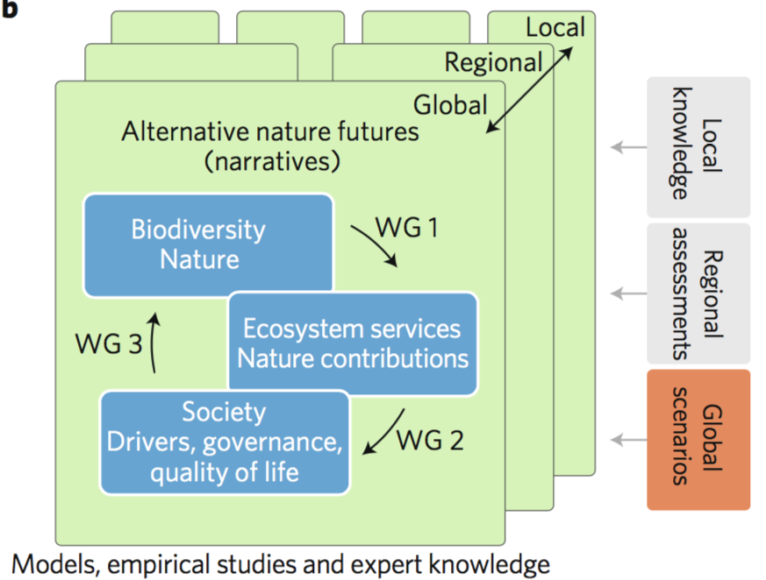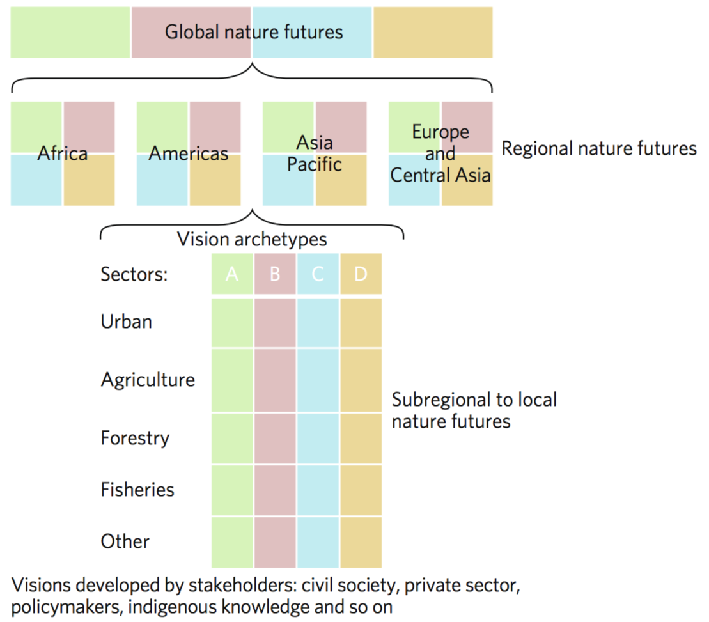
a. b.
Figure 1. a. Strategy to develop the new scenarios on biodiversity and ecosystem services, b. Constructing multiscale, multisectoral visions for Nature Futures. Taken from Rosa et al. (2017).

- At the global scale, nature futures could, for example, explore pathways to achieve the 2050 Vision of the Convention on Biological Diversity in the context of the Sustainable Development Goals. At the regional scale, nature futures can be informed by the ongoing IPBES regional assessments, which are collecting information on trends of biodiversity and ecosystem services, as well as by national and regional biodiversity targets (for example, national biodiversity strategies and action plans). Local studies, on the other hand, could provide knowledge on how to link biodiversity scenarios to decision-making, while being inclusive of the diversity of nature values held by different local communities.
- Once the alternative nature futures have been identified, qualitative and quantitative approaches (for example, modelling, empirical studies and expert knowledge) can be used to identify potential pathways for reaching the desired goals, including specific policy alternatives, and taking into account feedbacks between biodiversity, ecosystem services, traditional knowledge, human well-being and decision-making. These analyses could be carried out in working groups, focusing on three topics (Fig. 1a): (1) models of interactions between biodiversity and ecosystem services; (2) social–ecological feedbacks, such as individual and institutional behavioural responses to changes in nature and their impact on human well-being; and (3) trajectories of indirect (for example, socioeconomic changes) and direct (for example, land-use change) drivers of change and their impacts on nature.
- Our knowledge about the relationships between biodiversity and ecosystem functioning, and therefore services, has improved greatly, and this knowledge can be incorporated into models for the new scenarios. In developing this new generation of scenarios, it is vital to not only include key stakeholders in identifying the futures, but also to describe and model how they may respond to changes in drivers, biodiversity, ecosystem services and human well-being associated with each future. Models that couple social and ecological dynamics are becoming available, demonstrating that insights from social–ecological feedbacks can be critical for anticipating regime shifts. Many of these social–ecological feedbacks play out across multiple scales and locations through telecoupling between the production and consumption of ecosystem services, often mediated by trade, but also through institutional and governance linkages.

initial visioning EXERCISE
- The IPBES Expert Group on Scenarios and Modelling, with the support of its Technical Support Unit (TSU), initiated the development of Multiscale Scenarios for Nature Futures based on positive visions for our relationship with nature. As the first step of this process, a stakeholder workshop was held on 4-8 September 2017 in Auckland, New Zealand. Over 70 participants from government agencies, inter-governmental organizations, non-governmental organizations, academia and the private sector, from 31 countries, and with a range of sectoral expertise on biodiversity topics, from agriculture to fisheries, worked together in visioning futures. This workshop was carried out in four steps using a suite of scenario building methods. First the participants identified important themes to develop the visions. Next, thematic groups identified the main trends in each theme with a set of “seeds” – emerging initiatives with potential – that could contribute to positive futures for biodiversity. Implications of these emerging initiatives across a range of sectors were identified and a pathway analysis on transforming current regime into desirable future regimes was conducted. Then, narratives for the visions were developed for each theme based on the results of previous exercises. Finally, common and unique elements across the visions and gaps were identified, and the regional relevance of each vision with existing challenges (lock-in’s) and opportunities (cracks) were discussed. The visioning used an approach developed by researchers in the Seeds of the Good Anthropocene Project (Bennett et al. 2016) designed to support the bottom-up divergent visioning of the future.
- From the initial visions developed during the workshop, common themes emerged on preferences for the future of our relationship with nature. Some visions emphasize the indirect and intangible benefits of biodiversity, while others emphasize the direct uses of nature. Some visions emphasize localization of ecosystem service flows and the development of multifunctional landscapes, while others emphasize the management of ecosystem service flows at a global level. Other themes emerging from a cross-cutting analysis include the appreciation of specific elements of biodiversity or a more holistic appreciation of biodiversity, varying degrees of the use of technology to improve ecosystem services, and varying intensities of biodiversity management. Shared themes across multiple visions include green infrastructure, a circular economy, context-dependent learning to inform environmental governance, increased equity and reduction of humanity’s global footprint. Several visions require a societal paradigm shift and significant changes in values.
- These visions differ conceptually from traditional scenarios that are used in environmental management in that they focus on biodiversity and ecosystem services, and they vision only positive futures. Moreover, these visions also allow for the inclusion of dynamic processes and feedbacks between humans and nature that are missing in current scenarios, including but not limited to changes in socio-cultural values, qualitative values, such as sense of place, changes in practices, distribution of stakeholders’ preferences, teleconnections, and the complexity of biodiversity change (e.g. invasive and endemic species, spatial scale).

a WAY forward
- The initial visions developed from the workshop are a first step in a five-year process of developing Multiscale Scenarios for Nature Futures, in a continuous iteration of visioning, stakeholder consultation, and modelling (Figure 2a, 2b). They do not represent all possible visions of positive futures. At a later stage, the visions will need to be consolidated into a smaller set of visions through follow-on global and regional consultations. Concurrently, the expert group and the modelling community will collaboratively develop storylines and scenarios for each of the visions in dialogue with stakeholders. The gaps identified in initial visions will be filled during the consultation process.
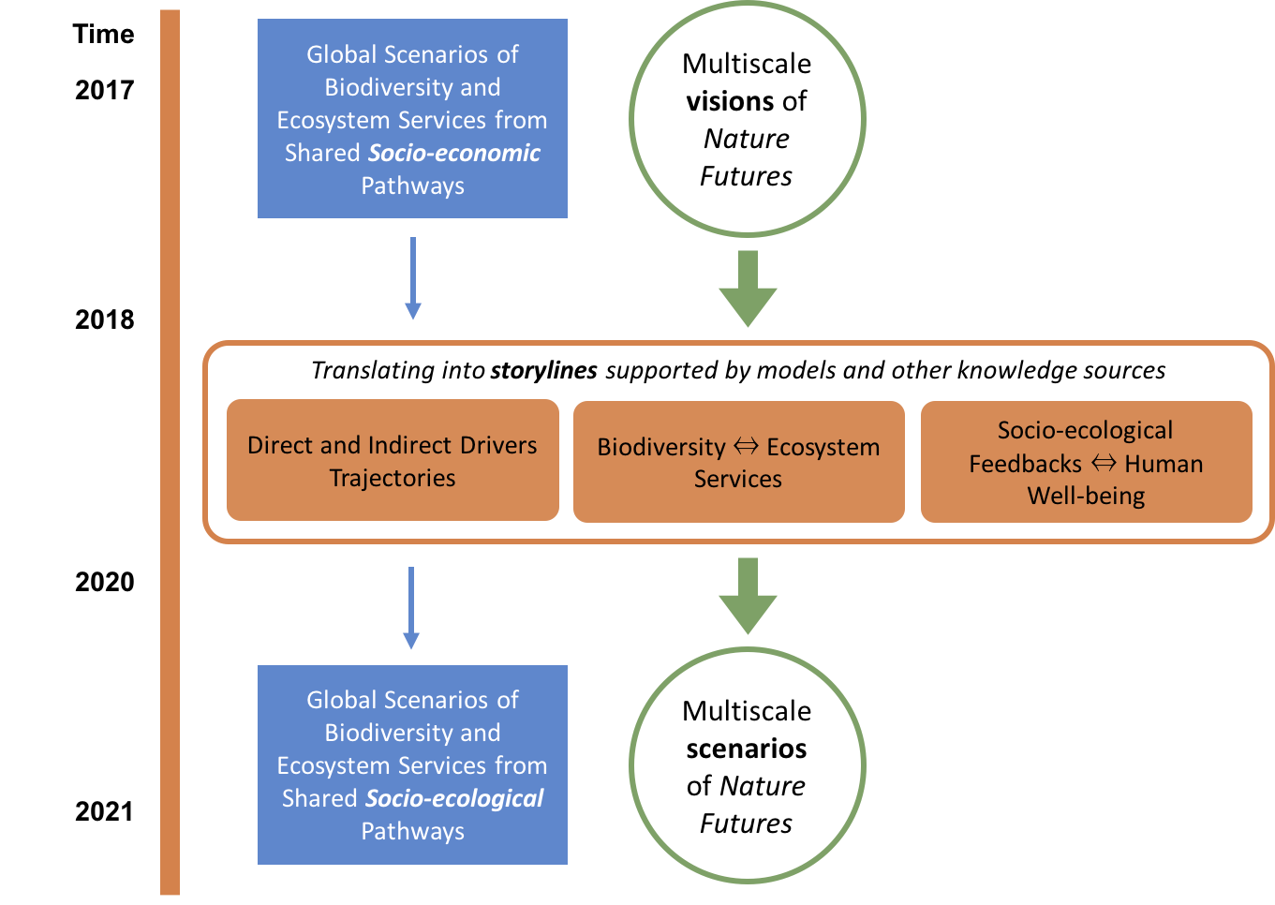

a.
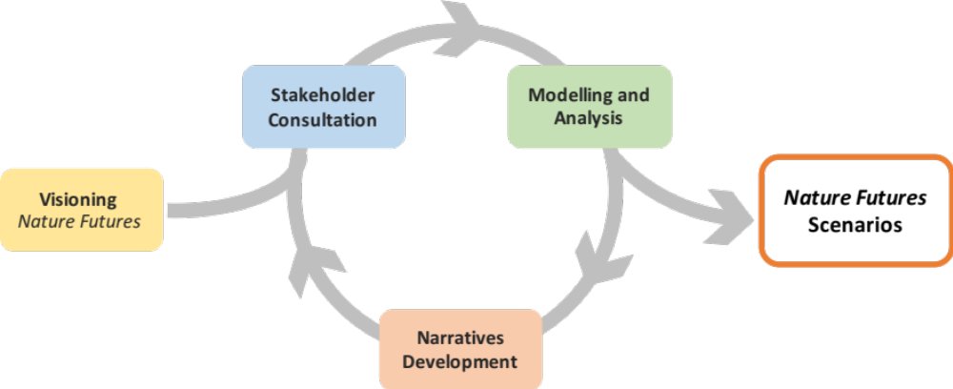
b.
Figure 2. a. 2017-2021 timeline for the Nature Futures Scenarios development, b. Stakeholder consultation, visioning, and modelling iterative process.

- The IPBES Expert Group on Scenarios and Modelling, with the support of its Technical Support Unit (TSU), will take the lead on the development of narratives and modelling and analysis to produce the scenarios on Nature Futures. The expert group will consult iteratively a wide range of stakeholders and experts through international platforms such as IPBES Plenary, CBD SBSTTA and COP, the World Economic Forum, and other relevant initiatives, and at least two full cycles of stakeholder consultation, modelling and analysis, and narrative development are expected over the next 4 years (Figure 2). Hopefully, a new generation of “shared socio-ecological pathways” will also be developed based on the experience of the Nature Futures Scenarios, in order to incorporate the central role of biodiversity on general scenarios for human development.
- The activities for developing the Nature Future Scenarios include visioning of the positive outlooks for nature through stakeholder engagement, identifying pathways building on existing innovative good practices with potential challenges and opportunities for regime shifts, translating visions into scenarios with quantitative modelling and qualitative integration of multiple knowledge systems, assessing policy and management relevance in support of enhanced use of scenarios and modelled results in conservation policies and practices, and bridging scientific communities and stakeholder groups through results dissemination and dialogue (Figure 2b).

IV. REFERENCEs
Bennett, E.M., Solan, M., Biggs, R., McPhearson, T., Norström, A.V., Olsson, P., Pereira, L., Peterson, G.D., Raudsepp‐Hearne, C., Biermann, F. (2016) Bright spots: seeds of a good Anthropocene. Frontiers in Ecology and the Environment, 14(8): 441–448.
Díaz S, Demissew S, Joly C, Lonsdale WM, Larigauderie A (2015a) A Rosetta Stone for Nature’s Benefits to People. PLoS Biol 13(1):
Díaz, S et al, The IPBES Conceptual Framework — connecting nature and people, (2015b) Current Opinion in Environmental Sustainability, 14, 1-16,
IPBES (2016) Summary for policymakers of the methodological assessment of scenarios and models of biodiversity and ecosystem services of the Intergovernmental Science-Policy Platform on Biodiversity and Ecosystem Services. Ferrier, S., Ninan, K.N., Leadley, P., Alkemade, R., Acosta, L.A., Akçakaya, H.R., Brotons, L., Cheung, W., Christensen, V., Harhash, K.A., Kabubo-Mariara, J., Lundquist, C., Obersteiner, M., Pereira, H., Peterson, G., Pichs-Madruga, R., Ravindranath, N.H., Rondinini, C., Wintle, B. (eds.) Secretariat of the Intergovernmental Science-Policy Platform on Biodiversity and Ecosystem Services, Bonn, Germany.
Kok, M.T.J., Kok, K., Peterson, G.D., Hill, R., Agard, J., Carpenter, S.R. (2017) Biodiversity and ecosystem services require IPBES to take novel approach to scenarios. Sustain. Sci., 12(1): 177-181.
Pereira, H.M., Leadley, P.W., Proenca, V., et al. (2010) Scenarios for global biodiversity in the 21st century. Science, 330, 1496-1501.
Rosa, I.M.D., Pereira, H.M., Ferrier, S., Alkemade, R., Acosta, L.A., Akcakaya, R., Belder, E. den, Fazel, A.M., Fujimori, S., Harfoot, M., HarhaK.A.sh, , Harrison, P.A., Hauck, J., Hendriks, R.J.J., Hernández, G., Jetz, W., Karlsson-Vinkhuyzen, S.I., Kim, H.J., King, N., Kok, M.T.J., Kolomytsev, G.O., Lazarova, T., Leadley, P., Lundquist, C.J., García Márquez, J., Meyer, C., Navarro, L.M., Nesshöver, C., Ngo, H.T., Ninan, K.N., Palomo, M.G., Pereira, L.M., Peterson, G.D., Pichs, R., Popp, A., Purvis, A., Ravera, F., Rondinini, C., Sathyapalan, J., Schipper, A.M., Seppelt, R., Settele, J., Sitas, N., van Vuuren, D., (2017) Multiscale scenarios for nature futures. Nat. Ecol. Evol. 1 (10), 1416 – 1419.

__________

* CBD/SBSTTA/21/1.
In the IPBES conceptual framework (Diaz et al 2015a, 2015b) the term “biodiversity” is used interchangeably with the term “nature” and the term “ecosystem services” is used interchangeably with the term “nature’s benefits to people”
This could include workshops held on the margins of SBSTTA-22 in July 2018 and COP-14 in November 2018.

