|  |  |  |
| --- | --- | --- |
| Macintosh HD:Users:bilodeau:Desktop:logos:template 2017:un.emf | Macintosh HD:Users:bilodeau:Desktop:logos:template 2017:unep-old.emf | **CBD** |

|  |  |  |
| --- | --- | --- |
|  |  | Distr.  GENERAL  CBD/POST2020/WS/2019/6/INF/2  5 June 2019  ENGLISH ONLY |

CoNSULTATION WORKSHOP OF BIODIVERSITY-RELATED CONVENTIONS ON THE POST-2020 GLOBAL BIODIVERSITY FRAMEWORK

First meeting

Bern, 10-12 June 2019

# **Annotated outline of selected resources relevant to the contribution of other multilateral environmental agreements to the post-2020 global biodiversity framework**

The present note provides information on selected resources relevant to the development of a post-2020 global biodiversity framework of common value to the biodiversity-related conventions and Rio conventions. It serves as a preliminary compilation to inform stakeholders and facilitate access to existing resources and work carried in the context of enhancing cooperation and synergies among conventions. It has been compiled by the United Nations Environment Programme World Conservation Monitoring Centre (UNEP-WCMC) and is presented in the form in which it was received.

**Annotated outline of selected resources of relevance to the consultation workshop of biodiversity-related conventions on the post-2020 global biodiversity framework**

*June 2019*

This document has been compiled by the UN Environment World Conservation Monitoring Centre (UNEP-WCMC) under the UN Environment project on *Realizing synergies for biodiversity* as an input to the consultation workshop of biodiversity-related conventions on the post-2020 global biodiversity framework. The UN Environment project on *Realizing synergies for biodiversity* is supported by the European Commission and the government of Switzerland.

1. **Strategic Planning**
   1. **Figure on *Strategies, strategic plans and other frameworks under the biodiversity-related conventions* (SCBD 2018/19)**: ***ANNEX 1*** *of this document*.
   2. **UNEP (2016). Enhancing cooperation among the seven biodiversity related agreements and conventions at the national level using national biodiversity strategies and action plans. UNEP, Nairobi, Kenya:**

<https://wedocs.unep.org/bitstream/handle/20.500.11822/9966/role-mea-synergies-sdgs.pdf?sequence=1&amp%3BisAllowed>=

The paper outlines the links between the Sustainable Development Goals and multilateral environmental agreements in general and biodiversity-related multilateral environmental agreements in particular, with a special focus on Sustainable Development Goal targets and indicators in an attempt to inform discussions within the Inter-Agency and Expert Group on Sustainable Development Goal Indicators of the United Nations Statistical Commission and at the multilateral environmental agreement level. For an adapted version of the report’s table 1 on **Links between Sustainable Development Goals and targets and key multilateral environmental agreements**, please view ***ANNEX 2*** *of this document*.

* 1. **Mapping of the Aichi Biodiversity Targets and targets of the strategic plans of CITES, CMS and Ramsar (2018)**, adapted from: *Rogalla von Bieberstein et. al. 2019. Improving collaboration in the implementation of global biodiversity conventions. Conservation Biology*, [doi.org/10.1111/cobi.13252](https://doi.org/10.1111/cobi.13252): ***ANNEX 3*** *of this document*.

1. **Shared resources and approaches**
   1. **UNEP-WCMC (2018). Mapping of current and potential use of biodiversity indicators across intergovernmental processes**. Output is a table that shows a mapping of global biodiversity indicators to Sustainable Development Goals (SDGs), biodiversity-related conventions: Convention on Biological Diversity (CBD), Convention on International Trade in Endangered Species of Wild Fauna and Flora (CITES), Convention on the Conservation of Migratory Species of Wild Animals (CMS), Ramsar Convention on Wetlands of International Importance (Ramsar), and the Intergovernmental science-policy Platform on Biodiversity and Ecosystem Services (IPBES): <https://www.unep-wcmc.org/system/comfy/cms/files/files/000/001/401/original/Cross_mapping_A3_final.pdf>

The table was based on global indicator reviews conducted by UNEP-WCMC, and aims to enhance coherence in the development and use of indicators across multiple intergovernmental processes. It demonstrates where there is consistency in the current use of biodiversity-related indicators in global indicators frameworks (official indicators in green). In addition, it shows the potential for future synergies (relevant indicators in orange) ahead of reviews of SDG indicators and the development of the global post-2020 framework for biodiversity. In particular, this mapping features global indicators with the greatest potential for synergistic use across multiple intergovernmental processes.

* 1. **FOEN, UNEP-WCMC, NatureConsult (2016). Elements for a modular reporting against the Aichi Biodiversity Targets. UNEP-WCMC, Cambridge.** This study, commissioned by the Swiss Federal Office for the Environment (FOEN), presents elements for a modular approach to reporting that can be integrated into the reporting guidelines of the Convention on Biological Diversity (CBD) for the next national reporting cycle (6th National Reports). In addition to the reporting needs of the CBD, the work draws on information collected through reporting processes under the other six biodiversity-related conventions, as well as seven intergovernmental assessment processes related to biodiversity: <https://www.cbd.int/doc/meetings/cop/cop-13/information/cop-13-inf-24-en.pdf>.

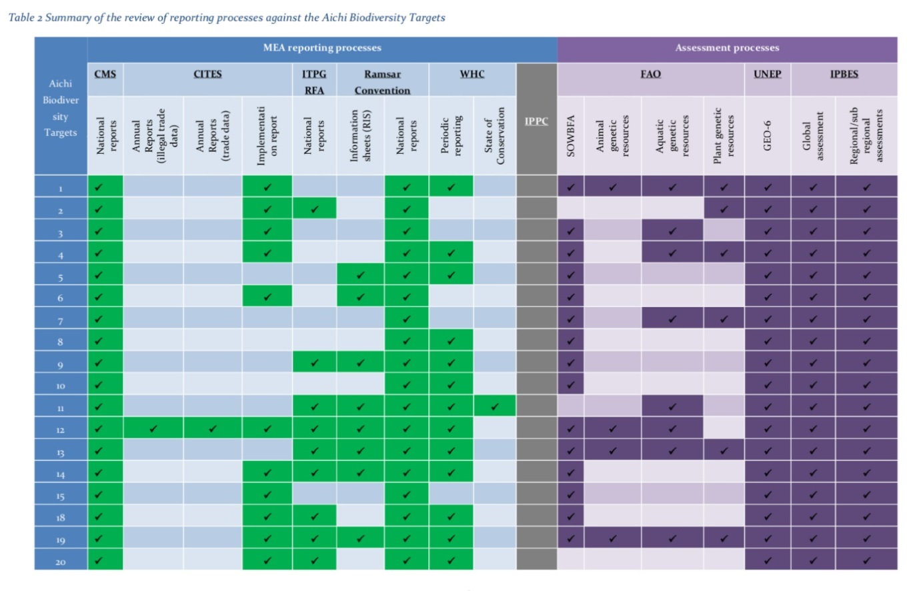The approach aims at making best use of the opportunity created through the adoption of the Strategic Plan for Biodiversity 2011-2020 and it’s Aichi Biodiversity Targets as the global framework for biodiversity conservation until 2020. Therefore, the suggested series of modules is based on the structure provided by the Aichi Biodiversity Targets. In addition to an overview of the range of information available under the different reporting and assessment processes that can be used to inform the final review of the Strategic Plan for Biodiversity (table 2 – see below), three example modules, based on Aichi Biodiversity Targets 1, 5 and 12 were developed, providing a clear indication of how the information gathered through other reporting processes can be integrated into the reporting process under the CBD.

* 1. **Inter-agency and Expert Group on SDG Indicators.** **Tier classification of the Global SDG indicators with indication of custodian and partner agencies, including MEAs** (e.g. Ramsar) (22 May 2019). <https://unstats.un.org/sdgs/iaeg-sdgs/tier-classification/>

This document contains the updated tier classification, based on changes made by the Inter-agency and Expert Group on SDG Indicators (IAEG-SDGs) following its physical and virtual meetings since March 2016. The latest changes reflect the decisions made during the 9th meeting of the IAEG-SDGs in March 2019.

**UNEP (2019). Measuring Progress: towards achieving the environmental dimension of the SDGs. UNEP, Nairobi, Kenya**: <https://wedocs.unep.org/bitstream/handle/20.500.11822/27627/MeaProg2019.pdf?sequence=1&isAllowed=y>

Measuring Progress is a derivative product of the sixth report in the GEO series (GEO-6; UNEP 2019a). This publication complements the GEO and provides an overview of the current state of the environmental dimensions of sustainable development based on the SDG indicators - including the availability of statistical and spatial data, analytical methods and visualisations - and identifies knowledge and information gaps in terms of assessing progress towards the environmental dimension of the SDGs.

**2.3 UNEP Sourcebook of opportunities for enhancing cooperation among the biodiversity-related conventions, *Annex 2. Potential areas of overlap between the information requirements of the biodiversity-related conventions* (2015)**: <http://wcmc.io/sourcebook-web>.

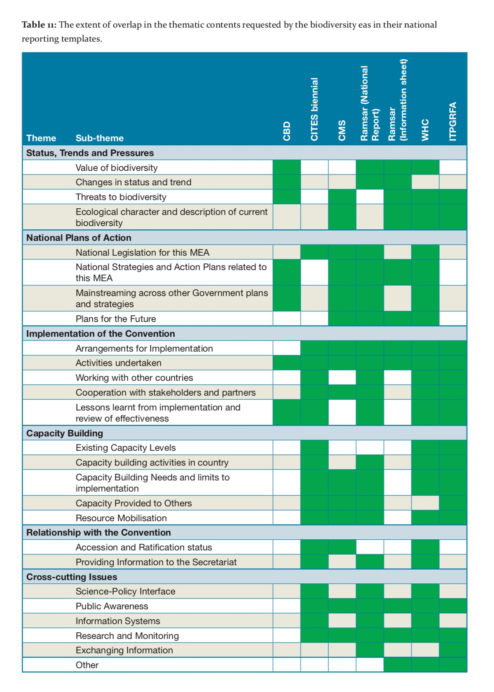

1. **Cooperation among the biodiversity-related conventions**

**3.1 Development of the "MEA synergies" debate, with a particular focus on the biodiversity-related conventions and the International Environmental Governance (IEG) reform process (August 2014)**: <https://www.cbd.int/doc/meetings/biodiv/brcws-2016-01/other/brcws-2016-01-unep-01-en.pdf>.

Background Information to the first UN Environment multi-stakeholder expert meeting on elaboration of options for synergies among biodiversity-related Multilateral Environmental Agreements, organized in 2014 in Interlaken, Switzerland.

**3.2 UNEP (2015). Sourcebook of opportunities for enhancing cooperation among the Biodiversity-related Conventions at national and regional levels. UNEP, Nairobi, Kenya:** wcmc.io/sourcebook-web

The Sourcebook focuses on what can be achieved through cooperation among those implementing the Biodiversity-related Conventions at national and regional levels. It provides practical examples, checklists, lessons learnt and case studies from around the world which can provide an inspiration for those countries interested in exploring synergies opportunities in their own national and local circumstances.

**3.3 CBD, UNCCD, UNCCC (2012). Joint publications on:**

1. **Action on Adaptation**: <https://unfccc.int/resource/docs/publications/rio_20_adaptation_brochure.pdf>

This publication on the occasion of the Rio+20 conference highlights the roles of the Rio conventions’ processes involved in biodiversity, combating desertification/land degradation and climate change as important contributors to the global sustainable development agenda, drawing attention to successes and future opportunities.

1. **Action on Forests**: <https://unfccc.int/resource/docs/publications/rio_20_forests_brochure.pdf>

This information brochure provides a snapshot of the synergies and linkages with respect to forests between combating climate change and desertification and the conservation and sustainable use of biodiversity.

1. **Action on Gender**: <https://unfccc.int/resource/docs/publications/roi_20_gender_brochure.pdf>

The brochure take a closer look at the goals, objectives and opportunities relevant to the integration of gender into each of the three Rio conventions.

**3.4** **Information portal on “Increasing access to guidance and supporting knowledge sharing among the biodiversity-related conventions to enhance potential synergies”. UNEP-WCMC (2018)**: [wcmc.io/biodiversitysynergies](http://www.unep-wcmc.org/resources-and-data/biodiversitysynergies)

The portal provides access to the following resources:

1. **Compendium of guidance on synergies among biodiversity-related conventions at the national level (March 2018)**: wcmc.io/compendium_synergies

The purpose of the document is to help increase access to existing guidance material on synergies among the biodiversity-related conventions and to provide a basis for identifying gaps in the available guidance.

1. **Compendium of guidance for capturing, managing and using data and information (March 2018)**: wcmc.io/compendium_data

The primary aim of this document is to assist national government, agency and NGO staff responsible for MEA implementation at the national level who are responsible for the capture, management and use of data and information.

1. **Compendium of guidance on key global databases related to biodiversity-related conventions (March 2018)**: wcmc.io/compendium_database

This compendium of guidance provides details of global-level databases relevant to the implementation of the biodiversity-related conventions.

1. **Overview of existing initiatives for enhancing coordination and collaboration at various levels across the biodiversity-related conventions (March 2018)**: [wcmc.io/synergies_overview](http://wcmc.io/synergies_overview)

Rather than providing a comprehensive review, this paper aims to provide an overview of a range of different types of initiative for enhancing coordination and collaboration at various levels across the biodiversity-related conventions. In order to facilitate easy reference, the paper is structured around the thematic headings of annex I of CBD COP decision XIII/24 on “Options for action by Parties of the various biodiversity-related conventions to enhance synergies at the national level”.

**Annex 1: Strategies, strategic plans and other frameworks under the biodiversity-related conventions**

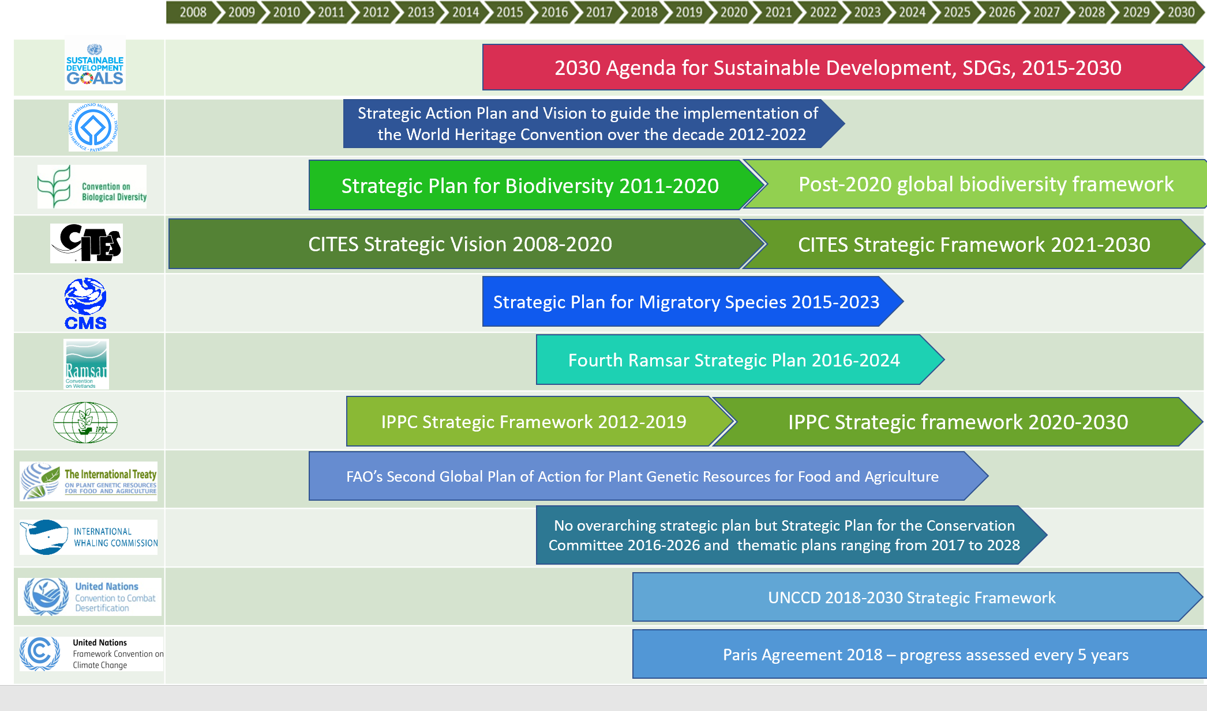

**Annex 2: Indicative mapping of Links between Sustainable Development Goals and targets and key multilateral environmental agreements, adapted from UNEP (2016). Enhancing cooperation among the seven biodiversity related agreements and conventions at the national level using national biodiversity strategies and action plans. UNEP, Nairobi, Kenya; *table 1*.**

|  |  |  |  |  |  |  |  |  |  |  |  |
| --- | --- | --- | --- | --- | --- | --- | --- | --- | --- | --- | --- |
| SDG and Target numbers | Target text | CBD[1] | CITES[2] | CMS[3] | Ramsar[4] | WHC[5] | ITPGRFA[6] | IPPC[7] | UNFCCC[8] | UNCCD[9] | Chemicals[10] |
| Goal 1: No Poverty | |  | | | | | | | | | |
| 1.4 | By 2030, ensure that all men and women, in particular the poor and the vulnerable, have equal rights to economic resources, as well as access to basic services, ownership and control over land and other forms of poverty, inheritance, natural resources, appropriate new technology and financial services, including microfinance. |  |  |  |  |  |  |  |  |  |  |
| 1.5 | By 2030, build the resilience of the poor and those in vulnerable situations and reduce their exposure and vulnerability to climate-related extreme events and other economic, social and environmental shocks and disaster |  |  |  |  |  |  |  |  |  |  |
| 1.b | Create sound policy frameworks at the national, regional and international levels, based on pro-poor and gender-sensitive development strategies, to support accelerated investment in poverty eradication actions |  |  |  |  |  |  |  |  |  |  |
| Goal 2: Zero Hunger | |  | | | | | | | | | |
| 2.3 | By 2030, double the agricultural productivity and incomes of small-scale food producers, in particular women, indigenous peoples, family farmers, pastoralists and fishers, including through secure and equal access to land, other productive resources and inputs, knowledge, financial services, markets and opportunities for value addition and non-farm employment. |  |  |  |  |  |  |  |  |  |  |
| 2.4 | By 2030, ensure sustainable food production systems and implement resilient agricultural practices that increase productivity and production, that help maintain ecosystems, that strengthen capacity for adaptation to climate change, extreme weather, drought, flooding and other disasters and that progressively improve land and soil quality. |  |  |  |  |  |  |  |  |  |  |
| 2.5 | By 2020, maintain the genetic diversity of seeds, cultivated plants and farmed and domesticated animals and their related wild species, including through soundly managed and diversified seed and plant banks at the national, regional and international levels, and promote access to and fair and equitable sharing of benefits arising from the utilization of genetic resources and associated traditional knowledge, as internationally agreed. |  |  |  |  |  |  |  |  |  |  |
| 2.a | Increase investment, including through enhanced international cooperation, in rural infrastructure, agricultural research and extension services, technology development and plant and livestock gene banks in order to enhance agricultural productive capacity in developing countries, in particular least developed countries. |  |  |  |  |  |  |  |  |  |  |
| 2.b | Correct and prevent trade restrictions and distortions in world agricultural markets, including through the parallel elimination of all forms of agricultural export subsidies and all export measures with equivalent effect, in accordance with the mandate of the Doha Development Round. |  |  |  |  |  |  |  |  |  |  |
| Goal 3: Good Health and Well-Being | |  | | | | | | | | | |
| 3.9 | By 2030, substantially reduce the number of deaths and illnesses from hazardous chemicals and air, water and soil pollution and contamination. |  |  |  |  |  |  |  |  |  |  |
| Goal 6: Clean Water and Sanitation | |  | | | | | | | | | |
| 6.6 | By 2020, protect and restore water-related ecosystems, including mountains, forests, wetlands, rivers, aquifers and lakes |  |  |  |  |  |  |  |  |  |  |
| Goal 8: Decent work and Economic Growth | |  | | | | | | | | | |
| 8.8 | Protect labour rights and promote safe and secure working environments for all workers, including migrant workers, in particular women migrants, and those in precarious employment |  |  |  |  |  |  |  |  |  |  |
| Goal 9: Industry, Innovation and Infrastructure | |  | | | | | | | | | |
| 9.4 | By 2030, upgrade infrastructure and retrofit industries to make them sustainable, with increased resource-use efficiency and greater adoption of clean and environmentally sound technologies and industrial processes, with all countries taking action in accordance with their respective capabilities |  |  |  |  |  |  |  |  |  |  |
| 9.5 | Enhance scientific research, upgrade the technological capabilities of industrial sectors in all countries, in particular developing countries, including, by 2030, encouraging innovation and substantially increasing the number of research and development workers per 1 million people and public and private research and development spending |  |  |  |  |  |  |  |  |  |  |
| Goal 11: Sustainable Cities and Communities | |  | | | | | | | | | |
| 11.4 | Strengthen efforts to protect and safeguard the world’s cultural and natural heritage |  |  |  |  |  |  |  |  |  |  |
| 11.6 | By 2030, reduce the adverse per capita environmental impact of cities, including by paying special attention to air quality and municipal and other waste management |  |  |  |  |  |  |  |  |  |  |
| 11.a | Support positive economic, social and environmental links between urban, peri-urban and rural areas by strengthening national and regional development planning |  |  |  |  |  |  |  |  |  |  |
| 11.b | By 2020, substantially increase the number of cities and human settlements adopting and implementing integrated policies and plans towards inclusion, resource efficiency, mitigation and adaptation to climate change, resilience to disasters, and develop and implement, in line with the Sendai Framework for Disaster Risk Reduction 2015-2030, holistic disaster risk management at all levels |  |  |  |  |  |  |  |  |  |  |
| Goal 12: Responsible consumption and Production | |  | | | | | | | | | |
| 12.2 | By 2030, achieve the sustainable management and efficient use of natural resources |  |  |  |  |  |  |  |  |  |  |
| 12.4 | By 2020, achieve the environmentally sound management of chemicals and all wastes throughout their life cycle, in accordance with agreed international frameworks, and significantly reduce their release to air, water and soil in order to minimize their adverse impacts on human health and the environment |  |  |  |  |  |  |  |  |  |  |
| 12.5 | By 2030, substantially reduce waste generation through prevention, reduction, recycling and reuse |  |  |  |  |  |  |  |  |  |  |
| 12.7 | Promote public procurement practices that are sustainable, in accordance with national policies and priorities |  |  |  |  |  |  |  |  |  |  |
| 12.8 | By 2030, ensure that people everywhere have the relevant information and awareness for sustainable development and lifestyles in harmony with nature |  |  |  |  |  |  |  |  |  |  |
| 12.c | Rationalize inefficient fossil-fuel subsidies that encourage wasteful consumption by removing market distortions, in accordance with national circumstances, including by restructuring taxation and phasing out those harmful subsidies, where they exist, to reflect their environmental impacts, taking fully into account the specific needs and conditions of developing countries and minimizing the possible adverse impacts on their development in a manner that protects the poor and the affected communities |  |  |  |  |  |  |  |  |  |  |
| Goal 13: Climate Action | |  | | | | | | | | | |
| 13.1 | Strengthen resilience and adaptive capacity to climate-related hazards and natural disasters in all countries |  |  |  |  |  |  |  |  |  |  |
| 13.2 | Integrate climate change measures into national policies, strategies and planning |  |  |  |  |  |  |  |  |  |  |
| 13.3 | Improve education, awareness-raising and human and institutional capacity on climate change mitigation, adaptation, impact reduction and early warning |  |  |  |  |  |  |  |  |  |  |
| 13.a | Implement the commitment undertaken by developed-country parties to the United Nations Framework Convention on Climate Change to a goal of mobilizing jointly $100 billion annually by 2020 from all sources to address the needs of developing countries in the context of meaningful mitigation actions and transparency on implementation and fully operationalize the Green Climate Fund through its capitalization as soon as possible |  |  |  |  |  |  |  |  |  |  |
| 13.b | Promote mechanisms for raising capacity for effective climate change-related planning and management in least developed countries and small island developing States, including focusing on women, youth and local and marginalized communities |  |  |  |  |  |  |  |  |  |  |
| Goal 14: Life Below Water | |  | | | | | | | | | |
| 14.1 | By 2025, prevent and significantly reduce marine pollution of all kinds, in particular from land-based activities, including marine debris and nutrient pollution |  |  |  |  |  |  |  |  |  |  |
| 14.2 | By 2020, sustainably manage and protect marine and coastal ecosystems to avoid significant adverse impacts, including by strengthening their resilience, and take action for their restoration in order to achieve healthy and productive oceans |  |  |  |  |  |  |  |  |  |  |
| 14.3 | Minimize and address the impacts of ocean acidification, including through enhanced scientific cooperation at all levels |  |  |  |  |  |  |  |  |  |  |
| 14.4 | By 2020, effectively regulate harvesting and end overfishing, illegal, unreported and unregulated fishing and destructive fishing practices and implement science-based management plans, in order to restore fish stocks in the shortest time feasible, at least to levels that can produce maximum sustainable yield as determined by their biological characteristics |  |  |  |  |  |  |  |  |  |  |
| 14.5 | By 2020, conserve at least 10 per cent of coastal and marine areas, consistent with national and international law and based on the best available scientific information |  |  |  |  |  |  |  |  |  |  |
| 14.7 | By 2030, increase the economic benefits to Small Island developing States and least developed countries from the sustainable use of marine resources, including through sustainable management of fisheries, aquaculture and tourism |  |  |  |  |  |  |  |  |  |  |
| 14.a | Increase scientific knowledge, develop research capacity and transfer marine technology, taking into account the Intergovernmental Oceanographic Commission Criteria and Guidelines on the Transfer of Marine Technology, in order to improve ocean health and to enhance the contribution of marine biodiversity to the development of developing countries, in particular small island developing States and least developed countries |  |  |  |  |  |  |  |  |  |  |
| 14.b | Provide access for small-scale artisanal fishers to marine resources and markets |  |  |  |  |  |  |  |  |  |  |

**Annex 3: Mapping of the Aichi Biodiversity Targets and objectives and targets of the strategic plans of CITES, CMS and Ramsar**

Adapted from: Table 2 on “The 20 Aichi Biodiversity Targets of the Strategic Plan for Biodiversity 2011-2020 relative to the strategic plans of CITES (Convention on International Trade in Endangered Species of Wild Fauna and Flora 2016), CMS (Convention on Migratory Species 2014) and Ramsar (Ramsar Convention on Wetlands 2015)”, included in Rogalla von Bieberstein et. al. 2019. Improving collaboration in the implementation of global biodiversity conventions. Conservation Biology, [doi.org/10.1111/cobi.13252](https://doi.org/10.1111/cobi.13252).

The text has been modified for length. The full text directly sourced from the individual convention’s strategic plans and can be found in Appendix S1 of the above mentioned article online. Where objectives and targets from CITES, CMS, or the Ramsar Convention apply to multiple Aichi Biodiversity Targets, text is only provided for the first match.

| Aichi Biodiversity Targets | CITES (objectives) | CMS (targets) | Ramsar (targets) |
| --- | --- | --- | --- |
| Target 1: Awareness of biodiversity | **1.4:** identification of conservation needs of species; **1.8:** capacity building; **2.2:** Sufficient resources; **3.2:** Awareness of CITES; **3.3:** Enhanced cooperation; **3.4:** Contribution to Millennium Development Goals and Sustainable Development Goals | **1:** Awareness of migratory species, their habitats and migratory systems | **11:** Demonstration, documentation and dissemination of benefits; **16:** capacity development and education; **19**: Capacity building for the Strategic Plan |
| Target 2: Biodiversity integrated into development and poverty reduction strategies and accounting and reporting systems | **1.1:** compliance with CITES;  **1.5:** Best available scientific information; **3.1** Cooperation with international financial mechanisms; **3.3:** see Aichi target 1; **3.4:** see Aichi target 1; **3.5:** Cooperation with international organizations | **2:** Integrated of values into development and poverty reduction strategies and accounting and reporting systems | **1:** Integration of benefits into policy strategies relating to key sectors; **11:** see Aichi target 1 |
| Target 3: Elimination of harmful incentives and application of positive incentives | **1.1:** see Aichi target 2; **1.2:** Transparent administrative procedures; **2.2:** see Aichi target 1; **3.3:** see Aichi target 1; **3.4** see Aichi target 1 | **4:** Elimination of harmful incentives and application of positive incentives | **3**: Good practices for the wise use of water and wetlands |
| Target 4: Sustainable production and consumption | **1.1:** see Aichi target 2; **1.5:** see Aichi target 2; **1.6:** managing shared wildlife resources; **1.7:** reducing illegal wildlife trade; **3.2:** see Aichi target 1; **3.3:** see Aichi target 1**; 3.4:** see Aichi target 1; **3.5:** see Aichi target 2 | **5:** Sustainable production and consumption | **3:** see Aichi target 3; **9:** resource management within a river basin or along a coastal zone |
| Target 5: Habitat loss, degradation and fragmentation | **1.5:** see Aichi target 2; **1.6:** see Aichi target 4; **1.7** see Aichi target 4; **3.4:** see Aichi target 1; **3.5:** see Aichi target 2 | **10:** Key habitats and sites for migratory species identified and protected | **Goal 1**: Addressing the drivers of wetland and degradation; **7**: Addressing threats to sites at risk of losing their ecological character |
| Target 6: Sustainable management of fish and invertebrate stocks and aquatic plants | **1.1:** see Aichi target 2; **1.4:** see Aichi target 1; **1.5** see Aichi target 2; **1.6:** see Aichi target 4; **1.7:** see Aichi target 4; **3.4:** see Aichi target 1; **3.5:** see Aichi target 2 | **6:** Avoidance of adverse impacts of fisheries and hunting | **5:** effective planning and integrated management; **9:** see Aichi target 4; **13:** Sustainability of key sectors contributing to biodiversity conservation and human livelihoods |
| Target 7: Sustainable agriculture, aquaculture, and forestry | **1.5:** see Aichi target 2; **1.6:** see Aichi target 4; **1.7:** see Aichi target 4; **3.4:** see Aichi target 1; **3.5:** see Aichi target 2 | **5:** see Aichi Target 4 | **2:** Water use respects wetland ecosystem needs; **3:** see Aichi target 3; **7:** see Aichi target 5; **9:** see Aichi target 4; **13** see Aichi target 6 |
| Target 8: Pollution and eutrophication | No equivalent objective | **7:** Reduction of anthropogenic pressures to levels that are not detrimental | **2:** see Aichi target 7; **3:** see Aichi target 3 |
| Target 9: Invasive alien species and pathways | **1.1:** see Aichi target 2; **1.3:** Implementation is consistent with decisions adopted by the Conference of the Parties; **1.5:** see Aichi target 2; **1.7:** see Aichi target 4; **3.3:** see Aichi target 1 | **7:** See Aichi target 8 | **Target 4:** Invasive alien species and pathways |
| Target 10: Anthropogenic pressures on coral reefs and other vulnerable ecosystems impacted by climate change or ocean acidification | **1.1:** see Aichi target 2; **1.4:** see Aichi target 1; **1.5:** see Aichi target 2; **1.6:** see Aichi target 4; **1.7:** see Aichi target 4; **3.4:** see Aichi target 1; **3.5:** see Aichi target 2 | **7:** See Aichi target 8 | **6:** Increase in area, numbers, and ecological connectivity in particular underrepresented types of wetlands |
| Target 11: Effectively and equitably managed, ecologically representative and well connected protected areas and other effective area-based conservation measures | **1.4:** see Aichi target 1; **3.5:** see Aichi target 2 | **10:** see Aichi target 5 | **Goal 2:** Effectively conserving and managing the Ramsar Site network; **5:** see Aichi target 6**; 6:** see Aichi target 10; **7:** see Aichi target 5 |
| Target 12: Prevention of extinctions and improved conservation status of threatened species | **1.1:** see Aichi target 2; **1.4:** see Aichi target 1; **1.5:** see Aichi target 2; **1.6:** see Aichi target 4; **1.7:** see Aichi target 4; **1.8:** see Aichi target 1; **2.2:** see Aichi target 1; **2.3:** Sufficient resources for capacity-building; **3.2:** see Aichi target 1; **3.3:** see Aichi target 1; **3.4:** see Aichi target 1; **3.5:** see Aichi target 2 | **8:** Improvement of the conservation status of threatened migratory species. | **5:** see Aichi target 6; **7:** see Aichi target 5; **8:** National wetland inventories |
| Target 13: Maintaining genetic diversity of cultivated plants and farmed and domesticated animals and of wild relatives | No equivalent objective | **12:** Safeguarding the genetic diversity of wild populations of migratory species. | **11:** see Aichi Target 1 |
| Target 14: Safeguarding and restoration of ecosystems services | **1.3:** see Aichi target 9; **1.5:** see Aichi target 2; **3.3:** see Aichi target 1; **3.4:** see Aichi target 1  **Objective 3.5** see Aichi target 2 | **11:** Maintaining and restoration of migratory species and their habitats which provide important ecosystem services | **8:** see Aichi target 12; **11:** see Aichi target 1;  **12:** Restoration of degraded wetlands. |
| Target 15: Enhancing ecosystem resilience and carbon stocks through conservation and restoration | No equivalent objective | **11:** see Aichi target 14 | **12:** see Aichi target 14 |
| Target 16: The Nagoya Protocol on Access to Genetic Resources and the Fair and Equitable Sharing of Benefits | **Objective 1.1** see Aichi target 2 | No equivalent target | No equivalent target |
| Target 17: National Biodiversity Strategy and Action Plans (NBSAPs) | **Objective 3.4** see Aichi target 1 | **13:** Inclusion of priorities related to migratory species and migratory systems in NBSAPs | **19** see Aichi target 1 |
| Target 18: Traditional knowledge, innovations and practices of indigenous and local communities | **1.1:** see Aichi target 2; **1.3:** see Aichi target 9; **1.5:** see Aichi target 2;  **3.2;** see Aichi target 1; **3.4** see Aichi target 1 | **14:** Traditional knowledge, innovations and practices of indigenous and local communities | **8** see Aichi target 12; **10:**  Traditional knowledge, innovations and practices of indigenous and local communities; **16:** see Aichi target 1 |
| Target 19: Improving knowledge, the science base and technologies | **1.4:** see Aichi target 1; **1.5:** see Aichi target 2; **1.6:** see Aichi target 4; **1.8:** see Aichi target 1; **2.2:** see Aichi target 1; **2.3:** see Aichi target 12; **3.3:** see Aichi target 1; **3.4:** see Aichi target 1; **3.5:** see Aichi target 2 | **15:** Improved science base, information, awareness, understanding and technologies | **8:** see Aichi target 12; **14:** Scientific and technical guidance |
| Target 20: Mobilization of financial resources | **2.1:** Sufficient financial resources;  **2.2:** see Aichi target 1; **2.3:** see Aichi target 12; **3.1:** see Aichi target 2 | **16:** Mobilization of adequate resources | **17:** Financial and other resources for implementation |

**__________**

1. Convention on Biological Diversity (CBD)
2. Convention on International Trade in Endangered Species of Wild Fauna and Flora (CITES)
3. Convention on the Conservation of Migratory species of Wild animals (CMS)
4. Convention on Wetlands of International Importance (Ramsar Convention on Wetlands)
5. Convention concerning the Protection of the World Cultural and Natural Heritage (World Heritage Convention, WHC)
6. International Treaty on Plant Genetic Resources for Food and Agriculture (ITPGRFA)
7. International Plant Protection Convention (IPPC)
8. United Nations Framework Convention on Climate Change (UNFCCC)
9. United Nations Convention to Combat Desertification (UNCCD)
10. Chemical Conventions (Basel Convention on the Control of Transboundary Movements of Hazardous Wastes and their Disposal, Rotterdam Convention on the Prior Informed Consent Procedure for Certain Hazardous Chemicals and Pesticides in International Trade, Stockholm Convention on Persistent Organic Pollutants)