|  |  |  |
| --- | --- | --- |
| Macintosh HD:Users:bilodeau:Desktop:logos:template 2017:un.emf |  | **CBD** |
| Macintosh HD:Users:bilodeau:Desktop:logos:template 2017:cbd.emf | | Distr.  GENERAL  CBD/SBI/3/7/Add.2  23 October 2020  ORIGINAL: ENGLISH |

SUBSIDIARY BODY ON IMPLEMENTATION

Third meeting

Venue and dates to be determined

Item 7 of the provisional agenda[1]*

Proposals to strengthen technical and scientific cooperation in support of the post-2020 global biodiversity framework

*Note by the Executive Secretary*

# Introduction

1. Article 18(1) of the Convention on Biological Diversity requires Parties to promote international technical and scientific cooperation in the field of conservation and sustainable use of biological diversity, where necessary, through the appropriate international and national channels.[2] Article 18 also require Parties, in accordance with national legislation and policies, to encourage and develop methods of cooperation for the development and use of technologies, including indigenous and traditional technologies, in pursuit of the objectives of the Convention, and, subject to mutual agreement, promote the establishment of joint research programmes and joint ventures for the development of relevant technologies. In addition, related articles are also relevant to technical and scientific cooperation, such as Articles 7, 12, 14, 16, 17 and 19.
2. Various provisions of other biodiversity-related conventions require Parties to promote, technical and scientific cooperation. For example, the preamble of the Convention on International Trade in Endangered Species of Wild Fauna and Flora (CITES) also recognizes the importance of international cooperation for the protection of certain species of wild fauna and flora. Article 2 of the Convention on Migratory Species of Wild Animals requires Parties to promote, cooperate in and support research relating to migratory species. The International Treaty on Plant Genetic Resources for Food and Agriculture also stresses the importance of international cooperation. Article 4 of the World Heritage Convention requires each State Party to do all it can, including with international assistance and cooperation, to ensure the identification, protection and conservation of its cultural and natural heritage.
3. The Conference of the Parties has adopted a number of decisions relating to technical and scientific cooperation and technology transfer.[3] In decisions [XI/2](https://www.cbd.int/doc/decisions/cop-11/cop-11-dec-02-en.pdf) and [XII/2](https://www.cbd.int/doc/decisions/cop-12/cop-12-dec-02-en.pdf) B, the Executive Secretary was requested to develop a coherent, consistent and coordinated approach to technical and scientific cooperation and technology transfer. In response, a number of measures and initiatives were developed. However, those efforts have been beset by various challenges and limitations. For example, the number of reported successful cases of technology transfer in the context of the Convention on Biological Diversity remains low.
4. The present proposals were prepared in response to paragraphs 8 and 9 of decision 14/24 B of the Conference of the Parties and in the context of the preparation of the post-2020 global biodiversity framework. It was recognized that the effective implementation of the framework will require effective means of implementation, including enhanced technical and scientific cooperation, technology transfer and promotion of innovative solutions, if meaningful change is to occur on the ground.
5. The Executive Secretary prepared draft proposals which were considered by the Subsidiary Body on Scientific, Technical and Technological Advice at its twenty-third meeting. In response to recommendation [23/6](https://www.cbd.int/doc/recommendations/sbstta-23/sbstta-23-rec-06-en.pdf) of the Subsidiary Body, the Executive Secretary further developed the proposals, taking into account views and suggestions from Parties, other Governments, indigenous peoples and local communities, and relevant stakeholders and organizations. The present document presents the revised proposals.
6. The proposals build on previous work on technical and scientific cooperation and technology transfer under the Convention and draw on the experiences and lessons learned from various initiatives within and outside the Convention.[4] Furthermore, they take into account the earlier proposals regarding the development of a coherent approach to technical and scientific cooperation and technology transfer,[5] proposals on options for measures and mechanisms to facilitate access to and adaptation of technologies,[6] as well as proposals for the establishment of a biodiversity technology initiative.[7]

# Goal, objectives and guiding principles

## Goal and objectives

1. The overall goal is to promote and facilitate collaboration and cooperation among Parties and relevant organizations to enable them to effectively utilize science, technology, best practices, and innovation to support the implementation of the post-2020 global biodiversity framework in order to achieve the objectives of the Convention and its Protocols. The specific objectives are as follows:
   1. To enhance local, national, regional and international capacities in relation to science, technology and innovation by means of human resources development and institutional capacity development;[8]
   2. To enable technology horizon scanning, assessment, monitoring, and judgement on the appropriate technologies;
   3. To promote and facilitate the development, transfer and use of appropriate technologies, including indigenous and traditional technologies subject to prior informed consent of indigenous people and local communities, as applicable;[9]
   4. To promote and encourage joint research, cooperation and collaboration in the use of scientific advances and good practices in research, including as a modality for sharing the benefits arising from research and development on genetic resources and traditional knowledge, as applicable;[10]
   5. To promote the development, implementation and scaling up of appropriate and responsible innovative solutions,[11] including biodiversity-supportive technologies, modern biotechnology and other emerging technologies, such as artificial intelligence, use of big data and blockchains, according to national and international regulations, based on a precautionary approach, and in line with the objectives of the Convention on Biological Diversity;
   6. To facilitate access to and exchange of relevant technical and scientific data, information and knowledge, including, but not limited to, results of technical, scientific and socioeconomic research, specialized knowledge, including policy-based information, indigenous and traditional knowledge, and best practices.[12]

## Guiding principles

1. In the light of past operational experience, best practices, and lessons learned, technical and scientific cooperation initiatives (activities, projects and programmes), including technology assessment, horizon scanning and monitoring, would be guided by the following principles:[13]
   1. *Demand-driven:* Initiatives should be started at the request of Parties and relevant institutions and stakeholders, including indigenous peoples and local communities, in response to their identified and prioritized needs and in accordance with national legislation;
   2. *Flexibility:* Initiatives should be implemented in a flexible and adaptive manner, taking into account the varying needs, conditions and circumstances of the Parties and stakeholders involved, and in accordance with the precautionary approach;
   3. *Efficiency:* Measures should be taken to ensure that the initiatives achieve the intended results on time and with the least possible resources;
   4. *Efficacy:* Measures should be taken to ensure that the initiatives generate the desired changes while taking into account the potential interconnections and unintended impacts, and that results can be monitored, assessed and evaluated quantitatively and qualitatively;
   5. *Tailored:* Initiatives should be adapted to local conditions and circumstances, also taking into account cultural and other considerations, to foster buy-in and uptake, ownership, and sustainability at the local level;
   6. *Programmatic:* Delivery should be done through sustained long-term engagement and in a holistic and integrated manner, whereby various interventions (activities, projects and other initiatives) unified by an overarching vision and common objectives, are interconnected to achieve larger-scale and sustained impact that is more than the sum of its components;
   7. *Synergistic:* Initiatives should be implemented in a collaborative, interlinked, complementary and mutually supportive manner to achieve enhanced impact in supporting the implementation of the post-2020 global biodiversity framework at all levels and across conventions, processes and sectors;
   8. *Multi-stakeholder engagement:* Initiatives should actively engage relevant societal actors, institutional partners and providers of technical assistance, including (i) indigenous peoples and local communities and their networks; (ii) multidisciplinary research and professional networks; (iii) civil society, including youth networks; (iv) academic and scientific institutions; (v) the private sector; (vi) subnational, national and regional governmental institutions; (vii) national and international non-governmental organizations, including organizations engaging in citizen science; (viii) bilateral and multilateral institutions; and (ix) funding institutions;
   9. *Mutual respect:* Initiatives should adhere to the principles of mutual respect and equality and mutual benefit, under a human rights approach, including respect for diverse knowledge systems including the knowledge and experience of practitioners, indigenous peoples and local communities;
   10. *Respect for regulatory requirements:* Initiatives should adhere to appropriate and proportionate safeguards and comply with the legal and regulatory requirements of collaborating countries;
   11. *Continuous learning:* Initiatives should incorporate provisions for continuous education and learning opportunities, including interdisciplinary education in the research and development of new and emerging technologies, as a part of the long-term programmatic approach to strengthen the technical knowledge of the recipients;
   12. *Participation:* Initiatives should seek to maximize participatory approaches, recognizing the value of drawing on diverse perspectives, including those from outside the technical and scientific realm;
   13. *Precaution:* Initiatives should operationalize the precautionary approach as set out in the Convention on Biological Diversity and its protocols as a balance against risks arising from new technological threats;
   14. *Free, prior and informed consent:* Initiatives should respect the principle of free, prior and informed consent of indigenous peoples and local communities when considering the introduction, dissemination or use of innovations that may potentially impact their rights, traditional practices and territories;
   15. *Liability and redress:* Initiatives should take into account the requirement for ensuring liability and redress, as well as options for recall in the event the introduction or use of innovations cause unexpected or unanticipated adverse effects on the conservation and sustainable use of biodiversity.

# Main focal areas

1. Technical and scientific cooperation work in support of the post-2020 global biodiversity framework could be organized around the following focal areas:
   1. *Science*: Promotion of research cooperation to foster effective generation and use of relevant scientific and analytical information and facilitate science-policy dialogue to support evidence-based policies, actions, tools and mechanisms, based on or informed by the best available science;[14]
   2. *Technology*: Horizon scanning, technology assessment, development, transfer, promotion, monitoring, governance, and use of appropriate technologies, including biotechnology, existing know-how of relevant sectors and indigenous and traditional technologies and knowledge, to scale up solutions;
   3. *Innovation:* Promotion of appropriate, supportive and socially responsible innovation, in line with the needs of people and the environment.

# Possible pathways and actions

1. Technical and scientific cooperation and technology transfer in support of the post-2020 global biodiversity framework could be facilitated and strengthened through a number of strategic pathways and actions, subject to the availability of resources, and in line with the long-term strategic framework for capacity-building beyond 2020. These pathways and possible actions, which Parties, relevant organizations, and other stakeholders could pursue or implement, as appropriate, include the following:
   1. *Matchmaking*
2. Providing information and guidance regarding technical and scientific cooperation, with a view to facilitating access to technical expertise and know-how;
3. Fostering interdisciplinary networking among international, regional and national providers and partners[15] to harness technical and institutional knowledge in biodiversity-related fields;
4. Mobilizing technical assistance through matchmaking between requesting Parties, based on self-identified needs, and Parties and/or relevant institutions and stakeholders in a position to assist;[16]
5. Promoting partnerships and joint ventures to accelerate the development and diffusion of appropriate technologies and equitable scalable solutions;
6. Promoting the engagement of all sectors, including the private sector, in the development and application of innovative solutions, while ensuring that such engagement does not overshadow, marginalize or take advantage of the actions of the public sector and communities;
   1. *Network development and partnership-building*
7. Catalysing and strengthening international and regional technical and scientific cooperation networks and partnerships, including regional technology assessment platforms, the Consortium of Scientific Partners on Biodiversity, and others;
8. Promoting the use of relevant communities of practice, including the NBSAP Forum, the Global ABS Community, the Biodiversity and Ecosystem Services Network (BES-Net), the Sub-Global Assessment Network and others;
9. Promoting the sharing of relevant and appropriate biodiversity research data, including through platforms that facilitate systematization and data backup in an open-source setting, provide adequate protection against exploitation and appropriation, and respect principles of free, prior and informed consent; and developing safeguards against misuse and extractive data mining by or commercial or other data aggregators;
10. Further improving biodiversity monitoring through cooperation with, inter alia, the Committee on Earth Observation Satellites and the Group on Earth Observations Biodiversity Observation Network (GEO-BON);
11. Improving the governance, fair acquisition, coordination, delivery and controlled use of biodiversity-related Earth observation data and related services;
12. Strengthening long-term field monitoring programmes for biodiversity through cooperation, exchange of experiences, methodology transfer and data-sharing;
13. Identifying, publicizing and linking centres of expertise;
    1. *Capacity development in areas related to technical and scientific cooperation*
14. Supporting Parties to develop and implement enabling and synergistic policies, regulatory frameworks, institutional arrangements and incentives to catalyse and scale up innovation;
15. Strengthening the organizational capacities of scientific institutions, including through educational programmes, exchange of experts and mentoring of young scientists;
16. Facilitating the provision of skills training to develop technical know-how in specialized areas, such as remote sensing, scenario analyses and modelling, valuation of biodiversity and ecosystem functions and services, modern biotechnology, DNA technologies, gene editing, synthetic biology, digital sequence information, status assessments for species and ecosystems, identification of spatial biodiversity priority areas, and others;[17]
17. Facilitating the provision of guidance material on social and ethical matters related to science and technology;
    1. *Facilitation of research and development*
18. Strengthening the organizational capacities of national and subnational scientific institutions to conduct relevant research by facilitating partnerships with counterpart organizations in other countries, joint research projects, and exchange of experts and staff;
19. Supporting the establishment or strengthening of technology incubator programmes and accelerator mechanisms to promote and facilitate the development of biodiversity-related innovations and solutions, including locally designed technologies and solutions, and indigenous technologies;
    1. *Identification and promotion of exemplary cooperation initiatives*
20. Facilitating the sharing of relevant information, success stories, exemplary cooperation projects (bright spots), case studies, and best practices, in line with the knowledge management component of the post-2020 global biodiversity framework,[18] including information on results of technical and scientific research, relevant training and technical assistance programmes, and funding mechanisms;
21. Identifying, mapping and publicizing existing relevant technologies with a view to facilitating their accessibility and utilization;
22. Identifying, mapping and publicizing impactful innovations with a view to facilitating their implementation and scaling up;
23. Organizing technology and innovation fairs and expos to showcase cutting-edge technologies and solutions.
24. The choice of which actions to apply would be determined on a case-by-case basis depending on various factors, including the needs and circumstances of the Party(ies) requesting assistance, the level of technical and financial resources required, the ability of the countries to absorb and sustain the technologies, and other considerations.
25. Based on previous experience, it is anticipated that the pathways and actions listed above could help address some of the obstacles and challenges that have beset technical and scientific cooperation efforts. For example, they could help to:
    1. *Increase the number of successful cooperation partnerships established:* By scaling up activities and resources to respond to most requests for assistance submitted by Parties and relevant institutions to meet technical and scientific needs;
    2. *Strengthen existing networks:* Through partnerships and exchange programmes between Parties and technical partners, technical training, local knowledge transfer, and sharing of equipment and expertise among institutions and countries;
    3. *Increase the visibility and use of local and indigenous technologies and solutions:* Support the development and promotion of endogenous technologies and solutions to foster sustainability and reduce dependence on external technologies;
    4. *Better technology governance*: Ensure that technology and innovation intended for attaining biodiversity-related goals, or with potential impact on biodiversity, is first evaluated to be in line with the aims of the Convention on Biological Diversity, the rights-based approach (including free, prior and informed consent), and the precautionary approach;
    5. *Establish channels for synergistic implementation at the national level:* Ensure uptake of technologies and solutions for increasing effectiveness of national efforts.

# Options for institutional mechanisms and modalities

1. Enhanced technical and scientific cooperation in support of the post-2020 global biodiversity framework will require an effective governance structure, efficient operational mechanisms, transparent processes and procedures based on a synergistic approach, and adequate financial and human resources.
2. With regard to governance, the Conference of the Parties would provide the overall strategic and policy/political guidance. The Informal Advisory Group on Technical and Scientific Cooperation, whose establishment is to be considered by the Conference of the Parties at its fifteenth meeting pursuant to decision 14/24 B, paragraph 5, would provide advice and recommendations on programmatic and operational matters. The proposed terms of reference of the Informal Advisory Group are presented in document CBD/SBI/3/7, annex III.
3. Possible options for operational institutional mechanisms to facilitate and enhance technical and scientific cooperation in support of the post-2020 global biodiversity framework could include the following:
   1. A global technical and scientific cooperation support centre autonomous from the Secretariat, working in close collaboration with various technical assistance providers;
   2. Regional and/or subregional technical and scientific cooperation support centres designated by the Conference of the Parties;
   3. Initiatives and programmes implemented/coordinated by the Secretariat of the Convention on Biological Diversity, in collaboration with partners.

## *Option A: Global technical and scientific cooperation support centre*

1. Under this option, technical and scientific cooperation and technology transfer would be promoted and facilitated by an autonomous global technical and scientific cooperation support centre that would be separate from the Secretariat of the Convention on Biological Diversity. This operational entity would be hosted and managed by a reputable international institution designated by the Conference of the Parties and could operate in a manner similar to such entities as the Climate Technology Centre and Network (CTCN), an operational arm of the United Nations Framework Convention on Climate Change (UNFCCC) Technology Mechanism and hosted by the United Nations Environment Programme and the United Nations Industrial Development Organization (UNIDO).[19]
2. Criteria for selecting the host institution for the centre would be considered and approved by the Conference of the Parties at its fifteenth meeting. The Conference of the Parties may, for example, require that any organization or consortium wishing to host such a global support centre should have:
   1. Demonstrated ability to provide technical advice and support to Parties in planning and implementing country-led projects and/or programmes;
   2. Broad experience in the areas of work undertaken by Parties in implementing the Convention on Biological Diversity and its protocols;
   3. Capacity to mobilize resources for technical scientific cooperation programmes;
   4. Appropriate policies, procedures and other institutional mechanisms and demonstrated ability in place to manage multiple complex projects and programmes;
   5. Active networks of collaborators, including institutions working at both the global and regional levels on biodiversity-relevant issues;
   6. Experience of working with other biodiversity-related conventions, intergovernmental processes, indigenous peoples and local communities, civil society and other stakeholders.
3. The global support centre would have a mandate to mobilize resources to promote and facilitate technical and scientific cooperation and technology transfer in support of the post-2020 global biodiversity framework. It would provide a central “one-stop shop” for Parties to submit their requests for assistance or opportunities for technical and scientific cooperation and support. Its specific proposed functions would include the following:
   1. *Operate a help desk:* to provide, at the request of Parties and relevant institutions and stakeholders, including indigenous peoples and local communities, information, advice, and technical support, including in terms of articulating their needs and developing targeted project proposals, in collaboration with a network of institutional partners and providers of technical assistance to harness a broader pool of institutional knowledge and technical expertise;
   2. *Facilitate matchmaking:* to connect requesting Parties and relevant partners selected from among the members of the above-mentioned network of partners and providers, in order to respond to self-identified and self-prioritized needs;
   3. *Provide project support services:* to assist with the implementation of technical and scientific cooperation projects in order to:

(i) Foster North-South, South-South and triangular partnerships, using a programmatic approach;

(ii) Facilitate the development, transfer and diffusion of technologies, including existing tools and techniques, scalable initiatives, and innovative local solutions;

(iii) Facilitate access to and utilization of scientific knowledge, information, and data, as well as indigenous and traditional knowledge;

* 1. *Facilitate information-sharing* through the identification and submission to the clearing‑house mechanism of information referred to in paragraph 10, subparagraph (e)(i) above;
  2. Perform such other activities as may be necessary to carry out its functions.

1. The global centre would work under the strategic guidance of the Conference of the Parties and would take into consideration the advice and recommendations of the above-mentioned Informal Advisory Group on Technical and Scientific Cooperation. The centre would submit progress reports on its activities to the Conference of the Parties through the Secretariat of the Convention on Biological Diversity. A schematic illustration of the possible operational framework of the global centre, and its relationship with the Conference of the Parties and other stakeholders, is presented in figure 1 below.
2. The global support centre would require dedicated resources for its operations. If this option is selected, the Conference of the Parties may wish to invite the financial mechanism of the Convention and other donors to provide the global centre with funding to enable it to provide Parties with timely support so that they can access relevant technologies, expertise and other technical support required in order to implement the post-2020 global biodiversity framework effectively.

**Figure 1. Schematic illustration of the global institutional mechanism to support technical and scientific cooperation (proposed option “A”)**

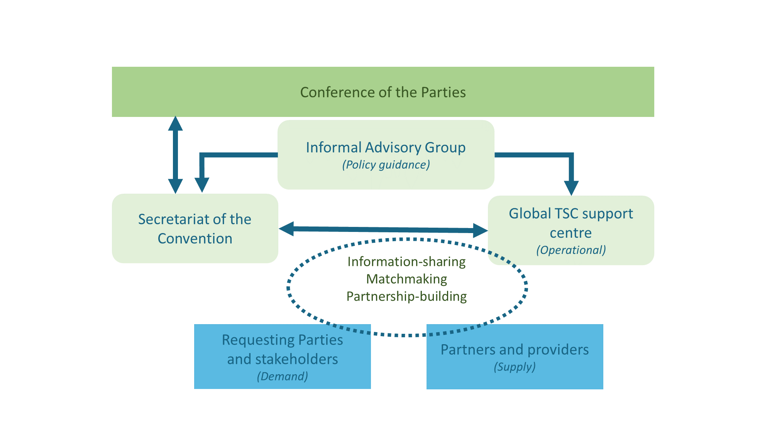

## *Option B: Regional and/or subregional technical and scientific cooperation support centres*

1. Under this option, technical and scientific cooperation and technology transfer would be promoted and facilitated through regional and/or subregional centres designated by the Conference of the Parties. The regional support centres would be hosted in existing partner institutions that possess relevant expertise and institutional capacity to provide technical assistance to countries in the region or subregion, upon request, as well as capacity to mobilize resources for technical scientific cooperation projects and programmes in their respective regions.[20]
2. Criteria for selecting the host institutions for the centres would be considered and approved by the Conference of the Parties at its fifteenth meeting. The Conference of the Parties may, for example, require that any organization or institution wishing to host such a centre should have:
   1. Demonstrated ability to provide technical advice and support to Parties in planning and implementing country-led projects and/or programmes;
   2. Broad experience in the areas of work undertaken by Parties in implementing the Convention on Biological Diversity and its protocols;
   3. Capacity to mobilize resources for technical scientific cooperation programmes;
   4. Appropriate policies, procedures and other institutional mechanisms and demonstrated ability in place to manage multiple complex projects and programmes;
   5. Active networks of collaborators, including institutions working at regional and subregional levels on biodiversity-relevant issues;
   6. Experience of working with other biodiversity-related conventions, intergovernmental processes, indigenous peoples and local communities, civil society and other stakeholders.
3. The regional support centres would carry out functions similar to those of the global centre as described above but would operate within their respective regions or subregions. Where necessary, they would coordinate with other centres to mobilize all the expertise required to fully support the implementation of the post-2020 global biodiversity framework and address priorities identified in their regions or subregions. They would also collaborate with and support any existing regional technology assessment platforms that engage a range of stakeholders in a participatory approach to horizon scanning, technology assessment, monitoring, capacity development, citizen science and other activities to support responsible research and innovation.
4. The centres would work under the strategic guidance of the Conference of the Parties and would take into consideration the relevant guidance and recommendations of the Informal Advisory Group on Technical and Scientific Cooperation. The centres would submit progress reports on their activities to the Conference of the Parties through the Secretariat of the Convention. A schematic illustration of the proposed regionally based institutional mechanism to promote and support technical and scientific cooperation, including the relationship between the above components, the Conference of the Parties and other stakeholders, is presented in figure 2 below.
5. The regional support centres would require dedicated resources for their operations. If this option is selected, the Conference of the Parties may wish to invite the financial mechanism of the Convention and other donors to provide the regional centres with funding to enable them to provide Parties with timely support so that they can access relevant technologies, expertise and other technical support required in order to implement the post-2020 global biodiversity framework effectively.

**Figure 2. Schematic illustration of the regional institutional mechanism to support technical and scientific cooperation (proposed option “B”)**

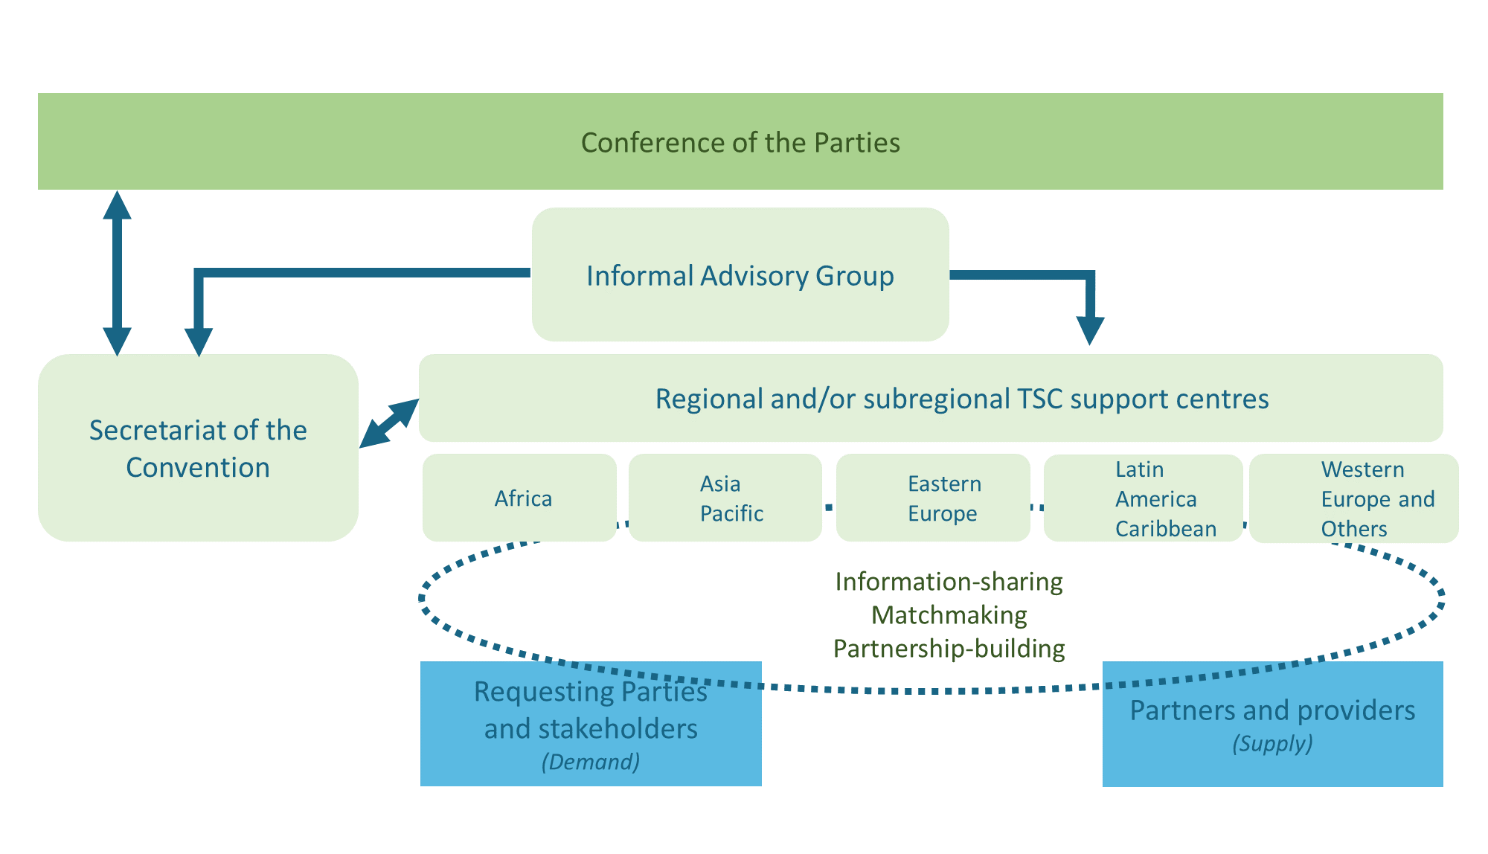

## *Option C: Technical and scientific cooperation support through Secretariat-coordinated programmes*

1. Under this option, technical and scientific cooperation and technology transfer would continue to be promoted and facilitated through programmes coordinated by the Secretariat of the Convention in collaboration with relevant partners and initiatives.[21] Each programme would implement targeted interventions. The Secretariat would submit progress reports to the Conference of the Parties, which would take into consideration the guidance of the Informal Advisory Group on Technical and Scientific Cooperation. The functions of the different programmes would vary on the basis of the priorities and requirements of Parties.
2. The Secretariat would also continue to promote and facilitate technical and scientific cooperation through partnership agreements and collaborative programmes with various partners and initiatives, including research and academic institutions, United Nations agencies, and international organizations and networks.[22]
3. To play the above roles more effectively in support of the post-2020 global biodiversity framework, the Secretariat would require adequate and predictable funding support. The Secretariat’s core budget would need to provide for dedicated staff positions for technical and scientific cooperation, as well as for core activities. At present, the functions related to technical and scientific cooperation are largely performed by project staff funded by the Republic of Korea through the Bio-Bridge Initiative. The current funding commitment for the Bio-Bridge Initiative is scheduled to end in 2020.

# Role of the Secretariat of the Convention

1. In line with Article 24 of the Convention, the Secretariat of the Convention will:
   1. Prepare or submit, as appropriate, relevant documents and reports on technical and scientific cooperation and technology transfer (Articles 16-18 of the Convention) for the Conference of Parties and its subsidiary bodies;
   2. Compile relevant information related to technical and scientific cooperation and technology transfer in the field of biological diversity and make it available through the clearing-house mechanism, in line with the knowledge management component of the post-2020 global biodiversity framework;
   3. Maintain active communication with Parties and stakeholders involved or interested in technical and scientific cooperation;
   4. Coordinate, as appropriate, with biodiversity-related conventions, relevant Parties’ agencies, the Consortium of Scientific Partners on Biodiversity, the Global Partnership for Business and Biodiversity, and other relevant networks and initiatives with technical and scientific expertise and/or involved in technical and scientific cooperation;
   5. Co-organize with partners biodiversity science forums, technology and innovation expos and other events on the margins of international meetings;
   6. Perform such other activities as may be necessary to carry out its functions.

# Monitoring and review

1. The present proposals will be reviewed periodically and, if necessary, updated to ensure their continued relevance and effectiveness in supporting the implementation of the post-2020 global biodiversity framework. A first review will be carried out in 2025 and an independent evaluation will be undertaken in 2030, together with the review of the long-term strategic framework for capacity development and the review of the post-2020 global biodiversity framework. The reviews will be based on the information provided by Parties in their national reports and on voluntary reports and case studies provided by non-government actors to the secretariats of biodiversity-related conventions and processes.
2. Indicators to monitor progress on technical and scientific cooperation and technology transfer, including the utilization of science, technology and innovation, will be included in the monitoring framework for the post-2020 global biodiversity framework. A complementary set of indicators and a methodology for measuring progress could be prepared with the support of experts and practitioners and made available for use, as appropriate, by government and non-government actors at the subnational, national and regional levels. The periodic review and update of the proposals will be informed by information generated from the monitoring process, which may be communicated through the Parties’ national reports and the voluntary reports by non-governmental actors.

__________

1. * CBD/SBI/3/1.
2. In the context of these proposals, technical and scientific cooperation refers to a process whereby two or more countries, indigenous peoples and local communities, and/or institutions pursue their individual or collective biodiversity-related goals through cooperative actions. This may include the creation and/or exchange of scientific knowledge, data, expertise, resources, technologies and technical know-how, where necessary through appropriate international, regional and subregional and/or national institutions. It may also include human resources development, institution building, joint training of personnel, exchange of experts, joint research programmes, joint ventures for the development and diffusion of technologies (including indigenous and traditional technologies), and transfer of technology and know-how.
3. These include decisions VII/29, VIII/12, IX/14, X/16, X/23, XI/13, XII/2 B, XIII/23, XIII/31 and 14/24 B.
4. See [CBD/SBSTTA/23/6](https://www.cbd.int/doc/c/e36d/fdb8/fa8e366fbbceabb670a14c2e/sbstta-23-06-en.pdf) and the scoping document ([CBD/COP/13/INF/22](https://www.cbd.int/doc/meetings/cop/cop-13/information/cop-13-inf-22-en.pdf)).
5. See [UNEP/CBD/WGRI/5/3/Add.1](https://www.cbd.int/doc/meetings/wgri/wgri-05/official/wgri-05-03-add1-en.pdf).
6. See [UNEP/CBD/COP/8/19/Add.2](https://www.cbd.int/doc/meetings/cop/cop-08/official/cop-08-19-add2-en.pdf).
7. See [UNEP/CBD/WG-RI/3/10](https://www.cbd.int/doc/meetings/wgri/wgri-03/official/wgri-03-10-en.pdf).
8. This is pursuant to Article 18, paragraph 2, of the Convention.
9. This is pursuant to Article 18, paragraph 4, of the Convention.
10. This is pursuant to Article 12 of the Convention.
11. For the purposes of the present document, “innovation” is described as a process that encompasses design, experimentation, application and scaling up of new ideas and solutions, resulting in transformative and more impactful change. Innovative solutions could cover scientific, technical, governance, finance or societal innovation.
12. This is pursuant to Article 17, paragraph 2, of the Convention.
13. These guiding principles are consistent with the normative and operational principles outlined in the framework of operational guidelines on United Nations support to South-South and triangular cooperation ([SSC/19/3](https://digitallibrary.un.org/record/826679?ln=en)).
14. Article 12, paragraphs (b) and (c), of the Convention requires Parties to promote and encourage research which contributes to the conservation and sustainable use of biological diversity, particularly in developing countries, inter alia, in accordance with decisions of the Conference of the Parties taken in consequence of recommendations of the Subsidiary Body on Scientific, Technical and Technological Advice, and, in keeping with the provisions of Articles 16, 18 and 20, promote and cooperate in the use of scientific advances in biological diversity research in developing methods for conservation and sustainable use of biological resources.
15. Including but not limited to specialized networks, academic and scientific institutions, the private sector, governmental and non-governmental organizations, indigenous peoples and local communities, bilateral and multilateral institutions, and funding institutions.
16. Including indigenous peoples and local communities, specialized networks, academic and scientific institutions, the private sector, governmental and non-governmental organizations, bilateral and multilateral institutions, and funding institutions.
17. Pursuant to decision 14/24 B of the Conference of the Parties.
18. See [CBD/SBI/3/8/Add.1](https://www.cbd.int/doc/c/2bb9/93c2/37bfbef3a4a5b8f146fa00e0/sbi-03-08-add1-en.pdf).
19. For details, see [UNEP/CBD/SBSTTA/19/INF/13](https://www.cbd.int/doc/meetings/sbstta/sbstta-19/information/sbstta-19-inf-13-en.pdf) and <https://www.ctc-n.org/>.
20. The regional and/or subregional centres could operate in a manner similar to such entities as the Stockholm Convention regional and subregional centres, which provide technical assistance and promote the transfer of technology to developing country Parties and Parties with economies in transition relating to the implementation of their obligations under the Stockholm Convention (see <http://chm.pops.int/Partners/RegionalCentres/Overview/tabid/425/Default.aspx>).
21. Such initiatives include the Bio-Bridge Initiative, the Forest Ecosystem Restoration Initiative, the Global Taxonomy Initiative, and the Sustainable Ocean Initiative.
22. These might include the Technology Facilitation Mechanism of the United Nations, the United Nations Committee on Science and Technology for Development, the High-level Panel of Experts to the Committee on World Food Security, the Climate Technology Centre and Network (for example on promoting ecosystem-based solutions to climate change), the International Barcode of Life (iBOL), the Global Biodiversity Information Facility (GBIF), the Consortium of International Agricultural Research Centers (CGIAR Centers), and the Group on Earth Observations Biodiversity Observation Network (GEO-BON). Others include the CBD Alliance, the International Panel of Experts on Sustainable Food Systems, La Via Campesina, the Global Alliance for the Future of Food, the Global Partnership for Plant Conservation, the Collaborative Partnership on Sustainable Wildlife Management, the Biodiversity Indicators Partnership, the Global Biological Resource Centre Network (GBRCN), the Global Invasive Alien Species Information Partnership, the Global Genome Biodiversity Network (GGBN), the Global Ocean Biodiversity Initiative, the Sustainable Ocean Initiative and the Consortium of Scientific Partners on Biodiversity. An overview of some of these and other relevant initiatives is provided in [UNEP/CBD/WGRI/5/3/Add.1](https://www.cbd.int/doc/meetings/wgri/wgri-05/official/wgri-05-03-add1-en.pdf) and [UNEP/CBD/WGRI/5/INF/2](https://www.cbd.int/doc/meetings/wgri/wgri-05/information/wgri-05-inf-02-en.pdf).