 |  | CBD/SBSTTA/28/INF/2/Rev.1

 | Distr.: General  25 June 2026  English/French only

Subsidiary Body on Scientific,
Technical and Technological Advice
Twenty-eighth meeting
Nairobi, 27 July–1 August 2026
Item 8 of the provisional agenda*
Marine and coastal biodiversity
Submissions for the description of ecologically or biologically significant marine areas and the modification of existing descriptions**
Note by the Secretariat

I. Introduction
- Pursuant to decision 16/16, the Executive Secretary issued notification No. 2025-034, dated 17 March 2025, inviting eligible proponents to submit to the Secretariat descriptions of new ecologically or biologically significant marine areas (EBSAs) and of modifications to descriptions of existing EBSAs, in line with the modalities contained in the annex to that decision.
- The Secretariat subsequently received and uploaded to its website 29 submissions containing descriptions of new areas and modifications to existing descriptions. They were open for comment from 1 November 2025 to 1 May 2026, and the comments that were received were posted in the information-sharing mechanism. All the submissions are proposed to be included in the EBSA repository and, therefore, before they can be included therein, they must be considered by the Subsidiary Body and the Conference of the Parties.
- In response to notification No. 2025-138, which invited comments on these submissions, and following a six-month comment period, during which comments on 24 of the 29 submissions were received from one organization (the Global Ocean Biodiversity Initiative), the proponents revised the descriptions in response to the comments.
- The present document contains the full versions (in the language in which they were submitted), of the revised 24 submissions, and the five original submissions, as referred to in document CBD/SBSTTA/28/7 and summarized in document CBD/SBSTTA/28/7/Add.1. Table 1 contains the name of each submission, together with the respective proponent and the type of submission.

Table 1
Submissions for the description of ecologically or biologically significant marine areas and the modification of existing descriptions provided in response to notification No. 2025-138
Name of area | Proponent | Type of submission
- Bentiaba | Angola | Description of a new area
- Chiloango Mangroves | Angola | Description of a new area
3. Longa Coastline | Angola | Description of a new area
4. Mussulo-Kwanza-Cabo Ledo Complex | Angola | Modification of an existing description
- Ombaca Canyon and Seamount Complex | Angola | Description of a new area
- Ponta Padrao Mangroves and Turtle Beaches | Angola | Description of a new area
- L_Embouchure de la Lagune Aby | Côte d'Ivoire | Description of a new area
- Cape Fria | Namibia | Description of a new area
- Namib Flyway | Namibia | Modification of an existing description
- Namibian Islands | Namibia | Modification of an existing description
- Walvis Ridge Namibia | Namibia | Description of a new area
- Namibe | Namibia, Angola | Modification of an existing description
- Orange Cone | Namibia, South Africa | Modification of an existing description
- Orange Seamount and Canyon Complex | Namibia, South Africa, | Modification of an existing description
- Agulhas Bank Nursery Area | South Africa | Modification of an existing description
- Algoa to Amathole | South Africa | Modification of an existing description
- Browns Bank | South Africa | Modification of an existing description
- Cape Canyon and Associated Islands Bays and Lagoon | South Africa | Modification of an existing description
- Childs Bank and Shelf Edge | South Africa | Modification of an existing description
- Kingklip Corals | South Africa | Modification of an existing description
- KwaZulu-Natal Bight and uThukela River | South Africa | Modification of an existing description
- Mallory Escarpment and Trough | South Africa | Modification of an existing description
- Namaqua Coastal Area | South Africa | Modification of an existing description
- Namaqua Fossil Forest | South Africa | Modification of an existing description
- Protea Banks and Sardine Route | South Africa | Modification of an existing description
- Protea Seamount Cluster | South Africa | Description of a new area
- Seas of Good Hope | South Africa | Description of a new area
- Shackleton Seamount Complex | South Africa | Modification of an existing description
- Tsitsikamma-Robberg | South Africa | Description of a new area

II. Submissions for the description of ecologically or biologically significant marine areas and the modification of existing descriptions

Angola

1. Bentiaba (description of a new area)
How was the submission developed?
The EBSA area description and revision process was part a broader project on ecosystem-based MSP in the BCLME, namely the Benguela Current Marine Spatial Management and Governance Project (MARISMA, 2014-2023). This was a regional capacity-building and development cooperation project implemented by the Benguela Current Commission, the Governments of Angola, Namibia and South Africa, and GIZ, the German Agency for Development Cooperation (Deutsche Gesellschaft für Internationale Zusammenarbeit.

The MARISMA project undertook a gap analysis of the EBSA network utilizing spatial data that was not available when the initial set of EBSA were described in South-Eastern Atlantic workshop, April 2013.

The overall approach to EBSA delineation, description and engagement followed these key steps:

Initial Systematic Conservation Planning (SCP) Analyses: A gap analysis was undertaken, and new areas identified using systematic conservation planning tools such as Marxan, based on biodiversity input data including ecosystem types, species distributions, and ecological processes.

National Workshops: The boundaries of potential new areas and refined EBSA boundaries were iteratively reviewed and adjusted through workshops held within each of the three countries (Angola, Namibia, South Africa). These workshops allowed country-specific input and tailoring of boundaries and descriptions to national contexts and priorities.

Regional Workshops and Bilateral Meetings between Countries: Workshops at the regional level especially focused on transboundary EBSAs shared between the countries, but also examined the overall approach to EBSAs, their delineation, description and the engagement approach. The aim was to harmonize boundaries, align management recommendations, and foster cooperation across national borders for effective regional marine biodiversity management. Additional specific bilateral meetings were held where necessary.

Technical and Scientific Peer Review: The descriptions of new areas and modifications of existing descriptions underwent technical review nationally and regionally (through technical review workshops involving relevant experts); and internationally with a further regional review workshop with participation of experts from the Global Ocean Biodiversity Initiative (GOBI) and members of the CBD's Informal Advisory Group on EBSAs; ensuring robustness of the exercise. The process is documented in peer reviewed literature (Harris et al., 2019, 2022).

Political Approval: The descriptions of new areas and modifications of existing descriptions were administratively and politically approved through all required stages up to the national ministerial level in each country and were then submitted to the CBD Secretariat by the National CBD Focal Points.

Data Sharing and Accessibility: All information, including descriptions of new areas and modifications of existing descriptions, boundaries, status assessments, management recommendations, and stakeholder feedback, were made available through online repositories such as the project's EBSA Portal (https://cmr.mandela.ac.za/Research-Projects/EBSA-Portal); and the descriptions of new areas and modifications of existing descriptions were also shared via the Benguela Current Convention's Geodata Portal (https://geodata.benguelacc.org/ ). This facilitated transparency, accessibility, and ongoing updating of data and products for biodiversity specialists and other stakeholders.

The delineation process used a combination of Systematic Conservation Planning and multi-criteria analysis methods. The key features used in the analysis were:
- Irreplaceable and near irreplaceable (i.e. very high selection frequency) sites, as well as primary and secondary focus areas identified in the SCP undertaken for the BCLME by Holness et al. (2014).
- Threatened Benthic and Coastal Ecosystems. The analysis focussed on the inclusion of the most threatened ecosystem types found in the area.
- Key physical features such as canyons and some small seamounts from the BCC spatial mapping project (Holness et al., 2014), GEBCO data, and global benthic geomorphology mapping (www.bluehabitats.org, Harris et al., 2014).
- Areas of high relative naturalness identified by Holness et al. (2014) were prioritized.
- Some additional manual editing of the boundaries of the area was undertaken to align with recognizable geographic features on the coast.

The multi-criteria analysis resulted a value surface. The cut-off values used to determine the extent of the area was based on expert input and quantitative analysis of effective inclusion of the above features. This entailed taking an iterative parameter calibration-based approach whereby the spatial efficiency of the inclusion of the targeted features was evaluated. The approach aimed to identify a cut-off which most efficiently included prioritised features while minimizing the inclusion of impacted areas. The final boundaries shown in the map were validated in an expert workshop.

Traditional knowledge was not incorporated into this process, and consultations with indigenous peoples or local communities were not undertaken. Therefore, documentation of Free, Prior and Informed Consent (FPIC) is not relevant for this EBSA process.

Where is the submission intended to be included?
[X] EBSA repository
[ ] EBSA information-sharing mechanism

Abstract:
Bentiaba includes 190 km of coastline, extends 50 km offshore northward and 300 km offshore southward and spans a total area of 35,631 km². The underlying geology comprises sandy, muddy and rocky substrates. In its southern portion, the continental shelf drops steeply to significant depths very near to the coast, which contributes to coastal upwelling and drives high productivity in the area. The area includes 24 different ecosystem types, ranging from intertidal to abyssal types, and includes seamounts and canyons. The diversity of species within the area is particularly high compared with the surrounding areas. The area is currently subjected to very few pressures, and thus most of it is in a highly natural condition. It is recognized as a priority area for marine biodiversity in the Benguela Current Large Marine Ecosystem.

Introduction:
A key characteristic of the oceanography on the Angolan continental shelf is the upwelling process that starts in May-June, reaches its peak in August-September and probably ends near the end of the year. This upwelling results in intense primary production that in turn influences the production and distribution of fish, thereby playing a critical ecological role for ecosystems in the area. It is known that fish species often adapt their reproductive strategies to ocean currents and productivity cycles, so spawning times and the distribution of the main Angolan species tend to coincide with the observed seasonal oceanographic patterns (Sætersdal et al., 1999).

The offshore ecosystems in the area have not been sufficiently surveyed to allow for a full understanding of their ecological and biological importance. However, it can be said that many seamounts support endemic species and poorly known biodiversity (Sink, 2004). The coastal ecosystems are better researched in Angola, with these ecosystems characterized by diverse communities. Invertebrate animal diversity is represented by Echinodermata, Ctenophora, Sipunculida, Polychaeta, Bryozoa, Brachiopoda, Tunicata and Pycnogonida groups. The Crustaceans and Molluscs, which are of commercial importance, also constitute very important groups in the area (Migoto and Marques, 2003 In: Silva, 2015). Vertebrate communities are similarly diverse, with turtles, marine and coastal birds, seals, dolphins and whales (e.g., the humpback whale (Megaptera novaeangliae) and the Blue whale (Balaenoptera musculus)) all being of great importance. The small pelagic fish found in Angolan waters are made up of sardinellas (Sardinella aurita and Sardinella madeirensis) and mackerel (Cunene Horse Mackerel and Cape Horse Mackerel), with the latter being the major fisheries resource species in the area. Other important pelagic species include the Engraulis encrasicolus and the Sardinops ocellata (Silva, 2015) that originate from the temperate waters of Namibia, limited in the north by the Baía dos Tigres Bank (Bianchi 1986 In: Silva 2015). The yellowfin tuna (Thunnus albacares) and the bigeye tuna (Thunnus obesus) are the most important species of large pelagic fish.

In the area specifically, there are 24 ecosystem types. Although the area has not been well sampled, it is presumed to be diverse based on the different types of communities associated with those 24 habitats. The shore types include boulder and rocky shores, mixed and sandy shores, with islands shelf, seamount, slope and abyss types represented offshore. Because this site comprises a collection of features and ecosystems that are connected by the same ecological processes, it can be considered a Type 2 EBSA (sensu Johnson et al. 2018).

Location:
The area is located along the Bentiaba coast of Angola, south of Lucira, in Namibe Province, and lies entirely within the exclusive economic zone of Angola.
The coordinates of a minimum bounding box covering the entire scope of the area are:
- Latitude: -14.032, -12.931, -14.779, -15.88
- Longitude: 9.479, 12.426, 13.116, 10.169

Feature description:
The morphology of the seabed in this area suggests that the underlying geology comprises sandy, muddy and rocky substrates. (ARC, 2013). The area spans the section of the Namibe coast where the continental shelf is very narrow because it drops steeply, reaching deep depths very near to the shore. Beyond the 200 m isobath, the continental shelf slopes down to a -3000-m deep abyss with a very smooth and regular gradient. Based on available information for northern Angola, deep-water sediments seem to be dominated by silts and clays with a very high organic carbon content. There are many offshore geomorphic features in this area that are not described in the maritime charts, but that were mapped for the BCLME (Holness et al., 2014), including canyons and seamounts, around which the area is delineated. Even though the area is in an “L shape”, the features in both of these “arms” are similar.

Ocean currents and circulation patterns in the region include a complex set of flows that are linked to a larger system of currents in the tropical east Atlantic. The dominant circulation patterns of the Angolan central and southern continental shelf are driven by the warm Angola Current that moves southwards, and where this current meets the cold Benguela Current at the Angola-Benguela Front (Moroshkin et al., 1970; Meeuwis and Lutjeharms, 1990; Shannon and O'Toole, 1998; and Lass et al., 2000). The Angola Current is fast and stable and penetrates up to depths of 250-300 m, covering both the continental shelf and slope. The typical current speed is 50 cm.s⁻¹ but it can reach or even exceed speeds of 70 cm.s⁻¹ (Moroshkin et al., 1970). The origin of this current, at least on the surface, is the southeastern arm of the South Equatorial Counter-Current.

The Angola-Benguela Front forms where the warm Angola Current, moving south, meets with the cold Benguela Current, moving north. This phenomenon occurs typically in the south of the Bay of Lobito at 14°S – 16°S and is a semi-permanent oceanographic feature. The gradients of temperatures at the surface reach 4°C.°latitude⁻¹, but on average are 1.5°C.°latitude⁻¹. This Front varies by season, reaching maximum levels in the summer when it is wider and is located further south, compared to winter when the front retracts towards the north and has a lower temperature gradient. These variations are related to the seasonality of the Angola Current (Meeuw and Lutjeharms, 1990). Episodic inflows of warm, saline water towards the south may displace the Angola-Benguela Front up to 23°S (Shannon et al, 1986), with effects associated with the general level of biological productivity in the north of the system. Shannon et al (1986) classified these events as ‘Niños de Benguela’ because they are comparable to the ‘El Niño’ of the tropical east Pacific Ocean. However, a northward shift of the Angola-Benguela Front has never been observed on this same scale.

The thermoclines are well developed on the Angolan continental shelf, with depths above 10 - 20m of mixed strata (Van Bennekom & Berger, 1984). Temperature gradients may reach 0.32 °C.m⁻¹ at depths of 25 - 50m, with corresponding firm salinity gradients (Lass et al. 2000). The thermoclines are interrupted by the coastal upwelling along the entire Angolan coast. This coastal upwelling is the most significant oceanographic characteristic of the region and starts in May-June, reaches its peak in August-September and probably ends near the end of the year. Upwelling results from interactions between the main currents of the region and generates areas of divergence both in the continental margin and along the equator. The intensity of these processes depends on season and latitude (ARC, 2013). This is largely due to seasonality in the Benguela Current that flows towards the north, bringing cold water to the Angola-Benguela Front region, and the coastal upwelling driven by the southerly winds that are characteristic of the region (Hardman-Mountford et al 2003).

Upwelling plays a crucial ecological role as it results in a substantial increase in primary production that is of great importance for supporting fish stocks and influencing their distribution. It is known that fish species often adapt their reproductive strategies to ocean currents and productivity cycles, so spawning times and the distribution of the main Angolan species tend to coincide with the observed seasonal oceanographic patterns (Sætersdal et al., 1999). Phytoplankton production rates in the area near the Angola-Benguela Front (>400 gC.m⁻².yr⁻¹) are higher compared to that in northern Angolan (<250 gC.m⁻².yr⁻¹) but much lower than the estimated production rate of >1 000 gC.m⁻².yr⁻¹ further South in the Benguela Current system (ARC, 2013).

The zooplankton consists of crustaceans and other animals that feed on phytoplankton and protists such as Telonemia, and also includes some eggs and larvae of bigger animals. The zooplankton of the region is not well known. However, data from the Angola-Benguela Front show that the species in the Front and immediately north of it (i.e., in the southern Angola Current) are similar to those species in the northern Benguela Current, which are dominated by calanoid copepods (Calanoides and Calanus spp.) (ARC, 2013).

Distributions of ichthyoplankton (fish eggs and larvae) are also poorly known in Angolan waters. However, eggs of the South American pilchard Sardinops sagax and larvae of the Round Sardinella (Sardinella aurita), European Anchovy (Engraulis encrasicolus), Cape horse mackerel (Trachurus Trachurus capensis) and hake (Merluccius sp.) as well as some other mesopelagic species have been recorded within the southern portion of the Angola–Benguela Front.

In general, the benthic fauna of tropical West Africa is relatively low in diversity in comparison with other tropical regions, showing levels of benthic diversity similar to that in the Mediterranean. This low diversity has been attributed to a lack of coral reefs and seagrass meadows along the West African coast; the lack of hard benthic substrates; localised upwelling of colder water in some sites; and the high turbidity from estuarine plumes (ARC, 2013). Nevertheless, invertebrate animal diversity is represented by Echinodermata, Ctenophora, Sipunculida, Polychaeta, Bryozoa, Brachiopoda, Tunicata and Pycnogonida groups. The Crustaceans and Molluscs, which are of commercial importance, also constitute very important groups in the area (Migoto and Marques, 2003 In: Silva, 2015). Furthermore, even though these systems are yet to be sampled, seamounts are known to support diverse assemblages, and are habitat for species that are fragile, sensitive, vulnerable and slow growing, e.g., habitat-forming corals and sponges.

Whales and dolphins are commonly seen along the Angolan coast with 11 species of dolphins and 14 species of whales confirmed in the wider south-west Africa (ARC, 2011). Among these, three Balaeonoptera whale species are classified as Endangered (IUCN, 2011), namely: the Sei whale (B. borealis), Blue whale (B. musculus), and Fin whale (B. physalus). Among the dolphins, only the Atlantic humpback dolphin (Sousa teuszii) is Critically Endangered (but this species was not observed in the study area by Weir, 2010).

The other main species of marine mammals that may be found in the study area include the pinnipeds, such as the Cape Fur Seal (Arctocephalus pusillus). A. pusillus are much more commonly found in high seas in the South of Angola, where there is a big colony in Baía dos Tigres, near the southern boundary with Namibia (Morais et al., 2006).

Importantly, the collection of 24 diverse habitats, and thus presumably communities, in such close proximity resulted in this area being selected in a systematic conservation plan for the region that sought to identify areas of ecological priority (Holness et al., 2014). Most ecosystem types in the area have been assessed as “Least Threatened” but there is one Endangered ecosystem type (viz. Namibe Exposed Rocky Shore) (Holness et al., 2014; Table below). The combination of upwelling, seamount and canyon features all contribute to the increased productivity of this area. Although the area spans a broad depth range, there are species in this area that similarly have a broad depth range, e.g., the Sipunculid, Onchnesoma steenstrupi found from the subtidal shallow (<10m) to deep sea (1500m; ARC, 2013). Notwithstanding, biodiversity information is very limited for this site, and future research and surveys are highly recommended.
Summary of types of habitats and status of threats for Bentiaba. (Holness et al. (2014)).
Threat Status | Ecosystem Type | Area (km2) | Area (%)
Endangered | Namibe Exposed Rocky Shore | 2 9 | 0
Least Threatened | Benguela Boulder Beach Rocky Shore | 0 0 | 0
 | Benguela Estuarine Shore | 0 0 | 0
 | Benguela Exposed Rocky Shore | 0 6 | 0
 | Benguela Inshore | 18 6 | 0
 | Benguela Intermediate Sandy Beach | 0 3 | 0
 | Benguela Island | 180 3 | 1
 | Benguela Mixed Shore | 0 5 | 0
 | Benguela Reflective Sandy Beach | 1 3 | 0
 | Benguela Sheltered Rocky Shore | 31 6 | 0
 | Cunene Abyss | 6 821 1 | 19
 | Namibe Boulder Beach Rocky Shore | 0 2 | 0
 | Namibe Dissipative-Intermediate Sandy Beach | 0 6 | 0
 | Namibe Estuarine Shore | 5 0 | 0
 | Namibe Inshore | 145 2 | 0
 | Namibe Intermediate Sandy Beach | 14 3 | 0
 | Namibe Lower Slope | 19 409 9 | 54
 | Namibe Mixed Shore | 23 6 | 0
 | Namibe Reflective Sandy Beach | 15 4 | 0
 | Namibe Seamount | 2 119 9 | 6
 | Namibe Shelf | 1 233 5 | 3
 | Namibe Shelf Edge | 1 079 3 | 3
 | Namibe Sheltered Rocky Shore | 32 9 | 0
 | Namibe Upper Slope | 4 494 1 | 13
Grand Total |  | 35 631 2 | 100
Feature condition and future outlook:
Bentiaba has many features and ecosystem types that need to be protected for the area to maintain the characteristics that meet the EBSA criteria. There are 24 ecosystem types represented, one of which is an Endangered rocky shore ecosystem type; the other 23 ecosystem types are Least Concern (Holness et al., 2014). The area is currently subjected to very few pressures, and thus most of the site is in a highly natural condition. An assessment of ecological condition based on cumulative pressures within the area showed that 85 % of the benthic area is in good ecological condition, and 14 % is in fair ecological condition; 60% of the pelagic area is in Good condition and 39 % is in Fair condition (Holness et al., 2014). This suggests that most of the area is highly natural. Most ecosystem types are Not Protected, four are Poorly Protected and only one is Moderately Protected.

Assessment of the area against CBD EBSA Criteria:
CBD EBSA Criteria  (Annex I to decision IX/20) | Description  (Annex I to decision IX/20) | Ranking of criterion relevance  (please mark one column with an X)
CBD EBSA Criteria  (Annex I to decision IX/20) | Description  (Annex I to decision IX/20) | No information |  | Low |  |  | Medium |  | High
Uniqueness or rarity | Area contains either (i) unique (“the only one of its kind”), rare (occurs only in few locations) or endemic species, populations or communities, and/or (ii) unique, rare or distinct, habitats or ecosystems; and/or (iii) unique or unusual geomorphological or oceanographic features. |  |  |  |  |  |  |  | X
Regional delineation of seamounts and canyons in the Benguela Current Large Marine Ecosystem revealed that these are rare features that likely also support rare and/or unique biological communities. The canyons and seamounts in this particular area are especially rare in the region given their close proximity to the coast, whereas most other features like these are located much further offshore (Holness et al., 2014).
Special importance for life-history stages of species | Areas that are required for a population to survive and thrive. |  |  |  |  |  | X
Seamounts are known to be associated with relatively high productivity from upwelling, and that they consequently serve as foraging and aggregation areas for many top predators, and other threatened vertebrates, such as turtles. They may also provide important “stepping stones” that allow species to expand their ranges.
The benthic ecosystem types support dead organic matter originating from the ocean surface and is a habitat for some species of shrimp, crabs and lobsters. Available data suggests that benthic organisms are abundant with a uniform distribution in regions shallower than -400 m, but are rare and irregularly distributed in deeper waters. A common species is the Sipunculid, Onchnesoma steenstrupi. This species is found largely distributed in water depths ranging from subtidal shallow (<10m) to deep sea (1500m) and occurs in the Northeast Atlantic, Mediterranean Sea, and Gulf of Florida and has also been seen at depths of 1200m along the coast of Nigeria (ARC, 2013).
Importance for threatened, endangered or declining species and/or habitats | Area containing habitat for the survival and recovery of endangered, threatened, declining species or area with significant assemblages of such species. |  |  |  | X
Of the 24 ecosystem types in the area, only one is threatened: the Endangered Namibe Exposed Rocky Shore. The species diversity is not well known for the area. Although the site is likely to provide habitat that supports threatened species, e.g., turtles, cetaceans, birds and some fish (e.g., Vulnerable Sardinella maderensis), this criterion is conservatively ranked Low until more information is available.
Vulnerability, fragility, sensitivity, or slow recovery | Areas that contain a relatively high proportion of sensitive habitats, biotopes or species that are functionally fragile (highly susceptible to degradation or depletion by human activity or by natural events) or with slow recovery. |  |  |  |  |  | X
The biological communities in Bentiaba have not been comprehensively sampled. However, it is well established that seamounts serve as an important habitat for fragile species that are sensitive to disturbance and take long to recover, including corals and sponges. Conservatively, therefore, this area is ranked as Medium, but may very well be High.
Biological productivity | Area containing species, populations or communities with comparatively higher natural biological productivity. |  |  |  |  |  |  |  | X
Seasonal upwelling plays a crucial ecological role in the area as it results in a substantial increase in primary production that is of great importance for supporting fish stocks and influencing their distribution. Phytoplankton production rates in the area near the Angola-Benguela Front (>400 gC.m⁻².yr⁻¹) are higher compared to that in northern Angola (<250 gC.m⁻².yr⁻¹) but much lower than the estimated production rate of >1 000 gC.m⁻².yr⁻¹ further South in the Benguela Current system (ARC, 2013).
Biological diversity | Area contains comparatively higher diversity of ecosystems, habitats, communities, or species, or has higher genetic diversity. |  |  |  |  |  |  |  | X
The area comprises a particularly diverse collection of 24 habitats that range from intertidal to abyssal types (Holness et al., 2014). In turn, these are expected to support a rich diversity of species within this discrete geographic area, with known representation of numerous invertebrate phyla, as well as vertebrates such as whales, dolphins, seals, birds, turtles, and diverse assemblages of commercially important fish species including both large and small pelagics.
Naturalness | Area with a comparatively higher degree of naturalness as a result of the lack of or low level of human-induced disturbance or degradation. |  |  |  |  |  |  |  |  | X
An assessment of ecological condition based on cumulative pressures within the area showed that 85 % of the benthic area is in good ecological condition, and 14 % is in fair ecological condition; 60% of the pelagic area is in Good condition and 39 % is in Fair condition (Holness et al., 2014). This suggests that most of the area is highly natural.

References:
Angola Resources Consultants (ARC) (2013). Estudo de Impacte Ambiental do Levantamento Sísmico 3D no Offshore da Bacia do Namibe (Blocos 11-13, 27-30 e 42-45). Relatório preparado para WesternGeco. Relatório Nº. LA713G0812. Fevereiro 2013.
Branch, B. (1998). Field guide to snakes and other reptiles of Southern Africa. Third edition. STRUIK. Cape Town., RSA. 399p.
Hardman-Mountford NJ, AJ Richardson, JJ Agenbag, E Hagen, L Nykjaer, FA Shillington, and C Villacastin 2003. Ocean climate of the South East Atlantic observed from satellite data and wind models. Progress in Oceanography 59 (2003): 181–221.
Holness, S., Kirkman, S., Samaai, T., Wolf, T., Sink, K., Majiedt, P., Nsiangango, S., Kainge, P., Kilongo, K., Kathena, J., Harris, L., Lagabrielle, E., Kirchner, C., Chalmers, R., Lombard, M. 2014. Spatial Biodiversity Assessment and Spatial Management, including Marine Protected Areas. Final report for the Benguela Current Commission project BEH 09-01.
Johnson, D.E., Barrio Froján, C., Turner, P.J., Weaver, P., Gunn, V., Dunn, D.C., Halpin, P., Bax, N.J., Dunstan, P.K., 2018. Reviewing the EBSA process: Improving on success. Marine Policy 88, 75-85.
Lass HU, M Schmidt, V Morholz, and G Nausch 2000. Hydrographic and current measurements in the area of the Angola-Benguela Front. J. Phys. Oceanogr., 30: 2589-2609.
Meeuwis JM and JRE Lutjeharms, 1990. Surface thermal characteristics of the Angola-Benguela front. S. Afr. J. Mar. Sci., 9: 261-279.
Migoto, A. E. & Marques, A. C. (2003). Avaliação do estado do conhecimento da diversidade biológica do Brasil. Invertebrados marinhos. Ministério do Meio Ambiente.
Morais, M., Torres, M., Martins, M. (2005). Análise da Biodiversidade Marinha e Costeira, e Identificação das Pressões de Origem Humana sobre os Ecossistemas Marinhos e Costeiros. Estudo Temático n.º2. Projecto 00011125, Estratégia e Plano de Acção Nacionais para a Biodiversidade (NBSAP). Ministério do Urbanismo e Ambiente, Junho de 2005.
Moroshkin KV, VA Bunov and RP Bulatov 1970. Water circulation in the eastern South Atlantic Ocean. Oceanology, 10: 27-34.
Sætersdal, G., Bianchi, G., Strømme, T., Venema, S.C., 1999. The DR. FRIDTJOF NANSEN Programme 1975–1993. Investigations of fishery resources in developing countries. History of the programme and review of results. FAO Fisheries Technical Paper. No. T391. Rome, FAO. 434p.
Shannon LV, AJ Boyd, GB Brundrit and J Taunton-Clark 1986. On the existence of an El Nino-type phenomenon in the Benguela system. J. Mar. Res., 44(3): 495-520.
Shannon LV and M O'Toole 1998. Integrated overview of the oceanography and environmental variability of the Benguela Current region. Synthesis and Assessment of information on BCLME. Thematic Report 2. UNDP/GEF (RAF/96/G43). 58pp.
Silva, J.M. (2015). Zona Costeira de Angola. VII Congresso sobre Planeamento e Gestão das Zonas Costeiras dos Países de Expressão Portuguesa. Participação Ativa nas Zonas Costeiras Aveiro, 14 a 16 de Outubro de 2015.
Sink, K. 2004. Appendix 2: Threats affecting marine biodiversity in South Africa. In: Lombard and Strauss. 2004. National Spatial Biodiversity Assessment. Marine Component (Republic of South Africa). National Botanical Institute, RSA.
Van Bennekom, A.J. and Berger, G.W. 1984. Hydrography and silica budget of the Angola Basin. Neth. J. Sea Res., 17(2-4): 149-200.

Maps and Figures:
GIS data available at: https://cmr.mandela.ac.za/cmr/media/Store/documents/EBSA/Descriptions/Angola/Angola_EBSAs_2020-SHP.zip
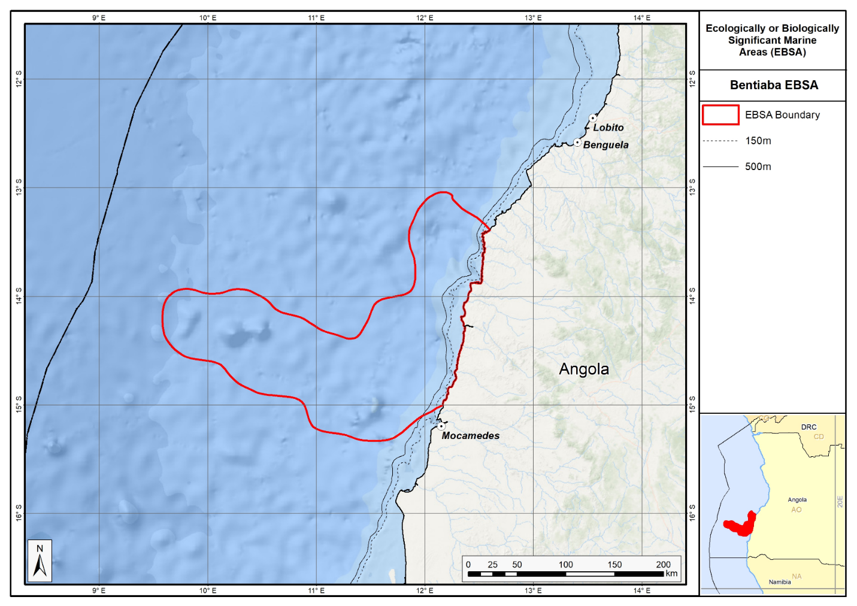
Map of the Bentiaba area.

Rights and permissions:
No limits on sharing or publication.

2. Chiloango Mangroves (description of a new area)

How was the submission developed?
The process to identify potential new areas meeting EBSA criteria and to modify existing descriptions of EBSAs was part a broader project on ecosystem-based MSP in the BCLME, namely the Benguela Current Marine Spatial Management and Governance Project (MARISMA, 2014-2023). This was a regional capacity-building and development cooperation project implemented by the Benguela Current Commission, the Governments of Angola, Namibia and South Africa, and GIZ, the German Agency for Development Cooperation (Deutsche Gesellschaft für Internationale Zusammenarbeit.

The MARISMA project undertook a gap analysis of the existing EBSA network utilizing spatial data that was not available when the initial set of EBSA were described in South-Eastern Atlantic workshop, April 2013.

The overall approach to EBSA identification, delineation, description and engagement followed these key steps:

Initial Systematic Conservation Planning (SCP) Analyses: A gap analysis was undertaken, and new areas identified using systematic conservation planning tools such as Marxan, based on biodiversity input data including ecosystem types, species distributions, and ecological processes.

National Workshops: The boundaries of potential new areas and modified boundaries of existing areas were iteratively reviewed and adjusted through workshops held within each of the three countries (Angola, Namibia, South Africa). These workshops allowed country-specific input and tailoring of boundaries and descriptions to national contexts and priorities.

Regional Workshops and Bilateral Meetings between Countries: Workshops at the regional level especially focused on transboundary EBSAs shared between the countries, but also examined the overall approach to EBSAs, their delineation, description and the engagement approach. The aim was to harmonize boundaries, align management recommendations, and foster cooperation across national borders for effective regional marine biodiversity management. Additional specific bilateral meetings were held where necessary.

Technical and Scientific Peer Review: The areas and modified descriptions of existing EBSAs underwent technical review nationally and regionally (through technical review workshops involving relevant experts); and internationally with a further regional review workshop with participation of experts from the Global Ocean Biodiversity Initiative (GOBI) and members of the CBD's Informal Advisory Group on EBSAs; ensuring robustness of the exercise. The process is documented in peer reviewed literature (Harris et al., 2019, 2022).

Political Approval: The submissions were administratively and politically approved through all required stages up to the national ministerial level in each country and were then submitted to the CBD Secretariat by the National CBD Focal Points.

Data Sharing and Accessibility: All information, including boundaries, status assessments, management recommendations, and stakeholder feedback, were made available through online repositories such as the project's EBSA Portal (https://cmr.mandela.ac.za/Research-Projects/EBSA-Portal); and the submissions were also shared via the Benguela Current Convention's Geodata Portal (https://geodata.benguelacc.org/ ). This facilitated transparency, accessibility, and ongoing updating of data and products for biodiversity specialists and other stakeholders.

The delineation process used a combination of Systematic Conservation Planning and multi-criteria analysis methods. The key features used in the analysis were:
- Irreplaceable and near irreplaceable (i.e. very high selection frequency) sites, as well as primary and secondary focus areas identified in the SCP undertaken for the BCLME by Holness et al. (2014).
- Threatened and sensitive Benthic and Coastal Ecosystems. The analysis focussed on the inclusion of the most threatened and sensitive ecosystem types found in the area, especially the mangrove ecosystems.
- Areas of high relative naturalness identified by Holness et al. (2014) were prioritized.
- Some additional manual editing of the boundaries of the area was undertaken to align with recognizable geographic features on the coast.

The multi-criteria analysis resulted a value surface. The cut-off value used to determine the extent of the area was based on expert input and quantitative analysis of effective inclusion of the above features. This entailed taking an iterative parameter calibration-based approach whereby the spatial efficiency of the inclusion of the targeted features was evaluated. Significant manual refinement of the boundaries was then undertaken based on aerial imagery. The final boundaries shown in the map were validated in an expert workshop.

Traditional knowledge was not incorporated into this process, and consultations with indigenous peoples or local communities were not undertaken. Therefore, documentation of Free, Prior and Informed Consent (FPIC) is not relevant for this EBSA process.

Where is the submission intended to be included?
[X] EBSA repository
[ ] EBSA information-sharing mechanism

Abstract:
Mangroves and riverine forest are major features of the area and have a significance that is greater locally than it is globally. Three of the four habitats in the area are threatened. The area includes around 130 ha of wetland, encompassing small lagoons surrounded by endangered mangroves. Most importantly, the area supports many species that have slow growth and reproduction rates, in particular globally threatened species, such as olive ridley and leatherback turtles, which nest in the area, and manatees, which are resident in the area. The latter have been hunted throughout their range and appear, despite limited quantitative data, to have been extirpated in many places. In addition, anthropogenic pressure on mangroves is evident in the area, where there are signs of advanced habitat degradation and destruction.

Introduction:
There are two estuaries in Cabinda: the Cabinda and Chiloango Estuaries in the north and south of the provice, respectively. At the boundary with the Republic of the Congo in the north, the Cabinda River reaches the sea through the Massabi Lagoon. The area, however, lies at the mouth of the Chiloango River in the south, which flows into the sea through the estuary (Giresse and Kouyoumontzakis, 1985). The river is approximately 168 km long, originating from springs in the Democratic Republic of Congo (DRC), and in some places forms the boundary that separates DRC from the province of Cabinda in Angola (Sonangol, 2012). It is a coastal area that is a discrete site centred around the mangroves and its associated threatened species, and is thus a Type 1 EBSA (sensu Johnson et al. 2018).

The Chiloango Estuary area comprises four biotypes: marine, estuarine, riverine forest, and wetland areas. There are approximately 130 hectares of wetland areas encompassing small lagoons, surrounded by Endangered mangroves. The mangroves and riverine forest associated with the river were fundamental in choosing this area; although not globally significant, these mangroves are of key local significance. Consequently, the reason this area was not included in the original set of EBSAs at the South Eastern Atlantic Workshop in 2013 (UNEP/CBD/RW/EBSA/SEA/1/4) is because this local knowledge was not available at that meeting and is better than the information included in international datasets (e.g., WCMC and the World Mangrove Atlas).

In the area, the mangroves and riverine forest are bounded by a sandy beach, surrounded by the estuary, and extend to the river and margins of the lagoon. The mangroves cover the alluvial areas of the Chiloango River mouth, corresponding to sites subjected to temporary flooding resulting from changing tides, and are populated by Rhizophora mangle (Diniz, 2006). Mangrove forest is scattered along the Angolan coastline and forms a transition ecosystem between land and sea of enormous biological and ecological importance, providing shelter and nurseries for crustaceans and fish that are of economic and tourism importance to the country (EPANB, 2006). The area supports a rich diversity of avifauna, herpetofauna and ichthyofauna (MINAMB et al., 2015). Most importantly, it provides critical habitat for threatened species, such as African manatees that are threatened throughout their range and showing signs of local extirpations (Keith Diagne, 2015), and olive ridley and leatherback turtles that nest on the adjacent beaches.

Location:
The area is in the northern half of Cabinda Province, Angola, and includes the Chiloango estuary and 6 km of rocky, sandy and mixed shores adjacent to the mouth. The furthest extent inland is approximately 1.2 km from the coastline. The whole of the area lies entirely within the exclusive economic zone of Angola.
The coordinates of a minimum bounding box covering the entire scope of the area are:
- Latitude: -5.139, -5.23, -5.253, -5.161
- Longitude: 12.167, 12.195, 12.123, 12.095

Feature description:
The Chiloango River mouth is dominated by muds from the river. Fresh-water flow out of the Chiloango River also forms a plume of low-salinity water in the adjacent coastal area that, in turn, affects the nearshore coastal processes. These features, as well as the local extent of the turtle nesting beaches, contributed to defining the alongshore extent of the area. Because this is coastal, it is described primarily for its benthic features, although the overlying water column in the estuary, surf and inner shelf is very tightly coupled to the key features and species of this site.

The mangrove forests of the region include species such as Rhizophora (R. mangle, R. racemosa and R. harrisonii), which tolerate high levels of salinity. The mangroves cover the whole Chiloango riverbed up to the high tide mark and extend up to the wetland area associated with the river. The Chiloango River is the southern hydrographic basin included in the Lower Guinea ichthyofaunal province, which is one of the 10 ichthyofaunal provinces as defined by Roberts (cited in Darwall et al., 2011). The Lower Guinea ichthyofaunal province extends from the Chiloango River to the Cross River in the north, and shares a boundary with the Congo River basin to the east. This region contains a rich diversity of species, and more than half of the freshwater or marine fish species seen here are endemic to the region. This region also has relatively high numbers of freshwater fish species that are threatened and have limited geographic ranges (Darwall et al., 2011). Further, a species of fresh water crab belonging to the tropical African endemic family, Potamonautidae, is found in the rivers of Cabinda (Darwall et al., 2011). Although biodiversity data are largely limited for Angola, this region is known to have the highest diversity of dragonflies and damselflies (Odonata) within the whole of Africa.

In terms of birds, it is important to mention the rich diversity that includes resident, visiting and seasonal migratory birds that feed and rest here. Among these, it is worth mentioning the presence of cattle egrets, white chest crows, spotted kingfishers, white chested mouse birds and black bishops, among others. In terms of the most relevant reptiles, olive ridley and leatherback turtles can be observed nesting in the region. The beaches here thus provide critical habitat to support important life-history stages of these two threatened species. Marine mammals are also found along the coastline, such as the common whale, humpback whale, common dolphin and spotted dolphin (ACEPA, 2012). The West African Manatee (Trichechus senegalensis) is another threatened marine mammal that is important in the areas, and is classified by the IUCN as Vulnerable largely due to species declines due to hunting and habitat loss (Powell & Kouadio, 2008; Keith Diagne, 2015). Historically, its presence has been recorded in the Chiloango River, but the current distribution is unknown (MINUA, 2006; Morais, 2006), and local extirpations of this species are known across its distribution (Keith Diagne, 2015). The area contains 4 ecosystem types, with two ecosystem types in the area have been assessed as “Endangered” (viz. Cabinda Reflective Sandy Beach and Cabinda Sheltered Rocky Shore) and one as “Vulnerable” (Cabinda Mixed Shore) (Holness et al., 2014; Table below).

Summary of types of habitats and status of threats for the Chiloango Mangroves. Data from Holness et al. (2014).
Threat Status | Ecosystem Type | Area (km2) | Area (%)
Endangered | Cabinda Reflective Sandy Beach | 4.7 | 28
 | Cabinda Sheltered Rocky Shore | 0.3 | 2
Vulnerable | Cabinda Mixed Shore | 4.7 | 27
Least Threatened | Cabinda Estuarine Shore | 7.4 | 43
Grand Total |  | 17.1 | 100

Feature condition and future outlook:
Across the system, the ecological condition of the mangrove varies a lot, i.e., from pristine areas to fully deforested areas. Current anthropogenic pressure is visible and worrying, with signs of advanced habitat degradation and destruction in some places (MINAMB et al, 2015). It is thus important that the Chiloango Mangroves are protected to prevent the extinction or extirpation of fauna and flora that contribute to the region’s ecological integrity, especially the iconic and threatened manatee and turtle species. An assessment of ecological condition based on cumulative pressures indicates that 83 % of the area is in Fair condition and the remainder in Good condition, suggesting some degradation, but that the bulk of biodiversity and ecological processes are still intact. This means that recognition of the area as an EBSA and implementing appropriate conservation and management measures in this area will contribute to protecting the existing biodiversity.

Assessment of the area against CBD EBSA Criteria:
CBD EBSA Criteria  (Annex I to decision IX/20) | Description  (Annex I to decision IX/20) | Ranking of criterion relevance  (please mark one column with an X)
CBD EBSA Criteria  (Annex I to decision IX/20) | Description  (Annex I to decision IX/20) | No information |  | Low |  |  | Medium |  | High
Uniqueness or rarity | Area contains either (i) unique (“the only one of its kind”), rare (occurs only in few locations) or endemic species, populations or communities, and/or (ii) unique, rare or distinct, habitats or ecosystems; and/or (iii) unique or unusual geomorphological or oceanographic features. |  |  |  |  |  | X
Systems comprising the complex of river, estuary, shore, mangrove and forest are relatively rare in the area, and this particular site comprises the second largest mangrove forest in the country. Further, more than half of the freshwater or marine fish species seen here are endemic to the region. It is also a biodiversity hotspot for dragonflies and damselflies: it has the highest diversity of these insects in all of Africa.
This system has unique ecological characteristics as it associates different aquatic ecosystems. The estuary has riverine (Chiloango River), brackish (estuary), marine (Atlantic Ocean) and wetland areas (the Usanka Lagoon, as the largest wetland area). The interaction of different areas/ components of this system and its abiotic conditions allowed for the establishment of different fauna and flora species. This location has already been described as a coast sensitive location (MINAMB, 2015).
Special importance for life-history stages of species | Areas that are required for a population to survive and thrive. |  |  |  |  |  |  |  | X
The area is important for as a foraging and resting site for multiple bird species, and as nesting grounds for olive ridley and leatherback turtles. The mangroves also provide key habitat as nursery areas for fish and crustaceans in the estuary.
The migratory birds use the area for resting. Furthermore, the olive ridley and leatherback turtles that are threatened species are also found here. The African Manatee (Trichechus senegalensis) is also found within this area. The Manatee features in the IUCN Red List (in Category V) and is defined as a species that is vulnerable to extinction (Annex I) by the Convention for Threatened Species International Commerce (CITES) and at the same time features in the Annex I of Hunting Law currently in force in Angola providing total protection (MINUA, 2005b).
Importance for threatened, endangered or declining species and/or habitats | Area containing habitat for the survival and recovery of endangered, threatened, declining species or area with significant assemblages of such species. |  |  |  |  |  |  |  | X
Olive ridley and leatherback turtles are both Vulnerable species that nest on the beaches in this EBSA. Given that these and green turtles nest a little further south at Malongo (monitored as part of the Cabinda Gulf Oil Company—Chevron (CABGOC) environment programme: Malongo Sea Turtle Protection Program; Fancony & Abel, 2012), it is likely that the latter species nests in Chiloango Mangroves as well. The African Manatee (Trichechus senegalensis) is also a Vulnerable species found within this area. Sites that support manatees are particularly important because this mammal has been extirpated from many sites in its distribution due to hunting and habitat fragmentation (Keith Diagne, 2015). That this site supports both manatees and nesting turtles thus makes this area particularly important for threatened species. In terms of ecosystems, the more than half the area comprises threatened ecosystem types, including Endangered rocky and sandy shores, and Vulnerable mixed shores.
Vulnerability, fragility, sensitivity, or slow recovery | Areas that contain a relatively high proportion of sensitive habitats, biotopes or species that are functionally fragile (highly susceptible to degradation or depletion by human activity or by natural events) or with slow recovery. |  |  |  |  |  |  |  | X
The area comprises several features that are fragile, sensitive to disturbance and that will take a long time to recover. Sensitive species with slow recovery include the turtles, manatee, and some of the birds; the mangroves are also sensitive, slow growing and take long to recover from disturbance. The area contains 3 ecosystem types which are likely to be sensitive, namely the “Endangered” types (viz. Cabinda Reflective Sandy Beach and Cabinda Sheltered Rocky Shore) and the “Vulnerable” type (Cabinda Mixed Shore) (Holness et al., 2014.
Biological productivity | Area containing species, populations or communities with comparatively higher natural biological productivity. |  |  |  |  |  | X
Mangroves are among the most productive ecosystems (FAO 1994) and provide highly productive coastal lagoons and estuaries and contains essential organic nutrients. Mangroves are also an important site for reproduction and growth (nursery) of larvae and juvenile stages of important species (Shumway, 1999). This is considered the second biggest mangrove section of the country (MINAMB, 2015).
Biological diversity | Area contains comparatively higher diversity of ecosystems, habitats, communities, or species, or has higher genetic diversity. |  |  |  |  |  |  |  | X
All habitats in this site present a set of favorable conditions for the existence of different species of plants and animals. The mangroves offer areas for feeding, reproduction, development and resting for an important component of the biodiversity. The mangrove forests of the region include species such as Rhizophora (R. mangle, R. racemosa and R. harrisonii), which tolerate high levels of salinity. The mangroves cover the whole Chiloango riverbed up to the high tide mark and extend up to the wetland area associated with the river. The Chiloango River is the southern hydrographic basin included in the Lower Guinea ichthyofaunal province, which is one of the 10 ichthyofaunal provinces as defined by Roberts (cited in Darwall et al., 2011). The Lower Guinea ichthyofaunal province extends from the Chiloango River to the Cross River in the north, and shares a boundary with the Congo River basin to the east. This region contains a rich diversity of species, and more than half of the freshwater or marine fish species seen here are endemic to the region. This region also has relatively high numbers of freshwater fish species that are threatened and have limited geographic ranges (Darwall et al., 2011). Further, a species of fresh water crab belonging to the tropical African endemic family, Potamonautidae, is found in the rivers of Cabinda (Darwall et al., 2011). Although biodiversity data are largely limited for Angola, this region is known to have the highest diversity of dragonflies and damselflies (Odonata) within the whole of Africa.
In terms of birds, it is important to mention the rich diversity that includes resident, visiting and seasonal migratory birds that feed and rest here. Among these, it is worth mentioning the presence of cattle egrets, white chest crows, spotted kingfishers, white chested mouse birds and black bishops, among others. Marine mammals are also found along the coastline, such as the common whale, humpback whale, common dolphin and spotted dolphin (ACEPA, 2012). The West African Manatee (Trichechus senegalensis) is another threatened marine mammal that is important in the areas, and is classified by the IUCN as Vulnerable largely due to species declines due to hunting and habitat loss (Powell & Kouadio, 2008; Keith Diagne, 2015). Historically, its presence has been recorded in the Chiloango River, but the current distribution is unknown (MINUA, 2006; Morais, 2006), and local extirpations of this species are known across its distribution (Keith Diagne, 2015). The area contains 4 ecosystem types, with two ecosystem types in the area have been assessed as “Endangered” (viz. Cabinda Reflective Sandy Beach and Cabinda Sheltered Rocky Shore) and one as “Vulnerable” (Cabinda Mixed Shore) (Holness et al., 2014.
Naturalness | Area with a comparatively higher degree of naturalness as a result of the lack of or low level of human-induced disturbance or degradation. |  |  |  |  |  |  | X
Part of the area remains natural, however, a fairly large area has been negatively impacted subsistence agriculture, opening of waterways by local people, wood cutting and coal making (wood from the mangroves), and pollution from discarded waste. A systematic assessment of ecological condition based on cumulative pressures indicates that 83 % of the area is in Fair condition and the remainder in Good condition, suggesting some degradation, but that the bulk of biodiversity and ecological processes are still intact.

References:
Angolan Association of the Oil Exploration and Production Companies (Associação das Companhias de Exploração e Produção de Angola - ACEPA) (2014) Environmental and Social Baseline to Determine the Coastal Sensitivity of the Areas Between Luanda and Namibe.
Bianchi, G., 1992. Demersal assemblages of the continental shelf and upper slope of Angola. Mar. Ecol. Prog. Ser., 81: 101-120.
Darwall, W.R.T., Smith, K.G., Allen, D.J., Holland, R.A, Harrison, I.J., and Brooks, E.G.E. (eds.). (2011) The Diversity of Life in African Freshwaters: Under Water, Under Threat. An analysis of the status and distribution of freshwater species throughout mainland Africa. Cambridge, United Kingdom and Gland, Switzerland: IUCN. xiii+347pp+4pp cover.
Diniz, A. C. 2006. Características Mesológicas de Angola. Instituto Português de Apoio ao Desenvolvimento. Lisboa, 2006.
Fancony, P., Abel, A. 2012. Effective Management Of Endangered Species In Oil and Gas Operations. International Conference on Health, Safety and Environment in Oil and Gas Exploration and Production, 11-13 September, Perth, Australia, https://doi.org/10.2118/156766-MS.
FAO (1994) Mangrove forest management guidelines (English) In: Food and Agricultural Organisation (FAO) Forestry Paper, no. 117 / FAO, Rome (Italy). Forest Resources Division, 339 p.http://archive.org/stream/mangroveforestma034845mbp/mangroveforestma034845mbp_djvu.txt (accessed 17 April 2013).
Giresse, P. and Kouyoumontzakis, G., 1985. Gabon, Congo, Cabinda and Zaire, pp 625-638. In: Bird, EC and Schwartz, ML (Eds.). The World's Coastline. New York, Van Nostrand Reinhold Co. 1071 pp.
Johnson, D.E., Barrio Froján, C., Turner, P.J., Weaver, P., Gunn, V., Dunn, D.C., Halpin, P., Bax, N.J., Dunstan, P.K., 2018. Reviewing the EBSA process: Improving on success. Marine Policy 88, 75-85.
Keith Diagne, L., 2015. Trichechus senegalensis (errata version published in 2016). The IUCN Red List of Threatened Species 2015: e.T22104A97168578. http://dx.doi.org/10.2305/IUCN.UK.2015-4.RLTS.T22104A81904980.en. Downloaded on 28 August 2018.
Kuedikuenda, S., Xavier, M. (2009). Framework Report on Angola’s Biodiversity. Ministério do Ambiente. Luanda, 2009.
Holness, S., Kirkman, S., Samaai, T., Wolf, T., Sink, K., Majiedt, P., Nsiangango, S., Kainge, P., Kilongo, K., Kathena, J., Harris, L., Lagabrielle, E., Kirchner, C., Chalmers, R., Lombard, M. 2014. Spatial Biodiversity Assessment and Spatial Management, including Marine Protected Areas. Final report for the Benguela Current Commission project BEH 09-01.
Ministério do Urbanismo e Ambiente (MINUA), 2006. Programa de Investimento Ambiental. Relatório do Estado Geral do Ambiente em Angola. Angola.
Ministério do Ambiente (MINAMB), Holísticos, C4 EcoSolutions (2015). “Approaching the urgent adaptation needs and reinforcement of the Angolan abilities in regards to climate change” – Description of selected sites: Chiloango.
Powell, J. & Kouadio, A. (2008) Trichechus senegalensis. In: IUCN 2012. IUCN Red List of Threatened Species. Version 2012.1. http://www.iucnredlist.org. Acedido a 19 de Setembro de 2012.
Shumway, C.A. 1999. Forgotten Waters: Freshwater and Marine Ecosystems in Africa. Strategies for Biodiversity Conservation and Sustainable Development.
http://pdf.usaid.gov/pdf_docs/PNACF449.pdf (accessed 17 April 2013).
Sonangol (2012), Bodiversidade em Cabinda. Luanda, 2012.

Maps and Figures:
GIS data available at: https://cmr.mandela.ac.za/cmr/media/Store/documents/EBSA/Descriptions/Angola/Angola_EBSAs_2020-SHP.zip

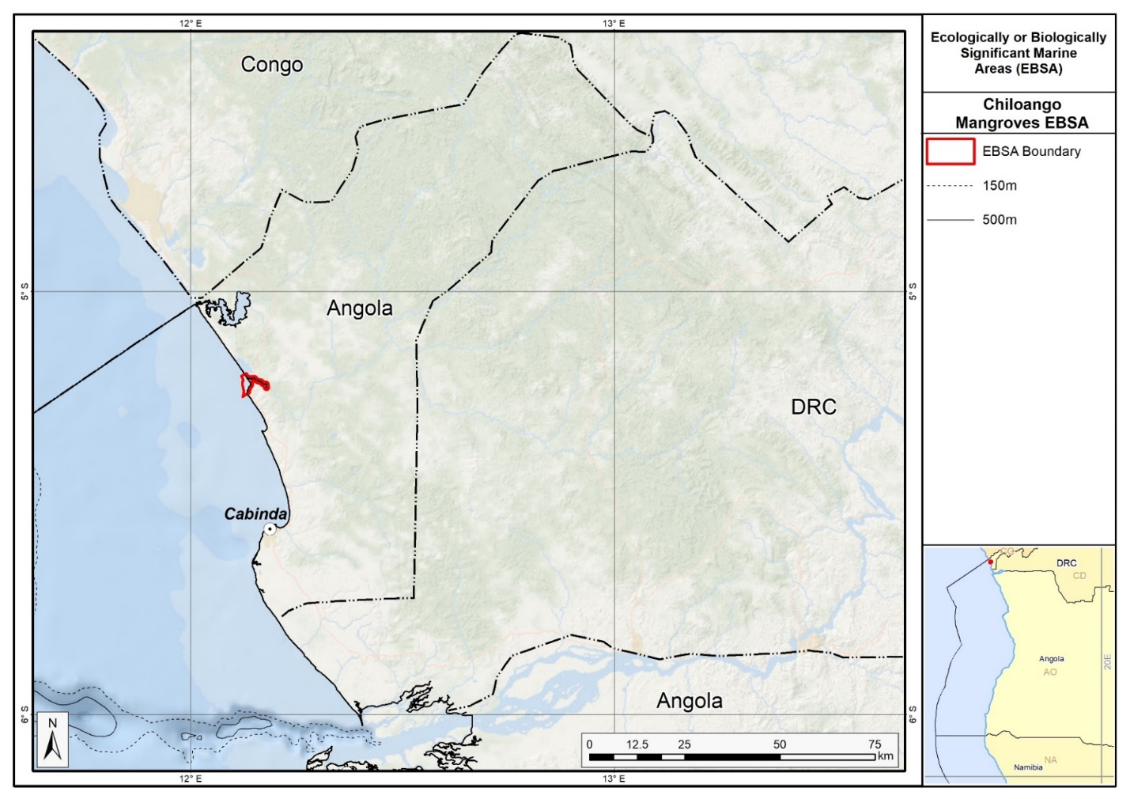
Map of the Chiloango Mangroves area.

Rights and permissions:
No limits on sharing or publication.

3. Longa coastline (description of a new area)

How was the submission developed?
The process to identify potential areas meeting EBSA criteria and to revise existing EBSAs was part a broader project on ecosystem-based MSP in the BCLME, namely the Benguela Current Marine Spatial Management and Governance Project (MARISMA, 2014-2023). This was a regional capacity-building and development cooperation project implemented by the Benguela Current Commission, the Governments of Angola, Namibia and South Africa, and GIZ, the German Agency for Development Cooperation (Deutsche Gesellschaft für Internationale Zusammenarbeit.

The MARISMA project undertook a gap analysis of the existing EBSA network utilizing spatial data that was not available when the initial set of EBSA were described in South-Eastern Atlantic workshop, April 2013.

The overall approach to EBSA identification, delineation, description and engagement followed these key steps:

Initial Systematic Conservation Planning (SCP) Analyses: A gap analysis was undertaken, and new areas identified using systematic conservation planning tools such as Marxan, based on biodiversity input data including ecosystem types, species distributions, and ecological processes.

National Workshops: The boundaries of potential new areas new and refined EBSA boundaries were iteratively reviewed and adjusted through workshops held within each of the three countries (Angola, Namibia, South Africa). These workshops allowed country-specific input and tailoring of boundaries and descriptions to national contexts and priorities.

Regional Workshops and Bilateral Meetings between Countries: Workshops at the regional level especially focused on transboundary EBSAs shared between the countries, but also examined the overall approach to EBSAs, their delineation, description and the engagement approach. The aim was to harmonize boundaries, align management recommendations, and foster cooperation across national borders for effective regional marine biodiversity management. Additional specific bilateral meetings were held where necessary.

Technical and Scientific Peer Review: The descriptions of new areas and modifications of existing descriptions underwent technical review nationally and regionally (through technical review workshops involving relevant experts); and internationally with a further regional review workshop with participation of experts from the Global Ocean Biodiversity Initiative (GOBI) and members of the CBD's Informal Advisory Group on EBSAs; ensuring robustness of the exercise. The process is documented in peer reviewed literature (Harris et al., 2019, 2022).

Political Approval: The descriptions of new areas and modifications of existing descriptions were administratively and politically approved through all required stages up to the national ministerial level in each country and were then submitted to the CBD Secretariat by the National CBD Focal Points.

Data Sharing and Accessibility: All information, descriptions of new areas and modifications of existing descriptions, status assessments, management recommendations, and stakeholder feedback, were made available through online repositories such as the project's EBSA Portal (https://cmr.mandela.ac.za/Research-Projects/EBSA-Portal); and the submissions were also shared via the Benguela Current Convention's Geodata Portal (https://geodata.benguelacc.org/ ). This facilitated transparency, accessibility, and ongoing updating of data and products for biodiversity specialists and other stakeholders.

The delineation process used a combination of Systematic Conservation Planning and multi-criteria analysis methods. The key features used in the analysis were:
- Irreplaceable and near irreplaceable (i.e. very high selection frequency) sites, as well as primary and secondary focus areas identified in the SCP undertaken for the BCLME by Holness et al. (2014).
- Threatened and sensitive Benthic and Coastal Ecosystems. The analysis focussed on the inclusion of the most threatened and sensitive ecosystem types found in the area, especially the lagoon and coastal ecosystems.
- Areas of high relative naturalness identified by Holness et al. (2014) were prioritized.
- Some additional manual editing of the boundaries of the area was undertaken to align with recognizable geographic features on the coast.

The multi-criteria analysis resulted a value surface. The cut-off value used to determine the extent of the area was based on expert input and quantitative analysis of effective inclusion of the above features. This entailed taking an iterative parameter calibration-based approach whereby the spatial efficiency of the inclusion of the targeted features was evaluated. Significant manual refinement of the boundaries was then undertaken based on aerial imagery. The final boundaries shown in the map were validated in an expert workshop.

Traditional knowledge was not incorporated into this process, and consultations with indigenous peoples or local communities were not undertaken. Therefore, documentation of Free, Prior and Informed Consent (FPIC) is not relevant for this EBSA process.

Where is the submission intended to be included?
[X] EBSA repository
[ ] EBSA information-sharing mechanism

Abstract:
The area includes the mouth of the Longa River, which comprises a mostly undisturbed high-energy marine system, including a very well-protected lagoon behind a sand dune cordon. The coastal configuration creates a particular suite of abiotic conditions that support a rich diversity of flora and fauna. The site is thus especially important for supporting various life-history stages as well as threatened and declining species and habitats. Most notably, it has the highest nest density of vulnerable olive ridley turtles. Many of the biodiversity features within the area, such as sea turtles, birds and some mangrove species, are sensitive to disturbance, grow slowly or take a significant amount of time to mature.

Introduction:
The coastal portion of the Longa River is characterized by an 8-km long dune-backed sandy shore that shelters a narrow estuarine lagoon in the northern half of the central Angolan coast. The estuary mouth itself breaks through the dunes at various locations along this sandy shore; sometimes in the northern portion of the lagoon, and sometimes in the southern portion. The Longa’s waters are dark (almost black) due to leaching tannins. The plume of brackish and nutrient-rich water exiting the estuary mouth moves to the west and north (Morais et al., 2005). The distinct character of this estuarine system is one of the reasons why this area meets the EBSA criteria. However, there is a clear need for more research to better understand the biodiversity patterns, ecological processes and ecological role of the estuarine lagoon system.

What is known, though, is that the estuary is rarely subjected to sudden alterations from estuary-mouth closure, thus allowing mangroves and marginal banks with vegetation to establish within the system (Holísticos, 2014). The vegetation in the surrounds is predominantly made up of dry forest formations, bushy savannah (with Adansonia, Sterculia, Acacia), grassy savannah (of Setaria welwitschii), grassy steppe with shrubs and trees (Hyphaene gossweileri) and palustrine wetlands (Diniz, 2006). The area extends beyond the estuary system itself, and includes approximately 470 km² (44 km alongshore) of sandy, mixed and rocky shores, and adjacent inshore and estuarine habitats. Most importantly, these beaches support the highest nest densities in Angola for Vulnerable olive ridley turtles. Another species that this site has supported historically is the Vulnerable African manatee. There are no known recent records of this species in Longa River, and so contemporary presence of this species in the Longa Coastline area is not known. Research is required to determine if manatees still exists in the area of if it has been extirpated (and if the latter, why).

The mangroves were fundamental in choosing this site; although not globally significant, these mangroves are of key local significance because they are the southernmost mangroves in Angola. Consequently, the reason this area was not included in the original set of EBSAs at the South Eastern Atlantic Workshop in 2013 (UNEP/CBD/RW/EBSA/SEA/1/4) is because this information was not available at that meeting and local knowledge is better than the information included in international datasets (e.g., WCMC and the World Mangrove Atlas). Further, results from the turtle monitoring programme in the area had not yet been published and thus were not available at the meeting; it was not known at the time how important this site is for these threatened species. Because this is a discrete site that is centred around the mangroves, lagoon and the associated threatened species, it is presented as a Type 1 EBSA (sensu Johnson et al. 2018). It is coastal, and thus does not extend far offshore.

Location:
The area is in Cuanza Sul Province, in central Angola, near the southern border of the Quiçama national park. It includes the Longa River estuary, lagoon and mouth and 44 km of adjacent coastline, covering an approximate area of 470 km². The whole area lies entirely within the exclusive economic zone of Angola.
The coordinates of a minimum bounding box covering the entire scope of the area are:
- Latitude: -9.954, -10.283, -10.373, -10.045
- Longitude: 13.35, 13.602, 13.484, 13.232

Feature description:
Longa Coastline is a coastal area is in the province of Cuanza-Sul, Angola, and is thus described primarily for its benthic features, although the overlying water column in the estuary and nearshore is very tightly coupled to the ecology of the site. This area spans the confluence of estuarine and marine systems with specific characteristics. However, future research on the lagoon component is required to understand the broader significance of this coastal feature. For example, what other species are present; what is the importance/role of the crocodiles, birds and mangrove species; what are the dynamics of the estuary and the effects during mouth breaching or mouth closure and back flooding?

The mangroves, comprising trees and shrubs, are the characteristic vegetation of the area, represented by families of Rhizophoraceae and Avicenniaceae. They provide feeding, breeding, nursery and resting areas for an important component of the local biodiversity. The main indicators of this include a high number of crustaceans (lobsters on the marine side; shrimps and crabs on the estuarine side) as well as many species of fish, among which are representatives of families such as Megalopidae, Carangidae, Lutjanidae, Sciaenidae, Polynemidae, Mugilidae and Clariidae (Holísticos, 2014).

Many bird species use the various ecosystems within the area. Birds rest along the sandy shoreline, nest along the vegetation (mangroves and riparian forest) and move among the local habitats. The most dominant groups are sea swallows and seagulls, some waders, diving birds, aquatic birds and birds of prey (MINAMB et al., 2015). The presence of Asian woolly neck (Ciconia episcopus) was confirmed, which is classified as Vulnerable in accordance with the IUCN Threatened Species Red List (Bird Life International, 2017). This bird is mainly threatened due to hunting by humans and loss of habitat.

The area is seen as the most important site for marine turtles nesting along the Angolan coast. The Kitabanga Project has been ongoing since 2003 in this area and currently monitors around 10 km of beach around the Longa River mouth. It has particularly high nest densities for olive ridley turtles (Lepidochelys olivacea). According to Morais (2014), the Longa region is seen as extremely important for olive ridley turtles, a species classified in the IUCN Red List as Vulnerable, with an average density of 175 nests.km⁻¹. The leatherback turtle (Dermochelys coriacea), classified by the IUCN Red List as Vulnerable, is also present at much lower densities of 2 nests.km⁻¹. However, this region is under high pressure from the artisanal fisheries sector where, during the period of 2013/2014, 136 turtles were captured (Morais, 2014). There are also many other reptile species within the area. Crocodiles, for example, are commonly seen along the river banks and along the whole inner side of the sandy shoreline where they rest and nest (MINAMB et al., 2015).

Among the aquatic mammals, manatees use mostly or exclusively the inshore waters up to estuarine areas from the Longa River to the north, and are seen in some estuaries. However, recent records do not show the presence of manatees in the area. Major threats to this animal’s survival are human exploration (illegal hunting), degradation and/or loss of habitat and accidental capture in nets (Morais et al., 2005), and thus the species is classified as Vulnerable. Further research is required to confirm the presence or extirpation of manatees in this area.

The area contains 7 ecosystem types, including 4 Endangered ecosystem type (Kwanza Exposed Rocky Shore, Kwanza Inshore, Kwanza Intermediate Sandy Beach and Kwanza Mixed Shore), and one Vulnerable type (Kwanza Estuarine Shore) (Holness et al., 2014; Table below).

Summary of types of habitats and status of threats for the Longa Coastline. Data from Holness et al. (2014).
Threat Status | Ecosystem Type | Area (km²) | Area (%)
Endangered | Kwanza Exposed Rocky Shore | 1.9 | 0
 | Kwanza Inshore | 383.6 | 82
 | Kwanza Intermediate Sandy Beach | 3.0 | 1
 | Kwanza Mixed Shore | 45.0 | 10
Vulnerable | Kwanza Estuarine Shore | 7.0 | 1
Least Threatened | Kwanza Reflective Sandy Beach | 11.4 | 2
 | Kwanza Sheltered Rocky Shore | 17.7 | 4
Grand Total |  | 469.5 | 100

Feature condition and future outlook:
The people living in the surrounding areas come to this site daily in order to carry out commercial activities. The most popular products sold along the road are already made (i.e. meat, fish, and cold beverages) to feed lorry and bus drivers. The environmental conditions of the estuary mouth and the inner side of the estuary are mainly regulated by the river, especially the levels of flood and drought conditions. These are dependent on the rainy season and annual rainfall rate. Beyond the ongoing turtle monitoring, no research is planned for the area, however, it is highlighted here as a priority.

An assessment of ecological condition of the area based on cumulative pressures show that 15 % of the benthic area is in Good condition, and the remaining 85 % is in Fair condition; 100 % of the pelagic area is in Good condition. This suggests that, although there is widespread modification of the area, biodiversity and the ecological processes are still largely intact.

Assessment of the area against CBD EBSA Criteria:
CBD EBSA Criteria  (Annex I to decision IX/20) | Description  (Annex I to decision IX/20) | Ranking of criterion relevance  (please mark one column with an X)
CBD EBSA Criteria  (Annex I to decision IX/20) | Description  (Annex I to decision IX/20) | No information |  | Low |  |  | Medium |  | High
Uniqueness or rarity | Area contains either (i) unique (“the only one of its kind”), rare (occurs only in few locations) or endemic species, populations or communities, and/or (ii) unique, rare or distinct, habitats or ecosystems; and/or (iii) unique or unusual geomorphological or oceanographic features. |  |  |  |  |  | X
The Longa River mouth is a regionally unique site where there is the combination of a high-energy marine system and a very sheltered estuarine system that jointly created a distinct set of abiotic conditions that support a rich diversity of flora and fauna. It is also one of the most important rookeries in Angola for nesting olive ridley turtles, and the southernmost mangrove community in Angola. Further research is required to fully understand the biodiversity patterns, ecological processes and role of this regionally unique estuarine lagoon system, which may be understated here.
Special importance for life-history stages of species | Areas that are required for a population to survive and thrive. |  |  |  |  |  |  |  | X
One of the most important attributes of this area is that it is one of the most important turtle rookeries along the Angolan coast. The average nest densities recorded between 2011 and 2015 are as follows: 175 nests.km⁻¹ for the olive ridley turtle (classified as Vulnerable) and 2 nests.km⁻¹ for leatherback turtles (classified as Vulnerable) (Morais, 2016).
The mangroves also offer feeding, breeding, nursery and/or resting sites for many species, including crustaceans, fish and birds. For example, species that use the estuary for breeding and nursery areas include lobsters on the marine side, shrimps and crabs on the estuarine side, and fish from many different families (Holísticos, 2014). The most dominant birds present in the area are sea swallows and seagulls, some waders, diving birds, aquatic birds and birds of prey (MINAMB et al., 2015) that use the site mainly for feeding and resting.
Importance for threatened, endangered or declining species and/or habitats | Area containing habitat for the survival and recovery of endangered, threatened, declining species or area with significant assemblages of such species. |  |  |  |  |  |  |  | X
This area is highly important for threatened species, particularly for Vulnerable turtles and manatees. Turtle nesting occurs along the whole strip of sand mainly between September and December, with hatching between October and January. Turtle nesting and hatching in this area is monitored by the Kitabanga Project – Conservation of Marine Turtles. Currently, the project monitors around 10 km of beaches of the Longa River mouth. The average nest density recorded between 2011 and 2015 was 175 nests.km⁻¹ for olive ridley turtles and 2 nests.km⁻¹ for leatherback turtles (Morais, 2016), both of which species are listed as Vulnerable. For this reason, Longa Coastline is of extreme importance for olive ridley turtles because it is the area in Angola that contains the highest nest densities. This is one of the main motivations for proposing this area as an EBSA, and for requiring coastal conservation measures.
The African manatee (Trichechus senegalensis) was, in the recent past, found in this area. However, there are no recent records of manatees in the area. The manatee is a Vulnerable species that is showing declines across its range, and extirpations at some sites due to hunting and habitat destruction (Keith Diagne, 2015). Research is required to determine whether this site still supports manatees, or if it has been extirpated (and if so, why). There are also several threatened bird species in the area, e.g., the Asian woolly neck (Ciconia episcopus), which is classified as Vulnerable. Finally, the area includes various threatened habitats, including four Endangered sandy, rocky and mixed shore types, and one inshore type, and one Vulnerable estuarine shore type.
Vulnerability, fragility, sensitivity, or slow recovery | Areas that contain a relatively high proportion of sensitive habitats, biotopes or species that are functionally fragile (highly susceptible to degradation or depletion by human activity or by natural events) or with slow recovery. |  |  |  |  |  |  |  | X
The area comprises several features that are fragile, sensitive to disturbance and that will take a long time to recover. Sensitive species with slow recovery following impacts to populations include the turtles (around 30 years to sexual maturity), manatees (30-year generation time) and some of the birds. The mangroves are the most sensitive ecosystem in the area because the trees are slow growing. Research is required to determine the vulnerability and sensitivity of the estuarine lagoon system.
Biological productivity | Area containing species, populations or communities with comparatively higher natural biological productivity. | X
No data exist for this particular system; however it is known that mangroves are among the most productive ecosystems (FAO 1994), in turn supporting highly productive coastal lagoons and estuaries that contain essential organic nutrients. Mangroves are also important fish spawning sites and nursery areas for larvae and juvenile stages of important species (Shumway, 1999), with lobsters and shrimps of importance in the Longa River.
Biological diversity | Area contains comparatively higher diversity of ecosystems, habitats, communities, or species, or has higher genetic diversity. |  |  |  |  |  |  |  | X
All habitats in this site present a set of favorable conditions for a rich diversity of species, from plants to iconic vertebrates. The high diversity of plant species at this site comes from the combination of dune, mangrove and forest areas in the area that each support different floral communities. Similarly, habitat diversity contributes to diverse animal species assemblages, with a high number of crustaceans (i.e., lobsters in the marine shore and shrimps and crabs in the estuarine shore) and many species of fish (namely Megalopidae, Carangidae, Lutjanidae, Sciaenidae, Polynemidae, Mugilidae and Clariidae families) (Holísticos, 2014). The most dominant groups of birds include sea swallows and seagulls, some waders, diving birds, aquatic birds and birds of prey (MINAMB et al., 2015). Crocodiles are frequently observed resting and nesting along the riverside and on the inner side of the sandy riverbank (MINAMB et al., 2015), with other reptiles including several species of turtles, some of which nest on the site’s beaches. Manatees were historically present at this site too, but it is not clear if this is still the case.
Naturalness | Area with a comparatively higher degree of naturalness as a result of the lack of or low level of human-induced disturbance or degradation. |  |  |  |  |  |  | X
An assessment of ecological condition of the area based on cumulative pressures show that 15 % of the benthic area is in Good ecological condition, and the remaining 85 % is in Fair ecological condition; 100 % of the pelagic area is in Good ecological condition. This suggests that, although there is widespread modification of the area, biodiversity and the ecological processes are still largely intact.
Some important areas of mangrove and the riparian vegetation around the River Mouth are in pristine condition with little signs of human intervention or global degradation. It is estimated that the size of this area is 30 ha (MINAMB et al., 2015). However, outside of this area some impact result from activities of the community along this road who moves daily to this area to carry out commercial activities. The environmental conditions of the river mouth and the inner side of the estuary are mainly regulated by associated riverside factors, especially the levels of flooding and drought conditions.

References:
Angolan Association of the Oil Exploration and Production Companies (Associação das Companhias de Exploração e Produção de Angola, ACEPA) (2014). Environmental and Social Characterisation to Determine the Coastal Sensitivity of the Areas Between Luanda and Namibe.
BirdLife International. 2017. Ciconia episcopus. (amended version published in 2016) The IUCN Red List of Threatened Species 2017: e.T22727255A110064997. http://dx.doi.org/10.2305/IUCN.UK.2017-1.RLTS.T22727255A110064997.en. Downloaded on 14 December 2017.
FAO (1994). Mangrove forest management guidelines (English) In: Food and Agricultural Organisation (FAO) Forestry Paper, no. 117 / FAO, Rome (Italy). Forest Resources Division, 339 p. http://archive.org/stream/mangroveforestma034845mbp/mangroveforestma034845
mbp djvu.txt (accessed 17 April 2013)
Holísticos (2014). Caracterização Ambiental e Social para o Desenho da Sensibilidade Costeira entre Luanda e Namibe. Relatório Final, Dezembro de 2014.
Holness, S., Kirkman, S., Samaai, T., Wolf, T., Sink, K., Majiedt, P., Nsiangango, S., Kainge, P., Kilongo, K., Kathena, J., Harris, L., Lagabrielle, E., Kirchner, C., Chalmers, R., Lombard, M. 2014. Spatial Biodiversity Assessment and Spatial Management, including Marine Protected Areas. Final report for the Benguela Current Commission project BEH 09-01.
Johnson, D.E., Barrio Froján, C., Turner, P.J., Weaver, P., Gunn, V., Dunn, D.C., Halpin, P., Bax, N.J., Dunstan, P.K., 2018. Reviewing the EBSA process: Improving on success. Marine Policy 88, 75-85.
Morais, M., Torres, M., Martins, M. (2005). Análise da Biodiversidade Marinha e Costeira, e Identificação das Pressões de Origem Humana sobre os Ecossistemas Marinhos e Costeiros (Estudo Temático n.º2 Projecto 00011125 – Estratégia e Plano de Acção Nacionais para a Biodiversidade (NBSAP). Ministério do Urbanismo e Ambiente. Junho 2005
Morais, M. (2014). Relatório de Actividades, Resultados e Gastos Referentes à Temporada 2013/2014 do Projecto Kitabanga - Conservação de Tartarugas Marinhas. Faculdade de Ciências da Universidade Agostinho Neto. Maio 2014.
Morais, M. (2016). Apresentação pública “Projecto Kitabanga - Estudo e Conservação de Tartarugas Marinhas”.
Morais, M. 2004. Informação para a selecção de zonas húmidas e sua classificação como sítios RAMSAR (RIS) em Angola. IUCN ROSA / MINUA. Luanda.
Ministério do Ambiente (MINAMB), Holísticos, C4 EcoSolutions (2015). “Approaching the urgent adaptation needs and reinforcement of the Angolan abilities in regards to climate change” – Description of selected sites: Longa.
Ministério do Urbanismo e Ambiente (MINUA) (2006). Programa de Investimento Ambiental (2006) Relatório do Estado Geral do Ambiente em Angola. Angola.
Shumway, C.A. (1999). Forgotten Waters: Freshwater and Marine Ecosystems in Africa. Strategies for Biodiversity Conservation and Sustainable Development. Available at: http://pdf.usaid.gov/pdf_docs/PNACF449.pdf (accessed 17 April 2013).

Maps and Figures:
GIS data available at: https://cmr.mandela.ac.za/cmr/media/Store/documents/EBSA/Descriptions/Angola/Angola_EBSAs_2020-SHP.zip
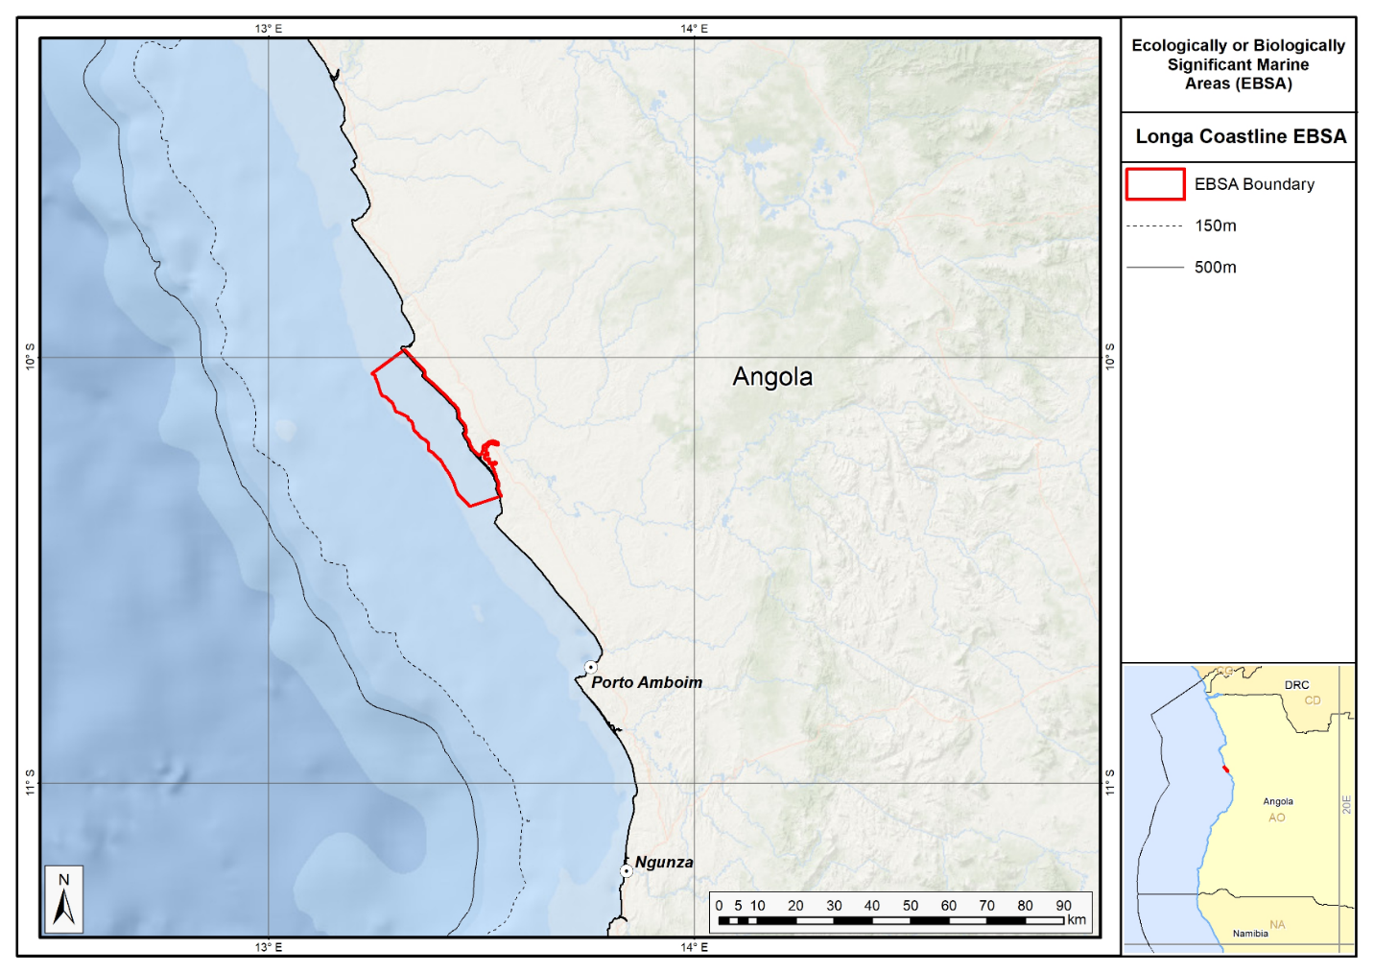
Map of the Longa Coastline area.

Rights and permissions:
No limits on sharing or publication.

4. Mussulo-Kwanza-Cabo Ledo complex (modification of the existing Ramiros-Palmerinhas Coastal Area)
Reason for the modification:
The EBSA description is being modified because of newly available or accessible knowledge on features associated with the area, based on additional scientific data especially new systematic spatial planning and assessments of biodiversity. The descriptions and supporting information are substantially extended, updated and refined beyond the original descriptions from the South-Eastern Atlantic workshop, April 2013. The modifications involve changes to the textual description, changes to the ranking of the area against the EBSA criteria, and changes in shape, location and size of the area.

The original descriptions of Ecologically or Biologically Significant Marine Areas (EBSAs) in the Benguela Current Large Marine Ecosystem (BCLME) were described in the South-Eastern Atlantic workshop (April 2013). The descriptions were generally characterized by generic, often fairly geometric delineations, consisting of approximate bounding boxes around the features for which the EBSA was described. This coarse scale of delineation was appropriate for a global scale but posed challenges for inclusion in national-level, place-based ocean management. The original boundaries were not sufficiently refined to capture the full extent of key biodiversity features and often overlapped with areas of lower biodiversity value or poor ecological condition.

Additionally, the original EBSA descriptions suffered from shortfalls related to limited spatial data and lack of systematic conservation planning approaches at the time they were first proposed. This meant that many boundaries did not precisely encompass biodiversity priority areas, potentially leading to conflicts with other ocean sectors and limiting their practical usefulness for marine spatial planning (MSP). The coarse scale and lack of detailed data constrained the ability to develop effective zoning and management recommendations that balance biodiversity protection with economic activities.

How was the submission developed?
The EBSA revision process was part a broader project on ecosystem-based MSP in the BCLME, namely the Benguela Current Marine Spatial Management and Governance Project (MARISMA, 2014-2023). This was a regional capacity-building and development cooperation project implemented by the Benguela Current Commission, the Governments of Angola, Namibia and South Africa, and GIZ, the German Agency for Development Cooperation (Deutsche Gesellschaft für Internationale Zusammenarbeit.

Because of these shortcomings of the existing EBSA boundaries, description and valuations set out in the previous section, the MARISMA project undertook a refinement process. This process used systematic conservation planning (SCP) tools, such as Marxan, to generate finer-scale, more accurate boundaries based on updated biodiversity data and expert input. This process also allowed for the identification of new EBSAs and the splitting of some original EBSAs into multiple refined areas to better reflect discrete biodiversity features and ecological processes. The refined EBSA boundaries were more suitable for MSP and conservation management because they focused on core natural and near-natural areas, avoided unnecessary conflicts with other sectors, and incorporated a systematic, data-driven approach to spatial prioritization.

The overall approach to the EBSA update and engagement followed these key steps:

Initial Systematic Conservation Planning (SCP) Analyses: Existing EBSAs were refined and new areas identified using systematic conservation planning tools such as Marxan, based on biodiversity input data including ecosystem types, species distributions, and ecological processes.

National Workshops: The refined and new EBSA boundaries were iteratively reviewed and adjusted through workshops held within each of the three countries (Angola, Namibia, South Africa). These workshops allowed country-specific input and tailoring of EBSA boundaries and descriptions to national contexts and priorities.

Regional Workshops and Bilateral Meetings between Countries: Workshops at the regional level especially focused on transboundary EBSAs shared between the countries, but also examined the overall approach to EBSAs, their delineation, description and the engagement approach. The aim was to harmonize boundaries, align management recommendations, and foster cooperation across national borders for effective regional marine biodiversity management. Additional specific bilateral meetings were held where necessary.

Technical and Scientific Peer Review: The revised and new EBSAs underwent technical review nationally and regionally (through technical review workshops involving relevant experts); and internationally with a further regional review workshop with participation of experts from the Global Ocean Biodiversity Initiative (GOBI) and members of the CBD's Informal Advisory Group on EBSAs; ensuring robustness of the exercise. The process is documented in peer reviewed literature (Harris et al., 2019, 2022).

Political Approval: The EBSAs were administratively and politically approved through all required stages up to the national ministerial level in each country and were then submitted to the CBD Secretariat by the National CBD Focal Points.

Data Sharing and Accessibility: All information, including refined EBSA boundaries, status assessments, management recommendations, and stakeholder feedback, were made available through online repositories such as the project's EBSA Portal (https://cmr.mandela.ac.za/Research-Projects/EBSA-Portal); and the EBSA were also shared via the Benguela Current Convention's Geodata Portal (https://geodata.benguelacc.org/ ). This facilitated transparency, accessibility, and ongoing updating of data and products for biodiversity specialists and other stakeholders.

The EBSA description was updated by including the few additional studies available on the area. A summary table of the represented habitats and their threat status was also included as supplementary information. Evaluations of criteria did not change from those of the original Ramiros-Palmerinhas EBSA. The biggest change to the EBSA was a significant refinement of the EBSA delineation. This was done to more closely focus the EBSA on the key biodiversity features. The two biggest changes were an extension southward along the coast to fully include the Kwanza Estuary and an extension offshore to include important adjacent canyons and shelf ecosystems. Revised boundaries were extensively discussed in a series of stakeholder meetings.

The delineation process used a combination of Systematic Conservation Planning and multi-criteria analysis methods. The key features used in the analysis were:
- Irreplaceable and near irreplaceable (i.e. very high selection frequency) sites, as well as primary and secondary focus areas identified in the SCP undertaken for the BCLME by Holness et al. (2014).
- Threatened Benthic and Coastal Ecosystems. The analysis focussed on the inclusion of the most threatened ecosystem types found in the area. These types are highlighted in the table in the Other relevant website address or attached documents section. Key threatened ecosystem types were the endangered The BCC spatial assessment (Holness et al., 2014) identified two Critically Endangered ecosystems (Luanda Inshore and Luanda Reflective Sandy Beach), nine Endangered ecosystems (Bengo Shelf, Bengo Shelf Edge, Kwanza Inshore, Kwanza Intermediate Sandy Beach, Kwanza Mixed Shore, Kwanza Shelf, Kwanza Shelf Edge, Luanda Lagoon Coast and Luanda Mixed Shore), and two Vulnerable types (Kwanza Estuarine Shore and Luanda Sheltered Rocky Shore).
- Key physical features such as canyons and some small seamounts from the BCC spatial mapping project (Holness et al., 2014), GEBCO data, and global benthic geomorphology mapping (www.bluehabitats.org, Harris et al., 2014).
- Boundaries of Important Bird and Biodiversity Areas and proposed Ramsar sites were included.
- Areas of high relative naturalness identified by Holness et al. (2014) were prioritized.
- Some additional manual editing of the boundaries of the EBSA was undertaken to align with recognizable geographic features on the coast.

The multi-criteria analysis resulted a value surface. The cut-off value used to determine the extent of the EBSA was based on expert input and quantitative analysis of effective inclusion of the above features. This entailed taking an iterative parameter calibration-based approach whereby the spatial efficiency of the inclusion of the targeted features was evaluated. The approach aimed to identify a cut-off which most efficiently included prioritised features while minimizing the inclusion of impacted areas. The final boundaries shown in the map below were validated in an expert workshop.

Traditional knowledge was not incorporated into this process, and consultations with indigenous peoples or local communities were not undertaken. Therefore, documentation of Free, Prior and Informed Consent (FPIC) is not relevant for this EBSA process.

Where is the submission intended to be included (choose one option, and please note that there are different procedures for these two intended end points)?
[X] EBSA repository
[ ] EBSA information-sharing mechanism

Abstract:
Changes from the original version: The abstract has been shortened to meet CBD specifications. Additional details are largely focussed on the offshore elements, including additional biological and oceanographic details especially on the shelf-incising canyons and seamounts.
The Mussulo-Kwanza-Cabo Ledo complex is an expansion of the Ramiros-Palmerinhas Coastal Area EBSA and encompasses two estuaries, coastal islands, mangroves, sandy beaches and saltmarsh vegetation across intertidal flats and proposed Ramsar wetlands. The area is an important bird and biodiversity area for migratory aquatic birds, a breeding site for threatened marine turtles and a nursery for crabs, and it has diverse marine life. The inshore waters are crucial horse mackerel nurseries: the eggs and larvae of those fish have recently been found up to 1,300 m offshore. The boundary now includes shelf-incising canyons that retain fish-spawning products and adjacent seamounts that support leatherback turtle foraging. Fragile habitat-forming species are found in the canyons and seamounts, which increases the site’s vulnerability. The boundary of the existing EBSA has been expanded southward to encompass river-driven ecological processes that provide nutrients and sediments. All additions to the existing EBSA reflect regional systematic conservation priorities. The site is significant for supporting critical life-history stages and threatened species and habitats, and demonstrates exceptional diversity, productivity and vulnerability.

Introduction:
Changes from the original version: The introduction has been extensively expanded to reflect the inclusion of deeper water ecosystems. Details on ecosystem types and their threat statuses are presented based on newer ecosystem mapping and systematic assessments. It is presented as a Type 2 EBSA (sensu Johnson et al. 2018) because it comprises a cluster of spatially fixed ecosystems and features but that are all connected by the same ecological processes and thus are evaluated as a single unit.

The coastal Mussulo-Kwanza-Cabo Ledo Complex is located to the south of Luanda city, in the province of Luanda, in the northern portion of the Benguela Current Large Marine Ecosystem. It is a Type 2 EBSA (sensu Johnson et al. 2018) because it comprises a cluster of spatially fixed ecosystems and features but that are all connected by the same ecological processes and thus are evaluated as a single unit. The area extends from the coast to the lower slope, and includes two estuaries with mangroves, low-growing saltmarsh species, intertidal flats, sandy-, mixed- and rocky shores, lagoon habitat, the shelf and shelf edge, upper and lower slope, seamounts and shelf-incising canyons. It is an important site for bird aggregations and breeding turtles, and as nursery habitat for many species, including crabs and fish, notably for the horse mackerel. The site also includes representative portions of 13 threatened ecosystems, including two Critically Endangered and nine Endangered types. By implication, therefore, the site also includes some of the last remaining habitat for many threatened species. Information for the site, especially offshore, is relatively limited but some surveys have been completed.

With the accession of Angola to the Ramsar Convention on Wetlands, it was proposed to create and protect certain wetlands which have fundamental ecological functions for the regulation of water regimes and also serve as a habitat for flora and fauna especially for waterbirds. The 1,616 hectares area of Saco dos Flamingos (within the EBSA) has been proposed as a Ramsar site. The Kitabanga – Conservação de Tartarugas Marinhas project has been in place since 2003. Currently, it monitors about 12km in the beach of the Palmeirinhas. Nests densities recorded between 2011 and 2015 were as follows: 45 nests.km-1 for the olive ridley turtle and 2.6 nests.km-1 for the leatherback turtle (Morais, 2015). In 2006 there was a multidisciplinary sampling of estuaries in Angola, which included that of the Kwanza river in the southern region of the extended area (da Silva Neto, 2007). The project included biodiversity studies (birds, fish, invertebrates and vegetation) and hydrological processes. The results form part of the motivation for extending the EBSA southwards.

Location:
Changes from the original version: The revised description expands the geographical boundaries of the EBSA to include deeper shelf areas and key physical features. It is based on specific ecosystem mapping which contrasts with the original broader and coarser bounding boxes. The location section provides bounding box coordinates and shares a link to the specific spatial data. Motivation for the spatial changes, and details of the spatial planning are given in “How was the submission developed?” Section.

The area encompasses the bays of Corimba, Luanda and Mussulo, including Saco dos Flamingos and Ilhéu dos Pássaros. The revised boundaries include the mouth of the Kwanza River and end north of Cabo Ledo. It covers approximately 110 km of coastline and it extends approximately 125 km offshore, at its furthest point. The whole area lies entirely within the exclusive economic zone of Angola.
The coordinates of a minimum bounding box covering the entire scope of the area are:
- Latitude: -7.974, -9.508, -9.975, -8.441
- Longitude: 12.978, 13.535, 12.246, 11.689

Feature description of the area:
Changes from the original version: The revised text substantially elaborates on the species and ecosystems in the EBSA. It provides a detailed summary of ecosystem types present, including specific threat statuses, focussing on the threatened ecosystems, which was not included in the original. A summary table of ecosystem types and threat statuses is presented.

The coastal vegetation in the area is dominated by mangroves (Rhizophora mangle, Laguncularia racemosa and Avicenna germinans), with low-growing saltmarsh species of intertidal flats (Sesuvium portulacastrum, S. mesembritemoides and Salicornia sp.). The site is important for aquatic birds, with 61 congregatory waterbird species recorded, some of which occur in numbers which are at least nationally significant (BirdLife International, 2005). These include significant numbers of resident waterbirds as well as waders from the Palearctic while migrating south in the austral spring and returning in the late summer, for which the lagoon and intertidal flats are important foraging areas (Dean 2001). The threatened Cape gannet Morus capensis and Damara tern Sterna balaenarum are important non-breeding visitors to the inshore area (BirdLife International 2013). According to the IUCN Red List, these two species are classified as "Endangered" and "Vulnerable", respectively (http://www.iucnredlist.org/). Marine turtles, including the green Chelonia mydas (Endangered), leatherback Dermochelys coriacea (regionally Critically Endangered; globally Vulnerable) and olive ridley Lepidochelys olivacea (Vulnerable) occur in the area. Weir et al. (2007) surveyed the area and found that leatherback and olive ridley turtles were nesting on the beaches in the vicinity of the mangroves, with the nest density of the latter as high as 32 km⁻¹ at Palmeirinhas. In 2006, a multidisciplinary survey of the estuaries of Angola, including the Kwanza River estuary at the southern extent of the area, was conducted (da Silva Neto, 2007). The project included studies of biodiversity (birds, fish, invertebrates, vegetation) and hydrological processes. The biological diversity in the area of the Kwanza bar reveals the presence of specimens of crustaceans such as shrimp (Penaeus sp.) and crab (Callinectes sp.). The ichthyofauna includes species that are ecologically adapted to the brackish environment, with emphasis on some species of the Clariidae and Mugilidae family. Also included are fish species of the families Soleidae, Lutjanidae, Lobotidae and Plynemidae (Holisticos, 2014). The inshore area is also an important nursery for horse mackerel, with the eggs and larvae getting exported offshore to -1300 m. Evidence from other systems indicates that seamounts and canyons can play and important role in retention of fish spawning products (Rojas & Landaeta, 2014), and thus the boundary of the EBSA was expanded to include the shelf-incising canyons that likely play a key role in this nursery function. The largest adjacent seamounts are also included, additionally because they are also recognised habitat important for leatherback foraging.

Although specific detailed biodiversity data on the offshore seamounts and canyons are lacking, these are significant features that are subject to fairly low levels of impact and hence are likely to be in good condition and support a representative range of biodiversity. These ecosystems also characteristically support fragile, habitat-forming species, such as sponges and corals, which add to the site’s vulnerability. Despite limited biodiversity information, 13 of the 23 ecosystem types represented in this EBSA are threatened, including two Critically Endangered and nine Endangered types (Table below; Holness et al., 2014). By implication, therefore, the site is also important for threatened species.

Summary of ecosystem types and threat status for Mussulo-Kwanza -Cabo Ledo Complex. Data from Holness et al. (2014).
Threat Status | Ecosystem Type | Area (km2) | Area (%)
Critically Endangered | Luanda Inshore | 38.5 | 0
 | Luanda Reflective Sandy Beach | 30.3 | 0
Endangered | Bengo Shelf | 556.2 | 3
 | Bengo Shelf Edge | 475.2 | 3
 | Kwanza Inshore | 737.5 | 4
 | Kwanza Intermediate Sandy Beach | 34.4 | 0
 | Kwanza Mixed Shore | 28.8 | 0
 | Kwanza Shelf | 1 868.1 | 11
 | Kwanza Shelf Edge | 961.3 | 6
 | Luanda Lagoon Coast | 151.4 | 1
 | Luanda Mixed Shore | 0.8 | 0
Vulnerable | Kwanza Estuarine Shore | 1.2 | 0
 | Luanda Sheltered Rocky Shore | 0.1 | 0
Least Threatened | Bengo Lagoon Coast | 0.4 | 0
 | Bengo Mixed Shore | 0.0 | 0
 | Bengo Upper Slope | 3 779.6 | 23
 | Congo Lower Slope | 2 619.5 | 16
 | Congo Seamount | 508.9 | 3
 | Kwanza Lower Slope | 501.5 | 3
 | Kwanza Reflective Sandy Beach | 40.9 | 0
 | Kwanza Sheltered Rocky Shore | 8.1 | 0
 | Kwanza Upper Slope | 4 212.2 | 25
 | Luanda Intermediate Sandy Beach | 0.0 | 0
Grand Total |  | 16 554.8 | 100

Feature condition and future outlook:
Changes from the original version: The section has been substantially expanded to include specific data on ecological condition from regional assessment processes.

The Mussulo area is a confirmed Important Bird Area (BirdLife International 2013). The mangrove ecosystem of the area is not represented in mangrove communities elsewhere on the Angolan coast, and their botanical interest alone has been used to justify its conservation (Huntley 1974, UNEP 2007). The mangroves are threatened by the human occupation of coastal areas (BirdLife International 2005) and associated activities, which lead to damage, fragmentation and loss, with implications for their function as refuge, breeding or foraging areas for diverse species, including turtles, birds, fish and crustaceans. Other threats, particularly for the estuaries, include invasive alien plants, coastal erosion and artisanal fishing using set-nets and gill nets (da Silva Neto et al. 2007). Offshore pressures relate largely to fisheries. Revision of the EBSA boundary has largely excluded areas of direct impact, and therefore most of the EBSA area is in a Good (55 %) or Fair condition (32 %) (Holness et al., 2014). Nevertheless, the area is likely to be significantly impacted by activities directly adjacent to the EBSA (particularly from Luanda Bay), and this assessment of condition is likely to be highly optimistic. Further research for the area is recommended, particularly in terms of fully understanding the role of the canyons and seamounts in enhancing productivity and supporting species’ life-histories within this EBSA.

Assessment of the area against CBD EBSA Criteria:
Changes from the original version: No changes to the evaluation criteria have been made, but the revised and expanded text provides more detailed supporting evidence and updated scientific references to justify rankings, particularly referring to new ecosystem mapping, the inclusion of valuable/productive and sensitive offshore features, and assessments of ecological condition and status.
CBD EBSA Criteria  (Annex I to decision IX/20) | Description  (Annex I to decision IX/20) | Ranking of criterion relevance  (please mark one column with an X)
CBD EBSA Criteria  (Annex I to decision IX/20) | Description  (Annex I to decision IX/20) | No information |  | Low |  |  | Medium |  | High
Uniqueness or rarity | Area contains either (i) unique (“the only one of its kind”), rare (occurs only in few locations) or endemic species, populations or communities, and/or (ii) unique, rare or distinct, habitats or ecosystems; and/or (iii) unique or unusual geomorphological or oceanographic features. |  |  |  |  |  | X
The mangrove ecosystem of the area, which consists of Rhizophora mangle, Laguncularia racemosa and Avicenna germinans is not represented in mangrove communities elsewhere on the Angolan coast, and their botanical interest alone has been used to justify its conservation (UNEP 2007).
Special importance for life-history stages of species | Areas that are required for a population to survive and thrive. |  |  |  |  |  |  |  | X
The Islands of Migratory Birds (Ilhéu dos Pássaros) is internationally recognized as an Important Bird Area – it is a vital feeding and resting site for large numbers of migrating waterbirds (Birdlife International 2005, 2013). The beaches are used for breeding by globally Vulnerable leatherback turtles as well as Vulnerable olive ridley turtles, which have been found to have high nesting densities at Palmeirinhas by Weir et al. (2007). The densities of nests recorded in Palmeirinhas between 2011 and 2015 were 45 nests.km⁻¹ for the olive ridley turtle nests and 2.6 nests.km⁻¹ for the leatherback turtle (monitored beach 12 km). The area is reported to be an important nursery ground for crabs (Simão pers.comm.). Horse mackerel also spawn in the area, with the eggs and larvae transported offshore to about -1300 m. Other studies have suggested that canyons and seamounts can act to aid retention of these products (Rojas & Landaeta, 2014).
Importance for threatened, endangered or declining species and/or habitats | Area containing habitat for the survival and recovery of endangered, threatened, declining species or area with significant assemblages of such species. |  |  |  |  |  |  |  | X
The beaches are used for breeding by globally Vulnerable leatherback turtles as well as Vulnerable olive ridley turtles which have high nesting densities at Palmeirinhas (Weir et al. 2007). Threatened bird species Cape gannet Morus capensis and Damara tern Sterna balaenarum are important non-breeding visitors to the inshore area (Birdlife 2005, 2013). The West African manatee Trichechus senegalensis (IUCN Vulnerable) is also reported from this area (Kwanza River) (Morais et al., 2006; da Silva Neto et al. 2007), with the estuarine habitat being considered important for this threatened species (Morais et al., 2006; Powell and Kouadio, 2008).
The BCC spatial assessment (Holness et al., 2014) identified two Critically Endangered ecosystems (Luanda Inshore and Luanda Reflective Sandy Beach), nine Endangered ecosystems (Bengo Shelf, Bengo Shelf Edge, Kwanza Inshore, Kwanza Intermediate Sandy Beach, Kwanza Mixed Shore, Kwanza Shelf, Kwanza Shelf Edge, Luanda Lagoon Coast and Luanda Mixed Shore), and two Vulnerable types (Kwanza Estuarine Shore and Luanda Sheltered Rocky Shore). In the absence of more specific biodiversity information, it can be assumed that these threatened ecosystems support similarly threatened communities of species.
Vulnerability, fragility, sensitivity, or slow recovery | Areas that contain a relatively high proportion of sensitive habitats, biotopes or species that are functionally fragile (highly susceptible to degradation or depletion by human activity or by natural events) or with slow recovery. |  |  |  |  |  | X
The area is key for several relatively long-lived species that reproduce slowly and recover slowly from population declines, such as turtles and manatees (Sarti Martinez 2000, Powell and Kouadio 2008), not to mention mangroves. The mangroves, estuaries and associated low-growing saltmarsh and flat intertidal habitat are all sensitive to anthropogenic pressures such as traffic, pollution, deforestation, development and associated fragmentation, with implications for their function as refugia, breeding or foraging areas. Restoration of degraded mangroves is an extremely complex, costly, long-term process, and hence protection of intact mangroves is a far more preferable option. The canyons and seamounts represented in the EBSA are also highly likely to support fragile habitat-forming species such as corals and sponges, as is characteristic of these features.
Biological productivity | Area containing species, populations or communities with comparatively higher natural biological productivity. |  |  |  |  |  | X
Mangroves are among the most productive terrestrial ecosystems (FAO 1994) and provide the highly productive coastal lagoons and tidal estuaries with which they are interlinked with essential organic nutrients; they are also critical breeding grounds and nurseries for larval and juvenile stages of important fisheries species (Shumway 1999). The seamounts and canyons may also play a role in enhancing local productivity.
Biological diversity | Area contains comparatively higher diversity of ecosystems, habitats, communities, or species, or has higher genetic diversity. |  |  |  |  |  | X
The area contains 23 different ecosystem types (estuaries, lagoons, mangroves, saltmarshes, flat intertidal habitats, beaches and inshore areas), with associated diversity of species. At least 61 congregatory waterbird species use this area as well as non-breeding waterbird (BirdLife International 2005, 2013), several breeding sea turtle species (Weir et al. 2007), aquatic mammals such as the manatee (da Silva Neto et al. 2007), crabs, shrimps, sea snails and fishes. Field research has confirmed high diversity in this area, although this is still being included in reports.
Naturalness | Area with a comparatively higher degree of naturalness as a result of the lack of or low level of human-induced disturbance or degradation. |  |  |  |  |  |  | X
Much of the area is currently relatively pristine but coastal development (BirdLife International 2005) and vehicles in the coastal zone are having some impact in the area. It is also affected by effluent, e.g. from hospitality industry, bungalows, etc, and offshore pressures relate mostly to fisheries. Overall, however, the BCC spatial assessment showed that most of the EBSA area is in a Good (55 %) or Fair condition (32 %; Holness et al., 2014). Nevertheless, the area is likely to be significantly impacted by activities directly adjacent to the EBSA (particularly from Luanda Bay), and this assessment of condition is likely to be highly optimistic.

References:
Changes from the original version: The description includes a substantially updated and expanded reference list reflecting new mapping and assessments.

BirdLife International. 2005 BirdLife’s online World Bird Database: the site for bird conservation. Version 2. Cambridge, UK: BirdLife International. Available at http://www.birdlife.org. Accessed 11 April 2013
BirdLife International 2013. Marine e-Atlas: Delivering site networks for seabird conservation. Confirmed IBA site ‘Mussulo’. Available online: http://54.247.127.44/marineIBAs/default.html Accessed 11 April 2013
BirdLife International (2017) Important Bird Areas factsheet: Mussulo. Downloaded from http://www.birdlife.org on 05/12/2017
Dean, W. R. J. 2001. Angola. Pp. 71 – 91 in L. D. C. Fishpool and M. I. Evans, eds. Important Bird Areas in Africa and associated islands: Priority sites for conservation. Newbury and Cambridge. UK: Pices Publications and BirdLife International (BirdLife Conservation Series No. 11).
da Silva Neto, D., Boyd, A., Holtzhausen, H.,van Niekerk, L., Lamberth, S., Paterson, J., Bazika, B., Camarada, T., Pinto, M., Afonso, E., Cangajo, E., Estevão, V., Bornman, T.,Wooldridge, T., Deyzel, S., Buco, A., Jónico, V., Monteiro, F., Velasco, L., Fernandes, B. 2007. Baseline surveying of species and biodiversity in estuarine habitats. Final Integrated Report on BCLME Region. BCLME Project BEHP/BAC/03/04
FAO. 1994. Mangrove forest management guidelines (English) In: Food and Agricultural Organisation (FAO) Forestry Paper, no. 117 / FAO, Rome (Italy). Forest Resources Division, 339 p. http://archive.org/stream/mangroveforestma034845mbp/mangroveforestma034845mbp_djvu.txt (accessed 17 April 2013)
Holísticos. 2014. Caracterização Ambiental e Social para o Desenho da Sensibilidade Costeira entre Luanda e Namibe. Relatório Final, Dezembro de 2014.
Holness, S., Kirkman, S., Samaai, T., Wolf, T., Sink, K., Majiedt, P., Nsiangango, S., Kainge, P., Kilongo, K., Kathena, J., Harris, L., Lagabrielle, E., Kirchner, C., Chalmers, R., Lombard, M. 2014. Spatial Biodiversity Assessment and Spatial Management, including Marine Protected Areas. Final report for the Benguela Current Commission project BEH 09-01.
Huntley, B.J. 1974. Outlines of wildlife conservation in Angola. Journal of the Southern African Wildlife Management Association 4: 157–166
Johnson, D.E., Barrio Froján, C., Turner, P.J., Weaver, P., Gunn, V., Dunn, D.C., Halpin, P., Bax, N.J., Dunstan, P.K., 2018. Reviewing the EBSA process: Improving on success. Marine Policy 88, 75-85.
Morais, M., Torres, M., Martins, M. 2005. Análise da Biodiversidade Marinha e Costeira, e Identificação das Pressões de Origem Humana sobre os Ecossistemas Marinhos e Costeiros. Estudo Temático n.º2. Projecto 00011125, Estratégia e Plano de Acção Nacionais para a Biodiversidade (NBSAP). Ministério do Urbanismo e Ambiente, Junho de 2005.
Morais, M. 2015. Projecto Kitabanga – Conservação de tartarugas marinhas. Relatório final da temporada 2014/2015. Universidade Agostinho Neto / Faculdade de Ciências. Luanda.
Morais, Michel. 2016. Apresentação pública “Projecto Kitabanga - Estudo e Conservação de Tartarugas Marinhas”.
Morais, M. 2004. Informação para a selecção de zonas húmidas e sua classificação como sítios RAMSAR (RIS) em Angola. IUCN ROSA / MINUA. Luanda.
Morais, M., Torres, M.O.F., Martins, M.J. 2006. Biodiversidade Marinha e Costeira em Angola. Identificação e Análise de Pressões de Origem Antrópica. Ministério do Urbanismo e Ambiente. Luanda.
Morais, M., Velasco, L. Carvalho, E. 2006. Avaliação da condição e distribuição do manatim africano (Trichechus senegalensis) ao longo do rio Cuanza. Universidade Agostinho Neto e Ministério do Urbanismo e Ambiente. Luanda, Angola.
Powell, J. & Kouadio, A. 2008. Trichechus senegalensis. In: IUCN 2012. IUCN Red List of Threatened Species. Version 2012.2. www.iucnredlist.org. Downloaded on 11 April 2013.
Rojas, P.M., Landaeta, M.F. 2014. Fish larvae retention linked to abrupt bathymetry at Mejillones Bay (northern Chile) during coastal upwelling events. Lat. Am. J. Aquat. Res., 42(5): 989-1008.
Sarti Martinez, A.L. (Marine Turtle Specialist Group) 2000. Dermochelys coriacea. In: IUCN 2012. IUCN Red List of Threatened Species. Version 2012.2. www.iucnredlist.org. Downloaded on 15 April 2013.
Shumway, C.A. 1999. Forgotten Waters: Freshwater and Marine Ecosystems in Africa. Strategies for Biodiversity Conservation and Sustainable Development. http://pdf.usaid.gov/pdf_docs/PNACF449.pdf (accessed 17 April 2013).
UNEP. 2007. Mangroves of Western and Central Africa. UNEP-Regional Seas Programme/UNEPWCMC. http://www.unep-wcmc.org/resources/publications/UNEP_WCMC_bio_series/26.htm. (Accessed 11 April 2013)
Weir CR, Ron T, Morais M, Duarte ADC. 2007. Nesting and at-sea distribution of marine turtles in Angola, West Africa, 2000–2006: occurrence, threats and conservation implications. Oryx 41: 224-231

Maps and Figures:
GIS data available at: https://cmr.mandela.ac.za/cmr/media/Store/documents/EBSA/Descriptions/Angola/Angola_EBSAs_2020-SHP.zip

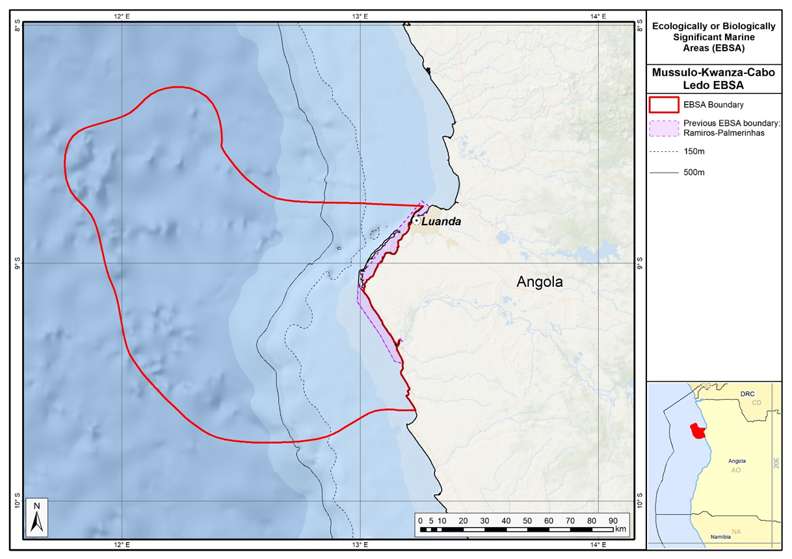
Map of the Mussulo-Kwanza-Cabo Ledo Complex area in relation to the original Ramiros-Palmerinhas EBSA.

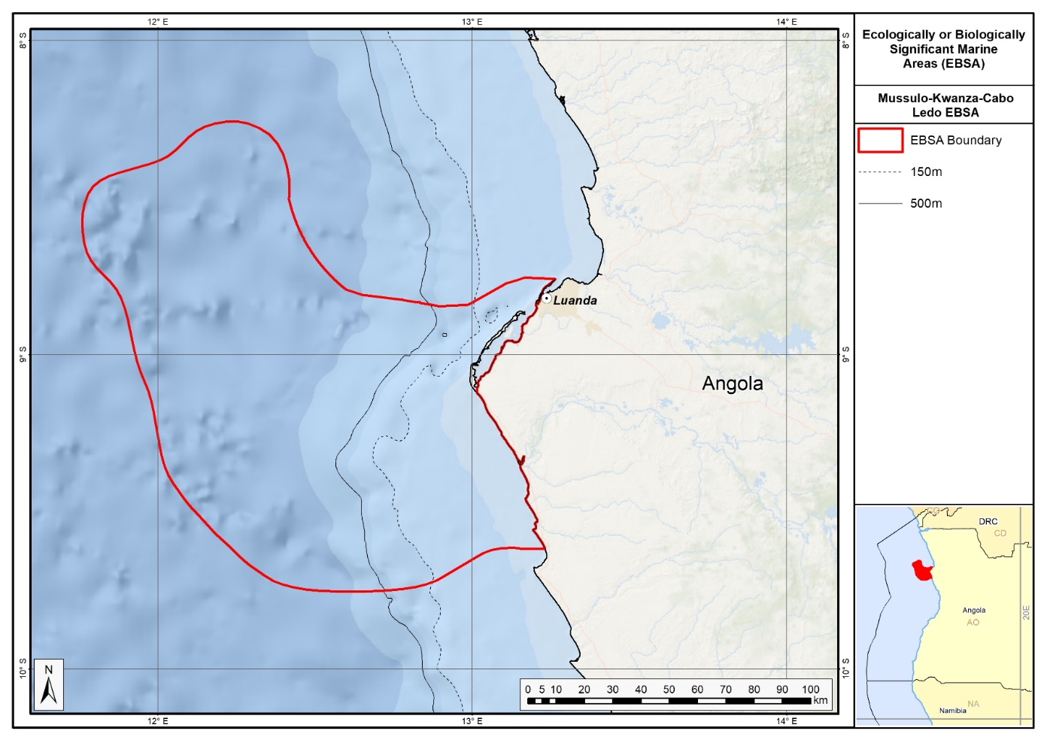
Map of the Mussulo-Kwanza-Cabo Ledo Complex area.

Rights and permissions:
No limits on sharing or publication.

5. Ombaca canyon and seamount complex (description of a new area)
How was the submission developed?
The process to identify potential areas meeting EBSA criteria and to revise existing EBSA was part a broader project on ecosystem-based MSP in the BCLME, namely the Benguela Current Marine Spatial Management and Governance Project (MARISMA, 2014-2023). This was a regional capacity-building and development cooperation project implemented by the Benguela Current Commission, the Governments of Angola, Namibia and South Africa, and GIZ, the German Agency for Development Cooperation (Deutsche Gesellschaft für Internationale Zusammenarbeit.

The MARISMA project undertook a gap analysis of the existing EBSA network utilizing spatial data that was not available when the initial set of EBSA were described in South-Eastern Atlantic workshop, April 2013.

The overall approach to EBSA delineation, description and engagement followed these key steps:

Initial Systematic Conservation Planning (SCP) Analyses: A gap analysis was undertaken, and new areas identified using systematic conservation planning tools such as Marxan, based on biodiversity input data including ecosystem types, species distributions, and ecological processes.

National Workshops: The boundaries of potential new areas new and refined EBSA boundaries were iteratively reviewed and adjusted through workshops held within each of the three countries (Angola, Namibia, South Africa). These workshops allowed country-specific input and tailoring of boundaries and descriptions to national contexts and priorities.

Regional Workshops and Bilateral Meetings between Countries: Workshops at the regional level especially focused on transboundary EBSAs shared between the countries, but also examined the overall approach to EBSAs, their delineation, description and the engagement approach. The aim was to harmonize boundaries, align management recommendations, and foster cooperation across national borders for effective regional marine biodiversity management. Additional specific bilateral meetings were held where necessary.

Technical and Scientific Peer Review: The descriptions of new areas and modifications of existing descriptions underwent technical review nationally and regionally (through technical review workshops involving relevant experts); and internationally with a further regional review workshop with participation of experts from the Global Ocean Biodiversity Initiative (GOBI) and members of the CBD's Informal Advisory Group on EBSAs; ensuring robustness of the exercise. The process is documented in peer reviewed literature (Harris et al., 2019, 2022).

Political Approval: The descriptions of new areas and modifications of existing descriptions were administratively and politically approved through all required stages up to the national ministerial level in each country and were then submitted to the CBD Secretariat by the National CBD Focal Points.

Data Sharing and Accessibility: All information, including descriptions of new areas and modifications of existing descriptions , status assessments, management recommendations, and stakeholder feedback, were made available through online repositories such as the project's EBSA Portal (https://cmr.mandela.ac.za/Research-Projects/EBSA-Portal); the descriptions of new areas and modifications of existing descriptions were also shared via the Benguela Current Convention's Geodata Portal (https://geodata.benguelacc.org/ ). This facilitated transparency, accessibility, and ongoing updating of data and products for biodiversity specialists and other stakeholders.

The delineation process used a combination of Systematic Conservation Planning and multi-criteria analysis methods. The key features used in the analysis were:
- Irreplaceable and near irreplaceable (i.e. very high selection frequency) sites, as well as primary and secondary focus areas identified in the SCP undertaken for the BCLME by Holness et al. (2014).
- Threatened Benthic and Coastal Ecosystems. The analysis focussed on the inclusion of the most threatened ecosystem types found in the area.
- Key physical features such as canyons and some small seamounts from the BCC spatial mapping project (Holness et al., 2014), GEBCO data, and global benthic geomorphology mapping (www.bluehabitats.org, Harris et al., 2014).
- Areas of high relative naturalness identified by Holness et al. (2014) were prioritized.
- Some additional manual editing of the boundaries of the area was undertaken to align with recognizable geographic features on the coast.

The multi-criteria analysis resulted a value surface. The cut-off value used to determine the extent of the area was based on expert input and quantitative analysis of effective inclusion of the above features. This entailed taking an iterative parameter calibration-based approach whereby the spatial efficiency of the inclusion of the targeted features was evaluated. The approach aimed to identify a cut-off which most efficiently included prioritised features while minimizing the inclusion of impacted areas. The final boundaries shown in the map were validated in an expert workshop.

Traditional knowledge was not incorporated into this process, and consultations with indigenous peoples or local communities were not undertaken. Therefore, documentation of Free, Prior and Informed Consent (FPIC) is not relevant for this EBSA process.

Where is the submission intended to be included (choose one option, and please note that there are different procedures for these two intended end points)?
[X] EBSA repository
[ ] EBSA information-sharing mechanism

Abstract:
The main aspects of the area are offshore canyons, seamounts and vital oceanographic features that contribute to elevated productivity. The area is situated 120 km offshore from Porto Amboim, Angola, extends to the edge of the country’s exclusive economic zone and covers approximately 37,321 km². Although its biodiversity has not been comprehensively surveyed, the area is known to support turtle and cetacean species. Furthermore, the seasonal upwelling creates periods of intense primary productivity that, in turn, promotes productivity among many fish species that are commercially important throughout the Benguela Current Large Marine Ecosystem, thereby supporting their and other crucial species’ very early life-history stages. It is likely that the canyons and seamounts support diverse communities that are highly likely to support fragile habitat-forming species, such as corals and sponges. Currently, the entire area is in a good ecological condition, with virtually pristine biodiversity patterns and intact processes.

Introduction:
The site comprises a rugged benthic topography of canyons and seamounts, situated within the semi-permanent Angola-Benguela Front. A key characteristic of the oceanography on the Angolan continental shelf is the upwelling phenomenon that starts in May-June, reaches its peak in August-September and probably ends near the end of the year. This upwelling results in intense primary production that in turn influences the production and distribution of fish, thereby playing a critical ecological role for ecosystems in the area. It is known that fish species often adapt their reproductive strategies to ocean currents and productivity cycles, so spawning times and the distribution of the main Angolan species tend to coincide with the observed seasonal oceanographic patterns (Sætersdal et al., 1999). The interactions of the main currents in the region generate areas of divergence along the continental margin (such as the coastal upwelling) as well as along the equator. The intensity of these processes varies with each season.

Location:
The complex is approximately 120 km offshore from Porto Amboim, between Luanda and Benguela, and has an area of 37,321 km². It abuts the outer boundary of the country’s exclusive economic zone, within which it lies entirely.
The coordinates of a minimum bounding box covering the entire scope of the area are:
- Latitude: -9.418, -11.344, -12.65, -10.724
- Longitude: 10.906, 13.13, 11.999, 9.775

Feature description of the area:
The outer portion of the continental shelf and slope is mostly regular with a smooth, gentle gradient of approximately 20 m.km⁻¹ within the depth range of -200 to -1000 m, and of approximately 12 m.km⁻¹ between depth ranges of -1000 to -2000 m. At approximately 50 km from the Benguela coastline, the seabed maintains these characteristics but, immediately to the north (towards Sumbe), the seabed rises sharply to depths of shallower than -1000m. The area includes 5 mapped ecosystem types, which is highly diverse for the Angolan offshore region (Holness et al., 2014; Table below). Ecosystems include Abyss, Lower Slope, Seamounts and Upper Slope types.

Ocean currents and circulation patterns in the region include a complex set of flows that are linked to a larger system of currents in the tropical east Atlantic. The dominant circulation patterns of the Angolan central and southern continental shelf are driven by the warm Angola Current that moves southwards, and where this current meets the cold Benguela Current at the Angola-Benguela Front (Moroshkin et al., 1970; Meeuwis and Lutjeharms, 1990; Shannon and O'Toole, 1998; and Lass et al., 2000). The Angola Current is fast and stable and penetrates up to depths of 250-300 m, covering both the continental shelf and slope. The typical current speed is 50 cm.s⁻¹ but it can reach or even exceed speeds of 70 cm.s⁻¹ (Moroshkin et al., 1970). The origin of this current, at least on the surface, is the southeastern arm of the South Equatorial Counter-Current.

The Angola-Benguela Front forms where the warm Angola Current, moving south, meets with the cold Benguela Current, moving north. This phenomenon occurs typically in the south of the Bay of Lobito at 14°S – 16°S and is a semi-permanent oceanographic feature. The gradients of temperatures at the surface reach 4°C.°latitude⁻¹, but on average are 1.5°C.°latitude⁻¹. This Front varies by season, reaching maximum levels in the summer when it is wider and is located further south, compared to winter when the front retracts towards the north and has a lower temperature gradient. These variations are related to the seasonality of the Angola Current (Meeuw and Lutjeharms, 1990). Episodic inflows of warm, saline water towards the south may displace the Angola-Benguela Front up to 23°S (Shannon et al, 1986), with effects associated with the general level of biological productivity in the north of the system. Shannon et al (1986) classified these events as ‘Niños de Benguela’ because they are comparable to the ‘El Niño’ of the tropical east Pacific Ocean. However, a northward shift of the Angola-Benguela Front has never been observed on this same scale. High concentrations of phytoplankton biomass occur below the surface where the water column is highly stratified, a phenomenon that also occurs offshore of central Angola (Holligan et al., 1984, Joint et al., 1986, In: ARC, 2013).

Data presented by the INIP (2013) show that phytoplankton is dominated by diatoms and dinoflagellates throughout most of the year in almost all years that were studied (2004, 2008, 2009 and 2010), but that dinoflagellates and cyanobacteria (blue algae) may have dominance over diatoms (2011) and that cyanobacteria may completely dominate the composition of phytoplankton (2012).

There is a lack of detailed knowledge regarding the concentrations and distributions of ichthyoplankton (fish eggs and larvae) in Angolan waters, but eggs and larvae of South African pilchard (sardines; Sardinops sagax), Round Sardinella (Sardinella aurita), European anchovy (Engraulis encrasicolus), cape horse mackerel (Trachurus trachurus capensis) and hakes (Merluccius sp.) occur in the Angola-Benguela Front area as well as the mesopelagic zone. Round Sardinella and Madeiran Sardinella (Sardinella aurita and S. eba (maderensis)) juveniles are vastly distributed over the Angolan Continental Shelf (Wysokinski, 1986, INIP, 2013), thus it is likely that these species, together with Cunene horse mackerel (Trachurus trecae), are important components of the region’s ichthyoplankton (ARC, 2013). The area coincides with the distribution of two species of Sardinella (S. maderensis and S. aurita), Cunene horse mackerel (Trachurus trecae), other demersal fish (mainly Dentex) and deep-water king prawns (ARC, 2013). Other species occurring in deeper areas of the continental shelf and slope include squid, shrimps, crabs and Smallscale Splitfin (Synagrops microlepis) (ARC, 2013).

Five turtle species have been recorded in Angolan waters, namely: leatherbacks (Dermochelys coriacea), olive ridleys (Lepidochelys olivacea), green turtles (Chelonia mydas), loggerheads, (Caretta caretta) and hawksbills (Eretmochelys imbricata) (Carr and Carr 1991; Fretey 2001, Weir et al. 2007). Of these species, only the green turtles, leatherbacks and olive ridleys nest in Angola (Carr and Carr 1991; Fretey 2001). Leatherbacks are known to forage in productive waters and around seamounts, and likely use this area as a foraging ground.

Whales and dolphins are commonly observed in Angolan waters with confirmation of 11 dolphin and 14 whale species in the region. Among these, four species are classified as threatened as per the IUCN criteria (IUCN, 2013) namely, Sei whale, blue whale and common whale being classified as Endangered, while the Sperm Whale is classified as Vulnerable.

Broadly, therefore, the area is a particularly productive, with productivity likely also enhanced by the rugged undersea topography. However, more research is required to better establish the linkages between the benthic and pelagic systems, that might ultimately require splitting this area into a benthic and dynamic pelagic EBSA. Also, the link between the seamounts within and beyond Angola’s EEZ needs to be investigated, as well as the dynamics of the Angola-Benguela Front in Angola and in the adjacent ABNJ; this new information, subject to international processes, may require an extension of this EBSA into ABNJ. In the interim, however, it is presented here as a Type 2/4 EBSA (sensu Johnson et al. 2018) as a collection of features that are connected by the same ecological processes, and as a dynamic feature viz. the Angola-Benguela Front.

Summary of types of habitats and status of threats for Ombaca Canyon and Seamount Complex. Data from Holness et al. (2014).
Threat Status | Ecosystem Type | Area (km²) | Area (%)
Least Threatened | Cunene Abyss | 8 916.1 | 24
 | Kwanza Lower Slope | 18 078.1 | 48
 | Kwanza Seamount | 5 864.9 | 16
 | Kwanza Upper Slope | 243.9 | 1
 | Lobito Upper Slope | 7.5 | 0
 | Sumbe Upper Slope | 4 210.8 | 11
Grand Total |  | 37 321.2 | 100

Feature condition and future outlook:
An assessment of ecological condition based on cumulative pressures within the area showed that 100 % of the benthic and pelagic area is in good ecological condition, suggesting that the whole area is (near) pristine, and has virtually all natural biodiversity patterns and processes still intact. The ecosystem types are not protected.

Assessment of the area against CBD EBSA Criteria:
CBD EBSA Criteria  (Annex I to decision IX/20) | Description  (Annex I to decision IX/20) | Ranking of criterion relevance  (please mark one column with an X)
CBD EBSA Criteria  (Annex I to decision IX/20) | Description  (Annex I to decision IX/20) | No information |  | Low |  |  | Medium |  | High
Uniqueness or rarity | Area contains either (i) unique (“the only one of its kind”), rare (occurs only in few locations) or endemic species, populations or communities, and/or (ii) unique, rare or distinct, habitats or ecosystems; and/or (iii) unique or unusual geomorphological or oceanographic features. |  |  |  |  |  |  |  | X
Regional delineation of seamounts and canyons in the Benguela Current Large Marine Ecosystem revealed that these are rare features (Holness et al., 2014) that likely also support rare and/or unique biological communities.
Special importance for life-history stages of species | Areas that are required for a population to survive and thrive. |  |  |  |  |  | X
Seamounts are known to be associated with relatively high productivity from upwelling, and that they consequently serve as foraging and aggregation areas for many top predators, and other threatened vertebrates, such as turtles – and particularly, leatherbacks. They may also provide important “stepping stones” that allow species to expand their ranges.
Importance for threatened, endangered or declining species and/or habitats | Area containing habitat for the survival and recovery of endangered, threatened, declining species or area with significant assemblages of such species. |  |  |  |  |  | X
Although none of the ecosystem types represented in the area are threatened, there are several threatened species that frequent the area. These include five turtle species: leatherbacks (Dermochelys coriacea, Vulnerable), olive ridleys (Lepidochelys olivacea, Vulnerable), green turtles (Chelonia mydas, Endangered), and hawksbills (Eretmochelys imbricata, Critically Endangered) (Carr and Carr 1991; Fretey 2001, Weir et al. 2007). Seamounts are generally associated with higher productivity where turtles, particularly leatherbacks, spend time foraging. Four species of cetaceans are classified as threatened, including three Endangered whales (Sei whale, blue whale and common whale) and the Vulnerable Sperm Whale. Other threatened species include the fish Sardinella maderensis that is listed as Vulnerable.
Vulnerability, fragility, sensitivity, or slow recovery | Areas that contain a relatively high proportion of sensitive habitats, biotopes or species that are functionally fragile (highly susceptible to degradation or depletion by human activity or by natural events) or with slow recovery. |  |  |  |  |  | X
The biological communities associated with the Ombaca Canyon and Seamount Complex have not been comprehensively sampled. However, it is well established that seamounts serve as an important habitat for many fragile, habitat-forming species, including corals and sponges. The turtles and cetaceans associated with this site are also slow growing, and are vulnerable to and slow to recover from declines in their populations. The turtle species are leatherbacks (Dermochelys coriacea), olive ridleys (Lepidochelys olivacea), green turtles (Chelonia mydas), loggerheads, (Caretta caretta) and hawksbills (Eretmochelys imbricata) (Carr and Carr 1991; Fretey 2001, Weir et al. 2007). The key slow growing and vulnerable cetaceans are classified as threatened as per the IUCN criteria (IUCN, 2013) namely, Sei whale, blue whale and common whale being classified as Endangered, while the Sperm Whale is classified as Vulnerable. Conservatively, this area is ranked as Medium, but may very well be High.
Biological productivity | Area containing species, populations or communities with comparatively higher natural biological productivity. |  |  |  |  |  |  |  | X
Biological productivity is elevated in the region as a result of the seasonal upwelling. This results in intense primary production (by diatoms, dinoflagellates and cyanobateria) that in turn influences the production and distribution of fish, thereby playing a critical ecological role for ecosystems in the area. Seamounts are also recognized as sites of relatively higher productivity compared to surrounding areas.

Biological diversity | Area contains comparatively higher diversity of ecosystems, habitats, communities, or species, or has higher genetic diversity. |  |  |  |  |  | X
The area has not yet been comprehensively sampled for biodiversity, however, evidence suggests that the area is substantially more diverse that the broader area. There is likely a rich diversity associated with the complex bottom topography, as has been found on other seamounts and in other canyons, including both benthic and pelagic assemblages. Of the diversity that is known, there are many crustacean, fish, turtle, and cetacean species that are resident in or migratory through the area. Studies in the area recorded 195 sampled species (of 8 phyla). However, the juvenile stage was not taken into account when quantifying benthic diversity statistics (except for biomass), resulting in a total of 191 species (excluding the juvenile stage). This was relatively high compared to other sites.
Naturalness | Area with a comparatively higher degree of naturalness as a result of the lack of or low level of human-induced disturbance or degradation. |  |  |  |  |  |  |  |  | X
An assessment of ecological condition based on cumulative pressures within the area showed that 100 % of the benthic and pelagic area is in Good ecological condition, suggesting that the whole area is (near) pristine (Holness et al., 2014).

References:
ARC (2013). Estudo de Impacte Ambiental do Projecto de Perfuração no Bloco 24. Relatório Preparado para a BP Exploration Angola (Kwanza-Benguela) Limited. Relatório No. LA753. Dezembro de 2013.
Auel, H., Hagen, W., Ekau, W., and Verheye H.M., 2005. Metabolic adaptations and reduced respiration of the copepod Calanoides carinatus during diapause at depth in the Angola-Benguela Front and northern Benguela upwelling region. Afr. J. Mar. Sci., 27(3): 653-657.
Cadee G.C. 1978. Primary production and chlorophyll in the Zaire river, estuary and plume. Neth. J. Sea Res., 12: 368-381.
Carr T. and C. Carr. 1991. Survey of the sea turtles of Angola. Biological Conservation, 58: 19-29.
Drits A.V. E.G. Arashkevitch and T.N. Semenoval. 1992. Pyrosoma atlanticum (Tunicata, Thaliacea). Grazing impact on phytoplankton standing stock and role in organic carbon flux. J. Plankt. Res., 14(6): 799-809.
Ekau W. and H.M. Verheye. 2005. Influence of oceanographic fronts and low oxygen on the distribution of ichthyoplankton in the Benguela and southern Angolan currents. Afr. J. mar Sci., 27(3): 629-639.
Fretey, J. 2001. Biogeography and Conservation of Marine Turtles of the Atlantic Coast of Africa. Biogeographie et conservation des tortues marines de la côte atlantique de l’Afrique. CMS Technical Series Publication No 6, UNEP/CMS Secretariat, Bonn, Germany.
Holligan P.M., P.J. LeB. Williams, D. Purdie and R.P. Harris. 1984. Photosynthesis, respiration and nitrogen supply of plankton populations in stratified, frontal and tidally mixed shelf waters. Mar. Ecol. Prog. Ser., 17: 201-213.
Holness, S., Kirkman, S., Samaai, T., Wolf, T., Sink, K., Majiedt, P., Nsiangango, S., Kainge, P., Kilongo, K., Kathena, J., Harris, L., Lagabrielle, E., Kirchner, C., Chalmers, R., Lombard, M. 2014. Spatial Biodiversity Assessment and Spatial Management, including Marine Protected Areas. Final report for the Benguela Current Commission project BEH 09-01.
INIP. 2013. Environmental Activity and Fishing Resources, Block 19/24. Report of the Angolan Institute of Fisheries Research for BP Oil Company, Luanda January 2013. 50pp.
Johnson, D.E., Barrio Froján, C., Turner, P.J., Weaver, P., Gunn, V., Dunn, D.C., Halpin, P., Bax, N.J., Dunstan, P.K., 2018. Reviewing the EBSA process: Improving on success. Marine Policy 88, 75-85.
Joint I.R., N.J.P. Owens and A.J. Pomroy. 1986. Seasonal production of photosynthetic picoplankton and nanoplankton in the Celtic Sea. Mar. Ecol. Prog. Ser., 28(2): 251-258.
Lass HU, M Schmidt, V Morholz, and G Nausch 2000. Hydrographic and current measurements in the area of the Angola-Benguela Front. J. Phys. Oceanogr., 30: 2589-2609.
Moroshkin KV, VA Bunov and RP Bulatov 1970. Water circulation in the eastern South Atlantic Ocean. Oceanology, 10: 27-34.
Meeuwis JM and JRE Lutjeharms, 1990. Surface thermal characteristics of the Angola-Benguela front. S. Afr. J. Mar. Sci., 9: 261-279.
Richardson A.J., H.M. Verheye, V Herbert, C Rogers and L.M. Arendse. 2001. Egg production, somatic growth and productivity of copepods in the Benguela Current system and the Angola-Benguela Front. S. Afr. J. Sci., 97: 251-257.
Sætersdal, G., Bianchi, G., Strømme, T., Venema, S.C., 1999. The DR. FRIDTJOF NANSEN Programme 1975–1993. Investigations of fishery resources in developing countries. History of the programme and review of results. FAO Fisheries Technical Paper. No. T391. Rome, FAO. 434p.
Shannon LV, AJ Boyd, GB Brundrit and J Taunton-Clark 1986. On the existence of an El Nino-type phenomenon in the Benguela system. J. Mar. Res., 44(3): 495-520.
Shannon LV and M O'Toole 1998. Integrated overview of the oceanography and environmental variability of the Benguela Current region. Synthesis and Assessment of information on BCLME. Thematic Report 2. UNDP/GEF (RAF/96/G43). 58pp.
Verheye H.M., W. Hagen, H. Auel, W. Ekau, N. Loick, I Rheenen, P. Wencke and S Jones. 2005. Life strategies, energetics and growth characteristics of Calanoides carinatus (Copepoda) in the Angola-Benguela frontal region. Afr. J. mar. Sci., 27(3): 641-651.
Weir CR, Ron T, Morais M, Duarte ADC. 2007. Nesting and at-sea distribution of marine turtles in Angola, West Africa, 2000–2006: occurrence, threats and conservation implications. Oryx 41: 224-231.
Wysokinski, A. 1986. The living marine resource of the southeast Atlantic. FAO Fish. Tech. Pap., (178) Rev: 120 pp.

Maps and Figures:
GIS data available at: https://cmr.mandela.ac.za/cmr/media/Store/documents/EBSA/Descriptions/Angola/Angola_EBSAs_2020-SHP.zip

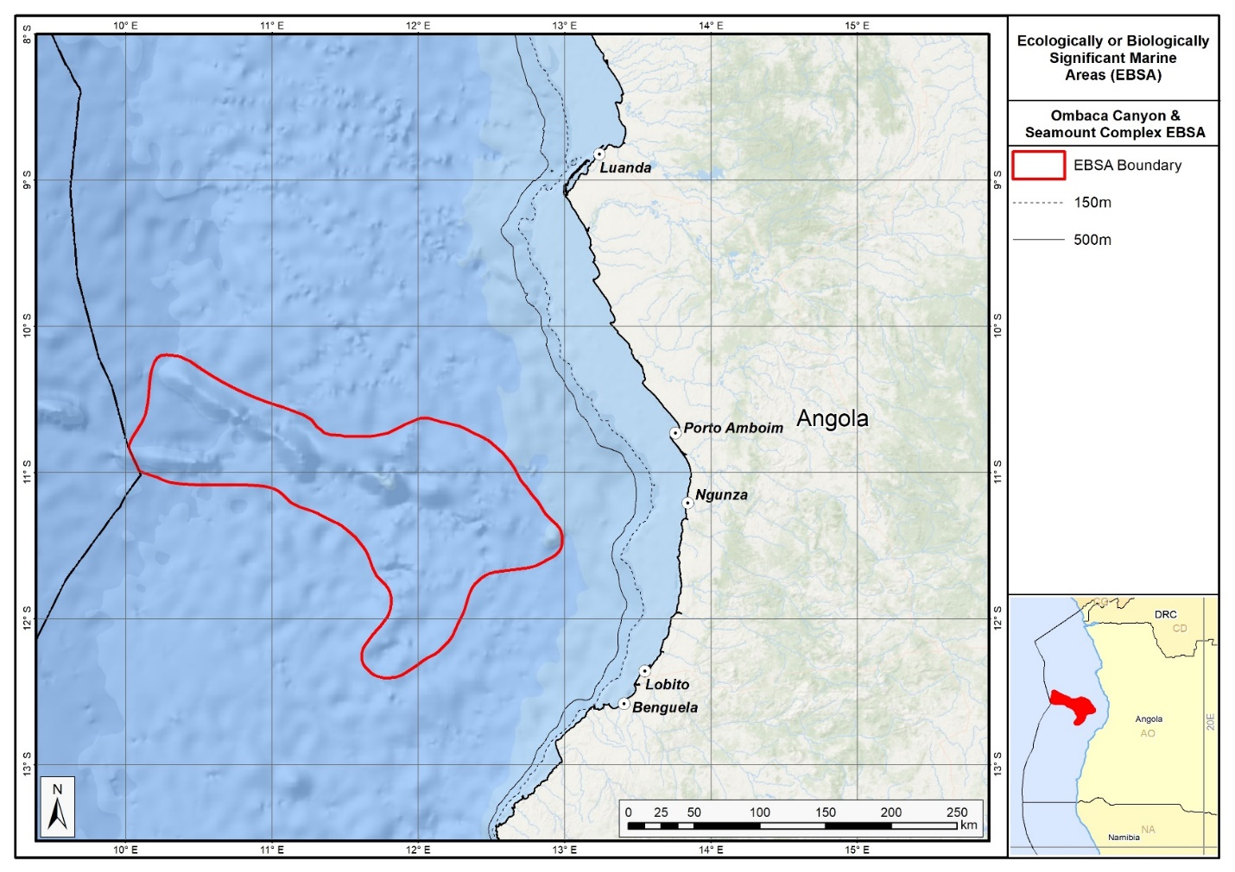
Map of the Ombaca Canyon and Seamount Complex area.
Rights and permissions:
No limits on sharing or publication.

6. Ponta Padrao mangroves and turtle beaches (description of a new area)

How was the submission developed?
The process to identify potential areas meeting EBSA criteria and to modify existing descriptions was part a broader project on ecosystem-based MSP in the BCLME, namely the Benguela Current Marine Spatial Management and Governance Project (MARISMA, 2014-2023). This was a regional capacity-building and development cooperation project implemented by the Benguela Current Commission, the Governments of Angola, Namibia and South Africa, and GIZ, the German Agency for Development Cooperation (Deutsche Gesellschaft für Internationale Zusammenarbeit.

The MARISMA project undertook a gap analysis of the existing EBSA network utilizing spatial data that was not available when the initial set of EBSA were described in South-Eastern Atlantic workshop, April 2013.

The overall approach to EBSA identification, delineation, description and engagement followed these key steps:

Initial Systematic Conservation Planning (SCP) Analyses: A gap analysis was undertaken, and new areas identified using systematic conservation planning tools such as Marxan, based on biodiversity input data including ecosystem types, species distributions, and ecological processes.

National Workshops: The boundaries of potential new areas new and refined EBSA boundaries were iteratively reviewed and adjusted through workshops held within each of the three countries (Angola, Namibia, South Africa). These workshops allowed country-specific input and tailoring of boundaries and descriptions to national contexts and priorities.

Regional Workshops and Bilateral Meetings between Countries: Workshops at the regional level especially focused on transboundary EBSAs shared between the countries, but also examined the overall approach to EBSAs, their delineation, description and the engagement approach. The aim was to harmonize boundaries, align management recommendations, and foster cooperation across national borders for effective regional marine biodiversity management. Additional specific bilateral meetings were held where necessary.

Technical and Scientific Peer Review: The descriptions of new areas and modifications of existing descriptions underwent technical review nationally and regionally (through technical review workshops involving relevant experts); and internationally with a further regional review workshop with participation of experts from the Global Ocean Biodiversity Initiative (GOBI) and members of the CBD's Informal Advisory Group on EBSAs; ensuring robustness of the exercise. The process is documented in peer reviewed literature (Harris et al., 2019, 2022).

Political Approval: The descriptions of new areas and modifications of existing descriptions were administratively and politically approved through all required stages up to the national ministerial level in each country and were then submitted to the CBD Secretariat by the National CBD Focal Points.

Data Sharing and Accessibility: All information, including descriptions of new areas and modifications of existing descriptions, boundaries, status assessments, management recommendations, and stakeholder feedback, were made available through online repositories such as the project's EBSA Portal (https://cmr.mandela.ac.za/Research-Projects/EBSA-Portal); and the descriptions of new areas and modifications of existing descriptions were also shared via the Benguela Current Convention's Geodata Portal (https://geodata.benguelacc.org/ ). This facilitated transparency, accessibility, and ongoing updating of data and products for biodiversity specialists and other stakeholders.

The delineation process used a combination of Systematic Conservation Planning and multi-criteria analysis methods. The key features used in the analysis were:
- Irreplaceable and near irreplaceable (i.e. very high selection frequency) sites, as well as primary and secondary focus areas identified in the SCP undertaken for the BCLME by Holness et al. (2014).
- Threatened and sensitive Benthic and Coastal Ecosystems. The analysis focussed on the inclusion of the most threatened and sensitive ecosystem types found in the area, especially the mangrove ecosystems.
- Areas of high relative naturalness identified by Holness et al. (2014) were prioritized.
- Some additional manual editing of the boundaries of the area was undertaken to align with recognizable geographic features on the coast.

The multi-criteria analysis resulted a value surface. The cut-off value used to determine the extent of the area was based on expert input and quantitative analysis of effective inclusion of the above features. This entailed taking an iterative parameter calibration-based approach whereby the spatial efficiency of the inclusion of the targeted features was evaluated. Significant manual refinement of the boundaries was then undertaken based on aerial imagery. The final boundaries shown in the map were validated in an expert workshop.

Traditional knowledge was not incorporated into this process, and consultations with indigenous peoples or local communities were not undertaken. Therefore, documentation of Free, Prior and Informed Consent (FPIC) is not relevant for this EBSA process.

Where is the submission intended to be included (choose one option, and please note that there are different procedures for these two intended end points)?
[X] EBSA repository
[ ] EBSA information-sharing mechanism

Abstract:
At the mouth of the Congo River, the area covers 17 km of coastline and includes some of the most important mangroves in Angola associated with the River. The bay is linked with a network of canals and coves, including, most notably, the Pululu, Moita Seca and Soyo canals, which are largely covered by mangrove forest. The area’s plants, birds, mammals, reptiles, fish and invertebrates are particularly diverse and, most significantly, it provides a critical habitat for vulnerable manatees (which are facing local extirpations as a result of hunting and habitat degradation) and vulnerable nesting turtles. Several species in the area, including of manatees, turtles, birds and mangroves, are sensitive to disturbance and have slow growth or reproduction rates.

Introduction:
The Ponta Padrao Mangroves and Turtle Beaches on the Sereia Peninsula, in Soyo, which is along the northern border of Angola’s Zaire Province at the Congo River mouth. It falls in the savannah forest and Angolan woods ecoregion that is composed of palm trees, forest remnants, bush, mangroves and coastal areas. The coastal influences are key to the formation of the Sereia Peninsula, which in turn is fundamental to the maintenance of the estuarine character of Diogo Cão Bay (ERM, 2006a). The Sereia Peninsula has tree- and shrub-form mangroves that serve as a shelter for bird and turtle nests, as well as fulfilling other ecological roles. Apart from the widely distributed and sensitive mangrove habitats, there is a unique area comprising remnants of Atlantic forest that is important in terms of biodiversity. In fact, it represents the last large area of this type in the region (ERM, 2006b).

The zonation of the Sereia mangroves differs from the general zonation of the West African mangrove communities, as described by Chapman (1976), Tomlinson (1986) and Saenger and Bellan (1995). The sandy soil plays a major role in the system laying down fine materials, clay and limos, in the mangroves or near to it. It is confined to the Moita Seca Canal, some sites of the Pululu Canal and is prevalent near Diogo Cão Bay. These locations are clearly identified by the presence of tall mangrove forms. In most other similar sites in West Africa, sandy sediments are colonized by Avicennia germinans, although R. racemosa may act as the pioneer of low-salinity sands (Lebigre, 1983). Bottom sediments along the outer side of Diogo Cão Bay and along the transport canal to the Base of Kwanda have high concentrations of mud (20-95%), while equivalent sediments of the Base of Kwanda up to the furthest points of the Pululu canal are predominantly sand (CSIR, 2003b; Herod, 2003). The Sereia Peninsula mangroves together with the mangroves in the south of the Kwanda Base occupy approximately 39 km². This is relatively small (8 %) in comparison to the broader distribution of mangroves (i.e., in the estuary of the Congo River as a whole), but locally it represents a significant habitat (ENSR, 2005). The mangroves contribute vast amounts of organic carbon to the waterbody of the estuary in the way of leaves, debris and dissolved materials (ERM, 2006a), which elevates the local productivity.

A critical feature of the site is the beaches that line the mangroves. The nearly the full spectrum of beach morphodynamic types is represented, from reflective to dissipative-intermediate types, with the bulk being intermediate. These beaches provide excellent habitat for turtles to nest, particularly for olive ridleys. Green turtles and leatherbacks are also present in the area, with the former recorded nesting there too. However, only a 15 km section of the coast is monitored, and local turtle nest densities may be higher than currently reported.

The mangroves and riverine forest associated with the river were fundamental in choosing this site; although not globally significant, these mangroves are of key local significance. Consequently, the reason this area was not included in the original set of EBSAs at the South Eastern Atlantic Workshop in 2013 (UNEP/CBD/RW/EBSA/SEA/1/4) is because this local knowledge was not available at that meeting and is better than the information included in international datasets (e.g., WCMC and the World Mangrove Atlas). Further, the turtle monitoring programme in the area had barely started at the time of the first workshop, and again, the nest data that were just starting to be collected were not available at that meeting; it was not known at the time how important this site is for these threatened species. Because this is a discrete site that is centred around the mangroves and its associated threatened species, it is a Type 1 EBSA (sensu Johnson et al. 2018).

Location:
The coastal area is located in the town of Soyo, in the extreme north of Zaire Province. It covers approximately 50 km². The whole area lies entirely within the exclusive economic zone of Angola.
The coordinates of a minimum bounding box covering the entire scope of the area are:
- Latitude: -6.071, -6.154, -6.198, -6.115
- Longitude: 12.336, 12.381, 12.302, 12.256

Feature description of the area:
Ponta Padrao Mangroves and Turtle Beaches is a coastal area and is thus described primarily for its benthic features, although the overlying water column in the estuary, surf and nearshore is tightly coupled to the key features and species at this site. The mangroves in the study area are part of the East Atlantic forest, and are some of the most important mangroves in Angola. The area comprises tree- and shrub-form mangroves of two main species: Rhizophora racemosa and R. harrisonii, with R. mangle also present but less abundant. Mangroves made up of the African Rhizophora are very tolerant to fresh water (Saenger & Bellan, 1995; Lebigre, 1983, 1999) but may also survive under high salinity levels for at least part of the year. This is consistent with observations of the mangroves in this area; they are almost exclusively fresh water in some places and dominated by R. racemosa and R. harrisonii. In some places, the transitional mangroves have a terrestrial component whose characteristic species are ferns Bolbitis auriculata and the thorny shrub Drepanocarpus lunatus (CSIR, 2005c).

The area contains 5 ecosystem types, including one Critically Endangered ecosystem type (Congo Intermediate Sandy Beach ), one Endangered ecosystem type (Congo Inshore), and one Vulnerable type (Congo Dissipative-Intermediate Sandy Beach) (Holness et al., 2014; Table below).

Plant diversity at the site extends to the adjacent forest and dunes as well. The only area of true forest in the area occurs in the Sereia Forest. It covers an area of approximately 4 ha (ERM, 2006). The species of forest trees generally include a variety of fig species, African nutmeg (Pycanthus kombo) and woody species such as Entandrophragma angolensis. It is likely that there is an important component of shrubs and numerous lianas (ERM, 2006a). Although forests are terrestrial systems, they are included in this area because they are interspersed with canals and tributaries that define the extent of the mangroves and other strongly coast-associated features. Similarly, the dunes behind the turtle nesting beaches are a key component of the coastal system because the critical linkages between beaches and dunes are important to maintain to secure resilience of sandy shores in the face of global change, and especially sea-level rise. The dune vegetation of the coastline is dominated by pioneering species. This flora is typical of the Central and West African coast (Lebrun, 1954; Davies and Le Maitre, 2003; CSIR, 2003a), comprising of a variety of herbs (Sesuvium crystallinum, Ipomoea pes-caprae, Canavallia obtusifolia), grasses (Sporobolus virginicus, Eragrostis linearis, etc.) and shrubs (Scaevola plumieri and Chrysobalanus icaco) (ERM, 2006a).

Bird diversity is also rich, including resident, migrating, visiting, and seasonal birds that use the area as a resting and feeding place. The mangroves of Soyo have similar bird communities to the mangroves of the Park des Mangroves in the Democratic Republic of Congo (DRC), which is a designated Ramsar site. Coastal birds found in the area include Phalaropus fulicarius, Larus fuscus, Larus dominicanus, Sterna albifrons and S. maxima (Dean, 2000; Dowsett and Simpson, 1991; Urban et al., 1986). Birds that feed on fish are uncommon within Diogo Cão Bay, although certain species of birds such as the Ceryle maxima, H. chelicuti and H. senegalensis, wader birds and bigger aquatic birds such as Cape cormorants (Phalacrocorax capensis) and small and great white egrets (Egretta alba and E. garzetta) use the margins of the mangrove canals as feeding grounds. The palm-nut vulture (Gypohierax angolensis) and the African fish eagle (Haliaeetus vocifer) are commonly seen over the river-mouth waters and the former over the palm tree savannah as well. A series of threatened and endemic species were identified in Angola, although only some of them exist in the area because there is not enough adequate habitat to support them.

Given the diverse habitats in the area, the area also supports a variety of mammal species. In terms of terrestrial mammals, notable species are the side-striped jackal and wildcat. Marine mammals include cetaceans such as the blue whale, Rorquais, common dolphin and spotted dolphin that are found along the whole of the Angolan coastline. Perhaps most important of all, this site seems to be especially significant for Vulnerable manatees, with these mammals being reported as common in the Congo River (Keith Diagne, 2015). Manatees are in a general state of population decline, with local extirpations reported across its range due to hunting and habitat destruction (Keith Diagne, 2015), making sites where these animals are abundant even more important. Manatees have been hunted in the Congo River, with one hunter noting that he had killed three manatees per week for 30 years (Keith Diagne, 2015). However, current data on the abundance of manatees are limited.

The local reptiles include snakes and marine turtles that nest in the region. Up to five species of turtles (all of which are listed by the IUCN as threatened) use the Atlantic beach in the southeast of Ponta do Padrão as a nesting place (ENSR, 2005), although the site is primarily recognized as a rookery for Vulnerable olive ridley turtles. There are no records of nests in the inner coastline (to the east) of the Peninsula within Diogo Cão Bay, possibly due to high levels of human activity and low salinity (CSIR, 2005). The Kitabanga Project for conservation of marine turtles that was set up in 2003 currently monitors approximately 15 km of the beach of Soyo. The densities of nests recorded between 2011 and 2015 were as follows: 61 nests.km⁻¹ for olive ridley turtles, 0.2 nests.km⁻¹ for green turtles, and no records for leatherback turtles.

The diversity of marine and freshwater fish species is also particularly high. The following commercial species of fish predominate: corvina, sardines, grouper, saw fish, snapper, hammer shark, flounder, stingray, bagre, barracuda, red snapper, grey reef sharks, twaite shad, big eyed haemulidae, beltfish, mullets, and Guinea corvina (ACEPA, 2012). Many of these fish rely on the local zooplankton, which are abundant in the area. There are many invertebrates in the area, including crabs, snails, oysters and shrimps, although the latter are commercially over-exploited. Despite the significant organic flow to Diogo Cão Bay originating from the mangrove and aquatic vegetation, the available data suggest that the benthos is actually impoverished (CSIR, 2005). Within the mangrove margins, macrofauna is limited to mudskippers (Periopthalmus sp) and mangrove crabs (Sesarma sp).

Summary of types of habitats and status of threats for the Ponta Padrao Mangroves and Turtle Beaches. Data from Holness et al. (2014).
Threat Status | Ecosystem Type | Area (km²) | Area (%)
Critically Endangered | Congo Intermediate Sandy Beach | 4.9 | 10
Endangered | Congo Inshore | 0.3 | 1
Vulnerable | Congo Dissipative-Intermediate Sandy Beach | 0.4 | 1
Least Threatened | Congo Estuarine Shore | 41.5 | 83
 | Congo Reflective Sandy Beach | 3.0 | 6
Grand Total |  | 50.1 | 100

Feature condition and future outlook:
The lack of basic infrastructure surrounding the area, such as drinking water, electricity and access roads, makes establishing private settlements in the vicinity very unlikely. However, tourists who come to see the classified historical monument, Ponta do Padrão, do occasionally visit the beach. Overall, however, the site is in good to fair ecological condition based on an assessment of cumulative pressures. The site is not protected.

Assessment of the area against CBD EBSA Criteria:
CBD EBSA Criteria  (Annex I to decision IX/20) | Description  (Annex I to decision IX/20) | Ranking of criterion relevance  (please mark one column with an X)
CBD EBSA Criteria  (Annex I to decision IX/20) | Description  (Annex I to decision IX/20) | No information |  | Low |  |  | Medium |  | High
Uniqueness or rarity | Area contains either (i) unique (“the only one of its kind”), rare (occurs only in few locations) or endemic species, populations or communities, and/or (ii) unique, rare or distinct, habitats or ecosystems; and/or (iii) unique or unusual geomorphological or oceanographic features. |  |  |  |  |  | X
Apart from largely distributed habitats of sensitive mangrove, there is only a single area of remnants of important Atlantic forest in terms of biodiversity, which represents the very last area of this kind of habitat in the region.
Special importance for life-history stages of species | Areas that are required for a population to survive and thrive. |  |  |  |  |  |  |  | X
Turtle nesting occurs on the Atlantic beaches along the whole peninsula. It is also a nesting and breeding site for many bird species and a feeding and resting place of many other species. The vast mangroves are of extreme importance for fish reproduction in the Congo River mouth. The calm waters of the mangrove forest act as nurseries for juvenile fish and shrimps and the aerial roots, low-level logs and the mud surfaces generally support a varied fauna of oysters, snails, crabs and other invertebrates (Morais et al., 2005).
Importance for threatened, endangered or declining species and/or habitats | Area containing habitat for the survival and recovery of endangered, threatened, declining species or area with significant assemblages of such species. |  |  |  |  |  |  |  | X
Most importantly, this area supports many threatened species, notably turtles, manatees, and birds. The Kitabanga Project is a marine turtle conservation program that was set up in 2003. It currently monitors approximately 15 km of the Soyo beaches. Densities of turtle nests recorded between 2011 and 2015 are as follows: 61 nests.km⁻¹ for Vulnerable olive ridley turtles, 0.2 nests.km⁻¹ for Endangered green turtles and no records for the Vulnerable leatherback turtle (Morais, 2016). The Congo River is also a site where Vulnerable manatees are commonly found. African manatees are in a general state of population decline, with local extirpations reported across its range due to hunting and habitat destruction (Keith Diagne, 2015), making sites where these animals are abundant even more important. Manatees have been hunted in the Congo River, with one hunter noting that he had killed three manatees per week for 30 years (Keith Diagne, 2015), which is more than 4500 animals. However, current data on the abundance of manatees are limited. There are also several threatened bird species that use the site as a nesting, breeding, foraging and resting site.
In terms of habitats, there is only one area where remnants of the important Atlantic forest remain; thus, the area contains the very last area of this kind of habitat in the region. It also contains Critically Endangered and Vulnerable sandy beach types, and an Endangered inshore ecosystem.
Vulnerability, fragility, sensitivity, or slow recovery | Areas that contain a relatively high proportion of sensitive habitats, biotopes or species that are functionally fragile (highly susceptible to degradation or depletion by human activity or by natural events) or with slow recovery. |  |  |  |  |  |  |  | X
The area comprises several features that are fragile, sensitive to disturbance and that will take a long time to recover. The mangroves are the most sensitive ecosystem in the area. Sensitive species with slow recovery following impacts to populations include the turtles (around 30 years to sexual maturity), manatees (30-year generation time) and some of the birds. Further, although beaches are largely resilient ecosystems, the adjacent dune systems are very sensitive to disturbance, and the more mature dune forests can take centuries to recover from disturbance.
Biological productivity | Area containing species, populations or communities with comparatively higher natural biological productivity. |  |  |  |  |  | X
Mangroves are among the most productive ecosystems (FAO 1994) and provide coastal lagoons and estuaries with essential organic nutrients. Mangroves are also an important breeding and nursery area for larvae and important species in juvenile stages, especially for the fish and crustaceans in this area (Shumway, 1999).
Biological diversity | Area contains comparatively higher diversity of ecosystems, habitats, communities, or species, or has higher genetic diversity. |  |  |  |  |  |  |  | X
The diversity of habitats on the peninsula provide favorable conditions for many species from the marine, coastal, estuarine and terrestrial realms to occur. The site supports particularly diverse assemblages of birds, fish, turtles, invertebrates, small mammals, and snakes. For example, bird species include resident, migrating, visiting, and seasonal birds that comprise similar communities to those at Park des Mangroves in the Democratic Republic of Congo (DRC), which is a designated Ramsar site. The mammals include terrestrial species, such as jackals and wildcats, and marine species, such as a variety of dolphins and whales, and importantly, manatees. Reptiles similarly include terrestrial and marine representatives, including snakes and sea turtles. Both marine and freshwater fish are present, with species ranging from teleost fish to sharks and stingrays. Invertebrates are also diverse, including some commercially important species, such as shrimp.
The plant diversity is particularly notable, with the combination of dune, mangrove and forest species represented in the area, over and above the likely rich communities of microflora that are associated with the high organic loads from the mangroves.
Naturalness | Area with a comparatively higher degree of naturalness as a result of the lack of or low level of human-induced disturbance or degradation. |  |  |  |  |  |  | X
The ecosystem shows some degree of anthropogenic degradation caused by existent populations as well as by the setting up of new artificial canals, mangrove wood cutting and the presence of communities. An assessment of ecological condition of the area based on cumulative pressures show that 15 % of the benthic area is in good condition, and the remaining 85 % is in fair condition; 100 % of the pelagic area is in Good condition (Holness et al., 2014). This suggests that, although there is widespread modification of the area, biodiversity and the ecological processes are still largely intact.

References:
Angola LNG ESHIA Addendum Report October 2009.
Angola Resources Consultants (ARC), 2013. Estudo de Impacte Ambiental Social e da Saúde do Projecto de Desenvolvimento do Pólo Oeste no Bloco 15/06, Zaire Angola. Maio 2013.
Chapman, V.J. (1976). Mangrove Vegetation. Vaduz: J Cramer.
Checklist Ministério do Ambiente (MINAMB), Holísticos, C4 EcoSolutions (2015). “Approaching the urgent adaptation needs and reinforcement of the Angolan abilities in regards to climate change” – Description of selected sites: Zaire-Soyo.
CSIR (2003) - Angola LNG Project, Phase 4: Qualitative EIA: Impacts of Site development options on mangroves and related ecosystems (Preliminary Report).
CSIR 2003a. Cameroon National Oil Spill Contingency plan (Draft). February 2003. CSIR Report No. ENVS-C 2003-008.Environmentek, CSIR, Stellenbosch.
CSIR 2003b. Supplemental Data Acquisition Program for Angola LNG Project Site Selection – Phase 2: Preliminary London Convention Compliance Assessment. Report prepared for Texaco Angola Natural Gas Inc. CSIR Report No. ENV-S-C 2003-100C. Environmentek, CSIR, Stellenbosch.
CSIR (2003c) Angola LNG Project – Environmental Due Diligence and Geotechnical Evaluation: Soyo Site. Report prepared for Texaco Angola Natural Gas Inc. CSIR Report No ENV-S-C 2003-063.
CSIR (2005) Angola LNG Project: Environmental, socioeconomic and Health Impact Assessment: Sediment and Water Quality. CSIR Report (in prep).
Dar Al-Handasah (1999) Programma de Desenvolvimento Urbano e Socio Económico. Sumário Executivo.
Davies, S.J. and Le Maitre, D.C., 2003. Peninsula Mussulo Masterplan: Ecological Sensitivity Analysis. CSIR Report No: ENV-S-C 2002-091. CSIR-Environmentek, Stellenbosch, South Africa. Prepared for Africon, South Africa.
Dean, W.R.J. (2000) The birds of Angola. BOU Checklist Series 18 British Ornithological Union, Tring, Herts, Engalnd 433pp.
Dowsett, R.J. and Simpson, R.D.H (1991) The status of seabirds off the coast of Congo. In: Dowsett, RJ and Dowsett-Lemaire, F (eds.) Flora and fauna of the Kouilou Basin (Congo) and their exploitation Tauraco Research Report 4: 241-250.
ENSR International (2005). Scoping Phase Supporting Document for the Angola LNG Project, Proposed Angola LNG Project Environmental, Socioeconomic, and Health Impact Assessment (ESHIA), Março 2005.
ERM (2006a). Angola LNG Environmental, Social and Health Impact Assessment (unpublished).
ERM (2006b). Projecto Angola LNG, Relatório para Divulgação do ESHIA, Sumário Executivo. 2006.
Herod, J., 2003. Trip Report - Visit to Dredging International, Antwerp, Belgium. Copy supplied by John Herod, ChevronTexaco.
Holísticos (2013). Caracterização Ambiental e Social para o Desenho da Sensibilidade Costeira entre Cabinda e Kwanza Sul (Quicombo). Relatório Final, Maio, 2012.
Holness, S., Kirkman, S., Samaai, T., Wolf, T., Sink, K., Majiedt, P., Nsiangango, S., Kainge, P., Kilongo, K., Kathena, J., Harris, L., Lagabrielle, E., Kirchner, C., Chalmers, R., Lombard, M. 2014. Spatial Biodiversity Assessment and Spatial Management, including Marine Protected Areas. Final report for the Benguela Current Commission project BEH 09-01.
Johnson, D.E., Barrio Froján, C., Turner, P.J., Weaver, P., Gunn, V., Dunn, D.C., Halpin, P., Bax, N.J., Dunstan, P.K., 2018. Reviewing the EBSA process: Improving on success. Marine Policy 88, 75-85.
Lebigre, J-M., 1983. Le mangroves des rias du littoral Gabonais. Essai de cartographie typologique. Revue des Bois et Fôret des Tropiques 199: 3-27.
Lebigre, J-M., 1999. Natural dynamics of mangals through their margins: diagnostic elements. Hydrobiologia 413: 103-113.
Lebrun, J., 1954. Sur la végétation du secteur littoral du Congo Belge. Vegetation 5-6: 157-160.
Morais, M., Torres, M., Martins, M. (2005). Análise da Biodiversidade Marinha e Costeira, e Identificação das Pressões de Origem Humana sobre os Ecossistemas Marinhos e Costeiros. Estudo Temático n.º2. Projecto 00011125, Estratégia e Plano de Acção Nacionais para a Biodiversidade (NBSAP). Ministério do Urbanismo e Ambiente, Junho de 2005.
Morais, Michel. 2016. Apresentação pública “Projecto Kitabanga - Estudo e Conservação de Tartarugas Marinhas”.
Saenger, P. and Bellan, M.F., 1995. The mangrove vegetation of the Atlantic coast of Africa. A review. Laboratoire d’Ecolgie Terrestre (UMR 9964), Centre Nationale De La Recherche Scientifique, Universite de Toulouse III, France.
Shumway, C.A. 1999. Forgotten Waters: Freshwater and Marine Ecosystems in Africa. Strategies for Biodiversity Conservation and Sustainable Development.
http://pdf.usaid.gov/pdf_docs/PNACF449.pdf (accessed 17 April 2013).
Tomlinson, P.B., 1986. The Botany of Mangroves. Cambridge University Press, Cambridge.
Urban, E.K., Fry, C.H. and Keith, S. (eds.) (1986) The Birds of Africa Vol. 2. Academic Press, London.

Maps and Figures:
GIS data available at: https://cmr.mandela.ac.za/cmr/media/Store/documents/EBSA/Descriptions/Angola/Angola_EBSAs_2020-SHP.zip
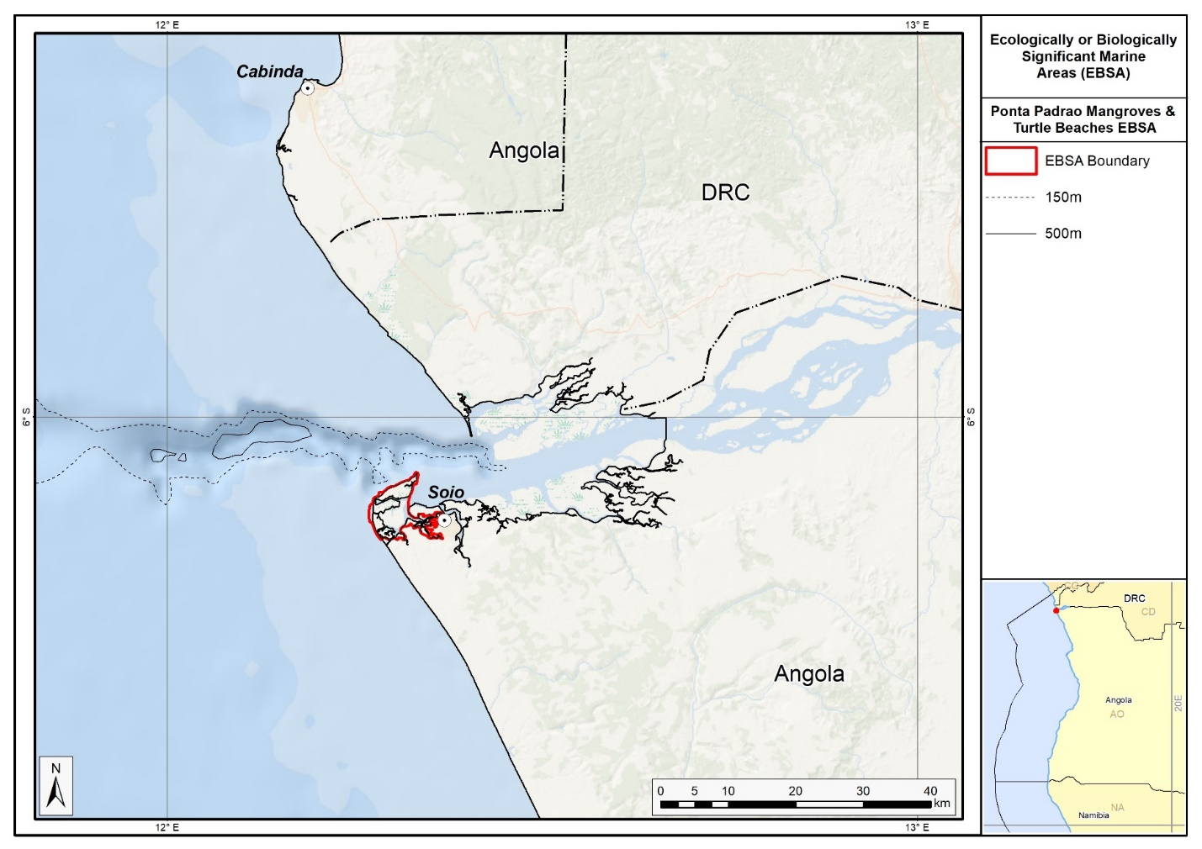
Map of the Ponta Padrao Mangroves and Turtle Beaches area.

Rights and permissions:
No limits on sharing or publication.

Côte d’Ivoire

7. L’Embouchure de la Lagune Aby (description of a new area)
How was the submission developed?
La soumission a été développée dans le cadre du projet Gestion Intégrée de l’Aire marine d’Importance Écologique et / ou Biologique et Côtière d’Abidjan à Assinie (GIAMAA). Le processus de description de l’Aire marine d’Importance Ecologique et / ou Biologique de l’embouchure de la lagune aby (Côte d’Ivoire, Afrique de l’ouest) a porté sur différentes étapes et différents acteurs. Il a commencé par l’information et la sensibilisation des parties prenantes sur la thématique, des ateliers de renforcements de capacité, de collectes de données, de validations, de vérification d’informations. Plusieurs acteurs clés ont pris part à ces activités notamment les autorités administratives et politiques, les autorités coutumières, les coopératives de pêcheurs, les mareyeuses, les associations des jeunes, les associations des femmes, les ONGs locales, les opérateurs économiques et la communauté scientifique.

Where is the submission intended to be included?
[X] EBSA repository
[ ] EBSA information-sharing mechanism

Abstract:
Cette zone, qui se caractérise par une forte biodiversité et remplit des fonctions écologiques essentielles, englobe les îles Ehotilé, le canal d’Assinie et les eaux côtières avoisinantes. Elle abrite une diversité d’écosystèmes (mangroves, herbiers marins, vasières et zones profondes), qui soutiennent une faune abondante : tortues marines, poissons, crustacés, lamantins et oiseaux migrateurs. Sa productivité est renforcée par les remontées d’eau froide et le brassage des eaux marines et lagunaires.

Introduction:
Dans l'optique d'aider ses États membres à mettre en place une politique de gestion intégrée et durable de leurs zones marines et côtières, la Convention relative à la coopération en matière de protection et de mise en valeur du milieu marin et des zones côtières de la région de l'Afrique de l'Ouest, du Centre et du Sud, à laquelle la Côte d'Ivoire fait partie, développe en partenariat avec le Centre d'Expertise Norvégien GRID Arendal, un projet dénommé « Marine Management In West Africa through Training and Application » visant la conservation des écosystèmes marins et côtiers et de la biodiversité. Ce projet a pour objectif de promouvoir l'utilisation durable des ressources marines et côtières et l'utilisation à long terme des services écosystémiques.

La Côte d'Ivoire a été retenue au titre des pays bénéficiaires de projet pilote. Ce projet porte sur la Gestion Intégrée de l’Aire marine d’Importance Écologique et / ou Biologique d'Abidjan à Assinie (GIAMAA). Il se décline en trois principales activités, que sont la rédaction du Rapport de l’État de l’Environnement Marin de la Côte d’Ivoire (REEM-CI), l’identification et la description d’Aires marines d’Importance Écologique et/ou Biologique (AIEB) et la Planification Spatiale Marine (PSM).

La Côte d’Ivoire est située en Afrique de l’Ouest et fait frontière avec le Liberia, la Guinée, le Mali, le Burkina Faso et le Ghana. Au Sud, elle est limitée par l’Océan Atlantique. Elle dispose d’une façade maritime de 200 NM qui s’étend du cap des Palmes, à l’extrême Ouest (frontière du Liberia) au cap des Trois Pointes, à l’Est à la frontière du Ghana (Lemasson et Rebert, 1968 ; Koffi et al.,1993 ; Abe, 2005 ; Abe et Kaba, 1997). Le littoral est long de 566 km. Le plateau continental ivoirien est étroit, abrupt et peu accidenté dans son ensemble. Il a une largeur qui varie de 20 à 35 km. Il est de 20 km au Cap des Palmes, s’élargit pour atteindre 35 km dans la région d’Abidjan et se rétrécit enfin à 24 km à l’extrême Est. La superficie totale du plateau continental est d’environ 12 200 km² dont plus d’un quart appartient à l’Aire marine d’Importance Écologique et / ou Biologique d’Assinie dans laquelle est incluse l’aire (Abé et Kaba, 1997 ; Anoh et Pottier, 2008).

La Côte d’Ivoire dispose de quatre (04) Aires marines d’Importance Écologique ou Biologique (AIEB), adoptées à la COP 12 (2014), sont : (1) le Canyon et le mont sous-marin de Tabou ; (2) la route des crevettes et des sardines ; (3) le Canyon et le trou sans fond d’Abidjan ; (4) la zone de reproduction des thons et espèces associées du large. Une cinquième AIEB, embouchure de la lagune Aby, a été désignée par la Côte d’Ivoire au niveau national en 2020. Le présent document sur le site de l’Embouchure de la lagune Aby a pour objet de soumettre le site en question à la CDB pour être érigé en Aire marine d’Importance Écologique et / ou Biologique (AIEB). Plusieurs raisons militent en faveur de ce classement notamment le nombre élevé d’écosystèmes et d’habitats comparativement aux autres aires marines du pays, la préservation des services écosystémiques de la région, la diversité élevée d’animaux aquatiques menacés et / ou vulnérables, la diversité élevée du nombre d’espèces vulnérables et / ou en extinction, la diversité élevée de la faune aviaire avec plus de 143 espèces. De plus, au niveau national, le site regorge d’un parc national et au niveau international, il a été érigé en site « RAMSAR ». Enfin parmi les aires prioritaires établies par l’Organisation Non Gouvernementale, ‘’Conservation Internationale’’; le site est caractérisé par : M6 : Haute priorité pour la conservation des mammifères ; B4 : Haute priorité pour la conservation des oiseaux ; AFW7 : Très haute priorité pour la conservation des écosystèmes d’eau douce et M7 : Très haute priorité pour la conservation des écosystèmes marins.

Une des prochaines étapes concernant les AIEB de la Côte d’Ivoire est la création d’Aires Marines Protégées (AMP). Dans ce contexte cinq (5) projets de création d’aires marines protégées i incluses dans les Aires marines d’Importance Écologique et / ou Biologique (AIEB) sont à l’étude. Le site de Grand-Béreby pris comme pilote a été officiellement créé par le décret n°2022-448 du 6 juillet 2022. La gestion de l’Aire Marine Protégée de Grand – Béréby est assurée par l’Office Ivoirien des Parcs et Réserves (OIPR).

Location:
L’embouchure de la lagune est en partie comprise dans l’aire marine d’Assinie et se situe entre 4°5’ et 3°0’ de latitude nord et 2°5’ et 3°5’ de longitude ouest. Elle regroupe les îles Ehotilé (722 ha), le canal d’Assinie et l’embouchure du complexe lagunaire Aby-Tendo-Ehy (300 ha), et les eaux côtières jouxtant l’embouchure (600 ha).

Feature description of the area:
L’aire est située à Assinie (région du Sud-Comoé, Côte d’Ivoire). Le site est une zone à haute valeur écologique et biologique, essentiel pour la conservation de la biodiversité marine ivoirienne. Il constitue un écosystème modèle de coexistence entre milieux lagunaires et marins. Ce site est l’unique zone deltaïque de Côte d’Ivoire et abrite une grande diversité d’espèces endémiques et menacées. Il joue un rôle écologique majeur car zone de reproduction, d’alimentation et de refuge pour de nombreuses espèces. Toutefois, ce site est vulnérable car les écosystèmes en particulier le mangroves et d’autres habitats sensibles sont menacés par les pressions anthropiques (pollution, surpêche) et l’érosion côtière. Cette description portera sur les aspects géologique, géomorphologique, climatique, hydrologique, régime thermique des eaux, salinité des eaux, littoral, littoral vers le large, remonté des eaux froides et productivité.

Au plan géologique, le complexe repose sur une mosaïque de sols qui s’est développée selon la topographie et la profondeur de la nappe phréatique (Koffi et al., 1993). Dans les zones surélevées, sur des sables du quaternaire, sont présents des sols ferralitiques fortement dénaturés. Cette texture sableuse à sablo-argileuse confère aux horizons de surface de ces sols une fertilité très moyenne. Dans les zones basses, les sols sont hydromorphes humiques ou podzolisés avec une fertilité pratiquement nulle. Cette podzolisation est favorisée par la perméabilité des sables grossiers, la forte pluviométrie et la faible profondeur des nappes phréatiques.

Au plan géomorphologique, la zone humide de l’embouchure de la lagune Aby appartient à l’étroit cordon littoral de très basse altitude, qui constitue une barrière pour le complexe des lagunes Aby-Tendo-Ehy (Koffi et al., 1993). Ce cordon est périodiquement submergé lors des fortes marées d’équinoxe, qui surviennent en mars et en septembre (Diabagaté, 2008). L’exutoire de ce complexe lagunaire est constamment menacé par d’importants dépôts d’atterrissements apportés par la dérive littorale Ouest-Est du Golfe de Guinée (Konan et al., 2016). Cet exutoire permet un échange constant entre les eaux douces et les eaux marines en amont duquel s’est développé par envasement de dépôts fluviaux et lagunaires, une zone deltaïque à laquelle appartiennent les îles Ehotilé.

Au plan climatique, l’aire est située dans le domaine tropical humide caractérisé par deux saisons de pluie (juin/juillet – octobre/novembre) et deux saisons sèches (août/septembre –décembre/mai). La grande saison pluvieuse qui couvre les mois de mars à novembre est interrompue par une petite saison sèche d’août à septembre. Elle est suivie de la petite saison des pluies en octobre ; puis vient la grande saison sèche qui dure de décembre à mai. La précipitation moyenne annuelle est de 2100 mm. La température moyenne annuelle est de 26,5°C avec des écarts de 1° à 3°C. L’humidité moyenne relative avoisine 85% (Sankare, 2007 ; Ali, 2009).

Au plan hydrologique, la région est drainée par les eaux douces du fleuve Tanoé, les eaux lagunaires et les eaux marines. Les eaux lagunaires présentent des salinités qui varient entre 0‰ et 30‰ et les eaux marines sont en permanence salées et plus ou moins supérieures à 35‰. Les apports en eaux continentales du complexe lagunaire-marin proviennent de plusieurs cours d’eau dont les plus importants sont : la rivière Bia au Nord, qui se déverse dans la lagune Aby, et la rivière Tanoé à l’Est, qui se déverse dans la lagune Tendo. Le milieu marin est soumis à des processus d’upwellings de fortes amplitudes (Verstraete, 1970). Ces upwellings contribuent à l’enrichissement des eaux marines en nutriments et à l’augmentation de la productivité primaire phytoplanctonique et secondaire zooplanctonique (Reyssac, 1966 ; Binet, 1972a ; 1979b ; Binet et al., 1972 ; Le Borgne et Binet, 1979, Djagoua, 2011). La production phytoplanctonique est comprise entre 500 et 8000 cellules/l soit 94 à 130 g C/m²/an alors que la production zooplanctonique varie entre 4 et 10 ml/m³ (N’Douba et Beibro, 2005).

Au plan du régime thermique des eaux, la température moyenne oscille entre 25 – 31°C aussi bien en lagune qu’en mer. Le minimum (25 – 27 ° C) s’observe durant la saison des pluies et le maximum (27 – 31 °C) d’Avril à Août pendant la saison sèche (Sankare, 2007 ; Ali., 2009).

Au plan de la salinité des eaux, en milieu marin, les valeurs observées sont comprises entre 30‰ et 35‰ avec de faibles niveaux de salinité durant les saisons de pluies et de crues et des salinités élevées pendant les saisons sèches et chaudes. Les eaux lagunaires sont relativement moins salées. Leurs salinités sont comprises entre 25 et 30‰ durant les saisons sèches et entre 0 et 15‰ en saisons de pluies et de crues. L’influence conjuguée des eaux marines et des eaux douces joue sur la plupart des paramètres physico-chimiques de l’aire et est responsable de la répartition des organismes vivants (N’Douba et Beibro, 2005).

Au niveau du littoral, l’aire est sablonneux et présente par endroits des dunes, des fourrés d’arbustes, des mangroves et des
cocoteraies (Osemwegie et al. 2016). Dans les mangroves bordant les îles Ehotilé, on note sur la principale île (Assoko-Monobaha), des sables mouvants qui dénotent de l’instabilité de certaines îles.

Du littoral vers le large, l’aire présente plusieurs habitats comprenant des sables moyens à très fins, des vases sableuses, des vases et des faciès particuliers comme les pelottes, les thanatocénoses et les algues calcaires. Les thanatocénoses représentent le faciès le plus important après les vases et comprennent de longs bancs rochers. La diversité écosystémique, notamment le milieu aquatique, l’embouchure, les îles, le cap des trois pointes, les mangroves, les canyons et les petits monts sous-marins contribuent à la diversification des habitats.

Upwellings et productivité, selon Martin (1969), l’aire fait partie du Golfe de Guinée et, de ce fait, est fortement influencée par le courant de Guinée et le contre-courant ivoirien. Ces différents courants engendrent dans la région, des upwellings côtiers durant les saisons de crue et de pluie. Selon Le Loeuff et Intes (1968), Verstraete (1970), Marchal (1994), ces upwellings sont importants et riches en nutriments, drainés par les cours d’eau notamment la Bia et le Tanoé, qui se déversent dans la région. La conséquence écologique de cette situation est la forte production de phytoplancton et de zooplancton observée dans l’aire (Reyssac, 1966 ; Binet, 1972a ; 1972b ; Le Borgne et Binet, 1979). Cette forte production primaire est à la base d’une chaine alimentaire dominée par les Poissons et particulièrement, les sardines. Selon Karamoko (2002), les nutriments de la région sont aussi à la base des proliférations des macroalgues, qui constituent une source de nourriture pour les crustacés et les tortues. Ces espèces les utilisent aussi comme refuges (Karamoko, 2002).

Diversité biologique, les habitats de l’aire sont diversifiés. Ceux-ci sont colonisés par de nombreuses espèces végétales et animales.

Espèces végétales lagunaires, dans le milieu lagunaire, Sankare (2007) a enregistré la présence de plusieurs espèces d’algues dominées par les Enteromorphes (Enteromorpha intestinalis (Linnaeus) et les Ulva. Sur les berges de presque toutes les îles sont signalées des mangroves luxuriantes de Rhizophora racemosa (G. Mey, 1818) à l’intérieur desquelles on observe par endroits des herbiers aquatiques tels que les Blutaparon vermiculare (L) Mears 1982 et Paspalum vaginatum (L. 1757) (Figure 2 et Figure 3). Durant la montée des eaux marines, les îles sont envahies et toutes les prairies sont submergées. Si le processus a lieu le jour, le lamantin Trichechus senegalensis (Johann H.F. 1795) demeure discret. Ce qui n’est pas le cas quand le processus se déroule la nuit. En effet, le lamantin Trichechus senegalensis (Johann H.F. 1795) qui est friand des herbiers envahit la zone pour brouter ces plantes aquatiques.

Espèces animales lagunaires, dans le même environnement, on rencontre des invertébrés dont les plus fréquents sont les mélanides, les Crabes nageurs et les Crevettes roses. Le milieu lagunaire est riche d’environ une soixantaine d’espèces de Poissons dont les plus abondants sont les Clupeidae Sardinella aurita (Valenciennes, 1847), Sardinella maderensis (Lowe, 1839), syn. S. eba (Valenciennes, 1847), Ethmalosa fimbriata (Bowdich, 1825). On observe également dans ce milieu le lamantin Trichechus senegalensis (Johann H.F. 1795), l’hippopotame amphibie Hippopotamus amphibius (Linnaeus, 1758), de nombreux oiseaux aquatiques et des chauves-souris du genre Chiroptera (Blumenbach, 1779).

Selon N’Douba et Beibro (2005), les Chauve-souris du genre Chiroptera (Blumenbach, 1779) colonisent par milliers les mangroves des îles Ehotilé. Leurs envols au crépuscule constituent un spectacle particulier (Figure 4). C’est le seul endroit sur le littoral de l’Afrique de l’Ouest où sont regroupés par milliers ces mammifères. Ces chauves-souris vont à la recherche de leur nourriture tous les soirs et de ce fait, envahissent le ciel de la lagune Aby. S’ajoutent à cette observation écologique, les vols des oiseaux aquatiques comme les martins pêcheurs piscivores et les éperviers, qui chassent leurs proies (OIPR ; 2013).

Espèces marines végétales, elles comprennent de nombreuses macroalgues vertes. Les espèces dominantes sont les Ulva et les Enteromorphes, brunes et rouges fixées dans le fond marin sur les rochers et dans les sédiments. Depuis quelques années, des algues brunes exotiques, les sargasses envahissent le milieu. Ces macroalgues viennent de l’Amérique, au Nord du Brésil. Il s’agit de Sargassum fluitans (Børgesen, 1914) et Sargassum natans (Agardh, 1820) qui envahissent le milieu et les plages quelques temps avant la saison des pluies. Avec les pluies et les crues on assiste à une baisse de la salinité en mer suivie de la disparition de ces plantes.

Espèces marines animales, cette catégorie d’espèces comprend la faune benthique dominée par les Mollusques dont les mytiles Mytilus perna (Linnaeus, 1758). Ces derniers servent aussi de nourritures aux Poissons et aux Crustacés représentés par les Langoustes Panulirus regius (de Brito Capello, 1864), les Cigales Scyllarides latus (Latreille, 1803) et les Crevettes roses Penaeus notialis (Pérez Farfante, 1967).

Les Poissons englobent les espèces pélagiques et démersales (Marchal, 1966 ; Barro, 1968 ; Troadec, 1968 ; Troadec, 1971 ; Garcia, 1972 ; Albaret et Gerlotto, 1976 ; Caverivière, 1994). Ces espèces comprennent entre autres Elops senegalensis (Regan, 1909),Tarpon atlanticus (Valenciennes, 1846) syn. Megalops atlantica (Valenciennes, 1846), Albula vupes (Linnaeus, 1758); Sardinella aurita (Valenciennes, 1847) ; Sardinella maderensis (Lowe, 1839), syn. S. eba (Valenciennes, 1847), Ethmalosa fimbriata (Bowdich, 1825), Ilisba africana (Bloch, 1795), Engraulis encrasicolas (Linnaeus, 1758), syn. Anchoa gihzeensis (Rossignol et Blache, 1961) ; Arius heudeloti (Valenciennes, 1840) , Hemiramphus brasiliensis (Linnaeus, 1758) , Adioryx bastatas (Valenciennes, 1829) , Dicentrarcbus punctatus (Bloch, 1792), syn. Morone punctata (Bloch, 1792) , Epinephelus (Cephalopholis) taeniops (Valenciennes, l828), Edagatis bipinnulata (Quoy et Gaimard, 1824), Seriola dumerili (Risso, 1810) et Caranx bippos (Linnaeus, 1766).

Les reptiles sont dominés par les tortues marines telles que la tortue luth Dermochelys coriacea, la tortue olivâtre Lepidochelys olivacea (Eschscholtz, 1829), la tortue verte Chelonia mydas (Linnaeus, 1758) et la tortue imbriquée Eretmochelys imbricata (Linnaeus, 1766). De plus, le littoral de la région constitue des lieux de nidification et de ponte de nombreuses espèces de tortues marines d’après Karamoko (2002).

Espèces amphidromiques, ces espèces sont dominées par les Crabes nageurs Callinectes amnicola (Rochebrune, 1883), les Crevettes roses Penaeus notialis Pérez (Farfante, 1967), les Poissons et particulièrement les Clupeidae : Ethmalosa fimbriata (Bowdich, 1825), Sardinella aurita (Valenciennes, 1847) et Sardinella maderensis (Lowe, 1839) et enfin, le mammifère aquatique, le Lamantin Trichechus senegalensis (Johann H.F., 1795).

Feature condition and future outlook:
Dans l’ensemble, l’aire est plus ou moins préservée. Cela est lié principalement au fait, que les îles Ehotilé et les eaux marines côtières font l’objet de surveillance par l’Office Ivoirien des Parcs et Réserves (OIPR) et des populations riveraines. Toutefois, à cause de la présence du Cap des trois pointes, des rochers et de falaises au niveau de la frontière avec le Ghana, le littoral situé en Côte d’Ivoire est relativement instable. La conséquence de cette situation est, que l’on enregistre des sables mouvants dans certaines îles avec les déplacements de l’embouchure, entrainant de fait, sa fermeture progressive ; ce qui contribue aux modifications qualitatives et quantitatives de la diversité biologique. Elle est amplifiée par l’extraction minière qui rejette des eaux usées dans le milieu aquatique. Compte tenu de l’importance écologique de cette aire marine et de l’insuffisance d’informations sur les sables mouvants, du processus de la fermeture progressive de l’embouchure et son déplacement, de l’existence des lamantins et des chauves-souris, ainsi que des baleines qui échouent sur les plages de la zone, l’État ivoirien a jugé utile de mettre en œuvre un programme d’étude sur la biodiversité et le fonctionnement de l’Aire marine d’Importance Écologique et / ou Biologique de l’embouchure de la lagune Aby.

Assessment of the area against CBD EBSA Criteria:
CBD EBSA Criteria  (Annex I to decision IX/20) | Description  (Annex I to decision IX/20) | Ranking of criterion relevance  (please mark one column with an X)
CBD EBSA Criteria  (Annex I to decision IX/20) | Description  (Annex I to decision IX/20) | No information |  | Low |  |  | Medium |  | High
Uniqueness or rarity | Area contains either (i) unique (“the only one of its kind”), rare (occurs only in few locations) or endemic species, populations or communities, and/or (ii) unique, rare or distinct, habitats or ecosystems; and/or (iii) unique or unusual geomorphological or oceanographic features. |  |  |  |  |  |  |  | X
Cette aire est la seule zone deltaïque de Côte d’Ivoire (Chantraine ,1980). Elle abrite 9 îles incluant les 06 îles du Parc National des îles Ehotilé et est caractérisée par:

Nombre élevé d’écosystèmes et d’habitats comparativement aux autres aires marines du pays :l’Aire est la seule aire marine ivoirienne, qui dispose de nombreux écosystèmes et d’habitats. Ces derniers comprennent le milieu lagunaire et les eaux marines côtières, un ensemble de neuf (09) îles (île Balouhaté, île Assoko-Monobaha, île Meha, île Elouamin, île Niamouin, île Napleou, île N’gramaina, île Esso, île Bosson Assoun) réparties dans un delta allant de la lagune Tendo au Sud-Ouest à la localité d’Assinie - Mafia au Sud-Est, des forêts de mangroves, un canal, une embouchure, les habitats de la colonne d’eau, les habitats des sédiments comme les sables, les vases, les argiles et leurs combinaisons, les habitats des macroalgues, les plages, etc.

Préservation des services écosystémiques de la région : l’Aire est un complexe de deux unités, le milieu lagunaire et les eaux marines côtières, qui se complètent dans leur fonctionnement et dans les services qu’ils rendent à la population. Les deux milieux communiquent à travers le canal d’Assinie. Les îles Ehotilé, en plus, jouent un rôle essentiel d’échanges entre l’Océan Atlantique et les écosystèmes de terre ferme. Leur position en aval et centrale du bassin versant des rivières Bia et Tanoé, leur permet de jouer un rôle important au niveau des mouvements d’eau et des échanges de matières. De ce fait, les îles Ehotilé amortissent les vagues et préservent les services du système. Elles régulent également les entrées d’eaux douces et leurs nutriments dans les eaux marines. Elles contribuent, en effet, à la balance des eaux. En revanche, les eaux marines côtières contribuent à la balance normale tant du point de vue climatique que fonctionnel de toute la région.

Aire prioritaire établie par l’Organisation Non Gouvernementale Conservation Internationale
l’Aire est caractérisée par les critères ci-après selon Bakarr et al. (2001)
M6 : Haute priorité pour la conservation des mammifères ;
B4 : Haute priorité pour la conservation des oiseaux ;
AFW7 : Très haute priorité pour la conservation des écosystèmes d’eau douce ;
M7 : Très haute priorité pour la conservation des écosystèmes marins.

L’Aire est également caractérisée par des particularités suivantes :
- Une des îles du delta abrite une importante colonie de chauve-souris. Il s’agit de l’île Balouaté. Les individus dont le nombre estimé à plusieurs milliers, font partie de l’espèce Heidolon helvumou appelées communément roussettes des palmiers. Ces chiroptères considérés comme les remplaçants des ancêtres disparus, sont respectés par les populations riveraines (N’Douba et Beibro, 2005 ; OIPR, 2013) ;
- Existence d’un site archéologique, l’archéologue français, Jean Poleta a effectué des fouilles sur les îles et a fait plusieurs découvertes. Les résultats de ces recherches disponibles à l’Université Félix Houphouët Boigny de Cocody-Abidjan ont permis de rétablir l’histoire des premières pénétrations des Européens en Côte d’Ivoire et le genre de relation qui existait entre ces peuples et ces Explorateurs.
- Enfin, la région est caractérisée par des upwellings qualifiés de matures, très riches en nutriments avec une production primaire relativement faible (Reyssac, 1966), une forte productivité secondaire (Binet, 1972 ; 1979), compensée par les algues géantes et une forte productivité de poissons et de crustacés (Sankare et al., 2010) ;
- Enfin, le site présente une forêt luxuriante de mangroves de Rhizophora racemosa (G. Mey, 1818) à l’intérieur desquelles on observe par endroits des herbiers aquatiques tels que les Blutaparon vermiculare (L. 1982) et Paspalum vaginatum (L. 1757)

Special importance for life-history stages of species | Areas that are required for a population to survive and thrive. |  |  |  |  |  |  |  | X
Les principales raisons qui ont motivé le classement élevé de l’Aire sont les suivantes :
Aire lagunaire et mangroves importantes sources de nutriments et d’aliments pour le cycle de vie de certains animaux aquatiques
- D’après N’Douba et Beibro (2005) et OIPR (2013), une bonne proportion de l’avifaune nidifie sur ce site. Il s’agit, notamment, de la sarcelle à oreillons Nettapus auritus, du cormoran africain Phalacrocorax africanus, de la cigogne épiscopale Ciconiae piscopus, etc. ;
- C’est une zone de refuge pour les pigeons verts soumis à la chasse sportive dans les milieux adjacents à la zone humide (N’Douba et Beibro, 2005 ; OIPR, 2013) ;
- C’est un lieu de refuge et de reproduction de la communauté de chiroptères (Chiroptera) qui est intensément braconnée vers les secteurs plus à l’Ouest (OIPR, 2013) ;
La zone offre des refuges à de nombreuses espèces de la faune aquatique durant une partie ou la totalité de leur cycle de vie dans le milieu.
- C’est le cas des Crabes nageurs, des Crevettes roses et des Crevettes grises Macrobrachium vollenhoveni, (Herklots, 1857)
- Dans leur phase juvénile ; de nombreux Poissons d’eau douce comme le tilapia (Tilapia sp.) et d’eau de mer tels que les ethmaloses, Ethmalosa fimbriata (Bowdich, 1825) et des liches Trachinotus teraia (Cuvier in Cuvier & Valenciennes, 1832).

Littoral sablonneux avec par endroits des plantations de cocotiers
- Le littoral est un lieu privilégié de nidification de la tortue verte. Les femelles pondent dans des nids sur les plages (Karamoko, 2002)
Importance for threatened, endangered or declining species and/or habitats | Area containing habitat for the survival and recovery of endangered, threatened, declining species or area with significant assemblages of such species. |  |  |  |  |  |  |  | X
Les principales raisons qui ont motivé le classement élevé de l’Aire sont les suivantes :

Diversité élevée du nombre d’espèces vulnérables et en extinction
Espèces menacées d’extinction (Voir Annexe I de la CITES et de la CMS) et intégralement protégées par la législation nationale selon N’Douba et Beibro (2005) :
- La tortue verte Chelonia mydas, l’éléphant de forêt Loxondonta africana cyclotis, le crocodile du Nil Crocodylus niloticus, le chimpanzé Pan troglodytes, le crocodile de forêt Osteolaemus tetraspis, le crocodile à long museau Crocodylus cataphractus, le lamantin Trichechus senegalensis
Espèces vulnérables (annexes II et III de la CITES et de la CMS) et protégées partiellement par la législation nationale :
- Plus d’une trentaine d’espèces de la faune aviaire du complexe est dans cette catégorie et notamment : l’aigle pêcheur africain Haliaetus vocifer, le balbuzard pêcheur Pandion haliaetus, le petit serpentaire Polyboroides radiatus, l’éffraie africaine Tyto alba, le touraco à gros bec Touraco macrorhynchus, le faucon ardoisé Falco ardociaceus, le milan brun/noir Milvus migrans, le palmiste africain Gypohierax angolensis, la sarcelle à oreillons Nettapus auritus, etc. (N’Douba et Beibro (2005).
- Des mammifères et reptiles de la zone sont également vulnérables selon la liste rouge de l’UICN: les serpents naja Naja sp., le chat doré Felis aurata, la loutre à joues blanches Aonyxcapensis, la loutre à cou tacheté Lutramaculi collis, l’hippopotame aquatique Hippopotamus amphibius, le chevrotain aquatique Hyemoschus aquaticus, la kinixys rongée (Kinixys erosa et les baleines : la baleine à bosse et la baleine à bec. (N’Douba et Beibro (2005).
Importance de la faune aviaire
La faune aviaire est riche de plus de 143 espèces (N’Douba et Beibro, 2005 ; Gueye et al., 2020). On y trouve des oiseaux d’eau l’anhinga d’Afrique Anhinga rufa, le cormoran africain Phalacrocorax africanus, le héron garde boeuf Ardeola ibis, le héron crabier Ardeola ralloides le héron à dos vert Butorides striatus, l’aigrette dimorphe Egretta gularis, le héron bihoreau Nycticorax nycticorax, la cigogne épiscopale Ciconia episcopus, le Dendrocygne veuve Dendrocygna viduata, etc., des oiseaux migrateurs le milan noir, Milvus migrans, le martin chasseur à tête grise Halcyon leucocephala, le martinet à dos blanc Apus affinis, le pigeon vert à font nu Treron australis, l’aigle pêcheur Haliaetus vocifer, le héron cendré, Ardea cinerea, l’aigrette garzette Egretta garzetta, le balbusard pêcheur Pandion haliaetus , le Vautour charognard Necrosyrtes monachus et le Perroquet jaco Psittacus erithacus,.

Importance de la faune halieutique
La faune aquatique, notamment celle des poissons, est l’une des plus abondantes du littoral ivoirien
Cette faune comprend les espèces suivantes : Elops senegalesis (Regan, 1909), Tarpon atlanticus (Valenciennes, 1846) syn. Megalops atlantica (Valenciennes, 1846), Albula vupes (Linnaeus, 1758) ; Sardinella aurita (Valenciennes, 1847) ; Sardinella maderensis (Lowe, 1839), syn. S. eba (Valenciennes, 1847), Ethmalosa fimbriata (Bowdich, 1825), quelques animaux plus ou moins inféodés aux zones humides : le lamantin Trichechus senegalensis. Des travaux récents ont permis de le localiser dans les îles Ehotilé (N’Douba et Beibro, 2005). Il s’agit de la Loutre à cou tacheté Lutra maculicolis et de la Loutre à joues blanches Aonyx capensis.

Par ailleurs, le complexe est classé D₁, c’est-à-dire d’importance biologique exceptionnelle par l’ONG Conservation Internationale (2001). Cette aire forme un vaste ensemble qui s’étend jusqu’au Ghana à l’est avec le complexe ghanéen de la lagune Aby et au cap des Trois Pointes du groupe d’Ankassa jema.
Vulnerability, fragility, sensitivity, or slow recovery | Areas that contain a relatively high proportion of sensitive habitats, biotopes or species that are functionally fragile (highly susceptible to degradation or depletion by human activity or by natural events) or with slow recovery. |  |  |  |  |  | X
Les principales raisons qui ont motivé le classement moyennement élevé de l’aire sont les suivantes :

Dégradation des écosystèmes et des habitats
L’embouchure est l’objet de fermeture progressive et de déplacement vers l’est (Koffi et al., 1993). Les habitats de fond tels que les fonds sableux ou vaseux ou les mélanges et surtout les habitats de rochers peuvent être détruits par les chaluts ou les phénomènes naturels d’érosion (Martin, 1979 ; Koffi et al., 1993). Ces fonds sont riches en espèces fragiles notamment les Crevettes roses dont le cycle biologique nécessite d’une part, les milieux précités et d’autre part, les milieux lagunaires ou les eaux saumâtres (Garcia, 1972).

Biological productivity | Area containing species, populations or communities with comparatively higher natural biological productivity. |  |  |  |  |  |  |  | X
Les principales raisons qui ont motivé le classement élevé de l’aire sont les suivantes :

L’Aire présente une forte productivité algale comparativement aux autres aires marines du pays. Sankare et al. (2010) y ont enregistré une forte productivité des Mollusques, des Crevettes roses, des Poissons tels que les sardines Sardinella sp. et les Ethmaloses Ethmalosa fimbriata. Cette situation serait liée à la diversité des habitats signalée dans les paragraphes précédents. Ainsi, à côté de la chaîne alimentaire classique, on note dans la région une productivité primaire due aux algues marines qui sont soit source d’habitats, soit source de nourriture pour certains Crustacés, Tortues marines et Poissons. Par conséquent, cette seconde chaine contribue à l’augmentation de la productivité de la région (Sankare et al., 2010).
Biological diversity | Area contains comparatively higher diversity of ecosystems, habitats, communities, or species, or has higher genetic diversity. |  |  |  |  |  |  |  | X
Les principales raisons qui ont motivé le classement élevé de l’aire sont les suivantes :

Forte productivité
La région est riche et très productive en macroalgues submersibles. Durant certaines périodes de l’année, et particulièrement après les saisons pluvieuses de juin à juillet, les Ulva et les Enteromorphes prolifèrent et envahissent toute la lagune et les eaux marines côtières.
Importance des mangroves
La région présente une mangrove riche, d’une surface de plus de 900 ha. Les racines de la mangrove piègent les sédiments et les vases riches en matières organiques et les feuilles mortes des arbres. L’ensemble est à la base de productions primaire bactérienne et algale riches et d’une chaine alimentaire aquatique dominée par les Crabes marcheurs, les Poissons brouteurs et herbivores. De plus, la région produit beaucoup d’herbiers aquatiques en l’occurrence les Paspalum vaginatum qui sont sources d’aliments pour les lamantins.

Forte production de Crustacés et de Poissons
- La région comporte de nombreuses espèces aquatiques avec des captures de Crabes nageurs qui dépassent 2500 tonnes par an et des prises de Poissons qui avoisinent 5000 tonnes par an (Sankare et al., 2010).
- La diversité biologique marine est très élevée comparativement à d’autres aires marines du pays. On y retrouve plus de 60 % des espèces marines de la Côte d’Ivoire. Celles-ci englobent les groupes taxonomiques tels que les Polychètes, les Mollusques, les Crustacés, les Poissons, les Reptiles et les Mammifères aquatiques marins comme les lamantins, les Oiseaux aquatiques (MarchaL, 1966a ; 1966b ; Le Loeuff et Intes, 1968 ; Caverivière, 1994 ; Marchal, 1994).
- La faune aviaire est riche de plus de 143 espèces (N’DOUBA et BEIBRO, 2005). On y trouve des oiseaux d’eau (Podiceps ruficollis (Grèbe castagneux), Anhinga rufa (Anhinga d’Afrique), Phalacrocorax africanus (Cormoran africain), Ardeola ibis (Héron garde boeuf), Ardeola ralloides (Héron crabier), Butorides striatus (Héron à dos vert), Egretta gularis (Aigrette dimorphe), Nycticorax nycticorax (Héron bihoreau), Ciconia episcopus (Cigogne épiscopale), Dendrocygna viduata (Dendrocygne veuve), etc., des oiseaux migrateurs (Milvus migrans (Milan noir), Halcyon leucocephala (Martin chasseur à tête grise), Apus affinis (Martinet à dos blanc), Treron australis (Pigeon vert à font nu), Haliaetus vocifer (Aigle pêcheur), Ardea cinerea (héron cendré), Egretta garzetta (Aigrette garzette), Pandion haliaetus (Balbusard pêcheur).
- La faune aquatique, notamment celle des poissons, est l’une des plus abondantes du littoral Ivoirien
Cette faune comprend les espèces suivantes : autres Elops senegalemis (Regan, 1909), Tarpon atlanticus (Valenciennes, 1846) syn. Megalops atlantica (Valenciennes, 1846), Albula vupes (Linnaeus, 1758); Sardinella aurita (Valenciennes, 1847) ; Sardinella maderensis (Lowe, 1839), syn. S. eba (Valenciennes, 1847), Ethmalosa fimbriata (Bowdich, 1825), quelques animaux plus ou moins inféodés aux zones humides : Trichechus senegalensis (Lamantin). Des travaux récents ont permis de le localisé dans les îles Ehotilé. Il s’agit de la Loutre à cou tacheté (Lutra maculicolis) et de la Loutre à joues blanches (Aonyx capensis).

Naturalness | Area with a comparatively higher degree of naturalness as a result of the lack of or low level of human-induced disturbance or degradation. |  |  |  |  |  |  | X
Les principales raisons qui ont motivé le classement moyennement élevé de l’aire sont les suivantes :

Les Zones nationales protégées dans la région
Dans cette région on enregistre des aires de conservation d’importance nationale comme le Parc National des îles Ehotilé

Les zones protégées d’importance internationale
Ce sont le site RAMSAR des îles Ehotilé et le site Ehotilé Essouman proposé comme bien mixte (culturel et naturel) sur la liste du patrimoine mondial de l’UNESCO.
Le site regorge de plusieurs Aires marines d’Importance Écologique et / ou Biologique reconnues comme la route des sardines.
Comparativement aux autres aires marines et côtières des eaux territoriales, l’aire présente un caractère naturel ou sauvage préservé à cause de la proximité de la frontière avec le Ghana. De plus, certains habitats ne permettent pas l’accès aux eaux marines côtières par la plage. Ces milieux peu accessibles constituent des écosystèmes propices à la nidification des tortues marines. En effet, ces dernières évitent les zones habitées ou occupées par l’homme. Toutefois, cette aire marine est fréquentée depuis quelques temps par des pêcheurs clandestins artisanaux allochtones comme autochtones qui pêchent dans les eaux marines côtières (Sankare et al., 2010) et qui s’attaquent aussi aux bois pour faire des « acadja » et des bois d’énergie dont la proportion est estimée actuellement entre 30% et 40% de destruction. Toutefois, les agents de l’OIPR et certaines populations riveraines surveillent les activités sur les plans d’eaux lagunaires et marines.
References:
Abé J. et Kaba N. 1997. Côte d’Ivoire : Profil environnemental de la zone côtière. Rap. ONUDI-FEM, 151p
Abe J., 2005. Contribution à la connaissance de la morphologie et de la dynamique sédimentaire du littoral Ivoirien (cas du littoral d’Abidjan): Essais de modélisation en vue d’une gestion rationnelle. Thèse de Doctorat d’Etat Sc. Nat, Université de Cocody. Abidjan, Côte d’Ivoire.
Albaret J.-J. et Gerlotto F., 1976. Biologie de l’ethmalose (Ethmalosa fimbriata, Bowdich) en Côte d'Ivoire. 1. Description de la reproduction et des premiers stades larvaires. Doc. Sci. Centr. Rech. Océanogr. Abidjan, 7(1) : 113-133.
Ali K. E., 2009. Relation entre les variations de la température de la surface de la mer et des précipitations le long de la bande côtière du Nord du Golfe de Guinée. Thèse de l’Université de Cocody, Abidjan, Côte d’Ivoire.
Anoh K.P. et Pottier P., 2008. Géographie du littoral de Côte-d’Ivoire : éléments de réflexion pour une politique de gestion intégrée. CNRS-LETG UMR 6554 et IGT : Nantes – Abidjan. Les Cahiers d’Outre-Mer, 251: 485-489.
Bakarr M., Bailey B., Byler D., Ham R., Oliveiri S., Omland M., et Semkow K. 2001. De la forêt à la mer : les liens de biodiversité de la Guinée au Togo. Conservation internationale. ISBN : 1-881173-57-7. www.conservation.org; 78 p
Barro M., 1968. Première estimation sur la croissance des Brachydeuterus auritus (Val. 1834) en Côte d'Ivoire. Doc. Sci. Centr. Rech. Océanogr. Abidjan, 31, 18 p.
Barro M., 1979. Reproduction de Brachydeurerus auritus (val. 1831) (poissons, Pomadosyidae) en Côte d’Ivoire. Doc. Scient. Centre Rech. Océanogr. Dakar-Thiaroye, 68: 57-62.
Binet D., 1972. Variation des biovolumes de zooplancton du plateau continental entre le cap des palmes et le cap des trois pointes. Doc. Scient. Centre Rech. Océanogr. Abidjan, 3(2): 60-93.
Binet D., 1979. Estimation de la production zooplanctonique sur le plateau continental ivoirien. Doc. Sci. Centr. Rech. Océanogr. Abidjan, 10(1): 80-97.
Binet D., Gaborit M. et Roux M., 1972. Copépodes pélagiques du plateau ivoirien. Utilisation de l’analyse des correspondances dans l’étude des variations saisonnières. Doc. Sci. Centr. Rech. Océanogr. Abidjan, 3(1) : 47-79.
Caverivière P., 1994. Les peuplements ichtyologiques démersaux, écologie et biologie. In : Le Loeuff P., Marchal E. et Amon Kothias J-B (eds). Environnement et ressources aquatiques de Côte d’Ivoire. Tome 1 : Le milieu marin. CRO, 583 p.
CDB, 2014. Atelier régional de l’atlantique sud-est pour faciliter la description des aires marines d’importance écologique et / ou biologique. Swakopmund, Namibie, 8-12 avril 2013. Rapport de synthèse, 5 p.
Chantraine J-M, 1980 ; la lagune aby (Côte d’Ivoire) :morphologie, hydrologie,paramètre physico-chimiques Doc. Sci. Centr. Rech. Océanogr. Abidjan,2 .39-77:
Convention Internationale, 2001. Conservation des espèces migratrices appartenant à la faune sauvage. Annexes I et II, 21 p.
Convention Internationale, 2017. Commerce des espèces de faune et de flore sauvages menacées d'extinction. Annexes I, II & III (02/01/2017), 75 p.
Diabagaté S., 2008. Le littoral ivoirien face aux risques naturels. DEA, Université de Cocody, Abidjan, Côte d’Ivoire.
Djagoua, É.V., Larouche, P., Kassi J.B., Affian, K. et Saley M.B., 2011. Variabilité saisonnière et interannuelle de la concentration de la chlorophylle dans le Golfe de Guinée à partir des images Sea-WiFS. International Journal of Remote Sensing, 32(14): 3851-3874.
Garcia S., 1972. Biologie de Penaeus duorarum en Côte d'Ivoire. II : Ponte et migration. Doc. Sci. Centr. Rech. Océanogr. Abidjan, 3(1) : 19-45.
Gueye M.F., Odoukpe K. S.G., N’goran A.P-N. et Yaokokore-Beibro K.H.,2020. Diversité des Oiseaux du littoral Sud-Est ivoirien. International Journal of Innovation and Scientific Research 48 (2) : 154-163
Karamoko M., 2002. Identification et étude de la reproduction, de la distribution géographique et des facteurs de menace des tortues marines migrant sur le littoral ivoirien : cas du département de Tabou. Mémoire de DEA, UFR Biosciences. Université de Cocody, Abidjan, Côte d’Ivoire.
Koffi K. Ph., Affian K. et Abe J., 1993. Contribution à l'étude des caractéristiques morphologiques de l'unité littorale de côte d'ivoire, golfe de guinée. Cas du périmètre littoral de Port-bouët. J. Ivoir. Océanol. Limnol., 2(1): 43-52.
Konan, K.E., Abe, J., Aka, K., Neumeier, U., Nyssen, J., Ozer, A., 2016. Impacts des houles exceptionnelles sur le littoral ivoirien du Golfe de Guinée. GEO Morphologie, 22(1), 105-120.
Le Borgne R. et Binet D., 1979. Dix ans de mesures de biomasses de zooplancton à la station côtière d’Abidjan : 1969-1979. Doc. Sci. Centr. Rech. Océanogr. Abidjan, 10(2): 165-176
Le Loeuff P. et Intes A., 1968. La faune benthique du plateau continental de côte d’ivoire, récoltes au chalut, abondance, répartition, variations saisonnières (mars 1966, février 1967). Doc. Sci. Centr. Rech. Océanogr. Abidjan, 25, 78 p.
Lemasson L. et Rebert J.P., 1968. Observations de courants sur le plateau continental ivoirien : mise en évidence d’un sous-courant. Doc. Scient. Prov. Centre Rech. Océanogr. Abidjan, 22, 66 p.
Marchal E.G., 1966. Œufs, larves et post-larves de l’anchois du golfe de guinée (Anchoviella guineensis). Doc. Sci. Centr. Rech. Océanogr. Abidjan, 5: 1-145.
Marchal E.G., 1994. Biologie et écologie des poissons pélagiques côtiers du littoral ivoirien. In : Le Loeuff P., Marchal E. et Amon Kothias J-B (eds). Environnement et ressources aquatiques de Côte d’Ivoire. Tome 1 : Le milieu marin. CRO, 583 p.
N’Douba V. et Beibro H. Y., 2005. Site RAMSAR : Iles Ehotilé et Essouman. Fiche descriptive sur les zones humides RAMSAR (fdr). Comité RAMSAR de Côte-d’Ivoire (CONARAMS), Ministère des Eaux et Forêts ; Direction de la Faune et des Ressources Cynégétiques. Rapport, 26p.
OIPR, 2013. Proposition d’inscription du parc national des îles Ehotilés sur la liste du patrimoine mondial. Ministère de l’Environnement de la Salubrité Urbaine et du Développement Durable, Ministère de la Culture et de la Francophonie, Office Ivoirien des Parcs et Réserves, 42 p
OIPR, 2025. Coordonnées géographiques de l’AIEB de l’embouchure de la lagune Aby ( Côte d’Ivoire). Doc.rest.1 p.
Osemwegie, I., N’da Hyppolite, D., Stumpp, C., Reichert, B. and Biemi, J., 2016. Mangrove Forest Characterization in Southeast Côte d’Ivoire. Open Journal of Ecology, 6: 138-150. http://dx.doi.org/10.4236/oje.2016.63014
Reyssac T., 1966. le phytoplancton entre Abidjan et l’équateur pendant la saison chaude. Doc. Scient. Prov. Centre Rech. Océanogr. Abidjan, 2, 11 p.
Sankare Y., 2007. Bioécologie, exploitation et gestion des crabes nageurs Callinectes amnicola (decapode ; Portunidae) du complexe lagunaire Aby-Tendo-Ehy – Côte d’Ivoire). Thèse Doctorat Unique, Hydrobiologie, Ecologie Benthique, Université de Cocody, Abidjan, Côte d’Ivoire.
Sankare Y., Joanny T. et Amon Kothias J.B., 2010. Rapport d'exécution de la convention n° 2009 039 006 relative à l’évaluation des ressources maritimes halieutiques démersales et thonières de la Côte d’Ivoire conclue entre le CRO et le PAGDRH. RAPPORT, CRO/PAGDRH, 87 p.
Troadec J.P., 1971. Biologie et dynamique d’un sciaenidae ouest-africain Pseudolithus senegalensis (V.). Doc. Sci. Centr. Rech. Océanogr. Abidjan, 2(3): 225 p.
Verstraete J.M., 1970. Etude quantitative de l’upwelling sur le plateau continental ivoirien. Doc. Sci. Centr. Rech. Océanogr. Abidjan, 1(3) : 1-17.

Maps and Figures:

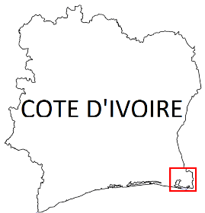

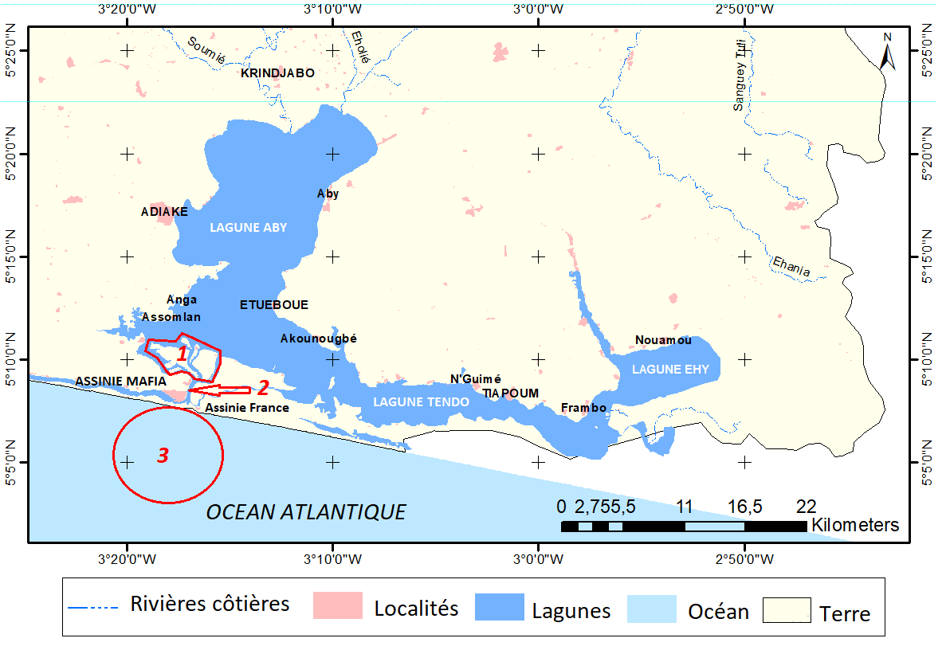

Plan de L’ Embouchure de da Lagune Aby.

Figure 1 : Complexe lagunaire Aby-Tendo-Ehy et de l’embouchure de la lagune Aby (Côte d’Ivoire, vue générale ; bleu : milieu lagunaire ; 1 : Parc National des iles Ehotilé ; 2 : Canal et embouchure de la lagune Aby ;3 : Eaux marines côtière)
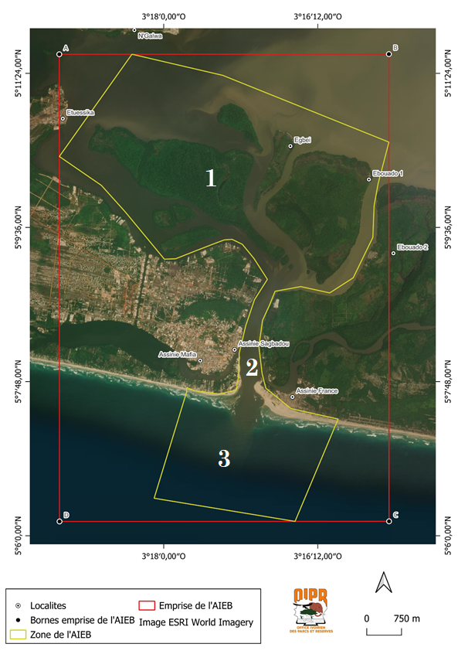
Figure 2 : Localisation et présentation de l’embouchure de la lagune Aby (Côte d’Ivoire, vue générale aérienne)
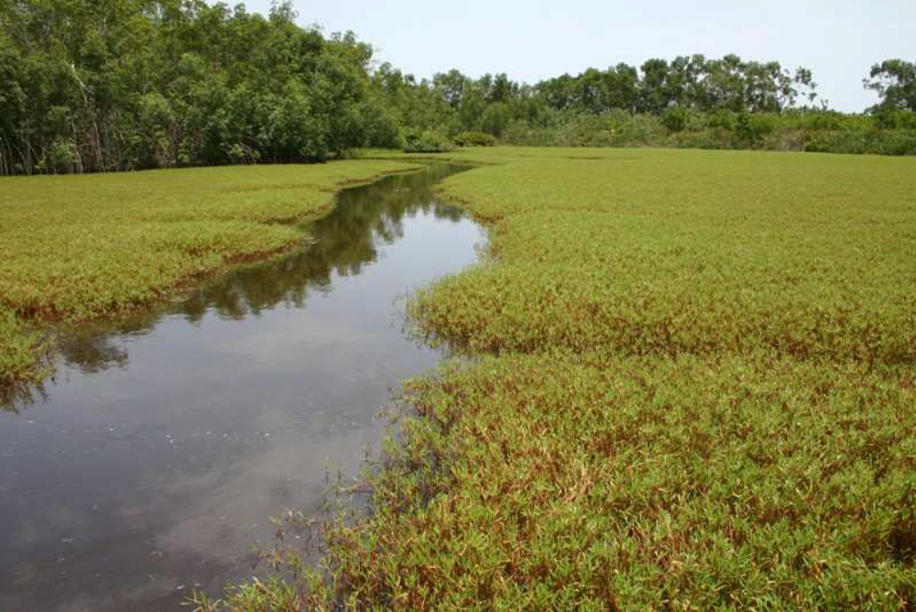

Figure 3 : Prairie de Blutaparon vermiculare (L. 1982), (île Balouhaté, Crédit OIPR, 2013)

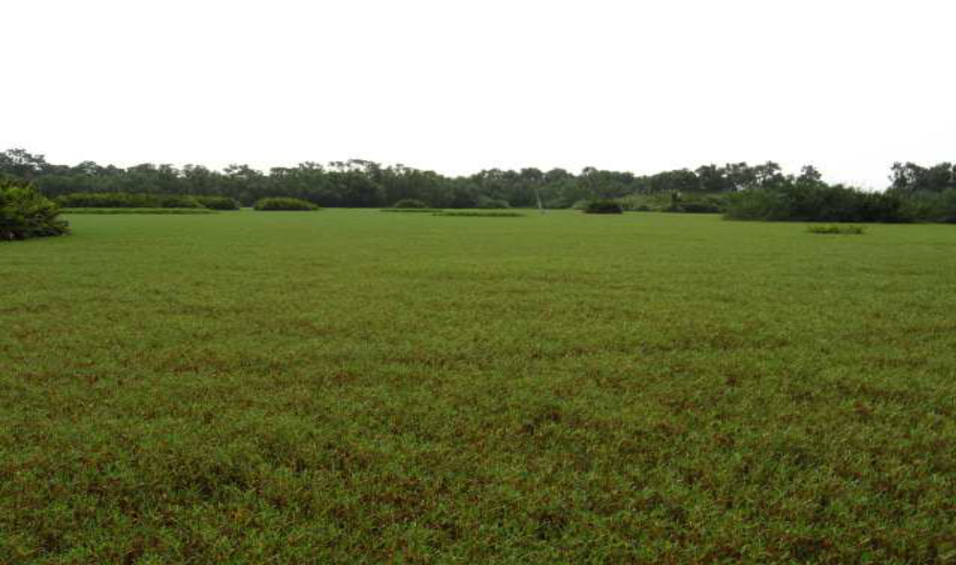
Figure 4 : Prairie de Paspalum vaginatum (L. 1757), (île Balouhaté, Crédit OIPR, 2013)

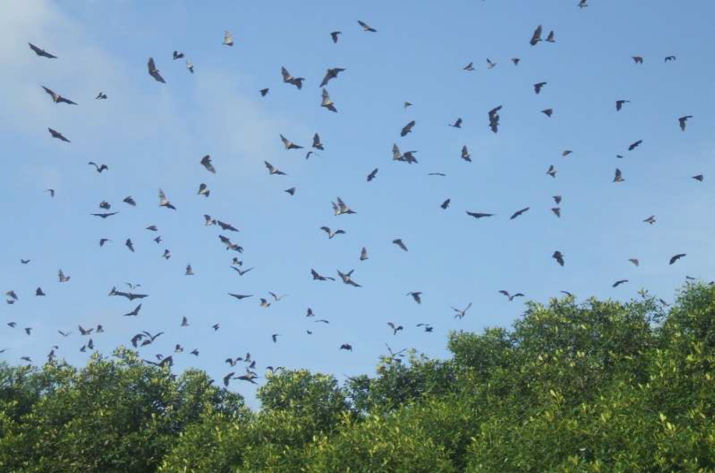

Figure 5 : Envol au crépuscule des chauves-souris de l’espèce Heidolon helvumou (Blumenbach, 1779) de l’embouchure de la lagune Aby (île Balouaté, Crédit OIPR, 2013)

Namibia

8. Cape Fria (description of a new area)

How was the submission developed?
The process to identify potential areas meeting EBSA criteria and to revise existing EBSA was part a broader project on ecosystem-based MSP in the BCLME, namely the Benguela Current Marine Spatial Management and Governance Project (MARISMA, 2014-2023). This was a regional capacity-building and development cooperation project implemented by the Benguela Current Commission, the Governments of Angola, Namibia and South Africa, and GIZ, the German Agency for Development Cooperation (Deutsche Gesellschaft für Internationale Zusammenarbeit.

The MARISMA project undertook a gap analysis of the existing EBSA network utilizing spatial data that was not available when the initial set of EBSA were described in South-Eastern Atlantic workshop, April 2013.

The overall approach to EBSA identification, delineation, description and engagement followed these key steps:

Initial Systematic Conservation Planning (SCP) Analyses: A gap analysis was undertaken, and new areas identified using systematic conservation planning tools such as Marxan, based on biodiversity input data including ecosystem types, species distributions, and ecological processes.

National Workshops: The boundaries of potential new areas and refined EBSA boundaries were iteratively reviewed and adjusted through workshops held within each of the three countries (Angola, Namibia, South Africa). These workshops allowed country-specific input and tailoring of boundaries and descriptions to national contexts and priorities.

Regional Workshops and Bilateral Meetings between Countries: Workshops at the regional level especially focused on transboundary EBSAs shared between the countries, but also examined the overall approach to EBSAs, their delineation, description and the engagement approach. The aim was to harmonize boundaries, align management recommendations, and foster cooperation across national borders for effective regional marine biodiversity management. Additional specific bilateral meetings were held where necessary.

Technical and Scientific Peer Review: The submissions underwent technical review nationally and regionally (through technical review workshops involving relevant experts); and internationally with a further regional review workshop with participation of experts from the Global Ocean Biodiversity Initiative (GOBI) and members of the CBD's Informal Advisory Group on EBSAs; ensuring robustness of the exercise. The process is documented in peer reviewed literature (Harris et al., 2019, 2022).

Political Approval: The submissions were administratively and politically approved through all required stages up to the national ministerial level in each country and were then submitted to the CBD Secretariat by the National CBD Focal Points.

Data Sharing and Accessibility: All information, including boundaries, status assessments, management recommendations, and stakeholder feedback, were made available through online repositories such as the project's EBSA Portal (https://cmr.mandela.ac.za/Research-Projects/EBSA-Portal); and the submissions were also shared via the Benguela Current Convention's Geodata Portal (https://geodata.benguelacc.org/ ). This facilitated transparency, accessibility, and ongoing updating of data and products for biodiversity specialists and other stakeholders.

The Cape Fria area was identified in a gap analysis as one of the two highest priority potential EBSA areas (along with Walvis Ridge Namibia) screened by the national EBSA process (including review of the spatial data from Holness et al. (2014) and inputs from expert workshops). The new sites were screened against the CBD criteria. Initial assessments indicated that it warranted inclusion. A final delineation and evaluation process was then undertaken, which resulted in the current description of the area.

The delineation process used a combination of Systematic Conservation Planning (SCP) and Multi-Criteria Analysis methods. The key features used in the analysis were:
- Irreplaceable and near irreplaceable (i.e. very high selection frequency) sites, as well as primary and secondary focus areas identified in the SCP undertaken for the BCLME by Holness et al. (2014).
- Threatened Benthic and Coastal Ecosystems. The analysis focussed on the inclusion of the most threatened ecosystem types found in the area. These types are highlighted in the table in the Other relevant website address or attached documents section. Key threatened ecosystem types were the endangered Central Namib Outer Shelf and the Kunene Outer Shelf, and the vulnerable Kunene Shelf Edge. Delineations and ecosystem threat status from Holness et al. (2014).
- Areas important for threatened and special species were included. The priority areas and buffer distances around colonies were from Holness et al. (2014). Note that the full extent of the buffer was not necessarily included in the area. Features included in the analysis were:
  - African Penguin colonies and a 20km buffer.
  - Bank Cormorant, Cape Cormorant, White Breasted Cormorant and Crowned Cormorant colonies and a 40km buffer.
  - Gannet colonies with a 40km buffer.
  - High density and diversity bird sites.
  - Seal Colonies and a 20km buffer.
- Areas of high relative naturalness identified in the SCP undertaken for the BCLME by Holness et al. (2014).
- Additional expert identified areas important for key bird species (especially Damara Tern, see Braby et al. 1992).

The multi-criteria analysis resulted in a value surface. The cut-off value (used to determine the extent of the area) was based on expert input and quantitative analysis of effective inclusion of the above features. This entailed taking an iterative parameter calibration-based approach whereby the spatial efficiency of the inclusion of the targeted features was evaluated. The approach aimed to identify a cut-off which most efficiently included prioritised features while minimizing the inclusion of impacted areas. The final boundaries shown in the map below were validated in an expert workshop.

Traditional knowledge was not incorporated into this process, and consultations with indigenous peoples or local communities were not undertaken. Therefore, documentation of Free, Prior and Informed Consent (FPIC) is not relevant for this EBSA process.

Where is the submission intended to be included (choose one option, and please note that there are different procedures for these two intended end points)?
[X] EBSA repository
[ ] EBSA information-sharing mechanism

Abstract:
The area includes Cape Fria and, further north, Angra Fria, a prominent bay. The Namibian continental shelf is narrowest in this area, where an intense upwelling cell drives high productivity and supports foraging by top predators. The upwelling cell also marks the northern boundary of the Benguela current, and, as a result, Cape Fria is in a biogeographic transition zone where biodiversity is elevated owing to overlapping species distributions. The site is critical for seasonal aggregations of almost the entire global population of Damara terns and is an important breeding area for Cape fur seals. The coast remains relatively pristine.
Introduction:
Cape Fria, also known as Cape Frio, is located along the northern Namibian coast, adjacent to the Skeleton Coast Park. This site was not included in the initial set of EBSAs proposed in Namibia because: it was identified only during a gap analysis of the Namibian EBSA network; local knowledge of the Damara Tern aggregations (see below) was not available at the original South Eastern Atlantic EBSA Workshop in 2013; and data and information on the area are both relatively limited because it is so remote. During the gap analysis, it was determined that Cape Fria is a separate area from the Namibe EBSA (previously named: Kunene-Tigres), rather than an extension of it, because it is centred around a separate upwelling cell that is not connected to the upwelling cell that enhances productivity in Namibe.

The Cape Fria area lies at the northern limit of the Benguela Current, possibly influenced by the Angola-Benguela Frontal Zone, and thus within the transition zone between the temperate and sub-tropical bioregions. The larger component extends 40 km offshore, and includes inshore waters on the narrowest portion of the Namibian shelf, spanning a depth range of 0-250 m. It also includes a narrower coastal extension for approximately 60 km alongshore to the south, and approximately 5 km offshore. The unusual shape of this area reflects the foraging ranges of different species that are responding to the upwelling-driven productivity. The broad northern portion is the foraging range of Cape fur seals, because that area supports an important breeding Cape fur seal colony. The narrower southern portion represents the foraging range of Damara Terns that rest on the adjacent shore. Interestingly, this area appears to contain almost the entire global population of Damara Tern on a seasonal basis. The Cape Fria area also includes important threatened benthic shelf habitats. This site comprises a collection of features and ecosystems that are connected by the same ecological processes, but some features (e.g., the Damara Tern aggregations) are ephemeral; therefore, it can be considered a Type 2/3 EBSA (sensu Johnson et al. 2018).

Location:
Cape Fria is located approximately 50 km south of the border between Angola and Namibia. The main body of the area extends 40 km offshore and 100 km along the coast, while an additional section of inshore habitat extends alongshore for approximately 60 km southwards with an offshore width of approximately 5 km. The area is entirely within the exclusive economic zone of Namibia.
The coordinates of a minimum bounding box covering the entire scope of the area are:
- Latitude: -17.908, -19.193, -19.523, -18.237
- Longitude: 11.777, 12.646, 12.159, 11.29.

Feature description of the area:
The Cape Fria area includes coastal and nearshore elements, and thus described for both benthic and pelagic features. It was identified in a gap analysis (using a systematic conservation planning approach) as an important inshore focus area for conservation of biodiversity features that are not yet sufficiently represented in the existing Namibian EBSA and marine protected area network (Holness et al., 2014). Local habitat heterogeneity is relatively high in this area, with 17 ecosystem types identified (Holness et al., 2014; Table in the Other relevant website address or attached documents section). Two of these habitats are Endangered: Central Namib Outer Shelf and Kunene Outer Shelf, with the area being particularly important for the latter. In addition, a small portion of the Vulnerable Kunene Shelf Edge ecosystem type is also found within the Cape Fria area. These threat statuses were determined by assessing the weighted cumulative impacts of various pressures (e.g., extractive resource use, pollution, development, and others) on each ecosystem type for Namibia (Holness et al., 2014; Table below).

Importantly, productivity offshore of Cape Fria is high because it is the site of the second-most intensive upwelling cell in Namibia. Here upwelling is driven both by wind and bottom topography because the site is at the narrowest portion of the continental shelf (Sakko, 1998); further, the wind shadow and poleward currents also contribute to phytoplankton blooms (Jury, 2017). This elevated productivity is at the heart of the area, because it consequently forms a key foraging area for several top predators. The Cape Fria coast supports an important breeding site for Cape fur seals, Arctocephalus pusillus pusillus, with an increasing local population, compared to largely declining populations in southern Namibia (Kirkman et al., 2012). These seals spend time foraging in the northern portion of the area. Cape Fria also supports several species of shore- and seabirds, including over-wintering Palearctic migrant bird species. Most notably, there is evidence that Cape Fria may contain, either seasonally or episodically, almost the entire global population of Damara Tern, Sternula balaenarum, a vulnerable species, endemic to the Benguela System (Braby et al., 1992). The focus area appears to be an annual congregation site prior to the flock migrating northwards. It has been suggested that this is likely to be linked to high food availability, i.e., a high-energy coastline with a presumably reliable food source that is available at night and within about 5 km of the shore. Damara Terns forage more in the southern portion of the area, closer to the shore compared to that of the seals.

Although bird diversity and abundance are fairly low at Cape Fria (Tarr & Tarr, 1987), it may support a relatively high local biodiversity overall because it is situated within the transition zone between the temperate and sub-tropical bioregions (Sakko 1998). Consequently, the communities at Cape Fria comprise species from both bioregions at the northern and southern limits of their respective distributions. This includes various linefish and other commercially important species, such as deep-water hake (Holtzhausen et al., 2001, Kirchner et al., 2011), large-eye dentex (Dentex macrophthalmus), thinlip splitfin (Synagrops microlepis), longfin bonefish (Pterothrissus belloci) and the African mud shrimp (Soleonocera africana; Bianchi et al., 1999).

Summary of ecosystem types and threat status for Cape Fria. Data from Holness et al. (2014).
Threat Status | Ecosystem type | Area (km²) | Area (%)
Endangered | Central Namib Outer Shelf | 243.0 | 5.0
 | Kunene Outer Shelf | 1 342.5 | 27.8
Vulnerable | Kunene Shelf Edge | 3.8 | 0.1
Least Threatened | Central Namib Inner Shelf | 829.4 | 17.2
 | Kunene Exposed Rocky Shore | 0.3 | 0.0
 | Kunene Inner Shelf | 1 551.1 | 32.2
 | Kunene Inshore | 275.4 | 5.7
 | Kunene Intermediate Sandy Beach | 61.0 | 1.3
 | Kunene Mixed Shore | 6.3 | 0.1
 | Kunene Reflective Sandy Beach | 1.9 | 0.0
 | Hoanib Dissipative-Intermediate Sandy Beach | 9.8 | 0.2
 | Hoanib Dissipative Sandy Beach | 7.0 | 0.1
 | Hoanib Exposed Rocky Shore | 0.4 | 0.0
 | Hoanib Inshore | 445.4 | 9.2
 | Hoanib Intermediate Sandy Beach | 38.4 | 0.8
 | Hoanib Mixed Shore | 7.9 | 0.2
 | Hoanib Sheltered Rocky Shore | 0.03 | 0.00
Grand Total |  | 4 823.8 | 100.0

Feature condition and future outlook:
Cape Fria and surrounds is a remote coastal area adjacent to the Skeleton Coast National Park. The focus area is inaccessible to the public, with only limited tourism permitted in the area, and consequently, this area is near-pristine. According to data from Holness et al. (2014) nearly 90 % of the area is classified as being in good condition, with almost all of the remaining area classified as being in fair condition. Inshore and coastal habitats are in particularly good condition and are effectively well protected as a result of their remote location and the terrestrial Skeleton Coast National Park. However, pending plans to build an industrial port and associated infrastructure at Cape Fria or Angra Fria (Paterson, 2007) could potentially impact this. Onshore and offshore prospecting and mining (i.e., diamonds, oil, precious metals) is minimal at present but is expected to occur in the future.

Assessment of the area against CBD EBSA Criteria:
CBD EBSA Criteria  (Annex I to decision IX/20) | Description  (Annex I to decision IX/20) | Ranking of criterion relevance  (please mark one column with an X)
CBD EBSA Criteria  (Annex I to decision IX/20) | Description  (Annex I to decision IX/20) | No information |  | Low |  |  | Medium |  | High
Uniqueness or rarity | Area contains either (i) unique (“the only one of its kind”), rare (occurs only in few locations) or endemic species, populations or communities, and/or (ii) unique, rare or distinct, habitats or ecosystems; and/or (iii) unique or unusual geomorphological or oceanographic features. |  |  |  |  |  | x
Cape Fria is both unique and rare for several reasons. It falls within a transition zone between the temperate and sub-tropical bioregions, and includes a relatively rare upwelling cell, second in intensity only to the Lüderitz upwelling cell. Further, a systematic conservation planning assessment (that was undertaken as a gap analysis) identified Cape Fria as an important inshore focus area for place-based conservation of biodiversity features that were not yet sufficiently represented in the existing Namibian EBSA and marine protected area network (Holness et al., 2014). Portions of this focus area were always required to meet biodiversity conservation targets, and hence it can be considered to be “irreplaceable”. Finally, existing evidence indicates that the area may either seasonally or episodically contain almost the entire global population of Damara Tern, Sternula balaenarum, a Benguela System endemic species (Braby et al., 1992). The area appears to be an annual congregation area prior to the flock migrating northwards. It has been suggested that this is likely to be a congregation area linked to high food availability, i.e., a high-energy coastline with a presumably reliable food source that is available at night and within about 5 km of the shore.
Special importance for life-history stages of species | Areas that are required for a population to survive and thrive. |  |  |  |  |  |  |  | x
Cape Fria is an important site for Cape fur seals, which, although it was only relatively recently established as a breeding colony, supports an increasing seal population (Kirkman et al., 2012). This site also exhibits strong terrestrial links because the expanding seal colony supports an expanding population of the Endangered Lappet-faced Vulture, Torgos tracheliotos (Braby, pers. comm.). The Cape Fria area is also an overwintering site for Palearctic waders, although at fairly low densities (Tarr & Tarr, 1987). Further, as noted previously, Cape Fria hosts almost the entire global population of Damara Tern either seasonally or episodically, in what seems to be an annual congregation area prior to the flock migrating northwards (Braby et al., 1992). It is likely that this is linked to high food availability at the site, i.e., a high-energy coastline with a presumably reliable food source that is available at night, and within about 5 km of the shore. Finally, Cape Fria is a transition zone between the cool, temperate southern areas that are influenced by the Benguela current, and a more sub-tropical climate to the north of Namibia (Tarr 1987), and thus may possibly be an important area for adaptation to climate change and range shifts. This is supported by the fact that the area constitutes the northern or southern limit for a number of fish species (Bianchi et al., 1999; Holtzhausen et al., 2001; Kirchner et al., 2011).
Importance for threatened, endangered or declining species and/or habitats | Area containing habitat for the survival and recovery of endangered, threatened, declining species or area with significant assemblages of such species. |  |  |  |  |  |  |  | X
The Cape Fria area contains two Endangered ecosystem types: Central Namib Outer Shelf and Kunene Outer Shelf, with the area being particularly important for the latter. In addition, a small portion of the Vulnerable Kunene Shelf Edge ecosystem type is found in this area. As noted previously, the site is also important for the Vulnerable Damara Tern, Sternula balaenarum (Braby et al., 1992), and for Cape fur seals that seem to be generally declining in abundance at rookeries in southern Namibia but increasing here (Kirkman et al., 2014).
Vulnerability, fragility, sensitivity, or slow recovery | Areas that contain a relatively high proportion of sensitive habitats, biotopes or species that are functionally fragile (highly susceptible to degradation or depletion by human activity or by natural events) or with slow recovery. | X
There is no information to guide ranking the area on this criterion. It could possibly be ranked low because the conditions are unstable and unpredictable, preventing very vulnerable species from persisting (Sakko 1998). However, it could also be argued that the Cape Fria upwelling cell is vulnerable to impacts from climate change.
Biological productivity | Area containing species, populations or communities with comparatively higher natural biological productivity. |  |  |  |  |  |  |  | X
There is an upwelling cell at Cape Fria that enhances local productivity (Sakko, 1998). Upwelling is year-round, but is intensified in winter and early spring (Hutchings et al., 2006; Jury, 2017). It is driven both by wind and bottom topography because the Namibian continental shelf is at its narrowest around Cape Fria (Sakko, 1998); further, the wind shadow and poleward currents also contribute to the phytoplankton blooms (Jury, 2017). This upwelling cell is second in intensity only to the Lüderitz upwelling cell, and the high productivity here that underpins the top predator foraging areas is at the heart of this site’s value.
Biological diversity | Area contains comparatively higher diversity of ecosystems, habitats, communities, or species, or has higher genetic diversity. |  |  |  |  |  | X
The Cape Fria focus area is an area of relatively high sub-tidal and coastal biodiversity because it is at the transition between temperate and sub-tropical biogeographic regions, with communities comprising species at their southern and northern bioregional limits (Sakko 1998). It is possible that this is enhanced by high productivity from the Cape Fria upwelling cell, and the close proximity to the Walvis Ridge, which has high habitat heterogeneity. Local habitat heterogeneity is also very high, with 17 habitats represented within the area, which is extremely high for the Namibian portion of the Benguela system (Holness et al. 2014).
Naturalness | Area with a comparatively higher degree of naturalness as a result of the lack of or low level of human-induced disturbance or degradation. |  |  |  |  |  |  |  |  | X
Cape Fria is a remote coastal area adjacent to the Skeleton Coast Park. The focus area is inaccessible to the public, with only limited tourism permitted in the area, and because of this, is currently near-pristine.
References:
Bianchi, G., Carpenter, K.E., Roux, J-P., Molloy, F.J., Boyer, D., Boyer, H.J. 1999. FAO species identification guide for fishery purposes. Field guide to the living marine resources of Namibia. Rome, FAO. 265pp.
Braby, R., Braby, S.J., Simmons, R.E. 1992. 5000 Damara Terns in the northern Namib Desert: a reassessment of world population numbers. Ostrich, 63: 133-135.
Harris, L., Holness, S., Finke, G., Kirkman, S., Sink, K., 2019. Systematic Conservation Planning as a Tool to Advance Ecologically or Biologically Significant Area and Marine Spatial Planning Processes, in: Zaucha, J., Gee, K. (Eds.), Maritime Spatial Planning. Palgrave Macmillian, Cham.
Harris, L.R., Holness, S.D., Finke, G., Amunyela, M., Braby, R., Coelho, N., Gee, K., Kirkman, S.P., Kreiner, A., Mausolf, E., Majiedt, P., Maletzky, E., Nsingi, K.K., Russo, V., Sink, K.J., Sorgenfrei, R., 2022. Practical Marine Spatial Management of Ecologically or Biologically Significant Marine Areas: Emerging Lessons From Evidence-Based Planning and Implementation in a Developing-World Context. Front. Mar. Sci. 9.
Holness, S., Kirkman, S., Samaai, T., Wolf, T., Sink, K., Majiedt, P., Nsiangango, S., Kainge, P., Kilongo, K., Kathena, J., Harris, L., Lagabrielle, E., Kirchner, C., Chalmers, R., Lombard, M. 2014. Spatial Biodiversity Assessment and Spatial Management, including Marine Protected Areas. Final report for the Benguela Current Commission project BEH 09-01.
Holtzhausen, J.A., Kirchner, C.H., Voges, S.F. 2001. Observations on the linefish resources of Namibia, 1990-2000, with special reference to West Coast steenbras and silver kob. South African Journal of Marine Science, 23: 135-144.
Hutchings L., Verheye H.M., Huggett J.A., Demarcq H., Cloete R., Barlow R.G., Louw D., da Silva, A. 2006. Variability of plankton with reference to fish variability in the Benguela Current Large Marine Ecosystem – an overview. In: Benguela – predicting a large marine ecosystem. Shannon V., Hempel G., Malanotte-Rizzoli P., Moloney C., Woods, J. (eds). Elsevier, Amsterdam. Pages: 91-124.
Johnson, D.E., Barrio Froján, C., Turner, P.J., Weaver, P., Gunn, V., Dunn, D.C., Halpin, P., Bax, N.J., Dunstan, P.K., 2018. Reviewing the EBSA process: Improving on success. Marine Policy 88, 75-85.
Jury, M.R. 2017. Coastal upwelling at Cape Frio: Its structure and weakening. Continental Shelf Research, 132: 19-28.
Kirchner C., Japp D.W., Purves M.G., Wilkinson, S. (eds) 2011. Benguela Current Large Marine Ecosystem. Annual state of fish stocks report. Windhoek. 92 pp.
Kirkman, S.P., Yemane, D., Oosthuizen, W.H., Meÿer, M.A., Kotze, P.G.H., Skrypzeck, H., Vaz Velho, F., Underhill, L.G. 2012. Spatio-temporal shifts of the dynamic Cape fur seal population in southern Africa, based on aerial censuses (1972–2009). Marine Mammal Science, 29: 497–524.
Paterson J.R.B. 2007. The Kunene River Mouth: Managing a unique environment. MSc Thesis, Unversity of KwaZulu Natal, Pietermaritzburg, South Africa: 124 pp.
Ryan, P. G., Cooper, J., Stutterheim, C. J. 1984. Waders (Charadrii) and other coastal birds of the Skeleton Coast, South West Africa. Madoqua, 14: 71-78.
Sakko, A.L. 1998. The influence of the Benguela upwelling system on Namibia's marine biodiversity. Biodiversity & Conservation, 7: 419-433.
Tarr, J.G, Tarr., P.W. 1987. Seasonal abundance and the distribution of coastal birds on the northern Skeleton Coast, South West Africa/Namibia. Madoqua, 15: 63-72.

Maps and Figures:
GIS data available at: https://cmr.mandela.ac.za/cmr/media/Store/documents/EBSA/Descriptions/Namibia/Namibia_EBSAs_2020-SHP.zip
\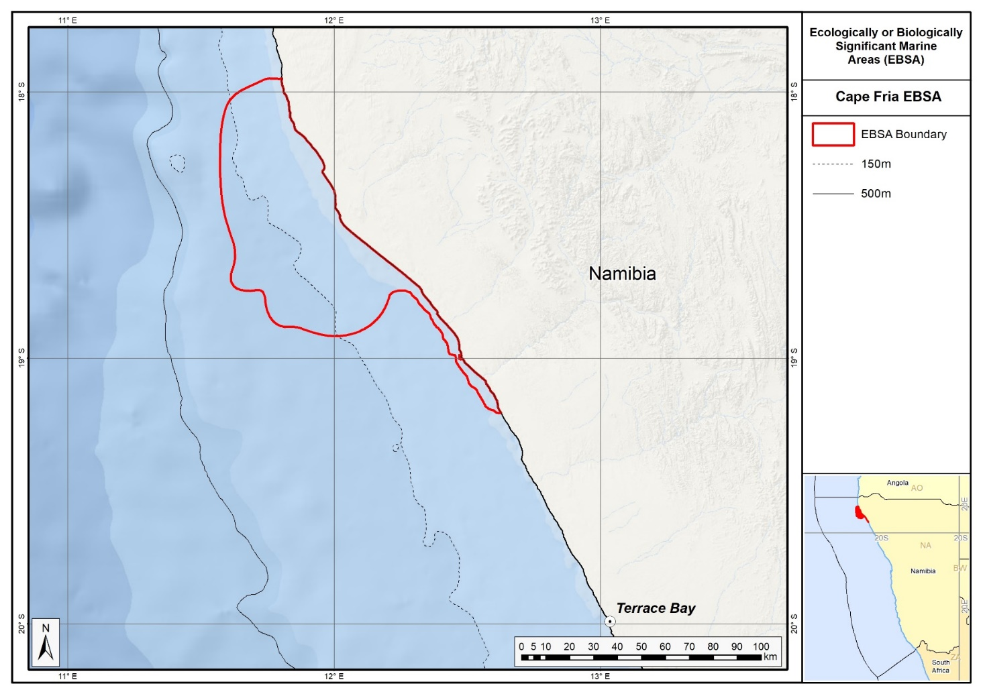
Map of the Cape Fria area.

Rights and permissions:
No limits on sharing or publication.

9. Namib Flyway (modification of the existing Namib Flyway)⁵
Reason for the modification:
The EBSA description is being modified because of newly available or accessible knowledge on features associated with the area, based on additional scientific data especially new systematic spatial planning and assessments of biodiversity. The descriptions and supporting information are substantially extended, updated and refined beyond the original descriptions from the South-Eastern Atlantic workshop, April 2013. The modifications involve changes to the textual description, changes to the ranking of the area against the EBSA criteria, and changes in shape, location and size of the area.

The original descriptions of Ecologically or Biologically Significant Marine Areas (EBSAs) in the Benguela Current Large Marine Ecosystem (BCLME) were described in the South-Eastern Atlantic workshop (April 2013). The descriptions were generally characterized by generic, often fairly geometric delineations, consisting of approximate bounding boxes around the features for which the EBSA was described. This coarse scale of delineation was appropriate for a global scale but posed challenges for inclusion in national-level, place-based ocean management. The original boundaries were not sufficiently refined to capture the full extent of key biodiversity features and often overlapped with areas of lower biodiversity value or in poor ecological condition.

Additionally, the original EBSA descriptions suffered from shortfalls related to limited spatial data and lack of systematic conservation planning approaches at the time they were first proposed. This meant that many boundaries did not precisely encompass biodiversity priority areas, potentially leading to conflicts with other ocean sectors and limiting their practical usefulness for marine spatial planning (MSP). The coarse scale and lack of detailed data constrained the ability to develop effective zoning and management recommendations that balance biodiversity protection with economic activities.

How was the submission developed?
The EBSA revision process was part a broader project on ecosystem-based MSP in the BCLME, namely the Benguela Current Marine Spatial Management and Governance Project (MARISMA, 2014-2023). This was a regional capacity-building and development cooperation project implemented by the Benguela Current Commission, the Governments of Angola, Namibia and South Africa, and GIZ, the German Agency for Development Cooperation (Deutsche Gesellschaft für Internationale Zusammenarbeit.

Because of these shortcomings of the existing EBSA boundaries, description and valuations set out in the previous section, the MARISMA project undertook a refinement process. This process used systematic conservation planning (SCP) tools, such as Marxan, to generate finer-scale, more accurate boundaries based on updated biodiversity data and expert input. This process also allowed for the identification of new EBSAs and the splitting of some original EBSAs into multiple refined areas to better reflect discrete biodiversity features and ecological processes. The refined EBSA boundaries were more suitable for MSP and conservation management because they focused on core natural and near-natural areas, avoided unnecessary conflicts with other sectors, and incorporated a systematic, data-driven approach to spatial prioritization.

The overall approach to the EBSA update and engagement followed these key steps:

Initial Systematic Conservation Planning (SCP) Analyses: Existing EBSAs were refined and new areas identified using systematic conservation planning tools such as Marxan, based on biodiversity input data including ecosystem types, species distributions, and ecological processes.

National Workshops: The refined and new EBSA boundaries were iteratively reviewed and adjusted through workshops held within each of the three countries (Angola, Namibia, South Africa). These workshops allowed country-specific input and tailoring of EBSA boundaries and descriptions to national contexts and priorities.

Regional Workshops and Bilateral Meetings between Countries: Workshops at the regional level especially focused on transboundary EBSAs shared between the countries, but also examined the overall approach to EBSAs, their delineation, description and the engagement approach. The aim was to harmonize boundaries, align management recommendations, and foster cooperation across national borders for effective regional marine biodiversity management. Additional specific bilateral meetings were held where necessary.

Technical and Scientific Peer Review: The revised and new EBSAs underwent technical review nationally and regionally (through technical review workshops involving relevant experts); and internationally with a further regional review workshop with participation of experts from the Global Ocean Biodiversity Initiative (GOBI) and members of the CBD's Informal Advisory Group on EBSAs; ensuring robustness of the exercise. The process is documented in peer reviewed literature (Harris et al., 2019, 2022).

Political Approval: The EBSAs were administratively and politically approved through all required stages up to the national ministerial level in each country and were then submitted to the CBD Secretariat by the National CBD Focal Points.

Data Sharing and Accessibility: All information, including refined EBSA boundaries, status assessments, management recommendations, and stakeholder feedback, were made available through online repositories such as the project's EBSA Portal (https://cmr.mandela.ac.za/Research-Projects/EBSA-Portal); and the EBSA were also shared via the Benguela Current Convention's Geodata Portal (https://geodata.benguelacc.org/ ). This facilitated transparency, accessibility, and ongoing updating of data and products for biodiversity specialists and other stakeholders.

The EBSA description was updated substantially by searching for and including all relevant information from the latest research within the area. This resulted in the addition of 14 new references to the original description, including the latest biodiversity information from the Ocean Biodiversity Information System (OBIS). A summary table of the represented habitats and their threat status was also included as supplementary information. Two criteria were upgraded by one category rank: Uniqueness and rarity was upgraded from Medium to High after consolidating the latest information, and Naturalness was upgraded from Low to Medium on the basis of the revised boundary, particularly because the heavily impacted areas were deliberately excluded in the new delineation.

The most important change to the EBSA was a significant refinement of the EBSA delineation. This was done to more closely focus the EBSA on the key biodiversity features that underlie its EBSA status to improve precision. The delineation process included an initial stakeholder workshop, a technical mapping process and a subsequent expert review workshop where boundary delineation options were finalised. A map showing the original and the revised EBSA boundaries is provided in the Maps and Figures Section.

The delineation process used a combination of Systematic Conservation Planning (SCP) and Multi-Criteria Analysis methods. The key features used in the analysis were:
- Irreplaceable and near irreplaceable (i.e. very high selection frequency) sites, as well as primary and secondary focus areas identified in the SCP undertaken for the BCLME by Holness et al. (2014).
- Threatened Benthic and Coastal Ecosystems. The analysis focussed on the inclusion of the most threatened ecosystem types found in the area. These types are highlighted in the table in the Other relevant website address or attached documents section. Key threatened ecosystem types were the endangered Central Namib Outer Shelf, Kuiseb Lagoon Coast and Kuiseb Mixed Shore. Delineations and ecosystem threat status from Holness et al. (2014). The Endangered pelagic habitat (Ca14) was also included.
- Areas important for threatened and special species were included. The priority areas and buffer distances around colonies were from Holness et al. (2014). Note that the full extent of the buffer was not necessarily included in the EBSA. Features included in the analysis were:
  - African Penguin colonies and a 20km buffer.
  - Bank Cormorant, Cape Cormorant, White Breasted Cormorant and Crowned Cormorant colonies and a 40km buffer.
  - Gannet colonies with a 40km buffer.
  - High density and diversity bird sites.
  - Seal Colonies and a 20km buffer.
- Boundaries of Important Bird and Biodiversity Areas (IBA).
- Areas of high fish species diversity from the NansClim project (See Holness et al. 2014 for details).
- Areas of high relative naturalness identified in the SCP undertaken for the BCLME by Holness et al. (2014).
- Additional expert identified areas important for cetaceans (especially Atlantic bottlenose, dusky, and the Heaviside dolphins). These are particularly areas off Pelican Point and sub-tidal areas shallower than 50m water depths.

The multi-criteria analysis produced a value surface. The cut-off value (used to determine the spatial extent of the EBSA) was based on expert input and quantitative analysis of effective inclusion of the above features. This entailed taking an iterative parameter calibration-based approach whereby the spatial efficiency of the inclusion of the targeted features was evaluated. The approach aimed to identify a cut-off which most efficiently included prioritised features while minimizing the inclusion of impacted areas. The final boundaries shown in the map were validated in an expert workshop.

Traditional knowledge was not incorporated into this process, and consultations with indigenous peoples or local communities were not undertaken. Therefore, documentation of Free, Prior and Informed Consent (FPIC) is not relevant for this EBSA process.

Where is the submission intended to be included (choose one option, and please note that there are different procedures for these two intended end points)?
[X] EBSA repository
[ ] EBSA information-sharing mechanism

Abstract:
Changes from the original version: The abstract was rewritten to emphasize the Namib Flyway’s refined spatial extent and ecological process connectivity underpinning it as a Type 2 EBSA (sensu Johnson et al. 2018) representing a collection of features and ecosystems that are connected by the same ecological processes. The revision highlights the recognition of importance for life-history stages, threatened species, and biological productivity with greater detail and updated conservation status compared to the earlier summary.

The Namib Flyway is a highly productive area in the Benguela system that attracts large numbers of seabirds, shorebirds, marine mammals, sea turtles and other fauna. It contains two marine Ramsar sites, six terrestrial important bird and biodiversity areas, two proposed marine important bird and biodiversity areas and vital spawning and nursery areas for some fish species. The upwelling cell off Lüderitz has its effect further north of that town owing to the longshore drift and predominant onshore winds. Thus, primary production of the Benguela current is highest in the central regions of the Namibian coast, driven by delayed blooming. The site comprises a collection of features and ecosystems that are connected by the same ecological processes. The area is highly relevant in terms of its importance for life-history stages of species, threatened, endangered or declining species, habitats and biological productivity.

Introduction:
Changes from the original version: The new introduction provides a more detailed ecological context, including the refined description of coastal features and upwelling influence, and notes the inclusion of additional IBAs and marine Ramsar sites, reflecting improved biodiversity knowledge and spatial accuracy.

The main coastal features contain two sheltered bays (Walvis Bay and Sandwich Harbour), another north-facing but less sheltered bay (Conception Bay), three lagoons (Cape Cross lagoons, Swakop River Mouth Lagoon, and Walvis Bay Lagoon), one cape (Cape Cross) and one man-made shallow water habitat (Mile 4 salt works); the remaining coastline is high energy. The sheltered bays and shallow waters lead to warmer waters and higher productivity. There is a weak upwelling cell off Walvis Bay, which adds to the productivity. The area has been recognized as an important area by the United Nations Environment Programme, African Eurasian Migratory Waterbird Agreement; and the Convention on Migratory Species or “Bonn Convention”. BirdLife International has been funding a seabird breeding project in this area through its Rio Tinto BirdLife Partnership action fund. Two of Namibia’s five Ramsar sites (Walvis Bay and Sandwich Harbour) are included; both Ramsar sites are of international importance for resident bird species as well as resident and transient marine mammals, and constitute key refueling and roosting habitats for many species of migrating waterbirds. Of Namibia’s 19 IBAs, six border or fall in the area (viz., Cape Cross Lagoon, Namib-Naukluft Park, Mile 4 salt works, 30 km beach Walvis-Swakopmund, Walvis Bay and Sandwich Harbour). The area also encompasses key spawning and nursery areas of various fish species, including sardine and anchovy - important forage fish for a range of marine predators.

Location:
Changes from the original version: The new description offers a more precise and expanded boundary, extending offshore up to 83 km in parts and narrowing in others, contrasting with the earlier fixed 50 nautical mile offshore extent; it also defines the EBSA as a connected ecologically based system rather than a single geometric polygon.
Using local knowledge of the area and its processes, the boundary of the original EBSA has been refined to improve precision. The Namib Flyway comprises two foraging areas in the north and south of the area, which are connected by a much narrower flyway corridor. The Namib Flyway extends from 18 km north of Cape Cross to 30 km south of Conception Bay, spanning approximately 380 km of coastline on the inshore area that borders the Dorob national park, Cape Cross seal reserve and the Namib-Naukluft park, roughly between latitudes S 21° and 24°. The northern and southern parts extend offshore for up to 83 km, and the central portion is a narrow strip that extends no further than 7 km offshore. The entire area falls within the exclusive economic zone of Namibia.
The coordinates of a minimum bounding box covering the entire scope of the area are:
- Latitude: -21.252, -24.144, -24.431, -21.539
- Longitude: 14.14, 14.961, 13.951, 13.13
Feature description of the area:
Changes from the original version: The updated feature description incorporates a broader range of species and habitats, refines population details (e.g., discrete Bottlenose Dolphin population), and adds ecosystem threat status data, improving upon the older description’s general listing of fauna and habitats. The description is also based on the features within the refined/revised geographic extent. The EBSA description was updated substantially by searching for and including all relevant information from the latest research within the area. This resulted in the addition of 14 new references to the original description, including the latest biodiversity information from the Ocean Biodiversity Information System (OBIS). A summary table of the represented habitats and their threat status was also included as supplementary information.
The coastline includes mixed rocky and sandy shoreline, which together with the adjacent marine inshore environment supports resident, Palearctic, Oceanic and intra-African migrant bird species. These include seabirds (e.g., terns, gulls, cormorants, gannets, shearwaters, albatrosses, petrels, skuas); shorebirds (e.g., plovers, sandpipers, turnstones, whimbrels, stints, oystercatchers, curlews, knots, godwits, avocets) and waterbirds (e.g., flamingos, ducks, grebes, coots, gallinules, herons). At least 17 threatened bird species occur in the area, either throughout the year or seasonally (Wearne & Underhill 2005, Simmons et al., 2015, IUCN 2016, SABAP_2 2017). Up to about 400,000 birds may be found during summer at Walvis Bay and Sandwich Harbour alone (Simmons 2002, Wearne & Underhill 2005). Cetaceans such as Bottlenose Dolphins, Heaviside’s Dolphins and Southern Right Whales also breed in this area; the small local inshore population of Bottlenose Dolphins appears to be discrete, utilizing a core area between Cape Cross and Sandwich Harbour (Findlay et al., 1992, Elwen & Leeney, 2009). Humpback and Minke whales are common in the area, whereas other species like Fin Whales, beaked whales and other cetaceans also occur there occasionally (e.g. Findlay et al., 1992); however, detailed distribution and population data for most cetacean species in the area are lacking. Seven threatened fish and condricthian species have been recorded in the Namib Flyway area (OBIS 2017), and it is also an important foraging area for leatherback turtles (Shackelton 1993, De Padua Almeida et al., 2003). Four Cape Fur Seal breeding colonies exist at Cape Cross, Pelican Point, Sandwich Harbour and Conception Bay (Kirkman et al., 2013); and the area includes seal foraging hotspots (Skern-Mauritzen et al., 2009). Altogether, there are records for 247 species from this area (OBIS 2017).
The Namib Flyway also includes three Endangered ecosystem types (Central Namib Outer Shelf, Kuiseb Lagoon Coast and Kuiseb Mixed Shore), with the area being particularly important for Central Namib Outer Shelf and Kuiseb Lagoon Coast. These threat statuses were estimated by assessing the weighted cumulative impacts of various pressures (e.g., extractive resource use, pollution, development, and others) on each ecosystem type for Namibia (Holness et al., 2014; Table below).

Summary of ecosystem types and ecosystem threat status for Namib Flyway. Data from Holness et al. (2014).
Threat Status | Ecosystem type | Area (km²) | Area (%)
Endangered | Central Namib Outer Shelf | 2 041.2 | 19.9
 | Kuiseb Lagoon Coast | 148.8 | 1.4
 | Kuiseb Mixed Shore | 28.4 | 0.3
Least Threatened | Central Namib Inner Shelf | 6 461.1 | 62.9
 | Kuiseb Dissipative-Intermediate Sandy Beach | 39.1 | 0.4
 | Kuiseb Exposed Rocky Shore | 0.03 | 0.0
 | Kuiseb Inshore | 1 361.6 | 13.2
 | Kuiseb Intermediate Sandy Beach | 148.8 | 1.4
 | Kuiseb Reflective Sandy Beach | 32.3 | 0.3
 | Kuiseb Sandy Beach Sandy Beach | 16.3 | 0.2
Grand Total |  | 10 277.6 | 100

Feature condition and future outlook:
Changes from the original version: The update provides a more detailed assessment of naturalness and condition, noting improvements due to refined boundaries excluding impacted areas, while explicitly listing current and emerging threats such as proposed industrial developments and climate change impacts.
The terrestrial part of the area to the low water mark is protected in three national parks, namely Dorob National Park, Cape Cross Seal Reserve and Namib-Naukluft Park. The area has three towns and a village: the main harbour town of Namibia: Walvis Bay, in addition to Swakopmund and Henties Bay and the village of Wlotzkasbaken. There is a political drive to expand the towns and village into the Dorob National Park irrespective of the biodiversity importance of the bordering terrestrial and coastal areas. This will require deproclamation. The marine component is partially protected by fishery management regulations such as a “no trawl zone” up to the 200-m depth contour; however, purse-seining activities in the area threaten already depleted local pelagic fish stocks on which a number of marine predators depend (e.g. Sherley et al., 2017). The area is under threat from a large-scale harbour expansion at Walvis Bay, a proposed industrial park, and seabed mining (e.g., for phosphates). Uncontrolled coastal development and off-shore oil exploration are additional threats. Climate change may alter productivity and therefore the area’s capacity to support the large number of animals that are dependent on this area (Roux 2003). Revision of the EBSA boundary has resulted in an improvement in the site’s overall naturalness because many areas of direct impact in the previous delineation are now excluded. Most of the EBSA area is now in a Good (87 %) or Fair condition (9 %) (Holness et al., 2014). Nevertheless, the area is likely to be significantly impacted by activities directly adjacent to the EBSA, and this assessment of condition is likely to be highly optimistic.
Assessment of the area against CBD EBSA Criteria:

Changes from the original version: Two criteria were upgraded by one category rank. Uniqueness or rarity was upgraded from Medium to High after consolidating the latest information (and the expanded inclusion of now unique features such as Sandwich Harbour rather than only Walvis Bay). Naturalness was upgraded from Low to Medium on the basis of the revised boundary, particularly because the heavily impacted areas were deliberately excluded in the new delineation. The descriptions were expanded to reflect addition references and quantitative data.
CBD EBSA Criteria  (Annex I to decision IX/20) | Description  (Annex I to decision IX/20) | Ranking of criterion relevance  (please mark one column with an X)
CBD EBSA Criteria  (Annex I to decision IX/20) | Description  (Annex I to decision IX/20) | No information |  | Low |  |  | Medium |  | High
Uniqueness or rarity | Area contains either (i) unique (“the only one of its kind”), rare (occurs only in few locations) or endemic species, populations or communities, and/or (ii) unique, rare or distinct, habitats or ecosystems; and/or (iii) unique or unusual geomorphological or oceanographic features. |  |  |  |  |  |  |  | x
The combination of features is unique for the Benguela Region. The uniqueness was increased by the expansion of the site to include Sandwich Harbour and Walvis Bay (rather than only Walvis Bay which was previously included), i.e. hence both bay/lagoon systems are now included which increases global uniqueness. Further unique features for Sandwich Harbour are the presence of freshwater aquifers that seep out at the base of the Namib dunes, and create unique lagoon characteristics for the region. Further, is the only high-productivity area featuring bays and lagoons on the Namibian coast apart from Lüderitz, which is a very different hard rock system. For the Benguela region, it is the only Important Bird and Biodiversity Areas that features sandy bays and spits. A number of species that are endemic or near-endemic to the Benguela region occur here, including breeding residents such as the Damara Tern, Cape Cormorant and Heaviside’s Dolphin (Sakko 1998; Simmons et al., 1998; Maartens 2003; Kemper et al., 2007; Elwen & Leeney 2009).
Special importance for life-history stages of species | Areas that are required for a population to survive and thrive. |  |  |  |  |  |  |  | x
The Namib Flyway is an important over-wintering area for several threatened bird species, such as Lesser and Greater Flamingos, Chestnut-banded Plovers and Black-necked Grebes. Numerous sea- and shorebird species, migratory species (Palaearctic and intra-African birds), and resident species use the area for roosting and feeding. This area includes four Cape fur seal colonies, and turtle and cetacean breeding and foraging areas, and includes a small, discrete inshore population of Bottlenose Dolphins (Shackelton 1993; Sakko 1998; Simmons et al., 1998; De Padua Almeida et al., 2003; Maartens 2003; Kemper et al., 2007; Elwen & Leeney 2009; Kirkman et al., 2013; Simmons et al., 2015). It is also a key foraging area for recently fledged African Penguins originating from southern Namibia and the west coast of South Africa (Sherley et al., 2017). Furthermore, the area encompasses known spawning and key nursery areas for several fish species, including sardine and silver kob (Holtzhausen et al., 2001; Hutchings et al., 2002).
Importance for threatened, endangered or declining species and/or habitats | Area containing habitat for the survival and recovery of endangered, threatened, declining species or area with significant assemblages of such species. |  |  |  |  |  |  |  | X
Leatherback turtles from the Indian Ocean (regionally Critically Endangered), southwest Atlantic (regionally Critically Endangered), and southeast Atlantic (regionally Data Deficient) come to forage in the offshore waters off Walvis Bay and Sandwich Harbour, where certain jellyfish species occur in great numbers. Other globally threatened species like African Penguins, Cape, Bank and Crowned Cormorants, Damara Terns, Lesser Flamingos and Chestnut-banded Plovers (IUCN 2016) are attracted to this area’s high productivity to forage and/or to breed (Shackelton 1993; Sakko 1998; De Padua Almeida et al., 2003; Kemper et al., 2007; Simmons et al., 2015; IUCN 2016). Seven threatened fish and condricthian species have been recorded in the area, including the Endangered Lithognathus lithognathus, Argyrosomus hololepidotus, and Petrus rupestris, and Vulnerable Mustelus mustelus, Oxynotus centrina, Alopias vulpinus, Cetorhinus maximus (OBIS 2017). Holness et al. (2014) identified three Endangered ecosystem types (Central Namib Outer Shelf, Kuiseb Lagoon Coast and Kuiseb Mixed Shore), with the area being particularly important for Central Namib Outer Shelf and Kuiseb Lagoon Coast.
Vulnerability, fragility, sensitivity, or slow recovery | Areas that contain a relatively high proportion of sensitive habitats, biotopes or species that are functionally fragile (highly susceptible to degradation or depletion by human activity or by natural events) or with slow recovery. |  |  |  |  |  | X
This area is highly sensitive to hydrocarbon and other industrial pollution. Sheltered bays and lagoons are not able to dilute or flush pollutants out of the system easily (Shackelton 1993). Climate change, including a rise in sea surface temperatures, may contribute to an increased vulnerability of the habitats and species in the area (Roux 2003).
Biological productivity | Area containing species, populations or communities with comparatively higher natural biological productivity. |  |  |  |  |  |  |  | X
The central Namibian coast is situated down-stream of the intensive Lüderitz upwelling cell, and it features sheltered bays; it thus boasts a high level of plankton production, which in turn provides a rich food source to other marine organisms. Migratory species are able to fatten up rapidly here to prepare for long journeys. Leatherback turtles, for example, come from as far as the Indian Ocean, Brazil and Gabon to forage in this area. The Namib Flyway also supports an important nursery area for sardine and other fish species and sustains the highest abundance of cetaceans and seals in relation to the rest of the Namibian coastline (Sakko 1998; Holtzhausen et al., 2001; Hutchings et al., 2002; Maartens 2003; Kemper et al., 2007).
Biological diversity | Area contains comparatively higher diversity of ecosystems, habitats, communities, or species, or has higher genetic diversity. |  |  |  |  |  | X
The area is characterized by significant habitat heterogeneity, which results in relatively high diversity of species, particularly waterbirds and marine mammals, in comparison to other areas along the Namibian shore (Shackelton 1993; Sakko 1998; Simmons et al., 1998; De Padua Almeida et al., 2003; Maartens 2003; Kemper et al., 2007). There are records for 247 different species from this area (OBIS 2017).
Naturalness | Area with a comparatively higher degree of naturalness as a result of the lack of or low level of human-induced disturbance or degradation. |  |  |  |  |  |  | X
Coastal town developments and, more recently, the large-scale expansion of the Walvis Bay harbour have impacted the naturalness of the broader area and impacts are very likely to spill over into the EBSA footprint. The area has also experienced high fishing pressure in the past. Some coastal parts have also been modified for large-scale salt production, as well as for guano harvesting (Maartens 2003). The coastal area south of Sandwich Harbour, however, remains largely intact. Revision of the EBSA boundary has resulted in an improvement in the site’s overall naturalness because many areas of direct impact in the previous delineation are now excluded. Most of the EBSA area is now in a Good (87 %) or Fair condition (9 %) (Holness et al., 2014). Nevertheless, because it is likely that spillover effects from adjacent development are significantly underestimated in the assessment of condition, the EBSA was ranked as Medium rather than High in terms of the naturalness criterion.
References:
Changes from the original version: The submission integrates 14 new scientific references and updated biodiversity databases such as OBIS, reflecting advances in research since the earlier description, which relied on a smaller reference set.
De Padua Almeida, A., Filgueiras, H., Braby, R., Tiwari, M. 2003. Increasing evidence of leatherback migrations from Brazilian beaches to the west African Coast. Sea Turtle Newsletter, 1: 9-11.
Elwen, S.H., Leeney, R.H. 2009. Report of the Namibian Dolphin Project 2010: Ecology and Conservation of Dolphins in Namibia. Submitted to the Ministry of Fisheries and Marine Resources, Namibia. 26 pp.
Findlay, K.P., Best, P.B., Ross, G.J.B., Cockcroft V.G. 1992. The distribution of small odontocete cetaceans off the coasts of South Africa and Namibia. South African Journal of Marine Science, 12: 237-270.
Harris, L., Holness, S., Finke, G., Kirkman, S., Sink, K., 2019. Systematic Conservation Planning as a Tool to Advance Ecologically or Biologically Significant Area and Marine Spatial Planning Processes, in: Zaucha, J., Gee, K. (Eds.), Maritime Spatial Planning. Palgrave Macmillian, Cham.
Harris, L.R., Holness, S.D., Finke, G., Amunyela, M., Braby, R., Coelho, N., Gee, K., Kirkman, S.P., Kreiner, A., Mausolf, E., Majiedt, P., Maletzky, E., Nsingi, K.K., Russo, V., Sink, K.J., Sorgenfrei, R., 2022. Practical Marine Spatial Management of Ecologically or Biologically Significant Marine Areas: Emerging Lessons From Evidence-Based Planning and Implementation in a Developing-World Context. Front. Mar. Sci. 9.
Holness, S., Kirkman, S., Samaai, T., Wolf, T., Sink, K., Majiedt, P., Nsiangango, S., Kainge, P., Kilongo, K., Kathena, J., Harris, L., Lagabrielle, E., Kirchner, C., Chalmers, R., Lombard, M. 2014. Spatial Biodiversity Assessment and Spatial Management, including Marine Protected Areas. Final report for the Benguela Current Commission project BEH 09-01.
Holtzhausen, J.A., Kirchner, C.H., Voges, S.F. 2001. Observations on the linefish resources of Namibia, 1990-2000, with special reference to West Coast steenbras and silver kob. South African Journal of Marine Science, 23: 135-144.
Hutchings, L., Beckley, L.E., Griffiths, M.H., Roberts, M.J., Sundby, S., van der Lingen, C. 2002. Spawning on the edge: spawning grounds and nursery areas around the southern African coastline. Marine and Freshwater Research, 53: 307-318.
IUCN. 2016. IUCN Red List of Threatened Species. Version 2016-3. www.iucnredlist.org. Downloaded on 10 May 2017.
Johnson, D.E., Barrio Froján, C., Turner, P.J., Weaver, P., Gunn, V., Dunn, D.C., Halpin, P., Bax, N.J., Dunstan, P.K., 2018. Reviewing the EBSA process: Improving on success. Marine Policy 88, 75-85.
Kemper, J., Underhill, L.G., Crawford, R.J.M., Kirkman, S.P. 2007. Revision of the conservation status of seabirds and seals breeding in the Benguela ecosystem. Pp 325 – 342 in Final report for the BCLME (Benguela Current Large Marine Ecosystem) project on top predators as biological indicators of ecosystem change in the BCLME. Kirkman, S.P. (Ed) Animal Demography Unit, University of Cape Town.
Kirkman, S.P., Yemane, D., Oosthuizen, W.H., Meÿer, M.A., Kotze, P.G.H., Skrypzeck, H.l., Vaz Velho, F. Underhill, L.G. 2013. Spatio-temporal shifts of the dynamic Cape fur seal population in southern Africa, based on aerial censuses (1972-2009). Marine Mammal Science, 29: 497-524.
Maartens, L. 2003. Biodiversity Pp 103 – 135 In: Namibia’s Marine Environment. Molloy, F., Reinikainen, T. (Eds) Directorate of Environmental Affairs (DEA) of the Ministry of Environment and Tourism, Namibia.
OBIS. 2017. Summary statistics of biodiversity records in the Namib Flyway EBSA. (Available: Ocean Biogeographic Information System. Intergovernmental Oceanographic Commission of UNESCO. www.iobis.org. Accessed: 2017-07-27).
Roux J-P. 2003. Risks. In: Molloy, F., Reinikainen, T. (Eds) Namibia’s marine environment. Directorate of Environmental Affairs of the Ministry of Environment and Tourism, Windhoek, Namibia, pp. 137-152.
SABAP 2. 2017. Southern African Bird Atlas Project 2. http://sabap2.adu.org.za/index.php. Last accessed 10 May 2017.
Sakko, A. 1998. Biodiversity of marine habitats. In: Biological Diversity in Namibia – A Country Study. Barnard, P. (Ed) Namibian National Biodiversity Task Force. DEA, Windhoek. Pp 189-226.
Shackelton, L. 1993. Environmental Data Workshop for Oil Spill Contingency Planning; Centre for Marine Studies, University of Cape Town, Cape Town.
Sherley, R.B., Ludynia, K., Dyer, B.M., Lamont, T., Makhado, A.B., Roux, J-P., Scales, K.L., Underhill, L.G., Votier, S.C. 2017. Metapopulation tracking juvenile penguins reveals and ecosystem-wide ecological trap. Current Biology, 27: 1-6.
Simmons, R.E. 2002. Sandwich Harbour bird monitoring January 2002. Lanioturdus, 35: 2-4.
Simmons, R.E., Boix-Hinzen, C., Barnes, K.N., Jarvis A.M., Robertson, A. 1998. Important Bird Areas of Namibia. In: Important Bird Areas of southern Africa. Barnes K.N. (Ed) BirdLife South Africa, Johannesburg. Pp 295-332.
Simmons, R.E., Brown, C.J., Kemper, J. 2015. Birds to watch in Namibia: red, rare and endemic species. Ministry of Environment and Tourism and Namibia Nature Foundation, Windhoek, Namibia.
Simmons, R.E., Kolberg, H., Braby, R., Erni, B. 2015. Declines in migrant shorebird populations from a winter-quarter perspective. Conservation Biology, 29: 877-887
Skern-Mauritzen, M., Kirkman, S.P., Olsen, E., Bjørge, A., Drapeau, L., Meÿer, M.A., Roux, J-P., Swanson, S., Oosthuizen, W.H. 2009. Do inter-colony differences in Cape fur seal foraging behavior reflect large-scale changes in the northern Benguela ecosystem? African Journal of Marine Science, 31: 399-408.
Wearne K., Underhill, L.G. 2005. Walvis Bay, Namibia: a key wetland for waders and other coastal birds in southern Africa. Wader Study Group Bulletin, 107: 24-30.

Maps and Figures:
GIS data available at: https://cmr.mandela.ac.za/cmr/media/Store/documents/EBSA/Descriptions/Namibia/Namibia_EBSAs_2020-SHP.zip
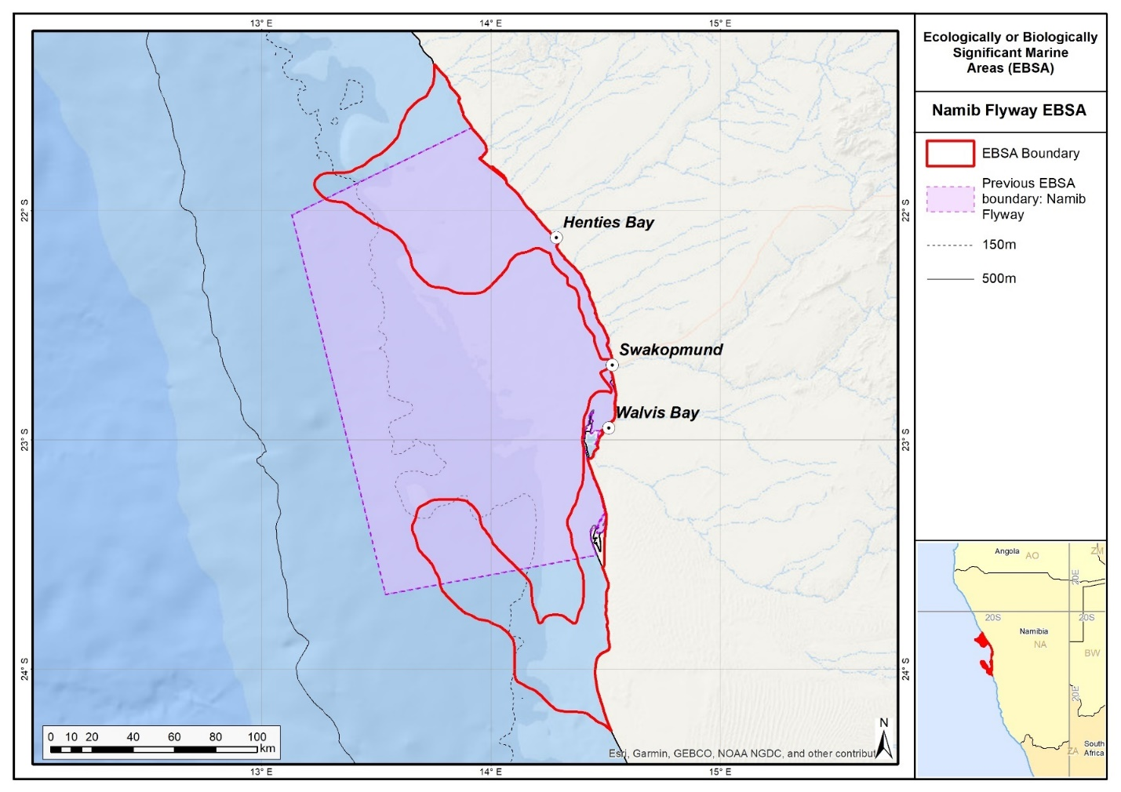
Map of the Namib Flyway area in relation to the original boundaries of the Namib Flyway EBSA.

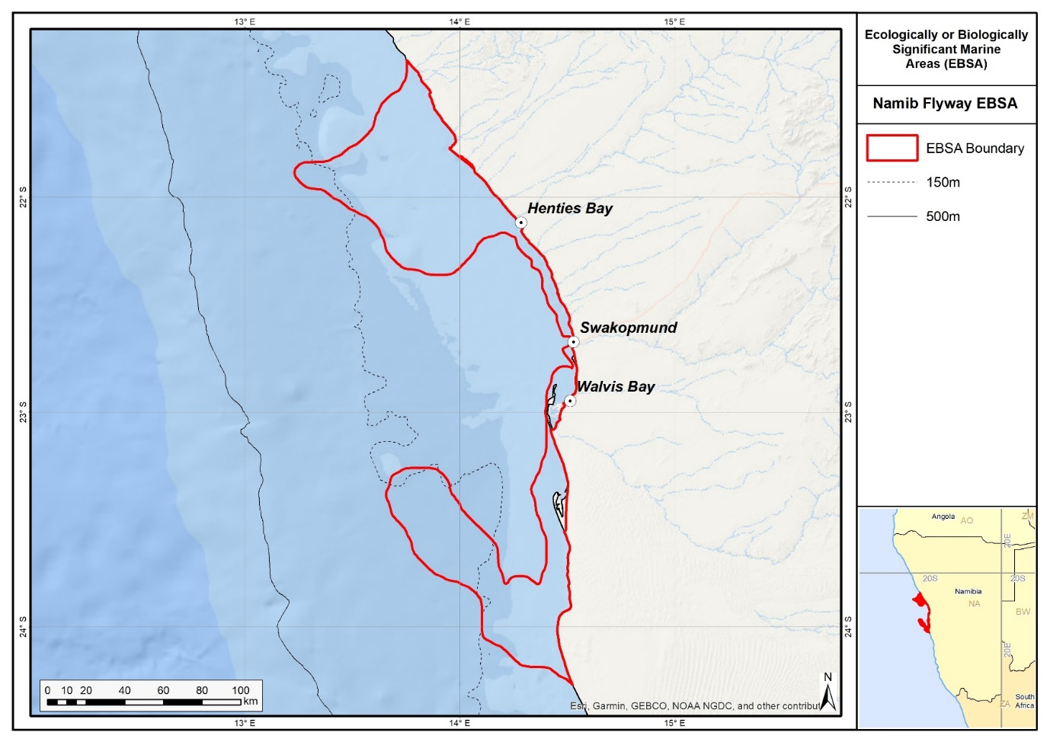
Map of the Namib Flyway area.

Rights and permissions:
No limits on sharing or publication.

10. Namibian Islands (modification of the existing Namibian Islands)⁵

Reason for the modification:
The EBSA description is being modified because of newly available or accessible knowledge on features associated with the area, based on additional scientific data especially new systematic spatial planning and assessments of biodiversity. The descriptions and supporting information are substantially extended, updated and refined beyond the original descriptions from the South-Eastern Atlantic workshop, April 2013. The modifications involve changes to the textual description, changes to the ranking of the area against the EBSA criteria, and changes in shape, location and size of the area.

The original descriptions of Ecologically or Biologically Significant Marine Areas (EBSAs) in the Benguela Current Large Marine Ecosystem (BCLME) were described in the South-Eastern Atlantic workshop (April 2013). The descriptions were generally characterized by generic, often fairly geometric delineations, consisting of approximate bounding boxes around the features for which the EBSA was described. This coarse scale of delineation was appropriate for a global scale but posed challenges for inclusion in national-level, place-based ocean management. The original boundaries were not sufficiently refined to capture the full extent of key biodiversity features and often overlapped with areas of lower biodiversity value or poor ecological condition.

Additionally, the original EBSA descriptions suffered from shortfalls related to limited spatial data and lack of systematic conservation planning approaches at the time they were first proposed. This meant that many boundaries did not precisely encompass biodiversity priority areas, potentially leading to conflicts with other ocean sectors and limiting their practical usefulness for marine spatial planning (MSP). The coarse scale and lack of detailed data constrained the ability to develop effective zoning and management recommendations that balance biodiversity protection with economic activities.

Specific addition data included:
- While populations of breeding seabirds were previously noted, we have added mention of non-breeding seabirds.
- The African Penguin has been uplisted to Critically Endangered in the most recent IUCN Red List assessment: https://datazone.birdlife.org/species/factsheet/african-penguin-spheniscus-demersus.

How was the submission developed?
The EBSA revision process was part a broader project on ecosystem-based MSP in the BCLME, namely the Benguela Current Marine Spatial Management and Governance Project (MARISMA, 2014-2023). This was a regional capacity-building and development cooperation project implemented by the Benguela Current Commission, the Governments of Angola, Namibia and South Africa, and GIZ, the German Agency for Development Cooperation (Deutsche Gesellschaft für Internationale Zusammenarbeit.

Because of these shortcomings of the existing EBSA boundaries, description and valuations set out in the previous section, the MARISMA project undertook a refinement process. This process used systematic conservation planning (SCP) tools, such as Marxan, to generate finer-scale, more accurate boundaries based on updated biodiversity data and expert input. This process also allowed for the identification of new EBSAs and the splitting of some original EBSAs into multiple refined areas to better reflect discrete biodiversity features and ecological processes. The refined EBSA boundaries were more suitable for MSP and conservation management because they focused on core natural and near-natural areas, avoided unnecessary conflicts with other sectors, and incorporated a systematic, data-driven approach to spatial prioritization.

The overall approach to the EBSA update and engagement followed these key steps:

Initial Systematic Conservation Planning (SCP) Analyses: Existing EBSAs were refined and new areas identified using systematic conservation planning tools such as Marxan, based on biodiversity input data including ecosystem types, species distributions, and ecological processes.

National Workshops: The refined and new EBSA boundaries were iteratively reviewed and adjusted through workshops held within each of the three countries (Angola, Namibia, South Africa). These workshops allowed country-specific input and tailoring of EBSA boundaries and descriptions to national contexts and priorities.

Regional Workshops and Bilateral Meetings between Countries: Workshops at the regional level especially focused on transboundary EBSAs shared between the countries, but also examined the overall approach to EBSAs, their delineation, description and the engagement approach. The aim was to harmonize boundaries, align management recommendations, and foster cooperation across national borders for effective regional marine biodiversity management. Additional specific bilateral meetings were held where necessary.

Technical and Scientific Peer Review: The revised and new EBSAs underwent technical review nationally and regionally (through technical review workshops involving relevant experts); and internationally with a further regional review workshop with participation of experts from the Global Ocean Biodiversity Initiative (GOBI) and members of the CBD's Informal Advisory Group on EBSAs; ensuring robustness of the exercise. The process is documented in peer reviewed literature (Harris et al., 2019, 2022).

Political Approval: The EBSAs were administratively and politically approved through all required stages up to the national ministerial level in each country and were then submitted to the CBD Secretariat by the National CBD Focal Points.

Data Sharing and Accessibility: All information, including refined EBSA boundaries, status assessments, management recommendations, and stakeholder feedback, were made available through online repositories such as the project's EBSA Portal (https://cmr.mandela.ac.za/Research-Projects/EBSA-Portal); and the EBSA were also shared via the Benguela Current Convention's Geodata Portal (https://geodata.benguelacc.org/ ). This facilitated transparency, accessibility, and ongoing updating of data and products for biodiversity specialists and other stakeholders.

The main change was to include the previously omitted important bird foraging areas surrounding the islands, which also represent foraging, breeding and nursery areas for other significant species. A robust process was used in the delineation of the Namibian Islands MPA (e.g. consideration of foraging distances of key species and ecological process areas around the islands - see Currie et al. 2008 for specifics). This scientific and technical process was combined with the public, political and administrative processes required for gazetting of protected areas. Therefore, the boundary of the original EBSA has been extended to include key foraging areas, such that it now matches that of the NIMPA boundary. A map showing the original and the revised EBSA boundaries is provided in the Maps and Figures Section.

The EBSA description was updated substantially by searching for and including all relevant information from the latest research within the area. Eleven new references were added to the Namibian Islands EBSA description, as part of an updated literature search for relevant information. A summary table of the represented habitats and their threat status was also included as supplementary information. Following the description update, two criteria were upgraded in ranks, largely due to the change in the EBSA boundary, which now spans the full extent of the Namibian Islands MPA. Uniqueness and rarity were upgraded from Low to High (especially linked to the inclusion of large portions of the global range of species, such as bank cormorant, and full inclusion of the Namibian Islands), and Naturalness was upgraded from Medium to High.

Traditional knowledge was not incorporated into this process, and consultations with indigenous peoples or local communities were not undertaken. Therefore, documentation of Free, Prior and Informed Consent (FPIC) is not relevant for this EBSA process.

Where is the submission intended to be included (choose one option, and please note that there are different procedures for these two intended end points)?
[X] EBSA repository
[ ] EBSA information-sharing mechanism

Abstract:
Changes from the original version: The abstract was rewritten to reflect the revised delineation which expands the boundary of the Namibian Islands EBSA to align with the Namibian Islands Marine Protected Area (NIMPA), incorporating key seabird foraging areas that were previously omitted. It emphasizes the ecological importance of these extended waters for both threatened seabirds and Critically Endangered leatherback turtles, reflecting updated understanding of species' life-history requirements.

The Namibian Islands are located offshore in the central region of the Benguela Current Large Marine Ecosystem within the intensive Lüderitz upwelling cell. The islands and their surrounding waters are described primarily for their significance for life-history stages of threatened seabird species. The islands are crucial seabird breeding sites within the existing Namibian Islands marine protected area, and the surrounding waters are also crucial foraging grounds for those seabirds, where adults forage for themselves and their chicks, and for critically endangered leatherbacks from the Western Indian Ocean that nest in South Africa. The boundaries of the marine protected area are based predominantly on the foraging ecology of important threatened breeding seabirds. The expansion of the boundaries of the existing Namibian Islands EBSA results in the inclusion of important features of the islands and adjacent marine environment.

Introduction:
Changes from the original version: Unlike the previous introductory description which focused primarily on the breeding islands, the revised description recognizes the broader ecological connectivity by including adjacent productive waters critical for foraging and nursery habitats. It also identifies the EBSA as a Type 2 area (sensu Johnson et al. 2018)., emphasizing the integration of multiple connected ecosystems and ecological processes.

The Namibian Islands is a coastal EBSA that is located in the central region of the BCLME within the Lüderitz Upwelling Cell. This upwelling cell plays a significant role in regulating the biomass of fish stocks of central Namibia. Consequently, the islands and adjacent productive waters provide important breeding and foraging habitat for threatened seabirds and marine mammals, and includes important nursery grounds for the commercially important west coast rock lobster, Jasus lalandii (Currie et al., 2008). It is also recognized as a foraging site for regionally Critically Endangered leatherbacks from the Western Indian Ocean that nest in South Africa (Harris et al., 2017). Thus, although the focus of this EBSA is on seabird breeding and foraging, there are several other important species for which this site is important.

The key ecological value of this site was recognised prior to the EBSA process, and in 2009, the Namibian Ministry of Fisheries and Marine Resources (MFMR) gazetted the Namibian Islands Marine Protected Area (NIMPA). The NIMPA covers nearly 1 million ha of coastal waters that encompass all the natural seabird breeding islands in Namibia and the key supporting seabird foraging areas in the surrounding sea. It was later recognised that the original EBSA delineation had focussed on only the breeding islands, and had omitted the critical foraging grounds surrounding the islands that provide fish for the adult birds and as they provision for their chicks. Consequently, the EBSA boundary was revised to include the full extent of this significant ecological feature, following a similar delineation process to how the NIMPA was defined. Because this site comprises a collection of features and ecosystems that are connected by the same ecological processes, it can be considered a Type 2 EBSA (sensu Johnson et al. 2018).

Location:
Changes from the original version: The revised description extends the EBSA boundaries considerably offshore and alongshore to match the Namibian Islands Marine Protected Area (NIMPA) limits, reflecting a more precise and ecologically relevant delineation based on seabird foraging ecology. This contrasts with the earlier, more geometric and limited bounding boxes around the islands alone.

The boundary of the existing Namibian Islands EBSA has been adjusted to include important seabird foraging areas. It extends alongshore about 400 km from Meob Bay to Chameis Bay, Namibia, and, on average, 30 km offshore from the high-water mark. It is located between S 24° and 28° and is within the exclusive economic zone of Namibia.
The coordinates of a minimum bounding box covering the entire scope of the area are:
- Latitude: -24.432, -27.93, -28.061, -24.562
- Longitude: 14.691, 15.689, 15.23, 14.233

Feature description of the area:
Changes from the original version: The revised description incorporates a more comprehensive inventory of species and ecosystems, including detailed recognition of endemic and threatened seabird populations, marine mammals, rock lobster nurseries, and Critically Endangered ecosystem types. The description is also based on the features within the refined/revised geographic extent and an expanded and updated set of references and data, including systematic assessments of ecosystem status. It better acknowledges the high productivity of the Lüderitz Upwelling Cell and the impacts of historical overfishing on ecosystem health.

The Namibian Islands EBSA is described for both benthic and pelagic features, primarily as a key breeding and foraging area for threatened seabirds, but also as breeding, nursery or foraging areas for several other species that are iconic, threatened or of commercial importance. Eleven seabird species breed on the islands, of which eight are endemic to southern Africa (Kemper et al., 2007). Of these, the African Penguin (Spheniscus demersus) is listed as globally Critically Endangered (Sherley et al. 2024); the Bank Cormorant (Phalacrocorax neglectus) and the Cape Cormorant (P. capensis) are listed as globally Endangered; and the Cape Gannet (Morus capensis) is listed as globally Vulnerable and locally Critically Endangered (Simmons et al., 2015, IUCN 2016). The Namibian populations of African Penguins, Cape Gannets and Bank Cormorants breed exclusively within this EBSA. Productivity at this site is also particularly high because it is situated in the Lüderitz Upwelling Cell in the Benguela Current, which plays a significant role in regulating the biomass of fish stocks of central Namibia. However, the depletion of small pelagic fish stocks in the late 1960s through over-fishing, particularly in southern Namibia, has negatively impacted this area (Roux et al., 2013). This provides special justification for protecting this area to conserve the important threatened species that are so dependent on it.

In recognition of the ecological significance of this area, the design of the NIMPA took seabird tracking data into account to ensure inclusion of critical foraging areas of resident breeding birds (Ludynia et al., 2010a, 2012). Three rock lobster sanctuaries, one linefish sanctuary and key calving areas of southern right whales were also included (Currie et al., 2008). This site is a foraging area for regionally Critically Endangered leatherback turtles from the Western Indian Ocean that nest in South Africa (Harris et al., 2017). The NIMPA, which adjoins the Namib-Naukluft and Tsau//Khaeb national parks on the landward side, is sectioned into zones of increasing protection levels, with the highest protection status afforded to the islands. Six of the islands are also designated as Important Bird and Biodiversity Areas (IBAs; Simmons et al., 2015). Altogether, 140 species have been recorded in the EBSA (OBIS 2017).

The Namibian Islands also includes two Critically Endangered ecosystem types (Namaqua Intermediate Sandy Beach and Namaqua Reflective Sandy Beach), one Endangered ecosystem types (Kuiseb Mixed Shore), and three Vulnerable types (Lüderitz Outer Shelf, Namaqua Exposed Rocky Shore and Namaqua Inshore). These threat statuses were estimated by assessing the weighted cumulative impacts of various pressures (e.g., extractive resource use, pollution, development, and others) on each ecosystem type for Namibia (Holness et al., 2014; Table below).

Summary of ecosystem types and threat status for the Namibian Islands EBSA. Data from Holness et al. (2014).
Threat Status | Ecosystem type | Area (km²) | Area (%)
Critically Endangered | Namaqua Intermediate Sandy Beach | 2.1 | 0.0
 | Namaqua Reflective Sandy Beach | 0.3 | 0.0
Endangered | Kuiseb Mixed Shore | 10.1 | 0.1
Vulnerable | Lüderitz Outer Shelf | 706.7 | 7.4
 | Namaqua Exposed Rocky Shore | 3.6 | 0.0
 | Namaqua Inshore | 62.6 | 0.7
Least Threatened | Central Namib Inner Shelf | 1 074.8 | 11.3
 | Kuiseb Dissipative-Intermediate Sandy Beach | 3.2 | 0.0
 | Kuiseb Exposed Rocky Shore | 3.1 | 0.0
 | Kuiseb Inshore | 586.0 | 6.2
 | Kuiseb Intermediate Sandy Beach | 40.1 | 0.4
 | Kuiseb Reflective Sandy Beach | 13.1 | 0.1
 | Lüderitz Dissipative Sandy Beach | 4.7 | 0.0
 | Lüderitz Dissipative-Intermediate Sandy Beach | 4.3 | 0.0
 | Lüderitz Exposed Rocky Shore | 42.6 | 0.4
 | Lüderitz Inner Shelf | 4 654.8 | 49.0
 | Lüderitz Inshore | 356.2 | 3.8
 | Lüderitz Intermediate Sandy Beach | 40.8 | 0.4
 | Lüderitz Island | 1 331.5 | 14.0
 | Lüderitz Lagoon Coast | 3.2 | 0.0
 | Lüderitz Mixed Shore | 35.0 | 0.4
 | Lüderitz Reflective Sandy Beach | 13.5 | 0.1
 | Lüderitz Sheltered Rocky Shore | 4.1 | 0.0
 | Lüderitz Very Exposed Rocky Shore | 1.0 | 0.0
 | Namaqua Dissipative-Intermediate Sandy Beach | 7.6 | 0.1
 | Namaqua Inner Shelf | 486.0 | 5.1
 | Namaqua Mixed Shore | 0.2 | 0.0
Grand Total |  | 9 491.1 | 100.0

Feature condition and future outlook:
Changes from the original version: The revised description provides a more nuanced assessment of threats based on updated references, including the critical role of small pelagic fish stock depletion on seabird populations and emerging risks from marine mining and coastal development. It also highlights the improved protection status resulting from the EBSA boundary alignment with the NIMPA. There is a more detailed evaluation of ecosystem threat status and protection.

A lack of quality food poses the greatest threat to seabird populations breeding on Namibia’s islands (Ludynia et al., 2010b, Simmons et al., 2015). The collapse of sardine stocks in the 1960s and anchovy populations in the 1990s (Roux et al., 2013), both significant prey species, threaten the viability of African Penguin, Cape Gannet and Cape Cormorant populations in particular. The recovery of small pelagic fish stocks in southern Namibia is therefore crucial to the continued survival of these species. The coast is vulnerable to marine pollution, especially oil spills, and even a small oil spill at a key breeding site such as Mercury Island could put a significant proportion of the global population of African Penguin, Cape Gannets and/or Bank Cormorants at risk. Namibia’s National Oil Spill Contingency Plan is currently being updated, and a process to draft the Oil Spill Sensitivity Mapping is underway for improved monitoring and prevention. Breeding habitat degradation and associated disturbance (e.g. from guano harvesting) has further rendered breeding seabirds, particularly African Penguins and Cape Gannets, at risk. An increasing emphasis on marine mining, including inshore and coastal mining south of Lüderitz may pose additional threats to seabirds, rock lobsters and marine mammals, such as prey displacement and modification of key marine habitats.

Holness et al. (2014) estimated habitat threat status by assessing the weighted cumulative impacts of various pressures (e.g., extractive resource use, pollution, development and others) on each ecosystem type for Namibia (Table in the previous section). The results identified small areas of two Critically Endangered ecosystem types (viz. the Namaqua Intermediate Sandy Beach and Namaqua Reflective Sandy Beach) within the Namibian Islands EBSA. The Critically Endangered status implies that very little (<= 20 %) of the total area of these habitats are in natural/pristine condition, and it is expected that important components of biodiversity pattern have been lost and that ecological processes have been heavily modified. Furthermore, one Endangered ecosystem type (viz. the Kuiseb Mixed Shore) and three Vulnerable ecosystem types (viz. the Lüderitz Outer Shelf, Namaqua Exposed Rocky Shore, and Namaqua Inshore) were identified. In particular, the Namibian Islands EBSA is very important for the Lüderitz Outer Shelf, Namaqua Inshore and Kuiseb Mixed Shore ecosystem types. Overall, Holness et al. (2014) classified 91 % of the Namibian Islands area as being in good condition, which is consistent with the inclusion of the entire area in the NIMPA as part of the EBSA’s boundary revision.

The delineation of Namibian Islands matches that of Namibian Islands Marine Protected Area, such that 100% of the EBSA is protected. The adjacent terrestrial area is also protected in the Sperrgebiet and Namib-Naukluft National Parks. Consequently, 24 of the 27 ecosystem types are Well Protected, and the other three are Moderately Protected (Holness et al., 2014).

Assessment of the area against CBD EBSA Criteria:
Changes from the original version: The revised description upgrades the rankings of uniqueness or rarity from “Low” to “High” reflecting that the description now includes all rather than some of the islands. The evaluation of naturalness was upgraded by one category to "High," reflecting the inclusion of the full extent of the Namibian Islands MPA and the broader foraging areas which are largely in a natural condition. It offers more detailed justification for each criterion, drawing on updated scientific data and better recognizing the EBSA’s critical importance for threatened species, ecosystem vulnerability, biological productivity, diversity, and condition.
CBD EBSA Criteria  (Annex I to decision IX/20) | Description  (Annex I to decision IX/20) | Ranking of criterion relevance  (please mark one column with an X)
CBD EBSA Criteria  (Annex I to decision IX/20) | Description  (Annex I to decision IX/20) | No information |  | Low |  |  | Medium |  | High
Uniqueness or rarity | Area contains either (i) unique (“the only one of its kind”), rare (occurs only in few locations) or endemic species, populations or communities, and/or (ii) unique, rare or distinct, habitats or ecosystems; and/or (iii) unique or unusual geomorphological or oceanographic features. |  |  |  |  |  |  |  | X
The entire Namibian population of African Penguins (25 % of the global population), Cape Gannets (11 %) and Bank Cormorants (89 %) breed in the EBSA (Kemper et al., 2007, Ludynia et al., 2012). Cape Gannets breed on only six islands globally; three of these are in Namibia, all of which form part of the EBSA. Of the eleven seabird species that breed on the islands, eight are endemic to southern Africa (Kemper et al., 2007).
Special importance for life-history stages of species | Areas that are required for a population to survive and thrive. |  |  |  |  |  |  |  | X
The islands (and two coastal caves) support the entire Namibian breeding populations of three threatened seabird species. Due to their inaccessibility by terrestrial predators, these sites offer safe breeding and moulting habitat (Kemper 2006, Kemper et al., 2007). Breeding penguins and cormorants forage almost exclusively within the boundaries of the EBSA; breeding gannets have larger foraging ranges, but core feeding activities take place within the EBSA (Ludynia et al., 2010a, 2012). In Namibia, the majority of calving sites for Southern Right Whales (a species that was nearly hunted to extinction in Namibia and has only recently returned to Namibian waters to breed) fall within the EBSA (Roux et al., 2001). Namibian Islands also provides crucial breeding and feeding habitat to a large proportion of the global population of Heaviside’s dolphins at the centre of its distribution (Roux et al., 2001). Furthermore, the extensive kelp beds between Sylvia Hill and Chameis Bay provide important habitat for rock lobsters, including juveniles, immature and egg-bearing females (Currie et al., 2008). Leatherback turtles from the Western Indian Ocean also use the EBSA as a foraging ground (Harris et al., 2017).
Globally threatened White-chinned Petrels (Procellaria aequinoctialis, from Crozet Islands and the Kerguelen Archipelago) and Atlantic Yellow-nosed Albatrosses (Thalassarche chlororhynchos, from Gough Island), and Black-browed Albatrosses (Thalassarche melanophris, from South Georgia) forage within waters of the EBSA during the non-breeding period (austral winter) (Lascelles et al., 2016).
Importance for threatened, endangered or declining species and/or habitats | Area containing habitat for the survival and recovery of endangered, threatened, declining species or area with significant assemblages of such species. |  |  |  |  |  |  |  | X
The Namibian Islands EBSA constitute crucial breeding habitat for several seabird species endemic to the southern African region. The Critically Endangered African Penguin is of particular concern, with recent population assessments showing sharp declines (Sherley et al. 2024). The Endangered Cape Cormorant and Bank Cormorant, as well as the locally Critically Endangered Cape Gannet (Simmons et al., 2015) are also important. The breeding populations of these species continue to decline globally, and certainly the depletion, and lack of recovery, of small pelagic fish stocks (e.g., sardine, anchovy) in southern Namibia continue to play a key role in the decline of these species locally (IUCN 2016). Also, some regionally Critically Endangered leatherback turtles from the Western Indian Ocean that nest in South Africa use this area as a foraging ground (Harris et al., 2017). Furthermore, the Namibian Islands EBSA includes important threatened habitats (Holness et al., 2014). These include two Critically Endangered ecosystem types (Namaqua Intermediate Sandy Beach and Namaqua Reflective Sandy Beach), one Endangered type (Kuiseb Mixed Shore), and three Vulnerable types (Lüderitz Outer Shelf, Namaqua Exposed Rocky Shore, Namaqua Inshore; Table in the Feature description of the area section.).
Vulnerability, fragility, sensitivity, or slow recovery | Areas that contain a relatively high proportion of sensitive habitats, biotopes or species that are functionally fragile (highly susceptible to degradation or depletion by human activity or by natural events) or with slow recovery. |  |  |  |  |  |  |  | X
Breeding seabirds, particularly penguins, are vulnerable to extreme environmental events such as heat waves or severe storms, in part because the nesting habitat has been modified by historic and, to a limited extent, more recent guano harvesting. This may be exacerbated further by the effects of climate change (Griffiths et al., 2005; Kemper et al., 2007). Sea-level rise will threaten the existence and/or spatial extent of the low-lying islands (Roux 2003). In addition, the lack of good-quality small pelagic prey (because of stock depletion followed by a lack of recovery) has led to degraded seabird foraging habitats.
Biological productivity | Area containing species, populations or communities with comparatively higher natural biological productivity. |  |  |  |  |  | X
The Namibian Islands EBSA is situated within the intensive Lüderitz Upwelling Cell, which induces high levels of productivity and thus abundant fish and higher trophic level populations. However, the depletion of small pelagic fish stocks in the late 1960s through over-fishing, particularly in southern Namibia, has resulted in a degraded marine ecosystem (Roux et al., 2013), characterized by a decrease in productivity and changes in the overall trophic function in this area.
Biological diversity | Area contains comparatively higher diversity of ecosystems, habitats, communities, or species, or has higher genetic diversity. |  |  |  | X
As a cold-water and predominantly sandy-bottomed marine environment, the northern Benguela Current ecosystem is considered relatively poor in biological diversity compared to more tropical or substrate-diverse marine ecosystems. However, the coastline and near-shore waters along which the EBSA is situated are characterized by both rocky and sandy substrates, which support a limited (and poorly studied) array of micro- and macroscopic benthos, including seaweeds and invertebrate species (Sakko 1998, Harris et al., 1998). The biodiversity in the inter-tidal zones of the islands tends to be greater than elsewhere in the area, possibly due to high nutrient input from seabird guano. Altogether, 140 species have been recorded in the EBSA (OBIS 2017).
Naturalness | Area with a comparatively higher degree of naturalness as a result of the lack of or low level of human-induced disturbance or degradation. |  |  |  |  |  |  |  |  | X
The islands themselves have been modified from their pristine states through anthropogenic impacts such as intensive guano scraping activities on the islands (Griffiths et al., 2005). However, the area overall is in good and improving condition, and is fully included in the Marine Protected Area. The surrounding marine environment is well within the Namibian 200 m no-trawl protection zone. Purse-seining is prohibited within the EBSA (as per NIMPA regulations) in order to encourage the recovery of small pelagic fish stocks that are vital to the area’s ecosystem health and functioning. A commercial and recreational lobster fishery is located along the southern coast of Namibia. Coastal development and marine mining in the area have been limited but are expected to expand. Although there have been significant historical impacts (especially on the islands specifically) and there are regional risks from adjacent areas, 91 % of the Namibian Islands EBSA was classified as being in good condition, based on current levels of impacting activities (Holness et al., 2014). This is consistent with the inclusion of the entire area in the NIMPA as part of the EBSA’s boundary revision.

References:
Changes from the original version: The revised description includes updated and expanded literature, incorporating recent peer-reviewed studies and regional assessments that were not referenced previously.
Boyer, D.C., Hampton, I. 2001. An overview of the marine living resources of Namibia. South African Journal of Science, 23: 5-35.
Currie, H., Grobler, K., Kemper, J. 2008. Concept note, background document and management proposal for the declaration of Marine Protected Areas on and around the Namibian islands and adjacent coastal areas.
Griffiths, C.L., Van Sittert, L., Best, P.B., Brown, A.C., Clark, B.M., Cook, P.A., Crawford, R.J.M., David, J.H.M., Davies, B., Griffiths, M.H., Hutchings, K., Jerardino, A., Kruger, N., Lamberth, S., Leslie, R.W., Melville-Smith, R., Tarr, R., van der Lingen, C.D. 2005. Impacts of human activities on marine animal life in the Benguela: a historical overview. Oceanography and Marine Biology: Annual Review, 42: 303-392.
Harris, J.M., Branch, G.M., Elliott, B.L., Currie, B., Dye, A.H., McQuaid, D.D., Tomalin, B.J., Velasquez, C. 1998. Spatial and temporal variability in recruitment of intertidal mussels around the coast of southern Africa. South African Journal of Zoology, 33: 1-11.
Harris, L., Holness, S., Finke, G., Kirkman, S., Sink, K., 2019. Systematic Conservation Planning as a Tool to Advance Ecologically or Biologically Significant Area and Marine Spatial Planning Processes, in: Zaucha, J., Gee, K. (Eds.), Maritime Spatial Planning. Palgrave Macmillian, Cham.
Harris, L.R., Holness, S.D., Finke, G., Amunyela, M., Braby, R., Coelho, N., Gee, K., Kirkman, S.P., Kreiner, A., Mausolf, E., Majiedt, P., Maletzky, E., Nsingi, K.K., Russo, V., Sink, K.J., Sorgenfrei, R., 2022. Practical Marine Spatial Management of Ecologically or Biologically Significant Marine Areas: Emerging Lessons From Evidence-Based Planning and Implementation in a Developing-World Context. Front. Mar. Sci. 9.
Harris, L.R., Nel, R., Oosthuizen, H., Meyer, M., Kotze, D., Anders, D., McCue, S., Bachoo, S. 2017. Managing conflicts between economic activities and threatened migratory marine species towards creating a multi-objective blue economy. Conservation Biology, in press.
Holness, S., Kirkman, S., Samaai, T., Wolf, T., Sink, K., Majiedt, P., Nsiangango, S., Kainge, P., Kilongo, K., Kathena, J., Harris, L., Lagabrielle, E., Kirchner, C., Chalmers, R., Lombard, M. 2014. Spatial Biodiversity Assessment and Spatial Management, including Marine Protected Areas. Final report for the Benguela Current Commission project BEH 09-01.
IUCN. 2016. IUCN Red List of Threatened Species. Version 2016-3. www.iucnredlist.org. Downloaded on 1 February 2017.
Johnson, D.E., Barrio Froján, C., Turner, P.J., Weaver, P., Gunn, V., Dunn, D.C., Halpin, P., Bax, N.J., Dunstan, P.K., 2018. Reviewing the EBSA process: Improving on success. Marine Policy 88, 75-85.
Kemper, J. 2006. Heading towards extinction? Demography of the African penguin in Namibia. PhD thesis, University of Cape Town, Cape Town, South Africa, 241 pp.
Kemper, J., Underhill, L.G., Crawford, R.J.M., Kirkman, S.P. 2007. Revision of the conservation status of seabirds and seals breeding in the Benguela ecosystem. In: Kirkman, S.P. (Ed.), Final Report of the BCLME (Benguela Current Large Marine Ecosystem) Project on Top Predators as Biological Indicators of Ecosystem Change in the BCLME. Avian Demography Unit, Cape Town, pp. 325–342.
Kolberg, H. 1992. Untersuchungen bei, und Zählung der Billenpinguine (Spheniscus demersus) auf der Insel Halifax. Mitteilungen: Namibia Wissenschaftliche Gesellschaft 33: 57-71.
Lascelles, B.G., Taylor, P.R., Miller, M.G.R., Dias, M.P., Oppel, S., Torres, L., Hedd, A., Le Corre, M., Phillips, R.A., Shaffer, S.A., Weimerskirch, H., Small, C., 2016. Applying Global Criteria to Tracking Data to Define Important Areas for Marine Conservation. Diversity & Distribution. 22, 422–431. https://doi.org/10.1111/ddi.12411
Ludynia, K., Jones, R., Kemper, J., Garthe, S., Underhill, L.G. 2010a. Foraging behaviour of bank cormorants in Namibia: implications for conservation. Endangered Species Research, 12: 31-40.
Ludynia, K., Kemper, J., Roux, J. 2012. The Namibian Islands’ Marine Protected Area: Using seabird tracking data to define boundaries and assess adequacy. Biological Conservation, 156: 136-145.
Ludynia, K., Roux, J-P., Jones, R., Kemper, J., Underhill, L.G. 2010b. Surviving off junk: low-energy prey dominates the diet of African penguins Spheniscus demersus at Mercury Island, Namibia, between 1996 and 2009. African Journal of Marine Science, 32: 563-572.
OBIS. 2017. Summary statistics of biodiversity records in the Namibian Islands EBSA. (Available: Ocean Biogeographic Information System. Intergovernmental Oceanographic Commission of UNESCO. www.iobis.org. Accessed: 2017-07-27).
Pallett J. (ed.) 1995. The Sperrgebiet: Namibia’s least known wilderness. DRFN & NAMDEB, Windhoek, Namibia. Roux J-P (2003) – Risks. In: Molloy F. & T. Reinikainen (eds.). Namibia’s marine environment. Directorate of Environmental Affairs of the Ministry of Environment and Tourism, Windhoek, Namibia, pp. 137-152.
Roux, J-P., Best, P.B., Stander, P.E. 2001. Sightings of southern right whales (Eubalaena australis) in Namibian waters 1971-1999. Cetacean Resource Management (Special Issue), 2: 181-185.
Roux, J-P., van der Lingen, C.D., Gibbons, M.J., Moroff, N.E., Shannon, L.J., Smith, A.D.M., Cury, P.M. 2013. Jellyfication of marine ecosystems as a likely consequence of overfishing small pelagic fishes: lessons from the Benguela. Bulletin of Marine Science, 89: 249-284.
Sakko, A. 1998. The influence of the Benguela upwelling system on Namibia’s marine biodiversity. Biodiversity and Conservation, 7: 419-433.
Sherley, R.B., Makhado, A.B., Crawford, R.J.M., Hagen, C., Kemper, J., Ludynia, K., Masotla, M.J., McInnes, A.M., Pichegru, L., Tom, D., Upfold, L. and Waller, L.J. 2024. The African Penguin should be considered Critically Endangered. Ostrich https://doi.org/10.2989/00306525.2024.2355618
Simmons, R.E., Brown, C.J., Kemper, J. 2015. Birds to watch in Namibia: red, rare and endemic species. Ministry of Environment and Tourism and Namibia Nature Foundation, Windhoek, Namibia.
Van der Lingen, C.D., Shannon, L.J., Cury, P., Kreiner, A., Moloney, C.L., Roux, J-P. Vaz-Velho, F. 2006. Resource and ecosystem variability, including regime shifts, in the Benguela Current System. In: Shannon, V., Hempel, G., Malanotte-Rizzoli, P., Moloney, C.L., Woods, J. (eds) Benguela: Predicting a Large Marine Ecosystem. Elsevier, Amsterdam, pp 147–185.

Maps and Figures:
GIS data available at: https://cmr.mandela.ac.za/cmr/media/Store/documents/EBSA/Descriptions/Namibia/Namibia_EBSAs_2020-SHP.zip
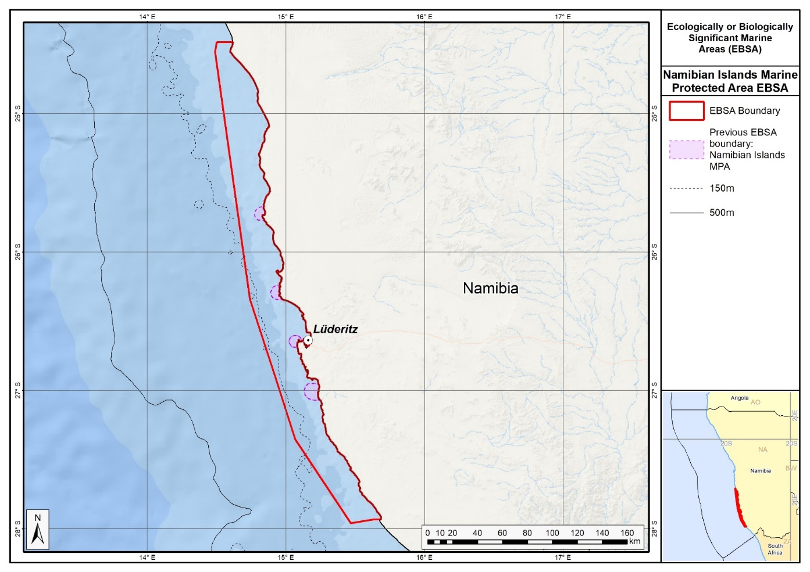
Map of the Namibian Islands area in relation to the original Namibian Islands EBSA.

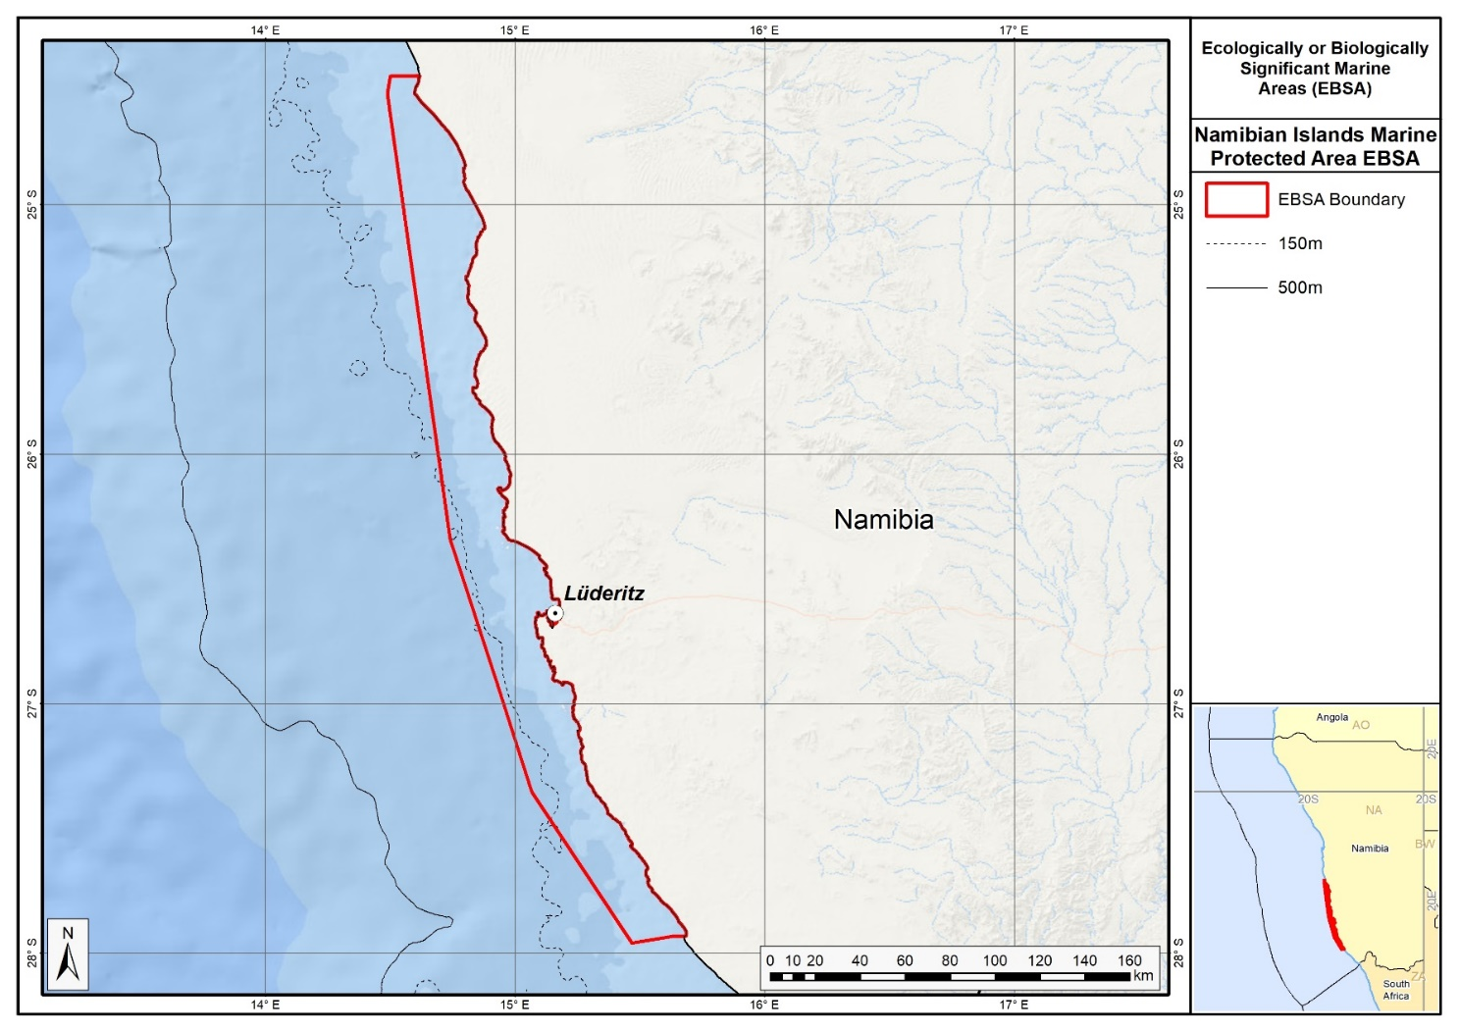
Map of the Namibian Islands area.

Rights and permissions:
No limits on sharing or publication.

11. Walvis Ridge Namibia (description of a new area)

How was the submission developed?
The process to identify potential areas meeting EBSA criteria and to revise existing EBSA was part a broader project on ecosystem-based MSP in the BCLME, namely the Benguela Current Marine Spatial Management and Governance Project (MARISMA, 2014-2023). This was a regional capacity-building and development cooperation project implemented by the Benguela Current Commission, the Governments of Angola, Namibia and South Africa, and GIZ, the German Agency for Development Cooperation (Deutsche Gesellschaft für Internationale Zusammenarbeit.

The MARISMA project undertook a gap analysis of the existing EBSA network utilizing spatial data that was not available when the initial set of EBSA were described in South-Eastern Atlantic workshop, April 2013.

The overall approach to EBSA identification, delineation, description and engagement followed these key steps:

Initial Systematic Conservation Planning (SCP) Analyses: A gap analysis was undertaken, and new areas identified using systematic conservation planning tools such as Marxan, based on biodiversity input data including ecosystem types, species distributions, and ecological processes.

National Workshops: The boundaries of potential new areas and refined EBSA boundaries were iteratively reviewed and adjusted through workshops held within each of the three countries (Angola, Namibia, South Africa). These workshops allowed country-specific input and tailoring of boundaries and descriptions to national contexts and priorities.

Regional Workshops and Bilateral Meetings between Countries: Workshops at the regional level especially focused on transboundary EBSAs shared between the countries, but also examined the overall approach to EBSAs, their delineation, description and the engagement approach. The aim was to harmonize boundaries, align management recommendations, and foster cooperation across national borders for effective regional marine biodiversity management. Additional specific bilateral meetings were held where necessary.

Technical and Scientific Peer Review: The submissions underwent technical review nationally and regionally (through technical review workshops involving relevant experts); and internationally with a further regional review workshop with participation of experts from the Global Ocean Biodiversity Initiative (GOBI) and members of the CBD's Informal Advisory Group on EBSAs; ensuring robustness of the exercise. The process is documented in peer reviewed literature (Harris et al., 2019, 2022).

Political Approval: The submissions were administratively and politically approved through all required stages up to the national ministerial level in each country and were then submitted to the CBD Secretariat by the National CBD Focal Points.

Data Sharing and Accessibility: All information, including boundaries, status assessments, management recommendations, and stakeholder feedback, were made available through online repositories such as the project's EBSA Portal (https://cmr.mandela.ac.za/Research-Projects/EBSA-Portal); and submissions were also shared via the Benguela Current Convention's Geodata Portal (https://geodata.benguelacc.org/ ). This facilitated transparency, accessibility, and ongoing updating of data and products for biodiversity specialists and other stakeholders.

The Walvis Ridge area was identified in a gap analysis as one of the two highest priority potential EBSA areas (along with the Cape Fria area) screened by the national EBSA process (including review of the spatial data from Holness et al. (2014) and inputs from expert workshops). The area was screened against the CBD criteria. Initial assessments indicated that it warranted inclusion. A final delineation and evaluation process was then undertaken, which resulted in the current description of the area.

The Namibian portion of the Walvis Ridge was considered by the Namibian Government to be one of the highest priority potential areas screened in its national EBSA process. The original intent was to extend and revise the existing high seas Walvis Ridge EBSA to include the adjacent sections in the Namibian EEZ. Ecologically and physically the Walvis Ridge is clearly a single feature which does not stop at the Namibian EEZ boundary. The Walvis Ridge system is a unique geomorphological feature with important biodiversity values. Given the global rarity of the connection between the hotspot track and continental flood basalt province, it was seen as imperative that the full extent of this feature was encompassed within the EBSA. Hence, a process was initiated by the Namibian government with the South East Atlantic Fisheries Organisation (SEAFO), which is the intergovernmental fisheries science and management body responsible for the high seas area within which the Walvis Ridge is partially located. However, it became clear that this process was not politically feasible within reasonable timelines. Therefore, the Namibian government is pursuing the recognition of the portion of the Walvis Ridge which falls within the Namibian EEZ as a separate but complementary EBSA to the existing Walvis Ridge EBSA. It remains the intent to secure a single unified EBSA should this becomes possible in the future.

The original high seas EBSA description was revised and updated with the latest research and biodiversity information from OBIS. Consequently, six new references were included. Following revision of the boundary, and an updated literature search, three criteria have been upgraded. Vulnerability, fragility and sensitivity, and Naturalness have both been upgraded from Medium to High, and Biological productivity has been upgraded from Data Deficient to Medium.

The delineation process used a combination of Systematic Conservation Planning (SCP) and Multi-Criteria Analysis methods. The features used in the analysis were:
- Key features from GEBCO data, global benthic geomorphology mapping (www.bluehabitats.org, Harris et al., 2014), and data from BCC spatial mapping project (Holness et al., 2014). The main features included were areas of complex habitat heterogeneity, including steep slopes, canyons, embayments formed by massive submarine slides, trough-like structures, a graben, abyssal plains, and shallow summits of seamounts and guyots.
- Areas with a high selection frequency in the regional spatial prioritization to meet biodiversity targets efficiently, as well as include key geomorphological features of the Ridge (Holness et al., 2014).
- Features that are continuous with the Ridge, as well as isolated hills that are in close proximity were included.

The multi-criteria analysis resulted in a value surface. The cut-off value (used to determine the extent of the area) was based on expert input and quantitative analysis of effective inclusion of the above features. This entailed taking an iterative parameter calibration-based approach whereby the spatial efficiency of the inclusion of the targeted features was evaluated. The approach aimed to identify a cut-off which most efficiently included prioritised features while minimizing the inclusion of impacted areas. The final boundaries shown in the map (provided in the Maps and Figures Section) were validated in an expert workshop.

Traditional knowledge was not incorporated into this process, and consultations with indigenous peoples or local communities were not undertaken. Therefore, documentation of Free, Prior and Informed Consent (FPIC) is not relevant for this EBSA process.

Where is the submission intended to be included (choose one option, and please note that there are different procedures for these two intended end points)?
[X] EBSA repository
[ ] EBSA information-sharing mechanism

Abstract
The area lies adjacent to the Walvis Ridge EBSA with which it covers the full extent of a significant hotspot track consisting of a seamount chain formed by submarine volcanism that extends from the Namibian continental margin to the Tristan da Cunha group and Gough Island. The area contains the globally rare connection of a hotspot track to continental flood basalt. Its complex benthic topography creates high habitat heterogeneity, likely supporting elevated biodiversity, including vulnerable sessile macrofauna and demersal fish associated with seamounts. Productivity is enhanced by upwelling generated through interactions between the ridge’s geomorphology and the nutrient-rich Benguela current, making the Namibian portion of Walvis Ridge particularly ecologically important. Although there is fishing in its north, the area remains in a good condition.
Introduction:
The aseismic Walvis Ridge is a seamount chain formed by hotspot submarine volcanism, some of which are guyots, that is connected to a continental flood basalt province in northern Namibia. The ridge presents a barrier between North Atlantic Deep Water to the north and Antarctic Bottom Water to the south. The surface oceanographic regime is the South Atlantic Subtropical Gyre bounded by the productive waters of the Benguela Current System and the Subtropical Convergence Zone. The feature described here is depth-bound around the 4000-m isobath and contains significant areas within the likely vertical extent of near-surface zooplankton migration (1000 m). Although biologically significant, data from research cruises are patchy and variable, however the greater area is known to support a high diversity of seabirds, some of which are threatened. Further, the steep slopes and seamounts that are characteristic of the ridge likely support enhanced primary production, abundance and species richness. Because this site comprises a complex of features and ecosystems that are connected by the same ecological processes, it can be considered a Type 2 EBSA (sensu Johnson et al. 2018).

Location:
The Walvis Ridge extends south-west across the South-East Atlantic Ocean from the northern Namibian shelf (S 18°) to the Tristan da Cunha group at the Mid-Atlantic Ridge (S 38°). The existing Walvis Ridge EBSA has its north-eastern boundary at the exclusive economic zone of Namibia. The area described in the present submission is contiguous with the existing Walvis Ridge EBSA and spans only the portion of the ridge that is within the exclusive economic zone of Namibia. Given the global rarity of the connection between a hotspot track and the continental flood basalt province, it is imperative that the full extent of this feature is encompassed within an EBSA, including the portion in the exclusive economic zone of Namibia, in which the area lies entirely.

The coordinates of a minimum bounding box covering the entire scope of the area are:
- Latitude: -18.084, -21.279, -22.502, -19.307
- Longitude: 11.068, 12.616, 10.091, 8.543

Feature description of the area:
Walvis Ridge is both a benthic and water column feature: it is a chain of seamounts that individually and collectively constitute an ecologically and biologically significant deep-sea feature, as also recognized by the Census of Marine Life project (CenSeam: http://censeam.niwa.co.nz). Walvis Ridge also includes a number of deep-sea features in addition to the seamounts and guyots, such as steep canyons, embayments formed by massive submarine slides, trough-like structures, a graben, abyssal plains, and a fossilized cold-water coral reef mound community (GEOMAR 2014). Based on these physical features, the ridge can be divided into three sections (GEOMAR 2014). The portion of the ridge within the area forms part of the northern section, which extends SW from the Namibian shelf, with a steep NW scarp, ridge-type seamounts, and guyots with rift arms (GEOMAR 2014).

The high habitat heterogeneity supports moderately diverse biological communities, including benthic macrofauna such as brachiopods, sponges, octocorals, deep-water hexacorals, gastropods, bivalves, polychaetes, bryozoans, cirriped crustaceans, basket stars, ascidians, isopods and amphipods (GEOMAR 2014). Presumably this diversity extends along the full extent of the ridge, and into the Namibian portion. Productivity seems to increase from SW to NE along Walvis Ridge, with sediment organic carbon and the abundance and diversity of phytoplankton communities increasing towards the Namibian shelf, likely reflecting patterns of nutrient transport and upwelling in the north-flowing Benguela Current that are more intense closer to the African continent (GEOMAR 2014).

This area was not included in the original South Eastern Atlantic Workshop that was held in 2013 because it was highlighted only later in a gap analysis of the national and regional EBSA networks, using systematic conservation planning (Holness et al., 2014). Further, new information has since become available following a recent research cruise (GEOMAR 2014), which has added certainty of the significance of the features. The area boundary links tightly to important benthic features comprising the ridge (produced by combining GEBCO data with that from www.bluehabitats.org: see Harris et al., 2014, and data from Holness et al., 2014). Those features that are continuous with the ridge, as well as isolated hills that are in close proximity are included. The area also includes sites with a high selection frequency in the regional gap analysis (Holness et al., 2014), which suggests that they are irreplaceable areas in the region.

The Walvis Ridge Namibia includes two Vulnerable ecosystem types (Central Namib Shelf Edge and Kunene Shelf Edge), and contains significant areas of an addition eight ecosystem types, with the area being particularly important for the Kunene Lower Slope and the Namib Lower Slope. These threat statuses were estimated by assessing the weighted cumulative impacts of various pressures (e.g., extractive resource use, pollution, development, and others) on each ecosystem type for Namibia (Holness et al., 2014; Table below).

Summary of ecosystem types and threat status for Walvis Ridge Namibia. Data from Holness et al. (2014).
Threat Status | Ecosystem type | Area (km²) | Area (%)
Vulnerable | Central Namib Shelf Edge | 18,113 | 26.1
 | Kunene Shelf Edge | 6,458 | 9.3
Least Threatened | Kunene Abyss | 5,920 | 8.5
 | Kunene Lower Slope | 8,664 | 12.5
 | Kunene Seamount | 3,818 | 5.5
 | Kunene Upper Slope | 2,298 | 3.3
 | Namib Abyss | 383 | 0.6
 | Namib Lower Slope | 16,573 | 23.9
 | Namib Seamount | 2,290 | 3.3
 | Namib Upper Slope | 4,931 | 7.1
Grand Total |  | 69,448 | 100.0

Feature condition and future outlook:
The Walvis Ridge area is primarily recognized as a geological feature but the biota in the area could be vulnerable to fishing (e.g., orange roughy; SEAFO report in FAO Statistical Area 47). The fisheries within the Namibian EEZ are managed by Namibia’s Ministry of Fisheries and Marine Resources. Oil exploration has already taken place within the area, namely Welwitschia-1 well, which was drilled in 2014 at 20°11’9.79”S, 11°19’3.27”E. Although it was found to be dry, future drilling activities in the area are likely. The area is largely in good condition, though some impacted areas exist on the far eastern edge (Holness et al., 2014).

The Walvis Ridge EBSA and Walvis Ridge Namibia area should ideally be merged because they both represent the same feature; however, the former is in the high seas and the latter is under national jurisdiction. Consequently, this merger will depend on international processes around EBSAs that span across country EEZs and ABNJ. It is thus recommended that ABNJ and BBNJ processes are engaged in the future to understand the link between these two areas and how they might be merged in the future.

Assessment of the area against CBD EBSA Criteria:

CBD EBSA Criteria  (Annex I to decision IX/20) | Description  (Annex I to decision IX/20) | Ranking of criterion relevance  (please mark one column with an X)
CBD EBSA Criteria  (Annex I to decision IX/20) | Description  (Annex I to decision IX/20) | No information |  | Low |  |  | Medium |  | High
Uniqueness or rarity | Area contains either (i) unique (“the only one of its kind”), rare (occurs only in few locations) or endemic species, populations or communities, and/or (ii) unique, rare or distinct, habitats or ecosystems; and/or (iii) unique or unusual geomorphological or oceanographic features. |  |  |  |  |  |  |  | X
As the only extensive seamount chain off of the Mid-Atlantic Ridge in the Southeast Atlantic, the Walvis Ridge is a unique geomorphological feature. It is also one of the few hotspot tracks on earth that connects to continental flood basalt. This rare connection falls within the Walvis Ridge Namibia area.
Special importance for life-history stages of species | Areas that are required for a population to survive and thrive. |  |  |  |  |  |  |  | x
Seamount chains may facilitate connectivity between individual seamounts over extensive distances. The varied topography and geomorphology support demersal fish resources (based on demersal fisheries records in locations shallower than 2000 m). The varied bathymetry dictates the distribution area and provides significant habitat for bentho-pelagic species (e.g., hotspots for orange roughy), and is also likely to do so for epi-pelagics (Clark et al., 2007, Rogers and Gianni, 2010). These seamounts are significant habitats for cold-water corals and sponges (Zibrowius and Gili, 1990; GEOMAR 2014). Thus, the Walvis Ridge is of special importance for sessile macrofauna and for demersal fish associated with seamounts (FAO FIRMS species distribution maps) (http://firms.fao.org). It includes parts of the foraging areas for globally threatened seabirds, such as the Tristan Albatross (Diomedea dabbenena), Wandering Albatross (Diomedea exulans) and Atlantic Yellow-nosed Albatross (www.seabirdtracking.org). The series of seamounts provides a potential stepping stone feature for organisms from coast to mid ocean (e.g., dispersion of the benthic octopod, Scaeurgus unicirrhus; Sanchez and Alvarez, 1988).
Importance for threatened, endangered or declining species and/or habitats | Area containing habitat for the survival and recovery of endangered, threatened, declining species or area with significant assemblages of such species. |  |  |  |  |  | X
Bluefin and big-eye tuna occur in the area (e.g., FishBase), and orange roughy hotspots within the area are known (SEAFO information). Several threatened seabird species also use the Namibian portion of the Walvis Ridge for foraging, e.g., the endangered Atlantic Yellow-nosed Albatross (www.seabirdtracking.org; BirdLife International, 2017). The area meets the BirdLife Important Bird Areas Criteria for Atlantic Yellow-nosed Albatross (BirdLife 2009, 2010) A1 Regular presence of threatened species; A4ii >1% of the global population of a seabird.
The Walvis Ridge Namibia includes two Vulnerable ecosystem types (Central Namib Shelf Edge and Kunene Shelf Edge)(Holness et al., 2014).
Vulnerability, fragility, sensitivity, or slow recovery | Areas that contain a relatively high proportion of sensitive habitats, biotopes or species that are functionally fragile (highly susceptible to degradation or depletion by human activity or by natural events) or with slow recovery. |  |  |  |  |  |  |  | X
Habitat-forming sessile megafauna are fragile and vulnerable to bottom contact fishing gears and slow to recover from damage. Habitat prediction models and observational data (Durán Muñoz et al., 2012, GEOMAR 2014, Perez et al., 2012) indicate presence of cold-water corals and sponges, and other delicate fauna such as basket and feather stars (see also the OBIS database for species records: http://www.iobis.org/explore/#/area/351). Based on empirical evidence (e.g., observations from Spanish/Namibian cruises on the Valdivia Bank, and along the whole ridge; GEOMAR 2014) the seamounts and deep-sea features along the Walvis Ridge have sensitive habitats, biotopes and species, justifying high criterion ranking.
Biological productivity | Area containing species, populations or communities with comparatively higher natural biological productivity. |  |  |  |  |  | X
Productivity appears to increase from SW to NE along the Walvis Ridge, as seen in the sediment organic carbon load, and abundance and diversity of plankton that both increase closer to the Namibian shelf (GEOMAR 2014). Several seamounts also extend into the photic zone and may have enhanced primary production. Significant areas are within the likely vertical range of epipelagic zooplankton migration (Jacobs and Bett, 2010).
Biological diversity | Area contains comparatively higher diversity of ecosystems, habitats, communities, or species, or has higher genetic diversity. |  |  |  |  |  | X
Data on biological diversity associated with the Walvis Ridge are limited, however there are some data on seabirds, fish, and benthic mega-, macro- and meiofauna (see Perez et al., 2012 for a review, and GEOMAR 2014), including 17 922 records of 907 species listed on the OBIS database (OBIS 2017). Observations and the range of habitats created by the seamount chain and immediately adjacent abyssal area suggest comparatively higher diversity of ecosystems, habitats, communities, and species. This has been confirmed to some extent through bathymetric/geological surveys and biological sampling of the benthos, which revealed a variety of benthic macrofauna (GEOMAR 2014). Presumably the comparatively higher biodiversity associated with this geological feature extends into the Namibian portion of the ridge that comprises the Namibian focus area.
Naturalness | Area with a comparatively higher degree of naturalness as a result of the lack of or low level of human-induced disturbance or degradation. |  |  |  |  |  |  |  |  | X
Human influence along the Walvis Ridge is largely historic, fisheries were and are mainly confined to seamount summits (SEAFO information, Clark et al., 2007, and relevant papers cited in Perez et al., 2012), and oil exploration drilling has been limited to date. Apart from seamounts that are likely to have been impacted by bottom-fishing, the remainder of the area is considered to have a high degree of naturalness. The focus area is largely in good condition, though some impacted areas exist on the far eastern edge (Holness et al., 2014).
References:
BirdLife International. 2009. Designing networks of marine protected areas: exploring the linkages between Important Bird Areas and ecologically or biologically significant marine areas. Cambridge, UK: BirdLife International. www.cbd.int/doc/meetings/mar/ewbcsima- 01/other/ewbcsima-01-birdlife-02-en.pdf.
BirdLife International. 2010. Marine Important Bird Areas toolkit: standardised techniques for identifying priority sites for the conservation of seabirds at-sea. BirdLife International, Cambridge UK. Version 1.1: May 2010. www.birdlife.org/eu/pdfs/Marine_IBA_Toolkit_2010.pdf.
Census of Marine Life project CenSeam http://censeam.niwa.co.nz, http://seamounts.sdsc.edu.
Clark, M.R., Vinichenko, V.I., Gordon, J.D.M, Beck-Bulat, G.Z., Kukharev, N.N., Kakora, A.F. 2007. Large scale distant water trawl fisheries on seamounts. Pp. 361-412 in Seamounts: Ecology, Fisheries and Conservation. Fish and Aquatic Resources Series 12, T.J. Pitcher, T. Morato, P.J.B. Hart, M.R. Clark, N. Haggan and R.S. Santos, eds, Blackwell Publishing, Oxford.
Durán Muñoz, P., Sayago-Gil, M., Murillo, F.J., Del Río, J.L., López-Abellán, L.J., Sacau, M., Serralde, R. 2012. Actions taken by fishing nations towards identification and protection of vulnerable marine ecosystems in the high seas: The Spanish case (Atlantic Ocean). Marine Policy, 36: 536–543.
FAO FIRMS (Fishery Resources Monitoring System) firms.fao.org.
GEBCO (General Bathymetric Chart of the Oceans) Available at http://www.gebco.net/data_and_poducts/gridded_bathymetry_data/.
GEOMAR, 2014. RV SONNE Fahrtbericht / Cruise Report SO233 WALVIS II: Cape Town, South Africa - Walvis Bay, Namibia: 14.05-21.06.2014. Hoernle, K., Werner, R., Lüter, C (eds). Helmholtz-Zentrum für Ozeanforschung Kiel, Germany: Nr. 22 (N. Ser.), 153 pp.
Harris, L., Holness, S., Finke, G., Kirkman, S., Sink, K., 2019. Systematic Conservation Planning as a Tool to Advance Ecologically or Biologically Significant Area and Marine Spatial Planning Processes, in: Zaucha, J., Gee, K. (Eds.), Maritime Spatial Planning. Palgrave Macmillian, Cham.
Harris, L.R., Holness, S.D., Finke, G., Amunyela, M., Braby, R., Coelho, N., Gee, K., Kirkman, S.P., Kreiner, A., Mausolf, E., Majiedt, P., Maletzky, E., Nsingi, K.K., Russo, V., Sink, K.J., Sorgenfrei, R., 2022. Practical Marine Spatial Management of Ecologically or Biologically Significant Marine Areas: Emerging Lessons From Evidence-Based Planning and Implementation in a Developing-World Context. Front. Mar. Sci. 9.
Harris, L.R., Nel, R., Oosthuizen, H., Meyer, M., Kotze, D., Anders, D., McCue, S., Bachoo, S. 2017. Managing conflicts between economic activities and threatened migratory marine species towards creating a multi-objective blue economy. Conservation Biology, in press.
Harris, P.T., Macmillan-Lawler, M., Rupp, J., Baker, E.K. 2014. Geomorphology of the oceans. Marine Geology, 352: 4-24.
Holness, S., Kirkman, S., Samaai, T., Wolf, T., Sink, K., Majiedt, P., Nsiangango, S., Kainge, P., Kilongo, K., Kathena, J., Harris, L., Lagabrielle, E., Kirchner, C., Chalmers, R., Lombard, M. 2014. Spatial Biodiversity Assessment and Spatial Management, including Marine Protected Areas. Final report for the Benguela Current Commission project BEH 09-01.
Jacobs, C.L., Bett, B.J. 2010. Preparation of a bathymetric map and GIS of the South Atlantic Ocean: a review of available biologically relevant South Atlantic Seamount data for the SEAFO Scientific Committee. National Oceanographic Centre Southampton, Research and consultancy Report No. 71 (unpublished manuscript).
Johnson, D.E., Barrio Froján, C., Turner, P.J., Weaver, P., Gunn, V., Dunn, D.C., Halpin, P., Bax, N.J., Dunstan, P.K., 2018. Reviewing the EBSA process: Improving on success. Marine Policy 88, 75-85.
OBIS. 2017. Summary statistics of biodiversity records in the Walvis Ridge EBSA. (Available: Ocean Biogeographic Information System. Intergovernmental Oceanographic Commission of UNESCO. www.iobis.org. Accessed: 2017-07-27).
Perez, J.A.A, dos Santos Alves, E., Clark, M.R., Bergstad, O.A., Gebruk, A., Azevedo Cardoso, I., Rogacheva, A. 2012. Patterns of life on the southern Mid-Atlantic Ridge: Compiling what is known and addressing future research. Oceanography, 25: 16-31.
Reid, T., Ronconi, R., Cuthbert, R., Ryan, P.G. 2014. The summer foraging ranges of adult spectacled petrels Procellaria conspicillata. Antarctic Science, 26: 23-32.
Rogers, A.D., Gianni, M. 2010. The implementation of UNGA Resolutions 61/105 and 64/72 in the Management of Deep-Sea Fisheries on the High Seas. Report prepared for the Deep Sea Conservation Coalition, International Programme on the State of the Ocean, London UK. 97 pp.
Sanchez, P., Alvarez, J.A. 1988. Scaeurgus unicirrhus (Orbigny, 1840) (Cephalopoda Octopodidae): First record from the South-east Atlantic. South African Journal of Marine Science, 7: 69-74.
Zibrowius, H., Gili, J.M. 1990. Deep-water Scleractinia (Cnidaria Anthozoa) from Namibia, South Africa and Walvis Ridge, southeastern Atlantic. Scientia Marina, 54: 19-46.

Maps and Figures:
GIS data available at: https://cmr.mandela.ac.za/cmr/media/Store/documents/EBSA/Descriptions/Namibia/Namibia_EBSAs_2020-SHP.zip
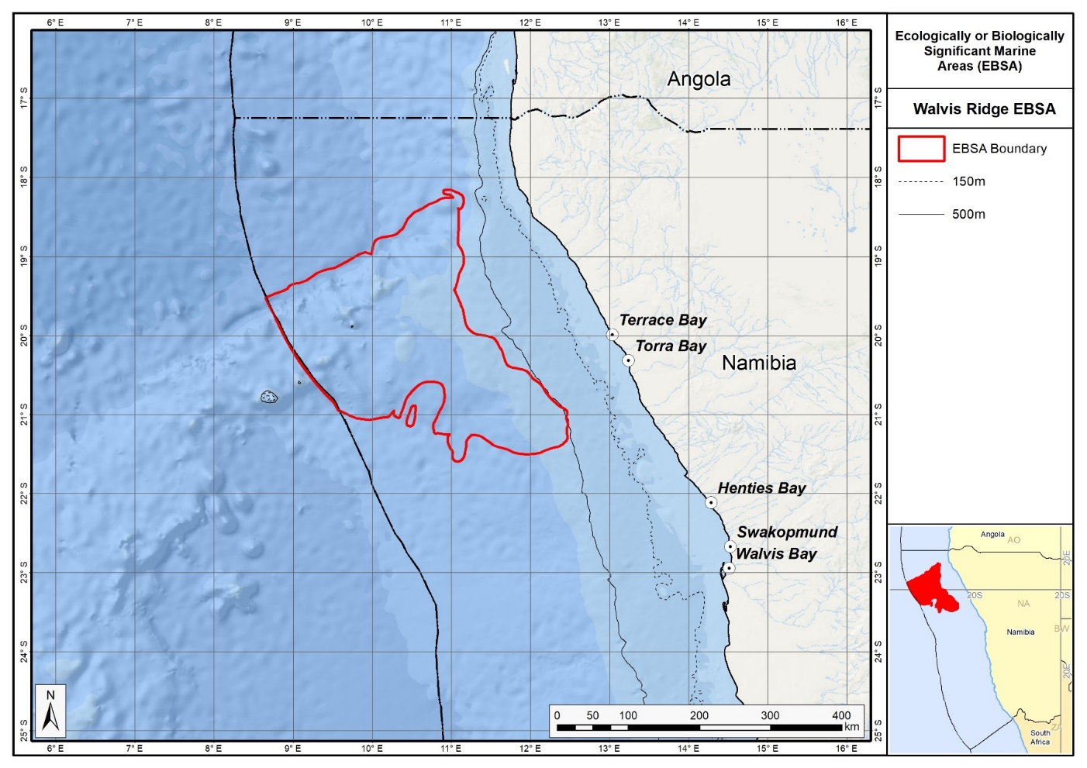
Map of the Walvis Ridge Namibia area.
Rights and permissions:
No limits on sharing or publication.

Angola and Namibia

12. Namibe (modification of the existing Kunene-Tigres)⁵

Reason for the modification:
The EBSA description is being modified because of newly available or accessible knowledge on features associated with the area, based on additional scientific data especially new systematic spatial planning and assessments of biodiversity. The descriptions and supporting information are substantially extended, updated and refined beyond the original descriptions from the South-Eastern Atlantic workshop, April 2013. The modifications involve changes to the textual description, changes to the ranking of the area against the EBSA criteria, and changes in shape, location and size of the area.

The original descriptions of Ecologically or Biologically Significant Marine Areas (EBSAs) in the Benguela Current Large Marine Ecosystem (BCLME) were described in the South-Eastern Atlantic workshop (April 2013). The descriptions were generally characterized by generic, often fairly geometric delineations, consisting of approximate bounding boxes around the features for which the EBSA was described. This coarse scale of delineation was appropriate for a global scale but posed challenges for inclusion in national-level, place-based ocean management. The original boundaries were not sufficiently refined to capture the full extent of key biodiversity features and often overlapped with areas of lower biodiversity value or poor ecological condition.

Additionally, the original EBSA descriptions suffered from shortfalls related to limited spatial data and lack of systematic conservation planning approaches at the time they were first proposed. This meant that many boundaries did not precisely encompass biodiversity priority areas, potentially leading to conflicts with other ocean sectors and limiting their practical usefulness for marine spatial planning (MSP). The coarse scale and lack of detailed data constrained the ability to develop effective zoning and management recommendations that balance biodiversity protection with economic activities.

How was the submission developed?
The EBSA revision process was part a broader project on ecosystem-based MSP in the BCLME, namely the Benguela Current Marine Spatial Management and Governance Project (MARISMA, 2014-2023). This was a regional capacity-building and development cooperation project implemented by the Benguela Current Commission, the Governments of Angola, Namibia and South Africa, and GIZ, the German Agency for Development Cooperation (Deutsche Gesellschaft für Internationale Zusammenarbeit.

Because of these shortcomings of the existing EBSA boundaries, description and valuations set out in the previous section, the MARISMA project undertook a refinement process. This process used systematic conservation planning (SCP) tools, such as Marxan, to generate finer-scale, more accurate boundaries based on updated biodiversity data and expert input. This process also allowed for the identification of new EBSAs and the splitting of some original EBSAs into multiple refined areas to better reflect discrete biodiversity features and ecological processes. The refined EBSA boundaries were more suitable for MSP and conservation management because they focused on core natural and near-natural areas, avoided unnecessary conflicts with other sectors, and incorporated a systematic, data-driven approach to spatial prioritization.

The overall approach to the EBSA update and engagement followed these key steps:

Initial Systematic Conservation Planning (SCP) Analyses: Existing EBSAs were refined and new areas identified using systematic conservation planning tools such as Marxan, based on biodiversity input data including ecosystem types, species distributions, and ecological processes.

National Workshops: The refined and new EBSA boundaries were iteratively reviewed and adjusted through workshops held within each of the three countries (Angola, Namibia, South Africa). These workshops allowed country-specific input and tailoring of EBSA boundaries and descriptions to national contexts and priorities.

Regional Workshops and Bilateral Meetings between Countries: Workshops at the regional level especially focused on transboundary EBSAs shared between the countries, but also examined the overall approach to EBSAs, their delineation, description and the engagement approach. The aim was to harmonize boundaries, align management recommendations, and foster cooperation across national borders for effective regional marine biodiversity management. Additional specific bilateral meetings were held where necessary.

Technical and Scientific Peer Review: The revised and new EBSAs underwent technical review nationally and regionally (through technical review workshops involving relevant experts); and internationally with a further regional review workshop with participation of experts from the Global Ocean Biodiversity Initiative (GOBI) and members of the CBD's Informal Advisory Group on EBSAs; ensuring robustness of the exercise. The process is documented in peer reviewed literature (Harris et al., 2019, 2022).

Political Approval: The EBSAs were administratively and politically approved through all required stages up to the national ministerial level in each country and were then submitted to the CBD Secretariat by the National CBD Focal Points.

Data Sharing and Accessibility: All information, including refined EBSA boundaries, status assessments, management recommendations, and stakeholder feedback, were made available through online repositories such as the project's EBSA Portal (https://cmr.mandela.ac.za/Research-Projects/EBSA-Portal); and the EBSA were also shared via the Benguela Current Convention's Geodata Portal (https://geodata.benguelacc.org/ ). This facilitated transparency, accessibility, and ongoing updating of data and products for biodiversity specialists and other stakeholders.

Revisions to the Namibian portion of the EBSA are largely a slight refinement of the boundaries, editing and formatting of the description, updates on references, and addition of some quantitative data from the from the BCC spatial mapping project (Holness et al., 2014). The original EBSA description was revised and updated with the latest research and biodiversity information from OBIS. The changes in Angola are more significant and are linked to the extension of the boundary to match that of the terrestrial Iona National Park and include significant offshore features such as canyons and seamounts. The overall motivation for the EBSA and the criteria ranks remain largely the same, with one upgrade to the “Productivity” criteria to High. A table of the habitats represented in the EBSA and their associated threat status were also included. The name change from Kunene-Tigres to Namibe reflects the change in overall geographical footprint of the EBSA.

The delineation process used a combination of Systematic Conservation Planning (SCP) and Multi-Criteria Analysis methods. The features used in the analysis were:
- Threatened Benthic and Coastal Ecosystems. The analysis focussed on the inclusion of the most threatened ecosystem types found in the area. These types are highlighted in the table in the Other relevant website address or attached documents section. Key threatened ecosystem types were the endangered Cunene Outer Shelf, and numerous vulnerable types including Cunene Shelf Edge, Tombua Estuarine Shore, Tombua Inshore, Tombua Mixed Shore, Tombua Reflective Sandy Beach and Tombua Sheltered Rocky Shore. Delineations and ecosystem threat status from Holness et al. (2014).
- Areas of high relative naturalness identified in the SCP undertaken for the BCLME by Holness et al. (2014).
- Key physical features such as canyons, areas in proximity to islands, and some small seamounts from the BCC spatial mapping project (Holness et al., 2014), GEBCO data, and global benthic geomorphology mapping (www.bluehabitats.org, Harris et al., 2014).
- Irreplaceable and near irreplaceable (i.e. very high selection frequency) sites, as well as primary and secondary focus areas identified in the SCP undertaken for the BCLME by Holness et al. (2014).
- Some additional manual editing of the northern boundary of the EBSA was undertaken to align with the boundaries of Iona National Park.

The multi-criteria analysis resulted in a value surface. The cut-off value (used to determine the extent of the EBSA) was based on expert input and quantitative analysis of effective inclusion of the above features. This entailed taking an iterative parameter calibration-based approach whereby the spatial efficiency of the inclusion of the targeted features was evaluated. The approach aimed to identify a cut-off which most efficiently included prioritised features while minimizing the inclusion of impacted areas. The revised boundaries of the EBSA were validated at a series of national (in both Angola and Namibia) and regional meetings.

Traditional knowledge was not incorporated into this process, and consultations with indigenous peoples or local communities were not undertaken. Therefore, documentation of Free, Prior and Informed Consent (FPIC) is not relevant for this EBSA process.

Where is the submission intended to be included (choose one option, and please note that there are different procedures for these two intended end points)?
[X] EBSA repository
[ ] EBSA information-sharing mechanism

Abstract:
Changes from the original version: The abstract is expanded and provides more detail than previously. The revised highlights that the original Kunene-Tigres EBSA was extended northward to include adjacent canyons, seamounts, and the full coastline of the Iona National Park, reflecting a broader geographical footprint. A more inclusive description of the important features is included.

Namibe is a transboundary area shared by Angola and Namibia and is an extension of the existing Kunene-Tigres EBSA. The Kunene River mouth and associated wetlands influence salinity, sediment and productivity in the Baía dos Tigres complex 50 km north, which is a regionally unique feature driving elevated local productivity. In the delineation of the existing EBSA, shelf-incising canyons and seamounts that also contribute to productivity and foraging habitat were excluded. New information has led to the proposal for a northward extension to include within the EBSA adjacent canyons, seamounts and the full coastline of the Iona national park. Namibe comprises highly diverse species and habitats in close proximity, many of which are threatened, with unique features promoting high productivity. It therefore supports critical life histories of important species, providing foraging, breeding and resting habitats for seals, fish, turtles and migratory and resident birds.

Introduction:
Changes from the original version: The introduction has been extensively revised and expanded. Unlike the original description, which focused primarily on the Kunene River mouth and Tigres Island-Bay complex, the revised description emphasizes the ecological connectivity between these features and adjacent offshore habitats such as seamounts and canyons. It also incorporates new information about the importance of the Iona National Park coastline as part of the transboundary ecosystem. The revised description includes updated scientific data and spatial assessments, providing a more comprehensive ecological context.

Adjacent to the arid, mostly uninhabited, and remote 100 km of the southern Angolan coastline is an area of limited geographic but notable ecological prominence. Tigres Island and adjacent bay are a remnant of the pre-1970s peninsula formed by sediment discharged from the Kunene River. These features form a rare coastal wetland that plays an important role in the life cycles of many marine and terrestrial fauna (Simmons et al., 2006, Paterson 2007). The predominantly sandy island, measuring ~6 km at its widest point and ~22 km in length, has withstood the weathering effects of the Atlantic since the breaching of the isthmus in 1973, and has become an important site for a number of migratory and resident aquatic fauna (Morant 1996b, Simmons et al., 2006, Dyer 2007, Meÿer 2007). Approximately 50 km south of Tigres Island is an ecologically significant natural marine-freshwater feature: the Kunene River mouth. Although discharge volumes are erratic, this sub-tropical, perennial river may discharge up to 30 million m³ of fresh water per day into the sea. This has pronounced physicochemical influences on the adjacent marine habitat (sublittoral to littoral coastal region) to an extent of ~100 km from the river mouth, mostly northwards, but also southwards during certain times of the year and during abnormal climatic events, such as Benguela Niños (Simmons et al., 1993, Shillington 2003). A lagoon extends 2 km south from the river mouth (Simmons et al., 1993). These features provide foraging, roosting and breeding habitat for a range of fauna, including sea- and shorebirds (Braine 1990, Simmons et al., 1993, Anderson et al., 2001, Dyer 2007, Simmons 2010), marine and freshwater reptiles (Griffin & Channing 1991, Simmons et al., 1993, Griffin 1994, Carter & Bickerton 1996, Griffin 2002), crustaceans (Carter & Bickerton 1996), marine and freshwater fish species (Simmons et al., 1993, Hay et al., 1997, Fishpool & Evans 2001, Holtzhausen 2003), as well as resident (Meÿer 2007) and transient marine mammals (Paterson 2007). In this region the presence of the Cape Fur Seal (Arctocephalus pusillus) is verified. This species is strongly associated with the cooler waters of the Benguela Current ecosystem and, therefore, its distribution extends to the western coast of southern Africa to the south of Angola. A. pusillus are most common in southern Angola, where there is a large colony in Tigres Bay (Morais et al., 2006). Weir (2013) found that this was the most common marine mammal species in the Benguela region but rarely seen in the northern-most regions. This confirms the link between the northern Angolan section of the EBSA and the Namibian sections.

The revised boundary for this EBSA now includes the full extent of the coastline of the adjacent Iona National Park, which is an Important Bird and Biodiversity Area that similarly supports migratory and resident birds in this area. Further, since the original description, a regional map of marine ecosystems has become available for Namibia and Angola (Holness et al., 2014). It was then noted that the original Kunene-Tigres EBSA contained seamounts and canyons that were also likely contributing to the elevated productivity that underpins the key foraging areas for the species noted above. Therefore, the EBSA was extended northward to include adjacent seamounts and canyons that were in close proximity to Tigres Island and adjacent to the Iona National Park IBA. The southern boundary was also refined to improve precision based on the new habitat map. The habitats that are influenced by the Kunene River, i.e., those formed from terrigenous sediments flowing out of the river, are now included in their full extent. Furthermore, the real extent of the Kunene Estuary, on which this whole EBSA depends, is now included to improve precision over the much smaller representation of the estuary in the original boundary. Namibe can be considered a Type 2 EBSA (sensu Johnson et al. 2018) because it comprises a collection of features and ecosystems that are connected by the same ecological processes.

Location:
Changes from the original version: The revised description expands the geographical boundaries of the EBSA to approximately 15,000 km², and also refines offshore boundaries to include deeper shelf areas and key physical features. The revised delineation aligns the northern boundary with the Iona National Park limits.

The area extends along the shore approximately 170 km north of the Kunene mouth into southern Angola, to the northern boundary of the Iona national park, at Curoca River, and 40 km south of the Kunene mouth into northern Namibia. The maximum offshore extent is approximately 100 km, although the Namibian section extends only 40 km offshore. The area includes the Baía dos Tigres lagoon and approximately 12 km of the Kunene estuary. Namibe is well within the exclusive economic zones of the two neighbouring countries that it straddles (Angola and Namibia) and more than 80% of the area is in the exclusive economic zone of Angola. In Namibia, the area borders the Skeleton Coast national park; and in Angola it borders the Iona national park. It has a total area of approximately 15,000 km².
The coordinates of a minimum bounding box covering the entire scope of the area are:
- Latitude: -17.726, -15.634, -15.697, -17.789
- Longitude: 10.809, 10.939, 11.94, 11.81

Feature description of the area:
Changes from the original version: The revised description focusses on the higher habitat heterogeneity within the expanded EBSA notably due to the inclusion of offshore canyons and seamounts. It reflects the new identification of 25 habitats identified, and includes data from new quantitative assessments of ecosystem threat status and condition. It provides more detailed information on species richness, including updated bird species counts and threatened species lists, reflecting enhanced biodiversity knowledge.

Namibe comprises a rich diversity of features, species and habitats. The southern portion includes the Kunene estuary and surrounding river-influenced ecosystems, with the bulk of the influence from the river (freshwater, sediment and nutrients) transported north, connecting to Tigres Island and Tigres Bay in Angola. The surrounding ecosystems also include canyons and seamounts that contribute to the productivity and diversity in the EBSA. Tigres Bay is approximately 11 km at its widest point (northern region of Tigres Bay) and ~8.5 km at its narrowest point (southern limit of Tigres Island from the mainland), with a longitudinal extent of ~60 km.

Surveys of the area have recorded 26 bird species with abundances of around 13000 individuals (Simmons et al., 1993, Simmons et al., 2006, Simmons 2010). Several bird species breed on Tigres Island or along the bay (including globally threatened Cape Cormorants and Damara Terns, and locally threatened Great White Pelicans and Caspian Terns; Simmons et al., 2006; Dyer 2007; Simmons 2010) and Cape fur seals breed on the island (Meÿer 2007). The Kunene River mouth and adjacent marine habitat supports a lower bird density (~4000 individuals) than does Tigres Bay, but a higher species richness, and serves as a refuelling and resting area for Palearctic migrant bird species (Simmons et al., 1993). At least 119 bird species have been recorded at the Kunene River mouth (Paterson 2007), and there are records of 381 species in the EBSA area, of which 2 are Critically Endangered, 3 are Endangered, and 9 are Vulnerable (OBIS, 2017). Iona National Park in Angola is an Important Bird and Biodiversity Area. Furthermore, the Kunene-Namib area is known to support the largest density of green turtles in Namibia (Griffin & Channing 1991; Simmons et al., 2006), with olive ridleys also present. In addition, there are many species of fish, sharks and cetaceans in the area, some of which are threatened, that breed and/or forage in this EBSA (Hay et al., 1997, Holtzhausen 2003, Paterson 2007).

Habitat heterogeneity is high, with 25 habitats present in the EBSA. These include substantial representation of two threatened ecosystem types: the Endangered Kunene Outer Shelf, and Vulnerable Kunene Shelf Edge. In addition, smaller areas of five further Vulnerable types are found, viz. Tombua Estuarine Shore, Tombua Inshore, Tombua Mixed Shore, Tombua Reflective Sandy Beach, and Tombua Sheltered Rocky Shore. These threat statuses were determined by assessing the weighted cumulative impacts of various pressures (e.g., extractive resource use, pollution, development and others) on each ecosystem type for Namibia and Angola (Table below; Holness et al., 2014).

Summary of ecosystem types and threat status for Namibe. Data from Holness et al. (2014).

Threat Status | Ecosystem Type | Area (km²) | Area (%)
Endangered | Cunene Outer Shelf | 919.6 | 6%
Vulnerable | Cunene Shelf Edge | 601.9 | 4%
 | Tombua Estuarine Shore | 3.8 | 0%
 | Tombua Inshore | 56.6 | 0%
 | Tombua Mixed Shore | 0.5 | 0%
 | Tombua Reflective Sandy Beach | 22.1 | 0%
 | Tombua Sheltered Rocky Shore | 2.4 | 0%
Least Threatened | Cunene Dissipative-Intermediate Sandy Beach | 11.6 | 0%
 | Cunene Estuarine Shore | 6.2 | 0%
 | Cunene Inner Shelf | 2,220.9 | 15%
 | Cunene Inshore | 655.8 | 4%
 | Cunene Intermediate Sandy Beach | 56.6 | 0%
 | Cunene Island | 860.6 | 6%
 | Cunene Lagoon Coast | 5.1 | 0%
 | Cunene Low-energy Reflective Sandy Beach | 14.3 | 0%
 | Cunene Lower Slope | 3,720.9 | 25%
 | Cunene Mixed Shore | 28.5 | 0%
 | Cunene Reflective Sandy Beach | 57.6 | 0%
 | Cunene Shelf | 2,443.9 | 16%
 | Cunene Upper Slope | 3,112.2 | 21%
 | Namibe Shelf | 148.4 | 1%
 | Namibe Shelf Edge | 61.4 | 0%
 | Namibe Upper Slope | 25.9 | 0%
 | Tombua Intermediate Sandy Beach | 5.7 | 0%
 | Tombua Low-energy Reflective Sandy Beach | 12.8 | 0%
Grand Total |  | 15,055.4 | 100%

Feature condition and future outlook:
Changes from the original version: The revised description includes additional data from a quantitative assessment of condition, identifying 63% of the area as in fair condition and 25% in good condition, with human impacts varying between Angolan and Namibian portions.

Due to the remoteness of the Namibe focus area, limited human impacts (apart from current mining/exploration) on the marine and coastal areas have resulted in this area being relatively pristine. However, threats to the pristine nature of this ecologically important area include industrial interests upstream of the Kunene River mouth (including proposals to dam the river for power generation) and recent increases in fishing, mining and tourism interests on both sides of the Kunene River mouth (Simmons et al., 1993, Paterson 2007). The Namibian portions of the area are generally in good condition, although most of the Angolan area is in fair condition, primarily due to the high intensity of artisanal and commercial fishing taking place there (Holness et al., 2014). Consequently, 63 % of the overall area has been identified as being in fair condition, and 25 % in good condition.

Assessment of the area against CBD EBSA Criteria:
Changes from the original version: The assessment is largely stable, however substantial additional information which supports the assessed criteria is provide based on new mapping and quantitative assessments of ecosystem status. The “Biological productivity” criteria has been adjusted from “Medium” to “High” based on the new inclusion of ecosystems that are characteristically associated with relatively higher productivity, including wetlands of the Kunene estuary, seamounts and canyons.

CBD EBSA Criteria  (Annex I to decision IX/20) | Description  (Annex I to decision IX/20) | Ranking of criterion relevance  (please mark one column with an X)
CBD EBSA Criteria  (Annex I to decision IX/20) | Description  (Annex I to decision IX/20) | No information |  | Low |  |  | Medium |  | High
Uniqueness or rarity | Area contains either (i) unique (“the only one of its kind”), rare (occurs only in few locations) or endemic species, populations or communities, and/or (ii) unique, rare or distinct, habitats or ecosystems; and/or (iii) unique or unusual geomorphological or oceanographic features. |  |  |  |  |  |  |  | x
The Namibe area is regionally unique in the Benguela System, being the only sheltered, predominantly marine, sandy bay with a link to a perennial river for a 1500 km stretch along the Namibian coast and a 200 km stretch along the Angolan coast (Simmons et al., 2006). The area is both geographically and biologically isolated, and is ranked amongst the most threatened in Namibia (Simmons et al. 1993, Carter and Bickerton 1996, Barnard and Curtis 1998, Bethune 1998, De Moor et al., 2000). It supports reptilian fauna unique to Southern Africa (Kolberg & Simmons 1998). Furthermore, the Kunene wetland is globally unique as it is the only freshwater input area that is located adjacent to an upwelling cell, viz. the Kunene upwelling cell, and wedged within the longitudinal range of a warm-cold water frontal system, i.e., the Angola-Benguela frontal system (Lutjeharms & Meeuwis 1987, Paterson 2007).
Special importance for life-history stages of species | Areas that are required for a population to survive and thrive. |  |  |  |  |  |  |  | x
The Namibe wetlands serve as resting grounds for Palearctic migratory birds that use the area to build up energy reserves during their seasonal migrations (Simmons et al., 1993). The area (particularly Tigres Island) also serves as the breeding site for several bird species (Simmons et al., 2006, Simmons 2010). In addition to a colony of Cape fur seals, a number of other marine mammals (in particular Heaviside’s dolphins, long-finned pilot whales, bottlenose dolphins, beaked whales and Atlantic humpback dolphins) have also been recorded in the general area (Dyer 2007, Paterson 2007). However, little research has been done on cetaceans there, and they are currently considered to be only transient visitors to the area (Paterson 2007). Namibe is very important for green turtles, with high densities of these animals known to occur in the area, which also represents the southern-most distribution of the species along the African west coast (Carr & Carr 1991, Griffin and Channing 1991, Carter & Bickerton 1996, Branch 1998, Griffin 2002, Fretey 2001, Paterson 2007). Furthermore, Namibe is an important spawning area for many marine fish species found along the northern and central Namibian coast (Hay et al., 1997, Holtzhausen 2003).
Importance for threatened, endangered or declining species and/or habitats | Area containing habitat for the survival and recovery of endangered, threatened, declining species or area with significant assemblages of such species. |  |  |  |  |  | X
The EBSA contains significant areas of two threatened habitats, namely the Endangered Kunene Outer Shelf, and Vulnerable Kunene Shelf Edge. In addition, smaller areas of five further Vulnerable types are found, viz. Tombua Estuarine Shore, Tombua Inshore, Tombua Mixed Shore, Tombua Reflective Sandy Beach, and Tombua Sheltered Rocky Shore. These threat statuses were determined by assessing the weighted cumulative impacts of various pressures (e.g., extractive resource use, pollution, development and others) on each ecosystem type for Namibia and Angola (Table in features description; Holness et al., 2014).
Further, the Kunene-Tigres area (including the island, the bay, the river mouth and adjacent marine environment) supports threatened and/or regionally endemic bird species – in particular the Great White Pelican: Pelecanus onocrotalus, Cape Cormorant: Phalacrocorax capensis, Lesser Flamingo: Phoeniconaias minor, African Black Oystercatcher: Haematopus moquini, Hartlaub’s Gull: Chroicocephalus hartlaubii, Caspian Tern: Hydroprogne caspia and Damara Tern: Sternula balaenarum (Barnard & Curtis 1998, Anderson et al., 2001, Simmons et al., 2006, Simmons et al., 2015). Cetaceans that are endemic to the region (e.g., Heaviside’s dolphin: Cephalorhynchus heavisidii), or are threatened (e.g., the Vulnerable sperm whale, Physeter microcephalus; OBIS 2017) also make use of this area during their life cycles (Paterson 2007). Other threatened species in the area include the fish and condricthian species: Squatina oculata and Squatina aculeate (Critically Endangered); Argyrosomus hololepidotus, Rostroraja alba, and Sphyrna lewini (Endangered); and Thunnus obesus, Mustelus mustelus, Rhinobatos albomaculatus, Oxynotus centrina, Oreochromis macrochir, and Centrophorus squamosus (Vulnerable; OBIS, 2017). The resident edible freshwater prawn: Macrobrachium vollenhovenii is also believed to be geographically, ecophysiologically and morphologically distinct here due to the physical characteristics of the Kunene River mouth (Carter and Bickerton 1996, Patterson 2007). Large aggregations of green turtles, Chelonia mydas, found in the area further support the significance of the area in relation to this EBSA criterion; Vulnerable olive ridley turtles, Lepidochelys olivacea, are also present. This criterion is ranked as medium because the cetaceans listed are probably non-resident here, and there are other areas along the Namibian coast that are considered more important in terms of supporting threatened and endemic bird species.
Vulnerability, fragility, sensitivity, or slow recovery | Areas that contain a relatively high proportion of sensitive habitats, biotopes or species that are functionally fragile (highly susceptible to degradation or depletion by human activity or by natural events) or with slow recovery. |  |  |  |  |  | X
The EBSA is largely underpinned by the influence of the Kunene River. Consequently, there is a moderate level of vulnerability and sensitivity to disturbance because changes to the freshwater outflow could result in significant changes to the ecosystems it influences by altering sediment delivery, salinity and nutrient concentrations. The vulnerability of the site to changes in productivity is, in part, buffered by the numerous other features that also contribute to productivity in the area, including the upwelling cell and the seamounts and canyons. The Kunene wetlands are believed to be vulnerable to environmental change mainly as a result of anthropogenic stress from activities such as fishing, mining and industrial development (Schneider & Miller 1992; Simmons et al., 1993; De Moor et al., 2000; Paterson 2007). The species at the site include turtles, cetaceans, sharks, seals and birds that are sensitive to delines in population abundance, and would be slow to recover from impacts.
Historically, dams constructed along the upper reaches of the Kunene River (six in total) have not had significant negative impacts on the flow characteristics of the river and naturalness of the adjacent wetland (Paterson 2007). This may be linked to the fact that the six dams have never been in operation at the same time due to structural damages sustained during the historic civil unrest in the region. This, however, may change as there is a proposal for a new hydroelectric dam to be built in the vicinity of the Epupa Falls (Dentlinger 2005), and potential still exists for the renovation of the existing six dams (Paterson 2007). Limited fishing occurs in the area that poses threats to vulnerable species such green turtles (which are often targeted by small military contingents near the Kunene River mouth) and marine mammals, which can get entangled in gillnets used by the fishers on the Angolan side of the border (Paterson 2007). On the Namibian side, diamond mining poses a threat to the area; prospecting taking place some 10 km south of the Kunene River mouth (Schneider & Miller 1992; Paterson 2007). There has also been a proposal for a deepwater harbour at one of two locations (viz. Cape Fria or Angra Fria), which are located roughly 160 and 130 km south of the Kunene River mouth, respectively (Paterson 2007). There have also been calls for the investigation of aquaculture viability at the Kunene River mouth, focusing on the edible freshwater prawn that is resident to the area (Paterson 2007). Furthermore, limited tourism interests are already established on the Namibian side and with tourism gaining momentum on the Angolan side, this industry could also pose a threat to the naturalness of the area if not properly regulated (Simmons et al., 2006, Paterson 2007).
Biological productivity | Area containing species, populations or communities with comparatively higher natural biological productivity. |  |  |  |  |  |  |  | X
The Namibe area is considered to be productive due to its unique geographical location. It is situated within the moderately strong Kunene Upwelling Cell, within the longitudinal range of the Angola-Benguela frontal system (Lutjeharms & Meeuwis 1987, Paterson 2007), and at the mouth of one of only two perennial rivers in Namibia. The nutrients carried by the Benguela Current are supplemented by nutrient inputs from the Kunene River, providing a rich food supply that supports a diverse fish community in the area (Paterson 2007). In addition, the EBSA contains ecosystems that are characteristically associated with relatively higher productivity, including wetlands, seamounts and canyons. Jointly, this collection of productive features results in a site of high productivity that in turn provides foraging areas for several species, including seals, birds and turtles that breed or rest in the coastal areas (e.g., Simmons et al., 2006; Dyer 2007; Simmons 2010), as well as supporting many fish species that spawn in the area (Paterson 2007).
Biological diversity | Area contains comparatively higher diversity of ecosystems, habitats, communities, or species, or has higher genetic diversity. |  |  |  |  |  |  |  | X
Habitat heterogeneity in Namibe is high, with 15 distinct ecosystem types present in the EBSA (Holness et al., 2014). The Namibe wetlands also support a high diversity of species, including terrestrial, freshwater and marine fauna (Paterson 2007). Over and above freshwater and marine reptiles (e.g., Nile soft-shelled terrapin, Nile crocodile, green turtle and Nile monitor), and cetaceans, the area also supports a large colony of Cape fur seals (Griffin & Channing 1991, Simmons et al., 1993, Carter & Bickerton 1996, Patterson 2007). The Kunene river mouth is also one of Namibia’s most diverse bird areas, with a total of at least 119 bird species (including 8 resident waders, 22 palearctic waders, 32 wetland-, 19 marine- and 38 non-wetland bird species; Ryan et al., 1984, Braine 1990, Simmons et al., 1993, Anderson et al., 2001, Paterson 2007). In terms of ichthyofauna, 65 freshwater fish species (five of which are endemic to the area) and 19 marine fish species have been recorded in Namibe (Hay et al., 1997, Holtzhausen 2003, Paterson 2007).
Naturalness | Area with a comparatively higher degree of naturalness as a result of the lack of or low level of human-induced disturbance or degradation. |  |  |  |  |  |  | X
In Namibia, human impacts on the Namibe area have been limited due to its remoteness. However, historic and current fishing activities, combined with dam construction, mining and prospecting activities in and around the area have had some impacts on the local naturalness (Simmons et al., 1993, De Moor et al., 2000, Paterson 2007). Much of the Angolan area was identified as being in fair condition by Holness et al. (2014) largely due to the high intensity of artisanal and commercial fishing. Consequently, overall 63 % of the area is in fair condition and 25 % in good condition.

References:
Changes from the original version: New and updated references are included, increasing the references from 26 to 41; notably the new national and regional ecosystem assessments which were not previously available.
Anderson M.D., Anderson R.A., Anderson S.L., Anderson T.A., Bader U., Heinrich D., Hofmeyer J.H., Kolberg C., Kolberg H., Komen L., Paterson B., Paterson J., Sinclair K., Sinclair W., van Zijl D., van Zijl, H. 2001. Notes on the birds and other animals recorded at the Kunene River mouth from 6-8 January 2001. Bird Numbers, 10: 52-56.
Barnard P. Curtis, B. 1998. Sites of special ecological importance. In: Biological Diversity in Namibia: a Country Study. Barnard, P. (ed.) 1998. Namibian National Biodiversity Task Force, Windhoek. Pages: 74-75.
Bethune S. 1998. Wetland habitats. In: Biological Diversity in Namibia: a Country Study. Barnard, P. (ed.). Namibian National Biodiversity Task Force. Windhoek. Pages 60-66.
Braine S. 1990. Records of birds of the Kunene River estuary. Lanioturdus, 25: 38–44.
Carr T., Carr, N. 1991. Surveys of the Sea Turtles of Angola. Biological Conservation, 58: 19-29.
Carter R., Bickerton, I.B. 1996. Chapter 5 Aquatic Fauna. In: Environmental Study of the Kunene River Mouth. Morant, P. D. ed.). CSIR Report EMAS - C96023. CSIR, Stellenbosch.
De Moor F.C., Barber-James H.M., Harrison, A.D., Lugo-Ortiz, C.R. 2000. The macro-invertebrates of the Kunene River from the Ruacana Falls to the river mouth and assessment of the conservation status of the river. African Journal of Aquatic Sciences, 25: 105-122.
Dentlinger, L. 2005. Namibia, Angola eye reviving Kunene hydropower plans. The Namibian. Wednesday, August 17. Dyer B.M. 2007. Report on top-predator survey of southern Angola including Ilha dos Tigres, 20-29 November 2005. In: Kirkman, S.P. (Ed.), Final Report of the BCLME (Benguela Current Large Marine Ecosystem) Project on Top Predators as Biological Indicators of Ecosystem Change in the BCLME. Avian Demography Unit, Cape Town, pp. 303–306.
Fishpool L.D.C., Evans, M.I. (eds.) 2001. Important Bird Areas in Africa and associated islands: Priority sites for conservation. Newbury and Cambridge, UK: Pisces Publications and BirdLife International. BirdLife Conservation Series No. 11.
Fretey, J. 2001. Biogeography and conservation of marine turtles of the Atlantic coast of Africa. CMS Technical Series Publication No. 6, UNEP/CMS Secretariat, Bonn, Germany: 429 pp.
Griffin, M. 1994. Report on the Reptiles of the Kunene Mouth. In: Tyldesley, P. (Comp) Report on an Integrated Scientific Data Collecting Expedition to the Mouth of the Kunene River 19/04/94 – 23/04/94. NNF report.
Griffin, M. 2002. Annotated checklist and provisional conservation status of Namibian reptiles. Technical Reports of Scientific Services No 1, Ministry of Environment and Tourism, Windhoek: 168 pp.
Griffin, M., Channing, A. 1991. Wetland: associated reptiles and amphibians of Namibia – a national review. Madoqua, 17: 221-225.
Harris, L., Holness, S., Finke, G., Kirkman, S., Sink, K., 2019. Systematic Conservation Planning as a Tool to Advance Ecologically or Biologically Significant Area and Marine Spatial Planning Processes, in: Zaucha, J., Gee, K. (Eds.), Maritime Spatial Planning. Palgrave Macmillian, Cham.
Harris, L.R., Holness, S.D., Finke, G., Amunyela, M., Braby, R., Coelho, N., Gee, K., Kirkman, S.P., Kreiner, A., Mausolf, E., Majiedt, P., Maletzky, E., Nsingi, K.K., Russo, V., Sink, K.J., Sorgenfrei, R., 2022. Practical Marine Spatial Management of Ecologically or Biologically Significant Marine Areas: Emerging Lessons From Evidence-Based Planning and Implementation in a Developing-World Context. Front. Mar. Sci. 9.
Hay, C.J., van Zyl, B.J., van der Bank F.H., Ferreira J.T., Steyn, G.J. 1997. A survey of the fishes of the Kunene River, Namibia. Madoqua, 19: 129-141.
Holness S., Kirkman S., Samaai T., Wolf T., Sink K., Majiedt P., Nsiangango S., Kainge P., Kilongo K., Kathena J., Harris L., Lagabrielle E., Kirchner C., Chalmers R., Lombard, M. 2014. Spatial Biodiversity Assessment and Spatial Management, including Marine Protected Areas. Final report for the Benguela Current Commission project BEH 09-01.
Holtzhausen, H. 2003. Fish of the Kunene River mouth. BCLME Orange-Kunene estuaries workshop. 21-23 October 2003, Swakopmund, Namibia.
Johnson, D.E., Barrio Froján, C., Turner, P.J., Weaver, P., Gunn, V., Dunn, D.C., Halpin, P., Bax, N.J., Dunstan, P.K., 2018. Reviewing the EBSA process: Improving on success. Marine Policy 88, 75-85.
Kolberg H. & Simmons R.E. 1998. Wetlands. In: Biological Diversity in Namibia: a Country Study. Barnard, P. (ed.). 1998. Namibian National Biodiversity Task Force. Windhoek. Pages 47-48.
Lutjeharms, J.R.E., Meeuwis, J.M. 1987. The extent and variability of the South East Atlantic upwelling. South African Journal of Marine Science, 5: 51-62.
Meÿer, M.A. 2007. The first aerial survey of Cape Fur Seal numbers at Baia dos Tigres, southern Angola. In: Kirkman, S.P. (Ed.), Final Report of the BCLME (Benguela Current Large Marine Ecosystem) Project on Top Predators as Biological Indicators of Ecosystem Change in the BCLME. Avian Demography Unit, Cape Town, pp. 307.
Morant, P.D. 1996a. Chapter 1 Introduction. In: Morant, P. D. 1996 (ed.) Environmental Study of the Kunene River Mouth. CSIR Report EMAS-C96023. CSIR Stellenbosch.
Morant, P.D. 1996b. Chapter 6 Avifauna of the Kunene River Mouth. In: Morant, P. D. 1996 (ed.) Environmental Study of the Kunene River Mouth. CSIR Report EMAS-C96023. CSIR Stellenbosch.
OBIS. 2017. Summary statistics of biodiversity records in the Kunene-Tigres EBSA. (Available: Ocean Biogeographic Information System. Intergovernmental Oceanographic Commission of UNESCO. www.iobis.org. Accessed: 2017-07-27).
Paterson, J.R.B. 2007. The Kunene River Mouth: Managing a unique environment. MSc Thesis, Unversity of KwaZulu Natal, Pietermaritzburg, South Africa: 124 pp.
Ryan, P.G., Cooper, J., Stutterheim, C. J. 1984. Waders (Charadrii) and other coastal birds of the Skeleton Coast, South West Africa. Madoqua, 14: 71-78.
Schneider, G.I.C., Miller, R.McG. 1992. Diamonds. Ministry of Mines and Energy Geological Survey Namibia. Economic Geology Series open file report.
Shillington, F. 2003. Oceanography. In: Namibia’s Marine Environment. Molloy, F. and Reinikainen, T. (eds.). Directorate of Environmental Affairs of the Ministry of Environment and Tourism, Namibia. Windhoek: 162 pp.
Simmons, R.E. 2010. First breeding records for Damara Terns and density of other shorebirds along Angola’s Namib Desert coast. Ostrich, 81: 19-23.
Simmons, R.E., Braby R, Braby, S.J. 1993. Ecological studies of the Kunene River mouth: avifauna, herpetofauna, water quality, flow rates, geomorphology and implications of the Epupa Dam. Madoqua, 18: 163-180.
Simmons, R.E., Brown, C.J., Kemper, J. 2015. Birds to watch in Namibia: red, rare and endemic species. Ministry of Environment and Tourism and Namibia Nature Foundation, Windhoek, Namibia.
Simmons, R.E., Sakko A., Paterson J. & A. Nzuzi 2006. Birds and Conservation Significance of the Namib Desert's least known coastal wetlands: Baia and Ilha dos Tigres, Angola. African journal of marine science, 28: 713-717.

Maps and Figures:
GIS data available at: https://cmr.mandela.ac.za/cmr/media/Store/documents/EBSA/Descriptions/Namibia/Namibia_EBSAs_2020-SHP.zip or https://cmr.mandela.ac.za/cmr/media/Store/documents/EBSA/Descriptions/Angola/Angola_EBSAs_2020-SHP.zip

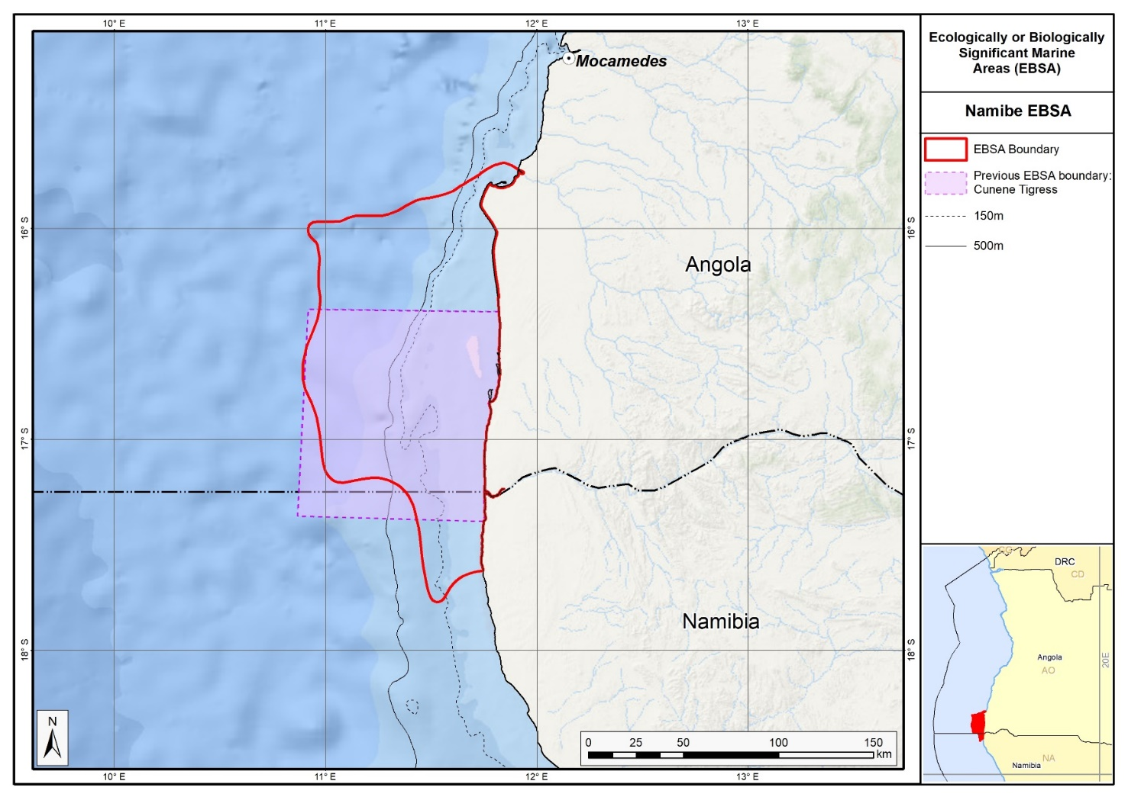Map of the Namibe area in relation to the original Kunene-Tigres EBSA.
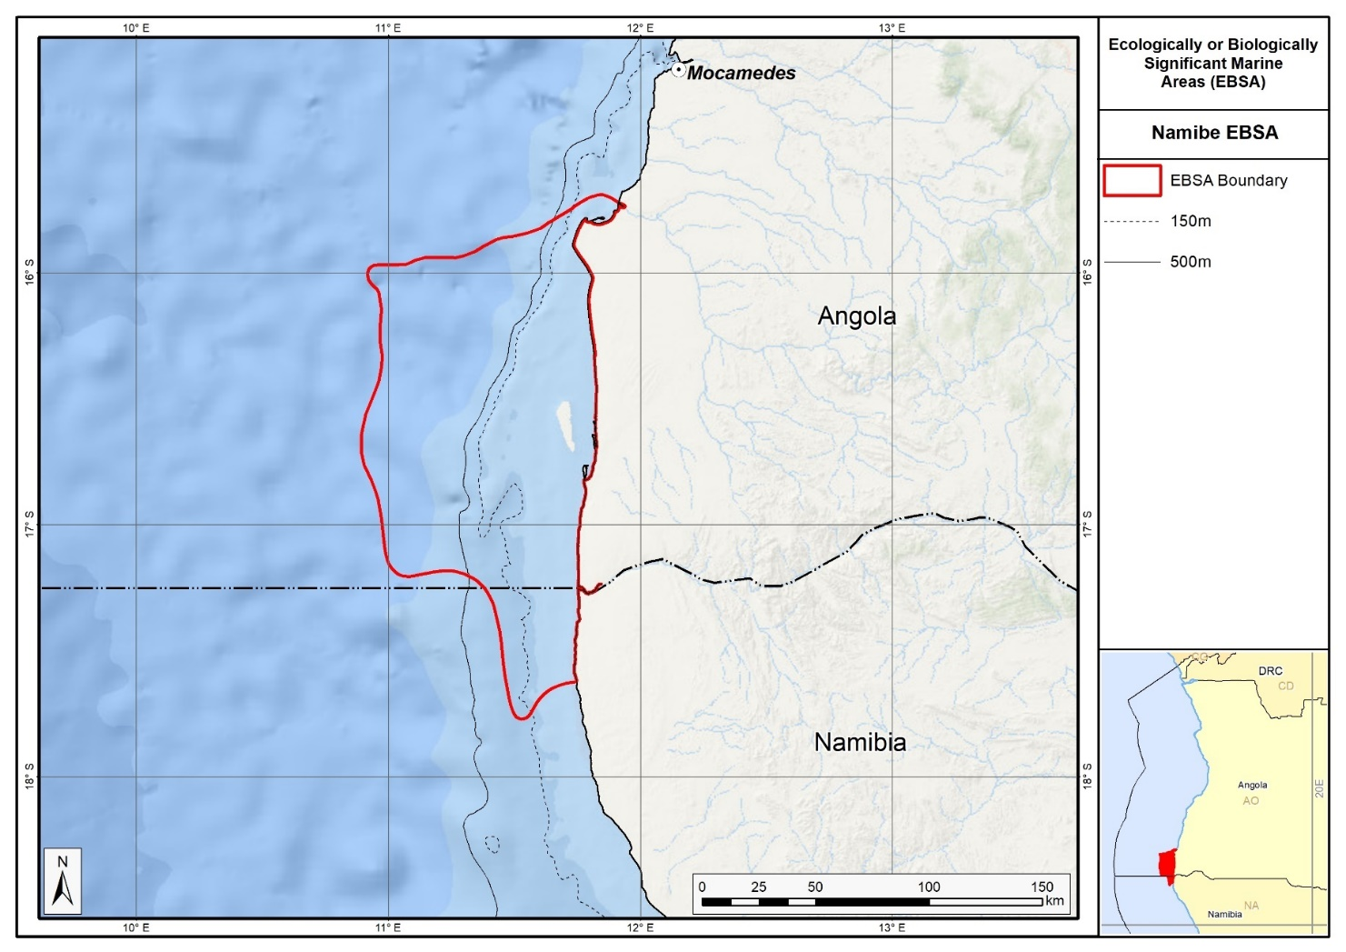
Map of the Namibe area.

Rights and permissions:
No limits on sharing or publication.

Namibia and South Africa

13. Orange Cone (modification of the existing Orange Cone)⁵
Reason for the modification:
The EBSA description is being modified because of newly available or accessible knowledge on features associated with the area, based on additional scientific data especially new systematic spatial planning and assessments of biodiversity. The descriptions and supporting information are substantially extended, updated and refined beyond the original descriptions from the South-Eastern Atlantic workshop, April 2013. The modifications involve changes to the textual description, changes to the ranking of the area against the EBSA criteria, and changes in shape, location and size of the area.

The original descriptions of Ecologically or Biologically Significant Marine Areas (EBSAs) in the Benguela Current Large Marine Ecosystem (BCLME) were described in the South-Eastern Atlantic workshop (April 2013). The descriptions were generally characterized by generic, often fairly geometric delineations, consisting of approximate bounding boxes around the features for which the EBSA was described. This coarse scale of delineation was appropriate for a global scale but posed challenges for inclusion in national-level, place-based ocean management. The original boundaries were not sufficiently refined to capture the full extent of key biodiversity features and often overlapped with areas of lower biodiversity value or in poor ecological condition.

Additionally, the original EBSA descriptions suffered from shortfalls related to limited spatial data and lack of systematic conservation planning approaches at the time they were first proposed. This meant that many boundaries did not precisely encompass biodiversity priority areas, potentially leading to conflicts with other ocean sectors and limiting their practical usefulness for marine spatial planning (MSP). The coarse scale and lack of detailed data constrained the ability to develop effective zoning and management recommendations that balance biodiversity protection with economic activities.

How was the submission developed?
The EBSA revision process was part a broader project on ecosystem-based MSP in the BCLME, namely the Benguela Current Marine Spatial Management and Governance Project (MARISMA, 2014-2023). This was a regional capacity-building and development cooperation project implemented by the Benguela Current Commission, the Governments of Angola, Namibia and South Africa, and GIZ, the German Agency for Development Cooperation (Deutsche Gesellschaft für Internationale Zusammenarbeit.

Because of these shortcomings of the existing EBSA boundaries, description and valuations set out in the previous section, the MARISMA project undertook a refinement process. This process used systematic conservation planning (SCP) tools, such as Marxan, to generate finer-scale, more accurate boundaries based on updated biodiversity data and expert input. This process also allowed for the identification of new EBSAs and the splitting of some original EBSAs into multiple refined areas to better reflect discrete biodiversity features and ecological processes. The refined EBSA boundaries were more suitable for MSP and conservation management because they focused on core natural and near-natural areas, avoided unnecessary conflicts with other sectors, and incorporated a systematic, data-driven approach to spatial prioritization.

The overall approach to the EBSA update and engagement followed these key steps:

Initial Systematic Conservation Planning (SCP) Analyses: Existing EBSAs were refined and new areas identified using systematic conservation planning tools such as Marxan, based on biodiversity input data including ecosystem types, species distributions, and ecological processes.

National Workshops: The refined and new EBSA boundaries were iteratively reviewed and adjusted through workshops held within each of the three countries (Angola, Namibia, South Africa). These workshops allowed country-specific input and tailoring of EBSA boundaries and descriptions to national contexts and priorities.

Regional Workshops and Bilateral Meetings between Countries: Workshops at the regional level especially focused on transboundary EBSAs shared between the countries, but also examined the overall approach to EBSAs, their delineation, description and the engagement approach. The aim was to harmonize boundaries, align management recommendations, and foster cooperation across national borders for effective regional marine biodiversity management. Additional specific bilateral meetings were held where necessary.

Technical and Scientific Peer Review: The revised and new EBSAs underwent technical review nationally and regionally (through technical review workshops involving relevant experts); and internationally with a further regional review workshop with participation of experts from the Global Ocean Biodiversity Initiative (GOBI) and members of the CBD's Informal Advisory Group on EBSAs; ensuring robustness of the exercise. The process is documented in peer reviewed literature (Harris et al., 2019, 2022).

Political Approval: The EBSAs were administratively and politically approved through all required stages up to the national ministerial level in each country and were then submitted to the CBD Secretariat by the National CBD Focal Points.

Data Sharing and Accessibility: All information, including refined EBSA boundaries, status assessments, management recommendations, and stakeholder feedback, were made available through online repositories such as the project's EBSA Portal (https://cmr.mandela.ac.za/Research-Projects/EBSA-Portal); and the EBSA were also shared via the Benguela Current Convention's Geodata Portal (https://geodata.benguelacc.org/ ). This facilitated transparency, accessibility, and ongoing updating of data and products for biodiversity specialists and other stakeholders.

The EBSA description was updated substantially by searching for and including all relevant information from the latest research within the area. One criterion rank, Importance for threatened species and habitats, was upgraded from Medium to High based on additional data and extension of the EBSA to include the Orange River Estuary, which is an important Ramsar site. Small additions, such as biodiversity information from OBIS were also made. A table of the habitats represented in the EBSA and their associated threat status were also included.

The biggest change to the EBSA was a significant refinement of the EBSA delineation. This was done to more closely focus the EBSA on the key biodiversity features that underpin its EBSA status. The delineation process included an initial stakeholder workshop, a technical mapping process and then an expert review workshop where boundary delineation options were finalised. The delineation process used a combination of Systematic Conservation Planning (SCP) and Multi-Criteria Analysis methods. The features used in the analysis were:
- Threatened Benthic and Coastal Ecosystems. The analysis focussed on the inclusion of the most threatened ecosystem types found in the area. These types are highlighted in the table in the Other relevant website address or attached documents section.
- The key muddy ecosystem types associated with the Orange Cone were identified based on data from new studies by Karenyi (2014) and Karenyi et al. (2016).
- Irreplaceable and near irreplaceable (i.e. very high selection frequency) sites, as well as primary and secondary focus areas identified in the SCP undertaken for the BCLME by Holness et al. (2014).
- Areas of high relative naturalness identified in the SCP undertaken for the BCLME by Holness et al. (2014).
- The Orange River Estuary Ramsar site was included.

The multi-criteria analysis resulted in a value surface. The cut-off value (used to determine the extent of the EBSA) was based on expert input and quantitative analysis of effective inclusion of the above features. This entailed taking an iterative parameter calibration-based approach whereby the spatial efficiency of the inclusion of the targeted features was evaluated. The approach aimed to identify a cut-off which most efficiently included prioritised features while minimizing the inclusion of impacted areas. The final boundaries shown in the map below were validated in a series of national (in both South African and Namibian) and regional (BCC) meetings.

Traditional knowledge was not incorporated into this process, and consultations with indigenous peoples or local communities were not undertaken. Therefore, documentation of Free, Prior and Informed Consent (FPIC) is not relevant for this EBSA process.

Where is the submission intended to be included (choose one option, and please note that there are different procedures for these two intended end points)?
[X] EBSA repository
[ ] EBSA information-sharing mechanism

Abstract:
Changes from the original version: The abstract was rewritten to reflect the revised spatial extent of the Orange Cone to include the Orange River Estuary, recognized as an important Ramsar site, enhancing the area's conservation significance. It includes updated ecosystem threat statuses to reflect ten threatened ecosystem types, including two Critically Endangered, four Endangered, and four Vulnerable types, which were not fully detailed in the previous description. Additionally, it emphasizes emerging evidence supporting ecological dependence on Orange River outflow for pelagic species reproduction.

The Orange Cone is a transboundary area between Namibia and South Africa that spans the Orange River mouth, which has the highest amount of marine run-off of any river in both countries. The estuary is rich in biodiversity, and the coastal area contains 10 threatened ecosystem types: two are critically endangered, four are endangered and four are vulnerable. The marine environment has weak winds and slow, variable currents, which are conducive to pelagic species reproduction. Given the area’s similarities with Thukela Banks, South Africa, for fish recruitment, a similar ecological dependence on Orange River outflow is likely in the area, although evidence in that regard is still emerging. Comparable habitats occur only 300 km south (Olifants River) and 1,300 km north (Kunene). The Orange River mouth is a transboundary Ramsar site, is part of Tsau //Khaeb national park, Namibia, is under protection consideration in South Africa and is an important bird and biodiversity area.

Introduction:
Changes from the original version: The revised description provides a more precise delineation of the marine area ecologically coupled to the estuary, acknowledging that the boundaries were previously poorly defined and potentially extensive. It reflects new data on marine ecosystem types. It also highlights recent scientific data on the variability of freshwater outflow influence, which can range from a few kilometers to hundreds of kilometers alongshore, especially during floods. Furthermore, it situates the Orange Cone as a Type 1 EBSA (sensu Johnson et al., 2018), based on spatially stable features, refining the earlier more approximate bounding.

The Orange Cone spans the coastal boundary between South Africa and Namibia. The Orange River estuary extends approximately 10 km inland of the sea in a hydrological sense, although estuarine-dependent species migrate much further upstream. The estuary is substantially modified but under rehabilitation. Boundaries of the marine area that is ecologically coupled to the estuary are not accurately known, but could be extensive: seasonally and inter-annually, the marine habitat affected by freshwater outflow varies from a few kilometres to hundreds of kilometres in the longshore direction during floods, particularly southwards (Shillington et al., 1990). This area is located 50 km north and south of the Orange River, extending 30 - 45 km offshore, and includes the full extent of the estuary. There are 16 marine and coastal ecosystem types represented in the area (Sink et al., 2012, 2019; Holness et al., 2014). The associated pelagic environment is characterized by upwelling, giving rise to cold waters with high productivity/chlorophyll levels (Lagabrielle 2009). However, the winds in the area are weaker compared to that to the north or south of the river mouth, leading to less local upwelling (Boyd, 1988). The site is presented as a Type 1 EBSA because it contains “Spatially stable features whose positions are known and individually resolved on the maps” (sensu Johnson et al., 2018).

Location:
Changes from the original version: The description reflects the revised spatial extent of the Orange Cone which now includes the Orange River Estuary, and an offshore spatial extend based on improved data and systematic conservation planning approaches. The revised description modifies the spatial boundaries, extending the northern and southern limits to 50 km from the Orange River and the offshore boundary to 30–45 km, whereas the previous description used 30 km north and south and approximately 60 km offshore.

The Orange River estuary is located at S 29° and forms the boundary between Namibia and South Africa. The northern and southern boundaries of the area are located 50 km north and south of the Orange River, respectively, and the western boundary of the area extends from 30 to 45 km offshore, thereby ensuring that the area includes the full extent of the estuary. The broader area has characteristics of the Orange Cone marine environment as far as 100 km offshore, however. The proposed EBSA straddles coastal and marine areas within the exclusive economic zones of Namibia and South Africa.

The coordinates of a minimum bounding box covering the entire scope of the area are:
- Latitude: -28.309, -28.509, -29.12, -28.921
- Longitude: 15.996, 16.831, 16.685, 15.85

Feature description of the area:
Changes from the original version: The revised description incorporates 16 marine and coastal ecosystem types compared to fewer types previously noted, and provides quantitative data on their statuses. It highlights updated oceanographic characterizations such as weaker winds and slower currents leading to stratification. It introduces new sediment and habitat data from recent studies (Karenyi 2014; Karenyi et al. 2016) that allowed for more accurate EBSA boundary delineation. Additionally, it strengthens the hypothesis of the Orange River's role in supporting fish recruitment, supported by mounting unpublished evidence linking river flow to fish biomass, which was only tentatively suggested before.

There are 16 ecosystem types represented in this EBSA (Sink et el., 2012, 2019; Holness et al., 2014). The associated pelagic environment is characterized by upwelling, giving rise to cold waters with high productivity (Lagabrielle 2009). However, the winds in the Orange Cone are weaker than those north or south of the area, leading to some stratification (Boyd 1988). Moreover, currents in the inshore region, and indeed over much of the Orange Cone area, have slower speeds than those occurring further north or south, and movements in both upper and lower layers are dominated by diurnal and/or inertial motions (Iita et al., 2001, Largier and Boyd, 2001).

The river and estuary have received substantial research attention over the last decade; the adjacent marine environment much less so, apart from some research during the Large Marine Ecosystem (LME) project from 1995-2000. However, given the proven role of the Thukela River outflow for the recruitment of fish stocks in the adjacent marine area on the South African east coast (Turpie and Lamberth 2010), it is hypothesized that the Orange River plays a similar role on the South African west coast. Although not formally described, evidence is mounting to support this hypothesis, because there are seemingly many relationships between Orange River flow volumes and demersal, pelagic and nearshore fish biomass (S.J. Lamberth, pers.com, unpublished). For example, the sole fishery collapse was associated with a change in local sediment particle size, because it altered burying difficulty and exposure to predators. Also, anchovy (mostly juveniles) appear to be positively correlated with the size of the plume, because the plume probably serves as a turbidity refuge. Furthermore, the conditions in the area are consistent with the criteria for supporting pelagic species’ reproduction (Parrish et al., 1983).

Because of a previous lack of research, the boundaries of the marine zone that is ecologically coupled to the estuary were not accurately known, but were thought to be extensive. For example, geological research suggests that the sediment from the Orange River travels as far north as southern Angola (1750 km north of the mouth), and comprises >80 % of the dune sand along the Skeleton Coast in Namibia (Garzanti et al., 2014). A particular challenge to determining the river’s extent of influence is that the marine habitat affected by freshwater outflow varies greatly both seasonally and inter-annually, from a few to hundreds of kilometres in the longshore direction (mainly southwards) during floods (Shillington et al., 1990). Submarine delta deposits off the mouth of the Orange River extend 26 km offshore, and 112 km alongshore (Rodgers & Rau 2006). The terrigenous material exiting the Orange River has a heterogeneously integrated catchment signal (Hermann et al., 2016) that is generally confined to about 50 km from the shore (Rodgers & Rau 2006). Since the original description of this EBSA, recent work on marine sediments and delineation of muddy sediment associated habitats have allowed a far more precise delineation of the Orange Cone (Karenyi, 2014; Karenyi et al., 2016). It is largely these new data which were used to refine the Orange Cone EBSA boundary, which was noted in the original description as being an approximation that needed further research so it could be properly delineated.

In terms of uniqueness of habitat (i.e., refuge for estuarine-dependent or partially dependent fish, and birds), approximately similar estuarine and adjacent inshore habitats are not encountered for over 300 km further south to the Olifants River and over 1300 km further north, until the Kunene River (Lamberth et al., 2008, van Niekerk et al., 2008). The fact that the estuary is a declared Ramsar site (Ramsar 2013; note that the adjacent Namibian and South African Ramsar sites were joined into a transboundary site) and an Important Bird and Biodiversity Area (IBA; BirdLife International 2013) is an important recognition of its importance to birds as well as other species. Altogether, 206 species have been recorded in the EBSA, including 4 threatened fish and condricthian species (OBIS 2017).

The Orange Cone also includes two Critically Endangered ecosystem types (Namaqua Intermediate Sandy Beach and Namaqua Reflective Sandy Beach), four Endangered ecosystem types (Cool Temperate Large Fluvially Dominated Estuary, Orange Cone Inner Shelf Mud Reef Mosaic, Orange Cone Muddy Mid Shelf
and Southern Benguela Reflective Sandy Shore), with the area being particularly important for Orange Cone Inner Shelf Mud Reef Mosaic and Orange Cone Muddy Mid Shelf, and an additional four Vulnerable types (Namaqua Exposed Rocky Shore, Namaqua Kelp Forest, Namaqua Mixed Shore and Namaqua Inshore). These threat statuses were estimated by assessing the weighted cumulative impacts of various pressures (e.g., extractive resource use, pollution, development, and others) on each ecosystem type for Namibia and South Africa (Holness et al., 2014; Sink et al., 2019; Table below).

Summary of ecosystem types and threat status for the Orange Cone [data sources: Sink et al. (2019) and Holness et al. (2014)].
Threat Status | Ecosystem Type | Area (km²) | Area (%)
Critically Endangered | Namaqua Intermediate Sandy Beach | 29.7 | 0.9
Critically Endangered | Namaqua Reflective Sandy Beach | 3.1 | 0.1
Endangered | Cool Temperate Large Fluvially Dominated Estuary | 30.2 | 1.0
 | Orange Cone Inner Shelf Mud Reef Mosaic | 338.8 | 10.7
 | Orange Cone Muddy Mid Shelf | 858.0 | 27.2
 | Southern Benguela Reflective Sandy Shore | 0.2 | 0.0
Vulnerable | Namaqua Exposed Rocky Shore | 4.9 | 0.2
 | Namaqua Kelp Forest | 0.3 | 0.0
 | Namaqua Mixed Shore | 2.7 | 0.1
 | Namaqua Inshore | 322.9 | 10.2
Near Threatened | Southern Benguela Intermediate Sandy Shore | 0.6 | 0.0
Least Concern | Namaqua Sandy Mid Shelf | 0.5 | 0.0
 | Southern Benguela Dissipative Sandy Shore | 1.8 | 0.1
 | Southern Benguela Dissipative-Intermediate Sandy Shore | 0.1 | 0.0
 | Namaqua Estuarine Shore | 4.3 | 0.1
 | Namaqua Inner Shelf | 1560.1 | 49.4
Grand Total |  | 3158.3 | 100.0

Feature condition and future outlook:
Changes from the original version: The revised description acknowledges the ongoing negative impacts on estuarine habitats due to altered flow regimes and mining activities but notes rehabilitation efforts and progress in estuary management plans. It provides a more comprehensive assessment of ecosystem threat statuses, identifying multiple Critically Endangered, Endangered, and Vulnerable ecosystem types, whereas the prior description highlighted fewer habitat threat details. The revised text also points to the fair ecological condition of many habitats despite localized degradation, using quantitative data to update the earlier more general condition assessments.

The impact of reduced and altered flow at the estuary mouth and into the marine environment has had a negative impact on the estuarine habitat, including the salt marsh, which was exacerbated by inappropriate developments associated with mining at the site (van Niekerk and Turpie 2012). The impact of these changes on the marine offshore environment is not yet known. Both the flow regime (as it will reach the mouth and the marine area) and rehabilitation of the estuary and salt marsh area need to be addressed. However, an estuary management plan is in an advanced stage, and protected area status for the estuary is well advanced as well (van Niekerk and Turpie 2012). Regarding the marine and coastal habitats and biodiversity of the area, the coastline and inshore area to 30 m depth is under considerable threat from mining impacts and is currently unprotected (Sink et al., 2012).

Ecosystem threat status has been estimated in South Africa (Sink et al., 2012, 2019) and Namibia (Holness et al., 2014; Table in the Feature description of the area section) by assessing the weighted cumulative impacts of various pressures (e.g., extractive resource use, pollution, development and others) on each ecosystem type. These include 2 Critically Endangered, four Endangered and four Vulnerable ecosystem types. The Critically Endangered status implies that very little (<= 20%) of the total area of the habitats assessed are in natural/pristine condition, and it is expected that important components of biodiversity pattern have been lost and that ecological processes heavily modified. However, within the area, much of these ecosystem types were assessed to be in fair ecological condition, although there are some portions that are also in poor ecological condition.

Assessment of the area against CBD EBSA Criteria:
Changes from the original version: One criterion rank, Importance for threatened species and habitats, was upgraded from Medium to High based on additional data and extension of the EBSA to include the Orange River Estuary, which is an important Ramsar site and critical for threatened migratory birds. The change was further supported by additional quantitative data on ecosystem threat statuses, demonstrating the presence of more threatened ecosystem types. Small additions, such as biodiversity information from OBIS were also made for various descriptions.

CBD EBSA Criteria  (Annex I to decision IX/20) | Description  (Annex I to decision IX/20) | Ranking of criterion relevance  (please mark one column with an X)
CBD EBSA Criteria  (Annex I to decision IX/20) | Description  (Annex I to decision IX/20) | No information |  | Low |  |  | Medium |  | High
Uniqueness or rarity | Area contains either (i) unique (“the only one of its kind”), rare (occurs only in few locations) or endemic species, populations or communities, and/or (ii) unique, rare or distinct, habitats or ecosystems; and/or (iii) unique or unusual geomorphological or oceanographic features. |  |  |  |  |  |  |  | x
In terms of habitat uniqueness (i.e., refugia for estuarine-dependent or partially estuarine-dependent fish and birds, and freshwater outflow to the marine environment), approximately similar estuarine and adjacent inshore habitat are not encountered for over 300 km further south to the Olifants River, and over 1300 km further north, until the Kunene River (van Niekerk et al., 2008, Lamberth et al., 2008). The marine area is fed by the estuarine outflow, and also has its own oceanographic characteristics in terms of inertial currents and stratification, thus being largely “sheltered” from Benguela System forcing (Boyd 1988, Largier and Boyd 2001) that influences the whole Benguela region.
Special importance for life-history stages of species | Areas that are required for a population to survive and thrive. |  |  |  |  |  |  |  | x
A total of 33 fish species from 17 families have been captured from the Orange River estuary (van Niekerk et al., 2008). Out of these species, 34 % showed some degree of estuarine (i.e., euryhaline) dependence, 24 % were marine and the remaining 42 % were freshwater species. The high diversity and abundance of estuarine-dependant and marine species suggests that this is an extremely important estuarine nursery area, especially for Kob species (van Niekerk and Turpie 2012), and not just a freshwater conduit as previously thought (van Niekerk et al., 2008). Certainly, oceanographic conditions in the area are consistent with the criteria proposed by Parrish et al. (1983) for the reproduction of pelagic species, and the system is also hypothesised to play a similar role to that of the comparable Thukela River/Thukela Banks (on the South African east coast) where the freshwater outflow is proven to support recruitment of fish stocks (Turpie and Lamberth 2010). Evidence is continually mounting to confirm the role of the Orange Cone in supporting key life-history stages. For example, the area is the northern margin of the important west coast nursery ground for pelagic fish species with periodic spawning (Hutchings et al., 2002). The Orange Cone is also an important recruitment/nursery area and one of three primary population components for shallow water hake (Jansen et al., 2016). Furthermore, northern sections of the Orange Cone, particularly a coastal reef called “Mittag”, are important for the Namibian commercial rock lobster fishery (Currie et al., 2008).
The estuary and wetland area are also an important stopover site for migrating shorebirds and other waterbirds, and provides breeding habitat for birds such as White-breasted Cormorants (Crawford et al., 2013) and Cape Cormorants. However, due to the destruction of breeding islands by the 1988 flood, the latter have not bred there since (H. Kolberg pers. obs). The value of the site is recognised internationally with both Ramsar and IBA status. In fact, the Orange River Mouth Wetlands are said to be the sixth most important coastal wetlands for birds, supporting as many as 26000 individuals of 56 species (BirdLife International, 2018).
South of the Kunene River (over 1300 km to the north of the Orange River), the only permanently open estuaries on the west coast of the sub-region include the Orange, Olifants and Berg Rivers (Lamberth et al., 2008). Migration up and down the west coast of southern Africa by marine and estuarine species, e.g., Angolan dusky kob, and west coast steenbras, may be dependent on the availability of warm water refugia offered by these estuary mouths and their plumes, especially during upwelling months (Lamberth et al., 2008).
Importance for threatened, endangered or declining species and/or habitats | Area containing habitat for the survival and recovery of endangered, threatened, declining species or area with significant assemblages of such species. |  |  |  |  |  |  |  | X
The area is also an important nursery for coastal fish species, such as kob (van Niekerk and Turpie 2012) which are overexploited (Mann 2000). The estuary includes important breeding habitat for Endangered Cape Cormorants (Crawford et al., 2016), and also contains Endangered Ludwig’s bustard and Vulnerable Damara Terns (Birdlife International, 2018). Four fish and condricthian species recorded in the EBSA are threatened, including the Endangered Rostroraja albai and Mustelus mustelus, and Vulnerable Galeorhinus galeus and Squalus acanthias (OBIS 2017).
Ten of the 16 ecosystem types represented in this EBSA are threatened, including two Critically Endangered, four Endangered and four Vulnerable ecosystem types (Holness et al., 2014; Sink et al., 2019). Because ecosystem types are generally a very good surrogate for species-level biodiversity patterns, the implication, therefore, is that the species and biological communities that are associated with and unique to these habitats are similarly declining and threatened.
Vulnerability, fragility, sensitivity, or slow recovery | Areas that contain a relatively high proportion of sensitive habitats, biotopes or species that are functionally fragile (highly susceptible to degradation or depletion by human activity or by natural events) or with slow recovery. |  |  |  |  |  | X
The estuarine salt marsh area is vulnerable and has been slow to show recovery despite rehabilitation efforts (van Niekerk and Turpie 2012). There has also been a marked decline in certain fish stocks that were previously exploited in the region (Lamberth et al., 2008). Mining and habitat modification are thought to have had an impact with respect to these changes.
Biological productivity | Area containing species, populations or communities with comparatively higher natural biological productivity. |  |  |  |  |  | X
Winds in the Orange Cone are weaker than those which occur to the north or south of the area, leading to some stratification (Boyd 1988). This, and the effect of the fresh water inflow, may serve to concentrate productivity within the area. New sediment and habitat data from recent studies (Karenyi 2014; Karenyi et al. 2016) that strengthen the hypothesis of the Orange River's role in supporting fish recruitment, supported by mounting unpublished evidence linking river flow to fish biomass, which was only tentatively suggested before. Further, the inclusion of the large and highly productive estuarine and mudbank systems of the Orange River Estuary, are likely to increase the overall productivity of the system compared the area that was previously evaluated.
Biological diversity | Area contains comparatively higher diversity of ecosystems, habitats, communities, or species, or has higher genetic diversity. |  |  |  |  |  | X
Altogether, 206 species have been recorded in the Orange Cone EBSA (OBIS 2017). A high diversity of fish species (33 species from 17 families) has been captured from the Orange River estuary (van Niekerk et al., 2008), including freshwater, marine and estuarine-dependent species. The marine area served as the conduit supporting the estuary’s biodiversity for migratory marine and estuarine-dependent species, as well as marine pelagic and demersal species, including their juvenile stages. Furthermore, the fact that the estuary is a declared Ramsar site (Ramsar 2013) and an IBA (BirdLife International 2013) are important recognitions of its importance to birds and other species. There are 16 ecosystem types represented in this EBSA (Holness et al., 2014; Sink et al., 2019).
Naturalness | Area with a comparatively higher degree of naturalness as a result of the lack of or low level of human-induced disturbance or degradation. |  |  |  |  |  |  | X
There are significant impacts from coastal diamond mining in Namibia and, to a lesser extent, in South Africa (Sink et al., 2012; Holness et al., 2014). However, although data are sparse, the area has been shown to be largely in fair condition (Sink et al., 2012; Holness et al., 2014), but there have been long-term declines in fish catch.

References:
Changes from the original version: New and updated references were included, notably the national and regional ecosystem assessments which were not previously available.
Anderson, M.D., Kolberg H., Anderson P.C., Dini J., Abrahams A. 2003. Waterbird populations at the Orange River mouth from 1980 – 2001: a re-assessment of its Ramsar status. Ostrich, 74: 1-14.
BirdLife International (2018) Important Bird Areas factsheet: Orange River Mouth Wetlands. Downloaded from http://www.birdlife.org on 30/08/2018.
BirdLife International. 2013. Important Bird Areas: ZA023 Orange River mouth wetlands. URL: www.birdlife.org/datazone/sitefactsheet.php?id=7098 [accessed on 22 April 2013]
Boyd, A. J. 1988. The Oceanography of the Namibian Shelf. PhD Thesis University of Cape Town. 190 pp.
Crawford, R.J.M., Randall, R.M., Cook, T.R., Ryan, P.G., Dyer, B.M., Fox, R., Geldenhuys, D., Huisamen, J., McGeorge, C., Smith, M.K., Upfold, L., Visagie, J., Waller, L.I., Whittington, P.A., Wilke, C.G., Makhado, A.B. 2016. Cape cormorants decrease, move east and adapt foraging strategies following eastward displacement of their main prey. African Journal of Marine Science, 38: 373-383.
Crawford, R.J.M., Randall, R.M., Whittington, P.A., Waller, L., Dyer, B.M., Allan, D.G., Fox, C., Martin, A.P., Upfold, L., Visagie, J., Bachoo, S., Bowker, M., Downs, C.T., Fox, R., Huisamen, J., Makhado, A.B., Oosthuizen, W.H., Ryan, P.G., Taylor R.H., Turpie, J.K. 2013. South Africa's coastal-breeding white-breasted cormorants: population trends, breeding season and movements, and diet. African Journal of Marine Science, 35: 473-490.
Currie H., Grobler K., Kemper, J. 2008. Concept note, background document and management proposal for the declaration of Marine Protected Areas on and around the Namibian islands and adjacent coastal areas.
Garzanti, E., Vermeesch, P., Andò, S., Lustrino, M., Padoan, M., Vezzoli, G. 2014. Ultra-long distance littoral transport of Orange sand and provenance of the Skeleton Coast Erg (Namibia), Marine Geology, 357: 25-36.
Harris, L., Holness, S., Finke, G., Kirkman, S., Sink, K., 2019. Systematic Conservation Planning as a Tool to Advance Ecologically or Biologically Significant Area and Marine Spatial Planning Processes, in: Zaucha, J., Gee, K. (Eds.), Maritime Spatial Planning. Palgrave Macmillian, Cham.
Harris, L.R., Holness, S.D., Finke, G., Amunyela, M., Braby, R., Coelho, N., Gee, K., Kirkman, S.P., Kreiner, A., Mausolf, E., Majiedt, P., Maletzky, E., Nsingi, K.K., Russo, V., Sink, K.J., Sorgenfrei, R., 2022. Practical Marine Spatial Management of Ecologically or Biologically Significant Marine Areas: Emerging Lessons From Evidence-Based Planning and Implementation in a Developing-World Context. Front. Mar. Sci. 9.
Herrmann, N., Boom, A., Carr, A.S., Chase, B.M., Granger, R., Hahn, A., Zabel, M., Schefuß, E. 2016. Sources, transport and deposition of terrestrial organic material: A case study from southwestern Africa. Quaternary Science Reviews, 149: 215-229.
Holness S., Kirkman S., Samaai T., Wolf T., Sink K., Majiedt P., Nsiangango S., Kainge P., Kilongo K., Kathena J., Harris L., Lagabrielle E., Kirchner C., Chalmers R., Lombard M. 2014. Spatial Biodiversity Assessment and Spatial Management, including Marine Protected Areas. Final report for the Benguela Current Commission project BEH 09-01.
Hutchings, L., Beckley, L.E., Griffiths, M.H., Roberts, M.J., Sundby, S., van der Lingen, C. 2002. Spawning on the edge: spawning grounds and nursery areas around the southern African coastline. Marine and Freshwater Research, 53: 307-318.
Iita, A., Boyd, A.J., Bartholomae, C.H. 2001. A snapshot of the circulation and hydrology of the southern and central shelf regions of the Benguela Current in winter 1999. South African Journal of Science, 97: 213–217.
Jansen, T., Kristensen, K., Kainge, P., Durholtz, D., Strømme, T., Thygesen, U.H., Wilhelm, M.R., Kathena, J., Fairweather, T.P., Paulus, S., Degel, H., Lipinski, M.R., Beyer, J.E. 2016. Migration, distribution and population (stock) structure of shallow-water hake (Merluccius capensis) in the Benguela Current Large Marine Ecosystem inferred using a geostatistical population model. Fisheries Research, 179: 156–167.
Johnson, D.E., Barrio Froján, C., Turner, P.J., Weaver, P., Gunn, V., Dunn, D.C., Halpin, P., Bax, N.J., Dunstan, P.K., 2018. Reviewing the EBSA process: Improving on success. Marine Policy 88, 75-85.
Karenyi, N. 2014. Patterns and Drivers of Benthic Macrofauna to Support Systematic Conservation Planning for Marine Unconsolidated Sediment. Nelson Mandela Metropolitan University, Port Elizabeth.
Karenyi, N., Sink, K., Nel, R. 2016. Defining seascapes for marine unconsolidated shelf sediments in an eastern boundary upwelling region: The southern Benguela as a case study. Estuarine, Coastal and Shelf Science, 169: 195-206.
Lagabrielle E. 2009. Preliminary report: National Pelagic Bioregionalisation of South Africa. Cape Town: South African National Biodiversity Institute.
Lamberth, S.J., Van Niekerk, L., Hutchings, K. 2008. Comparison of, and the effects of altered freshwater inflow on, fish assemblages of two contrasting South African estuaries: the cool-temperate Olifants and the warm-temperate Breede. African Journal of Science, 30: 331–336.
Mann BQ. 2000. Status Reports for Key Linefish Species. Durban: Oceanographic Research Institute Special Publication
OBIS. 2017. Summary statistics of biodiversity records in the Orange Cone EBSA. (Available: Ocean Biogeographic Information System. Intergovernmental Oceanographic Commission of UNESCO. www.iobis.org. Accessed: 2017-07-27).
Parrish, R.H., A. Bakun, D.M. Husby, and C.S. Nelson. 1983. Comparative climatology of selected environmental processes in relation to eastern boundary current pelagic fish reproduction. p. 731-778. In: G.D. Sharp and J. Csirke (eds.) Proceedings of the Expert Consultation to Examine Changes in Abundance and Species Composition of Neritic Fish Resources. FAO Fish. Rep. 291(3), 1224 pp.
Ramsar. 2013. Orange River Mouth, Ramsar site no. 526. The annotated Ramsar list: South Africa. URL: www.ramsar.org/cda/en/ramsar-documents-list-anno-southafrica/main/ramsar [accessed on 22 April 2013]
Rodgers, J., Rau, A.J. 2006. Surficial sediments of the wave-dominated Orange River Delta and the adjacent continental margin off south-western Africa. African Journal of Marine Science, 28: 511-524.
Shillington, F.A., Brundrit, G.B., Lutjeharms, J.R.E., Boyd, A.J., Agenbag, J.J., Shannon, L.V. 1990. The coastal current circulation during the Orange River flood 1988. Transaction of the Royal Society of South Africa, 47: 308-329.
Sink, K., Holness, S., Harris, L., Majiedt, P., Atkinson, L., Robinson, T., Kirkman, S., Hutchings, L., Leslie, R., Lamberth, S., Kerwath, S., von der Heyden, S., Lombard, A., Attwood, C., Branch, G., Fairweather, T., Taljaard, S., Weerts, S., Cowley, P., Awad, A., Halpern, B., Grantham, H., Wolf, T. 2012. National Biodiversity Assessment 2011: Technical Report. Volume 4: Marine and Coastal Component. South African National Biodiversity Institute, Pretoria.
Sink, K.J., van der Bank, M.G., Majiedt, P.A., Harris, L.R., Atkinson, L., Karenyi, N., Kirkman, S. (eds) 2019. National Biodiversity Assessment 2018 Technical Report Volume 4: Marine Realm. South African National Biodiversity Institute, Pretoria.
Turpie, J., Lamberth, S.J. 2010. Characteristics and value of the Thukela Banks crustacean and linefish fisheries, and the potential impacts of changes in river flow. African Journal of Marine Science, 32: 613-624.
Van Niekerk, L. and Turpie, J.K. (eds). 2012. South African National Biodiversity Assessment 2011: Technical Report. Volume 3: Estuary Component. CSIR Report Number CSIR/NRE/ECOS/ER/2011/0045/B. Council for Scientific and Industrial Research, Stellenbosch.
van Niekerk, L., Neto, D.S., Boyd, A.J., Holtzhausen, H. 2008. BCLME Project BEHP/BAC/03/04: Baseline Surveying of Species and Biodiversity in Estuarine Habitats. Benguela Environment Fisheries Interaction & Training Programme and Instituto Nacional de Investigacao Pesqueira. 152 pp.

Maps and Figures:
GIS data available at: https://cmr.mandela.ac.za/cmr/media/Store/documents/EBSA/Descriptions/Namibia/Namibia_EBSAs_2020-SHP.zip or https://cmr.mandela.ac.za/cmr/media/Store/documents/EBSA/Descriptions/SouthAfrica/Shapefile-RSA_EBSAs_final.zip
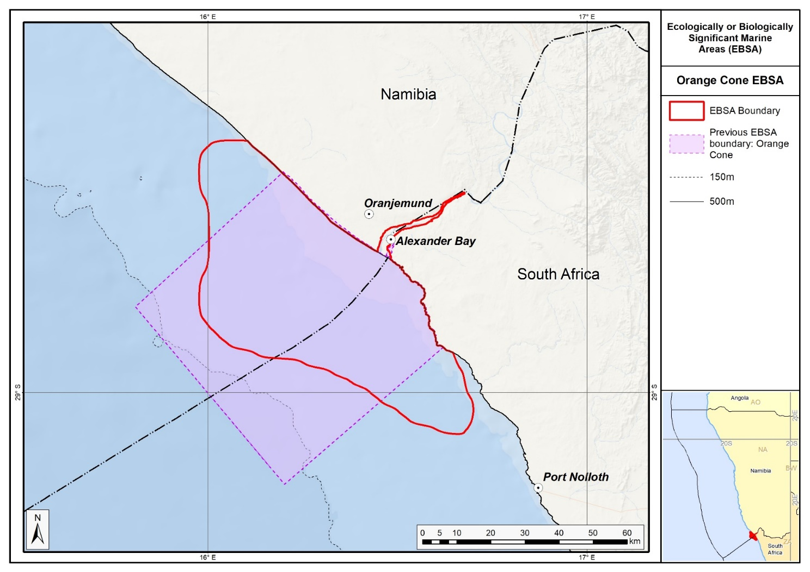
Map of the Orange Cone area in relation to the original Orange Cone EBSA.

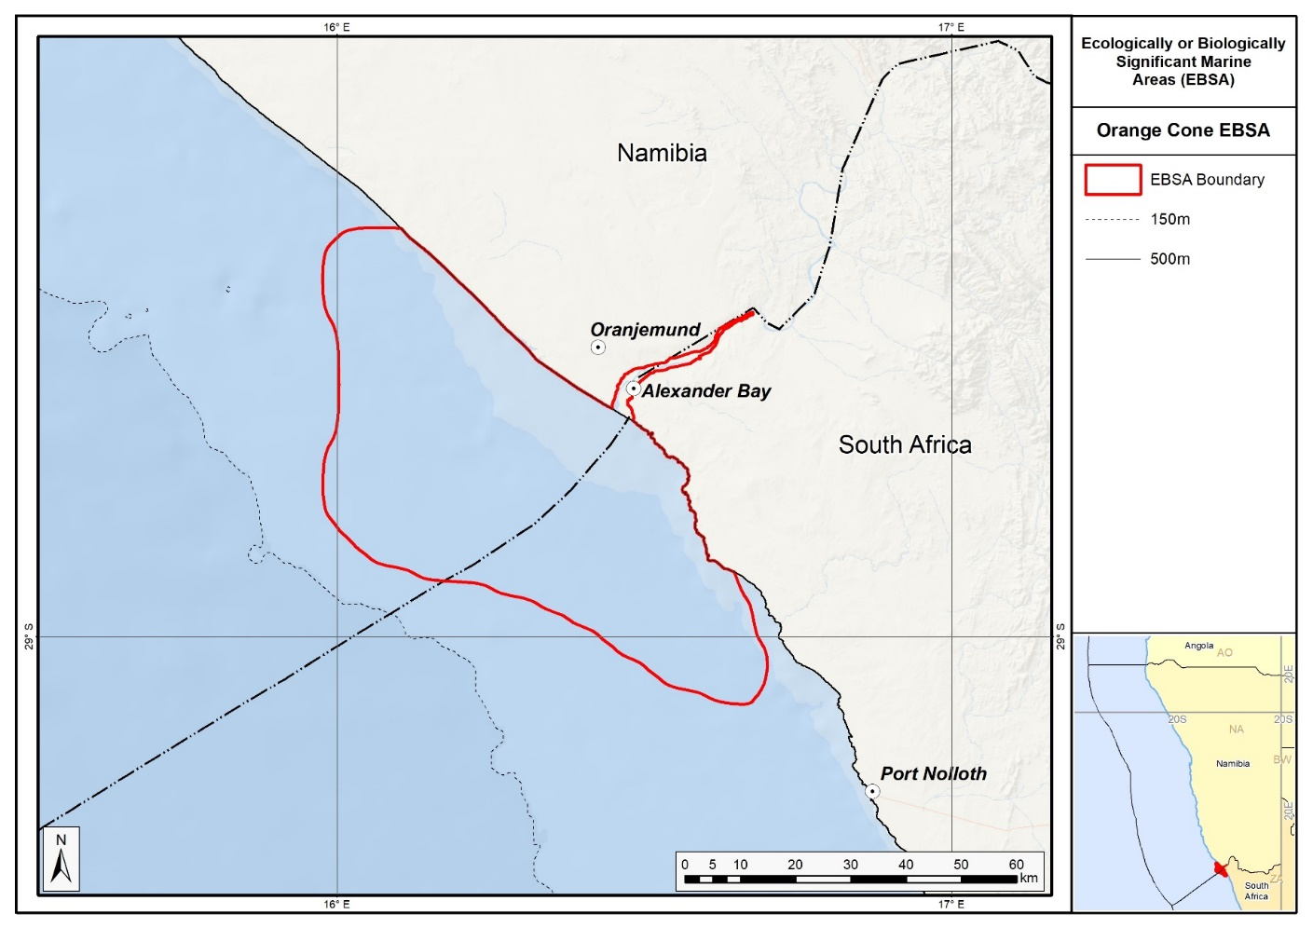
Map of the Orange Cone area.

Rights and permissions:
No limits on sharing or publication.

14. Orange seamount and canyon complex (modification of the existing Orange Shelf Edge)⁵

Reason for the modification:
The EBSA description is being modified because of newly available or accessible knowledge on features associated with the area, based on additional scientific data especially new systematic spatial planning and assessments of biodiversity. The descriptions and supporting information are substantially extended, updated and refined beyond the original descriptions from the South-Eastern Atlantic workshop, April 2013. The modifications involve changes to the textual description, changes to the ranking of the area against the EBSA criteria, and changes in shape, location and size of the area.

The original descriptions of Ecologically or Biologically Significant Marine Areas (EBSAs) in the Benguela Current Large Marine Ecosystem (BCLME) were described in the South-Eastern Atlantic workshop (April 2013). The descriptions were generally characterized by generic, often fairly geometric delineations, consisting of approximate bounding boxes around the features for which the EBSA was described. This coarse scale of delineation was appropriate for a global scale but posed challenges for inclusion in national-level, place-based ocean management. The original boundaries were not sufficiently refined to capture the full extent of key biodiversity features and often overlapped with areas of lower biodiversity value or in poor ecological condition.

Additionally, the original EBSA descriptions suffered from shortfalls related to limited spatial data and lack of systematic conservation planning approaches at the time they were first proposed. This meant that many boundaries did not precisely encompass biodiversity priority areas, potentially leading to conflicts with other ocean sectors and limiting their practical usefulness for marine spatial planning (MSP). The coarse scale and lack of detailed data constrained the ability to develop effective zoning and management recommendations that balance biodiversity protection with economic activities.

How was the submission developed?
The EBSA revision process was part a broader project on ecosystem-based MSP in the BCLME, namely the Benguela Current Marine Spatial Management and Governance Project (MARISMA, 2014-2023). This was a regional capacity-building and development cooperation project implemented by the Benguela Current Commission, the Governments of Angola, Namibia and South Africa, and GIZ, the German Agency for Development Cooperation (Deutsche Gesellschaft für Internationale Zusammenarbeit.

Because of these shortcomings of the existing EBSA boundaries, description and valuations set out in the previous section, the MARISMA project undertook a refinement process. This process used systematic conservation planning (SCP) tools, such as Marxan, to generate finer-scale, more accurate boundaries based on updated biodiversity data and expert input. This process also allowed for the identification of new EBSAs and the splitting of some original EBSAs into multiple refined areas to better reflect discrete biodiversity features and ecological processes. The refined EBSA boundaries were more suitable for MSP and conservation management because they focused on core natural and near-natural areas, avoided unnecessary conflicts with other sectors, and incorporated a systematic, data-driven approach to spatial prioritization.

The overall approach to the EBSA update and engagement followed these key steps:

Initial Systematic Conservation Planning (SCP) Analyses: Existing EBSAs were refined and new areas identified using systematic conservation planning tools such as Marxan, based on biodiversity input data including ecosystem types, species distributions, and ecological processes.

National Workshops: The refined and new EBSA boundaries were iteratively reviewed and adjusted through workshops held within each of the three countries (Angola, Namibia, South Africa). These workshops allowed country-specific input and tailoring of EBSA boundaries and descriptions to national contexts and priorities.

Regional Workshops and Bilateral Meetings between Countries: Workshops at the regional level especially focused on transboundary EBSAs shared between the countries, but also examined the overall approach to EBSAs, their delineation, description and the engagement approach. The aim was to harmonize boundaries, align management recommendations, and foster cooperation across national borders for effective regional marine biodiversity management. Additional specific bilateral meetings were held where necessary.

Technical and Scientific Peer Review: The revised and new EBSAs underwent technical review nationally and regionally (through technical review workshops involving relevant experts); and internationally with assistance from experts from the Global Ocean Biodiversity Initiative (GOBI) and members of the CBD's Informal Advisory Group on EBSAs, ensuring robustness of the exercise. The process is documented in peer reviewed literature (Harris et al., 2019, 2022).

Political Approval: The EBSAs were administratively and politically approved through all required stages up to the national ministerial level in each country and were then submitted to the CBD Secretariat by the National CBD Focal Points.

Data Sharing and Accessibility: All information, including refined EBSA boundaries, status assessments, management recommendations, and stakeholder feedback, were made available through online repositories such as the project's EBSA Portal (https://cmr.mandela.ac.za/Research-Projects/EBSA-Portal); and the EBSA were also shared via the Benguela Current Convention's Geodata Portal (https://geodata.benguelacc.org/ ). This facilitated transparency, accessibility, and ongoing updating of data and products for biodiversity specialists and other stakeholders.

Only slight revision of the EBSA description was done since no new research has been carried on this area since its original adoption in 2014. Small additions, such as biodiversity information from OBIS and updated South African assessments were made, but none of these edits were significant enough to drive a change in the EBSA criteria rankings. A table of the ecosystem types represented in the EBSA and their associated threat status was also included.

The biggest change to the EBSA was a significant refinement of the EBSA delineation. This was done to focus more closely the EBSA on the key biodiversity features that underpin its EBSA status. The delineation process included an initial stakeholder workshop, a technical mapping process and then an expert review workshop where boundary delineation options were finalised. The delineation process used a combination of Systematic Conservation Planning (SCP) and Multi-Criteria Analysis methods. The features used in the analysis were:
- Threatened Benthic and Coastal Ecosystems. The analysis focussed on the inclusion of the most threatened ecosystem types found in the area. These types are highlighted in the table in the Other relevant website address or attached documents section. Additional weight was given to the priority shelf edge habitats which are core to the EBSA description.
- Areas of highest fish diversity from Kirkman et al. (2013) were included.
- Areas of high relative naturalness identified in the SCP undertaken for the BCLME by Holness et al. (2014).
- Key physical features such as seamounts and canyons from the BCC spatial mapping project (Holness et al., 2014), GEBCO data, and global benthic geomorphology mapping (www.bluehabitats.org, Harris et al., 2014).
- Irreplaceable and near irreplaceable (i.e. very high selection frequency) sites, as well as primary and secondary focus areas identified in the SCP undertaken for the BCLME by Holness et al. (2014).

The multi-criteria analysis resulted in a value surface. The cut-off value (used to determine the extent of the EBSA) was based on expert input and quantitative analysis of effective inclusion of the above features. This entailed taking an iterative parameter calibration-based approach whereby the spatial efficiency of the inclusion of the targeted features was evaluated. The approach aimed to identify a cut-off which most efficiently included prioritised features while minimizing the inclusion of impacted areas. The final boundaries shown in the map below were validated in a series of national (in both South African and Namibian) and regional (BCC) meetings.

Traditional knowledge was not incorporated into this process, and consultations with indigenous peoples or local communities were not undertaken. Therefore, documentation of Free, Prior and Informed Consent (FPIC) is not relevant for this EBSA process.

Where is the submission intended to be included (choose one option, and please note that there are different procedures for these two intended end points)?
[X] EBSA repository
[ ] EBSA information-sharing mechanism

Abstract:
Changes from the original version: The abstract was rewritten reflect the updated the spatial scope notably the incorporation of Tripp Seamount and a shelf-indenting canyon on the Namibian side. It reflects the refined the understanding of ecosystem types present, recognizing at least eleven distinct types with updated threat assessments, and emphasizes the area's persistent hotspot status for demersal fish biodiversity linked to habitat heterogeneity.

The Orange seamount and canyon complex lies along the western continental margin of Namibia and South Africa and spans their shared border. In Namibia, it includes Tripp seamount and a shelf-indenting canyon. The area encompasses shelf and shelf-edge habitats with hard and unconsolidated substrates, with at least 11 ecosystem types. In recent assessments, three of the types have been shown to be threatened (one is endangered and two are vulnerable), but the area is one of the few areas where the types remain in a relatively natural condition. Data from long-term trawl surveys indicate that the area is a persistent hotspot for demersal fish biodiversity, which is likely linked with the area’s high habitat heterogeneity. The combination of threatened yet intact ecosystems, diverse habitats and exceptional fish biodiversity makes the Orange seamount and canyon complex ecologically significant.

Introduction:
Changes from the original version: The revised description reflects a more precise delineation of habitats, including hard and unconsolidated shelf and shelf edge benthic environments between 350-1200 m depth, and explicitly integrates new spatial biodiversity data from both South Africa and Namibia. It incorporates updated oceanographic context related to the Benguela upwelling system and better contextualizes the area's ecological significance through recent systematic spatial planning and biodiversity assessments. The revised description also clarifies the EBSA’s classification as a Type 2 EBSA (sensu Johnson et al. 2018), recognizing the connection of multiple features and ecosystems by shared ecological processes.

The area occurs at the outer shelf and shelf edge of the western continental margin of South Africa and Namibia, spanning the border between the two countries. It includes hard and unconsolidated (sand) shelf and shelf edge benthic habitat at depths of approximately 350-1200 m on the South African side (Sink et al., 2012, 2019). On the Namibian side, it includes Tripp seamount and a shelf-indenting submarine canyon, providing a heterogeneous habitat (Holness et al., 2014). The pelagic environment in the area is characterized by medium productivity, cold to moderate Atlantic temperatures (SST mean = 18.3 °C) and moderate chlorophyll levels related to the eastern limit of the Benguela upwelling on the outer shelf (Lagabrielle 2009).

Since the original description and delineation, the boundary of this EBSA has been revised largely because of new evidence that has emerged after South Eastern Atlantic Workshop to identify EBSAs in 2013. A new map of Namibian Ecosystem Types has been generated, and the new boundary builds on existing (SA) and new (Namibia) spatial assessment and prioritisation (Holness et al., 2014; Sink et al., 2019). These new datasets have facilitated more precision in the boundary definition such that the EBSA now better represents the underlying features that make this site regionally significant for threatened species and habitats and diverse assemblages, in a highly natural area. Orange Seamount and Canyon Complex can be considered a Type 2 EBSA (sensu Johnson et al. 2018) because it comprises a collection of features and ecosystems that are connected by the same ecological processes.

Location:
Changes from the original version: The section reflects a significant refinement of the EBSA delineation.

The area occurs at the outer shelf and shelf edge of the western continental margin of Namibia and South Africa, spanning the border between the two countries. It is entirely within the exclusive economic zones of the two countries.

The coordinates of a minimum bounding box covering the entire scope of the area are:
- Latitude: -29.802, -28.055, -29.31, -31.056
- Longitude: 13.272, 14.707, 16.234, 14.799

Feature description of the area:
Changes from the original version: The revised description incorporates a broader range of ecosystem types, with a more detailed account of habitat heterogeneity including seamounts and submarine canyons. It updates the status of ecosystem types with recent quantitative threat assessments and recognizes the area's pelagic environment characterized by medium productivity influenced by the Benguela upwelling.

The area includes a high diversity of shelf and shelf-edge habitat with hard or unconsolidated (sand) substrates (Sink et al., 2012, 2019; Holness et al., 2014). It includes eleven ecosystem types that have been identified for South Africa and Namibia (Sink et al., 2019; Holness et al., 2014). On the Namibian side, it includes Tripp seamount and a shelf-indenting canyon. The pelagic environment of the area is characterized by medium productivity, cold to moderate temperatures, and moderate chlorophyll levels related to the eastern limit of the Benguela upwelling on the outer shelf (Lagabrielle 2009).

The area has been subjected to annual demersal fish trawl surveys conducted by the Department of Agriculture, Forestry and Fisheries of South Africa (see Atkinson et al., 2011 for details), and under the Nansen Programme in Namibia (see Jonsen and Kathena 2012 for details). Based on spatial modeling of nearly 30 years of distribution and abundance data from these surveys, Kirkman et al., (2013) identified a persistent hotspot of species richness for demersal fish species that coincides with part of the area. This may be related to the local habitat heterogeneity, including the presence of a shelf-indenting submarine canyon and the close proximity of a seamount. Generally, however, seamounts and canyons in the region have been poorly studied (Sink et al., 2011).

The Orange Seamount and Canyon Complex includes one Endangered ecosystem type (Namaqua Shelf Edge) and two Vulnerable types (Southern Benguela Rocky Shelf Edge and Southern Benguela Sandy Shelf Edge), with the area being particularly significant for Namaqua Shelf Edge and Southern Benguela Sandy Shelf Edge. These threat statuses were estimated by assessing the weighted cumulative impacts of various pressures (e.g., extractive resource use, pollution, development, and others) on each ecosystem type for Namibia and South Africa (Holness et al., 2014; Sink et al., 2019; Table below).

Summary of ecosystem types and threat status for the Orange Seamount and Canyon Complex. Data from Sink et al., 2019 and Holness et al., 2014.
Threat Status | Ecosystem Type | Area (km²) | Area (%)
Endangered | Namaqua Shelf Edge | 3065.9 | 10.5
Vulnerable | Southern Benguela Rocky Shelf Edge | 751.7 | 2.6
 | Southern Benguela Sandy Shelf Edge | 1780.6 | 6.1
Least Concern | Southeast Atlantic Lower Slope | 139.9 | 0.5
 | Southeast Atlantic Mid Slope | 993.1 | 3.4
 | Southeast Atlantic Upper Slope | 2133.3 | 7.3
 | Southern Benguela Sandy Outer Shelf | 3003.1 | 10.3
 | Namaqua Outer Shelf | 8702.9 | 29.7
 | Namib Lower Slope | 4315.1 | 14.7
 | Namib Seamount | 393.1 | 1.3
 | Namib Upper Slope | 3988.7 | 13.6
Grand Total |  | 29267.4 | 100.0

Feature condition and future outlook:
Changes from the original version: The revised description provides updated threat status assessments from both South African and Namibian studies. The description now focusses on the threatened ecosystem types, while providing new quantitative evidence that much of the EBSA remains in good to fair condition. The revised description also notes new marine protected areas within the EBSA.

Sink et al., (2012, 2019) estimated the threat status of coastal and marine habitats in South Africa by assessing the cumulative impacts of various pressures (e.g., extractive resource use, pollution and others) on each ecosystem type. This analysis was extended to Namibia by Holness et al. (2014). Although most ecosystem types were assessed as Least Concern, the area does include one Endangered ecosystem type (Namaqua Shelf Edge) and two Vulnerable types (Southern Benguela Rocky Shelf Edge and Southern Benguela Sandy Shelf Edge). Despite this, the EBSA has a lot of natural habitat, although there are some portions that have been moderately modified, largely because this area has been subjected to relatively little extractive resource use (e.g., fishing, mining) pressure and is relatively remote from sources of pollution. Overall, the assessments of Sink et al. (2012) and Holness et al. (2014) classified 78 % of the Orange Seamount and Canyon Complex area as being in good condition, with an additional 13 % being in fair condition.

Previously, the Orange Seamount and Canyon Complex area was identified by Majiedt et al. (2013) as one of six marine ‘primary focus areas’ for spatial protection in South Africa, with the good condition of threatened habitats and the relative absence of anthropogenic pressures as the major drivers of this selection. This has resulted in two portions of the EBSA being proclaimed as marine protected areas. On the Namibian side, the assessment of Holness et al. (2014) identified the Namibian portions of the EBSA as being of high priority for place-based conservation measures. Tripp seamount on the Namibian side of the border is the location of a productive pelagic pole-and-line tuna fishery (FAO 2007). Although no research is currently planned for this area, it is recommended for this EBSA, particularly towards informing appropriate spatial management of this site.

Assessment of the area against CBD EBSA Criteria:
Changes from the original version: No changes in ranking are proposed. Only slight revision of the motivations was done since little new research has been carried on this area since its original adoption in 2014. Small additions, such as a few new references, biodiversity information from OBIS and updated South African and Namibian quantitative ecosystem assessments are reflected in the text, but none of these changes were significant enough to drive a change in the EBSA criteria rankings.

CBD EBSA Criteria  (Annex I to decision IX/20) | Description  (Annex I to decision IX/20) | Ranking of criterion relevance  (please mark one column with an X)
CBD EBSA Criteria  (Annex I to decision IX/20) | Description  (Annex I to decision IX/20) | No information |  | Low |  |  | Medium |  | High
Uniqueness or rarity | Area contains either (i) unique (“the only one of its kind”), rare (occurs only in few locations) or endemic species, populations or communities, and/or (ii) unique, rare or distinct, habitats or ecosystems; and/or (iii) unique or unusual geomorphological or oceanographic features. |  |  | X
Neither the benthic nor pelagic ecosystem types that are known to occur in the area are unique to the area (Sink et al., 2011).
Special importance for life-history stages of species | Areas that are required for a population to survive and thrive. |  |  |  |  |  | X
Globally threatened White-chinned Petrels (Procellaria aequinoctialis, from Crozet Islands and the Kerguelen Archipelago) and Atlantic Yellow-nosed Albatrosses (Thalassarche chlororhynchos, from Gough Island), and Black-browed Albatrosses (Thalassarche melanophris, from South Georgia) forage within waters of the EBSA during the non-breeding period (austral winter) (Lascelles et al., 2016). This evidence supports the ranking of medium.
Apart from the importance for the specific seabird species mentioned above, elsewhere it has been shown that seamounts, shelf breaks and submarine canyons (all of which occur in the area) constitute important foraging habitats for pelagic-feeding vertebrates such as seabirds, cetaceans and large fish species, including migratory species, which exploit elevated primary production and high standing stocks of zooplankton, fish, and other organisms at these features (Dearden and Topelko 2005, Sydeman et al., 2006, Morato et al., 2008). Generally, however, seamounts and canyons in the region have been poorly studied (Sink et al., 2011); though the additional bird tracking evidence is beginning to improve the knowledge base.
Importance for threatened, endangered or declining species and/or habitats | Area containing habitat for the survival and recovery of endangered, threatened, declining species or area with significant assemblages of such species. |  |  |  |  |  |  |  | X
Threat status assessments of ecosystem types by Sink et al. (2012, 2019) and Holness et al., (2014) highlighted several threatened ecosystem types that are represented in the EBSA. Threatened ecosystem types include the Endangered Namaqua Shelf Edge and Vulnerable Southern Benguela Rocky Shelf Edge and Southern Benguela Sandy Shelf Edge. This implies that, although there are sufficient areas of intact biodiversity of these habitats to meet the conservation targets, there has been habitat degradation and some loss of ecosystem processes. The importance of the area for the conserving the threatened ecosystem types represented in the Orange Seamount and Canyon Complex was emphasized by Majiedt et al. (2013) and Holness et al. (2014).
Globally threatened White-chinned Petrels (Procellaria aequinoctialis, from Crozet Islands and the Kerguelen Archipelago) and Atlantic Yellow-nosed Albatrosses (Thalassarche chlororhynchos, from Gough Island), and Black-browed Albatrosses (Thalassarche melanophris, from South Georgia) forage within waters of the EBSA during the non-breeding period (austral winter) (Lascelles et al., 2016).
Vulnerability, fragility, sensitivity, or slow recovery | Areas that contain a relatively high proportion of sensitive habitats, biotopes or species that are functionally fragile (highly susceptible to degradation or depletion by human activity or by natural events) or with slow recovery. |  |  |  |  |  | X
The threatened status of three ecosystem types (Sink et al., 2012, 2019) implies that degradation and some loss of ecosystem processes has been associated with these ecosystem types in other areas, and therefore that they are vulnerable to the effects of human activities. Seamounts, submarine canyons and the shelf break, all of which occur in the area, are all vulnerable and sensitive ecosystems (FAO 2009). Seamount communities are particularly vulnerable to human activities (e.g. trawling) due to intrinsic biological factors that are characteristic of seamount-associated species (e.g. slow growth rate, late maturation), with the likelihood of very long time scales of recovery if damaged (Gjerde & Breide, 2003, Clark et al., 2006).
Biological productivity | Area containing species, populations or communities with comparatively higher natural biological productivity. |  |  |  |  |  | X
The area is at the eastern limit of the Benguela upwelling region (Hutchings et al., 2009), where the pelagic environment is characterized by medium productivity, and moderate chlorophyll levels (Lagabrielle 2009). However, shelf edge environments (e.g. Springer et al., 1996, Piatt et al., 2006, Coleman et al., 2011), seamounts (e.g. Moore et al., 2002, Pitcher et al., 2011) and submarine canyons (e.g. de Leo et al., 2010, McClain and Barry 2010), all of which occur in the area, are associated with elevated productivity and biomass levels, spanning several trophic levels. Tripp seamount on the Namibian side of the border supports a productive pole-and-line tuna fishery (FAO 2007).
Biological diversity | Area contains comparatively higher diversity of ecosystems, habitats, communities, or species, or has higher genetic diversity. |  |  |  |  |  |  |  | X
Based on spatial modelling of 20-30 years of distribution and abundance data from demersal trawl surveys in Namibian and South African waters, Kirkman et al. (2013) identified the area as a persistent hotspot of species richness for demersal fish species. This may be linked to the habitat heterogeneity of the area, including the shelf edge, the presence of a shelf-indenting submarine canyon and the close proximity of a seamount. Further, 487 species have been recorded in the area (OBIS 2017). Diversity of ecosystem types is also high, with 11 ecosystem types occurring in the area (Sink et al., 2012; Holness et al., 2014).
Naturalness | Area with a comparatively higher degree of naturalness as a result of the lack of or low level of human-induced disturbance or degradation. |  |  |  |  |  |  |  |  | X
The area on the South African side is one of the few areas where the threatened ecosystem types are in good condition (relatively natural/pristine), largely because it has been subjected to relatively low levels of anthropogenic pressures (Sink et al., 2011, 2019). The importance of the area for the conservation of the threatened ecosystem types represented there has therefore been emphasized by Majiedt et al., (2013). Although there are impacted areas, much of the Namibian portion of the area is also in good condition (Holness et al., 2014).

References:
Changes from the original version: New and updated references were included, notably the national and regional ecosystem assessments which were not previously available.

Atkinson L.J., Leslie, R.W., Field, J.G., Jarre, A. 2011. Changes in demersal fish assemblages on the west coast of South Africa, 1986–2009. African Journal of Marine Science, 33: 157–170
Clark, M.R., Tittensor, D., Rogers, A.D., Brewin, P., Schlacher, T., Rowden, A., Stocks, K., Consalvey, M. 2006. Seamounts, deep-sea corals and fisheries: vulnerability of deep-sea corals to fishing on seamounts beyond areas of national jurisdiction. UNEP-WCMC, Cambridge, UK.
Coleman, F.C., Scanlon, K.M., Koenig, C.C. 2011. Groupers on the edge: Shelf edge spawning habitat in and around marine reserves of the northeastern Gulf of Mexico. Professional Geographer, 63: 456-474.
De Leo, F.C., Smith, C.R., Rowden, A.A., Bowden, D.A., Clark, M.R. 2010. Submarine canyons: hotspots of benthic biomass and productivity in the deep sea. Proceedings of the Royal Society B, 277: 2783-2792.
Dearden, P., Topelko, K.N. 2005. Establishing criteria for the identification of ecologically and biologically significant areas on the high seas. Background paper prepared for Fisheries and Oceans Canada. Marine protected Areas Research Group, 50 pp.
FAO. 2007. Namibia: Country Profiles. Food and Agricultural Organisation (FAO) Country Profiles. http://www.fao.org/fi/website/FIRetrieveAction.do?dom=countrysector&xml=FICP_NA.xml&lang=en. (accessed 17 April 2012).
FAO. 2009. Appendix F: International Guidelines for the Management of Deep-sea Fisheries in the High Seas. In: Report of the Technical Consultation on International Guidelines for the Management of Deepsea Fisheries in the High Seas. Rome, 4–8 February and 25-29 August 2008. FAO Fisheries and Aquaculture Report No. 881. Rome, Italy: Food and Agriculture Organization of the United Nations. pp. 39-51.
Gjerde, K.M., Breide, C. 2003. Towards a Strategy for High Seas Marine Protected Areas: Proceedings of the IUCN, WCPA and WWF Experts Workshop on High Seas Marine Protected Areas, 15-17 January 2003, Malaga, Spain.
Harris, L., Holness, S., Finke, G., Kirkman, S., Sink, K., 2019. Systematic Conservation Planning as a Tool to Advance Ecologically or Biologically Significant Area and Marine Spatial Planning Processes, in: Zaucha, J., Gee, K. (Eds.), Maritime Spatial Planning. Palgrave Macmillian, Cham.
Harris, L.R., Holness, S.D., Finke, G., Amunyela, M., Braby, R., Coelho, N., Gee, K., Kirkman, S.P., Kreiner, A., Mausolf, E., Majiedt, P., Maletzky, E., Nsingi, K.K., Russo, V., Sink, K.J., Sorgenfrei, R., 2022. Practical Marine Spatial Management of Ecologically or Biologically Significant Marine Areas: Emerging Lessons From Evidence-Based Planning and Implementation in a Developing-World Context. Front. Mar. Sci. 9.
Holness S., Kirkman S., Samaai T., Wolf T., Sink K., Majiedt P., Nsiangango S., Kainge P., Kilongo K., Kathena J., Harris L., Lagabrielle E., Kirchner C., Chalmers R., Lombard M. 2014. Spatial Biodiversity Assessment and Spatial Management, including Marine Protected Areas. Final report for the Benguela Current Commission project BEH 09-01.
Hutchings, L., van der Lingen, C.D. Shannon, L.J., Crawford, R.J.M., Verheye, H.M.S., Bartholomae, C.H., van der Plas, A.K., Louw, D., Kreiner, A., Ostrowski, M., Fidel, Q., Barlow, R.G., Lamont, T., Cotzee, J., Shillington, F., Veitch, J., Currie, J.C., Monteiro, P.P.S. 2009. The Benguela Current: An ecosystem of four components. Progress in Oceanography, 83: 15 – 32.
Johnsen, E., Kathena, J. 2012. A robust method for generating separate catch time-series for each of the hake species caught in the Namibian trawl fishery. African Journal of Marine Science, 34: 43–53.
Johnson, D.E., Barrio Froján, C., Turner, P.J., Weaver, P., Gunn, V., Dunn, D.C., Halpin, P., Bax, N.J., Dunstan, P.K., 2018. Reviewing the EBSA process: Improving on success. Marine Policy 88, 75-85.
Kirkman, S.P., Yemane, D., Kathena, J., Mafwila, S., Nsiangango, S., Samaai, T., Axelsen, B., Singh, L. 2013. Identifying and characterizing demersal biodiversity hotspots in the BCLME: Relevance in the light of global changes. ICES Journal of Marine Science, 70: 943–954.
Lagabrielle E. 2009. Preliminary report: National Pelagic Bioregionalisation of South Africa. Cape Town: South African National Biodiversity Institute.
Lascelles, B.G., Taylor, P.R., Miller, M.G.R., Dias, M.P., Oppel, S., Torres, L., Hedd, A., Le Corre, M., Phillips, R.A., Shaffer, S.A., Weimerskirch, H., Small, C., 2016. Applying Global Criteria to Tracking Data to Define Important Areas for Marine Conservation. Diversity & Distribution. 22, 422–431. https://doi.org/10.1111/ddi.12411
Majiedt, P., Holness, S., Sink, K., Oosthuizen, A., Chadwick, P. 2013. Systematic Marine Biodiversity Plan for the West Coast of South Africa. South African National Biodiversity Institute, Cape Town.
McClain, C.R. Barry, J.P. 2010. Habitat heterogeneity, disturbance, and productivity work in concert to regulate biodiversity in deep submarine canyons. Ecology, 91: 964-76.
Moore, S.E., Watkins, W.A., Daher, M.A., Davies, J.R., Dahlheim, M.E., 2002. Blue whale habitat associations in the Northwest Pacific: analysis of remotely sensed data using a Geographic Information System. Oceanography, 15:, 20–25.
Morato, T., Varkey, D.A., Damaso, C., Machete, M., Santos, M., Prieto, R., Santos, R.S. and Pitcher, T.J. 2008. Evidence of a seamount effect on aggregating visitors. Marine Ecology Progress Series, 357: 23-32.
OBIS. 2017. Summary statistics of biodiversity records in the Orange Shelf EBSA. (Available: Ocean Biogeographic Information System. Intergovernmental Oceanographic Commission of UNESCO. www.iobis.org. Accessed: 2017-07-27).
Piatt, J.F., Wetzel, J., Bell, K., DeGange, A.R., Balogh, G.R., Drew, G.S., Geernaert, T., Ladd, C., Byrd G.V. 2006. Predictable hotspots and foraging habitat of the endangered shorttailed albatross (Phoebastria albatrus) in the North Pacific: Implications for conservation. Deep-Sea Research II, 53: 387-398.
Pitcher, T.J., Morato, T., Hart, P.J.B., Clark, M.R., Haggan, N., Santos, R.S. (Eds.). 2007. Seamounts: Ecology, Fisheries & Conservation. Blackwell Publishing, Oxford, UK.
Sink KJ, Attwood CG, Lombard AT, Grantham H, Leslie R, Samaai T, Kerwath S, Majiedt P, Fairweather T, Hutchings L, van der Lingen C, Atkinson LJ, Wilkinson S, Holness S, Wolf T. 2011. Spatial planning to identify focus areas for offshore biodiversity protection in South Africa. Unpublished Report. Cape Town: South African National Biodiversity Institute.
Sink, K., Holness, S., Harris, L., Majiedt, P., Atkinson, L., Robinson, T., Kirkman, S., Hutchings, L., Leslie, R., Lamberth, S., Kerwath, S., von der Heyden, S., Lombard, A., Attwood, C., Branch, G., Fairweather, T., Taljaard, S., Weerts, S., Cowley, P., Awad, A., Halpern, B., Grantham, H., Wolf T. 2012. National Biodiversity Assessment 2012: Technical Report. Volume 4: Marine and Coastal Component. South African National Biodiversity Institute, Pretoria.
Sink, K.J., van der Bank, M.G., Majiedt, P.A., Harris, L.R., Atkinson, L., Karenyi, N., Kirkman, S. (eds) 2019. National Biodiversity Assessment 2018 Technical Report Volume 4: Marine Realm. South African National Biodiversity Institute, Pretoria.
Springer, A.M., McRoy, C.P., Flint, M.V. 1996. The Bering Sea green belt: shelf-edge processes and ecosystem production. Fisheries Oceanography, 5: 205-223.
Sydeman, W.J., Brodeur, R.D., Grimes, C.B., Bychkov, A.S., McKinnell, S. 2006. Marine habitat “hotspots” and their use by migratory species and top predators in the North Pacific Ocean: Introduction. Deep-Sea Research Part II, 53: 247-249.

Maps and Figures:
GIS data available at: https://cmr.mandela.ac.za/cmr/media/Store/documents/EBSA/Descriptions/Namibia/Namibia_EBSAs_2020-SHP.zip or https://cmr.mandela.ac.za/cmr/media/Store/documents/EBSA/Descriptions/SouthAfrica/Shapefile-RSA_EBSAs_final.zip

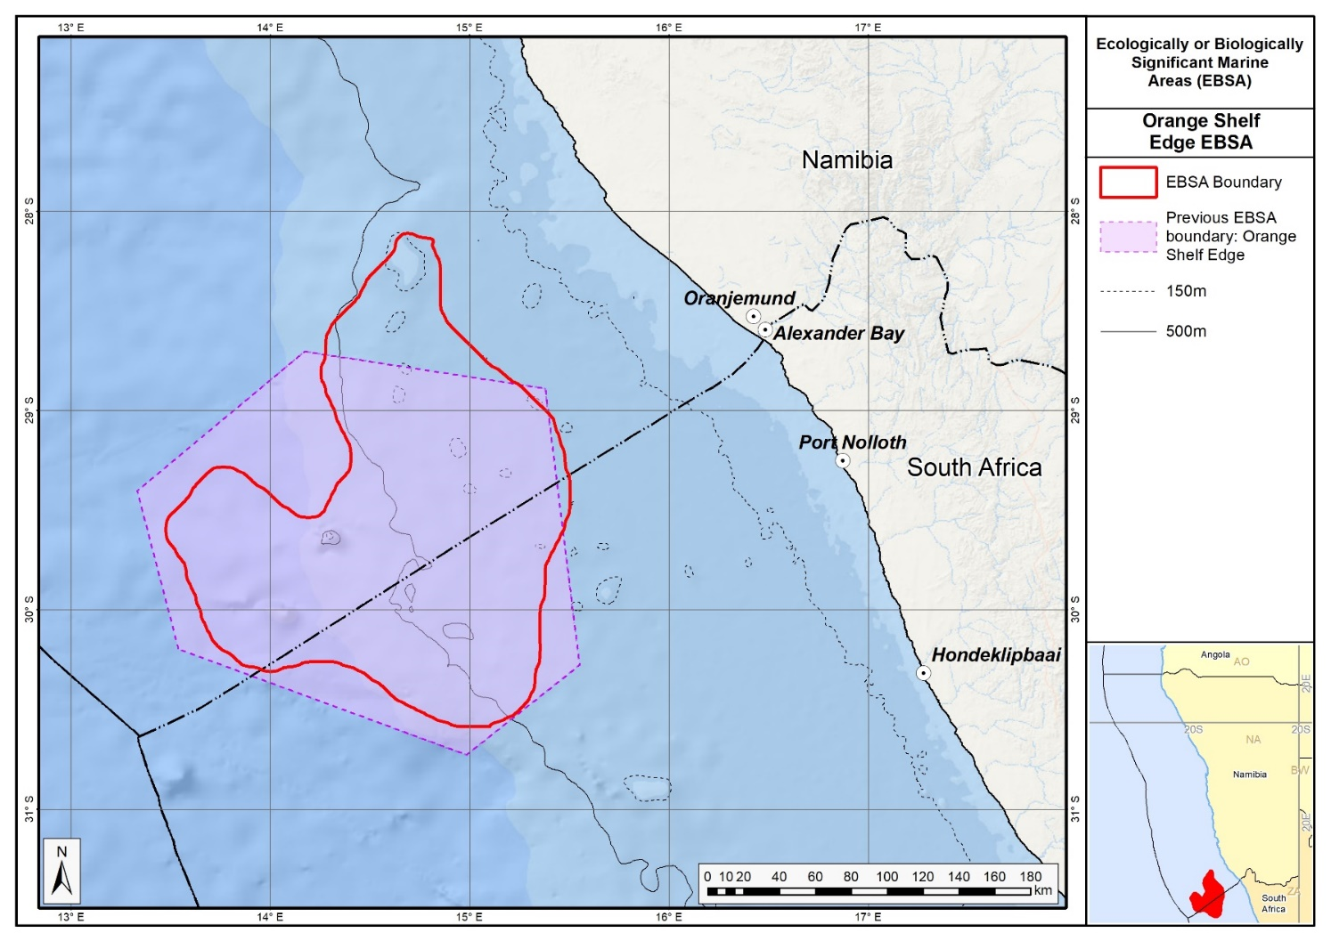Map of the Orange Seamount and Canyon Complex area in relation to the original Orange Shelf EBSA.
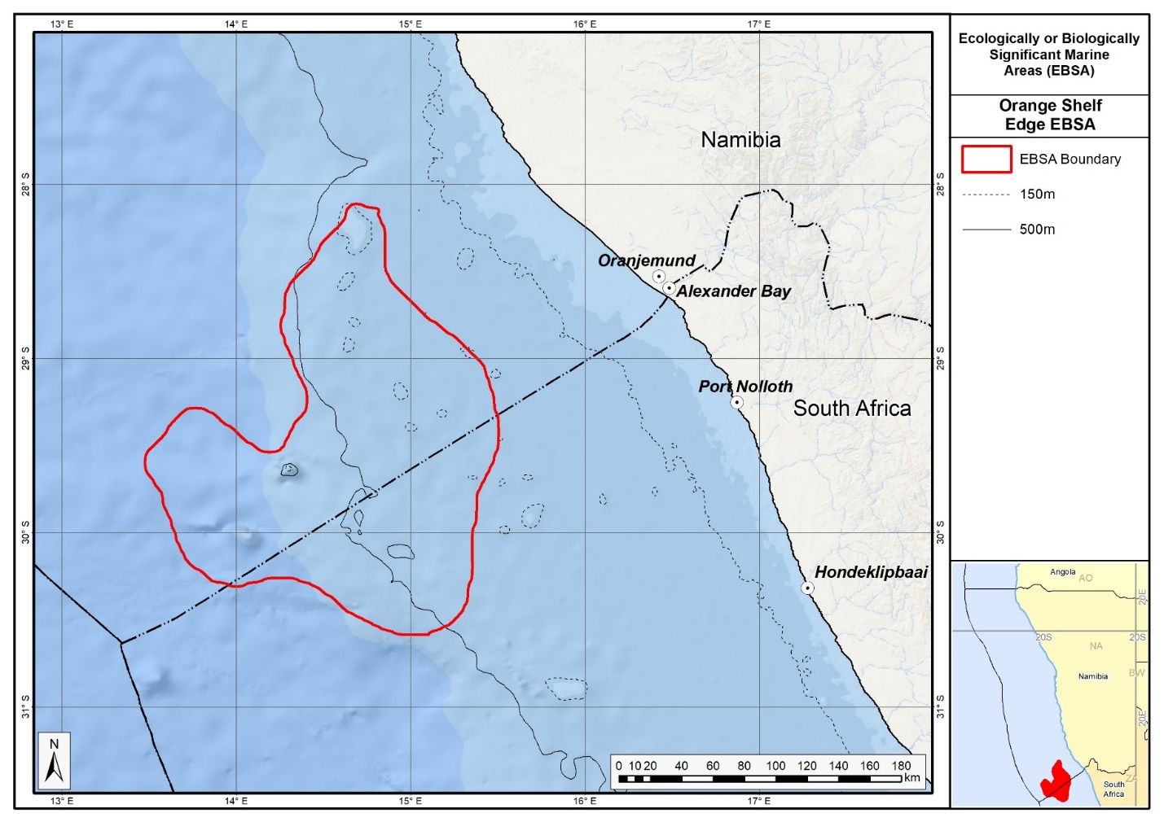
Map of the Orange Seamount and Canyon Complex area.

Rights and permissions:
No limits on sharing or publication.

South Africa

15. Agulhas Bank Nursery Area (modification of the existing Agulhas Bank Nursery Area)

Reason for the modification:
The EBSA description is being modified because of newly available or accessible knowledge on features associated with the area, based on additional scientific data especially new systematic spatial planning and assessments of biodiversity. The descriptions and supporting information are substantially extended, updated and refined beyond the original descriptions from the Southern Indian Ocean Regional EBSA Workshop, 2012. The modifications involve changes to the textual description, changes to the ranking of the area against the EBSA criteria, and changes in shape, location and size of the area.

The original descriptions of Ecologically or Biologically Significant Marine Areas (EBSAs) in the Benguela Current Large Marine Ecosystem (BCLME) were described in the Southern Indian Ocean Regional EBSA Workshop. The descriptions were generally characterized by generic, often fairly geometric delineations, consisting of approximate bounding boxes around the features for which the EBSA was described. This coarse scale of delineation was appropriate for a global scale but posed challenges for inclusion in national-level, place-based ocean management. The original boundaries were not sufficiently refined to capture the full extent of key biodiversity features and often overlapped with areas of lower biodiversity value or poor ecological condition.

Additionally, the original EBSA descriptions suffered from shortfalls related to limited spatial data and lack of systematic conservation planning approaches at the time they were first proposed. This meant that many boundaries did not precisely encompass biodiversity priority areas, potentially leading to conflicts with other ocean sectors and limiting their practical usefulness for marine spatial planning (MSP). The coarse scale and lack of detailed data constrained the ability to develop effective zoning and management recommendations that balance biodiversity protection with economic activities.

How was the submission developed?
The EBSA revision process was part a broader project on ecosystem-based MSP in the BCLME, namely the Benguela Current Marine Spatial Management and Governance Project (MARISMA, 2014-2023). This was a regional capacity-building and development cooperation project implemented by the Benguela Current Commission, the Governments of Angola, Namibia and South Africa, and GIZ, the German Agency for Development Cooperation (Deutsche Gesellschaft für Internationale Zusammenarbeit.

Because of these shortcomings of the existing EBSA boundaries, description and valuations set out in the previous section, the MARISMA project undertook a refinement process. This process used systematic conservation planning (SCP) tools, such as Marxan, to generate finer-scale, more accurate boundaries based on updated biodiversity data and expert input. This process also allowed for the identification of new EBSAs and the splitting of some original EBSAs into multiple refined areas to better reflect discrete biodiversity features and ecological processes. The refined EBSA boundaries were more suitable for MSP and conservation management because they focused on core natural and near-natural areas, avoided unnecessary conflicts with other sectors, and incorporated a systematic, data-driven approach to spatial prioritization.

The overall approach to the EBSA update and engagement followed these key steps:

Initial Systematic Conservation Planning (SCP) Analyses: Existing EBSAs were refined and new areas identified using systematic conservation planning tools such as Marxan, based on biodiversity input data including ecosystem types, species distributions, and ecological processes.

National Workshops: The refined and new EBSA boundaries were iteratively reviewed and adjusted through workshops held within each of the three countries (Angola, Namibia, South Africa). These workshops allowed country-specific input and tailoring of EBSA boundaries and descriptions to national contexts and priorities.

Regional Workshops and Bilateral Meetings between Countries: Workshops at the regional level especially focused on transboundary EBSAs shared between the countries, but also examined the overall approach to EBSAs, their delineation, description and the engagement approach. The aim was to harmonize boundaries, align management recommendations, and foster cooperation across national borders for effective regional marine biodiversity management. Additional specific bilateral meetings were held where necessary.

Technical and Scientific Peer Review: The revised and new EBSAs underwent technical review nationally and regionally (through technical review workshops involving relevant experts); and internationally with assistance from experts from the Global Ocean Biodiversity Initiative (GOBI) and members of the CBD's Informal Advisory Group on EBSAs, ensuring robustness of the exercise. The process is documented in peer reviewed literature (Harris et al., 2019, 2022).

Political Approval: The EBSAs were administratively and politically approved through all required stages up to the national ministerial level in each country and were then submitted to the CBD Secretariat by the National CBD Focal Points.

Data Sharing and Accessibility: All information, including refined EBSA boundaries, status assessments, management recommendations, and stakeholder feedback, were made available through online repositories such as the project's EBSA Portal (https://cmr.mandela.ac.za/Research-Projects/EBSA-Portal); and the EBSA were also shared via the Benguela Current Convention's Geodata Portal (https://geodata.benguelacc.org/ ). This facilitated transparency, accessibility, and ongoing updating of data and products for biodiversity specialists and other stakeholders.

Significant changes have been made to the Agulhas Bank Nursery Area EBSA description. Additional data have resulted in further substantiated evaluations of two of the EBSA criteria, namely Criterion 2: importance for life-history stages, and Criterion 3: importance for threatened species. Additional references have been added and updates to the description were made. A supplementary table of the habitats represented in the EBSA and their associated threat status was also included.

There has also been a significant delineation change of this EBSA to more closely focus the EBSA on the key biodiversity features that underlie its EBSA status. The delineation process included an initial stakeholder review which identified the need to update boundaries, a technical mapping process and then an expert review workshop where boundary delineation options were discussed. The boundaries were revised a final time to accommodate the latest NBA 2018 assessment results and the review workshop discussion. The delineation process used a combination of Systematic Conservation Planning and Multi-Criteria Analysis methods. The features used in the analysis were:
- Irreplaceable and near irreplaceable (i.e. very high selection frequency) sites, as well as focus areas identified in the Systematic Conservation Plans undertaken for the West Coast by Majiedt et al. (2013), offshore areas (Sink et al., 2011) and by Holness et al. (2014) were incorporated.
- Delineations and threat status of constituent ecosystem types in the area were included in the analysis and used to refine the boundary of the EBSA.
- Areas of high relative naturalness of benthic and coastal systems and pelagic systems identified in the National Biodiversity Assessment 2011 (Sink et al., 2012a) were included in the analysis.
- Distributions of known fragile, vulnerable and sensitive habitat-forming species were included (Unpublished SANBI and SAEON data).

The multi-criteria analysis resulted in a value surface. The cut-off value used to determine the extent of the EBSA was based on expert input and quantitative analysis of effective inclusion of the above features. This entailed taking an iterative parameter calibration-based approach whereby the spatial efficiency of the inclusion of the targeted features was evaluated. The approach aimed to identify a cut-off which most efficiently included prioritised features while minimizing the inclusion of impacted areas. The final boundaries shown in the map were validated in a national workshop.

Traditional knowledge was not incorporated into this process, and consultations with indigenous peoples or local communities were not undertaken. Therefore, documentation of Free, Prior and Informed Consent (FPIC) is not relevant for this EBSA process.

Where is the submission intended to be included (choose one option, and please note that there are different procedures for these two intended end points)?
[X] EBSA repository
[ ] EBSA information-sharing mechanism

Abstract:
Changes from the original version: The revised abstract largely retains previous information, but highlights that the EBSA boundary has been refined from its original delineation to better align with underlying biodiversity features, particularly fragile and sensitive habitat-forming species. It also mentions the two new offshore MPAs.

The Agulhas Bank serves as a critical spawning ground and nursery area and is the centre of abundance for numerous warm-temperate species, including several endemic sparids. The shelf area is unique along the otherwise narrow continental shelf of South Africa, given that it functions as the only warm-temperate nursery for species spawning on northern shelves and provides essential retention, recruitment and food resources through dense benthic copepod communities. Within the area are critically endangered mud habitats and distinctive high-profile volcanic offshore reefs supporting cold-water coral communities. It includes spawning aggregation sites for the threatened endemic reef fish Petrus rupestris. The boundary of the area is an update to the boundary of the existing EBSA and more precisely includes underlying biodiversity features, in particular fragile and sensitive habitat-forming species.

Introduction:
Changes from the original version: The revised largely includes the original content, but it is updated to include the two newly declared offshore MPAs. The geographic extent is more clearly specfified.

This area within the Agulhas Bank, on the south coast of South Africa, includes benthic and pelagic features that extend from the dune base to shallower than -150 m. Key benthic features include Critically Endangered mud habitats, high-profile volcanic deep reefs, low-profile deep reefs and rare gravels. The Agulhas Bank is important for numerous ecological processes, including spawning, larval retention, recruitment, connectivity and provision of nursery and foraging areas (Hutchings et al., 2002). This area is the centre of abundance of numerous warm temperate species, including several endemic sparids. Some of these species are threatened or overexploited (sparids and sciaenids), and the deep-reef habitats are considered important for the recovery of overexploited deep-reef fish species. However, two coastal MPAs at De Hoop and Still Bay provide some protection for some of the over-exploited species. A spawning area for the threatened endemic reef fish, Petrus rupestris, is located within this area, and aggregations of this species have recently been observed within this EBSA (Sink et al., 2010). The Agulhas Bank area has been identified as a priority using data provided through a national systematic planning initiative (Sink et al., 2011), and consequently two additional offshore MPAs have been declared. Hutchings et al. (2002) emphasise the importance of this area as one of three key nursery areas in South Africa and the only one in the warm temperate ecoregion.

Location:
Changes from the original version: The section reflects the updated spatial delineation, provide bounding box coordinates, and shares a link to the specific spatial data. Motivation for the spatial changes, and details of the spatial planning are given in “How was the submission developed?” Section.

The area extends from the dune base to the outer shelf, 175 km south of Cape Infanta in the Western Cape of South Africa, to a depth of approximately 150 m. Along the shore it spans the De Hoop marine protected area in the west to the headland that marks the start of Mossel Bay in the east. The area includes part of the Alphard and Agulhas Banks and is entirely within the exclusive economic zone of South Africa.

The coordinates of a minimum bounding box covering the entire scope of the area are:
- Latitude: -35.302, -33.456, -34.258, -36.104
- Longitude: 19.83, 21.205, 22.283, 20.908

Feature description of the area:
Changes from the original version: The revised description explicitly identifies 20 ecosystem types within the EBSA identified in new ecosystem mapping and assessments of threat status, including 1 Critically Endangered, 2 Endangered and 6 Vulnerable types. A table of ecosystem types and their statuses is presented. The new description shows how the boundary of this EBSA has been refined to improve precision so that it better represents the features comprising the EBSA, such as benthic ecosystem types and their condition, and fragile and sensitive habitat-forming species. The site is now presented as a Type 1 EBSA because it contains “Spatially stable features whose positions are known and individually resolved on the maps” (sensu Johnson et al., 2018).

Key benthic features include sandy and mud habitats, high-profile volcanic deep reefs, low-profile deep reefs and rare gravels. The Agulhas Bank is an important nursery area for species that spawn on the narrow shelf further north, including shad (Pomatomus saltatrix) and the sciaenid (Attractoscion aequidens). Squid also spawn in this area, and their paralarvae that hatch from the benthic eggs are dispersed across the bank, where they feed on a dense layer of copepods that occurs close to the seabed in this area (Hutchings et al., 2002). The Agulhas Bank area is moderately productive but has areas of relatively higher productivity within the broader area. There is a cold ridge of water on the central Agulhas Bank, which is a prominent subsurface feature during most summers (Swart and Largier 1987) and is associated with elevated phytoplankton concentrations (Probyn et al., 1994) and dense concentrations of copepods (Verheye et al.1994) and clupeoid fish eggs (Roel et al., 1994). The area is also frequented by migrating regionally Near Threatened loggerhead and regionally Critically Endangered leatherback turtles (Harris et al., 2018).

Threatened ecosystem types in the area include: Critically Endangered Agulhas Muddy Mid Shelf; Endangered Agulhas Bays – West; and Vulnerable Agulhas Exposed Rocky Shore, Agulhas Inner Shelf Reef Sand Mosaic, Agulhas Kelp Forest, Agulhas Sandy Inner Shelf, Agulhas Sheltered Rocky Shore, and Agulhas Very Exposed Rocky Shore (Table below; Sink et al., 2019). The Agulhas Blues, Agulhas Mid Shelf Reef Sand Mosaic, Agulhas Mixed Shore, Agulhas Muddy Outer Shelf, Agulhas Sandy Mid Shelf and Warm Temperate Predominantly Open Estuary are Near Threatened (Sink et al., 2019). Overexploited and threatened linefish include the endemic red steenbras (Petrus rupestris, Endangered), Dageraad (Chrysoblephus cristiceps, Endangered) and black musselcracker (Cymatoceps nasutus, Vulnerable) (Sink et al., 2012; Sink et al., 2010). The area is also important for juvenile silver kob (Argyrosomus inodorus; Lombard et al., 2010, Attwood et al., 2011). The reef habitats range from low to very high profile, mostly have low rugosity, and support a variety of wall sponges, corals, red algae, kelp, gorgonians, fish and sharks (Gotz et al., 2014; Makwela et al., 2016). Some of these threatened and over-exploited species are protected in the De Hoop and Still Bay MPAs along the coast.

Since the original description, the boundary of this EBSA has been refined to improve precision so that it better represents the features comprising the EBSA, such as benthic ecosystem types and their condition, and fragile and sensitive habitat-forming species. The new delineation reduces the size of the EBSA to about a third of its original extent to focus on key features and also aligns the EBSA better with the expanded the MPA network in South Africa. The site is presented as a Type 1 EBSA because it contains “Spatially stable features whose positions are known and individually resolved on the maps” (sensu Johnson et al., 2018).

Summary of ecosystem types and threat status for the Agulhas Bank Nursery Area EBSA. Data from Sink et al. (2019).
Threat Status | Ecosystem Type | Area (km²) | Area (%)
Critically Endangered | Agulhas Muddy Mid Shelf | 1731.8 | 12.7
Endangered | Agulhas Bays - West | 323.4 | 2.4
 | Agulhas Sheltered Rocky Shore | 0.2 | 0.0
Vulnerable | Agulhas Exposed Rocky Shore | 19.5 | 0.1
 | Agulhas Inner Shelf Reef Sand Mosaic | 389.5 | 2.9
 | Agulhas Kelp Forest | 0.5 | 0.0
 | Agulhas Sandy Inner Shelf | 12.4 | 0.1
 | Agulhas Very Exposed Rocky Shore | 1.4 | 0.0
 | Warm Temperate Predominantly Open Estuary | 2.6 | 0.0
Near Threatened | Agulhas Blues | 850.3 | 6.2
 | Agulhas Mid Shelf Reef Sand Mosaic | 723.0 | 5.3
 | Agulhas Mixed Shore | 41.6 | 0.3
 | Agulhas Muddy Outer Shelf | 358.0 | 2.6
 | Agulhas Sandy Mid Shelf | 7156.4 | 52.3
Least Concern | Agulhas Dissipative-Intermediate Sandy Shore | 12.6 | 0.0
 | Agulhas Intermediate Sandy Shore | 2.7 | 0.0
 | Agulhas Outer Shelf Gravel Sand Mosaic | 773.1 | 5.7
 | Agulhas Rocky Outer Shelf | 1250.0 | 9.1
 | Alphard Bank | 31.9 | 0.2
 | Warm Temperate Small Temporarily Closed Estuary | 0.2 | 0.0
Grand Total |  | 13681.0 | 100.0

Feature condition and future outlook:
Changes from the original version: The revised description introduces a more nuanced assessment of ecosystem condition, based on more up to date spatial assessments. It now includes the recent establishment of the Agulhas Bank Complex MPA and Agulhas Mud MPA, with the EBSA area within reserves increasing by more than an order of magnitude from 2% to 30%.

South Africa’s National Biodiversity Assessment 2011 (Sink et al., 2012) indicated a range in ecological condition in this area based on an assessment of cumulative pressures, although the latest assessment (Sink et al., 2019) and boundary revision is such that about half the EBSA is in good ecological condition; the rest is in fair ecological condition. There are deep reefs in the Agulhas Bank Nursery Area that are estimated to be in good ecological condition, even though pressures elsewhere have led to these habitats being considered threatened. Key activities in the area include commercial demersal trawl and longline fisheries, a midwater trawl fishery, trap fisheries for rock lobster, linefishing and expanding petroleum activities.

Protection of features in MPAs has been considerably expanded and strengthened following the proclamation of the Operation Phakisa MPA network in 2019 including the Agulhas Bank Complex MPA
and Agulhas Mud MPA, with the EBSA area within reserves increasing by more than an order of magnitude from 2% to 30%. These new MPAs cover the southern extension of the EBSA, south of Cape Infanta where ecological condition is good and ecosystem threat status is Near Threatened or Least Concern, which will proactively avoid those ecosystem types degrading further and becoming threatened. However, many of the threatened features listed above have no protection in the EBSA.

Assessment of the area against CBD EBSA Criteria:
Changes from the original version: The revised description retains the same rankings for all applicable EBSA criteria as the original. However, the revised description provides expanded justifications and updated scientific evidence supporting these criteria. It reflects newly available ecosystem mapping and status assessments.

CBD EBSA Criteria  (Annex I to decision IX/20) | Description  (Annex I to decision IX/20) | Ranking of criterion relevance  (please mark one column with an X)
CBD EBSA Criteria  (Annex I to decision IX/20) | Description  (Annex I to decision IX/20) | No information |  | Low |  |  | Medium |  | High
Uniqueness or rarity | Area contains either (i) unique (“the only one of its kind”), rare (occurs only in few locations) or endemic species, populations or communities, and/or (ii) unique, rare or distinct, habitats or ecosystems; and/or (iii) unique or unusual geomorphological or oceanographic features. |  |  |  |  |  |  |  | x
The volcanic offshore Alphard Bank is a unique feature that supports kelp, soft corals, stylasterine corals, and sponges (Sink et al., 2010; Makwela et al., 2016). Rare habitats within this area include some of the muddy and gravel ecosystem types (Sink et al., 2012a, 2019).
Special importance for life-history stages of species | Areas that are required for a population to survive and thrive. |  |  |  |  |  |  |  | X
The Agulhas Banks Nursery Area is of particular importance for the life-history stages of multiple fish species, including inter alia endemic, threatened, and commercially important species. Fish that use the area for spawning, are: Red steenbras (Petrus rupestris, Endangered) and other linefish species (Hutchings et al., 2002) including anchovy (Mhlongo et al., 2015). There have also been recent observations of spawning aggregations of the endemic reef fish Petrus rupestris within this area (Sink et al., 2010). It also serves as a nursery area for silver kob (Argyrosomus inodorus; Attwood et al., 2011), geelbek, shad, white stumpnose (Hutchings et al., 2002). This area also supports a relatively high proportion of juvenile hake (Merluccius capensis; Sink et al., 2011). Squid paralarvae (Downey-Breedt et al., 2016) and mussel larvae are also present, with mussel veligers found in high abundances up to 87 km from the shore (Weidberg et al., 2015).
Importance for threatened, endangered or declining species and/or habitats | Area containing habitat for the survival and recovery of endangered, threatened, declining species or area with significant assemblages of such species. |  |  |  |  |  |  |  | X
Threatened ecosystem types in the area include: Critically Endangered Agulhas Muddy Mid Shelf; Endangered Agulhas Bays – West; and Vulnerable Agulhas Exposed Rocky Shore, Agulhas Inner Shelf Reef Sand Mosaic, Agulhas Kelp Forest, Agulhas Sandy Inner Shelf, Agulhas Very Exposed Rocky Shore (Sink et al., 2019). The Agulhas Blues, Agulhas Mid Shelf Reef Sand Mosaic, Agulhas Mixed Shore, Agulhas Muddy Outer Shelf, and Agulhas Sandy Mid Shelf are Near Threatened (Sink et al., 2019). This area has also been identified through systematic planning as containing habitat important for overexploited and threatened linefish. This includes the endemic overexploited sparids such as red steenbras (Petrus rupestris), Dageraad (Chrysoblephus cristiceps, Endangered) and black musselcracker (Cymatoceps nasutus, Vulnerable) (Sink et al., 2012). The area is also recognized as important for the recovery of the overexploited silver kob (Argyrosomus inodorus; Attwood et al., 2011), and the reefs serve as aggregating structures for some overexploited fish species, such as the carpenter (Argyrozona argyrozona; Gotz et al., 2014). The overexploitation of linefish species is reported by Griffiths (2000). Further, regionally Near Threatened loggerheads and regionally Critically Endangered leatherbacks frequent this area on their migrations, also using the Agulhas Banks as a foraging ground (Harris et al., 2018).
Vulnerability, fragility, sensitivity, or slow recovery | Areas that contain a relatively high proportion of sensitive habitats, biotopes or species that are functionally fragile (highly susceptible to degradation or depletion by human activity or by natural events) or with slow recovery. |  |  |  |  |  | X
High-profile deep reefs and hard grounds with stylasterine corals, black corals, gorgonians and wall sponges have been observed in this area through in-situ ROV surveys (Sink et al., 2010; Makwela et al., 2016). All of these are fragile species that are sensitive to disturbance, taking very long to recover from any impacts to the seabed.
Biological productivity | Area containing species, populations or communities with comparatively higher natural biological productivity. |  |  |  |  |  | X
The Agulhas Bank area is moderately productive (Hutchings et al., 2002 and references therein) but has areas of relatively higher productivity within the broader area. There is a ridge of cold water, which is a prominent subsurface feature during most summers on the central Agulhas Bank (Swart and Largier 1987) and is associated with elevated phytoplankton concentrations (Probyn et al., 1994) and dense concentrations of copepods (Verheye et al.1994) and clupeoid fish eggs (Roel et al., 1994).
Biological diversity | Area contains comparatively higher diversity of ecosystems, habitats, communities, or species, or has higher genetic diversity. |  |  |  |  |  | X
There is high sparid and invertebrate biodiversity (core of the distribution of several endemic species) in the Agulhas Bank Nursey Area. The reef habitats range from low to very high profile, mostly have low rugosity, and support a variety of wall sponges, corals, red algae, kelp, gorgonians, fish and sharks (Gotz et al., 2014; Makwela et al., 2016). The site includes fish such as shad (Pomatomus saltatrix), geelbek (Attractoscion aequidens), red steenbras (Petrus rupestris), Dageraad (Chrysoblephus cristiceps), black musselcracker (Cymatoceps nasutus), and silver kob (Argyrosomus inodorus; Lombard et al., 2010; Sink et al., 2010; Attwood et al., 2011; Sink et al., 2012). Other well-known species include squid (Hutchings et al., 2002) and loggerhead and leatherback turtles (Harris et al., 2018). Further, this area was selected as a priority in systematic planning because of the relatively higher habitat diversity and thus opportunities to meet multiple biodiversity targets efficiently.
Naturalness | Area with a comparatively higher degree of naturalness as a result of the lack of or low level of human-induced disturbance or degradation. |  |  |  |  |  |  | X
There is only one pelagic ecosystem type (Ab2) within this area, which is in good ecological condition (Sink et al., 2012). Benthic condition ranges from poor to good (Sink et al., 2012), but some deep reefs are apparently untrawled and in good ecological condition. The volcanic feature known as the Alphard Banks is in good ecological condition (Sink et al., 2010). The two new MPAs in the EBSA also provide protection from many pressures and are in better ecological condition compared to that of the surrounding area.

References:
Changes from the original version: The revised description includes a substantially expanded reference list, incorporating recent peer-reviewed publications and technical reports.

Attwood, C.G., Petersen, S.L., Kerwath, S.E. 2011. By-catch in South Africa's inshore trawl fishery as determined from observer records. ICES Journal of Marine Science, 68: 2163-2174. DOI:10.1093/icesjms/frs162.
Downey-Breedt, N.J., Roberts, M.J., Sauer, W.H.H., Chang, N. 2016. Modelling transport of inshore and deep-spawned chokka squid (Loligo reynaudi) paralarvae off South Africa: the potential contribution of deep spawning to recruitment. Fisheries Oceanography, 25: 28–43.
Götz, A., Kerwath, S.E., Samaai, T., da Silva, C., Wilke, C.G., 2014. An Exploratory Investigation of the Fish Communities Associated with Reefs on the Central Agulhas Bank, South Africa. African Zoology 49, 253-264.Griffiths, MH. 2000. Long-term trends in catch and effort of commercial linefish off South Africa’s Cape Province: snapshots of the 20th century. South African Journal of Marine Science, 22: 81-110.
Harris, L., Holness, S., Finke, G., Kirkman, S., Sink, K., 2019. Systematic Conservation Planning as a Tool to Advance Ecologically or Biologically Significant Area and Marine Spatial Planning Processes, in: Zaucha, J., Gee, K. (Eds.), Maritime Spatial Planning. Palgrave Macmillian, Cham.
Harris, L.R., Holness, S.D., Finke, G., Amunyela, M., Braby, R., Coelho, N., Gee, K., Kirkman, S.P., Kreiner, A., Mausolf, E., Majiedt, P., Maletzky, E., Nsingi, K.K., Russo, V., Sink, K.J., Sorgenfrei, R., 2022. Practical Marine Spatial Management of Ecologically or Biologically Significant Marine Areas: Emerging Lessons From Evidence-Based Planning and Implementation in a Developing-World Context. Front. Mar. Sci. 9.
Harris, L.R., Nel, R., Oosthuizen, H., Meyer, M., Kotze, D., Anders, D., McCue, S., Bachoo, S. 2018. Managing conflicts between economic activities and threatened migratory marine species towards creating a multi-objective blue economy. Conservation Biology, 32: 411-423.
Hutchings, L., Beckley, L.E., Griffiths, M.H., Roberts, M.J., Sundby, S., van der Lingen, C. 2002. Spawning on the edge: spawning grounds and nursery areas around the southern African coastline. Marine and Freshwater Research, 53: 307-318.
Johnson, D.E., Barrio Froján, C., Turner, P.J., Weaver, P., Gunn, V., Dunn, D.C., Halpin, P., Bax, N.J., Dunstan, P.K., 2018. Reviewing the EBSA process: Improving on success. Marine Policy 88, 75-85.
Lagabrielle, E. 2009. Preliminary report: National Pelagic Bioregionalisation of South Africa. Cape Town: South African National Biodiversity Institute.
Lombard, A.T., Attwood, C., Sink, K., Grantham, H. 2010. Use of Marxan to identify potential closed areas to reduce by-catch in the South African trawl fishery. Cape Town: WWF South Africa and the Responsible Fisheries Alliance.
Lutjeharms, J.R.E., Cooper, J., Roberts, M. 2000. Upwelling at the inshore edge of the Agulhas Current. Continental Shelf Research, 20: 737 – 761.
Makwela, M.S., Kerwath, S.E., Götz, A., Sink, K., Samaai, T. & Wilke, C.G. 2016. Notes on a remotely operated vehicle survey to describe reef ichthyofauna and habitats – Agulhas Bank, South Africa. Bothalia, 46: a2108.
Mhlongo, N., Yemane, D., Hendricks, M., Van Der Lingen, C.D. 2015. Have the spawning habitat preferences of anchovy (Engraulis encrasicolus) and sardine (Sardinops sagax) in the southern Benguela changed in recent years? Fisheries Oceanography, 24: 1-14.
Probyn, T.A., Mitchell-Innes, B.A., Brown, P.C., Hutchings, L., Carter, R.A. 1994. A review of primary production and related processes on the Agulhas Bank. South African Journal of Science, 90: 166–73.
Roberson, L.A., Lagabrielle, E., Lombard, A.T., Sink, K., Livingstone, T., Grantham, H., Harris, J.M. 2017. Pelagic bioregionalisation using open-access data for better planning of marine protected area networks. Ocean & Coastal Management, 148: 214-230.
Roel, B.A., Hewitson, J., Kerstan, S., Hampton, I. 1994. The role of the Agulhas Bank in the life cycle of pelagic fish. South African Journal of Science, 90: 185–96.
Sink, K., Holness, S., Harris, L., Majiedt, P., Atkinson, L., Robinson, T., Kirkman, S., Hutchings, L., Leslie, R., Lamberth, S., Kerwath, S., von der Heyden, S., Lombard, A., Attwood, C., Branch, G., Fairweather, T., Taljaard, S., Weerts, S., Cowley, P., Awad, A., Halpern, B., Grantham, H., Wolf, T. 2012a. National Biodiversity Assessment 2011: Technical Report. Volume 4: Marine and Coastal Component. South African National Biodiversity Institute, Pretoria.
Sink, K.J., Attwood, C.G., Lombard, A.T., Grantham, H., Leslie, R., Samaai, T., Kerwath, S., Majiedt, P., Fairweather, T., Hutchings, L., van der Lingen, C., Atkinson, L.J., Wilkinson, S., Holness, S., Wolf, T. 2011. Spatial planning to identify focus areas for offshore biodiversity protection in South Africa. Unpublished Report. Cape Town: South African National Biodiversity Institute.
Sink, K.J., van der Bank, M.G., Majiedt, P.A., Harris, L.R., Atkinson, L., Karenyi, N., Kirkman, S. (eds) 2019. National Biodiversity Assessment 2018 Technical Report Volume 4: Marine Realm. South African National Biodiversity Institute, Pretoria.
Sink, K.J., Wilkinson, S., Atkinson, L.J., Sims, P.F., Leslie, R.W., Attwood, C.G. 2012b. The potential impacts of South Africa’s demersal hake trawl fishery on benthic habitats: historical perspectives, spatial analyses, current review and potential management actions. Unpublished report. Cape Town: South African National Biodiversity Institute.
Swart, V.P., and Largier, J.L. 1987. Thermal structure of Agulhas Bank water. In ‘The Benguela and Comparable Ecosystems’. (Eds A. I. L. Payne, J. A. Gulland and K. H. Brink.) South African Journal of Marine Science, 5: 243–53.
Verheye, H. M., Hutchings, L., Huggett, J. A., Carter, R. A., Peterson, W. T., and Painting, S. J. 1994. Community structure, distribution and trophic ecology of zooplankton on the Agulhas bank with special reference to copepods. South African Journal of Science, 90: 154–66.
Weidberg, N., Porri, F., Von der Meden, C.E.O., Jackson, J.M., Goschen, W., McQuaid, C.D. 2015. Mechanisms of nearshore retention and offshore export of mussel larvae over the Agulhas Bank. Journal of Marine Systems, 144: 70–80.

Maps and Figures:
GIS data available at: https://cmr.mandela.ac.za/cmr/media/Store/documents/EBSA/Descriptions/SouthAfrica/Shapefile-RSA_EBSAs_final.zip

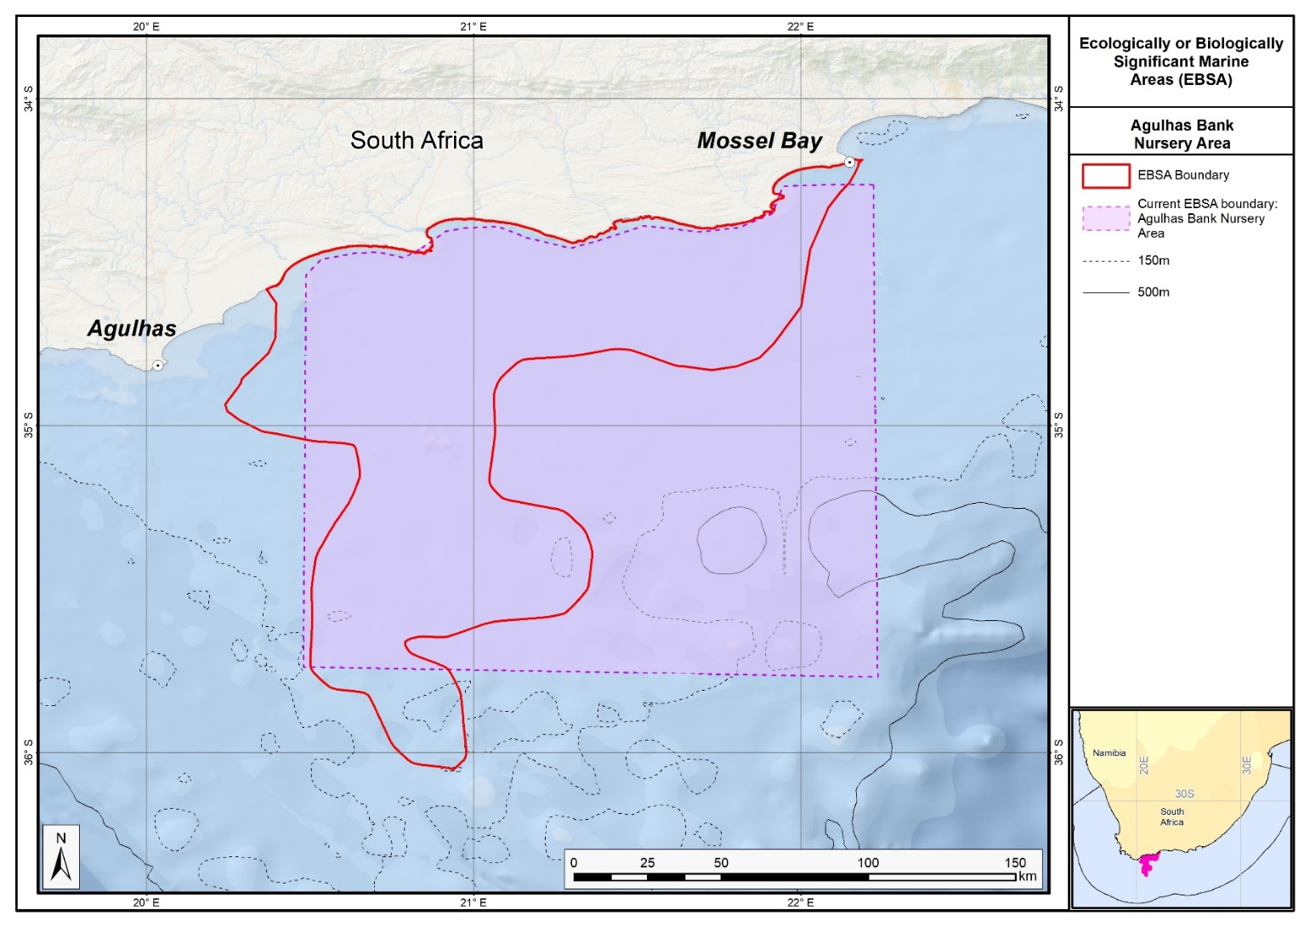
Map of the Agulhas Bank Nursery area in relation to the original Agulhas Bank Nursery EBSA.

.
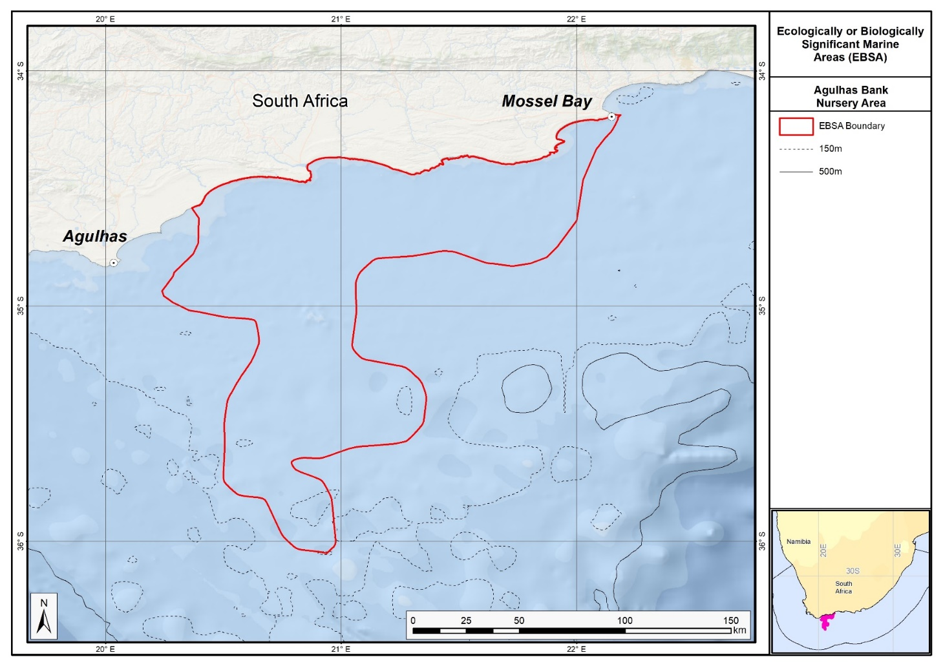
Map of the Agulhas Bank Nursery area.

Rights and permissions:
No limits on sharing or publication.

16. Algoa to Amathole (modification of the existing Offshore of Port Elizabeth)

Reason for the modification:
The EBSA description is being modified because of newly available or accessible knowledge on features associated with the area, based on additional scientific data especially new systematic spatial planning and assessments of biodiversity. The descriptions and supporting information are substantially extended, updated and refined beyond the original descriptions from the Southern Indian Ocean Regional EBSA Workshop, 2012. The modifications involve changes to the textual description, changes to the ranking of the area against the EBSA criteria, and changes in shape, location and size of the area.

The original descriptions of Ecologically or Biologically Significant Marine Areas (EBSAs) in the Benguela Current Large Marine Ecosystem (BCLME) were described in the Southern Indian Ocean Regional EBSA Workshop. The descriptions were generally characterized by generic, often fairly geometric delineations, consisting of approximate bounding boxes around the features for which the EBSA was described. This coarse scale of delineation was appropriate for a global scale but posed challenges for inclusion in national-level, place-based ocean management. The original boundaries were not sufficiently refined to capture the full extent of key biodiversity features and often overlapped with areas of lower biodiversity value or poor ecological condition.

Additionally, the original EBSA descriptions suffered from shortfalls related to limited spatial data and lack of systematic conservation planning approaches at the time they were first proposed. This meant that many boundaries did not precisely encompass biodiversity priority areas, potentially leading to conflicts with other ocean sectors and limiting their practical usefulness for marine spatial planning (MSP). The coarse scale and lack of detailed data constrained the ability to develop effective zoning and management recommendations that balance biodiversity protection with economic activities.

How was the submission developed?
The EBSA revision process was part a broader project on ecosystem-based MSP in the BCLME, namely the Benguela Current Marine Spatial Management and Governance Project (MARISMA, 2014-2023). This was a regional capacity-building and development cooperation project implemented by the Benguela Current Commission, the Governments of Angola, Namibia and South Africa, and GIZ, the German Agency for Development Cooperation (Deutsche Gesellschaft für Internationale Zusammenarbeit.

Because of these shortcomings of the existing EBSA boundaries, description and valuations set out in the previous section, the MARISMA project undertook a refinement process. This process used systematic conservation planning (SCP) tools, such as Marxan, to generate finer-scale, more accurate boundaries based on updated biodiversity data and expert input. This process also allowed for the identification of new EBSAs and the splitting of some original EBSAs into multiple refined areas to better reflect discrete biodiversity features and ecological processes. The refined EBSA boundaries were more suitable for MSP and conservation management because they focused on core natural and near-natural areas, avoided unnecessary conflicts with other sectors, and incorporated a systematic, data-driven approach to spatial prioritization.

The overall approach to the EBSA update and engagement followed these key steps:

Initial Systematic Conservation Planning (SCP) Analyses: Existing EBSAs were refined and new areas identified using systematic conservation planning tools such as Marxan, based on biodiversity input data including ecosystem types, species distributions, and ecological processes.

National Workshops: The refined and new EBSA boundaries were iteratively reviewed and adjusted through workshops held within each of the three countries (Angola, Namibia, South Africa). These workshops allowed country-specific input and tailoring of EBSA boundaries and descriptions to national contexts and priorities.

Regional Workshops and Bilateral Meetings between Countries: Workshops at the regional level especially focused on transboundary EBSAs shared between the countries, but also examined the overall approach to EBSAs, their delineation, description and the engagement approach. The aim was to harmonize boundaries, align management recommendations, and foster cooperation across national borders for effective regional marine biodiversity management. Additional specific bilateral meetings were held where necessary.

Technical and Scientific Peer Review: The revised and new EBSAs underwent technical review nationally and regionally (through technical review workshops involving relevant experts); and internationally with assistance from experts from the Global Ocean Biodiversity Initiative (GOBI) and members of the CBD's Informal Advisory Group on EBSAs, ensuring robustness of the exercise. The process is documented in peer reviewed literature (Harris et al., 2019, 2022).

Political Approval: The EBSAs were administratively and politically approved through all required stages up to the national ministerial level in each country and were then submitted to the CBD Secretariat by the National CBD Focal Points.

Data Sharing and Accessibility: All information, including refined EBSA boundaries, status assessments, management recommendations, and stakeholder feedback, were made available through online repositories such as the project's EBSA Portal (https://cmr.mandela.ac.za/Research-Projects/EBSA-Portal); and the EBSA were also shared via the Benguela Current Convention's Geodata Portal (https://geodata.benguelacc.org/ ). This facilitated transparency, accessibility, and ongoing updating of data and products for biodiversity specialists and other stakeholders.

Significant changes have been made to the delineation of the original Offshore of Port Elizabeth EBSA and to the description, such that it was necessary to split the EBSA into two, and revise the name of this one to Algoa to Amathole EBSA to accurately reflect the geographical location of the EBSA. Additional references have been added and significant updates to the description were made. A supplementary table of the habitats represented in the EBSA and their associated threat status was also included. Given the new extent and inclusion of additional features, criteria level changes were made to Criterion 1: Uniqueness or rarity and Criterion 7: Naturalness, respectively upgraded from medium to high, and low to medium.

An important change has been the significant revision of the EBSA boundaries to reflect the key biodiversity features in this area. The delineation process included an initial stakeholder review which identified the need to update boundaries, a technical mapping process and then an expert review workshop where boundary delineation options were finalised. The delineation process used a combination of Systematic Conservation Planning and Multi-Criteria Analysis methods. The features used in the analysis were:
- Key physical features (especially canyons) identified from the latest GEBCO data, global benthic geomorphology mapping (www.bluehabitats.org, Harris et al., 2014), the National Biodiversity Assessment 2011 (Sink et al., 2012) and BCC spatial mapping project (Holness et al., 2014) were incorporated. In addition, island linked ecosystem types were included.
- Irreplaceable and near irreplaceable (i.e. very high selection frequency) sites, as well as focus areas identified in the Systematic Conservation Plans undertaken for the West Coast by Majiedt et al. (2013), offshore areas (Sink et al., 2011) and by Holness et al. (2014) were incorporated.
- Delineations and threat status of constituent ecosystem types in the area were included in the analysis and used to refine the boundary of the EBSA.
- Areas important for threatened and special species were included. The priority areas and buffer distances around colonies were from Holness et al. (2014). Note that the full extent of the buffer was not necessarily included in the EBSA. Features included in the analysis were:
  - African Penguin colonies and a 20km buffer.
  - Cape Cormorant and White Breasted Cormorant colonies and a 40km buffer.
  - Gannet colonies with a 40km buffer.
  - Seal Colonies and a 20km buffer.
- Areas of high relative naturalness of benthic and coastal systems and pelagic systems identified in the National Biodiversity Assessment 2011 (Sink et al., 2012a) were included in the analysis.
- Distributions of known fragile, vulnerable and sensitive habitat-forming species were included (Unpublished SANBI and SAEON data).

The multi-criteria analysis resulted in a value surface. The cut-off value used to determine the extent of the EBSA was based on expert input and quantitative analysis of effective inclusion of the above features. This entailed taking an iterative parameter calibration-based approach whereby the spatial efficiency of the inclusion of the targeted features was evaluated. The approach aimed to identify a cut-off which most efficiently included prioritised features while minimizing the inclusion of impacted areas. The final boundaries shown in the map were validated in a national workshop.

Traditional knowledge was not incorporated into this process, and consultations with indigenous peoples or local communities were not undertaken. Therefore, documentation of Free, Prior and Informed Consent (FPIC) is not relevant for this EBSA process.

Where is the submission intended to be included (choose one option, and please note that there are different procedures for these two intended end points)?
[X] EBSA repository
[ ] EBSA information-sharing mechanism

Abstract:
Changes from the original version: The completely revised and rewritten abstract more clearly highlights the value of the EBSA, includes more specific data on threatened species (e.g. African Penguins, two turtle species and an endemic pipefish). A more specific description of ecosystem types is included.

The area has one of the largest collections of significant and special marine features in South Africa, supporting critical ecosystems, species, ecological processes and land-sea connections. Complex oceanography occurs where the Agulhas current departs the coast and generates cold-water eddies, shelf intrusions and offshore meanders. Those dynamics help to create spawning areas, nurseries and transport pathways for demersal and pelagic fish, which support diverse top predators, including sharks and seabirds. Algoa Bay islands host the easternmost colony of endangered African penguins and the largest Cape gannet colony in southern Africa. Critically endangered leatherback turtles and near threatened loggerhead turtles migrate through the area. The area encompasses 36 ecosystem types, of which 18 are threatened and 7 are near threatened, including submarine canyons, steep shelf edges, deep reefs and cold-water corals. Major biodiversity features include stromatolites, coelacanth sites, a critically endangered endemic estuarine pipefish, priority estuaries, rare ecosystem types and existing marine protected areas.

Introduction:
Changes from the original version: The completely revised and rewritten abstract provides an expanded description of the expanded geographic extent and details the depth range extension from the original upper slope limit (~1000 m) to approximately 2000 m, thereby encompassing a broader bathymetric gradient. It highlights extensive biological and oceanographic research in the area.

This EBSA spans the Eastern Cape shoreline in South Africa between Sardinia Bay MPA and Amathole MPA/Kei River mouth. It extends from the dune base to approximately the continental shelf break/slope, thus spanning a depth range of approximately 0-2000 m. It is important for both benthic and pelagic features, comprising an offshore area of high habitat complexity, and containing a myriad of unique and interesting biodiversity features. Benthic features include a large shelf-intersecting canyon (Sink et al., 2011), and rare seabed ecosystem types (Sink et al., 2012). The pelagic environment is characterised by complex ocean circulation patterns because the EBSA includes the point where the Agulhas Current leaves the coast, following the shelf break. This results in the formation of cold-water eddies, intrusions of Agulhas water onto the shelf, large offshore meanders of the Agulhas Current, and upwelling. This oceanography supports key ecological processes. Given the close proximity of the Eastern Cape universities, there is substantial ecological research and data available for this coastal area, and an extensive array of in-water devices for long-term ecological research within Algoa Bay.

Location:
Changes from the original version: The section reflects the updated spatial delineation, provides bounding box coordinates, and shares a link to the specific spatial data. Motivation for the spatial changes, and details of the spatial planning are given in “How was the submission developed?” Section. The key geographic change is the split of the original Offshore of Port Elizabeth EBSA into two, with this Algoa to Amathole EBSA extending eastwards and including important estuaries, canyons and shelf edge areas especially in the Amathole region.

The area spans the Eastern Cape shoreline between Sardinia Bay and Amathole marine protected areas, up to the Kei River mouth. It extends from the dune base to approximately the continental shelf break, as far west as south of Cape St. Francis, and also encompasses the functional zone of several priority estuaries. It lies entirely within the exclusive economic zone of South Africa.

The coordinates of a minimum bounding box covering the entire scope of the area are:
- Latitude: -33.721, -32.425, -33.438, -34.734
- Longitude: 25.317, 28.782, 29.161, 25.696

Feature description of the area:
Changes from the original version: This completely revised description includes a description of the value of the EBSA, substantial additional data on species, and a new focus on key estuary linked processes and species (including a Critically Endangered endemic pipefish). New data from on the National Biodiversity Assessment are provided on the diversity and threat status of ecosystems. New biological and oceanographic details are provided based on updated studies. The expanded MPA network is described. It is presented as a Type 2 EBSA because it contains “spatially stable features whose individual positions are known, but a number of individual cases are being grouped” (sensu Johnson et al., 2018).

Algoa to Amathole EBSA is one of the most ecologically and biologically significant areas in South Africa. This area contains a myriad of rare, unique and diverse physical and biological features that are found on the seabed and in the overlying water column, that in turn support many key processes, including critical land-sea connections. The EBSA centres approximately around Algoa Bay, which also aligns with where the Agulhas Current leaves the coast, following the shelf break. This results in complex ocean circulation, including the formation of cold-water eddies, intrusions of Agulhas water onto the shelf, and large offshore meanders of the Agulhas Current; and productivity is enhanced by coastal upwelling (Goschen et al., 2015) and relatively rare surf diatom accumulations in the surf zone (Campbell & Bate 1988, Campbell 1996). Consequently, the area serves as spawning and/or nursery grounds for certain commercially-important demersal and pelagic fish species (Pattrick et al., 2016; Rishworth et al., 2015), squid (Downey-Breedt et al., 2016; Lipiński et al., 2016) sharks (Smale et al., 2015) and whales (Melly et al., in press); as transiting/foraging areas for seabirds, sharks, cetaceans (e.g., Koper et al., 2016; Melly et al., in press), and turtles; and forms part of the migration routes of loggerhead and leatherback turtles (Harris et al., 2018), with hatchlings of both species passing through the area during their dispersal. Green turtles, killer whales and coelacanths have also been sighted in the area. Notably, Algoa Bay hosts the largest groups of bottlenose dolphins (Bouveroux et al., 2018), largest colony of Endangered African penguins (Pichegru et al., 2010), and largest colony of Cape gannets (Crawford et al., 2007) in the world.

The new delineation of this EBSA to include priority estuaries, now includes breeding sites of the Critically Endangered, and locally endemic pipefish: Syngnathus watermeyeri (Vorwerk et al., 2007). These estuaries, together with the extension to include the coastal areas, also better represents some critical ecological processes that support the important offshore features. For example, these include key linkages among spawning, post-hatch and nursery areas commercially important fish species that span the surf zone to nearshore and the shelf (Pattrick et al., 2016). Many of the fish in the area also use the estuaries for part of their life-histories.

The National Biodiversity Assessment (Table below; Sink et al., 2019) highlighted that there are 18 threatened ecosystem types, and a further seven Near Threatened ecosystem types. The threatened types include the Endangered Kei Fluvial Fan and Kei Reef Complex ecosystem types, and the Vulnerable Agulhas Bays - East, Agulhas Coarse Sediment Shelf Edge, Agulhas Exposed Rocky Shore, Agulhas Exposed-Stromatolite Rocky Shore, Agulhas Inner Shelf Reef Sand Mosaic, Agulhas Island Shore, Agulhas Mid Shelf Reef Complex, Agulhas Sandy Inner Shelf, Agulhas Sandy Outer Shelf, Agulhas Stromatolite Mixed Shore, Agulhas Upper Canyons, Agulhas Very Exposed Rocky Shore, Amathole Hard Shelf Edge, Warm Temperate Large Fluvially Dominated Estuary, Warm Temperate Large Temporarily Closed Estuary and Warm Temperate Predominantly Open Estuary ecosystem types.

Habitat diversity is also high within the EBSA. There are 36 ecosystem types represented (See Table below; Sink et al., 2019), with benthic features including stromatolites, canyons, steep shelf edge, deep reefs, outer shelf and shelf edge gravels, and reef-building cold-water corals ranging in depth between -100 and -1000 m. There is also growing research (with interesting results) into marine biochemistry, microbiology, and potential pharmaceuticals and natural products from the biota in Algoa Bay and surrounds (e.g., Matobole et al., 2017; Ntozonke et al., 2017; Waterworth et al., 2017), as well as research into the recently discovered stromatolites on the shore (Perissinotto et al., 2014).

There has been substantial research in the area since the EBSA was first proposed, that has contributed significantly to identifying the features that are present, their extent and importance. The boundary of this EBSA was refined to align with initiatives to expand South Africa’s MPA network, and better represent the underlying features comprising the EBSA to improve precision in the delineation, including: the canyons, rocky ridge, fragile and sensitive habitat-forming species, other key species, and key (threatened) habitats. The new boundary also includes more of the existing coastal MPAs in the region, and two new MPAs (namely Addo Elephant National Park MPA and Amathole Offshore MPA). It is presented as a Type 2 EBSA because it contains “spatially stable features whose individual positions are known, but a number of individual cases are being grouped” (sensu Johnson et al., 2018).

Summary of ecosystem types and threat status for the Algoa to Amathole EBSA. Data from Sink et al. (2019).
Threat Status | Ecosystem Type | Area (km²) | Area (%)
Endangered | Kei Fluvial Fan | 40.8 | 0.2
 | Kei Reef Complex | 93.0 | 0.5
Vulnerable | Agulhas Bays - East | 1003.0 | 5.1
 | Agulhas Coarse Sediment Shelf Edge | 1221.5 | 6.2
 | Agulhas Exposed Rocky Shore | 6.2 | 0.0
 | Agulhas Exposed-Stromatolite Rocky Shore | 3.6 | 0.0
 | Agulhas Inner Shelf Reef Sand Mosaic | 373.3 | 1.9
 | Agulhas Island Shore | 3.0 | 0.0
 | Agulhas Mid Shelf Reef Complex | 35.1 | 0.2
 | Agulhas Sandy Inner Shelf | 411.4 | 2.1
 | Agulhas Sandy Outer Shelf | 4525.8 | 23.0
 | Agulhas Stromatolite Mixed Shore | 4.0 | 0.0
 | Agulhas Upper Canyons | 102.0 | 0.5
 | Agulhas Very Exposed Rocky Shore | 0.4 | 0.0
 | Amathole Hard Shelf Edge | 468.7 | 2.4
 | Warm Temperate Large Fluvially Dominated Estuary | 5.7 | 0.0
 | Warm Temperate Large Temporarily Closed Estuary | 9.0 | 0.0
 | Warm Temperate Predominantly Open Estuary | 76.5 | 0.4
Near Threatened | Agulhas Boulder Shore | 0.6 | 0.0
Near Threatened | Agulhas Dissipative Sandy Shore | 1.5 | 0.0
Near Threatened | Agulhas Mid Shelf Reef Sand Mosaic | 396.0 | 2.0
 | Agulhas Mixed Shore | 60.4 | 0.3
 | Agulhas Sandy Mid Shelf | 3615.3 | 18.4
 | Agulhas Very Exposed-Stromatolite Rocky Shore | 0.2 | 0.0
 | Amathole Lace Corals | 131.7 | 0.7
Least Concern | Agulhas Dissipative-Intermediate Sandy Shore | 50.5 | 0.3
 | Agulhas Intermediate Sandy Shore | 0.8 | 0.0
 | Agulhas Lower Canyons | 1152.5 | 5.9
 | Natal Deep Shelf Edge | 370.7 | 1.9
 | Natal Pondoland Lower Canyons | 612.7 | 3.1
 | Pondoland Mid Shelf Coarse Sediment Reef Mosaic(B) | 1316.4 | 6.7
 | Pondoland Shelf Edge Gravel Reef Mosaic | 261.8 | 1.3
 | Southwest Indian Mid Slope | 2128.7 | 10.8
 | Southwest Indian Upper Slope | 1172.7 | 6.0
 | Warm Temperate Small Temporarily Closed Estuary | 3.6 | 0.0
N/A | Warm Temperate Micro-estuary | 0.5 | 0.0
Grand Total |  | 19659.6 | 100.0

Feature condition and future outlook:
Changes from the original version: The section has been substantially expanded to reflect newly available information. The revised description includes updated information on ecological condition, ecosystem threat statuses, and describes the large new MPAs in the EBSA which substantially improves protection.

The National Biodiversity Assessment (Sink et al., 2019) highlighted that Algoa to Amathole is largely in good (32%) to fair (44%) ecological condition, with a quarter (24%) in poor ecological condition, mainly linked to the development and economic nodes at Port Elizabeth and Port Alfred. Consequently, the bulk of the offshore extent is either Vulnerable (42%) or Near Threatened (21%), with only a fraction (1%) that is Endangered, and the rest, Least Concern (36%). The Endangered ecosystem types cluster at the Kei mouth, and/or contain fragile species: Kei Fluvial Fan; Kei Reef Mosaic and Agulhas Sheltered Rocky Shore. Key pressures include commercial demersal trawl and longline fisheries, a midwater trawl fishery, linefishing, trap fisheries for rock lobster, and shark fisheries. Red tides have also become more common in recent years, some of which have been toxic (Pitcher et al., 2014).

Protection of features in MPAs has been considerably expanded and strengthened following the proclamation of the Operation Phakisa MPA network in 2019, with the EBSA area within reserves increasing by more than an order of magnitude from <2% to 28%. These new MPAs (namely Addo Elephant National Park MPA and Amathole Offshore MPA) cover the eastern end of Algoa Bay, and offshore areas in Amathole, protecting key (fragile and/or threatened) species, important life-history stages and many ecosystem types.

Assessment of the area against CBD EBSA Criteria:
Changes from the original version: The revised description upgrades the ranking of Criterion 1 (Uniqueness or rarity) from medium to high, justified by the inclusion of rare ecosystem types, local endemic species, and unique geomorphological features like submarine canyons and stromatolites. Criterion 7 (Naturalness) was upgraded from low to medium, reflecting improved representation of natural habitats following boundary refinement and increased MPA coverage. Other criteria maintained their original evaluations but were supported with more detailed evidence, particularly on ecosystem and species threat and diversity.

CBD EBSA Criteria  (Annex I to decision IX/20) | Description  (Annex I to decision IX/20) | Ranking of criterion relevance  (please mark one column with an X)
CBD EBSA Criteria  (Annex I to decision IX/20) | Description  (Annex I to decision IX/20) | No information |  | Low |  |  | Medium |  | High
Uniqueness or rarity | Area contains either (i) unique (“the only one of its kind”), rare (occurs only in few locations) or endemic species, populations or communities, and/or (ii) unique, rare or distinct, habitats or ecosystems; and/or (iii) unique or unusual geomorphological or oceanographic features. |  |  |  |  |  |  |  | x
Rare ecosystem types in this region include outer shelf mixed sediments, canyons and stromatolites (Sink et al., 2019), and relatively rare – nationally and globally – surf diatom accumulations (Campbell 1996, Campbell & Bate 1988). This site includes a large canyon that intersects with the shelf (Sink et al., 2011). It also contains a Critically Endangered localised endemic estuarine pipefish, and sites where coelocanths are present.
Special importance for life-history stages of species | Areas that are required for a population to survive and thrive. |  |  |  |  |  |  |  | X
This area includes foraging areas for African penguins and Cape gannets (Sink et al., 2011). BirdLife International data also indicate importance for damara terns, kelp gulls and roseate terns. Species that have shown spawning activity in this area include (among others) kingklip, squid, sparids, sardine, anchovy, kob and hake (Hutchings et al., 2002, Sink et al., 2011; Mhlongo et al., 2015, Downey-Breedt et al., 2016; Lipiński et al., 2016; Pattrick et al., 2016). This is considered an area of crucial importance for the eggs and larvae spawned upstream to enter the Agulhas Bank nursery area (Hutchings et al., 2002). Offshore of Port Elizabeth is also particularly important for mussel larvae (Weidberg et al., 2015) and spiny lobsters (Santos et al., 2014). This area is also important as a nursery area for sharks (Smale et al., 2015) and whales (Melly et al., in press), and as transiting/foraging areas for seabirds, sharks, cetaceans (e.g., Koper et al., 2016; Melly et al., in press), and turtles (Harris et al., 2018).
The area is part of the recognized Southern Coastal and Shelf Waters of South Africa Important Marine Mammal Area. The southern coast of South Africa represents one of the world’s most productive marine regions, famed for its annual ‘Sardine Run’ which occurs along the southeast coast between May and June. This annual event supports a number of top predators, including common dolphins (Delphinus delphis), Indo-Pacific bottlenose dolphins (Tursiops aduncus), fur seals (Arctocephalus pusillus) and killer whales (Orcinus orca). The inshore waters, within 500m of the coast and with water depths of less than 25m, provide important year-round habitat for feeding and reproduction for Endangered Indian Ocean humpback dolphins (Sousa plumbea). Furthermore, the waters over the continental shelf, present important habitat for the inshore form of Bryde’s whale (Balaenoptera edeni). Further details and maps: https://www.marinemammalhabitat.org/factsheets/southern-coastal-shelf-waters-south-africa/
Importance for threatened, endangered or declining species and/or habitats | Area containing habitat for the survival and recovery of endangered, threatened, declining species or area with significant assemblages of such species. |  |  |  |  |  |  |  | X
This area includes areas important for the survival of several IUCN Red-listed species, including the African penguin Spheniscus demersus (Endangered on the IUCN Red List) and the Cape Gannet Morus capensis (Vulnerable on the IUCN Red List). This area is also used by green, loggerhead, and leatherback turtles (respectively listed as Endangered, Near Threatened and Critically Endangered on the IUCN global redlist for the South West Indian Ocean region; Petersen et al., 2009, Harris et al., 2018).
There are 18 threatened ecosystem types, and a further seven Near Threatened ecosystem types. The threatened types include the Endangered Kei Fluvial Fan and Kei Reef Complex ecosystem types, and the Vulnerable Agulhas Bays - East, Agulhas Coarse Sediment Shelf Edge, Agulhas Exposed Rocky Shore, Agulhas Exposed-Stromatolite Rocky Shore, Agulhas Inner Shelf Reef Sand Mosaic, Agulhas Island Shore, Agulhas Mid Shelf Reef Complex, Agulhas Sandy Inner Shelf, Agulhas Sandy Outer Shelf, Agulhas Stromatolite Mixed Shore, Agulhas Upper Canyons, Agulhas Very Exposed Rocky Shore, Amathole Hard Shelf Edge, Warm Temperate Large Fluvially Dominated Estuary, Warm Temperate Large Temporarily Closed Estuary and Warm Temperate Predominantly Open Estuary ecosystem types.
Vulnerability, fragility, sensitivity, or slow recovery | Areas that contain a relatively high proportion of sensitive habitats, biotopes or species that are functionally fragile (highly susceptible to degradation or depletion by human activity or by natural events) or with slow recovery. |  |  |  |  |  | X
This area includes submarine canyons, steep shelf edge, deep reefs and outer shelf and shelf edge gravels. These habitats may support fragile habitat-forming species. Cold-water corals (Goniocorella dumosa, Solenosmilia variabilis) have been recorded in the area (Sink et al., 2011) and are in the Iziko South African museum invertebrate collection.
Biological productivity | Area containing species, populations or communities with comparatively higher natural biological productivity. |  |  |  |  |  |  |  | X
Productivity offshore of Port Elizabeth is medium to high, and very variable. Chlorophyll-a concentrations are also highly variable, associated with frequent SST and chlorophyll fronts on the steep outer shelf (Lagabrielle 2009, Sink et al., 2011, Roberson et al., 2017). Coastal upwelling may be driven, or at least enhanced, by the formation of Natal pulses (Goschen et al., 2015).
Biological diversity | Area contains comparatively higher diversity of ecosystems, habitats, communities, or species, or has higher genetic diversity. |  |  |  |  |  |  |  | X
There are 36 ecosystem types comprising this EBSA, including rocky, mixed and boulder shores, stromatolites, estuaries, beaches, bays, shelf, shelf edge, and canyons (Sink et al., 2019). The associated communities supported by these habitats are thus also diverse.
Naturalness | Area with a comparatively higher degree of naturalness as a result of the lack of or low level of human-induced disturbance or degradation. |  |  |  |  |  |  | X
Although some areas are assessed as in poor condition (based on pressure data, see South Africa’s National Biodiversity Assessment 2011, Sink et al., 2012), there are many examples of ecosystem types in good condition and include examples of features that may support fragile and vulnerable habitat forming species (Sink et al., 2012).

References:
Changes from the original version: The revised description includes a substantially expanded reference list, incorporating recent peer-reviewed publications and technical reports.

BirdLife International, 2009. Designing networks of marine protected areas: exploring the linkages between Important Bird Areas and ecologically or biologically significant marine areas. Cambridge, UK: BirdLife International. www.cbd.int/doc/meetings/mar/ewbcsima-01/other/ewbcsima-01-birdlife-02-en.pdf
BirdLife International. 2010. Marine Important Bird Areas toolkit: standardised techniques for identifying priority sites for the conservation of seabirds at-sea. BirdLife International, Cambridge UK. Version 1.1: May 2010. www.birdlife.org/eu/pdfs/Marine_IBA_Toolkit_2010.pdf
Bouveroux, T.N., Caputo, M., Froneman, P.W., Plön, S. 2018. Largest reported groups for the Indo‐Pacific bottlenose dolphin (Tursiops aduncus) found in Algoa Bay, South Africa: Trends and potential drivers. Marine Mammal Science, in press. https://doi.org/10.1111/mms.12471
Campbell, E.E. (1996). The global distribution of surf diatom accumulations. Revista Chilena Historia Natural, 69: 495-501.
Campbell, E.E., Bate, G.C. 1988. The estimation of annual primary production in a high energy surf-zone. Botanica Marina, 31: 337-343.
Crawford, R. J. M., Dundee, B. L., Dyer, B. M., Klages, N. T., Meÿer, M. A., Upfold, L. 2007. Trends in numbers of Cape gannets (Morus capensis), 1956/57–2005/06, with a consideration of the influence of food and other factors – ICES Journal of Marine Science, 64: 169–177.
Downey-Breedt, N.J., Roberts, M.J., Sauer, W.H.H., Chang, N. 2016. Modelling transport of inshore and deep-spawned chokka squid (Loligo reynaudi) paralarvae off South Africa: the potential contribution of deep spawning to recruitment. Fisheries Oceanography, 25: 28–43.
Goschen, W.S., Bornman, T.G., Deyzel, S.H.P., Schumann, E.H. 2015. Coastal upwelling on the far eastern Agulhas Bank associated with large meanders in the Agulhas Current. Continental Shelf Research, 101: 34–46.
Harris, L., Holness, S., Finke, G., Kirkman, S., Sink, K., 2019. Systematic Conservation Planning as a Tool to Advance Ecologically or Biologically Significant Area and Marine Spatial Planning Processes, in: Zaucha, J., Gee, K. (Eds.), Maritime Spatial Planning. Palgrave Macmillian, Cham.
Harris, L.R., Holness, S.D., Finke, G., Amunyela, M., Braby, R., Coelho, N., Gee, K., Kirkman, S.P., Kreiner, A., Mausolf, E., Majiedt, P., Maletzky, E., Nsingi, K.K., Russo, V., Sink, K.J., Sorgenfrei, R., 2022. Practical Marine Spatial Management of Ecologically or Biologically Significant Marine Areas: Emerging Lessons From Evidence-Based Planning and Implementation in a Developing-World Context. Front. Mar. Sci. 9.
Harris, L.R., Nel, R., Oosthuizen, H., Meyer, M., Kotze, D., Anders, D., McCue, S., Bachoo, S. 2018. Managing conflicts between economic activities and threatened migratory marine species towards creating a multi-objective blue economy. Conservation Biology, 32: 411-423.
Hutchings, L., Beckley, L.E., Griffiths, M.H., Roberts, M.J., Sundby, S., van der Lingen, C. 2002. Spawning on the edge: spawning grounds and nursery areas around the southern African coastline. Marine and Freshwater Research, 53: 307-318.
IUCN-Marine Mammal Protected Areas Task Force, 2020. Southern Coastal and Shelf Waters of South Africa IMMA Factsheet. https://www.marinemammalhabitat.org/wp-content/uploads/imma-factsheets/WesternIndianOcean/southern-coastal-and-shelf-waters-of-south-africa-WesternIndianOcean.pdf.
Johnson, D.E., Barrio Froján, C., Turner, P.J., Weaver, P., Gunn, V., Dunn, D.C., Halpin, P., Bax, N.J., Dunstan, P.K., 2018. Reviewing the EBSA process: Improving on success. Marine Policy 88, 75-85.
Koper, R.P., Karczmarski, L., Du Preez, D., Plön, S. 2016. Sixteen years later: Occurrence, group size, and habitat use of humpback dolphins (Sousa plumbea) in Algoa Bay, South Africa. Marine Mammal Science, 32: 490–507.
Lagabrielle, E. 2009. Preliminary report: National Pelagic Bioregionalisation of South Africa. Cape Town: South African National Biodiversity Institute.
Lipiński, M.R., van der Vyver, J.S.F., Shaw, P., Sauer, W.H.H. 2016. Life cycle of chokka-squid Loligo reynaudii in South African waters, African Journal of Marine Science, 38:4, 589-593.
Lutjeharms, J.R.E., Cooper, J., Roberts, M. 2000. Upwelling at the inshore edge of the Agulhas Current. Continental Shelf Research, 20: 737 – 761.
Matobole, R., van Zyl, L., Parker‐Nance, S., Davies‐Coleman, M., Trindade, M. 2017. Antibacterial Activities of Bacteria Isolated from the Marine Sponges Isodictya compressa and Higginsia bidentifera Collected from Algoa Bay, South Africa. Marine Drugs, 15: 47.
Melly, B.L., McGregor, G., Hofmeyr, G.J.G., and Plön, S. in press. Spatio-temporal distribution and habitat preferences of cetaceans in Algoa Bay, South Africa. Journal of the Marine Biological Association of the United Kingdom, 1-15. https://doi.org/10.1017/S0025315417000340
Mhlongo, N., Yemane, D., Hendricks, M. 2015. Have the spawning habitat preferences of anchovy (Engraulis encrasicolus) and sardine (Sardinops sagax) in the southern Benguela changed in recent years? Fisheries Oceanography 24: 1–14.
Ntozonke, N., Okaiyeto, K., Okoli, A., Olaniran, A., Nwodo, U., Okoh, A. 2017. A Marine Bacterium, Bacillus sp. Isolated from the Sediment Samples of Algoa Bay in South Africa Produces a Polysaccharide-Bioflocculant. International Journal of Environmental Research and Public Health, 14: 1149.
Pattrick, P., Strydom, N.A., Harris, L., Goschen, W.S. 2016. Predicting spawning locations and modelling the spatial extent of post hatch areas for fishes in a shallow coastal habitat in South Africa. Marine Ecology Progress Series, 560: 223-235.
Perissinotto, R., Bornman, T.G., Steyn, P.-P., Miranda, N.A.F., Dorrington, R.A., Matcher, G.F., Strydom, N., Peer, N., 2014. Tufa stromatolite ecosystems on the South African south coast. South African Journal of Science 110, 01-08.
Pichegru, L., Grémillet, D., Crawford, R.J.M., Ryan, P.G. 2010. Marine no-take zone rapidly benefits endangered penguin. Biology Letters. DOI: 10.1098/rsbl.2009.0913
Pitcher, G.C., Cembella, A.D., Krock, B., Macey, B.M., Mansfield, L., Probyn, T.A. 2014. Identification of the marine diatom Pseudo-nitzschia multiseries (Bacillariophyceae) as a source of the toxin domoic acid in Algoa Bay, South Africa. African Journal of Marine Science, 36: 523-528.
Rishworth, G.M., Strydom, N.A., Potts, W. 2014. Fish utilization of surf-zones. Are they changing? A case study of the Sheltered, warm-temperate King’s Beach. African Zoology, 49: 5-21.
Roberson, L.A., Lagabrielle, E., Lombard, A.T., Sink, K., Livingstone, T., Grantham, H., Harris, J.M. 2017. Pelagic bioregionalisation using open-access data for better planning of marine protected area networks. Ocean & Coastal Management, 148: 214-230.
Santos, J., Rouillard, D., Groeneveld, J.C. 2014. Advection-diffusion models of spiny lobster Palinurus gilchristi migrations for use in spatial fisheries management. Marine Ecology Progress Series, 498: 227–241.
Sink, K., Holness, S., Harris, L., Majiedt, P., Atkinson, L., Robinson, T., Kirkman, S., Hutchings, L., Leslie, R., Lamberth, S., Kerwath, S., von der Heyden, S., Lombard, A., Attwood, C., Branch, G., Fairweather, T., Taljaard, S., Weerts, S., Cowley, P., Awad, A., Halpern, B., Grantham, H., Wolf, T. 2012. National Biodiversity Assessment 2011: Technical Report. Volume 4: Marine and Coastal Component. South African National Biodiversity Institute, Pretoria.
Sink, K.J., Attwood, C.G., Lombard, A.T., Grantham, H., Leslie, R., Samaai, T., Kerwath, S., Majiedt, P., Fairweather, T., Hutchings, L., van der Lingen, C., Atkinson, L.J., Wilkinson, S., Holness, S., Wolf, T. 2011. Spatial planning to identify focus areas for offshore biodiversity protection in South Africa. Unpublished Report. Cape Town: South African National Biodiversity Institute.
Sink, K.J., van der Bank, M.G., Majiedt, P.A., Harris, L.R., Atkinson, L., Karenyi, N., Kirkman, S. (eds) 2019. National Biodiversity Assessment 2018 Technical Report Volume 4: Marine Realm. South African National Biodiversity Institute, Pretoria.
Smale, M.J., Dicken, M.L., Booth, A.J. 2015. Seasonality, behaviour and philopatry of spotted ragged‑tooth sharks Carcharias taurus in Eastern Cape nursery areas, South Africa. African Journal of Marine Science, 37: 219-231.
Vorwerk, P.D., Froneman, P.W., Paterson, A.W. 2007. Recovery of the critically endangered river pipefish, Syngnathus watermeyeri, in the Kariega Estuary, Eastern Cape province. South African Journal of Science, 103: 199-201.
Waterworth, S., Jiwaji, M., Kalinski, J.-C., Parker-Nance, S., Dorrington, R. 2017. A Place to Call Home: An Analysis of the Bacterial Communities in Two Tethya rubra Samaai and Gibbons 2005 Populations in Algoa Bay, South Africa. Marine Drugs, 15: 95.
Weidberg, N., Porri, F., Von der Meden, C.E.O., Jackson, J.M., Goschen, W., McQuaid, C.D. 2015. Mechanisms of nearshore retention and offshore export of mussel larvae over the Agulhas Bank. Journal of Marine Systems, 144: 70–80.

Maps and Figures:
GIS data available at: https://cmr.mandela.ac.za/cmr/media/Store/documents/EBSA/Descriptions/SouthAfrica/Shapefile-RSA_EBSAs_final.zip

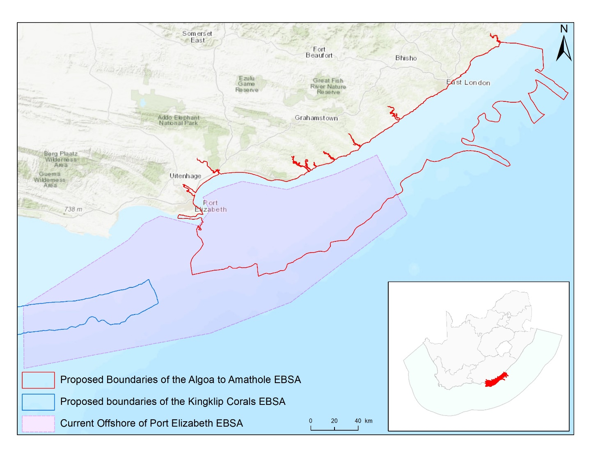
Map of the Algoa to Amathole area in relation to the original Offshore of Port Elizabeth EBSA.
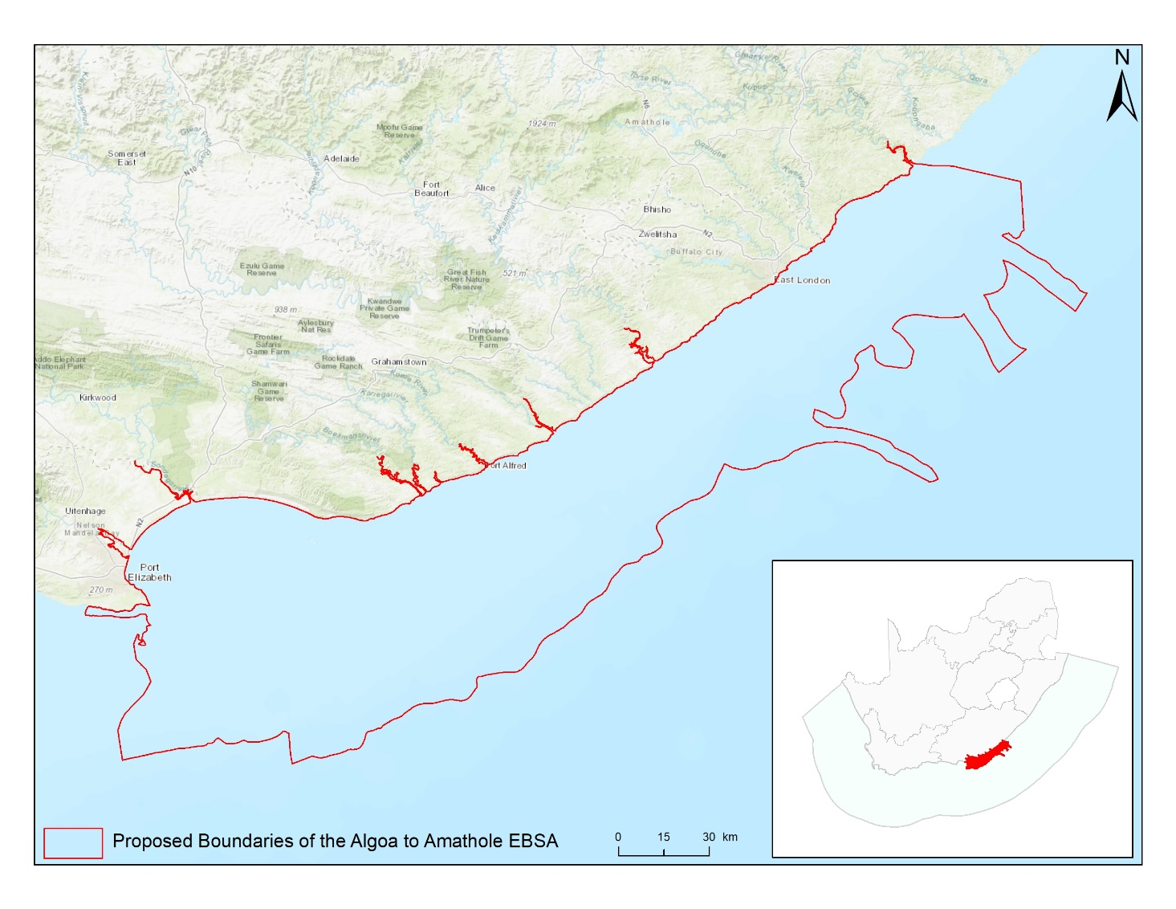
Map of the Algoa to Amathole area.

Rights and permissions:
No limits on sharing or publication.

17. Browns Bank (modification of the existing Browns Bank)⁵

Reason for the modification:
The EBSA description is being modified because of newly available or accessible knowledge on features associated with the area, based on additional scientific data especially new systematic spatial planning and assessments of biodiversity. The descriptions and supporting information are substantially extended, updated and refined beyond the original descriptions from the South-Eastern Atlantic workshop, April 2013. The modifications involve changes to the textual description, changes to the ranking of the area against the EBSA criteria, and changes in shape, location and size of the area.

The original descriptions of Ecologically or Biologically Significant Marine Areas (EBSAs) in the Benguela Current Large Marine Ecosystem (BCLME) were described in the South-Eastern Atlantic workshop (April 2013). The descriptions were generally characterized by generic, often fairly geometric delineations, consisting of approximate bounding boxes around the features for which the EBSA was described. This coarse scale of delineation was appropriate for a global scale but posed challenges for inclusion in national-level, place-based ocean management. The original boundaries were not sufficiently refined to capture the full extent of key biodiversity features and often overlapped with areas of lower biodiversity value or poor ecological condition.

Additionally, the original EBSA descriptions suffered from shortfalls related to limited spatial data and lack of systematic conservation planning approaches at the time they were first proposed. This meant that many boundaries did not precisely encompass biodiversity priority areas, potentially leading to conflicts with other ocean sectors and limiting their practical usefulness for marine spatial planning (MSP). The coarse scale and lack of detailed data constrained the ability to develop effective zoning and management recommendations that balance biodiversity protection with economic activities.

How was the submission developed?
The EBSA revision process was part a broader project on ecosystem-based MSP in the BCLME, namely the Benguela Current Marine Spatial Management and Governance Project (MARISMA, 2014-2023). This was a regional capacity-building and development cooperation project implemented by the Benguela Current Commission, the Governments of Angola, Namibia and South Africa, and GIZ, the German Agency for Development Cooperation (Deutsche Gesellschaft für Internationale Zusammenarbeit.

Because of these shortcomings of the existing EBSA boundaries, description and valuations set out in the previous section, the MARISMA project undertook a refinement process. This process used systematic conservation planning (SCP) tools, such as Marxan, to generate finer-scale, more accurate boundaries based on updated biodiversity data and expert input. This process also allowed for the identification of new EBSAs and the splitting of some original EBSAs into multiple refined areas to better reflect discrete biodiversity features and ecological processes. The refined EBSA boundaries were more suitable for MSP and conservation management because they focused on core natural and near-natural areas, avoided unnecessary conflicts with other sectors, and incorporated a systematic, data-driven approach to spatial prioritization.

The overall approach to the EBSA update and engagement followed these key steps:

Initial Systematic Conservation Planning (SCP) Analyses: Existing EBSAs were refined and new areas identified using systematic conservation planning tools such as Marxan, based on biodiversity input data including ecosystem types, species distributions, and ecological processes.

National Workshops: The refined and new EBSA boundaries were iteratively reviewed and adjusted through workshops held within each of the three countries (Angola, Namibia, South Africa). These workshops allowed country-specific input and tailoring of EBSA boundaries and descriptions to national contexts and priorities.

Regional Workshops and Bilateral Meetings between Countries: Workshops at the regional level especially focused on transboundary EBSAs shared between the countries, but also examined the overall approach to EBSAs, their delineation, description and the engagement approach. The aim was to harmonize boundaries, align management recommendations, and foster cooperation across national borders for effective regional marine biodiversity management. Additional specific bilateral meetings were held where necessary.

Technical and Scientific Peer Review: The revised and new EBSAs underwent technical review nationally and regionally (through technical review workshops involving relevant experts); and internationally with assistance from experts from the Global Ocean Biodiversity Initiative (GOBI) and members of the CBD's Informal Advisory Group on EBSAs, ensuring robustness of the exercise. The process is documented in peer reviewed literature (Harris et al., 2019, 2022).

Political Approval: The EBSAs were administratively and politically approved through all required stages up to the national ministerial level in each country and were then submitted to the CBD Secretariat by the National CBD Focal Points.

Data Sharing and Accessibility: All information, including refined EBSA boundaries, status assessments, management recommendations, and stakeholder feedback, were made available through online repositories such as the project's EBSA Portal (https://cmr.mandela.ac.za/Research-Projects/EBSA-Portal); and the EBSA were also shared via the Benguela Current Convention's Geodata Portal (https://geodata.benguelacc.org/ ). This facilitated transparency, accessibility, and ongoing updating of data and products for biodiversity specialists and other stakeholders.

Some technical revisions and updates to the description were made, even though little additional information was available. A supplementary table of the habitats represented in the EBSA and their associated threat status was also included.

The main change is that the boundary of this EBSA has been slightly adjusted to more closely focus the EBSA on the key biodiversity features that underlie its EBSA status. The delineation process included an initial stakeholder review which identified the need to update boundaries, a technical mapping process and then an expert review workshop where boundary delineation options were finalised. The delineation process used a combination of Systematic Conservation Planning and Multi-Criteria Analysis methods. The features used in the analysis were:
- Irreplaceable and near irreplaceable (i.e. very high selection frequency) sites, as well as focus areas identified in the SCP undertaken for the West Coast by Majiedt et al. (2013), offshore areas (Sink et al., 2011) and by Holness et al. (2014) were incorporated.
- Delineations and threat status of constituent ecosystem types in the area were included in the analysis and used to refine the boundary of the EBSA.
- Areas of high relative naturalness of benthic and coastal systems and pelagic systems identified in the National Biodiversity Assessment 2011 (Sink et al., 2012a) were included in the analysis.
- Distributions of known fragile, vulnerable and sensitive habitat-forming species were included (Unpublished SANBI and SAEON data).

The multi-criteria analysis resulted in a value surface. The cut-off value used to determine the extent of the EBSA was based on expert input and quantitative analysis of effective inclusion of the above features. This entailed taking an iterative parameter calibration-based approach whereby the spatial efficiency of the inclusion of the targeted features was evaluated. The approach aimed to identify a cut-off which most efficiently included prioritised features while minimizing the inclusion of impacted areas. The final boundaries shown in the map were validated in a national workshop.

Traditional knowledge was not incorporated into this process, and consultations with indigenous peoples or local communities were not undertaken. Therefore, documentation of Free, Prior and Informed Consent (FPIC) is not relevant for this EBSA process.

Where is the submission intended to be included (choose one option, and please note that there are different procedures for these two intended end points)?
[X] EBSA repository
[ ] EBSA information-sharing mechanism

Abstract:
Changes from the original version: The original abstract has been slightly rewritten for clarity, but does not contain any substantial new information.

Browns Bank encompasses benthic and pelagic habitats along the western continental margin of South Africa, featuring cold-water coral reefs and hard grounds that have not been trawled. The outer shelf and shelf edge area are a crucial spawning ground for demersal and pelagic fish species, having better larval retention than northern areas and connections with nurseries on the west coast and in Agulhas Bank. Located where the Agulhas and southern Benguela ecoregions converge, the area benefits from sporadic shelf-edge upwelling that enhances productivity. It supports threatened habitats and species, including a critically endangered benthic ecosystem, and overlaps significantly with proposed marine important bird and biodiversity areas for the Cory’s shearwater and Atlantic yellow-nosed albatross. Identified as a priority through systematic biodiversity planning, Browns Bank meets targets for habitat representation, hake spawning areas and fragile habitat-forming species. Its boundaries have been refined on the basis of benthic ecosystem threat assessments and the presence of vulnerable, slow-growing species.

Introduction:
Changes from the original version: The original abstract has been slightly rewritten for clarity, but does not contain any substantial new information. There are refined depth descriptions, as well as the inclusion of new oceanographic references.

The area is along the outer shelf and shelf edge of the western continental margin of South Africa, south and slightly east of Cape Agulhas. It includes benthic habitats, including rocky, sandy and reef substrates (Sink et al., 2019), and a pelagic ecosystem type that is characterised by elevated productivity and frequent fronts due to shelf-edge upwelling (Lutjeharms et al., 2000, Lagabrielle 2009, Roberson et al., 2017). The area ranges from approximately 150 m – 800 m depth and the Agulhas and Southern Benguela ecoregions meet at its south-eastern edge (Sink et al., 2012), with sporadic shelf-edge upwelling that enhances the productivity along its outer margin (Lagabrielle, 2009, Roberson et al., 2017). The area includes the western Agulhas Bank spawning ground, and is part of a critical area for retention of spawning products (Hutchings et al., 2002). It was identified as a priority area through a national plan to identify areas for offshore protection (Sink et al., 2011) and by a systematic biodiversity plan for the South African west coast (Majiedt et al., 2013).

Location:
Changes from the original version: The section reflects the updated spatial delineation, provides bounding box coordinates, and shares a link to the specific spatial data. Motivation for the spatial changes, and details of the spatial planning are given in “How was the submission developed?” Section. The main change is that the boundary of this EBSA has been slightly adjusted to more closely focus the EBSA on the key biodiversity features that underlie its EBSA status.

Browns Bank includes benthic and pelagic habitats of the outer shelf and shelf edge along the western continental margin of South Africa. The area is off the southwest coast of South Africa, almost directly south of Cape Agulhas, and is completely within the exclusive economic zone of South Africa.

The coordinates of a minimum bounding box covering the entire scope of the area are:
- Latitude: -35.569, -36.634, -37.155, -36.09
- Longitude: 19.178, 21.081, 20.789, 18.887

Feature description of the area:
Changes from the original version: The revised description significantly elaborates on the geomorphic and biodiversity features of the revised EBSA. The description includes substantial additional information on ecosystem types, their diversity and their threat status based on more recent systematic assessments. A table of ecosystem types and their statuses is now included. The description references additional up to date survey information. It proposes the site as a Type 1 EBSA because it contains “Spatially stable features whose positions are known and individually resolved on the maps” (sensu Johnson et al., 2018).

The Browns Bank area includes unconsolidated sandy habitats, hard ground and reef habitats (Sink et al., 2019). The pelagic habitat is characterised by elevated productivity and frequent fronts due to shelf edge upwelling (Lutjeharms et al., 2000, Lagabrielle 2009, Roberson et al., 2017). The biodiversity at Browns Bank includes benthic macrofaunal communities characterized by high abundances of brittle stars and many species of polychaetes (Karenyi, 2014); cold-water corals, brisingid starfish, and 77 morphospecies of macroinvertebrates have also been collected within the area (Sink 2016). Further, it is a proposed marine Important Bird Area (IBA) for two species of seabirds, Cory’s Shearwater and Atlantic Yellow-nosed Albatross (BirdLife International 2013), indicating that it holds a significant proportion of the global population of these species during some periods of each year for which data are available. Wandering, Shy, Black-browed, and Atlantic yellownose albatrosses sighted in the area, and Pintado petrels are noted as commonly occurring (Sink 2016). Browns Bank is also part of the western Agulhas Bank spawning ground as described by Hutchings et al. (2002). This area has been included in annual demersal fish trawl surveys conducted by the Department of Agriculture, Forestry and Fisheries, and was surveyed during the Deep Secrets cruise in 2016 (Sink 2016).

The boundary of this EBSA has been refined since it was first described. The new boundary falls almost entirely within the old boundary, comprising an area about two thirds of the original delineation. It was refined to improve precision based on selection frequency in the two systematic biodiversity plans covering this area (Sink et al., 2011; Majiedt et al., 2013), new focus area delineations for MPA expansion in South Africa, presence of fragile and sensitive habitat-forming species, and benthic ecosystem types that are threatened. The site is presented as a Type 1 EBSA because it contains “Spatially stable features whose positions are known and individually resolved on the maps” (sensu Johnson et al., 2018).

This EBSA contains 6 described ecosystem types. Most notably there is a large portion of the Critically Endangered Southern Benguela Rocky Shelf Edge Mosaic ecosystem type highlighted in the National Biodiversity Assessment (Table below; Sink et al., 2019). The remaining 5 ecosystem types (including large areas of the Southeast Atlantic Upper Slope and Southern Benguela Sandy Outer Shelf) were assessed as Least Concern.

Summary of ecosystem types and threat status for the Browns bank EBSA. Data from Sink et al. (2019).
Threat Status | Ecosystem Type | Area (km²) | Area (%)
Critically Endangered | Southern Benguela Rocky Shelf Edge Mosaic | 1197.1 | 21.2
Least Concern | Agulhas Outer Shelf Reef Coarse Sediment Mosaic | 385.5 | 6.8
 | Agulhas Rocky Shelf Edge | 414.8 | 7.3
 | Southeast Atlantic Upper Slope | 1938.1 | 34.3
 | Southern Benguela Sandy Outer Shelf | 1541.7 | 27.2
 | Southwest Indian Upper Slope | 180.5 | 3.2
Grand Total |  | 5657.7 | 100.0

Feature condition and future outlook:
Changes from the original version: The revised description includes updated information on ecological condition based on new assessments, and includes the newly declared Browns bank Corals MPA.

According to Wilkinson (2009) there are three areas of untrawled hard grounds on the shelf edge within this area, suggesting they are still intact. However, a recent assessment of cumulative pressures to South Africa’s marine environment showed that there is a small portion of the EBSA that is in good ecological condition, some parts in fair condition, but that most of the EBSA has been heavily modified and is in poor ecological condition (Sink et al., 2019).

Protection of the EBSA has been considerably expanded and strengthened following the proclamation of the Browns Bank Corals MPA in 2019. This 300 km² MPA secures the three areas of untrawled hard grounds on the shelf edge.

Assessment of the area against CBD EBSA Criteria:
Changes from the original version: The revised description retains the same rankings for all applicable EBSA criteria as the original. However, the revised text provides more detailed supporting evidence and updated scientific references to justify these rankings, strongly emphasizing the results of recent ecosystem mapping and systematic assessments of threat status to support the previous rarity, threatened ecosystem and naturalness evaluations.

CBD EBSA Criteria  (Annex I to decision IX/20) | Description  (Annex I to decision IX/20) | Ranking of criterion relevance  (please mark one column with an X)
CBD EBSA Criteria  (Annex I to decision IX/20) | Description  (Annex I to decision IX/20) | No information |  | Low |  |  | Medium |  | High
Uniqueness or rarity | Area contains either (i) unique (“the only one of its kind”), rare (occurs only in few locations) or endemic species, populations or communities, and/or (ii) unique, rare or distinct, habitats or ecosystems; and/or (iii) unique or unusual geomorphological or oceanographic features. |  |  |  |  |  |  |  | x
When first described, Browns Bank was identified by two systematic plans as a priority area because it is the only place where targets for the Southern Benguela Gravel Outer Shelf habitat (which is Critically Endangered) can be met (Majiedt et al., 2013, Sink et al., 2011). It should be noted that this ecosystem type has a limited extent with an estimated total area of less than 450 km². Since the revision of the National Marine Ecosystem Type Map and the EBSA boundary, this is still true; however, the ecosystem type is now called Southern Benguela Rocky Shelf Edge Mosaic. It is still Critically Endangered, but does extend a little beyond the extent of the EBSA along the shelf edge; the most intact parts of this ecosystem type are included in the EBSA.
Special importance for life-history stages of species | Areas that are required for a population to survive and thrive. |  |  |  |  |  |  |  | X
This area is part of the western Agulhas Bank spawning ground as described by Hutchings et al. (2002). The gadoid Cape hakes Merluccius capensis and M. paradoxus, the gempylid Thyrsites atun (snoek) and the clupeid Etremeus whiteheadii (round herring) move to the western Agulhas Bank and southern west coast to spawn, generally in late winter and early spring when offshore Ekman losses are at a minimum. The eggs and larvae drift northwards and inshore to the west coast nursery grounds. Browns Bank, an apex area of the Agulhas Bank, is recognized as a critical area for retention of spawning products because eddies in this area help to re-circulate water inshore and link important nursery areas with this spawning habitat on the shelf edge. Strong jet currents on the west coast oblige adult hake to shift southwards to spawn, to ensure that juveniles enter the west coast nursery grounds downstream (Hutchings et al., 2002). The area is also important for juvenile spiny lobsters (Santos et al., 2014). This shelf-edge area also constitutes foraging area for offshore seabirds (BirdLife International 2013). Limited tracking datasets have shown that the shelf edge is heavily used by a diversity of pelagic seabirds. In particular, the Browns Bank site is a proposed marine IBA for two species of seabirds; Cory’s Shearwater and Atlantic Yellow-nosed Albatross (BirdLife International 2013). Additional seabird tracking datasets may result in this site being an IBA for additional species in future.
The area is part of the recognized Southern Coastal and Shelf Waters of South Africa Important Marine Mammal Area. The southern coast of South Africa represents one of the world’s most productive marine regions, famed for its annual ‘Sardine Run’ which occurs along the southeast coast between May and June. This annual event supports a number of top predators, including common dolphins (Delphinus delphis), Indo-Pacific bottlenose dolphins (Tursiops aduncus), fur seals (Arctocephalus pusillus) and killer whales (Orcinus orca). Furthermore, the waters over the continental shelf, present important habitat for the inshore form of Bryde’s whale (Balaenoptera edeni). Further details and maps: https://www.marinemammalhabitat.org/factsheets/southern-coastal-shelf-waters-south-africa/
Importance for threatened, endangered or declining species and/or habitats | Area containing habitat for the survival and recovery of endangered, threatened, declining species or area with significant assemblages of such species. |  |  |  |  |  |  |  | X
The Atlantic Yellow-nosed Albatross is globally Endangered, and Browns Bank is a proposed marine IBA site for this species, indicating that it holds a significant proportion of the global population of this species during some periods of each year for which data are available (BirdLife International 2013). This area also contains the last moderately intact patches of Southern Benguela Rocky Shelf Edge Mosaic, a habitat rare type that is considered Critically Endangered (Sink et al., 2012a,b, 2019). Wandering albatross, Shy, Black browed, Atlantic yellownose and Pintado petrels are common in area (Sink 2016).
The area is part of the recognized Southern Coastal and Shelf Waters of South Africa Important Marine Mammal Area. The southern coast of South Africa represents one of the world’s most productive marine regions, famed for its annual ‘Sardine Run’ which occurs along the southeast coast between May and June. This annual event supports a number of top predators, including common dolphins (Delphinus delphis), Indo-Pacific bottlenose dolphins (Tursiops aduncus), fur seals (Arctocephalus pusillus) and killer whales (Orcinus orca). Furthermore, the waters over the continental shelf, present important habitat for the inshore form of Bryde’s whale (Balaenoptera edeni). Further details and maps: https://www.marinemammalhabitat.org/factsheets/southern-coastal-shelf-waters-south-africa/
Vulnerability, fragility, sensitivity, or slow recovery | Areas that contain a relatively high proportion of sensitive habitats, biotopes or species that are functionally fragile (highly susceptible to degradation or depletion by human activity or by natural events) or with slow recovery. |  |  |  |  |  | X
This area has hard ground habitats on the outer shelf and shelf edge that are considered sensitive to demersal trawling and mining (Sink et al., 2011, 2012a, 2012b). Recently, fisheries observers collected two species of cold-water corals within this area (Capricorn Fisheries Monitoring, unpublished information). The specimens are in the invertebrate collection at iZiko, the South African Museum in Cape Town. Further, recent samples of coral, Thouarella, hermit crabs, and brisingid sea stars have been collection or seen, and 77 invertebrate morpho-species were identified from the area in a recent survey (Sink 2016).
Biological productivity | Area containing species, populations or communities with comparatively higher natural biological productivity. |  |  |  |  |  | X
The Agulhas and Southern Benguela ecoregions meet at the southeastern boundary of the area and sporadic shelf edge upwelling enhances the productivity along its outer margin. Based on tracking data, the area holds a significant proportion of the global population of at least two species of seabirds, namely Cory’s Shearwater and the globally Endangered Atlantic Yellow-nosed Albatross (BirdLife International 2013).
Biological diversity | Area contains comparatively higher diversity of ecosystems, habitats, communities, or species, or has higher genetic diversity. |  |  |  | X
The national habitat map indicates a moderate number of ecosystem types within the area (Sink et al., 2012 a).
Naturalness | Area with a comparatively higher degree of naturalness as a result of the lack of or low level of human-induced disturbance or degradation. |  |  |  |  |  |  | X
There are three areas of untrawled hard grounds on the shelf edge within this area (Wilkinson 2009). The Southern Benguela Rocky Shelf Edge Mosaic ecosystem type is in poor condition and there is no remaining area of this ecosystem type left in good condition, and only fragments in moderate condition (Sink et al., 2012a,b, 2019).

References:
Changes from the original version: The revised description includes a substantially expanded reference list, incorporating recent peer-reviewed publications and technical reports.

BirdLife International, 2013. Marine e-Atlas: Delivering site networks for seabird conservation. Proposed IBA site ‘Atlantic, Southeast 19 – Marine’. Available online: http://54.247.127.44/marineIBAs/default.html. Accessed 11 March 2013
Harris, L., Holness, S., Finke, G., Kirkman, S., Sink, K., 2019. Systematic Conservation Planning as a Tool to Advance Ecologically or Biologically Significant Area and Marine Spatial Planning Processes, in: Zaucha, J., Gee, K. (Eds.), Maritime Spatial Planning. Palgrave Macmillian, Cham.
Harris, L.R., Holness, S.D., Finke, G., Amunyela, M., Braby, R., Coelho, N., Gee, K., Kirkman, S.P., Kreiner, A., Mausolf, E., Majiedt, P., Maletzky, E., Nsingi, K.K., Russo, V., Sink, K.J., Sorgenfrei, R., 2022. Practical Marine Spatial Management of Ecologically or Biologically Significant Marine Areas: Emerging Lessons From Evidence-Based Planning and Implementation in a Developing-World Context. Front. Mar. Sci. 9.
Hutchings, L., Beckley, L.E., Griffiths, M.H., Roberts, M.J., Sundby, S., van der Lingen, C. 2002. Spawning on the edge: spawning grounds and nursery areas around the southern African coastline. Marine and Freshwater Research, 53: 307-318.
IUCN-Marine Mammal Protected Areas Task Force, 2020. Southern Coastal and Shelf Waters of South Africa IMMA Factsheet. https://www.marinemammalhabitat.org/wp-content/uploads/imma-factsheets/WesternIndianOcean/southern-coastal-and-shelf-waters-of-south-africa-WesternIndianOcean.pdf.
Johnson, D.E., Barrio Froján, C., Turner, P.J., Weaver, P., Gunn, V., Dunn, D.C., Halpin, P., Bax, N.J., Dunstan, P.K., 2018. Reviewing the EBSA process: Improving on success. Marine Policy 88, 75-85.
Karenyi, N. 2014. Patterns and drivers of benthic macrofauna to support systematic conservation planning for marine unconsolidated sediment ecosystems. PhD thesis. Nelson Mandela Metropolitan University, Port Elizabeth.
Lagabrielle, E. 2009. Preliminary report: National Pelagic Bioregionalisation of South Africa. Cape Town: South African National Biodiversity Institute.
Lutjeharms, J.R.E., Cooper, J., Roberts, M. 2000. Upwelling at the inshore edge of the Agulhas Current. Continental Shelf Research, 20: 737 – 761.
Majiedt, P., Holness, S., Sink, K., Oosthuizen, A., Chadwick, P. 2013. Systematic Marine Biodiversity Plan for the West Coast of South Africa. South African National Biodiversity Institute, Cape Town.
Roberson, L.A., Lagabrielle, E., Lombard, A.T., Sink, K., Livingstone, T., Grantham, H., Harris, J.M. 2017. Pelagic bioregionalisation using open-access data for better planning of marine protected area networks. Ocean & Coastal Management, 148: 214-230.
Santos, J., Rouillard, D., Groeneveld, J.C. 2014. Advection-diffusion models of spiny lobster Palinurus gilchristi migrations for use in spatial fisheries management. Marine Ecology Progress Series, 498: 227–241.
Sink, K. 2016. Deep Secrets: the outer shelf and slope ecosystems of South Africa. Cruise Report: ALG 230 – ACEP_DSC.
Sink, K., Holness, S., Harris, L., Majiedt, P., Atkinson, L., Robinson, T., Kirkman, S., Hutchings, L., Leslie, R., Lamberth, S., Kerwath, S., von der Heyden, S., Lombard, A., Attwood, C., Branch, G., Fairweather, T., Taljaard, S., Weerts, S., Cowley, P., Awad, A., Halpern, B., Grantham, H., Wolf, T. 2012a. National Biodiversity Assessment 2011: Technical Report. Volume 4: Marine and Coastal Component. South African National Biodiversity Institute, Pretoria.
Sink, K.J., Attwood, C.G., Lombard, A.T., Grantham, H., Leslie, R., Samaai, T., Kerwath, S., Majiedt, P., Fairweather, T., Hutchings, L., van der Lingen, C., Atkinson, L.J., Wilkinson, S., Holness, S., Wolf, T. 2011. Spatial planning to identify focus areas for offshore biodiversity protection in South Africa. Unpublished Report. Cape Town: South African National Biodiversity Institute.
Sink, K.J., van der Bank, M.G., Majiedt, P.A., Harris, L.R., Atkinson, L., Karenyi, N., Kirkman, S. (eds) 2019. National Biodiversity Assessment 2018 Technical Report Volume 4: Marine Realm. South African National Biodiversity Institute, Pretoria.
Sink, K.J., Wilkinson, S., Atkinson, L.J., Sims, P.F., Leslie, R.W., Attwood, C.G. 2012b. The potential impacts of South Africa’s demersal hake trawl fishery on benthic habitats: historical perspectives, spatial analyses, current review and potential management actions. Unpublished report. Cape Town: South African National Biodiversity Institute.
Wilkinson, S. 2009. Ring Fencing the Trawl Grounds. South African Deep-sea Trawling Industry Association. Report prepared by Capricorn Fisheries Monitoring cc. Cape Town.

Maps and Figures:
GIS data available at: https://cmr.mandela.ac.za/cmr/media/Store/documents/EBSA/Descriptions/SouthAfrica/Shapefile-RSA_EBSAs_final.zip

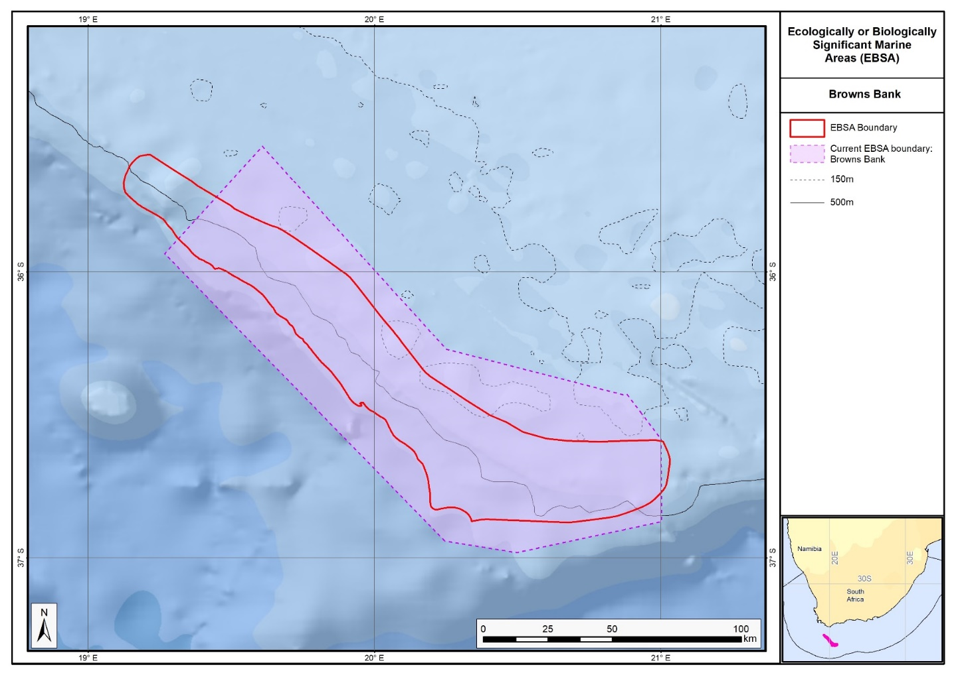
Map of the Browns Bank area in relation to the original Browns Bank EBSA.

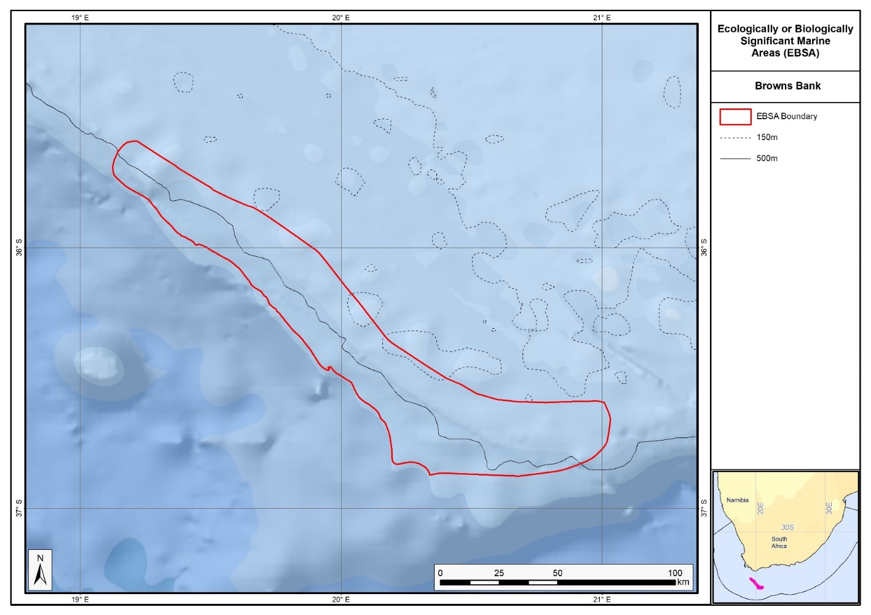
Map of the Browns Bank area.

Rights and permissions:
No limits on sharing or publication.

18. Cape Canyon and associated islands, bays and lagoons (modification of the existing Cape Canyon and Surrounds)⁵

Reason for the modification:
The EBSA description is being modified because of newly available or accessible knowledge on features associated with the area, based on additional scientific data especially new systematic spatial planning and assessments of biodiversity. The descriptions and supporting information are substantially extended, updated and refined beyond the original descriptions from the South-Eastern Atlantic workshop, April 2013. The modifications involve changes to the textual description, changes to the ranking of the area against the EBSA criteria, and changes in shape, location and size of the area. As a consequence of these changes, it became appropriate to alter the name to better describe the EBSA.

The original descriptions of Ecologically or Biologically Significant Marine Areas (EBSAs) in the Benguela Current Large Marine Ecosystem (BCLME) were described in the South-Eastern Atlantic workshop (April 2013). The descriptions were generally characterized by generic, often fairly geometric delineations, consisting of approximate bounding boxes around the features for which the EBSA was described. This coarse scale of delineation was appropriate for a global scale but posed challenges for inclusion in national-level, place-based ocean management. The original boundaries were not sufficiently refined to capture the full extent of key biodiversity features and often overlapped with areas of lower biodiversity value or poor ecological condition.

Additionally, the original EBSA descriptions suffered from shortfalls related to limited spatial data and lack of systematic conservation planning approaches at the time they were first proposed. This meant that many boundaries did not precisely encompass biodiversity priority areas, potentially leading to conflicts with other ocean sectors and limiting their practical usefulness for marine spatial planning (MSP). The coarse scale and lack of detailed data constrained the ability to develop effective zoning and management recommendations that balance biodiversity protection with economic activities.

How was the submission developed?
The EBSA revision process was part a broader project on ecosystem-based MSP in the BCLME, namely the Benguela Current Marine Spatial Management and Governance Project (MARISMA, 2014-2023). This was a regional capacity-building and development cooperation project implemented by the Benguela Current Commission, the Governments of Angola, Namibia and South Africa, and GIZ, the German Agency for Development Cooperation (Deutsche Gesellschaft für Internationale Zusammenarbeit.

Because of these shortcomings of the existing EBSA boundaries, description and valuations set out in the previous section, the MARISMA project undertook a refinement process. This process used systematic conservation planning (SCP) tools, such as Marxan, to generate finer-scale, more accurate boundaries based on updated biodiversity data and expert input. This process also allowed for the identification of new EBSAs and the splitting of some original EBSAs into multiple refined areas to better reflect discrete biodiversity features and ecological processes. The refined EBSA boundaries were more suitable for MSP and conservation management because they focused on core natural and near-natural areas, avoided unnecessary conflicts with other sectors, and incorporated a systematic, data-driven approach to spatial prioritization.

The overall approach to the EBSA update and engagement followed these key steps:

Initial Systematic Conservation Planning (SCP) Analyses: Existing EBSAs were refined and new areas identified using systematic conservation planning tools such as Marxan, based on biodiversity input data including ecosystem types, species distributions, and ecological processes.

National Workshops: The refined and new EBSA boundaries were iteratively reviewed and adjusted through workshops held within each of the three countries (Angola, Namibia, South Africa). These workshops allowed country-specific input and tailoring of EBSA boundaries and descriptions to national contexts and priorities.

Regional Workshops and Bilateral Meetings between Countries: Workshops at the regional level especially focused on transboundary EBSAs shared between the countries, but also examined the overall approach to EBSAs, their delineation, description and the engagement approach. The aim was to harmonize boundaries, align management recommendations, and foster cooperation across national borders for effective regional marine biodiversity management. Additional specific bilateral meetings were held where necessary.

Technical and Scientific Peer Review: The revised and new EBSAs underwent technical review nationally and regionally (through technical review workshops involving relevant experts); and internationally with assistance from experts from the Global Ocean Biodiversity Initiative (GOBI) and members of the CBD's Informal Advisory Group on EBSAs, ensuring robustness of the exercise. The process is documented in peer reviewed literature (Harris et al., 2019, 2022).

Political Approval: The EBSAs were administratively and politically approved through all required stages up to the national ministerial level in each country and were then submitted to the CBD Secretariat by the National CBD Focal Points.

Data Sharing and Accessibility: All information, including refined EBSA boundaries, status assessments, management recommendations, and stakeholder feedback, were made available through online repositories such as the project's EBSA Portal (https://cmr.mandela.ac.za/Research-Projects/EBSA-Portal); and the EBSA were also shared via the Benguela Current Convention's Geodata Portal (https://geodata.benguelacc.org/ ). This facilitated transparency, accessibility, and ongoing updating of data and products for biodiversity specialists and other stakeholders.

Some technical revisions and updates to the description were made, even though little additional information was available. A supplementary table of the habitats represented in the EBSA and their associated threat status was also included.
The main change is that the boundary of this EBSA has been significantly refined to more closely focus the EBSA on the key biodiversity features that underlie its EBSA status. The delineation process included an initial stakeholder review which identified the need to include additional features such as the full extent of the Cape Canyon and St Helena Bay, a technical mapping process and then an expert review workshop where boundary delineation options were finalised. The delineation process used a combination of Systematic Conservation Planning and Multi-Criteria Analysis methods. The features used in the analysis were:
- Key physical features (i.e. canyons and islands) from GEBCO data, global benthic geomorphology mapping (www.bluehabitats.org, Harris et al., 2014), and data from the South African National Biodiversity Assessment (Sink et al., 2012) and BCC spatial mapping project (Holness et al., 2014) were compiled. In addition, bays were mapped and included as these have been identified as important features in the new National Biodiversity Assessment 2018 (no reference available yet).
- Delineations and threat status of constituent ecosystem types in the area were included in the analysis and used to refine the boundary of the EBSA.
- Areas of high relative naturalness of benthic and coastal systems and pelagic systems identified in the National Biodiversity Assessment 2011 (Sink et al., 2012), the West Coast (Majiedt et al., 2013) and the BCLME spatial assessments (Holness et al., 2014) were included in the analysis.
- Areas important for threatened and special species were included. The priority areas and buffer distances around colonies were from Holness et al. (2014). Note that the full extent of the buffer was not necessarily included in the EBSA. Features included in the analysis were:
  - African Penguin colonies and a 20km buffer.
  - Bank Cormorant, Cape Cormorant, White Breasted Cormorant and Crowned Cormorant colonies and a 40km buffer.
  - Gannet colonies with a 40km buffer.
  - Seal Colonies and a 20km buffer.
- Irreplaceable and near irreplaceable (i.e. very high selection frequency) sites, as well as focus areas identified in the SCP undertaken for the West Coast by Majiedt et al. (2013), offshore areas (Sink et al., 2011) and for the BCLME by Holness et al. (2014) were incorporated.
- Distributions of known fragile, vulnerable and sensitive habitat-forming species were included (Unpublished SANBI and SAEON data).

The multi-criteria analysis resulted in a value surface. The cut-off value used to determine the extent of the EBSA was based on expert input and quantitative analysis of effective inclusion of the above features. This entailed taking an iterative parameter calibration-based approach whereby the spatial efficiency of the inclusion of the targeted features was evaluated. The approach aimed to identify a cut-off which most efficiently included prioritised features while minimizing the inclusion of impacted areas. The final boundaries shown in the map were validated in a national workshop. The new boundary comprises about two thirds of the original EBSA area and falls mostly within the previous delineation, except for a protrusion along the south east edge.

Traditional knowledge was not incorporated into this process, and consultations with indigenous peoples or local communities were not undertaken. Therefore, documentation of Free, Prior and Informed Consent (FPIC) is not relevant for this EBSA process.

Where is the submission intended to be included (choose one option, and please note that there are different procedures for these two intended end points)?
[X] EBSA repository
[ ] EBSA information-sharing mechanism

Abstract:
Changes from the original version: The revised abstract clarifies the expanded spatial scope of the area to explicitly include the full extent of Cape Canyon, St Helena Bay, multiple associated islands, bays, and a lagoon system, whereas the original description focused more narrowly on Cape Canyon and immediate surrounds. The revised text integrates updated systematic conservation planning outcomes and highlights additional threatened ecosystem types.

Cape Canyon is one of two submarine canyons off the west coast of South Africa (the other being the Cape Point valley), and the broader area, including Saint Helena Bay, has been recognized as important in three systematic conservation plans. It includes both benthic and pelagic features and is important for pelagic fish, foraging marine mammals and several threatened seabird species. The area is also important for threatened ecosystem types: it includes 9 endangered and 12 vulnerable ecosystem types, and 2 types that are near threatened. There is evidence that the submarine canyon hosts fragile habitat-forming species, and there are other unique and potentially vulnerable benthic communities in the area. The hard ground areas, in particular those outside the trawl footprint, are likely to be susceptible to damage, and there are increasing petroleum and mining applications in the area.

Introduction:
Changes from the original version: The revised introduction clarifies the geographic extent by including a more explicit shoreline boundary from Sixteen Mile Beach MPA to south of Lamberts Bay and incorporates eight named islands plus the entire St Helena Bay.

Cape Canyon and Associated Islands, Bays and Lagoon is bounded along the shore from the Sixteen Mile Beach MPA in the south to about 10 km south of Lamberts Bay in the north, extending further offshore in the southern part compared to the northern part. The EBSA includes Langebaan Lagoon, Saldanha Bay, eight islands (Robben, Dassen, Vondeling, Marcus, Malgas, Jutten, Schaapen, Meeuw), the Cape Canyon submarine canyon and adjacent shelf edge, and has been extended to include the whole of St Helena Bay. This area was identified as a priority area through a national plan to identify areas for offshore protection (Sink et al., 2011) and by a systematic biodiversity plan for the west coast (Majiedt et al., 2013). It was also identified as an important area for pelagic ecosystems and species (Grantham et al., 2011).

Location:
Changes from the original version: The section reflects the updated spatial delineation, provide bounding box coordinates, and shares a link to the specific spatial data. Motivation for the spatial changes, and details of the spatial planning are given in “How was the submission developed?” Section.

The area is located around the southwest coast of South Africa and is completely within the exclusive economic zone of the country. It is bounded along the shore from the Sixteen Mile Beach marine protected area in the south to approximately 10 km south of Lambert’s Bay in the north, extending much further offshore (approximately 70 km) in the southern part compared with that in the northern part (less than 10 km).

The coordinates of a minimum bounding box covering the entire scope of the area are:
• Latitude: -32.762, -32.166, -33.919, -34.515
• Longitude: 15.907, 18.319, 18.752, 16.339

Feature description of the area:
Changes from the original version: The revised description significantly elaborates on the geomorphic and biodiversity features of the expanded EBSA. The description includes substantial additional information on ecosystem types, their diversity and their threat status based on more recent systematic assessments. A table of ecosystem types and their statuses is now included. The description references additional up to date survey information. It proposes the EBSA as a Type 2 EBSA because it contains “spatially stable features whose individual positions are known, but a number of individual cases are being grouped” (sensu Johnson et al., 2018).

Cape Canyon and Associated Islands, Bays and Lagoon is a productive area with important benthic and pelagic habitats and physical features that jointly support important life-history stages of species, and threatened, fragile and vulnerable species and habitats. The main geological feature of this EBSA is Cape Canyon itself. It is one of two canyons on the South African west coast (the other being the Cape Point Valley), which has its head about 23 km offshore of Cape Colombine, at -168 m depth, and incises to a depth of about -900 m (De Wet 2012). New bathymetry data clearly show that the main channel (at the canyon head) comprises two separate, parallel channels in the northern and middle sections that combine to form a deeply incised main channel in the south that runs all the way to the outer continental slope, ending at about -3500 m in the Cape Basin (De Wet 2012). The western branch of the main channel is much more deeply incised than is the eastern branch by up to 100 m, and the slope of the western canyon margin is much steeper than that of the eastern side (De Wet 2012). The eight islands are other key geological features in this EBSA, as well as the adjacent lagoon and bay system on the coast. The area includes unconsolidated sand, mud and gravel benthic habitats and a pelagic ecosystem type that is characterised by elevated productivity and frequent fronts associated with shelf-edge upwelling (Lutjeharms et al., 2000, Lagabrielle 2009, Roberson et al., 2017).

The key geological features, described above, in turn support important biological communities, from fragile to threatened species. These include four distinct benthic macrofaunal communities characterized by molluscs, polychaetes, amphipods and brittle stars (Karenyi 2014), and hard-ground habitats that are poorly known (Sink et al., 2012b). Fragile cold-water corals have been collected within the area. Further, a recent survey sighted seapens, anemones, starfish and cloaked hermit crabs (Sink 2016); all of which species are sensitive to impacts to the seabed. Parts of this dynamic area, particularly within St Helena Bay, experience low-oxygen water that may support unique biological communities (Sink et al., 2011) that are also sensitive to disturbances. The small islands contained in the EBSA provide breeding habitat for several endemic seabird species, most of which are threatened, or seals (Kemper et al., 2007). The area encompasses a key foraging area for marine mammals (Best 2006, Barendse et al., 2011) and two marine Important Bird Areas (Birdlife et al., 2013). The focus area has also been included in annual demersal fish trawl surveys conducted by the Department of Agriculture, Forestry and Fisheries.

This EBSA contains an extreme level of diversity of ecosystem types, with 32 described types being found with the EBSA. Many of these types were identified as threatened ecosystems in the National Biodiversity Assessment (Table below; Sink et al., 2019), including 9 Endangered types (most notably large areas of Cape Bays, Cape Upper Canyons and Southern Benguela Muddy Shelf Edge), 12 Vulnerable types (most notably large areas of Cape Lower Canyons, Cape Rocky Inner Shelf, Cape Rocky Mid Shelf Mosaic
Cape Sandy Inner Shelf and Southern Benguela Rocky Shelf Edge), as well as a further 2 Near Threatened types.

Since the original description and delineation of the EBSA, new research has been conducted within the area, allowing a more comprehensive understanding of the features and communities at this site. Consequently, the boundary has been revised to improve precision in representing the key benthic and pelagic ecosystem types and features, as well as key biodiversity features that underpin the EBSA status, such as: fragile and sensitive habitat-forming species, islands, the canyon, and key species (e.g., colonial seabirds). Much of the improvement in the delineation was based on new bathymetry data (De Wet 2012), which has allowed a more precise, data-driven boundary for the EBSA rather than an expert-based boundary. It also based on new biological sampling that, for example, motivates for extending the EBSA to include the full extent of St Helana Bay to encompass those sensitive communities (Karenyi 2014, Sink 2016). Protection of features in MPAs has been considerably expanded and strengthened following the proclamation of the Operation Phakisa MPA network in 2019, with the EBSA area within reserves increasing by almost an order of magnitude from 1.1% to 8.4%. It is presented as a Type 2 EBSA because it contains “spatially stable features whose individual positions are known, but a number of individual cases are being grouped” (sensu Johnson et al., 2018).

Summary of ecosystem types and threat status for the Cape Canyon and Associated Islands, Bays and Lagoon. Data from Sink et al. (2019).
Threat Status | Ecosystem Type | Area (km²) | Area (%)
Endangered | Cape Bays | 114.3 | 0.7
 | Cape Island Shore | 2.9 | 0.0
 | Cape Sheltered Rocky Shore | 1.4 | 0.0
 | Cape Upper Canyons | 1893.8 | 11.4
 | Cool Temperate Arid Predominantly Closed Estuary | 0.1 | 0.0
 | Cool Temperate Estuarine Lake | 0.2 | 0.0
 | Cool Temperate Predominantly Open Estuary | 0.3 | 0.0
 | Southern Benguela Muddy Shelf Edge | 814.0 | 4.9
 | Southern Benguela Reflective Sandy Shore | 5.7 | 0.0
Vulnerable | Cape Boulder Shore | 1.3 | 0.0
 | Cape Exposed Rocky Shore | 16.0 | 0.1
 | Cape Kelp Forest | 4.7 | 0.0
 | Cape Lower Canyons | 2483.7 | 15.0
 | Cape Mixed Shore | 12.4 | 0.1
 | Cape Rocky Inner Shelf | 249.3 | 1.5
 | Cape Rocky Mid Shelf Mosaic | 2714.0 | 16.4
 | Cape Sandy Inner Shelf | 253.9 | 1.5
 | Cool Temperate Estuarine Lagoon | 60.2 | 0.4
 | Southern Benguela Rocky Shelf Edge | 1457.2 | 8.8
 | Southern Benguela Sandy Shelf Edge | 6.7 | 0.0
 | St Helena Bay | 545.3 | 3.3
Near Threatened | Cape Very Exposed Rocky Shore | 0.2 | 0.0
Near Threatened | Southern Benguela Intermediate Sandy Shore | 11.3 | 0.1
Least Concern | Cape Basin Abyss | 628.4 | 3.8
Least Concern | Namaqua Sandy Mid Shelf | 9.4 | 0.1
 | Southeast Atlantic Lower Slope | 1994.2 | 12.0
 | Southeast Atlantic Mid Slope | 7.1 | 0.0
 | Southeast Atlantic Upper Slope | 180.3 | 1.1
 | Southern Benguela Dissipative Sandy Shore | 14.1 | 0.1
 | Southern Benguela Dissipative-Intermediate Sandy Shore | 21.2 | 0.1
 | Southern Benguela Outer Shelf Rocky Sand Mosaic | 555.8 | 3.3
 | Southern Benguela Sandy Outer Shelf | 2526.0 | 15.2
Grand Total |  | 16585.5 | 99.9

Feature condition and future outlook:
Changes from the original version: The revised description presents a detailed assessment of ecological condition, quantifying the proportion of the EBSA in good, fair, and poor condition and associating these with ecosystem threat categories. It notes increased pressures including petroleum exploration and new seabed mining applications, with updated information on MPA coverage expanding from 1.1% to 8.4% through recent proclamations. The original description mentions pressures and the older coastal MPAs but is less quantitative and lacks recent policy developments.

Habitat condition within this broad area ranges from good to poor (Sink et al., 2012a; Sink et al., 2019). The EBSA is mostly in good (17%) or fair (40%) ecological condition. However, just less than half the area (43%) is in poor ecological condition, largely along the shelf edge and in the shallower parts of the EBSA. Consequently, the bulk of the offshore extent is either Endangered (17%) or Vulnerable (47%), with the Endangered types along the shore or around the shelf edge. However, there are many ecosystem types that are Least Concern that cover a third (36%) of the EBSA.

Pressures are increasing, although the area includes several coastal MPAs (Langebaan, Sixteen Mile Beach, Marcus Island, Malgas Island and, Jutten Island) which protect habitats and species to varying extents. It has been recommended that MPAs in the area should be considered for consolidation, extension, or re-zoning to resolve existing resource conflicts, protect threatened species in their core areas, and minimize stakeholder impacts (Sink et al., 2011). The lagoon system is vulnerable to further impacts, and the islands with their associated seabird colonies are all threatened (Kemper et al., 2007). Petroleum exploration is increasing in the area, and there are new applications for seabed mining for phosphates and other minerals.

Protection of features in MPAs has been considerably expanded and strengthened following the proclamation of the Operation Phakisa MPA network in 2019, with the EBSA area within reserves increasing by almost an order of magnitude from 1.1% to 8.4%. These new MPAs cover the Benguela Muds in the north west, a portion of Cape Canyon, and Robben Island. Existing protection was and is afforded to Langebaan Lagoon, Jutten, Malgas and Marcus Islands and Sixteen Mile Beach, and to Rocherpan in St Helena Bay.

Assessment of the area against CBD EBSA Criteria:
Changes from the original version: For “Uniqueness or rarity” the evaluation is upgraded from “Medium” to “High” based on the inclusion of the only lagoon in the country as well as rare offshore ecosystem types and specific habitats. For “Biological Diversity” the evaluation is upgraded from “Medium” to “High” based on the extreme ecosystem diversity found with South Africa’s national map indicates 32 ecosystem types in this area (Sink et al., 2019), and this diversity of ecosystem types is a key driver of this area’s value. The revised description retains the same rankings for the remaining EBSA criteria. However, the revised text provides more detailed supporting evidence and updated scientific references to justify these rankings.

CBD EBSA Criteria  (Annex I to decision IX/20) | Description  (Annex I to decision IX/20) | Ranking of criterion relevance  (please mark one column with an X)
CBD EBSA Criteria  (Annex I to decision IX/20) | Description  (Annex I to decision IX/20) | No information |  | Low |  |  | Medium |  | High
Uniqueness or rarity | Area contains either (i) unique (“the only one of its kind”), rare (occurs only in few locations) or endemic species, populations or communities, and/or (ii) unique, rare or distinct, habitats or ecosystems; and/or (iii) unique or unusual geomorphological or oceanographic features. |  |  |  |  |  |  |  | x
This area was identified by two systematic plans because of rare ecosystem types including the canyon, rare muds and low-oxygen benthic habitats (Sink et al., 2011, 2012a, 2012b, Majiedt et al., 2013). The Southern Benguela Muddy Shelf Edge comprises only two patches off Saldanha, covering an estimated 567 km², which is included in the EBSA. Cape Canyon is the largest of only two reported submarine canyons on the west coast of South Africa and in the southern Benguela. Further, this site contains the only lagoon in South Africa, and for Saldanha Bay is the largest natural harbour in the country.
Special importance for life-history stages of species | Areas that are required for a population to survive and thrive. |  |  |  |  |  |  |  | X
The area encompasses a key foraging area for marine mammals including humpback and southern right whales (Best 2006, Barendse et al., 2011) and two marine Important Bird Areas. Closer to shore the Canyon is adjacent to several terrestrial IBAs (Bird Island, Dassen Island, Heuningnes River and estuary system, and the Lower Berg river wetlands). The seas extending from these sites have been proposed as a marine IBA for the following seabird species: African Penguin, Bank Cormorant, Cape Cormorant, Cape Gannet, Caspian Tern, Crowned Cormorant, Damara Tern, Great Crested Tern, Kelp Gull and Hartlaub’s Gull. Further offshore, along the shelf edge where commercial fisheries are concentrated, BirdLife International has identified a large area, which overlaps with the Cape Canyon area, as a potential marine IBA for Atlantic Yellow-nosed and Black-browed albatrosses and Cory’s Shearwater. Several other species (e.g. Shy Albatross and White-chinned Petrel) are likely to qualify as trigger species in this area, but tracking data or analyses are lacking. Grantham et al. (2011) also showed that this area had the highest density of breeding seabirds that feed on pelagic species. High densities of sardine and anchovy eggs contributed to the high selection frequency of this broader area in the offshore systematic biodiversity plan for South Africa (Sink et al., 2011). Spawning and nursery habitat for Cape hakes is also included in this area (Sink et al., 2011, Kone et al., 2013).
The area is part of the recognized Southern Coastal and Shelf Waters of South Africa Important Marine Mammal Area. The southern coast of South Africa represents one of the world’s most productive marine regions. It supports a number of top predators, including common dolphins (Delphinus delphis), Indo-Pacific bottlenose dolphins (Tursiops aduncus), fur seals (Arctocephalus pusillus) and killer whales (Orcinus orca). The inshore waters, within 500m of the coast and with water depths of less than 25m, provide important year-round habitat for feeding and reproduction for Endangered Indian Ocean humpback dolphins (Sousa plumbea). Furthermore, the waters over the continental shelf, present important habitat for the inshore form of Bryde’s whale (Balaenoptera edeni). Further details and maps: https://www.marinemammalhabitat.org/factsheets/southern-coastal-shelf-waters-south-africa/
Importance for threatened, endangered or declining species and/or habitats | Area containing habitat for the survival and recovery of endangered, threatened, declining species or area with significant assemblages of such species. |  |  |  |  |  |  |  | X
This area is importance for several threatened seabirds including four Endangered seabirds – African Penguin, Bank Cormorant, and Black-browed and Atlantic Yellow-nosed albatrosses. These animals are highly dependent on this area for some or all of their life stages, particularly for foraging. In addition, several species of lower conservation threat status are similarly dependent on this area: the Vulnerable White-chinned Petrel, Cape Cormorant and Cape Gannet.
The inshore waters, within 500m of the coast and with water depths of less than 25m, provide important year-round habitat for feeding and reproduction for Endangered Indian Ocean humpback dolphins (Sousa plumbea) ( IUCN-Marine Mammal Protected Areas Task Force, 2020).
The area is dominated by a plethora of threatened ecosystem types identified in the National Biodiversity Assessment 2011 (Sink et al., 2012), BCC assessment Holness et al. (2014), and National Biodiversity Assessment 2018 (Sink et al., 2019), with the results from the most recent assessment (NBA 2018) reported here (Sink et al., 2019). Altogether, there are 21 (of 32) ecosystem types represented in the EBSA that are threatened. These include nine Endangered ecosystem types, namely: Cape Bays, Cape Island Shore, Cape Sheltered Rocky Shore, Cape Upper Canyons, Cool Temperate Arid Predominantly Closed Estuary, Cool Temperate Estuarine Lake, Cool Temperate Predominantly Open, Southern Benguela Muddy Shelf Edge and Southern Benguela Reflective Sandy Shore. A further 12 Vulnerable ecosystems are found in the area, namely: Cape Boulder Shore, Cape Exposed Rocky Shore, Cape Kelp Forest, Cape Lower Canyons, Cape Mixed Shore, Cape Rocky Inner Shelf, Cape Rocky Mid Shelf Mosaic, Cape Sandy Inner Shelf, Cool Temperate Estuarine Lagoon, Southern Benguela Rocky Shelf Edge, Southern Benguela Sandy Shelf Edge and St Helena Bay. There are also two ecosystem types that are Near Threatened (Sink et al., 2019).
Vulnerability, fragility, sensitivity, or slow recovery | Areas that contain a relatively high proportion of sensitive habitats, biotopes or species that are functionally fragile (highly susceptible to degradation or depletion by human activity or by natural events) or with slow recovery. |  |  |  |  |  |  |  | X
The submarine canyon in this area is considered vulnerable to impact because cold-water corals, gorgonians and other slow-growing, habitat-forming species were observed within this area on submersible footage (Diamondfields International unpublished footage, Sink and Samaai 2009). Gilchrist (1921) also reported cold water corals, black corals and two hundred large sponges in a single otter trawl in this area in 1920, and it was only in the 1990s that trawling was initiated in the hard-ground habitats within this area (Sink et al., 2012b). Deep reefs and hard grounds in the area are also likely to host fragile three-dimensional, habitat-forming species, although this has not been confirmed by in-situ research. These habitats are all considered sensitive to demersal trawling and mining (Sink et al., 2011, 2012a, 2012bb). The low-oxygen habitats and likely biological communities they support are also considered vulnerable.
Biological productivity | Area containing species, populations or communities with comparatively higher natural biological productivity. |  |  |  |  |  |  |  | X
The most persistent and intense upwelling cell on the entire South African west coast is found within this area at Cape Columbine, resulting in the area downstream having the highest productivity, organic loading (Demarq et al., 2007) and organic carbon deposits on the seafloor (Bailey 1991) on this coast. St Helena Bay has also been identified as the area having the most persistent oxygen-deficient water in the region (Bailey 1991). South of Cape Columbine, a different set of oceanographic features dominate, and frequent pulse upwelling events result in high productivity over shorter periods (Demarq et al., 2007). Cape Canyon and Surrounds includes part of the area with highest copepod biomass on the west coast (Grantham et al., 2011). Large populations of marine top predators forage and/or breed within the area, including several species of seabirds, cetaceans and seals (Best 2006, Barendse et al., 2011, Hutchings et al., 2012).
Biological diversity | Area contains comparatively higher diversity of ecosystems, habitats, communities, or species, or has higher genetic diversity. |  |  |  |  |  |  |  | X
South Africa’s national map indicates 32 ecosystem types in this area (Sink et al., 2019), and this diversity of ecosystem types is a key driver of this area’s selection in two systematic biodiversity plans (Sink et al., 2011, Majiedt et al., 2013). The submarine canyon, sand and mud habitats, patches of low oxygen water, bays, islands and the adjacent lagoon system contribute to the high habitat diversity in this area (Sink et al., 2011, 2012a, 2019, Majiedt et al., 2013). This is also the only place where two genomic clusters for Zostera capensis are present (in Langebaan).
Naturalness | Area with a comparatively higher degree of naturalness as a result of the lack of or low level of human-induced disturbance or degradation. |  |  |  |  |  |  | X
There is a moderate level of naturalness within this area. Of the two mapped submarine canyons, there is lower trawling effort and fewer pressures in the Cape Canyon, which is the closer canyon to the city of Cape Town (Sink et al., 2011, Sink et al., 2012a,b). Some of the canyon habitat is outside of the trawling footprint, and there are adjacent hard ground areas that are also untrawled (Wilkinson 2009, Sink et al., 2012b). However, there is a port at Saldanha, and several fisheries sectors operate within this area.
References:
Changes from the original version: The revised description includes a substantially expanded reference list, incorporating recent peer-reviewed publications and technical reports.
Bailey, G.W. 1991. Organic carbon flux and development of oxygen deficiency on the modern Benguela continental shelf of 22°S: spatial and temporal variability. In R. V. Tysen and T. H. Pearson, editors. Modern and Ancient Continental Shelf Anoxia. Geological Society. Pages 171-183.
Barendse, J., Best, P.B., Thornton, M., Elwen, S.H., Rosenbaum, H.C., Carvalho, I., Pomilla, C., Collins, T.J.Q., Meÿer, M.A., Leeney, R.H. 2011. Transit station or destination? Attendance patterns, regional movement, and population estimate of humpback whales Megaptera novaeangliae off western South Africa based on photographic and genotypic matching. In: Kirkman S, Elwen SH, Pistorius PA, Thornton M, Weir C (eds), Conservation biology of marine mammals in the southern African subregion. African Journal of Marine Science, 33: 353–373.
Best, P.B. 2006. The presence of right whales in summer on the west coast of South Africa: the evidence from historical records. African Journal of Marine Science, 28: 159–166.
BirdLife International, 2013. Marine e-Atlas: Delivering site networks for seabird conservation. Proposed IBA site ‘Atlantic, Southeast 19 – Marine’. Available online: http://54.247.127.44/marineIBAs/default.html. Accessed 11 March 2013
De Wet, W. 2012. Bathymetry of the South African Continental Shelf. MSc dissertation. University of Cape Town, South Africa.
Demarcq, H., Barlow, R., Hutchings, L. 2007. Application of a chlorophyll index derived from satellite data to investigate the variability of phytoplankton in the Benguela ecosystem. African Journal of Marine Science, 29: 271-282.
Gilchrist, J.D.F. 1921. Report of the Fisheries and Marine Biological Survey for the year 1920 1: 1-27.
Grantham, H.S., Game, E.T., Lombard, A.T., Hobday, A.J., Richardson, A.J., Beckley, L.E., Pressey, R.L., Huggert, J.A., Coetzee, J.C., van der Lingen, C.D., Petersen, S.L., Merkle, D., Possingham, H.P. 2011. Accommodating dynamic oceanographic processes and pelagic biodiversity in marine conservation planning. PLoS ONE 6: e16552. DOI:10.1371/journal.pone.0016552.
Harris, L., Holness, S., Finke, G., Kirkman, S., Sink, K., 2019. Systematic Conservation Planning as a Tool to Advance Ecologically or Biologically Significant Area and Marine Spatial Planning Processes, in: Zaucha, J., Gee, K. (Eds.), Maritime Spatial Planning. Palgrave Macmillian, Cham.
Harris, L.R., Holness, S.D., Finke, G., Amunyela, M., Braby, R., Coelho, N., Gee, K., Kirkman, S.P., Kreiner, A., Mausolf, E., Majiedt, P., Maletzky, E., Nsingi, K.K., Russo, V., Sink, K.J., Sorgenfrei, R., 2022. Practical Marine Spatial Management of Ecologically or Biologically Significant Marine Areas: Emerging Lessons From Evidence-Based Planning and Implementation in a Developing-World Context. Front. Mar. Sci. 9.
Holness, S., Kirkman, S., Samaai, T., Wolf, T., Sink, K., Majiedt, P., Nsiangango, S., Kainge, P., Kilongo, K., Kathena, J., Harris, L., Lagabrielle, E., Kirchner, C., Chalmers, R., Lombard, M. 2014. Spatial Biodiversity Assessment and Spatial Management, including Marine Protected Areas. Final report for the Benguela Current Commission project BEH 09-01.
Hutchings, L., Jarre, A., Lamont, T., van den Berg, M., Kirkman, S.P. 2012. St Helena Bay (southern Benguela) then and now: muted climate signals, large human impact. African Journal of Marine Science, 34: 559–583.
IUCN-Marine Mammal Protected Areas Task Force, 2020. Southern Coastal and Shelf Waters of South Africa IMMA Factsheet. https://www.marinemammalhabitat.org/wp-content/uploads/imma-factsheets/WesternIndianOcean/southern-coastal-and-shelf-waters-of-south-africa-WesternIndianOcean.pdf.
Johnson, D.E., Barrio Froján, C., Turner, P.J., Weaver, P., Gunn, V., Dunn, D.C., Halpin, P., Bax, N.J., Dunstan, P.K., 2018. Reviewing the EBSA process: Improving on success. Marine Policy 88, 75-85.
Karenyi, N. 2014. Patterns and drivers of benthic macrofauna to support systematic conservation planning for marine unconsolidated sediment ecosystems. PhD thesis. Nelson Mandela Metropolitan University, Port Elizabeth.
Kemper, J., Underhill, L.G., Crawford, R.J.M., Kirkman, S.P. 2007. Revision of the conservation status of seabirds and seals breeding in the Benguela Ecosystem. In: Kirkman, S.P. (ed.) Final Report of the BCLME (Benguela Current Large Marine Ecosystem) Project on Top Predators as Biological Indicators of Ecosystem Change in the BCLME. Avian Demography Unit, Cape Town, pp 325–342.
Koné, V. Lett, C., Fréon, P. 2013. Modelling the effect of food availability on recruitment success of Cape anchovy ichthyoplankton in the southern Benguela upwelling system, African Journal of Marine Science, 35: 151-161.
Lagabrielle, E. 2009. Preliminary report: National Pelagic Bioregionalisation of South Africa. Cape Town: South African National Biodiversity Institute.
Majiedt, P., Holness, S., Sink, K., Oosthuizen, A., Chadwick, P. 2013. Systematic Marine Biodiversity Plan for the West Coast of South Africa. South African National Biodiversity Institute, Cape Town.
Roberson, L.A., Lagabrielle, E., Lombard, A.T., Sink, K., Livingstone, T., Grantham, H., Harris, J.M. 2017. Pelagic bioregionalisation using open-access data for better planning of marine protected area networks. Ocean & Coastal Management, 148: 214-230.
Sink K., Samaai, T. Identifying Offshore Vulnerable Marine Ecosystems in South Africa, Unpublished Sink, K.J., Attwood, C.G., Lombard, A.T., Grantham, H., Leslie, R., Samaai, T., Kerwath, S., Majiedt, P., Fairweather, T., Hutchings, L., van der Lingen, C., Atkinson, L.J., Wilkinson, S., Holness, S., Wolf, T. 2011. Spatial planning to identify focus areas for offshore biodiversity protection in South Africa. Unpublished Report. Cape Town: South African National Biodiversity Institute.
Sink, K. 2016. Deep Secrets: the outer shelf and slope ecosystems of South Africa. Cruise Report: ALG 230 – ACEP_DSC.
Sink, K., Holness, S., Harris, L., Majiedt, P., Atkinson, L., Robinson, T., Kirkman, S., Hutchings, L., Leslie, R., Lamberth, S., Kerwath, S., von der Heyden, S., Lombard, A., Attwood, C., Branch, G., Fairweather, T., Taljaard, S., Weerts, S., Cowley, P., Awad, A., Halpern, B., Grantham, H., Wolf, T. 2012a. National Biodiversity Assessment 2011: Technical Report. Volume 4: Marine and Coastal Component. South African National Biodiversity Institute, Pretoria.
Sink, K.J., van der Bank, M.G., Majiedt, P.A., Harris, L.R., Atkinson, L., Karenyi, N., Kirkman, S. (eds) 2019. National Biodiversity Assessment 2018 Technical Report Volume 4: Marine Realm. South African National Biodiversity Institute, Pretoria.
Sink, K.J., Wilkinson, S., Atkinson, L.J., Sims, P.F., Leslie, R.W., Attwood, C.G. 2012b. The potential impacts of South Africa’s demersal hake trawl fishery on benthic habitats: historical perspectives, spatial analyses, current review and potential management actions. Unpublished report. Cape Town: South African National Biodiversity Institute.
Wilkinson, S. 2009. Ring Fencing the Trawl Grounds. South African Deep-sea Trawling Industry Association. Report prepared by Capricorn Fisheries Monitoring cc. Cape Town.

Maps and Figures:
GIS data available at: https://cmr.mandela.ac.za/cmr/media/Store/documents/EBSA/Descriptions/SouthAfrica/Shapefile-RSA_EBSAs_final.zip
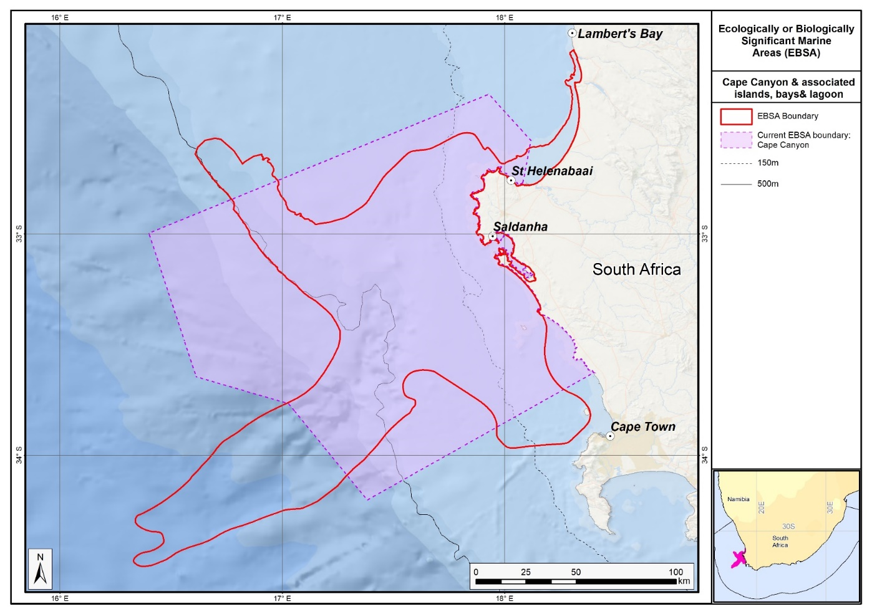
Map of the Cape Canyon and associated Islands, Bays and Lagoon area in relation to the original Cape Canyon and Surrounds EBSA.

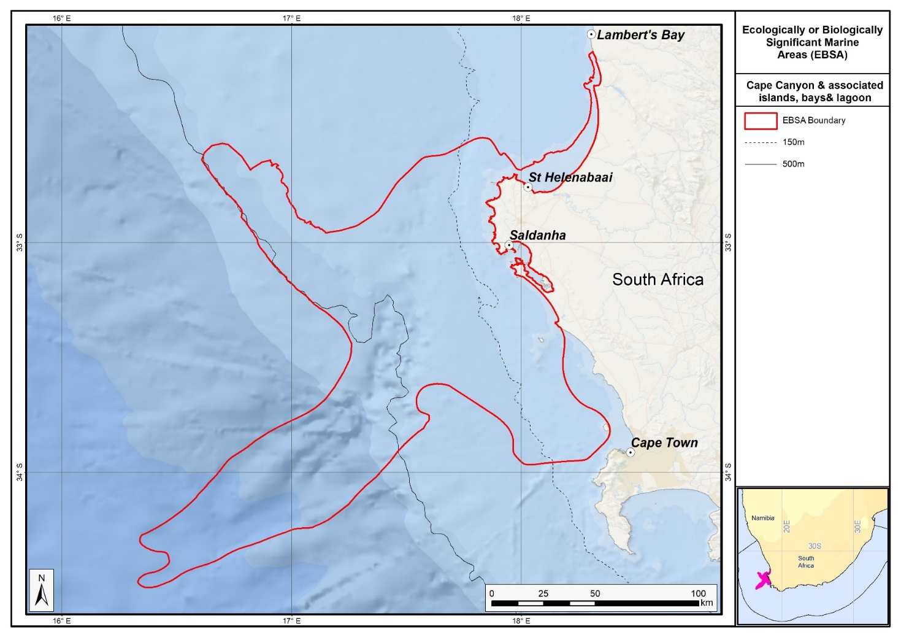
Map of the Cape Canyon and Associated Islands, Bays and Lagoon area.

Rights and permissions:
No limits on sharing or publication.

19. Childs Bank and shelf edge (modification of the existing Childs Bank)⁵

Reason for the modification:
The EBSA description is being modified because of newly available or accessible knowledge on features associated with the area, based on additional scientific data especially new systematic spatial planning and assessments of biodiversity. The descriptions and supporting information are substantially extended, updated and refined beyond the original descriptions from the South-Eastern Atlantic workshop, April 2013. The modifications involve changes to the textual description, changes to the ranking of the area against the EBSA criteria, and changes in shape, location and size of the area.

The original descriptions of Ecologically or Biologically Significant Marine Areas (EBSAs) in the Benguela Current Large Marine Ecosystem (BCLME) were described in the South-Eastern Atlantic workshop (April 2013). The descriptions were generally characterized by generic, often fairly geometric delineations, consisting of approximate bounding boxes around the features for which the EBSA was described. This coarse scale of delineation was appropriate for a global scale but posed challenges for inclusion in national-level, place-based ocean management. The original boundaries were not sufficiently refined to capture the full extent of key biodiversity features and often overlapped with areas of lower biodiversity value or in poor ecological condition.

Additionally, the original EBSA descriptions suffered from shortfalls related to limited spatial data and lack of systematic conservation planning approaches at the time they were first proposed. This meant that many boundaries did not precisely encompass biodiversity priority areas, potentially leading to conflicts with other ocean sectors and limiting their practical usefulness for marine spatial planning (MSP). The coarse scale and lack of detailed data constrained the ability to develop effective zoning and management recommendations that balance biodiversity protection with economic activities.

How was the submission developed?
The EBSA revision process was part a broader project on ecosystem-based MSP in the BCLME, namely the Benguela Current Marine Spatial Management and Governance Project (MARISMA, 2014-2023). This was a regional capacity-building and development cooperation project implemented by the Benguela Current Commission, the Governments of Angola, Namibia and South Africa, and GIZ, the German Agency for Development Cooperation (Deutsche Gesellschaft für Internationale Zusammenarbeit.

Because of these shortcomings of the existing EBSA boundaries, description and valuations set out in the previous section, the MARISMA project undertook a refinement process. This process used systematic conservation planning (SCP) tools, such as Marxan, to generate finer-scale, more accurate boundaries based on updated biodiversity data and expert input. This process also allowed for the identification of new EBSAs and the splitting of some original EBSAs into multiple refined areas to better reflect discrete biodiversity features and ecological processes. The refined EBSA boundaries were more suitable for MSP and conservation management because they focused on core natural and near-natural areas, avoided unnecessary conflicts with other sectors, and incorporated a systematic, data-driven approach to spatial prioritization.

The overall approach to the EBSA update and engagement followed these key steps:

Initial Systematic Conservation Planning (SCP) Analyses: Existing EBSAs were refined and new areas identified using systematic conservation planning tools such as Marxan, based on biodiversity input data including ecosystem types, species distributions, and ecological processes.

National Workshops: The refined and new EBSA boundaries were iteratively reviewed and adjusted through workshops held within each of the three countries (Angola, Namibia, South Africa). These workshops allowed country-specific input and tailoring of EBSA boundaries and descriptions to national contexts and priorities.

Regional Workshops and Bilateral Meetings between Countries: Workshops at the regional level especially focused on transboundary EBSAs shared between the countries, but also examined the overall approach to EBSAs, their delineation, description and the engagement approach. The aim was to harmonize boundaries, align management recommendations, and foster cooperation across national borders for effective regional marine biodiversity management. Additional specific bilateral meetings were held where necessary.

Technical and Scientific Peer Review: The revised and new EBSAs underwent technical review nationally and regionally (through technical review workshops involving relevant experts); and internationally with assistance from experts from the Global Ocean Biodiversity Initiative (GOBI) and members of the CBD's Informal Advisory Group on EBSAs, ensuring robustness of the exercise. The process is documented in peer reviewed literature (Harris et al., 2019, 2022).

Political Approval: The EBSAs were administratively and politically approved through all required stages up to the national ministerial level in each country and were then submitted to the CBD Secretariat by the National CBD Focal Points.

Data Sharing and Accessibility: All information, including refined EBSA boundaries, status assessments, management recommendations, and stakeholder feedback, were made available through online repositories such as the project's EBSA Portal (https://cmr.mandela.ac.za/Research-Projects/EBSA-Portal); and the EBSA were also shared via the Benguela Current Convention's Geodata Portal (https://geodata.benguelacc.org/ ). This facilitated transparency, accessibility, and ongoing updating of data and products for biodiversity specialists and other stakeholders.

Some technical revisions and updates to the description were made, even though little additional information was available. Small additions, such as biodiversity information from OBIS were made, but none of these edits were significant enough to drive a change in the EBSA criteria ranks. A supplementary table of the habitats represented in the EBSA and their associated threat status were also included.

Since its original description, the boundary of this EBSA has been refined to improve precision based on new bathymetry data, ecosystem information (condition and threat status of local benthic and pelagic ecosystem types, and presence of key features including fragile species), and to align with current MPA expansion initiatives. The boundary of this EBSA has been refined to more closely focus the EBSA on the key biodiversity features that underlie its EBSA status (Map of new and revised EBSA boundaries in the Maps and Figures Section). The delineation process included an initial stakeholder review, a technical mapping process and then an expert review workshop where boundary delineation options were finalised. The delineation process used a combination of Systematic Conservation Planning and Multi-Criteria Analysis methods. The features used in the analysis were:
- Delineations and threat status of constituent ecosystem types in the area were included in the analysis and used to refine the boundary of the EBSA.
- Irreplaceable and near irreplaceable (i.e. very high selection frequency) sites, as well as focus areas identified in the SCP undertaken for the BCLME by Holness et al. (2014) and Majiedt et al. (2013) were incorporated. In addition, focus areas for marine protection identified by Sink et al. (2011) were included.
- Key physical features such as the carbonate mound from the National Biodiversity Assessment 2011 (Sink et al., 2011) and BCC spatial mapping project (Holness et al., 2014) were incorporated. These data were refined using the latest GEBCO data and global benthic geomorphology mapping (www.bluehabitats.org, Harris et al., 2014).
- Areas of high relative naturalness identified in the National Biodiversity Assessment 2011 (Sink et al., 2011), the West Coast (Majiedt et al., 2013) and the BCLME spatial assessments (Holness et al., 2014) were included in the analysis. Both pelagic and benthic and coastal condition were incorporated.
- Distributions of known fragile, vulnerable and sensitive habitat-forming species were included (Unpublished SANBI and SAEON data).

The multi-criteria analysis resulted in a value surface. The cut-off value used to determine the extent of the EBSA was based on expert input and quantitative analysis of effective inclusion of the above features. This entailed taking an iterative parameter calibration-based approach whereby the spatial efficiency of the inclusion of the targeted features was evaluated. The approach aimed to identify a cut-off which most efficiently included prioritised features while minimizing the inclusion of impacted areas. The final boundaries shown in the map were validated in a national workshop. The new boundary comprises about two thirds of the original EBSA area and falls mostly within the previous delineation, except for a protrusion along the south east edge.

Traditional knowledge was not incorporated into this process, and consultations with indigenous peoples or local communities were not undertaken. Therefore, documentation of Free, Prior and Informed Consent (FPIC) is not relevant for this EBSA process.

Where is the submission intended to be included (choose one option, and please note that there are different procedures for these two intended end points)?
[X] EBSA repository
[ ] EBSA information-sharing mechanism

Abstract:
Changes from the original version: The revised description expands the abstract by including updated ecosystem type classifications and more specific reference to the inclusion of new bathymetric data and ecosystem condition assessments. It also broadens the scope by encompassing the shelf edge along with Childs Bank itself. The revised abstract emphasizes the presence of slow to recover, structurally complex and fragile species such as cold-water corals, gorgonians, and glass sponges, underscoring their ecological sensitivity.

Childs Bank and shelf edge is a unique submarine bank within the exclusive economic zone of South Africa, rising from a depth of 400 m to 180 m on the western continental margin. The area encompasses five benthic ecosystem types across the bank, outer shelf and shelf edge, supporting both hard and unconsolidated habitats. In recent revisions of the national marine ecosystem type map, the area contains two vulnerable and five least concern ecosystem types, with the bank’s benthic area in good ecological condition, indicating intact ecological processes. The bank supports structurally complex cold-water corals, hydrocorals, gorgonians and glass sponges, species that are fragile, sensitive to disturbance and slow to recover.

Introduction:
Changes from the original version: The revised description provides a more detailed geomorphological account of Childs Bank, specifying depth ranges and physical structure with updated citations. It details the inclusion of the adjacent shelf and shelf edge areas, recognizing their ecological significance. The inclusion of portions of the EBSA into a new MPA are described.

Childs Bank is the only known submarine bank in South Africa. It’s a rugged limestone feature found on the shelf, close to the shelf edge, on the western continental margin of South Africa, approximately 125 km offshore. It rises from a depth of -260 m in the east, -350 m in the west, to form a large, flattened plateau at -200 m (De Wet 2012). The margins of the bank slope gently on the north, east and south sides, but the western edge is a slump-generated outer face of 150 m in height that lies at the edge of the continental shelf, dropping steeply from -350 to -1500 m across a short distance of <60 km (De Wet 2012; Birch and Rogers 1973). The bank area has been estimated to cover 1450 km² (Sink et al., 2012a). The EBSA includes Childs Bank, the shelf and the shelf edge adjacent to the bank, the latter of which is considered likely to host vulnerable hard ground species. The sediment adjacent to the bank is predominantly fine sand with approximately 25% mud, and in some locations small amounts of gravel have been detected (Atkinson 2010). This area was identified as a priority area for protection through two planning studies identifying areas for offshore protection (Sink et al., 2011, Majiedt et al., 2013). Protection of Childs Bank in MPAs was subsequently afforded for the first time following the proclamation of the Childs Bank MPA in 2019, with the EBSA area within reserves increasing from no protection to 9%.

Location:
Changes from the original version: The section reflects the updated spatial delineation, provide bounding box coordinates, and shares a link to the specific spatial data. Motivation for the spatial changes, and details of the spatial planning are given in “How was the submission developed?” Section.

The area is located approximately 125 km off Hondeklipbaai on the west coast of South Africa, and its northern edge is approximately 90 km from the national border with Namibia. The boundary of the area has been refined using updated bathymetry data and information on various ecosystem features. It lies entirely within the exclusive economic zone of South Africa. It is situated largely on the outer shelf but also extends across the shelf edge and slope in some places.

The coordinates of a minimum bounding box covering the entire scope of the area are:
- Latitude: -29.849, -31.475, -32.156, -30.53
- Longitude: 16.038, 17.385, 16.564, 15.216

Feature description of the area:
Changes from the original version: The revised description explicitly identifies seven ecosystem types within the EBSA identified in new ecosystem mapping and assessments of threat status, including two categorized as Vulnerable and five as Least Concern, with detailed area percentages per type. The species descriptions are largely retained in the description. An additional explanation is provided of the refinements to the boundary and the classification / type of EBSA.

Childs Bank is a unique offshore submarine bank ecosystem type within South Africa’s EEZ, defined as the Southern Benguela Submarine Bank (Sink et al., 2012a). No other known submarine banks occur within South Africa’s EEZ. This EBSA comprises seven ecosystem types, two of which are Vulnerable (Childs Bank Coral Slope, Southern Benguela Sandy Shelf Edge), the rest of which are Least Concern (Childs Bank Plateau and Sandy Slope, Southern Benguela Hard Shelf Edge Mosaic, Southern Benguela Muddy Sands, Southern Benguela Outer Shelf Rocky Sand Mosaic, Southern Benguela Sandy Outer Shelf)(Table below; Sink et al., 2019). 37% of the Childs Bank and Shelf Edge slopes are trawled (Sink et al., 2012b), highlighting the importance of this site for marine living resources. However, there are several very fragile, vulnerable and sensitive species present in the area. Hydrocorals (e.g. Stylaster sp.), cold-water coral fragments, gorgonians (Acbaria rubra) and glass sponges (Rossella antarctica) were sampled at a virtually untrawled site adjacent to Childs Bank (Atkinson 2010; see also Gilchrist 1922, 1925, Van Bonde 1928, Atkinson et al., 2011). Further, skippers and deck hands from the trawl industry report fragments of corals sometimes caught in isolated locations in this area and that there are several patches of hard ground, requiring additional footrope protection (e.g., bobbins and rockhopper gear, Sink et al., 2012b).

The shelf edge area adjacent to Childs Bank is also a biodiversity hotspot for demersal fish and cephalopods in the southern Benguela (Kirkman et al., 2013). Benthic communities sampled adjacent to the Childs Bank mound revealed high abundance and biomass of benthic infauna and epifauna (Atkinson 2010, Atkinson et al., 2011), indicating that a rich benthic fauna occurs in this region. Two species of burrowing urchins (Spatangus capensis and Brissopsis lyrifera capensis) and a burrowing anemone species (Actinauge granulosus) were detected in high abundances in the Childs Bank and Shelf Edge region, contributing to the bioturbation and oxygenation of sediment, important ecological functions.

The boundary of this EBSA has been refined since its original delineation to improve precision based on new information. The new delineation was based on new bathymetry data, new ecosystem information (site selection frequency in two systematic conservation plans covering the area to meet biodiversity targets, the condition and threat status of the local benthic and pelagic ecosystem types, key features including the bank itself and associated fragile species), and focus areas for MPA expansion in South Africa. The new boundary comprises about two thirds of the original EBSA area and falls mostly within the previous delineation, except for a protrusion along the south east edge. It is presented as a Type 2 EBSA because it contains “spatially stable features whose individual positions are known, but a number of individual cases are being grouped” (sensu Johnson et al., 2018).

Summary of ecosystem types and threat status for Childs Bank and Shelf Edge EBSA. Data from Sink et al. (2019).
Threat Status | Ecosystem Type | Area (km²) | Area (%)
Vulnerable | Childs Bank Coral Slope | 505.5 | 3.7
 | Southern Benguela Sandy Shelf Edge | 2221.6 | 16.4
Least Concern | Childs Bank Plateau & Sandy Slope | 1620.3 | 11.9
 | Southern Benguela Hard Shelf Edge Mosaic | 1497.7 | 11.0
 | Southern Benguela Muddy Sands | 9.7 | 0.1
 | Southern Benguela Outer Shelf Rocky Sand Mosaic | 5989.2 | 44.1
 | Southern Benguela Sandy Outer Shelf | 1742.8 | 12.8
Grand Total |  | 13586.7 | 100.0

Feature condition and future outlook:
Changes from the original version: The revised description introduces a more nuanced assessment of ecosystem condition, based on more up to date spatial assessments. It reports the recent establishment of the Childs Bank MPA in 2019, which provides protection for two ecosystem types but notes five others remain poorly or unprotected.

Childs Bank and Shelf Edge is currently in Good ecosystem condition, based on cumulative impact scores from multiple anthropogenic pressures (Sink et al., 2012a; Sink et al., 2019). Good-condition sites are those which, based on the low levels of pressure, are expected have both biodiversity pattern and process largely intact and hence can be considered to be in a largely "natural" or "pristine" state. However, the area south and towards the shelf edge of Childs Bank were categorized as Fair and Poor, indicating that there is some impact on biodiversity pattern and/or ecological processes in a small component of the broader area (Sink et al., 2012a; Sink et al., 2019).

The trawl fishing intensity in the northern region of the fishing grounds, including Childs Bank and Shelf Edge, has declined since the mid-1990s (Russell Hall, Sea Harvest pers. comm.), and it is unlikely that this region was as intensively fished as the western grounds, closer to the port of Cape Town. No trawling occurs on the top of the bank, with most fishing taking place around the slope where hard ground, supporting vulnerable habitat-forming species, is most likely to occur. There is scope to protect this feature with limited, if any, adverse impact on the fishery (Sink et al., 2012b).

Protection of Childs Bank in MPAs was afforded for the first time following the proclamation of the Childs Bank MPA in 2019, with the EBSA area within reserves increasing from no protection to 9%. The new MPA covers most of Childs Bank itself, increasing the protection level of two ecosystem types (Childs Bank Coral and Childs Bank Plateau) to Well Protected. However, there are five other ecosystem types in this EBSA that are either Poorly Protected, or are Not Protected (Sink et al., 2019).

Assessment of the area against CBD EBSA Criteria:
Changes from the original version: The revised description retains the same rankings for all applicable EBSA criteria as the original, apart from the Special importance for life-history stages of species which downgraded from “Low” to “No Information” based on review comments. However, the revised text provides more detailed supporting evidence and updated scientific references to justify these rankings, especially for ecosystem threat status and ecological condition, based on more recent assessments.

CBD EBSA Criteria  (Annex I to decision IX/20) | Description  (Annex I to decision IX/20) | Ranking of criterion relevance  (please mark one column with an X)
CBD EBSA Criteria  (Annex I to decision IX/20) | Description  (Annex I to decision IX/20) | No information |  | Low |  |  | Medium |  | High
Uniqueness or rarity | Area contains either (i) unique (“the only one of its kind”), rare (occurs only in few locations) or endemic species, populations or communities, and/or (ii) unique, rare or distinct, habitats or ecosystems; and/or (iii) unique or unusual geomorphological or oceanographic features. |  |  |  |  |  |  |  | x
The Childs Bank submarine mound is the only such feature known to occur within South Africa’s EEZ and therefore represents a unique feature in this region (Sink et al., 2011, Sink et al., 2012, Majiedt et al., 2013). The selection of this area in a systematic biodiversity plan for the South African west coast is driven by the uniqueness of the site and reduced cost values (few anthropogenic pressures) in the area (Majiedt et al., 2013).
Special importance for life-history stages of species | Areas that are required for a population to survive and thrive. | X
There is no evidence to suggest that the Childs Bank and Shelf Edge area is of special importance for life history stages of particular species or populations; however, the ecosystem type is a unique feature within South Africa’s EEZ, and it is possible it may support key ecological processes that are, as yet, unstudied (Sink et al., 2011). Tuna fishers report that this area is a feeding area for tuna (Sink et al., 2011).
Importance for threatened, endangered or declining species and/or habitats | Area containing habitat for the survival and recovery of endangered, threatened, declining species or area with significant assemblages of such species. |  |  |  |  |  | X
There are two threatened ecosystem types in Childs Bank and Shelf Edge: the Vulnerable Childs Bank Coral Slope and Southern Benguela Sandy Shelf Edge ecosystem types (Sink et al., 2019). This area also has some importance for declining species. Some long-lived pelagic species (e.g., blue shark (IUCN Near Threatened) and mako shark (IUCN Vulnerable)) are also caught in fair numbers (~15% of total Atlantic catch) around Childs Bank (DAFF Linefish Section). Populations of these species are believed to be in global decline (Camhi et al., 2009).
Vulnerability, fragility, sensitivity, or slow recovery | Areas that contain a relatively high proportion of sensitive habitats, biotopes or species that are functionally fragile (highly susceptible to degradation or depletion by human activity or by natural events) or with slow recovery. |  |  |  |  |  |  |  | X
This area has hard ground habitats on the outer shelf and shelf edge that are considered sensitive to demersal trawling and mining (FAO 2006, FAO 2009, Rogers et al., 2008, Sink et al., 2011, 2012a, 2012b). Samples of cold-water corals, sponges and gorgonians have been reported from this area (Gilchrist 1922, Von Bonde 1928 and Atkinson 2010, 2011) and more recently, skippers and deck hands from commercial trawl vessels have indicated occurrences of such species in their nets when fishing in this area (Sink et al., 2012b).
Biological productivity | Area containing species, populations or communities with comparatively higher natural biological productivity. |  |  |  | X
Fine-scale variability within this area has not been examined but this area falls within the highly productive shelf area of the Benguela upwelling region (Lagabrielle 2009, Sink et al., 2011, Roberson et al., 2017).
Biological diversity | Area contains comparatively higher diversity of ecosystems, habitats, communities, or species, or has higher genetic diversity. |  |  |  |  |  | X
This area is considered to host high levels of biodiversity, e.g., infauna and epifauna (Atkinson 2010, Atkinson et al., 2011), demersal fish and cephalopods (Kirkman et al., 2013) and fragile and sensitive habitat-forming species.
Naturalness | Area with a comparatively higher degree of naturalness as a result of the lack of or low level of human-induced disturbance or degradation. |  |  |  |  |  |  |  |  | X
Childs Bank and Shelf Edge is in “Good” ecological condition, based on cumulative impact scores from multiple anthropogenic pressures (Sink et al., 2012a, Sink et al., 2019). This suggests that, based on the low levels of pressure, the site is expected have both biodiversity pattern and process largely intact and hence can be considered to be in a largely "natural" or "pristine" state.

References:
Changes from the original version: The revised description includes a substantially expanded reference list, incorporating recent peer-reviewed publications and technical reports.

Atkinson, L.J. 2010. Effects of demersal trawling on marine infaunal, epifaunal and fish assemblages: studies in the southern Benguela and Oslofjord. PhD dissertation, University of Cape Town pp. 141.
Atkinson, L.J., Field, J.G., Hutchings, L. 2011. Effects of demersal trawling along the west coast of southern Africa: multivariate analysis of benthic assemblages. Marine Ecology Progress Series: 430:241- 244. doi:10.3354/meps08956.
Birch, G.F., Rogers J. 1973. Nature of the sea floor between Luderitz and Port Elizabeth. South African Shipping News and Fishing Industry Review 18(7): 1-7.
Camhi, M.D., Valenti, S.V., Fordham, S.V., Fowler, S.L., Gibson, C. 2009. The Conservation Status of Pelagic Sharks and Rays: Report of the IUCN Shark Specialist Group Pelagic Shark Red List Workshop. IUCN Species Survival Commission Shark Specialist Group. Newbury, UK. x + 78 p.
De Wet, W. 2012. Bathymetry of the South African Continental Shelf. MSc dissertation. University of Cape Town, South Africa.
FAO, 2006. Management of Demersal Fisheries Resources of the Southern Indian Ocean. FAO Fisheries Circular No. 1020 FAO Rome 2006.
FAO, 2009. Annex F of the Report of the Technical Consultation on International Guidelines for the Management of Deepsea Fisheries in the High Seas. Rome, 4–8 February and 25-29 August 2008.
Gilchrist, J.D.F. 1925. List of fishes, etc., procured. Annexure A in Report of the Fisheries and Marine Biological Survey for the period June, 1923 – June, 1925 4: xxiii-xliii.
Harris, L., Holness, S., Finke, G., Kirkman, S., Sink, K., 2019. Systematic Conservation Planning as a Tool to Advance Ecologically or Biologically Significant Area and Marine Spatial Planning Processes, in: Zaucha, J., Gee, K. (Eds.), Maritime Spatial Planning. Palgrave Macmillian, Cham.
Harris, L.R., Holness, S.D., Finke, G., Amunyela, M., Braby, R., Coelho, N., Gee, K., Kirkman, S.P., Kreiner, A., Mausolf, E., Majiedt, P., Maletzky, E., Nsingi, K.K., Russo, V., Sink, K.J., Sorgenfrei, R., 2022. Practical Marine Spatial Management of Ecologically or Biologically Significant Marine Areas: Emerging Lessons From Evidence-Based Planning and Implementation in a Developing-World Context. Front. Mar. Sci. 9.
Holness, S., Kirkman, S., Samaai, T., Wolf, T., Sink, K., Majiedt, P., Nsiangango, S., Kainge, P., Kilongo, K., Kathena, J., Harris, L., Lagabrielle, E., Kirchner, C., Chalmers, R., Lombard, M. 2014. Spatial Biodiversity Assessment and Spatial Management, including Marine Protected Areas. Final report for the Benguela Current Commission project BEH 09-01.
Johnson, D.E., Barrio Froján, C., Turner, P.J., Weaver, P., Gunn, V., Dunn, D.C., Halpin, P., Bax, N.J., Dunstan, P.K., 2018. Reviewing the EBSA process: Improving on success. Marine Policy 88, 75-85.
Kirkman, S.P., Yemane, D., Kathena, J., Mafwila, S., Nsiangango, S., Samaai, T., Axelsen, B., Singh, L. 2013. Identifying and characterizing of demersal biodiversity hotspots in the BCLME: Relevance in the light of global changes. ICES Journal of Marine Science, 70: 943–954.
Lagabrielle, E. 2009. Preliminary report: National Pelagic Bioregionalisation of South Africa. Cape Town: South African National Biodiversity Institute.
Majiedt, P., Holness, S., Sink, K., Oosthuizen, A., Chadwick, P. 2013. Systematic Marine Biodiversity Plan for the West Coast of South Africa. South African National Biodiversity Institute, Cape Town.
Roberson, L.A., Lagabrielle, E., Lombard, A.T., Sink, K., Livingstone, T., Grantham, H., Harris, J.M. 2017. Pelagic bioregionalisation using open-access data for better planning of marine protected area networks. Ocean & Coastal Management, 148: 214-230.
Rogers, A.D., Clark, M.R, Hall-Spencer, K.M., Gjerde K.M. 2008. The Science behind the Guidelines: A Scientific Guide to the FAO Draft International Guidelines (December 2007) For the Management of Deep-Sea Fisheries in the High Seas and Examples of How the Guidelines May Be Practically Implemented. IUCN, Switzerland.
Sink, K., Holness, S., Harris, L., Majiedt, P., Atkinson, L., Robinson, T., Kirkman, S., Hutchings, L., Leslie, R., Lamberth, S., Kerwath, S., von der Heyden, S., Lombard, A., Attwood, C., Branch, G., Fairweather, T., Taljaard, S., Weerts, S., Cowley, P., Awad, A., Halpern, B., Grantham, H., Wolf, T. 2012a. National Biodiversity Assessment 2011: Technical Report. Volume 4: Marine and Coastal Component. South African National Biodiversity Institute, Pretoria.
Sink, K.J., Attwood, C.G., Lombard, A.T., Grantham, H., Leslie, R., Samaai, T., Kerwath, S., Majiedt, P., Fairweather, T., Hutchings, L., van der Lingen, C., Atkinson, L.J., Wilkinson, S., Holness, S., Wolf, T. 2011. Spatial planning to identify focus areas for offshore biodiversity protection in South Africa. Unpublished Report. Cape Town: South African National Biodiversity Institute.
Sink, K.J., van der Bank, M.G., Majiedt, P.A., Harris, L.R., Atkinson, L., Karenyi, N., Kirkman, S. (eds) 2019. National Biodiversity Assessment 2018 Technical Report Volume 4: Marine Realm. South African National Biodiversity Institute, Pretoria.
Sink, K.J., Wilkinson, S., Atkinson, L.J., Sims, P.F., Leslie, R.W., Attwood, C.G. 2012b. The potential impacts of South Africa’s demersal hake trawl fishery on benthic habitats: historical perspectives, spatial analyses, current review and potential management actions. Unpublished report. Cape Town: South African National Biodiversity Institute.

Maps and Figures:
GIS data available at: https://cmr.mandela.ac.za/cmr/media/Store/documents/EBSA/Descriptions/SouthAfrica/Shapefile-RSA_EBSAs_final.zip
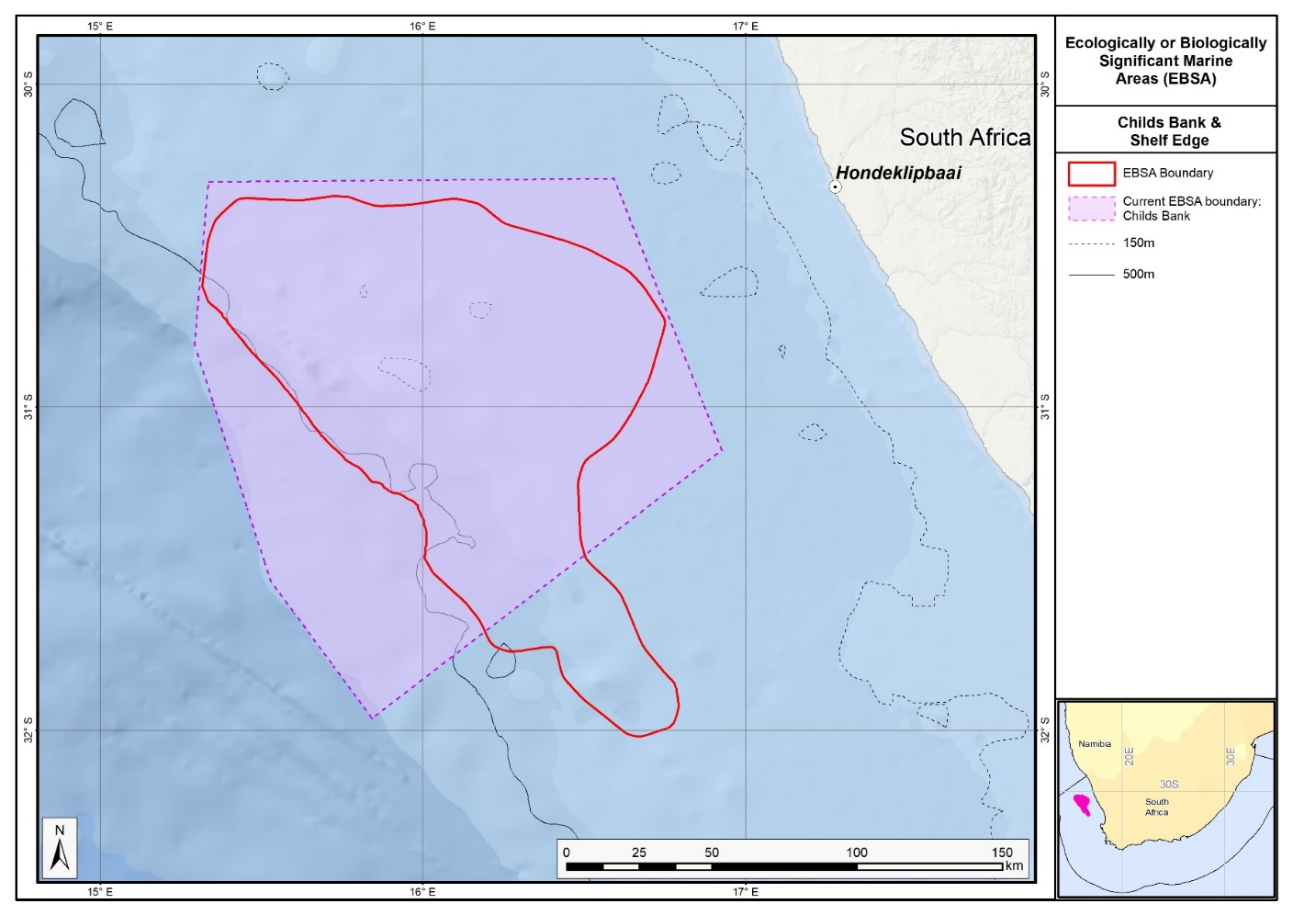
Map of the Childs Bank and Shelf Edge area in relation to the original Childs Bank EBSA.

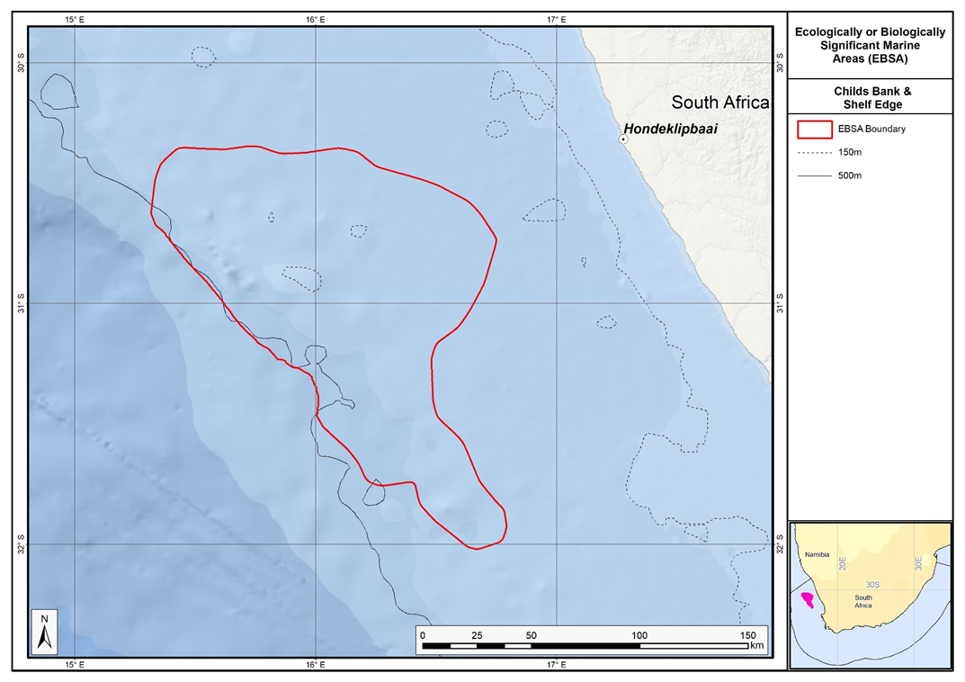
Map of the Childs Bank and Shelf Edge area.

Rights and permissions:
No limits on sharing or publication.

20. Kingklip corals (modification of the existing Offshore of Port Elizabeth)⁷

Reason for the modification:
The EBSA description is being modified because of newly available or accessible knowledge on features associated with the area, based on additional scientific data especially new systematic spatial planning and assessments of biodiversity. The descriptions and supporting information are substantially extended, updated and refined beyond the original descriptions from the Southern Indian Ocean Regional EBSA Workshop, 2012.The modifications involve changes to the textual description, changes to the ranking of the area against the EBSA criteria, and changes in shape, location and size of the area.

The original descriptions of Ecologically or Biologically Significant Marine Areas (EBSAs) in the Benguela Current Large Marine Ecosystem (BCLME) were described in the Southern Indian Ocean Regional EBSA Workshop. The descriptions were generally characterized by generic, often fairly geometric delineations, consisting of approximate bounding boxes around the features for which the EBSA was described. This coarse scale of delineation was appropriate for a global scale but posed challenges for inclusion in national-level, place-based ocean management. The original boundaries were not sufficiently refined to capture the full extent of key biodiversity features and often overlapped with areas of lower biodiversity value or poor ecological condition.

Additionally, the original EBSA descriptions suffered from shortfalls related to limited spatial data and lack of systematic conservation planning approaches at the time they were first proposed. This meant that many boundaries did not precisely encompass biodiversity priority areas, potentially leading to conflicts with other ocean sectors and limiting their practical usefulness for marine spatial planning (MSP). The coarse scale and lack of detailed data constrained the ability to develop effective zoning and management recommendations that balance biodiversity protection with economic activities.

How was the submission developed?
The EBSA revision process was part a broader project on ecosystem-based MSP in the BCLME, namely the Benguela Current Marine Spatial Management and Governance Project (MARISMA, 2014-2023). This was a regional capacity-building and development cooperation project implemented by the Benguela Current Commission, the Governments of Angola, Namibia and South Africa, and GIZ, the German Agency for Development Cooperation (Deutsche Gesellschaft für Internationale Zusammenarbeit.

Because of these shortcomings of the existing EBSA boundaries, description and valuations set out in the previous section, the MARISMA project undertook a refinement process. This process used systematic conservation planning (SCP) tools, such as Marxan, to generate finer-scale, more accurate boundaries based on updated biodiversity data and expert input. This process also allowed for the identification of new EBSAs and the splitting of some original EBSAs into multiple refined areas to better reflect discrete biodiversity features and ecological processes. The refined EBSA boundaries were more suitable for MSP and conservation management because they focused on core natural and near-natural areas, avoided unnecessary conflicts with other sectors, and incorporated a systematic, data-driven approach to spatial prioritization.

The overall approach to the EBSA update and engagement followed these key steps:

Initial Systematic Conservation Planning (SCP) Analyses: Existing EBSAs were refined and new areas identified using systematic conservation planning tools such as Marxan, based on biodiversity input data including ecosystem types, species distributions, and ecological processes.

National Workshops: The refined and new EBSA boundaries were iteratively reviewed and adjusted through workshops held within each of the three countries (Angola, Namibia, South Africa). These workshops allowed country-specific input and tailoring of EBSA boundaries and descriptions to national contexts and priorities.

Regional Workshops and Bilateral Meetings between Countries: Workshops at the regional level especially focused on transboundary EBSAs shared between the countries, but also examined the overall approach to EBSAs, their delineation, description and the engagement approach. The aim was to harmonize boundaries, align management recommendations, and foster cooperation across national borders for effective regional marine biodiversity management. Additional specific bilateral meetings were held where necessary.

Technical and Scientific Peer Review: The revised and new EBSAs underwent technical review nationally and regionally (through technical review workshops involving relevant experts); and internationally with assistance from experts from the Global Ocean Biodiversity Initiative (GOBI) and members of the CBD's Informal Advisory Group on EBSAs, ensuring robustness of the exercise. The process is documented in peer reviewed literature (Harris et al., 2019, 2022).

Political Approval: The EBSAs were administratively and politically approved through all required stages up to the national ministerial level in each country and were then submitted to the CBD Secretariat by the National CBD Focal Points.

Data Sharing and Accessibility: All information, including refined EBSA boundaries, status assessments, management recommendations, and stakeholder feedback, were made available through online repositories such as the project's EBSA Portal (https://cmr.mandela.ac.za/Research-Projects/EBSA-Portal); and the EBSA were also shared via the Benguela Current Convention's Geodata Portal (https://geodata.benguelacc.org/ ). This facilitated transparency, accessibility, and ongoing updating of data and products for biodiversity specialists and other stakeholders.

Recent survey data indicated that Kingklip Corals are small but rare and very vulnerable features justifying conservation attention, which were only partly represented in the original Offshore of Port Elizabeth EBSA. Significant changes have been made to the delineation of the Offshore of Port Elizabeth EBSA, such that it was necessary to split the EBSA into two, and revise the name of this one to Kingklip Corals EBSA to accurately reflect the features comprising the EBSA. This then also required a substantial revision to the description and criteria ranks. A supplementary table of the habitats represented in the EBSA and their associated threat status was also included. Given the new extent and inclusion of additional features, criteria level changes were made to almost all criteria.

The delineation process included an initial stakeholder review, a technical mapping process and then an expert review workshop where boundary delineation options were finalised. The delineation process used a combination of Systematic Conservation Planning and Multi-Criteria Analysis methods. The features used in the analysis were:
- Key physical features (i.e. the coral mound, ridge, koppies and surrounds) from recent survey work (Sink, 2016).
- Delineations and threat status of constituent ecosystem types in the area were included in the analysis and used to refine the boundary of the EBSA.
- Irreplaceable and near irreplaceable (i.e. very high selection frequency) sites which relate closely to the EBSA criteria of “Uniqueness and rarity” from the Systematic Conservation Planning process undertaken for Majiedt et al. (2013) and the broader analysis for the BCLME by Holness et al. (2014).
- Areas of high relative naturalness identified in the National Biodiversity Assessment 2011 (Sink et al., 2012), the West Coast (Majiedt et al., 2013) and the BCLME spatial assessments (Holness et al., 2014) were included in the analysis. Both pelagic and benthic and coastal condition were incorporated.
- Distributions of known fragile, vulnerable and sensitive habitat-forming species were included (Unpublished SANBI and SAEON data).

The multi-criteria analysis resulted a value surface. The cut-off value used to determine the extent of the EBSA was based on expert input and quantitative analysis of effective inclusion of the above features. This entailed taking an iterative parameter calibration-based approach whereby the spatial efficiency of the inclusion of the targeted features was evaluated. The approach aimed to identify a cut-off which most efficiently included prioritised features while minimizing the inclusion of impacted areas. The final boundaries shown in the map were validated in a national workshop.

Traditional knowledge was not incorporated into this process, and consultations with indigenous peoples or local communities were not undertaken. Therefore, documentation of Free, Prior and Informed Consent (FPIC) is not relevant for this EBSA process.

Where is the submission intended to be included (choose one option, and please note that there are different procedures for these two intended end points)?
[X] EBSA repository
[ ] EBSA information-sharing mechanism

Abstract:
Changes from the original version: The completely revised and rewritten abstract highlights the splitting of the existing Offshore of Port Elizabeth EBSA into two distinct components, one of which is the Kingklip Corals. This contrasts with the original description that treated Offshore of Port Elizabeth as a single EBSA. The motivation for this change is to better reflect discrete biodiversity features and ecological processes that were not adequately captured by the coarse original delineation. The revised abstract highlights the discovery of the Secret Reef, a biogenic coral reef structure outside the trawl footprint, supporting dense fragile coral and bryozoan communities, which was not previously described.

The discovery of important benthic features that were partially represented in the Offshore of Port Elizabeth EBSA has prompted the proposal to split that EBSA into two. The present description better represents the new features. Secret Reef is a newly discovered biogenic coral reef structure that is outside the trawl footprint on the shelf edge of the south coast of South Africa. Notably, it contains dense communities of fragile and sensitive coral and bryozoan species, which are relatively rare in the area. Secret Reef links with the Kingklip ridge and Kingklip koppies, offshore from Saint Francis Bay, which are a newly discovered unique rocky ridge and undersea hills that support fragile corals and are covered by dense clouds of plankton and hake. Three of the five ecosystem types in the area are threatened, including the endangered Kingklip ridge and the vulnerable Kingklip koppies and Agulhas coarse sediment shelf-edge ecosystem types.

Introduction:
Changes from the original version: The completely revised and rewritten introduction focusses the discovery of the Secret Reef, a biogenic coral reef structure outside the trawl footprint, supporting dense fragile coral and bryozoan communities, which was not previously described. It describes how this motivated the splitting of the existing Offshore of Port Elizabeth EBSA into two distinct components, one of which is the Kingklip Corals. It provides details on the ecosystems present and justifies the extension of the EBSA into the Secret Reef area. It is presented as a Type 2 EBSA because it contains “spatially stable features whose individual positions are known, but a number of individual cases are being grouped” (sensu Johnson et al., 2018).

An interesting feature was recently discovered inside the Offshore of Port Elizabeth EBSA: a unique rocky ridge protruding out of the upper slope that supports corals and is covered by dense clouds of plankton and hake (Sink 2016). Adjacent to the ridge is a series of rocky koppies (Afrikaans for ‘hills’). A little further west, also on the shelf edge and upper slope of the South African south coast, is Secret Reef. This is a newly discovered biogenic coral reef structure that supports fragile and sensitive corals and byrozoans. Given that these special benthic features appear to be connected along the shelf edge and upper slope, it prompted a split in the Offshore of Port Elizabeth EBSA into Algoa to Amathole, which comprises the bulk of the original EBSA, and this EBSA: Kingklip Corals. This allowed for a better delineation of an EBSA that more accurately reflected the underlying features, which in this case are largely benthic features.

Given its position on the shelf edge and upper slope, despite being a relatively small EBSA (approximately 23 km x 233 km), it spans a broad depth range of -150 to -1000 m. It comprises five ecosystem types, three of which are threatened, including an Endangered type. This area is also an important place in which to meet biodiversity targets because it had high selection frequency in a national systematic conservation plan (Sink et al., 2011; SANBI unpublished results in analysis for Madjiedt et al., 2013).

The reason this area was not fully included in the original Offshore of Port Elizabeth EBSA is because the constituent features were not yet discovered, and thus the information was not available at the Southern Indian Ocean Regional Workshop to Facilitate the Description of Ecologically or Biologically Significant Marine Areas (UNEP/CBD/RW/EBSA/SIO/1/4) in 2013. It is presented as a Type 2 EBSA because it contains “spatially stable features whose individual positions are known, but a number of individual cases are being grouped” (sensu Johnson et al., 2018).

Location:
Changes from the original version: The section reflects the updated spatial delineation focussed on Secret Reef, provides bounding box coordinates, and shares a link to the specific spatial data. Motivation for the spatial changes, and details of the spatial planning are given in “How was the submission developed?” Section. The key geographic change is the split of the original Offshore of Port Elizabeth EBSA into two, with this Kingklip Corals EBSA focussing on Secret Reef.

Secret Reef lies on Grue Bank, about 100 km offshore from Knysna and approximately halfway along the south coast of the country in the Agulhas current. The Kingklip corals area spans from Grue Bank to the middle of Saint Francis Bay offshore, along the shelf edge and a little down the slope. The area is entirely within the exclusive economic zone of South Africa.
The coordinates of a minimum bounding box covering the entire scope of the area are:
- Latitude: -34.942, -34.509, -34.806, -35.238
- Longitude: 22.752, 25.259, 25.31, 22.803

Feature description of the area:
Changes from the original version: The completely revised and rewritten introduction provides detailed morphological characteristics of Kingklip Ridge and koppies, including dimensions, depth ranges, and associated benthic species such as scleractinian corals, stylasterine corals, and bryozoans. It also notes the presence of dense plankton and hake clouds and evidence of trawling damage on reef-building corals, information absent in the original. The revised description includes details the ecosystems present and their threat status, and includes a new table.

Kingklip ridge rises like a wall on the upper slope, offshore of Cape St Francis. It has dimensions of 530 m wide and about 40 km long, running parallel to the shelf edge on the slope that goes from -200 m to -600 m and deeper (Sink 2016). At the crest and edges of the northern end of the ridge, at approximately -350 m, are reef-forming scleratinean corals (Sink 2016). Above the ridge are dense clouds of plankton and hake, and demersal trawlers reportedly use this feature against which they herd fish (Sink 2016). The Kingklip koppies, west of the ridge, are rocky hills that also support fragile benthic species. Even further west, Secret Reef is a newly discovered biogenic coral reef structure on the shelf edge and upper bathyal area (Sink 2016). It includes threatened benthic habitats and fragile, sensitive, vulnerable species, such as: scleractinian corals, stylasterine corals, bryozoans, molluscs, and crabs that have been sampled in this area (Sink 2016). Given the connections among these similar benthic features, they were delineated as a single EBSA. Thus, the EBSA is most important for benthic features, although the overlying water column is also relevant. It is presented as a Type 2 EBSA because it contains “spatially stable features whose individual positions are known, but a number of individual cases are being grouped” (sensu Johnson et al., 2018).

The ecosystem types represented in the EBSA include the Endangered Kingklip Ridge, Vulnerable Agulhas Coarse Sediment Shelf Edge and Kingklip Koppies, and Least Concern Agulhas Rocky Shelf Edge, and Southwest Indian Upper Slope (See Table below; Sink et al., 2019). Because these features are so recently discovered, there is very little information available about them, other than the data that were collected on the cruise when they were found (Sink 2016). These data include single-beam echo sounder depth transects, in situ samples, and ROV footage (Sink 2016).

Summary of ecosystem types and threat status for the Kingklip Corals EBSA. Data from Sink et al. (2019).
Threat Status | Ecosystem Type | Area (km²) | Area (%)
Endangered | Kingklip Ridge | 103.6 | 1.9
Vulnerable | Agulhas Coarse Sediment Shelf Edge | 2440.1 | 44.8
 | Kingklip Koppies | 642.9 | 11.8
Least Concern | Agulhas Rocky Shelf Edge | 1673.4 | 30.7
 | Southwest Indian Upper Slope | 582.5 | 10.7
Grand Total |  | 5442.5 | 100.0

Feature condition and future outlook:
Changes from the original version: The section has been almost completely revised to reflect the new more focussed delineation and newly available information. The revised section includes updated information on ecological condition, ecosystem threat statuses, and describes the new Port Elizabeth Corals MPA.

Ecological condition is estimated in South Africa by assessing cumulative pressures to the marine environment (Sink et al., 2012, 2019). Ecological condition is poor in the northern and eastern portions of the EBSA (over Kingklip Ridge and the easternmost Kingklip Koppies), and moderate to mostly good in the south west corner (over Secret Reef; Sink et al., 2019). The primary pressures in the area are from fishing for large pelagic fish, and demersal and pelagic sharks, with some influence from shipping and other fishing industries to a lesser degree. Secret Reef itself is outside of the trawl footprint so the site is high in live coral cover (Sink 2016). However, all of the reef-building coral observed on the Kingklip Ridge was broken, with evidence of both recent and older damage. This is presumed to be the result of trawling damage to the reef (Sink 2016). Research was recently conducted in the area as part of a larger programme to survey South Africa’s marine environment (Sink 2016). No future research is currently planned, although it has been strongly recommended (Sink 2016).

Protection of features in MPAs has been improved following the proclamation of the Operation Phakisa MPA network in 2019, with the EBSA area within reserves increasing from no protection to 4% protection. The new Port Elizabeth Corals MPA covers the Kingklip Ridge. This has improved the protection levels of some ecosystem types, but there are still some in the EBSA that are poorly or not protected.

Assessment of the area against CBD EBSA Criteria:
Changes from the original version: There are substantial criteria evaluation changes motivated by enhanced empirical data and finer spatial resolution of features, which allows for more precise and evidence-based rankings based on the specific features present. Changes to evaluations of EBSA Criteria:
- Uniqueness or Rarity: Upgraded from Medium to High in the revised description due to the identification of unique benthic features such as Secret Reef and endemic ecosystem types (Kingklip Ridge and Kingklip Koppies).
- Special importance for life-history stages of species: This is reduced from High to Medium, for this more geographically focussed EBSA.
- Vulnerability, Fragility, Sensitivity, or Slow Recovery: Upgraded from Medium to High due to recognition of fragile coral species and documented trawling damage, indicating high susceptibility and slow recovery potential.
- Biological Productivity: Downgraded from High to Medium as satellite data suggest productivity at Secret Reef is comparable to surrounding areas, despite local plankton and hake aggregations.
- Biological Diversity: This is reduced from High to Medium, for this more geographically focussed EBSA.
- Naturalness: Upgraded from Low to Medium, reflecting the near-pristine status of Secret Reef which is outside the trawl footprint.

CBD EBSA Criteria  (Annex I to decision IX/20) | Description  (Annex I to decision IX/20) | Ranking of criterion relevance  (please mark one column with an X)
CBD EBSA Criteria  (Annex I to decision IX/20) | Description  (Annex I to decision IX/20) | No information |  | Low |  |  | Medium |  | High
Uniqueness or rarity | Area contains either (i) unique (“the only one of its kind”), rare (occurs only in few locations) or endemic species, populations or communities, and/or (ii) unique, rare or distinct, habitats or ecosystems; and/or (iii) unique or unusual geomorphological or oceanographic features. |  |  |  |  |  |  |  | x
The coral mound comprising Secret Reef is a relatively rare feature in the broader area. It also contains the only known portions of the Kingklip Ridge and Kingklip Koppies ecosystem types, both of which are unique in South Africa.
Special importance for life-history stages of species | Areas that are required for a population to survive and thrive. |  |  |  |  |  | X
Further research is required to determine if this site supports important life-history stages of species. However, given the uniqueness of the ecosystem types and the dense clouds of plankton and hake above the Kingklip Ridge and Kingklip Koppies, it is presumed that this area is important for species’ life-histories.
Importance for threatened, endangered or declining species and/or habitats | Area containing habitat for the survival and recovery of endangered, threatened, declining species or area with significant assemblages of such species. |  |  |  |  |  |  |  | X
The site includes three threatened ecosystem types, two of which are found exclusively in the EBSA: Endangered Kingklip Ridge and Vulnerable Kingklip Koppies. It is not yet known whether this site is important for threatened or declining species, and this would require more research in the area. However, it is presumed that the two unique ecosystem types (Kingklip Ridge and Kingklip Koppies) both support threatened species given that the ecosystem types are threatened.
Vulnerability, fragility, sensitivity, or slow recovery | Areas that contain a relatively high proportion of sensitive habitats, biotopes or species that are functionally fragile (highly susceptible to degradation or depletion by human activity or by natural events) or with slow recovery. |  |  |  |  |  |  |  | X
Secret Reef is a biogenic coral mound that has fragile scleractinian corals, stylasterine corals, and bryozoans (Sink 2016). Similarly, Kingklip Ridge was observed to contain reef-building scleratinian corals, and Kingklip Koppies contained Thouarella (a primnoid coral), bamboo coral, many mobile invertebrates (Sink 2016). All of these are fragile, sensitive species that are vulnerable to damage, and that take long to recover from impacts.
Biological productivity | Area containing species, populations or communities with comparatively higher natural biological productivity. |  |  |  |  |  | X
There are dense clouds of plankton and hake over Kingklip Ridge (Sink 2016), suggesting high localised productivity at the site. However, time-averaged MODIS Aqua data on chlorophyll concentration (NASA Giovanni Portal: https://giovanni.gsfc.nasa.gov) shows that productivity inside Secret Reef is not higher compared to that of the surrounding area.
Biological diversity | Area contains comparatively higher diversity of ecosystems, habitats, communities, or species, or has higher genetic diversity. |  |  |  |  |  | X
Because Secret Reef is outside of the trawl footprint, reef diversity inside the EBSA is relatively higher than that in the surrounding area (Sink 2016). Further, the relatively small EBSA comprises five ecosystem types that span a depth range of 850 m.
Naturalness | Area with a comparatively higher degree of naturalness as a result of the lack of or low level of human-induced disturbance or degradation. |  |  |  |  |  |  | X
Secret Reef itself is outside of the trawl footprint, so this feature itself is close to pristine and high in live coral cover (Sink 2016). Based on a national assessment of cumulative pressures on the marine environment, the broader EBSA has portions in good and poor ecological condition, with a much smaller area that is moderately modified, (Sink et al., 2019). Thus, overall, the condition is fair.

References:
Changes from the original version: The references are updated and focussed on this new more geographically specific EBSA.

Harris, L., Holness, S., Finke, G., Kirkman, S., Sink, K., 2019. Systematic Conservation Planning as a Tool to Advance Ecologically or Biologically Significant Area and Marine Spatial Planning Processes, in: Zaucha, J., Gee, K. (Eds.), Maritime Spatial Planning. Palgrave Macmillian, Cham.
Harris, L.R., Holness, S.D., Finke, G., Amunyela, M., Braby, R., Coelho, N., Gee, K., Kirkman, S.P., Kreiner, A., Mausolf, E., Majiedt, P., Maletzky, E., Nsingi, K.K., Russo, V., Sink, K.J., Sorgenfrei, R., 2022. Practical Marine Spatial Management of Ecologically or Biologically Significant Marine Areas: Emerging Lessons From Evidence-Based Planning and Implementation in a Developing-World Context. Front. Mar. Sci. 9.
Johnson, D.E., Barrio Froján, C., Turner, P.J., Weaver, P., Gunn, V., Dunn, D.C., Halpin, P., Bax, N.J., Dunstan, P.K., 2018. Reviewing the EBSA process: Improving on success. Marine Policy 88, 75-85.
Majiedt, P., Holness, S., Sink, K., Oosthuizen, A., Chadwick, P. 2013. Systematic Marine Biodiversity Plan for the West Coast of South Africa. South African National Biodiversity Institute, Cape Town.
Sink, K. 2016. Deep Secrets: the outer shelf and slope ecosystems of South Africa. Cruise Report: ALG 230 – ACEP_DSC.
Sink, K., Holness, S., Harris, L., Majiedt, P., Atkinson, L., Robinson, T., Kirkman, S., Hutchings, L., Leslie, R., Lamberth, S., Kerwath, S., von der Heyden, S., Lombard, A., Attwood, C., Branch, G., Fairweather, T., Taljaard, S., Weerts, S., Cowley, P., Awad, A., Halpern, B., Grantham, H., Wolf, T. 2012. National Biodiversity Assessment 2011: Technical Report. Volume 4: Marine and Coastal Component. South African National Biodiversity Institute, Pretoria.
Sink, K.J., Attwood, C.G., Lombard, A.T., Grantham, H., Leslie, R., Samaai, T., Kerwath, S., Majiedt, P., Fairweather, T., Hutchings, L., van der Lingen, C., Atkinson, L.J., Wilkinson, S., Holness, S., Wolf, T. 2011. Spatial planning to identify focus areas for offshore biodiversity protection in South Africa. Unpublished Report. Cape Town: South African National Biodiversity Institute.
Sink, K.J., van der Bank, M.G., Majiedt, P.A., Harris, L.R., Atkinson, L., Karenyi, N., Kirkman, S. (eds) 2019. National Biodiversity Assessment 2018 Technical Report Volume 4: Marine Realm. South African National Biodiversity Institute, Pretoria.

Maps and Figures:
GIS data available at: https://cmr.mandela.ac.za/cmr/media/Store/documents/EBSA/Descriptions/SouthAfrica/Shapefile-RSA_EBSAs_final.zip
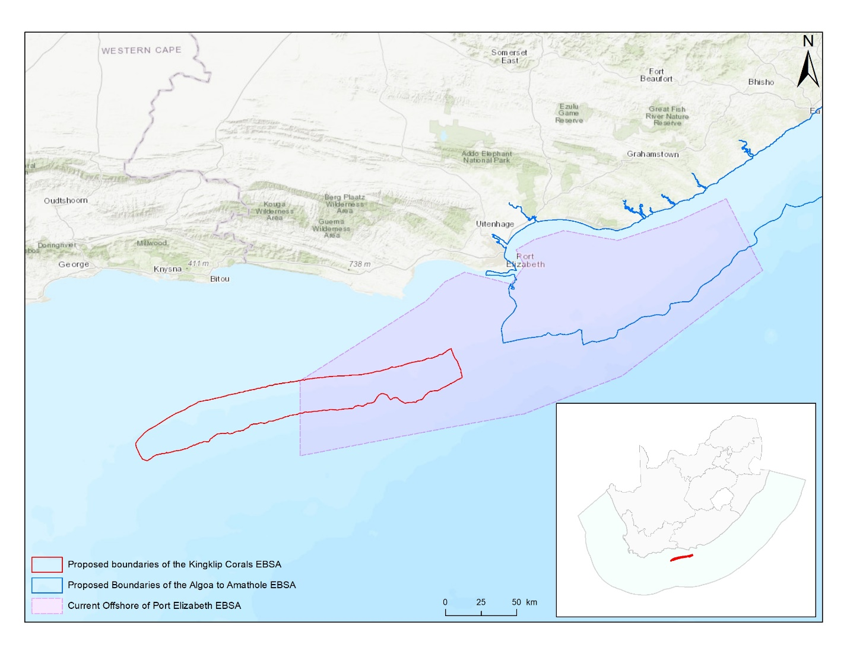
Map of the Kingklip Corals area in relation to the original Offshore of Port Elizabeth EBSA. The map also shows the Algoa to Amathole area which focusses on and expands on the features in the east of the original EBSA.

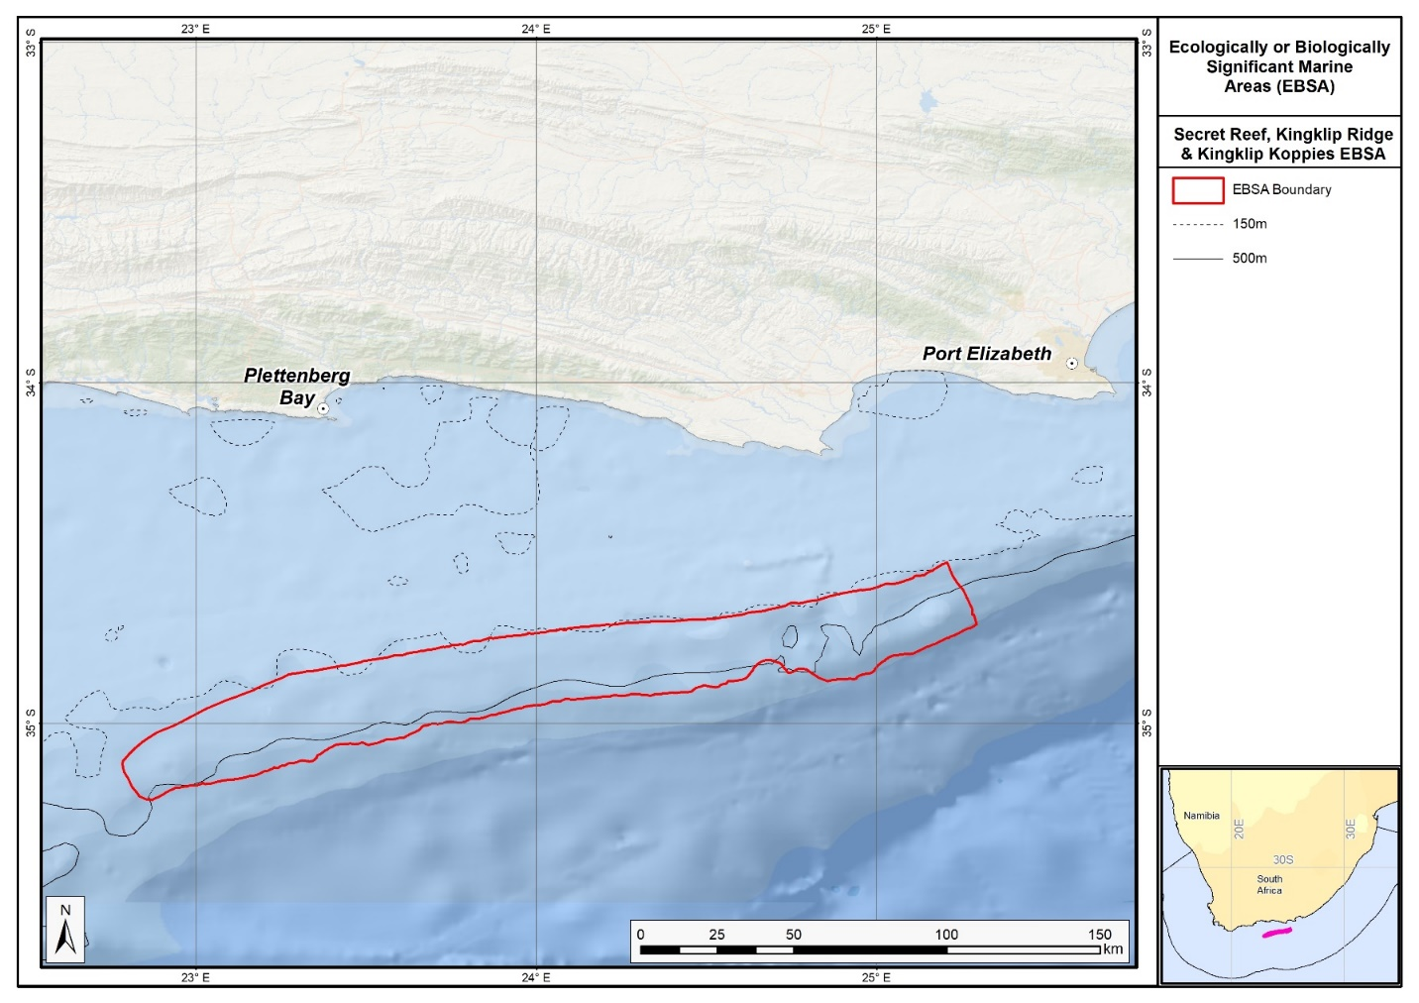
Map of the Kingklip Corals area.
Rights and permissions:
No limits on sharing or publication.

21. KwaZulu-Natal bight and uThukela River (modification of the existing Natal Bight)

Reason for the modification:
The EBSA description is being modified because of newly available or accessible knowledge on features associated with the area, based on additional scientific data especially new systematic spatial planning and assessments of biodiversity. The descriptions and supporting information are substantially extended, updated and refined beyond the original descriptions from the Southern Indian Ocean Regional EBSA Workshop, 2012. The modifications involve changes to the textual description, changes to the ranking of the area against the EBSA criteria, and changes in shape, location and size of the area. As a consequence of these changes, it became appropriate to alter the name to better describe the EBSA.

The original descriptions of Ecologically or Biologically Significant Marine Areas (EBSAs) in the Benguela Current Large Marine Ecosystem (BCLME) were described in the Southern Indian Ocean Regional EBSA Workshop. The descriptions were generally characterized by generic, often fairly geometric delineations, consisting of approximate bounding boxes around the features for which the EBSA was described. This coarse scale of delineation was appropriate for a global scale but posed challenges for inclusion in national-level, place-based ocean management. The original boundaries were not sufficiently refined to capture the full extent of key biodiversity features and often overlapped with areas of lower biodiversity value or poor ecological condition.

Additionally, the original EBSA descriptions suffered from shortfalls related to limited spatial data and lack of systematic conservation planning approaches at the time they were first proposed. This meant that many boundaries did not precisely encompass biodiversity priority areas, potentially leading to conflicts with other ocean sectors and limiting their practical usefulness for marine spatial planning (MSP). The coarse scale and lack of detailed data constrained the ability to develop effective zoning and management recommendations that balance biodiversity protection with economic activities.

How was the submission developed?
The EBSA revision process was part a broader project on ecosystem-based MSP in the BCLME, namely the Benguela Current Marine Spatial Management and Governance Project (MARISMA, 2014-2023). This was a regional capacity-building and development cooperation project implemented by the Benguela Current Commission, the Governments of Angola, Namibia and South Africa, and GIZ, the German Agency for Development Cooperation (Deutsche Gesellschaft für Internationale Zusammenarbeit.

Because of these shortcomings of the existing EBSA boundaries, description and valuations set out in the previous section, the MARISMA project undertook a refinement process. This process used systematic conservation planning (SCP) tools, such as Marxan, to generate finer-scale, more accurate boundaries based on updated biodiversity data and expert input. This process also allowed for the identification of new EBSAs and the splitting of some original EBSAs into multiple refined areas to better reflect discrete biodiversity features and ecological processes. The refined EBSA boundaries were more suitable for MSP and conservation management because they focused on core natural and near-natural areas, avoided unnecessary conflicts with other sectors, and incorporated a systematic, data-driven approach to spatial prioritization.

The overall approach to the EBSA update and engagement followed these key steps:

Initial Systematic Conservation Planning (SCP) Analyses: Existing EBSAs were refined and new areas identified using systematic conservation planning tools such as Marxan, based on biodiversity input data including ecosystem types, species distributions, and ecological processes.

National Workshops: The refined and new EBSA boundaries were iteratively reviewed and adjusted through workshops held within each of the three countries (Angola, Namibia, South Africa). These workshops allowed country-specific input and tailoring of EBSA boundaries and descriptions to national contexts and priorities.

Regional Workshops and Bilateral Meetings between Countries: Workshops at the regional level especially focused on transboundary EBSAs shared between the countries, but also examined the overall approach to EBSAs, their delineation, description and the engagement approach. The aim was to harmonize boundaries, align management recommendations, and foster cooperation across national borders for effective regional marine biodiversity management. Additional specific bilateral meetings were held where necessary.

Technical and Scientific Peer Review: The revised and new EBSAs underwent technical review nationally and regionally (through technical review workshops involving relevant experts); and internationally with assistance from experts from the Global Ocean Biodiversity Initiative (GOBI) and members of the CBD's Informal Advisory Group on EBSAs, ensuring robustness of the exercise. The process is documented in peer reviewed literature (Harris et al., 2019, 2022).

Political Approval: The EBSAs were administratively and politically approved through all required stages up to the national ministerial level in each country and were then submitted to the CBD Secretariat by the National CBD Focal Points.

Data Sharing and Accessibility: All information, including refined EBSA boundaries, status assessments, management recommendations, and stakeholder feedback, were made available through online repositories such as the project's EBSA Portal (https://cmr.mandela.ac.za/Research-Projects/EBSA-Portal); and the EBSA were also shared via the Benguela Current Convention's Geodata Portal (https://geodata.benguelacc.org/ ). This facilitated transparency, accessibility, and ongoing updating of data and products for biodiversity specialists and other stakeholders.

Some technical revisions and updates to the description were made based on recent research. A supplementary table of the habitats represented in the EBSA and their associated threat status was also included. A criteria level change was made on Criterion 5: Biological productivity and Criterion 6: Biological diversity, with ranks respectively upgraded from Medium to High, and Low to Medium. This was based on new research for productivity (Scharler et al., 2016) and demersal fish diversity (Fennessey 2016). Further, empirical evidence from the National Biodiversity Assessment (Sink et al., 2012) showed that a rank of Low for Criterion 7: Naturalness was not justified for this EBSA, and thus the rank was upgraded to Medium.

The main change is that the boundary of this EBSA has been slightly adjusted to more closely focus the EBSA on the key biodiversity features that underly its EBSA status. In particular, this includes adding the lower reaches of the uThukela River, which provides the critical link between land and sea in delivering sediment to the near- and offshore ecosystems comprising the Natal Bight. The delineation process included an initial stakeholder review which identified the need to update boundaries, a technical mapping process and then an expert review workshop where boundary delineation options were finalised. The delineation process used a combination of Systematic Conservation Planning and Multi-Criteria Analysis methods. The features used in the analysis were:
- The key Natal Bight ecosystems (i.e. those shelf and inshore types dominated by sediment inputs) were focussed on.
- Irreplaceable and near irreplaceable (i.e. very high selection frequency) sites, as well as focus areas identified in the national SCP analysis undertaken as part of Majiedt et al. (2013) and focus areas for offshore protection (Sink et al., 2011) were included.
- Key physical features (especially canyons) identified from the latest GEBCO data, global benthic geomorphology mapping (www.bluehabitats.org, Harris et al., 2014) and the National Biodiversity Assessment 2011 (Sink et al., 2012) were incorporated.
- Delineations and threat status of constituent ecosystem types in the area were included in the analysis and used to refine the boundary of the EBSA.
- Areas of high relative naturalness of benthic and coastal systems and pelagic systems identified in the National Biodiversity Assessment 2011 (Sink et al., 2012a) and 2018 (Sink et al., 2019) were included in the analysis.
- Distributions of known fragile, vulnerable and sensitive habitat-forming species were included (Unpublished SANBI and SAEON data).

The multi-criteria analysis resulted in a value surface. The cut-off value used to determine the extent of the EBSA was based on expert input and quantitative analysis of effective inclusion of the above features. This entailed taking an iterative parameter calibration-based approach whereby the spatial efficiency of the inclusion of the targeted features was evaluated. The approach aimed to identify a cut-off which most efficiently included prioritised features while minimizing the inclusion of impacted areas. The final boundaries shown in the map were validated in a national workshop.

Traditional knowledge was not incorporated into this process, and consultations with indigenous peoples or local communities were not undertaken. Therefore, documentation of Free, Prior and Informed Consent (FPIC) is not relevant for this EBSA process.

Where is the submission intended to be included (choose one option, and please note that there are different procedures for these two intended end points)?
[X] EBSA repository
[ ] EBSA information-sharing mechanism

Abstract:
Changes from the original version: The revised abstract more tightly links the EBSA to the uThukela River, as a critical component linking terrestrial and marine ecosystems. More specific data on the diversity and threat status of ecosystems is included.

The KwaZulu-Natal bight and uThukela River area supports crucial ecological processes, including terrestrial-marine connectivity, larval retention, recruitment, and nursery and foraging areas. It encompasses rare ecosystem types and species with limited distributions. Cool, productive waters reach the shelf through upwelling driven by the Agulhas current and wind, while continental run-off from the uThukela River delivers essential detritus that drives food webs and maintains mud and unconsolidated sediment habitats. Such turbid, nutrient-rich conditions support critical life-history phases for crustaceans, demersal fish, migratory species, turtles and sharks, including threatened species. Particularly vulnerable ecosystems include submarine canyons, cold-water corals and slow-growing sparids. The area is exceptionally important for threatened ecosystem types: of its 28 ecosystems, 21 (75%) are threatened, including 1 that is critically endangered, 9 that are endangered and 11 that are vulnerable, and 3 are near threatened.

Introduction:
Changes from the original version: The revised description retains the content from the previous version, but adds specific description of the improved delineation and ecological process focus. It specifically it highlights the process link to the uThukela River. It is presented as a Type 2 EBSA because it contains “spatially stable features whose individual positions are known, but a number of individual cases are being grouped” (sensu Johnson et al., 2018).

The KwaZulu-Natal Bight and uThukela River is important for numerous ecological processes, including terrestrial-marine connectivity, larval retention, recruitment and provision of nursery and foraging areas. The area incorporates rare ecosystem types and supports some species known to exist in few localities. Cool productive water is advected onto the shelf through Agulhas- and wind-driven upwelling cells, and continental runoff from the large uThukela River is important for the delivery of detritus to the bight (which drives food webs), and maintenance of mud and other unconsolidated-sediment habitats. The turbid, nutrient-rich conditions are important for life-history phases (breeding, nursery and feeding) for crustaceans, demersal fish, migratory fish, turtles and sharks. Some of these species are threatened (turtles, scalloped hammerhead) or overexploited (sparids and sciaenids), and the deep reef and palaeo-shoreline habitats are considered important for the recovery of overexploited deep-reef fish species. Other particularly vulnerable and fragile ecosystems and species include submarine canyons, cold-water corals and slow-growing sparids. One Critically Endangered and nine Endangered ecosystem types occur in this area and a further 11 are Vulnerable (Sink et al., 2019). The Thukela Banks have been identified as a priority area by two different systematic biodiversity plans, a national plan to identify focus areas for offshore protection (Sink et al., 2011) and a fine-scale provincial plan for the province of KwaZulu-Natal (Harris et al., 2011).

Since the original description and delineation, the boundary of the EBSA has been revised to improve precision and better represent the underlying features. Importantly, the lower reaches of the uThukela River are now included because it is the key driver of the system. It is the conduit for sediment delivery to the near- and offshore ecosystems of the KwaZulu-Natal Bight, and provides the critical link between land and sea that underpins this EBSA. In fact, it was considered such an important addition that it prompted a name change for this EBSA, from Natal Bight to KwaZulu-Natal Bight and uThukela River. Further, recent research in the area has, inter alia, improved knowledge of the seabed composition, and thus the extent of the mud habitats and the Bight itself is now better understood and mapped, allowing a more accurate delineation of the EBSA. It is presented as a Type 2 EBSA because it contains “spatially stable features whose individual positions are known, but a number of individual cases are being grouped” (sensu Johnson et al., 2018).

Location:
Changes from the original version: The section reflects the updated spatial delineation which tightens the boundaries of the EBSA to more closely link to underlying ecosystem features, most notably the uThukela Canyon and Thukela Banks. This contrasts with the original broader and coarser bounding boxes. The location section provides bounding box coordinates and shares a link to the specific spatial data. Motivation for the spatial changes, and details of the spatial planning are given in “How was the submission developed?” Section.

The area is located on the east coast of South Africa, extending from Maphelane to Durban, from the shore to a depth of 2,000 m, including the Thukela Banks, the KwaZulu-Natal bight nursery area, the shelf edge and the upper bathyal zone. The area is entirely within the exclusive economic zone of South Africa.

The coordinates of a minimum bounding box covering the entire scope of the area are:
- Latitude: -30.057, -28.185, -28.496, -30.368
- Longitude: 30.977, 31.458, 32.668, 32.187

Feature description of the area:
Changes from the original version: The revised text substantially elaborates on the extremely high diversity of ecosystems in the EBSA. It provides a detailed summary of ecosystem types present, including specific threat statuses, which was not included in the original. A summary table of ecosystem types and threat statuses is presented.

The area is characterized by extensive alluvial deposits forming banks, primarily off the uThukela River but also off the Mgeni River to a lesser degree (see Sink et al., 2011). The seafloor is thus sedimentary in nature but varies in the degree to which it is consolidated. The banks are productive in terms of benthic and deposit feeders, an attribute typical of such features.

The area has an extremely diverse range of ecosystem types being identified in the National Biodiversity Assessment (Table below; Sink et al., 2019). The EBSA includes 28 ecosystem types, one of which is Critically Endangered, nine of which are Endangered (including key areas of Durnford Inner Shelf Reef Complex, Natal Bight Deep Shelf Edge and Natal Bight Mid Shelf Reef Sand Mosaic), 11 are Vulnerable (including key areas of Durnford Mid Shelf Reef Complex, Natal Bight Muddy Inner Shelf, Natal Bight Muddy Shelf Edge, Natal Bight Outer Shelf Coarse Sediment Reef Mosaic, St Lucia Sandy Mid Shelf, uThukela Mid Shelf Coarse Sediment Reef Mosaic, uThukela Mid Shelf Mud Coarse Sediment Mosaic, and uThukela Outer Shelf Muddy Reef Mosaic) and a further three are Near Threatened (Table below; Sink et al., 2019).

Summary of ecosystem types and threat status for the KwaZulu-Natal Bight and uThukela River EBSA. Data from Sink et al. (2019).
Threat Status | Ecosystem Type | Area (km²) | Area (%)
Critically Endangered | Subtropical Estuarine Bay | 0.1 | 0.0
Endangered | Durnford Inner Shelf Reef Complex | 460.5 | 4.3
 | Natal Bight Deep Shelf Edge | 1654.6 | 15.6
 | Natal Bight Mid Shelf Reef Complex | 23.0 | 0.2
 | Natal Bight Mid Shelf Reef Sand Mosaic | 534.7 | 5.0
 | Natal Bight Sandy Inner Shelf | 145.9 | 1.4
 | Subtropical Estuarine Lake | 1.7 | 0.0
 | Subtropical Large Fluvially Dominated Estuary | 13.0 | 0.1
 | Subtropical Large Temporarily Closed Estuary | 1.0 | 0.0
 | Subtropical Predominantly Open Estuary | 2.7 | 0.0
Vulnerable | Durnford Mid Shelf Reef Complex | 431.8 | 4.1
 | Natal Bight Muddy Inner Shelf | 328.7 | 3.1
 | Natal Bight Muddy Shelf Edge | 400.6 | 3.8
 | Natal Bight Outer Shelf Coarse Sediment Reef Mosaic | 647.8 | 6.1
 | Natal Mixed Shore | 13.9 | 0.1
 | Natal-Delagoa Reflective Sandy Shore | 5.7 | 0.1
 | St Lucia Sandy Mid Shelf | 496.0 | 4.7
 | Subtropical Small Temporarily Closed Estuary | 0.5 | 0.0
 | uThukela Mid Shelf Coarse Sediment Reef Mosaic | 789.4 | 7.4
 | uThukela Mid Shelf Mud Coarse Sediment Mosaic | 1348.7 | 12.7
 | uThukela Outer Shelf Muddy Reef Mosaic | 531.8 | 5.0
Near Threatened | Natal Exposed Rocky Shore | 0.7 | 0.0
 | Natal-Delagoa Intermediate Sandy Shore | 23.3 | 0.2
 | uThukela Canyon | 417.8 | 3.9
Least Concern | Natal-Delagoa Dissipative-Intermediate Sandy Shore | 12.2 | 0.1
 | Southwest Indian Mid Slope | 0.8 | 0.0
 | Southwest Indian Upper Slope | 2281.4 | 21.5
 | St Lucia Sandy Inner Shelf | 31.6 | 0.3
Grand Total |  | 10599.8 | 100.0

Feature condition and future outlook:
Changes from the original version: The section has been expanded to reflect newly available information. The revised description includes updated information on ecological condition, ecosystem threat statuses, and describes the large new MPA in the EBSA which substantially improves protection.

The National Biodiversity Assessment 2011 (Sink et al., 2012) indicated declining condition overall in the original EBSA (based on pressure data and an ecosystem-pressure matrix) with conditions ranging from fair to poor across the overall area. An updated assessment (Sink et al., 2019) on the new delineation shows ecological condition ranges from good to poor across the EBSA, with condition generally worse closer to the shore. Key pressures include the crustacean trawl fishery, a line fishery targeting sparids and sciaenids, and there are emerging mining and petroleum applications. A submarine cable has recently been laid in the area. Research on a number of the aforementioned aspects has been undertaken (but not published) by the Oceanographic Research Institute in Durban. There is planned research in the area through the African Coelacanth Ecosystem Program Phase III.

Protection of features in MPAs has improved substantially following the proclamation of uThukela Banks MPA as part of the Operation Phakisa MPA network in 2019. Where previously there was no protection in the area, this has now increased to 39.4%. The new MPA covers the main portion of the bight where there are some portions of the Vulnerable and Endangered ecosystem types that are still in fair ecological condition, which will contribute to protecting these ecosystem types from further degradation. However, there are still features (e.g., the canyon) that have no protection in the EBSA.

Assessment of the area against CBD EBSA Criteria:
Changes from the original version: A criteria level change was made on Criterion 5: Biological productivity and Criterion 6: Biological diversity, with ranks respectively upgraded from Medium to High, and Low to Medium. This was based on new research for productivity (Scharler et al., 2016) and demersal fish diversity (Fennessey 2016), as well as improved data on ecosystem diversity National Biodiversity Assessment (Sink et al., 2019). Further, empirical evidence from the assessment (Sink et al., 2019) showed that a rank of Low for Criterion 7: Naturalness was not justified for this EBSA, and thus the rank was upgraded to Medium. Further, the revised text provides more detailed supporting evidence and updated scientific references to justify rankings, particularly referring to new survey data and results of ecosystem mapping and assessments of status.

CBD EBSA Criteria  (Annex I to decision IX/20) | Description  (Annex I to decision IX/20) | Ranking of criterion relevance  (please mark one column with an X)
CBD EBSA Criteria  (Annex I to decision IX/20) | Description  (Annex I to decision IX/20) | No information |  | Low |  |  | Medium |  | High
Uniqueness or rarity | Area contains either (i) unique (“the only one of its kind”), rare (occurs only in few locations) or endemic species, populations or communities, and/or (ii) unique, rare or distinct, habitats or ecosystems; and/or (iii) unique or unusual geomorphological or oceanographic features. |  |  |  |  |  | X
Endemic and rare species include: Spotted legskate (Anacanthobatis marmoratus), Porcupine stingray (Urogymnus asperrimus); the Bearded Goby (Taenioides jacksoni) is also endemic (Haupt 2010, Livingston et al., 2012). There are rare gravel and mud ecosystem types in the area, as well as a submarine canyon of limited extent (Sink et al., 2012). There is also a unique demersal fish community near the Thukela Banks (Fennesey 2016), and it is the only portion of the South African east coast that has a relatively wide shelf area.
Special importance for life-history stages of species | Areas that are required for a population to survive and thrive. |  |  |  |  |  |  |  | X
The KwaZulu-Natal Bight and uThukela River supports important life-history stages for a myriad of species. These functions include serving as a migration corridor for fish (e.g., Geelbek – Atractoscion aequidens, White stumpnose – Rhabdosargus holubi, Shad - Pomatomus saltatrix, Dusky kob - Argynosomus japonicas (Vulnerable), and Garrick – Lichia amia). It is also part of the migration route and spawning area for sardine – Sardinops sagax; many shark and fish species also spawn in the KwaZulu-Natal Bight (e.g., Bull shark – Carcharhinus leucas, Sand tiger shark – Carcharias taurus, Black musselcracker – Cymatoceps nasutus, and King mackerel – Scomber japonicas). The KwaZulu-Natal Bight and uThukela River is also an important nursery area for sharks and fish (e.g., Scalloped hammerhead – Sphyrna lewini (EN), Slinger – Chrysoblephus puniceus, Black musselcracker – Cymatoceps nasutus), and an important feeding and migration area for Critically Endangered leatherback turtles (Dermochelys coriacea; Haupt 2010, Harris et al., 2011, Vogt 2011, Sink et al., 2011, Ezemvelo KZN Wildlife 2012; Harris et al., 2018). There are also critical linkages between the Thukela Bank prawn-trawling ground and the estuarine nursery areas, emphasising the area’s role in ecosystem connectivity and supporting recruitment of many commercially important species (Scharler et al., 2016).
The South East African Coastal Migration Corridor Important Marine Mammal Area (IMMA), overlapping with the EBSA, serves as the primary migration route for Southern Hemisphere humpback whales (Megaptera novaeangliae) that feed in (sub)Antarctic waters during the Austral summer (December-May). These whales, belonging to the stock designated ‘C1’ by the International Whaling Commission, have been shown to be migrating to and from a breeding area off the coast of Mozambique. As they swim northward along the east coast waters of South Africa between June and August, they are funnelled closer to shore by the Agulhas Current. During the southward migration from September to November, they appear to swim slightly further offshore, but generally within 15km of the coast, as indicated both by both historic whaling catches and more recent shore-based surveys (IUCN-Marine Mammal Protected Areas Task Force, 2020.). Maps and further information at https://www.marinemammalhabitat.org/factsheets/south-east-african-coastal-migration-corridor/
Importance for threatened, endangered or declining species and/or habitats | Area containing habitat for the survival and recovery of endangered, threatened, declining species or area with significant assemblages of such species. |  |  |  |  |  |  |  | X
The KwaZulu-Natal Bight and uThukela River contains at least 11 threatened species, including: the Critically Endangered Seventy-four (Polysteganus undulosus), leatherbacks (Dermochelys coriacea) and hawksbills (Eretmochelys imbricata); Endangered Scalloped hammerhead (Sphyrna lewini), great hammerhead (Sphyrna mokarran), dageraad (Chrysoblephus christiceps), red stumpnose (Chrysoblephus gibbiceps), and green turtles (Chelonia mydas); and Vulnerable Flapnose houndshark (Scylliogaleus quecketti), porcupine stingray (Urogymnus asperrimus), dusky kob (Argynosomus japonicas), and bearded goby (Taenioides jacksoni). There are also endemic sparids of conservation concern: Polysteganus coeruleopunctatus, as well as Near Threatened loggerheads (Caretta caretta). There are 20 threatened ecosystem types, including nine Endangered types, and 11 Vulnerable types (Sink et al., 2019).
Vulnerability, fragility, sensitivity, or slow recovery | Areas that contain a relatively high proportion of sensitive habitats, biotopes or species that are functionally fragile (highly susceptible to degradation or depletion by human activity or by natural events) or with slow recovery. |  |  |  |  |  | X
The KwaZulu-Natal Bight and uThukela River contains features and species that are slow growing, fragile, and sensitive to disturbance, e.g., submarine canyons, shelf edge, deep reefs and cold-water corals (Sink et al., 2011, 2012).
Biological productivity | Area containing species, populations or communities with comparatively higher natural biological productivity. |  |  |  |  |  |  |  | X
The KwaZulu-Natal Bight and uThukela River contains Indian Ocean water, with high but variable chlorophyll-a levels associated with very frequent SST and chlorophyll-a fronts (Lagabrielle 2009, Roberson et al., 2017). This pelagic habitat (Cb3) is characterised by cool productive water that has been advected onto the shelf in this sheer-zone through Agulhas Current-driven upwelling cells (Lutjeharms et al., 2000, Lutjeharms et al., 2000). Upwelling in the KwaZulu-Natal Bight is largely wind-driven (Roberts & Nieuwenhuys, 2016). Further, it has recently been discovered that substantial inputs of (mainly terrigenous) detritus from the uThukela River drive food webs in the KwaZulu-Natal Bight and uThukela River, particularly of the benthic communities which dominate the local food webs (Scharler et al., 2016).
Biological diversity | Area contains comparatively higher diversity of ecosystems, habitats, communities, or species, or has higher genetic diversity. |  |  |  |  |  |  |  | X
There is high habitat heterogeneity in the KwaZulu-Natal Bight and uThukela River EBSA, with 28 ecosystem types represented (Sink et al., 2019) and new evidence of diverse demersal fish communities in the area (Fennessey 2016).
Naturalness | Area with a comparatively higher degree of naturalness as a result of the lack of or low level of human-induced disturbance or degradation. |  |  |  |  |  |  | X
Most of the area is in poor ecological condition, however, there is still 45% of the EBSA that is in good or fair ecological condition (Sink et al., 2019).

References:
Changes from the original version: The description includes a substantially updated and expanded reference list reflecting new surveys and assessments.

Ezemvelo KZN Wildlife, 2012. Focus areas for additional marine biodiversity protection in Natal, South Africa. Unpublished Report - Jan 2012. Scientific Services, Ezemvelo KZN Wildlife: Durban. Pp 62.
Fennessy, S. 2016. Subtropical demersal fish communities on soft sediments in the KwaZulu-Natal Bight, South Africa, African Journal of Marine Science, 38: sup1, S169-S180.
Harris, J.M., Livingstone, T., Lombard, A.T., Lagabrielle, E., Haupt, P., Sink, K., Mann, B., Schleyer, M. 2011 Marine Systematic Conservation Assessment and Plan for KwaZulu-Natal - Spatial priorities for conservation of marine and coastal biodiversity in KwaZulu-Natal. Ezemvelo KZN Wildlife.
Harris, L., Holness, S., Finke, G., Kirkman, S., Sink, K., 2019. Systematic Conservation Planning as a Tool to Advance Ecologically or Biologically Significant Area and Marine Spatial Planning Processes, in: Zaucha, J., Gee, K. (Eds.), Maritime Spatial Planning. Palgrave Macmillian, Cham.
Harris, L.R., Holness, S.D., Finke, G., Amunyela, M., Braby, R., Coelho, N., Gee, K., Kirkman, S.P., Kreiner, A., Mausolf, E., Majiedt, P., Maletzky, E., Nsingi, K.K., Russo, V., Sink, K.J., Sorgenfrei, R., 2022. Practical Marine Spatial Management of Ecologically or Biologically Significant Marine Areas: Emerging Lessons From Evidence-Based Planning and Implementation in a Developing-World Context. Front. Mar. Sci. 9.
Harris, L.R., Nel, R., Oosthuizen, H., Meyer, M., Kotze, D., Anders, D., McCue, S., Bachoo, S. 2018. Managing conflicts between economic activities and threatened migratory marine species towards creating a multi-objective blue economy. Conservation Biology, 32, 411-423.
Haupt, P. 2010. Conservation assessment and plan for fish species along the KwaZulu-Natal coast. MSc Thesis, Nelson Mandela Metropolitan University, South Africa.
Hutchings, L., Beckley, L.E., Griffiths, M.H., Roberts, M.J., Sundby, S., van der Lingen, C. 2002. Spawning on the edge: spawning grounds and nursery areas around the southern African coastline. Marine and Freshwater Research, 53: 307-318.
Johnson, D.E., Barrio Froján, C., Turner, P.J., Weaver, P., Gunn, V., Dunn, D.C., Halpin, P., Bax, N.J., Dunstan, P.K., 2018. Reviewing the EBSA process: Improving on success. Marine Policy 88, 75-85.
IUCN-Marine Mammal Protected Areas Task Force, 2021. South East African Coastal Migration Corridor IMMA Factsheet. https://www.marinemammalhabitat.org/ wp-content/uploads/imma-factsheets/
WesternIndianOcean/south-east-african-coastal-migration-corridor-WesternIndianOcean.pdf.
Lagabrielle, E. 2009. Preliminary report: National Pelagic Bioregionalisation of South Africa. Cape Town: South African National Biodiversity Institute.
Lutjeharms, J.R.E., Cooper, J., Roberts, M. 2000.Upwelling at the inshore edge of the Agulhas Current. Continental Shelf Research, 20: 737 – 761.
Lutjeharms, J.R.E., Gründlingh, M., Carter, R.A. 1989. Topographically induced upwelling in the Natal Bight. South African Journal of Science, 85: 310 -316.
Roberson, L.A., Lagabrielle, E., Lombard, A.T., Sink, K., Livingstone, T., Grantham, H., Harris, J.M. 2017. Pelagic bioregionalisation using open-access data for better planning of marine protected area networks. Ocean & Coastal Management, 148: 214-230.
Roberts, M.J., Nieuwenhuys, C. 2016. Observations and mechanisms of upwelling in the northern KwaZulu-Natal Bight, South Africa, African Journal of Marine Science, 38: S43-S63.
Scharler, U.M., van Ballegooyen, R.C. Ayers, M.J. 2016. A system-level modelling perspective of the KwaZulu-Natal Bight ecosystem, eastern South Africa, African Journal of Marine Science, 38: S205-S216.
Sink, K., Holness, S., Harris, L., Majiedt, P., Atkinson, L., Robinson, T., Kirkman, S., Hutchings, L., Leslie, R., Lamberth, S., Kerwath, S., von der Heyden, S., Lombard, A., Attwood, C., Branch, G., Fairweather, T., Taljaard, S., Weerts, S., Cowley, P., Awad, A., Halpern, B., Grantham, H., Wolf, T. 2012. National Biodiversity Assessment 2011: Technical Report. Volume 4: Marine and Coastal Component. South African National Biodiversity Institute, Pretoria.
Sink, K.J., Attwood, C.G., Lombard, A.T., Grantham, H., Leslie, R., Samaai, T., Kerwath, S., Majiedt, P., Fairweather, T., Hutchings, L., van der Lingen, C., Atkinson, L.J., Wilkinson, S., Holness, S., Wolf, T. 2011. Spatial planning to identify focus areas for offshore biodiversity protection in South Africa. Unpublished Report. Cape Town: South African National Biodiversity Institute.
Sink, K.J., van der Bank, M.G., Majiedt, P.A., Harris, L.R., Atkinson, L., Karenyi, N., Kirkman, S. (eds) 2019. National Biodiversity Assessment 2018 Technical Report Volume 4: Marine Realm. South African National Biodiversity Institute, Pretoria.
Taylor, F.E., Arnould, M.N., Bester, M.N, Crawford, R.J.M., Bruyn, P.J.N, Delords, K., Makhado, A.B., Ryan, P.G., Tosh, C.A., Weimerskirchs, H. 2011. The seasonal distribution and habitat use of marine top predators in the Southern Indian Ocean, and implications for conservation. WWF report, South Africa.

Maps and Figures:
GIS data available at: https://cmr.mandela.ac.za/cmr/media/Store/documents/EBSA/Descriptions/SouthAfrica/Shapefile-RSA_EBSAs_final.zip
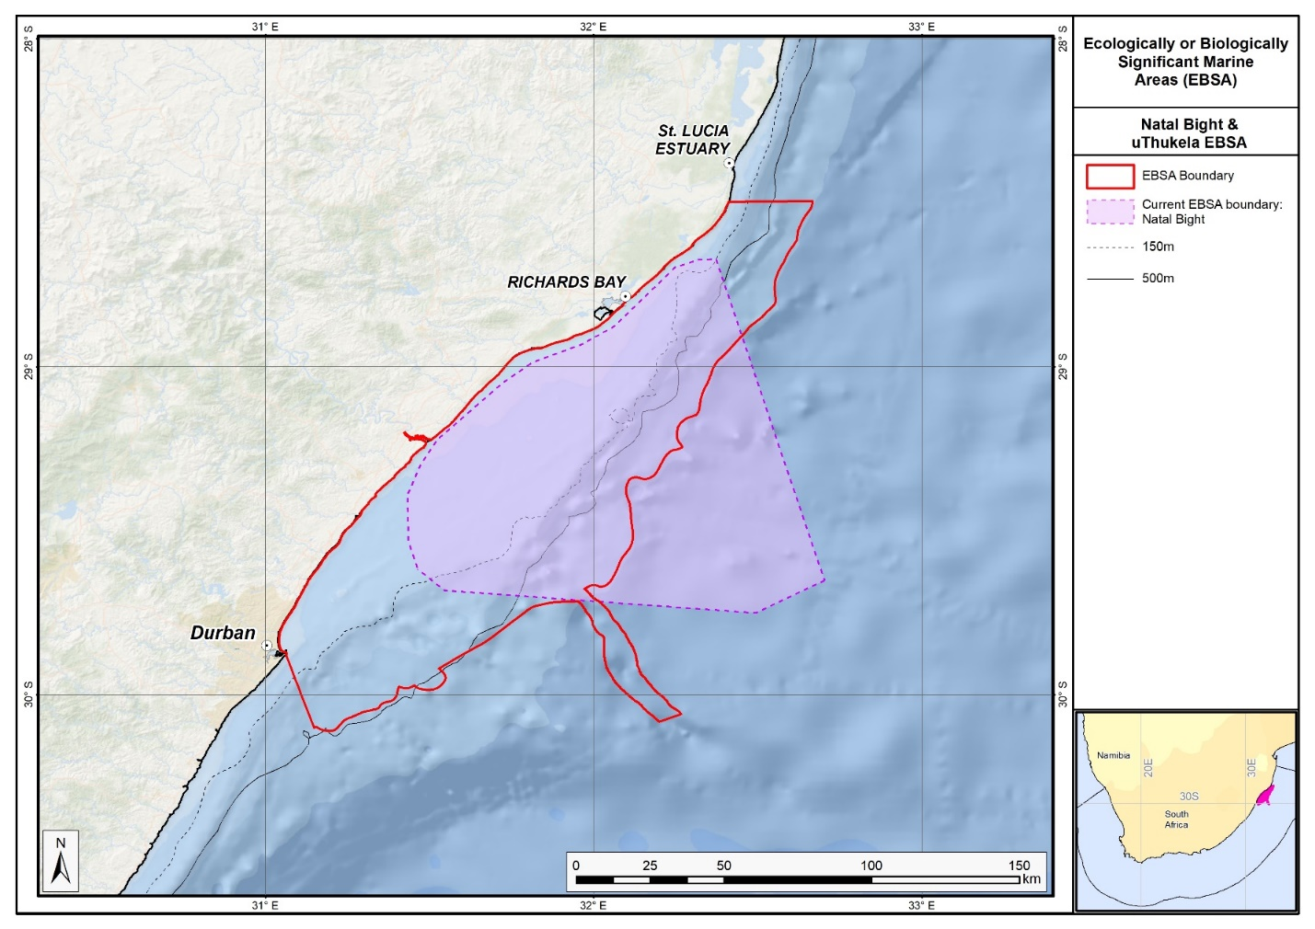
Map of the KwaZulu-Natal Bight and uThukela River area in relation to the original Natal Bight EBSA.

.
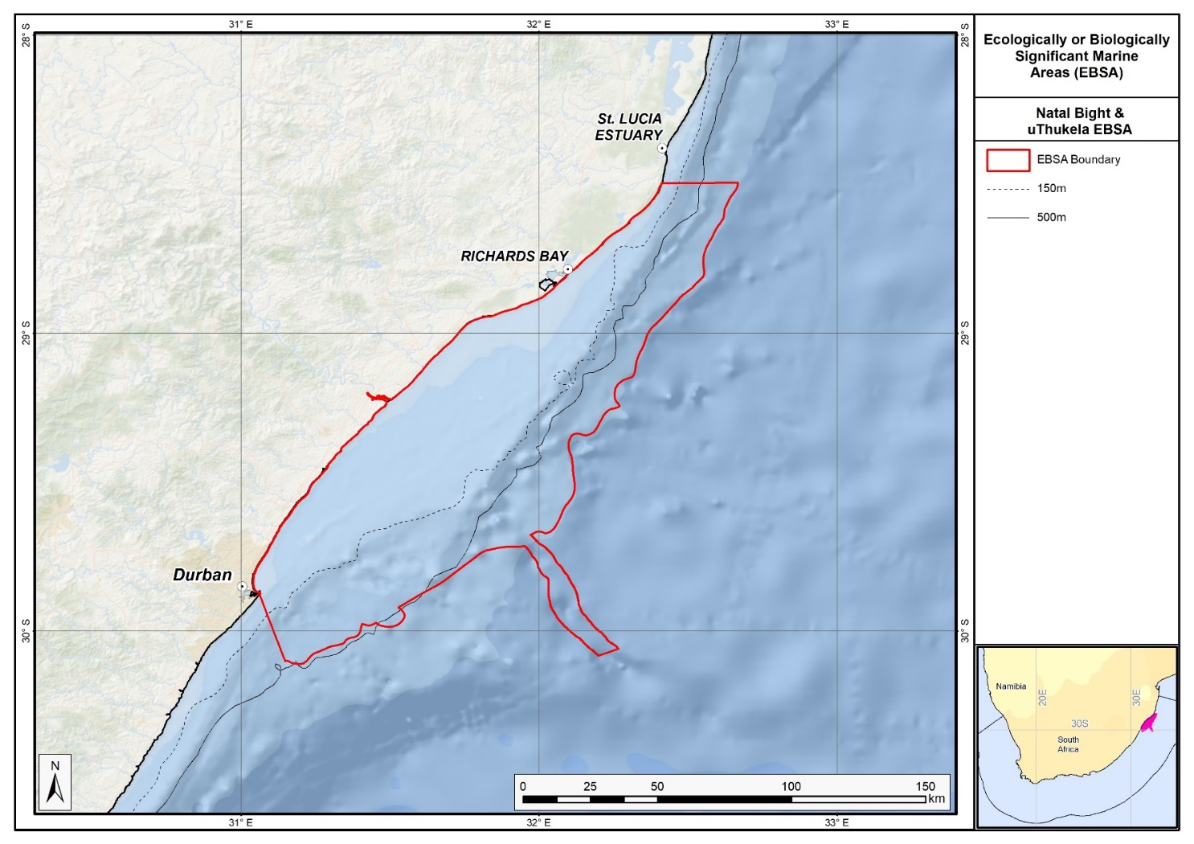
Map of the KwaZulu-Natal Bight and uThukela River area.
Rights and permissions:
No limits on sharing or publication.

22. Mallory escarpment and trough (modification of the existing Agulhas Slope and Seamounts)

Reason for the modification:
The EBSA description is being modified because of newly available or accessible knowledge on features associated with the area, based on additional scientific data especially new systematic spatial planning and assessments of biodiversity. The descriptions and supporting information are substantially extended, updated and refined beyond the original descriptions from the Southern Indian Ocean Regional EBSA Workshop, 2012. The modifications involve changes to the textual description, changes to the ranking of the area against the EBSA criteria, and changes in shape, location and size of the area.

The original descriptions of Ecologically or Biologically Significant Marine Areas (EBSAs) in the Benguela Current Large Marine Ecosystem (BCLME) were described in the Southern Indian Ocean Regional EBSA Workshop. The descriptions were generally characterized by generic, often fairly geometric delineations, consisting of approximate bounding boxes around the features for which the EBSA was described. This coarse scale of delineation was appropriate for a global scale but posed challenges for inclusion in national-level, place-based ocean management. The original boundaries were not sufficiently refined to capture the full extent of key biodiversity features and often overlapped with areas of lower biodiversity value or poor ecological condition.

Additionally, the original EBSA descriptions suffered from shortfalls related to limited spatial data and lack of systematic conservation planning approaches at the time they were first proposed. This meant that many boundaries did not precisely encompass biodiversity priority areas, potentially leading to conflicts with other ocean sectors and limiting their practical usefulness for marine spatial planning (MSP). The coarse scale and lack of detailed data constrained the ability to develop effective zoning and management recommendations that balance biodiversity protection with economic activities.

How was the submission developed?
The EBSA revision process was part a broader project on ecosystem-based MSP in the BCLME, namely the Benguela Current Marine Spatial Management and Governance Project (MARISMA, 2014-2023). This was a regional capacity-building and development cooperation project implemented by the Benguela Current Commission, the Governments of Angola, Namibia and South Africa, and GIZ, the German Agency for Development Cooperation (Deutsche Gesellschaft für Internationale Zusammenarbeit.

Because of these shortcomings of the existing EBSA boundaries, description and valuations set out in the previous section, the MARISMA project undertook a refinement process. This process used systematic conservation planning (SCP) tools, such as Marxan, to generate finer-scale, more accurate boundaries based on updated biodiversity data and expert input. This process also allowed for the identification of new EBSAs and the splitting of some original EBSAs into multiple refined areas to better reflect discrete biodiversity features and ecological processes. The refined EBSA boundaries were more suitable for MSP and conservation management because they focused on core natural and near-natural areas, avoided unnecessary conflicts with other sectors, and incorporated a systematic, data-driven approach to spatial prioritization.

The overall approach to the EBSA update and engagement followed these key steps:

Initial Systematic Conservation Planning (SCP) Analyses: Existing EBSAs were refined and new areas identified using systematic conservation planning tools such as Marxan, based on biodiversity input data including ecosystem types, species distributions, and ecological processes.

National Workshops: The refined and new EBSA boundaries were iteratively reviewed and adjusted through workshops held within each of the three countries (Angola, Namibia, South Africa). These workshops allowed country-specific input and tailoring of EBSA boundaries and descriptions to national contexts and priorities.

Regional Workshops and Bilateral Meetings between Countries: Workshops at the regional level especially focused on transboundary EBSAs shared between the countries, but also examined the overall approach to EBSAs, their delineation, description and the engagement approach. The aim was to harmonize boundaries, align management recommendations, and foster cooperation across national borders for effective regional marine biodiversity management. Additional specific bilateral meetings were held where necessary.

Technical and Scientific Peer Review: The revised and new EBSAs underwent technical review nationally and regionally (through technical review workshops involving relevant experts); and internationally with assistance from experts from the Global Ocean Biodiversity Initiative (GOBI) and members of the CBD's Informal Advisory Group on EBSAs, ensuring robustness of the exercise. The process is documented in peer reviewed literature (Harris et al., 2019, 2022).

Political Approval: The EBSAs were administratively and politically approved through all required stages up to the national ministerial level in each country and were then submitted to the CBD Secretariat by the National CBD Focal Points.

Data Sharing and Accessibility: All information, including refined EBSA boundaries, status assessments, management recommendations, and stakeholder feedback, were made available through online repositories such as the project's EBSA Portal (https://cmr.mandela.ac.za/Research-Projects/EBSA-Portal); and the EBSA were also shared via the Benguela Current Convention's Geodata Portal (https://geodata.benguelacc.org/ ). This facilitated transparency, accessibility, and ongoing updating of data and products for biodiversity specialists and other stakeholders.

Significant changes have been made to the delineation of the original Agulhas Slope and Seamounts EBSA and to the description, such that it is necessary to split the original EBSA into two, and revise the name of this EBSA to Mallory Escarpment and Trough to accurately reflect the features. Additional references have been added and updates to the description were made. A supplementary table of the ecosystem types represented in the EBSA and their associated threat status was also included.

An important change has been the significant delineation change of this EBSA to more closely focus the EBSA on the key biodiversity features in this area that support its EBSA status. The delineation process included an initial stakeholder review which identified the need to update boundaries, a technical mapping process and then an expert review workshop where boundary delineation options were reviewed, revised and finalised. The delineation process used a combination of Systematic Conservation Planning and Multi-Criteria Analysis methods. The features used in the analysis were:
- Key physical features (i.e. the seamounts, escarpment and trough) identified from the latest GEBCO data, global benthic geomorphology mapping (www.bluehabitats.org, Harris et al., 2014), the National Biodiversity Assessment 2011 (Sink et al., 2012) and BCC spatial mapping project (Holness et al., 2014) were incorporated.
- Irreplaceable and near irreplaceable (i.e. very high selection frequency) sites, as well as focus areas identified in the Systematic Conservation Plans undertaken for the West Coast by Majiedt et al. (2013), offshore areas (Sink et al., 2011) and by Holness et al. (2014) were incorporated.
- Delineations and threat status of constituent ecosystem types in the area were included in the analysis and used to refine the boundary of the EBSA.
- Areas of high relative naturalness of benthic and coastal systems and pelagic systems identified in the National Biodiversity Assessment 2011 (Sink et al., 2012a) were included in the analysis.
- Distributions of known fragile, vulnerable and sensitive habitat-forming species were included (Unpublished SANBI and SAEON data).

The multi-criteria analysis resulted a value surface. The cut-off value used to determine the extent of the EBSA was based on expert input and quantitative analysis of effective inclusion of the above features. This entailed taking an iterative parameter calibration-based approach whereby the spatial efficiency of the inclusion of the targeted features was evaluated. The approach aimed to identify a cut-off which most efficiently included prioritised features while minimizing the inclusion of impacted areas. The final boundaries shown in the map were validated in a national workshop.

Traditional knowledge was not incorporated into this process, and consultations with indigenous peoples or local communities were not undertaken. Therefore, documentation of Free, Prior and Informed Consent (FPIC) is not relevant for this EBSA process.

Where is the submission intended to be included (choose one option, and please note that there are different procedures for these two intended end points)?
[X] EBSA repository
[ ] EBSA information-sharing mechanism

Abstract:
Changes from the original version: The changes to the abstract focus on the specific inclusion of key Mallory escarpment and trough region, and the fact that the EBSA was split from the Agulhas Slope and Seamounts description to better focus on an represent underlying features.

The outer margin at the southern tip of the Agulhas Bank is a dynamic, highly productive offshore area with exceptional pelagic and benthic habitat heterogeneity. Located where the Agulhas and southern Benguela ecoregions converge, sporadic shelf-edge upwelling enhances productivity along the outer margin. The area is a recognized spawning ground for sardine, anchovy, horse mackerel and hake, with the apex functioning as a critical retention zone for spawning products. Eddies help to recirculate water inshore, linking important nursery areas with shelf-edge spawning habitats. The area includes the Mallory escarpment and trough segment of the Agulhas fracture zone, which is a unique regional feature with globally rare steep slopes (20°). The area has been identified as a priority through national spatial planning, owing to its high habitat diversity, and its boundary has been refined and split from that of the original Agulhas Slope and Seamounts EBSA, in order to represent underlying features better.

Introduction:
Changes from the original version: The introduction largely includes the original text but provides additional oceanographic details and up to date references. Additional references to the importance for turtles are included. The geomorphic uniqueness of the area is highlighted in the revised version.

Mallory Escarpment and Trough includes the outer margin along the southern tip of the Agulhas Bank in South Africa, chiefly encompassing the key features of the Agulhas Fracture Zone, including a slope as steep as 20° in some places (De Wet 2012). The Agulhas and Southern Benguela ecoregions (Sink et al., 2012) meet at this point, resulting in a dynamic offshore area with high pelagic and benthic habitat heterogeneity. Further, sporadic shelf-edge upwelling enhances the productivity along the outer margin (Lagabrielle, 2009, Roberson et al., 2017). The area is recognized as a spawning area for sardine, anchovy, horse mackerel and hake, and this apex of the Agulhas Bank is recognized as a critical area for retention of spawning products (Hutchings et al., 2002). Eddies in this area help recirculate water inshore and link important nursery areas with spawning habitat on the shelf edge. Leatherback turtles also frequent this area along their migrations (Harris et al., 2018). This area was identified as a priority through a national plan to identify focus areas for offshore protection (Sink et al., 2011) because it has relatively high habitat diversity and can meet multiple benthic and pelagic habitat conservation targets in a small area. It also contains regionally unique, globally very rare features.

Location:
Changes from the original version: The section reflects the updated spatial delineation focussed on the Mallory Escarpment and Trough, provides bounding box coordinates, and shares a link to the specific spatial data. Motivation for the spatial changes, and details of the spatial planning are given in “How was the submission developed?” Section. The key geographic change is the split of the original Agulhas Slope and Seamounts EBSA into two, with this Mallory Escarpment and Trough EBSA focussing on the trough and escarpment to accurately reflect the features.

The area is at the apex of the Agulhas Bank at the southern tip of the continental shelf edge off southern Africa. It is directly south of Cape Infanta and Cape Agulhas and is entirely within the exclusive economic zone of South Africa. It contains the Mallory escarpment and trough and lies immediately west of the Shackleton seamount complex area.
The coordinates of a minimum bounding box covering the entire scope of the area are:
- Latitude: -37.347, -36.615, -37.296, -38.029
- Longitude: 19.305, 21.903, 22.095, 19.497

Feature description of the area:
Changes from the original version: The revised description emphasizes the inclusion of benthic and pelagic features such as shelf edge, steep slope, trough, and shelf-edge upwelling, and highlights the presence of fragile and sensitive habitat-forming species. It describes the division from the original combined EBSA and underscores the high habitat diversity represented by six ecosystem types, based on new ecosystem assessments. A table of ecosystem types and their statuses is presented. The revised text also classifies the EBSA as Type 2, reflecting spatially stable features grouped together.

The area includes benthic and pelagic features, including: the shelf edge, a very steep slope and a trough as part of the Agulhas Fracture Zone; shelf-edge driven upwelling; and fragile and sensitive habitat-forming species. Habitat diversity is thus particularly high for a location this far offshore. This dynamic area consequently supports numerous ecological processes, such as spawning and foraging, and comprises a rich diversity of both resident (e.g., benthic gorgonians) and transient (e.g., migrating leatherbacks) species.

The delineation of this EBSA was refined since its first description, and is now split into two EBSAs: one for the seamounts, and one for the escarpment and trough features. The revision was based on high selection frequency of sites in the two systematic biodiversity plans covering the area, tighter alignment to the benthic topography (from a new national dataset: De Wet 2012), new focus areas for MPA expansion in South Africa, presence of fragile and sensitive habitat-forming species, and new delineation of the constituent ecosystem types. Effectively, these new data helped to improve the precision of the EBSA boundary so that it better reflects the underlying features. It is presented as a Type 2 EBSA because it contains “spatially stable features whose individual positions are known, but a number of individual cases are being grouped” (sensu Johnson et al., 2018).

The area includes six ecosystem types (which is relatively diverse for an area this far off the coast), including large areas of the Agulhas Basin Abyss and the Southwest Indian Lower Slope. All these ecosystems were assessed as being Least Concern in the National Biodiversity Assessment (Table below; Sink et al., 2019).

Summary of ecosystem types and threat status for the Mallory Escarpment and Trough EBSA. Data from Sink et al. (2019).
Threat Status | Ecosystem Type | Area (km²) | Area (%)
Least Concern | Agulhas Basin Abyss | 7799.9 | 59.7
 | Cape Basin Abyss | 357.1 | 2.7
 | Southeast Atlantic Lower Slope | 527.7 | 4.0
 | Southeast Atlantic Mid Slope | 3.0 | 0.0
 | Southwest Indian Lower Slope | 3487.2 | 26.7
 | Southwest Indian Mid Slope | 898.0 | 6.9
Grand Total |  | 13072.9 | 100.0

Feature condition and future outlook:
Changes from the original version: The section has been almost completely revised to reflect the splitting of the EBSA and newly available information. The revised description includes updated information on ecological condition, ecosystem threat statuses, and describes how the EBSA remains unprotected.

The shelf edge, slope and trough have not been sampled, although in-situ research is recommended in this area. Nevertheless, there are various fisheries operating in the area, but some of the hard grounds represented in the EBSA are outside of the trawl footprint. Broadly speaking, there is relatively little pressure in this area at present, the ecosystem types are in good ecological condition.

Mallory Escarpment and Trough is deeper than 1500 m and is thus largely in good ecological condition (55%), with the rest in fair ecological condition (45%); none of the EBSA extent is in poor ecological condition (Sink et al., 2019). Consequently, the full extent comprises ecosystem types that are Least Concern (100%) according to the National Biodiversity Assessment, providing excellent opportunity to protect the biodiversity in this area in a pristine or near-pristine state.

Protection of features in MPAs in the EBSAs adjacent to Mallory Escarpment and Trough have been considerably expanded and strengthened following the proclamation of the Operation Phakisa MPA network. However, this particular EBSA is one of only two in the country with no protection afforded to its special features, and all the constituent ecosystem types are either Poorly Protected or Not Protected. It is thus highly recommended as a site for future protected area expansion, particularly over the unique slope.

Assessment of the area against CBD EBSA Criteria:
Changes from the original version: The major change to the assessment is that the “Uniqueness or rarity” criteria has been upgraded from “Medium” to “High” based on the steep slope (20°) of Mallory Trough being the steepest portion of the entire South African continental shelf. It is also the only trough system in the Benguela region, and slopes as steep as 20° are globally very rare. Some additional oceanographic and species references are provided.

CBD EBSA Criteria  (Annex I to decision IX/20) | Description  (Annex I to decision IX/20) | Ranking of criterion relevance  (please mark one column with an X)
CBD EBSA Criteria  (Annex I to decision IX/20) | Description  (Annex I to decision IX/20) | No information |  | Low |  |  | Medium |  | High
Uniqueness or rarity | Area contains either (i) unique (“the only one of its kind”), rare (occurs only in few locations) or endemic species, populations or communities, and/or (ii) unique, rare or distinct, habitats or ecosystems; and/or (iii) unique or unusual geomorphological or oceanographic features. |  |  |  |  |  |  |  | x
The steep slope (20°) of Mallory Trough is the steepest portion of the entire South African continental shelf. It is also the only trough system in the Benguela region, and slopes as steep as 20° are globally very rare.
Special importance for life-history stages of species | Areas that are required for a population to survive and thrive. |  |  |  |  |  |  |  | X
The Agulhas Slope and Seamounts is recognized as a spawning area for small pelagic fish (sardine, anchovy, horse mackerel) and hake (Hutchings et al., 2002, Sink et al., 2011). This apex area of the Agulhas Bank is also recognized as a critical area for retention of spawning products. Eddies in this area help re-circulate water inshore and link important nursery areas with spawning habitat on the shelf edge. The shelf edge constitutes foraging area for offshore seabirds (Birdlife data, see references below).
Importance for threatened, endangered or declining species and/or habitats | Area containing habitat for the survival and recovery of endangered, threatened, declining species or area with significant assemblages of such species. |  |  |  |  |  | X
One of the pelagic ecosystem types in the area is characterised by elevated productivity and frequent fronts due to shelf edge upwelling (Lutjeharms et al., 2000, Lagabrielle 2009, Roberson et al., 2017). Consequently, regionally Critically Endangered leatherback turtles frequent this area (Petersen et al., 2009a; Harris et al., 2018), and the shelf edge is a feeding area for threatened seabirds such as Albatross (Petersen et al., 2009b).
Vulnerability, fragility, sensitivity, or slow recovery | Areas that contain a relatively high proportion of sensitive habitats, biotopes or species that are functionally fragile (highly susceptible to degradation or depletion by human activity or by natural events) or with slow recovery. |  |  |  |  |  |  |  | X
This area includes hard shelf edge and a very steep slope. These are likely to support fragile long-lived biota. Video images of the shelf edge show cold-water corals, gorgonians and large sponges (Sink et al., 2011). Vulnerable biota that use this area include long-lived seabirds, turtles and sharks, and the area has been identified by analyses aimed at identifying priority areas for reducing by-catch in the large pelagic fishery (Sink et al., 2011.)
Biological productivity | Area containing species, populations or communities with comparatively higher natural biological productivity. |  |  |  |  |  |  |  | X
There is higher productivity here, which is related to the eastern limit of the Benguela upwelling on the outer shelf (Pelagic ecosystem type Ab3) and very frequent SST and chlorophyll fronts (Lutjeharms et al., 2000, Lagabrielle 2009, Sink et al., 2011, 2012, Roberson et al., 2017). Cool productive water is advected onto the shelf in this sheer zone through Agulhas Current–driven upwelling cells (Lutjeharms et al., 2000).
Biological diversity | Area contains comparatively higher diversity of ecosystems, habitats, communities, or species, or has higher genetic diversity. |  |  |  |  |  |  |  | X
This area has high pelagic and benthic habitat heterogeneity for an offshore site, comprising six ecosystem types at the confluence of the Indian and Atlantic Ocean basins. The very steep slope is also expected to host a rich diversity of species because it spans a very large depth range over a proportionately small area.
Naturalness | Area with a comparatively higher degree of naturalness as a result of the lack of or low level of human-induced disturbance or degradation. |  |  |  |  |  |  |  |  | X
Rough grounds and strong currents already offer some protection from pressures to this area (Sink et al., 2011, 2012). Relatively lower levels of disturbance occur in this area (Sink et al., 2012), and most of the local hard areas fall outside of the hake trawl footprint (Sink et al., 2011).

References:
Changes from the original version: The revised description includes a substantially expanded reference list, incorporating recent peer-reviewed publications and technical reports.

De Wet, W. 2012. Bathymetry of the South African Continental Shelf. MSc dissertation. University of Cape Town, South Africa.
Harris, L., Holness, S., Finke, G., Kirkman, S., Sink, K., 2019. Systematic Conservation Planning as a Tool to Advance Ecologically or Biologically Significant Area and Marine Spatial Planning Processes, in: Zaucha, J., Gee, K. (Eds.), Maritime Spatial Planning. Palgrave Macmillian, Cham.
Harris, L.R., Holness, S.D., Finke, G., Amunyela, M., Braby, R., Coelho, N., Gee, K., Kirkman, S.P., Kreiner, A., Mausolf, E., Majiedt, P., Maletzky, E., Nsingi, K.K., Russo, V., Sink, K.J., Sorgenfrei, R., 2022. Practical Marine Spatial Management of Ecologically or Biologically Significant Marine Areas: Emerging Lessons From Evidence-Based Planning and Implementation in a Developing-World Context. Front. Mar. Sci. 9.
Harris, L.R., Nel, R., Oosthuizen, H., Meyer, M., Kotze, D., Anders, D., McCue, S., Bachoo, S. 2018. Managing conflicts between economic activities and threatened migratory marine species towards creating a multi-objective blue economy. Conservation Biology, 32, 411-423.
Hutchings, L., Beckley, L.E., Griffiths, M.H., Roberts, M.J., Sundby, S., van der Lingen, C. 2002. Spawning on the edge: spawning grounds and nursery areas around the southern African coastline. Marine and Freshwater Research, 53: 307-318.
Johnson, D.E., Barrio Froján, C., Turner, P.J., Weaver, P., Gunn, V., Dunn, D.C., Halpin, P., Bax, N.J., Dunstan, P.K., 2018. Reviewing the EBSA process: Improving on success. Marine Policy 88, 75-85.
Lagabrielle, E. 2009. Preliminary report: National Pelagic Bioregionalisation of South Africa. Cape Town: South African National Biodiversity Institute.
Lutjeharms, J.R.E., Cooper, J., Roberts, M. 2000. Upwelling at the inshore edge of the Agulhas Current. Continental Shelf Research, 20: 737 – 761.
Roberson, L.A., Lagabrielle, E., Lombard, A.T., Sink, K., Livingstone, T., Grantham, H., Harris, J.M. 2017. Pelagic bioregionalisation using open-access data for better planning of marine protected area networks. Ocean & Coastal Management, 148: 214-230.
Sink, K. 2016. Deep Secrets: the outer shelf and slope ecosystems of South Africa. Cruise Report: ALG 230 – ACEP_DSC.
Sink, K., Holness, S., Harris, L., Majiedt, P., Atkinson, L., Robinson, T., Kirkman, S., Hutchings, L., Leslie, R., Lamberth, S., Kerwath, S., von der Heyden, S., Lombard, A., Attwood, C., Branch, G., Fairweather, T., Taljaard, S., Weerts, S., Cowley, P., Awad, A., Halpern, B., Grantham, H., Wolf, T. 2012. National Biodiversity Assessment 2011: Technical Report. Volume 4: Marine and Coastal Component. South African National Biodiversity Institute, Pretoria.
Sink, K.J., Attwood, C.G., Lombard, A.T., Grantham, H., Leslie, R., Samaai, T., Kerwath, S., Majiedt, P., Fairweather, T., Hutchings, L., van der Lingen, C., Atkinson, L.J., Wilkinson, S., Holness, S., Wolf, T. 2011. Spatial planning to identify focus areas for offshore biodiversity protection in South Africa. Unpublished Report. Cape Town: South African National Biodiversity Institute.
Sink, K.J., van der Bank, M.G., Majiedt, P.A., Harris, L.R., Atkinson, L., Karenyi, N., Kirkman, S. (eds) 2019. National Biodiversity Assessment 2018 Technical Report Volume 4: Marine Realm. South African National Biodiversity Institute, Pretoria.

Maps and Figures:
GIS data available at: https://cmr.mandela.ac.za/cmr/media/Store/documents/EBSA/Descriptions/SouthAfrica/Shapefile-RSA_EBSAs_final.zip

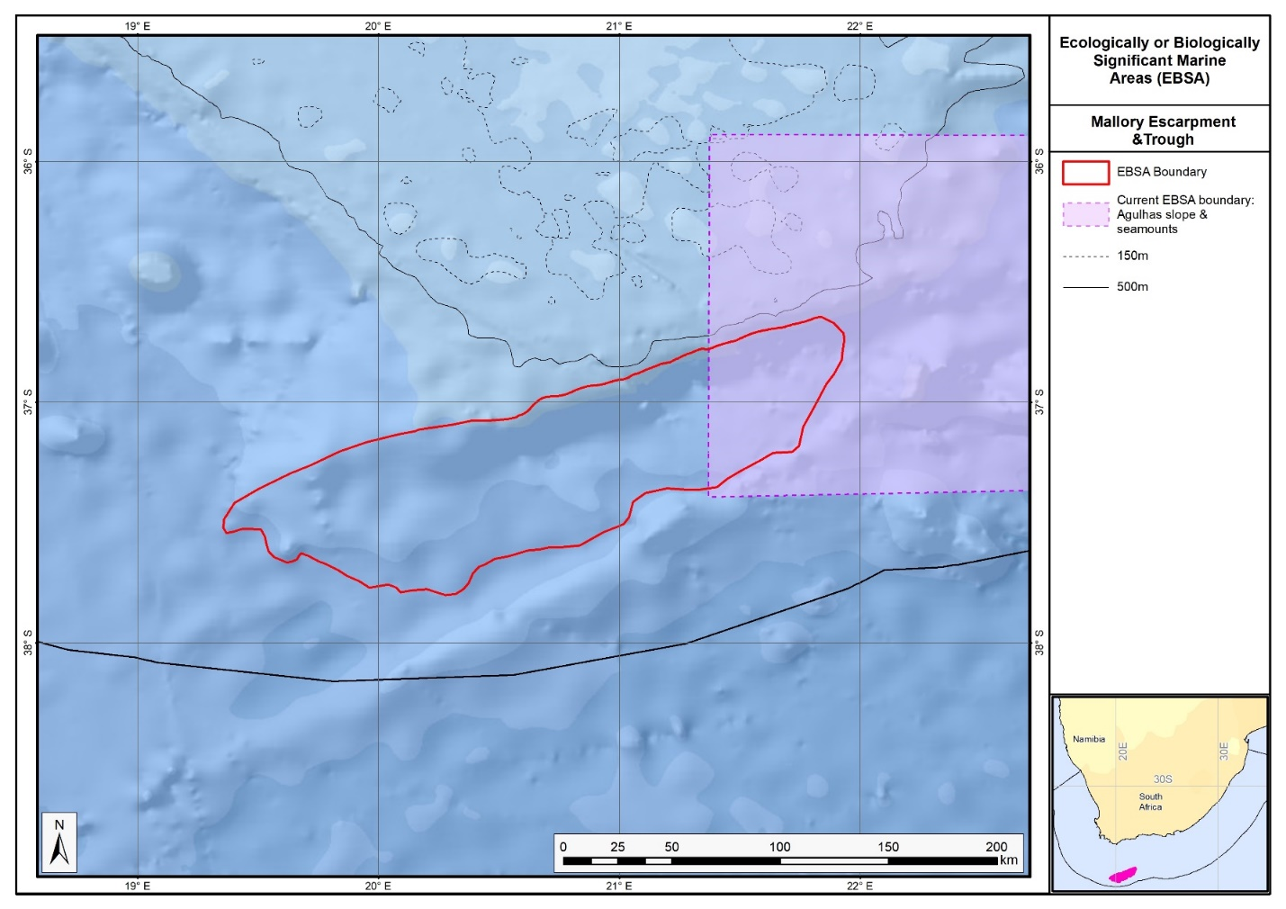
Map of the Mallory Escarpment and Trough area in relation to the original Agulhas Slope and Seamounts EBSA.
.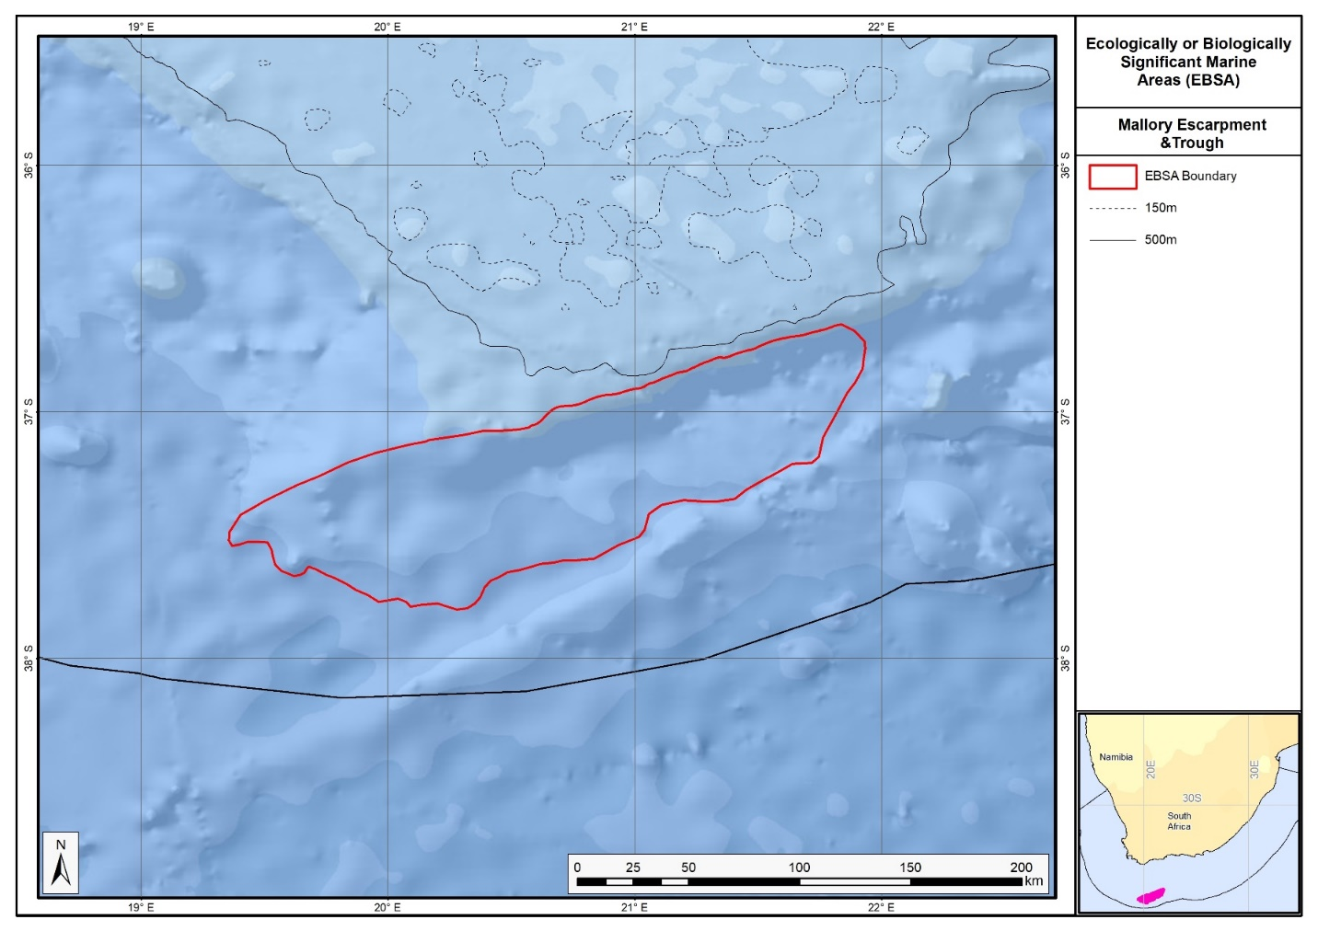
Map of the Mallory Escarpment and Trough area.

Rights and permissions:
No limits on sharing or publication.

23. Namaqua Coastal Area (modification of the existing Namaqua Coastal Area)

Reason for the modification:
The EBSA description is being modified because of newly available or accessible knowledge on features associated with the area, based on additional scientific data especially new systematic spatial planning and assessments of biodiversity. The descriptions and supporting information are substantially extended, updated and refined beyond the original descriptions from the South-Eastern Atlantic workshop, April 2013. The modifications involve changes to the textual description, changes to the ranking of the area against the EBSA criteria, and changes in shape, location and size of the area.

The original descriptions of Ecologically or Biologically Significant Marine Areas (EBSAs) in the Benguela Current Large Marine Ecosystem (BCLME) were described in the South-Eastern Atlantic workshop (April 2013). The descriptions were generally characterized by generic, often fairly geometric delineations, consisting of approximate bounding boxes around the features for which the EBSA was described. This coarse scale of delineation was appropriate for a global scale but posed challenges for inclusion in national-level, place-based ocean management. The original boundaries were not sufficiently refined to capture the full extent of key biodiversity features and often overlapped with areas of lower biodiversity value or in poor ecological condition.

Additionally, the original EBSA descriptions suffered from shortfalls related to limited spatial data and lack of systematic conservation planning approaches at the time they were first proposed. This meant that many boundaries did not precisely encompass biodiversity priority areas, potentially leading to conflicts with other ocean sectors and limiting their practical usefulness for marine spatial planning (MSP). The coarse scale and lack of detailed data constrained the ability to develop effective zoning and management recommendations that balance biodiversity protection with economic activities.

How was the submission developed?
The EBSA revision process was part a broader project on ecosystem-based MSP in the BCLME, namely the Benguela Current Marine Spatial Management and Governance Project (MARISMA, 2014-2023). This was a regional capacity-building and development cooperation project implemented by the Benguela Current Commission, the Governments of Angola, Namibia and South Africa, and GIZ, the German Agency for Development Cooperation (Deutsche Gesellschaft für Internationale Zusammenarbeit.

Because of these shortcomings of the existing EBSA boundaries, description and valuations set out in the previous section, the MARISMA project undertook a refinement process. This process used systematic conservation planning (SCP) tools, such as Marxan, to generate finer-scale, more accurate boundaries based on updated biodiversity data and expert input. This process also allowed for the identification of new EBSAs and the splitting of some original EBSAs into multiple refined areas to better reflect discrete biodiversity features and ecological processes. The refined EBSA boundaries were more suitable for MSP and conservation management because they focused on core natural and near-natural areas, avoided unnecessary conflicts with other sectors, and incorporated a systematic, data-driven approach to spatial prioritization.

The overall approach to the EBSA update and engagement followed these key steps:

Initial Systematic Conservation Planning (SCP) Analyses: Existing EBSAs were refined and new areas identified using systematic conservation planning tools such as Marxan, based on biodiversity input data including ecosystem types, species distributions, and ecological processes.

National Workshops: The refined and new EBSA boundaries were iteratively reviewed and adjusted through workshops held within each of the three countries (Angola, Namibia, South Africa). These workshops allowed country-specific input and tailoring of EBSA boundaries and descriptions to national contexts and priorities.

Regional Workshops and Bilateral Meetings between Countries: Workshops at the regional level especially focused on transboundary EBSAs shared between the countries, but also examined the overall approach to EBSAs, their delineation, description and the engagement approach. The aim was to harmonize boundaries, align management recommendations, and foster cooperation across national borders for effective regional marine biodiversity management. Additional specific bilateral meetings were held where necessary.

Technical and Scientific Peer Review: The revised and new EBSAs underwent technical review nationally and regionally (through technical review workshops involving relevant experts); and internationally with assistance from experts from the Global Ocean Biodiversity Initiative (GOBI) and members of the CBD's Informal Advisory Group on EBSAs, ensuring robustness of the exercise. The process is documented in peer reviewed literature (Harris et al., 2019, 2022).

Political Approval: The EBSAs were administratively and politically approved through all required stages up to the national ministerial level in each country and were then submitted to the CBD Secretariat by the National CBD Focal Points.

Data Sharing and Accessibility: All information, including refined EBSA boundaries, status assessments, management recommendations, and stakeholder feedback, were made available through online repositories such as the project's EBSA Portal (https://cmr.mandela.ac.za/Research-Projects/EBSA-Portal); and the EBSA were also shared via the Benguela Current Convention's Geodata Portal (https://geodata.benguelacc.org/ ). This facilitated transparency, accessibility, and ongoing updating of data and products for biodiversity specialists and other stakeholders.

Some technical revisions and updates to the description were made, even though little additional information was available, and no new research has been carried out in the area since its original adoption in 2014. Small additions, such as biodiversity information from OBIS were made, but none of these edits were significant enough to drive a change in the EBSA criteria ranks. A supplementary table of the habitats represented in the EBSA and their associated threat status was also included.
The boundary of this EBSA has been refined to more closely focus the EBSA on the key biodiversity features that underlie its EBSA status. The delineation process included an initial stakeholder review, a technical mapping process and then an expert review workshop where boundary delineation options were finalised. The delineation process used a combination of Systematic Conservation Planning and Multi-Criteria Analysis methods. The features used in the analysis were:
- Delineations and threat status of consitituent ecosystem types in the area were included in the analysis and used to refine the boundary of the EBSA.
- Irreplaceable and near irreplaceable (i.e. very high selection frequency) sites, as well as focus areas identified in the SCP undertaken for the West Coast by Majiedt et al. (2013) and for the BCLME by Holness et al. (2014) were incorporated.
- Areas of high relative naturalness of benthic and coastal systems identified in the National Biodiversity Assessment 2011 (Sink et al., 2012), the West Coast (Majiedt et al., 2013) and the BCLME spatial assessments (Holness et al., 2014) were included in the analysis.
- Distributions of known fragile, vulnerable and sensitive habitat-forming species were included (Unpublished SANBI and SAEON data).

The multi-criteria analysis resulted in a value surface. The cut-off value used to determine the extent of the EBSA was based on expert input and quantitative analysis of effective inclusion of the above features. This entailed taking an iterative parameter calibration-based approach whereby the spatial efficiency of the inclusion of the targeted features was evaluated. The approach aimed to identify a cut-off which most efficiently included prioritised features while minimizing the inclusion of impacted areas. The final boundaries shown in the map were validated in a national workshop. The new boundary extends the EBSA further offshore.

Traditional knowledge was not incorporated into this process, and consultations with indigenous peoples or local communities were not undertaken. Therefore, documentation of Free, Prior and Informed Consent (FPIC) is not relevant for this EBSA process.

Where is the submission intended to be included (choose one option, and please note that there are different procedures for these two intended end points)?
[X] EBSA repository
[ ] EBSA information-sharing mechanism

Abstract:
Changes from the original version: The revised description expands the abstract by emphasizing the extension of the EBSA boundary offshore by 7-20 km to better capture ecological features, whereas the original summary focused primarily on the area’s high productivity and biomass and its relatively pristine condition. The revised description more explicitly notes the inclusion of threatened ecosystem types and the area's role as a refuge for estuarine habitats and coastal fish species. This update reflects improved scientific understanding and spatial data accuracy, enhancing the relevance of the EBSA for conservation planning.

The Namaqua Coastal Area lies along the west coast of South Africa within the Namaqua bioregion. The area is distinguished by exceptional productivity and high community biomass. Much of the area has relatively pristine habitat conditions, owing to minimal anthropogenic pressures, compared with other coastal areas in Northern Cape. The natural state makes it critically important for conserving threatened ecosystem types, including two endangered types and four vulnerable types. The area is a vital refuge for estuarine habitats and coastal fish species. Following recent research into underlying biodiversity patterns, the boundary of the area described in the present submission extends from 7 to 20 km offshore from that of the existing EBSA. The expansion helps to reflect better the area’s ecological features and thereby ensure more effective conservation alignment with the region’s biological significance.

Introduction:
Changes from the original version: The revised description provides a more detailed spatial framing of the area, specifying its location from the estuary of the Spoeg River to the estuary of the Sout River and extending offshore to approximately 33-36 km, whereas the original description mentioned the area extending to the 120 m depth contour without precise offshore distance. The revised text incorporates updated ecosystem classifications (Namaqua coastal, inner, middle, and outer shelf ecosystem types) and more recent pelagic productivity data linked to upwelling processes.

The Namaqua Coastal Area is located from the estuary of the Spoeg River to the estuary of the Sout River in the Namaqua biogeographic region (bioregion) of South Africa (Sink et al., 2012), and from the dune base to approximately 33-36 km offshore. It consists of Namaqua coastal, inner, middle and outer shelf ecosystem types (Sink et al., 2019). The associated pelagic environment is characterized by upwelling, giving rise to very cold waters with very high productivity/chlorophyll levels (Lagabrielle 2009, Roberson et al., 2017). Altogether, the area includes three estuaries (van Niekerk and Turpie, 2012).

Location:
Changes from the original version: The section reflects the updated spatial delineation, provide bounding box coordinates, and shares a link to the specific spatial data. Motivation for the spatial changes, and details of the spatial planning are given in “How was the submission developed?” Section.

The area is within the exclusive economic zone of South Africa, occurring on the west coast, in the Namaqua bioregion. It is bounded to the north and south by the estuaries of the Spoeg and Sout Rivers, respectively, and extends offshore from approximately 33 to 36 km.
The coordinates of a minimum bounding box covering the entire scope of the area are:
- Latitude: -30.334, -31.271, -31.476, -30.539
- Longitude: 17.281, 17.868, 17.54, 16.953

Feature description of the area:
Changes from the original version: The revised description integrates updated ecosystem typologies, including coastal, inner, middle, and outer shelf types, and notes the presence of three estuaries with specific references. It also highlights a recent partial protection within the Namaqua National Park MPA declared in 2019, an element absent in the original description. New data on ecosystem types and threat status are provided. The revised text includes updated oceanographic references and emphasizes the ecological importance of upwelling-driven productivity. These updates stem from new data sources and reflect changes in protection status, enhancing the biological and conservation context. The site is presented as a Type 1 EBSA because it contains “Spatially stable features whose positions are known and individually resolved on the maps” (sensu Johnson et al., 2018).

The area consists of Namaqua coastal, inner, middle and outer shelf ecosystem types (See Table below; Sink et al., 2019). There are also three estuaries in the area (van Niekerk and Turpie 2011). The associated pelagic environment is characterized by very high productivity, high chlorophyll and very cold water (SST mean = 15.2°C) caused by upwelling (Lagabrielle 2009, Roberson et al., 2017), also serving as an important area for coastal fish (Turpie et al., 2000). A portion of the EBSA has recently been protected in the Namaqua National Park MPA declared in 2019.

The area is important for a number of threatened ecosystems identified in the National Biodiversity Assessment (Sink et al., 2019; Table below). Two of the ecosystem types represented in the area (Cool Temperate Arid Predominantly Closed Estuary; Southern Benguela Reflective Sandy Shore) are Endangered (Sink et al., 2019). This implies that very little of the total area of these ecosystem types in South Africa is in natural/pristine condition. The Vulnerable Namaqua Exposed Rocky Shore, Namaqua Kelp Forest, Namaqua Mixed Shore, Namaqua Very Exposed Rocky Shore and Southern Benguela Intermediate Sandy Shore are also found in the area. However, these ecosystem types were all found to be in good condition in the area, therefore the importance of the area for the conservation of these threatened ecosystem types has been emphasized (Majiedt et al., 2013).

Since original description, the EBSA has been extended offshore by approximately 7-20 km so that the new offshore extent is 36 km at its widest point. The alongshore extent remains the same as before between the Spoeg and Sout estuaries. The extension was based on better alignment with the features comprising the EBSA, and their condition and threat status. This was based on new research (Karenyi 2014) that has allowed better ecosystem mapping in the area, thus affording more precision in the EBSA boundary rather than following an old proposed MPA boundary that was not adopted. The site is presented as a Type 1 EBSA because it contains “Spatially stable features whose positions are known and individually resolved on the maps” (sensu Johnson et al., 2018).

Summary of ecosystem types and threat status for the Namaqua Coastal Area. Data from Sink et al. (2019).
Threat Status | Ecosystem Type | Area (km²) | Area (%)
Endangered | Cool Temperate Arid Predominantly Closed Estuary | 0.5 | 0.0
 | Southern Benguela Reflective Sandy Shore | 1.4 | 0.0
Vulnerable | Namaqua Exposed Rocky Shore | 12.1 | 0.3
 | Namaqua Kelp Forest | 1.7 | 0.0
 | Namaqua Mixed Shore | 19.2 | 0.5
 | Namaqua Very Exposed Rocky Shore | 1.2 | 0.0
Near Threatened | Southern Benguela Intermediate Sandy Shore | 3.1 | 0.1
Least Concern | Namaqua Muddy Mid Shelf Mosaic | 2333.1 | 66.5
 | Namaqua Sandy Inner Shelf | 303.7 | 8.7
 | Namaqua Sandy Mid Shelf | 230.9 | 6.6
 | Southern Benguela Dissipative-Intermediate Sandy Shore | 4.2 | 0.1
 | Southern Benguela Muddy Sands | 345.1 | 9.8
 | Southern Benguela Sandy Outer Shelf | 250.6 | 7.1
Grand Total |  | 3507.1 | 100.0

Feature condition and future outlook:
Changes from the original version: The revised description presents an updated and more nuanced assessment of ecosystem threat statuses, identifying two Endangered and multiple Vulnerable ecosystem types, whereas the original noted three Critically Endangered habitats but lacked detailed threat status quantification. It also reports the improved protection status of the area due to the 2019 MPA declaration, increasing protection from zero to 16%, which was not mentioned previously. The revised version incorporates recent assessments of human impact and habitat condition, highlighting the area's relatively pristine state compared to other Northern Cape coastal areas. These changes are motivated by new spatial threat analyses and reflect progress in conservation measures.

Sink et al. (2012, 2019) estimated the threat status of marine and coastal ecosystem types identified for South Africa by assessing the (weighted) cumulative impacts of various pressures (e.g., extractive resource use, pollution, development, and others) on each ecosystem type. Six of the ecosystem types represented in the area are threatened, including two Endangered (Cool Temperate Arid Predominantly Closed Estuary; Southern Benguela Reflective Sandy Shore) and four Vulnerable types (Namaqua Exposed Rocky Shore; Namaqua Kelp Forest; Namaqua Mixed Shore; Namaqua Very Exposed Rocky Shore; Southern Benguela Intermediate Sandy Shore)(See table in Feature Description). This implies that there has been substantial degradation in natural/pristine condition of these ecosystem types, and it is expected that important components of biodiversity pattern have been lost and that ecological processes have been moderately to heavily modified. However, the core of the area identified for the EBSA, namely the coastal extent of the area (between the Brak and Sout rivers) is the only stretch of coast in the Northern Cape province of South Africa that is in good (natural/pristine) condition (Sink et al., 2012). This is because very little mining (the most prominent anthropogenic pressure on this coastline) or other pressures have affected this section. Moreover, other habitat in the area (particularly that between the Spoeg and Groen rivers) was assessed to be mainly in fair condition, with little industry present in the area except for some boat-based mining for which SCUBA is used (Majiedt et al., 2013). Of the three estuaries in the area, two (the Groen and the Spoeg) have been identified as national priorities for estuarine protection (van Niekerk and Turpie 2012).

The lack of marine protected areas in South Africa’s Northern Cape province has been highlighted as an issue of concern (Sink et al., 2012, Majiedt et al., 2013). Considering this and the following characteristics of the area: (i) the threatened ecosystem types represented there, (ii) the relative lack of human industry and consequently the good condition of much of the habitat in the area, (iii) the connectivity between part of the area and an established terrestrial national park, and (iv) the priority for national estuarine conservation of two of the river mouths in the area, most of the extent of the area has been identified as priority marine/coastal habitat for spatial protection (Sink et al., 2012, Majiedt et al., 2013). Furthermore, a complementarity analysis based on fish distribution data indicated that the coast within the area is a priority area for the conservation of coastal fish species in South Africa (Turpie et al., 2000). In an attempt to start to address these concerns, a portion of the EBSA has recently been protected in the Namaqua National Park MPA declared in 2019. This resulted in the EBSA area within reserves increasing from no protection to 16%. The new MPA is the first and only MPA along South Africa’s west coast (north of Langebaan Lagoon and adjacent islands), and the only coastal reserve in the Namaqua ecoregion. Consequently, many of the represented ecosystem types are still poorly protected overall, although some are now moderately protected, and one is well protected.

Assessment of the area against CBD EBSA Criteria:
Changes from the original version: The revised description retains the same rankings for all applicable EBSA criteria as the original. However, the revised text provides more detailed supporting evidence and updated scientific references to justify these rankings, more strongly emphasizing the area's role as a nursery for commercially important fish species and the presence of threatened ecosystem types in good condition.

CBD EBSA Criteria  (Annex I to decision IX/20) | Description  (Annex I to decision IX/20) | Ranking of criterion relevance  (please mark one column with an X)
CBD EBSA Criteria  (Annex I to decision IX/20) | Description  (Annex I to decision IX/20) | No information |  | Low |  |  | Medium |  | High
Uniqueness or rarity | Area contains either (i) unique (“the only one of its kind”), rare (occurs only in few locations) or endemic species, populations or communities, and/or (ii) unique, rare or distinct, habitats or ecosystems; and/or (iii) unique or unusual geomorphological or oceanographic features. |  |  | x
None of the ecosystem types represented in the area are unique to the area (Sink et al., 2012, 2019, Majiedt et al., 2013).
Special importance for life-history stages of species | Areas that are required for a population to survive and thrive. |  |  |  |  |  | X
The area is part of the important west coast nursery area for commercially caught pelagic fish species in South Africa (Hutchings et al., 2002). It also includes three estuaries that may also provide nurseries for coastal fish species (van Niekerk and Turpie 2000), many of which are in an over-exploited state (Mann 2000). The site also includes breeding habitat for birds, such as white breasted cormorants (Crawford et al., 2013) and roost sites for African black oystercatchers (Rao et al., 2014).
Importance for threatened, endangered or declining species and/or habitats | Area containing habitat for the survival and recovery of endangered, threatened, declining species or area with significant assemblages of such species. |  |  |  |  |  |  |  | X
Two of the ecosystem types represented in the area (Cool Temperate Arid Predominantly Closed Estuary; Southern Benguela Reflective Sandy Shore) are Endangered (Sink et al., 2019). This implies that very little of the total area of these ecosystem types in South Africa is in natural/pristine condition. The Vulnerable Namaqua Exposed Rocky Shore, Namaqua Kelp Forest, Namaqua Mixed Shore, Namaqua Very Exposed Rocky Shore and Southern Benguela Intermediate Sandy Shore are also found in the area. However, these ecosystem types were all found to be in good condition in the area, therefore the importance of the area for the conservation of these threatened ecosystem types has been emphasized (Majiedt et al., 2013). The Namaqua Coastal Area is also important for estuarine conservation, given the presence of three estuaries and the fact that the conservation status of ±80 % of South Africa’s estuarine area is classified as threatened (van Niekerk and Turpie 2012). Furthermore, populations of many coastal fish species in South Africa are under severe conservation threat, mainly due to overexploitation (Mann 2000), and the Namaqua Coastal Area is a key site for protection of coastal fish species in South Africa (Turpie et al., 2000).
Vulnerability, fragility, sensitivity, or slow recovery | Areas that contain a relatively high proportion of sensitive habitats, biotopes or species that are functionally fragile (highly susceptible to degradation or depletion by human activity or by natural events) or with slow recovery. |  |  |  |  |  | X
The threatened status of ecosystem types that occur in the focus area (Sink et al., 2012), implies that degradation and some loss of ecosystem processes has been associated with these ecosystem types in other areas, and therefore that they are vulnerable to effects of human activities.
Biological productivity | Area containing species, populations or communities with comparatively higher natural biological productivity. |  |  |  |  |  |  |  | X
The pelagic environment associated with this area is characterized by very cold water, high chlorophyll concentrations and high biological productivity, due to wind-induced upwelling (Hutchings et al., 2009, Lagabrielle 2009, Roberson et al., 2017). Due to the abundance of nutrients associated with the upwelling, the biomass of communities along the shoreline (intertidal) is significantly higher than that in the other two bioregions of South Africa (Bustamante and Branch 1996).
Biological diversity | Area contains comparatively higher diversity of ecosystems, habitats, communities, or species, or has higher genetic diversity. |  |  |  | X
Although the productivity and biomass of communities along the shore of the Namaqua bioregion (where the EBSA occurs) is higher than elsewhere in the country, the species diversity is lower than elsewhere (Bustamante and Branch 1996).
Naturalness | Area with a comparatively higher degree of naturalness as a result of the lack of or low level of human-induced disturbance or degradation. |  |  |  |  |  |  |  |  | X
There is a relative lack of human activities (past and present) in the Namaqua Coastal Area. Consequently, even ecosystem types that are threatened at a national level are in good condition in this area (Sink et al., 2012), and hence have been highlighted as conservation priority areas along the South African west coast (Majiedt et al., 2013).

References:
Changes from the original version: The revised description includes a substantially expanded reference list, incorporating recent peer-reviewed publications and technical reports.

Bustamante, R.H., Branch, G.M. 1996. Large scale patterns and trophic structure of southern African rocky shores. The roles of geographic variation and wave exposure. Journal of Biogeography 23: 339-351.
Crawford, R.J.M., Randall, R.M., Whittington, P.A., Waller, L., Dyer, B.M., Allan, D.G., Fox, C., Martin, A.P., Upfold, L., Visagie, J., Bachoo, S., Bowker, M., Downs, C.T., Fox, R., Huisamen, J., Makhado, A.B., Oosthuizen, W.H., Ryan, P.G., Taylor R.H., Turpie, J.K. 2013. South Africa's coastal-breeding white-breasted cormorants: population trends, breeding season and movements, and diet. African Journal of Marine Science, 35: 473-490.
Harris, L., Holness, S., Finke, G., Kirkman, S., Sink, K., 2019. Systematic Conservation Planning as a Tool to Advance Ecologically or Biologically Significant Area and Marine Spatial Planning Processes, in: Zaucha, J., Gee, K. (Eds.), Maritime Spatial Planning. Palgrave Macmillian, Cham.
Harris, L.R., Holness, S.D., Finke, G., Amunyela, M., Braby, R., Coelho, N., Gee, K., Kirkman, S.P., Kreiner, A., Mausolf, E., Majiedt, P., Maletzky, E., Nsingi, K.K., Russo, V., Sink, K.J., Sorgenfrei, R., 2022. Practical Marine Spatial Management of Ecologically or Biologically Significant Marine Areas: Emerging Lessons From Evidence-Based Planning and Implementation in a Developing-World Context. Front. Mar. Sci. 9.
Holness, S., Kirkman, S., Samaai, T., Wolf, T., Sink, K., Majiedt, P., Nsiangango, S., Kainge, P., Kilongo, K., Kathena, J., Harris, L., Lagabrielle, E., Kirchner, C., Chalmers, R., Lombard, M. 2014. Spatial Biodiversity Assessment and Spatial Management, including Marine Protected Areas. Final report for the Benguela Current Commission project BEH 09-01.
Hutchings, L., van der Lingen, C.D., Griffiths, M., Roberts, M.R., Beckley, L.E., Sundby, S. 2002. Spawning on the edge: spawning grounds and nursery areas around the South African coast. Marine and Freshwater Research, 53: 307–318.
Hutchings, L., van der Lingen, C.D., Shannon, L.J., Crawford, R.J.M., Verheye, H.M.S., Bartholomae, C.H., van der Plas, A.K., Louw, D., Kreiner, A., Ostrowski, M., Fidel, Q., Barlow, R.G., Lamont, T., Cotzee, J., Shillington, F., Veitch, J., Currie, J.C., Monteiro, P.M.S. 2009. The Benguela Current: An ecosystem of four components. Progress in Oceanography, 83: 15 – 32.
Johnson, D.E., Barrio Froján, C., Turner, P.J., Weaver, P., Gunn, V., Dunn, D.C., Halpin, P., Bax, N.J., Dunstan, P.K., 2018. Reviewing the EBSA process: Improving on success. Marine Policy 88, 75-85.
Karenyi, N. 2014. Patterns and drivers of benthic macrofauna to support systematic conservation planning for marine unconsolidated sediment ecosystems. PhD thesis. Nelson Mandela Metropolitan University, Port Elizabeth.
Lagabrielle, E. 2009. Preliminary report: National Pelagic Bioregionalisation of South Africa. Cape Town: South African National Biodiversity Institute.
Majiedt, P., Holness, S., Sink, K., Oosthuizen, A., Chadwick, P. 2013. Systematic Marine Biodiversity Plan for the West Coast of South Africa. South African National Biodiversity Institute, Cape Town.
Mann, B.Q. 2000. Status Reports for Key Linefish Species. Durban: Oceanographic Research Institute Special Publication.
Rao, A.S., Hockey, P.A.R., Montevecchi, W.A. 2014. Coastal Dispersal by Pre-Breeding African Black Oystercatchers Haematopus Moquini. Marine Ornithology, 42: 105–112.
Roberson, L.A., Lagabrielle, E., Lombard, A.T., Sink, K., Livingstone, T., Grantham, H., Harris, J.M. 2017. Pelagic bioregionalisation using open-access data for better planning of marine protected area networks. Ocean & Coastal Management, 148: 214-230.
Sink, K., Holness, S., Harris, L., Majiedt, P., Atkinson, L., Robinson, T., Kirkman, S., Hutchings, L., Leslie, R., Lamberth, S., Kerwath, S., von der Heyden, S., Lombard, A., Attwood, C., Branch, G., Fairweather, T., Taljaard, S., Weerts, S., Cowley, P., Awad, A., Halpern, B., Grantham, H., Wolf, T. 2012. National Biodiversity Assessment 2011: Technical Report. Volume 4: Marine and Coastal Component. South African National Biodiversity Institute, Pretoria.
Sink, K.J., van der Bank, M.G., Majiedt, P.A., Harris, L.R., Atkinson, L., Karenyi, N., Kirkman, S. (eds) 2019. National Biodiversity Assessment 2018 Technical Report Volume 4: Marine Realm. South African National Biodiversity Institute, Pretoria.
Turpie, J.K., Beckley, L.E., Katua, S.M. 2000. Biogeography and the selection of priority areas for conservation of South African coastal fishes. Biological Conservation, 92: 59–72.
Van Niekerk, L., Turpie, J.K. (eds). 2012. South African National Biodiversity Assessment 2011: Technical Report. Volume 3: Estuary Component. CSIR Report Number CSIR/NRE/ECOS/ER/2011/0045/B. Council for Scientific and Industrial Research, Stellenbosch.

Maps and Figures:
GIS data available at: https://cmr.mandela.ac.za/cmr/media/Store/documents/EBSA/Descriptions/SouthAfrica/Shapefile-RSA_EBSAs_final.zip
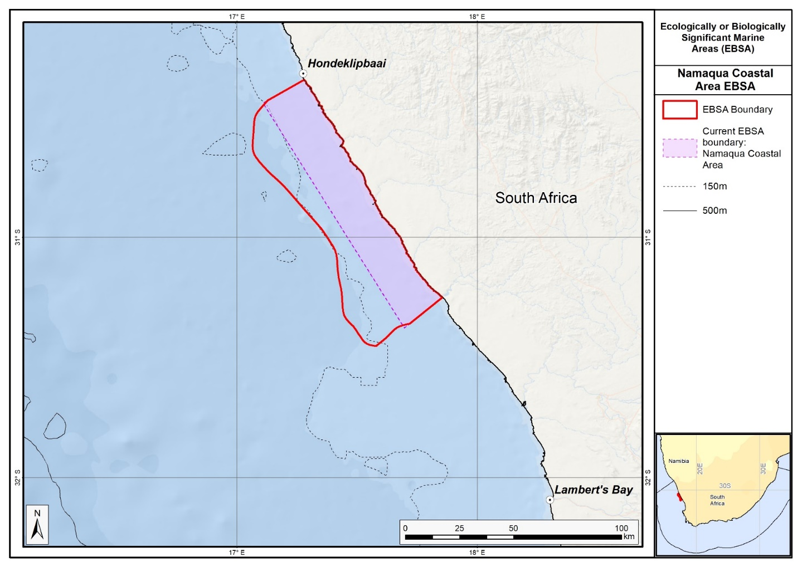
Map of the Namaqua Coastal Area area in relation to the original boundaries of the EBSA.

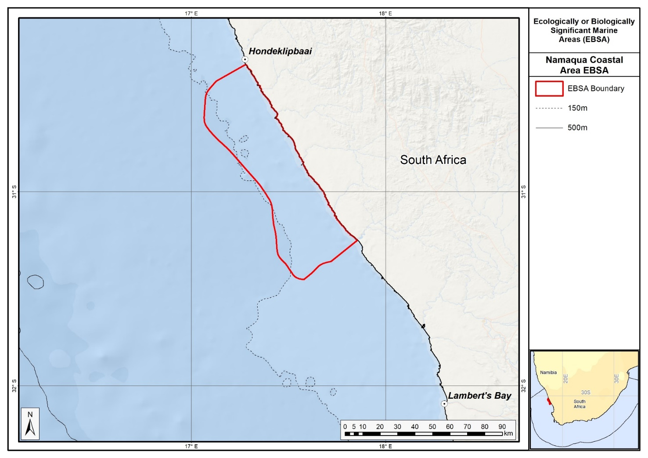
Map of the Namaqua Coastal Area area.

Rights and permissions:
No limits on sharing or publication.

24. Namaqua Fossil Forest (modification of the existing Namaqua Fossil Forest)

Reason for the modification:
The EBSA description is being modified because of newly available or accessible knowledge on features associated with the area, based on additional scientific data especially new systematic spatial planning and assessments of biodiversity. The descriptions and supporting information are substantially extended, updated and refined beyond the original descriptions from the South-Eastern Atlantic workshop, April 2013. The modifications involve changes to the textual description, changes to the ranking of the area against the EBSA criteria, and changes in shape, location and size of the area.

The original descriptions of Ecologically or Biologically Significant Marine Areas (EBSAs) in the Benguela Current Large Marine Ecosystem (BCLME) were described in the South-Eastern Atlantic workshop (April 2013). The descriptions were generally characterized by generic, often fairly geometric delineations, consisting of approximate bounding boxes around the features for which the EBSA was described. This coarse scale of delineation was appropriate for a global scale but posed challenges for inclusion in national-level, place-based ocean management. The original boundaries were not sufficiently refined to capture the full extent of key biodiversity features and often overlapped with areas of lower biodiversity value or in poor ecological condition.

Additionally, the original EBSA descriptions suffered from shortfalls related to limited spatial data and lack of systematic conservation planning approaches at the time they were first proposed. This meant that many boundaries did not precisely encompass biodiversity priority areas, potentially leading to conflicts with other ocean sectors and limiting their practical usefulness for marine spatial planning (MSP). The coarse scale and lack of detailed data constrained the ability to develop effective zoning and management recommendations that balance biodiversity protection with economic activities.

How was the submission developed?
The EBSA revision process was part a broader project on ecosystem-based MSP in the BCLME, namely the Benguela Current Marine Spatial Management and Governance Project (MARISMA, 2014-2023). This was a regional capacity-building and development cooperation project implemented by the Benguela Current Commission, the Governments of Angola, Namibia and South Africa, and GIZ, the German Agency for Development Cooperation (Deutsche Gesellschaft für Internationale Zusammenarbeit.

Because of these shortcomings of the existing EBSA boundaries, description and valuations set out in the previous section, the MARISMA project undertook a refinement process. This process used systematic conservation planning (SCP) tools, such as Marxan, to generate finer-scale, more accurate boundaries based on updated biodiversity data and expert input. This process also allowed for the identification of new EBSAs and the splitting of some original EBSAs into multiple refined areas to better reflect discrete biodiversity features and ecological processes. The refined EBSA boundaries were more suitable for MSP and conservation management because they focused on core natural and near-natural areas, avoided unnecessary conflicts with other sectors, and incorporated a systematic, data-driven approach to spatial prioritization.

The overall approach to the EBSA update and engagement followed these key steps:

Initial Systematic Conservation Planning (SCP) Analyses: Existing EBSAs were refined and new areas identified using systematic conservation planning tools such as Marxan, based on biodiversity input data including ecosystem types, species distributions, and ecological processes.

National Workshops: The refined and new EBSA boundaries were iteratively reviewed and adjusted through workshops held within each of the three countries (Angola, Namibia, South Africa). These workshops allowed country-specific input and tailoring of EBSA boundaries and descriptions to national contexts and priorities.

Regional Workshops and Bilateral Meetings between Countries: Workshops at the regional level especially focused on transboundary EBSAs shared between the countries, but also examined the overall approach to EBSAs, their delineation, description and the engagement approach. The aim was to harmonize boundaries, align management recommendations, and foster cooperation across national borders for effective regional marine biodiversity management. Additional specific bilateral meetings were held where necessary.

Technical and Scientific Peer Review: The revised and new EBSAs underwent technical review nationally and regionally (through technical review workshops involving relevant experts); and internationally with assistance from experts from the Global Ocean Biodiversity Initiative (GOBI) and members of the CBD's Informal Advisory Group on EBSAs, ensuring robustness of the exercise. The process is documented in peer reviewed literature (Harris et al., 2019, 2022).

Political Approval: The EBSAs were administratively and politically approved through all required stages up to the national ministerial level in each country and were then submitted to the CBD Secretariat by the National CBD Focal Points.

Data Sharing and Accessibility: All information, including refined EBSA boundaries, status assessments, management recommendations, and stakeholder feedback, were made available through online repositories such as the project's EBSA Portal (https://cmr.mandela.ac.za/Research-Projects/EBSA-Portal); and the EBSA were also shared via the Benguela Current Convention's Geodata Portal (https://geodata.benguelacc.org/ ). This facilitated transparency, accessibility, and ongoing updating of data and products for biodiversity specialists and other stakeholders.

The EBSA description was updated by searching for and including all relevant information from the latest research within the area. A few technical revisions and updates to the description were made, even though little additional information was available. Small additions, such as biodiversity information from OBIS were also made. A table of the habitats represented in the EBSA and their associated threat status were also included. The boundaries were expanded based on new information from recent surveys in the adjacent area so that the new delineation now includes the likely full extent of the fossil outcrop. The new boundaries also include the extent of the newly declared Namaqua Fossil Forest MPA, which also contains an adjacent unprotected inner shelf mud ecosystem type.

Traditional knowledge was not incorporated into this process, and consultations with indigenous peoples or local communities were not undertaken. Therefore, documentation of Free, Prior and Informed Consent (FPIC) is not relevant for this EBSA process.

Where is the submission intended to be included (choose one option, and please note that there are different procedures for these two intended end points)?
[X] EBSA repository
[ ] EBSA information-sharing mechanism

Abstract:
Changes from the original version: The revised description reflects the proposed expanded spatial delineation to better capture the likely full extent of the fossil outcrop. The revised text is expanded for clarity, and includes reference to a newly identified habitat-forming sponge species.

The Namaqua Fossil Forest is a 2 km² seabed outcrop of fossilized yellowwood trees at a depth of between 136 and 140 m, 30 km offshore from the west coast of South Africa. The boundary of the area spans 25 km by 35 km to accommodate the feature’s likely extended but imprecisely known area. Fossilized tree trunks in the area have been colonized by fragile, habitat-forming scleractinian corals, confirmed by underwater surveys, and outcrops comprise laterally extensive rock slabs (greater than 5 m by less than 1 m by less than 0.5 m). Regional side scan sonar results suggest that the outcrop is unique to the area. The site remains unmined despite falling within a diamond mining lease and is protected by a “no go” buffer around known fossil locations. Hard grounds north of the original discovery are believed to be part of the fossil forest. A newly described habitat-forming sponge also occurs in the area. The Namaqua Fossil Forest is a unique feature with substantial structural complexity that is highly vulnerable to the impact of human activity.

Introduction:
Changes from the original version: The introduction in the revised description provides a more detailed geographic context, and gives an overview of why the EBSA was enlarged. The remaining test has been rewritten for clarity but largely retains the original content.

The Namaqua Fossil Forest is a small (2 km²) seabed outcrop composed of fossilized yellowwood trees in the 136-140 m depth range on the middle shelf off the Namaqualand coast in South Africa. The EBSA boundaries are larger at approximately 25 km by 35 km as this is necessary to accommodate likely extended area of the feature which is not precisely known. The area is approximately 30 km offshore between Port Nolloth and Kleinsee. Fossilized tree trunks have been colonized by fragile, habitat-forming scleractinian corals. Based on regional side-scan sonar interpretations, the outcrop is believed to be unique to the area. Fragments of fossil tree trunks were, however, recovered from mined areas about 60 km away from this site but those fragments are no longer in-situ and were removed from the seabed. The site is within the productive southern Benguela ecosystem but there is no information on local-scale oceanography for this area.

Location:
Changes from the original version: The geographic data have been updated to reflect the new delineation, and a link is provided to the spatial data.

The area is on the middle shelf off the Namaqualand coast in South Africa. It is within the exclusive economic zone of South Africa.

The coordinates of a minimum bounding box covering the entire scope of the area are:
- Latitude: -29.72, -29.417, -29.417, -29.72
- Longitude: 16.5, 16.5, 16.755, 16.755

Feature description of the area:
Changes from the original version: The revised description substantially elaborates on the physical characteristics of the fossilized wood outcrops, including dimensions and the inferred lithology (claystone). It introduces newly discovered hard grounds north of the original fossil site and documents the presence of a newly described habitat-forming sponge species. The boundary has been expanded to include these features and the recently established Namaqua Fossil Forest MPA. The revised description includes a tabulated summary of four ecosystem types within the EBSA, all assessed as Least Concern, with detailed area coverage percentages. This more systematic presentation replaces the previous narrative which did not specify ecosystem threat statuses. The site is presented as a Type 3 EBSA: Spatially stable features whose individual positions are not known (sensu Johnson et al., 2018).

This is a benthic feature composed of laterally extensive slabs of rock of lengths greater than 5 m and usually less than 1 m in width. The fossilized wood is reported to extend to 0.5 m in height although the geology of the broader area includes erosion-resistant, high-relief areas (up to 5 m) (Stevenson and Bamford 2003). The lithology has not been sampled directly, but is believed to be claystone. According to in-situ observations during submersible surveys, the fossilized wood has been colonized by scleractinian corals. Apparently, no biological sampling has been conducted previously at the site, with research activities being focused rather on the geology of the area. Two species of fossil wood were documented in the area, both from the Podocarpidae family; Podocarpus jago and P. umzambense, the former being a species described from this site (Bamford & Stevenson, 2002).

Since the original description and delineation of this EBSA, more recent surveys in the area have revealed hard grounds immediately north of the known location of the fossil forest, which are believed to be part of the same feature. Further, a newly described habitat-forming sponge has been recorded in the area (Samaai et al., 2017). Consequently, the boundary of the Namaqua Fossil Forest has been expanded to cover a broader area, which includes the delineation of a currently proposed MPA in South Africa. Although the boundary is still a geometric shape, the revision has improved the precision of the delineation by encompassing a more realistic representation of the full extent of the feature. More dedicated research in this area is required to refine the boundary further to the actual extent of the feature rather than this current approximation. Consequently, this site is presented as a Type 3 EBSA: Spatially stable features whose individual positions are not known (sensu Johnson et al., 2018).

There are four ecosystem types represented; most are muddy or sandy, with the Namaqua Mid Shelf Fossils ecosystem type containing the fossils themselves, and fragile scleractinian corals and habitat-forming sponges that are sensitive to damage. The Namaqua Muddy Mid Shelf Mosaic ecosystem type also likely supports fragile species. All four ecosystem types have been assessed as Least Concern. These threat statuses were estimated by assessing the weighted cumulative impacts of various pressures (e.g., extractive resource use, pollution, development, and others) on each ecosystem type for South Africa (Sink et al., 2019; Table below).

Summary of ecosystem types and threat status for Namaqua Fossil Forest. Data from Sink et al. (2019).

Threat status | Ecosystem Type | Area (km²) | Area (%)
Least Concern | Namaqua Mid Shelf Fossils | 20.1 | 2.4
 | Namaqua Muddy Mid Shelf Mosaic | 331.2 | 39.8
 | Namaqua Sandy Mid Shelf | 230.0 | 27.7
 | Southern Benguela Muddy Sands | 250.3 | 30.1
Grand Total |  | 831.6 | 100.0

Feature condition and future outlook:
Changes from the original version: The revised description confirms that the EBSA is almost entirely in good ecological condition, supported by cumulative impact assessments. It details the protection status within the newly declared MPA and mining lease arrangements, including the enforcement of a 250 m no-go buffer around fossil locations. It notes the abandonment of previous mining rights and the current absence of mining and trawling activities within the area.

Namaqua Fossil Forest is almost entirely in good ecological condition (100%), with a fraction that is in fair ecological condition (<1%)(Sink e al., 2019). This is because the original location where the fossils were discovered have been protected from mining, despite the fact that they occur within a mining lease area. Consequently, the whole EBSA comprises ecosystem types that are Least Concern.

The in-situ surveys of this unique site showed large, intact, fossilized tree trunks that support habitat-building corals and sponges. The site is considered to be unmined. It used to fall within a mining licence area (South African Sea Area MPT 25/2011 (in Concessions 5C and 4C)) where De Beers Consolidated Mines held a marine diamond mining right, which they have subsequently abandoned. Since then, Belton Park Trading 127 (Pty) Ltd have been granted Prospecting Rights for marine diamonds in Concessions 2C, 3C, 4C and 5C, which overlaps with this EBSA (in 4C and 5C). However, the Basic Assessment Report requires a 250 m “no-go” buffer around all known locations of fossilized yellowwood trees (CCA Environmental (Pty) Ltd, 2015). Currently, sampling operations have been undertaken in Concession 2C and 3C, but not near the EBSA (Andrea Pulfrich, pers. comm). There is no known future research planned for the area.

Approximately 2/3 of the EBSA, including all areas with confirmed fossils in a newly declared (in 2019) Marine Protected Area, the Namaqua Fossil Forest MPA. No mining or fishing activities which can impact seabed (e.g. trawl) are allowed in the MPA.

Assessment of the area against CBD EBSA Criteria:
Changes from the original version: The revised description maintains existing rankings reflecting limited local ecological data but recognized habitat vulnerability. An upgraded assessment of the Vulnerability, Fragility, Sensitivity, or Slow Recovery criterion resulted in a High ranking, emphasizing the sensitivity of fossilized wood and associated benthic organisms to disturbance, which was less explicitly stressed previously.
CBD EBSA Criteria  (Annex I to decision IX/20) | Description  (Annex I to decision IX/20) | Ranking of criterion relevance  (please mark one column with an X)
CBD EBSA Criteria  (Annex I to decision IX/20) | Description  (Annex I to decision IX/20) | No information |  | Low |  |  | Medium |  | High
Uniqueness or rarity | Area contains either (i) unique (“the only one of its kind”), rare (occurs only in few locations) or endemic species, populations or communities, and/or (ii) unique, rare or distinct, habitats or ecosystems; and/or (iii) unique or unusual geomorphological or oceanographic features. |  |  |  |  |  |  |  | x
Based on regional side-scan sonar interpretations covering more than 2300 km² between the area offshore of Chamais Bay in Namibia and offshore of the Buffels River in South Africa, there are no other known in situ fossilized yellowwood forests in the region (Stevenson and Bamford 2003). Further, the published images of in situ habitat-building corals prove this site to be one of the few confirmed localities of in situ cold-water corals in the region (Stevenson and Bamford 2003). Other fragments of fossil tree trunks were recovered from test-mine areas north-west of the area that meets the EBSA criteria, but these were buried fragments (Stevenson and Bamford 2003).
Special importance for life-history stages of species | Areas that are required for a population to survive and thrive. | X
Little is known about the biodiversity and ecology of this small area (Sink et al., 2012a).
Importance for threatened, endangered or declining species and/or habitats | Area containing habitat for the survival and recovery of endangered, threatened, declining species or area with significant assemblages of such species. | X
Little is known about the local-scale biodiversity and ecology of this small area (Sink et al., 2012a). However, at a national scale, the most recent map of ecosystem types indicates that there are four ecosystem types present in the area, all of which are Least Concern (Sink et al. 2019).
Vulnerability, fragility, sensitivity, or slow recovery | Areas that contain a relatively high proportion of sensitive habitats, biotopes or species that are functionally fragile (highly susceptible to degradation or depletion by human activity or by natural events) or with slow recovery. |  |  |  |  |  |  |  | X
The fossilized wood, accompanying cold-water coral colonies, and habitat-forming sponges are considered vulnerable to any activities that could impact on the seabed (FAO 2006, Rogers et al., 2008, FAO 2009, Sink et al., 2012a,b).
Biological productivity | Area containing species, populations or communities with comparatively higher natural biological productivity. |  |  |  |  |  | X
This small localized area is unlikely to be more or less productive than the area surrounding it, but it does occur within the productive Southern Benguela ecosystem (Lagabrille 2009, Sink et al., 2012a).
Biological diversity | Area contains comparatively higher diversity of ecosystems, habitats, communities, or species, or has higher genetic diversity. | X
Little is known about the biodiversity and ecology of this small area (Sink et al., 2012a).
Naturalness | Area with a comparatively higher degree of naturalness as a result of the lack of or low level of human-induced disturbance or degradation. |  | X
It is unknown whether this area has been impacted by human activities. The area has some overlap with a diamond mining lease area but apparently, it has not yet been mined (Leslie Roos, De Beers, South Africa pers. comm.). There is currently no mining within this offshore diamond mining lease although the future of mining in the area is uncertain (Sink et al., 2011, 2012a). Based on a cumulative-pressures assessment (of known impacts), almost the entire area is in good ecological condition (Sink et al., 2019), and there is no known fishing activity within the site.

References:
Changes from the original version: The expanded and updated reference list reflects the incorporation of new scientific research, systematic conservation planning outputs, and regional governance frameworks since the original 2013 description.

Bamford, M.K., Stevenson, I.R. 2002. A submerged Late Cretaceous Podocarpus Forest, West Coast, South Africa. South African Journal of Science, 98: 181-185.
CCA Environmental (Pty) Ltd. 2015. Marine Sediment Sampling Activities in Various Diamond Mining Concession Areas, West Coast, South Africa. Draft Basic Assessment Report. Prepared for: Department of Environmental Affairs, on behalf of: Belton Park Trading 127 (Pty) Ltd. IMD01PBA/DBAR/REV.0, 130 pp.
FAO, 2006. Management of Demersal Fisheries Resources of the Southern Indian Ocean. FAO Fisheries Circular No. 1020 FAO Rome 2006.
FAO, 2009. Annex F of the Report of the Technical Consultation on International Guidelines for the Management of Deepsea Fisheries in the High Seas. Rome, 4–8 February and 25-29 August 2008.
Harris, L., Holness, S., Finke, G., Kirkman, S., Sink, K., 2019. Systematic Conservation Planning as a Tool to Advance Ecologically or Biologically Significant Area and Marine Spatial Planning Processes, in: Zaucha, J., Gee, K. (Eds.), Maritime Spatial Planning. Palgrave Macmillian, Cham.
Harris, L.R., Holness, S.D., Finke, G., Amunyela, M., Braby, R., Coelho, N., Gee, K., Kirkman, S.P., Kreiner, A., Mausolf, E., Majiedt, P., Maletzky, E., Nsingi, K.K., Russo, V., Sink, K.J., Sorgenfrei, R., 2022. Practical Marine Spatial Management of Ecologically or Biologically Significant Marine Areas: Emerging Lessons From Evidence-Based Planning and Implementation in a Developing-World Context. Front. Mar. Sci. 9.
Holness, S., Kirkman, S., Samaai, T., Wolf, T., Sink, K., Majiedt, P., Nsiangango, S., Kainge, P., Kilongo, K., Kathena, J., Harris, L., Lagabrielle, E., Kirchner, C., Chalmers, R., Lombard, M. 2014. Spatial Biodiversity Assessment and Spatial Management, including Marine Protected Areas. Final report for the Benguela Current Commission project BEH 09-01.
Johnson, D.E., Barrio Froján, C., Turner, P.J., Weaver, P., Gunn, V., Dunn, D.C., Halpin, P., Bax, N.J., Dunstan, P.K., 2018. Reviewing the EBSA process: Improving on success. Marine Policy 88, 75-85.
Lagabrielle, E. 2009. Preliminary report: National Pelagic Bioregionalisation of South Africa. Cape Town: South African National Biodiversity Institute.
Rogers, A.D., Clark, M.R, Hall-Spencer, K.M., Gjerde, K.M. 2008. The Science behind the Guidelines: A Scientific Guide to the FAO Draft International Guidelines (December 2007) For the Management of Deep-Sea Fisheries in the High Seas and Examples of How the Guidelines May Be Practically Implemented. IUCN, Switzerland.
Samaai, T., Maduray, S., Janson, L., Gibbons, M.J., Ngwakum, B., Teske, P.R. 2017. A new species of habitat–forming Suberites (Porifera, Demospongiae, Suberitida) in the Benguela upwelling region (South Africa). Zootaxa: 4254, 49-81.
Sink, K., Holness, S., Harris, L., Majiedt, P., Atkinson, L., Robinson, T., Kirkman, S., Hutchings, L., Leslie, R., Lamberth, S., Kerwath, S., von der Heyden, S., Lombard, A., Attwood, C., Branch, G., Fairweather, T., Taljaard, S., Weerts, S., Cowley, P., Awad, A., Halpern, B., Grantham, H., Wolf T. 2012. National Biodiversity Assessment 2012: Technical Report. Volume 4: Marine and Coastal Component. South African National Biodiversity Institute, Pretoria.
Sink, K.J., van der Bank, M.G., Majiedt, P.A., Harris, L.R., Atkinson, L., Karenyi, N., Kirkman, S. (eds) 2019. National Biodiversity Assessment 2018 Technical Report Volume 4: Marine Realm. South African National Biodiversity Institute, Pretoria.
Sink, K.J., Wilkinson, S., Atkinson, L.J., Sims, P.F., Leslie, R.W., Attwood, C.G. 2012b. The potential impacts of South Africa’s demersal hake trawl fishery on benthic habitats: historical perspectives, spatial analyses, current review and potential management actions. Unpublished report. Cape Town: South African National Biodiversity Institute.
Stevenson, R., Bamford, M.K. 2003. Submersible-based observations of in-situ fossil tree trunks in Late Cretaceous seafloor outcrops, Orange Basin, western offshore, South Africa. South African Journal of Geology 106: 315-326.

Maps and Figures:
GIS data available at: https://cmr.mandela.ac.za/cmr/media/Store/documents/EBSA/Descriptions/SouthAfrica/Shapefile-RSA_EBSAs_final.zip
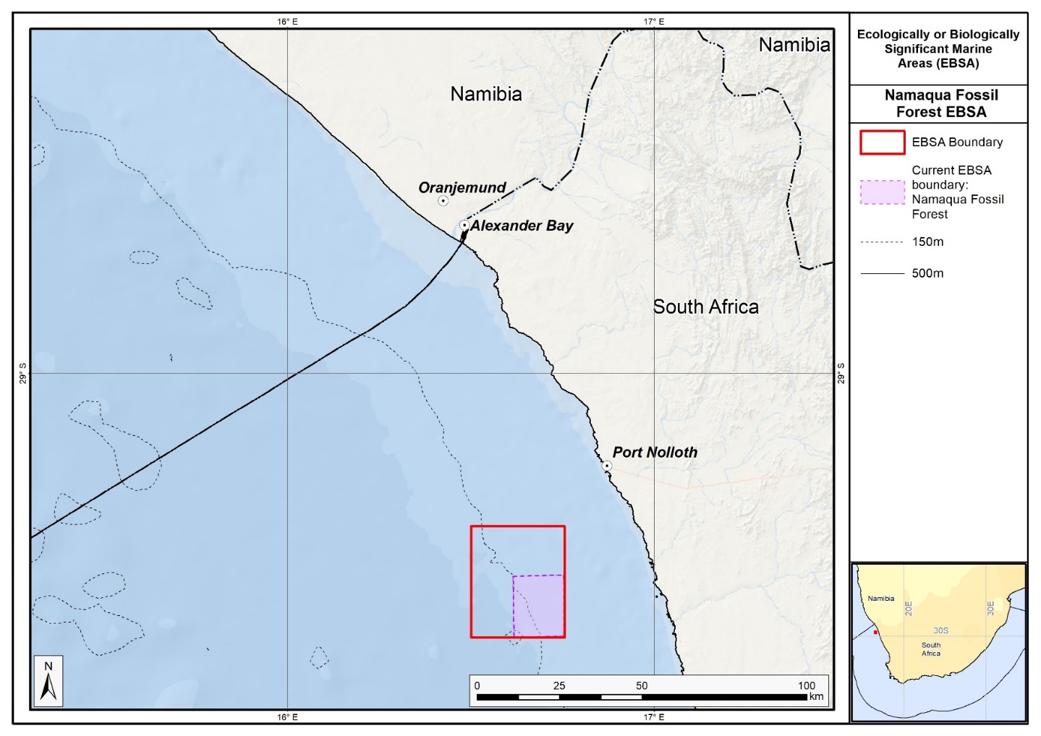
Map of the Namaqua Fossil Forest area in relation to the original Namaqua Fossil Forest EBSA.

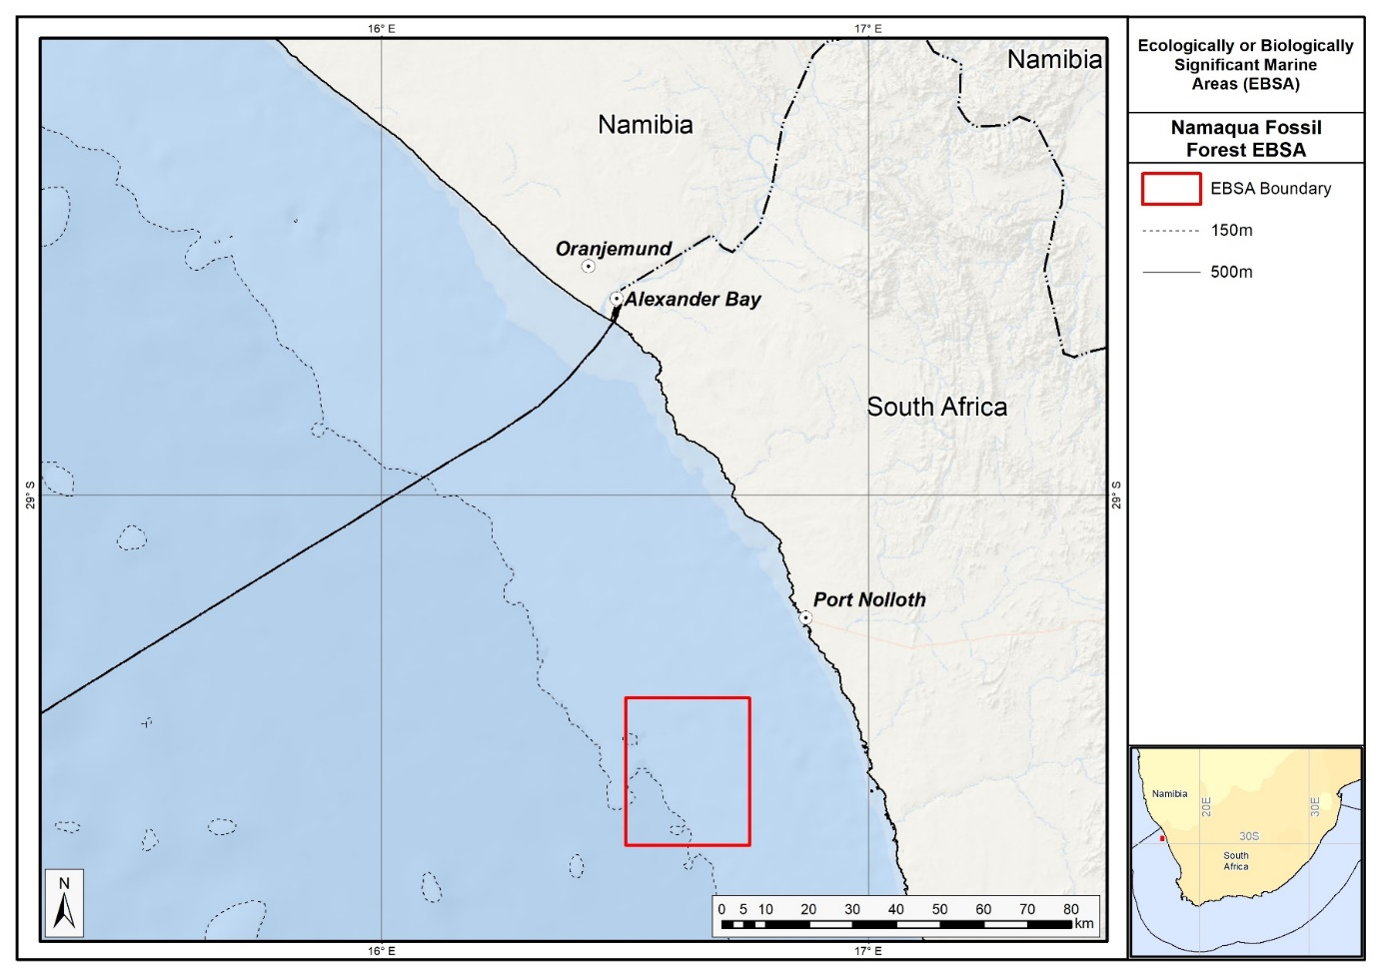
Map of the Namaqua Fossil Forest area.

Rights and permissions:
No limits on sharing or publication.

25. Protea Banks and Sardine Route (modification of the existing Protea Banks and Sardine Route)⁶

Reason for the modification:
The EBSA description is being modified because of newly available or accessible knowledge on features associated with the area, based on additional scientific data especially new systematic spatial planning and assessments of biodiversity. The descriptions and supporting information are substantially extended, updated and refined beyond the original descriptions from the Southern Indian Ocean Regional EBSA Workshop, 2012. The modifications involve changes to the textual description, changes to the ranking of the area against the EBSA criteria, and changes in shape, location and size of the area.

The original descriptions of Ecologically or Biologically Significant Marine Areas (EBSAs) in the Benguela Current Large Marine Ecosystem (BCLME) were described in the Southern Indian Ocean Regional EBSA Workshop. The descriptions were generally characterized by generic, often fairly geometric delineations, consisting of approximate bounding boxes around the features for which the EBSA was described. This coarse scale of delineation was appropriate for a global scale but posed challenges for inclusion in national-level, place-based ocean management. The original boundaries were not sufficiently refined to capture the full extent of key biodiversity features and often overlapped with areas of lower biodiversity value or poor ecological condition.

Additionally, the original EBSA descriptions suffered from shortfalls related to limited spatial data and lack of systematic conservation planning approaches at the time they were first proposed. This meant that many boundaries did not precisely encompass biodiversity priority areas, potentially leading to conflicts with other ocean sectors and limiting their practical usefulness for marine spatial planning (MSP). The coarse scale and lack of detailed data constrained the ability to develop effective zoning and management recommendations that balance biodiversity protection with economic activities.

How was the submission developed?
The EBSA revision process was part a broader project on ecosystem-based MSP in the BCLME, namely the Benguela Current Marine Spatial Management and Governance Project (MARISMA, 2014-2023). This was a regional capacity-building and development cooperation project implemented by the Benguela Current Commission, the Governments of Angola, Namibia and South Africa, and GIZ, the German Agency for Development Cooperation (Deutsche Gesellschaft für Internationale Zusammenarbeit.

Because of these shortcomings of the existing EBSA boundaries, description and valuations set out in the previous section, the MARISMA project undertook a refinement process. This process used systematic conservation planning (SCP) tools, such as Marxan, to generate finer-scale, more accurate boundaries based on updated biodiversity data and expert input. This process also allowed for the identification of new EBSAs and the splitting of some original EBSAs into multiple refined areas to better reflect discrete biodiversity features and ecological processes. The refined EBSA boundaries were more suitable for MSP and conservation management because they focused on core natural and near-natural areas, avoided unnecessary conflicts with other sectors, and incorporated a systematic, data-driven approach to spatial prioritization.

The overall approach to the EBSA update and engagement followed these key steps:

Initial Systematic Conservation Planning (SCP) Analyses: Existing EBSAs were refined and new areas identified using systematic conservation planning tools such as Marxan, based on biodiversity input data including ecosystem types, species distributions, and ecological processes.

National Workshops: The refined and new EBSA boundaries were iteratively reviewed and adjusted through workshops held within each of the three countries (Angola, Namibia, South Africa). These workshops allowed country-specific input and tailoring of EBSA boundaries and descriptions to national contexts and priorities.

Regional Workshops and Bilateral Meetings between Countries: Workshops at the regional level especially focused on transboundary EBSAs shared between the countries, but also examined the overall approach to EBSAs, their delineation, description and the engagement approach. The aim was to harmonize boundaries, align management recommendations, and foster cooperation across national borders for effective regional marine biodiversity management. Additional specific bilateral meetings were held where necessary.

Technical and Scientific Peer Review: The revised and new EBSAs underwent technical review nationally and regionally (through technical review workshops involving relevant experts); and internationally with assistance from experts from the Global Ocean Biodiversity Initiative (GOBI) and members of the CBD's Informal Advisory Group on EBSAs, ensuring robustness of the exercise. The process is documented in peer reviewed literature (Harris et al., 2019, 2022).

Political Approval: The EBSAs were administratively and politically approved through all required stages up to the national ministerial level in each country and were then submitted to the CBD Secretariat by the National CBD Focal Points.

Data Sharing and Accessibility: All information, including refined EBSA boundaries, status assessments, management recommendations, and stakeholder feedback, were made available through online repositories such as the project's EBSA Portal (https://cmr.mandela.ac.za/Research-Projects/EBSA-Portal); and the EBSA were also shared via the Benguela Current Convention's Geodata Portal (https://geodata.benguelacc.org/ ). This facilitated transparency, accessibility, and ongoing updating of data and products for biodiversity specialists and other stakeholders.

Some technical revisions and updates to the description were made, even though little additional information was available. A supplementary table of the habitats represented in the EBSA and their associated threat status was also included. Criterion 3: importance for threatened species was particularly much better substantiated, but this did not result in a change in the rank evaluation.

The main change is that the boundary of this EBSA has been slightly adjusted to more closely focus the EBSA on the key biodiversity features that underlie its EBSA status. The delineation process included an initial stakeholder review which identified the need to update boundaries, a technical mapping process and then an expert review workshop where boundary delineation options were discussed. The boundaries were revised a final time to accommodate the latest NBA 2018 assessment results and the review workshop discussion. The delineation process used a combination of Systematic Conservation Planning and Multi-Criteria Analysis methods. The features used in the analysis were:
- Irreplaceable and near irreplaceable (i.e. very high selection frequency) sites, as well as focus areas identified in the national SCP analysis undertaken for the West Coast by Majiedt et al. (2013), offshore areas (Sink et al., 2011) and by Holness et al. (2014) were incorporated.
- Key physical features (especially canyons) identified from the latest GEBCO data, global benthic geomorphology mapping (www.bluehabitats.org, Harris et al., 2014) and the National Biodiversity Assessment 2011 (Sink et al., 2012) were incorporated.
- Delineations and threat status of constituent ecosystem types in the area were included in the analysis and used to refine the boundary of the EBSA.
- Areas of high relative naturalness of benthic and coastal systems and pelagic systems identified in the National Biodiversity Assessment 2011 (Sink et al., 2012a) were included in the analysis.
- Distributions of known fragile, vulnerable and sensitive habitat-forming species were included (Unpublished SANBI and SAEON data).

The multi-criteria analysis resulted a value surface. The cut-off value used to determine the extent of the EBSA was based on expert input and quantitative analysis of effective inclusion of the above features. This entailed taking an iterative parameter calibration-based approach whereby the spatial efficiency of the inclusion of the targeted features was evaluated. The approach aimed to identify a cut-off which most efficiently included prioritised features while minimizing the inclusion of impacted areas. The final boundaries shown in the map were validated in a national workshop.

Traditional knowledge was not incorporated into this process, and consultations with indigenous peoples or local communities were not undertaken. Therefore, documentation of Free, Prior and Informed Consent (FPIC) is not relevant for this EBSA process.

Where is the submission intended to be included (choose one option, and please note that there are different procedures for these two intended end points)?
[X] EBSA repository
[ ] EBSA information-sharing mechanism

Abstract:
Changes from the original version: The revised abstract largely retains the original content but was rewritten for clarity. Additional information is included on the existing and expanded MPAs.

Protea Banks and Sardine Route is a coastal area that includes a vital component of the migration path, known as the sardine run, for several fish and an offshore area of high habitat complexity. Its benthic features include a unique deep-reef system known as Protea Banks, steep shelf edge and slope, and several submarine canyons. The sardine run is a temporary feature associated with foraging top predators, including seabirds, mammals, sharks and gamefish. Protea Banks is an aggregating area, where sciaenids and sparids have been reported to spawn. Some of those species are in decline and are considered threatened. The area has moderate productivity, and the sardine run is an important ecological process that facilitates the transfer of nutrients from the more productive Agulhas Bank into the more oligotrophic environment further north.

Introduction:
Changes from the original version: The revised description retains all content from the previous version, but adds specific description of the diversity of features. Specifically it highlights canyons, and describes in more detail the range of ecosystem types and their threat statuses based on recent assessments.

The Protea Banks and Sardine Route includes a key component of the migration path for several fish (known as the sardine run) and an offshore area of high habitat complexity. Benthic features include a unique deep reef system known as Protea Banks, steep shelf edge and slope, and several canyons. Protea Banks comprises a relatively shallow “seamount” that drops to extensive rocky flats that extend towards the shelf edge (the full extent of which is currently uncertain). Diversity is high in this area, with 40 ecosystem types represented in the EBSA, 20 of which are threatened and a further seven are Near Threatened (Sink et al., 2019). It constitutes a site of fish spawning aggregations and is home to an abundance of soft corals, algae and molluscs, many of which are endemic. The area includes benthic and pelagic features, with further details on habitats, processes and species detailed in Mann (2000), Freon et al. (2010), Sink et al. (2011), Harris et al. (2011) and Ezemvelo KZN Wildlife (2012). The sardine run is an annual, temporary feature usually associated with foraging top predators, including seabirds, mammals (O’Donoghue et al., 2010a, 2010b), sharks and gamefish (Dudley and Cliff 2010, Fennessy et al., 2010).

Location:
Changes from the original version: The section reflects the updated spatial delineation which tightens the boundaries of the EBSA to focus on core natural and near-natural areas, extending from Aliwal Shoal MPA to Dwesa-Cwebe MPA, with a more precise offshore delineation reflecting the narrow continental shelf and depth ranges down to 1800 m or more. This contrasts with the original broader and coarser bounding boxes. The location section provides bounding box coordinates, and shares a link to the specific spatial data. Motivation for the spatial changes, and details of the spatial planning are given in “How was the submission developed?” Section.

Protea Banks and Sardine Route is entirely within the exclusive economic zone of South Africa. Alongshore, it extends from the Aliwal Shoal marine protected area in the north, to the Dwesa-Cwebe marine protected area in the south. Although the area extends only from 25 to 35 km offshore from the dune base across most of the area, it covers a vast depth range because the continental shelf is so narrow in the area. Most of the area extends from sea level to a depth of 1,800 m.

The coordinates of a minimum bounding box covering the entire scope of the area are:
- Latitude: -32.326, -30.051, -30.455, -32.73
- Longitude: 28.811, 30.913, 31.35, 29.248

Feature description of the area:
Changes from the original version: The feature description has been substantially expanded to reflect the refined ecosystem linked boundaries and features, as well as new studies. Substantial additional information is given on ecosystem types, their diversity and their threat statuses based on new systematic assessment. A table of ecosystem types and their statuses is provided. The description also reflects new survey data, and how this helped refine the delineation. The EBSA is presented as a Type 2/4 EBSA (sensu Johnson et al., 2018) for containing “spatially stable features whose individual positions are known, but a number of individual cases are being grouped” and “features that are inherently not spatially fixed. The position of this feature moves seasonally and among years.”.

This area includes benthic and pelagic features, with details on habitats, processes and species in Mann (2000), Freon et al., (2010), Sink et al., (2011), Harris et al., (2011) and Ezemvelo KZN Wildlife (2012). The EBSA includes 40 ecosystem types, seven of which are Endangered, 13 are Vulnerable and a further seven are Near Threatened (Table below; Sink et al., 2019). This spans a rich diversity of types, including a variety of shore types (including estuarine shores), reefs, unconsolidated-sediment benthic types, slope types and canyons (Sink et al., 2019). The area includes part of a key migration pathway (known as the sardine run) that is an important ecological process believed to play a role in the transfer of productivity from the productive Agulhas Bank into the less productive area in southern KwaZulu-Natal. Some research has been conducted on the sardine migration (see Freon et al., 2010, Van der Lingen et al., 2010) but the heterogeneous benthic habitats in deep water are poorly studied. Key habitats include a unique deep-reef feature, submarine canyons (with seven reef-building cold-water coral records, representing three different species, in the national invertebrate museum collection), hard shelf edge and unconsolidated shelf and shelf edge sediments. In situ research is needed in the deeper areas of this EBSA.

There has been new research in the area since the EBSA was first proposed, that has contributed significantly to identifying the features that are present, their extent and importance. The boundary of this EBSA was also refined to align with initiatives to expand South Africa’s MPA network, and better represent the underlying features comprising the EBSA to improve precision in the delineation. The benthic features (e.g., reefs and canyons) are spatially fixed and grouped, and the sardine run is a seasonal phenomenon that occurs in the same area, but the exact position is variable across years.

Summary of ecosystem types and threat status for the Protea Banks and Sardine Route EBSA. Data from Sink et al. (2019).
Threat Status | Ecosystem Type | Area (km²) | Area (%)
Endangered | Natal Inner Shelf Reef Sand Mosaic | 215.5 | 2.3
 | Natal Mid Shelf Reef Gravel Mosaic | 841.1 | 9.0
 | Protea Mid Shelf Reef Complex | 15.5 | 0.2
 | Subtropical Large Fluvially Dominated Estuary | 1.7 | 0.0
 | Subtropical Large Temporarily Closed Estuary | 7.5 | 0.1
 | Subtropical Predominantly Open Estuary | 4.2 | 0.0
 | Trafalgar Reef Complex | 58.7 | 0.6
Vulnerable | Agulhas Exposed Rocky Shore | 0.7 | 0.0
 | Agulhas Very Exposed Rocky Shore | 0.3 | 0.0
 | Aliwal Shoal Reef Complex | 5.2 | 0.1
 | Natal Boulder Shore | 0.3 | 0.0
 | Natal Mixed Shore | 40.5 | 0.4
 | Natal-Delagoa Reflective Sandy Shore | 0.8 | 0.0
 | Pondoland Inner Shelf Reef Sand Mosaic (C) | 249.3 | 2.7
 | Port St Johns Inner Shelf Reef Mosaic (A) | 48.5 | 0.5
 | Port St Johns Muddy Mid Shelf | 124.8 | 1.3
 | Port St Johns Muddy Shelf Edge | 129.4 | 1.4
 | Subtropical Small Temporarily Closed Estuary | 7.7 | 0.1
 | Warm Temperate Large Temporarily Closed Estuary | 0.5 | 0.0
 | Warm Temperate Predominantly Open Estuary | 0.2 | 0.0
Near Threatened | Agulhas Dissipative Sandy Shore | 0.2 | 0.0
 | Agulhas Mixed Shore | 2.4 | 0.0
 | Natal Exposed Rocky Shore | 28.7 | 0.3
 | Natal Pondoland Shelf Edge Coarse Sand Reef Mosaic | 593.9 | 6.4
 | Natal Very Exposed Rocky Shore | 1.0 | 0.0
 | Natal-Delagoa Dissipative Sandy Shore | 0.7 | 0.0
 | Natal-Delagoa Intermediate Sandy Shore | 10.1 | 0.1
Least Concern | Agulhas Dissipative-Intermediate Sandy Shore | 0.1 | 0.0
 | Natal Deep Shelf Edge | 695.6 | 7.4
 | Natal Pondoland Lower Canyons | 868.7 | 9.3
 | Natal Pondoland Upper Canyons | 83.1 | 0.9
 | Natal-Delagoa Dissipative-Intermediate Sandy Shore | 9.2 | 0.1
 | Pondoland Mid Shelf Coarse Sediment Reef Mosaic(B) | 676.2 | 7.2
 | Pondoland Shelf Edge Gravel Reef Mosaic | 859.1 | 9.2
 | Southwest Indian Lower Slope | 384.5 | 4.1
 | Southwest Indian Mid Slope | 2234.1 | 23.9
 | Southwest Indian Upper Slope | 1146.3 | 12.3
 | Warm Temperate Small Temporarily Closed | 0.5 | 0.0
N/A | Subtropical Micro-estuary | 1.6 | 0.0
 | Warm Temperate Micro-estuary | 0.0 | 0.0
Grand Total |  | 9344.7 | 100.0

Feature condition and future outlook:
Changes from the original version: The section has been almost completely revised to reflect newly available information. The revised description includes updated information on ecological condition, ecosystem threat statuses, and describes the much expanded MPA network in the EBSA.

South Africa’s National Biodiversity Assessment 2011 (Sink et al., 2012) indicated declining conditions in the original delineation (based on pressure data and an ecosystem-pressure matrix), with conditions ranging from fair to poor. In an updated assessment, and in the new delineation, cumulative pressure was moderate across the EBSA overall; however, cumulative pressure in the northern portion and along the coast is high (Sink et al., 2019). Fish species in the area include threatened or depleted species.

There are five existing MPAs in this EBSA, some of which have moderate to high cumulative pressure within them. Although some areas within the EBSA have been protected in MPAs for a long time, this has been considerably expanded and strengthened following the proclamation of the Operation Phakisa MPA network in 2019, with the EBSA area within reserves more than doubling from 17% to 37%. Key expansions were the Protea Banks MPA and the Aliwal Shoal MPA. Although most of the ecosystem types in this area are now well or moderately protected, there are still some that are poorly or not protected.

Assessment of the area against CBD EBSA Criteria:
Changes from the original version: Three criteria received upgraded evaluations. “Importance for threatened, endangered or declining species and/or habitats” was upgraded from “Medium” to “High” based on new assessments showing the presence of 20 threatened ecosystem types within this EBSA, as well as addition information on threatened species. “Biological diversity” was upgraded from “Medium” to “High” based on new ecosystem data which showed high benthic habitat diversity in this area, with 40 ecosystem types represented in a relatively small area. “Naturalness” was upgraded from “Low” to “Medium” based on data from new national assessments of ecological condition.

CBD EBSA Criteria  (Annex I to decision IX/20) | Description  (Annex I to decision IX/20) | Ranking of criterion relevance  (please mark one column with an X)
CBD EBSA Criteria  (Annex I to decision IX/20) | Description  (Annex I to decision IX/20) | No information |  | Low |  |  | Medium |  | High
Uniqueness or rarity | Area contains either (i) unique (“the only one of its kind”), rare (occurs only in few locations) or endemic species, populations or communities, and/or (ii) unique, rare or distinct, habitats or ecosystems; and/or (iii) unique or unusual geomorphological or oceanographic features. |  |  |  |  |  |  |  | x
This area includes two unique features: a large component of the migratory route of a migratory population of sardines and a unique deep-reef feature that hosts species known only from this location. It is noted that this could be perceived as unique because deep reefs are poorly studied in this region, but no similar bathymetric features have been noted in this depth range in the province (Sink et al., 2011). The migratory route component is a key part of the migration path for several species and is part of a globally unique phenomenon referred to as the “sardine run” (Freon et al., 2010). The term “sardine run” is part of the cultural heritage of the South African nation and refers to a natural phenomenon that involves the coastal, alongshore movement during early austral winter of a small and variable fraction of the South African population of sardine (Sardinops sagax) from the eastern Agulhas Bank to the KwaZulu-Natal (KZN) coast. The sardine run is associated with foraging top predators such as seabirds, mammals (O’Donoghue et al., 2010a, 2010b), sharks and gamefish (Dudley and Cliff 2010, Fennessy et al., 2010) that facilitate its visual detection. This site also contains some endemic seaweed species (De Clerck et al., 2005).
Special importance for life-history stages of species | Areas that are required for a population to survive and thrive. |  |  |  |  |  |  |  | X
This area includes the Protea Banks, a known spawning aggregation site for several species (Mann 2000) and an area that is part of an important migration path for several species, most notably the “sardine run”. A genetically distinct portion of the South African population of sardine Sardinops sagax migrates through this area as part of a well-known phenomenon that is less well understood from a process perspective (Van der Lingen et al., 2010). The sardines are followed by large numbers of sharks, cetaceans and seabirds. Key species in this migration event include Geelbek (Atractoscion aequidens) and Garrick (Lichia amia), and the area is also important for the endemic and threatened sparid Seventy-four (Polysteganus undulosus) (Mann et al., 2000, Fennessey et al., 2010). This area is considered a nursing ground for the sparid Chrysoblephus puniceus (Ezemvelo KZN Wildlife 2012). BirdLife data indicate that this area is important for foraging white chinned petrels, and the sardine run is a key ecological event providing forage fish for Cape gannets (Freon et al., 2010, O’Donoghue et al., 2010).
The South East African Coastal Migration Corridor Important Marine Mammal Area (IMMA), overlapping with the EBSA, serves as the primary migration route for Southern Hemisphere humpback whales (Megaptera novaeangliae) that feed in (sub)Antarctic waters during the Austral summer (December-May). These whales, belonging to the stock designated ‘C1’ by the International Whaling Commission, have been shown to be migrating to and from a breeding area off the coast of Mozambique. As they swim northward along the east coast waters of South Africa between June and August, they are funnelled closer to shore by the Agulhas Current. During the southward migration from September to November, they appear to swim slightly further offshore, but generally within 15km of the coast, as indicated both by both historic whaling catches and more recent shore-based surveys (IUCN-Marine Mammal Protected Areas Task Force, 2020.). Maps and further information at https://www.marinemammalhabitat.org/factsheets/south-east-african-coastal-migration-corridor/
Importance for threatened, endangered or declining species and/or habitats | Area containing habitat for the survival and recovery of endangered, threatened, declining species or area with significant assemblages of such species. |  |  |  |  |  |  |  | X
This area has some importance for overexploited sparids and sciaenids (Mann 2000) and Vulnerable (IUCN global redlist) seabirds. Overexploited sparid and scienids include Chrysoblephus puniceus (Mann 2000). Cape gannets and white chinned petrels utilise this area (Freon et al., 2010, Birdlife tracking data). The Protea Banks and Sardine Route is also a key component of the regionally Critically Endangered leatherback turtles’ migration route (Harris et al., 2018), with hatchlings of both leatherbacks and (regionally Near Threatened) loggerheads also dispersing through the area. Green turtles and hawksbills are also present on reefs in the area as well. The 20 threatened ecosystem types within this EBSA include the Endangered: Natal Inner Shelf Reef Sand Mosaic, Natal Mid Shelf Reef Gravel Mosaic, Protea Mid Shelf Reef Complex, Subtropical Large Fluvially Dominated Estuary, Subtropical Large Temporarily Closed Estuary, Subtropical Predominantly Open Estuary, Trafalgar Reef Complex; and the Vulnerable: Agulhas Exposed Rocky Shore, Agulhas Very Exposed Rocky Shore, Aliwal Shoal Reef Complex, Natal Boulder Shore, Natal Mixed Shore, Natal-Delagoa Reflective Sandy Shore, Pondoland Inner Shelf Reef Sand Mosaic (C), Port St Johns Inner Shelf Reef Mosaic (A), Port St Johns Muddy Mid Shelf, Port St Johns Muddy Shelf Edge, Subtropical Small Temporarily Closed Estuary, Warm Temperate Large Temporarily Closed Estuary, and Warm Temperate Predominantly Open Estuary. A further seven ecosystem types are Near Threatened (Sink et al., 2019).
Vulnerability, fragility, sensitivity, or slow recovery | Areas that contain a relatively high proportion of sensitive habitats, biotopes or species that are functionally fragile (highly susceptible to degradation or depletion by human activity or by natural events) or with slow recovery. |  |  |  |  |  | X
This area includes submarine canyons, an area of steep shelf edge and a unique deep-reef system. These habitats may support fragile habitat-forming species. Seven records of two species of reef-building coldwater corals (Goniocorella dumosa, Solenosmilia variabilis) have been recorded in the area (Sink et al., 2011) and are in the Iziko South African museum invertebrate collection. In-situ surveys have not been undertaken in this area, and further research is needed to provide more information on habitat sensitivity..
Biological productivity | Area containing species, populations or communities with comparatively higher natural biological productivity. |  |  |  |  |  | X
This steep area has a relatively high frequency of chlorophyll-a and SST fronts (Lagabrielle 2009, Sink et al., 2012, Roberson et al., 2017). Further, the sardine run phenomenon provides a huge, albeit temporary, increase in productivity.
Biological diversity | Area contains comparatively higher diversity of ecosystems, habitats, communities, or species, or has higher genetic diversity. |  |  |  |  |  |  |  | X
Sink et al. (2011, 2019) showed high benthic habitat diversity in this area, with 40 ecosystem types represented in a relatively small area. The dynamic pelagic environment and the sardine run also contribute to the high diversity in the pelagic ecosystems (Freon et al., 2010, Van der Lingen et al., 2010).
Naturalness | Area with a comparatively higher degree of naturalness as a result of the lack of or low level of human-induced disturbance or degradation. |  |  |  |  |  |  | X
Cumulative pressure overall is moderate, with some coastal areas under much higher cumulative pressure (Sink et al., 2019). Consequently, the bulk of the EBSA is in either good or fair ecological condition with only some portions in poor ecological condition (Sink et al., 2019). There is no pelagic longlining inshore of 20 nm in this area (Sink et al., 2011).

References:
Changes from the original version: The revised description includes a substantially expanded reference list, adding recent peer-reviewed studies, national biodiversity assessments, and technical reports, increasing both the quantity and diversity of sources compared to the original version.

BirdLife International, 2009. Designing networks of marine protected areas: exploring the linkages between Important Bird Areas and ecologically or biologically significant marine areas. Cambridge, UK: BirdLife International. www.cbd.int/doc/meetings/mar/ewbcsima-01/other/ewbcsima-01-birdlife-02-en.pdf
BirdLife International, 2010. Marine Important Bird Areas toolkit: standardised techniques for identifying priority sites for the conservation of seabirds at-sea. BirdLife International, Cambridge UK. Version 1.1: May 2010. www.birdlife.org/eu/pdfs/Marine_IBA_Toolkit_2010.pdf
De Clerck, O., Bolton, J.J., Anderson, R.J., Coppejans, E. 2005. Guide to the seaweeds of KwaZulu-Natal. Scripta Botanica Belgica Vol.33. Meise: National Botanic Garden of Belgium.
Ezemvelo KZN Wildlife, 2012. Focus areas for additional marine biodiversity protection in KwaZulu-Natal, South Africa. Unpublished Report - Jan 2012. Scientific Services, Ezemvelo KZN Wildlife: Durban. Pp 62.
Fennessey, S.T., Pradervand, P., De Bryn P. 2010. Influence of the sardine run on selected nearshore predatory teleosts in KwaZulu-Natal. African Journal of Marine Science, 32: 375- 382.
Fréon, P., Coetzee, J.C., van der Lingen, C.D., Connell, A.D., O’Donoghue, S.H., Roberts, M.J., Demarcq, H., Attwood, C.G., Lamberth, S.J., Hutchings, L. 2010. Review and tests of hypotheses about causes of the KwaZulu-Natal sardine run. African Journal of Marine Science, 32: 449–479.
Harris, J.M., Livingstone, T., Lombard, A.T., Lagabrielle, E., Haupt, P., Sink, K., Mann, B., Schleyer, M. 2011. Marine Systematic Conservation Assessment and Plan for KwaZulu-Natal - Spatial priorities for conservation of marine and coastal biodiversity in KwaZulu-Natal. Ezemvelo KZN Wildlife.
Harris, L., Holness, S., Finke, G., Kirkman, S., Sink, K., 2019. Systematic Conservation Planning as a Tool to Advance Ecologically or Biologically Significant Area and Marine Spatial Planning Processes, in: Zaucha, J., Gee, K. (Eds.), Maritime Spatial Planning. Palgrave Macmillian, Cham.
Harris, L.R., Holness, S.D., Finke, G., Amunyela, M., Braby, R., Coelho, N., Gee, K., Kirkman, S.P., Kreiner, A., Mausolf, E., Majiedt, P., Maletzky, E., Nsingi, K.K., Russo, V., Sink, K.J., Sorgenfrei, R., 2022. Practical Marine Spatial Management of Ecologically or Biologically Significant Marine Areas: Emerging Lessons From Evidence-Based Planning and Implementation in a Developing-World Context. Front. Mar. Sci. 9.
Harris, L.R., Nel, R., Oosthuizen, H., Meyer, M., Kotze, D., Anders, D., McCue, S., Bachoo, S. 2018. Managing conflicts between economic activities and threatened migratory marine species towards creating a multi-objective blue economy. Conservation Biology, 32, 411-423.
Haupt, P. 2010. Conservation assessment and plan for fish species along the KwaZulu-Natal coast. MSc Thesis, Nelson Mandela Metropolitan University, South Africa.
Hutchings, L., Beckley, L.E., Griffiths, M.H., Roberts, M.J., Sundby, S., van der Lingen, C. 2002. Spawning on the edge: spawning grounds and nursery areas around the southern African coastline. Marine and Freshwater Research, 53: 307-318.
IUCN-Marine Mammal Protected Areas Task Force, 2021. South East African Coastal Migration Corridor IMMA Factsheet. https://www.marinemammalhabitat.org/ wp-content/uploads/imma-factsheets/
WesternIndianOcean/south-east-african-coastal-migration-corridor-WesternIndianOcean.pdf.
Johnson, D.E., Barrio Froján, C., Turner, P.J., Weaver, P., Gunn, V., Dunn, D.C., Halpin, P., Bax, N.J., Dunstan, P.K., 2018. Reviewing the EBSA process: Improving on success. Marine Policy 88, 75-85.
Lagabrielle, E. 2009. Preliminary report: National Pelagic Bioregionalisation of South Africa. Cape Town: South African National Biodiversity Institute.
Lutjeharms, J.R.E., Cooper, J., Roberts, M. 2000. Upwelling at the inshore edge of the Agulhas Current. Continental Shelf Research, 20: 737 – 761.
Lutjeharms, J.R.E., Gründlingh, M., Carter, R.A. 1989. Topographically induced upwelling in the Natal Bight. South African Journal of Science, 85: 310 -316.)
O’Donoghue, S.H., Drapeau, L., Dudley, S.F.J., Peddemors, V.M. 2010c. The KwaZulu-Natal sardine run: shoal distribution in relation to nearshore environmental conditions, 1997–2007. African Journal of Marine Science, 32: 293–307.
O’Donoghue, S.H., Drapeau, L., Peddemors, V.M. 2010a. Broad-scale distribution patterns of sardine and their predators in relation to remotely sensed environmental conditions during the KwaZulu- Natal sardine run. African Journal of Marine Science, 32: 279–291.
O’Donoghue, S.H., Whittington, P.A., Peddemors, V.M,. Dyer, B.M. 2010b. Abundance and distribution of avian and marine mammal predators of sardine observed during the 2005 KwaZulu-Natal sardine run survey. African Journal of Marine Science, 32: 361–374.
Roberson, L.A., Lagabrielle, E., Lombard, A.T., Sink, K., Livingstone, T., Grantham, H., Harris, J.M. 2017. Pelagic bioregionalisation using open-access data for better planning of marine protected area networks. Ocean & Coastal Management, 148: 214-230.
Sink, K., Holness, S., Harris, L., Majiedt, P., Atkinson, L., Robinson, T., Kirkman, S., Hutchings, L., Leslie, R., Lamberth, S., Kerwath, S., von der Heyden, S., Lombard, A., Attwood, C., Branch, G., Fairweather, T., Taljaard, S., Weerts, S., Cowley, P., Awad, A., Halpern, B., Grantham, H., Wolf, T. 2012. National Biodiversity Assessment 2011: Technical Report. Volume 4: Marine and Coastal Component. South African National Biodiversity Institute, Pretoria.
Sink, K.J., Attwood, C.G., Lombard, A.T., Grantham, H., Leslie, R., Samaai, T., Kerwath, S., Majiedt, P., Fairweather, T., Hutchings, L., van der Lingen, C., Atkinson, L.J., Wilkinson, S., Holness, S., Wolf, T. 2011. Spatial planning to identify focus areas for offshore biodiversity protection in South Africa. Unpublished Report. Cape Town: South African National Biodiversity Institute.
Sink, K.J., van der Bank, M.G., Majiedt, P.A., Harris, L.R., Atkinson, L., Karenyi, N., Kirkman, S. (eds) 2019. National Biodiversity Assessment 2018 Technical Report Volume 4: Marine Realm. South African National Biodiversity Institute, Pretoria.
www.seabirdtracking.org – tracking contributors who provided data presented at this workshop are: Maria Ana Dias, Paulo Catry, Teresa Catry, Robert Crawford, Richard Cuthbert, Karine Delord, Jacob Gonzalez-Solis, Jano Hennicke, Matthieu Le Corre, Deon Nel, Malcolm Nicoll, Jose Pedro Granadeiro, Samantha Petersen, Richard Phillips, Patrick Pinet, Jaime Ramos, Jean-Baptiste Thiebot, Ross Wanless, Henri Weimerskirch, Vikash Tatayah.
Maps and Figures:
GIS data available at: https://cmr.mandela.ac.za/cmr/media/Store/documents/EBSA/Descriptions/SouthAfrica/Shapefile-RSA_EBSAs_final.zip
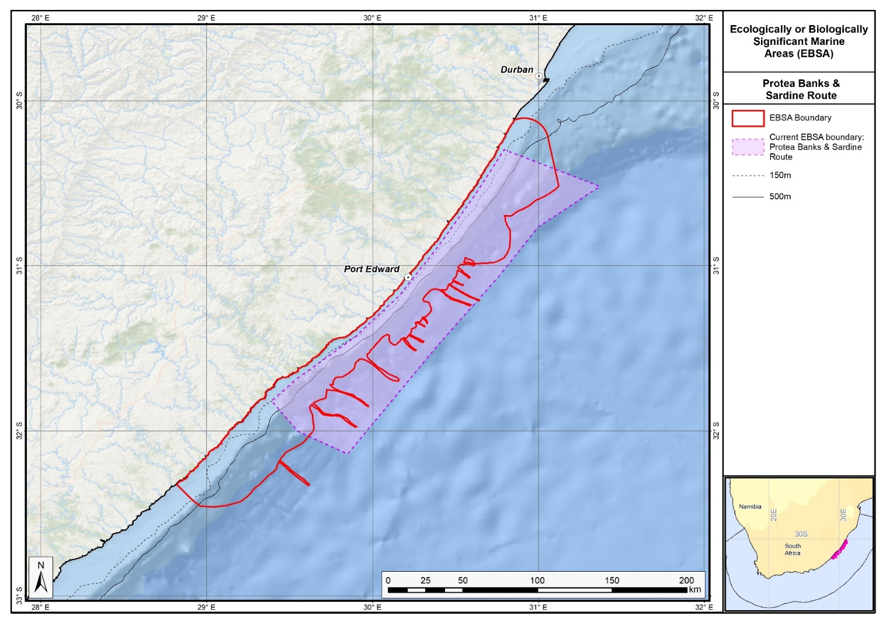
Map of the Protea Banks and Sardine Route area in relation to its original boundaries.

.
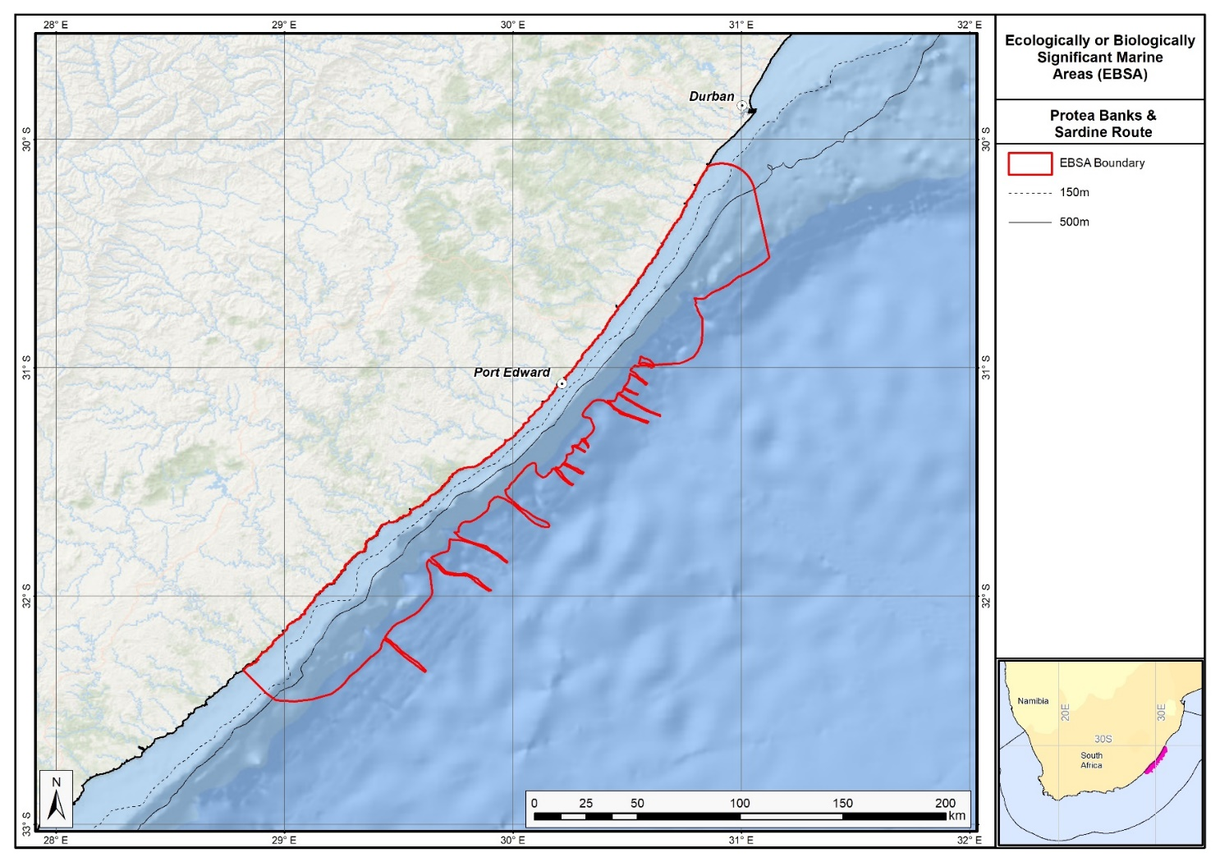
Map of the Protea Banks and Sardine Route area.

Rights and permissions:
No limits on sharing or publication.

26. Protea seamount cluster (description of a new area)

How was the submission developed?
The EBSA revision process was part a broader project on ecosystem-based MSP in the BCLME, namely the Benguela Current Marine Spatial Management and Governance Project (MARISMA, 2014-2023). This was a regional capacity-building and development cooperation project implemented by the Benguela Current Commission, the Governments of Angola, Namibia and South Africa, and GIZ, the German Agency for Development Cooperation (Deutsche Gesellschaft für Internationale Zusammenarbeit.

The MARISMA project undertook a gap analysis of the EBSA network utilizing spatial data that was not available when the initial set of EBSA were described in South-Eastern Atlantic workshop, April 2013.

The overall approach to EBSA delineation, description and engagement followed these key steps:

Initial Systematic Conservation Planning (SCP) Analyses: A gap analysis was undertaken, and new areas identified using systematic conservation planning tools such as Marxan, based on biodiversity input data including ecosystem types, species distributions, and ecological processes.

National Workshops: The new and refined EBSA boundaries were iteratively reviewed and adjusted through workshops held within each of the three countries (Angola, Namibia, South Africa). These workshops allowed country-specific input and tailoring of EBSA boundaries and descriptions to national contexts and priorities.

Regional Workshops and Bilateral Meetings between Countries: Workshops at the regional level especially focused on transboundary EBSAs shared between the countries, but also examined the overall approach to EBSAs, their delineation, description and the engagement approach. The aim was to harmonize boundaries, align management recommendations, and foster cooperation across national borders for effective regional marine biodiversity management. Additional specific bilateral meetings were held where necessary.

Technical and Scientific Peer Review: The revised and new EBSAs underwent technical review nationally and regionally (through technical review workshops involving relevant experts); and internationally with assistance from experts from the Global Ocean Biodiversity Initiative (GOBI) and members of the CBD's Informal Advisory Group on EBSAs, ensuring robustness of the exercise. The process is documented in peer reviewed literature (Harris et al., 2019, 2022).

Political Approval: The EBSAs were administratively and politically approved through all required stages up to the national ministerial level in each country and were then submitted to the CBD Secretariat by the National CBD Focal Points.

Data Sharing and Accessibility: All information, including refined EBSA boundaries, status assessments, management recommendations, and stakeholder feedback, were made available through online repositories such as the project's EBSA Portal (https://cmr.mandela.ac.za/Research-Projects/EBSA-Portal); and the EBSA were also shared via the Benguela Current Convention's Geodata Portal (https://geodata.benguelacc.org/ ). This facilitated transparency, accessibility, and ongoing updating of data and products for biodiversity specialists and other stakeholders.

A previous tentative description for a Protea Seamount EBSA was previously compiled, but was not submitted to CBD due to data limitations. Subsequent expert and systematic review of gaps in the EBSA network highlighted the requirements for the Protea Seamount Cluster EBSA, and delineation and description became possible due to improved spatial datasets. Initial draft EBSA boundaries were determined, and these were then evaluated against the EBSA criteria. Once it was determined that the area would meet EBSA criteria a formal boundary delineation and evaluation process was undertaken. The delineation process included an initial stakeholder review, a technical mapping process and then an expert review workshop where boundary delineation options were finalised. The delineation process used a combination of Systematic Conservation Planning and Multi-Criteria Analysis methods. The features used in the analysis were:
- Key physical features (i.e. the seamounts and seamount linked ecosystems) from the National Biodiversity Assessment 2011 (Sink et al., 2012) and BCC spatial mapping project (Holness et al., 2014) were incorporated. These data were refined using the latest GEBCO data and global benthic geomorphology mapping (www.bluehabitats.org, Harris et al., 2014).
- Irreplaceable and near irreplaceable (i.e. very high selection frequency) sites which relate closely to the EBSA criteria of “Uniqueness and rarity”, as well as focus areas identified in the SCP undertaken for the BCLME by Holness et al. (2014) and Majiedt et al. (2013) were incorporated. In addition, focus areas for marine protection identified by Sink et al. (2011) were included.
- Threatened and under-protected ecosystem types. The analysis attempted to focus on the inclusion of the most threatened and under-protected ecosystem types found in the area (Sink et al. 2012, 2019; Holness et al., 2014). However, as all types in the broader area were Least Concern and not protected, this aspect was not informative.
- Areas of high relative naturalness identified in the National Biodiversity Assessment 2011 (Sink et al., 2012), the West Coast (Majiedt et al., 2013) and the BCLME spatial assessments (Holness et al., 2014) were included in the analysis. Both pelagic and benthic and coastal condition were incorporated.
- Distributions of known fragile, vulnerable and sensitive habitat-forming species were included (Unpublished SANBI and SAEON data).

The multi-criteria analysis resulted a value surface. The cut-off value used to determine the extent of the EBSA was based on expert input and quantitative analysis of effective inclusion of the above features. This entailed taking an iterative parameter calibration-based approach whereby the spatial efficiency of the inclusion of the targeted features was evaluated. The approach aimed to identify a cut-off which most efficiently included prioritised features while minimizing the inclusion of impacted areas. The final boundaries shown in the map were validated in a national workshop.

Traditional knowledge was not incorporated into this process, and consultations with indigenous peoples or local communities were not undertaken. Therefore, documentation of Free, Prior and Informed Consent (FPIC) is not relevant for this EBSA process.

Where is the submission intended to be included (choose one option, and please note that there are different procedures for these two intended end points)?
[X] EBSA repository
[ ] EBSA information-sharing mechanism

Abstract:
The seamounts in the Protea seamount cluster support more productivity and diversity than adjacent sites and provide a site on which migratory species can aggregate. Notably, the area contains vulnerable and sensitive ecosystems and species, some of which are threatened. For example, the site is visited by regionally critically endangered leatherback turtles. The currently low anthropogenic pressure in the area means that the area is in a good condition, which therefore increases the importance of its protection.

Introduction:
The Protea Seamount Cluster focus area lies on the SSW flank of the Agulhas continental shelf: an oceanic plateau that extends several hundreds of kilometres south of South Africa. The focus area is south west of the Browns Bank EBSA, entirely within and up to the edge of the South African EEZ. The site includes the base of the lower slope, but falls mainly within the south Atlantic abyss. Late Eocene volcanism created the seamount cluster in this focus area, including Protea and Argentina Seamounts (among others). The Agulhas Current, which flows south-westward along the eastern coast of South Africa, has its retroflection in this area. Given this position, and its location relative to the Agulhas basin and Agulhas continental shelf, the seamount cluster is an important aggregation site for several migratory species, such as sharks, tuna, and turtles. These animals are also likely attracted to the site for the higher local productivity that is usually associated with seamounts. The Protea Seamount Cluster also contains vulnerable, fragile and sensitive ecosystems and species, and thus the focus area both includes and is important for both benthic and pelagic features. It is considered highly relevant in terms of the following EBSA criteria: “Uniqueness and rarity”, “Importance for threatened or declining ecosystems and species”, and “Naturalness”.

This site was recognised as important at the original South Eastern Atlantic Workshop for EBSA Identification in 2013, but that there was not enough information available to score it against the EBSA criteria at the time (see UNEP/CBD/RW/EBSA/SEA/1/4 Annex 6, Area 5). However, some new data and information have now made description and delineation of the EBSA possible, although criterion rankings still rely heavily on inferred information in many cases. Therefore, the criteria were benchmarked against those ranks given to other EBSAs described for seamounts specifically (see the section: Other relevant website address or attached documents). The seamounts are the underpinning feature of this EBSA, but it also comprises additional features and ecosystems that are connected by seamount-related ecological processes. Consequently, it can be considered a Type 2 EBSA (sensu Johnson et al. 2018).

Location:
The area is within the exclusive economic zone of South Africa, in the South Atlantic abyss off the south-south-west edge of the Agulhas continental shelf (an oceanic plateau that extends several hundreds of kilometres south of South Africa). It lies south-west of the Browns Bank EBSA and extends to the boundary of the exclusive economic zone of South Africa.
The coordinates of a minimum bounding box covering the entire scope of the area are:
- Latitude: -36.892, -36.099, -36.965, -37.758
- Longitude: 17.551, 19.063, 19.518, 18.006

Feature description of the area:
The Protea Seamount Cluster focus area is important for both its benthic and pelagic features, notably for supporting threatened habitats and species, and vulnerable, fragile and sensitive ecosystems and species. It comprises a seamount cluster that includes the Protea Seamount, and a few others, that rise from the southeast Atlantic abyss. The Agulhas Current, which flows south-westward along the eastern coast of South Africa, has its retroflection in this area. Given this position, and its location relative to the Agulhas basin and Agulhas continental shelf, local productivity is high at the site. Consequently, it serves as an important aggregation site for migratory species, such as sharks, seabirds (Halpin et al., 2009), and tuna. Further, adult female leatherback turtles have been satellite tracked to these seamounts and surrounds following nesting (Luschi et al., 2003, 2006, Robinson 2014, Harris et al., 2018), with the site likely used by juvenile turtles as well. There has been one previous scientific expedition to Protea Seamount (in 2001), which was focused on deep-sea pelagic birds.

The Protea Seamount Cluster had a high selection frequency in two systematic conservation plans to represent biodiversity efficiently (Majiedt et al., 2013; Sink et al., 2011). The EBSA was delineated based on this selection frequency, key features (seamounts, fragile and sensitive habitat-forming species, and portions of threatened habitat in good condition), and to align with a national initiative to expand MPAs in South Africa. Protecting this site is important because of its vulnerability to both pelagic fishing and benthic trawling. Although no research is currently planned for this area, it is recommended for this EBSA, particularly towards informing appropriate spatial management of this site.

Note that there are other seamounts in the surrounding area that are not included in the delineation of the EBSA because they are much smaller, unnamed, or there are no records of fragile, habitat-forming species for these sites and they are considered data deficient. There is a matrix of abyssal and bathyal habitat in between the seamounts that is included in the delineation because it represents the broader area where the top predators aggregate in the water column in response to the elevated productivity of the site, likely also encompassing the full extent of seamount-related ecological processes. In addition, it is an efficient way to include a natural, near-pristine portion of these ecosystem types in the EBSA network that is likely to be taken up in spatial management processes for the seamounts themselves, especially because these areas were identified as a priority in the two systematic conservation plans mentioned above.

There are 5 ecosystem types in the EBSA, all of which are considered to be Least Concern (See Table below)(Sink et al., 2019).

Summary of ecosystem types and threat status for Protea Seamount Cluster. Data from Sink et al. (2019).
Threat Status | Ecosystem Type | Area (km²) | Area (%)
Least Concern | Cape Basin Abyss | 1241.9 | 13.8
 | Cape Basin Complex Abyss | 5318.4 | 59.0
 | Southeast Atlantic Lower Slope | 0.2 | 0.0
 | Southeast Atlantic Seamount | 1576.3 | 17.5
 | Southeast Atlantic Slope Seamount | 882.7 | 9.8
Grand Total |  | 9019.5 | 100.0

Feature condition and future outlook:
Sink et al. (2012, 2019) estimated the threat status of marine ecosystem types in South Africa by assessing the cumulative impacts of various pressures (e.g. extractive resource use, pollution and others) on each ecosystem type. The latest assessment (Sink et al., 2019) shows the whole area to be in natural ecological condition. However, the area is highly vulnerable to exploitation due to its unprotected status. The area is in a good condition, largely because it has been subjected to relatively little extractive resource use (e.g. fishing, mining) pressure and is relatively remote and often subjected to high seas with winds of around 50 knots.

Assessment of the area against CBD EBSA Criteria:

To benchmark the criteria ranking for this area, we plotted the frequency of all criteria ranks for seamount-related EBSAs in the global network (Figure below).
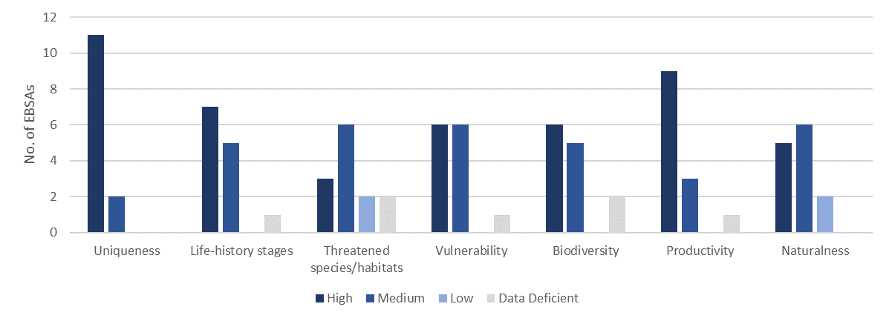
Frequency of the criteria ranks for EBSAs in the global network that are described specifically for seamounts (n=13): Juan Fernández Ridge Seamounts; Emperor Seamount Chain and Northern Hawaiian Ridge; North-east Pacific Ocean Seamounts; New England and Corner Rise Seamounts; Tabou Canyon and Seamount; Cayar Seamount; Atlantis Seamount; Coral Seamount and Fracture Zone Feature; Agulhas Slope and Seamounts; Central Louisville Seamount Chain; Monowai Seamount; Seamounts of West Norfolk Ridge; and Sagami Trough and Island and Seamount Chain of Izu-Ogasawara.

CBD EBSA Criteria  (Annex I to decision IX/20) | Description  (Annex I to decision IX/20) | Ranking of criterion relevance  (please mark one column with an X)
CBD EBSA Criteria  (Annex I to decision IX/20) | Description  (Annex I to decision IX/20) | No information |  | Low |  |  | Medium |  | High
Uniqueness or rarity | Area contains either (i) unique (“the only one of its kind”), rare (occurs only in few locations) or endemic species, populations or communities, and/or (ii) unique, rare or distinct, habitats or ecosystems; and/or (iii) unique or unusual geomorphological or oceanographic features. |  |  |  |  |  | X
This is the only seamount cluster in the Atlantic Ocean portion of the South African EEZ, although there are other seamount clusters in the surrounding area beyond national jurisdiction.
Special importance for life-history stages of species | Areas that are required for a population to survive and thrive. |  |  |  |  |  | X
Data are relatively limited for assessing this criterion. However, given the locally high productivity in the focus area, it is expected that the Protea Seamount Cluster is a key foraging site for migratory species in particular. Further, all other EBSAs globally that include seamounts rank the site at medium or high importance for this criterion, indicative of the ecological role that the feature plays in offshore systems that can be inferred here too. OBIS-SEAMAP (Halpin et al., 2009) shows 1-10 records of megavertebrate (marine mammal, seabird, sea turtle and ray and shark) observations for most of the area around these seamounts in the southeast Atlantic, and a 10-100 records within the EBSA region.
Importance for threatened, endangered or declining species and/or habitats | Area containing habitat for the survival and recovery of endangered, threatened, declining species or area with significant assemblages of such species. |  |  |  |  |  | X
This a site where regionally Critically Endangered leatherback turtles have been recorded based on satellite tracking data (Harris et al., 2018), and a site where other threatened species (e.g., tuna, sharks and seabirds) are expected or known to occur. Global rankings for seamount-specific EBSAs are either High or Medium for this criterion; data are limited for this site specifically, thus it is scored as Medium.
Vulnerability, fragility, sensitivity, or slow recovery | Areas that contain a relatively high proportion of sensitive habitats, biotopes or species that are functionally fragile (highly susceptible to degradation or depletion by human activity or by natural events) or with slow recovery. |  |  |  |  |  |  |  | X
Almost all other seamount-specific EBSAs rank this criterion as Medium or High. This is because seamounts are habitats for many indicator species of vulnerable marine ecosystems (Watling & Auster 2017). Therefore, within Protea Seamount Cluster, it is likely that there are fragile, sensitive species, such as corals and sponges, that are vulnerable to impacts on the seabed and that would take a long time to recover if impacted. This is supported by known presence localities of fragile, vulnerable and sensitive habitat-forming species (Unpublished SANBI and SAEON data) within the EBSA area. Further, the top predators that frequent this site (e.g., Harris et al., 2018) are also slow to recover from population impacts, particularly leatherback turtles given how long they take to reach sexual maturity, and the low survivorship from hatchling to adult (approximately 1 in 1000 survive).
Biological productivity | Area containing species, populations or communities with comparatively higher natural biological productivity. |  |  |  |  |  | X
Seamounts are considered to be relatively productive systems, with most other EBSAs for seamounts ranking this criterion as High. No data are available for the Protea Seamount Cluster; however, Chlorophyll-a concentrations (MODIS-Aqua data on the NASA Giovanni Portal: https://giovanni.gsfc.nasa.gov/giovanni) show marginally higher values within this area compared to the surrounding abyss.
Biological diversity | Area contains comparatively higher diversity of ecosystems, habitats, communities, or species, or has higher genetic diversity. |  |  |  |  |  |  |  | X
Specific data are sparse, however, given the habitat heterogeneity as a result of the seamount cluster, local biodiversity is expected to be higher than adjacent sites, which is confirmed by the global rankings of seamount-specific EBSAs that score this criterion either High or Medium. Further, given the productivity and physical location that makes aggregation of migratory species likely, biodiversity is expected to be higher than the surrounding area. This is supported by the relatively greater abundances (likely representing a greater diversity of species) of megavertebrates in the EBSA region compared to that of the surrounding area (Halpin et al., 2009), and records of up to 100 species of animals in the OBIS database (http://www.iobis.org) within this EBSA. There are four main ecosystem types that make up this EBSA, with a very small portion of a fifth ecosystem type (Sink et al.,2019). This is high relative to most other sites well off the continental shelf.
Naturalness | Area with a comparatively higher degree of naturalness as a result of the lack of or low level of human-induced disturbance or degradation. |  |  |  |  |  |  |  |  | X
The focus area is all assessed to be in natural ecological condition (Sink et al., 2012, 2019), largely because the area has been subjected to relatively low levels of anthropogenic pressures because it is relatively remote and often subjected to high seas with winds of around 50 knots. This contrasts with many seamounts further north in the Benguela system that are not in good ecological condition because they have high fishing pressure.

References:
Halpin, P.N., A.J. Read, E. Fujioka, B.D. Best, B. Donnelly, L.J. Hazen, C. Kot, K. Urian, E. LaBrecque, A. Dimatteo, J. Cleary, C. Good, L.B. Crowder, and K.D. Hyrenbach. 2009. OBIS-SEAMAP: The world data center for marine mammal, sea bird, and sea turtle distributions. Oceanography, 22: 104-115
Harris, L., Holness, S., Finke, G., Kirkman, S., Sink, K., 2019. Systematic Conservation Planning as a Tool to Advance Ecologically or Biologically Significant Area and Marine Spatial Planning Processes, in: Zaucha, J., Gee, K. (Eds.), Maritime Spatial Planning. Palgrave Macmillian, Cham.
Harris, L.R., Holness, S.D., Finke, G., Amunyela, M., Braby, R., Coelho, N., Gee, K., Kirkman, S.P., Kreiner, A., Mausolf, E., Majiedt, P., Maletzky, E., Nsingi, K.K., Russo, V., Sink, K.J., Sorgenfrei, R., 2022. Practical Marine Spatial Management of Ecologically or Biologically Significant Marine Areas: Emerging Lessons From Evidence-Based Planning and Implementation in a Developing-World Context. Front. Mar. Sci. 9.
Harris, L.R., Nel, R., Oosthuizen, H., Meyer, M., Kotze, D., Anders, D., McCue, S., Bachoo, S. 2018. Managing conflicts between economic activities and threatened migratory marine species towards creating a multi-objective blue economy. Conservation Biology, 32: 411-423.
Johnson, D.E., Barrio Froján, C., Turner, P.J., Weaver, P., Gunn, V., Dunn, D.C., Halpin, P., Bax, N.J., Dunstan, P.K., 2018. Reviewing the EBSA process: Improving on success. Marine Policy 88, 75-85.
Luschi, P., Lutjeharms, J.R.E., Lambardi, P., Mencacci, R., Hughes, G.R., and Hays, G.C. 2006. A review of migratory behaviour of sea turtles off southeastern Africa. South African Journal of Science, 102: 51-58.
Luschi, P., Sale, A., Mencacci, R., Hughes, G.R., Lutjeharms, J.R.E., Papi, F. 2003. Current transport of leatherback sea turtles (Dermochelys coriacea) in the ocean. Proceedings of the Royal Society of London. Series B: Biological Sciences, 270: S129-S132.
Majiedt, P., Holness, S., Sink, K., Oosthuizen, A., Chadwick, P. 2013. Systematic Marine Biodiversity Plan for the West Coast of South Africa. South African National Biodiversity Institute, Cape Town.
Robinson, N. 2014. Migratory ecology of sea turtles. PhD Thesis. Perdue University, USA.
Sink, K., Holness, S., Harris, L., Majiedt, P., Atkinson, L., Robinson, T., Kirkman, S., Hutchings, L., Leslie, R., Lamberth, S., Kerwath, S., von der Heyden, S., Lombard, A., Attwood, C., Branch, G., Fairweather, T., Taljaard, S., Weerts, S., Cowley, P., Awad, A., Halpern, B., Grantham, H., Wolf, T. 2012. National Biodiversity Assessment 2011: Technical Report. Volume 4: Marine and Coastal Component. South African National Biodiversity Institute, Pretoria.
Sink, K.J., Attwood, C.G., Lombard, A.T., Grantham, H., Leslie, R., Samaai, T., Kerwath, S., Majiedt, P., Fairweather, T., Hutchings, L., van der Lingen, C., Atkinson, L.J., Wilkinson, S., Holness, S., Wolf, T. 2011. Spatial planning to identify focus areas for offshore biodiversity protection in South Africa. Unpublished Report. Cape Town: South African National Biodiversity Institute.
Sink, K.J., van der Bank, M.G., Majiedt, P.A., Harris, L.R., Atkinson, L., Karenyi, N., Kirkman, S. (eds) 2019. National Biodiversity Assessment 2018 Technical Report Volume 4: Marine Realm. South African National Biodiversity Institute, Pretoria.

Maps and Figures:
GIS data available at: https://cmr.mandela.ac.za/cmr/media/Store/documents/EBSA/Descriptions/SouthAfrica/Shapefile-RSA_EBSAs_final.zip

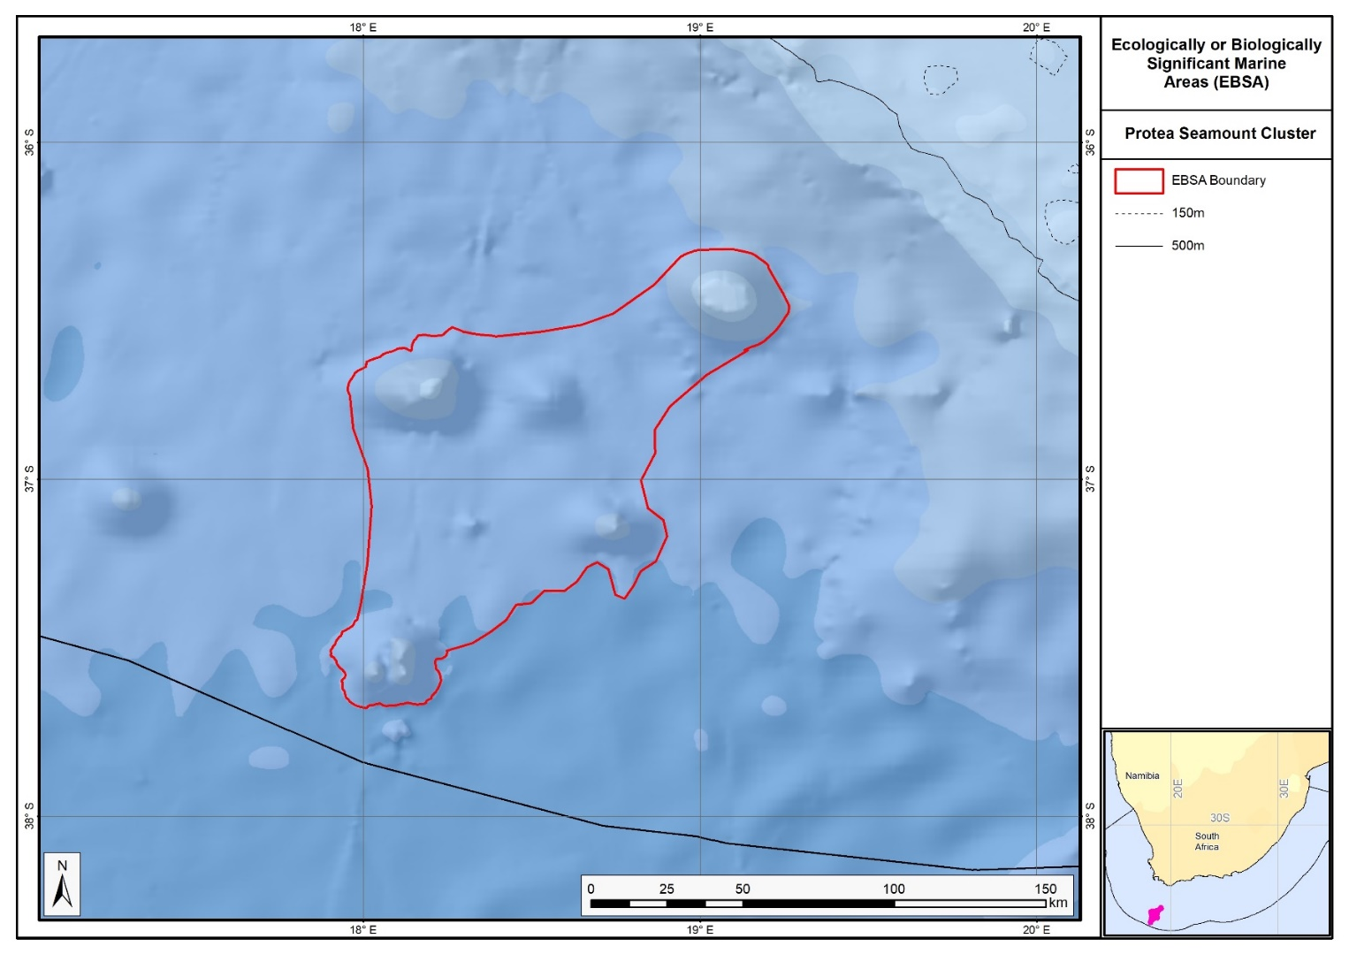
Map of the Protea Seamount Cluster area.

Rights and permissions:
No limits on sharing or publication.

27. Seas of Good Hope (description of a new area)

How was the submission developed?
The EBSA revision process was part a broader project on ecosystem-based MSP in the BCLME, namely the Benguela Current Marine Spatial Management and Governance Project (MARISMA, 2014-2023). This was a regional capacity-building and development cooperation project implemented by the Benguela Current Commission, the Governments of Angola, Namibia and South Africa, and GIZ, the German Agency for Development Cooperation (Deutsche Gesellschaft für Internationale Zusammenarbeit.

The MARISMA project undertook a gap analysis of the EBSA network utilizing spatial data that was not available when the initial set of EBSA were described in South-Eastern Atlantic workshop, April 2013.

The overall approach to EBSA delineation, description and engagement followed these key steps:

Initial Systematic Conservation Planning (SCP) Analyses: A gap analysis was undertaken, and new areas identified using systematic conservation planning tools such as Marxan, based on biodiversity input data including ecosystem types, species distributions, and ecological processes.

National Workshops: The new and refined EBSA boundaries were iteratively reviewed and adjusted through workshops held within each of the three countries (Angola, Namibia, South Africa). These workshops allowed country-specific input and tailoring of EBSA boundaries and descriptions to national contexts and priorities.

Regional Workshops and Bilateral Meetings between Countries: Workshops at the regional level especially focused on transboundary EBSAs shared between the countries, but also examined the overall approach to EBSAs, their delineation, description and the engagement approach. The aim was to harmonize boundaries, align management recommendations, and foster cooperation across national borders for effective regional marine biodiversity management. Additional specific bilateral meetings were held where necessary.

Technical and Scientific Peer Review: The revised and new EBSAs underwent technical review nationally and regionally (through technical review workshops involving relevant experts); and internationally with assistance from experts from the Global Ocean Biodiversity Initiative (GOBI) and members of the CBD's Informal Advisory Group on EBSAs, ensuring robustness of the exercise. The process is documented in peer reviewed literature (Harris et al., 2019, 2022).

Political Approval: The EBSAs were administratively and politically approved through all required stages up to the national ministerial level in each country and were then submitted to the CBD Secretariat by the National CBD Focal Points.

Data Sharing and Accessibility: All information, including refined EBSA boundaries, status assessments, management recommendations, and stakeholder feedback, were made available through online repositories such as the project's EBSA Portal (https://cmr.mandela.ac.za/Research-Projects/EBSA-Portal); and the EBSA were also shared via the Benguela Current Convention's Geodata Portal (https://geodata.benguelacc.org/ ). This facilitated transparency, accessibility, and ongoing updating of data and products for biodiversity specialists and other stakeholders.

Expert and systematic review of gaps in the EBSA network highlighted the requirements for the Seas of Good Hope EBSA. The area had high selection frequency in spatial assessments (Majiedt et al., 2013; Holness et al., 2014) and contained a number of threatened ecosystem types identified in the National Biodiversity Assessment 2011 (Sink et al., 2012). Initial draft EBSA boundaries were determined, and these were then evaluated against the EBSA criteria. Once it was determined that the area would meet EBSA criteria, a formal boundary delineation and evaluation process was undertaken. The delineation process included an initial stakeholder review, a technical mapping process and then an expert review workshop where boundary delineation options were discussed. The boundaries were revised a final time to accommodate the latest NBA 2018 assessment results and the review workshop discussion. The delineation process used a combination of Systematic Conservation Planning and Multi-Criteria Analysis methods. The features used in the analysis were:
- Key physical features (i.e. islands) from the National Biodiversity Assessment 2011 (Sink et al., 2012) and BCC spatial mapping project (Holness et al., 2014) were incorporated. In addition, bays were mapped and included as these have been identified as important features in the new National Biodiversity Assessment 2018 (no reference available yet).
- Delineations and threat status of constituent ecosystem types in the area were included in the analysis and used to refine the boundary of the EBSA.
- Irreplaceable and near irreplaceable (i.e. very high selection frequency) sites which relate closely to the EBSA criteria of “Uniqueness and rarity” from the Systematic Conservation Planning process undertaken for Majiedt et al. (2013) and the BCLME by Holness et al. (2014).
- Areas of high relative naturalness identified in the National Biodiversity Assessment 2011 (Sink et al., 2012), the West Coast (Majiedt et al., 2013) and the BCLME spatial assessments (Holness et al., 2014) were included in the analysis. Both pelagic and benthic and coastal condition were incorporated.
- Distributions of known fragile, vulnerable and sensitive habitat-forming species were included (Unpublished SANBI and SAEON data).
- Areas important for threatened and special species were included. The priority areas and buffer distances around colonies were from Holness et al. (2014). Note that the full extent of the buffer was not necessarily included in the EBSA. Features included in the analysis were:
  - African Penguin colonies and a 20km buffer.
  - Bank Cormorant, Cape Cormorant, White Breasted Cormorant and Crowned Cormorant colonies and a 40km buffer.
  - Seal Colonies and a 20km buffer.

The multi-criteria analysis resulted in a value surface. The cut-off value used to determine the extent of the EBSA was based on expert input and quantitative analysis of effective inclusion of the above features. This entailed taking an iterative parameter calibration-based approach whereby the spatial efficiency of the inclusion of the targeted features was evaluated. The approach aimed to identify a cut-off which most efficiently included prioritised features while minimizing the inclusion of impacted areas. The final boundaries shown in the map were validated in a national workshop.

Traditional knowledge was not incorporated into this process, and consultations with indigenous peoples or local communities were not undertaken. Therefore, documentation of Free, Prior and Informed Consent (FPIC) is not relevant for this EBSA process.

Where is the submission intended to be included (choose one option, and please note that there are different procedures for these two intended end points)?
[X] EBSA repository
[ ] EBSA information-sharing mechanism

Abstract:
The area encompasses the coastal tip of Africa around Cape Point and Cape Agulhas, South Africa, extending from the coast to the inner shelf and including important islands and major bays, such as False Bay and Walker Bay. The area is critically important for threatened species and habitats, supporting vital life-history stages for numerous top predators, including sharks, whales, and, of most significance, seabirds, in particular the endangered African penguin. The area contains threatened coastal, inshore and inner-shelf ecosystems and provides crucial breeding and foraging grounds. It is one of only a few locations in the country to contain such rare features as surf diatom accumulations, which fuel heightened sandy shore productivity. Significantly, the Benguela and Agulhas currents converge in the area, creating the meeting point of the Atlantic and Indian Oceans.

Introduction:
Seas of Good Hope is a coastal EBSA at the southernmost tip of Africa that includes both benthic and pelagic features, and key links between the terrestrial and marine realms. The area extends from the dune base at the back of the shore to depths that are mostly shallower than 150 m. The Agulhas and Benguela Currents meet offshore of this EBSA, with the sea surface temperature between Cape Point and Cape Agulhas being generally cooler than that further offshore where the warmer Agulhas current has a greater influence. The area is important for many commercially important fish species (e.g., Watermeyer et al., 2016), and forms part of their spawning grounds. Consequently, it provides key foraging habitat for numerous top predators, including sharks, whales, seals and seabirds (e.g., Crawford et al., 2008; Pichegru et al., 2010; Best et al. 2015). The EBSA also contains important breeding and resting sites for these top predators, both on the mainland, in bays and on several islands that are contained within the EBSA (e.g., Best 2000; Underhill et al., 2006; Kirkman et al., 2013). Seas of Good Hope also includes areas of high productivity formed by relatively rare surf diatom accumulations. Given the close proximity of the EBSA to key research institutions, and the rich diversity of key marine species and features in the area, there are many datasets available for the site.

The reason this site was not part of the original list of EBSAs first proposed in the South Eastern Atlantic EBSA Identification Workshop in 2013 (UNEP/CBD/RW/EBSA/SEA/1/4) is because the value of the area was recognised only afterwards in a gap analysis. It is presented as a Type 2 EBSA because it contains “spatially stable features whose individual positions are known, but a number of individual cases are being grouped” (sensu Johnson et al., 2018).

Location:
The area is in the exclusive economic zone of South Africa. From just south of Camps Bay, the area wraps around the tip of Cape Point and extends along the shore to the western end of the terrestrial De Mond nature reserve, in Struisbaai, just east of Cape Agulhas. It extends from the dune base to the inner shelf, generally following the 150 m isobath.

The coordinates of a minimum bounding box covering the entire scope of the area are:
- Latitude: -33.893, -34.711, -35.246, -34.428
- Longitude: 18.345, 20.201, 19.966, 18.109

Feature description of the area:
Seas of Good Hope is important for both benthic and pelagic features. The benthic features include ecosystem types comprising mosaics of sand and reef, kelp beds, and several islands (Seal Island, Dyer Island, Geyser Rock, Quoin Rock), and shore habitats including rocky, sandy, mixed and estuarine shores; the pelagic features include important spawning and foraging grounds for a variety of fish and top predators, and areas of high primary productivity. Benthic-pelagic coupling is also a key feature of this EBSA, particularly important in the two important bay systems that are in the EBSA, and for land-sea connectivity among ecosystem types. Overall, the EBSA’s most key attributes are that it includes many threatened species and 23 threatened ecosystem types, and supports important life-history stages of many species, including some of the threatened taxa.

Of the 32 ecosystem types represented in Seas of Good Hope, two thirds (n=23) are threatened, including one Critically Endangered and eight Endangered and 14 Vulnerable types (See Table below)(Sink et al., 2019). By implication, these support biological communities that are also threatened. The EBSA forms part of the spawning grounds for many commercially important fish species (e.g., Watermeyer et al., 2016). Consequently, it provides key foraging habitat for numerous top predators, including sharks, whales, seals and seabirds (e.g., Crawford et al., 2008; Pichegru et al., 2010; Best et al. 2013, Kock et al., 2018), many of which species are also threatened. It also contains important breeding and resting sites for top predators in bays, on the islands and the mainland. For example, it contains island-based (Seal Island, Dyer Island, Geyser Rock) and the only mainland-based (Boulders Beach, Stony Point) colonies of breeding Critically Endangered African penguins (Underhill et al., 2006), and Seal Island, Geyser Rock and Quoin Rock support breeding colonies of Cape fur seals (Kirkman et al., 2013). The EBSA may also include areas where southern right whales give birth to and nurse their calves, and possibly mate (Best 2000).

Secondary attributes of Seas of Good Hope support all other EBSA criteria except for Naturalness. The EBSA includes relatively rare surf diatom accumulations that are present at a few sites along the South African south coast, and only several other places, globally (Campbell & Bate., 1988, Campbell 1996). These surf diatom accumulations fuel sandy beach food webs with particularly high productivity. The kelp beds in the adjacent habitat also provide beach-cast kelp wrack, which also creates particularly productive sandy shore systems (e.g., Dugan et al., 2003; Rodil et al., 2018). Cape Point represents a biogeographic break between the warm and cold temperate coastal systems (Sink et al., 2012), and thus diversity at this site is comparatively higher than adjacent sites because it includes representatives from both bioregions. And finally, the reef and hard ground habitats all support fragile species, that are slow growing and sensitive to disturbance.

Summary of ecosystem types and threat status for Seas of Good Hope. Data from Sink et al. (2019).
Threat Status | Ecosystem Type | Area (km²) | Area (%)
Critically Endangered | Cool Temperate Large Temporarily Closed Estuary | 4.4 | 0.1
Endangered | Agulhas Sheltered Rocky Shore | 0.6 | 0.0
 | Cape Island Shore | 0.1 | 0.0
 | Cape Sheltered Rocky Shore | 0.1 | 0.0
 | Cool Temperate Estuarine Lake | 5.0 | 0.1
 | Cool Temperate Predominantly Open Estuary | 0.4 | 0.0
 | Cool Temperate Small Temporarily Closed Estuary | 2.4 | 0.0
 | Southern Benguela Reflective Sandy Shore | 0.1 | 0.0
 | Warm Temperate Estuarine Lake | 0.9 | 0.0
Vulnerable | Agulhas Exposed Rocky Shore | 22.6 | 0.3
 | Agulhas Inner Shelf Reef Sand Mosaic | 520.8 | 7.7
 | Agulhas Island Shore | 3.4 | 0.1
 | Agulhas Kelp Forest | 11.7 | 0.2
 | Agulhas Outer Shelf Reef Sand Mosaic | 1899.6 | 28.2
 | Agulhas Reflective Sandy Shore | 0.8 | 0.0
 | Agulhas Very Exposed Rocky Shore | 2.5 | 0.0
 | Cape Boulder Shore | 1.0 | 0.0
 | Cape Exposed Rocky Shore | 7.7 | 0.1
 | Cape Kelp Forest | 3.6 | 0.1
 | Cape Mixed Shore | 7.7 | 0.1
 | Cape Rocky Inner Shelf | 188.6 | 2.8
 | Cape Rocky Mid Shelf Mosaic | 335.1 | 5.0
 | False and Walker Bays | 1681.2 | 24.9
Near Threatened | Agulhas Boulder Shore | 0.9 | 0.0
 | Agulhas Dissipative Sandy Shore | 21.9 | 0.3
 | Agulhas Mid Shelf Reef Sand Mosaic | 1970.5 | 29.2
 | Agulhas Mixed Shore | 35.1 | 0.5
 | Cape Very Exposed Rocky Shore | 0.3 | 0.0
 | Southern Benguela Intermediate Sandy Shore | 0.2 | 0.0
Least Concern | Agulhas Dissipative-Intermediate Sandy Shore | 12.3 | 0.2
 | Agulhas Intermediate Sandy Shore | 2.2 | 0.0
 | Southern Benguela Dissipative Sandy Shore | 0.3 | 0.0
 | Southern Benguela Dissipative-Intermediate Sandy Shore | 0.4 | 0.0
N/A | Cool Temperate Micro-estuary | 0.8 | 0.0
Grand Total |  | 6745.5 | 100.0

Feature condition and future outlook:
Although the Cape peninsula is protected in a marine protected area, there are numerous threats to the marine environment in this EBSA, particularly within False Bay and Walker Bay. There are several fisheries operating in the area, including those for West coast rock lobster, squid, linefish, and sharks, as well as subsistence and recreational shore and boat-based fishing, kelp harvesting, and bait collecting (Sink et al., 2012). Given the close proximity to the Cape Town harbour, and the numerous smaller ports within the EBSA, shipping is a relatively high pressure here. The coast is under particular pressure from coastal development (outside the many terrestrial nature reserves in the western half of the EBSA), with associated pressures such as waste water discharge; there are also several invasive invertebrates that are primarily associated with rocky shores that have affected native populations (Sink et al., 2012). Global change pressures are affecting the distribution of local fish stocks, which in turn are affecting some of the top predators, including Critically Endangered African penguins, and Endangered Cape gannets (Crawford et al., 2008; Pichegru et al., 2010). A recent assessment of the ecological condition of the marine realm shows that this EBSA is in fair to poor ecological condition (Sink et al., 2019).

The Seas of Good Hope is approximately 13% protected. The existing MPAs include Table Mountain National Park that wraps around the False Bay peninsula; Betty’s Bay and Walker Bay MPAs. Most of the ecosystem types represented in this EBSA are either Moderately or Well Protected (Sinke et al.,2019).

Assessment of the area against CBD EBSA Criteria:

CBD EBSA Criteria  (Annex I to decision IX/20) | Description  (Annex I to decision IX/20) | Ranking of criterion relevance  (please mark one column with an X)
CBD EBSA Criteria  (Annex I to decision IX/20) | Description  (Annex I to decision IX/20) | No information |  | Low |  |  | Medium |  | High
Uniqueness or rarity | Area contains either (i) unique (“the only one of its kind”), rare (occurs only in few locations) or endemic species, populations or communities, and/or (ii) unique, rare or distinct, habitats or ecosystems; and/or (iii) unique or unusual geomorphological or oceanographic features. |  |  |  |  |  | X
The EBSA contains three of 14 sites in South Africa where surf diatom accumulations are present (Campbell 1996), and the only mainland colonies of Critically Endangered African penguins (Underhill et al., 2006). False and Walker Bay are also relatively rare geomorphic features in the BCLME. It also encompasses the only coastal area where the Indian and Atlantic Oceans meet.
Special importance for life-history stages of species | Areas that are required for a population to survive and thrive. |  |  |  |  |  |  |  | X
Seas of Good Hope is an important spawning ground for commercially important fish species (e.g., Watermeyer et al., 2016). Consequently, it provides key foraging habitat for numerous top predators, including sharks, whales, seals and seabirds (e.g., Crawford et al., 2008; Pichegru et al., 2010; Best et al. 2013). It also contains important breeding and resting sites for top predators, in bays, on the islands and the mainland. For example, it contains island-based and the only mainland-based colonies of breeding Critically Endangered African penguins (Underhill et al., 2006), and Seal Island, Geyser Rock and Quoin Rock support breeding colonies of Cape fur seals (Kirkman et al., 2013). The EBSA may also include areas where southern right whales give birth to and nurse their calves, and possibly mate (Best 2000).
The Cape Coastal Waters IMMA serves as one of the world’s three most important calving and nursery grounds for southern right whales (Eubalaena australis). Decades of aerial surveys reveal that the species is present between June and November each year, and that densities of cow-calf pairs are highest in the nearshore waters between Cape Agulhas and the eastern extent of St. Sebastian Bay, while unaccompanied adults are most common between Walker Bay and False Bay. Most mother-calf pairs are encountered within about 0.9 km from the shore, with an apparent preference for sheltered, shallow, waters of sedimentary substrate that are protected from open-ocean swell and seasonal winds. Numbers of cow-calf pairs dropped markedly between 2015 and 2017 but appeared to increase again to expected levels in 2018 (IUCN-Marine Mammal Protected Areas Task Force, 2021). Further details and maps: https://www.marinemammalhabitat.org/factsheets/cape-coastal-waters/
Part of the EBSA surrounding the Cape Peninsula overlaps with ‘Table Mountain National Park and Surrounds’ Key Biodiversity Area (Key Biodiversity Areas Partnership, 2026). Although the KBA spans both terrestrial and marine habitat, key marine species that contributed to the KBA identification include the Critically Endangered African Penguin (Spheniscus demersus)(Birdlife International, 2024), Endangered Bank Cormorant (Phalacrocorax neglectus), and the Afro-Australian Fur Seal (Arctocephalus pusillus). All three species use the EBSA year-round. Further details and maps: https://www.keybiodiversityareas.org/site/factsheet/100953.
Further details on the Critically Endangered African Penguin (Spheniscus demersus) which heavy uses this area (Birdlife International, 2024) are available at https://datazone.birdlife.org/species/factsheet/african-penguin-spheniscus-demersus .
Importance for threatened, endangered or declining species and/or habitats | Area containing habitat for the survival and recovery of endangered, threatened, declining species or area with significant assemblages of such species. |  |  |  |  |  |  |  | X
There are a number of threatened species that depend on this EBSA focus area for foraging and/or breeding, including Vulnerable white shark, Endangered Indian Ocean humpback dolphin, Endangered Cape gannet, Critically Endangered African penguin, Endangered Cape cormorant, Endangered bank cormorant, white-breasted cormorant, and Near Threatened crowned cormorant. Importantly, some of these species have high residency within the EBSA, e.g., white sharks have specific locations within False Bay where they have high levels of occurrence (Kock et al., 2018), and are especially resident in inshore areas between Walker Bay and around Cape Agulhas (A. Kock, Unpublished tracking data).
The Cape Coastal Waters IMMA serves as one of the world’s three most important calving and nursery grounds for southern right whales (Eubalaena australis). Decades of aerial surveys reveal that the species is present between June and November each year, and that densities of cow-calf pairs are highest in the nearshore waters between Cape Agulhas and the eastern extent of St. Sebastian Bay, while unaccompanied adults are most common between Walker Bay and False Bay. Most mother-calf pairs are encountered within about 0.9 km from the shore, with an apparent preference for sheltered, shallow, waters of sedimentary substrate that are protected from open-ocean swell and seasonal winds. Numbers of cow-calf pairs dropped markedly between 2015 and 2017 but appeared to increase again to expected levels in 2018 (IUCN-Marine Mammal Protected Areas Task Force, 2021). Further details and maps: https://www.marinemammalhabitat.org/factsheets/cape-coastal-waters/
Part of the EBSA surrounding the Cape Peninsula overlaps with ‘Table Mountain National Park and Surrounds’ Key Biodiversity Area (Key Biodiversity Areas Partnership, 2026). Although the KBA spans both terrestrial and marine habitat, key marine species that contributed to the KBA identification include the Critically Endangered African Penguin (Spheniscus demersus)(Birdlife International, 2024), Endangered Bank Cormorant (Phalacrocorax neglectus), and the Afro-Australian Fur Seal (Arctocephalus pusillus). All three species use the EBSA year-round. Further details and maps: https://www.keybiodiversityareas.org/site/factsheet/100953.
Further details on the Critically Endangered African Penguin (Spheniscus demersus) which heavy uses this area (Birdlife International, 2024) are available at https://datazone.birdlife.org/species/factsheet/african-penguin-spheniscus-demersus .
The area includes a very high diversity of threatened ecosystem types. Of the 34 ecosystem types in the EBSA, 23 are threatened, including one Critically Endangered, eight Endangered and 14 Vulnerable ecosystem types (Sink et al., 2019). By implication, the biological communities associated with these ecosystems are also likely to be threatened. There are also a further six ecosystem types in the EBSA that are considered Near Threatened (Sink et al., 2019).
Vulnerability, fragility, sensitivity, or slow recovery | Areas that contain a relatively high proportion of sensitive habitats, biotopes or species that are functionally fragile (highly susceptible to degradation or depletion by human activity or by natural events) or with slow recovery. |  |  |  |  |  | X
The top predators represented in this EBSA have a slow recovery time following impacts to their respective populations. Further, the reefs and hard grounds contain fragile species that are slow growing, and sensitive to disturbance.
Biological productivity | Area containing species, populations or communities with comparatively higher natural biological productivity. |  |  |  |  |  | X
The kelp beds and surf diatom accumulations contribute to elevated productivity for coastal ecosystems, notably the sandy shores (Campbell and Bate, 1988, Rodil et al., 2018). As a spawning area for commercially important fish species, productivity across the shelf is also relatively high.
Biological diversity | Area contains comparatively higher diversity of ecosystems, habitats, communities, or species, or has higher genetic diversity. |  |  |  |  |  |  |  | X
The Agulhas and Benguela currents also meet in the broader area surrounding the EBSA. Consequently, Cape Point is a biogeographic break between the warm and cold temperate bioregions, and thus biodiversity in the area is expected to relatively higher here compared to that of surrounding areas. This is additionally true because the conditions range from fully sheltered within the bays, to fully exposed on the open coast, and because it contains 34 different ecosystem types, each likely supporting their own biological communities (Sink et al., 2019). The EBSA is also known to support diverse assemblages of key species (e.g., Best et al., 2013).
Naturalness | Area with a comparatively higher degree of naturalness as a result of the lack of or low level of human-induced disturbance or degradation. |  |  |  |  | X
Although there are some areas that are protected or under relatively low pressure within this EBSA, the bays in particular are under high pressure from human activities, and the condition of the ecosystem types across the EBSA as a whole is generally quite poor (Sink et al., 2012, 2019). Global change pressures are also strongly felt in this area, with the knock-on effects observed at the top-predator level (Crawford et al., 2008; Pichegru et al., 2010).

References:
Best, L.N., Attwood, C.G., da Silva, C., and Lamberth, S.J. 2013. Chondrichthyan occurrence and abundance trends in False Bay, South Africa, spanning a century of catch and survey records. African Zoology, 48: 201-227.
Best, P.B. 2000. Coastal distribution, movements and site fidelity of right whales Eubalaena australis off South Africa, 1969–1998. South African Journal of Marine Science, 22: 43-55.
BirdLife International, 2024. Species factsheet: African Penguin Spheniscus demersus. Downloaded from https://datazone.birdlife.org/species/factsheet/african-penguin-spheniscus-demersus
Campbell, E.E. 1996. The global distribution of surf diatom accumulations. Revista Chilena Historia Natural, 69: 495-501.
Campbell, E.E., Bate, G.C. 1988. The estimation of annual primary production in a high energy surf-zone. Botanica Marina, 31: 337-343.
Crawford, R.J.M., Underhill, L.G., Coetzee, J.C., Fairweather, T., Shannon, L.J., Wolfaardt, A.C. 2008. Influences of the abundance and distribution of prey on African penguins Spheniscus demersus off western South Africa. African Journal of Marine Science, 30: 167-175.
Dugan, J., Hubbard, D.M., McCrary, M.D., Pierson, M.O. 2003. The response of macrofauna communities and shorebirds to macrophyte wrack subsidies on exposed sandy beaches of southern California. Estuarine, Coastal and Shelf Science, 58S: 25-40.
Harris, L., Holness, S., Finke, G., Kirkman, S., Sink, K., 2019. Systematic Conservation Planning as a Tool to Advance Ecologically or Biologically Significant Area and Marine Spatial Planning Processes, in: Zaucha, J., Gee, K. (Eds.), Maritime Spatial Planning. Palgrave Macmillian, Cham.
Harris, L.R., Holness, S.D., Finke, G., Amunyela, M., Braby, R., Coelho, N., Gee, K., Kirkman, S.P., Kreiner, A., Mausolf, E., Majiedt, P., Maletzky, E., Nsingi, K.K., Russo, V., Sink, K.J., Sorgenfrei, R., 2022. Practical Marine Spatial Management of Ecologically or Biologically Significant Marine Areas: Emerging Lessons From Evidence-Based Planning and Implementation in a Developing-World Context. Front. Mar. Sci. 9.
IUCN-Marine Mammal Protected Areas Task Force, 2021. Cape Coastal Waters IMMA Factsheet. https://www.marinemammalhabitat.org/wp-content/uploads/imma-factsheets/WesternIndianOcean/cape-coastal-waters-WesternIndianOcean.pdf.
Johnson, D.E., Barrio Froján, C., Turner, P.J., Weaver, P., Gunn, V., Dunn, D.C., Halpin, P., Bax, N.J., Dunstan, P.K., 2018. Reviewing the EBSA process: Improving on success. Marine Policy 88, 75-85.
Key Biodiversity Areas Partnership, 2026. Table Mountain National Park and Surrounds (100953)
South Africa, Africa. https://www.keybiodiversityareas.org/site/factsheet/100953
Kirkman, S.P., Yemane, D., Oosthuizen, W.H., Meÿer, M.A., Kotze, P.G.H., Skrypzeck, H., Vaz Velho, F., Underhill, L.G. 2013. Spatio-temporal shifts of the dynamic Cape fur seal population in southern Africa, based on aerial censuses (1972–2009). Marine Mammal Science, 29: 497–524.
Kock, A.A., Photopoulou, T., Durbach, I., Mauff, K., Meÿer, M., Kotze, D., Griffiths, C.L., O’Riain, M.J. 2018. Summer at the beach: spatio-temporal patterns of white shark occurrence along the inshore areas of False Bay, South Africa. Movement Ecology 6, 7.
Pichegru, L., Ryan, P.G., Crawford, R.J.M., van der Lingen, C.D., Grémillet, D. 2010. Behavioural inertia places a top marine predator at risk from environmental change in the Benguela upwelling system. Marine Biology, 157: 537-544.
Rodil, I.F., Lastra, M., López, J., Mucha, A.P., Fernandes, J.P., Fernandes, S.V., Olabarria, C. 2018. Sandy Beaches as Biogeochemical Hotspots: The Metabolic Role of Macroalgal Wrack on Low-productive Shores. Ecosystems, in press.
Sink, K., Holness, S., Harris, L., Majiedt, P., Atkinson, L., Robinson, T., Kirkman, S., Hutchings, L., Leslie, R., Lamberth, S., Kerwath, S., von der Heyden, S., Lombard, A., Attwood, C., Branch, G., Fairweather, T., Taljaard, S., Weerts, S., Cowley, P., Awad, A., Halpern, B., Grantham, H., Wolf, T. 2012. National Biodiversity Assessment 2011: Technical Report. Volume 4: Marine and Coastal Component. South African National Biodiversity Institute, Pretoria.
Sink, K.J., van der Bank, M.G., Majiedt, P.A., Harris, L.R., Atkinson, L., Karenyi, N., Kirkman, S. (eds) 2019. National Biodiversity Assessment 2018 Technical Report Volume 4: Marine Realm. South African National Biodiversity Institute, Pretoria.
Underhill, L.G., Crawford, R.J.M., Wolfaardt, A.C., Whittington, P.A., Dyer, B.M., Leshoro, T.M., Ruthenberg, M., Upfold, L., Visagie, J. 2006. Regionally coherent trends in colonies of African penguins Spheniscus demersus in the Western Cape, South Africa, 1987–2005. African Journal of Marine Science, 28: 697-704.

Maps and Figures:
GIS data available at: https://cmr.mandela.ac.za/cmr/media/Store/documents/EBSA/Descriptions/SouthAfrica/Shapefile-RSA_EBSAs_final.zip
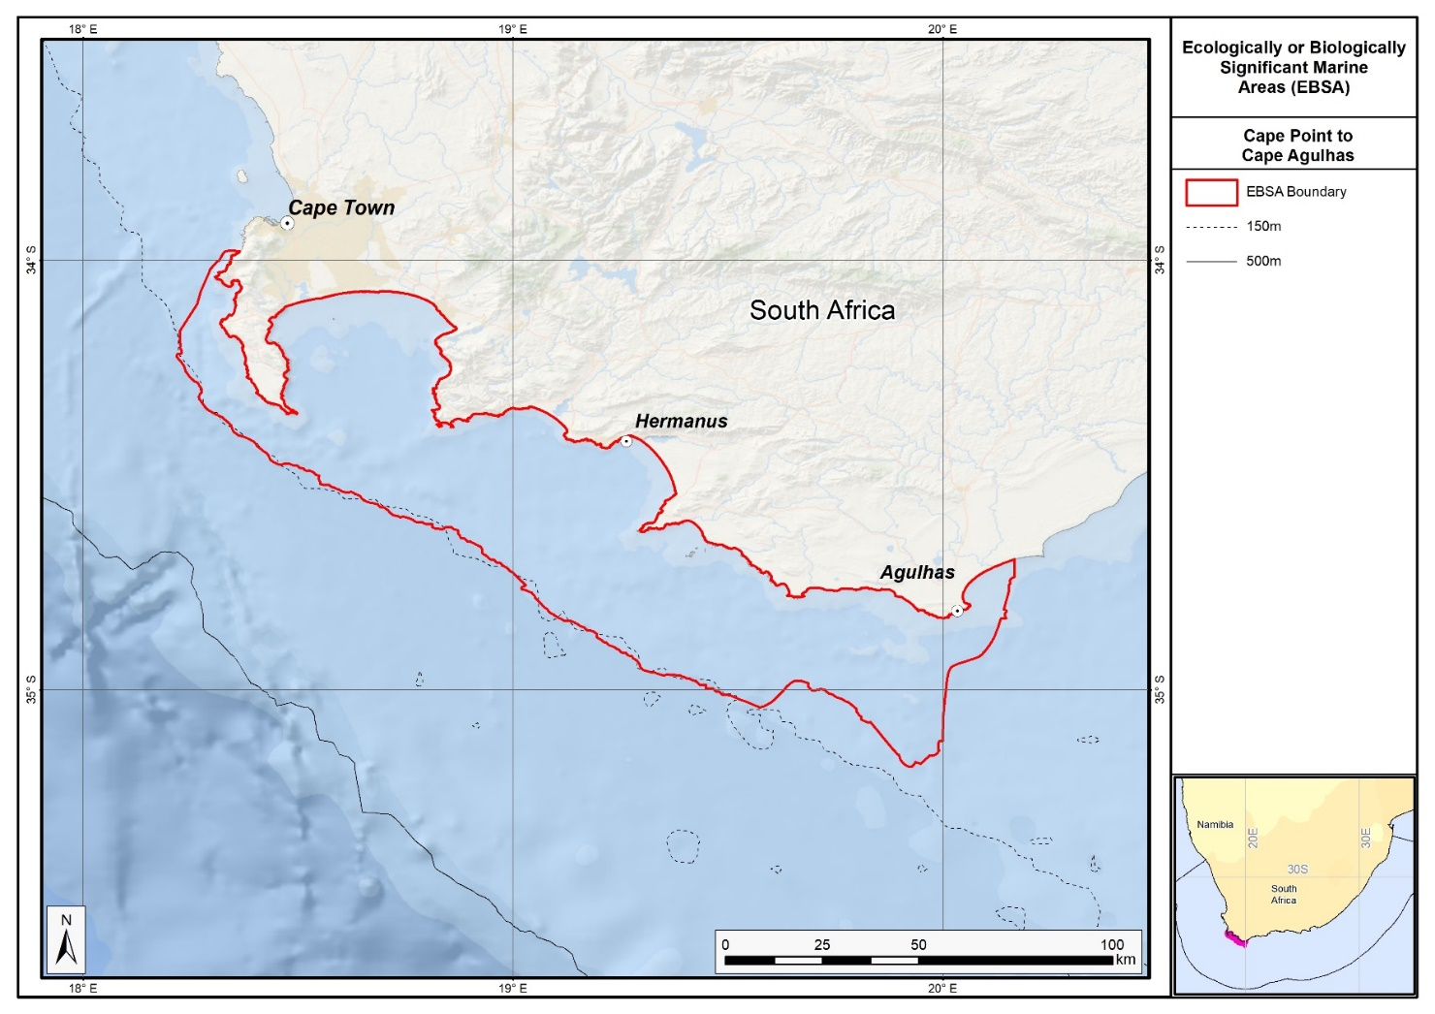
Map of the Seas of Good Hope area.

Rights and permissions:
No limits on sharing or publication.

28. Shackleton seamount complex (modification of the existing Agulhas Slope and Seamounts)⁹

Reason for the modification:
The EBSA description is being modified because of newly available or accessible knowledge on features associated with the area, based on additional scientific data especially new systematic spatial planning and assessments of biodiversity. The descriptions and supporting information are substantially extended, updated and refined beyond the original descriptions from the Southern Indian Ocean Regional EBSA Workshop, 2012. The modifications involve changes to the textual description, changes to the ranking of the area against the EBSA criteria, and changes in shape, location and size of the area.

The original descriptions of Ecologically or Biologically Significant Marine Areas (EBSAs) in the Benguela Current Large Marine Ecosystem (BCLME) were described in the Southern Indian Ocean Regional EBSA Workshop. The descriptions were generally characterized by generic, often fairly geometric delineations, consisting of approximate bounding boxes around the features for which the EBSA was described. This coarse scale of delineation was appropriate for a global scale but posed challenges for inclusion in national-level, place-based ocean management. The original boundaries were not sufficiently refined to capture the full extent of key biodiversity features and often overlapped with areas of lower biodiversity value or poor ecological condition.

Additionally, the original EBSA descriptions suffered from shortfalls related to limited spatial data and lack of systematic conservation planning approaches at the time they were first proposed. This meant that many boundaries did not precisely encompass biodiversity priority areas, potentially leading to conflicts with other ocean sectors and limiting their practical usefulness for marine spatial planning (MSP). The coarse scale and lack of detailed data constrained the ability to develop effective zoning and management recommendations that balance biodiversity protection with economic activities.

How was the submission developed?
The EBSA revision process was part a broader project on ecosystem-based MSP in the BCLME, namely the Benguela Current Marine Spatial Management and Governance Project (MARISMA, 2014-2023). This was a regional capacity-building and development cooperation project implemented by the Benguela Current Commission, the Governments of Angola, Namibia and South Africa, and GIZ, the German Agency for Development Cooperation (Deutsche Gesellschaft für Internationale Zusammenarbeit.

Because of these shortcomings of the existing EBSA boundaries, description and valuations set out in the previous section, the MARISMA project undertook a refinement process. This process used systematic conservation planning (SCP) tools, such as Marxan, to generate finer-scale, more accurate boundaries based on updated biodiversity data and expert input. This process also allowed for the identification of new EBSAs and the splitting of some original EBSAs into multiple refined areas to better reflect discrete biodiversity features and ecological processes. The refined EBSA boundaries were more suitable for MSP and conservation management because they focused on core natural and near-natural areas, avoided unnecessary conflicts with other sectors, and incorporated a systematic, data-driven approach to spatial prioritization.

The overall approach to the EBSA update and engagement followed these key steps:

Initial Systematic Conservation Planning (SCP) Analyses: Existing EBSAs were refined and new areas identified using systematic conservation planning tools such as Marxan, based on biodiversity input data including ecosystem types, species distributions, and ecological processes.

National Workshops: The refined and new EBSA boundaries were iteratively reviewed and adjusted through workshops held within each of the three countries (Angola, Namibia, South Africa). These workshops allowed country-specific input and tailoring of EBSA boundaries and descriptions to national contexts and priorities.

Regional Workshops and Bilateral Meetings between Countries: Workshops at the regional level especially focused on transboundary EBSAs shared between the countries, but also examined the overall approach to EBSAs, their delineation, description and the engagement approach. The aim was to harmonize boundaries, align management recommendations, and foster cooperation across national borders for effective regional marine biodiversity management. Additional specific bilateral meetings were held where necessary.

Technical and Scientific Peer Review: The revised and new EBSAs underwent technical review nationally and regionally (through technical review workshops involving relevant experts); and internationally with assistance from experts from the Global Ocean Biodiversity Initiative (GOBI) and members of the CBD's Informal Advisory Group on EBSAs, ensuring robustness of the exercise. The process is documented in peer reviewed literature (Harris et al., 2019, 2022).

Political Approval: The EBSAs were administratively and politically approved through all required stages up to the national ministerial level in each country and were then submitted to the CBD Secretariat by the National CBD Focal Points.

Data Sharing and Accessibility: All information, including refined EBSA boundaries, status assessments, management recommendations, and stakeholder feedback, were made available through online repositories such as the project's EBSA Portal (https://cmr.mandela.ac.za/Research-Projects/EBSA-Portal); and the EBSA were also shared via the Benguela Current Convention's Geodata Portal (https://geodata.benguelacc.org/ ). This facilitated transparency, accessibility, and ongoing updating of data and products for biodiversity specialists and other stakeholders.

Significant changes have been made to the delineation of the original Agulhas Slope and Seamounts EBSA and to the description, such that it is necessary to split the original EBSA into two, and revise the name of this EBSA to Shackleton Seamount Complex to accurately reflect the features. Additional references have been added and updates to the description were made. A supplementary table of the habitats represented in the EBSA and their associated threat status was also included.

An important change has been the significant delineation change of this EBSA to more closely focus the EBSA on the key biodiversity features in this area that support its EBSA status. The delineation process included an initial stakeholder review which identified the need to update boundaries, a technical mapping process and then an expert review workshop where boundary delineation options were reviewed, revised again and then finalised. The delineation process used a combination of Systematic Conservation Planning and Multi-Criteria Analysis methods. The features used in the analysis were:
- Key physical features (i.e. the seamounts, escarpment and trough) identified from the latest GEBCO data, global benthic geomorphology mapping (www.bluehabitats.org, Harris et al., 2014), the National Biodiversity Assessment 2011 (Sink et al., 2012) and BCC spatial mapping project (Holness et al., 2014) were incorporated.
- Irreplaceable and near irreplaceable (i.e. very high selection frequency) sites, as well as focus areas identified in the Systematic Conservation Plans undertaken for the West Coast by Majiedt et al. (2013), offshore areas (Sink et al., 2011) and by Holness et al. (2014) were incorporated.
- Delineations and threat status of constituent ecosystem types in the area were included in the analysis and used to refine the boundary of the EBSA.
- Areas of high relative naturalness of benthic and coastal systems and pelagic systems identified in the National Biodiversity Assessment 2011 (Sink et al., 2012a) were included in the analysis.
- Distributions of known fragile, vulnerable and sensitive habitat-forming species were included (Unpublished SANBI and SAEON data).

The multi-criteria analysis resulted a value surface. The cut-off value used to determine the extent of the EBSA was based on expert input and quantitative analysis of effective inclusion of the above features. This entailed taking an iterative parameter calibration-based approach whereby the spatial efficiency of the inclusion of the targeted features was evaluated. The approach aimed to identify a cut-off which most efficiently included prioritised features while minimizing the inclusion of impacted areas. The final boundaries shown in the map were validated in a national workshop.

Traditional knowledge was not incorporated into this process, and consultations with indigenous peoples or local communities were not undertaken. Therefore, documentation of Free, Prior and Informed Consent (FPIC) is not relevant for this EBSA process.

Where is the submission intended to be included (choose one option, and please note that there are different procedures for these two intended end points)?
[X] EBSA repository
[ ] EBSA information-sharing mechanism

Abstract:
Changes from the original version: The changes to the abstract focus on the specific inclusion of key seamounts, and the splitting of the original single EBSA into two distinct EBSA, viz. Shackleton Seamount Complex and Mallory Escarpment and Trough.

The southern tip of the Agulhas Bank is a highly dynamic offshore area with exceptional productivity and diverse pelagic and benthic habitats. As the convergence point of the Agulhas and Southern Benguela ecoregions, it benefits from sporadic shelf-edge upwelling that enhances productivity. The area is a crucial spawning habitat for sardine, anchovy, horse mackerel and hake. The apex area of the Agulhas Bank is critical for retaining spawning products, with eddies recirculating water inshore, connecting important nursery areas with shelf-edge spawning grounds. The area encompasses the Mallory, Shackleton and Natal seamounts. The existing EBSA was originally identified as a priority for spatial planning owing to its high habitat diversity; for the present submission, it has been refined and split into two areas, namely, Shackleton seamount complex and Mallory escarpment and trough.

Introduction:
Changes from the original version: The introduction largely includes the original text but provides additional oceanographic details and up to date references. Additional references to the importance for turtles are included.

Shackleton Seamount Complex includes the outer margin along the southern tip of the Agulhas Bank in South Africa. It is a dynamic offshore area with high pelagic and benthic habitat heterogeneity. The area includes outer shelf, shelf edge, slope and seamount habitats. The Agulhas and Southern Benguela ecoregions meet at this point (Sink et al., 2012), and sporadic shelf edge upwelling enhances the productivity along the outer margin (Lagabrielle, 2009, Roberson et al., 2017). The site is recognized as a spawning area for sardine, anchovy, horse mackerel and hake, and this apex of the Agulhas Bank is recognized as a critical area for retention of spawning products (Hutchings et al., 2002). Here, eddies help recirculate water inshore and link important nursery areas with spawning habitat on the shelf edge. Leatherback turtles also frequent these seamounts along their migrations (Harris et al., 2018). This area was identified as a priority through a national plan to identify focus areas for offshore protection (Sink et al., 2011) because it has relatively high habitat diversity and can meet multiple benthic and pelagic habitat conservation targets in a small area.

Location:
Changes from the original version: The section reflects the updated spatial delineation focussed on the seamounts, provides bounding box coordinates, and shares a link to the specific spatial data. Motivation for the spatial changes, and details of the spatial planning are given in “How was the submission developed?” Section. The key geographic change is the split of the original Agulhas Slope and Seamounts EBSA into two, with this Shackleton Seamount Complex focussing on the seamounts to accurately reflect the features.

The area is at the apex of the Agulhas Bank at the southern tip of the continental shelf edge off southern Africa. It is directly south of Mossel Bay and is entirely within the exclusive economic zone of South Africa. It lies immediately east of the Mallory escarpment and trough area.

The coordinates of a minimum bounding box covering the entire scope of the area are:
- Latitude: -35.746, -37.432, -37.82, -36.133
- Longitude: 22.868, 23.385, 22.121, 21.604

Feature description of the area:
Changes from the original version: The feature description has been completely rewritten to reflect the more seamount focussed EBSA. Substantial additional information is given on ecosystem types, their diversity and their threat statuses based on new systematic assessment. A table of ecosystem types and their statuses is provided. The description also reflects new survey data. Further, the EBSA is now presented as a Type 2 EBSA because it contains “spatially stable features whose individual positions are known, but a number of individual cases are being grouped” (sensu Johnson et al., 2018).

The area includes benthic and pelagic features, including shelf edge, slope and seamounts, shelf-edge driven upwelling, and fragile and sensitive habitat-forming species. It contains the Mallory, Shackleton and Natal Seamounts. Habitat diversity is thus particularly high, with eight ecosystem types occurring in this dynamic area (which is relatively very diverse for an area this far off the coast), including large areas of the Agulhas Basin Abyss, Agulhas Rocky Shelf Edge, Southwest Indian Lower Slope, Southwest Indian Mid Slope and Southwest Indian Seamount. All these ecosystems were assessed as being Least Concern in the National Biodiversity Assessment (Table below; Sink et al., 2019). It consequently supports numerous ecological processes, such as spawning and foraging, and comprises a rich diversity of both resident (e.g., benthic gorgonians) and transient (e.g., migrating leatherbacks) species. Two sites at the northern edge of the EBSA were recently surveyed; however, deteriorating weather conditions limited research operations (Sink 2016). Nevertheless, the sites were reported to be less muddy than expected, and samples of yellow scleractinian coral, stylasterine corals and bryozoans were collected (Sink 2016).

The delineation of this EBSA was refined since its first description, and is now split into two EBSAs: one for the seamounts, and one for the escarpment and trough features. The revision was based on high selection frequency of sites in the two systematic biodiversity plans covering the area, tighter alignment to the benthic topography (from a new national dataset: De Wet 2012), new focus areas for MPA expansion in South Africa, presence of fragile and sensitive habitat-forming species, and presence of threatened benthic ecosystem types. Effectively, these new data helped to improve the precision of the EBSA boundary so that it better reflects the underlying features. It is presented as a Type 2 EBSA because it contains “spatially stable features whose individual positions are known, but a number of individual cases are being grouped” (sensu Johnson et al., 2018).

Summary of ecosystem types and threat status for the Shackleton Seamount Complex EBSA. Data from Sink et al. (2019).
Threat Status | Ecosystem Type | Area (km²) | Area (%)
Least Concern | Agulhas Basin Abyss | 3403.0 | 28.4
Least Concern | Agulhas Outer Shelf Reef Coarse Sediment Mosaic | 805.8 | 6.7
 | Agulhas Rocky Shelf Edge | 1003.6 | 8.4
 | Southwest Indian Lower Slope | 1765.0 | 14.7
 | Southwest Indian Mid Slope | 1260.7 | 10.5
 | Southwest Indian Seamount | 2072.4 | 17.3
 | Southwest Indian Slope Seamount | 888.7 | 7.4
 | Southwest Indian Upper Slope | 733.0 | 6.1
Grand Total |  | 11932.2 | 99.6

Feature condition and future outlook:
Changes from the original version: The section has been almost completely revised to reflect newly available information. The revised description includes updated information on ecological condition, ecosystem threat statuses, and describes the newly declared South West Indian Seamounts MPA.

The shelf edge and seamounts have not been sampled, although in-situ research is recommended in this area. Nevertheless, there are various fisheries operating in the area, but some of the hard grounds represented in the EBSA are outside of the trawl footprint. Shackleton Seamount Complex is largely in good ecological condition (76%), with most of the remaining area in fair ecological condition (24%) and a fraction (<1%) that is in poor ecological condition. Consequently, whole EBSA is Least Concern (100%)(Sink et al., 2019). Broadly speaking, there is relatively little pressure in this area at present, and the ecosystem types are in good condition.

Protection of features in MPAs has been considerably expanded and strengthened following the proclamation of the Operation Phakisa MPA network in 2019, with the EBSA area within reserves increasing from no protection to 41% protected. These new South West Indian Seamounts MPA covers the Natal seamount, but not Mallory or Shackleton Seamounts in the middle of the EBSA. There are also still some ecosystem types within the EBSA that are poorly or not protected.

Assessment of the area against CBD EBSA Criteria:
Changes from the original version: The revised description retains the same rankings for the EBSA criteria as for the original Agulhas Slope and Seamounts EBSA. However, the revised text provides more detailed supporting evidence and updated scientific references to justify these rankings, particularly referring to new survey data and results of ecosystem mapping and assessments of status.

CBD EBSA Criteria  (Annex I to decision IX/20) | Description  (Annex I to decision IX/20) | Ranking of criterion relevance  (please mark one column with an X)
CBD EBSA Criteria  (Annex I to decision IX/20) | Description  (Annex I to decision IX/20) | No information |  | Low |  |  | Medium |  | High
Uniqueness or rarity | Area contains either (i) unique (“the only one of its kind”), rare (occurs only in few locations) or endemic species, populations or communities, and/or (ii) unique, rare or distinct, habitats or ecosystems; and/or (iii) unique or unusual geomorphological or oceanographic features. |  |  |  |  |  | x
This area includes 3 of 4 known seamounts within the Davie Seamount cluster (Sink et al., 2011, 2012). These seamounts are relatively isolated and are thus likely to host distinct communities.
Special importance for life-history stages of species | Areas that are required for a population to survive and thrive. |  |  |  |  |  |  |  | X
Shackleton Seamount Complex is recognized as a spawning area for small pelagic fish (sardine, anchovy, horse mackerel) and hake (Hutchings et al., 2002, Sink et al., 2011). This apex area of the Agulhas Bank is also recognized as a critical area for retention of spawning products. Eddies in this area help re-circulate water inshore and link important nursery areas with spawning habitat on the shelf edge. The shelf edge constitutes foraging area for offshore seabirds (Birdlife data, see references below), and the seamounts are a foraging area for leatherback turtles (Harris et al., 2018). It is also an important Mako shark nursery area.
The area overlaps part of the recognized Southern Coastal and Shelf Waters of South Africa Important Marine Mammal Area (IUCN-Marine Mammal Protected Areas Task Force, 2020). The southern coast of South Africa represents one of the world’s most productive marine regions, famed for its annual ‘Sardine Run’ which occurs along the southeast coast between May and June. This annual event supports a number of top predators, including common dolphins (Delphinus delphis), Indo-Pacific bottlenose dolphins (Tursiops aduncus), fur seals (Arctocephalus pusillus) and killer whales (Orcinus orca). Furthermore, the waters over the continental shelf, present important habitat for the inshore form of Bryde’s whale (Balaenoptera edeni). Further details and maps: https://www.marinemammalhabitat.org/factsheets/southern-coastal-shelf-waters-south-africa/
Importance for threatened, endangered or declining species and/or habitats | Area containing habitat for the survival and recovery of endangered, threatened, declining species or area with significant assemblages of such species. |  |  |  |  |  | X
One of the pelagic ecosystem types in the area is characterised by elevated productivity and frequent fronts due to shelf edge upwelling (Lutjeharms et al., 2000, Lagabrielle 2009, Roberson et al., 2017). Consequently, regionally Critically Endangered leatherback turtles frequent this area (Petersen et al., 2009a; Harris et al., 2018), and the shelf edge is a feeding area for threatened seabirds such as Albatross (Petersen et al., 2009b).
Vulnerability, fragility, sensitivity, or slow recovery | Areas that contain a relatively high proportion of sensitive habitats, biotopes or species that are functionally fragile (highly susceptible to degradation or depletion by human activity or by natural events) or with slow recovery. |  |  |  |  |  |  |  | X
This area includes hard shelf edge and seamounts (some of the hard grounds are untrawled). These are likely to support fragile long-lived biota. Video images of the shelf edge show cold-water corals, gorgonians and large sponges (Sink et al., 2011). Vulnerable biota that use this area include long-lived seabirds, turtles and sharks, and the area has been identified by analyses aimed at identifying priority areas for reducing by-catch in the large pelagic fishery (Sink et al., 2011.)
Biological productivity | Area containing species, populations or communities with comparatively higher natural biological productivity. |  |  |  |  |  |  |  | X
There is higher productivity here, which is related to the eastern limit of the Benguela upwelling on the outer shelf (Pelagic ecosystem type Ab3) and very frequent SST and chlorophyll fronts (Lutjeharms et al., 2000, Lagabrielle 2009, Sink et al., 2011, 2012, Roberson et al., 2017). Cool productive water is advected onto the shelf in this sheer zone through Agulhas Current-driven upwelling cells (Lutjeharms et al., 2000).
Biological diversity | Area contains comparatively higher diversity of ecosystems, habitats, communities, or species, or has higher genetic diversity. |  |  |  |  |  |  |  | X
This area has high pelagic and benthic habitat heterogeneity. Four pelagic ecosystem types (Ab3, Bc1, Cb3 and Cb4) and occur in this dynamic area (Sink et al., 2011, 2012), with eight ecosystem types present that include shelf, slope, seamount and abyssal types (Sink et al., 2019).
Naturalness | Area with a comparatively higher degree of naturalness as a result of the lack of or low level of human-induced disturbance or degradation. |  |  |  |  |  |  |  |  | X
Rough grounds and strong currents already offer some protection from pressures to this area (Sink et al., 2011, 2012). Relatively lower levels of disturbance occur in this area (Sink et al., 2012), and most of the local hard areas fall outside of the hake trawl footprint (Sink et al., 2011).

References:
Changes from the original version: The revised description includes a substantially expanded reference list, incorporating recent peer-reviewed publications and technical reports.

De Wet, W. 2012. Bathymetry of the South African Continental Shelf. MSc dissertation. University of Cape Town, South Africa.
Harris, L., Holness, S., Finke, G., Kirkman, S., Sink, K., 2019. Systematic Conservation Planning as a Tool to Advance Ecologically or Biologically Significant Area and Marine Spatial Planning Processes, in: Zaucha, J., Gee, K. (Eds.), Maritime Spatial Planning. Palgrave Macmillian, Cham.
Harris, L.R., Holness, S.D., Finke, G., Amunyela, M., Braby, R., Coelho, N., Gee, K., Kirkman, S.P., Kreiner, A., Mausolf, E., Majiedt, P., Maletzky, E., Nsingi, K.K., Russo, V., Sink, K.J., Sorgenfrei, R., 2022. Practical Marine Spatial Management of Ecologically or Biologically Significant Marine Areas: Emerging Lessons From Evidence-Based Planning and Implementation in a Developing-World Context. Front. Mar. Sci. 9.
Harris, L.R., Nel, R., Oosthuizen, H., Meyer, M., Kotze, D., Anders, D., McCue, S., Bachoo, S. 2018. Managing conflicts between economic activities and threatened migratory marine species towards creating a multi-objective blue economy. Conservation Biology, 32, 411-423.
Hutchings, L., Beckley, L.E., Griffiths, M.H., Roberts, M.J., Sundby, S., van der Lingen, C. 2002. Spawning on the edge: spawning grounds and nursery areas around the southern African coastline. Marine and Freshwater Research, 53: 307-318.
IUCN-Marine Mammal Protected Areas Task Force, 2020. Southern Coastal and Shelf Waters of South Africa IMMA Factsheet. https://www.marinemammalhabitat.org/wp-content/uploads/imma-factsheets/WesternIndianOcean/southern-coastal-and-shelf-waters-of-south-africa-WesternIndianOcean.pdf.
Johnson, D.E., Barrio Froján, C., Turner, P.J., Weaver, P., Gunn, V., Dunn, D.C., Halpin, P., Bax, N.J., Dunstan, P.K., 2018. Reviewing the EBSA process: Improving on success. Marine Policy 88, 75-85.
Lagabrielle, E. 2009. Preliminary report: National Pelagic Bioregionalisation of South Africa. Cape Town: South African National Biodiversity Institute.
Lutjeharms, J.R.E., Cooper, J., Roberts, M. 2000. Upwelling at the inshore edge of the Agulhas Current. Continental Shelf Research, 20: 737 – 761.
Roberson, L.A., Lagabrielle, E., Lombard, A.T., Sink, K., Livingstone, T., Grantham, H., Harris, J.M. 2017. Pelagic bioregionalisation using open-access data for better planning of marine protected area networks. Ocean & Coastal Management, 148: 214-230.
Sink, K. 2016. Deep Secrets: the outer shelf and slope ecosystems of South Africa. Cruise Report: ALG 230 – ACEP_DSC.
Sink, K., Holness, S., Harris, L., Majiedt, P., Atkinson, L., Robinson, T., Kirkman, S., Hutchings, L., Leslie, R., Lamberth, S., Kerwath, S., von der Heyden, S., Lombard, A., Attwood, C., Branch, G., Fairweather, T., Taljaard, S., Weerts, S., Cowley, P., Awad, A., Halpern, B., Grantham, H., Wolf, T. 2012. National Biodiversity Assessment 2011: Technical Report. Volume 4: Marine and Coastal Component. South African National Biodiversity Institute, Pretoria.
Sink, K.J., Attwood, C.G., Lombard, A.T., Grantham, H., Leslie, R., Samaai, T., Kerwath, S., Majiedt, P., Fairweather, T., Hutchings, L., van der Lingen, C., Atkinson, L.J., Wilkinson, S., Holness, S., Wolf, T. 2011. Spatial planning to identify focus areas for offshore biodiversity protection in South Africa. Unpublished Report. Cape Town: South African National Biodiversity Institute.
Sink, K.J., van der Bank, M.G., Majiedt, P.A., Harris, L.R., Atkinson, L., Karenyi, N., Kirkman, S. (eds) 2019. National Biodiversity Assessment 2018 Technical Report Volume 4: Marine Realm. South African National Biodiversity Institute, Pretoria.

Maps and Figures:
GIS data available at: https://cmr.mandela.ac.za/cmr/media/Store/documents/EBSA/Descriptions/SouthAfrica/Shapefile-RSA_EBSAs_final.zip
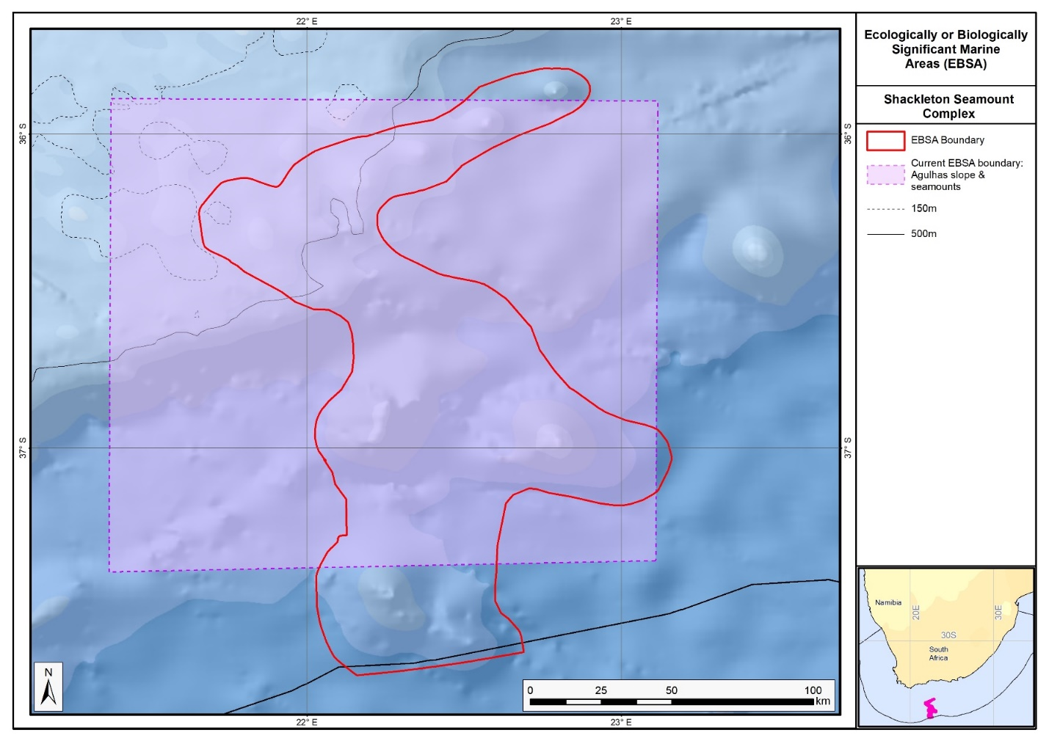
Map of the Shackleton Seamount Complex area in relation to the original Agulhas Slope and Seamounts EBSA.

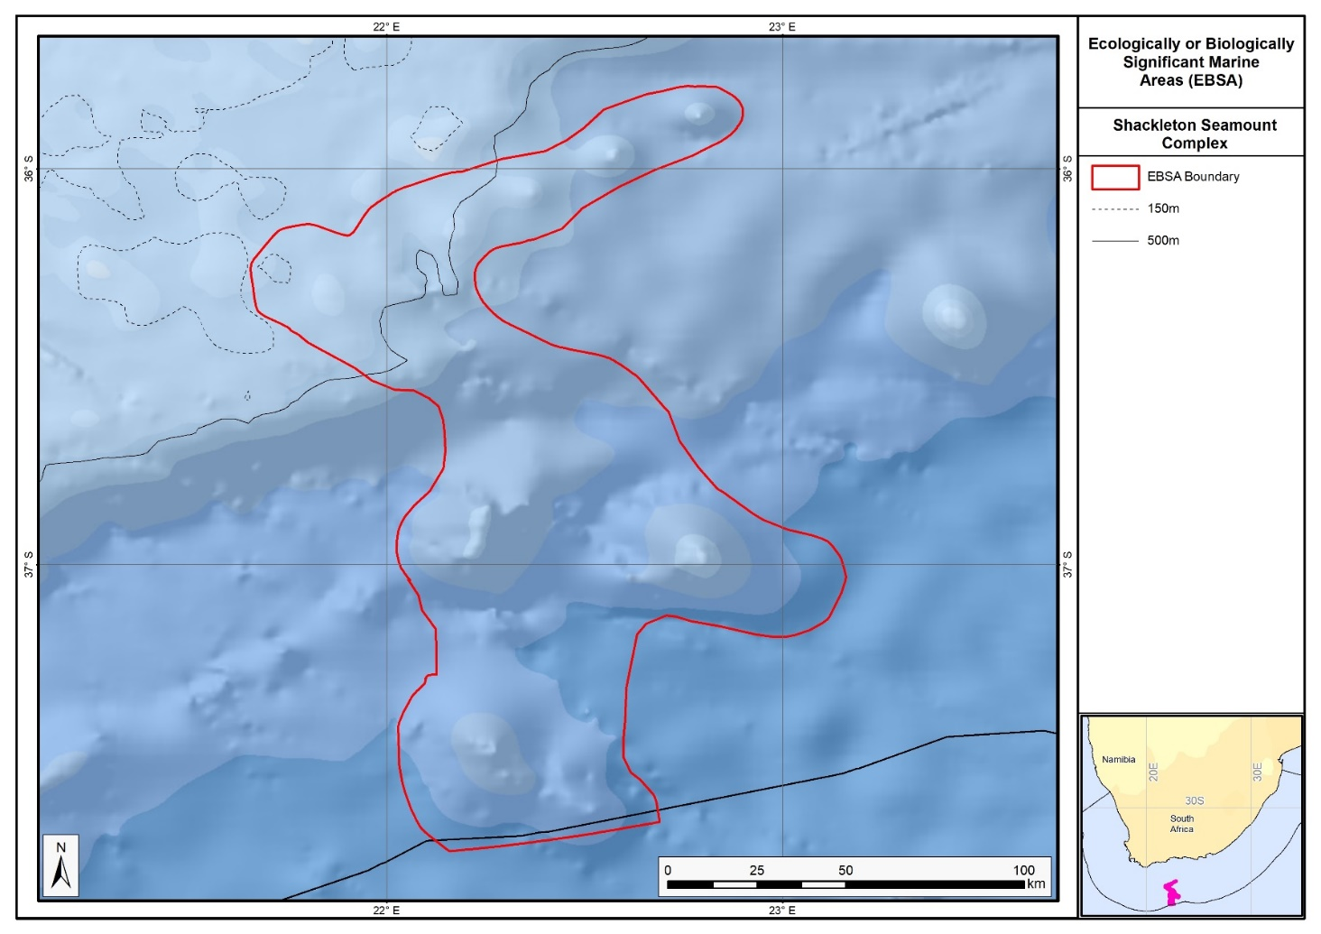
Map of the Shackleton Seamount Complex area.

Rights and permissions:
No limits on sharing or publication.

29. Tsitsikamma-Robberg (description of a new area)

How was the submission developed?
The EBSA revision process was part a broader project on ecosystem-based MSP in the BCLME, namely the Benguela Current Marine Spatial Management and Governance Project (MARISMA, 2014-2023). This was a regional capacity-building and development cooperation project implemented by the Benguela Current Commission, the Governments of Angola, Namibia and South Africa, and GIZ, the German Agency for Development Cooperation (Deutsche Gesellschaft für Internationale Zusammenarbeit.

The MARISMA project undertook a gap analysis of the EBSA network utilizing spatial data that was not available when the initial set of EBSA were described in South-Eastern Atlantic workshop, April 2013.

The overall approach to EBSA delineation, description and engagement followed these key steps:

Initial Systematic Conservation Planning (SCP) Analyses: A gap analysis was undertaken, and new areas identified using systematic conservation planning tools such as Marxan, based on biodiversity input data including ecosystem types, species distributions, and ecological processes.

National Workshops: The new and refined EBSA boundaries were iteratively reviewed and adjusted through workshops held within each of the three countries (Angola, Namibia, South Africa). These workshops allowed country-specific input and tailoring of EBSA boundaries and descriptions to national contexts and priorities.

Regional Workshops and Bilateral Meetings between Countries: Workshops at the regional level especially focused on transboundary EBSAs shared between the countries, but also examined the overall approach to EBSAs, their delineation, description and the engagement approach. The aim was to harmonize boundaries, align management recommendations, and foster cooperation across national borders for effective regional marine biodiversity management. Additional specific bilateral meetings were held where necessary.

Technical and Scientific Peer Review: The revised and new EBSAs underwent technical review nationally and regionally (through technical review workshops involving relevant experts); and internationally with assistance from experts from the Global Ocean Biodiversity Initiative (GOBI) and members of the CBD's Informal Advisory Group on EBSAs, ensuring robustness of the exercise. The process is documented in peer reviewed literature (Harris et al., 2019, 2022).

Political Approval: The EBSAs were administratively and politically approved through all required stages up to the national ministerial level in each country and were then submitted to the CBD Secretariat by the National CBD Focal Points.

Data Sharing and Accessibility: All information, including refined EBSA boundaries, status assessments, management recommendations, and stakeholder feedback, were made available through online repositories such as the project's EBSA Portal (https://cmr.mandela.ac.za/Research-Projects/EBSA-Portal); and the EBSA were also shared via the Benguela Current Convention's Geodata Portal (https://geodata.benguelacc.org/ ). This facilitated transparency, accessibility, and ongoing updating of data and products for biodiversity specialists and other stakeholders.

The Robberg-Tsitsikamma area was highlighted in a recent expert and systematic review of gaps in the EBSA network. The area also has high selection frequency in spatial assessments (Sink et al., 2011; Unpublished data linked to Majiedt et al., 2013; Holness et al., 2014) and contains threatened ecosystem types identified in the National Biodiversity Assessment 2011 (Sink et al., 2012). Initial draft EBSA boundaries were determined, and these were then evaluated against the EBSA criteria. Once it was determined that the area would meet EBSA criteria a formal boundary delineation and evaluation process was undertaken. The delineation process included an initial stakeholder review, a technical mapping process and then an expert review workshop where boundary delineation options were discussed. The boundaries were revised a final time to accommodate the latest NBA 2018 assessment results and the review workshop discussion. The delineation process used a combination of Systematic Conservation Planning and Multi-Criteria Analysis methods. The features used in the analysis were:
- Irreplaceable and near irreplaceable (i.e. very high selection frequency) sites which relate closely to the EBSA criteria of “Uniqueness and rarity” from the offshore prioritisation process (Sink et al., 2011), the Systematic Conservation Planning process undertaken for Majiedt et al. (2013) and the additional unpublished analysis for the broader BCLME region by Holness et al. (2014).
- Delineations and threat status of constituent ecosystem types in the area were included in the analysis and used to refine the boundary of the EBSA.
- Areas of high relative naturalness identified in the National Biodiversity Assessment 2011 (Sink et al., 2012), the West Coast (Majiedt et al., 2013) and the BCLME spatial assessments (Holness et al., 2014) were included in the analysis. Both pelagic and benthic and coastal condition were incorporated.
- Distributions of known fragile, vulnerable and sensitive habitat-forming species were included (Unpublished SANBI and SAEON data).

The multi-criteria analysis resulted a value surface. The cut-off value used to determine the extent of the EBSA was based on expert input and quantitative analysis of effective inclusion of the above features. This entailed taking an iterative parameter calibration-based approach, whereby the spatial efficiency of the inclusion of the targeted features was evaluated. The approach aimed to identify a cut-off which most efficiently included prioritised features while minimizing the inclusion of impacted areas. The final boundaries shown in the map were validated in a national workshop.

Traditional knowledge was not incorporated into this process, and consultations with indigenous peoples or local communities were not undertaken. Therefore, documentation of Free, Prior and Informed Consent (FPIC) is not relevant for this EBSA process.

Where is the submission intended to be included (choose one option, and please note that there are different procedures for these two intended end points)?
[X] EBSA repository
[ ] EBSA information-sharing mechanism

Abstract:
The area has a high diversity and abundance of species, including fragile, vulnerable, sensitive and slow-growing species that in turn support many top predators. Numerous threatened species are in the area, including an endangered endemic seahorse species and several critically endangered fish species. The area supports important life-history stages of those threatened species and other species. Several critically endangered and endangered ecosystem types are present in the area, which is mostly in a good or fair ecological condition.

Introduction:
Tsitsikamma-Robberg is a coastal EBSA that includes the Tsitsikamma, Robberg and Goukamma MPAs, and is bordered along most of its shore length by the Garden Route National Park. The EBSA also forms part of the Garden Route Biosphere Reserve. Fourteen estuaries open into this EBSA, with the Keurbooms, Groot, Sout, Knysna and Goukamma Estuaries included in the EBSA boundary. As a coastal EBSA, the depth range is relatively shallow, with most of the area covering the middle shelf. Depths are generally shallower than -100 m, although slightly deeper waters are contained in the western offshore extension. The EBSA contains important inshore reefs, vulnerable, fragile and sensitive species, and is also rich in top predators (sharks, cetaceans and marine mammals), some of which are threatened species. Inclusion of the Keurbooms and Knysna Estuaries in the EBSA means that it also contains two of only three estuaries in South Africa where the Knysna seahorse (Hippocampus capensis) is found: one of the two Endangered seahorse species globally. Given the diversity contained within the EBSA, there are many ecotourism operators (whale watching, fishing charters) and marine researchers working in this area. Notably, Tsitsikamma MPA is Africa’s oldest marine reserve, and therefore, there is a lot of research on the reef and fish communities contained within it. The EBSA had a high selection frequency in a national systematic conservation plan, and was also identified as a key site in South Africa’s protected area expansion strategy.

The significance of this site is largely underpinned by the inshore reefs. However, it also includes several other biodiversity features, such as critical linkages between land and sea via the five key estuaries, and important shore habitats that support critical life history stages of animals such as seals. Consequently, this site can be considered a Type 2 EBSA (sensu Johnson et al. 2018).

Location:
The area extends along the southern coast of South Africa from the eastern boundary of the Goukamma marine protected area, to approximately 8 km west of the Robberg Peninsula, and offshore by between approximately 15 and 18 km, largely following the 100 m isobath. The western half of the area has an offshore extension, roughly opposite the Knysna estuary. It includes the five largest estuaries in the area: Keurbooms, Groot, Sout, Knysna and Goukamma. Tsitsikamma-Robberg is entirely within the exclusive economic zone of South Africa.

The coordinates of a minimum bounding box covering the entire scope of the area are:
- Latitude: -34.015, -33.855, -34.349, -34.508
- Longitude: 22.828, 24.26, 24.315, 22.883

Feature description of the area:
The features contained within the EBSA are largely benthic, but several of the top predators are associated more with the pelagic environment. The EBSA status of this site is largely underpinned by the inshore reefs, and those in Tsitsikamma MPA have been protected since the 1964, making it the oldest marine reserve in Africa. These reefs comprise numerous fragile and sensitive species that are slow growing, including both habitat-forming reef species, as well as animals such as sparids. Echo-sounder and stereo-BRUV data show that reefs within the EBSA have high structural complexity (which tends to be associated with higher diversity and abundance of fish and ), and in some places include boulder reefs that appear to be a unique ecosystem type in South Africa, supporting abundant carpenter, panga and giant octopus communities (Anthony Bernard, SAIAB, pers. comm.). As a result of the large, old, no-take reserves, species abundance and diversity in this EBSA’s MPAs are much higher compared to that of the surrounding area. In turn, the area supports key populations of top predators, including Cape fur seals, sharks, seabirds and cetaceans by providing breeding and foraging habitat for them. There are several threatened species in this area, including top predators and species of commercial importance. There are also 19 ecosystem types in the EBSA, including 10 threatened ecosystem types, which by implication support biological communities that are also threatened (See Table below)(Sink et al., 2019).

Given the abundant marine life in the area, and the large no-take reserve that serves as a pristine reference site, there is a long history of marine research in this area, and a thriving ecotourism industry, including Blue Flag boats and beaches. The EBSA had a high selection frequency in a national systematic conservation plan indicative that this is a key area in which biodiversity targets need to be met (Sink et al., 2011, 2012, SANBI unpublished results), and it is also recognised as a focus area for protected area expansion in South Africa. The broader area, including the terrestrial side, is similarly recognised for its key ecological value. Most of the EBSA is backed by the terrestrial Garden Route National Park, and it forms part of the much larger Garden Route Biosphere Reserve that was declared by UNESCO in 2017. It also includes the Tsitsikamma-Plettenberg Bay Important Bird and Biodiversity Area, within which at least 300 species of birds have been recorded (Marnewick et al., 2015).

Summary of ecosystem types and threat status for the Tsitsikamma-Robberg EBSA. Data from Sink et al. (2019).
Threat Status | Ecosystem Type | Area (km²) | Area (%)
Endangered | Agulhas Bays - West | 118.8 | 4.5
 | Agulhas Sheltered Rocky Shore | 0.3 | 0.0
Vulnerable | Agulhas Exposed Rocky Shore | 26.0 | 1.0
 | Agulhas Inner Shelf Reef Sand Mosaic | 178.2 | 6.7
 | Agulhas Mid Shelf Reef Complex | 12.1 | 0.5
 | Agulhas Sandy Outer Shelf | 14.8 | 0.6
 | Agulhas Very Exposed Rocky Shore | 0.8 | 0.0
 | Warm Temperate Estuarine Bay | 30.1 | 1.1
 | Warm Temperate Large Temporarily Closed Estuary | 3.1 | 0.1
 | Warm Temperate Predominantly Open Estuary | 16.6 | 0.6
Near Threatened | Agulhas Boulder Shore | 0.1 | 0.0
Near Threatened | Agulhas Mixed Shore | 9.2 | 0.3
 | Agulhas Sandy Mid Shelf | 1636.0 | 61.9
Least Concern | Agulhas Dissipative-Intermediate Sandy Shore | 8.5 | 0.3
 | Agulhas Inner Shelf Reef Complex | 17.7 | 0.7
 | Agulhas Intermediate Sandy Shore | 2.6 | 0.1
 | Agulhas Outer Shelf Reef Coarse Sediment Mosaic | 566.6 | 21.4
 | Warm Temperate Small Fluvially Dominated Estuary | 0.7 | 0.0
 | Warm Temperate Small Temporarily Closed Estuary | 1.5 | 0.1
Grand Total |  | 2643.6 | 100.0

Feature condition and future outlook:
A lot of the EBSA is in good ecological condition, but there are smaller portions that are in fair or poor condition based on a national analysis of cumulative threats to the marine realm (Sink et al., 2012, 2019). Notably, the South African government recently opened sections of the previously no-take Tsitsikamma MPA for recreational fishing.

Protection of features in MPAs has remained stable, with the EBSA area within reserves remaining at 13%. However, parts of Tsitsikamma MPA have been opened to recreational fishing, such that protection in some ways has declined in this area. Although many of the ecosystem types are well or moderately protected, there are still some that are poorly protected
(Sinke et al.,2019).

Assessment of the area against CBD EBSA Criteria:

CBD EBSA Criteria  (Annex I to decision IX/20) | Description  (Annex I to decision IX/20) | Ranking of criterion relevance  (please mark one column with an X)
CBD EBSA Criteria  (Annex I to decision IX/20) | Description  (Annex I to decision IX/20) | No information |  | Low |  |  | Medium |  | High
Uniqueness or rarity | Area contains either (i) unique (“the only one of its kind”), rare (occurs only in few locations) or endemic species, populations or communities, and/or (ii) unique, rare or distinct, habitats or ecosystems; and/or (iii) unique or unusual geomorphological or oceanographic features. |  |  |  |  |  | X
The uniqueness of the area is largely driven by the effect of Africa’s oldest MPA, providing a reference site for ecological research. Other rare features include presence of Endangered humpback dolphins, the tombolo at Robberg Peninsula, and some endemic species, such as the Knysna seahorse (Lockyear et al., 2006) and African Black Oystercatcher (Marnewick et al., 2015). There is a boulder reef present in the EBSA that appears to be a unique ecosystem type in South Africa (Anthony Bernard, SAIAB, pers. comm.). The site also had a high selection frequency, meaning that the area is important for meeting biodiversity feature targets.
Special importance for life-history stages of species | Areas that are required for a population to survive and thrive. |  |  |  |  |  |  |  | X
As an IBA, the site supports many breeding bird species, e.g., White-breasted Cormorants, Caspian Terns and White-fronted Plovers, and is also a notably important breeding site (1% or more of the congregatory population threshold) for Kelp Gulls, (Endangered) Cape Cormorants, and (endemic) African Black Oystercatchers (Marnewick et al., 2015). In fact, the Keurbooms Estuary mouth is the largest breeding colony of Kelp gulls on the South African south coast, and one of the largest in the country (Whittington et al., 2015). The EBSA supports a Southern right whale breeding area, and a breeding colony of Cape fur seals at Robberg (Huisamen et al., 2011). During the latter pupping season, white sharks are known to be drawn to the area to forage on the young seals. The EBSA also includes the Keurbooms and Knysna Estuaries, which are two of only three estuaries in which Endangered, endemic Knysna seahorses live (Lockyear et al., 2006).
The EBSA overlaps the Cape Coastal Waters Important Marine Mammal Area, which serves as one of the world’s three most important calving and nursery grounds for southern right whales (Eubalaena australis). Decades of aerial surveys reveal that the species is present between June and November each year, and that densities of cow-calf pairs are highest in the nearshore waters between Cape Agulhas and the eastern extent of St. Sebastian Bay, while unaccompanied adults are most common between Walker Bay and False Bay. Most mother-calf pairs are encountered within about 0.9 km from the shore, with an apparent preference for sheltered, shallow, waters of sedimentary substrate that are protected from open-ocean swell and seasonal winds. Numbers of cow-calf pairs dropped markedly between 2015 and 2017 but appeared to increase again to expected levels in 2018. The inshore waters, within 500m of the coast and with water depths of less than 25m, provide important year-round habitat for feeding and reproduction for Endangered Indian Ocean humpback dolphins (Sousa plumbea) (IUCN-Marine Mammal Protected Areas Task Force, 2021). Further details and maps: https://www.marinemammalhabitat.org/factsheets/cape-coastal-waters/
Importance for threatened, endangered or declining species and/or habitats | Area containing habitat for the survival and recovery of endangered, threatened, declining species or area with significant assemblages of such species. |  |  |  |  |  |  |  | X
One of the key attributes of this EBSA is its importance for threatened species. These include (among others): Critically Endangered Seventy-four Seabream, Critically Endangered Dageraad, Endangered Knysna seahorses, Endangered humpback dolphins, Endangered White Steenbras, Endangered Cape Cormorants, Vulnerable white sharks. Near Threatened Roman Seabream and Near Threatened African Clawless Otters are also present. These species are top predators, iconic species, or commercially important species that have been overexploited outside of the MPAs in this area.
Given that ecosystem types are frequently used as a surrogate for biodiversity, South Africa places key importance on its national ecosystem type map for biodiversity planning and assessment (Sink et al., 2012). Tsitsikamma-Robberg includes two Endangered and eight Vulnerable ecosystem types (Sink et al., 2019). By implication, these habitats each support biological communities that are likely threatened as well.
The EBSA overlaps the Cape Coastal Waters Important Marine Mammal Area, which serves as one of the world’s three most important calving and nursery grounds for southern right whales (Eubalaena australis). Decades of aerial surveys reveal that the species is present between June and November each year, and that densities of cow-calf pairs are highest in the nearshore waters between Cape Agulhas and the eastern extent of St. Sebastian Bay, while unaccompanied adults are most common between Walker Bay and False Bay. Most mother-calf pairs are encountered within about 0.9 km from the shore, with an apparent preference for sheltered, shallow, waters of sedimentary substrate that are protected from open-ocean swell and seasonal winds. Numbers of cow-calf pairs dropped markedly between 2015 and 2017 but appeared to increase again to expected levels in 2018. The inshore waters, within 500m of the coast and with water depths of less than 25m, provide important year-round habitat for feeding and reproduction for Endangered Indian Ocean humpback dolphins (Sousa plumbea) (IUCN-Marine Mammal Protected Areas Task Force, 2021). Further details and maps: https://www.marinemammalhabitat.org/factsheets/cape-coastal-waters/.
Vulnerability, fragility, sensitivity, or slow recovery | Areas that contain a relatively high proportion of sensitive habitats, biotopes or species that are functionally fragile (highly susceptible to degradation or depletion by human activity or by natural events) or with slow recovery. |  |  |  |  |  |  |  | X
The area contains vulnerable inshore reefs that include sensitive, fragile and vulnerable habitat-forming species. Further, some of the top predator and some sparid populations are also vulnerable to population impacts because the species are slow growing and late maturing.
Biological productivity | Area containing species, populations or communities with comparatively higher natural biological productivity. |  |  |  |  |  | X
Time-averaged MODIS Aqua data on chlorophyll concentration (NASA Giovanni Portal: https://giovanni.gsfc.nasa.gov) shows that productivity inside Tsitiskamma-Robberg is higher compared to that of the surrounding area, particularly close to the shore. Local productivity is also higher because of the no-take MPAs supporting high abundances of biota, especially fish (Edgar et al., 2014), and thus contributing to more productive biological communities.
Biological diversity | Area contains comparatively higher diversity of ecosystems, habitats, communities, or species, or has higher genetic diversity. |  |  |  |  |  |  |  | X
The focus area includes representation of 19 different ecosystem types, each likely supporting their own biological communities (Sink et al., 2019). There is also high diversity of fish and sharks (Wood et al., 2000) in the EBSA, and it includes the Tsitsikamma-Plettenberg Bay Important Bird and Biodiversity Area, within which at least 300 species of birds have been recorded (Marnewick et al., 2015).
Naturalness | Area with a comparatively higher degree of naturalness as a result of the lack of or low level of human-induced disturbance or degradation. |  |  |  |  |  |  | X
The EBSA focus area is predominantly in good or fair ecological condition as per a national cumulative threat assessment of pressures on South Africa’s marine environment (Sink et al., 2012). This is partly because the area includes three MPAs, the largest of which is an old (proclaimed in 1964) no-take reserve, and the adjacent hinterland (although not part of the EBSA) mostly comprises the Garden Route National Park, and more recently (2017), the Garden Route Biosphere Reserve.

References:
Edgar, G.J., Stuart-Smith, R.D., Willis, T.J., Kininmonth, S., Baker, S.C., Banks, S., Barrett, N.S., Becerro, M.A., Bernard, A.T., Berkhout, J., Buxton, C.D., Campbell, S.J., Cooper, A.T., Davey, M., Edgar, S.C., Forsterra, G., Galvan, D.E., Irigoyen, A.J., Kushner, D.J., Moura, R., Parnell, P.E., Shears, N.T., Soler, G., Strain, E.M., Thomson, R.J. 2014. Global conservation outcomes depend on marine protected areas with five key features. Nature, 506: 216-20.
Harris, L., Holness, S., Finke, G., Kirkman, S., Sink, K., 2019. Systematic Conservation Planning as a Tool to Advance Ecologically or Biologically Significant Area and Marine Spatial Planning Processes, in: Zaucha, J., Gee, K. (Eds.), Maritime Spatial Planning. Palgrave Macmillian, Cham.
Harris, L.R., Holness, S.D., Finke, G., Amunyela, M., Braby, R., Coelho, N., Gee, K., Kirkman, S.P., Kreiner, A., Mausolf, E., Majiedt, P., Maletzky, E., Nsingi, K.K., Russo, V., Sink, K.J., Sorgenfrei, R., 2022. Practical Marine Spatial Management of Ecologically or Biologically Significant Marine Areas: Emerging Lessons From Evidence-Based Planning and Implementation in a Developing-World Context. Front. Mar. Sci. 9.
Huisamen, J., Kirkman, S.P., Watson, L.H., Cockcroft, V.G. and Pistorius, P.A., 2011. Recolonisation of the Robberg Peninsula (Plettenberg Bay, South Africa) by Cape fur seals. African Journal of Marine Science, 33(3): 453-461.
IUCN-Marine Mammal Protected Areas Task Force, 2021. Cape Coastal Waters IMMA Factsheet. https://www.marinemammalhabitat.org/wp-content/uploads/imma-factsheets/WesternIndianOcean/cape-coastal-waters-WesternIndianOcean.pdf.
Johnson, D.E., Barrio Froján, C., Turner, P.J., Weaver, P., Gunn, V., Dunn, D.C., Halpin, P., Bax, N.J., Dunstan, P.K., 2018. Reviewing the EBSA process: Improving on success. Marine Policy 88, 75-85.
Lockyear, J.F., Hecht, T., Kaiser, H., Teske, P.R. 2006. The distribution and abundance of the endangered Knysna seahorse Hippocampus capensis (Pisces: Syngnathidae) in South African estuaries. African Journal of Aquatic Science, 31: 275-283.
Marnewick, M.D., Retief, E.F., Theron, N.T., Wright, D.R., Andersonm T.A. 2015. Important Bird and Biodiversity Areas of South Africa. Johannesburg: BirdLife South Africa.
Sink, K., Holness, S., Harris, L., Majiedt, P., Atkinson, L., Robinson, T., Kirkman, S., Hutchings, L., Leslie, R., Lamberth, S., Kerwath, S., von der Heyden, S., Lombard, A., Attwood, C., Branch, G., Fairweather, T., Taljaard, S., Weerts, S., Cowley, P., Awad, A., Halpern, B., Grantham, H., Wolf, T. 2012. National Biodiversity Assessment 2011: Technical Report. Volume 4: Marine and Coastal Component. South African National Biodiversity Institute, Pretoria.
Sink, K.J., Attwood, C.G., Lombard, A.T., Grantham, H., Leslie, R., Samaai, T., Kerwath, S., Majiedt, P., Fairweather, T., Hutchings, L., van der Lingen, C., Atkinson, L.J., Wilkinson, S., Holness, S., Wolf, T. 2011. Spatial planning to identify focus areas for offshore biodiversity protection in South Africa. Unpublished Report. Cape Town: South African National Biodiversity Institute.
Sink, K.J., van der Bank, M.G., Majiedt, P.A., Harris, L.R., Atkinson, L., Karenyi, N., Kirkman, S. (eds) 2019. National Biodiversity Assessment 2018 Technical Report Volume 4: Marine Realm. South African National Biodiversity Institute, Pretoria.
Whittington, P.A., Crawford, R.J.M., Martin, A.P., Randall, R.M., Brown, M., Ryan, P.G., Dyer, B.M., Harrison, K.H.B., Huisamen, J., Makhado, A.B., Upfold, L., Waller, L.J., Witteveen, M. 2016. Recent Trends of the Kelp Gull (Larus dominicanus) in South Africa. Waterbirds, 39: 99-113.
Wood, A.D., Brouwer, S.L., Cowley, P.D., Harrison, T.D. 2000. An updated check list of the ichthyofaunal species assemblage of the Tsitsikamma National Park, South Africa. Koedoe, 43: 13.

Maps and Figures:
GIS data available at: https://cmr.mandela.ac.za/cmr/media/Store/documents/EBSA/Descriptions/SouthAfrica/Shapefile-RSA_EBSAs_final.zip

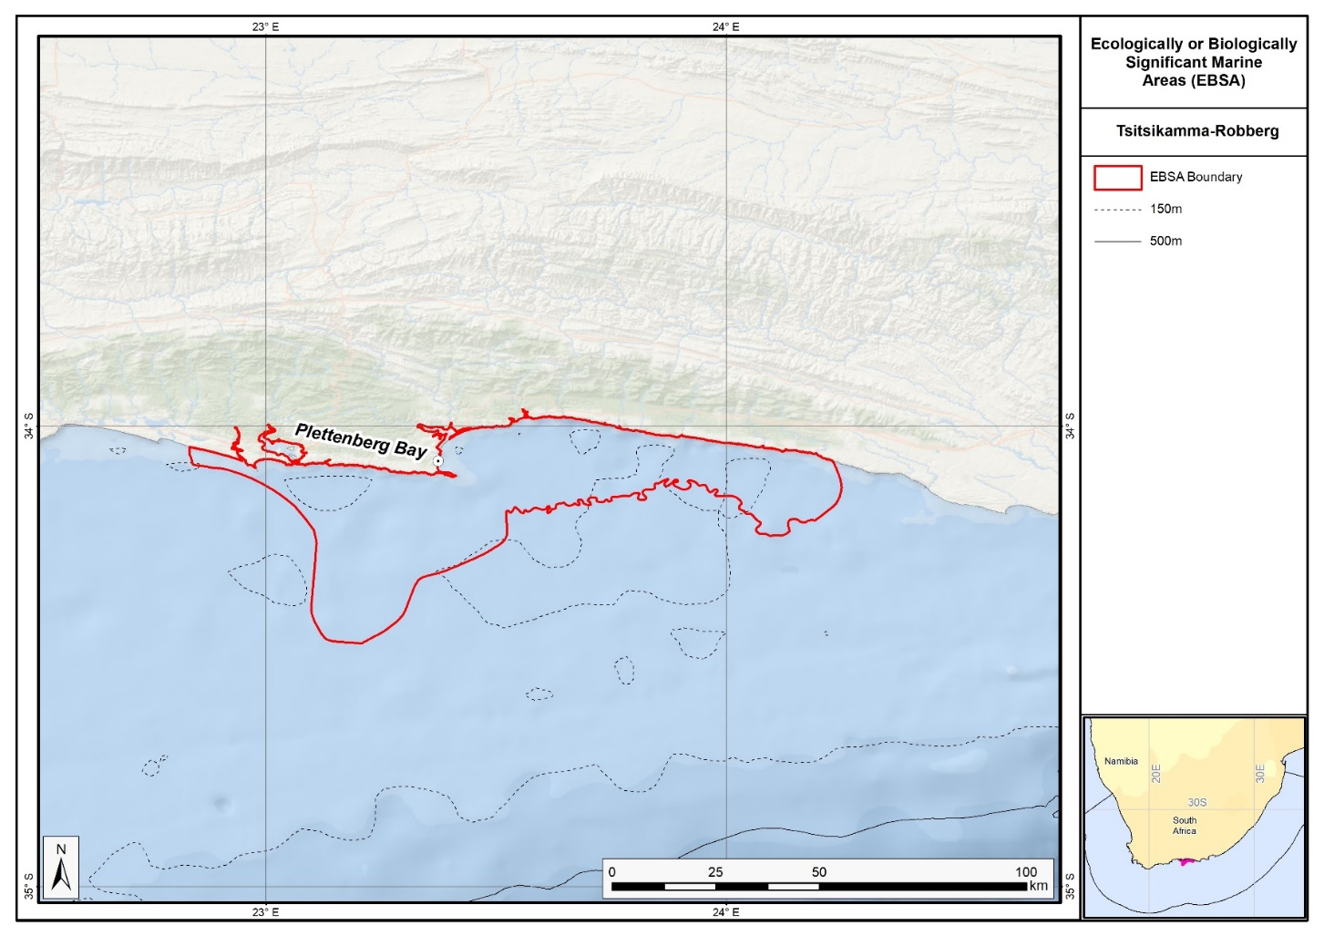
Map of the Tsitsikamma-Robberg area.

__________

* CBD/SBSTTA/28/1.
** The present document is being issued without formal editing.
See www.cbd.int/ebsa/ism/submissions/records1.
See notification No. 2025-138.
Described at the South-Eastern Atlantic regional workshop to facilitate the description of ecologically or biologically significant marine areas, held from 8 to 12 April 2013, and adopted by the Conference of the Parties at its twelfth meeting. The text, boundaries, map and descriptions have all been substantially modified and extensively rewritten.
Described in the Southern Indian Ocean regional workshop to facilitate the description of ecologically or biologically significant marine areas, held from 30 July to 3 August 2012, and adopted by the Conference of the Parties at its twelfth meeting. The text, boundaries, map and descriptions have all been substantially modified and rewritten.
Described at the Southern Indian Ocean regional workshop to facilitate the description of ecologically or biologically significant marine areas, held from 30 July to 3 August 2012, and adopted by the Conference of the Parties at its twelfth meeting. The text, boundaries, map and descriptions have all been substantially modified and rewritten. The existing EBSA has also been split into two components – Algoa to Amathole and Kingklip corals – to reflect discrete biodiversity features and ecological processes better.
Described at the Southern Indian Ocean Regional workshop to facilitate the description of ecologically or biologically significant marine areas, held from 30 July to 3 August 2012, and adopted by the Conference of the Parties at its twelfth meeting. The text, boundaries, map and descriptions have all been substantially modified and rewritten. The name has been revised to reflect better the features of the area.
Described in the Southern Indian Ocean regional workshop to facilitate the description of ecologically or biologically significant marine areas, held from 30 July to 3 August 2012, and adopted by the Conference of the Parties at its twelfth meeting. The text, boundaries, map and descriptions have all been substantially modified and rewritten. The original EBSA has also been split into two components – Mallory escarpment and trough and the Shackleton seamount complex – to better reflect discrete biodiversity features and ecological processes.
Described at the South-Eastern Atlantic regional workshop to facilitate the description of ecologically or biologically significant marine areas, held from 8 to 12 April 2013, and adopted by the Conference of the Parties at its twelfth meeting. The text, boundaries, map and descriptions have all been substantially modified and extensively rewritten.
Described at the South-Eastern Atlantic regional workshop to facilitate the description of ecologically or biologically significant marine areas, held from 8 to 12 April 2013, and adopted by the Conference of the Parties at its twelfth meeting. The text and descriptions have all been substantially modified and rewritten, and the boundary delineation has been altered slightly.

