 |  | CBD/SBI/6/INF/12

 | Distr.: General  22 December 2025  English only

Subsidiary Body on Implementation
Sixth meeting
Rome, 16–19 February 2026
Item 10 of the provisional agenda*
Administrative and budgetary matters:
functional review of the Secretariat
Functional review of the Secretariat
Note by the Secretariat
- The present document contains the report on the external in-depth functional review of the Secretariat of the Convention on Biological Diversity, which has been prepared by the United Nations Development Programme Management Consulting Team. Its executive summary is provided in document CBD/SBI/6/10, together with background information on the functional review process. The report is made available in the form and language in which it was received by the Secretariat.

Report on the External In-depth Functional Review of the Secretariat of the Convention on Biological Diversity

I. EXECUTIVE SUMMARY
- This report presents the external Functional Review of the Secretariat of the Convention on Biological Diversity (SCBD), conducted by the UNDP Management Consulting Team in response to COP decisions 15/34 and 16/28. The review assessed whether the Secretariat’s structure, functions, and resources are fit to support the Kunming–Montreal Global Biodiversity Framework (KMGBF) and service the Convention and its Protocols effectively

- Conducted over six months, the review combined quantitative and qualitative analysis of structure, staffing, budgets, and business processes, benchmarking with peer MEA secretariats, and extensive engagement through surveys, focus groups, workshops, and consultations with senior management and the COP Bureau. Two workstreams guided the process: Strategic Direction (clarifying mandate and priorities) and Operating Model Design (assessing structure and efficiency).

- The review confirmed strong delivery, deep technical expertise, and a high level of staff commitment. It also identified several opportunities to strengthen the Secretariat’s ability to support to KMGBF and service the Convention and its Protocols effectively. Enhancing the linkage between planning and resources, full implementation and operationalization of the Results-Based Budgeting framework and improving coordination across units would contribute to more coherent and efficient operations. Optimizing workload distribution and strengthening delegation of authority would further support timely decision-making and reduce pressure on units. As staffing levels have stagnated despite an expanded mandate, addressing capacity needs will be important to alleviate operational pressures and enable sustainable delivery.

- To address these opportunities and issues, the review proposes an operating model in which functions are consolidated into three divisions reporting to the Office of the Executive Secretary, namely the Policy, Capacity and Monitoring Division, the Strategic Partnerships, Financing and Economy Division, and the Protocols Division. The review also proposes the establishment of three units, specifically the Intergovernmental Meeting Support Cluster, the Administrative and Operational Support Section and the IT and Digital Transformation Unit. In addition, the Office of the Executive Secretary will comprise the following units: Secretariat Support Unit, the Documentation and Language Unit, Legal and Intergovernmental Affairs Unit, and the Programme Management Unit.

- Recommendations are presented under seven opportunity areas: (1) Structural and Strategic Alignment, (2) Cross-Cutting Coherence, (3) Empowerment and Accountability, (4) Human Resource Capacity and Resourcing, (5) Transformation of Ways of Working, (6) Performance and Data Management, and (7) Digital Transformation.

- It is recommended that implementation be phased. Short-term actions (0-3 months) should focus on preparatory steps for implementing structural changes, establishing governance, identifying and securing resources and capacities required to implement recommendations, instituting business process ownership, and implementing results-based budgeting. Medium-term actions (3-6 months) involve initiation of structural alignment, but also focus on strengthening coordination, integrating results-based management, and enhancing staff development. Long-term actions (6+ months) will complete structural realignment, institutionalize accountability, modernize processes and systems.

- It is recommended that a dedicated change-management mechanism under the Executive Secretary oversee implementation, monitor progress, and ensure transparency. Collectively, these reforms would chart a clear path toward a fit-for-purpose, agile, and results-oriented Secretariat, better equipped to deliver on COP mandates and support Parties in achieving the goals and targets of the KMGBF.

A. Purpose and scope of the review
- In its decision 15/34 (paragraph 35), the Conference of the Parties (COP) to the Convention on Biological Diversity (CBD) requested the Executive Secretary, in consultation with the Executive Director of the United Nations Environment Programme (UNEP), to undertake an external, in-depth functional review of the Secretariat’s structure and the implementation of its programme of work. The review was intended to update the Secretariat’s organizational structure and grading of posts in light of the Kunming–Montreal Global Biodiversity Framework (KMGBF) and to strengthen its capacity to support implementation by Parties.

- In its subsequent decision 16/28 (paragraph 11), the COP urged the Executive Secretary to finalize the functional review, taking into account the scoping report referenced in decision 16/4. The COP emphasized that the review should determine whether the Secretariat is appropriately structured and adequately resourced to perform its functions effectively, particularly in servicing meetings under the Convention and its Protocols and in supporting implementation of the KMGBF, and, where gaps exist, identify the adjustments required to address them.

- In response to these mandates, the Secretariat of the Convention on Biological Diversity (SCBD) engaged the Management Consulting Team (MCT) of the United Nations Development Programme (UNDP) to facilitate the external functional review. The engagement, formalized through a Letter of Understanding signed in April 2025, defined the objectives, scope, methodology, and deliverables of the review. The functional review was designed to assess the Secretariat’s structure, business processes, and resource allocation with a view to ensuring alignment with its core functions and strategic priorities as established by the COP. The scope of work focused on analysis and recommendations related to the Secretariat’s structure and functions of teams. This did not include a review of individual positions or the grading/classification of posts as this is proposed to be undertaken as part of the implementation phase following decisions on the overall direction of change.

B. Methodology and approach
- The functional review was conducted over a six-month period, following a structured and participatory process designed to generate evidence-based findings and co-created recommendations. The process was divided into two main phases, namely analysis and design, implemented through two concurrent workstreams on Strategic Direction and Operating Model Design. Throughout the process, the team remained mindful of data limitations, including gaps in available metrics.

- The Analysis phase focused on developing a comprehensive understanding of the Secretariat’s current structure, functions, and resource allocation (“as-is” state). This included a review of mandates, organizational charts, staff composition, funding sources, and key intergovernmental business processes, such as governing and subsidiary bodies data gaps or quality issues existed, the review drew on all available information while remaining aware of these limitations.

- The Design phase built on the findings of the analysis to develop future-oriented recommendations for a fit-for-purpose structure and operating model (“to-be” state). This phase emphasized functional alignment, clarity of roles, integration across divisions, and coherence with the Secretariat’s strategic vision and COP decisions.

- The two workstreams were implemented as follows: (a) Strategic Direction: examined the Secretariat’s mandate, priorities, and positioning to ensure alignment with the Kunming–Montreal Global Biodiversity Framework and evolving expectations from Parties. This stream included internal consultations, workshops, and visioning sessions to articulate the Secretariat’s desired future state; and (b) Operating Model Design: assessed key business processes, functions, and resource allocation to identify areas for improvement. The team analyzed workflows, reporting lines, interdependencies across divisions, and facilitated staff workshops to identify bottlenecks and propose solutions for improved coherence and effectiveness.

- The review employed mixed analytical methods, combining quantitative data analysis (performance indicators, staffing tables, budgets, work plans, resource allocation) with qualitative insights (staff interviews, focus groups, and document review). Comparative benchmarking was undertaken against selected multilateral environmental agreement (MEA) secretariats to identify practices in structure, governance, and resource management in similar organizations.

- Staff engagement was central to the review. Over the course of the engagement, the UNDP Management Consulting Team conducted consultations with senior leadership, unit-level focus groups with all staff, facilitated Secretariat-wide workshops, and launched an all-staff survey to collect views on structure, functions, and ways of working. These activities ensured that the review reflected staff perspectives and fostered ownership of the process.

- Continuous consultation and validation were ensured through the Functional Review Internal Task Team and the Engagement Team, which provided technical and subject matter support throughout the process, fostering informed decision-making. Emerging findings were reviewed with the SCBD Senior Management Team and presented to the COP Bureau at key milestones for feedback and strategic guidance. This iterative validation helped mitigate the impact of data limitations by grounding findings in collective insights and expert judgment.

- Key outputs of the process include: (a) Diagnostic analysis of the Secretariat’s structure, functions, and resources; (b) Results of the staff survey and synthesis of focus group inputs; (c) A conference management business process map, draft standard operating procedure and improvement recommendations; (d) Workshop reports on strategic alignment, visioning, and operating model design; (e) A performance indicator analysis; (f) An analysis of work undertaken by units by KMGBF targets; and (g) A draft proposal for a fit-for-purpose structure and operating model with accompanying implementation and change management considerations.

- Together, these outputs form the analytical foundation for the functional review’s recommendations, which aim to strengthen the Secretariat’s ability to service the governing bodies effectively, deliver on its mandates, and support Parties in implementing the KMGBF.

C. Overview of key findings
- The functional review identified a range of institutional strengths and challenges across the Secretariat’s structure, resourcing, business processes, and coordination mechanisms. The functional review confirmed that the Secretariat has maintained a strong record of delivery despite significant operational and resource pressures. It benefits from dedicated and technically skilled staff, a collaborative culture, and a consistent ability to meet Party expectations under demanding conditions. At the same time, the analysis identified several institutional areas where greater coherence, clarity, and integration would further strengthen the Secretariat’s performance and sustainability.

- The functional review’s key findings are as follows:

Structural and strategic alignment
- The Secretariat has made meaningful progress in supporting the goals and targets of the KMGBF, particularly through strong contributions to implementation, mainstreaming, and capacity-building. Mapping of Secretariat workstreams shows clear alignment with KMGBF priorities. At the same time, the current structure presents opportunities to strengthen coherence and better balance functions across the breadth of KMGBF targets. Enhancing coordination, clarifying institutional accountabilities and reinforcing strategic planning would help ensure that decisions, budgeting and resource mobilization are more closely aligned with strategic priorities.

- More specifically, the review resulted in the following observations:
  - There is strong potential to further integrate thematic work streams within capacity-building, knowledge management, and monitoring, reporting and review;
  - Resource mobilization and stakeholder engagement functions would benefit from a more unified and strategic focus;
  - Conference services could be strengthened to ensure sustainable and efficient support in view of resource constraints and a growth in servicing requirements over the past years;
  - IT services, currently distributed over several units, present opportunities for more integrated digital support;
  - The Results-Based Budget (RBB) framework, while in place, could be more fully leveraged to support integrated planning, budgeting, prioritization and reporting .

Cross-cutting coherence
- While collaboration within teams is strong, coordination across divisions and units can be further improved. Current mechanisms for cross-Secretariat planning and information-sharing can be improved to enhance coordination and collaboration, supporting more integrated work across functional areas and enabling more efficient use of resources. Furthermore, enhancing internal communication and embedding consistent change management practices would help reinforce collective ownership and institutional coherence.

Empowerment and accountability
- At the executive level, delegated authority for procurement is limited and has not kept up with price inflation over the past decade, thereby limiting executive authority and leading to cumbersome administrative processes. More generally, the level of dependence on the United Nations Environment Programme (UNEP) and the United Nations Office at Nairobi (UNON) for administrative and operational functions can lengthen processing times and reduce Secretariat flexibility and agility when it comes to administrative transactions.

Human resource capacity and resourcing
- As noted above, over the past decade, Secretariat staffing levels have stagnated, while the scope and volume of work have expanded substantially. This development has led to ad-hoc arrangements with staff taking on extra duties, the use of short-term contractors to fill gaps and work overload in some areas, particularly at peak times. The lack of staff resources has, in part, been aggravated by delays in recruitment. Ensuring adequate staffing and HR capacity is necessary to improve recruitment and onboarding thus supporting a more sustainable distribution of workload, and the ability for the Secretariat to meet its mandated functions while safeguarding staff wellbeing.

Performance Metrics
- While the Secretariat has established comprehensive planning and reporting mechanisms for intergovernmental processes linked to the COP and its subsidiary bodies, internal performance tracking across the Secretariat could be strengthened. The absence of a Secretariat-wide performance measurement framework and performance metrics and quality data proved to be a challenge for the Functional Review, but also creates ongoing challenges for the SCBD, namely in strategic planning, prioritization, accountability, and, importantly, in providing evidence to support budget requests, staffing adjustments and process improvements. At the same time, several units—such as Editorial and Language Unit, DevOps, HR, IT, Travel and Procurement have developed team-level performance metrics that provide a strong foundation and useful starting point for building a more coherent Secretariat-wide performance measurement framework.

Ways of working
- The COP determines the core budget on a two-year cycle, and many activities depend on voluntary contributions which creates uncertainties and challenges in planning and executing work. Currently, the Secretariat lacks a comprehensive approach to strategic planning that effectively integrates long-term budgetary considerations with programmatic priorities. This disconnect hinders alignment of divisional and unit-level work with the Secretariat’s overarching goals and priorities.

D. Key recommendations and proposed functional model
- The functional review produced several recommendations grouped under seven interrelated opportunity areas. Together, these recommendations aim to strengthen the Secretariat’s structure, systems, and working methods to enhance coherence, accountability, and alignment with the KMGBF.

a. Structural and strategic alignment

- The review recommends realigning the Secretariat’s functions and structures to better reflect the four goals and 23 targets of the KMGBF and ensure improved coherence in servicing the Convention and its Protocols. This includes clarifying linkages between programmatic and cross-cutting functions and ensuring that related activities are organized under consistent reporting lines. Strengthening functional alignment will improve coordination, clarify accountability, and enable the Secretariat to deliver more cohesive support to Parties under the KMGBF. The specific structural changes underpinning these recommendations, including the reorganization and reallocation of units, are set out in the annex.

- More specifically, it is recommended to make structural adjustments guided by the following six functional groupings in addition to the overall executive management and executive management support functions:
  - Policy, Capacity and Monitoring, an integrated division focused on delivering on the KMGBF goals and targets, encompassing thematic Support, including all work related to programmatic, scientific, technical and policy support, and work related to capacity-building, National Biodiversity Strategies and Action Plans (NBSAPs), Technical and Scientific Cooperation (TSC) and Clearing-House (CH) mechanisms, and monitoring, review and reporting
  - Strategic Partnerships, Financing & Economy, an integrated division focused on work related to resource mobilization and economic integration of biodiversity targets, engagement with non-Party actors
  - Protocols, dedicated to servicing COP-MOPs and compliance committees for both Biosafety and ABS
  - Intergovernmental Meetings Support, supporting the formal and informal meetings of the intergovernmental process
  - Administrative and Operational Support, including all administrative support to Secretariat operations
  - IT and Digital Transformation, including Digital Solutions, IT infrastructure management, and IT support for clearing houses, and corporate knowledge management
  - Japan Biodiversity Fund,

- The review recommends the following specific changes to the current Secretariat structure:

Office of Executive Secretary

- Strengthen budgetary planning and monitoring by moving and strengthening the Programme Management Unit currently housed in the Administration Division to the Office of the Executive Secretary to support the effective use of the Results-Based Budgeting and Planning (RBBP) framework as the Secretariat’s central strategic management tool for implementing the KMGBF and aligning resources with COP and Protocol decisions.

Policy, Capacity and Monitoring Division

- Provide a clearer focus on Secretariat programmatic, scientific, technical and policy support in areas central to the KMGBF, including work on biome-based Programmes of Work, reducing threats to biodiversity, and promoting sustainable use and traditional knowledge, by bundling related staff resources in one division with expertise in the current Biodiversity, Science, Policy and Governance (BSPG) Unit forming the core capability.

- Make better use of synergies in support of key cross-cutting implementation functions such as capacity-building, NBSAPs, TSC and CH mechanisms, and monitoring, review and reporting by bundling related staff resources in one division, with expertise in the current Capacity Building (CB) and Knowledge Management (KM) Units, and the Monitoring Review and National Reporting Unit (MRNR).

Strategic Partnerships, Financing, and Economy Division

- Provide a stronger strategic focus on engaging a broad range of actors, mainstreaming biodiversity across economic sectors and levels of governance, and supporting resource mobilization, by combining Secretariat support related to the following areas in one division:
- Support to the engagement of major groups and stakeholder
- Cooperation with other UN actors
- Support related to Article 8(j)
- Support to Resource Mobilization (including Cali Fund and Financial Mechanism)
- Communications and Awareness-Raising
- Corporate Knowledge Management

- This would require bundling resources currently distributed across various units with expertise in the Biodiversity, Economy Transformation and Innovation (BETI) Unit, the Stakeholder Engagement and Cooperation (SEC) and the People and Biodiversity (PBU) Unit forming its core capability into three units within this division.

Protocols Division

- Cluster work related to Access and Benefit Sharing, Digital Sequence Information (DSI) on Genetic Resources and Biosafety in one division. Consolidating the two Protocol units into a single division would strengthen coherence across Protocol implementation, streamline support to Parties, and enable shared planning and expertise. This integration would enhance collaboration and operational efficiency, and position the Secretariat to deliver more consistent, coordinated, and technically robust services across both Protocols.

Intergovernmental Meetings Support

- Strengthen support to intergovernmental meetings by creating a self-standing unit under direct oversight of the Deputy Executive Secretary and establishing a senior manager position to oversee and guide conference logistics and meetings management, participant registration, and travel for participants. By establishing a direct link to, and oversight by, Executive Management, these services should be more closely integrated with functions undertaken by the Documentation and Language Unit currently proposed to be part of the Executive Management function.

Administrative and Operational Support Section

- Strengthen the administrative backbone of the Secretariat by focusing the Division’s work on the following core services:
(a) Human Resources
(b) Finance and Budget
(c) General Administration (including facility management and procurement)

IT and Digital Transformation Unit

- Enhance strategic focus in the planning and execution of IT services by consolidating resources currently distributed across the Administration Division IT Unit and the CBKM, IT/DevOps sub-unit under a unified IT and Digital Transformation Unit to enhance efficiency, coordination and support for digital innovation. This unit would focus on three areas of work: i) providing tools and solutions for use by Parties and other external stakeholders (e.g. knowledge products, CHM, website), ii) leading on internal digital transformation to improve internal processes and workflows, coordination, knowledge management, and performance and data management, iii) support the administration of IT equipment, infrastructure, and systems.

Japan Biodiversity Fund
- The Fund is aligned with its mandate and continues to provide substantive support to the Secretariat on delivering targeted capacity-building and implementation support. The review highlights an opportunity to strengthen coordination between the JBF and the Secretariat’s broader financial-mechanism functions to ensure a more comprehensive and strategically integrated approach to financing. Enhanced coordination would support greater coherence in resource mobilization efforts and improve alignment with Parties’ priority implementation needs.

b. Cross-cutting coherence
- The review highlighted opportunities to strengthen integration and coordination across Secretariat-wide processes and frameworks. More coherent governance arrangements and streamlined workflows would enhance efficiency, consistency, and institutional learning. To support this, the review recommends establishing designated business process owners for key cross-cutting functions. Consultations with Secretariat units underscored that clearer functional ownership and defined points of accountability would facilitate stronger collaboration, reduce overlap and enable more consistent and coordinated delivery across divisions.
- Business process owners would provide technical guidance and services in their respective areas of expertise, ensure consistent application of Secretariat-wide standards, and be accountable for integrating lessons learned into internal policies and procedures. This approach would strengthen cross-functional coherence, promote institutional learning, and help embed shared standards and practices across the Secretariat. Based on the review and consultations, the proposed business process owners are:
- Communications: Communications and Awareness Unit
- Resource Mobilization: Resource Mobilization & Strategic Financing Unit
- Stakeholder Engagement: Stakeholder Engagement and Cooperation Unit
- Capacity Building: Capacity Building, Monitoring and Reporting Unit
- Knowledge Management: Capacity Building, Monitoring and Reporting Unit
- Conference Management: Conference Services Unit

c. Empowerment and accountability
- Strengthening empowerment and accountability within the Secretariat is essential to ensure timely and effective decision-making. The review recommends that, where feasible, authority be delegated to division heads for areas such as budget management and procurement, in line with United Nations rules and regulations. In particular, increasing delegation of authority limits from UNEP for low-value procurement would help reduce delays and improve operational efficiency, considering the value for low value procurement has been US$10,000 for over 10 years.

- Greater delegation of authority must be complemented by clear accountability frameworks and performance monitoring mechanisms. Enhancing managerial empowerment would improve leadership responsibility for results, encourage initiative at the mid-management level, and contribute to a more agile and responsive Secretariat.

d. Human resource capacity and staff resourcing
- The review found that staffing shortages and high and uneven workloads constrain the Secretariat’s performance and staff well-being. In addition, team organigrams and job descriptions are outdated. To address these challenges, the review recommends strengthening the HR team and undertaking an internal review of recruitment processes to ensure the timeliness of backfilling vacant positions in coordination with UNEP and UNON and updating and publishing individual job descriptions and team structures to reflect current functions.

- Additional actions should include: establishing a regular process to review and keep up to date the Secretariat’s job descriptions and staffing data, improving coordination with UNEP and UNON on recruitment, and exploring opportunities for administrative efficiency through economies of scale in contracting and shared services. Enhanced workforce planning, including better use of temporary capacity, will help ensure that the Secretariat is better staffed to meet operational needs.

- Given the Secretariat’s expanding workload and persistent capacity gaps identified across several technical and operational areas, strengthened workforce planning must also be accompanied by increased staffing capacity, particularly in units facing increased demands. More deliberate use of temporary capacity can help address short-term pressures, but sustainable delivery of core functions will require bolstering permanent staffing levels.

e. Transforming ways of working
- The review recommends that the Secretariat adopt a more structured, Secretariat-wide approach to planning and coordination of work, building on the RBB framework to better align activities with functional roles and strategic priorities. Strengthened work planning would help reduce overlapping efforts, particularly as it relates to stakeholder engagement, resource mobilization and implementation support, improve coordination across units and support a more balanced distribution of workload. A more formalized internal process for change management, communication, and accountability would further enhance transparency and staff engagement. Several of these improvements have already been recognized by senior management and are in the early stages of implementation, providing a foundation for more integrated and coherent organizational practices going forward.

- In addition, the review proposes the strengthening of the resource mobilization function to ensure adequate resources are available to support priority activities. The development of biannual resource mobilization plans following each COP to monitor implementation of funding strategies and strengthen the link between decisions, resource allocation, and delivery. Reinforcement of the Secretariat’s long-term budgetary planning processes would also be beneficial. The development of multi-year financial projections informed by historical funding patterns and anticipated mandates will help the Secretariat in achieving greater predictability and alignment of divisional activities with overall organizational priorities.

- Collectively, these recommendations are intended to ensure that the Secretariat operates in a more coherent, coordinated, and forward-looking manner. These recommendations will necessitate the strengthening of the Programme Management Unit to support these functions and its elevation to the Office of the Executive Secretary. Their implementation will enable the Secretariat to better align its structure and resources with its strategic objectives, improve coordination efficiency, and strengthen its capacity to support Parties in achieving the goals and targets of the Kunming–Montreal Global Biodiversity Framework.

f. Management of the Secretariat’s Functional Performance Delivery
- To address the lack of comprehensive and reliable internal performance metrics and data to inform the management of the Secretariat’s function, the Secretariat should develop and apply a Secretariat-wide set of high-level performance metrics aligned with supporting the implementation of KMGBF and COP decisions. These metrics are intended to capture Secretariat-wide functional delivery of teams, rather than individual staff performance. Developing and maintaining such performance data would require additional capacity and specialized expertise for data collection, analysis and management. Once established, the performance data could be used to prepare a centralized performance dashboard, and to support planning, budgeting, request for resources and resource allocation. The Programme Management Unit would be well placed to assume ownership of the framework and ensure its ongoing relevance and application.

g. Digital Transformation
- Develop a Secretariat-Wide Digital Transformation Strategy that articulates a unifying vision for digital services supporting KMGBF implementation, priorities for modernizing key processes and platforms, strengthening data governance, quality and analytics. This strategy will guide digital/AI initiatives across units with the goal of ensuring a more efficient secretariat and enhanced service delivery to Parties. This recommendation would require additional resources, both to develop and implement the strategy.

E. Next steps and expected outcomes

- The successful implementation of the Functional Review’s recommendations will require a phased and well-coordinated approach led by the Executive Secretary and ideally managed by an appointed implementation lead. In the immediate term, the Secretariat will need to establish a dedicated implementation and change-management mechanism responsible for translating the recommendations into concrete actions, sequencing reforms, and monitoring progress. Implementing these reforms will also require additional resources for staffing and specialized expertise to ensure that changes are adequately supported and sustained. This mechanism will ensure that reform efforts remain transparent and inclusive.
- Short-term priorities should include:

(a) finalization of the proposed operating model and structure;
(b) identification for additional posts and resources to implement recommendations;
(c) detailed plan for adjustments to positions and levels in alignment with endorsed structure;
(d) the development of updated or new job descriptions;
(e) the launch of Secretariat-wide communication on the reform process;
(f) the designation of business process owners; and
(g) the integration of results-based budgeting as a standard management practice.
- Medium-term actions should focus on:
(a) initiation of structural alignment process in line with SCBD and UNEP policies and procedures
(b) strengthening coordination and coherence across the new functional clusters,
(c) embedding accountability mechanisms, and
(d) enhancing staff capacities through targeted development initiatives.
(e) development and implementation of performance and data management framework
(f) development of a digital transformation strategy
- Furthermore, the implementation of integrated planning, budgeting, and monitoring systems should be prioritized to improve decision-making, transparency, and alignment between strategic priorities and resource allocation.

- In the long term, the Secretariat will need to institutionalize the new operating model, ensuring that organizational structures, processes, and systems are fully aligned. Sustained leadership engagement, proactive communication, and continued consultation with staff and governing bodies will be essential to consolidating these reforms.

- It is also recognized that any budgetary implications arising from the implementation of the functional review, including those related to additional staffing capacity and funding of activities, will require approval by the Parties. The Secretariat will therefore need to ensure that all proposed adjustments with financial impact are transparently costed, justified, and presented for consideration through the appropriate intergovernmental processes.

- The expected outcomes of this process include a more coherent and strategically aligned Secretariat with clear accountability, optimized resource utilization, and an enhanced ability to deliver on COP mandates. The restructured organization will be better positioned to support Parties in achieving the goals and targets of the KMGBF through improved coordination, strengthened partnerships, and more efficient servicing of intergovernmental processes, including governing and subsidiary bodies. Ultimately, the implementation of the review’s recommendations will enable the Secretariat to function as a more agile, results-oriented, and future-ready institution capable of responding effectively to the evolving global biodiversity agenda.

ANNEX I: Detailed Report on the Functional Review of the Secretariat of the Convention on Biological Diversity

I. INTRODUCTION AND BACKGROUND
- In its decision 15/34 (paragraph 35), the Conference of the Parties (COP) to the Convention on Biological Diversity (CBD) requested the Executive Secretary, in consultation with the Executive Director of the United Nations Environment Programme (UNEP), to carry out an external in-depth functional review of the structure of the Secretariat and the implementation of its programme of work. The review was to update the Secretariat’s structure and grading of posts in light of the Kunming–Montreal Global Biodiversity Framework (KMGBF) and to strengthen its capacity to support implementation by Parties.

- In its subsequent decision 16/28 (paragraph 11), the COP urged the Executive Secretary to complete the functional review, taking into consideration the scoping report referenced in decision 16/4. The COP emphasized that the review should assess whether the Secretariat is appropriately structured and adequately resourced to undertake its functions effectively, in particular for servicing meetings under the Convention and its Protocols and for supporting implementation of the KMGBF, and, if not, identify the adjustments needed to achieve this.

- In response to these mandates, the Secretariat of the Convention on Biological Diversity (SCBD) engaged the Management Consulting Team (MCT) of the United Nations Development Programme (UNDP) to facilitate the external functional review. The engagement, formalized through a Letter of Understanding signed in April 2025, set out the objectives, scope, methodology, and deliverables of the review. The functional review was designed to assess the Secretariat’s structure, business processes, and resource allocation with a view to ensuring alignment with its core functions and strategic priorities as defined by the COP.

- The review was conducted through two interrelated workstreams: (a) Strategic Direction, focused on clarifying the Secretariat’s mandate, priorities, and positioning to support the KMGBF; and (b) Operating Model Design, focused on assessing the Secretariat’s current structure, resources, and key business processes to identify opportunities for improved coherence, efficiency, and impact.

- The methodology combined quantitative and qualitative approaches, including a comprehensive review of organizational data, resource allocation, and business processes; analysis of functional linkages across divisions and units; staff surveys and focus groups; and benchmarking against comparable multilateral environmental agreement (MEA) secretariats. This evidence base was complemented by a participatory approach that engaged staff at all levels of the Secretariat throughout the process.

- Consultation and validation were integral to the review process. The UNDP MCT team worked closely with the SCBD leadership, the Senior Management Team, the Functional Review Internal Task Team, and the Extended Engagement Team to co-develop findings and recommendations. The SCBD leadership comprises the Executive Secretary and Deputy Executive Secretary, while the Senior Management Team includes senior managers at P5 level and above. The Internal Task Team consists of staff from various teams and levels to ensure broad representation, and the Extended Engagement Team, composed of five staff members, provided regular guidance and feedback to the UNDP MCT team. The COP Bureau was regularly briefed on progress, emerging findings, and next steps to ensure the review remained transparent, consultative, and aligned with the mandate provided by Parties.

- The findings and recommendations of the functional review will serve as the basis for a fit-for-purpose structure and operating model that strengthens the Secretariat’s ability to deliver on its core mandates, service the governing bodies efficiently, and effectively support implementation of the KMGBF.

II.INSTITUTIONAL SETTING OF THE CBD SECRETARIAT
- The Secretariat of the Convention on Biological Diversity (SCBD) was established under Article 24 of the Convention to support the achievement of its three objectives: the conservation of biological diversity, the sustainable use of its components, and the fair and equitable sharing of benefits arising from the utilization of genetic resources. The Secretariat’s principal functions are to prepare for and service meetings of the Conference of the Parties (COP) and subsidiary bodies, to coordinate with relevant international institutions, and to facilitate the implementation, monitoring, and review of the Convention and its Protocols.

- As a body institutionally linked to the United Nations Environment Programme (UNEP), the Secretariat serves as a neutral and technical body staffed by international civil servants accountable to the COP. It operates under the financial rules adopted by the COP through decision I/6 and is funded through trust funds to which all Parties contribute. The Secretariat is based in Montreal, Canada, and currently employs 101 core staff.

A. Operational goals and core functions
- The Secretariat’s operational goals are guided by its core mandate, as detailed in Article 24 of the Convention, and by the evolving priorities of the Parties as captured in decisions of the COP and the COP/MOP, including broad strategic frameworks, such as the Kunming–Montreal Global Biodiversity Framework (KMGBF) adopted in 2022. In support of the Convention and its Protocols, the Secretariat facilitates cooperation, provides technical and administrative assistance, and coordinates the activities necessary to achieve the four overarching outcome-oriented goals and targets of the KMGBF for 2050: (a) protecting and restoring ecosystems, (b) promoting sustainable use and management, (c) ensuring fair and equitable benefit-sharing, and (d) strengthening implementation and financial resources, and twenty three action-oriented targets for 2030.

- The Secretariat’s day-to-day functions include preparing and servicing COP and subsidiary body meetings; providing policy and technical support; synthesizing and disseminating information on implementation; coordinating inter-agency collaboration; and supporting Parties in national implementation, reporting and capacity-building. It also compiles national reports, facilitates access to scientific and technical information, and manages clearing-house mechanisms to support transparency, knowledge-sharing, and monitoring of progress.

- The operational goals elaborated in the Secretariat’s Results-Based Budget (RBB) framework, adopted at COP 16, provide a structured basis for planning and performance monitoring. These include:
(a) enabling global convergence on integrated and gender-responsive approaches to conservation, sustainable use, and benefit-sharing; (b) supporting national implementation of the Convention and its Protocols through the application of the KMGBF; (c) strengthening awareness, communication, and stakeholder engagement across sectors of society; (d) facilitating regular review and adaptive management of implementation; and (e) ensuring strengthened leadership, management, and accountability within the Secretariat.

B. Vision and mission under the KMGBF
- The Secretariat’s vision, articulated through discussions with staff and leadership, is to operate as a trusted, responsive, and results-oriented institution that effectively supports Parties in implementing the KMGBF and advancing global biodiversity goals and targets. Its mission, also informed by staff dialogue rather than any formal mandate, reflects a commitment to enabling cooperation among Parties and stakeholders by providing timely, evidence-based, and coordinated support that advances the objectives of the Convention and its Protocols.

- In the context of the KMGBF and building on its operation under previous Strategic Plan for Biodiversity 2011-2020, the Secretariat’s role has further evolved from one primarily focused on servicing intergovernmental meetings to one that also emphasizes awareness-raising, facilitation of implementation, monitoring, and review. This includes providing analytical and operational support as well as capacity- building activities to Parties, strengthening linkages between decisions, work programmes, and financing, and ensuring coherence across the Convention, the Cartagena Protocol on Biosafety, and the Nagoya Protocol on Access and Benefit-Sharing.

- To fulfil this role, there is a need to strengthen internal planning, coordination, and monitoring systems, to ensure that the delivery of services and outputs is aligned with the priorities identified by the COP. Greater integration of strategic planning and resource management would enable the Secretariat to proactively respond to the needs of Parties while maintaining transparency and accountability in its operations.

C. Linkages with the Results-Based Budget Framework and COP mandates
- The Results-Based Budget (RBB) framework constitutes the Secretariat’s central strategic and operational tool for implementing the decisions and mandates of the Conference of the Parties and its Protocols. It translates the priorities agreed by Parties into a coherent results chain, providing a mechanism for linking policy priorities with programmatic and financial planning, supporting evidence-based management and reporting to the COP. Through this framework, the Secretariat ensures that its planning, budgeting, and performance monitoring remain fully aligned with COP-endorsed objectives and with the broader vision of the Kunming–Montreal Global Biodiversity Framework.

- Each outcome area of the RBB framework corresponds directly to the Secretariat’s obligations under COP decisions. Outcome 1 supports the COP mandate to promote global coordination and convergence in biodiversity policy by advancing integrated and gender-responsive approaches to conservation, sustainable use, and benefit-sharing. Outcome 2 reflects the Parties’ call for strengthened national implementation of the KMGBF and the Protocols through technical support and capacity-building. Outcome 3 advances awareness, communication, and stakeholder engagement in line with COP decisions on mainstreaming biodiversity across sectors. Outcome 4 responds to mandates for regular review, assessment, and adaptive management of implementation, and Outcome 5 supports the Parties’ expectations for strengthened leadership, management, and accountability within the Secretariat.

- By linking outcomes to specific activities and budget lines, the RBB framework provides a unified structure for planning, implementation, and performance monitoring. It enables the Secretariat to track progress on delivering its mandated outputs, facilitates prioritization in line with agreed outcomes, and strengthens alignment between resources and expected results.

- While the RBB does not replace the need for broader strategic positioning and planning, it serves as a key internal tool through which the Secretariat translates COP decisions into operational plans, monitors delivery, and reports on progress. Formalizing and strengthening the use of the RBB as an integrated planning and monitoring framework will enhance coherence between the Secretariat’s strategic vision, resource allocation, and the implementation of COP and Protocol mandates.

III. ANALYSIS OF STRUCTURE, FUNCTIONS AND RESOURCES
- The analysis examined the Secretariat’s organizational structure, functions, and resources to assess how effectively they enable the delivery of its mandate and support implementation of the KMGBF. It combined quantitative analysis of staffing levels, budget trends, and resource allocation with qualitative insights from staff surveys, focus groups, and consultations across divisions. The review evaluated how functions are distributed, how resources are utilized, and how coordination mechanisms operate in practice. It also assessed efficiency, workflows, and institutional culture, including the Secretariat’s capacity to adapt and sustain performance under increasing demands. The analysis provides an evidence-based understanding of current strengths, constraints, and interdependencies, serving as the foundation for the recommendations and structural adjustments proposed in subsequent sections.

A. Organizational and Functional Analysis
- The Secretariat currently operates within a divisional structure composed of the Office of the Executive Secretary (OES) and three divisions, including the Science, Society and Sustainable Futures Division (SSSF), the Implementation Support Division (ISD), the Administration Division. The Japan Biodiversity Fund, Access and Benefit-sharing Unit, Biosafety Unit, Legal and Intergovernmental Affairs Unit, Communications and Awareness Unit, Editorial and Language Unit and Secretariat Support Unit report directly to the Executive Secretary (ANNEX II).

- Staffing levels have stagnated over the past decade, varying between 100-112 personnel and currently comprising 101 core staff, 27 consultants and 26 ICs at the time of analysis. This is about the same level as in 2016. However, the distribution of staff and workload across functions has evolved unevenly, largely in response to COP mandates and available funding. Professional and above positions have gradually increased from 55 to 63, before slightly dropping to 57. General Service positions have steadily increased from 45 to 48, then declined to 40. Junior Professional Officers (JPOs) and other personnel categories remain minimal, ranging between 1 and 4 positions.

Figure 1. Historic staff count (source: SCBD payroll data 2016 – June 2025).

a. Key insights on structure and functions
- The review found that the Secretariat’s structure enables the delivery of a broad and diverse set of functions, with many units contributing actively to areas such as capacity-building, stakeholder engagement, meeting services, communications and resource mobilization in line with their respective COP-mandated work programmes. At the same time, the distribution of these functions across numerous units, each responding to different thematic mandates, means that related cross-cutting activities can be channeled through various biome-based programmes . This has created opportunities to strengthen coordination, clarify roles and responsibilities and better align work processes across the Secretariat. Strengthening this alignment would help coordinate work more effectively, enhance efficiency and ensure a clearer and more balanced distribution of accountability.

- The Secretariat’s middle management layer currently operates with limited delegated authority, which results in a higher concentration of operational decision-making at the Senior Management Team level. While this structure ensures consistency, it also places additional demands on senior leadership and can constrain agility and timely implementation. Strengthening the decision-making role of middle management, building on the practice of regular meetings for coordination introduced last year, would help distribute responsibilities more effectively and create greater space for strategic oversight and forward planning. The Secretariat has already begun taking steps to enhance managerial delegation and support more responsive and adaptive decision-making. Collaboration among staff remains strong, with a shared commitment to continuous delivery despite capacity and process constraints.
Efficiency of operational processes and systems
- The analysis of processes and staff feedback revealed that some core administrative and coordination workflows are perceived as complex and fragmented. Dependencies on UNEP and UNON systems, particularly in procurement, human resources, and travel, extend processing times and limit flexibility for Secretariat-specific needs. While these arrangements ensure compliance with UN rules, they also create procedural bottlenecks that affect the timeliness of delivery.

Staff survey results indicate opportunities to strengthen consistency and clarity in the Secretariat’s standard operating procedures and cross-unit planning mechanisms. While feasibility screening of COP decisions does take place after each COP, staff noted that clearer prioritization based on available resources would further support realistic planning and help ensure that efforts align with what can be delivered within existing funding. Enhancing clarity in roles and responsibilities, together with more structured planning processes, would contribute to a more even distribution of workload and reduce the need for reactive adjustments. Greater digital integration and streamlined coordination tools would also improve efficiency and enable staff to focus more time on substantive work.
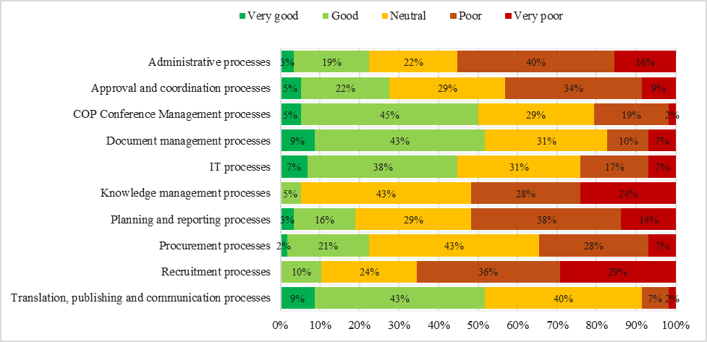
Figure 2. Business process efficiency and effectiveness (source: SCBD staff survey June 2025).
- The review also found that the Secretariat does not operate with coherent internal metrics to measure the performance of Secretariat functions. During the Functional Review, it was challenging to collect reliable and comparable data, as divisions and units do not use standardized systems and processes for tracking outputs, workload, or efficiency. While some units track activities informally, these practices are inconsistent, largely qualitative, and not quite linked to strategic objectives, KMGBF outcomes, or internal performance indicators. Existing corporate systems that could support measurement, such as meeting and document tracking, are inconsistently used, resulting in data gaps and quality issues. The absence of comprehensive, comparable data makes it difficult to establish baselines, quantify workload, assess efficiency, or determine the cost of delivering mandated activities. This lack of measurable performance information limits strategic planning, prioritization, accountability, and evidence-based resource requests, and contributes to the perception of overstretch. At the same time, several units—such as Editorial and Language Unit, DevOps, HR, IT, Travel and Procurement have developed team-level performance metrics that provide a strong foundation and useful starting point for building a more coherent Secretariat-wide performance measurement framework

- The review further identified that the Secretariat could strengthen its use of digital tools and modern workflow systems hampers efficiency. Feedback from staff surveys and focus groups highlighted that key processes such as document management during meetings remain manual or reliant on outdated platforms, resulting in duplication of effort and slower information flows. The absence of an overarching digital strategy means that innovations are introduced on an ad hoc basis, without interoperability or alignment to broader KMGBF implementation needs. Strengthening digitization, automation, and integrated systems would support more timely decision-making, reduce administrative burden, and enhance the Secretariat’s ability to manage increasing complexity.

- At the same time, the review noted ongoing efforts by the Secretariat to modernize processes, including initiatives to improve information management, internal coordination, and the use of digital tools. Strengthening the Secretariat’s ability to leverage UNEP and UNON capacity where possible, particularly in areas such as human resources, while maintaining flexibility for Secretariat-specific process improvements, will be important to enhance efficiency and reduce administrative strain.

Institutional culture, ways of working, and change readiness
- The staff survey and focus group discussions highlighted a strong culture of commitment and resilience across the Secretariat. Staff collaboration within teams and peer-to-peer support remain among the Secretariat’s greatest strengths. However, internal communication and coordination between divisions can be improved. Limited Secretariat-wide planning and information-sharing mechanisms contribute to parallel processes and uneven workloads.

- The organizational culture is characterized by adaptability and dedication, but also by fatigue, affecting staff wellbeing, associated with high workloads and constrained resources. Staff expressed a desire for clearer communication on priorities and a more structured approach to change management. While previous reform efforts have generated valuable lessons, insufficient follow-up and change ownership have reduced their long-term impact. Building a shared understanding of priorities, improving transparency around decision-making, and empowering middle management will be key to fostering a more sustainable and cohesive work culture.

b. Workload and performance indicator analysis
- To complement the functional assessment of the Secretariat’s organizational structure, the review analyzed workload, performance indicators, and the alignment of activities with the KMGBF. This analysis drew on Secretariat-wide data covering meetings, documents, statements, notifications, and workstreams mapped to KMGBF targets. The data were examined across three periods, COP 14 to 15, COP 15 to 16, and COP 16 to 17, to identify trends, changes in activity levels, and the distribution of workload across divisions and units.

- The mapping of workstreams to KMGBF targets shows that Secretariat activities are most heavily concentrated in the “Tools and Solutions for Implementation and Mainstreaming” and “Meeting People’s Needs through Sustainable Use and Benefit-sharing” categories. These findings reflect the Secretariat’s strong focus on enabling functions such as implementation support and specifically capacity-building. By contrast, comparatively fewer activities map to the KMGBF targets addressing “Reducing Threats to Biodiversity,” illustrating somewhat of an imbalance between technical and scientific work and broader implementation- and support-focused functions. The Biodiversity, Science, Policy and Governance’s Unit are concentrated in the “Reducing Threats to Biodiversity.”
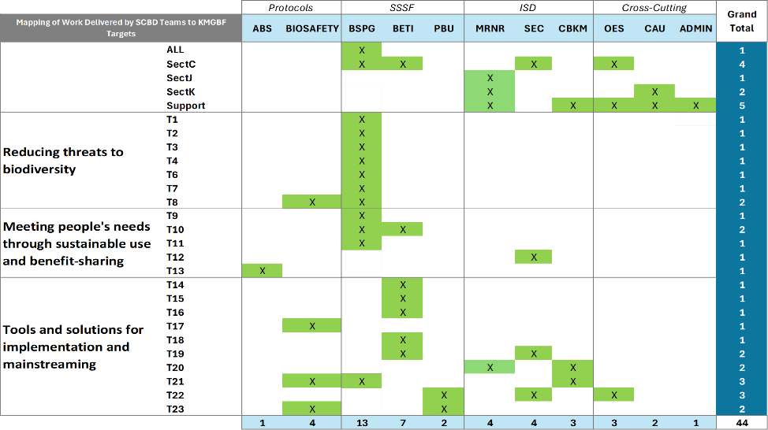
Figure 3. Mapping of Work Delivered by SCBD Divisions and Teams to KMGBF Targets.
- The analysis of performance indicators provides further insight into the Secretariat’s workload across meetings, documentation, and other outputs. Of the 24 indicators provided by the Secretariat, 12 were used in the review, focusing on measurable and comparable categories across the three COP-to-COP periods. These include indicators related to formal meetings, expert groups, workshops, and the production and posting of documents and statements. Data was normalized by calculating annual averages for each period to account for differences in reporting cycles. There are important limitations to the available data. The COP 16–17 cycle is still ongoing. In addition, the COP 14–15 cycle was an outlier compared to standard COP cycles and may not be representative of typical workload patterns.
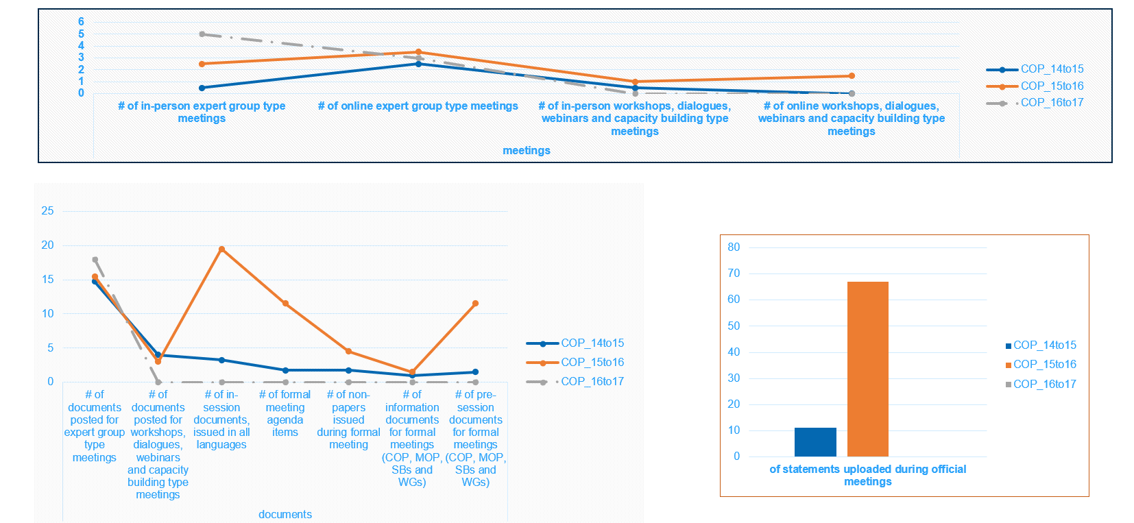
Figure 4. Workload indicator data across SCBD (source: SCBD data September 2025).
- Workload trends to show a clear spike in activity between COP 15 and COP 16, with increases across nearly all meeting and document categories. This trend was validated by reviewing the number of pages and words the Editorial and Language Unit edited and translated between 2021-2024. This surge reflects the resumption of in-person meetings following COVID-19 disruptions, the intensive preparation of technical and policy documents during the adoption of the KMGBF, and heightened demands for statements, briefings, and documentation. As the data were collected prior to the start of subsidiary body meetings in September, the period from COP 16 to 17 represents an outlier, though it shows a steady rise in technical and capacity-building work.

- While activity levels increased significantly after COP 15, staffing levels did not grow proportionately. This mismatch has contributed to sustained pressure on Secretariat personnel, particularly in technical, editorial, and conference-support functions. The data also indicate an ongoing increase in workshops, dialogues, webinars, and technical meetings, core functions that require substantial preparation and coordination despite not always being visible within formal meeting cycles.

- Together, these findings underscore the need to rebalance workloads and align staffing and resources more closely with COP mandates and KMGBF expectations. They also highlight the importance of streamlining internal processes, enhancing digital tools, and reinforcing planning and prioritization mechanisms to support a more predictable and sustainable distribution of work.

c. Functional mapping results
- A Secretariat-wide Full-Time Equivalent (FTE) mapping exercise was conducted to assess the distribution of staff effort across seven functional areas: (1) arranging for and servicing intergovernmental meetings; (2) management and administration; (3) support to implementation by Parties; (4) communication, awareness-building and outreach; (5) scientific, technical and policy support; (6) monitoring, reporting and review of implementation of the Convention and its Protocols, including the compliance mechanism for the Protocols; and (7) fostering stakeholder engagement, cooperation, collaboration and partnerships.

- The functional mapping exercise results, conducted by all Secretariat units, show that approximately 33 percent of staff capacity is spent on scientific, technical and implementation support to Parties (16 percent implementation, 10 percent scientific and technical support and 7 percent monitoring and review), 24 percent of Secretariat capacity is dedicated to arranging and servicing intergovernmental meetings, while 22 percent is allocated to management and administration (ANNEX III).

- The mapping highlights clear functional strengths across divisions: OES concentrates on intergovernmental coordination and policy support, the Administration Division anchors core administrative functions, and Implementation Support Division (ISD) and Science, Society and Sustainable Futures Division (SSSF) allocate significant effort to technical, scientific and implementation-related work. The Protocols units display a diverse functional profile in line with their treaty-specific mandates, while the JBF focuses primarily on fund administration, with some contribution to broader Secretariat activities. The mapping also showed that core staff are highly involved in core servicing and operational functions, whereas consultants contribute more significantly to scientific and technical support activities.

- Across the Secretariat, several functions, such as communications, capacity-building and stakeholder engagement, are carried out by multiple units, reflecting thematic mandates of a cross-cutting nature but also indicating opportunities to strengthen coordination and clarify responsibilities. Overall, the results point to a well-engaged workforce with scope to streamline cross-division roles and enhance coherence in how functions are delivered. The analysis indicates that functions such as communications, capacity-building and stakeholder engagement are carried out across multiple units in line with thematic mandates on a wide range of biomes. Ensuring that functionally related activities are coordinated by and channeled through the units responsible for those functions would strengthen the efficient use of resources, as highlighted during functional mapping consultations with units.

B. Resource and Budget Considerations
- The Secretariat’s human and financial resources form the foundation of its ability to deliver on its mandate and meet the expectations of the Parties. Over the past decade, funding and expenditure patterns have evolved. Key trends in budget, staffing and resource utilization indicate that there are opportunities to strengthen cost efficiency, transparency, and alignment between resources and priorities.

a. Analysis of budget trends and funding
- The analysis of the Secretariat’s financial and staffing data covering 2016 to mid-2025 shows that overall expenditure and funding patterns have remained broadly stable, with slight gradual growth aligned to successive biennial budgets approved by the Conference of the Parties. Total staff-related costs have averaged between 10 and 14 million United States dollars per year since COP 12, reaching an estimated 16.5 million dollars in 2025 based on the approved COP 16 core and Programme Support Cost budgets.

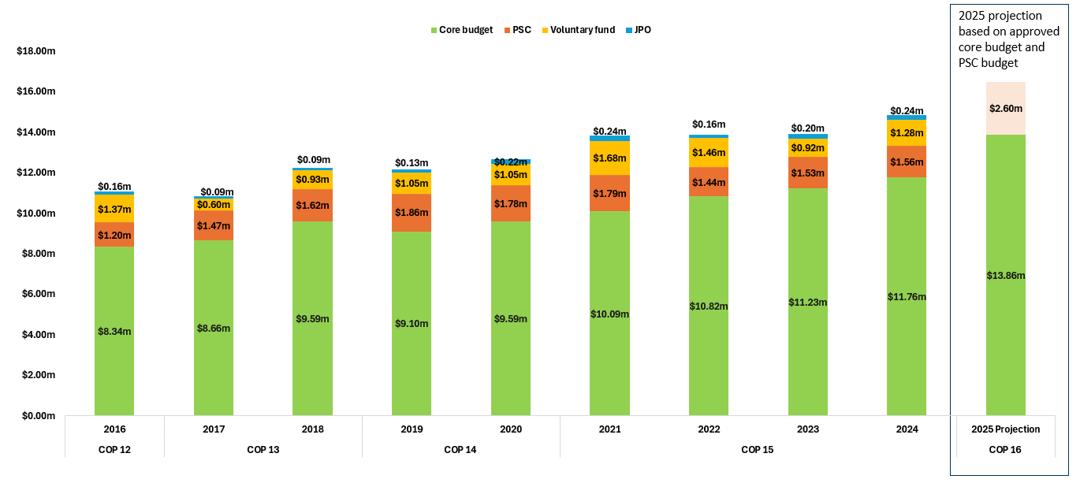
Figure 5. Staff cost by funding sources (Source: SCBD payroll data 2016 – June 2025).
- The core budget continues to provide the main source of financing for the Secretariat’s staffing and operational needs, complemented by Programme Support Costs (PSC), voluntary contributions, and Junior Professional Officer (JPO) posts. PSC funding has remained steady, averaging approximately 1.5 million dollars annually, while voluntary and JPO contributions have represented a modest but stable share of total staff expenditure.

- Since the introduction of the Integrated Core Budget in 2017, the Convention and its Protocols have been financed under a unified framework with agreed proportional allocations. This structure has enhanced predictability and transparency in resource planning while maintaining accountability for each instrument. The core budget distribution has remained relatively consistent, with approximately 72 percent allocated to the Convention, 15 percent to the Cartagena Protocol, and 13 percent to the Nagoya Protocol.
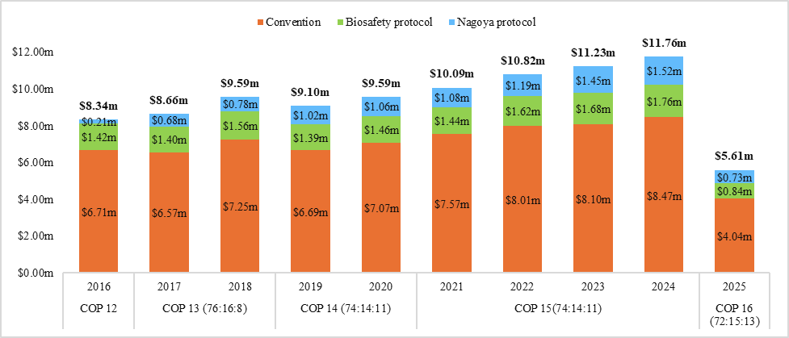
Figure 6. Breakdown of actual core budget by components (source: SCBD payroll data 2016 – June 2025).
- The comparison between approved budgets and actual expenditures indicates prudent fiscal management, staying within approved budgets, and generally high utilization of approved resources. Budget consumption rates have ranged between 80 and 95 percent, with a steady increase in consumption rate since 2021. The lower utilization rate recorded for 2025 reflects the timing of expenditure within the biennium and ongoing staff recruitment linked to COP 16 implementation.
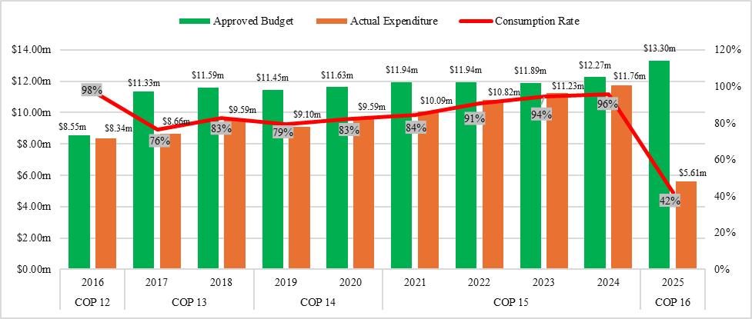
Figure 7. Approved budget and actual consumption (source: SCBD payroll data 2016 – June 2025).
- While the Secretariat has managed its resources effectively, overall funding growth has not fully matched the expansion in its mandate and workload, particularly in relation to increased meeting servicing demands, support for national implementation, and enhanced monitoring under the KMGBF. The Secretariat has demonstrated adaptability by leveraging supplementary funding but this approach underscores the continued need to align resource mobilization and allocation efforts with strategic and functional priorities to ensure sustainability and effective delivery.

b. Analysis of staffing and functional availability
- Over the past six years, core staffing levels at the Secretariat have stagnated while demands on the organization have grown. Between 2016 and 2025, the total number of personnel fluctuated within a narrow band of 100 to 112, beginning with 104 personnel in 2016, peaking at 112 in 2021, and falling to a historic low of 101 in 2025. During the same period, the Secretariat’s workload has expanded considerably. The number, frequency, and complexity of decisions adopted by the Conference of the Parties have increased over successive cycles, resulting in a broader and more detailed mandate for the Secretariat.

Figure 8. Historic headcount by staffing categories (source: SCBD payroll data 2016 – June 2025).

- Parties have formally acknowledged a “cumulative increase in the magnitude of the Secretariat’s programme of work over many bienniums,” including more extensive intersessional work, higher demand for policy and technical support, and significantly greater pressures on conference servicing, registration, translation, and administrative functions. Additionally, COP meetings themselves have grown in scale, with recent sessions recording substantially higher attendance compared with earlier COPs. Taken together, a stagnant staffing base and a steadily increasing workload present an unsustainable trajectory for the Secretariat.

- The composition of the workforce has remained relatively stable, with a core goup of staff providing continuity and institutional memory, complemented by consultants and ICs to manage temporary workload peaks and specialized technical needs. Core staff account for approximately 89 to 94 percent of total staff expenditure, indicating limited reliance on short-term personnel. Consultant and IC costs, representing 6 to 11 percent of personnel expenditures, are primarily linked to technical, editorial, and event support functions.

Figure 9. Total personnel headcount (source: SCBD payroll data 2016 – June 2025).
- The cost of ICs and consultants has increased moderately in recent years in line with workload surges during major conference cycles, including COP 15 and the lead-up to COP 16. While this flexible resourcing approach has supported the delivery of time-bound outputs without permanent increases in staffing levels, it also carries important limitations. The time and administrative processes required to recruit and onboard short-term personnel place additional workload on regular staff, and the reliance on temporary contracts for recurring functions risks weakening the Secretariat’s sustainable technical capacity, particularly where core technical work is carried out by non-permanent staff. These factors underscore the need to reassess longer-term capacity and staffing resourcing requirements.

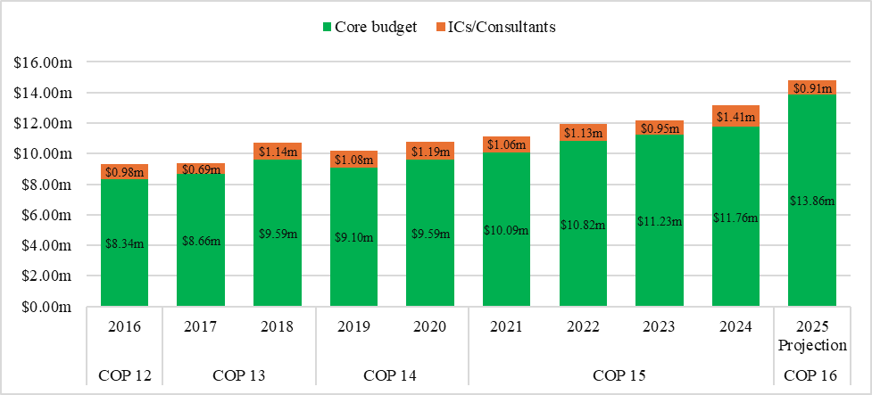
Figure 10. Cost of core staff and individual consultants (source: SCBD payroll data 2016 – June 2025).

- The Secretariat’s overtime data further illustrates the growing workload intensity among General Service staff, who regularly perform duties usually performed by professional staff. Overtime payments have increased more than threefold between 2016 and 2023, peaking in years coinciding with major conference and reporting cycles. The average overtime share of total payroll has remained moderate, around 4 to 5 percent, but higher spikes in 2019 and 2023 underscore the Secretariat’s limited flexibility during high-demand periods. While overtime declined temporarily in 2020–2021 due to COVID-19 disruptions, subsequent rebounds in 2022–2024 reflect resumed in-person operations.
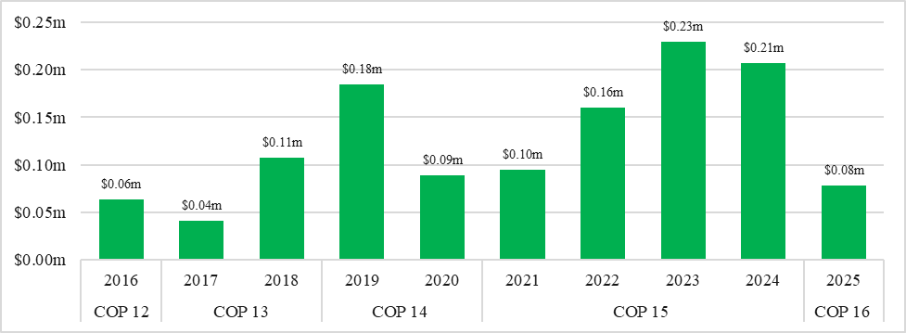
Figure 11. General service overtime payments (source: SCBD Payroll data 2016 – June 2025).
- Focus group discussions and staff survey results reveal that workload pressures are unevenly distributed across units. Divisions involved in servicing meetings, capacity-building, and administrative support face sustained high demand, while other areas experience more cyclical peaks. The limited availability of permanent posts in these areas constrains institutional continuity and increases operational risk.
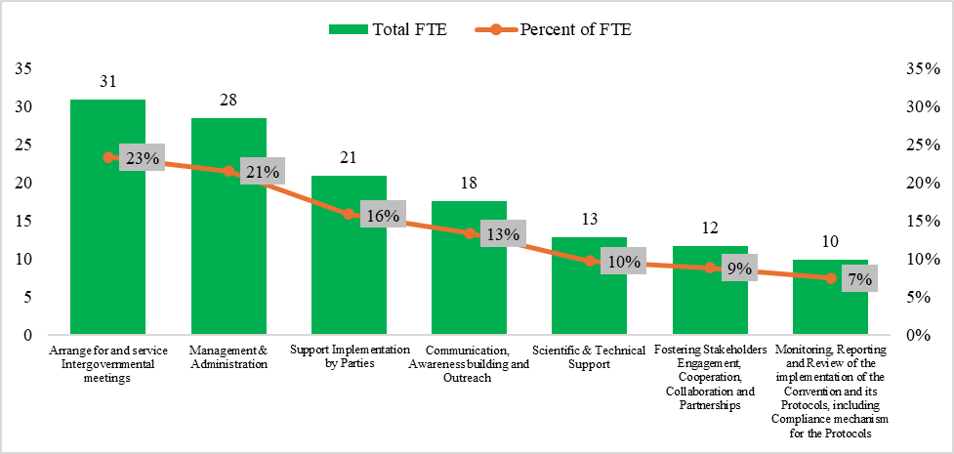
Figure 12. Estimated use of capacity across the Secretariat (source: functional mapping exercise).
- Overall, while the Secretariat has demonstrated resilience and adaptability through effective use of flexible arrangements, the current model offers limited space to act on decisions from Parties and to undertake meaningful strategic workforce planning and forward-looking leadership. Persistent capacity gaps, particularly in high-demand technical and operational areas, constrain the Secretariat’s ability to respond effectively to expanding mandates. Strengthening the balance between core and temporary capacity, with increased staffing in areas facing the greatest gaps, coupled with a clearer alignment of functions and resources, is essential to ensure long-term operational stability and enable the Secretariat to better anticipate and manage workload fluctuations.

c. Opportunities to enhance organizational capacity, cost efficiency and transparency
- Opportunities exist to strengthen organizational capacity, cost efficiency and transparency by optimizing the use of existing resources, improving internal coordination and reinforcing financial planning. Aligning resource allocation more closely with strategic priorities to would help reduce workload, enhance accountability and ensure that financial and human resources are directed toward high-priority, mandated activities and tangible results. Given the Secretariat’s growing workload and persistent capacity gaps, these measures must be accompanied by additional staffing in critical areas to ensure sustainability and reduce excessive workload pressures.

- Unifying resource mobilization under a single organizational structure, together with partnerships and communications, would support a more coordinated and diversified approach to fundraising. A formalized structure would strengthen donor relations, ensure consistent messaging and help mobilize predictable and sustainable resources in the face of financial constraints. Consolidating these functions would also enhance internal financial transparency and strengthen strategic and financial planning efforts, allowing the Secretariat to align resources more effectively with its mandated priorities and long-term operational needs.

- The full application of results-based budgeting (RBB) principles would enable more strategic and evidence-based planning of activities and expenditures. By systematically linking financial resources to clearly defined outputs and outcomes, RBB would enhance transparency, strengthen performance monitoring, and ensure that budgetary allocations are directly aligned with organizational priorities and expected results.

- As proposed by COP Bureau members, the Secretariat should give priority to the implementation of adopted decisions that are adequately funded, and to mandated activities for which resources have been secured. This approach would promote prudent resource management, prevent the expansion of unfunded mandates, and help maintain a sustainable workload commensurate with available financial and human capacities in support of staff wellbeing and financial sustainability.

V. PROPOSED STRUCTURAL OPERATING MODEL
- The proposed adjustments to the Secretariat’s structure and operating model aim to strengthen strategic coherence, improve coordination across functions, and enhance the Secretariat’s capacity to support implementation of the Kunming–Montreal Global Biodiversity Framework (KMGBF) and decisions of the Conference of the Parties and its Protocols. The proposed model builds on the findings of the functional review and seeks to address fragmentation, overlapping responsibilities, and uneven accountability identified in the analysis.

A. Guiding principles
- The design of the proposed operating model is guided by a set of principles derived from the functional review findings and organizational design best practices. These include:

- Alignment with mandates and strategic priorities: ensuring that structures and functions are directly linked to the KMGBF goals and targets and to COP and Protocol mandates.
- Coherence and integration: reducing fragmentation by grouping related functions under clear, outcome-oriented clusters and strengthening collaboration between policy, technical, and administrative functions.
- Accountability and empowerment: enabling greater delegation of authority and managerial accountability while maintaining transparency and oversight.
- Efficiency and sustainability: improving the balance between technical and operational capacity, reducing duplication of functions, and optimizing available resources.
- Agility and adaptability: establishing a structure that can evolve with emerging priorities, new mandates, and changing resource environments.
- Institutional learning and inclusiveness: fostering cross-unit knowledge sharing, communication, and participatory approaches to planning and decision-making.

B. Overview of proposed functional model
- To better support the goals and targets of the KMGBF and ensure coherence across the Convention and its Protocols, the Secretariat’s structure should be functionally aligned around its core mandates. The proposed structure introduces a more functionally integrated and strategically aligned model (ANNEX III). The model consolidates the Secretariat’s functions into the following organizational structure under the oversight of the Office of the Executive Secretary (OES):

- Office of the Executive Secretary (OES):
The Programme Management Unit (PMU) should be positioned centrally under the Office of the Executive Secretary to support the effective use of the Results-Based Budgeting and Planning (RBBP) framework as the Secretariat’s central strategic management tool for implementing the KMGBF and aligning resources with COP and Protocol decisions. The Legal and Intergovernmental Affairs (LIA) Unit should remain within the OES, reflecting its Secretariat-wide advisory and coordination role. The Secretariat Support Unit should also continue to be housed under the OES, given its core function in supporting the Executive Secretary and Deputy Executive Secretary through correspondence management, calendar and meeting coordination, organizational support and programmatic coordination support for intergovernmental meetings. It is further recommended that the Editorial and Language Unit (ELU) be under the OES as the Documentation and Language Unit and works closely with legal and senior management to focus on ensuring consistency, quality, and alignment of documentation across the Secretariat, as opposed to being treated as an administrative support function. The review notes that the ELU has recently been allocated an additional P3 post that is in the process of being filled; it is recommended that the team’s workload be closely monitored once this position is onboarded to assess whether further capacity may be required to adequately mange the Unit’s expanding workload.

- Policy, Capacity and Monitoring Division (PCMD):
This division should consolidate scientific and technical functions with implementation support, and focus on delivering on the KMGBF, including currently underserved goals and targets. This division should be reorganized into three areas: biome-based science and policy; cross-cutting science and policy; and capacity building, monitoring and reporting. The Division should comprise the Biodiversity, Science, Policy and Governance (BSPG) Unit, the Capacity-Building and Knowledge Management (CBKM) Unit and the Monitoring, Review and National Reporting (MRNR) Unit. The implementation support function should continue to encompass capacity-building, monitoring, reporting and review to assist Parties in translating global targets into national action.

- Strategic Partnerships, Financing & Economy Division:
A Strategic Partnerships, Financing & Economy Division should be established, bringing together the Communications and Awareness Unit (CAU), the Stakeholder Engagement and Cooperation (SEC) Unit, the Peoples and Biodiversity Unit (PBU), and the Biodiversity Economy Transformation and Innovation (BETI) Unit. Integrating these functions would reinforce coherence across communications, engagement of indigenous peoples and local communities and stakeholder, advocacy, and resource mobilization. The cluster would enhance the Secretariat’s ability to engage strategically with partners and donors, promote consistent messaging, and align outreach and partnership efforts with KMGBF implementation priorities. The establishment of a new, formalized resource mobilization function within this division would further strengthen fundraising efforts and would require dedicated resources to operate effectively.

- Protocols Division (PD):
To further strengthen functional coherence and streamline delivery under the KMGBF, the Protocols, thematic support, and implementation support functions should be unified under one organizational reporting structure. This integration would facilitate closer coordination and synergies between scientific and technical work, capacity-building, monitoring and review, and policy support related to benefit sharing, digital sequence information of genetic resources, biosafety, biotechnology, and synthetic biology. By aligning these related areas within a single operational framework, the Secretariat would be better equipped to deliver integrated, evidence-based, and results-oriented support to Parties and ensure coherent implementation of the Convention and its Protocols under the KMGBF.

- Intergovernmental Meeting Support Cluster:
Conference management, registration and travel arrangements should be brought together under a new Intergovernmental Meeting Support Cluster. This unified service would strengthen the planning, coordination, and delivery of COP, COP-MOP, and subsidiary body meetings. The cluster would promote a more integrated approach to logistical and operational support, improving timeliness, coordination, and service quality for intergovernmental processes.

- Administrative and Operational Support Section:
The Administration Division should focus on human resources, finance and facilities management functions. Travel arrangements, which were previously grouped with these functions, should be placed under the Intergovernmental Meeting Support Cluster. Information technology and digital transformation capacities should be consolidated under a separate unit.

- IT & Digital Transformation Unit:
The Administration Division IT Unit and the CBKM IT/DevOps sub-unit should be unified under an IT and Digital Transformation structure to strengthen efficiency, coordination of IT services, and digital innovation. The consolidated unit would provide integrated IT administration, infrastructure management, and digital solutions development, while also supporting the Clearing-House Mechanism and corporate knowledge management systems. Bringing these functions together would enhance service delivery, reduce fragmentation, and better enable Secretariat-wide digital modernization.

- Japan Biodiversity Fund Unit:
The Japan Biodiversity Fund should remain an independent unit, given its distinct mandate and funding arrangements. The unit is responsible for managing the Fund in accordance with donor requirements, supporting capacity-building initiatives for Parties, and facilitating knowledge management related to JBF-supported activities. Maintaining the unit’s standalone structure ensures continued accountability, visibility, and dedicated coordination of JBF resources in support of implementation of the Convention and the KMGBF.

- The proposed model reflects a moderate degree of functional specialization while promoting greater horizontal collaboration and coherence across clusters. By consolidating related functions under unified reporting structures, it aims to strengthen coordination between related functions, and enable a more efficient use of resources. This integrated approach is expected to enhance collaboration across the Secretariat and ensure that the Convention and its Protocols are implemented in a cohesive and mutually reinforcing manner in support of the KMGBF.

C. Overview of changes in functions and interlinkages among divisions and units
- The proposed adjustments entail a consolidation and realignment of functions to improve the flow of information, reduce duplication and administrative bottlenecks, and create clearer linkages between programmatic and operational areas.

- The current division-based structure would evolve toward a more functionally integrated model, where thematic and implementation divisions work in close coordination with intergovernmental meeting services, supported by centralized corporate and digital services. Scientific and technical support functions would be brought into closer alignment with implementation and reporting processes, while communication and partnership functions would operate as cross-cutting enablers serving all clusters.

- The Intergovernmental Meetings Support cluster would absorb conference management-related functions previously dispersed across multiple divisions, allowing for unified planning and logistical coordination. Similarly, the consolidation of communication, stakeholder engagement, and resource mobilization under Strategic Partnerships, Financing and Economy Division would streamline external engagement, ensuring consistency in messaging and improved alignment between advocacy, cooperation, and fundraising.

- The IT and Digital Transformation unit would work in close collaboration with other units to develop Secretariat-specific digital tools and platforms. Strengthening internal IT oversight and integrating digital support with business process improvement would enhance efficiency, document management, data management, and institutional knowledge-sharing.

D. Expected benefits
- Implementation of the proposed structural and functional adjustments is expected to generate several benefits across institutional, operational, and programmatic dimensions:

- Greater strategic coherence, achieved by aligning structures and functions with the goals and targets of the KMGBF and COP mandates, clarifying linkages between programmatic and cross-cutting areas, and ensuring that related activities operate under consistent reporting lines.

- Improved coordination and efficiency, through the consolidation of related services and functions, reduction of duplication, clearer accountability lines, and more streamlined business processes and workflows.

- Enhanced service delivery to Parties, enabled by stronger integration of thematic and implementation functions and the Protocols under one reporting framework, promoting cohesive support for KMGBF implementation, capacity-building, and monitoring.

- Stronger communications and partnerships, by unifying communications, stakeholder engagement, and resource mobilization functions within a single Strategic Partnerships, Financing & Economy Division, reinforcing consistent messaging, coordinated outreach, and more strategic collaboration with partners and donors.
- Optimized operational support, by centralizing corporate services, modernizing digital systems under the IT and Digital Transformation Cluster, and improving timeliness, transparency, and coordination across administrative and support services.

- Increased institutional learning and adaptability, through the introduction of business process owners, clearer functional accountability, and closer horizontal collaboration across clusters, enabling a more agile, knowledge-driven, and future-ready Secretariat.

VI. LIST OF RECOMMENDATIONS AND NEXT STEPS

A. Consolidated list of recommendations
- The review identified a consolidated set of recommendations categorized under seven interrelated opportunity areas:

- Structural and Strategic Alignment
  - Realign Secretariat functions to effectively support Parties in the implementation of the Convention, the Protocols, and the KMGBF.
  - Establish a Strategic Partnerships, Financing and Economy Division to lead stakeholder engagement, communications, and resource mobilization and identify capacity to lead and strengthen the Secretariat’s capacity to effectively support Parties in their resource mobilization for the implementation of the KMGBF.
  - Bring together the Stakeholder Engagement and Cooperation (SEC) Unit, Communications & Awareness (CA) Unit, Biodiversity Economic Transformation and Innovation (BETI) Unit and People and Biodiversity Unit (PUB) under the Strategic Partnerships, Financing and Economy Division. This recommendation may require limited transition support, such as structured strategy and goal-setting workshops and team-building activities to ensure effective integration and cohesion across the newly consolidated functions.
  - Maintain BSPG as the thematic support function and unify thematic support, implementation support, including the Capacity-Building and Knowledge Management (CBKM) Unit and the Planning, Monitoring, Review and Reporting (PMRR) Unit.
  - Unify Protocols under a Protocols Division.
  - Integrate Protocol-related communications capacity within the Communications and Awareness Unit (CAU).
  - Consolidate the Information Technology (IT) Unit and CBKM/DevOps sub-unit under an IT & Digital Transformation reporting structure.
  - Move the Programme Management Unit (PMU) to the OES, maintain Legal and Intergovernmental Affairs Unit within OES and relocate Editorial & Language Unit under OES. The PMU recommendation will require additional capacity for planning and coordination functions.
  - Group the conference management, registration, travel and procurement functions under a new Intergovernmental Meetings Support cluster.
  - Maintain human resources, finance and facilities management functions under an Administrative and Operational Support Section.

- Cross-cutting Coherence
  - Empower business process owners to provide Secretariat units with guidance and services in their respective areas of expertise.
  - Hold business process owners accountable for their area of expertise and empower them to strengthen impact evaluation and assessments to continuous documentation of lessons learned and incorporation of learnings into current policies and procedures
  - Assign functional business process ownership as follows:
    - Communications: Communications and Awareness Unit
    - Resource Mobilization: Resource Mobilization & Strategic Financing Unit
    - Stakeholder Engagement: Strategic Partnerships, Financing & Economy Division
    - Capacity Building: Capacity Building, Monitoring and Reporting Unit
    - Knowledge Management: Capacity Building, Monitoring and Reporting Unit
    - Conference Management: Conference Services Unit

- Empowerment and Accountability
  - Request increased delegation of authority from UNEP, particularly for procurement threshold, where the value for low-value procurement has been US$10,000 for over 10 years and administrative decisions.
  - Delegate budget authority and strengthen accountability mechanisms for Division Heads.

- Human Resource Capacity and Resourcing
  - Review recruitment processes to ensure timely backfilling of posts in coordination with UNEP and UNON.
  - Launch an exercise to review, update and publish individual and team terms of reference. This recommendation requires surge HR capacity.
  - Update the Secretariat’s organigram and establish a process to review and update on a routine basis.
  - Strengthen coordination with UNEP and MEAs to support administrative business process improvements, career development, identify opportunities to leverage economies of scale in contracting, deployment of temporary capacity, and share lessons learned on operational issues.

- Transformation of Ways of Working
  - Strengthen Secretariat-wide work planning to reduce duplication and support workload management.
  - Develop biannual funding mobilization plans following each COP, including roles and responsibilities and monitoring and evaluation mechanisms. This recommendation may require dedicated expertise.
  - Strengthen the role of the Programme Management Unit to improve the link between decision tracking, RBB alignment, and implementation monitoring. This recommendation requires additional capacity.
- Performance and Data Management
  - Establish a coherent set of KPIs, as appropriate. at Secretariat, division, and unit levels.
  - Standardize data collection, reporting systems, and quality assurance processes.
  - Build a centralized Secretariat-wide performance dashboard.
  - Integrate performance metrics into planning, budgeting, and resource allocation.
  - Clarify roles, responsibilities, and governance arrangements for performance management.
  - Strengthen staff capacity, tools, and systems for data and performance management.

- Digital Transformation
  - Develop a Secretariat-wide Digital Transformation Strategy with a unified vision for digital services supporting KMGBF implementation. This recommendation may require digital strategy expertise.
  - Modernize key processes, platforms, and digital workflows across the Secretariat.
  - Strengthen data governance, data quality, and analytics capabilities. This recommendation may require specialized expertise.
  - Guide digital and AI initiatives across units to enhance Secretariat efficiency and improve service delivery to Parties and Protocols. This recommendation may require specialized expertise.

B. Implementation sequencing of functional recommendations
- The recommendations presented are framed at the functional level. As a next step, the Secretariat will need to accept and translate the functional recommendations into a finalized organizational structure, confirming the configuration of divisions, units and teams, reporting lines and the role and responsibilities at the position level. The implementation of these changes will require a phased approach that aligns with UNEP’s administrative process and reflects the Secretariat’s operational context. A structured implementation plan should be developed and will enable the Secretariat to achieve early gains, maintain reform momentum, and progressively institutionalize changes over the short, medium and long term and should be accompanied by sustained change-management efforts.
Short-term (first three months)
- Short-term actions focus on completing the detailed organizational structure and determining adjustments to individual positions and levels. During this period, the Secretariat should engage UNEP HR and administrative services to identify classification needs and approval pathways. These actions should also identify the need for additional posts and support the development of updated or new job descriptions where required. At this time, a detailed transition plan should also be developed, covering HR actions, resources implications, communications and risk mitigation activities. Early and transparent engagement with the Secretariat personnel, including information sessions and accessible communications materials, will support building trust and the change management process.
Medium-term (three to six months)
- Once the structural design is approved, the Secretariat should proceed with the formal HR and administrative actions required to operationalize it. This includes classification reviews, updates to individual and team TORs, competitive processes or reassignments where needed, and alignment of Umoja cost centers and reporting lines. During this phase, the Secretariat should also begin implementing the core workflows envisioned in the functional model and initiate implementation of the Secretariat-wide performance and data management framework, as well as the digital transformation strategy, under guidance of the IT and Digital Transformation Unit. Newly consolidated teams should be supported through integration, team-building activities and targeted capacity-strengthening activities. Regular communication will help maintain momentum and ensure staff understand both the changes and their rationale.
Long-term (six months and beyond)
- In the longer term, the focus shifts to embedding the new operating model and ensuring it delivers the intended improvements in coordination, clarity, and strategic alignment. This includes establishing and refining Secretariat-wide planning and prioritization mechanisms; updating standard operating procedures; and strengthening cross-divisional collaboration. Annual reviews should assess the effectiveness of the structural changes and identify adjustments based on operational learning and evolving mandates. Here there is an opportunity to strengthen the collections and analysis of data that provide insights on the Secretariats operations, including monitoring the implementation of the structural change.

- Continued engagement with staff will be important to reinforce the Secretariat’s direction and demonstrate progress. Overall, the transition from functional recommendations to a fully operational organizational structure is an iterative process that requires deliberate sequencing, rigorous planning, and sustained change-management efforts. By grounding structural decisions in the functional analysis presented in this review, the Secretariat can position itself to operate more coherently, efficiently, and responsively in support of the objectives of the Convention and the Kunming–Montreal Global Biodiversity Framework.

C. Notes on implementation, governance and follow-up of recommendations
- The successful implementation of the functional review’s recommendations will require a structured and phased approach, resources for implementation, clear governance arrangements and continued engagement with the Secretariat’s leadership, staff, and the Conference of the Parties (COP) Bureau. Implementation should build on the strong collaboration established throughout the review process and be guided by principles of transparency, inclusiveness, and accountability.

- To ensure effective follow-up, the Secretariat is recommended to establish a dedicated implementation and change management mechanism under the direction of the Executive Secretary. This mechanism would be responsible for translating the approved recommendations into concrete actions, developing a sequenced implementation plan, and monitoring progress against agreed milestones. Regular internal updates would facilitate coordination across divisions and promote collective ownership of the reform process.

- Governance of the implementation process will be anchored in existing management structures to ensure coherence with corporate accountability frameworks. The Senior Management Team would provide strategic oversight and validation of key decisions, while an internal task team could support technical coordination and communication with staff. The COP Bureau would be kept informed of progress through briefings, providing guidance and ensuring continued alignment with the mandate given by Parties.

- Implementation should be phased to balance ambition with feasibility. Initial efforts could focus on short-term measures that enhance clarity of functions, strengthen management accountability, and improve coordination mechanisms. Medium-term actions would then address structural adjustments, workforce planning, and process modernization, supported by capacity-building and change-management initiatives to reinforce staff engagement and readiness.

- Effective communication will be essential throughout the transition. A clear communication plan, outlining key messages, responsibilities, and feedback channels, would help maintain transparency, reduce uncertainty, and ensure that staff understand how the changes contribute to the Secretariat’s long-term vision. Staff engagement should remain continuous, allowing for iterative feedback as reforms are introduced.

- Sustained follow-up on the functional review’s recommendations will enable the Secretariat to consolidate institutional reforms and achieve long-term gains in coherence, efficiency, and impact. With appropriate governance, planning, and engagement, the review’s outcomes can serve as a catalyst for a more strategically aligned, responsive, and fit-for-purpose organization in support of Parties and the Kunming–Montreal Global Biodiversity Framework.

ANNEX II. CURRENT ORGANOGRAM

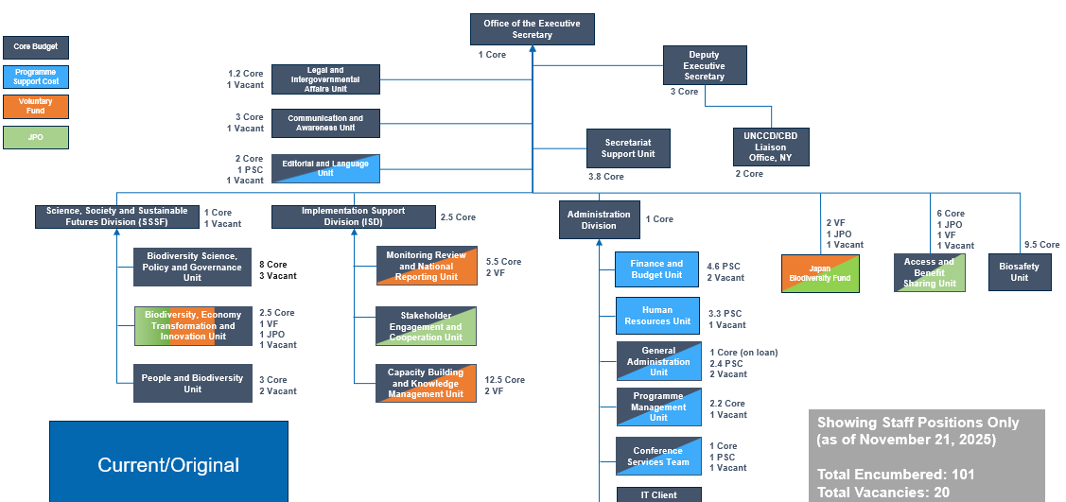

ANNEX III. SUMMARY OF FUNCTIONAL MAPPING RESULTS
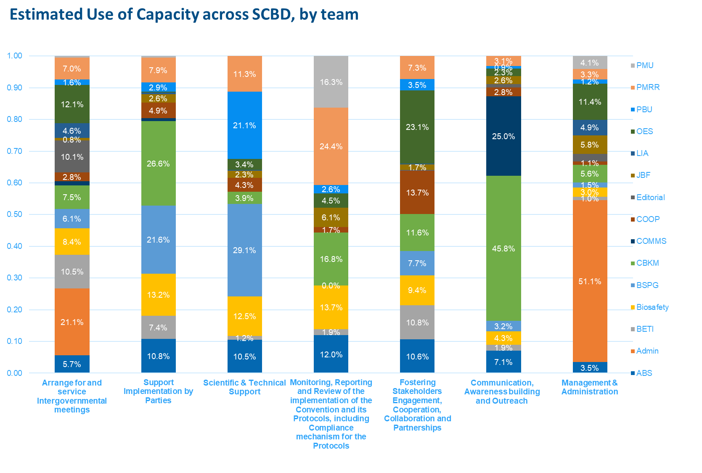

ANNEX IV. ORGANIZATIONAL SCHEMATIC AND DESIGN PRINCIPLES
A. Organizational Schematic Structure
The proposed organizational structure of the Secretariat of the Convention on Biological Diversity (SCBD) follows a functionally integrated model aligned with the Kunming–Montreal Global Biodiversity Framework (KMGBF). It establishes clear linkages between strategic direction, technical delivery, intergovernmental servicing, and operational support functions.
1. Office of the Executive Secretary (OES)
- Represents the Convention and its Protocols in relevant international processes and fora.
- Oversees the overall organization and delivery of COP, COP/MOPs and subsidiary bodies, ensuring alignment among different intergovernmental processes, and coordinates the operation of the Bureau of the Conference of the Parties.
- Provides overall strategic direction, corporate governance, and accountability for the Secretariat.
- Oversees planning, decision tracking, monitoring, and coordination of implementation across divisions.
- Comprises the Programme Management Unit (PMU), the Legal and Intergovernmental Affairs (LIU) Unit, the Secretariat Support Unit and the Document and Language Unit (DLU).

1.1 Secretariat Support Unit (OES/SSU)
  - Manages notifications, correspondence, communications, and official document routing for the Executive Secretary and Deputy Executive Secretary.
  - Oversees calendar management and the coordination of senior-level, heads of unit and all staff meetings.
  - Provides organizational and logistical support to ensure smooth functioning of the Office.

1.2 Legal and Intergovernmental Affairs Unit (OES/LIAU)
  - Provides legal advice on the Convention and its Protocols and UN rules and procedures.
  - Drafts, reviews, and interprets legal instruments, agreements, and governance documents.
  - Ensures procedural consistency across COP, COP-MOP, and subsidiary body processes.

1.3 Programme Management Unit (OES/PMU)
- Supports the Executive Secretary and DES with strategic planning, corporate coordination, and Secretariat-wide monitoring.
- Oversees Results-Based Budgeting (RBB), fund allocation, and performance tracking.
- Supports the ES and DES with secretariat-wide planning processes, alignment across divisions and the planning towards different subsidiary bodies.

1.4 Documentation and Language Unit (OES/DLU)
- Supports the Meeting Secretaries (COP, COP/MOP and Subsidiary Bodies) with the full workflow for meeting documentation, including quality control and quality assurance.
- Provides editorial services for official documents and corporate materials.
- Oversees language services, ensuring consistency and accuracy across all UN languages.

2. Policy, Capacity & Monitoring Division (PCMD)
- Leads the scientific, technical, and policy work of the Secretariat across the Convention and its Protocols’ biome-based thematic and cross-cutting areas.
- Manages and coordinates the work for the Subsidiary Body on Scientific, Technical and Technological Advice, and manages the operation of the Bureau of the SBSTTA.
- Provides guidance, analysis, and coordination to support Parties in implementing the Kunming–Montreal Global Biodiversity Framework.
- Oversees three units responsible for biome-based programmes of work, cross-cutting scientific work, and capacity-building, monitoring, and reporting.
- Comprises the Monitoring, Review, National Reporting Unit (MRNR), the Capacity-Building and Knowledge Management Unit (CBKM) and the Biodiversity, Science, Policy and Governance Unit (BSPG).

2.1 Biome-based Science and Policy Unit (PCMD/BSPU)
  - Leads and coordinates the implementation of biome-based programmes of work.
  - Provides scientific and technical inputs relating to ecosystems and biome-level policy integration.

2.2 Cross-cutting Science and Policy Unit (PCMD/CSPU)
  - Coordinates scientific and technical work on reducing threats to biodiversity.
  - Supports sustainable-use policy development and review.
  - Leads work on traditional knowledge and related cross-cutting thematic areas.

  - Capacity-building, Monitoring and Reporting Unit (PCMD/CMRU)
- Coordinates capacity-building support to Parties and stakeholders.
- Oversees work related to the Technical and Scientific Cooperation (TSC) programme and the Clearing-House Mechanism (CHM).
- Leads monitoring, reporting, and review processes under the Convention and the KMGBF.

3. Strategic Partnerships, Financing & Economy Division (SPFED)
- Merges the work on Article 8j, stakeholder engagement, communications, outreach, and resource mobilization into a unified structure.
- Oversees three new units that deliver financing, cooperation, communication, and knowledge management functions.
- Manages and coordinates the work for the Subsidiary Body on Implementation and the Subsidiary Body on Article 8j, and supports the management of the Bureau of the Conference of the Parties
- Comprises the Communications and Awareness Unit (CAU), the Stakeholder Engagement and Cooperation Unit (SEC), the Peoples and Biodiversity Unit (PBU), and the Biodiversity Economy Transformation and Innovation Unit (BETI).

3.1 Resource Mobilization and Strategic Financing Unit (SPFED/RMSFU)
- Leads resource mobilization efforts, including the DSI/Cali Fund.
- Oversees the financial mechanism and related strategic financing processes.

3.2 Engagement and Cooperation Unit (SPFED/ECU)
- Supports implementation of Article 8(j) and engagement with indigenous peoples and local communities, major groups and stakeholders.
- Coordinates cooperation with UN actors, partners, and stakeholder platforms.
- Facilitates strategic outreach and participation processes.

  - Communication and Awareness Unit (SPFED/CAU)
- Leads all communication and public awareness activities of the Secretariat.
- Supports outreach, advocacy, and visibility efforts.
- Oversees corporate knowledge management functions.

4. Protocols Division (PD)
- Provides substantive leadership for the Cartagena Protocol on Biosafety and the Nagoya Protocol on Access and Benefit Sharing.
- Oversees analytical, technical, and policy support for Protocol-related implementation.
- Manages two technical units covering ABS and biosafety-related workstreams.

4.1 ABS Unit (PD/ABSU)
- Leads policy and technical work related to Access and Benefit Sharing.
- Oversees digital sequence information (DSI) of genetic resources and benefit-sharing processes under the Protocol.
- Manages and coordinates the work for the COP-MOP of Nagoya Protocol

4.2 Biosafety and Biotechnology Unit (PD/BBU)
- Supports implementation of biosafety, biotechnology, and synthetic biology work under the Cartagena Protocol.
- Provides technical inputs, policy guidance, and substantive servicing for relevant bodies.
- Manages and coordinates the work for the COP-MOP of Cartagena Protocol

5. Administrative and Operational Support Section (AOSS)
- Provides integrated administrative, human resources, financial, and general operational services to the Secretariat.
- Ensures efficient processes for budgeting, staffing, procurement, and facilities management.
- Oversees three units delivering core corporate support services.

5.1 Finance and Budget Unit (AOSS/FBU)
  - Manages budget formulation, expenditure monitoring, and financial reporting.
  - Ensures alignment of financial resources with programme and organizational priorities.

5.2 Human Resources Unit (AOSS/HRU)
  - Manages human resources services, including recruitment and onboarding.
  - Supports staff administration, HR advisory functions, and workforce planning.

5.3 General Administration Unit (AOSS/GAU)
  - Oversees procurement and vendor management.
  - Manages facilities services, logistics, and general administrative support.

6. IT and Digital Transformation Unit (IDTU)

  - Provides IT administration, network and infrastructure management, and user support.
  - Develops and maintains digital solutions and platforms used across the Secretariat.
  - Provides IT support for the Clearing-House Mechanism (CHM) and corporate knowledge management systems.
  - Maintains regular coordination with the Office of the Executive Secretary to support governance workflows and meeting documentation systems.

7. Conference Servies Unit (CSU)
- Coordinates conference management and logistical delivery for COPs, COP-MOPs, SB meetings, and other official events.
- Oversees participant registration processes and provides on-site meeting support.
- Manages travel arrangements and associated servicing requirements for meetings.
- Works in close collaboration with the Documentation and Language Unit and the Office of the Executive Secretary on intergovernmental meeting support.

8. Japan Biodiversity Fund (JBF)
- Manages the Japan Biodiversity Fund in alignment with donor requirements and Secretariat priorities.
- Supports capacity-building activities for Parties, with a focus on implementation of the Convention and the KMGBF.
- Leads knowledge management efforts related to JBF-supported initiatives, ensuring lessons learned and good practices are shared across the Secretariat and Parties.

This structure promotes cross-functional coordination while maintaining clear accountability lines and alignment with the Secretariat’s mandate under the Convention and its Protocols.
B. Organizational Design Principles
The proposed structure is guided by organizational design standards and good practices, ensuring fitness for purpose, transparency, and flexibility. The following principles underpin the recommended operating model:
- Mandate Alignment: Structures and functions derive directly from the mandates of the Convention, its Protocols, and the KMGBF goals and targets, ensuring relevance and coherence with COP decisions.
- Functional Coherence: Related activities are grouped under unified leadership to reduce duplication, improve coordination, and promote synergies across thematic and operational areas.
- Subsidiarity and Delegation: Authority is delegated to the lowest appropriate level to enable timely decision-making, empower managers, and strengthen accountability for results.
- Accountability and Transparency: Clear reporting lines and results-based management frameworks ensure that performance, decision-making, and resource use are traceable and auditable.
- Integration and Collaboration: Cross-cutting functions—such as communications, knowledge management, and resource mobilization—operate through Secretariat-wide frameworks to promote institutional learning and consistency.
- Efficiency and Sustainability: The structure balances technical and administrative capacities, rationalizes support services, and promotes economies of scale in collaboration with UNEP and UNON.
- Adaptability and Agility: The model allows flexibility to evolve with emerging mandates, resource environments, and technological developments, ensuring responsiveness to Party needs.
- Inclusiveness and Staff Engagement: The design reinforces participatory approaches, valuing staff expertise and engagement in decision-making, change management, and continuous improvement.
- Digital Transformation and Innovation; Systems and workflows leverage technology to enhance knowledge-sharing, process efficiency, and data-driven decision-making across the Secretariat.

ANNEX V. COMPARATIVE BENCHMARKING SUMMARY
A. Overview and Methodology
The benchmarking exercise compared the structure, budgets, and operational models of the Secretariats of five Multilateral Environmental Agreements (MEAs): the Convention on Biological Diversity (CBD), United Nations Framework Convention on Climate Change (UNFCCC), Convention on the Conservation of Migratory Species (CMS), Convention on International Trade in Endangered Species of Wild Fauna and Flora (CITES), and the Convention to Combat Desertification (CCD).
Data sources included official budget documents, organizational charts, audit and OIOS reports, and COP statistics (2021–2025). Budgets were standardized to biennial values and converted to USD for comparability. Funding categories were disaggregated into core (Party-approved assessed contributions) and non-core (voluntary funds, cost recovery, and fee-based income).
B. Key Comparative Observations
1. Budget Overview
- All MEA Secretariats face constraints in core funding, relying heavily on voluntary contributions to sustain operations.
- On average, 70–75% of core budgets are allocated to staff costs.
- The CBD relies on core funding for approximately 65% of its total budget..
- Some Secretariats benefit from stable host-country or fee-based contributions that provide supplementary income.

2. Organizational Structure
- The CBD Secretariat is mid-sized (101 core staff), larger than CCD (87), CMS (39), and CITES (33), but smaller than UNFCCC (457).
- The share of administrative and operations functions (10–18% of total staff) is consistent across Secretariats, indicating proportional organizational footprints.

3. Administrative and Operational Services
- CBD’s administrative and operations footprint (17% of staff) aligns with peers, though non-core funding for operations (USD 6 million) remains modest compared to UNFCCC (USD 67 million) and CCD (USD 8 million).
- UNFCCC maintains dedicated budget, HR, procurement, travel, and risk management units, as well as a specialized Organizational Development and Oversight Unit for change management.
- CMS and UNFCCC include strategic budget or fundraising units under executive management, a model that could strengthen CBD’s resource mobilization function.
- ICT services in all Secretariats function as integrated administrative enablers supporting governance and information management.

4. Conference Servicing
- CBD’s COPs (7,000–8,000 participants, peaking at 20,000) are mid-sized compared to UNFCCC (35,000–85,000) and larger than CITES/CMS (1,500–2,500).
- UNFCCC maintains a dedicated conference unit of 21 staff and a USD 28 million budget, whereas CBD’s conference functions remain embedded within Administration, limiting scalability.

5. Communication and External Relations
- All MEAs maintain dedicated communications and outreach units reporting directly to executive management.
- UNFCCC’s Communications and Engagement Division operates as a cross-cutting entity across divisions, ensuring coherence and visibility—a potential model for CBD’s proposed Strategic Partnerships, Financing & Economy function.

C. Core Functional Architecture of MEA Secretariats
Across all organizations, six core functions are consistently present:
- Executive management and governance;
- Support to governing bodies and conferences;
- Technical and substantive support to Parties;
- Legal and procedural support;
- Outreach and communications;
- Administrative and operational support, including IT.

This alignment confirms that the CBD’s current and proposed structures are broadly consistent with peer organizations, while improvements in integration, delegation, and dedicated resource mobilization capacity would enhance effectiveness.
D. Key Insights for the Functional Review
- Mandates, staffing levels and funding models vary significantly across MEA Secretariats, making direct comparisons challenging. As a result, benchmarking provides only limited basis for drawing meaningful recommendations, given the differing institutional contexts, resource structures and operational models involved.
- Based on the benchmarking, the SCBD may benefit from more integrated conference servicing, communications and partnership functions, which would enhance coherence, strengthen coordination and improve support to Parties.Greater internal delegation and formalized business process ownership would mirror good practices observed in UNFCCC and CMS.
- Introducing an organizational development and change management function, as seen in UNFCCC, would support continuous improvement and institutional learning.

ANNEX VI. Functional Schematic of Current Divisions, Units, and Key Functions and Their Reassignment Under the Proposed Model
Division | Team/Unit | Key Functions | New Division/Unit
Executive Secretary | Secretariat Support Unit | Correspondence Management | Office of Executive Secretary
Executive Secretary | Secretariat Support Unit | Organizational Support | Office of Executive Secretary
Executive Secretary | Secretariat Support Unit | Information Management | Office of Executive Secretary
Executive Secretary | Secretariat Support Unit | Substantive support to ES and DES | Office of Executive Secretary
Executive Secretary | Secretariat Support Unit | Calendar and Meeting Management | Office of Executive Secretary
Executive Secretary | Legal & Intergovernmental Affairs Unit | Provide legal advice on the Convention, Protocols, and UN rules | Office of Executive Secretary
Executive Secretary | Legal & Intergovernmental Affairs Unit | Draft, review, and negotiate legal instruments and agreements | Office of Executive Secretary
Executive Secretary | Legal & Intergovernmental Affairs Unit | Ensure procedural consistency of Secretariat work and COP processes | Office of Executive Secretary
Executive Secretary | Legal & Intergovernmental Affairs Unit | Support Parties on compliance, liability, and ratification/accession issues | Office of Executive Secretary
Executive Secretary | Legal & Intergovernmental Affairs Unit | Manage accreditation, credentials, and drafting of COP decisions | Office of Executive Secretary
Executive Secretary | Legal & Intergovernmental Affairs Unit | Liaise with UNEP and MEA legal networks to share expertise | Office of Executive Secretary
Executive Secretary | Editorial & Language Unit | Manage documentation flow, formatting, templates, and web posting | Office of Executive Secretary
Executive Secretary | Editorial & Language Unit | Edit Secretariat documents for quality and UN editorial standards | Office of Executive Secretary
Executive Secretary | Editorial & Language Unit | Coordinate contractual translation services and quality control | Office of Executive Secretary
Executive Secretary | Editorial & Language Unit | Provide editorial and documentation guidance to the Secretariat | Office of Executive Secretary
Executive Secretary | Editorial & Language Unit | Support multilingual meetings with editing, translation, and document processing | Office of Executive Secretary
Executive Secretary | Editorial & Language Unit | Develop documentation management tools and streamline processes | Office of Executive Secretary
Executive Secretary | Communications & Awareness Unit | Develop, strength and implement partnerships to multiply messages and reach. | Strategic Partnerships, Financing & Economy Division
Executive Secretary | Communications & Awareness Unit | Engage with media organizations and secure coverage at strategic moments. | Strategic Partnerships, Financing & Economy Division
Executive Secretary | Communications & Awareness Unit | Consolidate and grow online and social media communities. | Strategic Partnerships, Financing & Economy Division
Executive Secretary | Communications & Awareness Unit | Create communications products for the Protocols and all divisions of the Secretariat. | Strategic Partnerships, Financing & Economy Division
Executive Secretary | Communications & Awareness Unit | Create multimedia content for social media and the website. | Strategic Partnerships, Financing & Economy Division
Executive Secretary | Communications & Awareness Unit | Create interview content for the Executive Secretary. | Strategic Partnerships, Financing & Economy Division
Executive Secretary | Communications & Awareness Unit | Collaborate with the incoming COP 16 presidency for strong communications efforts. | Strategic Partnerships, Financing & Economy Division
SSSF | Biodiversity, Science, Policy and Governance Unit | Deliver scientific and technical support across biodiversity programmes and thematic areas | Policy, Capacity & Monitoring Division
SSSF | Biodiversity, Science, Policy and Governance Unit | Conduct policy analysis and develop recommendations to guide conservation and sustainable use | Policy, Capacity & Monitoring Division
SSSF | Biodiversity, Science, Policy and Governance Unit | Implement capacity-building initiatives for Parties at national and regional levels | Policy, Capacity & Monitoring Division
SSSF | Biodiversity, Science, Policy and Governance Unit | Coordinate and collaborate with Parties, divisions, and partners to foster knowledge exchange and best practices | Policy, Capacity & Monitoring Division
SSSF | Biodiversity, Economy Transformation and Innovation | Resource mobilization | Strategic Partnerships, Financing & Economy Division
SSSF | Biodiversity, Economy Transformation and Innovation | Subsidies/incentives | Strategic Partnerships, Financing & Economy Division
SSSF | Biodiversity, Economy Transformation and Innovation | Mainstreaming | Strategic Partnerships, Financing & Economy Division
SSSF | Biodiversity, Economy Transformation and Innovation | Business engagement | Strategic Partnerships, Financing & Economy Division
SSSF | People and Biodiversity Unit | The implementation of Article 8j and related provisions: The Unit leads and services meetings of the Working Group on Article 8(j) and related Provisions (WG8J), which focuses on traditional knowledge and issues related to indigenous peoples and local communities; | Strategic Partnerships, Financing & Economy Division
SSSF | People and Biodiversity Unit | Gender and Biodiversity and the implementation of the Gender Plan of Action: The Unit supports Parties and partners with women's groups, other organizations and other stakeholders to implement the KMGBF and the CBD Gender Plan of Action (GPA | Strategic Partnerships, Financing & Economy Division
SSSF | People and Biodiversity Unit | The implementation of the Human rights-based approach of the KMGBF. | Strategic Partnerships, Financing & Economy Division
ISD | Monitoring Review & National Reporting Unit | NBSAPs and national target setting | Policy, Capacity & Monitoring Division
ISD | Monitoring Review & National Reporting Unit | National Reports | Policy, Capacity & Monitoring Division
ISD | Monitoring Review & National Reporting Unit | Biodiversity monitoring | Policy, Capacity & Monitoring Division
ISD | Monitoring Review & National Reporting Unit | Global analysis and global review | Policy, Capacity & Monitoring Division
ISD | Monitoring Review & National Reporting Unit | Coordination with IPBES | Policy, Capacity & Monitoring Division
ISD | Monitoring Review & National Reporting Unit | SBI Open-ended Forum and NBSAP regional dialogues | Policy, Capacity & Monitoring Division
ISD | Monitoring Review & National Reporting Unit | Non-state actor contributions | Policy, Capacity & Monitoring Division
ISD | Stakeholder Engagement & Cooperation Unit | Stakeholder engagement, with particular responsibility for youth and for subnational and local authorities | Strategic Partnerships, Financing & Economy Division
ISD | Stakeholder Engagement & Cooperation Unit | Cooperation with other international organizations and conventions | Strategic Partnerships, Financing & Economy Division
ISD | Stakeholder Engagement & Cooperation Unit | Financial Mechanism and cooperation with the Global Environment Facility | Strategic Partnerships, Financing & Economy Division
ISD | Capacity Building & Knowledge Management Unit | Coordinate, facilitate and support the planning, delivery, monitoring and evaluation of CB&D support to Parties | Policy, Capacity & Monitoring Division
ISD | Capacity Building & Knowledge Management Unit | Catalyze, promote and facilitate (Technical and Scientific Cooperation) TSC & TT among Parties | Policy, Capacity & Monitoring Division
ISD | Capacity Building & Knowledge Management Unit | Facilitate knowledge management, including the collection, organization, access to, sharing and uptake of relevant data, information and knowledge among Parties and stakeholders (KM) | Policy, Capacity & Monitoring Division
ISD | Capacity Building & Knowledge Management Unit | Support the development and maintenance of the CHM, CBD website and portals (CHM) | IT & Digital Transformation Unit
ISD | Capacity Building & Knowledge Management Unit | Develop and manage the Secretariat’s IT solutions and infrastructure (IT/DevOps) | IT & Digital Transformation Unit
Protocol | Access & Benefit Sharing Unit | Support to ratifications and implementation; | Protocols Division
Protocol | Access & Benefit Sharing Unit | Following developments, assessing progress towards implementation and compliance with the Protocol | Protocols Division
Protocol | Access & Benefit Sharing Unit | Supporting further policy developments | Protocols Division
Protocol | Access & Benefit Sharing Unit | Capacity-building and development and awareness raising | Protocols Division
Protocol | Biosafety Unit | The Cartagena Protocol on Biosafety (adopted 29 January 2000; entry into force 11 September 2003; 173 Parties);​ | Protocols Division
Protocol | Biosafety Unit | The Nagoya – Kuala Lumpur Supplementary Protocol on Liability and Redress (Supplementary Protocol) (adopted 15 October 2010; entry into force: 5 March 2018; 54 Parties);​ | Protocols Division
Protocol | Biosafety Unit | Specific issues falling under the Convention with relevance to biosafety, in particular synthetic biology; NBSAP revision process, KMGBF, monitoring framework​ | Protocols Division
Protocol | Biosafety Unit | Cross-cutting Secretariat activities e.g. registration for large meetings; servicing of intergovernmental meetings; outreach. | Protocols Division
JBF | Japan Biodiversity Fund | Technical support for NBSAP development, revision, and implementation by developing countries | Japan Biodiversity Fund
JBF | Japan Biodiversity Fund | Thematic Programme Projects | Japan Biodiversity Fund
JBF | Japan Biodiversity Fund | Community Development and Knowledge Management for the Satoyama Initiative (COMDEKS) with UNDP | Japan Biodiversity Fund
JBF | Japan Biodiversity Fund | Participation support of LDCs, SIDs, and women’s organizations | Japan Biodiversity Fund
Administration | Programme Management Unit | Coordinate and optimize the results-based management framework, including KPIs, monitoring, and reporting on outcomes and outputs. | Office of Executive Secretary
Administration | Programme Management Unit | Guide Secretariat staff in managing, monitoring, and reporting on activities and projects, particularly those funded by voluntary contributions, and support the use of UMOJA IPMR and Grantor modules. | Office of Executive Secretary
Administration | Programme Management Unit | Support senior management in mobilizing voluntary resources by tracking funding needs and engaging with potential donors. | Office of Executive Secretary
Administration | Programme Management Unit | Advise senior management on the multi-year programme of work, broader planning processes, and provide strategic guidance for divisional and unit workplans. | Office of Executive Secretary
Administration | Finance & Budget Unit | Programme planning | Administrative and Operational Support Section
Administration | Finance & Budget Unit | Budgeting and expenditure monitoring and reporting | Administrative and Operational Support Section
Administration | Finance & Budget Unit | Travel Operations | Conference Services Support
Administration | Human Resources Unit | providing administrative and personnel support to SCBD staff, guidance on all human resources ranging from recruitment, onboarding, separation for staff, consultants, individual contractors, translators and report writers for Secretariat meetings and interns as well as benefits and conditions of service. | Administrative and Operational Support Section
Administration | General Administration Unit | Space management | Administrative and Operational Support Section
Administration | General Administration Unit | Provision and maintenance of services for the operation of the Secretariat; | Administrative and Operational Support Section
Administration | General Administration Unit | Liaising with Host Government and Protocol Privileges and Immunities | Administrative and Operational Support Section
Administration | General Administration Unit | Managing procurement operations | Administrative and Operational Support Section
Administration | Conference Services Team | Plan and coordinate the delivery of logistical arrangements for all the meetings, workshops and conferences organized by the Secretariat. | Intergovernmental Meeting Support Cluster/Unit
Administration | IT | IT Administration (end-user support, networks, security | IT & Digital Transformation Unit

LIST OF FIGURES
Figure 1. Historic head count (source: SCBD payroll data 2016 – June 2025)
Figure 2. Business process efficiency and effectiveness (source: SCBD staff survey June 2025)
Figure 3. Mapping of work delivered by SCBD divisions and teams to KMGBF targets
Figure 4. Workload indicators across SCBD (source: SCBD data September 2025)
Figure 5. Staff cost by funding sources (Source: SCBD payroll data 2016 – June 2025)
Figure 6. Breakdown of actual core budget by components (source: SCBD payroll data 2016 – June 2025)
Figure 7. Approved budget and actual consumption (source: SCBD payroll data 2016 – June 2025)
Figure 8. Historic headcount by personnel categories (source: SCBD payroll data 2016 – June 2025)
Figure 9. Total personnel headcount (source: SCBD payroll data 2016 – June 2025)
Figure 10. Staff costs of core staff and individual consultants (source: SCBD payroll data 2016 – June 2025)
Figure 11. General service overtime payments (source: SCBD Payroll data 2016 – June 2025)
Figure 12. Estimated use of capacity across the Secretariat (source: functional mapping exercise)
__________

* CBD/SBI/6/1.

