|  |  |  |  |  |
| --- | --- | --- | --- | --- |
| **Macintosh HD:Users:bilodeau:Desktop:logos:template 2017:un.emf** | Macintosh HD:Users:bilodeau:Desktop:logos:template 2017:unep-old.emf | **CBD** | | |
|  | | |  | Distr.  GENERAL  CBD/SBI/2/8  31 May 2018  ORIGINAL: ENGLISH |

SUBSIDIARY BODY ON IMPLEMENTATION

Second meeting

Montreal, Canada, 9-13 July 2018

Item 8 of the provisional agenda

# The financial mechanism (Article 21)

# Introduction

1. There have been two major developments regarding the financial mechanism of the Convention since the thirteenth meeting of the Conference of the Parties. First, the sixth comprehensive study of the Global Environment Facility (OPS6) was completed by the GEF Independent Evaluation Office in December 2017. Second, the negotiations for the seventh replenishment of the Global Environment Facility Trust Fund (GEF-7) were concluded in April 2018, with pledges of US$ 4.1 billion announced. The replenishment package includes GEF-7 policy recommendations, GEF-7 programming directions, as well as the GEF-7 resource allocation and targets, with explicit consideration of the guidance provided by the Conference of the Parties in decision [XIII/21](https://www.cbd.int/doc/decisions/cop-13/cop-13-dec-21-en.pdf), as well as the report on a full assessment of the amount of funds needed for the implementation of the Convention and its Protocols for the seventh replenishment period of the Global Environment Facility.
2. The present document has been prepared to provide an update on implementation of decision XIII/21, following the structural elements of the Memorandum of Understanding between the Conference of the Parties to the Convention on Biological Diversity and the Council of the Global Environment Facility agreed to in decision [III/8](https://www.cbd.int/decision/cop/default.shtml?id=7104). The following four sections focus on: (a) guidance from the Conference of the Parties; (b) reporting; (c) monitoring and evaluation; and (d) determination of funding requirements.
3. In addition, as the Strategic Plan for Biodiversity 2011-2020 is approaching its conclusion, it will be important to consider the role of the financial mechanism in the post-2020 period. A process for the follow-up to the Strategic Plan for Biodiversity 2011-2020 will be considered by the Subsidiary Body on Implementation under agenda item 3. Section V of the present document discusses issues that could be explored in this context.
4. The final section of the present document contains a set of recommendations for consideration by the Subsidiary Body on Implementation.

# I. Guidance from the Conference of the Parties

1. Further to Article 21, paragraph 1, as well as the Memorandum of Understanding adopted by the Conference of the Parties in decision III/8, the Conference of the Parties at its tenth meeting decided that guidance to the financial mechanism, for a specific replenishment period, consists of a consolidated list of programme priorities that defines what to be financed, and an outcome oriented framework, taking into account the Strategic Plan for Biodiversity 2011-2020, including its Aichi Biodiversity Targets and associated indicators (decision X/24, para. 4). Further to this decision, consolidated guidance, including the four-year framework of programme priorities (2018-2022) for the seventh replenishment of the Global Environment Facility Trust Fund was adopted by the Conference of the Parties at its thirteenth meeting in decision XIII/21. In the same decision, the Conference of the Parties introduced the consideration of programmatic synergies among the biodiversity-related conventions in its guidance to the financial mechanism.

## A. Response to the guidance from the thirteenth meeting of the Conference of the Parties

1. As provided in the Memorandum of Understanding, the GEF reports to the Conference of the Parties include specific information on how the GEF Council, its Secretariat and its Implementing and Executing Agencies have applied the guidance and implemented the policy, strategies, programme priorities and eligibility criteria determined by the Conference of the Parties, as well as any other decision of the Conference of the Parties communicated to GEF, under Article 21 of the Convention. The Council also reports on its monitoring and evaluation activities concerning projects in the biodiversity focal area. Accordingly, the GEF preliminary report described in section III, including the evaluation reports of the GEF Independent Evaluation Office, has provided information on how GEF has applied and implemented the guidance provided by the Conference of the Parties for the GEF-6 period. The present section is therefore focused on the latest guidance from the thirteenth meeting of the Conference of the Parties.
2. In the past biennium, the CBD and GEF secretariats consulted extensively during the preparation of the GEF-7 replenishment document on programming directions (GEF/R.7/19, 2 April 2018), as it serves as the first entry point for implementing the consolidated guidance including the four-year framework of programme priorities (2018-2022) for the seventh replenishment of the Global Environment Facility Trust Fund, and the further guidance contained in sections A and E of decision XIII/21. In the GEF-7 replenishment document on programming directions, the biodiversity focal area strategy is built around achieving the three priority clusters of the four-year framework of programme priorities (2018-2022): (a) mainstream biodiversity across sectors as well as landscapes and seascapes; (b) address direct drivers to protect habitats and species; and (c) further develop biodiversity policy and institutional frameworks. The document further sets out, in its annex II, programming options available to countries, in form of biodiversity focal area investments, impact programmes, and other focal areas, against the individual priorities and expected outcomes under each priority cluster of the four-year framework.
3. In paragraph 3 of decision [XIII/821](https://www.cbd.int/doc/decisions/cop-13/cop-13-dec-21-en.pdf), the Conference of the Parties encouraged the Global Environment Facility to continue and further strengthen integrated programming as a means to harness opportunities for synergy. According to the GEF-7 replenishment document on programming directions, integrated programming opportunities are provided through selected impact programmes focusing on: (a) food systems, land use and restoration; (b) sustainable cities; and (c) sustainable forest management.
4. In paragraphs 7 and 8 of decision XIII/21, the Conference of the Parties took note with appreciation of the elements of advice and input received from other biodiversity-related conventions, and noted that the elements and input that fall within the mandate of the Global Environment Facility were reflected at a strategic level, in the four-year framework of programme priorities, and that this will further enhance programmatic synergies among the biodiversity-related conventions. The GEF-7 replenishment document on programming directions indicates: “The GEF-7 biodiversity focal area investments and associated programming strategies fully embody integrated approaches to achieve the biodiversity conservation and sustainable use outcomes of the four-year framework while supporting the implementation of all of the biodiversity-related conventions in a synergistic way.” Although not all the biodiversity-related conventions are referred to explicitly in the document, project opportunities can be found in several focal area investments and impact programmes:
5. World Heritage Convention and Ramsar Convention on Wetlands: global protected area estate, sustainable forest management impact programme, inclusive conservation;
6. Convention on International Trade in Endangered Species of Wild Fauna and Flora: global wildlife programme;
7. International Plant Protection Convention: Sustainable use of plant and animal genetic resources, sustainable forest management impact programme;
8. Convention on Conservation of Migratory Species: global protected area estate, global wildlife program, inclusive conservation;
9. International Treaty on Plant Genetic Resources for Food and Agriculture: sustainable use of plant and animal genetic resources, implementing the Nagoya Protocol on Access and Benefit Sharing, food systems, land use, and restoration impact programme.
10. Decision XIII/21 also contains further guidance to the financial mechanism with respect to ecosystem restoration, the Strategic Plan for Biodiversity 2011-2020, Aichi Biodiversity Targets 11 and 12, the sixth national report, cross-sectoral mainstreaming, traditional knowledge, the Cartagena Protocol on Biosafety, and the Nagoya Protocol on Access and Benefit-sharing. The delivery mechanisms proposed in the GEF-7 Programming Directions document offer a variety of project funding opportunities for these subject areas, for instance,

* Ecosystem restoration: Food systems, land use and restoration impact programme;
* Strategic Plan: Enabling activities;
* Aichi Targets 11 and 12: Global protected area estate, global wildlife programme;
* Sixth national report: Enabling activities;
* Cross-sectoral mainstreaming: biodiversity mainstreaming in priorities sectors, impact programmes and natural capital;
* Traditional knowledge: Inclusive conservation;
* Cartagena Protocol on Biosafety: Implementation programme;
* Nagoya Protocol on Access and Benefit-sharing: Implementation programme;

## B. Future development of guidance

1. The guidance from the Conference of the Parties consists of a consolidation of existing further guidance and a four-year framework of programme priorities coinciding with a replenishment cycle of GEF Trust Fund. While the development of the first four-year outcome oriented framework of programme priorities, developed to cover the period of GEF-5 (2010-2014), preceded the adoption of the Strategic Plan for Biodiversity 2011-2020 in 2010, the following two four-years frameworks followed a strategic sequencing logic, in the sense that the four-year outcome oriented framework of programme priorities for GEF-6 provided broad guidance to implement the recent Strategic Plans, adopted under the Convention and the Cartagena Protocol, as well as the specific guidance developed under the Nagoya Protocol, while the four-year outcome oriented framework of programme priorities for GEF-7 highlighted areas where additional funding from GEF would provide the necessary support to achieve the current Strategic Plan in its remaining years, as well as prioritized support for key enabling activities, in particular those which will become important for the post-2020 period. However, the two frameworks were developed independently and, from this perspective, this strategic sequencing could be further strengthened and integrated under the successor agreement to the current Strategic Plan, ideally setting out a road map for financing the implementation of the successor framework throughout the coming decade. At the same time, opportunities could be explored to further improve the design of the four-year framework of programme priorities.

# II. Reporting from the Council of the Global Environment Facility

1. The Memorandum of Understanding, adopted in decision III/8, indicates that the reports should include specific information on how the GEF Council, its Secretariat and its Implementing and Executing Agencies have applied the guidance and implemented the policy, strategies, programme priorities and eligibility criteria determined by the Conference of the Parties, as well as any other decision of the Conference of the Parties communicated to GEF, under Article 21 of the Convention. The GEF Council should also report on its monitoring and evaluation activities concerning projects in the biodiversity focal area. In decision XII/30, the Conference of the Parties decided that the Global Environment Facility should make available a preliminary draft of its report to the Conference of the Parties, particularly focusing on the response of the Global Environment Facility to previous guidance from the Conference of the Parties, to the Subsidiary Body on Implementation prior to the meeting of the Conference of the Parties at which the report will be formally considered, with a view to promoting effective and timely consideration of the information provided in the report.
2. Annex II to decision XIII/21 provides a consolidation of requests related to the report from the GEF Council, including (a) submitting a preliminary draft, particularly focusing on the response of the Global Environment Facility to previous guidance from the Conference of the Parties, to the Subsidiary Body on Implementation; (b) information on the implementation of the four-year outcome oriented framework of programme priorities and how it responds to the individual elements; (c) planned response to the report on the determination of funding requirements. Decision XIII/21 also contains a number of paragraphs providing specific guidance to GEF including requests for specific information to be included in the report.
3. The preliminary draft report of the Global Environment Facility to the fourteenth meeting of the Conference of the Parties is available in document CBD/SBI/2/8/Add.1, for consideration by the Subsidiary Body. The responses provided by the GEF Council to the guidance contained in decision XIII/21 are provided in table 1 of its report.

# III. Monitoring and Evaluation

## Fifth review of effectiveness of the financial mechanism

1. In decision XIII/21, the Conference of the Parties requested the Executive Secretary to ensure the implementation of the fifth review of the effectiveness of the financial mechanism according to the terms of reference (para. 12), including making it available for consideration by the second meeting of the Subsidiary Body on Implementation. Due to a lack of voluntary contributions, it has not been financially possible to contract an experienced independent evaluator to undertake the review, in accordance with the objectives, methodology and criteria set out in the terms of reference contained in annex III of decision XIII/21. As decision XIII/21 called for considering reports of the GEF Independent Evaluation Office (GEF/IEO) that relate to GEF biodiversity activities within the framework of the financial mechanism, including the sixth comprehensive evaluation of the GEF (OPS6), the present section provides a brief overview of pertinent evaluation information already available from the GEF Independent Evaluation Office, in order to facilitate the consideration of implementing the fifth review of effectiveness of the financial mechanism by the Subsidiary Body on Implementation at its second meeting. A full summary of this information, including the conclusions of the GEF/IEO, is provided in information document CBD/SBI/2/INF/25.
2. The GEF/IEO has conducted numerous performance evaluations, corporate and country evaluations, and thematic and impact evaluations, as well as focal areas evaluations in the past replenishment cycle, and published the sixth comprehensive evaluation of the GEF in December 2017. Of particular relevance to biodiversity, the GEF/IEO has prepared evaluations on protected areas systems (GEF/ME/C.49/Inf.02, October 2015), species management, and access and benefit-sharing and the Nagoya Protocol (GEF/ME/C.53/Inf.03, November 2017). The evaluation of GEF support to biodiversity mainstreaming will be available in June 2018.
3. Regarding the list of action that should be taken by the Global Environment Facility to further improve the effectiveness of the financial mechanism, as contained in annex II to decision XIII/21, paragraph 28, as well as the additional action contained in its further guidance in the same decision, the following information has also been made available from the GEF/IEO:
4. Including gender in the financing of biodiversity and ecosystem services: the evaluation of gender mainstreaming in GEF (GEF/ME/C.52/Inf.09, May 2017);
5. Project procedure: evaluation of programmatic approaches in GEF (GEF/ME/C.52/Inf.01/Rev.01), evaluation of the multiple benefits of GEF’s multifocal area portfolio (GEF/ME/C.53/Inf.05), formative review of the integrated approach pilot programs (GEF/ME/C.53/Inf.04), review of GEF support for transformational change (GEF/ME/C.52/Inf.06), impact of GEF support on national environment laws and policies (GEF/ME/C.52/Inf.05), knowledge management needs assessment (GEF/ME/C.49/Inf.01), review of knowledge management in the GEF (GEF/ME/C.53/Inf.08), review of results-based management in the GEF (GEF/ME/C.52/Inf.07), the assessment of the GEF project cycle (OPS5 Technical Document #18, October 2013);
6. Catalytic role and co-financing: evaluation on co-financing (OPS5 Technical document #21, November 2013), the sixth comprehensive evaluation of the GEF (OPS6) (GEF/R.7/Misc/OPS6-Final Report, December 2017);
7. Incremental costs: evaluation of incremental cost assessment (GEF/ME/C.30/2, November 2, 2006) Sustainability: the sixth comprehensive evaluation of the GEF (OPS6) (GEF/R.7/Misc/OPS6-Final Report, December 2017);
8. Country ownership: evaluation of the GEF’s System for Transparent Allocation of Resources (GEF/ME/C.53/Inf.10, November 2017);
9. Compliance and collaboration of agencies: evaluation of the accreditation process for expansion of the GEF partnership (GEF/ME/C.48/Inf.03, June 2015), evaluation of the expansion of the GEF partnership - First Phase (GEF/ME/C.50/06, June 2016), review of the GEF policy on agency minimum standards on environmental and social safeguards (GEF/ME/C.52/Inf.08, May 2017), and comparative advantage, adequacy of funding /financing, health of the expanded GEF partnership and governance structure (GEF/ME/C.53/Inf.09, November 2017);
10. Monitoring and evaluation: the sixth comprehensive evaluation of the GEF (OPS6) (GEF/R.7/Misc/OPS6-Final Report, December 2017);
11. Small grants programme: the joint GEF/UNDP Small Grant Programme (SGP) evaluation (GEF/ME/C.48/Inf.02, May 2015);
12. Financial management: the sixth comprehensive evaluation of the GEF (OPS6) (GEF/R.7/Misc/OPS6-Final Report, December 2017).
13. During the preparation of the sixth comprehensive evaluation of the GEF, the Independent Evaluation Office engaged the staff of the Convention Secretariat as well as Parties and other stakeholders in all its thematic and impact assessments, through teleconference, interviews, online surveys and face-to-face meetings. The report of the sixth comprehensive evaluation of the GEF,[1] contains the following relevant findings and conclusions:
14. The GEF’s relevance in the global environment: with its broad focus and as a financial mechanism for environmental conventions, the GEF occupies a unique space in the global environmental financing architecture. The GEF focal area strategies have been responsive to convention guidance. GEF distinguishes itself from other environmental financial mechanisms in its ability to work through multiple Agencies in more than 140 recipient countries. GEF support to least developed countries (LDCs) and small island developing States (SIDS) has increased; however, support to middle-income countries remains critical;
15. Performance and impact: GEF has a strong track record in delivering overall good project performance; likely sustainability of outcomes remains the greatest challenge. GEF interventions have contributed to reducing environmental stress. The GEF is on track to meet its GEF-5 replenishment targets for most of the indicators, and to exceed a majority of GEF-6 targets. The GEF has played a catalytic role and supported transformational change primarily through mainstreaming. With their emphasis on integration, programmatic approaches and multifocal area projects are relevant in addressing drivers of environmental degradation; however, complex program designs have implications for outcomes, efficiency, and management. The integrated approach pilots are relevant to environmental issues and the countries/cities they serve, and have been designed for long-term sustainability. Additionality needs to be demonstrated and process issues require attention;
16. Financing, governance, policies, and internal systems: operational restrictions and lack of awareness of the GEF have resulted in limiting or not fully realizing the potential for successful engagement with the private sector. Overall, the GEF partnership is well governed; concerns continue to exist on matters related to representation, efficiency, accountability, and transparency. The GEF Gender Mainstreaming Policy has advanced GEF’s efforts to strengthen gender mainstreaming in GEF programming and operations in a more systematic manner; there is further room for improvement in implementation. GEF policies and guidance on safeguards and indigenous peoples have advanced the Facility’s efforts in these areas; gaps exist in the policy frameworks relative to good practice in partner Agencies and in implementation. Some progress has been made with regard to the GEF’s Project Management Information System (PMIS), results-based management system, and knowledge management; the availability and quality of information in these systems needs further improvement.
17. Drawing on the recommendations for the 29 individual evaluations that were conducted in the preparation of its sixth comprehensive evaluation, the Independent Evaluation Office developed the following set of strategic recommendations that are intended to inform future directions for GEF:
18. *Strategic positioning*. GEF should enhance its efforts in the biodiversity focal area, where there are limited sources of financing and few players with the GEF’s depth of knowledge and experience. GEF should explore its potential to be an incubator for countries to test and refine their approaches prior to seeking large-scale finance through other partners;
19. *Promoting transformational change*. To drive transformational change in any focal area, GEF will need to further its efforts in designing for transformation through adoption of systems approaches and addressing drivers of environmental degradation, and in promoting policy and regulatory reform and building institutional capacity in recipient countries. It would also require working with financial institutions to de-risk investment, develop structured finance deals, and demonstrate how to engage markets. Ex ante assessments of the potential for transformation based on clear criteria should be completed for projects at the design stage;
20. *Continuing focus on integration based on additionality*. GEF should continue pursuing an integrative principle in its programming based on scientific and technical merits, including demonstrated additionality, GEF experience, GEF comparative advantage, innovative contributions, environmental need, and national relevance;
21. *Improving financial management*. GEF should consider expanding the number and variety of donors from both members of the Organisation for Economic Co-operation and Development (OECD) and middle-income countries, including subnational states/provinces, that have not previously contributed and are increasingly in a position to do so. GEF should implement foreign exchange risk management within the parameters of the GEF Instrument, and/or as otherwise legally allowed to manage volatility;
22. *Engaging the private sector*. The GEF will need to adapt its strategy to improve its engagement with the private sector;
23. *Promoting gender equality*. In revising the Policy on Gender Mainstreaming, the GEF Secretariat needs to align the policy more closely with international gender mainstreaming good practice standards;
24. *Reviewing and revising safeguard policies*. The policy on safeguards and rules of engagement with indigenous peoples should be reviewed for gaps against good practices and updated accordingly;
25. *Strengthening operational governance*. The GEF Secretariat should develop and clearly communicate the criteria for program selection and design. Addressing the potential for conflicts of interest arising from the overlapping roles between implementing and executing Agencies—including for international civil society organization partner Agencies—is imperative;
26. *Improving systems for data, monitoring, and knowledge*. GEF systems for project management information, results, and knowledge must be further strengthened to enable the GEF to demonstrate its results and serve the needs of the partnership for learning.

## Future implementation of review of effectiveness of the financial mechanism

1. Article 21, paragraph 3, states that the Conference of the Parties shall review the effectiveness of the financial mechanism on a regular basis, and shall take appropriate action to improve the effectiveness of the mechanism if necessary. The original terms of reference for such review were initially adopted by the Conference of the Parties in decision III/7 (Guidelines for the review of the effectiveness of the financial mechanism), in 1996, and decision V/12 (Second review of the financial mechanism), in 2000. Similar terms of reference have been adopted for subsequent reviews of effectiveness of financial mechanism, with an experienced independent evaluator to be contracted for undertaking the review, in accordance with the adopted objectives, methodology and criteria. However, the implementation of the terms of reference for the review of effectiveness of financial mechanism has become subject to availability of voluntary contributions, which have not been always available in time for preparing a report on the effectiveness review. As a result, the fourth review of effectiveness of the financial mechanism was postponed from the eleventh meeting of the Conference of the Parties to the twelfth meeting (see decision XI/5, para. 7). Due to the lack of funding, the fifth review of the effectiveness of the financial mechanism has not been carried out.
2. Since the Conference of the Parties adopted an independent process for review of effectiveness in May 2000, the GEF Council decided to establish the Independent Evaluation Office to provide the independent evaluation function within GEF, in July 2003. The GEF/IEO is independent from the policymaking, the delivery, and management of assistance in GEF, and is accountable directly to the GEF Council. In undertaking evaluations, the GEF/IEO is guided by the following principles as spelled out in the GEF Monitoring and Evaluation (M&E) Policy 2010 (GEF/ME/C.39/6/Rev.1, November 17, 2010): independence, credibility, utility, impartiality, transparency, disclosure, ethical, participation, competencies and capacities. The GEF Evaluation Office Ethical Guidelines 2007 further require independence, impartiality, transparency, disclosure and knowledge sharing in its evaluations, and state that evaluations must give a comprehensive and balanced presentation of strengths and weaknesses of the policy, program, project, or organizational unit being evaluated. The evaluation process shall reflect impartiality at all stages and take due account of the views of stakeholders.

# IV. DETERMINATION OF FUNDING REQUIREMENTS

1. In decision [X/26](https://www.cbd.int/doc/decisions/cop-10/cop-10-dec-26-en.pdf), the Conference of the Parties decided to initiate an assessment of the amount of funds that are necessary to assist developing countries, in accordance with the guidance provided by the Conference of the Parties, in fulfilling their commitments under the Convention over the next GEF replenishment cycle. In anticipation of the seventh replenishment of the GEF Trust Fund, an expert team conducted a full assessment of funding needs and projected that the GEF-7 funding needs would fall within the range between US$ 2 billion and US$ 4.5 billion.[2] In decision XIII/21, the Conference of the Parties discussed the second determination of funding requirements, and requested the Global Environment Facility to take the Strategic Plan for Biodiversity 2011-2020 and the Aichi Biodiversity Targets as well as the report prepared by the expert team on a full assessment of the amount of funds needed for the implementation of the Convention and its Protocols for the seventh replenishment period of the Global Environment Facility into consideration in the process of the seventh period of replenishment of the Global Environment Facility Trust Fund but also noting the limitations identified by the expert team. It also invited the Global Environment Facility to indicate, in its regular report to the Conference of Parties, how it has responded during the replenishment cycle to this assessment.
2. In its preliminary report, GEF notes that, during the GEF-7 replenishment process, the above has been taken into consideration by the replenishment participants. The proposed GEF-7 biodiversity strategy and the aforementioned impact programmes all map their objectives and outcomes to their contributions to achieving the Aichi Biodiversity Targets.[3] According to the GEF-7 replenishment document on resource allocation scenarios and global environmental benefits targets (GEF/R.7/22, 2 April 2018), the GEF planned to increase funding share for the biodiversity focal area from 29.2 per cent at GEF6 to 31.9 per cent for GEF7, in order to further bolster the GEF’s ability to help combat the precipitous decline in global biodiversity by funding priority objectives identified in the four-year framework agreed by the Conference of the Parties at its thirteenth meeting. Within the biodiversity focal area, more emphasis is given to the GEF’s work on wildlife, in view of the high demand in GEF-6, and guidance from the Conference of the Parties. The pattern of its indicative allocations may be summarized as follows:
3. Two fifths (40 per cent) of its biodiversity funding will be targeted at programmes arguably aiming to achieve transformational change, including biodiversity mainstreaming in priorities sectors (19 per cent), impact programmes (19 per cent) and natural capital projects (2 per cent);
4. One fifth of its biodiversity focal area funding will be allocated as set aside for enabling activities (4 per cent), integrated programming (12 per cent), and global and regional programmes (4 per cent);
5. Protected areas will be allocated with 17 per cent;
6. Species management will benefit from 16 per cent of its biodiversity funding, including global wildlife programme (13 per cent), and prevention, control and management of invasive alien species (3 per cent);
7. A total of 7 per cent of its biodiversity focal area funding will support projects related to genetic resources, including sustainable use of genetic resources (3 per cent), implementation of the Nagoya Protocol on Access and Benefit Sharing (3 per cent), and of the Cartagena Protocol on Biosafety (1 per cent).

# V. Post-2020 implementation of Article 21

1. Article 21 of the Convention sets out the institutional provisions to address the need for predictability, adequacy and timely flow of funds referred to in Article 20. In the past two decades, the Conference of the Parties has continued to utilize the Global Environment Facility as the financial mechanism for the Convention, to finance incremental costs of implementing the Convention in accordance with the provisions of the Memorandum of Understanding between the Conference of the Parties to the Convention on Biological Diversity and the Council of the Global Environment Facility, adopted in decision III/8. GEF has evolved significantly, shifting its programming to a more integrated approach. The international financial system has also evolved significantly, with increasing diversity of funding instruments and sources. The development of new institutions, for instance, the Green Climate Fund, is also of relevance for the Convention on Biological Diversity. The post-2020 implementation of Article 21 thus needs to be addressed with an appropriate consideration of these broad trends in the financing landscape and architecture, which are briefly summarized below.

## A.Funding needs and sources

1. The post-2020 global framework for biodiversity will be developed within the context of other relevant international processes, in particular, the 2030 Agenda for Sustainable Development, and the Paris Agreement.[4] The United Nations Task Team Working Group on Sustainable Development Financing gathered cost estimates of the different dimensions of achieving the 2030 Agenda, as depicted below. This includes the funding needs of implementing the Strategic Plan for Biodiversity 2011-2020 as identified by the High-level Panel on Resource Mobilization.[5] Given the interlinkages between the 2030 Agenda and achieving the objectives of the Convention and its Protocols, the estimated funding requirements are relevant in considering the post-2020 implementation of Article 21.

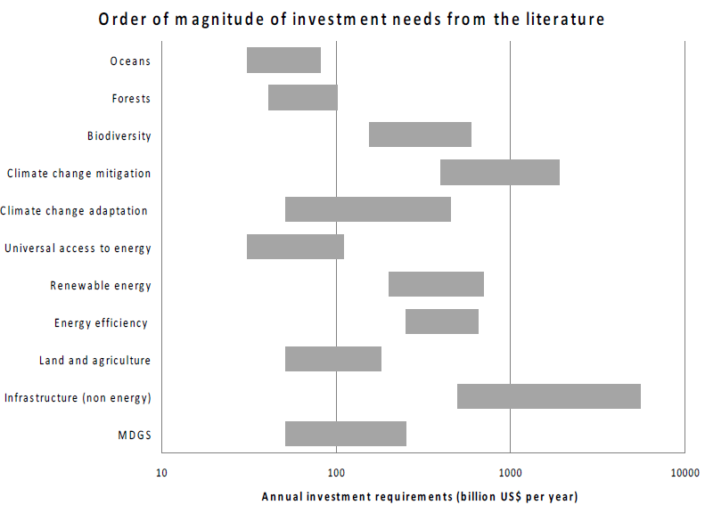

## B.Blended finance

1. According to the Blended Finance Taskforce of the Business & Sustainable Development Commission, the blended finance market doubled in size in the last five years, and it could double again in the next three or four years as providers of concessional and other forms of development capital earmark more money to be used for blending. Currently dominated by the focus on climate change, the enormous institutional investment markets could benefit from the unprecedented opportunity to increase portfolio exposure to biodiversity asset class as biodiversity equity and debt funds tend to provide portfolio diversification benefits, stronger long-term global returns, and lower default rates and better downside protection provided through blended finance. It is projected that international development cooperation could ramp up the mobilization ratios of their private sector arms from less than 2:1 to closer to 4:1 (or more) in the coming years.

## C. Green bonds

1. Driven largely by the climate change concerns, the green bond market has grown significantly in the past few years, tripling to about US$ 38 billion from 2008 to 2014, and reached about US$ 161 billion in 2017. 2017 has been marked as ‘the year of the sovereign’ in the green bond market, with inaugural issuances from Poland and France setting a precedent in late 2016 and early 2017, and Fiji and Nigeria becoming the first issuers among developing economies. In the German state of North Rhine Westphalia, 93 per cent of its budget for protection of natural resources was considered eligible for bond financing. Globally, biodiversity conservation received 4 per cent of bond proceeds, and sustainable land use benefited 2 per cent. According to the projections by the Climate Bonds Initiative, global green bond issuance can reach US$ 1 trillion in 2020.

## D. New funds

1. In response to growing demands, new funds have been recently established in the desertification and climate change contexts. In order to support sustainable land use, the Land Degradation Neutrality Fund, with the target size of US$ 300 million, was launched in 2017 at the thirteenth session of the Conference of the Parties of the United Nations Convention to Combat Desertification. In the climate change context, the Green Climate Fund, initiated by the fifteenth meeting of the Conference of the Parties to the United Nations Framework Convention on Climate Change (UNFCCC) in Copenhagen, and established by the sixteenth session of the UNFCCC Conference of the Parties in Cancun, Mexico, has attracted pledges of over US$ 10 billion, adding to the already considerable landscape of multilateral climate funds.[6] Meanwhile, the ratio of GEF biodiversity focal area allocations to official development assistance marked for biodiversity, as shown in the following graph, declined considerably in the past two decades, from nearly 10 per cent in the early 2000s to under 4 per cent in recent years.[7]

## E. Bilateral and multilateral financing

1. According to the 2018 report of the Inter-agency Task Force on Financing for Development, official development assistance provided by members of the Organisation for Economic Cooperation and Development (OECD) Development Assistance Committee (DAC) amounted to US$ 145.7 billion in 2016, while annual disbursements of non-grant subsidized finance from the seven multilateral development banks reached US$ 65.8 billion, with two new multilateral institutions founded to provide additional financing. The following diagrams demonstrate the increasing trend of bilateral and multilateral financing since the beginning of this century.

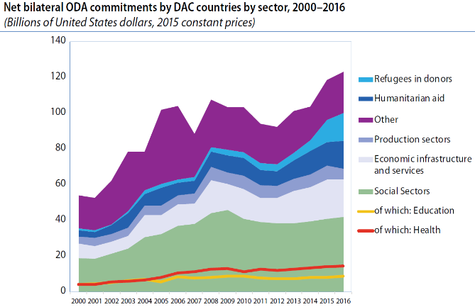 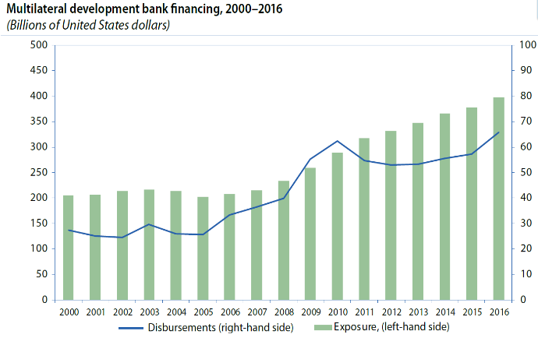

## F. New development partners

1. Estimates from the United Nations Department of Economic and Social Affairs suggest the financial component of South-South development cooperation, by considering official concessional resources (concessional loans and grants, debt relief and technical cooperation) provided by developing countries for development purposes, may have grown to reach US$ 26 billion in 2015. As shown below, southern partners’ non-core external contributions to the United Nations operational activities considerably more than doubled over 2010-2016.

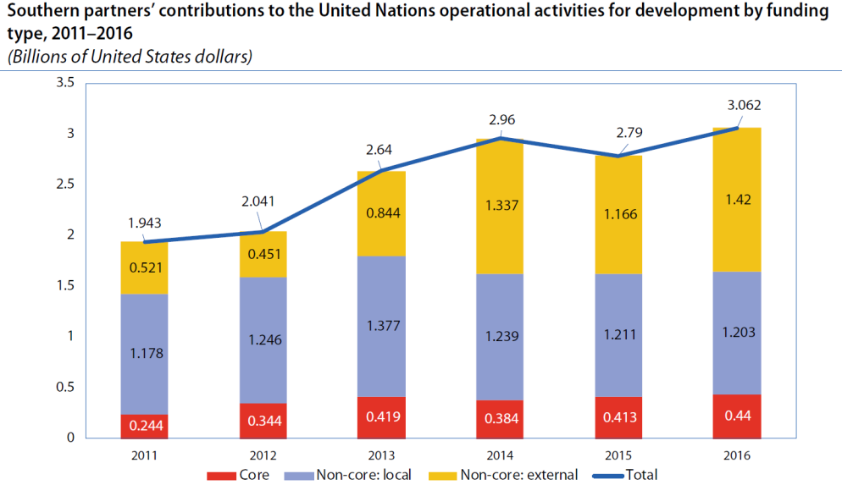

## F. Philanthropy

1. With rising wealth over the last 15 years, philanthropic giving and the number of foundations contributing to development have been rising around the world. Philanthropic flows from donor countries to developing countries have increased to US$ 64 billion.[8] Philanthropic foundations based in developing countries operate to a large extent domestically. Domestic philanthropic flows represent 83 per cent in Turkey, 60 per cent in Mexico and 35 per cent in China. Chinese foundations have increased from fewer than 200 in 2012 to 5,454 in 2016, and the top 75 Chinese foundations reported total expenditures of US$ 2.8 billion.

## G. Conclusion

1. The current arrangement for implementing Article 21 on financial mechanism of the Convention has been instrumental in financing the incremental costs of implementing the Convention by developing country Parties and Parties with economies in transition in the past 25 years. While GEF will likely continue to evolve in its approaches, the post-2020 implementation of Article 21 of the Convention needs to take these other developments into account in order to secure funding needed for the full implementation of the Convention. Meanwhile the post-2020 implementation of Article 21 of the Convention needs to further adapt to the broad global socioeconomic and financial context and align with the funding needs and opportunities arising out of the overall post-2020 implementation framework for the Convention and its Protocols.

# VI. SUGGESTED RECOMMENDATIONS

1. In the light of the above information, the Subsidiary Body on Implementation may wish to consider adopting a recommendation along the following lines:

*The Subsidiary Body on Implementation,*

*Noting with appreciation* the preliminary report of the Global Environment Facility,[9] as well as the sixth overall performance study of the Independent Evaluation Office of the Global Environment Facility,[10]

*Taking note* ofthe information regarding the implementation of Article 21 of the Convention contained in the note by the Executive Secretary on the financial mechanism,[11]

*Recommends* that the Conference of the Parties at its fourteenth meeting adopt a decision along the following lines:

*The Conference of the Parties*

1. *Welcomes* the successful conclusion of the seventh replenishment of the Global Environment Facility Trust Fund, and *expresses its appreciation* for the continuing financial support from Parties and Governments for carrying out the tasks under the global Strategic Plan for Biodiversity 2011-2020 in its remaining years, and supporting the implementation of the post-2020 global biodiversity framework in its first two years;

2. *Notes* that the biodiversity programming directions for the seventh replenishment of the Trust Fund reflect the guidance adopted by the Conference of the Parties at its thirteenth meeting, which includes the consolidated guidance to the financial mechanism and the four-year framework of programme priorities (2018-2022), as well as further guidance;

3. *Encourages* the Executive Secretary to work closely with and the Global Environment Facility Partnership in the transition to the post-2020 global biodiversity framework.

__________

1. CBD/SBI/2/INF/25.
2. UNEP/CBD/COP/13/12/Add.2.
3. CBD/SBI/2/8/Add.1.
4. United Nations, *Treaty Series*, Registration No. I-54113.
5. <https://www.cbd.int/doc/meetings/cop/cop-11/information/cop-11-inf-20-en.pdf>
6. See the data dashboard of Climate Funds Update (March 2018), at <https://climatefundsupdate.org/the-funds/>
7. The data regarding official development assistance is taken from: <http://stats.oecd.org/viewhtml.aspx?datasetcode=RIOMARKERS&lang=en>, and the GEF data is from various replenishment summary documents.
8. Hudson Institute (2017). *The Index of Global Philanthropy and Remittances 2016*, Center for Global Prosperity, available at: [www.hudson.org/cgp](http://www.hudson.org/cgp).
9. CBD/SBI/2/8/Add.1.
10. CBD/SBI/2/INF/25.
11. CBD/SBI/2/8.