 |  |  | CBD
 |  |  |  | Distr.  GENERAL  CBD/SOI/WS/2018/2/2  5 January 2018  ENGLISH ONLY
Sustainable ocean initiative SUBregional Capacity-Bulding Workshop for the CORAL TRIANGLE
Jakarta, 31 July - 3 August 2018

REPORT OF THE SUSTAINABLE OCEAN INITIATIVE SUBREGIONAL CAPACITY-BUILDING WORKSHOP FOR THE CORAL TRIANGLE

INTRODUCTION
- The Conference of the Parties to the Convention on Biological Diversity, at its tenth meeting, adopted the Strategic Plan for Biodiversity 2011-2020, with its Aichi Biodiversity Targets (decision X/2). The mission of the Strategic Plan is to take effective and urgent action to halt the loss of biodiversity in order to ensure that, by 2020, ecosystems are resilient and continue to provide essential services, thereby securing the planet’s variety of life, and contributing to human well-being and poverty eradication.
- The Conference of the Parties at its tenth meeting urged Parties and other Governments: (a) to achieve long-term conservation, management and sustainable use of marine resources and coastal habitats; (b) to establish and effectively manage marine protected areas, in order to safeguard marine and coastal biodiversity, marine ecosystem services, and sustainable livelihoods; and (c) to adapt to climate change, through appropriate application of the precautionary approach and the use of integrated marine and coastal area management, marine spatial planning, impact assessment, and other available tools. The Conference of the Parties at its tenth meeting emphasized the need for training and capacity-building for developing country Parties through regional workshops that contribute to sharing experiences and knowledge related to the conservation and sustainable use of marine and coastal biodiversity.
- Recognizing this urgent need, the Sustainable Ocean Initiative (SOI) came into existence in the margins of the tenth meeting of the Conference of the Parties, with the support of Japan, and in collaboration with various partners that were willing to provide the necessary expertise, technical and financial resources.
4. SOI focuses on achieving a balance between conservation and sustainable use of marine and coastal biodiversity by applying an action-oriented, holistic and integrated capacity-building framework. SOI is committed to building bridges between biodiversity conservation and resource management sectors. SOI has evolved as a global platform to build partnerships and enhance capacity to achieve the Aichi Biodiversity Targets in marine and coastal areas by:
- Achieving a balance between conservation and sustainable use and the promotion of flexible and diverse approaches;
- Identifying best practices, facilitating information sharing, and learning from experiences;
- Creating partnerships that can provide for targeted capacity-building, training, technical assistance and learning exchange;
- Providing for two-way communication among policymakers, scientific communities and local stakeholders;
- Facilitating monitoring of progress towards achieving the Aichi Biodiversity Targets on marine and coastal biodiversity;
- Facilitating the provision of guidance and guidelines that will help their achievement; and
- Improving the scientific basis for implementation.
5. Building on the experiences described above, the Executive Secretary convened the Sustainable Ocean Initiative Subregional Capacity-Building Workshop for the Coral Triangle, with financial support from the Government of Japan, through the Japan Biodiversity Fund, and the Government of Sweden. The workshop was hosted by the Government of Indonesia in Jakarta, from 31 July to 3 August 2018, and was organized in collaboration with the Government of Indonesia and various other partners, including the the Coral Triangle Initiative on Coral Reefs, Fisheries, and Food Security, the UNEP Coordinating Body on the Seas of East Asia, the ASEAN Centre for Biodiversity, the Partnership in Environmental Management for the Seas of East Asia, the Intergovernmental Oceanographic Commission and the Commonwealth Scientific and Industrial Research of Australia, and other relevant regional and international organizations and initiatives.
6. The workshop aimed to identify tools and approaches to support cross-sectoral management of various pressures on coral reefs and associated ecosystems, in the context of the Priority Actions mentioned above, as well as national, regional and global goals and initiatives. The workshop focussed on: (a) facilitating dialogue and information-sharing with regards to conservation and sustainable use of these ecosystems; (b) assessing the status of implementation of the Priority Actions and gaps in implementation; (c) identifying common challenges/barriers as well as approaches that have been successful in addressing challenges; (d) identifying tools to support cross-sectoral approaches to managing pressures on coral reefs and associated ecosystems; and (e) identifying concrete steps/actions to enhance collaboration across sectors to implement the Priority Actions, in support of the achievement of national, regional and global goals and priorities.
7. Participants in the workshop mainly comprised officials, experts and managers in different sectors and areas of work relevant to coral reefs and associated ecosystems from countries in the Coral Triangle region, as well as from relevant global and regional organizations.
8. The emphasis of the workshop was on exchange of information and experiences, active learning of skills and tools, and building regional-level networking and partnerships for information sharing and capacity-building to facilitate progress towards the achievement of the Aichi Biodiversity Targets in marine and coastal areas, particularly of Target 10 on coral reefs. The workshop was organized in plenary and breakout group sessions and included presentations with question-and-answer sessions, interactive group exercises, discussions in breakout groups, and participatory forums. The Secretariat, in consultation with collaborating organizations, nominated workshop co-chairs, facilitators and rapporteurs for both plenary and breakout groups, based on the expertise and experience of the workshop participants.
9. The workshop was co-chaired by Mr. Sugeng Harmono, Deputy Director of Biodiversity in the Ministry Coordinator for Maritime of Indonesia and Ms. Rosalie Masu, Deputy Director of the Inshore Fisheries Division of the Ministry of Fisheries and Marine Resources of Solomon Islands.
10. The workshop was attended by participants from Indonesia, Malaysia, Papua New Guinea, Philippines, Solomon Islands, Timor-Leste, UNESCO/Intergovermental Oceanographic Commission (OIC) OBIS, ASEAN Centre for Biodiversity, UNEP/Coordinating Body on the Seas of East Asia (COBSEA), Coral Triangle Initiative on Coral Reefs, Fisheries and Food Security (CTI-CFF), the Partnership in Environmental Management for the Seas of East Asia (PEMSEA), Commonwealth Scientific and Industrial Research Organizastion (CSIRO) of Australia, WWF Indonesia, Global Youth Biodiversity Network, O le Siosiomaga Society Inc., International Alliance of Indigenous and Tribal Peoples of the Tropical Forest (IAITPTF) and the Network of Indigenous Peoples – Solomon Islands. The full list of participants is provided in annex II.

ITEM 1. OPENING OF THE workshop
11. Ms. Indra Exploitasia, Director for Biodiversity Conservation in the Ministry of Environment and Forestry of Indonesia delivered opening remarks on behalf of the government of Indonesia. She welcomed all the participants and expressed her thanks to the Secretariat of the Convention on Biological Diversity for organizing this important subregional workshop in her country. She also thanked the Coral Triangle Initiative on Coral Reefs, Fisheries and Food Security as well as many other regional collaborating organizations for their cooperation. She expressed appreciation to the Governments of Japan and Sweden for providing financial resources for organizing the workshop. She highlighted the firm commitments of her government to achieve the Aichi Biodiversity Targets and Sustainable Development Goals, and especially Aichi Target 10 for coral reefs and closely associated ecosysems, and hoped that this workshop would excel countries’ capacities to identify tools and approaches to support cross-sectoral management of various pressures on coral reefs and associated ecosystems. She emphasized that Indonesia established a coral transplantation programme not only for commercial purposes but also for restocking to the wild to rehabilitate the coral reef ecosystem. Regulation on coral transplantation audit had been enacted and implemented to ensure its continuous performance, provide quality assurance and to ensure sustainable coral habitat.
12. Ms. Jihyun Lee delivered opening remarks on behalf of the Executive Secretary of the Convention on Biological Diversity, Dr. Cristiana Paşca Palmer. She offered sincere thanks to the Government of Indonesia for hosting this workshop. She also thanked the Coral Triangle Initiative on Coral Reefs, Fisheries and Food Security, PEMSEA, COBSEA and many other collaborators for providing valuable technical inputs to the workshop. She also acknowledged, with great appreciation, the financial contribution of the Government of Japan, through the Japan Biodiversity Fund, and the Government of Sweden, which supported the organization of the workshop. She noted that the Coral Triangle was one of the crown jewels of the global marine ecosystem. Covering 5.7 million square kilometers, it has 76% of all known coral species in the world, whole covering only 1.6% of the ocean. One third of the people in the region depended on marine ecosystem services and products for their livelihoods. She stated that providing ways for the region to develop sustainably and supporting its growing population, while conserving, restoring and maintaining healthy ecosystems was a major challenge. She also stated that in response to these troubling trends, the Conference of the Parties to the CBD adopted the Priority Actions to Achieve Aichi Biodiversity Target 10 for Coral Reefs and Closely Associated Ecosystems. These Priority Actions emphasized the importance of measures to mitigate pressures on coral reefs across sectors, and utilized cross-sectoral planning and management approaches to ensure that the range of uses, pressures and services related to coral reef ecosystems were accounted for in development, planning and management. The Priority Actions also addressed coral reef ecosystems as socio-ecological systems, in which measures had to be taken not only to conserve these sensitive ecosystems, but to also ensure sustainable livelihoods of reef-dependent coastal communities, including indigenous peoples and local communities.
13. Ms. Nora Ibrahim, Executive Director of the Coral Triangle Initiative on Cioral Reefs, Fisheries and Food Security (CTI-CFF), delivered an opening statement. She expressed appreciation to the Government of Indonesia for hosting the workshop. She mentioned that Aichi Biodiversity Target 10 and its Priority Actions were very similar to the activities of the CTI-CFF member countries in working together to sustain the extraordinary coastal and marine resources in the Coral Triangle by addressing crucial issues such as food security, climate change and marine biodiversity. The current CTI-CFF Regional Plan of Action (RPOA) with its Goals of Seascape, Ecosystem Approach to Fisheries Management (EAFM), marine protected areas (MPA), Climate change adaptation (CCA) and Threatened Species reflected the Priority Actions of Aichi Targets 10 and as well as actions needed to achieve Aichi Target 11 and a number of other Targets. She noted that the RPOA and national plans of actions (NPOAs) were currently undergoing a review process to better reflect new needs and cross cutting themes, and this workshop could provide useful inputs and insights for this review process.

ITEM 2. Workshop background, objectives, scope and expected outcomes
14. Ms. Jihyun Lee (CBD Secretariat) briefed the participants on the workshop objectives, scope and expected outputs/outcomes. She also informed the participants of the meeting documents as well as background information documents made available for the workshop, as made available on the CBD meeting website (https://www.cbd.int/meetings/SOI-WS-2018-02).
15. Mr. Joseph Appiott (CBD Secretariat) provided a presentation on the global context for the workshop, discussing the Aichi Biodiversity Targets, the Sustainable Development Goals as well as other relevant global processes, and highlighted the interlinakges among these processes as well as the role of implementation, reporting and monitoring.
16. Ms. Nora Ibrahim (CTI-CFF) provided an overview of the regional priorities under the Coral Triangle Initiative. She mentioned that the work of CTI-CFF contributed to the achievement of, inter alia, Aichi Biodiversity Target 10 and the Priority Actions, in particular with regard to sustainably managed fisheries for coral reefs and closely associated, land-based and sea-based sources of pollution, increased spatial coverage and effectiveness of marine and coastal protected areas in coral reefs and closely associated ecosystems, management of coastal development, improved reef-based socio-ecological systems, integrated watershed and marine management, capacity-building, and sustainable financing. Climate change was a major issue that needed more emphasis together with the issue of sustainable financing to ensure food security and sustainable livelihoods while conserving the marine biodiversity in the Coral Triangle region. It was hoped that there would be further collaboration between CBD and CTI CFF, inter alia, on sustainable financing, food security and livelihoods, getting international recognition of the Coral Triangle as the core of global marine biodiversity with selected sites listed as marine World Heritage Sites, PSSA, etc and the sharing of information on our respective portals. Participants from CTI-CFF also produced a description of the regional context for the Coral Triangle and relevance of the workshop for processes under the Coral Triangle Initiative for Coral Reefs, Fisheries and Food Security. This is provided in annex III.
17. Summaries of the above presentations are provided in annex IV.
18. Following the presentations, there were self-introductions and a group discussions on the participants’ needs and expectations from the workshop. Participants were asked to provide 1-2 key words each regarding their expectations of the workshop. The results of this exercise were synthesized in a “word cloud,” which is provided in annex V.

ITEM 3. Review of the progress in the national implementation of the priority actions to achieve Aichi Biodiversity Target 10 for coral reefs and closely associated ecosystems, including identification of challenges and opportunities.
19. Under this agenda item, participants from each country, from indigenous peoples and local communities and from relevant organizations in the region were invited to share their experiences in the implementation of the Strategic Plan for Biodiversity 2011-2020 and on achieving Aichi Biodiversity Targets in marine and coastal areas. Participants from countries were asked to present their experiences on either (a) their national CTI plans or (b) their efforts in line with Target 10 Priority Actions or both. In these presentations, they were asked to address the following:
- What are the objectives?
- What are policy, legal, institutional and financial mechanisms that have supported national implementation?
- What is the status of national implementation? Have national plans/policies been implemented at the local level through on-the-ground projects/programmes?
- What outcomes are expected and have been achieved so far?
- What are the main challenges/gaps?
20. Following these presentations, the participants were split into breakout groups to identify the main challenges to implementation of CTI national plans and/or Target 10 Priority Actions.
21. Next, participants from regional organizations were asked to give presentations on major regional goals/targets and progress towards them, and activities to support implementation, especially cross-sectoral approaches. There were presentations from the CTI-CFF Secretariat, the UNEP Coordinating Body on the Seas of East Asia (COBSEA), the Partnerships in Environmental Management for the Seas of East Asia (PEMSEA), the ASEAN Center for Biodiversity and WWF-Indonesia.
22. Mr.Simon Harding (Secretariat resource person) provided a presentation of the preliminary results and key themes of an analysis of the status of implementation of Target 10 Priority Actions in the Coral Triangle.
23. Next, participants from each country, with the support of other participants, were asked to conduct a SWOT (‘Strengths, Weaknesses, Opportunities, Threats’) analysis of implementation, identifying specific gaps and needs for implementation nalysis of national implementation, with a focus on either (a) the country’s national CTI plan or (b) other national plan(s). The results of this exercise are provided in annex VI.

ITEM 4. Sector-based and cross-sectoral tools and approaches to reduce the impacts of multiple stressors and enhance resilience of coral reefs and associated ecosystems
24. Under this agenda item, a series of presentations were provided on the different sector-based and cross-sectoral tools and approaches to reduce the impacts of multiple stressors and enhance resilience of coral reefs and associated ecosystems, as follows:
- Presentation on sectoral and cross-sectoral tools and approaches in the Target 10 Priority Actions by Jihyun Lee (CBD Secretariat);
- Presentation on ecosystem approach to fisheries by Gregory Bennet (CTI-CFF);
- Presentation on addressing land-based sources of pollution by Jerker Tamelander (COBSEA/UNEP);
- Presentation on marine spatial planning by Joe Appiott (CBD Secretariat).
25. Then, workshop participants were split into breakout groups and were asked to select one or more of the following tools approaches (a) fisheries management, (b) land-based and sea-based sources of pollution or (c) area-based management tools, including marine protected areas, and identify 3 main challenges and 3 main successful approaches in context of management of coral reefs and/or associated ecosystems.

ITEM 5. Means to enhance the enabling factors to support implementation, including education, awareness and communication, research and monitoring, use of traditional knowledge, information-sharing, stakeholder engagement, and engaging indigenous peoples and local communities
26. Under this agenda item, participants were split into breakout groups and, referring to successful approaches identified in previous breakout session, were asked to identify ways to enable the successful approaches. Groups could also use the strengths and opportunities identified in previous SWOT analysis.
27. Next, participants undertook a simulation exercise, using a hypothetical scenario, in which competing uses and conservation priorities for a given coastal area had to be reconciled using cross-sectoral collaboration and trade-offs among different stakeholders for marine spatial planning. The exercise approach and results are presented in annex VII.

ITEM 6. Identification of ways and means, including roles and responsibilities of different sectors and stakeholder groups, to further enhance national implementation of the priority actions to achieve Aichi Biodiversity Target 10 in line with existing national/regional strategies and plans
27. Under this agenda item, participants were asked, working at the national level, to pick a specific existing plan/policy from their country, such as a national CTI plan and develop a plan to improve implementation of this plan. These plans were asked to address the following:
- Elements of the existing national plan;
- Actions to improve implementation
- Existing strengths, assets and tools;
- Planning and management tools and approaches; and
- Actors that are/will be involved (including indigenous peoples and local communities)
28. Participants from governments were invited to seek input and support from the workshop resource speakers and from the participants from global and regional organizations.
29. These implementation strategies were then presented to the workshop plenary for feedback from the resource speakers and workshop participants. Participants were given a period of two weeks to revise their implementation plans, on the basis of input received during the plenary session.
30. These implementation plans are presented in annex VIII.

ITEM 7. Conclusion AND CLOSURE OF THE WORKSHOP
31. Under this agenda item, participants discussed opportunities for future collaboration, including in the context of SOI activities, building on the workshop discussions and outputs.
32. Brief closing statements were given by the workshop co-chairs and Ms. Jihyun Lee (CBD Secretariat).
33. The workshop closed at 4 p.m. on Friday, 3 August 2018.

Annex I

WORKSHOP PROGRAMME
Tuesday, July 31 2018 (Day 1)
Time | Workshop activities
9 to 9.30 a.m. | Agenda item 1. Opening of the workshop  Opening remarks  - Ms. Indra Exploitasia, Director for Biodiversity Conservation, Directorate-General for Biodiversity Conservation and Ecosystem, Ministry of Environment and Forestry  - Ms. Jihyun Lee on behalf of the Executive Secretary of the Convention on Biological Diversity  - Ms. Nora Ibrahim, Executive Director, Coral Triangle Initiative on Coral Reefs, Fisheries, and Food Security (CTI-CFF)  Group photo
9.30 to 10.10 a.m. | Agenda item 2. Workshop background, objectives, scope and expected outcomes  Background, objectives, expected outputs/outcomes of the workshop  - Presentation by Jihyun Lee, CBD Secretariat (10 min)  Global context—Aichi Targets and SDGs  - Presentation by Joe Appiott, CBD Secretariat (10 min)  Regional context: Regional priorities under the Coral Triangle Initiative  - Presentation by Nora Ibrahim, CTI-CFF (10 min)  Group discussion  Each group given 10 minutes for introductions and discussion on the following:  - What do you hope to achieve/learn this week?
10.10 a.m. to 10.30 a.m. | Coffee/tea break
10.30 a.m. to 12 p.m. | Agenda item 3. Review of progress in national implementation  3.1 Sharing national experiences  Participants from each country will jointly provide one presentation on either (i) their national CTI plans or (ii) their efforts in line with Target 10 Priority Actions or both. The presentations should address the following:  - What are the objectives?  - What are policy, legal, institutional and financial mechanisms that have supported national implementation?  - What is the status of national implementation? Have national plans/policies been implemented at the local level through on-the-ground projects/programmes?  - What outcomes are expected and have been achieved so far?  - What are the main challenges/gaps?  - Indonesia  - Malaysia  - Papua New Guinea  - Philippines  - Solomon Islands  - Timor-Leste  - Joint presentation on experiences of indigenous peoples and local communities
12 to 1 p.m. | Breakout group discussion (40 minutes)  Breakout groups discuss the main challenges to implementation of CTI national plans and/or Target 10 Priority Actions  Reporting back (20 minutes—3 minutes per table)
1 to 2 p.m. | Lunch
2 to 6 p.m. | Field trip –Shipwreck museum
7 to 9 p.m. | Reception hosted by the Government of Indonesia  By hotel pool

Wednesday, 1 August 2018 (Day 2)

Time | Workshop activities
9 to 10 a.m. | 3.2 Sharing regional experiences  Presentations from global/regional organizations/initiatives focusing on:  - Major regional goals/targets and progress towards them  - Activities to support implementation, especially cross-sectoral approaches  8 minutes each  - CTI-CFF Secretariat  - UNEP Coordinating Body on the Seas of East Asia (COBSEA)  - Partnerships in Environmental Management for the Seas of East Asia (PEMSEA)  - ASEAN Center for Biodiversity  - WWF-Indonesia  Q & A and plenary discussion
10 to 10:30 a.m. | 3.3 Status and experiences in the implementation of global, regional and national plans  - Preliminary results of analysis of status of implementation of Target 10 Priority Actions and key themes (15 min)  By Simon Harding (Secretariat resource person)  Q & A and plenary discussion
10:30 to 11 a.m. | Coffee/tea break
11a.m. to 12:30 p.m. | Breakout group discussion: SWOT Analysis of national implementation  On the basis of either (i) national CTI plan or (ii) other national plan(s), participants from each country will conduct a rapid SWOT (‘Strengths, Weaknesses, Opportunities, Threats’) analysis of implementation, in particular identifying specific gaps and needs for implementation
12.30 to 1.30 p.m. | Lunch
1.30 to 3 p.m. | Agenda item 4. Sector-based and cross-sectoral tools and approaches to reduce the impacts of multiple stressors and enhance resilience of coral reefs and associated ecosystems  Overview of sectoral and cross-sectoral tools and approaches in the Target 10 Priority Actions  - Theme presentation by Jihyun Lee (CBD Secretariat) (8 min)  - Presentation on ecosystem approach to fisheries (8 min)  By Gregory Bennet (CTI-CFF)  - Presentation on addressing land-based sources of pollution (8 min)  By Jerker Tamelander (COBSEA/UNEP)  - Presentation on marine spatial planning (8 min)  By Joe Appiott (CBD Secretariat)  Breakout group discussion (45 min)  Each group selects one or more of the following tools approaches (i) fisheries management, (ii) land-based and sea-based sources of pollution or (iii) area-based management tools, including marine protected areas, and identifies 3 main challenges and 3 main successful approaches in context of management of coral reefs and/or associated ecosystems
3 to 3.30 p.m. | Coffee/tea break
3.30 to 5 p.m. | Agenda item 5. Means to enhance the enabling factors to support implementation, including education, awareness and communication, research and monitoring, use of traditional knowledge, information-sharing, stakeholder engagement, and engaging indigenous peoples and local communities  Breakout group discussion –Means to enable successful approaches  Referring to successful approaches identified in previous breakout session, each group identifies ways to enable the successful approaches. Each group can use strengths and opportunities identified in previous SWOT analysis

Thursday, 2 August 2018 (Day 3)

Time | Workshop activities
9 a.m. to 12.30 p.m.  Coffee/tea provided | SIMULATION EXERCISE  Cross-sectoral, multi-stakeholder coordination for multi-sectoral planning.
12.30 to 1.30 p.m. | Lunch
2 to 5.30 p.m.  Coffee/tea provided | Agenda item 6. Developing implementation plans  - Building on previous workshop discussion, each country will outline next steps for ways to enhance implementation to address gaps, including potential sources of support and use of existing resources and strengths

Friday, 3 August 2018 (Day 4)
Time | Workshop activities
9 a.m. to 12.30 p.m.  Coffee/tea provided | Agenda item 6 (continued)  Developing implementation plans (continued)  Global partnership meeting held with global/regional organizations while countries work on implementation plans  - Launching of the CBD Global Coral Portal and opportunities to link your respective work on the portal  - Alignments and complementarities between the Target 10 Priority Actions and other important workplans, action plans, etc. at various scales  - Information that can contribute to the assessment of Aichi Target 10 for the forthcoming 5th Global Biodiversity Outlook  - Forthcoming discussions on the CBD post-2020 biodiversity framework and how coral reef issues may factor in  - Potential ways to highlight coral reef issues at CBD COP 14
12.30 to 1.30 p.m. | Lunch
1.30 to 3 p.m. | Agenda item 6 (continued)  Presentation of implementation plans
3 to 4 p.m. | Agenda item 7. Conclusion, next steps and closure of the workshop  - Key conclusions  - Future collaboration  - Evaluation of the workshop
Annex II

LIST OF PARTICIPANTS
PARTIES

Indonesia
- Mr. Amehr Hakim
Deputy Director for Arrangement on Conservation Area
Ministry of Marine Affairs and Fisheries
Email: mehrhakim_77@yahoo.com.id

- Ms. Nurul Dhewani Mirah Sjafrie
Reseancher
Research Center for Oceanography
Indonesian Institute of Sciences
E-mail: ndhewani@yahoo.com

- Ms. Sasanti Retno Suharti
Researcher
Research Center for Oceanography
Indonesian Institute of Sciences
E-mail: santi_rs02@yahoo.com

Malaysia
- Mr. Mohd Fazli Bin Long
State Director
Department of Marine Park of Pahang State
Ministry of Water, Land and Natural Resources
Email: mohdfazli@nre.gov.my

- Ms. Maznah Binti Yusoff
State Director
Kedah Marine Park
Ministry of Water, Land and Natural Resources
Email: maznahyusoff@nre.gov.my

- Mr. Dzulhaili bin Dzulkarnain
Assistant Secretary
Biodiversity and Forestry Management Division
Ministry of Water, Land and Natural Resources
E-mail: dzulhaili@kats.gov.my

Papua New Guinea
- Mr. Malcolm Keako
Senior Programme Officer
Sustainable Environment Program
Conservation and Environment Protection Authority
E-mail: mkeako@gmail.com

Philippines
- Ms. Desiree Eve Maaño
Supervising Ecosystems Management Specialist
Coastal and Marine Division
Biodiversity Management Bureau
Department of Environment and Natural Resources
E-mail: desireemaano@gmail.com; desireemaano@14.alumni.u-tokyo.ac.jp

- Ms. Sandra Victoria Arcamo
Chief Fisheries Resource Management Division
Bureau of Fisheries and Aquatic Resources
Department of Agriculture
E-mail: sandyarcamo@yahoo.com srcoralline88@gmail.com

- Ms. Maria Vanessa Baria-Rodriguez
Assistant Professor V
Marine Science Institute
University of the Philippines Diliman
E-mail: vanessa.baria@gmail.com vrodriguez@msi.upd.edu.ph

- Ms. Marlene Francia
Development Management Officer IV
Department of Environment and Natural Resources V
Cooperation and Development Division
E-mail: cdddenr5@yahoo.com marlene_francia@gmail.com

Solomon Islands
- Ms. Agnetha Zima Vave-Karamui
Chief Conservation Officer
Environment and Conservation Division
Ministry of Environment, Climate Change, Disaster Management & Meteorology
E-mail: AVave-Karamui@mecm.gov.sb; Agnetha.vavekaramui@gmail.com

- Ms. Rachel Kosalu Bare-Anita
Senior Marine Officer
Solomon Islands Maritime Safety Administration (SIMSA)
E-mail: RAnita@mid.gov.sb; raynrey@gmail.com

- Ms. Rosalie Masu
Deputy Director
Inshore Fisheries Division
Ministry of Fisheries and Marine Resources
E-mail: rmasu@fisheries.gov.sb; rosalie.masu2014@gmail.com

Timor-Leste
- Mr. Horacio Amaral Dos Santos Guterres
Director
National Directorate of Aquaculture
National Coordinating Committee (NCC)
CTI CFF Timor-Leste
Ministry of Agriculture and Fisheries
E-mail: falcaonapoleao@gmail.com

- Mr. Domingos Mesquita
Coordinating Marine Protected Areas –CTI
National Directorate of Climate Change
Secretary of State for Environment
E-mail: domingosmesquita78@gmail.com

- Mr. Marcal Gusmao
Vice Director of the Centre for Climate Change and Biodiversity
National University of Timor Lorosa’e
E-mail: marcalgusmao@gmail.com

NATIONAL PARTICIPANTS

- Mr. Sugeng Harmono
Deputy Director of Biodiversity
Ministry Coordinator for Maritime
E-mail: sugeng_harmono@yahoo.com

- Ms. Fitty Machmudah
Staff
Directorate Biodiversity Conservation
Ministry of Environment and Forestry
E-mail: fmachmudah@gmail.com

- Ms. Reny Puspasari
Researcher
Ministry of Marine Affairs and Fisheries
E-mail: reny.paksi@gmail.com

- Mr. Gunawan
Staff
Directorate Conservation Area
Ministry of Environment and Forestry
E-mail: subdit.pekk@gmail.com gun.wongalas@gmail.com

- Ms. Rusmiyana
Staff
Essential Ecosystem Management
Ministry of Environment and Forestry
E-mail: rihanna@europemail.com

- Mr. Muhammad Abraar
Researcher
Research Center for Oceanography
Indonesian Institute of Sciences
E-mail: abrarlipi@yahoo.co.id

- Mr. Muschan Ashari
Staff
Ministry of Marine Affairs and Fisheries
E-mail: muschanashari@gmail.com
ORGANIZATIONS

UNESCO/Intergovernmental Oceanographic Commission (OIC) OBIS
25. Mr. Eduardo Klein Salas
Co-Chair of OBIS Steering Group
E-mail: eklein@usb.ve

ASEAN Centre for Biodiversity
26. Ms. Claudia Binondo
Project Development Officer
E-mail: cbbinondo@aseanbiodiversity.org

UNEP Coordinating Body on the Seas of East Asia (COBSEA)
27. Mr. Jerker Tamelander
COBSEA Coordinator
Head of UN Environment Coral Reef Unit
E-mail: tamelander@un.org

Coral Triangle Initiative on Coral Reefs, Fisheries and Food Security
28. Ms. Sharifa Nora Ibrahim
Deputy Executive Director of Program Services (and AED)
CTI-CFF Secretariat
Manado, Indonesia
E-mail: nora@cticff.org

29. Mr. Gregory Bennett
Technical Program Senior Manager
CTI-CFF Regional Office
Manado, Indonesia
E-mail: gpbennett@cticff.org

Partnership in Environmental Management for the Seas of East Asia (PEMSEA)
30. Mr. Jae-Young Lee
Deputy Director of Planning
E-mail: jlee@pemsea.org

Commonwealth Scientific and Industrial Research Organization (CSIRO) of Australia
31. Ms. Donna Hayes
Marine and Atmospheric Research
Commonwealth Science and Industry Research Organization
E-mail: Donna.Hayes@csiro.au

WWF Indonesia
32. Mr. I Wayan Veda Santiadji
Coral Triangle Support Program Leader
Coral Triangle Program
WWF Indonesia
E-mail: vsantiadji@wwf.id; baliwaves@gmail.com

Global Youth Biodiversity Network – Southeast Asia Chapter
33. Mr. Kier Mitchel Pitogo
Country Coordinator
General Santos, Philippines
E-mail: kiermitchel@gmail.com; kepitogo@up.edu.ph

INDIGENOUS PEOPLES AND LOCAL COMMUNITIES
O le Siosiomaga Society Inc. (OLSSI)
34. Mr. Sapa Saifaleupolu
Environmental Consultant
Apia, Samoa
E-mail: s.saifaleupolu@gmail.com

International Alliance of Indigenous and Tribal Peoples of the tropical forest (IAITPTF)
35. Mr. Riko Stefanus
Field Officer
Koperasi Tuns Jaya Communities
Sumatra, Indonesia
E-mail: rskiluan@gmail.com

Network for Indigenous Peoples – Solomons (NIPS)
36. Mr. James Meimana
Legal, Fisheries and Marine Affairs Focal Point
Honiara, Solomon Islands
E-mail: jamesmeimana@gmail.com

SECRETARIAT OF THE CONVENTION ON BIOLOGICAL DIVERSITY
37. Ms. Jihyun Lee
Environmental Affairs Officer
Marine and Coastal Biodiversity
Secretariat of the Convention on Biological Diversity
Montreal, Quebec, Canada
Email: jihyun.lee@cbd.int
38. Mr. Joseph Appiott
Associate Programme Officer
Marine and Coastal Biodiversity
Secretariat of the Convention on Biological Diversity
Montreal, Quebec, Canada
Email: joseph.appiott@cbd.int

39. Mr. Simon Harding
Research Fellow
Institute of Marine Resources
Faculty of Science, Technology & Environment,
The University of the South Pacific, Private Mail Bag,
Laucala Campus, Suva. Fiji.
E-mail: simon.harding@usp.ac.fj
40. Ms. Johany Martinez
Programme Assistant
Marine and Coastal Biodiversity
Secretariat of the Convention on Biological Diversity
Montreal, Quebec, Canada
Email: johany.martinez@cbd.int
Annex III
REGIONAL CONTEXT FOR THE CORAL TRIANGLE AND RELEVANCE OF THE WORKSHOP FOR PROCESSES UNDER THE CORAL TRIANGLE INITIATIVE FOR CORAL REEFS, FISHERIES AND FOOD SECURITY, PARTNERSHIPS IN ENVIRONMENTAL MANAGEMENT FOR THE SEAS OF EAST ASIA (PEMSEA) AND THE ASEAN CENTRE FOR BIODIVERSITY

Background
The Coral Triangle is a geographical term that refers to a roughly triangular area of the tropical marine waters of Indonesia, Malaysia, Papua New Guinea, Philippines, Solomon Islands and Timor-Leste (the ‘CT6’) representing the custodians of the Coral Triangle area. Named for its astounding number of corals, the region nurtures six of the world’s seven marine turtle species and more than 2000 species of reef fish. It is estimated over 130 million people live and rely on its coral reefs for food, income and protection from storms. The Coral Triangle Initiative on Coral Reefs, Fisheries, and Food Security (CTI-CFF) is a multilateral partnership signed in 2009 by these six countries working together to sustain the extraordinary marine and coastal resources by addressing crucial issues such as food security, climate change and marine biodiversity. The initiative recognized the critical need to safeguard the region’s marine and coastal resource as people of the CTI region have had exhibited a high dependence on coral reefs and fisheries for their food and livelihood.

Relevance of the Workshop
The current CTI-CFF Regional Plan of Action (RPOA) with its goals on (i) strengthening the management of seascapes; (ii) promoting an ecosystem approach to fisheries management; (iii) establishing and improving effective management of marine protected areas; (iv) improving coastal community resilience to climate change; (v) and protecting threatened species reflects the Priority Actions of Aichi Targets 10 and 11. It is in this context that, with the support of the Australian Government, USAID, ADB, WCS and CTI-CFF, the RPOA and national plans of actions (NPOAs) of the Coral Triangle countries are currently undergoing a review process to better reflect our new needs and cross-cutting themes. Aichi Target 10 and its Priority Actions are very similar to the past and current activities of the CTI-CFF member countries in working together to sustain the extraordinary coastal and marine resources in the Coral Triangle by addressing crucial issues such as food security, climate change and marine biodiversity.

The work of the CTI CFF has contributed to and will continue towards the achievement of, inter alia, Aichi Biodiversity Targets 10 and 11 and the Priority Actions. Particularly on Sustainably managed fisheries for coral reefs and closely associated ecosystems (e.g., e-CDT, EAFM, Blue Carbon, etc), land-based and sea-based sources of pollution (wastes treatment, marine debris, shipping) , increased spatial coverage and effectiveness of marine and coastal protected areas (e.g., MPAs, CTMPAs, Seascapes ) in coral reefs and closely associated ecosystems, management of coastal development, improved reef-based socio-ecological systems within local context (e.g., CBNRM, CoastFish, etc,), integrated watershed and marine management (e.g., ICZM, Ridge to Reef, Seascape), capacity-building, legal and policy aspects, and sustainable financing.

It is important to note that climate change is a major issue that needs more emphasis together with the issue of sustainable financing to ensure food security and sustainable livelihoods, while conserving marine biodiversity in the Coral Triangle region. It is hoped that there will be further collaboration between CBD and CTI-CFF, inter alia, on sustainable financing, food security and livelihoods, and also on gender empowerment (as reflected in SDG 5), and improving international recognition of the Coral Triangle as a core of global marine biodiversity.

The Coral Triangle countries are committed to continued action, but nonetheless require support from the international community to affect real change. With the current RPOA review process, the CTI would improve its priority regional actions in terms of national, regional and international context. This is very timely as regional organizations receive more emphasis for the impetus for future global change.

It is paramount that working collaboratively with its Member countries, diverse development partners, non-government organizations and communities, as well as with other regional and global grouping, the CTI-CFF can integrate the efforts in full alignment with the concept and best practices of an ecosystem-based management approach to the conservation and sustainable use of living marine resources.

As the CTI manages a core of the global marine biodiversity, it is committed to provide the enabling environment for better articulation and coordination among marine environment-related national strategies and action plans of its member countries, as well as among the strategies, ocean policies, programmes and action plans of regional and global intergovernmental organizations concerned with sustainable development and climate change. The CTI-CFF looks forward to collaborating with other nations and organisations such as CBD and its Aichi Target 10 and Priority Actions. In the near future, we would also forge stronger partnerships benefitting the communities and coastal areas while sharing with the world its think tank and success impact stories and tools on food security, sustainable livelihoods and ecosystem resilience for coastal systems and communities in the face of climate change.

Annex IV

SUMMARIES OF PRESENTATIONS UNDER AGENDA ITEM 2: WORKSHOP BACKGROUND, OBJECTIVES, SCOPE AND CONTEXT

Context, objectives, approaches and expected outputs/outcomes of the workshop
Jihyun Lee, CBD Secretariat
Ms. Lee delivered a presentation outlining the context of the workshop and its focus on the Priority Actions for Aichi Target 10 for Coral Reefs and Closely Associated Ecosystems. She provided background on the Aichi Targets and highlighted their close interlinkages with the Sustainable Development Goals and in particular SDG 14. She described the CBDs relevant work on marine and coastal biodiversity, including the capacity development activities of the Sustainable Ocean Initiative and the work on facilitating the description of ecologically or biologically significant marine areas (EBSAs). She discussed the focus of this workshop on building on and facilitating regional scale cooperation. She discussed the objectives of the workshop as supporting enhanced national implementation towards achieving the Aichi Targets in marine and coastal areas, in particular by strengthening the scientific, technical and managerial capacity of relevant policymakers, managers and scientists from experts in the region in utilizing marine spatial planning as an approach for enhanced cross-sectoral coordination, planning and management. She noted the focus of the workshop on bringing together diverse expertise and experiences through cross-sectoral and interdisciplinary approaches, sharing knowledge, experiences, and lessons-learned and facilitating technical and financial partnerships at national, subregional, and regional scales.

Global Context: Sustainable Development Goal 14 and the Aichi Biodiversity Targets
Joseph Appiott, CBD Secretariat
Mr. Appiott provided a presentation on the global context for the workshop, in particular with regards to the Aichi Biodiversity Targets and the Sustainable Development Goals. He discussed the key aspect of the Aichi Targets with regards to marine and coastal biodiversity. He noted the focus of the 13th meeting of the Conference of the Parties (COP 13) to the CBD on mainstreaming biodiversity for well-being and the importance of mainstreaming and cross-sectoral approaches to counteract the multiple pressures on marine ecosystems and support marine ecosystems in providing essential services. He highlighted the importance of biodiversity to sustainable development and stressed the close interlinakges between the SDGs and the Aichi Targets. He also noted the various ongoing global intergovernmental processes with relevance to ocean issues. He stressed that global-level commitments reflect the will of governments and that only on-ground implementation will facilitate their achievement. He also stressed that individual targets and global goals cannot be achieved in isolation and that actions to achieve the Aichi Targets will also help to achieve the SDGs, and vice versa.
Regional Context: Regional Priorities under the Coral Triangle Initiative for Coral Reefs, Fisheries and Food Security
Ms. Nora Ibrahim, Coral Triangle Initiative for Coral Reefs, Fisheries and Food Security
Under the CTI-CFF, the six countries signed a declaration to protect the Coral Triangle and committed to implement a Regional Plan of Action (RPOA) with five goals: designation of effectively managed seascapes; application of an ecosystem approach to fisheries management; establishment of a fully functional marine protected area system; strengthening climate change adaptation and resilience; and improving the status of threatened marine species. The six countries then developed their respective CTI-CFF National Plans of Action to adopt the regional goals to their local conditions.

Since the 2009 establishment of the CTI-CFF, the countries of Coral Triangle have been focused on addressing the competing needs of coastal communities and economic growth through sustainable and collaborative approaches to management at large, “seascape” level, transboundary and multi-national scales. Seascapes offer a platform, a geographic area, within which all user groups can cooperate, coordinate and collaborate to manage for sustainable development, biodiversity conservation and human well-being. The CTI-CFF Regional Plan of Action identifies Seascapes as the first Goal: “Priority Seascapes Designated and Effectively Managed.”

The Seascape Working Group (SWG) is one of the five technical programs. To date, the SWG has identified three transnational level seascapes within the CTI region and they are: (i) the Bismarck Solomon Seas Ecoregion (BSSE), (ii) the Lesser Sunda Ecoregion (LSE), and (iii) The Sulu-Sulawesi Marine Ecoregion (SSME). The Coral Triangle region is a perfect example of this interconnectivity at a regional scale.

Annex V

WORD CLOUD BASED ON PARTICIPANTS’ ARTICULATED NEEDS AND EXPECTATIONS FOR THE WORKSHOP

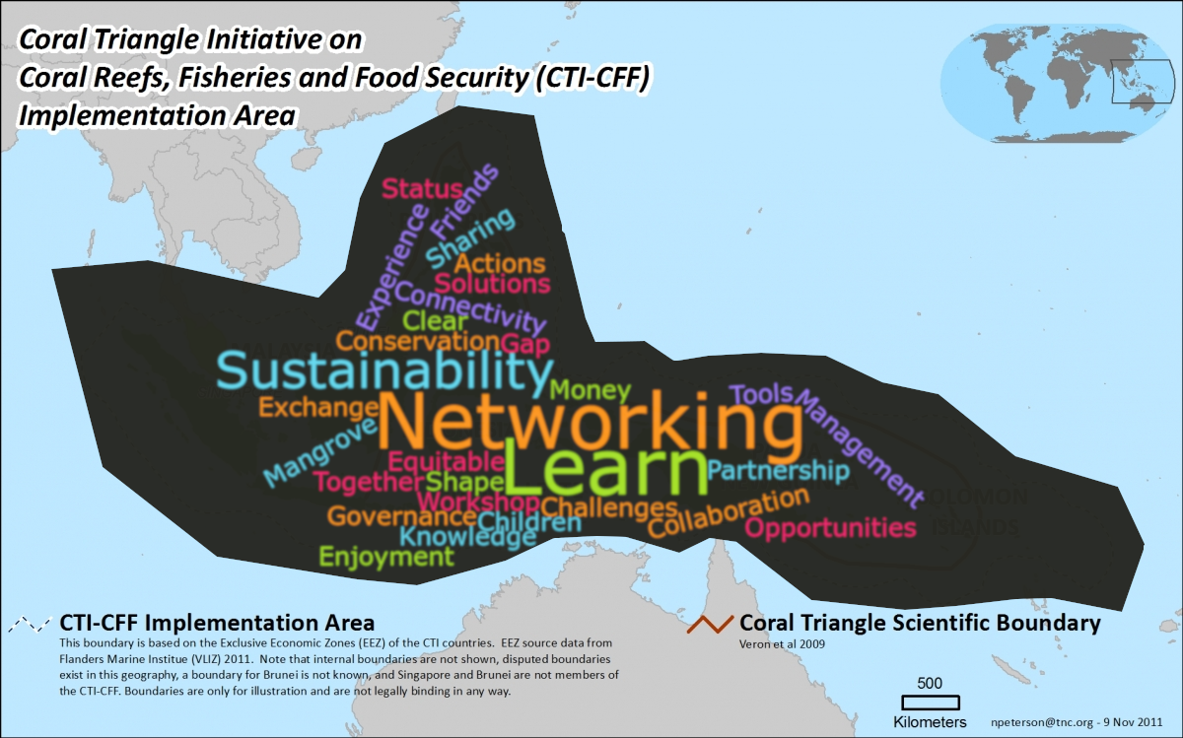

Annex VI
OUTPUTS OF THE SWOT (STRENGTHS, WEAKNESSES, OPPORTUNITIES AND THREATS) ANALYSIS OF NATIONAL PLANS/ACTIVITIES
SWOT Analysis of National Plans/Activities
Country: INDONESIA
Internal factors | Strengths:  - Data base of coral reef, mangrove and seagrass  - Biodiversity mapping (Geospatial Information Agency/BIG)  - National Law/regulation about coastal and small island protection  - A lot of marine experts  - 172 marine protected area (19.27 million ha)  - Guideline for coastal ecosystem assessment and coral rehabilitation  - EAFM guideline and implementation plan  - Fisheries management Area (FMA,11 area)  - Marine curricula for young generation  - Education and campaign  - Local wisdom (traditional knowledge)  - High of biodiversity  - National program for Reduce Green House Gases  - National Action Plan for endangered species  - National Action Plan for Fisheries management | Weaknesses:  - Huge and remote area  - Lack of surveillance and enforcement  - Lack of coordination among stakeholder (government, private sector, community)  - Government commitment for sustainable financial support  - Un integrated regulation  - Limitation on synchronizing and sharing data among different institution or agency  - Low human capacity to implement the program
External factors | Opportunities:  - Funding from private sector (CSR) & partners  - Financial and technical supporting from International and Regional Agency | Threats:  - Anthropogenic stressor (domestic/nutrient and industrial waste/plastic, heavy metals, tourism etc.)  - Natural disaster  - IUU Fishing  - Climate change  - Resource exploitation

SWOT Analysis of National Plans/Activities
Country: MALAYSIA
Internal factors | Strengths:  - Goals cover the whole country and involve the action plans cooperation between government, NGOs, local communities and business operators on the islands.  - The biodiversity resources not in critical level | Weaknesses:  - Lack of funding.  - Lack of manpower in management and administrative in generally.  - Constrain in expertise.  - Legislation Fisheries Act 1985 (need to be revised and the punishment must be specific to the offence).  - Lack of coordination from the relevant agencies, hard to get the cooperation to sit and find the solution from the problem or issue arise.
External factors | Opportunities:  - Generate own funding (impose entries or conservation fees and Cooperation with NGOs  - Create community-based management. Local stakeholders (communities, tourism operators) should be given more of a voice in the management of marine resources, as they are the main beneficiaries of healthy marine ecosystems and have the most to gain from healthy ecosystems. This vested interest will provide an incentive to local stakeholders to minimize impacts from their operations across the board.  - Increase involvement of staffs in related training programme, knowledge sharing between local and international education research center.  - Encourage local communities to involve in eco tourism activity. Instead provides an enormous opportunity to further showcase the tremendous economic, social, cultural, environmental, and heritage, this sector also will increase the social and economy status of local communities.  - Develop the Management Plans which include actions to mitigate local impacts in all Marine Parks  - Integrate State governments into the management of marine resources to ensure that development is managed in such a way that impacts on marine resources from, for example growing tourism, are taken into account and actions taken to minimize impacts.  - Involve cooperation between government, NGOs, local communities and business operators on the islands. This would be a good step forward in getting the different stakeholders and interest groups to work together to reduce local impacts to coral reefs in Malaysia, leading the way to greater local management of reefs. | Threats:  - Coastal development mostly the construction of tourism infrastructure or the renovation of existing infrastructure to help accommodate the growing number of tourists that visit Malaysia’s islands annually.  - Conflict of interest between government agencies and stakeholder  - Climate change, rising of sea temperature that can affect the health of coral reef

SWOT Analysis of National Plans/Activities
Country: PAPUA NEW GUINEA - Ridge to Reef Approach – Planning Tool
Internal factors | Strengths:  - Land to Sea integrated planning  - Facilitates multi – stakeholder participation  - Tool to assist effective decision making  - Empower communities  - Sustainable costal and fisheries management | Weaknesses:  - Lack of coordination among stakeholders  - Lack of data  - Lack of personnel  - Funding constraints  - Access to sites  - Enforcement and monitoring  - Weak legislations
External factors | Opportunities:  - Capacity building  - Resource mobilization  - Effective planning and management  - Seek funding from partners and donors  - Identify alternative livelihood options for communities  - Integrate with other existing plans for effective management  - Strengthen legislations  - Minimize environmental impacts | Threats:  - Conflicting land uses  - Government priorities – activities may not be supported  - Lack of consensus among the different stakeholders  - Development pressures  - Climate Change  - Natural disasters
SWOT Analysis of National Plans/Activities
Country: PHILIPPINES - ☒National CTI plan
Internal factors | Strengths:  - In –country marine ecosystems experts  - The country is a signatory to international policies on marine biodiversity  - National legislations in place to support implementation of the Plan  - Subscription to enabling approaches e.g. precautionary principle, participatory and multi-sectoral, science-based governance | Weaknesses:  - Bureaucracy/politics  - Logistics – strict procurement law, complicated budget and financial cycle  - The Plan is not widely disseminated or mainstreamed to the local level  - Information sharing mechanism
External factors | Opportunities:  - Potency on more engagement with Partners as well as other NGOs and funding institutions  - Track 2 diplomacy or technical discussion within CTI-CFF member states  - Updating of National Marine Policy to address the issues in relation to the conservation an marine resources e.g. defining roles of various actors, need to harmonize where there are overlaps/contradictions  - Monitoring and Evaluation system currently being developed | Threats:  - Change of constitution, form of government  - Emergence of natural catastrophic events  - Peace and order (security concerns in some areas)

SWOT Analysis of National Plans/Activities
Country: SOLOMON ISLANDS - ☒National CTI-CFF plan
Internal factors | Strengths:  - Established inter-agency platform between MFMR and MECDM and includes most national partners – coordination for CTI-CFF related activities, link to regional CTI program. National coordination committee  - CTI-CFF National Plan of Action in place – 10 years in implementation. NPOA in review – lessons learnt  - Focus on Community- based resource management as the primary approach to achieving CTI goals  - NPOA include themes on policy, legislation and strategy development, awareness and education and capacity building to support CBRM implementation.  - Development of CBRM products/tools  - Development of National Ocean Policy – cross-sectoral government platform (Ocean12) | Weaknesses:  - Maintaining NCC member participation/ momentum/interest  - More practioners involvement than government sectors participation (decision-makers v.s practitioners)  - No clear, strategic alignment of the themes to other relevant national, regional and international priorities e.g. SPC, SPREP, NBSAP (CBD);  - Scope of the NPOA limited – e.g. does not capture maritime issues, coastal developments that impacts on CBRM efforts  - Unequal distribution of implementation of activities more focused on the western –side of the country (partners presence, communication, infrastructure, supporting mechanisms, logistic costs)  - Data and information sharing – accessibility. Communication.  - Conflicting priorities between communities v.s national/provincial government programs  - Community engagement – issues of customary tenureship and ownership, Loss of traditional knowledge, governance structures; Limited support for incentives /benefits for communities engaging in resource management  - Political support and leadership  - Weak Enforcement of legislations – logging  - Budget allocation and financing priorities
External factors | Opportunities:  - International and regional (Asia – Pacific) partnerships and programs on coral reefs protection and management; sustainable fisheries management, research and monitoring etc. Expand collaboration and networks  - RPOA in review – Lesson learnt, re-prioritization for emerging issues (maritime, marine litter, blue carbon etc.)  - CTI Partners and networks – Australia, ADB and USAID, Universities | Threats:  - Donor priorities for investment  - Climate change

SWOT Analysis of National Plans/Activities
Country: TIMOR LESTE
Internal factors | Strengths:  - Country is committed to establish/improve MPA  - The country has stablished its legal frameworks including laws and policies, leading institution to CTI plan/activities, CTI stakeholders, marine policy  - National zero plastic programme | Weaknesses:  - Sustainable financial support  - Sectoral coordination  - Human resources: experts including zoning, analysis, management, monitoring and evaluation and (more) data collectors  - Keep changing in government structures  - Law enforcement  - Harmonize project activities of local, national and regional NGOs
External factors | Opportunities:  - NGOs (Roma luan in Atauro MPA, Haburas, Balibo ba oin) initiatives in planting of mangroves  - Cleaning/collecting of the plastics bags every year  - CPLP programmes on marine plastic debris  - Local knowledge transfer use of the local customary law “Tara bandu”  - Exchange site visit for local communities and NGOs  - Networking with academia, CTC, WWF, CTI, etc. | Threats:  - Inland deforestation impact through sedimentation impact  - Conflict interest e.g. no taking zones  - Coordination between sectors, NGOs and private beneficiaries  - Climate change

Annex VII
SUMMARY AND OUTCOMES OF marine spatial planning
SIMULATION EXERCISE
OBJECTIVES
On the basis of the principles described above, this exercise will provide a hands-on opportunity to simulate MSP, in particular elements 4 through 7 described above. In particular, the goals of the exercise are:
- To demonstrate the use of a GIS as a tool for visualizing geographical information in the context of a Marine Spatial Planning process.
- To demonstrate approaches to structuring multi-stakeholder discussions to reconcile different uses and priorities regarding marine resources in a spatial context
- To encourage participants to make justified trade-offs to maximize achievement of priorities of various stakeholders to the greatest extent possible
- To encourage participants to define a set of management actions to support long term conservation and sustainable development of marine biodiversity in the area, in particular taking into account Aichi Biodiversity Targets.
Methodology
The exercise focuses on a hypothetical scenario in the southern Caribbean (figure 1). The exercise was designed with open and free GIS software (http://qgis.org) and all of the data layers are made available for the participants in the form of printed maps and overlay transparencies.

The following data layers were made available for the exercise:
- Base layers: Coastline, urban areas polygon, roads, small populated sites, submarine cables, hydrology, bathymetry, shaded relief of the terrain;
- Oil & Gas industry: Off shore bidding blocks polygons, off-shore production wells, off-shore exploration wells, underwater pipelines, oil refineries;
- Maritime transport: Main shipping routes, anchoring areas, ports, shipping density;
- Fisheries: 2014 fishing boat locations, summary of daily visits by quadrants, density model of fishing boats presence;
- Aquaculture: Areas of aquaculture present and projected projects
- Biodiversity: Declared protected areas polygons, priority areas for conservation of marine biodiversity, OBIS marine biodiversity records, locations and cover of mangrove forests, coastal lagoons, seagrass meadows, rocky shores, turtle feeding areas, marine crocodile habitat, cetaceans habitat, bird nesting and feeding areas, large and small pelagic fish habitat, soft bottom benthic communities, hard bottom benthic communities; and
- Oceanography: Seasonal maps of sea surface temperature and chlorophyll A concentration
- Traditional owners: areas were rights of property has benn given to local populations
- Tourism: Tourism developing areas
- Wind and Wave farms: Areas of present and projected wind and wave energy projects

The group work was divided in several working teams. During the first session the participants grouped in order to represent one of the following types of stakeholder with interest in the area:
- Oil & Gas industry
- Wind & Wave energy
- Artisanal fisheries
- Aquaculture
- Maritime Transport
- Private tourism industry
- NGO for biodiversity conservation
- Traditional land owners

Every team was allowed 45 min to study the available information and discuss the strategy of their respective stakeholder group for use and/or management of the area. Also they evaluated all the possible trade-offs they are willing to accept during the negotiation with the other sectors. Then, during the second session, one or more participants of each sector participated in a small round table discussion with the representatives of the others sectors. During those discussions, they agreed on the best approaches to manage the area and produced a document with the trade-offs and agreements made. Also, they will produced a document with a set of cross-sectoral management actions to support long term conservation and sustainable development of marine biodiversity in the area, identifying Aichi Biodiversity Targets and SDG that benefits from the proposed actions. A SWOT analysis was made for each of the proposed areas to rate their level of feasibility and impact.

Rules
There are some conditions that all groups should follow in the process of defining the spatial plan and supporting management measures for the area .

- Each of the stakeholders must make decisions that guarantee the continuity of its activities, but at the same time they should be prepared to make some trade-offs.
- Spatial plans for the broader area can utilize any types of management tools/approaches (e.g., MPAs, functional use zoning of marine waters/coastal lands, fishery reserves, reference areas for research and monitoring, EIAs, etc.). Cross-sectoral management actions are preferred
- There must be at least one managed area with a higher level of protection than surrounding areas, in particular considering Aichi Target 11. Groups must decide the ideal shape and size of this managed area. Within this managed area, the following rules apply:
  - The maritime transit of commercial vessels will be allowed through the managed area, but no anchoring inside the area
  - No activity related to the extraction, transport or transformation of oil or gas will be allowed inside the managed area
  - Fishing activities inside the protected area will be allowed but it should be reduced to 25% of the fishing effort related to the actual effort (or 25% of the actual fishing grounds).

Description of the Data Layers
The exercise setting comprises an area of 21,500 km², located in the Gulf of Venezuela, Southern Caribbean Sea. The data layers are real and obtained from several sources. The case presented in this exercise is purely hypothetical

Base Layers and Oceanography
These layers comprise the coastline, rivers, roads and populated centers. The footprints of highly populated areas are also provided. The terrestrial and coastal environment is dry and xerophitic with almost no human development to the north of “Los Taques”. The wind is normally from the north-east with a mean velocity of about 6 m/s with frequent gusts of more that 20 m/s. The rivers are intermittent with flowing water only during the short rainy season. The annual precipitation is less than 400mm and the air temperature is between 24-35°C.

The bathymetry is very regular with a depth of 70m in some areas. Major bathymetry lines are shown in the map. A coastal and southward surface current (not shown) is present all year round, transporting sediments and nutrients from the rich upwelling areas. The tidal range is about 30cm but in several places the intertidal zone could be of tens of meters, as the beach profile is very flat. As a proxy descriptor of the upwelling phenomena, seasonal maps of surface chlorophyll concentration are provided.

Urban infrastructure
Human populated places are generally concentrated near the coast. The main city, “Punto Fijo” has a population of roughly 300,000. The economy of the area is related to the oil industry, fisheries, tourism and goat farming. The tourism sector is not very well-developed, with generally small hotels and few tourist services available, but there is a regional plan for the expansion of the sector in the near future on the northwest coast of the peninsula.

Traditional Land Owners
Several communities have been recognized as original people of those land and their rights have been recognized legally. They thus have the right for managing their areas. Normally they are small communities with couple of hundred inhabitants. In general, they are poorly attended in terms of access to goods and services. The communities exploit marine resources like fishes and coastal mollusks. Also maintain small cattle ranges, mostly goats.

Energy Sector: Oil, Gas, Wind, Wave
The area has two large refineries, which together represent the third largest refinery complex in the world. These refineries employ more than 5000 workers during the peak operating season. They receive crude oil from near Maracaibo Lake fields. There is also very active offshore development of gas and oil. The crude oil is transported by tankers and some products are delivered by pipelines. The refineries have a combined processing capacity of 940,000 barrels of oil per day. For the exercise, there is only one gas field developed offshore (“Perla” field), which is also serviced by a submarine pipeline to a near shore gas plant. There are also areas where wind and wave energy farms are established or in project.

Maritime Transport
Both commercial and oil-related shipping are present in the area. Roughly 350 vessels per month enter and exit the port of Guaraguao and the maritime terminals of Amuay and Cardon refineries. There is also a shipyard at “Los Taques”. The traffic depends greatly on the oil-related activities and in the near future, and, with the new offshore developments, the frequency and number of ships are expected to rise.

Fisheries and Aquaculture
No commercial fisheries are present in the area as the once prosperous industrial trawling was forbidden by law in 2010. Artisanal fisheries are well developed with roughly 500 registered small fishing boats (5-7 meters long with 3-4 fishermen per boat). The average monthly production per boat is 34 tonnes, but varies depending on the target species. Demersal species and shrimps comprise more than 60% of the landings. Although comprising a small volume, pelagic species have a higher high market price. The region also has several shrimp farms of different size managed by private sector. New aquaculture developments are also identified.

Private Tourism
Some areas have been identified with a high potential for tourism development. Basically in the Northeast of the peninsula, which is poorly developed, the tourism will focus on the use of sandy beaches, while in the Southern part, where the beaches are less appealing, the tourism could focus on bird watching. The presence of nesting and feeding sites for marine birds represent a potential resource for the eco-tourism activities. Especially important is the presence of the salt water crocodile, an endangered species. There is also an international airport in service.

Biodiversity
There are many coastal and marine ecosystems in the area. Mangrove forests in the south are very important as nurseries, bird nesting areas and habitats of the endangered coastal crocodile. Some ecosystems are very well represented, such as sandy beaches, but others are quite unique and located in very small patches (coastal lagoons or rocky shores). The information about the biodiversity in open waters is mostly related to benthic organisms, which are predominately detritivorous animals. The dynamics of the water column are governed by a seasonal upwelling process that occurs normally between January and April and provides a good source of nutrients from the bottom waters.

A recent study identified several areas considered important to the conservation of marine biodiversity, due to the ecosystems that it contains and its conservation status. There is a plan to incorporate those areas (or at least parts of them) into the national system of MPAs.

Pressures
Previous studies had identified and categorized six main types of pressures on the marine environment and its biodiversity: Impacts from the oil and gas industry, aquaculture farms, maritime transport, coastal urban development, inland runoff and ports and marinas. Each of the pressures is mapped according the source and a buffer is also provided to measure the extent of the impact. Each of the pressures is classified as low, medium or high intensity. Also, a map of aggregated threats is provided.

All of the data layers, information and description of the exercise is available at the Ocean Teacher Global Acamemy (OTGA, http://oceanteacher.org/) site, under the section of Marine Spatial Planning Courses (http://classroom.oceanteacher.org/course/view.php?id=206)

RESULTS
During the exercise, eight groups of stakeholders were organized: fishers, oil & gas industry, wave & wind energy, private tourism sector, traditional land owners, maritime transport, and conservation NGO. During the first session, individual stakeholders groups met in a round table in order to study the provided maps and data, and plan their strategy for the cross-sectoral negotiation. In the second session three negotiation tables were conformed grouping one participant from each sector and allowed then to discuss the cross-sectoral management options for the area and to develop the final configuration of a plan for the management of the area. At the end, all work groups, reached a sound agreement to manage the area, and made several compromises to guarantee the long term operations of their activities.

The following table summarizes the agreements
Summary of Management actions
Define one or more area to be formally designed as a Marine Protected Area
Promote legislation change to allow the creation of new MPAs
Move one maritime route farther north to avoid the high diversity area
Use directional drilling technology when exploiting Oil & Gas in hogh diversity areas
Provide adequate livelihood to fisher communities in the North of the peninsula with the support of the tourism and oil industry
Move the aquaculture activities from the southern gulf to the northern part of the peninsula, agreed with the aquaculture sector
Redistribute the fishing effort to avoid over-exploitation of high biodiversity areas
Aquaculter sector will adopt techniques using an ecosystem based approach, to minimize the environmental impacts
Tourism sector will develop new areas always under the guidance of an EIA study (Resort, Jetty)
Tourism sector will evaluate the carrying capacity of the area before developing new areas
Create education and public aware programs about marine biodiversity in the region, specially for deep sea corals and very sensitive areas.
Approach different state agencies and collaborate with them in the enforcement of the conservation of marine biodiversity
Regularly review the management plans with the concourse of all stakeholders
Promote the harmonization of policies by creating partnerships between with private industries
Provide financial support for the conservation actions from the revenue of the industries operating in the sector

Summarizing, the different sectors had reached the following agreements, most of all were common among the discussion tables:
- New protected areas will be created in the area, extending the existing national park or nominating already identified conservation important areas as new MPAs
- The Marine Managed Area will be extended to the South to deal with potential pollution problems and to the East to protect sensible ecosystems
- The oil industry further agreed to provide aid to the management actions and promote the sustainable use of the resources
- The tourism industry will move towards a low impact activities, incorporating fishers and local communities into their activities
- NGO and tourism sector will promote education and public aware programs on the importance and conservation of marine biodiversity.

All groups agreed on the difficulty of the negotiations with some sector, but after carefully analyzing the information provided, and the future developments plans of each of the sector, they reached a set of sound solutions for the management of the marine area.

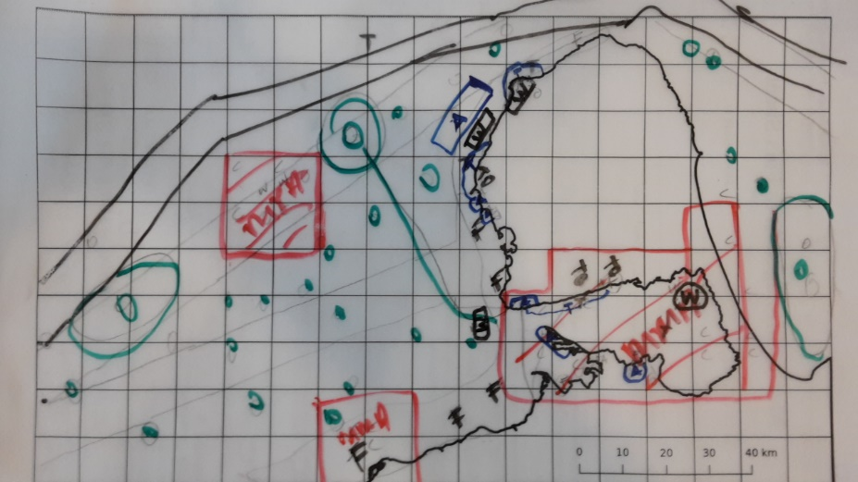
Maps produced by the groups
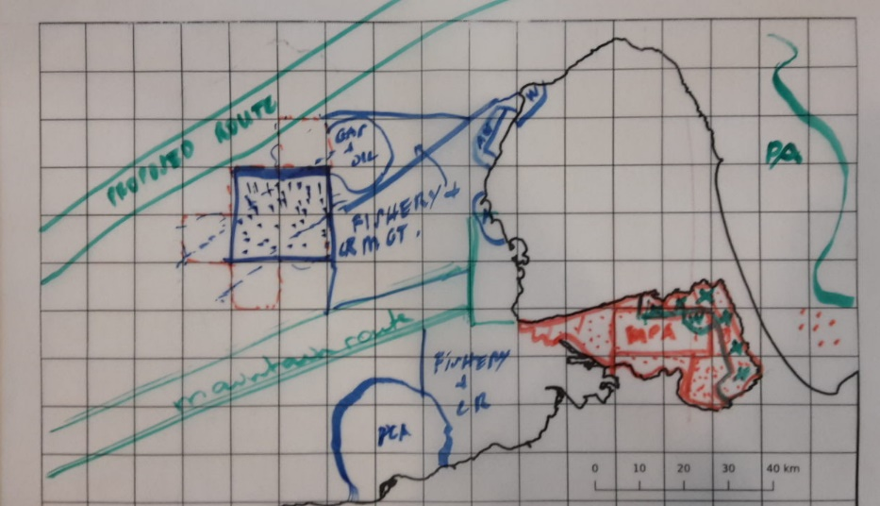

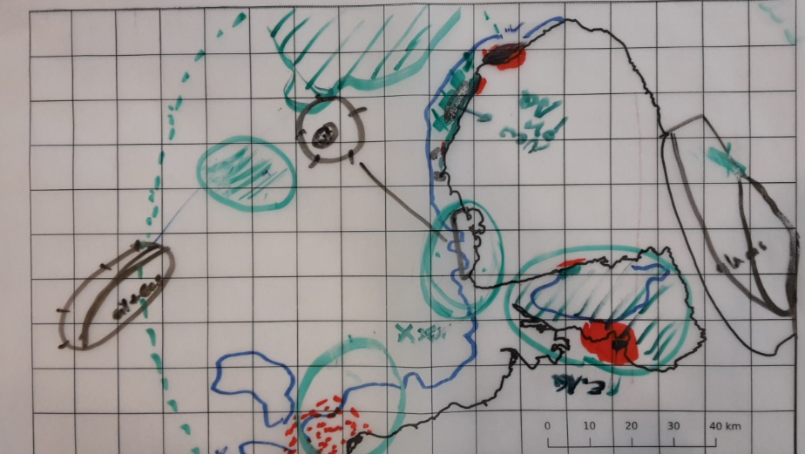

Examples of group reports
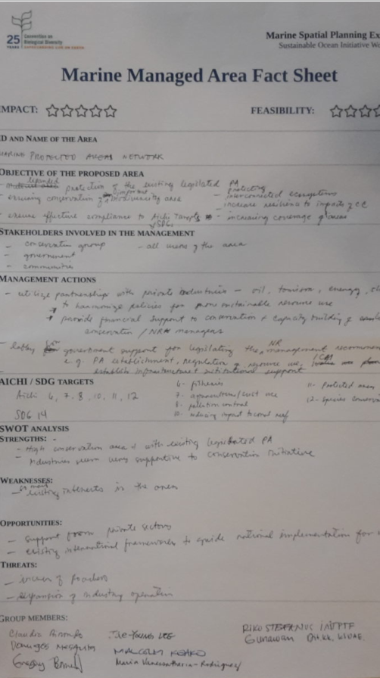
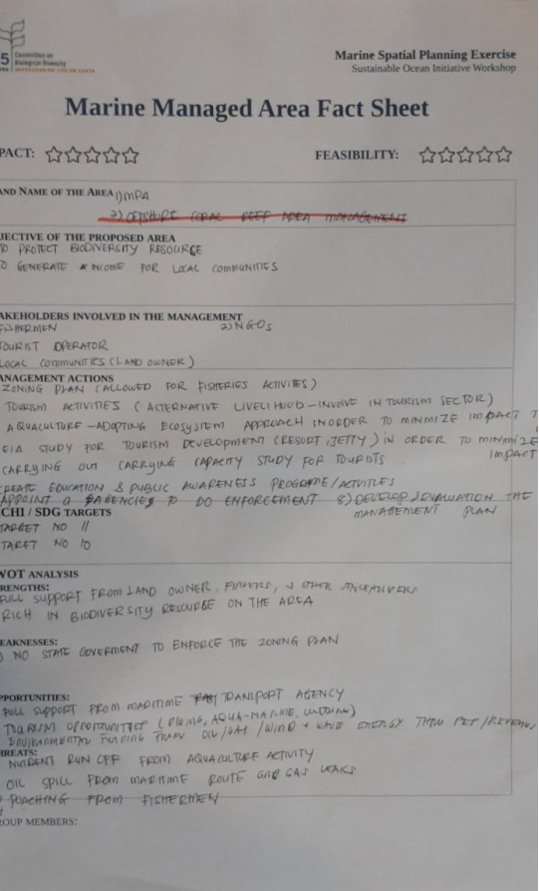

Annex VIII

IMPLEMENTATION PLANS

INDONESIA

NATIONAL PLAN OF ACTION TO SUPPORT/RELATED TO AICHI BIODIVERSITY TARGET 10
The extent of Indonesia’s ocean that reaches 5.8 sq.km, with about 81,000 km of coastline, has made Indonesia the world’s largest archipelago. Around 85,000 sq of coral reef area and around 24,000 sq.km of mangrove, bestowed Indonesia with an exceptionally high coral and fish diversity as well as the abundance of other marine resources. People of Indonesia depended to fish and other marine resources for their livelihood and main food source. With 60% of Indonesian population live within 50 km of the coast, other services given by marine resource such as coral reef are increasingly understood as safeguards to the society, economically and culturally. Twenty percent of the Indonesian’s GDP is derived from marine and fishery industries.

The invaluable marine resources, as true with elsewhere in the world, Indonesia’s marine resources are under a serious threat. As fishing is an occupation of last resort due to population growth, limited employment opportunities, lack of land and financial resources as well as open access fisheries, the number of Indonesian coastal fishers has increased by more than 40% over the last 10 years. This has triggered overfishing and destruction to the resources through cyanide and blast fishing. Global climate change and physical development have added complications to the condition of coastal marine resource, such that it has increased the vulnerability of coastal fisheries, hence the survival of coastal communities.

Indonesia’s Plan of Action mirrors the layout, structure, as well as targets laid out in the Regional Plan of Action. As with the Regional Plan of Action, the National Plan of Action consists of two major section; the first covers the overarching commitments specific to Indonesia’ position and conditions and the second lays out specific commitments related to priority actions aims to achieve targets agreed in the RPOA. The Plan of Action provides rationale for targets in each goal; priority actions committed by the government of Indonesia and are translated into series of activities, measures of outcome and time line. Priority actions and tangible activities contained in the national plan of actions were identified and agreed through a series of stakeholder consultations at the national and local level. Related to targets in each goal, such activities become the backbone in achieving each goal. The scope under which activities are set up includes assessment, monitoring, and research, capacity building, public/private partnerships, and enabling laws and policies.

The goal of NPOA Indonesia are related to the NPOA Regional on CTI-CFF. It have a 5 main goal as follow:
- Priority Seascape Designed and Effectively Managed
- EAFM and others marine resources fully applied
- MPA established and Effectively Managed
- Climate Change adaptation measured achieved
- Threatened species status improving

From those goals, it has 33 priorities Action Plans: 5 action plans (goal-1); 10 action plans (goal-2); 7 action plans (goal 3); 7 action plan (goal 4) and 4 action plans (goal 5).

The Indonesia’s NPOA that support Aichi Biodiversity Target 10 are as follows:
- Goal no 2
- Goal no 3 and
- Goal no 4

GOALS 2. The Ecosystem Approach For Fisheries Management (Eafm) And Other Marine Resources Can Be Applied
Target 1: The Availability of Legislation, Policy and a strong Regulatory framework for achieve the Ecosystem Approach to Fisheries Management (EAFM)
Priority Action
- Action 1. Developing regulations relating to EAFM in support of Law no. 27/2007 jo. UU no. 1/2014 on the Management of Coastal Areas and Small Islands and Law no. 31/2004 jo. UU no. 45/2009 on Fisheries (2020)
- Action 2. Implement and enforce legislation in combating IUU fishing as well as related issues (2020)
- Action 3. Implementation of an international action plan derived from IPOA (International Plan of Action) on fishery capacity.
- Action 4. Incorporate EAFM and Payment of Ecosystem Services (PES) in bilateral and regional fisheries management commitments (2020)

Target 2: Increase Revenue, Livelihood and Food Security to Support 50 Million Coastal Communities derived from various regions through the A New CTI Sustainable Coastal Fisheries and Poverty Reduction Initiative ("COASTFISH")
Priority Action
- Action 1. Continued the existing programs, and if necessary develop a program to improve revenue alternative, including capacity building and support for small-scale enterprises at the community level (eg marketing) (2020).
- Action 2. Add funds and/ or capital small business at the community level (2020).
- Action 3. Strengthen collaborative market information for small-scale fisheries products (2020).

Target 3: Effective action to help Ensure Exploitation of Joint Shrimp Stocks to be Sustainable, with Spawning Locations and Stages of Development of Protected Tuna Seeds.
Priority Action
- Action 1. Strengthening the management of tuna fisheries (2020).
- Action 2. Encourage the participation of the Tuna Association (in 2020).

Target 4: The Achievement of management trade of coral reef fish live and coral fishes ornamental more effective and sustainable
Priority Action
- Action 1. Develop and implement strategic plans fisheries sustainability for coral reef life (2020).

Achievements of Plan of Action
Goals Achieved:
- Reduce Illegal, Unreported and Unregulated (IUU) Fishing through the development of fishing communities based on the IUU reporting system,
- fishing in collaboration with NGOs and community communities, and monitoring in fishing vessels in 11 Fisheries Management Areas (WPP)
- 1,109,313 Fisherman Cards (2009 - 2017) and 500.000 Fishermen Insurance Premium (2016 - 2017) in 34 Provinces have been distributed
Next Steps:
    - Operationalization of the Fisheries Management Board to promote joint management of fisheries
    - Developing cultivation strategies for specific fisheries

GOALS 3. Marine Protected Areas (Mpas) Defined And Managed Effectively

Target 1: The MPA System in the Coral Triangle Area (CTMPAS) Continue and Fully Functioning
Priority Action
Action 1. Strengthen National Grand Strategy Marine Conservation Area (2020)
Action 2. Establish and strengthen cross-border conservation areas and collaboration among conservation areas across state boundaries (2020)
Action 3. Improve the MPA's planning and management of the threats and involvement of the society and related stakeholders (in 2020)
Action 4. Establish policies that allowing for sustainable MPA management (such as ongoing financing) (2020)
Action 5. Increase the capacity and strengthen the institutions for MPA planning, establishment and management (2020)
Action 6. Strengthen the communications, education and public awareness on MPAs (2020)
Action 7. Evaluate and improve the effective management of national MPA systems (2020)

Achievements of Plan of Action
Goal Achieved
- The total Marine Protected Area (MPA) area reaches 19.73 million hectares with a total of 172 MPAs (June, 2018) (95.7% of the total target of 20 million ha by 2020),
- Provide access and partnership to local communities for fishing,
- Indonesia's MPA covers 940,707 hectares or 37% of the coral reef ecosystem

Next Steps
- Development of MPA zoning plans and management,
- Strengthening partnership programs to support MPA management,
- Development of sustainable marine tourism in MPAs.

GOALS 4. Implementation of Climate Change Adaptation Action
Target 1: Development and implementation of action plans for climate change adaptation for Near-Shore Marine and coastal areas
Priority Action
Action 1. Identify and map the Indonesian coral triangle areas at a level of vulnerability towards the impacts of climate change and relate the information to biodiversity and socioeconomic values (2020).
Action 2. Prepare national guidelines for adaptation measures of potential impacts of climate change on marine and coastal ecosystems and communities on the basis of synthesis and understanding of available science, information and knowledge (2020).
Action 3. Formulate early warning systems and responses to weather variability, temperature variability and changes in storm phenomena, including coral bleaching and formulate direct strategies or quick responses to the potential impacts of climate change on fishermen, such as the impact of changing weather patterns and seasons, sea temperatures and storm (2020).
Action 4. Conduct and develop strategic research that provides important information to decrease the threat especially for coral reef ecosystems (2019).
Action 5. Improving education capacity, research and information systems on climate change issues related to consequences and adaptation measures (year 2020)

Achievements of Plan of Action
Goal Achieved
- Identify and propose existing institutions as the Center of Excellence for Climate Change Adaptation,
- Identify and map vulnerable areas and damage to ecosystems due to climate change and their development and research
Next Steps:
- Development of plans and management of areas affected by climate change,
- Engaging potential partners to support climate change adaptation activities,
- Inventory of climate change adaptation activities submitted or carried out by NGOs,
- Mainstreaming climate change adaptation with marine issues at UNFCCC
MALAYSIA

MARINE PARK MANAGEMENT PLAN
GOALS OF PLANS
- Clearly define management areas to ensure efficient and effective park management.
- Create the necessary infrastructure and support systems that enable the effective management of the area according to the defined zones and activities.
- Promote understanding and increase local knowledge of the value of the marine biodiversity found within the area, and the need to conserve and preserve marine resources and habitat, and highlight the ultimate benefits of protecting them
- Promote alternatives to economic livelihood and wealth generation (as opposed to fishing and any other activity detrimental to the MPA’s marine biodiversity) to enable the local community to benefit from preserving and protecting marine resources.
MAIN ELEMENTS
- Policy and Principle- The general conservation policy for Marine Park Areas is: “To conserve, preserve, and protect Malaysia’s Marine Park Biodiversity and at the same time to ensure that its resources are utilised in a responsible manner for the continued progress and socio-economic development of Marine Park Islands and the community”.
- Strategy - i. Zoning ii. Restoration iii. Regulatory iv. Compliance and Enforcement v. Monitoring and Research vi. Educational and Community Participation vii. Economic viii. Integrated Management Approach
- Marine Park Resources Management, Environment and Pollution, Artificial Reef Within and outside MP water, Tourism, Alternative Livelihood, Local Community Consultation and Advocacy, Scientific Research, Awareness and Education, Enforcement, Management control of structural construction on the coastal and/or within the water-body of Marine Park Waters
- Financing Conservation on Marine Biodiversity - provides alternative approaches to financing activities and programmes to conserve marine biodiversity within the Marine Park.
WHICH PARTS OF THE PLAN ARE NOT BEING ACHIEVED/IMPLEMENTED

Pollution--REASON
- The management of solid waste collection and disposal on the island is not effective, especially in the housing and village area. Solid waste is thrown into drains and rivers causing a bad odour, river pollution and a reduction in aesthetic value. The main issue is that the method of solid waste collection and solid waste transfer are not suitable. The waste collected generates leachate which can degrade the river and marine water quality, which in turn adversely impacts marine life. Leachate also creates odour problems. The need for proper management of solid waste is important as mostly of Marine Parks areas are widely known as a major tourist destination.
- Sewage treatment systems in these islands are technically not adequate. Some chalets and houses were built and designed without proper sewage treatment systems. Old type septic tank systems were implemented without proper scheduled maintenance. Untreated or poorly treated sewage that is directly discharged into the river will degrade the water quality of the river, estuaries and the sea. Another contributor to river pollution is improper management of sullage from bathrooms and kitchens. The main issue in the Marine Park Island Management Plan from the environmental perspective is that poorly treated sewage is directly discharged from residential properties/resorts/chalets into the drainage system and untreated sullage is also discharged directly from kitchens/bathrooms into drainage/streams.
- Most of the hotels, resorts and chalets were built along the beach corridor. Construction along the beach without proper mitigating measures can cause beach erosion and sedimentation. Sedimentation can cut off sunlight to coral reefs, which is vital for their health and growth.
- Lack of awareness from boat operator (especially operated by tourist operator and local community), solid waste and wastewater from marine vehicles are directly discharged into Marine Park waters.
- Lack of support from the relevant agencies, to date little concerted action has been taken in Malaysia to mitigate them and the damage caused to coral reefs.
- Lack of funding – in orders to manage the waste as generally.
ACTIONS TO IMPROVE IMPLEMENTATION
SHORT-TERM
- Managing solid waste from residential properties, resorts and chalets -identify a suitable approach for small volume solid waste treatment that is safe, cost-efficient and manageable.
- Managing sewage & sullage from residential properties, resorts and chalets - An efficient wastewater treatment plant is required to treat sewage and sullage to the standard enforced by the Department of Environmental.
- Managing environmental impact from development along beach corridor- identify and introduce a management system to manage the environmental impact due to development along the beach corridor and introduce stringent development control guidelines for all development in marine park islands .
- Preparation and development of collection centres for marine vehicles to discharge or transfer solid waste and wastewater. Local authority must appoint waste contractor to dispose of the waste.
- Ensure that all commercial passenger boats or marine vehicles are equipped with solid waste and wastewater facilities before issuing licenses or permits to the operators.
- Department should be included as a council member when deliberating approvals of all structural and development projects within and/or near to the marine park and must evaluate all possible development impacts and make sure that all physical and/or structural projects must have an approved Detailed Environmental Impact Assessment (DEIA).
MEDIUM-TERM
- Establishing contacts with key government agencies to enlist their support in implementing the local action plans developed previously. Targeted agencies included: Department of Environment; Department of Fisheries; State Governments that have direct authority over policy development and implementation.
- Provide a forum where local residents can express their views, feedbacks, response, comments and critics on issues related to community needs, livelihood and socioeconomic status arising from new or proposed projects, programmes, rules and regulations. Provide a forum where government agencies and other interested parties and stakeholders can effectively communicate with the local residents on issues related to their livelihood and socioeconomic status
- Identify highly sensitive environmental areas (HSEA) for MP islands and plan mitigation measures on how to reduce the negative impact of the activities of local people and tourists. A HSEA is an area where intrusion and pollution will have the worst impact especially on the environment and biodiversity of a MPA. An inventory of the resources in the Marine Park is needed to generate a HSEA map of all areas within Marine Park waters. The findings should include mitigation measures to reduce any adverse impacts from the surroundings that could affect the HSEA.
LONG -TERM
- Improve public awareness, understanding and appreciation of the marine and coastal environments of the Marine Park and of the potential impacts of human activities on these environments. Through public education, the plan aim to reduce the negative impacts of human activities on the values of the Marine Park and engender community stewardship of the marine environment.
- Develop a Local Impact Actions Plan (Solid Waste Management/Littering, Marine Debris, Sewage Pollution)

STRENGHTS, ASSETS, TOOLS THAT WE HAVE
- Local Communities -Local participation for the surveillance and enforcement of marine park area rules and regulations is through the Reef Watchers Programme. The main function of the Reef Watchers is to observe, record and report activities in the Marine Park area e.g. fishing, diving, coral taking and collection and other illegal activities during surveillance.
- International Cooperation-cooperates with various regional and international bodies and programmes such as the UNDP,GEF,CBD,CITES,UN,BOBLME,CTI and other agencies to share information in relation to management of marine park natural resources.
- NGOs-Appoint NGOs as co-partners in management of resources such public awareness programme as, assist in research and rehabilitation works in marine park.
- Patrolling Speed Boat and 24 hours of staffs on duties in island -Enhance the capabilities and effectiveness of the surveillance and enforcement activities in the Marine Park Waters and the enhancement, management and protection of marine park resources. Close working relationships with other enforcement agencies such as the Malaysian Maritime Enforcement Agency (APMM), Marine Police, Marine Department and Department of Fisheries in its efforts to enforce the Fisheries Act 1985.Collaborate with other enforcement agencies.
- Got the alternative approaches to financing activities and programmes to conserve marine biodiversity within the Marine Park by impose the conservation fee. Proceeds from fees will be credited into the Marine Park Reserve Trust Fund established under Section 10, Financial Procedure Act 1959 and will be used for the implementation of management, conservation, protection, enforcement, research, monitoring and education programmes within the Marine Park areas.
PLANNING AND MANAGEMENT TOOLS AND APPROACHES
Currently used
- Develop eco-certification scheme as proposed and establish guidelines and certification curriculum. All resorts in Marine Park were encouraged to obtain Eco certification by increasing the awareness of resort operators of the benefits of environmental best practices to their business. Besides that, eco-certification can increase their competitiveness against non-certified resorts as well as reduce their operating costs. Presently only the Green Hotel award is available in the country.
- Guided Tours - Tourism operators must provide or arrange to provide qualified tour guides for their customers for all activities within the marine park waters. Encourage all organized sea bound tours to refer to and record their tours with DMPM. The department is to consult with the operators on the administrative procedures.
- Compliance and Enforcement -This strategy aims at ensuring compliance to marine park rules and regulations to ensure that both locals and tourists/visitors comply with the do’s and don’ts within the marine park area. The focus is not to take legal action but to increase compliance through education. Proposed regular surveillance activities by the department enforcement units will emphasize the need to comply with the marine park culture of conserving and preserving marine biodiversity.
- Carrying out clean up campaigns to help solve the problem of floating or sunken trash that are be organised by resorts or dive shops and involve their guests/ customers and even some local villagers.
- Additional funding for programmes could be obtained from The Marine Park and Marine Reserve Trust Fund as well as from Corporate Social Responsibility (CSR) programmes of private entities.
OTHERS THAT MIGHT BE APPLIED
- Establishment of a working committee, whose members comprise elected local residents, that will represent the respective local community in forums, discussions and meetings with public and private agencies and individuals on matters related to their community.
- Try to provide guiding principles on how department and other implementing agencies can engage and optimize local community involvement in the decision making process in proposed projects, programmes, works and services that have an impact on the local communities.
- The number of visitors to Marine Park will be controlled through mutual agreement among tourist operators and department. Tourist operators will also be encouraged to develop a visitation schedule so that no particular site will be overly stressed due to too many tourists at any particular time
- An effective reporting system should be designed and activated, for anyone to report sightings of rubbish, especially huge floating, tangled “mats”. A contact name and number should be made available to the public, on banners and posters and also online domains. Publicity of this reporting system should be maximized and a simple guide on how to make a report should also be advertised using both print and social media. There should be a special team dedicated to the reporting system to ensure reports are recorded, replies are made and swift action is taken to address the issue reported. The reporting system should incorporate a system of fines and penalties for littering or improper disposal of trash.
- Awareness and advocacy programmes for tourists - Promote marine park islands or MPA island as a destination with a clear message pertaining to use and management regulations of MPAs, not just as a mass tourist destination. Educate tourists, tour agents and operators on their roles and responsibilities in conserving the environment of MPA. The importance of the marine park should be stressed in brochures and other promotional materials.
- Need to build a systematic knowledge of marine park resources through coordinated and integrated scientific research, to contribute to an understanding of marine biodiversity and their impact from global climate change, and to protect and conserve the environment within Marine Park Areas. Universities may assist DMPM to undertake joint research studies to collect and information to contribute towards effective marine park management.
- Recycling programmes - a great way to reduce the amount of trash being generated and can help curb this problem.
ACTORS THAT ARE CURRENTLY INVOLVED IN THE IMPLEMENTATION
- Local communities
- Tourist Operator
- State Government
- Federal Government
- NGOs and Corporate Body
ACTORS THAT ARE CAN BE INVOLVED IN FUTURE IMPLEMENTATION
- Members of Parliament and Assemblymen in coastal areas relevant to Marine Parks (can act as agents for DMPM to disseminate information to the general public).
- Tourist -involved in regular clean-up programs to solve the problem of trash on beaches and anywhere on land in the islands.
PAPUA NEW GUINEA
Country Implementation Plan
Improving LMMA Effectiveness and Sustainability
Desktop Review
“Kimbe Bay Local Managed Marine Areas (LMMAs)”
Priority Actions to Achieve Aichi Biodiversity Target 10 for Coral Reefs and Closely Associated Ecosystems

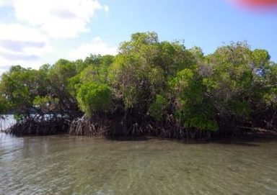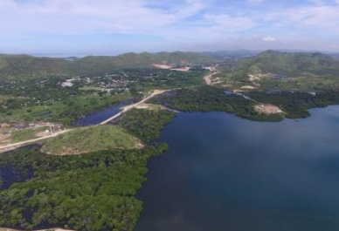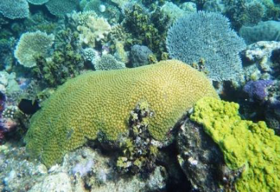

1. Introduction
Coral Reefs, Seagrass beds, mangroves, sand and mud shore and intertidal flats, Barrier dunes and their associated lagoons, deltaic floodplains and estuaries, rocky shorelines, reef walls and drop-off areas, sea mounts form the complex marine habitats of PNG. Marine organisms associated with this array of habitats are important components of the rich marine biodiversity of Papua New Guinea.

Coral diversity is typically very high in Papua New Guinea’s reefs and this is globally significant. In Kimbe Bay of West New Britain, a total of 345 species of coral were reported. This number compares favourably to that of other detailed surveys conducted in Australia, Japan, Indonesia, the Philippines and elsewhere in Papua New Guinea and at the time was amongst the highest ever reported from such a small area. Two thirds of the coral reefs surveyed had high levels of live reef cover (greater than 50 %), and many individual sites had extensive areas of very high coral cover (greater than 75 %) indicating the near pristine state of the coral reefs at those locations.

In Madang, biodiversity of reef fish fauna within the Locally Managed Marine Areas network is of global, national and local importance. In Milne Bay over 429 species of coral fauna, including 10 new species, were recorded during Rapid Assessment Program surveys carried out by Conservation International during 1998.

The above information clearly indicates the global significance of Papua New Guinea’s coral reefs, but these reefs are also vitally important to the local people as a primary resource supporting their traditional culture and sustainable livelihoods. Coral reef fisheries are a vital source of food and income for many coastal communities. They are important feeding and nursery habitats for many marine species. They provide a physical barrier to ocean swells and storm surges, protecting the shoreline against erosion. Behind the reefs, the sheltered reef lagoons provide habitats for a variety of important coastal species, notably seagrass beds and mangrove stands, which further stabilise the shoreline by anchoring the sediments.

In accordance with the National Constitution of Papua New Guinea under the 4th Goal and Directive Principles states “For Papua New Guinea’s natural resources and environment to be conserved and used for the collective benefit for us all, and to be replenished for the future generations”.
For some marine habitats and associated marine resources, especially within the vicinity of urban areas, human population pressure and urbanization related development activities have been impacting on them over the years to an extend that the habitat have been reduced to rubbles littered with anthropogenic wastes.

The PNG Marine Program will specifically address marine related issues and impacts.
The overarching purpose of the PNG Marine Program is to provide a framework for Government, the community and the business sector, in partnership, for managing PNG’s marine environment and resources for sustainable long term use and protection.

2. The Coral Triangle Initiative
The Coral Triangle Initiative (CTI) is a multi-lateral partnership aimed at sustainable management of the marine and coastal biological resources of the Coral Triangle region. It comprises all or parts of the exclusive economic zones of six countries: Philippines, Malaysia, Indonesia, Timor- Leste, PNG and Solomon Islands. The area spans 5.7million km2 making up only 1.6% of the planet’s oceanic area. The CTI Region is globally significant in marine life abundance and diversity including 76% of all known coral species, 37% of all known coral reef fish species, 53% of the world’s coral reefs, has the greatest extent of mangrove forests in the world, and spawning and juvenile growth areas of the world’s largest tuna fishery.
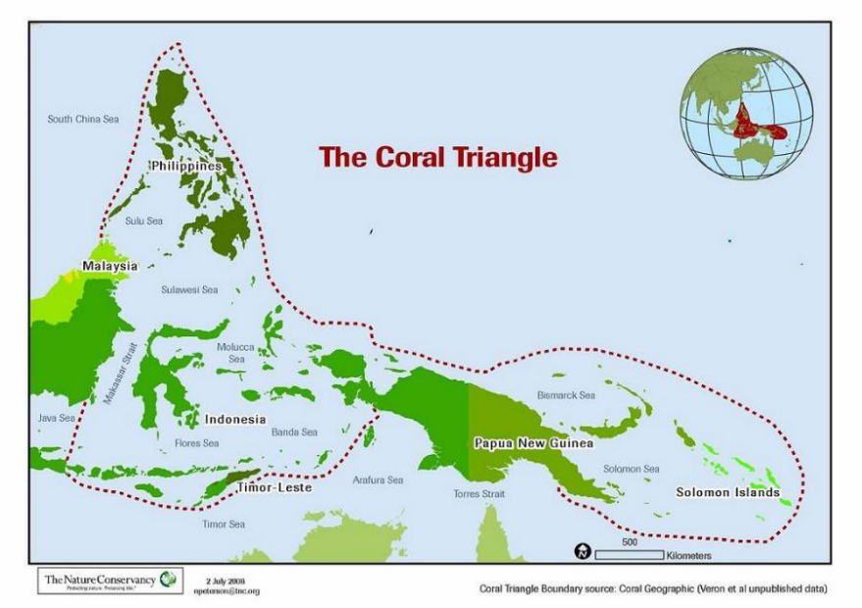

The Coral Triangle Region
These ecosystems and natural resources directly support the livelihoods of over 120 million people and provide indirect benefits for millions more across the globe.

These ecosystems and natural resources are being seriously threatened by over-fishing, destructive fishing practices (including cyanide and blast fishing), coral bleaching and ocean acidification due to climate change, pollution, and sedimentation from coastal development.

3. PNG Marine Program Overview
The PNG Marine Program is a response to the CTI’s call for a National Plan of Action.
PNG’s marine resources will continue to support the subsistence livelihood of coastal communities, augment income generation at the local level and fetch substantial revenue in the international market place as long as the threats posed by pollution, over-harvesting, destructive fishing and climate change are dealt with through a concerted effort by all stakeholders. In addition to fishing, the country’s unique marine environment and unmatched biodiversity presents numerous opportunities for nature based eco-tourism as well as responsibly managed commercial tourism providing diving, surfing and game fishing activities for national and overseas visitors.

The PNG Marine Program will provide a plan of action for all stakeholders to work towards in achieving poverty reduction and food security through sustainable management and utilization of marine resources.

Table - PNG Marine Program: Goals and Targets
Goals | Targets
1. ”Priority Seascapes” designated and effectively managed. | - “Priority Seascapes designated, with investment plans completed and sequenced  - Marine and coastal resources within all “Priority Seascapes” are being sustainably managed
2. Ecosystem approach to management of fisheries (EAFM) and other marine resources fully applied. | - Strong legislative, policy and regulatory frameworks in place to achieve an effective Ecosystem Approach to Fisheries Management (EAFM)  - Improved income, livelihoods and food security in an increasingly significant number of coastal communities across the country through a new sustainable coastal fisheries and poverty reduction initiative (“COASTFISH”)  - Effective measures in place to help ensure exploitation of shared tuna stocks is sustainable, with tuna spawning areas and juvenile growth stages adequately protected  - A more effective management and more sustainable trade in live reef fish and reef-based ornamentals achieved
3. Marine Protected Areas (MPAs) established and effectively managed. |  | Region-wide Coral Triangle MPA System (CTMPAS) in place and fully functional
4. Climate change adaptation measures achieved |  | - Region-wide early action plan for Climate Change Adaptation for the near-shore marine and coastal environment and small island ecosystems developed and implemented  - Networked national centers of excellence on climate change adaptation for marine and coastal environments are established and in full operation
5. Threatened species status improving |  | Improved status of sharks, sea turtles, seabirds, marine mammals, corals, seagrass, mangroves and other identified threatened species

4. Improving LMMA Effectiveness and Sustainability

Kimbe Bay Network of LMMAs
The PNG Marine Program will provide a plan of action for all stakeholders to work towards in achieving poverty reduction and food security through sustainable management and utilization of marine resources.
Locally Managed Marine Areas (LMMAs) can be defined as
“An area of nearshore waters and coastal resources that is largely or wholly managed at a local level by the coastal communities, land-owning groups, partner organizations, and/or collaborative government representatives who reside or are based in the immediate area.” Govan et al (2009)

Kimbe Bay is a spectacular land and seascape on the north coast of the island of West New Britain (WNB) in PNG (Fig 1: 5o 15’S; 150 o15’E). The landscape is dominated by numerous volcanic cones, which reach heights of over 2000m in close proximity to shore. Three of the volcanoes are currently active: Mt Pago, Mt Gabuna, and Mt Uluwan.

Kimbe is a large bay (140km x 70km), and a well-defined geographic feature with distinct boundaries: Willaumez Peninsula to the west and Cape Tokoro to the east.

The seascape is quite dramatic. Most of the Bay is deep (more than 500m), with a narrow shelf (less than 200m deep) along the coast. On the eastern and outer portions of the Bay, the shelf drops off steeply into very deep water (more than 2000m) very close to shore. The western portion of the Bay is shallower than the eastern side, but still reaches depths in excess of 600m.

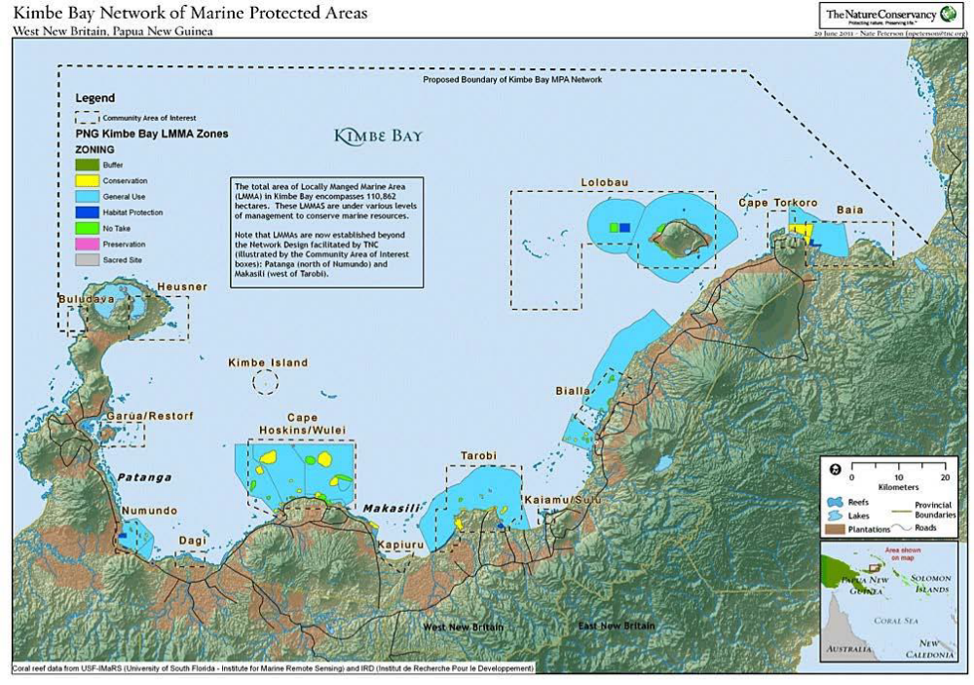

Kimbe Bay LMMAs
Rapid Ecological Assessments have described healthy coral reefs with high biodiversity, (Holthus 1994, Beger 2002, Turak & Aitsi 2002), particularly on the eastern and mid to outer portions of the Bay. These reefs are considered part of the global center of marine biodiversity area known as the coral triangle (Fig 4: Green & Mous 2004). Preliminary surveys have also described small, but ecologically significant mangrove forests and extensive seagrass communities in Stettin Bay, with reasonably high biodiversity (Sheaves 2002: further studies are required).

Kimbe Bay is also an integral component of the Bismarck Sea (Fig 1), which is the home of one of the most extensive coral reef systems in PNG. As part of the highest diversity area of coral reefs in the world, known as the Coral Triangle (Fig 4), the Bismarck Sea supports some of world’s highest marine biodiversity. It also provides important habitat for the Pacific’s largest sperm whale population, important turtle rookeries, and the most productive tuna and bait fisheries in the Western Pacific. In 2003, the East Bismarck Sea was recognized as a globally significant area for pelagic fishes (particularly tuna) and toothed whales (WWF 2003).

Situation Analysis
The Kimbe Bay Network of LMMAs were initially planned and designed to focus on the following components which include:
• Reef resilience and habitat connectivity
• Apply restrictions on harvesting and management plans
• Develop local level government by-laws

• Undertake efforts to build awareness and capacity
• User fees as the financing mechanism

The on ground situation reflects that most of these components are either not effective or there are improvements that need to made to assist in the management of the LMMAs. There was a study recently carried out by CSIRO and TNC in 2016 which highlighted the following:
- Not a single LMMA is actively being managed;
- No fees or fines have been collected;
- Many reefs are damaged or bleached, crown of thorns persist, and fish sizes and populations are small

Contributing Factors Affecting on Ground Implementation
Enforcement - not effective
- Ensure good communication and outreach within the community and in surrounding communities so that everyone knows the rules and areas being protected.
- Utilize traditional mechanisms and chiefly systems when possible.
- Seek government support for community regulations. This can increase credibility and recognition of rules.

Monitoring – lack monitoring
- Monitoring is carried out in order to detect changes in the marine areas, evaluate if and how management actions are working, revise the management plan, seek legal or monetary support for the LMMA, and to inform and engage community members to support the project.

Sustainable financing
- No financial mechanisms to support the activities of the LMMA apart from user fines
- Often times fines are not paid

Alternative livelihood opportunities
- Lack alternative livelihood activities to ease or supplement their dependence on marine resources

Actions to improve implementation - Short, medium & long-term plans
- Engage a range of stakeholder groups effectively and to build support for project, have good communication on all fronts (within sites and with neighbouring sites, partners, government, media), and be clear and open about the resource management processes.
- Investigate opportunities for the tourism sector to support and sustain LMMAs
- Improve compliance and reduce poaching by initiating an LMMA education and awareness programme targeting residents and visitors alike
- Develop regional and country-specific networks of LMMA practitioners to share best practice on management topics such as financing and evaluation and to encourage the development of further LMMAs.
- Integrate these networks with other existing Network
- Invest in research to better understand how LMMAs can meet their long-term goals.

Options to Improve Implementation
- Existing natural resource management initiatives - There are various initiatives being undertaken in the same area and components of these projects can be utilised to support and improve the activities in the Kimbe Bay LMMAs.
- Existing by-laws - Review the regulation and management structure to strengthen and make it effective
- Corporate social responsibility - Land use, particularly agriculture and forestry, are major industries in Kimbe Bay. Runoff from these activities appears to be causing significant impacts on nearshore ecosystems in some parts of the Bay (particularly the southwestern corner). Although arising from outside the marine environment, these threats are significant and will need to be addressed. Engage and have partnerships with the private sector to support conservation efforts
- Existing tourism sector - Investigate further opportunities for the tourism sector to effectively support and sustain LMMAs
- Centre for Locally Managed Marine Areas (CLMMA) - Seek support to assist with programs and on-ground activities

Planning/Management Tools & Approaches
Planning tools currently used include: Management effective’s tool, Ridge to Reef, EBFM. Other tools that can be applied include: Watershed Management, Marine Spatial Planning.

Stakeholders
There are various existing stakeholders and partners which include: Oil palm, Forestry, Fisheries, Agriculture, Communities, Government (Local, Provincial, and National), NGOs, Tourism and Centre for Locally Managed Marine Areas (CLMMA)
There are other relevant stakeholders that are not actively involved. These include:
- Ports Corporation - Shipping may pose a threat to marine ecosystems through ship groundings, pollution, and the introduction of invasive species, impacts appear to have been localized to date. Engage with the concerned stakeholders to support natural resource management activities.
- Private Sector - Most of the related expenditure from activities like ecotourism flows to local businesses, businesses elsewhere in PNG, and local communities. Explore options to have partnerships to support natural resource management activities.
PHILIPPINES

Philippines CTI Plan of Action
Implementation (Catch up) Plan for Goal 3

The Philippine National Plan of Action (NPOA) employs Integrated Coastal Management (ICM) as the overall framework in pursuing the five regional CTI goals. It draws heavily from the inputs provided by CRM practitioners representing public, private and NGO sectors all over the country. A bottom-up approach was utilized in coming up with the final list of actions and targets, most of which are cross-cutting and are representative of lessons learned in the course of implementing coastal resources management. There are five goals under the PH CTI NPOA: (i) “Priority seascapes” designated and effectively managed; (ii) Ecosystem Approach to Fisheries Management (EAFM) and other marine resources fully applied; (iii) Marine Protected Areas (MPAs) established and effectively managed (including community-based resource utilization and management); (iv) Climate change adaptation measures achieved; and (v) Threatened species status improving.

Out of the total of 60 actions indicated in the NPOA, 21 are already completed, 38 are ongoing and 1 is not yet started. For Goal 3 which pertains to the management of MPAs, there are 8 actions identified, 4 are completed while 4 are on-going.

I. Elements of the existing plan on Goal 3: Marine Protected Areas (MPAs) established and effectively managed

The following are 8 identified actions under goal 3, and the status of its implementation:
Targets/ Actions | Completed / In-Place | On-going | Remarks
Target #1 Region-wide coral triangle MPA system (CTMPAs) in place and fully functional
Action 1: Implement the Philippine marine sanctuary strategy | ✔ |  | - National MPAs: completed the National Integrated Protected Area System (NIPAS) Master Plan for implementation which includes comprehensive plan of actions including monitoring and evaluation system.  - Regular updating of the National MPA database through the MSN Network/ continue the MPA Management Effectiveness Assessment  - Technical and facilitation assistance in MPA establishment and management embedded and funded under the Coastal and Marine Ecosystems Management Program of the Philippines (CMEMP) (2016-2028).  - Committed to achieve the goal of 10% of the waters to become protected  - Currently 6% of the Territorial Waters are protected (43% are locally managed/ 57% are National MPAs)  - 1600+ Local MPAs in compliance to the Fisheries Code RA 10654 and Local Government Code  - 94 newly legislated NIPAS PAs, 30 are MPAs.  - Need to account Other Effective Area-Based Conservation Measures (OECMs) such as ICCAs in the figures.
Action 2: Implement the SSME MPA Sub- Committee Work Plan | ✔ |  | - Work Plan developed and adopted for implementation (℅ DENR-BMB)
Action 3: Identify priority marine key biodiversity areas (mKBAs) in the Philippines with at least one operational MPA network in each mKBA | ✔ |  | - Completed and on-going  - Marine Turtle Protected Area Network (MTPAN) under Sulu-Sulawesi Seascape Program  - Establishment of locally managed MPAs and MPA networks within mKBAs (Implemented projects: SMARTSEAS PH, ECOFISH, ADB RETA 7813)  - Verde Island Passage  - Southern Palawan  - Davao Gulf  - Tanon Strait  - Lanuza Bay  - El Nido -Taytay  - Currently developing sustainability plans for the management/ continuation of efforts from these projects in promoting MPANs by mainstreaming the goals and objectives in CMEMP.  - Currently developing a national policy framework/ guideline for MPANs in a form of joint administrative order from three main government agencies involved (DENR-DA-DILG)
Action 4: Link, network and develop new National Marine Centers of Excellence |  | ✔ | - In 2012, 6 Regional ICM Centers (RICs) were established, however, some of the efforts were not sustained. This needs to be revisited again, monitor the progress, and identify the gaps of the implementation, what went wrong, and what are the opportunities again. Review the possibility of reliving it or connecting it to the existing efforts now of the government and partners towards achieving this action. (eg BRING project under the DENR-UP MSI collaboration Project)
Action 5: Strengthen capacity of local government units and support services of the national government agencies on MPA management |  | ✔ | - Most of the government and partners’ recent projects and programs are focused on the capacitation of LGUs and MPA managers on the Management of MPAs. These are done through projects of DENR - PhilCORE, SCREMP- CMEMP, CARE-CADRES; DENR Capacity Building through USAID-NOAA projects, SMARTSEAS PH, ADB RETA 7813, GIZ PAME & SSS, DENR-BMB ICCA Project, Professional Masters in Tropical Marine Ecosystems Management under the DENR- UPMSI collaboration project.
Action 6: Establish appropriate economic instruments for regulatory and revenue  generating objectives |  | ✔ | - Ongoing projects and programs are under the implementation of CMEMP through providing assistance and grants for Biodiversity Friendly Enterprises; valuation and accounting of resources through projects under DENR-BMB UNDP BioFin, and DENR PhilWAVES.  - Policy Framework for the implementation and adoption of BDFE are currently underway  - Economic instruments embedded in recently enacted laws and currently undergoing field testing  - Incentives for best practices exist however, there is a need to assess the status of the recipients in terms of sustaining their good practices and positive impacts in relation to the awards.
Action 7: Rehabilitate and manage mangrove forest | ✔ |  | - Embedded, institutionalized, and funded through regular government budget (National Greening Program (NGP) and CMEMP)  - Scientific and ecological guidelines (Technical bulletins on mangrove plantation and development by DENR-ERDB)
Action 8: Develop, adopt and implement the national seagrass strategy |  | ✔ | - On-going data updating of seagrass - species abundance distribution and conservation by concerned agencies and institutions.  - Protection and conservation of the habitat is under the scope of CMEMP, but there is no specific technical bulletin of guidelines yet issued by the Government.

II. Actions to improve implementation

3. Marine Protected Areas (MPAs) established and effectively managed (including community-based resource utilization and management0

Actions | Short Term Plan | Medium Term Plan | Long Term Plan
ACTION 4. Link, network and develop new National Marine Centers of Excellence  • Establish a multidisciplinary experts group to develop the CTI Strategic Research Agenda  • Strengthen institutional and human capacity to conduct natural and social research through formal educational institutions | Review the possibility of reliving the RICs or connect it to the existing efforts now of the government and partners towards achieving this action. (eg Biodiversity Resource Information Network Group (BRING) under the DENR-UP MSI collaboration Project)  Scholarship grants for Professional Masters in Tropical Marine Ecosystems Management - PM TMEM | Institutionalization of BRING  Institutionalization of scholarship grants | BRING - Implementation and establishment of M&E  Application of PM-TMEM principles
ACTION 5. Strengthen capacity of local government units and support services of the national government agencies on MPA management  - Review existing policies, plans and programs and their implication on MPA management  - Promote participatory MPA management, including women and youth  - Promote reciprocal learning and capacity building initiatives among MPAs to gain insights, learn lessons, share best practices including sustainable financing and cost recovery mechanisms.  - Coordinate research and studies on MPAs to enhance understanding and factors aﬀecting them.  - Implement tools for assessing management eﬀectiveness  - Increase capacity building for Green Courts and prosecution service  - Increase financial resources to conduct Biodiversity Monitoring System (BMS) for its full implementation and to become a regular activity. | Creation of PAMBs to newly E-NIPAS MPAs (Ticao-Burias Protected Seascape etc)  Formulation and development of MPA management plans/ Climate-Smarting of the management plans  Development of capability trainings/IEC/skills re:, Community empowerment, Environmental leadership for the youth, women and IPs  Formulation of environmental policies for the youth, women and other stakeholder’s participation  Update and enhance the marine research agenda in collaboration with all concerned agencies and institutions  Harmonization of existing databases on MPAs/ Coastal and Marine environment. | Operationalization of PAMBs  -Implementation of MPA and MPAN management plans  National database and M and E system for MPAs and MPANs are operationalized.  Continuation of the recognition awards/ regular exchange and training programs.  Adoption of environmental policies thru legislation e.g. inclusion of marine biodiversity in elementary and secondary curriculum | Legislation of the remaining proclaimed PAs.  Continue the implementation and adoption, and progress on the MPA Management Effectiveness Assessment;  Regular updating of MPA plans, assessment and monitoring of the coastal and marine habitats, including offshore habitats.  Financing mechanism for each MPAs and MPANs in place, including enabling policies for its implementation. The goal is for these MPAs is to be self-sustaining in the long run.  Institutionalize enforcement alliances and coordination mechanism.
ACTION 6. Establish appropriate economic instruments for regulatory and revenue generating objectives  - Use economic valuation studies as basis for policies, fines, fiscal and other economic instruments  - Impose environmental user fee systems  - Develop incentive systems for good performing sectors and disincentive systems for those that are performing otherwise using valuation study results. | Economic instruments for regulatory and revenue generating objectives, and environmental user fee systems incorporated in existing national laws i.e. RA 9147 “Wildlife Act”, RA 10654 amending The Fisheries Code of 1998, RA 11038 The Expanded National Integrated Protected Area Systems Act of 2019  Incentives for best practices developed under Para El Mar - best protected MPAs; Search for Cleanest and Most Productive Coastal Communities (MMK) | Valuation studies used as bases for imposition of fines/penalties relative to marine resource damage i.e. coral reefs, seagrass beds, mangrove forest; reviewed to develop with a more realistic and equitable formula.  Existing incentive systems for best practices evaluated to assess positive impacts | Valuation system in calculating marine resource damage/s to impose commensurate and equitable fines/ penalties in place.  Appropriate and sustainable funds for marine resource protection embedded in concerned national agencies and coastal local government units’ budget allocation.
ACTION 8. Develop, adopt and implement the national seagrass strategy | Updating of seagrass data eg. species distribution, abundance, conservation | Formulation and development of a national seagrass strategy/plan | Legislation, institutionalization and implementation of the plan

III. Strengths, Assets, and available tools to apply

Marine protected areas (MPAs) are the most extensively implemented sustainable marine management and conservation tool in the Philippines. As such, there are already a set of comprehensive policies and guidelines in place which are developed through the strong inter-sectoral collaboration (pool of experts) from the government, policy makers, academe, field practitioners and other relevant stakeholders. One of the advantages and strengths in implementing this goal is that there is an emerging support now from the concerned national agencies (DENR, DA etc) which is reflected on the increase of funds/ budget to support the preparation and implementation of MPA Plans. There are also a lot of available information and tools that can be used to improve the implementation, which do not only focus on ecological aspect, but also on the socio-economic/ cultural dimension of the MPA implementation (eg, employing social marketing/ behavioral change). The strong partnership with different international funding agencies and institution is also one of the strengths and opportunities for the Philippines to aid in the MPA implementation. With this, Goal 3. can be achieved as long as long as the existing efforts are sustained and improved.

IV. Planning and Management Tools and Approaches

From the range of available planning and management tools, the participatory and community-based approach is one most widely used in the management planning process in the Philippines. Along with this are the following tools which are already/ regularly being employed/ needs to be employed in the management planning process:
- SWOT analysis
- Situational Analysis and LogFrame development leading to the development of more substantive/ useful M and E indicators
- Coastal Zoning: Use of GIS mapping and or, participatory community resource mapping.
- Science Based Approach: Use of technical guides/ Information on the planning process (example: (1) Fishing Industries’ Support in Handling Decisions Application (FISH-DA); (2) Fisheries for Sustaining People’s Access through Conservation and Equitable Systems (FISH-SPACE); (3) Capturing Coral Reef & Related Ecosystem Services (CCRES) tools

V. Actors that are/ will be involved

The stakeholders are multi-sectoral that encompass vertical and horizontal levels of society. In government, the central office of a national agency works directly with their regional offices down to the provinces for field implementation. The national government subscribe to participatory process and provide for venues to consult with the various stakeholders throughout the country in formulating laws, rules and regulations on marine resource protection i.e. National government agencies (Department of Environment and Natural Resources, Department of Agriculture - Bureau of Fisheries and Aquatic Resources Department of Science and Technology, Department of Interior and Local Government, National Commission on Indigenous Peoples, Philippine Navy, Youth, etc.), Academe (SUCs, HEIs, research institutions), environmental NGOs, private sector and industries. Likewise, it is deemed important to establish close linkages with the coastal local governments as they have full jurisdiction over their marine waters except in some areas designated as national waters. The local government in turn consult with their constituents from various sectors i.e. local representatives of government agencies, academe, NGOs, local leaders, indigenous peoples, youth, religious leaders etc. it is also recognized that there is a need to involve the marginalized sector of coastal communities (limited access to social media, print and broadcast media/communication), in the management and implementation. In order to engage them, the following are the recommended steps:

- intensify communication, education, and public awareness activities on coastal conservation and management;
- Employ social marketing approach;
- involvement of these sectors in planning/decision making process;
- incentivize local communities/institutions for outstanding contributions in coastal and marine conservation efforts

SOLOMON ISLANDS

Exercise on developing a plan to improve an implementation plan
Country: Solomon Islands
Case: Solomon Islands National Sea Cucumber Fishery Management and Development Plan
Submitted by the Solomon Islands during the SOI Sub-regional Capacity building workshop for the Coral Triangle, 31st July to 3rd August 2018, Gran Melia Hotel. Jakarta. Indonesia

Introduction:
The Solomon Islands National Sea Cucumber Fishery Management and Development Plan or the “Sea Cucumber plan” was gazetted in 2014 by the Ministry of Fisheries and Marine Resources.
There are more than 30 species of sea-cucumber in Solomon Islands waters. The management plan covers 27 species targeted for both commercial and scientific purposes. The fishery is highly vulnerable to overfishing because of its sedentary movement thus easy to be harvested e.g. gleaned from reef-flats and processed using low-technology (cleaned, boiled and dried).
The overall purpose of the Sea Cucumber Plan is to provide ecological sustainable management and development of the fishery including the establishment of effective and enforceable regulations.
The main elements of the existing plan are:
- To ensure that harvesting and processing of sea-cucumber has minimal impact on the marine environment
- To strengthen ongoing monitoring programs to ensure monitoring and collection of scientific information and export data
- To optimize sustainable economic returns from the fishery to industry, communities and resource owners
- To establish effective and enforceable regulations
This brief review outlines:
- Parts of the current plan not being achieved/implemented? Why?
- Actions to improve implementation
- Strengths, assets, tools etc. that can improve implementation
- Planning and management tools and approaches for application
- Actors that are/will be involved (including indigenous peoples and local communities)

- Parts of the Sea Cucumber Fishery Management plan which are not being achieved/implemented and Why?
Part of the Plan not achieved/implemented | Why?
PART IV: Fisheries management Objectives
Section 15(c) To strengthen ongoing monitoring programs to ensure monitoring and collection of scientific information and export data. | This has not being achieved due to Low capacity for ongoing monitoring program ($, HR) and lack of supporting infrastructure (e.g. database, mobile app)
Section 16(c) Apply restricts on particular fishing techniques or method. (d) Apply restrictions on particular sea cucumber species, including size or weight limitation. (e) Establish an ongoing program of catch and export data collection and of collecting scientific information to support management of the sea cucumber (f) Establish an effective monitoring and enforcement system to ensure compliance with the plan, license and condition of licenses and; (g) To promote and encourage the management of the sea cucumber fishery at provincial and local levels. | Restrictions on particular fishing techniques/methods not being achieved due to lack of monitoring and enforcement at community-levels.  Restrictions on species, size and weight limits not achieved or implemented as lack of monitoring and enforcement at community level and during compliance inspections. Also challenges in weight bulk consignments.  Catch and export data collection/scientific information not achieved/implementation due to lack of funding, organizing work-plans and scientific apparatus  Effective monitoring and enforcement system weak due to political interferences  Management at provincial and local levels limited due to funding difficulties/budget by national government.
Section 17 from (a) to (f): Organize consultations with key stakeholders (provincial Governments, communities, sea Cucumber collectors, processors, buyers and exporters, Non-Government organizations (NGOs) with the interest in the conservation, development and management of the sea cucumber fishery) in the Sea cucumber fishery at least once in each calendar year or may as necessary. | Not implemented due to budget constraints and lack of proper planning for consultations.
Part V: Management measures
Section 20(g) Review, Determination and Communication of export licenses by MFMR Licensing committee | Not achieved and implementation because of political interferences/conflict with decisions made by the Licensing committee
Section 21(A)(VI) Exporters/Licensees required providing training on sea-cucumber management and processing and (XII) Solomon Island nationals given priority over foreigners if they apply.  Section 21(B)(VII) Applicant history of co-operation and compliance with conservation and management measures imposed by provincial governments and MFMR.  Section 21(C) processing licenses are restricted for Solomon Islands living in Solomon Islands | Exporters and licensees not providing trainings/capacity-building opportunities for local communities as not imposed as a strong condition. Most exporters are focused on extraction not including trainings/capacity building programs.  Limited access by local communities to the sea-cucumber licensing processes – low capacity and need capital $  Licensing criteria in management sometimes inconsistent with imposed criteria by policy (Cabinet). Provincial governments are often times not consulted.
Section 23(b) has been convicted of any offence under the fisheries laws and plan. | Gaps remain in follow-ups of convictions and keeping records of cases
Section 25 No person shall harvest sea cucumber in other manner except (iii) only during daylight hours. | No enforcement at local levels for night-diving incidences (hard to enforce, not practical)
Section 28 (a) & (b) Data collection as stated, all licensed sea cucumber processors and beche-de-mer exporters shall complete and submit a monthly log sheet detailing, the quantity(total weight/numbers)of sea cucumber by species | Local purchase forms usually not properly filled by Exporters. Difficult to also get data from community-level traders as limited capacity and presence at collection points.
Section 29 (f) Export License holder required to clearly label containers with the species names, quantity of the product, and the license number of the exporter. | Lack of enforcement and monitoring, language barrier and labeling of species name using their own language.
Section (33) (a)-(f) Focus on Community Beche-de-mer Management Plans to managed their sea cucumber stock | Weak engagement with communities, no regular plans in place to development community bech-der-mer plans, limited awareness on benefits of development of community bech-der-mer plans, no capacity for supporting communities with management plans (resources, $, technical etc.)
Part VI: General
Section (34) Review and Amendments – To conduct an analysis of the conservation management measures | Limited budget, lack of proper data and information system to conduct ongoing analysis for reporting for policy decisions.

- Actions to improve Implementation
Short-term:
- Prioritize budget allocation for surveys, monitoring, stock assessments and training.
- Improve MFMR data and information management systems for communicating results for policy decisions
- Develop and conduct awareness and education program for local communities and exporters on regulations and license conditions.
- Review and strengthen community management area establishments and fisheries plans to include sea-cucumber management measures
- Engage communities and sea-cucumber processors at community levels to discuss alternative fuel options and explore opportunities to include in community livelihood programs.
- Encourage and/or conduct specific fisheries research on impacts of sea-cucumber fishery on environment.

Medium:
- Train local communities to monitor their stock and develop management plans for the fishery
- Improve infrastructure for collection of scientific information
- Improve licensee inspections for size limits, quota, quality, prohibitions and data forms
- Improve inspection protocols
- Involve communities in assist in enforcement of regulations (local rangers) and Provincial ordinances for the fishery

Long-term:
- Conduct cost and benefit analysis for Open and Closure Seasons of the fishery
- Establishment of MPAs – No Take Zones in designated areas
- Improve analysis of export data and scientific information
- Work with communities and resource owners to develop business plans for beche-der-mer e.g. avoid middlemen, get high prices for products
- Establish community-based cooperatives or sea-cucumber fishers, exporters and community networks
- Train communities and resource owners on quality processing and value adding methods for sea cucumber markets
- Work with Provinces to develop Provincial Fisheries Ordinances in line with national legislations and the sea cucumber management plan
- Aquaculture development and investment Selling products through other mechanisms (e.g. tenders)
- Develop additional legislation and/or policies to guide both closure and open seasons.

- Strengths to build on (tools, assets that we have)
- Management Plan in plan for guidance - Recognize Communities and Provincial governments role in conservation, management and development of the fishery and
- Partners (NGOs, communities) equipped to support surveys, monitoring and stock assessments
- Development of community fisheries management plans to include bech-der-mer management and monitoring
- Recognition of community management plans and bylaws
- Partners experienced in awareness programs in provinces /communities
- CBRM unit role in awareness raising and there are many partners doing monitoring and research work in-country
- Secretariat of Pacific Community (SPC) technical support
- Fisheries exports regulations in place
- There is a plan to improve databases. Now in scoping stage.
- There are Provincial-based Fisheries officers and Police presence in most provinces

- Planning and Management Approaches
Which are currently used and how can these be improved?
- Fisheries management tools
- Ecosystem approach tools
- Area-based management tools e.g. Marine protected areas, locally managed marine areas
Which others might be applied?
- Community-based resource management, community based fisheries management
- Stakeholders consultation and participation

- Actors that are or will be involved
Which are currently involved in the implementations?
- Government – Cabinet
- MFMR Sections – Compliance, Licensing, Inshore Fisheries (Research, CBRM), Policy
- Licensing Committee
- Fisheries Advisory Council
- Fishers
- Researchers
- NGO partners
- Local rangers
- Police

Which actors need to be involved that are currently not? How will you go about doing this?
- NGO partners
- Provincial Government
- Development partners and donors
- Sea-cucumber steering committee
- Community Fisheries management committees

TIMOR-LESTE

Leveraging implementation strategic action plan of the Timor Leste NBSAP: Mangrove

Prepared by
- Horacio Guterres, NCC-CTI CFF Timor Leste and Director of the Aquaculture, Ministry of Agriculture and Fisheries
- Domingos Mesquita, CTI stakeholder, MPA member of the Directorate for Climate Change, Secretariat of Environment
- Marcal Gusmao, ABS Focal Point of the UNCBD, UNTL

Background
Timor-Leste is situated at the heart of the Coral Triangle and home to some of the most significant marine biodiversity on earth including coral reefs. On the other hand the country recognize that it experiences the loss of its biodiversity including marine and coastal biodiversity. Human exploitation of forest including mangroves, marine and agricultural resources and the unsustainable land management practices and fisheries have transformed Timor-Leste’s natural environment into a predominantly rural agricultural landscape of low productivity and degraded mangroves.

Government of Timor Leste recognizes the importance of biodiversity conservation and sustainable use and thus in 2007 the country takes part in the UNCBD as a Party. Based on this the country developed its national implementation plan to conserve the biodiversity called National Biodiversity Strategies Action Plan (2011 – 2020). This implementation strategies has five priority strategies as follows:

Priority Strategy 1 | Mainstreaming biodiversity into sectoral plans and programs to address the underlying causes of biodiversity loss
Priority Strategy 2 | Protecting biodiversity and promoting sustainable use
Priority Strategy 3 | Building climate-resilient ecosystems through effectively managing protected areas and reducing threats to biodiversity
Priority Strategy 4 | Enhancing biodiversity and ecosystems services to ensure benefits for all
Priority Strategy 5 | Enhancing implementation of the NBSAP through participatory planning, knowledge management and capacity building, including at the district and sub-district and community levels

These priority strategies has 21 strategic action of plan for the period of 2015 and 2020. The strategies action is in line with the 20 Aichi biodiversity targets including the Aichi biodiversity target 10.

Objective
The objective of this short exercise highlight and analyze implementation of the marine and coastal related strategic action focusing on mangroves.

Methods
The analysis was delivered using a SWOT analysis. The analysis was done based on our experiences and knowledge including those learned from the workshop.

Results
Table 1. SWOT analysis of the national NBSAP
SWOT Analysis of National Strategic Action Plans of the NBSAP

Internal factors | Strengths:  - Country is committed to conserve its biodiversity and sustainable use in marine and terrestrial  - Being Party to the UNCBD, the country established its NBSAP to guide conservation and sustainable use as well as equitable use and sharing of the genetic resources  - The country takes part in the CTI and establish other relevant legal framework such draft marine policy and forest policy which also covers reforestation of the  - National zero plastic program | Weaknesses:  - Sustainable financial support  - Sectoral coordination  - Human resources: experts including zoning, analysis, management, monitoring and evaluation and (more) data collectors  - Keep changing in government structures  - Law enforcement  - Harmonize project activities of local, national and regional NGOs  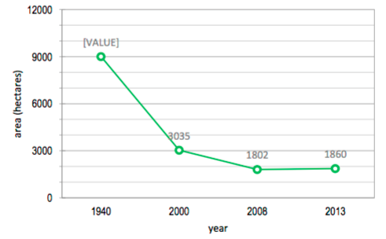  Reasons (of mangrove degradation):  - Fuel wood  - Infrastructure development such as housing/urban development as well as salt and shrimp farming  - Climate change?  - People are not aware of the functions of the mangroves  - Sedimentation impact
External factors | Opportunities:  - NGOs (Roma luan in Atauro MPA, Haburas, Balibo ba oin) initiatives in planting of mangroves  - Cleaning/collecting of the plastics bags every year  - CPLP programs on marine plastic debris  - Local knowledge transfer use of the local customary law “Tara bandu”  - Exchange site visit for local communities and NGOs  - Networking with academia, CTC, WWF, CTI, etc. | Threats:  - Inland deforestation impact through sedimentation impact  - Conflict interest e.g. no taking zones  - Coordination between sectors, NGOs and private beneficiaries  - Climate change

How to make weaknesses (Table 1) become parts of the strength in implementing National Strategic Action Plan? Table 2 shows ways to overcome these weaknesses (Table 1) and how to make it happen.

Weaknesses | Make weaknesses become strengths | How to make this happen
Sustainably financial (from government and donors) | The Government needs to prioritize biodiversity conservation program  There needs to have a co-financing among lines ministerial  Government requires to allocate budget for follow up management/maintenance, monitoring and reporting of the projects including project funded by donors (a big gap)  Increase institutional capacity such as proposal development and project implementation capacity to access to external funds e.g. GEF, GCF etc. GCF readiness | Increase understanding of decision makers to depends mangrove conservation programs  Influence decision makers to make right decision particularly conservation and sustainable use of mangroves  Identify the right person/s and capacity building for person/s on access and implementation of funds from donors
Lack of sectorial coordination | Promote and develop coordination among government institution, NGOs Local communities  All sectors (tourism, agriculture, infrastructure, industry, etc.) must be brought early into the biodiversity conservation and sustainable management process  Strengthening NGO advocacy in biodiversity conservation in general and mangrove in particular  Sectoral program implementation particularly in urban and infrastructure development requires a wider consultation with all stakeholders and use of the Marine Spatial Planning for mangroves | Create regular meetings to coordinate programs at all levels: decision makers, technical (working group discussion from all sectors including private and academia) and grass roots levels including vertical coordination among these levels of coordination
Human resources issues | Improve capacity building strategies & institutional governance of organizations from national to the local level  Promote responsible and sustainable of coastal and marine resource uses to eliminate sources of threats such as pollution, deforestation of mangroves and unsustainable means of fishing  Strengthening awareness raising about the function of mangrove on marine ecosystem, livelihood, social and cultural aspects as well as climate change mitigation and disaster risk reduction  Improve research, monitoring and reporting of the mangroves related activities | Build appropriate capacity for research, data collection/sharing, data analysis and interpretation, monitoring and reporting at all levels  Integrate mangrove conservation into curriculum and involvement of school and universities students in management and conservation activities  Campaign mangrove conservation through dissemination information via pamphlets, board information, Radio, TV, movie, etc.
Law enforcement | The development of specific policy and legislation to protected areas including mangroves is in process  Enforcement national law and policies on nature conservation, pollution and other related concerns, including traditional laws (Tara bandu) | Develop a clear and practical guidelines for implementation of laws and policies
Keep changing in government structures | The government should have “good political willing” .e.g. Put write persons on the write place, based on their background study, skills, etc. | It is suggested that decision makers (high levels) obligate with laws and regulations and transparency in appointing lower institutional leaders i.e. director, head of department, etc.
Harmonize project activities to local, national & regional NGOs and initiatives | Develop Marine Spatial Planning (MSP) and Coastal Spatial Coastal (CSP) of coastal and marine resource uses to eliminate sources of threats such as pollution, deforestation of mangroves and unsustainable means of fishing, mining etc.  CSP includes zoning of the areas based on e.g. vulnerability, mangrove replantation, no fishing and cutting activities, etc. | Develop map with mangrove areas and associated ecosystem including sea grass and coral reefs  Develop CSP zoning for mangrove conservation activities e.g. vulnerability, mangrove replantation, and management activities on sustainable fishing and cutting of mangroves (lifelihood), etc.

The weaknesses and ways to overcome described in Table 1 and Table 2 refer to mangrove conservation and sustainable activities. However, these strategies can be applied to wider biodiversity conservation and sustainable activities as well as access and equitable sharing of benefits arising from the utilization of genetic resources in marine and terrestrial.

Conclusion
- Country needs to have a strong communication and coordination between all stakeholders in designing and implementing NBSAP particularly mangrove conservation to be effective.
- Budget allocation in each responsible sector of the strategic action plan needs to be secured to implement the strategies through integrated management approaches
- improve technical capacity stakeholders including communities in monitoring, data collecting and analysis, management and reporting.

References
UNDP (2017). Building Shoreline Resilience of Timor-Leste to Protect Local Communities and Their Livelihood
RDTL (2011). Biodiversity Strategy and Action Plan of Timor-Leste (2011-2020)
------------

