 |  | CBD
 |  | Distr.  GENERAL  CBD/SBI/2/INF/31  30 June 2018  ENGLISH ONLY
SUBSIDIARY BODY ON IMPLEMENTATION
Second meeting
Montreal, Canada, 9-13 July 2018
Item 5 of the provisional agenda*

Mainstreaming biodiversity in the manufacturing and processing sector – analytical note
Note by the Executive Secretary

Introduction
- In decision XIII/3, paragraph 103, the Conference of the Parties decided to consider, at its fourteenth meeting, the mainstreaming of biodiversity into the sectors of energy and mining, infrastructure, manufacturing and processing, and health. The present information document focuses on the key dimensions of mainstreaming biodiversity into manufacturing and processing industries, briefly presenting this sector and its trends, why it matters for biodiversity conservation and sustainable use, what mainstreaming approaches have been used to date and what gaps need to be addressed.
- This information document complements the note by the Executive Secretary on biodiversity mainstreaming in the manufacturing and processing sector (CBD/SBI/2/4/Add.4) by providing more in-depth information on: (a) the definition of the manufacturing industries, their global status and trends; (b) the interactions between manufacturing and biodiversity, explaining the main impacts and dependencies of various manufacturing industries and identifying the risk areas for biodiversity; and (c) the biodiversity mainstreaming approaches in the manufacturing and processing sector, highlighting best practices, challenges and opportunities.

MAINSTREAMING BIODIVERSITY IN THE MANUFACTURING AND PROCESSING SECTOR

Analytical note on the nexus between biodiversity and the manufacturing and processing sectors, with draft recommendations

Table of contents
Table of contentS ii
List of Tables ii
List of figures iii
1. Introduction 5
2. Manufacturing and Processing: A brief introduction 6
2.1. Defining the manufacturing and processing sectors 6
2.2. From early to modern manufacturing 8
2.3. The economic importance of manufacturing today 11
3. Manufacturing and biodiversity: What interactions? 16
3.1. Inter-dependencies between business and ecosystems 18
3.2. A value chain perspective 20
3.3. Dependencies on ecosystem services of manufacturing industries 23
3.4. Environmental impacts of manufacturing industries 30
3.5. Biodiversity at risk: Which manufacturing industries matter the most? 37
4. Mainstreaming biodiversity in the manufacturing sector: Key approaches and challenges 41
4.1. The CBD and the private sector: A brief historical review 42
4.2. What contributions to the CBD objectives by the manufacturing sector? 44
4.3. Understanding the importance of biodiversity in manufacturing: Measurement and valuation for improved decision-making 49
4.4. Best practices in biodiversity mainstreaming: What opportunities in the manufacturing sector? 55
5. Policy recommendations 60
6. Annex 1 – Further UNSD ISIC Rev. 4 classification details 63

List of Tables
Table 1: Top 10 food processing companies in the world 9
Table 2: Global top 20 ranking of chemical companies in 2016 10
Table 3: The contributions of agriculture, industry, manufacturing and services to Gross Domestic Product worldwide (as % of GDP, from 2005 to 2016) 14
Table 4: Five key industry groups within the manufacturing sector according to six characteristics / needs (McKinsey 2012) 15
Table 5: Impacts and dependencies of different industries on ecosystem services according to the World Business Council on Sustainable Development (WBCSD 2011) 23
Table 6: Main direct and indirect dependencies on FEGS of manufacturing industries (UNSD industry classification) 30
Table 7: Examples of impact drivers linked to business inputs and outputs (adated from Natural Capital Coalition 2016) 33
Table 8: The manufacturing industries presenting major risk of future biodiversity loss 43
Table 9: The world's 10 most threatened forest biodiversity hotspots – what manufacturing industries and companies are implicated through their supply chains? 44
Table 10: Different value perspectives in business natural capital valuation (Natural Capital Coalition 2016) 56

List of figures
Figure 1: Value of the leading 10 textile exporters worldwide in 2016, by country (in billion United States dollars) 8
Figure 2: Passenger car production in selected countries in 2016, by country (in million units) 12
Figure 3: Leading Countries, Value Added in Manufacturing (Billion dollars, 2015) (Levinson 2017). 13
Figure 4: Natural capital / biodiversity, ecosystem and abiotic services and benefits to business and to society (Natural capital Coalition 2016) 18
Figure 5: Cascade model for ecosystem services (Potschin & Haines-Young, 2011) 19
Figure 6: Indicative materiality matrix of ecosystem impacts and dependencies for the value chain of barley used to produce beer 20
Figure 7: Conceptual model between business and ecosystems / natural capital - dependencies and impacts, costs and benefits, risks and opportunities (Natural Capital Coalition 2016) 21
Figure 8: Share of environmental impacts of the Kering supply chains ranked according to supplier type (CGMA 2014) 24
Figure 9: Linkages between ecosystem services and human well-being (MA 2005). 26
Figure 10: Illustration of a production function between the environment and human well-being how Final Ecosystem Goods and Services (FEGS) can be used to delineate the ecological production function from the economic production function. The beneficiary is specific and inherent to the FEGS in the production function (Landers and Nahlik, 2013: 5). 28
Figure 11: Relationships among nature and economic systems (Landers et al., 2016) 29
Figure 12: Generic steps in impact pathways for a chemical industry; highlighting the difference between an impact driver, changes in ecosystem attributes and impacts on human wellbeing / business profitability (Natural Capital Coalition 2016) 33
Figure 13: Water use in the manufacturing industry by activity in Europe countries, 2011 (m³ per inhabitant) 35
Figure 14: Location of the 147 E-PRTR facilities that contributed 50 % of the total damage costs estimated for 2008–2012 in Europe (EEA 2014) 36
Figure 15: Cumulative distribution of the estimated damage costs associated with emissions of selected pollutants from E-PRTR facilities in Europe, 2008–2012 (EEA 2014) 36
Figure 16: Aggregated damage costs of air emissions in Europe by sector, 2008–2012 (EEA 2014) 37
Figure 17: 2016 Environmental Profit & Loss of Kering, highlighting that land use-related impacts are the most significant externalities for the group (24%) and are largely found at the level of tier 4 suppliers (raw material production) where almost 50% of all group impacts occur 39
Figure 19: Mainstreaming natural capital into business decisions according the Natural Capital Coalition 46
Figure 20: Methodological toolbox for an integrated valuation of ecosystem services which considers non-monetary and monetary valuation methods and the value-pluralism (Gómez-Baggethun et al., 2014). 55
Figure 21: From single world views in valuation towards pluralistic valuations (Pascual et al., 2017) 58

Introduction

In decision XIII/3, paragraph 109, the Conference of the Parties decided to consider at its fourteenth meeting the mainstreaming of biodiversity into the sectors of energy and mining, infrastructure, manufacturing and processing, and health. To assist the Secretariat in preparing the foundation for these discussions, the Executive Secretary has commissioned, with the financial support from the European Union, an external consultant on the relationship between biodiversity and the manufacturing and processing sector.

The document provides information regarding:
- The definition of the manufacturing and processing sectors, their global status and trends (section 2);
- The interactions between manufacturing and biodiversity, explaining the main impacts and dependencies of each manufacturing industry and identifying the risk areas for biodiversity (section 3);
- The biodiversity mainstreaming approaches in the manufacturing and processing sector, highlighting best practices, challenges and opportunities (section 4);
- Policy recommendations towards more effective biodiversity mainstreaming n the manufacturing sector (section 5).

An early draft of this document was informed, in part, by stakeholder contributions at a side-event on biodiversity mainstreaming in the manufacturing sector which was held at SBSTTA 21 on December 11, 2017.

Manufacturing and Processing: A brief introduction

Manufacturing and processing industries, hereinafter referred to as “manufacturing industries”, include the processing of the products of various raw material producers into diversified goods, including the products of agriculture, forestry and fishing. Manufacturing is at the heart of our modern economies. Technological and organizational innovations have allowed the sector to diversify (e.g., from food production to the manufacture of chemicals, pharmaceutical products or motor vehicles) and change drastically over the years, for instance in terms of production processes and output volume. This section aims to succinctly present the manufacturing and processing sector. It offers a brief historical account of manufacturing, highlights its current economic importance in the world and identifies key trends influencing its future.

Defining the manufacturing and processing sectors

According to the United Nations Statistics Division (UNSD)’s International Standard Industrial Classification of All Economic Activities, manufacturing “includes the physical or chemical transformation of materials, substances, or components into new products.” Included in this definition are units (plants, factories or mills) that typically use power-driven machines and materials-handling equipment, units that transform materials or substances into new products by hand or in the worker's home and businesses that sell directly to the general public their products made on the same premises from which they are sold (e.g., bakeries and custom tailors). The output of a manufacturing process may be:
- Finished, i.e. ready for utilization or consumption, or
- Semi-finished, i.e. can become an input for further manufacturing.

Five typical manufacturing processes have been identified: Repetitive (dedicated production lines for the same or similar item all year long), discrete (highly diverse environment, ranging from few setups and changeovers to frequent setups and changeovers), “job shop” (production areas, with mostly human labour / limited mechanisation), batch process (analogous to discrete and job shop) and continuous process production (running 24/7 all the time). Most companies use more than one of these environments to get a single product out the door.

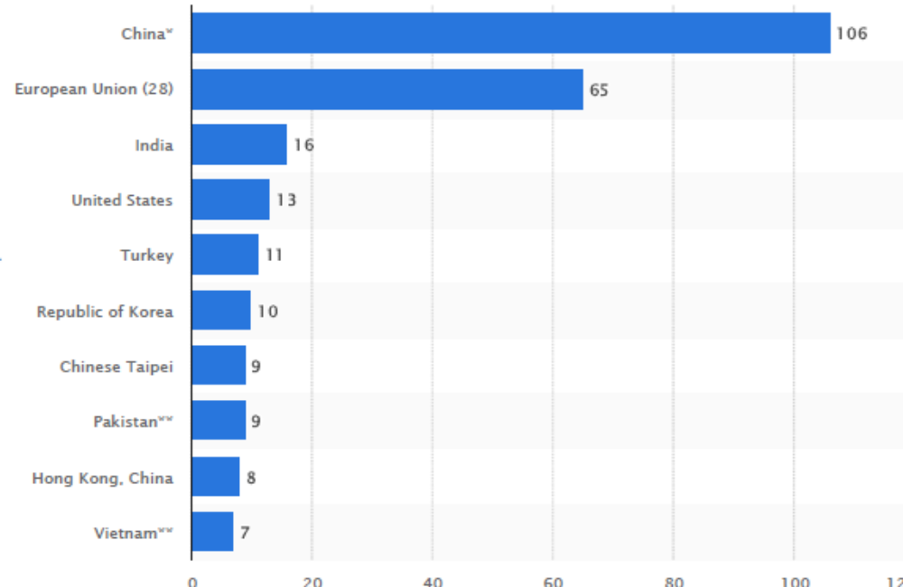
Figure 1: Value of the leading 10 textile exporters worldwide in 2016, by country or region
(in billion United States dollars)

The UNSD classifies manufacturing industries (section C) into the following divisions:
- 10 - Manufacture of food products (see Table 1 for the top 10 companies in the world);
- 11 - Manufacture of beverages;
- 12 - Manufacture of tobacco products;
- 13 - Manufacture of textiles (see Figure 10 for top 10 textile exporters worldwide);
- 14 - Manufacture of wearing apparel;
- 15 - Manufacture of leather and related products;
- 16 - Manufacture of wood and of products of wood and cork, except furniture; manufacture of articles of straw and plaiting materials;
- 17 - Manufacture of paper and paper products;
- 18 - Printing and reproduction of recorded media;
- 19 - Manufacture of coke and refined petroleum products;
- 20 - Manufacture of chemicals and chemical products (see Table 2 for ranking of top 20 companies);
- 21 - Manufacture of basic pharmaceutical products and pharmaceutical preparations;
- 22 - Manufacture of rubber and plastics products;
- 23 - Manufacture of other non-metallic mineral products;
- 24 - Manufacture of basic metals;
- 25 - Manufacture of fabricated metal products, except machinery and equipment;
- 26 - Manufacture of computer, electronic and optical products;
- 27 - Manufacture of electrical equipment;
- 28 - Manufacture of machinery and equipment n.e.c.;
- 29 - Manufacture of motor vehicles, trailers and semi-trailers;
- 30 - Manufacture of other transport equipment;
- 31 - Manufacture of furniture;
- 32 - Other manufacturing;
- 33 - Repair and installation of machinery and equipment.

This classification of manufacturing industries excludes some activities which sometimes involving transformation processes and are classified in other sections of ISIC, such as logging, classified in section A (Agriculture, forestry and fishing) and the beneficiation of ores and other minerals, classified in section B (Mining and quarrying). More detailed explanation of each division is presented in Annex 1.

Table 1: Top 10 food processing companies in the world
Rank | Company | Profit (2013)
1. | Nestlé | CHF 10.02 billion
2. | PepsiCo | US$ 6.74 billion
3. | Kraft | US$ 2.715 billion
4. | Anheuser-Busch InBev | US$14.394 billion
5. | Coca-Cola | US$ 9.01 billions
6. | JBS S.A | US$ 392.2 million
7. | Archer Daniels Midland | US$ 1.223 billion (FY 2012)
8. | Unilever | €5.3 billion
9. | Mars, Inc | US$33 billion (2014)
10. | Tyson Foods, Inc | US$ 778.0 million

From early to modern manufacturing

Before the invention of heavy machinery and automation, manufacturing was exclusively undertaken through manual activities. Skilled tradespeople were responsible for each major step of the manufacturing process, from product design to production. Key characteristics of early manufacturing systems included:
- The involvement of only the most skilled workers, with parents often passing down their skills to their children;
- Most skilled trades were performed locally and rurally, which could only support so many workers and output volumes;
- Apprenticing was often seen as an effective way for knowledge (e.g., quality) to be passed down correctly.

There were several key innovations that progressively led to industrialised societies, including but not limited to:
- The emergence of the division of labour: Collectives of manufacturers under one business hub were progressively set up, with central providers sub-contracting specific orders to rural manufacturers, spreading the workload among tradespeople and giving those tradespeople a wider customer base.
- The development of interchangeable parts led to reduced downtime, efficient labour usage and mass production. Similarly, fixtures, jigs and gauges paved the way for identical parts to be manufactured quickly and correctly before being passed along to less-skilled assembly workers.
- When water and steam power enabled production to be undertaken independently of human labour, specialized machines began replacing specialized people. The increase in machine efficiency and the reduced skill of workers led to drops in the cost of labour and cheaper products.
- The discovery and mainstreaming of electricity eventually allowed factories to be built anywhere power was available and the locations were now chosen based on the price of labour and the cost of shopping, so that many factories ended up being built near cities with harbours and railroads.

Such innovations emerged during the Industrial Revolution, which covered a period ranging from about 1740 to about 1850 in Britain and from 1815 to the end of the nineteenth century in Europe. However, the term “Revolution” is misleading for describing a complicated series of forces, processes and discoveries which worked very slowly but gradually in various industries (e.g., textiles, coal, iron, steel, petroleum) and created a new economic organization which is still spreading throughout the world (e.g., Roser 2016).

Table 2: Global top 20 ranking of chemical companies in 2016
1 | BASF, Germany / Diversified
2 | Dow Chemical, United States / Diversified
3 | Sinopec, China / Petrochemicals
4 | SABIC, Saudi Arabia / Petrochemicals
5 | Formosa Plastics, Chinese Taipei / Petrochemicals
6 | ExxonMobil, United States / Petrochemicals
7 | LyondellBasell, Netherlands / Petrochemicals
8 | Ineos Group Holdings, Switzerland / Petrochemicals
9 | Mitsubishi Chemical, Japan / Diversified
10 | DuPont, United States / Diversified
11 | Air Liquide, France / Industrial gases
12 | LG Chem, Republic of Korea / Diversified
13 | Toray Industries, Japan / Diversified
14 | Linde Germany / Industrial gases
15 | AkzoNobel, Netherlands / Diversified
16 | PPG Industries, United States / Diversified
17 | Evonik Industries, Germany / Diversified
18 | Reliance Industries, India / Petrochemicals
19 | Braskem, Brazil / Petrochemicals
20 | Sumitomo Chemical, Japan / Petrochemicals

The recent globalization of our economies, which started in the second half of the 20th century, was directly supported by the invention of containerized shipping. Raw materials could now be quickly processed at one location, shipped to factories and manufactured elsewhere, before being shipped again to the customers (e.g., motor vehicles). This meant that companies started to seek the locations with the lowest costs, notably labour costs.

This rise of modern manufacturing was further coupled to other key innovations, including but not limited to:
- Improved communications through the Internet;
- Just-in-time and lean manufacturing which eliminate waste and reduce flow times;
- Prefabrication which saves on time by shipping fully assembled or partially assembled units directly to the site where they will be used;
- Flexible manufacturing systems which allow for systems to react in case of predicted or unpredicted changes to workflow;
- Robotic systems cut down on labour costs, human error, and lag time between steps in the assembly process.

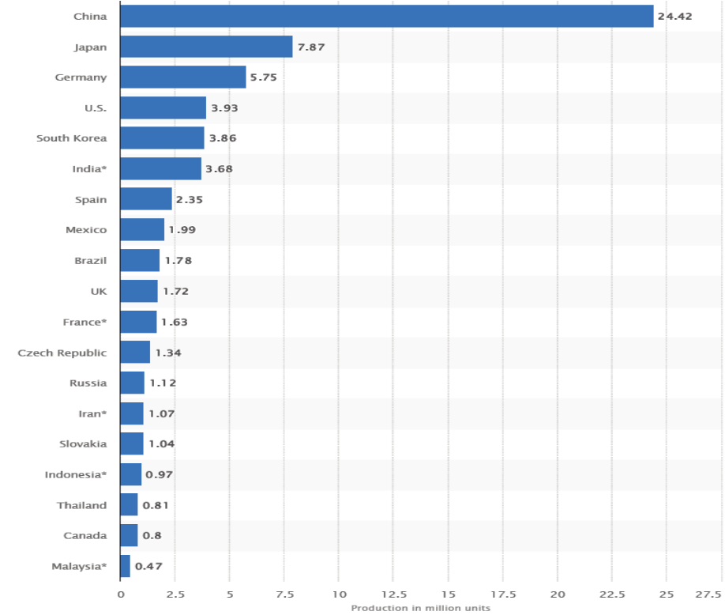
Figure 2: Passenger car production in selected countries in 2016, by country
(in million units)

The economic importance of manufacturing today

Key messages:
- Manufacturing industries account for approximately 15% of global Gross Domestic Product (GDP) over the past few years;
- There is significant spatial disparity in manufacturing output and industry growth prospects across countries;
- The main GDP manufacturing countries are, in decreasing order of global share in manufacturing GDP, China, United States, Japan, Germany and Republic of Korea (more than 50% of global manufacturing GDP).

According to the World Bank, manufacturing accounted for approximately 15% of global Gross Domestic Product (GDP) in 2016 (Table 3). Though there are some disparities across regions (e.g., lower share of GDP of the manufacturing sector for low income and sub-Saharan African nations on average), the share of GDP of the manufacturing sector has been decreasing progressively throughout the world over the last decade (from an 18% share of GDP in 2005), notably due to the rise of the services sector. As illustrated in Figure 3, manufacturing is concentrated in a limited number of countries, with often the co-location/clustering of industries and complementary industries in specific regions.

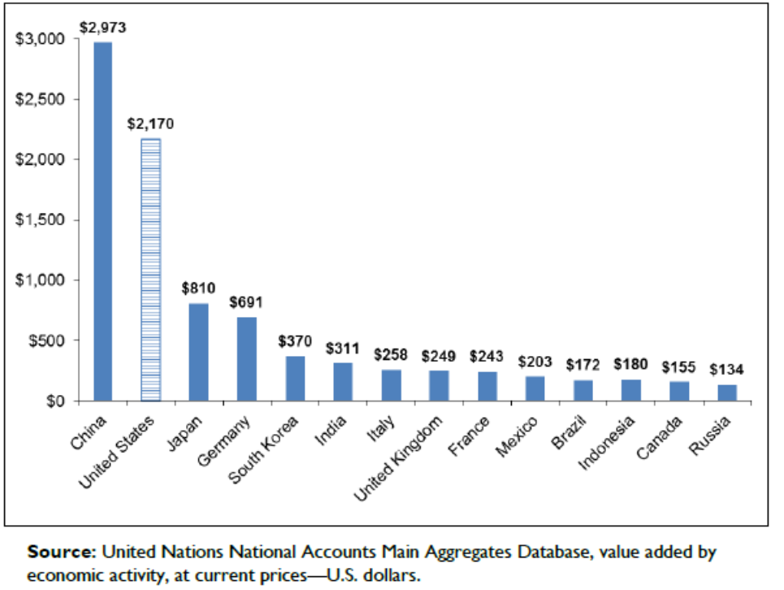
Figure 3: Leading Countries, Value Added in Manufacturing (Billion dollars, 2015) (Levinson 2017).

According to the International Labour Organization (ILO), manufacturing accounted for 23% of total employment worldwide in 2012. It was then projected to account for 24% of total employment worldwide by 2018.

Table 3: The contributions of agriculture, industry, manufacturing and services to Gross Domestic Product worldwide (as % of GDP, from 2005 to 2016)
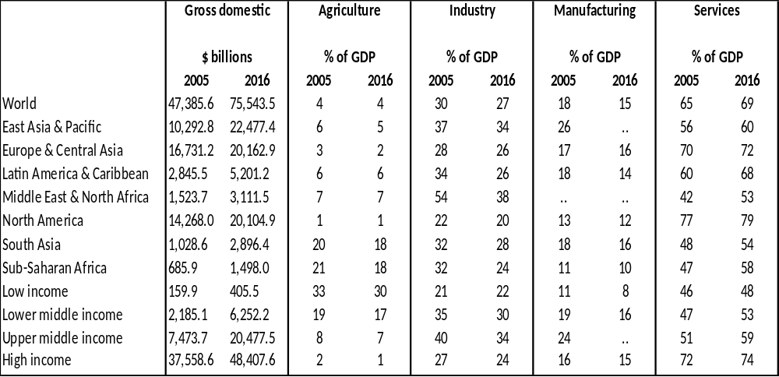

Moreover, the characteristics (e.g., research and development intensity, labour intensity, energy intensity) of industries within the manufacturing sector vary greatly, so that industries may be grouped into five categories according to McKinsey (2012) (Table 4): i.e., global innovation for local markets (34% of global manufacturing value added), regional processing (28% of global manufacturing value added), energy and/or resource intensive commodities (22% of global manufacturing value added), global technologies / innovators (9% of global manufacturing value added) and labour intensive tradable (7% of global manufacturing value added). The ownership of manufacturing companies is complex, varying from family owned businesses to multinationals listed on stock exchanges.

Table 4: Five key industry groups within the manufacturing sector according to six characteristics / needs (McKinsey 2012)
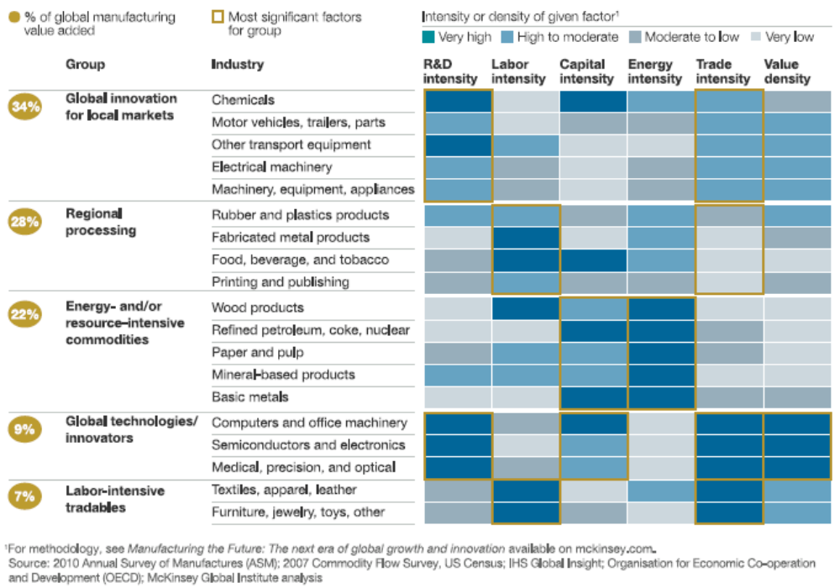

The importance of the manufacturing sector varies considerably across countries and industries. For instance, around 1 in 10 (9.0 %) of all enterprises in the EU-28’s non-financial business economy were classified to manufacturing in 2014, a total of 2.1 million enterprises: The EU manufacturing sector employed 29.9 million persons and generated EUR 1,710 billion of value added in 2014. In Nigeria, manufacturing remains at a relatively early stage of development, contributing only around 7% of GDP in 2013, but with output rising by 13% per year from 2010 to 2013. Based on current trends, this could yield a four-fold increase in manufacturing output by 2030 (PwC 2015). In the United Kingdom conversely, in recent years, the relative share of manufacturing in the economy has declined more rapidly than in other developed economies while the service sector has grown at a faster rate. United Kingdom manufacturing performance has been weak relative to international competitors in some key areas (Foresight 2013):
- Expenditure on manufacturing R&D has been low, especially with regard to new products;
- The level of investment in capital equipment has been relatively low for many decades;
- The United Kingdom’s share of global manufacturing exports has fallen from 7.2% in 1980 to 2.9% in 2012.
At the other hand of the spectrum, China is arguably the world's most important manufacturer, with its manufacturing GDP rising from about 385 US$ Billions in 2000 to 2857 US$ Billions in 2015. China makes and sells more manufacturing goods than any other country on the planet (e.g., Gao 2012).

2.3 What future for manufacturing?

Recently, global economic growth has been weak (UNCTAD 2016), growing at a rate below 2.5 per cent, and global trade slowed down dramatically to around 1.5% in 2015 and 2016, compared to 7% before the crisis. While global value chains remain concentrated among a relatively small number of countries, the manufacturing sector is looking for growth opportunities, by notably putting significant investment into research and development and new markets (e.g., KPMG International’s 2016 Global Manufacturing Outlook). According to UNIDO (2013; 2017), the megatrends affecting the “advanced manufacturing” industries include:
- Continuing ageing of the workforce in some developed countries, which is expected to challenge lifestyles and consumption patterns as well as to diminish the size of the available workforce for manufacturing;
- Changing manufacturing skills needs, which, combined with ageing populations, is already leading to a shortage of qualified manufacturing labour in some regions;
- Growing demand for customized products and services according to consumers’ individual specifications is becoming critical for market and value capture for companies around the world;
- Increasing demand for manufactured goods in cities, notably in the context of growing demand for urban mobility, energy, housing and telecommunication solutions;
- Growing interest in industrial and technological strategies by governments across both emerging and high-wage economies;
- Increased efforts to support reshoring to developed countries, as a potential strategy to expand the domestic manufacturing base and foster high-wage job creation, innovation and exports.

In addition, according to Hallward-Driemeier and Naygar (2018), The Internet of Things (IoT), advanced robotics, and 3-D printing are shifting the criteria that make locations attractive for production and are threatening significant disruptions in employment, particularly for low-skilled labour. For instance, an increasing number of companies process materials and manufacture finished products at the site of final use (e.g., building and assembling bridge components on-site), which has major implications for logistical networks.

Manufacturing and biodiversity: What interactions?

This section aims to unpack the interactions between manufacturing and biodiversity. It briefly covers (a) the inter-dependencies between business and biodiversity, (b) the interactions of manufacturing and biodiversity from a value chain perspective, (c) the dependencies of manufacturing industries on ecosystem services, (b) the environmental impacts of manufacturing industries and (c) the main risks for biodiversity in the future due to manufacturing trends.

According to the Natural Capital Protocol (Natural Capital Coalition 2016: 2), “natural capital can be defined as the stock of renewable and non-renewable natural resources (e.g., plants, animals, air, water, soils, minerals) that combine to yield a flow of benefits to people” (adapted from Atkinson & Pearce, 1995 and Jansson et al., 1994) (Figure 4). These benefits relate to the concept of ecosystem services, which was popularised by the 2005 Millennium Ecosystem Assessment (MA).

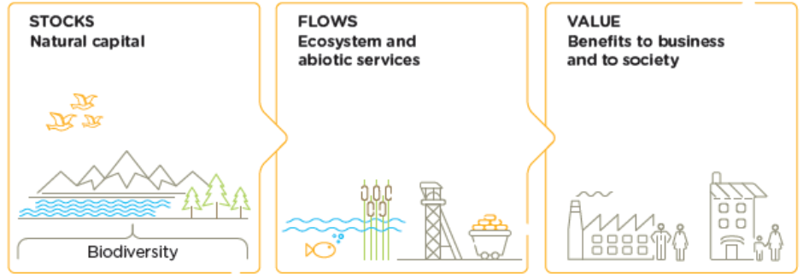
Figure 4: Natural capital / biodiversity, ecosystem and abiotic services and benefits to business and to society (Natural capital Coalition 2016)

Framing nature as ‘natural capital’ is a way of looking at ecosystems from an economic perspective, with living and non-living elements of the environment seen as a ‘stock’ or an ‘asset’ from which numerous benefits flow in the form of ecosystem services. In this context, biological diversity (i.e. thereafter referred to as “biodiversity”) can be understood as a key component of natural capital, with many of its dimensions (inter-)acting as enablers of ecosystem functions, processes and services (e.g., in reference to the cascade model – see Figure 5).

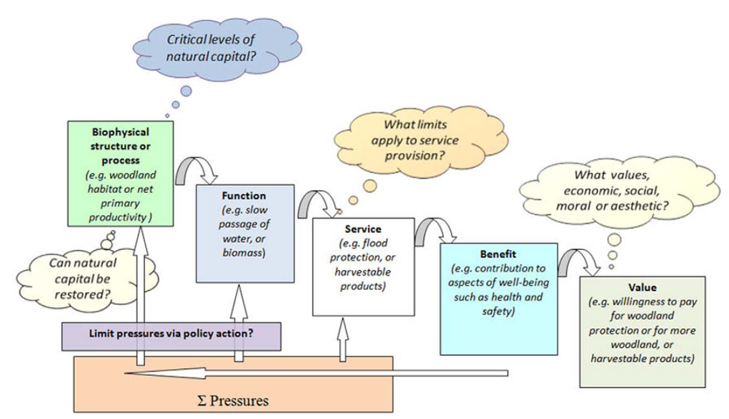
Figure 5: Cascade model for ecosystem services (Potschin & Haines-Young, 2011)

Inter-dependencies between business and ecosystems

Key messages:
- All businesses both depend and impact, directly and indirectly, on ecosystems;
- Ecosystem components can be divided into renewable (requiring stewardship for continued availability) and non-renewable (requiring responsible management while they’re being depleted) assets or stocks;
- Business impacts and dependencies on ecosystems create costs and benefits for business and society, generating risks but also creating opportunities.

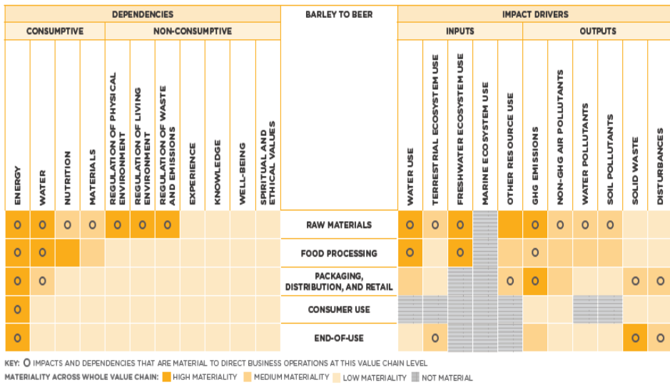
Figure 6: Indicative materiality matrix of ecosystem impacts and dependencies for the value chain of barley used to produce beer

All businesses both depend and impact, directly and indirectly, on ecosystems (Figures 2 and 3) and the associated services (Hanson et al., 2012; Houdet et al., 2012; TEEB 2012). This can be illustrated by the barley-to-beer value chain (Figure 6), which involves different impacts and dependencies on ecosystems at each step, from raw material production (e.g., water use) to end of use (e.g., solid waste). Yet, such interactions do not all have the same consequences as ecosystem components can be divided into renewable and non-renewable assets or stocks. While metals and minerals are non-renewable ecosystem assets (e.g. coal) whose exploitation can only lead to their eventual depletion, renewable ecosystem assets, such as water resources and populations of species, can (theoretically) be sustainably managed in perpetuity (i.e., concept of sustainable use of biodiversity).

This inter-dependency between business and ecosystems creates costs and benefits for business and society, generating risks but also creating opportunities (Figure 7). Ecosystem impacts and/or dependencies can directly affect business operations, which can generate positive (e.g., lower input costs) or negative effects (e.g., discontinued supply of raw materials, water shortages) (Natural Capital Coalition 2016). Simultaneously, these impacts / dependencies can also positively (e.g., improved water quantity and quality due to business’ efforts to sustainably manage its watershed) or negatively (e.g., air emissions) impact on particular stakeholders or on society as a whole. Eventually, stakeholder and societal responses to these effects can create additional risks and opportunities to businesses.

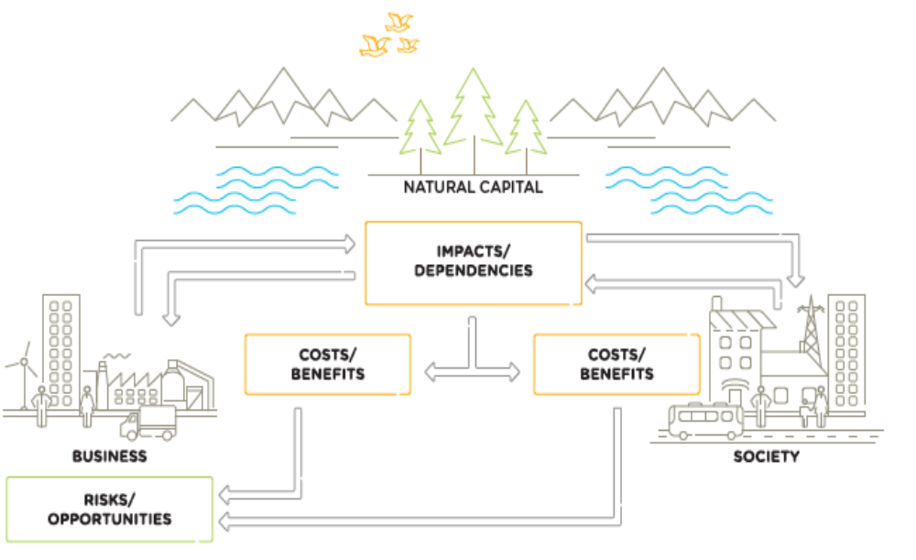
Figure 7: Conceptual model between business and ecosystems / natural capital - dependencies and impacts, costs and benefits, risks and opportunities (Natural Capital Coalition 2016)

A value chain perspective

Key messages:
- Manufacturing companies play a critical role in global supply / value chains, operating in close interactions with raw material producers and retailers;
- Manufacturing companies are responsible for a significant share of global resource consumption and environmental impacts;
- Manufacturing impacts and dependencies on ecosystems are both direct (e.g., at the level of manufacturing plants) and indirect (e.g., at the level of suppliers, such as raw material producers and transport companies);
- Manufacturing companies are thus both direct and indirect drivers of ecosystem change and biodiversity loss.

Manufacturing industries have significant impacts on ecosystems and human health (UNEP 2011). Manufacturing is responsible for around 35 per cent of global electricity use, over 20% of CO₂ emissions and over a quarter of primary resource extraction. It also accounts for up to 17 per cent of air pollution-related health damage, with estimates of gross air pollution damage ranging from 1 to 5 per cent of global GDP. Water use by industry is expected to grow to over 20 per cent of global total demand by 2030 (UNEP 2011).

What makes the manufacturing sector unique with respect to its interactions with ecosystems? As illustrated in Table 5, the impacts and dependencies on ecosystem services vary across industries: The manufacturing sector is linked primarily to provisioning services (i.e. dependencies / impacts on raw materials for various manufacturing processes) and some regulating services (e.g., water regulation and purification services of wetlands for a beverage factory). However, the nature of relationships between ecosystems and manufacturing activities is not homogenous across industries. Due to the role of manufacturing in global value chains, manufacturing businesses are typically not in direct contact with raw material extraction / production and consumption, so that many of their impacts and dependencies on natural capital are indirect.

Table 5: Impacts and dependencies of different industries on ecosystem services according to the World Business Council on Sustainable Development (WBCSD 2011)
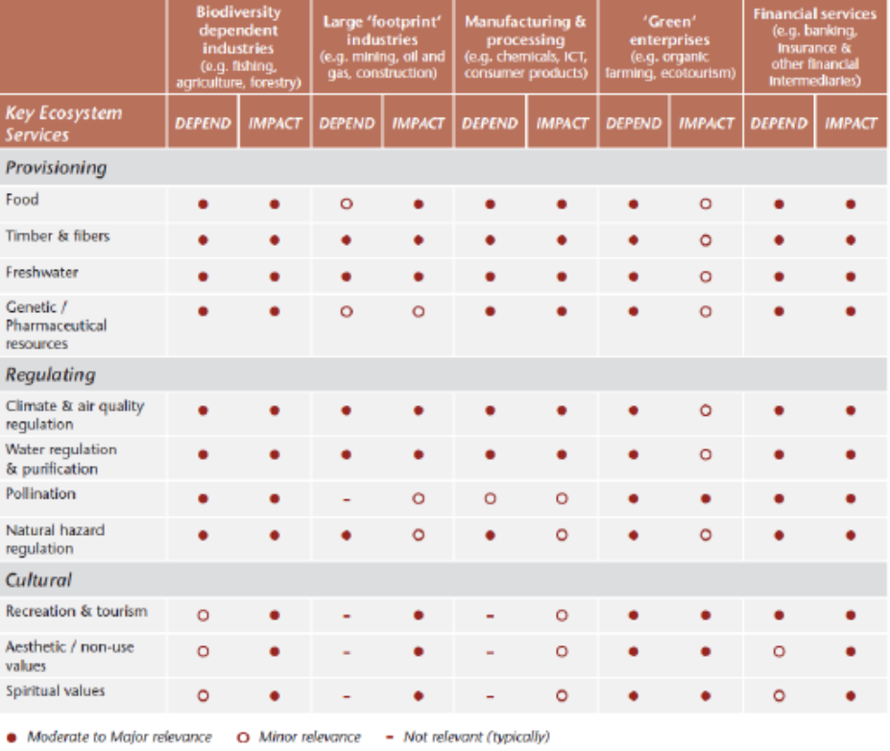

As illustrated by the Environmental Profit & Loss Statement of Puma (Figure 8), a sport and lifestyle brands, the majority of environmental impacts (57%) occur at the level of tier 4 suppliers (i.e. raw material producers such as cotton farmers). Manufacturers (tier 1 - manufacturer, tier 2 – outsourced processors and tier 3 – raw material processors) involved in Puma’s supply chains account for a lower share of environmental impacts (about 37%). However, they all rely on tier 4 suppliers to produce the goods sold by Puma to consumers worldwide.

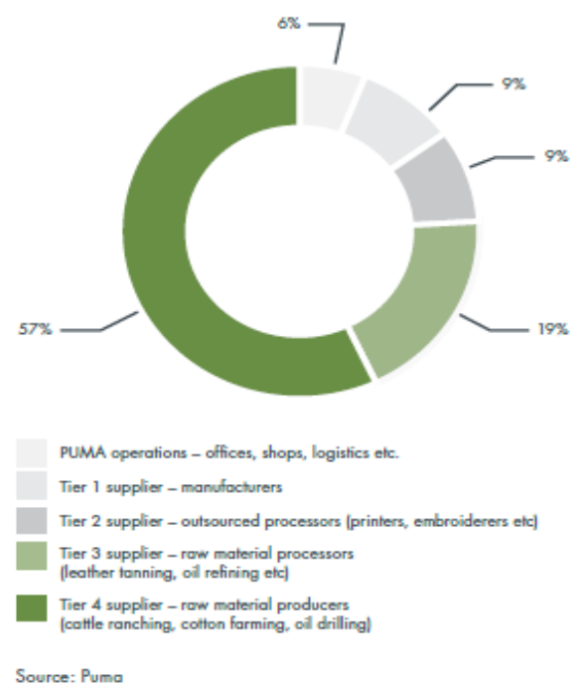
Figure 8: Share of environmental impacts of the Kering supply chains ranked according to supplier type (CGMA 2014)

Dependencies on ecosystem services of manufacturing industries

Key messages:
- They are several classifications of ecosystem services, each with its implications for measurement, valuation and decision-making. A critical concept to move forward in biodiversity mainstreaming is that of a Final Ecosystem Goods and Services (FEGS), which refers to the final product ‘produced’ by ‘natural environments’ with which a human beneficiary or a company interacts directly.
- Manufacturing companies have few direct interactions with the ‘natural’ environment: e.g., water extraction from an aquifer or river at a factory, ecosystems acting as recipients of air and water emissions from a manufacturing plant.
- The concept of indirect dependencies on ecosystem services is particularly important for manufacturers. Some manufacturers rely on the supply of renewable, biological raw materials (e.g., fibres, foods) while others use genetic resources and associated traditional knowledge, including the pharmaceutical, agriculture, industrial biotechnology, cosmetics, botanicals, and food and beverage sectors. In this context, FEGS are typically found at the suppliers of raw materials.
- This spatial and temporal distance between manufacturing companies and FEGS may partially explain the lack of recognition of the importance of ecosystem services by many manufacturing industries.

Attempting to understand and quantify the dependencies on biodiversity and ecosystem services of the manufacturing sector is not straightforward. This implies choosing an ecosystem services classification system, which has direct consequences for measurement, valuation and decision-making.

In 2005, the MA proposed four general types of ecosystem services (Figure 9):
- Supporting services: The natural processes that underlie and maintain other ecosystem services (e.g., nutrient cycling, primary production);
- Provisioning services: The goods or products from ecosystems used by people (e.g., water, timber, food);
- Regulating services: The benefits people receive from an ecosystem functioning to regulate natural processes (e.g., erosion control, temperance of flooding);
- Cultural services: The non-material human benefits from ecosystems (e.g., recreation, inspiration).
These broad categories of ecosystem services quickly gained world-wide recognition, and have been explicitly mentioned in (or adopted by) various corporate valuation guidance documents, such as The Guide to Corporate Ecosystem Valuation (WBCSD 2011).

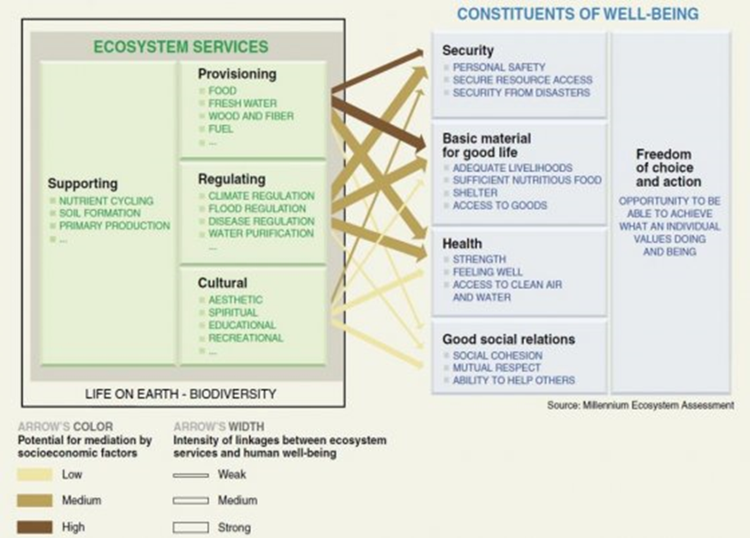

Figure 9: Linkages between ecosystem services and human well-being (MA 2005).

Yet, numerous efforts were made to further detail and classify different types of “ecosystem services” for improved valuation, accounting and / or decision-making (Liquete et al., 2013), including (but not limited to) The Economics of Ecosystems and Biodiversity (a 22-ecosystem-service “typology”; TEEB 2012) and The Common International Classification of Ecosystem Services (CICES) (Haines-Young and Potschin, 2013). This notably involved the differentiation of the broad notion of “ecosystem services” into ecosystem processes and functions (sometimes referred to as “intermediate ecosystem services”) and “final ecosystem goods and services” (FEGS) (e.g., Boyd and Banzhaf, 2007).

FEGS are the final (i.e., end) product ‘produced’ by ‘natural’ environments with which a human beneficiary (or a company) interacts directly (Landers and Nahlik, 2013). This means that the benefits of FEGS cannot be realized by companies without some varying amount of input of labour and capital goods (i.e., to produce conventional goods and services) (Boyd and Banzhaf 2007) (Figures 10 and 11). FEGS are free in themselves. What companies pay for typically include rights of access / use and the costs of labour and capital goods.

For instance, soils are the ecological foundation for producing food and fibre and are FEGS. Soil “health” may be measured using several indicators (e.g., bulk density, reactive carbon, soil enzymes, earthworms, etc.) (Landers et al., 2016). Farmers (i.e. beneficiaries) directly interact with soil to produce various crops (i.e. benefits). This means that many renewable living resources (e.g., crops, cattle, fish farmed, tree plantations) originally considered to be ecosystem services are not FEGS. They are not naturally occurring in the environment, they require significant and quantifiable inputs of human labour and capital and are already accounted for in business and national industrial accounts.

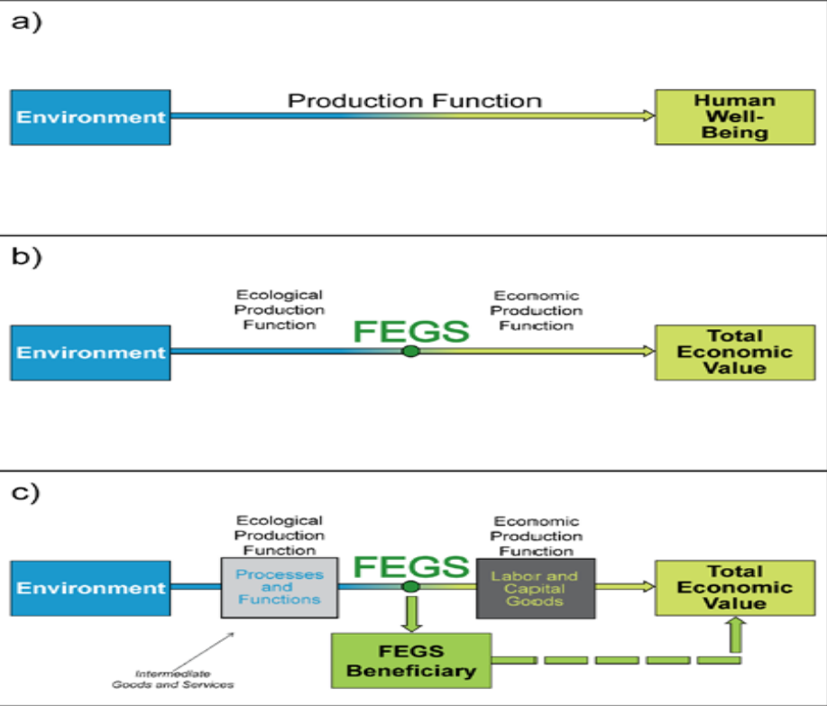
Figure 10: Illustration of a production function between the environment and human well-being how Final Ecosystem Goods and Services (FEGS) can be used to delineate the ecological production function from the economic production function. The beneficiary is specific and inherent to the FEGS in the production function (Landers and Nahlik, 2013: 5).

What does this mean for the manufacturing sector and its dependencies on biodiversity and ecosystem services?
- Firstly, the concept of FEGS (notably that of an ecological end-point; Figures 10 and 11) highlights that manufacturing companies have few direct interactions with the ‘natural’ environment. FEGS are few (or often absent) at the level of manufacturing activities, as varying quantities of labour and capital goods are required to capture the benefits from FEGS. FEGS are typically found interacting with suppliers of raw materials (i.e. resource extractors / producers).
- Secondly, the concept of FEGS enables us to explain, quantify and value the intricate inter-connectedness between natural ecosystems and the globalized economy, including manufacturing industries and their global value chains. For instance, without FEGS exploited by Tier 4 suppliers throughout the world (e.g., cattle, crocodile, cashmere or cotton farmers), Kering, a designer and retailer of luxury brands, would not be in a position to sell its products worldwide and make a profit from it. Accordingly, the concept of indirect dependencies on ecosystem services is particularly important for manufacturers. Many resources used by manufacturers are benefits derived from compound production between environmental and economic systems (e.g. leather, rubber, foods).
- Thirdly, these limited direct interactions between manufacturers and ecosystem services may partially explain the lack of recognition of the importance of ecosystem services by many companies (e.g., there are very few valuation studies on the ecosystem dependencies of manufacturing activities / companies). Humans do not protect or sustainably manage what they do not value. Humans cannot value what they do not measure. And humans do not measure what they cannot or do not see…

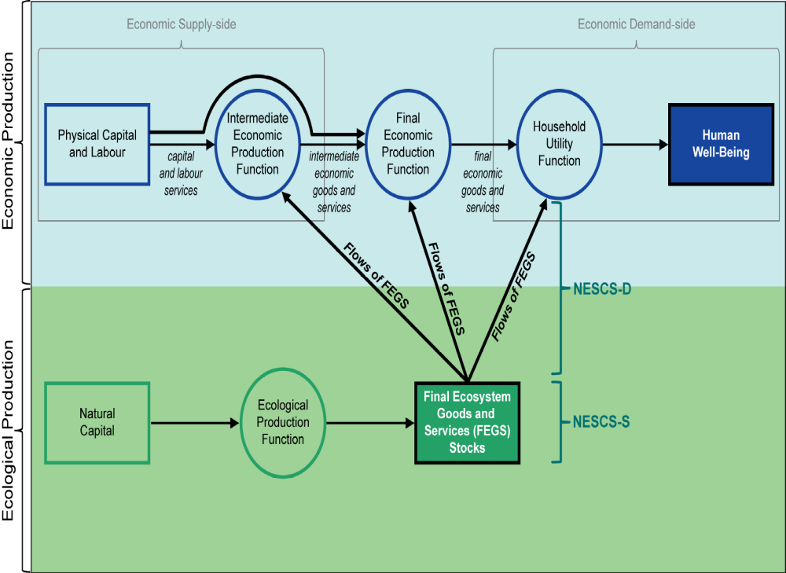
Figure 11: Relationships among nature and economic systems (Landers et al., 2016)

Table 6 summarizes the main direct and indirect dependencies on FEGS of various manufacturing industries, classified according the UNSD industry classification mentioned in section 2.1. Direct dependencies of many manufacturing industries on ecosystem services are often limited to water and the presence of the environment as a recipient for emissions / discharges (apart from a few exceptions where manufacturers also own assets involved in the production or extraction of raw materials). Indirect dependencies linked to the activities of manufacturing suppliers are more diverse and complex, contingent to the type of raw material extracted or produced for manufacturing transformation. Some manufacturers rely on the supply of renewable, biological raw materials (e.g., fibres, foods) while others use genetic resources and associated traditional knowledge, including the pharmaceutical, agriculture, industrial biotechnology, cosmetics, botanicals, and food and beverage sectors,.

Table 6: Main direct and indirect dependencies on FEGS of manufacturing industries (UNSD industry classification)
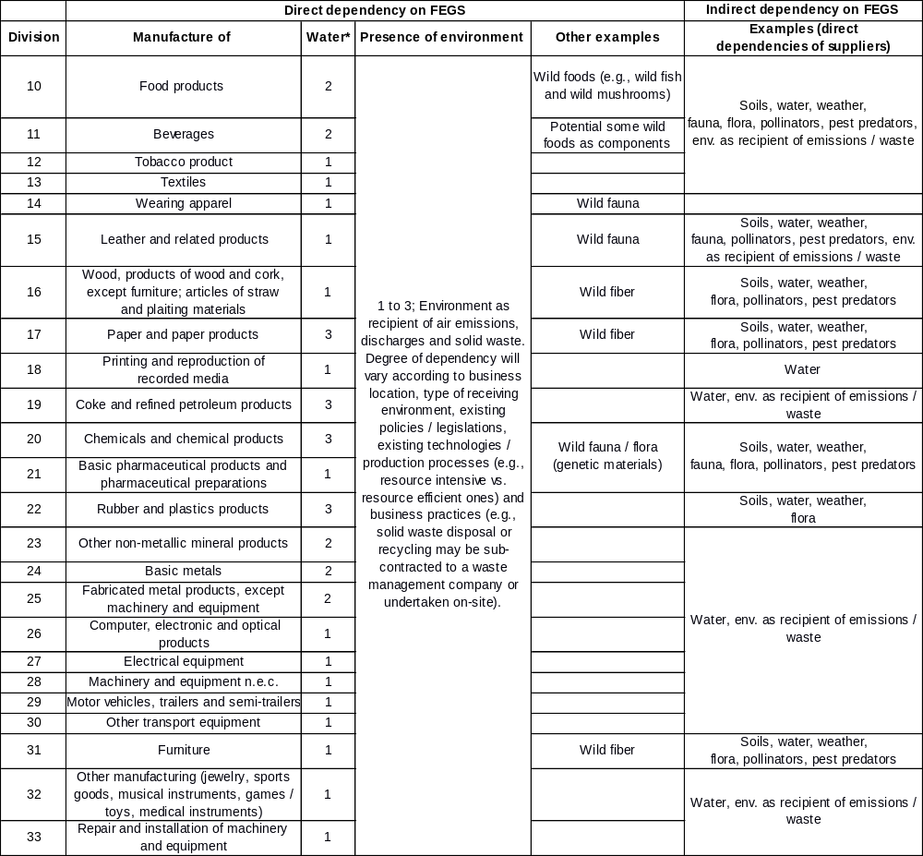
* Rating of importance: 1 – limited, 2 – medium, 3 – critical; Qualitative assessment based on data from Eurostat Statistics

A case study from Dow Chemical presents a good illustration of the importance of the “presence of the environment” as a FEGS (i.e. as a recipient for wastewater) for manufacturing industries. The company funded a study to investigate a business decision made in 1995, where a constructed wetland was built instead of a sequencing batch reactor to solve a regulatory compliance issue for a wastewater treatment system at the group’s Union Carbide Corp. plant in Seadrift, Texas (i.e. it was required to meet specific suspended solids requirements) (DiMuro et al., 2014). The study highlighted that:
- The total net present value savings for implementing the constructed wetland instead of the sequencing batch reactor were around $282 million over the project's lifetime;
- Lower energy and material inputs of the constructed wetland resulted in lower potential impacts for fossil fuel use, acidification, smog formation, and ozone depletion;
- The upstream land burdens (for the sequencing batch reactor) and the on-site acreage of the constructed wetland were similar in magnitude and importance, contrary to the assumption that green infrastructure always requires greater land area.

Environmental impacts of manufacturing industries

Key messages:
- All impact drivers interact with ecosystems (e.g., greenhouse gas emissions leading to climate change and hence changes in ecosystem processes and dynamics) and can lead to indirect changes in biodiversity patterns (e.g., climate change leading to changes in the spatial distribution of species);
- Some impact drivers (e.g., resource extraction, land use change) lead to direct, immediate changes in biodiversity (i.e. loss of habitats and species).
- Most governments and companies focus on measuring impact drivers rather than impacts in themselves;
- The impact drivers of each manufacturing industry vary widely, and are linked to the specificies of their production inputs (e.g., renewable and non-renewable resource use) and non-product outputs (e.g., air and water emissions);
- Impact drivers linked to non-product outputs can be traced down to specific manufacturing plants throughout the world. For instance, 50% of total damage costs of air emissions can be attributed to only 147 facilities in Europe and 90% of these costs to only 1 529 facilities; though not all belong to the manufacturing sector.
- Some impact drivers linked to production inputs (indirect ecosystem dependencies) lead to direct biodiversity impacts and are attributable to suppliers of raw materials (e.g., deforestation due to agricultural supply chains).

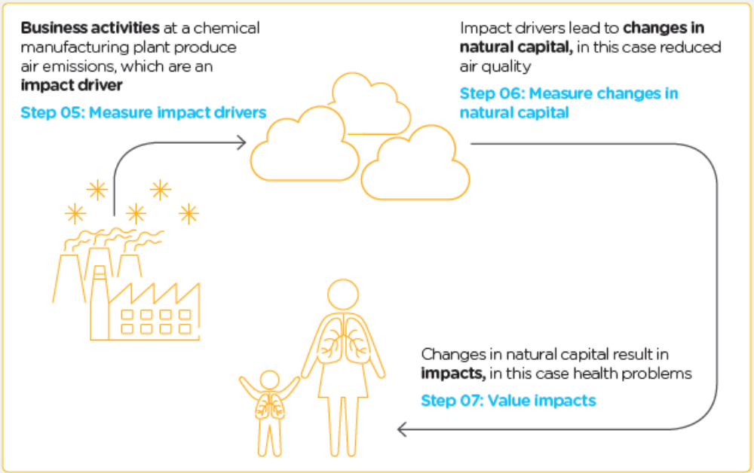
Figure 12: Generic steps in impact pathways for a chemical industry; highlighting the difference between an impact driver, changes in ecosystem attributes and impacts on human wellbeing / business profitability (Natural Capital Coalition 2016)

Distinguishing between an impact driver and an actual impact is critical to understanding the environmental impacts of manufacturing industries (Figure 12). An impact driver can be:
- A measurable quantity of an ecosystem component used as an input to production (e.g., volume of water used for cooling in a factory) or
- A measurable non-product output of a business activity (e.g., tons of greenhouse gas emissions).
An impact is a change in the quantity or quality of an ecosystem component or attribute, which occurs as a consequence of an impact driver, and may lead to changes in human well-being or organizational viability / profitability. In other words, environmental impacts are the negative or positive effect of business activity on ecosystems, including biodiversity (e.g., decrease in the population of a plant species is a negative impact of land use change / habitat transformation, which are both impact drivers). In addition, a single impact driver may be associated with multiple impacts and several impact drivers may act in synergy and result in a specific ecosystem change. Table 7 presents a high level list of impact drivers.

Table 7: Examples of impact drivers linked to business inputs and outputs (adated from Natural Capital Coalition 2016)
Business input or output | Impact driver category | Examples of specific, measurable impact drivers
Inputs | Renewable and non-renewable resource use | Weight of wild-caught fish / mammal by species, weight of wild fruits by species, volume / weight of wood / fibre / animal parts harvested per species, weight of mineral extracted, volume of water extracted
Inputs | Terrestrial ecosystem use | Area of agriculture by type, area of forest plantation by type, area of open cast mine by type, etc.
Inputs | Fresh water ecosystem use | Area of wetland, ponds, lakes, streams, rivers or peatland necessary to provide ecosystem services such as water purification, fish spawning etc., areas of infrastructure necessary to use rivers and lakes such as bridges, dams and flood barriers, etc.
Inputs | Marine ecosystem use | Area of aquaculture by type, area of seabed mining by type, etc.
Non-product outputs | GHG emissions | Volume of carbon dioxide (CO2), methane (CH4), nitrous oxide (N2O), sulphur hexafluoride (SF6), hydrofluorocarbons (HFCs) and perfluorocarbons (PFCs), etc.
Non-product outputs | Non-GHG air pollutants | Volume of fine particulate matter (PM2.5) and course particulate matter (PM10), volatile organic compounds (VOCs), mono-nitrogen oxides (NO and NO2, commonly referred to as NO2), sulphur dioxide (SO2), carbon monoxide (CO), etc.
Non-product outputs | Water pollutants | Volume discharged to receiving water body of nutrients (e.g., nitrates and phosphates) or other substances (e.g., heavy metals and chemicals).
Non-product outputs | Soil pollutants | Volume of water matter discharged and retained in soil over a given period.
Non-product outputs | Solid waste | Volume of waste by classification (i.e., non-hazardous, hazardous and radioactive), by specific material constituents (e.g., lead, plastic), or by disposal method (e.g., landfill, incineration, recycling, specialist processing).
Non-product outputs | Disturbances | Decibels and duration of noise, lumens and duration of light etc., at site of impact.

Companies and governments tend to focus on measuring impact drivers rather than assessing impacts in themselves. While detailed accounts of environmental impact drivers and / or impacts per industry type are difficult to find (overlooking data gaps, most reports compile data at a national level or per type of environmental impact driver), there are evidence that some manufacturing industries generate more impact drivers (and hence supposedly impacts) than others. For instance, here are some statistics for the EU 27 states (AMEC 2014):
- Air emissions in 2010:
  - Arsenic: Most of the emissions (6.2 tonnes) were emitted by activities such as the production of non-ferrous metals (3.2 tonnes) and the production of pig iron and steel (2.5 tonnes).
  - Lead: A total of 507.2 tonnes of lead were emitted by activities related to the production and processing of metals in the EU27 states, including the production of pig iron and steel (216 tonnes), metal ore roasting (37 tonnes) and the processing of non-ferrous metals (around 30 tonnes).
  - Polycyclic Aromatic Hydrocarbons (PAHs): The main source was the production of paper and cardboard (8 kt, 82% of total PAH emissions).
  - SOx emissions: The production and processing of metals contributed 5% of total emissions (202 kt) while the mineral industry gneerated 3% of total emissions (114 kt). The chemical industry (organic and inorganic chemicals) generated 50 kt.
- Water emissions in 2010:
  - Chlorides: The majority of the emissions (61%; (10 235 810 t) were emitted by a wide range of activities, including refineries, gasification, chemicals processes and metal processes.
  - Cyanides: The majority of emissions (84%; 166 512 kg)) were from sources which include a wide range of types of installations such as refineries, metal processes and chemical processes.
- Manufacturing water use (2011) (as an input impact driver) in European countries is dominated by the manufacture of petroleum, chemicals and chemical products as well as the manufacture of paper and paper products (Figure 13). The manufacture of food products also uses significant amounts of water.

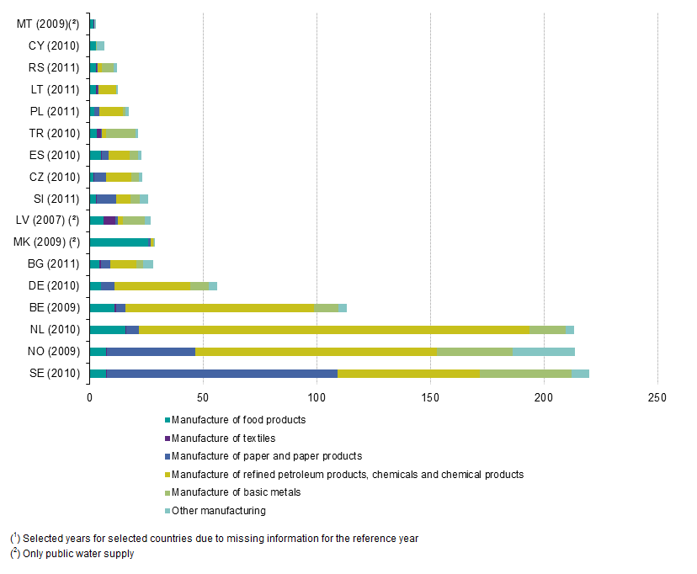
Figure 13: Water use in the manufacturing industry by activity in Europe countries, 2011 (m³ per inhabitant)

It is particularly important to recognize that impact drivers linked to non-product outputs can be traced down to specific manufacturing plants throughout the world. For instance, 50% of total damage costs of air emissions can be attributed to only 147 facilities in Europe and 90% of these costs to only 1,.529 facilities (EEA 2014) (Figures 14 and 15); though not all belong to the manufacturing sector. Overall, the combustion and production processes of manufacturing industries are second to the energy sector as the primary sources of damage costs due to air emissions in Europe (Figure 16).

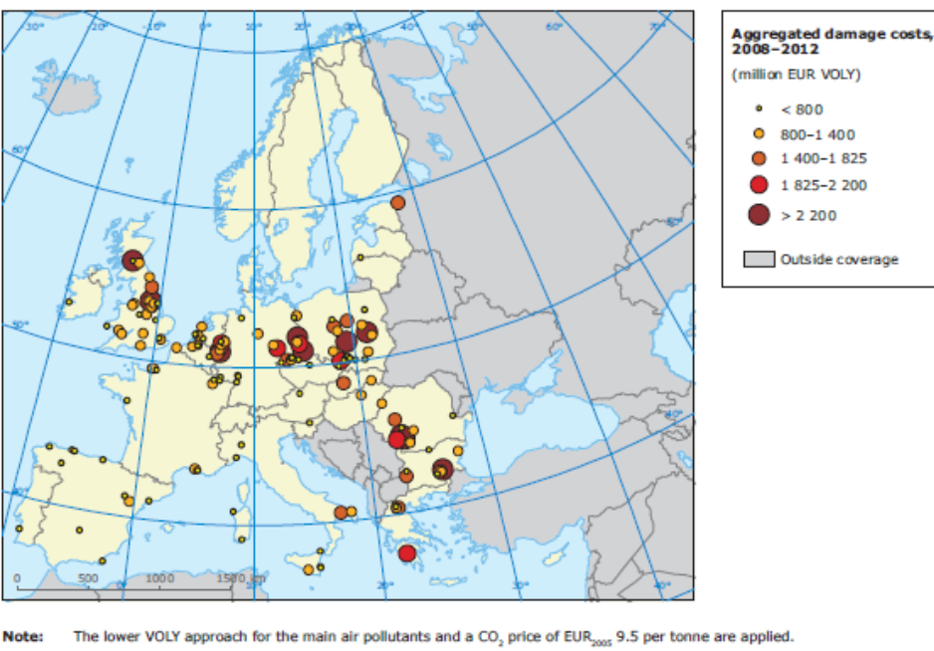
Figure 14: Location of the 147 E-PRTR facilities that contributed 50 % of the total damage costs estimated for 2008–2012 in Europe (EEA 2014)

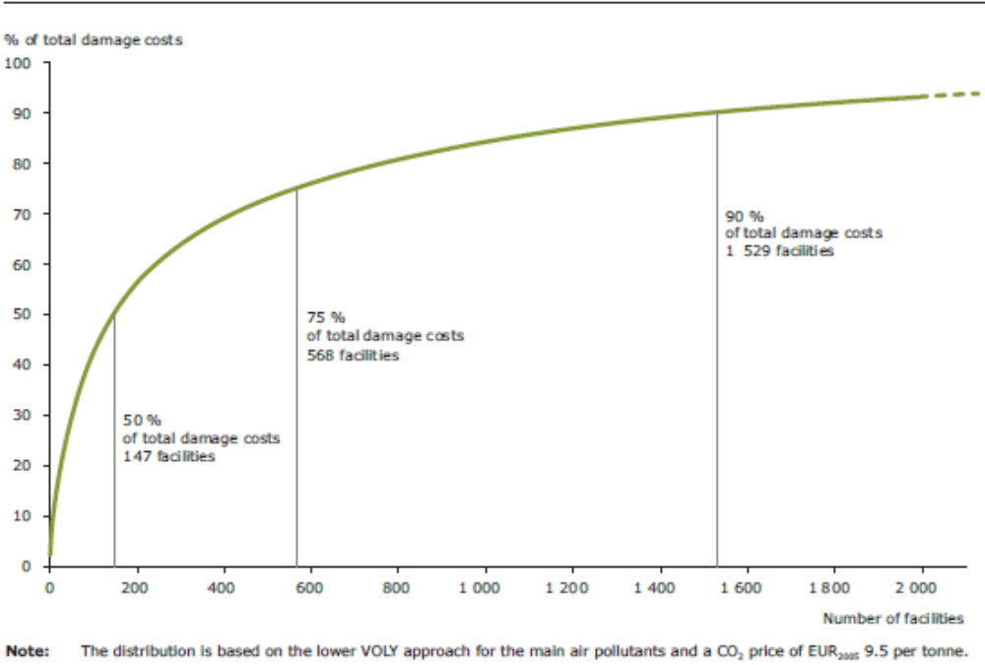
Figure 15: Cumulative distribution of the estimated damage costs associated with emissions of selected pollutants from E-PRTR facilities in Europe, 2008–2012 (EEA 2014)

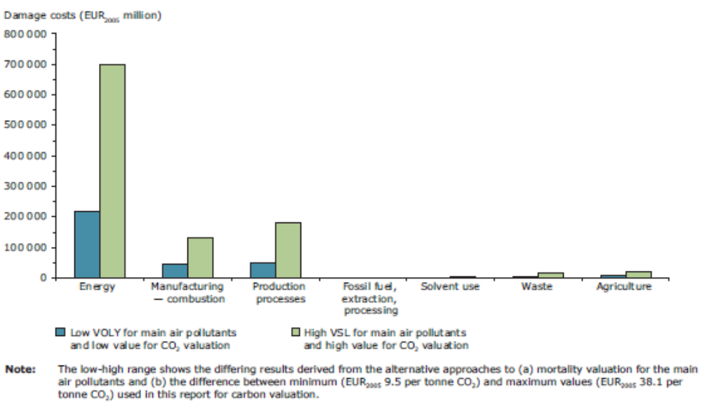
Figure 16: Aggregated damage costs of air emissions in Europe by sector, 2008–2012 (EEA 2014)

All impact drivers interact with ecosystems and may eventually lead to changes in biodiversity patterns, such as greenhouse gas emissions contributing to climate change and hence changes in the spatial distribution of species (e.g., Bellard et al., 2012) or water pollution changing aquatic biotic communities over time (e.g., Xu et al., 2014). However, some impact drivers (e.g., terrestrial land uses, freshwater and marine ecosystem uses) lead to direct, immediate changes in biodiversity (i.e. loss of habitats and species). In manufacturing, these impact drivers are typically linked to production inputs, and are thus linked to indirect ecosystem dependencies (see section 3.3 above).

In other words, the most immediate biodiversity-specific impact drivers (i.e. changes in land use) are not expected to occur at the level of manufacturing activities (except for the building of factories located in or near sensitive ecosystems) but rather at the level of their suppliers (e.g., deforestation due to oil palm plantations; Germer and Sauerborn, 2008; World Bank and International Finance Corporation, 2011). Figure 17 illustrates perfectly this point: Kering’s impacts related to land-use change (and hence biodiversity loss) are the most significant externalities for the group (24%) and are largely found at the level of tier 4 suppliers (raw material production) where almost 50% of all impacts occur. Indeed, the overall value chain impacts of industries can be significant compared to their immediate localized impact drivers (e.g., Jungmichel et al., 2017).

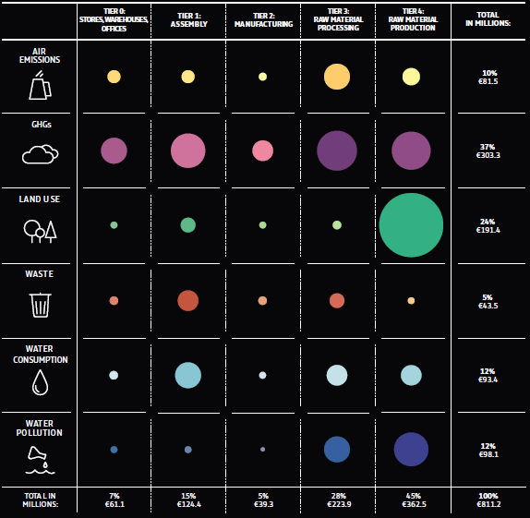
Figure 17: 2016 Environmental Profit & Loss of Kering, highlighting that land use-related impacts are the most significant externalities for the group (24%) and are largely found at the level of tier 4 suppliers (raw material production) where almost 50% of all group impacts occur

Biodiversity at risk: Which manufacturing industries matter the most?

Key messages:
- In the foreseeable future, major risks for biodiversity linked to the activities and growth of manufacturing industries include (a) point-source pollution (e.g., from chemical, metal or petroleum manufacturing); (b) land use changes linked to the supply of various manufacturing inputs (e.g., foods, beverages, textiles, rubber); and (c) the over-harvesting of wild species (e.g., fish, wood, natural and genetic materials);
- Most databases and research initiatives tracking environmental impacts focus on impact drivers (e.g., air emissions, water use) not impacts (e.g., decrease in population of a species, % loss of a specific habitat type) per se.
- To better inform policy and decision-making towards more effective biodiversity mainstreaming in the manufacturing sector, there is a need to assess and monitor the biodiversity impacts of manufacturing industries, individual companies and the associated supply chains.

The manufacturing sector’s relevance to satisfy the ever growing demands of consumers worldwide cannot be overstated. While some countries may be become even more industrialised than others, there is room for various developing nations to attract more manufacturing companies as they become more engaged in the globalized economy.

This expected growing importance of the manufacturing sector may lead to two major risks for biodiversity:
- Manufacturing production challenges: Unless cleaner production technologies are adopted / mainstreamed worldwide, there is a risk of increased point source pollution linked to new factories being built in countries with less strict environmental regulations and / or less effective environmental compliance. This risk applies particularly to the manufacturing industries with the biggest air and water emissions (e.g., manufacture of chemicals, metals, mineral products, steel and pig iron).
- Supply chain challenges: Unless the supply chains of manufacturing industries change the way manage their interactions with ecosystems (with wild species harvesting and land use change as the main impact drivers), significant further biodiversity loss is to be expected worldwide. Indeed, habitat loss and degradation create the biggest single source of pressure on biodiversity worldwide (Chaudhary et al., 2015; SCBD 2010). For terrestrial ecosystems, habitat loss is largely accounted for by conversion of wild lands to agriculture, which amounts to some 30% of land globally. This means that industries that manufacture food products, beverages, textiles / leather (e.g., Aiama et al., 2016), paper, rubber, wood products and tobacco products will be indirectly responsible for a significant proportion of future habitat loss worldwide due to land-intensive resource needs. In some areas, habitat loss has also recently been partly driven by the demand for agro-fuels (e.g., Gao et al., 2011), thus indirectly implicating the chemical industry. To these risks, we can add the overexploitation of wild species (e.g., overfishing, deforestation) which remains a major challenge in many countries. Finally, diffuse / non-point pollution sources, typically linked to commercial agriculture (including fish farming), also need to be highlighted. They also present major risks to freshwater and marine ecosystems, and can be correlated with the global supply chains of various manufacturing industries (e.g., foods, beverages, furniture, textiles, rubber).

Identifying the industries within the manufacturing sector that will have the greatest potential impacts on biodiversity at the global, regional / national and local levels is challenging, notably due to the global nature of supply chains. Table 8 highlights the manufacturing industries with are expected to generate the main risks for biodiversity, at the level of their direct operations and at that of their supply chains. However, this is a high level generalisation. Specific factories, in any industry, may have significant or limited environmental impact drivers due to a number of factors, including location / receiving environment, business practices / (lack of) environmental compliance, technologies used, location and practices of suppliers.

Besides, most databases and research initiatives focus on impact drivers (e.g., air emissions, water use) not impacts (e.g., decrease in population of a species, % loss of a specific habitat type) per se, which contributes to the challenge of matching specific manufacturing industries with the loss of specific biodiversity attributes. Table 9 highlights the most threatened forest biodiversity hotspots in 2011. While land use change - especially agriculture-driven - is the primary driver of habitat loss in these hotspots, which industries and companies, from which countries, have directly and indirectly contributed to such trends in deforestation? The lack of spatialized data sets on the land / resource / species intensity of global supply chains / manufactured products is indeed a major challenge to better inform policy and decision-making towards more effective biodiversity mainstreaming.

Table 8: The manufacturing industries presenting major risk of future biodiversity loss
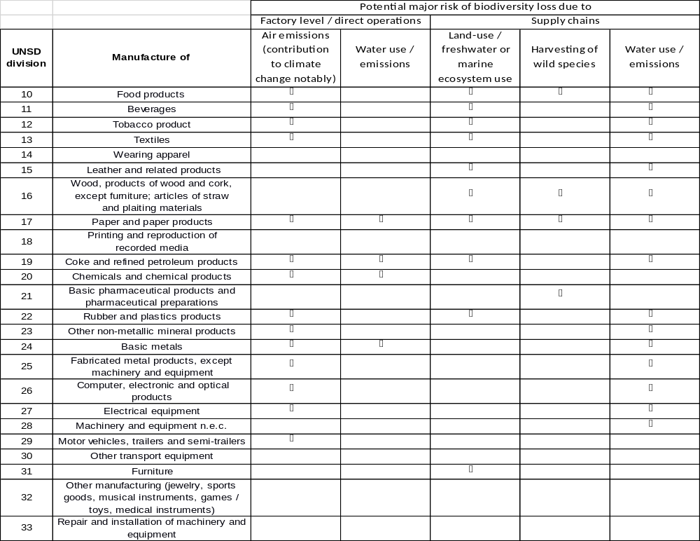

Table 9: The world’s 10 most threatened forest biodiversity hotspots – what manufacturing industries and companies are implicated through their supply chains?
 | Hotspot | Remaining habitat
1 | Indo-Burma (Asia-Pacific) | 5%
2 | New Caledonia(Asia-Pacific) | 5%
3 | Sundaland (Asia-Pacific) | 7%
4 | Philippines (Asia-Pacific) | 7%
5 | Atlantic Forest (South America) | 8%
6 | Mountains of Southwest China (Asia-Pacific) | 8%
7 | California Floristic Province (North America) | 10%
8 | Coastal Forests of Eastern Africa (Africa) | 10%
9 | Madagascar & Indian Ocean Islands (Africa) | 10%
10 | Eastern Afromontane (Africa) | 11%

Mainstreaming biodiversity in the manufacturing sector: Key approaches and challenges
Biodiversity mainstreaming refers to the process of embedding biodiversity considerations into policies, strategies and practices of public and private actors that impact or rely on biodiversity, so that it is conserved and / or sustainably used both locally and globally. Under the CBD, the theme of mainstreaming biodiversity is supported by Article 6, subsection b, which states that each party “integrate, as far as possible and as appropriate, the conservation and sustainable use of biodiversity in plans, programs and sectoral and intersectoral policies”; as well as in Article 10, subsection a, which calls on the parties to “integrate, as far as possible and as appropriate the conservation and sustainable use of biological resources into national decision-making.” This practically involves explicitly integrating renewable natural capital considerations into organizational/business, sectoral and/or cross-sectoral (e.g., IIED and UNEP-WCMC 2014; Secretariat of the Convention on Biological Diversity 2011):
- Legislations, regulations, standards, and guidelines;
- Policy documents;
- Strategies, plans and program of actions;
- Action plans and budgets;
- Service delivery and/or production processes; and
- Performance indicators, monitoring and reporting systems.

This means that biodiversity mainstreaming will mean different things to different stakeholders.
For the Global Environmental Facility, biodiversity mainstreaming focuses primarily on the following activities: “(i) developing policy and regulatory frameworks that remove perverse subsidies and provide incentives for biodiversity-positive land and resource use that remains productive but that does not degrade biodiversity, (ii) spatial and land-use planning to ensure that land and resources are used appropriately to maximize production without undermining or degrading biodiversity; and (iii) improving and changing production practices to be more biodiversity-positive with a focus on sectors that have significant biodiversity impacts such as agriculture, forestry, fisheries, tourism, and extractives.” According to the Natural Capital Coalition, from a business perspective, biodiversity mainstreaming into decision-making involves five key steps: measurement, valuation, decision-making, strategy and external disclosure (Figure 16).

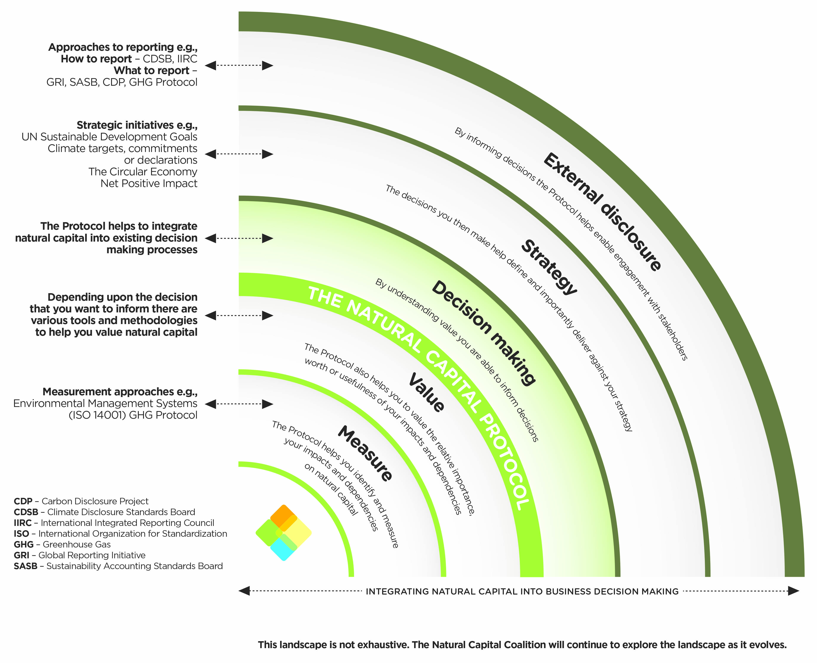
Figure 19: Mainstreaming natural capital into business decisions according the Natural Capital Coalition

Though each manufacturing industry has its specificities, notably do its different dependencies (section 3.3) and impacts (section 3.4) on biodiversity and ecosystem services, this section aims:
- To discuss the links between the CBD objectives, Aichi Targets and the manufacturing sector (section 4.1);
- To present the key challenges facing improved decision-making regarding biodiversity in the private sector in general (section 4.2);
- To highlight best practices in key mainstreaming approaches and tools and discuss their potential for the manufacturing sector (section 4.3);
- To identify some potential policy recommendations for future CBD negotiations (section 4.4).

The CBD and the private sector: A brief historical review

Key messages:
- The CBD formalised a private sector engagement process in 2010, eight years after the inception of the convention;
- A comprehensive decision on mainstreaming and the integration of biodiversity within and across sectors (decision XIII/3) was taken at CoP 13 in 2016;
- The SCBD is now undertaking many business-focused activities.

Though there are many links between the initial CBD objectives set out in 1992 and the private
sector, it was only from 2010 that the CBD formalised a private sector engagement process. The Global Partnership for Business and Biodiversity (GPBB) stems from the business engagement decisions taken at COP 10 and COP 11. The COP 10 decision requested the CBD Secretariat to “encourage establishment of the national and regional business and biodiversity initiatives by facilitating a forum of dialogue among Parties and other Governments, business, and other stakeholders, with a particular focus on the global level” (decision X/21/3a), and invited Parties to “support the establishment of national and regional business and biodiversity initiatives and to strive towards a global partnership on business and biodiversity by inviting ongoing initiatives and other interested stakeholders to be part of the business and biodiversity initiative…” (decision X/21/1d).

This was further reinforced at COP 11 with (decision XI/7/1) that “calls upon businesses to continue liaising with national governments, civil society organizations, academia and other stakeholders to formulate relevant actions for biodiversity conservation…” and (decision XI/7/5a) that requests that the Executive Secretary to “continue to facilitate dialogue among business, government and other stakeholders through ongoing support for national, regional and international business and biodiversity initiatives, using the Global Partnership as a framework”.

More recently, at its thirteenth meeting in 2016, the Conference of the Parties adopted a comprehensive decision on mainstreaming and the integration of biodiversity within and across sectors (decision XIII/3). In addition, at the high-level segment of the United Nations Biodiversity Conference (Cancun, Mexico, 2016), Parties adopted the Cancun Declaration. The decision provided guidance to Parties on a number of matters, and also requested the Executive Secretary to continue collaboration with a number of partners. At its thirteenth meeting, the Conference of the Parties focussed on the sectors of agriculture, forestry, fisheries and tourism. It decided to focus, at its fourteenth meeting, on the sectors of energy and mining, infrastructure, manufacturing and processing, and health.

In addition, at the COP 13 Business and Biodiversity Forum, business leaders were invited to sign the Business and Biodiversity Pledge to convey their commitment in biodiversity conservation and sustainable use, and in taking actions to achieve the Strategic Plan for Biodiversity 2011-2020. Among the various business-focused activities now being carried out by the Secretariat of the Convention on Biological Diversity (SCBD) are efforts:
- To help in the formation of regulation through COP decisions;
- To evaluate the effectiveness and use of various biodiversity-related tools and mechanisms;
- To facilitate the harmonization of biodiversity-related standards and guidelines where possible;
- To assess companies to understand and mainstream biodiversity; and
- To develop the Global Partnership for Business and Biodiversity (GPBB), which “is a network of networks, linking together the various National and Regional Initiatives such that they can share information and best practices, and cooperate on common projects, so as to encourage mainstreaming of biodiversity concerns by companies”.

What contributions to the CBD objectives by the manufacturing sector?

Key messages:
- All CBD strategic goals and most of the Aichi targets within each strategic goal are relevant to the private sector in general and to the manufacturing industries in particular;
- However, the framing of these targets does not place the onus of action on the private sector, despite the fact that it is the primary driver of biodiversity loss worldwide;
- Reframing / specifying how the private sector, including each manufacturing industry, can contribute, in practice, to each Aichi Target should be a priority;
- The development of industry specific targets and key performance indicators for inclusion in future national biodiversity strategies and action plans as well as the associated CBD national reporting initiatives should drive more effective CBD and member state engagement with the key actors in the manufacturing sector.

The CBD Aichi Targets are structured on five strategic goals:
- Strategic Goal A: Address the underlying causes of biodiversity loss by mainstreaming biodiversity across government and society;
- Strategic Goal B: Reduce the direct pressures on biodiversity and promote sustainable use;
- Strategic Goal C: To improve the status of biodiversity by safeguarding ecosystems, species and genetic diversity;
- Strategic Goal D: Enhance the benefits to all from biodiversity and ecosystem services;
- Strategic Goal E: Enhance implementation through participatory planning, knowledge management and capacity building.

All strategic goals and most of the targets within each strategic goal are relevant to the private sector in general and to the manufacturing industries in particular. Target 8 states that “by 2020, pollution, including from excess nutrients, has been brought to levels that are not detrimental to ecosystem function and biodiversity.” This concerns the direct operations of all manufacturers and this is where most efforts have been made to date (e.g., emissions control measures, resource efficient production processes, waste management procedures). However, few of the Aichi Targets are explicitly addressed to the private sector (i.e. formulated in such a way to request responses or contributions). Herewith a high level analysis of the business implications (e.g., gaps / challenges) of key Aichi Targets:
- Target 1 states that “2020, at the latest, people are aware of the values of biodiversity and the steps they can take to conserve and use it sustainably.” The need to recognize the values of biodiversity is also critical for the private sector. This lack of recognition may explain why there is limited quantitative information from the private sector (i.e. individual companies) on biodiversity dependencies (section 3.3).Targeting the manufacturing sector, especially for its dependencies on ecosystem services through its supply chains, should be a priority.
- Target 2 states that “By 2020, at the latest, biodiversity values have been integrated into national and local development and poverty reduction strategies and planning processes and are being incorporated into national accounting, as appropriate, and reporting systems.” The integration of biodiversity values in business strategies, planning and budgeting processes, accounting and reporting systems, should also be a priority. Besides, companies directly contribute data to national accounting systems as well as directly participle in many spatial planning processes at the local or national levels. For manufacturing companies, the challenge lies in doing so taking into account their supply chains.
- Target 3 states that “By 2020, at the latest, incentives, including subsidies, harmful to biodiversity are eliminated, phased out or reformed in order to minimize or avoid negative impacts, and positive incentives for the conservation and sustainable use of biodiversity are developed and applied, consistent and in harmony with the Convention and other relevant international obligations, taking into account national socio economic conditions.” This target is particularly important for the manufacturing sector, especially in the age of globalization where manufacturing industries are key components of global value chains. Incentives and subsidies influence many business decisions (e.g., factory site selection), while trade deals play a critical role in enabling / preventing the easy transport of resources from raw material producers to manufacturers and final products to consumers. From this perspective, one may question the effectiveness, at a planetary level, of biodiversity mainstreaming approaches focused on single-industry solutions at the national or local level. The need for approaches that target global value chains cannot be overemphasised (see section 3).
- Aichi Target 4 states that “by 2020, at the latest, Governments, business and stakeholders at all levels have taken steps to achieve or have implemented plans for sustainable production and consumption and have kept the impacts of use of natural resources well within safe ecological limits.” This targets specifically mentions the private sector. However, the challenge lies in understanding what sustainable production and consumption means for each manufacturing industry, and what are the responsibilities of manufacturing industries in global value chains, especially given that demand and product design are often beyond their direct control. Besides, from the perspective of a single manufacturing business, the concept of using natural resources well within safe ecological limits is not always straightforward. For instance, environmental impact assessments often fail to assess cumulative impacts at a regional or global level. One therefore needs to emphasise the importance of mainstreaming biodiversity through a global value chain approach, to address both factory level impacts and supplier-related uses of / impacts on biodiversity.
- Aichi Target 5 states that “by 2020, the rate of loss of all natural habitats, including forests, is at least halved and where feasible brought close to zero, and degradation and fragmentation is significantly reduced”. The role of manufacturing industries is twofold once more, first at the level of their direct operations (i.e. applying the impact mitigation hierarchy for the localisation, construction and management of factories) and then in terms of their sourcing policies (i.e. what materials to source in the context of the impact mitigation hierarch?).
- Aichi Target 6 states that “by 2020 all fish and invertebrate stocks and aquatic plants are managed and harvested sustainably, legally and applying ecosystem based approaches, so that overfishing is avoided, recovery plans and measures are in place for all depleted species, fisheries have no significant adverse impacts on threatened species and vulnerable ecosystems and the impacts of fisheries on stocks, species and ecosystems are within safe ecological limits.” Companies involved in the processing and preserving of fish, crustaceans and molluscs should be directly involved here, as should retailers selling fish to consumers. However, the target places the onus on the owner of fish resources, typically nation states.
- Aichi Target 7 states that “by 2020 areas under agriculture, aquaculture and forestry are managed sustainably, ensuring conservation of biodiversity.” Though this target directly concerns the suppliers of several manufacturing industries, their clients (e.g., manufacturers of foods, rubber products, beverages, textiles, wood products) have also a role to play in mainstreaming sustainable land use practices, notably through their choice of raw materials and / or the use of environmental considerations with respect to extraction / production processes in their contractual agreements with raw material extractors / producers / suppliers.
- Aichi Target 9 states that “by 2020, invasive alien species and pathways are identified and prioritized, priority species are controlled or eradicated, and measures are in place to manage pathways to prevent their introduction and establishment.” Target 9 has similar implications for manufacturing industries than Target 8.
- Manufacturing companies can also contribute to Aichi Targets 11, 12, 14 and 15, typically through:
  - Voluntary measures involving corporate social responsibility spending to support species conservation, protected area management or ecosystem restoration work (e.g., in ecosystems surrounding manufacturing plants);
  - The ambitious implementation of the impact mitigation hierarchy (i.e. the creation of new protected areas as part of offset measures);
  - Carbon offset projects with biodiversity co-benefits.
- By extension, manufacturing companies may contribute to Aichi Target 16 “By 2015, the Nagoya Protocol on Access to Genetic Resources and the Fair and Equitable Sharing of Benefits Arising from their Utilization is in force and operational, consistent with national legislation”. They may hold the rights over compounds developed from genetic resources and thus be involved in socio-economic activities aimed at sharing the benefits from the production and sale of such compounds.
- Aichi Target 19 is particularly important for manufacturing companies as end users of biodiversity information when making informed decisions about factory location, production technology (e.g., which technology has the biggest or lowest impact on biotic communities downstream) or material sourcing (e.g., which supplier is likely to extract or produce resources from biodiversity hotspot areas).
- Finally, Target 20 may become important for the private sector as a whole: “By 2020, at the latest, the mobilization of financial resources for effectively implementing the Strategic Plan for Biodiversity 2011-2020 from all sources, and in accordance with the consolidated and agreed process in the Strategy for Resource Mobilization, should increase substantially from the current levels.” Assessing the nature and scale of financial support that may be expected from manufacturing industries may not be straightforward, but their key role in global supply chains, which drive biodiversity loss, will lead to increasing discussions on how they can meaningfully contribute to conservation and sustainable use at the level of whole landscapes.

To illustrate the lack of quantitative information on private sector contributions to each Aichi target, one can go to national reports of parties to the convention. For instance, the 3rd national reports to the CBD of countries such as Australia, Brazil, Portugal and South Africa only provide narrated accounts of processes or initiatives involving the private sector (e.g., in response to Decision V/24 and the question “Has your country developed or explored mechanisms to involve the private sector in initiatives on the sustainable use of biodiversity?”).
These gaps and opportunities call greater focus on reframing / specifying how the private sector, including each manufacturing industry, can contribute, in practice, to each Aichi Target. This would involve, for instance, collaborating on the development of industry specific targets and key performance indicators for inclusion in future national biodiversity strategies and action plans as well as the associated CBD national reporting initiatives. This would eventually lead to more effective CBD and member state engagement with the key actors in the manufacturing sector.

Understanding the importance of biodiversity in manufacturing: Measurement and valuation for improved decision-making

Key messages:
- Much improved biodiversity measurement and valuation is needed for relevant, effective decision-making in the manufacturing sector;
- This calls for the development of a standardized biodiversity measurement protocol for business, which would include global value chain dimensions;
- This also requires more diverse and integrated value framing perspectives and initiatives so as to effectively convince all affected stakeholders (along global value chains) of the importance of biodiversity and of the need for its conservation and sustainable use.

A good understanding of biodiversity and ecosystem services, their benefits and trade-offs in development pathways has been advocated to be prerequisite for win–win–win situations for people, business and nature (Cadman et al., 2010; TEEB 2010). This is argued to be the case because a lack of knowledge can lead to wrong decisions and even conflicts or catastrophes. Companies are often not aware of the benefits they receive from biodiversity and ecosystem services and do now quantify the full extent of their environmental impacts. This has been argued to prevent them from integrating the values of nature into policy and decision-making as well as strategic planning and operational routines (e.g., Houdet et al., 2012).

To address this, building the business case is often highlighted as a prerequisite for business to recognize biodiversity as a material (important) issue. This involves the framing of value propositions, such as reputational and brank risks, compliance and liability risks, cost savings and new business opportunities, according to the expected values and needs of the target business audience (e.g., a company executive versus an environmental manager) so as to convince it. Yet, making the business case requires the appropriate set of information. This is why there has been increasing interests worldwide in the measurement and valuation of ecosystems / environmental impacts / natural capital (Waage, 2014; Natural Capital Coalition, 2014). These are marketed as a key vehicle to integrate ecological understanding and economic considerations to redress the traditional neglect of business dependencies and impacts on ecosystem services in both private and public policy, decision-making and operations (TEEB 2012).

From this perspective, it is critical to distinguish between measurement and valuation:
- Measurement is the process of determining the amounts, extent, and condition of ecosystem components, functions, processes and services, in physical terms.
- Valuation refers to the process of estimating the relative importance, worth, or usefulness of ecosystem benefits and costs to people (or to a business), in a particular context. As put by Dendoncker et al. (2013), valuation is “the act of assessing, appraising or measuring value, as value attribution, or as framing valuation”. Valuation may thus involve qualitative, quantitative, or monetary approaches, or a combination of these.
Measurement and valuation go hand in hand, with measurement being a first step towards valuation. There cannot be any ecosystem impact or dependency valuation without any prior ecosystem impact or dependency measurement: i.e. you need to assess how much natural resource or ecosystem service you use or impact before you can value its importance in a specific business context.

Biodiversity has received very little attention in business measurement (e.g., lack of quantified biodiversity-focused data in sustainability reports) and valuation to date. One key reason for this may be the lack of standardized biodiversity measuring protocol for business, as is available for the measurement of greenhouse gas emissions. Addressing this gap will go a long way towards putting biodiversity on the table for discussion by board members of manufacturing industries: i.e. companies currently do not know how to measure their biodiversity impacts and dependencies in a cost-effective manner (i.e. actual biodiversity loss, for instance expressed in habitat or population loss; beyond indicators on impact drivers related to air / water emissions and solid waste).

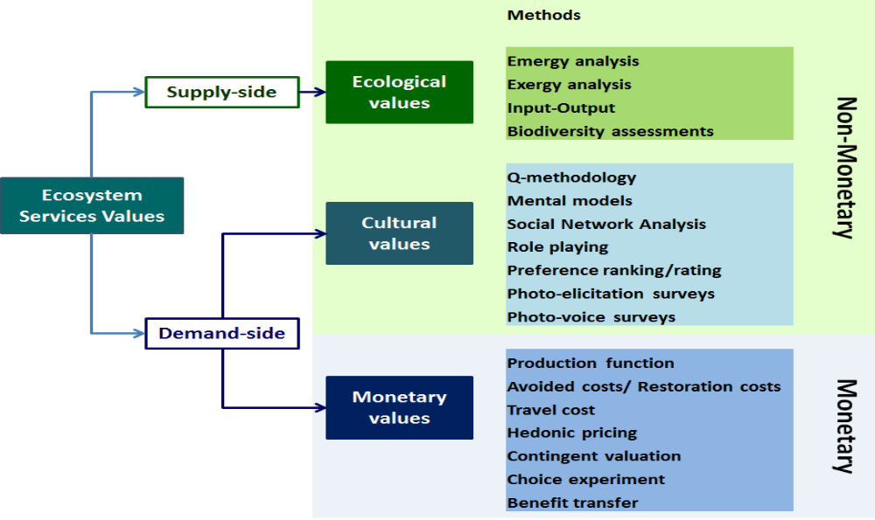
Figure 20: Methodological toolbox for an integrated valuation of ecosystem services which considers non-monetary and monetary valuation methods and the value-pluralism (Gómez-Baggethun et al., 2014)

Another challenge is linked to existing misunderstandings about values, valuation processes, their uses and applications in real world settings. Many stakeholders focus on monistic valuation approaches (i.e. a single currency / indicator / value type is used to convince people) failing to recognize the diversity of values that people adhere to and the associated valuation approaches / methods (Figure 20). Typically, many assume that monetary valuation (i.e. a single, monistic value framing perspective) is the only way to convince decision-makers in the private sector of the importance of biodiversity and its conservation / sustainable use. Yet, the overreliance on monetary value framing may not be successful in convincing everyone, including company management and employees, as it fails to recognize that:
- Not all biodiversity components have significant economic values (e.g., threatened species little known by the public and companies) while economic valuation methods have well researched limitations (e.g., TEEB 2010).
- The economic value of ecosystem services is often smaller to that of industrial projects in trade-off analysis (e.g., Houdet and Chikozho, 2015), this approach thus often working against conservation or sustainable use interests.
- Economic values do not equate to financial values (i.e. actual business revenues, expenses, assets and liabilities): Highly valuable ecosystem services in economic terms may not necessarily be captured or appropriated by business due to the lack of existing markets and / or enabling regulatory environments which allow the trade of exchangeable units related to such ecosystem services (e.g., market regulations enabling carbon credit trading) (Ruhl et al., 2017). This implies that business do not readily change their viewpoints and practices based on the results of monetary valuation studies. They require tangible, demonstrable proof that revenue from biodiversity can be generated and captured for their own purposes for them to conserve or manage it sustainability.
- The business case can be made through multiple value framing perspectives (e.g., Maze et al. 2016) (Table 10) which can all contribute to changing social norms that may eventually lead to changes in (what is considered acceptable) business practices. This argument can be made in reference to relatively recent (from the perspective of the history of human species) changes in social norms regarding child labour or slavery where competing value perspectives have been used to drive meaningful change.

Table 10: Different value perspectives in business natural capital valuation (Natural Capital Coalition 2016)
Value perspective | Typically used to
Business value | - Assess how natural capital impacts and/or dependencies affect, positively or negatively, the financial performance of the company (i.e., the bottom line) and thus the value at risk.  - Assess company exposure to risks arising from its impacts and/or dependencies.  - Minimise company expenses or liabilities and maximise company revenues/receivables.  - Communicate to shareholders, budget control staff, management and creditors.
Societal value | - Understand the significance of your natural capital impacts and dependencies to other/external stakeholders.  - Determine outcomes for society, assess which stakeholders are affected and how much, and assess net impacts to society.  - Investigate the potential nature and extent of future risks and opportunities, including license to operate, and reputational issues.  - Assess risks and opportunities associated with environmental externalities, either positive or negative.  - Communicate to employees and external stakeholders (e.g., regulators, local communities, consumers, non-governmental organizations, suppliers, contractors and clients).
Both value perspectives | - Undertake a comprehensive natural capital assessment. Assessing societal values, in particular your future impacts on society, enables all potential business values to be considered as well.

While the Intergovernmental Science-Policy Platform on Biodiversity and Ecosystem Services (IPBES) scientific community acknowledges that decision making relies to a great extent on the instrumental values of nature’s values to people (Pascual et al., 2017), it supports the recent call for integrating the multiple values of ecosystem services and biodiversity in decision making. As argued by Gómez-Baggethun et al. (2014), for more than a decade, the literature on ecosystem services valuation has stressed the importance of integrating social, ecological, and monetary aspects of the values of ecosystem services and biodiversity in decision-making, rather than relying only on monistic approaches dominated by a single worldview (Figure 21). Interdisciplinarity, transdisciplinarity, and methodological pluralism are key elements in integrated ecosystem services valuation: “The process of synthesizing relevant sources of knowledge and information to elicit the various ways in which people conceptualize and appraise ecosystems services values, resulting in different valuation frames that are the basis for informed deliberation, agreement and decision” (Gómez-Baggethun et al., 2014: 20).

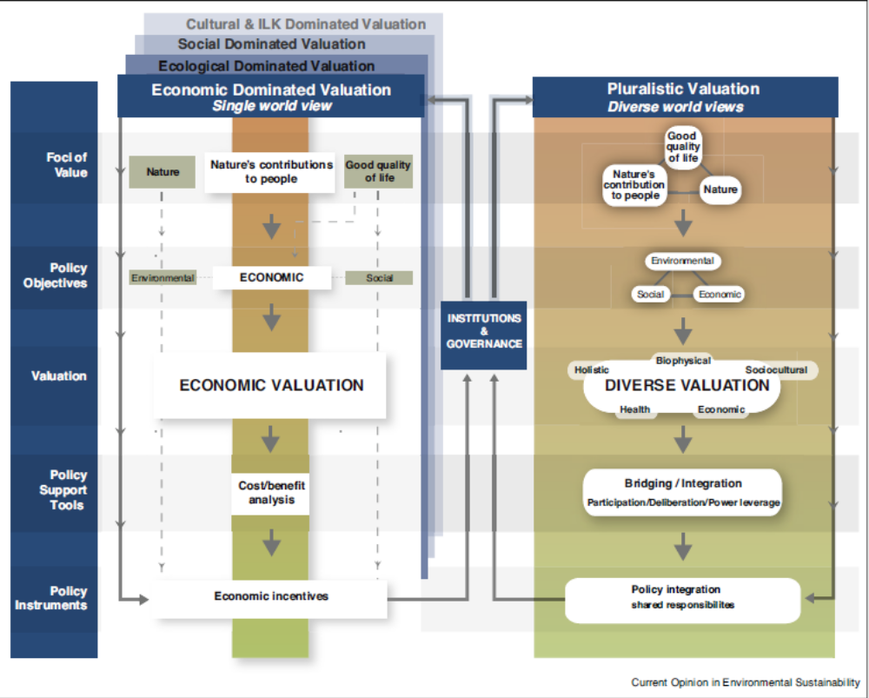
Figure 21: From single world views in valuation towards pluralistic valuations (Pascual et al., 2017)

To summarize, biodiversity mainstreaming in the manufacturing sector is facing a dual challenge from a measurement and valuation perspective:
- The need for a standardized biodiversity measurement protocol, which would include global value chain dimensions; and
- The need for more diverse and integrated value framing perspectives and initiatives so as to effectively convince all affected stakeholders (along global value chains) of the importance of biodiversity and of the need for its conservation and sustainable use.
Recognising these challenges, several projects have currently been launched, including by the Natural Capital Coalition - Cambridge Conservation Initiative partnership and the South African National Biodiversity and Business Network.

Best practices in biodiversity mainstreaming: What opportunities in the manufacturing sector?

Key messages:
- Several key environmental management tools are progressively integrating biodiversity considerations, such as environmental management systems, environmental and social impact assessments, life-cycle impact assessments, environmental management accounting and reporting / disclosure, or externality valuation and disclosure;
- Best practice case studies in biodiversity mainstreaming remain limited: Companies going beyond mere compliance should be recognized, supported and rewarded;
- Public policies must play a greater role in promoting best practices, including in terms of public procurement, financing rules and processes, disclosure requirements, trade agreements and fiscal reform.

As discussed in section 3 above, the interactions between manufacturing and biodiversity are complex and occur at multiple scales, across global value chains. The effective mainstreaming of biodiversity should thus involve managing biodiversity dependencies and impacts at each step of the value chain of products manufactured, from the production / extraction of raw materials upstream to the end-of-life of goods and services (e.g., disposal and recycling practices). The approaches and tools to do so may be industry specific (e.g., specific pollution or emissions standards for different manufacturing processes) or have broader scopes (e.g., corporate sustainability standards, no-net-loss approaches).

Herewith a selection of best practices from a variety of approaches and tools, within the manufacturing sector or beyond, highlighting why they should be supported in relevant manufacturing industries:
- Environmental Management Systems: There has been significant advancements in embedding biodiversity considerations in Environmental Management Systems (e.g., ISO 14001, EU Eco-Management and Audit Scheme - EMAS); typically with targets and key performance indicators for monitoring selected biodiversity attributes at the owned or leased sites of multinational companies. This can be correlated to a large extent with efforts made to improve the surface area and condition of habitats (as well as populations of threatened species) at the level of manufacturing plants (e.g., work done for General Motors and Cemex by the Wildlife Habitat Council; O’Gorman 2017; similar work in Germany; sixty-two Toshiba company sites worldwide). Moreover, various other sectoral initiatives have developed useful site level guidelines and best practices that could be adapted to various manufacturing sectors to improve biodiversity management of factory sites (e.g., the Cross-Sector Biodiversity Initiative, The Energy and Biodiversity Initiative).
- Environmental and Social Impact Assessments and the Impact Mitigation Hierarchy: An increasing number of companies are adopting and / or applying no-net-loss / net-positive impact approached or policies based on the full implementation of the Impact Mitigation Hierarchy (from avoidance to offset measures), though no high profile example from the manufacturing sector has been identified to date. This may be voluntary or done in response to specific legislative contexts. While existing regulations are more likely than not to have affected projects involving manufacturing businesses (e.g., construction of a new factory), for instance in the context of the various wetland and species offset programs in the USA or the EU, most widely publicised examples relate to mining, oil / gas and infrastructure projects in non-OECD countries (e.g. Business and Biodiversity Offset Programme case studies) in response to environmental safeguards from financial institutions. Whether or not these approaches actually deliver no-net-loss as it is commonly understood is debatable. Notably, the last step of this hierarchy, the offsetting phase, has been heavily criticised due to a number of issues, including (but not limited to) the scope of biodiversity attributes included in no-net-loss accounting (which varies according to the country), the associated units of exchanges for gain / loss calculation (e.g., Maron et al., 2018) and the impact leakages of offset measures based on averted loss principles (e.g., Moilanen and Laitila, 2016). Nevertheless, there is potential for manufacturing industries to further explore no-net-loss / net-positive impact approaches throughout their value chains (i.e. for the historical and new residual impacts of their raw material suppliers, such as in the commercial agriculture and forestry sector; e.g. Aiama et al., 2015), not just at the level of their factories. This may become part of the discussions for supplier / commodity selection as well as the definitions of terms and conditions in contractual agreements. No-net-loss / net-positive impact approaches are consistent with achieving no (net) deforestation as understood by parties to the New York Declaration on Forests (2014) or the Amsterdam declarations on “imported deforestation” (2015).
- Life-cycle assessments: Beyond site level approaches, the manufacturing sector should embrace product life cycle assessments which include biodiversity impacts (e.g., Curran et al., 2016; de Baan et al., 2013; Souza et al., 2015). These could be coupled to the support of labelling and certification schemes used for various commodities used in industrial production processes (e.g., Aluminium Stewardship Council; Gulbrandsen 2010; KPMG 2012; UNEP-WCMC 2011). For instance, as of 2017, the Roundtable on Sustainable Palm Oil had a membership of 763 consumer goods manufacturers, 536 processors and/or traders, 66 retailers and 174 producers.
- Environmental management accounting and reporting / disclosure: Environmental management accounting, in particular greenhouse gas accounting and reporting, has largely become mainstreamed in many countries. For instance, thousands of companies (including many manufacturing businesses) participate voluntarily in the Climate Disclosure Project, which has led to significant changes in their climate change policies and strategies so as to demonstrate improved climate performance over time. However, corporate biodiversity measurement is currently very limited (i.e. focused on high level principles and management approach discourses) despite the availability of some guidance documents (e.g., GRI 2007). Building a standardized biodiversity measurement protocol (including supply chain impacts; i.e. notion of different scope of greenhouse gas accounting) and mainstreaming the disclosure of biodiversity performance would go a long way in mainstreaming biodiversity in business strategies, as recently advocated at the 2017 Biodiversity and Business Indaba of the South African National Biodiversity and Business Network. Manufacturing companies should be key targets for the pilot-testing of such tools. Any such measurement could benefit from quantitative targets and trends against which to assess progress.
- Externality valuation and disclosure: The disclosure of environmental externalities has been attempted by a very limited number of companies (e.g., the 1990 environmental report of BSO/Origin - Huizing and Dekker, 1992; Novo Nordisk - Danish Environmental Protection Agency 2014). This should be encouraged, especially if valuations have comprehensive scopes, going beyond direct operations to include supply chains and the use and end-of-life of manufactured products. As demonstrated by Kering, the valuation of negative environmental externalities (including land use change as an impact driver) throughout its global supply chains can (a) be disclosed regularly (done almost on a yearly basis to show group trends), (b) drive sustainable innovation in product design, and (c) help secure raw material supply through direct engagement with raw material suppliers (e.g., to improve the sustainability of production processes and avoid unexpected costs due to resource shortages or changes in legislations). Focusing on the environmental reality of the global value chains of a whole group is visionary in a world where corporations tend to focus on the ‘positive spinning’ of selective environmental disclosures regarding events that occur at the level of direct operations (e.g., Lewis 2016; Lyon and Maxwell, 2011). There is much potential for all manufacturing industries to follow this approach.
- Last, but not least, to ensure biodiversity mainstreaming occurs in the manufacturing industries throughout the world, biodiversity-specific considerations (e.g., requirements preventing / restricting the use of threatened species or greenfield development in threatened ecosystems such as the ones listed on the IUCN Red List of Ecosystems) should be integrated in existing and future public policies (i.e. in the context of Inclusive Green Growth approaches: e.g., AfDB et al., 2012; UKAID 2010; UNEP 2010,2011, 2013), such as:
  - Project financing procedures that include best practice biodiversity provisions (e.g., no-net-loss targets in IFC performance standard 6);
  - Greener public procurement (e.g., Grolleau et al., 2004; Lundberg et al., 2009);
  - Environmental fiscal reform (e.g., Schlegelmilch and Joas, 2015; Slunge and Sterner 2009), including the review of preserve subsidies for both pollutants and the support of activities (e.g., land use change) leading to biodiversity loss (CES 2012);
  - Greener trade agreements (Arnell 2003; Berger et al., 2017; Mao et al., 2015; Sheldon 2006).

Policy recommendations

Effectively mainstreaming biodiversity conservation and sustainable use requires thinking beyond traditional environmental governance and management models. This is due to the nature of global value chains in which manufacturing companies play a significant, but limited role : e.g., no or very limited control over raw material extraction / harvesting, product needs and design influenced by retailers.

The key challenges to address can be summarized into two inter-linked broad approaches:
- Supporting manufacturing companies recognize, measure, value, manage responsively and disclose (their performance related to) their direct and indirect dependencies and on impacts biodiversity throughout global value chains;
- Designing, adopting and implementing enabling policy and legislative environments (i.e. both incentives and disincentives) that work across nations so as to effectively target the whole global value chains of manufactured products when striving for biodiversity mainstreaming best practices.

More specifically, there is a new for manufacturing companies to:
- Better measure and value their biodiversity dependencies, with a focus on (a) the environment as a recipient of their emissions and (b) their indirect dependencies throughout their supply chains;
- Better measure and value their biodiversity impacts, beyond the measurement of impact drivers (e.g., amounts of air emissions and solid waste, volumes of water emissions, amounts of resource used, extent of ecosystem used) towards actual biodiversity losses (or gains), with a focus on their indirect impacts throughout their supply chains (especially land use changes due to the agricultural and forestry sectors);
- Engage more with their whole value chains so as to promote the implementation of the impact mitigation hierarchy (ideally with no-net-loss or net-positive-impact targets) at each step of value added creation, from resource extraction / production to the end of life of goods sold (e.g., disposal, recycling);
- Become more transparent to all stakeholders as regards to their direct and indirect biodiversity impacts and dependencies, including their socio-economic consequences for affected stakeholders (i.e. externalities), notably through regular, annual disclosures;
- Collect and disclose quantified information about their contributions to all the Aichi Targets, where appropriate for their specific industry.

In addition, parties could consider the following:
- Explore the potential for adapting the CBD strategic objectives and Aichi Targets to individual industries and whole product / commodity value chains (i.e. to make them SMART – specific, measureable, attainable, relevant, time bound – for manufacturing companies) and encourage companies in reporting on their Aichi Targets contributions;
- Formalise binding engagements with manufacturing industries on biodiversity conservation and sustainable use targets for direct operations as well as upstream (i.e. suppliers) and downstream (i.e. use and end of life of manufactured products);
- Support development of a standardized biodiversity measurement protocol, which would include global value chain dimensions (e.g., accounting for biodiversity losses / gains across different scopes, from direct operations to upstream and downstream dimensions);
- Support relevant stakeholders (e.g., notably the IPBES and NCC) in the development of more diverse and integrated value framing perspectives and initiatives so as to effectively convince all affected stakeholders (along global value chains) of the importance of biodiversity and of the need for its effective conservation and sustainable use;
- Effectively engage with environmental business associations (e.g., WBCSD), NGOs (e.g., Natural Capital Coalition, IUCN), multi-stakeholder initiatives (e.g. Aluminium Stewardship Council), industry leaders, as well as international and national industry bodies and professional associations to (a) raise the profile of biodiversity in manufacturing, (b) help develop the business case for each manufacturing industry and (c) promote industry best practices (e.g., no-net-loss approaches, promotion of relevant labelling schemes, product life cycle assessments which include biodiversity impacts, embedding biodiversity targets in environmental management schemes);
- Invite the financial sector to become more transparent with respect to their dealings with the manufacturing sector, including in terms of project finance, business finance and insurance products, with a focus on including biodiversity safeguards throughout their activities (e.g., project finance due diligence processes and disclosure requirements, biodiversity risk exposure disclosure to external stakeholders).
- Develop, adopt and enforce company disclosure requirements (adapted to different company sizes) for:
  - Direct and indirect biodiversity impacts and dependencies, including their socio-economic consequences for affected stakeholders (i.e. externalities),
  - Contributions to the Aichi Targets,
  - The development of national databases of biodiversity accounts that would track the biodiversity impacts and dependencies of both gross domestic product accounts and national imports / exports;
- Develop, adopt and enforce biodiversity safeguard requirements (e.g., applying the impact mitigation hierarchy and making explicit references to various best practice tools / policies and international conventions such as the World Heritage Convention and CITIES):
  - All public procurement involving manufactured goods, including supply chain aspects;
  - International development aid (included climate related finance), including for the procurement of manufactured goods;
  - Forthcoming fiscal reforms, striving for the reversal / cancellation of perverse subsidies and (at least partial) shift of the tax burden from labour and income / capital to resource and ecosystem (e.g., land and marine surface area) use (which would be particularly relevant to manufacturing industries and their suppliers);
  - Forthcoming trade agreement negotiations, with a focus on supporting mechanisms (e.g., performance / compliance based financing) to improve environmental regulations and compliance enforcement where appropriate.

Annex 1 – Further UNSD ISIC Rev. 4 classification details

This Annex draws the International Standard Industrial Classification of All Economic Activities.

Division 10 - Manufacture of food products - includes the processing of the products of agriculture, forestry and fishing into food for humans or animals, and includes the production of various intermediate products that are not directly food products. This division is organized by activities dealing with different kinds of products: meat, fish, fruit and vegetables, fats and oils, milk products, grain mill products, animal feeds and other food products. It includes the following Groups:
- 101 - Processing and preserving of meat;
- 102 - Processing and preserving of fish, crustaceans and molluscs;
- 103 - Processing and preserving of fruit and vegetables;
- 104 - Manufacture of vegetable and animal oils and fats;
- 105 - Manufacture of dairy products;
- 106 - Manufacture of grain mill products, starches and starch products;
- 107 - Manufacture of other food products;
- 108 - Manufacture of prepared animal feeds.

Division 11 includes the manufacture of beverages, such as non-alcoholic beverages and mineral water, manufacture of alcoholic beverages mainly through fermentation, beer and wine, and the manufacture of distilled alcoholic beverages. It is limited to the Group 110 - Manufacture of beverages.

Division 12 includes the processing of an agricultural product, tobacco, into a form suitable for final consumption. It is limited to the Group 120 - Manufacture of tobacco products.

Division 13 is divided into the following Groups:
- 131 - Spinning, weaving and finishing of textiles;
- 139 - Manufacture of other textiles.
This division includes preparation and spinning of textile fibres as well as textile weaving, finishing of textiles and wearing apparel, manufacture of made-up textile articles, except apparel (e.g. household linen, blankets, rugs, cordage etc.).

Division 14 is divided into the following Groups:
- 141 - Manufacture of wearing apparel, except fur apparel;
- 142 - Manufacture of articles of fur;
- 143 - Manufacture of knitted and crocheted apparel.
Division 14 includes all tailoring (ready-to-wear or made-to-measure), in all materials (e.g. leather, fabric, knitted and crocheted fabrics etc.), of all items of clothing (e.g. outerwear, underwear for men, women or children; work, city or casual clothing etc.) and accessories.

Division 15 includes dressing and dyeing of fur and the transformation of hides into leather by tanning or curing and fabricating the leather into products for final consumption. It also includes the manufacture of similar products from other materials (imitation leathers or leather substitutes), such as rubber footwear, textile luggage etc. This Division is divided into the following Groups:
- 151 - Tanning and dressing of leather; manufacture of luggage, handbags, saddlery and harness; dressing and dyeing of fur;
- 152 - Manufacture of footwear.

Division 16 - manufacture of wood and of products of wood and cork, except furniture; manufacture of articles of straw and plaiting materials - is divided into the following Groups:
- 161 - Sawmilling and planing of wood;
- 162 - Manufacture of products of wood, cork, straw and plaiting materials.
This division includes the manufacture of wood products, such as lumber, plywood, veneers, wood containers, wood flooring, wood trusses, and prefabricated wood buildings. The production processes include sawing, planing, shaping, laminating, and assembling of wood products starting from logs that are cut into bolts, or lumber that may then be cut further, or shaped by lathes or other shaping tools. The lumber or other transformed wood shapes may also be subsequently planed or smoothed, and assembled into finished products, such as wood containers.

Division 17 contains the single Group 170 - Manufacture of paper and paper products. This division includes the manufacture of pulp, paper and converted paper products. The manufacture of these products is grouped together because they constitute a series of vertically connected processes. More than one activity is often carried out in a single unit. There are essentially three activities: The manufacture of pulp involves separating the cellulose fibres from other impurities in wood or used paper. The manufacture of paper involves matting these fibres into a sheet. Converted paper products are made from paper and other materials by various cutting and shaping techniques, including coating and laminating activities. The paper articles may be printed (e.g. wallpaper, gift wrap etc.), as long as the printing of information is not the main purpose.

Division 18 - printing and reproduction of recorded media - is divided into the following Groups:
- 181 - Printing and service activities related to printing;
- 182 - Reproduction of recorded media.
This division includes printing of products, such as newspapers, books, periodicals, business forms, greeting cards, and other materials, and associated support activities, such as bookbinding, plate-making services, and data imaging. The support activities included here are an integral part of the printing industry, and a product (a printing plate, a bound book, or a computer disk or file) that is an integral part of the printing industry is almost always provided by these operations. Processes used in printing include a variety of methods for transferring an image from a plate, screen, or computer file to a medium, such as paper, plastics, metal, textile articles, or wood.

Division 19 - manufacture of coke and refined petroleum products - is divided into the following Groups:
- 191 - Manufacture of coke oven products;
- 192 - Manufacture of refined petroleum products.
This division includes the transformation of crude petroleum and coal into usable products. The dominant process is petroleum refining, which involves the separation of crude petroleum into component products through such techniques as cracking and distillation. This division also includes the manufacture for own account of characteristic products (e.g. coke, butane, propane, petrol, kerosene, fuel oil etc.) as well as processing services (e.g. custom refining).
This division includes the manufacture of gases such as ethane, propane and butane as products of petroleum refineries.

Division 20 - manufacture of chemicals and chemical products – contains the following Groups:
- 201 - Manufacture of basic chemicals, fertilizers and nitrogen compounds, plastics and synthetic rubber in primary forms;
- 202 - Manufacture of other chemical products;
- 203 - Manufacture of man-made fibres.
This division includes the transformation of organic and inorganic raw materials by a chemical process and the formation of products. It distinguishes the production of basic chemicals that constitute the first industry group from the production of intermediate and end products produced by further processing of basic chemicals that make up the remaining industry classes.

Division 21 - manufacture of basic pharmaceutical products and pharmaceutical preparations - contains Group 210: Manufacture of pharmaceuticals, medicinal chemical and botanical products. This division includes the manufacture of basic pharmaceutical products and pharmaceutical preparations. This includes also the manufacture of medicinal chemical and botanical products.

Division 22 - Manufacture of rubber and plastics products - is divided into the following Groups:
- 221 - Manufacture of rubber products;
- 222 - Manufacture of plastics products.
This division includes the manufacture of rubber and plastics products. This division is characterized by the raw materials used in the manufacturing process. However, this does not imply that the manufacture of all products made of these materials is classified here.

Division 23 - manufacture of other non-metallic mineral products – includes the following Groups:
- 231 - Manufacture of glass and glass products;
- 239 - Manufacture of non-metallic mineral products n.e.c.
This division includes manufacturing activities related to a single substance of mineral origin. This division includes the manufacture of glass and glass products (e.g. flat glass, hollow glass, fibres, technical glassware etc.), ceramic products, tiles and baked clay products, and cement and plaster, from raw materials to finished articles. The manufacture of shaped and finished stone and other mineral products is also included in this division.

Division 24 - manufacture of basic metals – is broken down into the following Groups:
- 241 - Manufacture of basic iron and steel;
- 242 - Manufacture of basic precious and other non-ferrous metals;
- 243 - Casting of metals.
This division includes the activities of smelting and/or refining ferrous and non-ferrous metals from ore, pig or scrap, using electrometallurgic and other process metallurgic techniques. This division also includes the manufacture of metal alloys and super-alloys by introducing other chemical elements to pure metals. The output of smelting and refining, usually in ingot form, is used in rolling, drawing and extruding operations to make products such as plate, sheet, strip, bars, rods, wire, tubes, pipes and hollow profiles, and in molten form to make castings and other basic metal products.

Division 25 - manufacture of fabricated metal products, except machinery and equipment - includes three Groups:
- 251 - Manufacture of structural metal products, tanks, reservoirs and steam generators;
- 252 - Manufacture of weapons and ammunition;
- 259 - Manufacture of other fabricated metal products; metalworking service activities.
This division includes the manufacture of "pure" metal products (such as parts, containers and structures), usually with a static, immovable function, as opposed to the following divisions 26-30, which cover the manufacture of combinations or assemblies of such metal products (sometimes with other materials) into more complex units that, unless they are purely electrical, electronic or optical, work with moving parts. The manufacture of weapons and ammunition is also included in this division.

Division 26 - manufacture of computer, electronic and optical products - includes the manufacture of computers, computer peripherals, communications equipment, and similar electronic products, as well as the manufacture of components for such products. Production processes of this division are characterized by the design and use of integrated circuits and the application of highly specialized miniaturization technologies. The division also contains the manufacture of consumer electronics, measuring, testing, navigating, and control equipment, irradiation, electromedical and electrotherapeutic equipment, optical instruments and equipment, and the manufacture of magnetic and optical media. This Division includes several Groups:
- 261 - Manufacture of electronic components and boards;
- 262 - Manufacture of computers and peripheral equipment;
- 263 - Manufacture of communication equipment;
- 264 - Manufacture of consumer electronics;
- 265 - Manufacture of measuring, testing, navigating and control equipment; watches and clocks;
- 266 - Manufacture of irradiation, electromedical and electrotherapeutic equipment;
- 267 - Manufacture of optical instruments and photographic equipment;
- 268 - Manufacture of magnetic and optical media.

Division 27 - manufacture of electrical equipment - is divided into the following Groups:
- 271 - Manufacture of electric motors, generators, transformers and electricity distribution and control apparatus;
- 272 - Manufacture of batteries and accumulators;
- 273 - Manufacture of wiring and wiring devices;
- 274 - Manufacture of electric lighting equipment;
- 275 - Manufacture of domestic appliances;
- 279 - Manufacture of other electrical equipment.
This division includes the manufacture of products that generate, distribute and use electrical power. Also included is the manufacture of electrical lighting, signalling equipment and electric household appliances.

Division 28 - manufacture of machinery and equipment n.e.c. – is broken down into the following Groups:
- 281 - Manufacture of general-purpose machinery;
- 282 - Manufacture of special-purpose machinery.

This division includes the manufacture of machinery and equipment that act independently on materials either mechanically or thermally or perform operations on materials (such as handling, spraying, weighing or packing), including their mechanical components that produce and apply force, and any specially manufactured primary parts. This includes the manufacture of fixed and mobile or hand-held devices, regardless of whether they are designed for industrial, building and civil engineering, agricultural or home use. The manufacture of special equipment for passenger or freight transport within demarcated premises also belongs within this division.

This division distinguishes between the manufacture of special-purpose machinery, i.e. machinery for exclusive use in an ISIC industry or a small cluster of ISIC industries, and general-purpose machinery, i.e. machinery that is being used in a wide range of ISIC industries. This division also includes the manufacture of other special-purpose machinery, not covered elsewhere in the classification, whether or not used in a manufacturing process, such as fairground amusement equipment, automatic bowling alley equipment, etc.

Division 29 - manufacture of motor vehicles, trailers and semi-trailers - is divided into the following Groups:
- 291 - Manufacture of motor vehicles;
- 292 - Manufacture of bodies (coachwork) for motor vehicles; manufacture of trailers and semi-trailers;
- 293 - Manufacture of parts and accessories for motor vehicles.
This division includes the manufacture of motor vehicles for transporting passengers or freight. The manufacture of various parts and accessories, as well as the manufacture of trailers and semi-trailers, is included here.

Division 30 - manufacture of other transport equipment - is divided into the following Groups:
- 301 - Building of ships and boats;
- 302 - Manufacture of railway locomotives and rolling stock;
- 303 - Manufacture of air and spacecraft and related machinery;
- 304 - Manufacture of military fighting vehicles;
- 309 - Manufacture of transport equipment n.e.c.
This division includes the manufacture of transportation equipment such as ship building and boat manufacturing, the manufacture of railroad rolling stock and locomotives, air and spacecraft and the manufacture of parts thereof.

Division 31 contains the Group 310 - Manufacture of furniture. This Group relates to the manufacture of furniture and related products of any material except stone, concrete and ceramic. The processes used in the manufacture of furniture are standard methods of forming materials and assembling components, including cutting, moulding and laminating. The design of the article, for both aesthetic and functional qualities, is an important aspect of the production process.

Division 32 - other manufacturing - is divided into the following Groups:
- 321 - Manufacture of jewellery, bijouterie and related articles;
- 322 - Manufacture of musical instruments;
- 323 - Manufacture of sports goods;
- 324 - Manufacture of games and toys;
- 325 - Manufacture of medical and dental instruments and supplies;
- 329 - Other manufacturing n.e.c.
This division includes the manufacture of a variety of goods not covered in other parts of the classification. Since this is a residual division, production processes, input materials and use of the produced goods can vary widely and usual criteria for grouping classes into divisions have not been applied here.

Division 33 - repair and installation of machinery and equipment - is divided into the following Groups:
- 331 - Repair of fabricated metal products, machinery and equipment;
- 332 - Installation of industrial machinery and equipment.
This division includes the specialized repair of goods produced in the manufacturing sector with the aim to restore machinery, equipment and other products to working order. The provision of general or routine maintenance (i.e. servicing) on such products to ensure they work efficiently and to prevent breakdown and unnecessary repairs is included.

This division does only include specialized repair and maintenance activities. A substantial amount of repair is also done by manufacturers of machinery, equipment and other goods, in which case the classification of units engaged in these repair and manufacturing activities is done according to the value-added principle which would often assign these combined activities to the manufacture of the good. The same principle is applied for combined trade and repair.

__________

* CBD/SBI/2/1.
Hereinafter referred to as “manufacturing industries”. Manufacturing includes the processing of the products of various raw material producers into diversified goods, including the products of agriculture, forestry and fishing.
United Nations Statistics Division (2017). International Standard Industrial Classification of All Economic Activities, Rev.4. https://unstats.un.org/unsd/cr/registry/regcst.asp?Cl=27, accessed on 5 January 2018.
URL: https://www.statista.com/statistics/236397/value-of-the-leading-global-textile-exporters-by-country/, accessed February 19, 2018.
Roser, C. (2016). “Faster, Better, Cheaper" in the History of Manufacturing: From the Stone Age to Lean Manufacturing and Beyond. Productivity Press, 417 Pages.
URL: https://cen.acs.org/sections/global-top-50.html, accessed February 19, 2018.
URL: https://www.statista.com/statistics/226032/light-vehicle-producing-countries/, accessed February 19, 2018.
URL: http://wdi.worldbank.org/table/4.2#, accessed on November 9, 2017.
Levinson, M. (2017). U.S. manufacturing in international perspective. Congressional Research Service, R42135, 19p.
URL: http://www.ilo.org/global/research/global-reports/global-employment-trends/2014/WCMS_234879/lang--en/index.htm, accessed on November 9, 2017.
World Bank national accounts data, and OECD National Accounts data files. URL: http://wdi.worldbank.org/table/4.2#, accessed on January 6, 2018.
McKinsey (2012). Manufacturing the future: The next era of global growth and innovation. URL: https://www.mckinsey.com/business-functions/operations/our-insights/the-future-of-manufacturing, accessed on November 7, 2017.
URL: http://ec.europa.eu/eurostat/statistics-explained/index.php/Manufacturing_statistics_-_NACE_Rev._2 accessed on January 15, 2018.
PwC (2015). The World in 2050 Will the shift in global economic power continue? URL: https://www.pwc.com/gx/en/issues/the-economy/assets/world-in-2050-february-2015.pdf, accessed on January 5, 2018.
Foresight (2013). The Future of Manufacturing: A new era of opportunity and challenge for the United Kingdom Summary Report The Government Office for Science, London. URL: https://www.ifm.eng.cam.ac.uk/uploads/Resources/Future_of_Manufacturing_Report.pdf, accessed on January 5, 2018.
URL: http://wdi.worldbank.org/table/4.3#, accessed on January 6, 2018.
Gao, Y. (2012). China as the workshop of the world: an analysis of the national and industry level of China in the international division of labour. Routledge, NY.
UNCTAD (2016). The Trade and Development Report (TDR) 2016. URL: http://unctad.org/en/pages/PublicationWebflyer.aspx?publicationid=1610, accessed on November 9, 2017.
URL: https://home.kpmg.com/xx/en/home/campaigns/2016/05/kpmg-internationals-2016-global-manufacturing-outlook-competing-for-growth.html, accessed on November 7, 2017.
López-Gómez, C., O’Sullivan, E., Gregory, M., Fleury, A., Gomes, L. (2013). Emerging Trends in Global Manufacturing Industries. United Nations Industrial Development Organization.
López-Gómez, C., Leal-Ayala, D., Palladino, M., O’Sullivan, E. (2017). Emerging trends in global advanced manufacturing: Challenges, opportunities and policy responses. United Nations Industrial Development Organization.
Advanced manufacturing technology is defined as computer-controlled or micro-electronics-based equipment used in the design, manufacture or handling of a product. OECD Frascati Manual, Sixth edition, 2012; URL: https://stats.oecd.org/glossary/detail.asp?ID=52, accessed November 9, 2017.
Hallward-Driemeier, M., Nayyar, G. (2018). Trouble in the Making? The Future of Manufacturing-Led Development. Washington, DC: World Bank. doi:10.1596/978-1-4648-1174-6.
Natural Capital Coalition (2016). Natural Capital Protocol. (Online) Available at: www.naturalcapitalcoalition.org/protocol, accessed November 9, 2017.
Atkinson, G., Pearce, D., (1995). “Measuring sustainable development.” In: Bromley, D. W., (ed.) Handbook of Environmental Economics. Blackwell, Oxford, United Kingdom, pp. 166-182.
Jansson, A., Hammer, M., Folke, C., Costanza, R. (1994). Investing in natural capital: The ecological economics approach to sustainability. Washington, D.C.: Island Press.
Millennium Ecosystem Assessment (MA) (2005). Ecosystems and human well-being: Current state and trends. Island Press, Washington, DC.
Natural Capital Coalition (2016). Natural Capital Protocol. (Online) Available at: www.naturalcapitalcoalition.org/protocol, accessed November 9, 2017.
"Ecosystem" means a dynamic complex of plant, animal and micro-organism communities and their non-living environment interacting as a functional unit (Article 2 of the Convention on Biological Diversity).
Biodiversity is defined as the variability among living organisms from all sources including, inter alia, terrestrial, marine and other aquatic ecosystems and the ecological complexes of which they are part; this includes diversity within species, between species and of ecosystems.” URL: https://www.cbd.int/convention/articles/default.shtml?a=cbd-02, accessed on January 5, 2018.
Potschin, M., Haines-Young, R. (2011). Ecosystem services: Exploring a geographical perspective. Progress in Physical Geography 35(5): 575-594.
Natural Capital Coalition (2016b). Natural Capital Protocol – Food and Beverage Sector Guide. (Online) Available at: www.naturalcapitalcoalition.org/protocol, accessed November 7, 2017.
Hanson, C., Ranganathan, J., Iceland, C., Finisdore, J. (2012). The corporate ecosystem services review: Guidelines for identifying business risks and opportunities arising from ecosystem change. World Resources Institute, Washington, DC, Version 2.0 (of same authors and report name from 2008).
Houdet, J., Trommetter, M., Weber, J. (2012). Understanding changes in business strategies regarding biodiversity and ecosystem services. Ecological Economics 73: 37-46.
TEEB (2012). The Economics of Ecosystems and Biodiversity in Business and Enterprise. Edited by Joshua Bishop. Earthscan, London and New York.
Natural Capital Coalition (2016). Natural Capital Protocol. (Online) Available at: www.naturalcapitalcoalition.org/protocol, accessed November 9, 2017.
Natural Capital Coalition (2016). Natural Capital Protocol. (Online) Available at: www.naturalcapitalcoalition.org/protocol, accessed November 9, 2017.
UNEP (2011). Manufacturing: Investing in energy and resource efficiency.
Ibid 21.
World Business Council on Sustainable Development (WBCSD), 2011. Guide to corporate ecosystem valuation. A framework for improving corporate decision-making, 76 pp.
Chartered Global Management Accountant (2014). Rethinking the value chain. Accounting for natural capital in the value chain. CGMA briefing, 16p.
Millennium Ecosystem Assessment (MA) (2005). Ecosystems and human well-being: Current state and trends. Island Press, Washington, DC.
World Business Council for Sustainable Development (WBCSD) (2011). Guide to corporate ecosystem valuation. World Business Council for Sustainable Development, International Union for the Conservation of Nature, ERM and PwC. Available online at: http://www.wbcsd.org/pages/edocument/edocumentdetails.aspx?id=104&nosearchcontextkey=true. Accessed December, 2015.
Liquete, C., Piroddi, C., Drakou, E.G., Gurney, L., Katsanevakis, S., et al. (2013). Current status and future prospects for the assessment of marine and coastal ecosystem services: A systematic review. PLoS ONE 8(7): e67737. doi:10.1371/journal.pone.0067737
Most of these efforts discarded the MA “supporting services” category (i.e. no direct link to beneficiaries or users to be classified as an ecosystem service) and have excluded abiotic services from their classification.
TEEB (2012). The Economics of Ecosystems and Biodiversity in Business and Enterprise. Edited by Joshua Bishop. Earthscan, London and New York.
Haines-Young, R., Potschin, M. (2013). Common International Classification of Ecosystem Services (CICES). Report to the European Environment Agency EEA/BSS/07/007
Boyd, J., Banzhaf, S. (2007). What are ecosystem services? The need for standardized environmental accounting units. Ecological Economics 63(2): 616-626.
By doing so, one moves away from the general “ecosystem to human well-being” approach of the Millennium Ecosystem Assessment (2005) which implies that there is an environmental-human continuum and generates risks of double-counting in valuation, accounting and decision-making processes. As put by Landers and Nahlik (2013: 4), “unless both environmental and economic (i.e., labour, and capital goods) inputs are well-specified in the general production function, it is difficult (or impossible) to explicitly separate the goods and services provided by (or predominantly by) the environment from the investment humans make to realize the total economic value of those goods and services. For example, agricultural commodities (e.g., corn, cotton, etc.) have both an important ecological component and an important economic component that results in the overall production and availability of these goods.”
Landers, D.H., Nahlik, A.M. (2013). Final Ecosystem Goods and Services Classification System (FEGS-CS). EPA/600/R-13/ORD-004914. US Environmental Protection Agency, Office of Research and Development: Washington, DC.
Boyd, J., Banzhaf, S. (2007). What are ecosystem services? The need for standardized environmental accounting units. Ecological Economics 63(2): 616-626.
Landers, D., Nahlik, A., Johnson, M. (2016). Are carrots, corn and cattle really provided by Nature- If not, how can we appropriately identify the goods and services derived from agroecosystems? ACES 2016, Jacksonville, FL, December 05 - 09, 2016.
Landers, D.H., Nahlik, A.M. (2013). Final Ecosystem Goods and Services Classification System (FEGS-CS). EPA/600/R-13/ORD-004914. US Environmental Protection Agency, Office of Research and Development: Washington, DC.
Landers, D., Nahlik, A., Johnson, M. (2016). Are carrots, corn and cattle really provided by Nature- If not, how can we appropriately identify the goods and services derived from agroecosystems? ACES 2016, Jacksonville, FL, December 05 - 09, 2016.
A series of briefs and factsheets on these sectors have been prepared by the Secretariat in the Series “Bioscience at a Crossroads”; URL: https://www.cbd.int/abs/resources/factsheets.shtml; accessed on November 9, 2017.
“BioTrade” refers to those activities of collection, production, transformation, and commercialization of goods and services derived from native biodiversity under the criteria of environmental, social and economic sustainability. The revenue in 2012 for bio-trade companies was US$ 5.2 million. However, the market potential is estimated by UNCTAD at US$ 141 billion.
URL: http://ec.europa.eu/eurostat/statistics-explained/index.php/File:Water_use_in_the_manufacturing_industry_by_activity,_2011_(m%C2%B3_per_inhabitant).png, accessed on January 10, 2018.
DiMuro, J.L., Guertin, F.M., Helling, R.K., Perkins, J.L., Romer, S. (2014), A financial and environmental analysis of constructed wetlands for industrial wastewater treatment. Journal of Industrial Ecology 18, 631–640. doi:10.1111/jiec.12129
Natural Capital Coalition (2016). Natural Capital Protocol. (Online) Available at: www.naturalcapitalcoalition.org/protocol, accessed November 9, 2017.
Natural Capital Coalition (2016). Natural Capital Protocol. (Online) Available at: www.naturalcapitalcoalition.org/protocol, accessed November 9, 2017.
AMEC Environment & Infrastructure United Kingdom Limited (2014). Contribution of industry to pollutant emissions to air and water. In partnership with Bio Intelligence Service, Milieu, IEEP and REC. European Commission (DG Environment), 293p.
URL: http://ec.europa.eu/eurostat/statistics-explained/index.php/File:Water_use_in_the_manufacturing_industry_by_activity,_2011_(m%C2%B3_per_inhabitant).png, accessed on January 5, 2018.
European Environment Agency (2014). Costs of air pollution from European industrial facilities 2008–2012 — an updated assessment. EEA Technical Report, No 20/2014, 76p.
European Environment Agency (2014). Costs of air pollution from European industrial facilities 2008–2012 — an updated assessment. EEA Technical Report, No 20/2014, 76p.
European Environment Agency (2014). Costs of air pollution from European industrial facilities 2008–2012 — an updated assessment. EEA Technical Report, No 20/2014, 76p.
Bellard, C., Bertelsmeier, C., Leadley, P., Thuiller, W., & Courchamp, F. (2012). Impacts of climate change on the future of biodiversity. Ecology Letters, 15(4), 365–377. http://doi.org/10.1111/j.1461-0248.2011.01736.x
Xu, M., Wang, Z., Duan, X., Pan, B. (2014). Effects of pollution on aquatic ecology and water quality bio-assessment. Hydrobiologia 729. 10.1007/s10750-013-1504-y.
Germer, J. & Sauerborn, J. (2008). Estimation of the impact of oil palm plantation establishment on greenhouse gas balance. Environ Dev Sustain 10: 697.
World Bank and International Finance Corporation (2011). The World Bank Group Framework and IFC Strategy for Engagement in the Palm Oil Sector. 91p. URL: https://www.ifc.org/wps/wcm/connect/159dce004ea3bd0fb359f71dc0e8434d/WBG+Framework+and+IFC+Strategy_FINAL_FOR+WEB.pdf?MOD=AJPERES, accessed on January 5, 2018.
Jungmichel, N., Schampel, C., Weiss, D. (2017). Atlas on Environmental Impacts - Supply Chains – Environmental Impacts and Hot Spots in the Supply Chain. Analysis of environmental impacts in eight selected German industries along the global value chain from resource extraction to companies’ own sites. Berlin/Hamburg: adelphi/Systain, 52p.
URL: http://www.kering.com/en/sustainability/results, accessed on January 5, 2018.
Yet, the share of manufacturing in GDP compared to that other sectors (especially the services sector) is not expected to rise globally.
Mulatu, A., Gerlagh, R., Rigby, D., Wossink, A. (2010). Environmental regulation and industrial location in Europe. Environmental and Resource Economics 45:4, 459–479.
Chaudhary, A., Verones, F., de Baan, L., Hellweg, S. (2015). Quantifying land use impacts on biodiversity: Combining species–area models and vulnerability indicators. Environ. Sci. Technol. 49(16), 9987–9995.
Secretariat of the Convention on Biological Diversity (2010). Global Biodiversity Outlook 3. Montréal, 94p.
Aiama, D., Carbone, G., Cator, D., Challender, D. (2016). Biodiversity risks and opportunities in the apparel sector. IUCN, Gland, 41p.
Gao, Y., Skutsch, M., Masera, O and Pacheco, P. (2011) A global analysis of deforestation due to biofuel development. Working Paper 68. CIFOR, Bogor, Indonesia, 100p.
E.g. Pauly. D., Watson, R., Alder, J. (2005). Global trends in world fisheries: Impacts on marine ecosystems and food security. Phil. Trans. R. Soc. B 360, 5-12; Srinivasan, U.T., Cheung, W.W.L., Watson, R., Sumaila, U.R. (2010). Food security implications of global marine catch losses due to overfishing. Journal of Bioeconomics 12(3), 183-200.
Bianchi, C.A., Haig, S.M., (2013). Deforestation trends of tropical dry forests in central Brazil. Biotropica 45: 395–400; Meyfroidt, P., Rudel, T.K., Lambin, E.F. (2010). Forest transitions, trade, and the global displacement of land use. Proceedings of the National Academy of Sciences 107(49), 20917-20922.
e.g., Handy, R.D., Poxton, M.G., 1993. Nitrogen pollution in mariculture: Toxicity and excretion of nitrogenous compounds by marine fish. Reviews in Fish Biology and Fisheries 3(3), 205-241.
Adapted from URL: https://www.conservation.org/NewsRoom/pressreleases/Pages/The-Worlds-10-Most-Threatened-Forest-Hotspots.aspx, accessed on February 19, 2018.
Accessed on November 26, 2017; URL: http://cop13.mx/en/mainstreaming-biodiversity/
IIED, UNEP – WCMC, 2014. Mainstreaming biodiversity and development: Discussion Paper. NBSAPs 2.0: Mainstreaming Biodiversity and Development project, 68p.
Secretariat of the Convention on Biological Diversity, 2011. NBSAP training modules version 2.1 – Module 3. Mainstreaming biodiversity into national sectoral and cross-sectoral strategies, policies, plans and programs. Montreal, 39p.
Accessed on November 26, 2017; URL: https://www.thegef.org/news/un-biodiversity-conference-cop13-mainstreaming-biodiversity-well-being
Natural Capital Coalition (2016). Natural Capital Protocol. (Online) Available at: www.naturalcapitalcoalition.org/protocol, accessed November 9, 2017.
Natural Capital Coalition (2016). Natural Capital Protocol. (Online) Available at: www.naturalcapitalcoalition.org/protocol, accessed November 9, 2017.
Accessed January 24, 2017 at URL: https://www.cbd.int/business/pledges/pledge.pdf
Accessed January 24, 2017 at URL: https://www.cbd.int/business/gp/structure.shtml
URL: https://www.cbd.int/sp/elements/, accessed on December 5, 2017.
By focus on minimising or reducing their emissions, manufacturing companies are also contributing to Target 10, which states that “by 2015, the multiple anthropogenic pressures on coral reefs, and other vulnerable ecosystems impacted by climate change or ocean acidification are minimized, so as to maintain their integrity and functioning.”
Houdet, J., Trommetter, M., Weber, J., 2012. Understanding changes in business strategies regarding biodiversity and ecosystem services, Ecological Economics 73, 37-46.
Houdet, J., Germaneau, C., 2014. Accounting for biodiversity and ecosystem services from an EMA perspective. Towards a standardised Biodiversity Footprint methodology. Jones, M. (Ed.), Accounting for biodiversity. Routledge, 52-80.
Houdet, J., Burritt, R., Farrell, K. N., Martin-Ortega, J., Ramin, K., Spurgeon, J., Atkins, J., Steuerman, D., Jones, M., Maleganos, J., Ding, H., Ochieng, C., Naicker, K., Chikozho, C., Finisdore, J., Sukhdev, P., 2014. What natural capital disclosure for integrated reporting? Designing & modelling an Integrated Financial – Natural Capital Accounting and Reporting Framework. Synergiz – ACTS, Working Paper 2014-01, 62 p.
Houdet, J., Trommetter, M., Weber, J., 2010. Promoting business reporting standards for biodiversity and ecosystem services. The Biodiversity Accountability Framework. Orée - FRB, 16p.
Centre d’analyse stratégique (2012). Les aides publiques dommageables à la biodiversité, rapport de la mission présidée par Guillaume Sainteny, Paris, La Documentation française, 414 p.
E.g., Rudel, T. K. (2011). Local actions, global effects? Understanding the circumstances in which locally beneficial environmental actions cumulate to have global effects. Ecology and Society 16(2): 19; Spyce, A., M. Weber, Adamowicz, W. (2012). Cumulative effects planning: finding the balance using choice experiments. Ecology and Society 17(1): 22.
Aichi Target 11: By 2020, at least 17 per cent of terrestrial and inland water, and 10 per cent of coastal and marine areas, especially areas of particular importance for biodiversity and ecosystem services, are conserved through effectively and equitably managed, ecologically representative and well connected systems of protected areas and other effective area-based conservation measures, and integrated into the wider landscapes and seascapes.
Aichi Target 12: By 2020 the extinction of known threatened species has been prevented and their conservation status, particularly of those most in decline, has been improved and sustained.
Target 14: By 2020, ecosystems that provide essential services, including services related to water, and contribute to health, livelihoods and well-being, are restored and safeguarded, taking into account the needs of women, indigenous and local communities, and the poor and vulnerable.
Target 15: By 2020, ecosystem resilience and the contribution of biodiversity to carbon stocks has been enhanced, through conservation and restoration, including restoration of at least 15 per cent of degraded ecosystems, thereby contributing to climate change mitigation and adaptation and to combating desertification.
E.g., Hughes, J., Ahuja, L., Brownlie, S., Botha, M., Desmet, P., Heather-Clark, S. (2015). Using biodiversity plans to guide mitigation and offsets for a zinc mine in Nortehrn Cape, South Africa. IAIA15 Conference Proceedings. URL: http://conferences.iaia.org/2015/Final-Papers/Huges,%20Jessica%20-%20Using%20Biodiversity%20Plans%20to%20Guide%20Mitigation%20and%20Offsets%20for%20a%20Zinc%20Mine%20in%20Northern%20Cape,%20South%20Africa.pdf, accessed on January 5, 2018.
E.g., Bryan, B.A., Runting, R.K., Capon, T., Perring, M.P., Cunningham, S.C., Kragt, M.E., Nolan, M., Law, E.A., Renwick, A.R., Eber, S., Christian, R., Wilson, K.A. (2016). Designer policy for carbon and biodiversity co-benefits under global change. Nature Climate Change 6, 301-305.
By 2020, knowledge, the science base and technologies relating to biodiversity, its values, functioning, status and trends, and the consequences of its loss, are improved, widely shared and transferred, and applied.
URL: https://www.cbd.int/doc/world/au/au-nr-03-en.pdf, accessed on February 22, 2018.
URL: https://www.cbd.int/doc/world/br/br-nr-03-en.pdf, accessed on February 22, 2018.
URL: https://www.cbd.int/doc/world/pt/pt-nr-03-en.pdf, accessed on February 22, 2018.
URL: https://www.cbd.int/doc/world/za/za-nr-03-en.pdf, accessed on February 22, 2018.
E.g., Cadman, M., Petersen, C., Driver, A., Sekhran, N., Maze, K., Munzhedzi, S. (2010). Biodiversity for Development: South Africa’s landscape approach to conserving biodiversity and promoting ecosystem resilience. South African National Biodiversity Institute, Pretoria; TEEB, 2010. The Economics of Ecosystems and Biodiversity: Ecological and Economic Foundations. UNEP/Earthprint: London.
Houdet, J., Trommetter, M., Weber, J. (2012). Understanding changes in business strategies regarding biodiversity and ecosystem services. Ecological Economics 73: 37-46.
E.g., IIED – UNEP WCMC (2014). Developing a ‘business case’ for biodiversity Tips and tasks for influencing government and the private sector. 16p.; SANBI (2017). The business case for biodiversity stewardship. A report produced for the Department of Environmental Affairs. Developed by Cumming, T., Driver, A., Pillay, P., Martindale, G., Purnell, K., McCann, K. & Maree, K. South African National Biodiversity Institute, Pretoria; UNEP Finance Initiative (2007). Biodiversity and ecosystem services: A financial sector briefing, 12p.
Waage, S. (2014). Making sense of new approaches to business risk and opportunity assessment. BSR.
Natural Capital Coalition (2014). Valuing natural capital in business. Towards a harmonised protocol. ICAEW: London.
TEEB (2012). The Economics of Ecosystems and Biodiversity in Business and Enterprise. Edited by Joshua Bishop. Earthscan, London and New York.
Dendoncker, N., Keene, H., Jacobs, S., Gómez-Baggethun, E. (2013). Inclusive ecosystem services valuation. In S. Jacobs, N. Dendoncker and H. Keene (eds), Ecosystem services: Global issues, local practices, San Diego and Waltham, US: Elsevier, pp. 3-12.
E.g., Guan, Y. (2014). Reporting on Biodiversity and Ecosystem Services under the GRI – Case Study in the Global Forest Sector. Master thesis, 91p. URL: https://helda.helsinki.fi/bitstream/handle/10138/154155/reportin.pdf;sequence=1, accessed on January 12, 2018. ; Houdet, J., Trommetter, M., Weber, J., 2010. Promoting business reporting standards for biodiversity and ecosystem services. The Biodiversity Accountability Framework. Orée - FRB, 16p.
URL: http://www.ghgprotocol.org/, accessed on January 12, 2018.
Gómez-Baggethun, E., Martín Lopez, B., Barton, D., Braat, L., Saarikoski, H., Kelemen, M., García-Llorente, E., van den Bergh, J., Arias, P., Berry, P., Potschin, L.M., Keene, H., Dunford, R., Schröter-Schlaack, C., Harrison, P. (2014). State-of-the-art report on integrated valuation of ecosystem services. European Commission FP7 FP7 OpenNESS Project Deliverable 4.1., 33p.
TEEB, 2010. The Economics of Ecosystems and Biodiversity: Ecological and Economic Foundations. UNEP/Earthprint: London.
Houdet, J., Chikozho, C. (2015). The Valuation of ecosystem services in South African Environmental Impact Assessments. Review of selected mining case studies and implications for policy. The Journal of Corporate Citizenship Issue 60, 58-79.
Ruhl, J.B., Kant, S.E., Lant, C.L. (2007). The law and policy of ecosystem services. Island Press, 360p.
Maze, K., Barnett, M., Botts, E.A., Stephens, A., Freedman, M., Guenther, L. (2016). Making the case for biodiversity in South Africa: Re-framing biodiversity communications. Bothalia 46(1), a2039. http://dx.doi. org/10.4102/abc.v46i1.2039
Pascual, U., Balvanera, P., Diaz, D., Pataki, P., Roth, E., Stenseke, M., Watson, R.T., Dessane, E.B., Islar, M., Kelemen, E., Maris, V., Quaas, M., Subramanian, S.M., Wittmer, H., Adlan, A., Ahn, S., Al-Hafedh, Y.S., Amankwah, E., Asah, S.T., Berry, P., Bilgin, A., Breslow, S.J., Bullock, C., Caceres, D., Daly-Hassen, H., Figueroa, E., Golden, C.D., Gomez-Baggethun, E., Gonzalez-Jimenez, D., Houdet, J., Keune, H., Kumar, R., Ma, K., May, P.H., Mead, A., O’Farrell, P., Pandit, R., Pengue, W., Pichis-Madruga, R., Popa, F., Preston, S., Pacheco-Balanza, D., Saarikoski, H., Strassburg, B.B., van den Belt, M., Verma, M., Wickson, F., Yag, N., (2017). The value of nature’s contributions to people: the IPBES approach. Current Opinion in Environmental Sustainability 26: 7–16.
Gómez-Baggethun, E., Martín Lopez, B., Barton, D., Braat, L., Saarikoski, H., Kelemen, M., García-Llorente, E., van den Bergh, J., Arias, P., Berry, P., Potschin, L.M., Keene, H., Dunford, R., Schröter-Schlaack, C., Harrison, P. (2014). State-of-the-art report on integrated valuation of ecosystem services. European Commission FP7 FP7 OpenNESS Project Deliverable 4.1., 33p.
Gómez-Baggethun, E., Martín Lopez, B., Barton, D., Braat, L., Saarikoski, H., Kelemen, M., García-Llorente, E., van den Bergh, J., Arias, P., Berry, P., Potschin, L.M., Keene, H., Dunford, R., Schröter-Schlaack, C., Harrison, P. (2014). State-of-the-art report on integrated valuation of ecosystem services. European Commission FP7 FP7 OpenNESS Project Deliverable 4.1., 33p.
URL: https://naturalcapitalcoalition.org/projects/biodiversity/, accessed January 12, 2018.
URL: https://www.ewt.org.za/BUSINESSDEVELOPMENT/business.html, accessed January 12, 2018.
These approaches (e.g., clean technologies, resource efficiency, emissions reduction / avoidance, circular economy, industrial ecology) are not included here, as they are specific to production processes and / or industries and relate mostly to indirect drivers of biodiversity loss.
E.g., Hammerl, M., Hormann, S. (2016). The ISO management system and the protection of biological diversity. Lake Constance Foundation (LCF) and Global Nature Fund (GNF), Germany, 72p.
O’Gorman, M. (2017). The experience of the Wildlife Habitat Council. Presentation at a SBSTTA 21 side-event: Mainstreaming in the manufacturing sector. December 11, 2017.
URL: http://www.business-biodiversity.eu/en/company-premises, accessed on January 5, 2018.
URL: https://www.toshiba.co.jp/env/en/vision/biodiversity.htm, accessed on January 5, 2018.
The Cross-Sector Biodiversity Initiative is a partnership between IPIECA, the International Council on Mining and Metals (ICMM) and the Equator Principles Association, the European Bank for Reconstruction and Development (EBRD), the International Finance Corporation (IFC) and the Inter-American Development Bank (IDB) to develop and share good practices related to biodiversity and ecosystem services in the extractive industries. URL: http://www.csbi.org.uk/, accessed on January 5, 2018.
http://www.theebi.org/, accessed on January 5, 2018.
URL : http://bbop.forest-trends.org/pages/pilot_projects, accessed on January 9, 2018.; Business and Biodiversity Offsets Programme (BBOP) (2013). To no net loss and beyond: An overview of the Business and Biodiversity Offsets Programme (BBOP). BBOP: Washington, D.C., USA.
Rainey, H. J., Pollard, E. H., Dutson, G., Ekstrom, J. M., Livingstone, S. R., Temple, H. J., Pilgrim, J. D. (2015). A review of corporate goals of No Net Loss and Net Positive Impact on biodiversity. Oryx, 49(2), 232-238.
Maron, M., Brownlie, S., Bull, J.W., Evans, M.C., von Hase, A., Quétier, F., Watson, J.E., Gordon, A. (2018). The many meanings of no net loss in environmental policy. Nature Sustainability, 1(1), p.19.
Maron, M., Brownlie, S., Bull, J.W., Evans, M.C., von Hase, A., Quétier, F., Watson, J.E.M., Gordon, A. (2018). The many meanings of no net loss in environmental policy. Nature Sustainability 1, 19–27 (2018).
Moilanen, A., Laitila, J. (2016). FORUM: Indirect leakage leads to a failure of avoided loss biodiversity offsetting. The Journal of Applied Ecology, 53(1), 106–111.
Aiama, D., Edwards, S., Bos, G., Ekstrom, J., Krueger, L., Quétier, F., Savy, C., Semroc, B., Sneary, M., Bennun, L. (2015). No net loss and net positive impact approaches for biodiversity: exploring the potential application of these approaches in the commercial agriculture and forestry sectors. IUCN: Gland, Switzerland.
Curran, M., de Souza, D.M., Antón, A., Teixeira, R.F.M., Michelsen, O., Vidal-Legaz, B., Sala, S., Milà i Canals, L. (2016). How well does LCA model land use impacts on biodiversity? A comparison with approaches from ecology and conservation. Environmental Science & Technology 50 (6), 2782-2795.
de Baan, L., Alkemade, R., Koellner, T. (2013). Land use impacts on biodiversity in LCA: a global approach. The International Journal of Life Cycle Assessment 18 (6), 1216-1230.
Souza, D.M., Teixeira, R.F., Ostermann, O.P. (2015). Assessing biodiversity loss due to land use with Life Cycle Assessment: are we there yet? Glob Chang Biol. 21(1):32-47.
The Aluminium Stewardship Initiative (ASI) is a global, multi-stakeholder, non-profit standards setting and certification organisation. It is the result of producers, users and stakeholders in the aluminium value chain coming together with a commitment to maximising the contribution of aluminium to a sustainable society. URL: https://aluminium-stewardship.org/about-asi/, accessed on January 15, 2018.
Gulbrandsen, L.H. (2010). Transnational environmental governance: The emergence and effects of the certification of forests and fisheries. Edward Elgar: Cheltenham, United Kingdom.
KPMG (2012). Certification and biodiversity. Exploring improvements in the effectiveness of certification schemes on biodiversity. 59p.
UNEP-WCMC (2011). Review of the biodiversity requirements of standards and certification schemes: A snapshot of current practices. Secretariat of the Convention on Biological Diversity, Montréal, Canada. Technical Series No. 63, 30p.
International Federation of Accountants (IFAC) (2005). Environmental Management Accounting International Guidance Document. New York, 92p.
URL: https://www.cdp.net/en, accessed on January 5, 2018.
Global Reporting Initiative (2017). Biodiversity – A GRI reporting resource. 50p.
URL: https://www.ewt.org.za/BUSINESSDEVELOPMENT/business.html, accessed January 12, 2018.
Though many companies have valued some of their natural capital impacts and / or dependencies, disclosure is almost inexistent.
Huizing, A., Dekker, C. (1992). Helping to pull our planet out of the red: An environment report of BSO/Origin. Accounting, Organizations and Society 17(5), 449-458.
Danish Environmental Protection Agency (2014). Novo Nordisk’s environmental profit and loss account, 32p.
URL: http://www.kering.com/en/sustainability/results, accessed on January 5, 2018.
Lewis, J.K. (2016). Corporate Social Responsibility/Sustainability Reporting among the Fortune Global 250: Greenwashing or green supply chain? Faculty and Staff - Articles & Papers. Paper 56, 15p.
Lyon, T.P., Maxwell, J. W. (2011). Greenwash: Corporate Environmental Disclosure under threat of audit. Journal of Economics & Management Strategy, 20: 3-41.
URL: https://iucnrle.org/, accessed on January 12, 2018.
AfDB, Development Centre of the Organisation for Economic Cooperation and Development, UNDP and UNECA (2012). African Economic Outlook 2012. African Development Bank Group: Tunis, Tunisia.
UKAID (2010). Opportunities for low carbon investment in Tanzania: An assessment of future emissions growth and low carbon reduction potential. London.
United Nations Environment Programme (UNEP) (2010). Assessing the environmental impacts of consumption and production: Priority products and materials. A report of the working group on the environmental impacts of products and materials to the International Panel for Sustainable Resource Management. Hertwich, E., van der Voet, E., Suh, S., Tukker, A., Huijbregts M., Kazmierczyk, P., Lenzen, M., McNeely, J., Moriguchi, Y. Paris, 112p.
United Nations Environment Programme (UNEP) (2011). Low carbon development strategies: A primer on framing Nationally Appropriate Mitigation Actions (NAMAs) in developing countries. Søren Lütken, Jørgen Fenhann, Miriam Hinostroza, Sudhir Sharma, Karen Holm Olsen, UNEP Risø Centre Energy, Climate and Sustainable Development, Denmark.
United Nations Environment Programme (UNEP) (2013). Green economy scoping study: South African Green Economy Modelling Report (SAGEM) – Focus on Natural Resource Management, Agriculture, Transport and Energy Sectors, 128p.
URL: http://www.ifc.org/wps/wcm/connect/Topics_Ext_Content/IFC_External_Corporate_Site/Sustainability-At-IFC/Policies-Standards/Performance-Standards, accessed on February 15, 2018.
Grolleau, G., Mzoughi, N., Nouira, C. (2004). Public purchasing and eco-labelling schemes: Making the connection and reinforcing policy coherence. Journal of Interdisciplinary Economics 15(2), 131-151.
Lundberg, S., Marklund, P.O., Brännlund, R. (2009). Assessment of Green Public Procurement as a policy tool: Cost-efficiency and competition considerations, Umeå Economic Studies No 775.
Schlegelmilch, K., Joas, A. (2015). Fiscal considerations in the design of green tax reforms. Green Growth Knowledge Platform (GGKP) Third Annual Conference. Fiscal Policies and the Green Economy Transition: Generating Knowledge – Creating Impact 29-30 January, 2015, University of Venice, Venice, Italy.
Slunge, D., Sterner, T. (2009). Environmental Fiscal Reform in East and Southern Africa and its effects on income distribution. Rivista di Politica Economica July-October, 91-120.
Centre d’analyse stratégique (2012). Les aides publiques dommageables à la biodiversité, rapport de la mission présidée par Guillaume Sainteny, Paris, La Documentation française, 414 p.
Arnell, P. (2003), Greening trade and investment: environmental protection without protectionism by Eric Neumayer, 2001. Earthscan, 228 pp, ISBN 1-85383-788-1. Corp. Soc. Responsib. Environ. Mgmt, 10: 111–112. doi:10.1002/csr.34
Berger, A., Brandi, C., Bruhn, D., Chi, M. (2017). Towards “Greening” Trade? Tracking Environmental Provisions in the Preferential Trade Agreements of Emerging Markets. Discussion Paper / Deutsches Institut für Entwicklungspolitik ISSN 1860-0441
Mao, X., Song, P., Kørnøv, L., Corsetti, G. (2015). A review of EIAs on trade policy in China: Exploring the way for economic policy EIAs. Environmental Impact Assessment Review. 50, 53-65. DOI: http://dx.doi.org/10.1016/j.eiar.2014.08.010
Sheldon, I. (2006), Trade and Environmental Policy: A Race to the Bottom? Journal of Agricultural Economics, 57: 365–392. doi:10.1111/j.1477-9552.2006.00056.x
See section 4.2 for a short analysis of the relevance of individual Aichi Targets for the manufacturing sector.
The Intergovernmental Science-Policy Platform on Biodiversity and Ecosystem Services (IPBES) is the intergovernmental body which assesses the state of biodiversity and of the ecosystem services it provides to society, in response to requests from decision makers; URL: https://www.ipbes.net/, accessed on February 20, 2018.
The Natural Capital Coalition is a unique global multi-stakeholder collaboration that brings together leading initiatives and organizations to harmonize approaches to natural capital; URL: http://naturalcapitalcoalition.org/, accessed on February 20, 2018.
URL: http://whc.unesco.org/en/convention/, accessed on February 20, 2018.
URL: https://www.cites.org/, accessed on February 20, 2018.
United Nations Statistics Division (2017). International Standard Industrial Classification of All Economic Activities, Rev.4. https://unstats.un.org/unsd/cr/registry/regcst.asp?Cl=27, accessed on January 5, 2018.

