 | 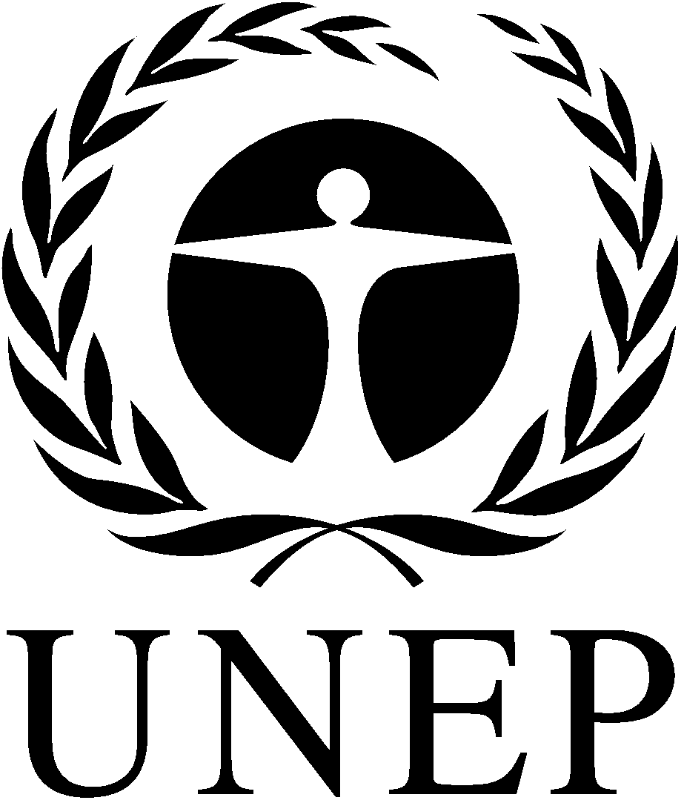 | CBD
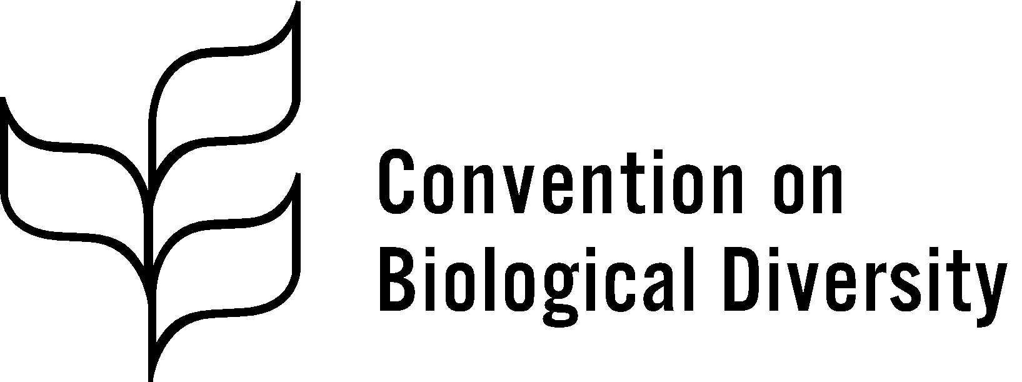 |  | Distr.  GENERAL  CBD/POST2020/WS/2020/2/3  20 February 2020  ENGLISH ONLY
THEMATIC CONSULTATION ON CAPACITY-BUILDING AND TECHNICAL AND SCIENTIFIC COOPERATION FOR THE POST-2020 GLOBAL BIODIVERSITY FRAMEWORK
Rome, 1-2 March 2020
Background document to facilitate discussions on the long-term strategic framework for capacity-building beyond 2020

INTRODUCTION
- In its decision XIII/23, the Conference of the Parties to the Convention on Biological Diversity, requested the Executive Secretary to initiate a process for preparing a long-term strategic framework for capacity-building beyond 2020, ensuring its alignment with the follow-up to the Strategic Plan for Biodiversity 2011-2020 and the capacity-building work of the Cartagena and the Nagoya Protocols, and ensuring its coordination with the timetable for the development of the post-2020 global biodiversity framework, with a view to the timely identification of priority capacity-building actions. As part of the process, the Conference of the Parties in its decision 14/24 requested the Executive Secretary to, among other activities, commission a study to provide the knowledge base for the preparation of the long-term strategic framework, develop draft elements of the framework, organize consultative workshops and online discussion forums to discuss the draft elements and submit the draft long-term strategic framework for consideration by the Subsidiary Body on Implementation at its third meeting and the Conference of the Parties at its fifteenth meeting.
- Pursuant to the above decisions, the Executive Secretary has, in consultation with the Co-Chairs of the Open-ended Working Group on the Post-2020 Global Biodiversity Framework and with support of a consultant, prepared the present background document with preliminary draft elements to be considered for inclusion in the long-term strategic framework for capacity-building beyond 2020. The draft elements take into account the findings of the study commissioned to provide an information base for the preparation of the long-term strategic framework, the views expressed during the regional consultations on the post-2020 global biodiversity framework held in 2019, the submissions from Parties, other Governments and relevant organizations, and experience and lessons learned from relevant processes and initiatives, including biodiversity-related conventions, the 2030 Agenda for Sustainable Development, the United Nations Framework Convention on Climate Change (UNFCCC), and the United Nations Convention to Combat Desertification (UNCCD).
- The draft elements also take into account the findings of the survey on capacity-building for coherent implementation of the biodiversity-related conventions conducted by the International Union for Conservation of Nature (IUCN) in the context of a United Nations Environment Programme project entitled “Environmental Treaties Programme: Realizing Synergies for Biodiversity”, supported by the European Union and the Government of Switzerland, and an analysis of capacity development for biodiversity and ecosystem services carried out by the Intergovernmental Science-Policy Platform on Biodiversity and Ecosystem Services (IPBES).
- Following the discussions at the present thematic consultation, a draft long-term strategic framework will be prepared and circulated for comments to Parties and relevant organizations and also made available for review during online consultations in March 2020. Subsequently, a revised draft incorporating the comments received will be prepared and submitted for consideration by the Subsidiary Body on Implementation at its third meeting, in May 2020, the Open-ended Working Group on the Post-2020 Global Biodiversity Framework at its third meeting, in July 2020, and ultimately by the Conference of the Parties at its fifteenth meeting, in October 2020.
- Purpose of the framework
- The elaboration of the framework is born out of the recognition that there is a need to galvanize urgent and transformative action by Governments and society to halt and, wherever possible, reverse the deterioration of biodiversity worldwide. Moreover, while capacity-building and development as a field is advancing, what is needed is a more strategic, comprehensive and sustained approach, one that builds permanent capacities to manage sectors and deliver results.
- The purpose of the strategic framework is to provide Parties and relevant stakeholders, including civil society, academia and the business community, with high-level strategic guidance and direction for capacity-building in support of the post-2020 global biodiversity framework. It is not a plan of action but, rather, an overarching framework providing a menu of core guiding principles, strategies and approaches, based on good practices and lessons learned over time, which Parties and stakeholders are encouraged to adapt and apply, as appropriate, to foster systematic, coherent and effective capacity-building action. The framework would help ensure that capacity-building actions across Parties and organizations are designed, delivered, monitored and evaluated effectively to achieve impactful and sustainable results. It would also enable Parties and stakeholders to better coordinate and streamline capacity-building efforts and to apply the most effective approaches and best practices to address common capacity-building challenges. Given the limited resources often available for capacity-building, it is imperative to ensure that capacity-building actions and investments are strategic and well-coordinated.
- Meaning and scope of capacity-building
- There is no single agreed definition of capacity or capacity-building. For the purpose of this framework, the definitions of the United Nations Development Group will be used. In this regard, capacity is generally understood as the ability of people, organizations and society as a whole to manage their affairs successfully. In turn, capacity-building is understood as the process whereby people, organizations and society as a whole unleash, strengthen, create, adapt and maintain capacity over time, in order to achieve development results.
- The term “capacity development” is now more often used by many organizations rather than “capacity-building”. The main difference between the two terms is that capacity-building implies starting to build something new from scratch while “capacity development” means building on existing capacities. However, capacity-building is used in this document since it is the term mentioned in the text of most biodiversity-related Conventions and the Protocols.
- Capacity-building encompasses various activities, tools, mechanisms and processes for strengthening countries’ capabilities to effectively carry out their functions and achieve desired results over time. In order to ensure that capacity-building initiatives result in sustainable capacities, it is important to consider not only capacity-building, but also capacity utilisation and capacity retention. The matrix in the table below shows how this approach can be applied at three levels.
Table. Capacity development, utilization and retention
Level ↓ | Development | UtiliZation | Retention
Systems | Establishment of adequate institutions, laws and regulations | Enforcement of laws and regulations for good governance | Regular adaptation of institutions, laws and regulations
Institutional | Establishment of efficient structures, processes and procedures | Integration of structures, processes and procedures in the daily workflows | Regular adaptation of structures, processes and procedures
Individual | Development of adequate skills, knowledge, competencies and attitudes | Application of skills, knowledge and competencies in the workplace | Reduction of staff turnover, facilitation of skills and knowledge transfer within institutions
- There are multiple types of capacities necessary for individuals, institutions and systems to function effectively. These include “hard” technical capacities, and “soft” capacities. Hard capacities include such things as technical and specialized knowledge and know-how and skills, institutional structures, and systems, while soft capacities include those values, skills and competencies that allow people to function in a social system, to adapt to new situations, and to identify and explore new opportunities, such as motivation, confidence, communication, leadership, problem-solving skills, organizational culture, systems and procedures and ability to analyse, adapt and change.
- Capacity-building in its broader sense is also an important part of processes of change and transformation. Change processes take time and require political commitment, visionary leadership, systematic planning, a high degree of investment, broad multisectoral participation.

I. Strategic Direction and Approach
A. Overall vision and theory of change
- The long-term strategic framework on capacity-building, similar to the post-2020 global biodiversity framework, is anchored to a theory of change (see figure below) that assumes a whole-of-government and whole-of-society approach is necessary to promote transformative actions and changes needed as a stepping stone towards the achievement of the 2050 Vision of “living in harmony with nature.” It also assumes that these actions will be supported by, inter alia, (a) enabling conditions and (b) adequate means of implementation, including financial resources, capacity and technology.

Figure. Visual representation of the theory of change
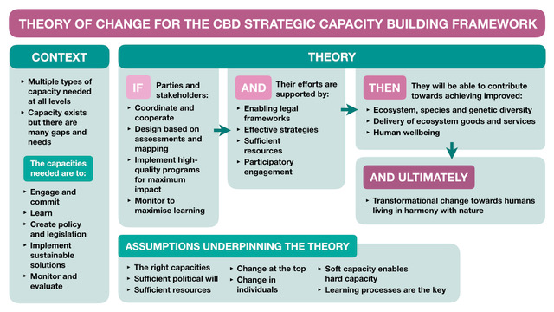
- This theory of change is an important tool for ensuring that the assumptions guiding decisions about the framework and how it is implemented are made explicit, checked for accuracy and reviewed regularly for relevance as contexts and conditions evolve and as capacities are put into place. It is also an important aid to ongoing reflection and learning to ensure that biodiversity capacity-building is consistently effective.
Box 1. The theory of change for the long-term capacity-building strategic framework
CONTEXT
- Nature is declining globally at rates unprecedented in human history – the rate of species extinctions is accelerating, and the health of ecosystems is deteriorating, thus undermining nature’s capacity to contribute to human well-being, sustainability and resilience.
- Multiple types of capacity are needed at all levels to address the above challenges and support transformational change towards realizing the 2050 vision of living in harmony with nature.
- Capacity exists but it is not sufficient or evenly distributed within and across the Parties; there are many gaps and unmet needs.
- There is urgent need for capacity to support transformative change, specifically capacities to:
  - Formulate or reform and implement enabling policies, legislation and incentives;
  - Design and apply appropriate and sustainable solutions
  - Engage, commit and cooperate across sectors;
  - Generate, share and use information and knowledge for informed decision-making and learning;
  - Monitor and evaluate progress, achievements and impact.

THEORY
IF Parties and relevant stakeholders:
- Design long-term capacity-building interventions based on country-driven needs assessments
- Implement high-quality programmes and targeted interventions for maximum impact;
- Adopt a systems-wide approach to capacity-building;
- Institutionalize capacity-building actions;
- Coordinate and cooperate at national and international levels through long-term partnerships;
- Share and promote application of best practices and lessons learned to improve future interventions;
- Regularly monitor capacity-building efforts to maximise learning and adapt as necessary …

AND their efforts are supported by:
- Adequate and predictable funding and other resources;
- Enabling legal frameworks and policies;
- Effective governance and political commitment at all levels;
- Effective organizational leadership, management strategies, systems and procedures;
- Active engagement and involvement key stakeholders from all sectors …

THEN they will be able to effectively contribute to:
- Reducing threats to biodiversity and ensuring that biodiversity is used sustainably in order to meet the needs of people and the planet;
- Fostering transformational change towards sustainability;

AND ULTIMATELY lead to a world living in harmony with nature where:
- Biodiversity is valued, conserved, restored and wisely used, maintaining ecosystem services, sustaining a healthy planet and delivering benefits for all people and the planet…

ASSUMPTIONS UNDERPINNING THE THEORY
- There are sufficient resources available for implementation
- A whole-of-government and whole-of-society approach will be adopted
- There is sufficient political will to drive change
- Change and commitment at the top will trickle down to improve sector performance
- Change in individual and organizational capacity will lead to improvement in performance
B. Guiding principles for capacity-building
- Implementation of capacity-building and development policies, programs, projects and other initiatives to support meeting international biodiversity obligations should be guided by principles and approaches based on experiences and lessons learned from previous and current initiatives. In general, capacity-building and development initiatives should:
(a) Be demand-driven, to ensure national ownership and leadership, and commitment to capacity-building interventions and outcomes;
(b) Be based on needs and priorities identified through participatory assessments and analysis;
(c) Strengthen capacity at the systems and institutional levels in addition to the individual level;
(d) Build on existing processes, institutions and endogenous capacities;
(c) Be guided by lessons learned;
(e) Be tailor-made to specific needs, recognizing that there is no simple, or “one size fits all” approach that works;
(f) Ensure full involvement, and acknowledgement of the perspectives of indigenous and local communities and relevant stakeholders, including youth, and women;
(g) Be participatory and incorporate gender considerations;
(i) Be based on recognized good practice principles for activities such as training;
(j) Have monitoring and evaluation frameworks built into interventions from the start.
C. Strategies for improving and streamlining capacity-building
- The following section outlines possible strategies to improve the effectiveness and impact of capacity-building efforts under the Convention and its Protocols beyond 2020. These include: (a) stock-taking, needs assessment and stakeholder mapping; (b) promoting strategic planning and alignment of capacity-building at all levels; (c) improving the governance of capacity-building efforts at the national and international levels; (d) institutionalizing capacity-building efforts; (e) adopting a systems approach; (f) promoting programmatic and regional approaches; (g) diversifying funding sources for capacity-building; (h) Enhancing monitoring and evaluation of capacity-building; (i) improving the dissemination of best practices and lessons learned; and (j) providing guidance, training, and resources to Parties and stakeholders for designing effective capacity-building interventions.
1. Stocktaking, needs assessments and stakeholder mapping
- In order to have effective capacity-building interventions it is important to take stock of what has been done and gain in-depth understanding of the needs of the different stakeholders. Stakeholder level mapping and analysis are essential to ensure that the desire for change is fully understood across sectors and stakeholder groups so that capacity-building initiatives can be planned to start at the most effective entry point in the system. Stakeholder mapping should include assessing the opportunities for and benefits of leveraging partnerships that would enhance the effectiveness and sustainability of interventions.
2. Promoting strategic planning and alignment of capacity-building
- To be effective, capacity-building should be planned and delivered in a strategic manner as part of the overall national development plan and policy, national biodiversity strategy and action plan or organizational strategy and aligned with the broader national strategies or cross-sectoral capacity-building plans and programmes. Thinking strategically about capacity-building would help ensure that capacity-building investments are prioritised and systematically implemented to address the most critical needs of the country. It is important to identify and prioritise critical capacity-building interventions at the strategic and operational levels. Prioritization of capacity-building investments, taking into account the strategic national and global biodiversity goals and targets, would help ensure that scarce resources are appropriately allocated across thematic areas and programmes, and between short-term, medium-term and long-term needs.
- Ideally, each Party should develop a national capacity development strategy that defines its desired capacity development goals in support of the implementation of the post-2020 global biodiversity framework, ensuring their alignment with this and other relevant global and regional strategic frameworks.
3. Strengthening the governance of capacity-building
- The governance of capacity-building is critical to ensuring effective, impactful and sustainable capacity-building results. Over the years, capacity-building under the Convention has been implemented in a diffuse manner without dedicated institutional oversight and coherent guidance. Capacity-building governance under the convention needs to be streamlined and strengthened at the national, regional and global levels. Possible strategies for strengthening capacity-building governance could include establishment of a high-level Committee on Capacity-building at the global level and similar bodies at the national level.
4. Institutionalizing capacity-building
- To increase the effectiveness of capacity-building activities, Parties and organizations are encouraged to take measures to institutionalize capacity-building programmes at various levels – regional, national and subnational – so that capacity is retained and sustained beyond technical assistance. This may include designating or putting in place structures through which capacity-building programmes could be offered on a regular and long-term basis. For example, Parties could identify and designate competent institutions (such as regional centres of expertise, universities, training centres, research institutes, and organizations) to serve as capacity-building providers or professional training agencies in different subjects. The designated institutions would upon request and as appropriate organize and deliver training activities, provide internships and fellowships, arrange mentorships across institutions, organize study visits and mobilise and offer advisory services. Technical and financial assistance could be channelled through those institutions to improve, expand and offer the capacity-building support activities and services to various stakeholders on a regular basis, in consultation with the Parties. It is also envisaged that the designated institutions would make their programmes effective and attractive and ultimately run them on a commercial basis, raising and reinvesting funds to ensure sustainability.
5. Adopting a systems approach to capacity-building
- A systems approach would foster more comprehensive, programmatic and synergetic to capacity-building interventions at the systemic and institutional levels. This may include developing capacity for reforming and streamlining policy and legal frameworks and institutional systems to make them more efficient. A systems level approach to capacity-building would also help to develop and retain internal capability within relevant national institutions and organizations to, for example, plan, manage and sustain effective policies or to engage key stakeholders, such as development assistance agencies and multilateral development banks, to integrate biodiversity considerations in their development assistance or lending policies, projects and programmes.
6. Promoting programmatic approaches
- As noted in the study conducted by UNEP-WCMC, the short-term project-based approach to capacity-building has not been a very effective way to deliver meaningful and long-lasting outcomes. Adopting a more programmatic approach would allow the organizations to provide medium-term capacity-building services to countries through comprehensive programmes and support over multiple planning cycles to facilitate strategic incremental development of capacities, with emphasis on institutionalization capacity-building processes rather than focusing on achieving particular capacity outputs per se. Such programmatic capacity-building interventions would require extensive consultations with relevant stakeholders, a combination of various capacity delivery modalities and effective result-based management to help achieve substantial and lasting results and impact.
7. Engaging the private sector
- Involvement of the private sector in the development of national capacities may be strategic because many of the technical and financial resources, expertise and technologies useful for the conservation and sustainable use of biodiversity lie in the hands of private entities. Parties and organizations may wish to proactively engage and cultivate working relationships with the private sector to support national capacity-building efforts and to invest in the transfer of biodiversity-friendly technologies and know-how that would support transformational change towards realizing the 2050 vision of living in harmony with nature.
8. Active engagement of academic institutions and networks
- The involvement of academic institutions and networks (including universities and colleges) in biodiversity capacity-building is currently very limited or not apparent. There is a need to more proactively and systematically engage these institutions to play a central role in developing capacities at various levels to strengthen biodiversity action and policy, including through education and training (or re-training) of policymakers and practitioners, research and analysis, design and implementation of innovative solutions to biodiversity challenges, and contribute to key policy and decision-making processes.
9. Diversifying capacity-building delivery methods and approaches
- As noted in the study conducted by UNEP-WCMC, there is a wide range of approaches and modalities being used to deliver capacity-building for biodiversity, including training workshops, formal education, mentoring and coaching, peer-to-peer learning, networking, technical assistance and others. Parties and organizations should, as appropriate, diversify the approaches and modalities used and, wherever possible, use a combination of different approaches and modalities in mutually reinforcing ways to increase effectiveness and impact.
10. Promoting systematic monitoring and evaluation of capacity-building efforts
- Parties and stakeholders should foster systematic monitoring and evaluation of capacity-building efforts to ensure that the intended capacity outcomes are achieved in an impactful and sustainable manner. Systematic monitoring and evaluation would also help to capture and correct mistakes, identify and share good practices and lessons learned to inform and improve capacity-building across Parties and organizations.
11. Enhancing knowledge management
- Parties and stakeholders should develop and implement capacity-building programs and mechanisms in the area of knowledge management, data management, and biodiversity informatics. Existing capacity-building programmes could be modularized and shared in a variety of modalities. New programmes can be developed in conjunction with a variety of stakeholders, such as academic institutions, GBIF, GEO-BON and others. In addition, technical capacity can be developed at the national and subnational levels.

II. FOCAL CAPACITY RESULT AREAS and PROGRAMMES
A. Results chain
- In line with the theory of change described in section I, sub-section A and consistent with the theory of change of the post-2020 global biodiversity framework, the long-term strategic framework for capacity-building is intended to achieve the headline results presented in Box 2, in a hierarchical order.
Box 2. Results chain for the long-term capacity-building strategic framework
The overall vision is:
All Parties and relevant stakeholders have in place the enabling conditions, institutions, organisations, systems and resources necessary to support transformational change towards living in harmony with nature.

Ultimate impact (vision level):
- Improved ecosystem, species and genetic diversity
- Improved delivery of ecosystem goods and services
- Improved human wellbeing

Long-term outcomes (goal/mission level)
- Parties and stakeholders work together collaboratively and in a coordinated manner to achieve the biodiversity goals and targets of the Convention and its Protocols
- Governments and relevant organizations have the necessary capacity to effectively design, implement, coordinate, monitor and evaluate biodiversity policies, programmes, projects and activities
- Policymakers easily access relevant information to make evidence-based policies and decisions
- Biodiversity institutions and organizations have enhanced capacity that enables them to fulfil their mandate, consistently achieve results and extend their impact

Intermediate/medium-term outcomes
- Sound enabling legal frameworks and policies in place
- Coherent and integrated institutional frameworks, systems and procedures in place
- Formal and informal partnerships and networks actively support biodiversity conservation and sustainable use efforts
- Institutions and organisations are able to design and implement relevant and high-quality programmes and projects that:
- Have realistic and achievable plans;
- Have sufficient budget and resources;
- Monitoring, evaluation and learning processes embedded from the start
- Institutions and organizations effectively engage and involve stakeholders in relevant processes.
- Operations of institutions and organizations supported by diverse funding sources
- Parties and organizations easily access and utilise relevant information, tools and solutions
- Performance of individuals greatly enhanced
- Developing country Parties formulate institutional capacity strengthening programmes

Outputs contributing to the above outcomes and impact
- Partnerships, coalitions and networks created/expanded
- National capacity-building strategies/ action plans developed and implemented
- Institutions and organisations are well equipped
- Relevant information and data made available to policy makers and decision makers
- Learning communities in place and active across various thematic areas
- A pool of suitably skilled and highly motivated policy makers, practitioners and experts on different thematic areas developed
- An institutional capacity development programme for national focal points successfully implemented;
- Standard learning packages available on various topics.

B. Functional capacities
- As noted in the report of the study to provide an information base for the preparation of the long-term strategic framework for capacity-building, the top priority functional capacities identified by Governments and indigenous peoples and local communities include the following, in order priority: capacities for resource mobilization, project design and management, stakeholder engagement, networking and partnership development, monitoring and evaluation, institutional building, strategic planning, communication and awareness raising, information and knowledge management, leadership and management, gender mainstreaming and policy design and enforcement. Capacity-building providers and donors will be encouraged to develop targeted capacity-building interventions or include capacity-building components in relevant projects and programmes to assist Parties and indigenous peoples and local communities to develop these capacities, as appropriate.
C. Technical capacities and thematic capacity-building actions plans and programmes
- The successful achievement of the various targets to be adopted in the post-2020 global biodiversity framework would require specific technical capacities. For example, to achieve a target on invasive alien species, a number of Parties may require expertise in DNA technologies to identify the species or the use of geographic information systems (GIS) and satellite imagery technologies to map the location of those species in order to design effective control and eradication measures.
- It is recommended that, following the adoption of the post-2020 targets, the Conference of the Parties request the Executive Secretary to establish commission thematic capacity needs assessments to identify the specific technical capacities needed to achieve each of the targets or related targets and prepare thematic capacity-building action plans for those targets. It is also recommended that, subsequently the Conference of the Parties invite Parties, other Governments and relevant organizations in a position to do so to design and develop dedicated global, regional and subregional and national programmes, as appropriate, to implement the thematic capacity-building action plans with specific capacity targets, milestones and indicators to be reached within a given period.

III. Implementation Strategies and Mechanisms
A. Introduction
- This section presents proposals for the implementation of the long-term strategy, including the integration of capacity-building in national biodiversity plans and possible partnerships and mechanisms for greater coordination and cooperation among stakeholders engaged in biodiversity capacity-development. Recommendations for enhancing synergies with other relevant international processes and funding considerations for capacity-building are also addressed.
B. Integrating capacity-building in national biodiversity strategies and action plans
- Parties are encouraged to develop a national biodiversity capacity-building strategy or action plan or integrate explicit capacity-building components in their national biodiversity strategies and action plans, as appropriate (see 3.4.1). The strategies can help identify capacity-building needs, goals, targets and milestones in support of the implementation of the post-2020 global biodiversity framework, ensuring their alignment with this and other relevant global and regional strategic frameworks. This may help Parties to ensure that capacity-building for biodiversity is thought through and planned strategically and coherently with a view to guiding and streamlining biodiversity capacity-building investments and institutionalizing capacity-building efforts, as appropriate.
C. Partnerships and networks for implementation
- In the international community, it is widely recognized that multi-stakeholder partnerships can be effective mechanisms for mobilizing and sharing knowledge, expertise, technology and financial resources to support country-driven priorities and strategies towards the achievement of the sustainable development goals. Key for the effective implementation of the long-term strategic framework is the establishment of partnerships. Partnerships may take different forms and involve various stakeholders. The following proposals take a spatial approach by suggesting strategic partnerships at the global, regional and national levels.
- At the global level, key organizations and donors engaged in biodiversity capacity-building and development could come together to set strategic priorities, pool resources and expertise to support the implementation of the framework. One practical mechanism would be through the establishment of multi-partner global biodiversity programmes on relevant topics or themes. Medium to long-term programmes instead of short-term projects could help facilitate the longer-term vision of capacity-building that is needed by many countries to implement their international commitments effectively. Instead of focusing on short-term project outputs, programmes could be designed to deliver comprehensive and more sustainable capacity outcomes.
- One of the key challenges to strengthening technical capacities needed to meet international biodiversity commitments has been a lack of endogenous expertise in many countries and a shortage of experts that could help build the capacities of others. Often, countries pertaining to a specific region share similar characteristics, including economic and social conditions, language and governance structures. Through the development of regional nodes, networks or centres of excellence, those specialized capacities could be built, and, in turn, the regional expertise could be leveraged by countries that require it. Too often, there is a reliance on outside expertise that does not translate into building capacities at the regional or national levels. Regional biodiversity networks and communities of practice based on shared interests, experiences and proximity to the countries could help facilitate more in-depth, peer-to-peer and lasting support for the implementation of the post-2020 biodiversity framework.
- Finally, at the national level, it is important that the Global Biodiversity Framework and the long-term strategic framework on capacity-building be considered in the development of the United Nations Development Assistance Framework (UNDAF). The United Nations country teams should incorporate biodiversity-related targets in UNDAF and establish clear linkages with the sustainable development goals. This is a strategic, medium-term results framework that describes how United Nations country teams will contribute to the achievement of sustainable development results based on a common country analysis and the comparative advantage of the United Nations. Capacity development needs of the Government are determined through consultations and detailed capacity needs assessments. This process helps identify different partners that can support implementation at the national level.
B. Mechanisms for coordination and collaboration
- To meet the targets of the post 2020 Global Biodiversity Framework and pave the way for the necessary transformative changes it is essential to move beyond silo thinking and planning. There is a need for greater coherence and coordination among stakeholders to ensure that biodiversity capacity-building is targeted, non-duplicative, consistent and continuing.
- Coordination needs to happen among different stakeholders and at various levels. In line with the partnerships suggested above coordination needs to take place at the global, regional and national level. At the global level it is important to create a high-level mechanism that brings together key stakeholders including parties, donor agencies, leaders of multilateral environmental agreements and organizations that deliver capacity-building including academia to improve coherence and coordination in capacity-building interventions in support of the long-term strategic framework (see 3.4.2).
- Existing coordination mechanisms, such as the Liaison Group of Biodiversity-related Conventions (known as BLG), could also be invited to incorporate the implementation of the long-term strategic framework on capacity-building in their agenda and expand their membership to include other key stakeholders (see sub-section E below).
- At the national level, it is essential that a whole-of-government approach be adopted for the implementation of the post-2020 biodiversity agenda and that national coordination mechanisms be established to support the means of implementation, including capacity-building. The different focal points of the biodiversity-related conventions and other relevant processes along with representatives of line ministries need to come together to decide on a road map for implementation. In many countries, coordination mechanisms have been established in the context of the Sustainable Development Goals. It is possible that these same mechanisms could incorporate the biodiversity agenda. The United Nations country team can play an important role in helping to determine needs and coordinating biodiversity capacity-building interventions.
E. North-South, South-South and triangular cooperation
- The implementation of the long-term strategic framework can benefit from existing and evolving forms of cooperation. Bilateral and multilateral cooperation opportunities can build in modalities for enhancing traditional North-South cooperation but also promoting, South-South and triangular cooperation. In today’s fast-paced world of technological advances, South-South cooperation plays an indispensable role. Peoples with close historical ties and similar development pathways facing shared challenges can exchange knowledge and solutions in the pursuit of common goals.
- The 2030 Agenda acknowledges the critical role that South-South cooperation plays in global development, and so do other important international processes, notably the Paris Agreement on Climate Change and the Addis Ababa Action Agenda on Financing for Development.
- Triangular cooperation creates horizontal coalitions that complement South-South and North-South cooperation, in the pursuit of shared development goals. Triangular cooperation is a multilateral approach that involves stakeholders with the following key roles: a beneficiary partner that is the target of the development results to be achieved through the triangular interventions; a pivotal partner that has proven experience and shares its resources, knowledge and expertise; and a facilitating partner that helps connect beneficiary and pivotal to form a partnership and provides financial and/or technical support. Partners are not only Governments and international organizations; civil society organizations, the private sector, philanthropy, subnational actors and academia are also increasingly participating in trilateral initiatives.
F. Synergies with the capacity-building work of other relevant conventions and processes
- At the global level, efforts to enhance synergies have been under way for some time. BLG brings together the heads of the secretariats of the seven biodiversity-related conventions. BLG meets regularly to explore opportunities for synergistic activities and increased coordination, and to exchange information. In addition, efforts are ongoing to build high-level coordination and synergies with the other Rio conventions and the 2030 Agenda for Sustainable Development.
- Capacity-building is always identified as one of the promising areas for integration and for building synergies among relevant conventions and other processes. Formal mechanisms to build synergies through joint capacity-building interventions have yet to be established. In the context of the post-2020 biodiversity agenda, renewed discussions are taking place on how to enhance these synergies.
- It is important that these ongoing discussions consider specific mechanisms and incentives to promote synergies centred around capacity-building. One such incentive could be specific funding earmarked for capacity-building interventions that integrate three or more biodiversity-related conventions.
- At the national level, it is important that the national focal points of relevant conventions and processes establish a mechanism to foster joint planning and coordination. Moreover, funding mechanisms such as GEF and the work being carried out under the United Nations Development Framework must take measures to promote integration and synergies as much as possible.
G. Mobilization of resources for capacity-building
- The development of the post 20202 global biodiversity framework includes a component on resource mobilization. The resulting strategy should make links to the long-term strategic framework on capacity-building. Firstly, strengthening the capacities of Parties and relevant stakeholders to mobilise resources for biodiversity has been identified as a priority. Secondly, it is important to highlight the link between the availability of resources, capacity-building and development as interdependent means of implementation.
- At the global level there is a need for greater focus on biodiversity within development and climate change finance. Related to this, international cooperation projects and programs must be designed to foster long term capacity-building and to achieve this the monitoring and evaluation of capacity-building must be improved.
- Key to the implementation of the long-term strategic framework is the mainstreaming of biodiversity into national planning and budgets. Domestic financial resources need to be invested to improve national capacities and to help creating an enabling environment for greater private sector investment.
- At the national level, UNDP’s BIOFIN initiative may offer opportunities for countries to consider in their resource mobilization strategies funds and resources in support of the long-term strategic framework on capacity-building.

IV. Monitoring, Evaluation and Reporting
A. Monitoring and evaluation framework
- In the international community, it is generally recognized that the capacity to plan, manage, implement, and account for results of policies, programmes and projects, is critical for achieving development objectives and that monitoring, and evaluation play a special role in achieving this. Unlike projects and programs supporting specific biodiversity targets or issues, capacity-building often does not have measurable outcomes. Instead, capacity-building supports a diverse set of goals in different sectors, at different levels, through various activities, in other words it is a means to an end. The nature of capacity-building presents multiple monitoring and evaluation challenges for practitioners.
- Some of the challenges include defining long-term outcomes of capacity-building rather than just short-term outputs generated by projects. For example, what kinds of outcomes can be achieved by helping a country build a national biodiversity strategic plan? Also, it can be challenging to establish causal links between specific capacity-building activities, improvements in organizational performance and the intended development outcome or target.
- In the context of the long-term strategic framework on capacity-building it is important that learning through monitoring and evaluation be systematically built into interventions to allow for continuous adaptive management and incremental improvements in capacity-building. In addition to the conventional results-based framework that many interventions already have in place, there is a need to address the issue of measuring and evaluating capacity-building results.
- There are two levels at which monitoring, and evaluation efforts need to be strengthened. The first is at the level of the long-term framework itself. It will be useful to establish a set of core indicators that will allow Parties and stakeholders at the global level to monitor the implementation of strategic directions and will facilitate the exchange of lessons and improvements. The second level is at the national level where most of the capacity-building in support of the Global Biodiversity Framework must take place.
- Several frameworks have been developed for assessing capacity-building, such as the Global Environmental Facility’s “Monitoring Guidelines of Capacity Development in GEF Projects, the UNDP Measuring Capacity and Pact’s Organizational Performance Index, among others.
- Developing a useful and practical tool anchored in the long-term strategic framework’s theory of change could help countries measure biodiversity capacity-building at the national level, systematically learn from their experiences and adjust to improve interventions. Developing such a tool could be a task for the global coordination mechanism or could be undertaken by the Subsidiary Body on Implementation of the Convention on Biological Diversity with the support of the CBD Secretariat.
B. Indicators for measuring the implementation of strategic directions
- To measure progress in terms of the uptake of the strategic directions proposed in this document it would be useful to establish a set of core indicators that could be measured and monitored at the global level.
- Some possible indicators include:
(a) Amount of funding (USD) made available for the establishment of global biodiversity capacity-building programmes;
(b) Number of partnerships established in support of the long-term strategic framework (the indicator will be disaggregated to show partnerships involving the business community and academia);
(c) Number of regional communities of practice, networks or centres of excellence established to support biodiversity capacity-building (by theme(s));
(d) Number of south-south and triangular cooperation initiatives undertaken in support of the framework;
(e) Number of countries that have incorporated capacity-building strategies as part of their national biodiversity strategies and action plans;
(f) Number of countries that have set up national coordination committees in support of biodiversity capacity-building;
(g) Number of countries with national biodiversity finance strategies that support capacity-building and development;
(h) National budget allocations (USD) in support of biodiversity capacity-building;
(i) Number of countries with UNDAF incorporating biodiversity capacity-building interventions;
(j) Number of countries systematically measuring and assessing capacity-building results;
(k) Number of biodiversity capacity-building projects involving two or more biodiversity-related multilateral agreements.
- Baselines for the core set of indicators will be established to facilitate monitoring and evaluation.
C. Communication and reporting
- A communications campaign will be undertaken to roll out the long-term strategic framework. The campaign will target Parties, international organizations, national governments, key stakeholders including academic associations, the business community, the Secretariats of biodiversity-related conventions, United Nations country teams and other relevant stakeholders. A dedicated website and platform will be created to share information regarding the long-term strategic framework.
- Key partners will be invited to formally pledge support to the implementation of the framework through the establishment of programs, partnerships, communities of practice and other elements proposed by the framework.
- Reporting on advances in biodiversity capacity-building in support of the post-2020 global biodiversity framework needs to take place at the global and national levels. At the global level, the reporting will be based on the periodic monitoring of the core set of indicators to be complemented with inputs from Parties and other capacity-building stakeholders, including lessons learned.
- At the national level and with the use of a monitoring tool to be developed, countries can include assessments towards capacity-building as part of their regular reporting exercises on the implementation of the post 2020 global biodiversity framework.
D. Review of the strategic framework
- The need for enhanced review mechanisms emerged from the submissions and the consultations that have taken place to date in the process to develop the post-2020 global biodiversity framework. Whatever form the enhanced review mechanism takes, it must also consider the capacity-building dimension. Requirements for measuring and reporting on capacity-building should be included in the national reporting guidelines for Parties.
- The periodic review of the usefulness and relevance of the long-term strategic framework along with capacity-building assessments at the national level could be integrated in the overall review mechanism of the global biodiversity strategic framework.
- The results of these reviews can be used to revise and update the strategic directions provided by the long-term framework.
__________

Six of the eight biodiversity-related conventions (CBD, CITES, CMS, IPPC, Ramsar and WHC) have developed a capacity-building strategy, framework or action plan. The International Treaty on Plant Genetic Resources for Food and Agriculture is also preparing its Capacity Development Strategy.
See details about capacity-building work for the Sustainable Development Goals at https://sustainabledevelopment.un.org/topics/capacity-building, UNFCCC at https://unfccc.int/topics#:51180260-1893-4e2a-98bf-e631de4ce1ea and UNCCD at https://knowledge.unccd.int/cbm/cops-and-process-capacity-building-unccd-throughout-years.
The IUCN survey report, entitled “Capacity-building and Synergies across the Biodiversity-related Conventions: Contributing to the design and subsequent implementation of a Long-term Strategic Framework for Capacity-building for Biodiversity beyond 2020”, is available as document CBD/POST2020/WS/2020/2/INF/3 at: https://www.cbd.int/conferences/post2020/POST2020-WS-2020-02/documents.
The analysis (UNEP/IPBES/3/INF/3) is available at: https://ipbes.net/document-library-catalogue/unepipbes3inf3.
UNDP. 2017. UNDAF Companion guidance: Capacity development. [Online]. [Accessed 12 February 2020]. Available from: https://undg.org/wp-content/uploads/2017/06/UNDG-UNDAF-Companion-Pieces-8-Capacity-Development.pdf.
European Parliament. 2017. Briefing note: Understanding capacity building/capacity development: A core concept of development policy. [Online]. [Accessed 11 December 2019]. Available from: http://www.europarl.europa.eu/RegData/etudes/BRIE/2017/599411/EPRS_BRI(2017)599411_EN.pdf
It is noted that these are important resources, interventions or enabling conditions for capacity-building and for the theory of change to work, but they are not capacity in and of themselves.
https://www.thegef.org/sites/default/files/publications/Monitoring_Guidelines_Report-final.pdf
https://www.undp.org/content/undp/en/home/librarypage/capacity-building/undp-paper-on-measuring-capacity.html
https://www.pactworld.org/library/pacts-organizational-performance-index-opi

