|  |  |  |  |  |
| --- | --- | --- | --- | --- |
| Macintosh HD:Users:bilodeau:Desktop:logos:template 2017:un.emf | Macintosh HD:Users:bilodeau:Desktop:logos:template 2017:unep-old.emf | **CBD** | | |
| CBD_logo_CMYK_black [Converted] | | | |  | Distr.  GENERAL  CBD/COP/14/INF/24  2 November 2018  ENGLISH ONLY |

CONFERENCE OF THE PARTIES TO THE CONVENTION ON BIOLOGICAL DIVERSITY

Fourteenth meeting

Item 8 of the provisional agenda[[1]](#footnote-1)\*

Sharm El-Sheikh, Egypt, 17-29 November 2018

**KEY FINDINGS FROM THE FOUR IPBES REGIONAL ASSESSMENTS OF BIODIVERSITY AND ECOSYSTEM SERVICES**

*Note by the Executive Secretary*

1. The Subsidiary Body on Scientific, Technical and Technological Advice (SBSTTA), at its twenty-second meeting, welcomed with appreciation the regional assessments of biodiversity and ecosystem services for Africa, the Americas, Asia and the Pacific, and Europe and Central Asia and the thematic assessment on land degradation and restoration of the Intergovernmental Science-Policy Platform on Biodiversity and Ecosystem Services. In the same recommendation SBSTTA invited the Executive Secretary of the Intergovernmental Science-Policy Platform on Biodiversity and Ecosystem Services, in collaboration with the co-chairs and authors of regional assessments, as appropriate, to make available to the Conference of the Parties at its fourteenth meeting information on the cross-regional analysis of the regional assessments on biodiversity and ecosystem services (SBSTTA recommendation 22/4).
2. In response to the invitation above the Executive Secretary is circulating herewith for the information of participants in the fourteenth meeting of the Conference of the Parties to the Convention on Biological Diversity an information document submitted by the Executive Secretary of the Intergovernmental Science-Policy Platform on Biodiversity and Ecosystem Services on the key findings from the four regional IPBES assessments. The report is being circulated in the form and language in which it was received by the Secretariat.

**Key findings from the four IPBES regional assessments of biodiversity and ecosystem services**

Bob Watson, Emma Archer, Luthando Dziba, Markus Fischer, Madhav Karki, Kalemani Jo Mulongoy, Jake Rice, Mark Rounsevell, Sonali Senaratna Sellamuttu, Cristiana Simão Seixas, and Maria Elena Zaccagnini

The Intergovernmental Science-Policy Platform on Biodiversity and Ecosystem Services (IPBES) recently published four landmark Regional Assessment Reports, one each for the Americas, Africa, Europe and Central Asia, and Asia and the Pacific. The findings of the four regional IPBES assessments are based on many thousand sources of scientific, and also indigenous and local knowledge. The reports focus on answers to key questions about the importance of biodiversity and the threats and opportunities for a sustainable future.

While there are many common and comparative key findings among the four regions, there are also differences between the regions and within the regions on the relative magnitudes of the trends in nature and biodiversity, nature’s contributions to people, indirect and direct drivers, plausible futures and response options, amongst others. On balance there are more commonalities than significant differences between the four regions (although the differences are important as described below).

***Common key findings from the regional assessments***

* ***Key Finding 1***: **Biodiversity and nature’s contributions to people are essential for a good quality of life,** and play a critical role in providing food, clean water, energy, medicines and securing livelihoods; regulating climate, air quality, freshwater quantity and quality, and pollination services; and are fundamental to social cohesion, spiritual fulfillment, preservation of cultural heritage, mental and physical well-being, and identity and sense of place
  + Biodiversity in all its forms and levels (genes, species, and ecosystems) is therefore a strategic asset for sustainable long-term development;
  + Unfortunately, the benefits are unevenly distributed, accessed and experienced by people and communities across and within regions and sub-regions.
  + ***Key Finding 2:*** **In many parts of the world, indigenous and local knowledge underpins the way nature benefits people and promotes the harmonious and respectful interaction between people and nature.** However, indigenous and local knowledge is under pressure and declining in all regions:
  + In Africa, existing indigenous and local knowledge on the management of biodiversity and nature’s contributions to people is reported to be declining in parts of the continent. It is crucial that the valuable natural resources and associated indigenous and local knowledge used to manage these resources are not lost, especially at a time when such knowledge is increasingly recognized as vital to the development of an ecologically sound, knowledge-based economy.
  + In the Americas the cultural diversity of indigenous peoples and local communities provides a plethora of knowledge and world views for using and managing biodiversity and nature’s contributions to people in a manner consistent with diverse cultural values promoting the respectful interaction of people with nature. When indigenous (and local) rights over lands and waters are recognized, major indigenous and local knowledge systems have shown their capacity to protect and manage the territories and resources under their particular set of values, technologies and practices, even in a globalized world. Nevertheless, 61% of the languages in the Americas, and the cultures associated with them, are in trouble or dying out, and the numbers of indigenous peoples and residents of local communities being displaced by poverty, conflict or encroachment, and migrating to urban centers, where their cultural practices are marginalized, is increasing.
  + In Asia Pacific traditional agrobiodiversity is in decline due to agricultural intensification, coupled with a corresponding loss of indigenous and local knowledge. There has been a considerable decline in the cultivation of native varieties of plants and a loss of crop genetic resources putting the food security for millions at risk.
  + In Europe and Central Asia, the knowledge and customary practices of indigenous and local communities enhance peoples’ quality of life by fostering cultural heritage and identity. However, the decline in indigenous and local knowledge has negatively impacted on the heritage and identity of indigenous peoples and local communities.
* ***Key Finding 3:*** **Biodiversity has significant market and non-market economic value *(illustrated by figure A – Americas figure SPM-6)* and non-economic (social/cultural) value.** People value nature for its important contributions to their cultural, spiritual, psychological, physical and economic well-being, and their interactions with nature are shaped by people’s diverse values and value systems. However, contributions of biodiversity or nature to human well-being tend to be under-appreciated and under-used in decision-making processes, in particular for non-material and regulating contributions to well-being. Valuation of biodiversity and nature’s contributions to people is a tool that can be used in decision-making and in communicating the importance of biodiversity/nature, and assisting in promoting their conservation and sustainable use and the equitable sharing of benefits. However, such valuation has to avoid the commodification of those contributions of nature to people related to culture and identity, respecting the diverse holders of cultural values that do not see their cultures as appropriate for commerce and value-based trade-off analyses. The following paragraphs summarize some of the economic values reported:
* The African regional assessment reported that existing studies on the valuation of biodiversity and nature’s contributions to people are few and tend to be limited in both geographic scope and types of ecosystems covered. However, the assessment reported that the economic value of marine and coastal nature’s contributions to people exceeded 35% of the GDP in some regions. It also reported economic values for coastal protection, water purification, carbon sequestration, erosion protection, timber production, and recreation ranging from $20-1200 per ha per year.
* The America’s assessment estimated the economic value of terrestrial nature’s contributions to people to be at least US $24.3 trillion per year, equivalent to the regions GDP. Economic values for different biomes were also estimated. There was a very large range of values for each biome depending on the types of contribution in the biome and their value for the inhabitants. For example, for areas of the Americas with coastal wetlands the economic values ranged from $25-2240 per ha per year with a median value of $424, and for areas where tropical forests occurred, values ranged from $0-1627 per ha per year, with a median value of $24.
* The Asia Pacific assessment reported that there were limited studies on the economic valuation of ecosystem goods and services in the region, and most of them were limited to North East Asia, primarily China, Japan and Korea. Economic values were reported for most units of analysis and for most material and regulating contributions to people. The available economic values ranged from $280-860 per ha per year for habitat maintenance, $110-800 per ha per year for carbon sequestration, $12-900 per ha per year for freshwater quality, and $40-340 per ha per year for food production.
* The European and Central Asia assessment reported market and non-market economic values for a wide range of material, regulating and non-material contributions, expressed in US dollars per hectare per year, including for food production ($233-916, depending on the type of food), the regulation of freshwater quality ($1,965), habitat maintenance ($765), climate ($464), air quality ($289), and tourism and recreation ($1,117).
* ***Key Finding 4:*** **Biodiversity (genes, species and ecosystems) continues to be degraded in all parts of the world, with a corresponding loss of nature’s contributions to people, hence undermining people’s quality of life.** The risk of loss of populations or extinction of species (mammals, birds, amphibians, reptiles, fish and plants) is increasing in terrestrial, coastal, marine and freshwater habitats in all regions of the world *(illustrated by figure D – Asia Pacific figure SPM-4)* caused directly or indirectly by anthropogenic drivers. The situation has become markedly worse in all regions during the last 20 years. With the exception of Europe and Central Asia, just over 20% of all species assessed by the IUCN are listed in the Red List as either extinct, extinct in the wild, critically endangered, endangered or vulnerable (i.e. extinct or threatened), with endemic species even more threatened.
  + In Africa, just over 20% of species that have been assessed by the IUCN are currently listed in the IUCN Red List as extinct or threatened, although the situation varies within and among the sub-regions, with East Africa and the islands with the greatest percentage (about 38%) of species at risk. Poaching and illegal trade has resulted in a significant decline in many species of wild fauna and flora. Among the 4,989 freshwater species assessed, 21% of all species are threatened and 91% of endemics are threatened.
  + In the Americas about 24.5% of all species assessed by the IUCN (about 14,000, with assessments focused on more vulnerable groups of species) and 25% of endemic species are currently listed in the IUCN Red List as extinct or threatened. There are significant differences from one sub-region to another with the largest number of endemic species at risk being in the Caribbean, about 55%. Particularly high proportions of forest birds and mammals, most amphibian groups and marine species such as turtles and sharks are assessed as facing high risks.
  + In Asia Pacific about 22% of all species that have been assessed by the IUCN and 25% of endemic species are currently listed in the IUCN Red List as extinct or threatened. There are significant differences from one sub-region to another with the largest number of species at risk being in South Asia, 19% of all species assessed and 45% of those that are endemic. Roughly 1 in 3 species of freshwater fish assessed is threatened.
  + In Europe and Central Asia about 13% of all species assessed by the IUCN and 28% of endemic species are currently listed in the IUCN red list as extinct or threatened. There are significant differences from one sub-region to another with the largest number of species at risk being in Central and Western Europe, 13% of all species and 35% of endemic species. Particularly threatened are mosses and liverworts (50%), freshwater fish (37%), freshwater snails (45%), vascular plants (335) and amphibians (23%). Of the 26% of marine fish species with known trend data, 26% have declining populations and only 2% have been increasing over the last decade. In all 48% of marine animal and plant species with known population trends have been declining in the last decade with only 6.5% increasing. Landscapes and seascapes have become more uniform in their species composition, and their diversity has thus decreased.
* ***Key Finding 5:*** **Literally all terrestrial, freshwater and marine ecosystems exhibit some level of degradation, with wetlands, forests and coral reefs being particularly transformed in most regions** *(illustrated by figure C – ECA figure SPM-6).*
* In Africa, most, if not all, terrestrial ecosystems, from forests to arid/semi-arid ecosystems, have already experienced major biodiversity losses, primarily due to an increasing change in land use, e.g., deforestation and conversion to agriculture, leading to habitat fragmentation and destruction. Freshwater biodiversity is currently under severe threat, as is much of Africa’s coastal and marine biodiversity. For example, 20-30% of mangrove cover has been lost in the past 25 years. Damage to coral reef systems, mostly due to pollution and climate change, has had adverse implications for fisheries, food security, tourism, and marine biodiversity in general, including significant impacts on marine protected areas. Over-fishing has had considerable negative impact on coastal and marine resources, resulting in declining fish stocks and threatening a number of species.
* In the Americas, wetlands have been highly transformed, primarily due to expansion of agriculture, ranching and urbanization. For example, over 50% of all wetlands in the United States have been lost since European settlement, with up to 90% lost in agricultural areas, and more than 90% of North American grasslands have been converted to agriculture, pastureland or urbanization. Marine biodiversity has experienced major losses in recent decades. Coral reefs had declined in cover by 50% by the 1970s, and only 10% remained by 2003, which was then followed by a major bleaching event in 2005. There have also been major losses in coastal salt marshes, sea grasses, and mangroves, which are being lost at over 2% per year. Most types of forest cover are significantly less today than original cover. For example, while 83% of the moist forest cover in Amazonia remains, only 12% of the Atlantic coast forest in South Americas remains, and the Andean tropical moist forest has suffered significant losses. By 2002 only 17.5% of lowland moist forest remained in Mexico.
* In Asia Pacific the assessment shows that all major ecosystems are threatened; the most threatened are forest, alpine ecosystems, wetlands, coastal and marine ecosystems especially, coral reefs. The data indicate that the region is having 1%–2% annual estimated coral loss even for the most managed reefs; 37% of aquatic and semi-aquatic species in the region’s freshwater ecosystems threatened; 60% of grasslands are degraded due to overgrazing by livestock, invasion by alien species, or conversion to agriculture. Coastal and marine ecosystems are threatened due to unsustainable aquaculture practices, overfishing and destructive harvesting practices, threatening the amount of exploitable fish stocks in most sub-regions. There is steep decline in key emblematic wildlife; large wild mammals and bird population have declined due to habitat degradation and fragmentation and nearly 25% of the region’s endemic species is threatened indicating serious loss of crop genetic resources. Similarly, invasive alien species have increased in number and abundance, reaching critical levels. However, there are some positive trends as well over the same period. North-East Asia and South Asia regions have shown an increase in forest cover of 22.9 % and 5.8 % respectively, through policies and instruments such as joint participatory management, payment for ecosystem services, and the restoration of degraded forests. Large wild mammals and birds populations have declined in most part of the region.
* In Europe and Central Asia, the extent of natural ecosystems has declined, and there have been declines in habitat intactness and functioning. 14 out of 15 habitat types have been declining in extent and biodiversity status since the 1950s. In general, these declines are currently continuing, albeit at a slower rate. Wetland extent has declined by 50% since 1970, lakes, ponds and streams are altered and disappearing as a consequence of agricultural intensification, irrigation and urban development. 53% of the EU’s rivers and lakes achieved a good ecological status in 2015 as defined by the EU water framework directive, similarly 30% of water samples in Russia were above water quality standards. However, 73% of the assessments of the EU’s freshwater habitat types show an unfavourable conservation status. Grasslands, tundra, mires and coastal marine habitats have been the most impacted since the 1950s.
* **Key Finding 6:** The emphasis on increasing the production of material contributions to people, e.g., food, fiber and energy to meet the needs of an ever-increasing population and a wealthier population has resulted in a decrease in most regulating contributions, e.g., pollination, climate, air quality, freshwater quantity and quality, and non-material contributions (illustrated by figure E – ECA- SPM-3). For example, food production has increased in most parts of the world through the conversion of natural habitats, i.e., extensification, and unsustainable intensification. This has caused a loss of biodiversity, which in turn can threaten food production.
* In Africa, the reductions in nature’s contributions to people increasingly impact daily lives and negatively impact the continent’s socio-economic development. The decline in biodiversity threatens food, water, energy, health and security, with further negative impacts on livelihoods. Loss of biodiversity also exacerbates climate-related risks, land degradation and desertification, loss of habitats for migratory birds, loss of soil fertility and production, and tourism. It further strains social relations and contributes to inequities among people that contribute, often significantly, to a number of conflicts on the continent. Overfishing is impacting on marine and coastal resources, leading to a decline in fish stocks.
* In the Americas 65% of nature’s contributions to people in all units of analysis are declining, with 21% declining strongly. The production of food from terrestrial agriculture and aquaculture has increased, while marine fish harvests have peaked and are decreasing as stocks decline or management reduces harvests rates. The Americas contain about 40% of the world’s ecosystem capacity to produce nature-based materials with only 13% of the world’s population, hence three times more natural resources per person than the global average. This has resulted in the Americas being the largest global exporter of food and one of the largest traders in bioenergy, which is fueling economic growth in many areas but increasing pressure on Nature and sparking a new round of forest and grassland transformation to agriculture and grazing, and diversion of freshwater to irrigation. Unsustainable extensification and intensification to increase food production are causing, respectively, the replacement and degradation of natural ecosystems that provide multiple material, non-material and regulating contributions to people, sustain many livelihoods and contribute to many aspects of quality of life, with less diverse ecosystems producing fewer of nature’s contributions to people and supporting fewer livelihoods. Literally all regulating contributions are decreasing or strongly decreasing, while most non-material contributions are stable or decreasing.
* In Asia and the Pacific, the declining status and trends in nature’s material goods and services threaten sustainable livelihoods and equitable development. Indeed, sustaining the viability of and access to ecosystem services is critical to contributing to poverty alleviation, which is still prevalent in many parts of the region. Even though terrestrial food production (crop and animal) has increased at a rate greater than population growth, the region is still a net importer of food. The expansion of agricultural land and highly intensive production systems may have caused significant declines of native species and their habitat leading to biodiversity loss, while it increases food and rural livelihood security.
* In all sub-regions of Europe and Central Asia between 1960 and 2016, there has been an increase in the production of food and biomass-based energy, but with negative trends in the majority of nature’s regulating contributions, especially habitat maintenance, pollination, regulation of freshwater quality and quantity, soil formation and regulation of floods, and in some non-material contributions such as learning derived from indigenous and local knowledge. The region is a net importer of renewable resources from outside the region, hence has a footprint on biodiversity and nature’s contributions to people in other regions.
* ***Key Finding 7:*** **Increases in population and growth in the economy, are two key indirect drivers. Together they have resulted in an increased demand for natural resources, which in turn has resulted in the fragmentation, conversion and overexploitation of ecosystems, accompanied by pollution, invasive alien species and climate change** *(illustrated by figure B – Africa Table SPM-1).* Unfortunately, the benefits of this growth are not distributed equitably among or within countries. The globalization of trade has led to a decoupling between where resources are produced and where they are consumed. To date, land use change/conversion has been the most dominant direct driver of biodiversity loss in most terrestrial ecosystems, while over-exploitation, i.e., over-fishing, has been the most dominant direct driver in marine ecosystems. There are synergistic and compounding effects among the drivers. Climate, which has already warmed, on average, by about 1oC compared to pre-industrial temperatures, and is projected to warm a further 1-3oC by the end of this century, interacts with, and amplifies, all other direct drivers. The individual and combined effect of all the direct drivers will have chronic and prolonged consequences for biodiversity, though these are often delayed due to the inertia and considerable time-lags in the response of ecological systems.
  + - * + In Africa the dominant indirect drivers are a combination of rapid population growth, urbanization, inappropriate economic policies and technologies, as well as socio-political and cultural pressures. These have driven the direct drivers of loss of biodiversity. The primary direct driver has been the unregulated conversion of forests, grasslands, wetlands and other natural areas for crop production, mining as well as urban and infrastructure development, which has led to habitat loss and fragmentation, degradation of water catchments and soil erosion. However, given Africa’s extreme vulnerability to climate change, climate change is likely to be a dominant driver of change in the future, which will compound existing stresses. As mentioned previously, the increasing demand for fish is the major cause of overfishing in the coastal and marine environments
        + In the Americas, the dominant indirect drivers have been increases in population and demographic trends, economic growth and increased consumption of goods and services, weak governance systems and inequality. These have led to habitat degradation due to land conversion (a significant amount to agriculture) and agricultural intensification, wetland drainage and conversion, urbanization and new infrastructure, and resource extraction. In general, intensive commercial agricultural practices have been unsustainable, replacing and degrading natural ecosystems that sustained livelihoods and contributed to many aspects of quality of life. Climate change is an increasingly important driver and is projected to be comparable to pressures from historic land conversion by the middle of this century.
        + In Asia and the Pacific, the major indirect drivers are demographic and socioeconomic changes, and weak governance and institutions, resulting in the conversion and degradation of habitats, and an increasing number of alien invasive species, and pollution. Rapid economic growth, globalization and international trade, urbanization and infrastructure development and rural to urban migration, are profoundly modifying consumption and production patterns and lifestyles, which are adversely affecting biodiversity. Invasive alien species currently constitute a major threat across the region, while climate change is projected to become significantly more important in the future. The consumption of traditional foods has decreased, with mixed cropping shifting towards commercial high-yielding crops. Of particular concern is the rapid increase in waste and pollution, especially plastic waste. The world’s top five plastic polluters are in this region and eight of the ten rivers in the world that carry the highest amounts of plastic waste into the ocean are also in this region.
        + In Europe and Central Asia, economic growth, as measured by GDP, is generally coupled with environmental degradation, and along with harmful agricultural and fishing subsidies, indirectly drive the loss of biodiversity. While the dominant direct driver to date has been land-use change caused in part by production-based subsidies that led to the unsustainable intensification of agricultural practices, the impact of climate change is increasing and likely to be one of the most important in the future. These drivers have been amplified by natural resource extraction, pollution and invasive alien species, which are likely to continue to pose considerable threats in the future, particularly in combination with climate change.
        + ***Key Finding 8:*** **There are some bright spots in all regions, including an increase in the number and area of both terrestrial and marine protected areas, and the restoration of some degraded areas.** However, many of the most important areas of biodiversity are not being protected, and not all protected areas are effectively managed. There has been a significant increase in the number of Important Bird and Biodiversity Areas (IBAs) and Alliance for Zero Extinction (AZEs) sites, with a current global pattern, in which 28 % of IBAs are completely covered by protected areas, compared to 22 % of AZE sites. Particularly in the light of climate change, which will cause fauna and flora to migrate pole-wards and upwards in altitude, mosaics of corridors and multifunctional landscapes based on up to date evidence will be required to connect different protected areas
        + In Africa, countries have declared 14% of the continent’s land mass (4,358,096 km2) and 2.6% of the seas (345,917 km2) as protected areas. There are 369 Ramsar sites, 142 UNESCO world heritage sites, 1255 important bird and biodiversity areas, and 158 Alliance for Zero Extinction sites in Africa. Africa has a number of large transboundary protected areas which are especially important for migratory species. Unfortunately, many of these protected areas are ecologically isolated, and are increasingly impacted by poaching, illegal harvesting, fire and fire suppression, invasion of alien species and other human activities that affect their sustainability.
        + In the Americas, protection of key biodiversity areas increased 17% from 1970 to 2010, but fewer than 20% of key biodiversity areas are protected. 18% of terrestrial land and 9% of marine areas (within the Exclusive Economic Zone, EEZ) are currently designated as protected areas. South America has the highest fraction of land designated as protected, whereas North America the most marine. The Americas host 25% of the world’s KBAs. However, not all biomes are well protected, e.g., only 0.3% of tropical dry forest in Mesoamerica, 7% in South America and 10% in the Caribbean are protected. Areas managed by Indigenous Peoples are increasingly recognized as contributing significantly to the protection of biodiversity. Currently, indigenous reserves in Latin America and the Caribbean account for around 12% of all protected land and in the Amazon, around 3000 indigenous lands (not all recognized) now cover over 2 million km2.
        + In Asia and the Pacific, between 2004 and 2017, protected area coverage increased by 03% in terrestrial systems, and 13.8% in marine systems overall. 13.3% of terrestrial land and 15.3% of marine areas are currently protected, with North East Asia and Oceania having the largest fractions of terrestrial land protected, and Oceania and South East Asia having the largest fraction of marine area. Unfortunately, only 4% of marine area is protected outside of Oceania. Approximately 25 % of AZE sites are completely covered by protected areas region-wide, as opposed to 18 % in the case of IBAs.
        + In Europe and Central Asia, the total coverage of protected areas is 10.2%, with 13.5% of its terrestrial area and 5.2% of its marine area (within the Exclusive Economic Zone) being protected. In Western and Central Europe, the total coverage of protected areas is 14.9%, with 26.7% of the terrestrial area and 6.8% of the marine area being protected. Key biodiversity areas cover 5.5% of Europe and Central Asia for Important Bird and Biodiversity Areas and 0.01% for the Alliance for Zero Extinction sites. As of 2017, the proportion of Key biodiversity areas fully covered by protected areas in Europe and Central Asia is 33.3% of Alliance for Zero Extinction sites and 28.1% of Important Bird and Biodiversity Areas
* ***Key Finding 9:*** **Few of the Aichi targets are likely to be met anywhere in the world.** The evidence suggests that some progress towards many of the Aichi targets is being made in most regions of the world, but this progress appears often to be at an insufficient rate, and for a number of targets there appears to be either no significant change or worse, there is movement away from the target *(illustrated by figure F – Africa SPM-8).*
* In Africa, with 50 countries, progress with respect to the 20 Aichi targets is mixed. For 5 of the Aichi targets, no country is on track to achieve the target. Some progress, albeit at an insufficient rate, is being made on all targets, ranging from a low of eleven countries for target 10 (ecosystems vulnerable to climate change) to a high of 39 countries for target 11 (protected areas). No progress, and even regression, from the target, is being made on all targets, ranging from a low of four countries for target 11 (protected areas) to a high of 28 countries for target 5 (habitat loss halved or reduced). Of significant concern is that 13 countries (25% of the total) are moving away from achieving target 5 (habitat loss halved or reduced). There is also no information for some of the countries for some of the targets.
* In the Americas, it is likely that few of the Aichi targets will be met for most countries, in part because of policy choices and trade-offs. Although the rate of loss of natural habitat has decreased in some biomes, degradation and fragmentation continue, making it unlikely to achieve target 5 (habitat loss halved or reduced). Unsustainable fishing continues in some areas (Aichi target 6). Likewise, many intensive agricultural, silvicultural and aquacultural systems do not employ biodiversity-friendly practices (Aichi target 7). Invasive species are widespread and continue to appear (Aichi target 9). Coral bleaching continues in response to pollution and climate change (Aichi target 10). The area of terrestrial and marine protected areas is 18% and 9%, respectively, hence target 11 is likely to be achieved numerically for the region (but not for all countries), although some biomes remain severely unprotected. Although conservation efforts have improved, overall extinction risk for species has increased in some sub-regions (Aichi target 12).
* In Asia Pacific, progress with respect to the 20 Aichi targets is mixed. Some progress, albeit at an insufficient rate, is being made in all or the majority of sub-regions on targets 2 to 7, 11 to 16, and 19. Target 17 (National biodiversity strategy and action plan adopted as policy instruments) is expected to be met in all regions. However, no progress, or moving away from the target, is being made on targets 1, 8 to10, and 20. There is also no information for target 13. In many countries, a long-term increase in forest and protected areas, combined with more effective management, has supported progress towards the achievement of multiple Aichi Targets and Sustainable Development Goals.
* In Europe and Central Asia, progress is being made in addressing the underlying causes of biodiversity loss by mainstreaming biodiversity across government and society through targets 1 and 2, however, perverse subsidies have not yet been reformed (target 3), and without complementary strategies for reducing the impacts of production and consumption, more efficient resource use alone is unlikely to lead to sustainable production and consumption (target 4) The pressure from drivers is unlikely to be reduced and the use of biodiversity is not yet sustainable, hence limited progress for targets 6 to10. Progress has been made toward improving the status of biodiversity by safeguarding ecosystems, species and genetic diversity through protected areas (target 11), but the extinction risk of domestic breeds is increasing (target 12), and the genetic diversity of cultivated plants is decreasing (target 13). The benefits of biodiversity and ecosystem services to all people has not been advanced due to the continuing deterioration of nature’s capacity to provide certain contributions and unequal distribution of nature’s contributions (targets 14 and 15). While progress is being made on contributing to the implementation of the Nagoya Protocol (target 16), only 25 countries (46%) and the EU had ratified it by 2017. Enhanced implementation through participatory planning knowledge management and capacity building has been positive where the Aichi targets have informed the development of national-level plans in all but 13 countries. However, progress has not been made with respect to indigenous and local knowledge and further mobilization of financial resources is critical (target 20).
* ***Key Finding 10:*** **Continued loss of biodiversity, especially when coupled with projected changes in climate, is likely to undermine achievement of many of the Sustainable Development Goals (SDGs) and many of the climate-related goals** *(illustrated by figure H -ECA).* Future impacts on biodiversity and nature’s contributions to people are typically under-estimated, since most scenarios consider only a few direct drivers, notably climate change. Such scenarios fail to capture interactions among drivers, as well as compounding factors. Between now and 2050, business-as-usual scenarios in all regions are projected to result in a continued loss of biodiversity, with climate change becoming a dominant driver for most ecosystems. Scenarios optimized for economic growth or regional competition tend to result in significant loss of biodiversity and nature’s contributions to people, whereas sustainability scenarios, which are characterized by environmental concern (including environmentally motivated changes in consumption patterns), social equity and human welfare and a balanced supply of nature’s contributions to people (a balance between material, regulating and non-material contributions), have much more positive outcomes and at least slow down the rate of loss of biodiversity and nature’s contributions to people *(illustrated by figure G – Americas SPM-7).* While future trade-offs between certain of nature’s contributions to people are inevitable, the severity of the trade-offs may be mitigated by timely, progressive and proactive policy interventions and environmental safeguards based on the most up to date evidence, and by mainstreaming/integrating environmental issues (e.g., biodiversity, climate change and land degradation) into all socio-economic sectors, such as agriculture, water, energy, health, transportation, infrastructure, and cities. This will be crucial as most biodiversity is, and will always remain, outside of protected areas. Analysis of different scenarios can help policymakers make better decisions on the most plausible futures for biodiversity and nature’s contributions to people.
* In Africa, five archetypes of scenarios were assessed (market forces, policy reform, fortress world, local sustainability and regional sustainability). The Market Forces archetype emphasizes the role of markets to deliver economic, social and environmental benefits through free trade and the commoditization of nature. The Policy Reform balances strong economic growth with minimizing environmental consequences through a holistic approach to governance. The Fortress World archetype prioritizes national sovereignty, self-reliance and security over other values, fragmenting international action around environmental issues. The Local Sustainability archetype prioritizes environmental protection, social equality and human welfare, but action towards sustainability is largely taken only at local levels. In the Regional Sustainability archetype, environmental consciousness is heightened, with technological innovation driving global and regional solutions to sustainability issues. In each of the scenarios analyzed, all of the drivers of biodiversity loss increased and biodiversity decreased. Achieving the 2030 Sustainable Development Goals and the African Union’s vision of an integrated, prosperous and peaceful Africa by 2063 is problematic under the fortress world scenario archetype, where national sovereignty, self-reliance and security are emphasized. The market forces and policy reform scenario archetypes are also unlikely to achieve the aforementioned visions, given the propensity of these scenarios to undermine the long-term natural resource base. The regional and local sustainability scenario archetypes provide the most likely opportunities for achieving multiple goals linked to the conservation and sustainable use of biodiversity and Africa’s development. The local sustainability scenario archetype, finally, emphasizes environmental protection, social equality and human welfare, with action largely being taken at the local level through participatory processes. However, regional ecological integrity is undermined by a lack of regional-scale coordination. The regional sustainability scenario archetype emphasizes environmental consciousness, with sustainability issues, such as sustainable land management driven by technological innovation and improved governance. Overall improvements in human well-being are expected under most scenarios, but these improvements typically come at the expense of the environment. Consequently, a range of targets aimed at facilitating transformative changes that achieve both human well-being and environmental sustainability outcomes have been adopted in Africa. Achieving a desirable and equitable future for Africa is informed by commitment to an existing set of regional and global goals and targets.
* In the Americas, three pathways (global technology, decentralized solutions and consumption change) of the great transitions scenario were analyzed, and compared to a business-as-usual scenario (BAU). The global technology scenario assumes adoption of large-scale top-down technologically-optimal solutions to address climate change and biodiversity, whereas the decentralized solutions scenario relies on local and regional efforts to ensure a sustainable quality of life, while the consumption change scenario assumes a growing awareness of sustainability issues which leads to less-material and less-energy consumption patterns. All ecosystems, albeit to differing degrees, will continue to be negatively affected, with a concomitant decrease in nature’s contribution to people. Mean species abundance (MSA) was used as a measure of biodiversity and the degree to which an ecosystem is intact. By 2010 about 30% of MSA had been lost since the start of the European settlement. Under the BAU scenario the MSA was projected to have decreased by 40% in the year 2050 relative to the year 1500, in comparison to about 36% under the global technology scenario and about 35% in the decentralized solutions and consumption change scenarios. Hence, biodiversity continues to be lost under all scenarios examined, albeit to a lesser degree under the three pathways of the great transitions scenario. Unsustainable agricultural practices and climate change are projected to be the major drivers of further degradation of most terrestrial, freshwater and coastal ecosystems, with the pressure from agriculture increasing at progressively slower rates whereas the pressure from changes in climate increasing at an ever growing pace. Under these pathways, climate change mitigation, the expansion of protected areas and the recovery of abandoned lands would significantly contribute to reducing the loss of biodiversity. Changes in nature and nature's contributions to people are increasingly driven by causal interactions between distant places (i.e., telecoupling), thus scenarios and models that incorporate telecouplings will better inform policy decisions.
* In Asia Pacific, four scenarios were analyzed in addition to business-as-usual, global technology, decentralized solution and consumption change (same as the Americas). The business-as-usual scenario suggests that the region will continue to lose biodiversity, as measured using the MSA, at the same rate as the global average. In most regions biodiversity continues to be lost, but at a slower rate than business-as-usual. The scenarios indicate that climate change, urbanization and agricultural intensification all impact biodiversity, albeit in different ways across the sub-regions, with climate change being the dominant driver in Western Asia and Oceania, but agriculture has the greatest influence in South East, North East and South Asia. Given the high social, economic and biological diversity of the region, a few regional and global scenarios and models will not address the entire array of complex human-nature interactions, but the Asia-Pacific assessment represents a start at teasing out the complexities. A combination of old and new drivers and factors such as increasing disasters, are shaping outcomes at different spatial and temporal scales, Decision-making based on harmonized scenarios and models at different temporal and spatial scales allows the mapping of plausible futures in diverse settings of the Asia-Pacific
* In Europe and Central Asia, five scenarios were analyzed in addition to business-as-usual, economic optimism, regional competition, inequality (increasing economic, political and social inequalities), regional sustainability and global sustainable development. Impacts on biodiversity and nature’s contributions to people under business-as-usual scenarios are overall negative. While they are highly variable regionally, they are generally more positive than for economic optimism and regional competition scenarios and more negative than for regional sustainability and global sustainable development. Scenarios considering climate change indicate increases in food, feed and bioenergy production in northern Europe but decreases in food and timber production in the southern part. Scenarios that assume proactive, environmental decision-making; promote environmental management approaches that support multi-functionality; and mainstream environmental issues across sectors, led to projections where undesirable trade-offs were mitigated between different ecosystem services and with biodiversity.
* ***Key Finding 11:*** **According to the assessed knowledge, biodiversity could be conserved and sustainably used with more integrated multi-sectoral policies, institutional arrangements, adequate financing, use of appropriate technologies and behavior changes leading to sustainable production and consumption.** However, we must recognize that there is a great diversity of policy instruments across the regions. Choice of low resource intensive diets (the composition of which may vary geographically), coupled with a reduction in food and water waste, would relieve pressures on biodiversity. Ecosystem-based approaches such as ecosystem-based adaptation, nature-based solutions, disaster risk reduction and sustainable forest, agriculture, fisheries and wildlife management, would provide multiple benefits and could foster synergies between biodiversity and climate change and sustainable development agendas.
* In Africa, enacting proactive legal and regulatory instruments for access and benefit sharing legislation is of vital importance for preserving the rights to local knowledge, genetic resources and sustainable utilization of biodiversity. The establishment and effective management of terrestrial and marine protected areas and other types of conservation areas, including community and privately managed conservation areas has contributed to the recovery of threatened species, especially in areas critical for biodiversity and to improved nature based tourism. This is one of the most successful integrated policy decisions that has been implemented by many African Governments. A key challenge remains the effective management of protected areas in order to build on the success of declaring such protected areas. Other measures such as restoration of various degraded ecosystems and sustainable use of indigenous cereals and plants have also contributed to the restoration of areas critical for biodiversity and food security, respectively. Further, the control of invasive alien species and reintroduction of wild animals are yielding positive results in enhancing biodiversity and nature’s contributions to people through ecotourism income, thus contributing to improved quality of life. In addition, progress in the sustainable use of indigenous cereals such as teff and improved forage production from selection and breeding of indigenous legumes for livestock production also contribute to food security.
* In the Americas, a broad array of policy instruments, such as payment for ecosystem services, rights-based instruments and voluntary eco-certification, can be used by a range of actors to better mainstream biodiversity and nature’s contributions to people into policy and management. Policy interventions can be more effective when they take into account casual interactions between distant places and leakage and spillover effects at many levels and scales across the region. Implementation of public policies is most effective with, inter alia, appropriate combinations of behavioral change, improved technology, effective governance arrangements, education and awareness programmes, scientific research, monitoring and evaluation, adequate finance arrangements, and supporting documentation and capacity building.
* In Asia and the Pacific, new and adaptive multiple-use land management practices are helping many countries to place their conservation efforts on a recovery trajectory by stabilizing land-use and sea-use change. Both market and non-market-based mechanisms (e.g. payment for ecosystem services, including REDD+ and voluntary systems such as eco-labelling) can better channel private sector finance into conservation. The application of natural capital accounting can assist in the internalization of the value of nature and nature’s contributions to people within development programmes and generate options for enhancing revenue for financing conservation. Removing perverse incentives combining various policies, building partnerships with the private sector and scaling up collaborative management and governance mechanisms are some of the ways of accelerating progress towards the achievement of the biodiversity goals.
* In Europe and Central Asia, mainstreaming the conservation and sustainable use of biodiversity and the sustained use of nature’s contributions to people into policies, plans, programmes, strategies, and practices of public and private actors could be achieved with more proactive, focused and goal-oriented environmental action, including quantitative goals. A mix of governance options, policies and management practices is currently available to reduce the loss of biodiversity and nature’s contributions to people, but further commitment is needed to adopt and implement them. While legal and regulatory instruments are the backbone of policy mixes, economic, financial, social and information-based instruments provide additional incentives to trigger behavior change. Further developing rights-based instruments could fully integrate the fundamental principles of good governance, equalizing power relations and facilitating capacity-building for indigenous peoples and local communities. The removal of harmful subsidies in various sectoral policies, such as agriculture, fisheries and energy, would reduce negative impacts on biodiversity and allow for a more cost-effective use of public funds. Innovative economic and financial instruments could include biodiversity offsets and habitat banking, tax reliefs, ecological fiscal transfer and integrated funding for biodiversity and climate change adaptation. Ecological fiscal reforms would provide integrated incentives and provide leverage to redirect activities that support sustainable development.
* ***Key Finding 12:*** **More collaborative, inclusive, participatory and decentralized governance systems, at national, regional and global scales, involving governments, private sector, civil society and IPLCs, is likely to result in the development and ownership of more sustainable practices that would facilitate the sustainable use of biodiversity.** These governance systems will vary depending on the socio-economic-political environment in which they operate. Regional and transboundary collaboration is considered vital and has shown positive results in almost all regions. Partnerships with the private sector, individuals and non-governmental organizations could assist countries in meeting the growing shortfalls in funding conservation efforts.
* In Africa, polycentric governance approaches bring together multiple stakeholders (public, private and local communities) with different perspectives, bridge sectors, and operate at multiple levels and scales, over different time frames. Polycentric approaches offer an alternative to top-down approaches that are less sensitive to local constraints, and to bottom-up approaches that are sometimes inadequate for dealing with issues at higher decision-making levels. When supported by appropriate legal, regulatory, economic and financial instruments, these approaches can harness consensus and co-learning through dialogue and knowledge co-production, while enacting principles of equity, transparency, accountability and participation. Although resource-intensive in the short-term because they demand significant time for dialogue and consultation, polycentric approaches offer agility in responding to change, reduce conflict, balance conservation and development objectives, and yield positive results in the medium to long term. A polycentric governance system is thus critical for enabling Africa’s diverse natural assets to deliver equitable benefits to people. Practiced for many years in Africa for managing diverse interests in resources, polycentric governance is grounded in the processes of accountability through stakeholder engagement, and addresses trade-offs. It further entails working across scales, sectors, values, and knowledge systems, integrating indigenous and local knowledge and their institutions, as well as adaptive management. It further involves building a sense of social responsibility and pursues what might be termed “no regrets” options, particularly in relation to the drivers of changes to nature and nature’s contributions to people. Therefore, governance options that harness synergies and deliver multiple benefits, facilitated by an enabling environment, can help to balance access to, and allocation of, ecosystem services in Africa.
* In the Americas factors, to promote conservation and sustainable use of biodiversity and nature’s contributions to people can be aided by enabling governance arrangements, including partnerships and participatory deliberative processes, and recognition of the rights of indigenous peoples, local communities and people in vulnerable situations, in accordance with national legislation. However, regardless of the degree of participation in governance, existing social and cultural inequalities can be reinforced by unequal power exercised by participants within the governance processes, so effective governance requires capacity building for all stakeholder groups and equal access to information.
* In Asia and the Pacific, governance options and institutional arrangements for reducing loss of biodiversity are more likely to work if integrated frameworks, partnership development, cross-sectoral cooperation and the smart use of policy instruments are adopted. Regional and transboundary management of important landscapes and seascapes, which is producing benefits beyond national boundaries, is providing new opportunities for conservation of threatened ecosystems. More democratic, transparent and inclusive governance systems promote collective decision-making and co-production of ecosystem goods and services benefiting all stakeholders. These emerging governance systems could enable better implementation of national biodiversity strategies and action plans and help to accelerate the progress towards meeting the Aichi Targets. Innovative partnerships with the private sector can significantly scale-up funding for a range of biodiversity protection and ecosystem conservation efforts throughout the Asia-Pacific region.
* In Europe and Central a wide range of actors and stakeholders are increasingly being integrated into governance processes. This can have a positive effect on biodiversity and nature’s contributions to people if the effectiveness, efficiency and equity implications, and taking power relationships and asymmetries into account, of such integration are carefully monitored and evaluated. In parallel to top-down governance, decision-making is increasingly being devolved to public-private partnerships, co-management arrangements or even private governance involving many stakeholders. Further increasing participation and stakeholder involvement would help to integrate various forms of knowledge in policymaking and decision-making while promoting shared responsibility. Promising developments include the establishment of new protected areas, and the protection of cultural landscapes, where various forms of knowledge are integrated into management. Developing pathways and corresponding experiments in a participatory manner, including all relevant stakeholder groups and indigenous peoples and local communities, enables the inclusion of a diversity of perspectives and promotes the necessary deliberation of strategic planning and agenda-setting. Governing complex adaptive systems involving nature and people, which often includes various forms of incomplete knowledge, would benefit from limiting institutional failures and promoting policy processes that stimulate adaptation and learning. Hence, policies, programmes and strategies may be seen as experiments that require governance and management for – rather than against – change, and systematic monitoring and evaluation. This can be achieved incrementally through adaptive governance and management and the systematic improvement of policy implementation, or via transition governance and management, and the organization of evolutionary processes of societal change.
* ***Key Finding 13:*** **While knowledge gaps were identified in each regional assessment, the general conclusion is that current knowledge is enough to implement more effective and sustainable management of biodiversity.** While many of the key uncertainties are similar in each region of the world, the priorities differ among and between them. Major gaps in knowledge include a more quantified understanding of:
* nature’s contributions to people, which include ecosystem goods and services, and how biodiversity contributes to these;
* nature’s contributions to different aspects of people’s quality of life, particularly of non-material contributions,
* the contribution of indigenous and local knowledge into national and international policy and regulatory frameworks and initiatives to create synergies and complementarities across knowledge systems;
* the status and trends of nature, including habitat extent and intactness, species conservation status, and the relationship between ecosystem functioning and species interactions;
* drivers of change in biodiversity and nature’s contributions to people, in particular how combinations of interacting direct and indirect drivers influence biodiversity and nature’s contributions to people. Furthermore, it is critical to understand the time lags between a change in the drivers and the effect on biodiversity, given that some can be almost immediate, while others can be decades or more;
* In addition, there is a lack of integrated scenario and modeling studies and their interactive and cross-scale analysis, in particular scenario studies which evaluate the impact of multiple interacting drivers on biodiversity and nature’s contributions to people, and models which explore the full range of synergies and trade-offs between multiple aspects of biodiversity, nature’s contributions to people (ecosystem services) and quality of life across different scales.
* ***Conclusion:*** The bottom line is that while the loss of biodiversity is an important environmental issue, it is also an ethical, moral, social, economic and development issue. Human well-being depends on actions being taken now to address the loss of biodiversity and to address human-induced climate change. Decisions taken today by Governments, private sector and individuals will affect current and future generations, with poor people being the most vulnerable. According to the available evidence, these decisions would need to lead to societal transformation and behavioural change, if the conservation and sustainable use of biodiversity and sustainable development at large were to be achieved. Therefore, developing an effective, realistic and monitorable post-2020 agenda is an urgent priority,

***Illustrative Figures from the summary for policymakers of the four IPBES regional assessments***

**Figure A: Estimated economic values of ecosystem services in the Americas (Figure SPM 6)**

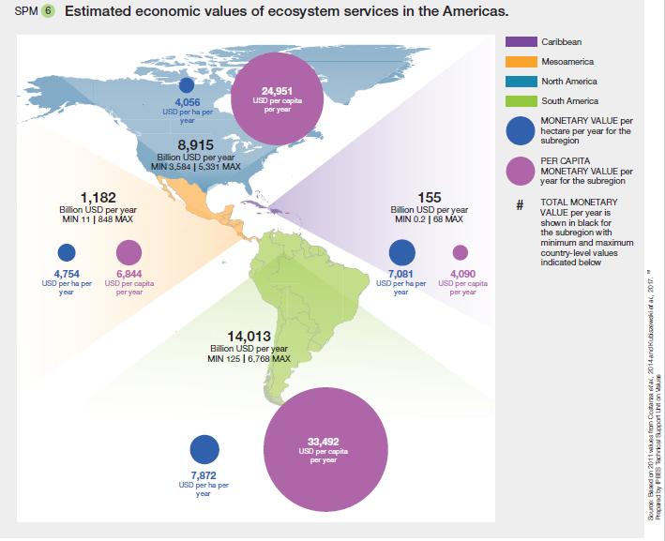

**Figure B: Key drivers of biodiversity change in Africa per sub-region and ecosystem type (Table SPM 1)**

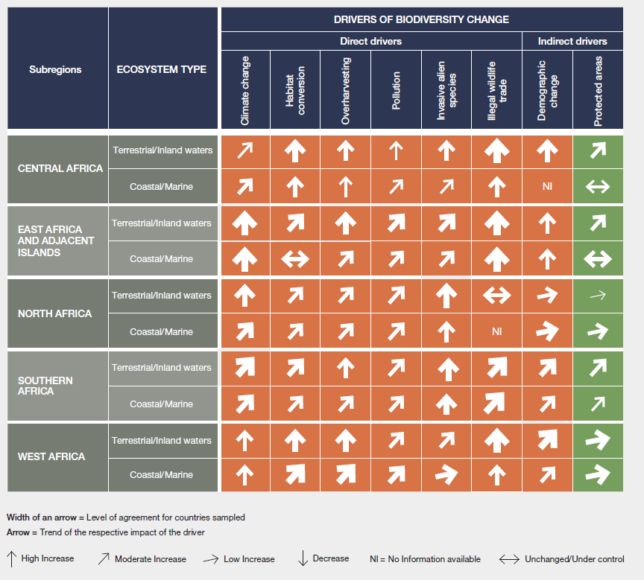

**Figure C: Assessment of past (~1950–2000) and current (~2001–2017) trends in biodiversity status of marine, inland surface water and terrestrial ecosystems for the four subregions and the whole of Europe and Central Asia (Figure SPM-6)**

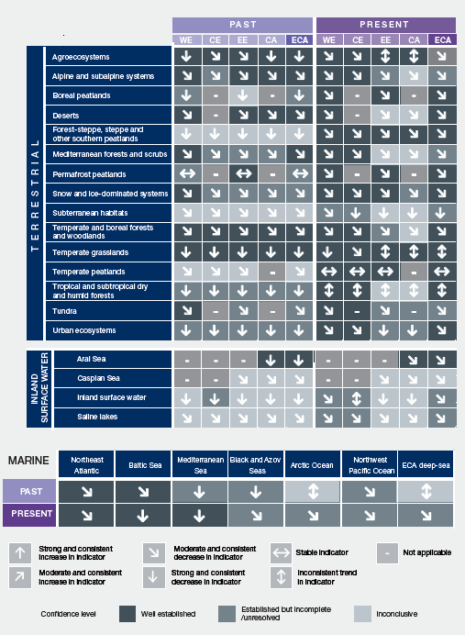

Figure D: Overall extinction risk of species in the Asia-Pacific region (Figure SPM-4)

Based on the IUCN Red List of Threatened Species.[[2]](#footnote-2) Red lines show the best estimates of percentages of threatened species, assuming that data deficient species are threatened in the same proportion as non-data deficient species.

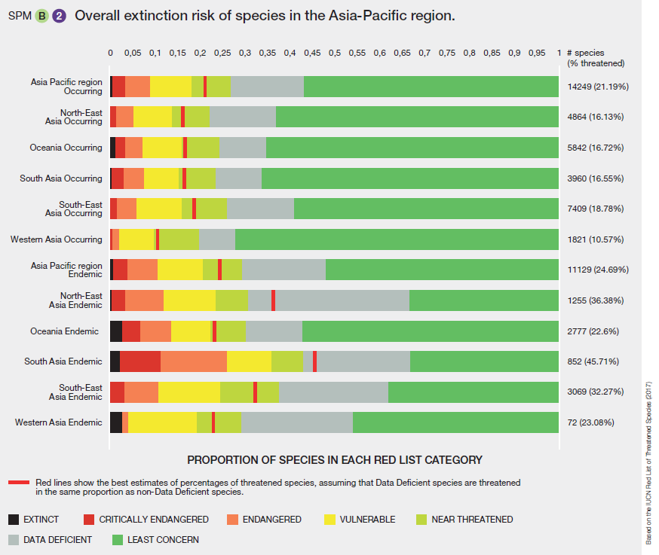

**Figure E: Trends in nature’s contributions to people (1960–2016) for Europe and Central Asia and the sub-regions (Figure SPM – ECA)**.

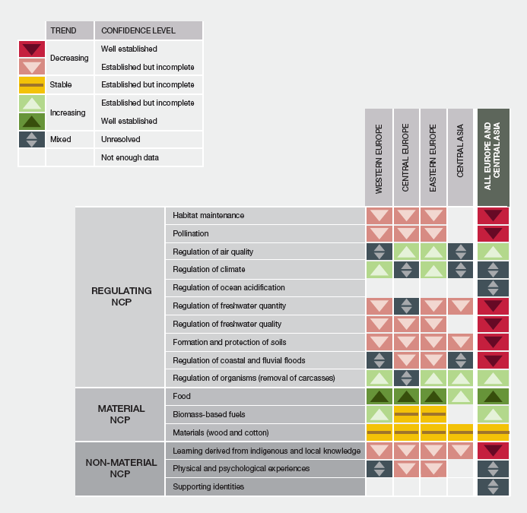

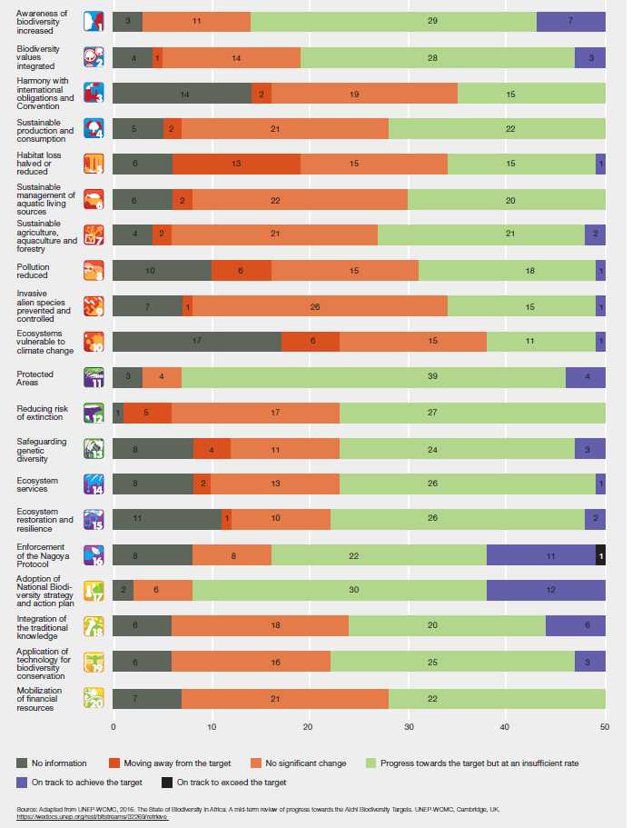**Figure F: Overview of the current and anticipated contribution of African countries towards the achievement of the Aichi Biodiversity Targets based on the fifth national reports submitted to the secretariat of the Convention on Biological Diversity as of September 2017 (50 African countries) – Figure SPM 8 (Africa)**

**Figure G: Projected trends in Biodiversity (Mean Species Abundance) for the Americas (SPM 7)**

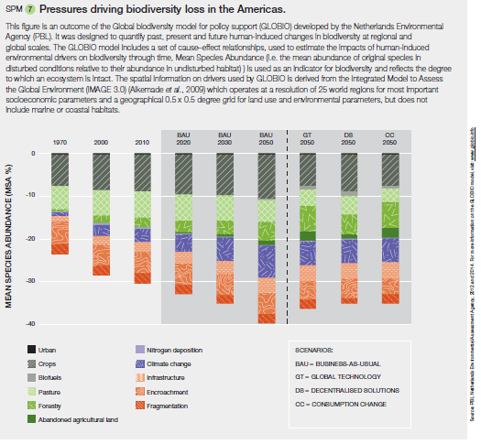

*Source*: PBL. Netherlands Environmental Assessment Agency, 2012 and 2014. For more information on the GLOBIO model, visit: [www.globio.info](http://www.globio.info). [[3]](#footnote-3)

**Figure H: Implications for Aichi targets and the Sustainable development Goals (SDGs)**

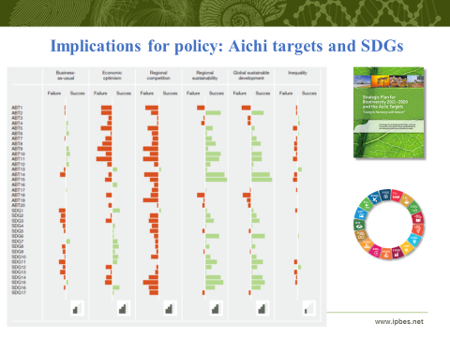

\_\_\_\_

1. \* CBD/COP/14/1. [↑](#footnote-ref-1)
2. Data available from [www.iucnredlist.org](file:///C:\Users\felice.vanderplaat\Documents\IPBES-6\SPMs\Updated\after%20Medellin\AP\www.iucnredlist.org). [↑](#footnote-ref-2)
3. [↑](#footnote-ref-3)