 |  | CBD/SBI/4/INF/8
 |  | Distr.: General  22 April 2024  English only
Subsidiary Body on Implementation
Fourth meeting
Nairobi, 21–29 May 2024
Item 5 (a) of the provisional agenda*
Capacity-building and development, technical and scientific cooperation, clearing- house mechanism and knowledge management under the Convention and its Protocols

Compilation of submissions for the peer review of the draft knowledge management strategy to support the implementation of the Kunming-Montreal Global Biodiversity Framework**
  - Note by the Secretariat

Introduction
- Pursuant to paragraph 9 of decision 15/16, the Executive Secretary is circulating herewith, for the information of participants at the fourth meeting of the Subsidiary Body on Implementation, a compilation of submissions received by the Secretariat in response to notification No. 2024-010 of 31 January 2024 regarding the peer review of the draft knowledge management strategy to support the implementation of the Kunming-Montreal Global Biodiversity Framework.
- Submissions were received from the following Parties: Belgium, Burkina Faso, Ethiopia, South Africa, Spain, Tajikistan and United Kingdom of Great Britain and Northern Ireland. Submissions were also received from the following organizations: CBD Women’s Caucus, the Consultative Group on International Agricultural Research (CGIAR), Chemichemi Foundation, The Swedish Museum of Natural History (GBIF Sweden), HUN-REN Centre for Ecological Research – Hungary, the International Union for Conservation of Nature (IUCN), the network of Marine Protected Area managers in the Mediterranean (MedPAN), the Organisation of Eastern Caribbean States (OECS) Commission, the Partnership for Participatory Monitoring and Management Partnership, the UN Environment Programme World Conservation Monitoring Centre (UNEP-WCMC), the University of Sienna and the University of Aberdeen.
- The information compiled in this document is structured as follows: section A contains the submissions from Parties; and section B comprises the submissions from organizations.

Table of Contents
A. SUBMISSIONS FROM PARTIES 3
Australia 3
Belgium 6
Burkina Faso 19
Ethiopia 22
South Africa 26
Spain 32
Tajikistan 36
United Kingdom 39
B. SUBMISSIONS FROM ORGANIZATIONS 41
CBD Women’s Caucus 41
CGIAR 44
Chemichemi Foundation 47
GBIF Sweden, The Swedish Museum of Natural History 50
HUN-REN Centre for Ecological Research, Hungary 53
IUCN 55
MedPAN 58
OECS Commission 62
Participatory Monitoring and Management Partnership 64
UNEP-WCMC 67
University of Siena 71
University of Aberdeen 75

SUBMISSIONS FROM PARTIES

Australia
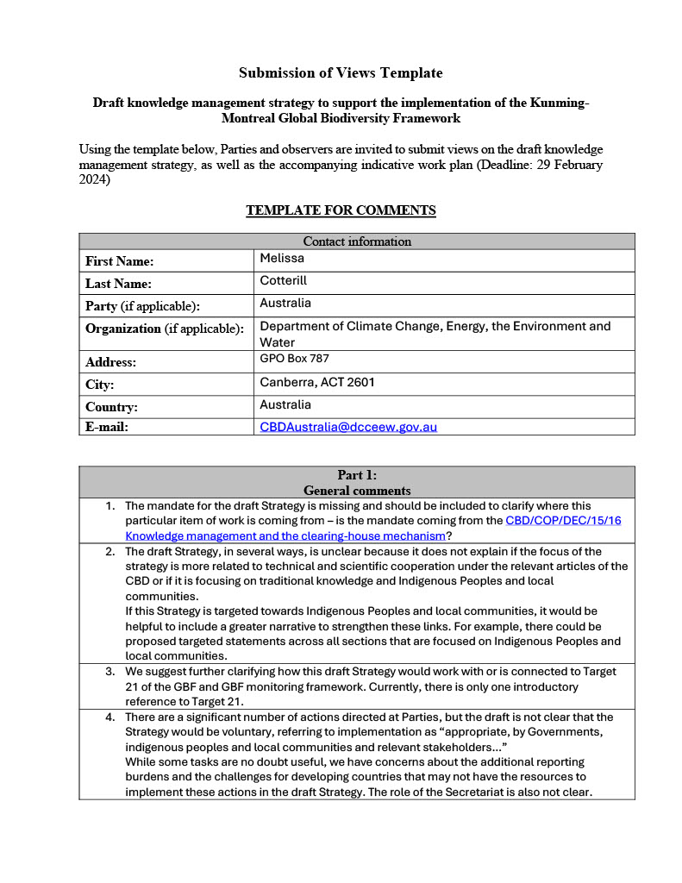
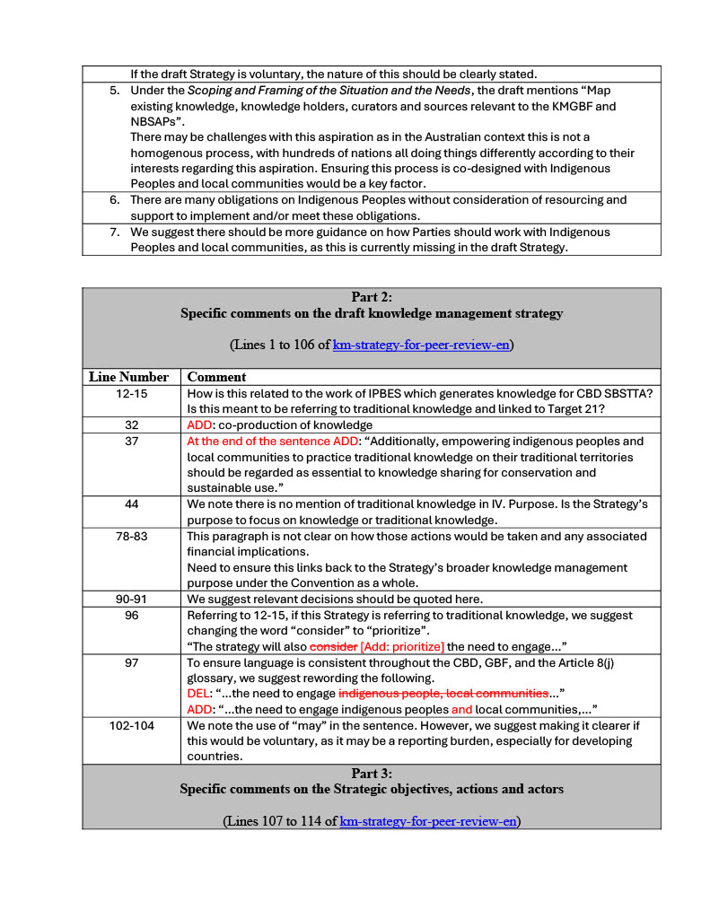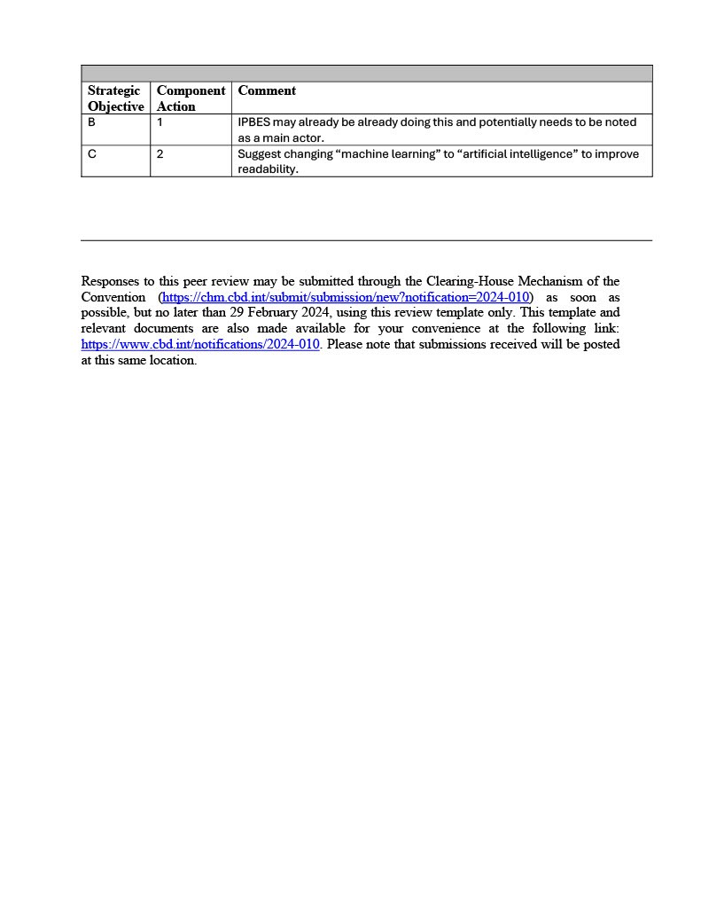

Belgium
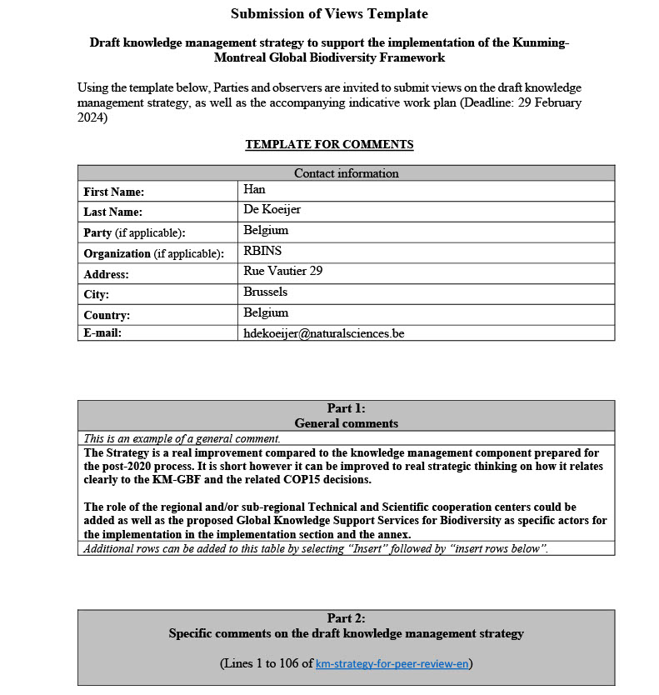
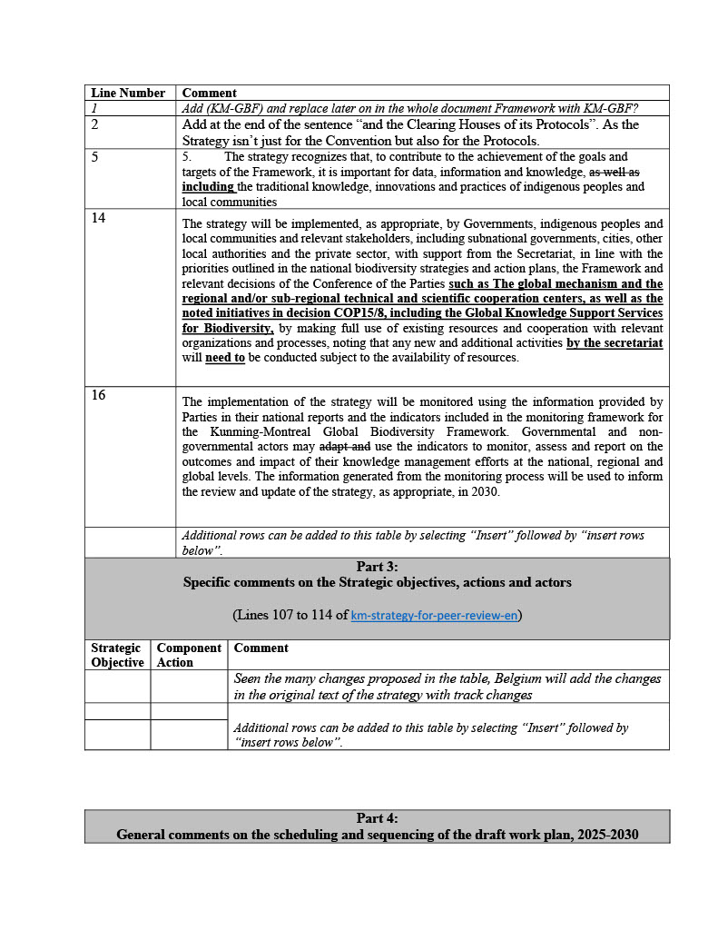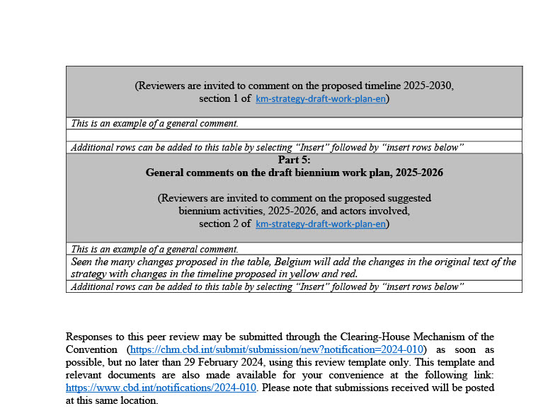

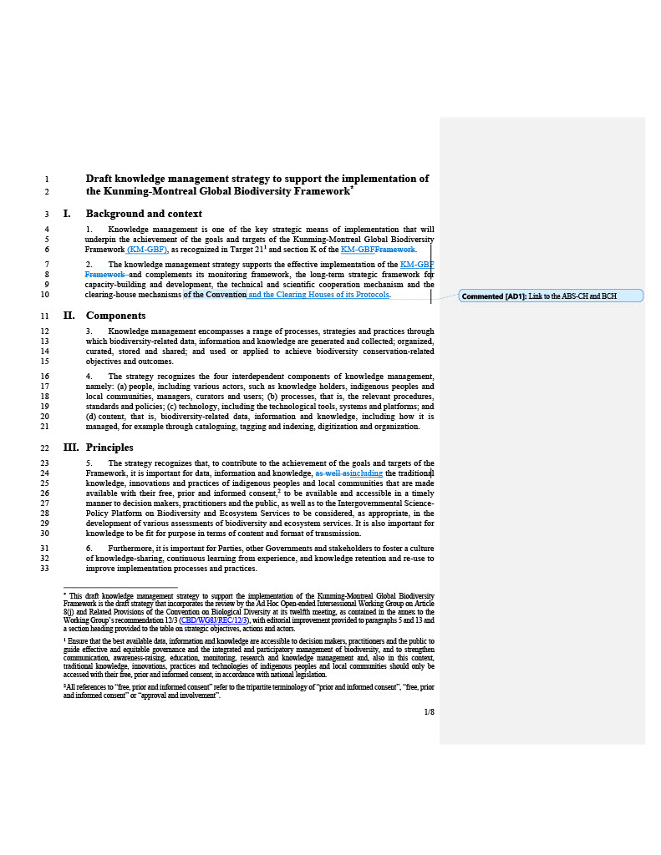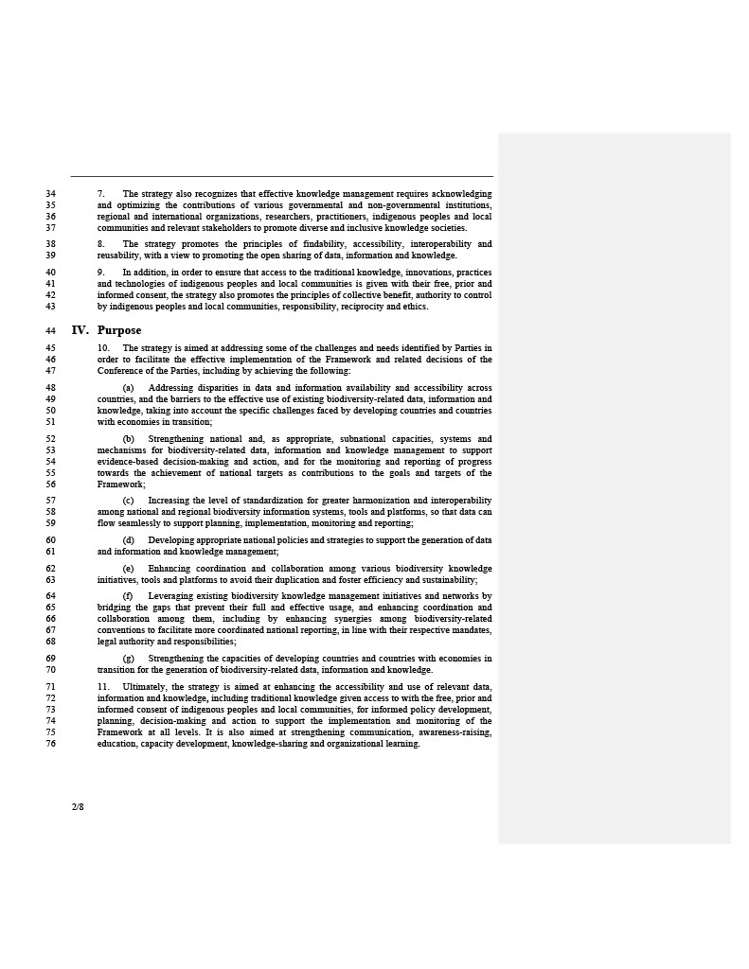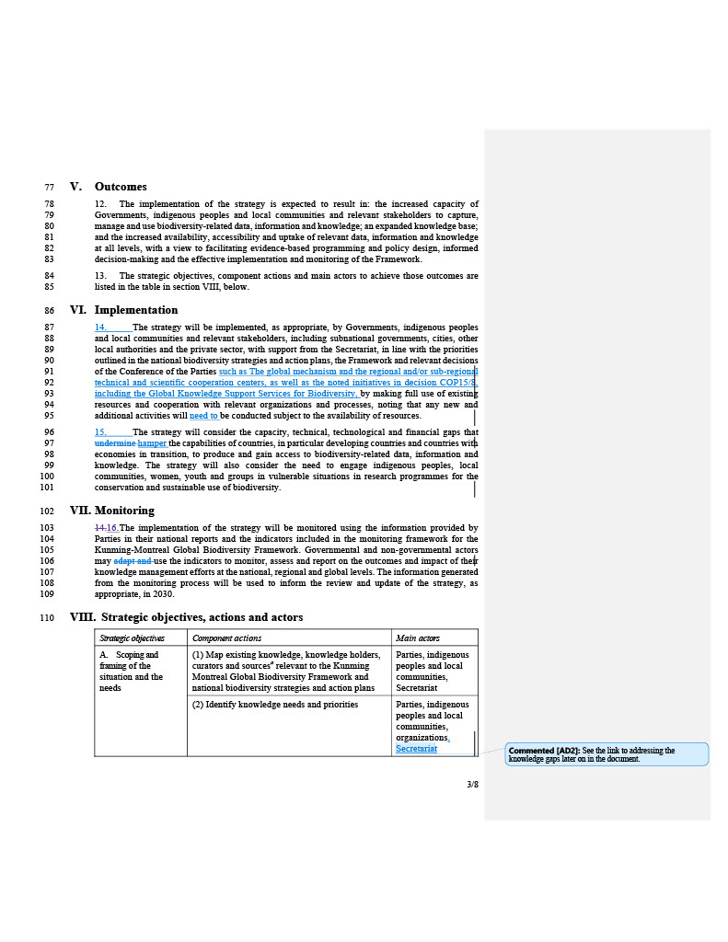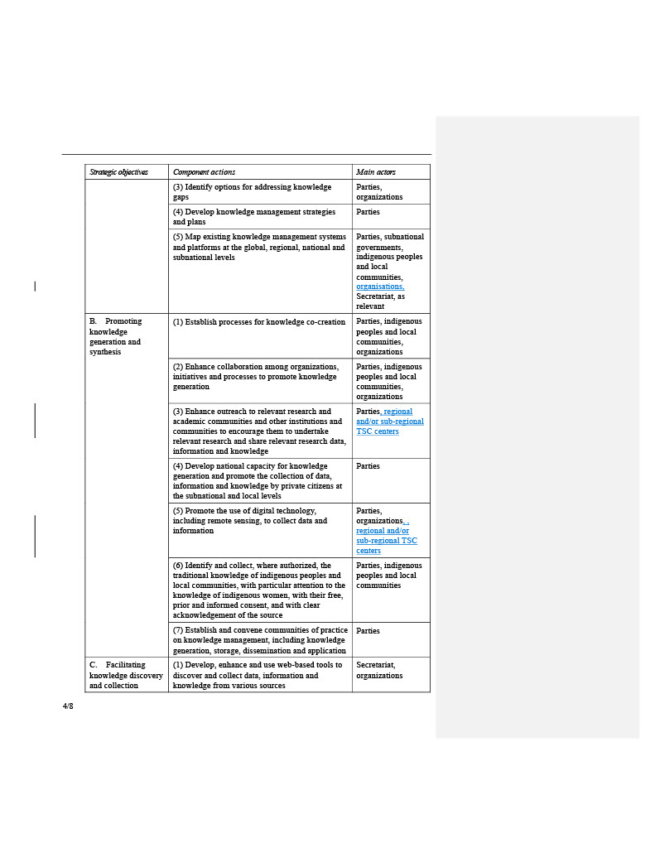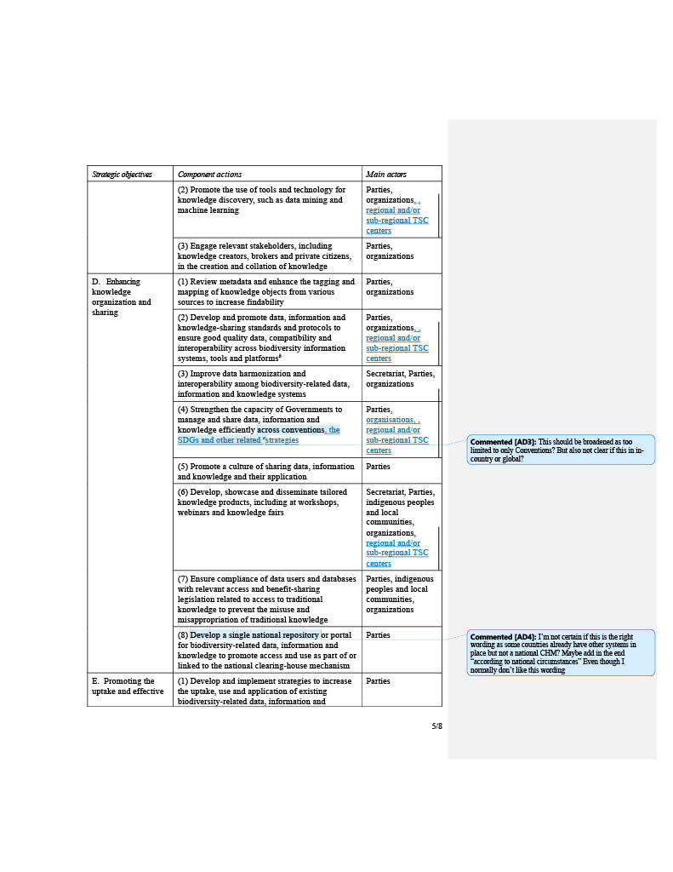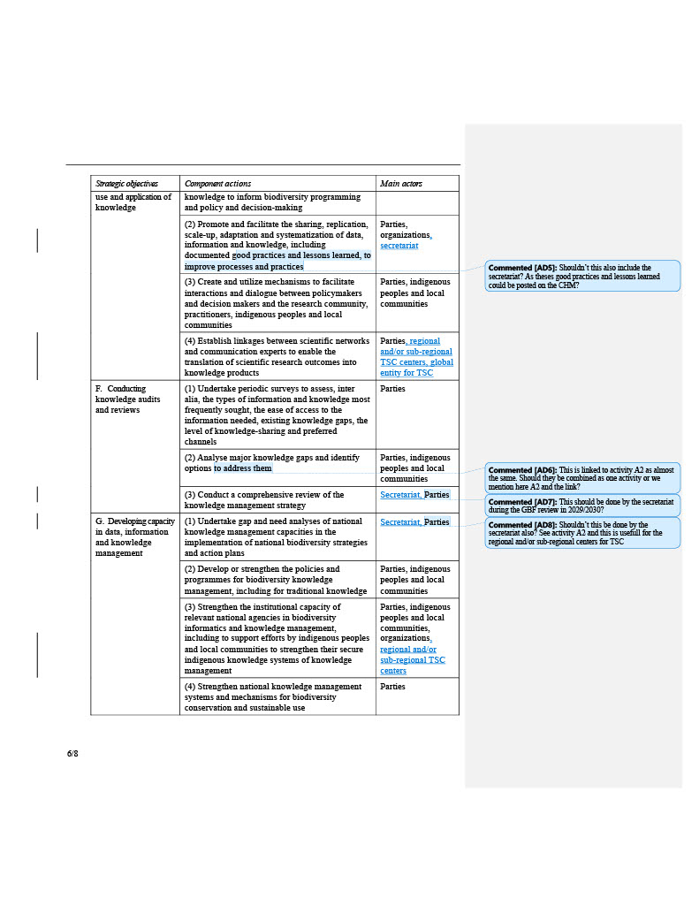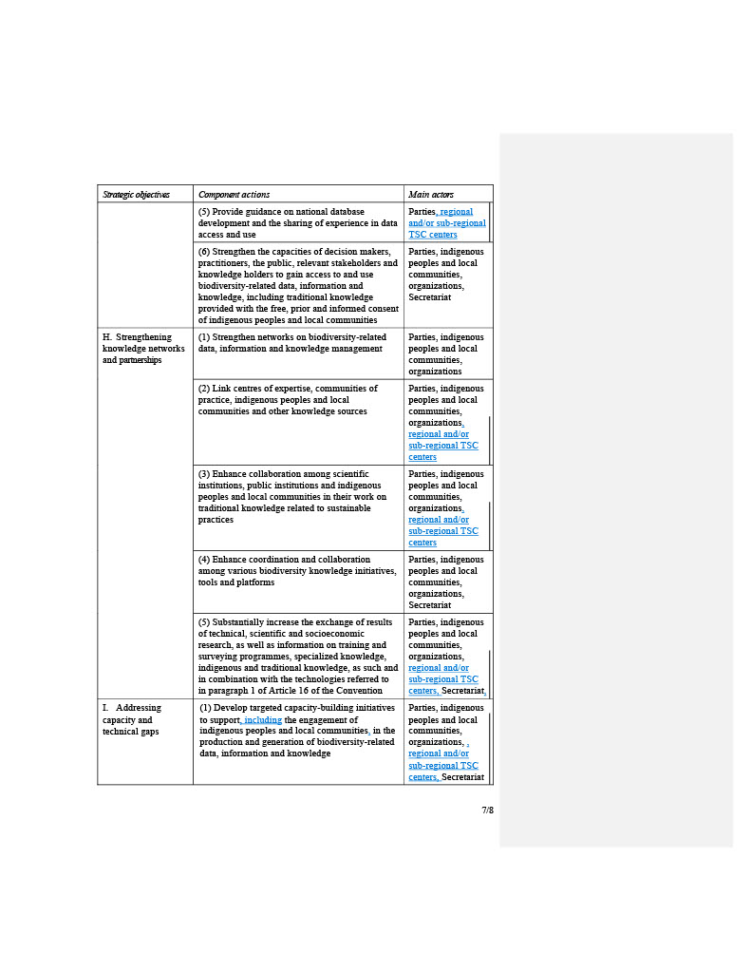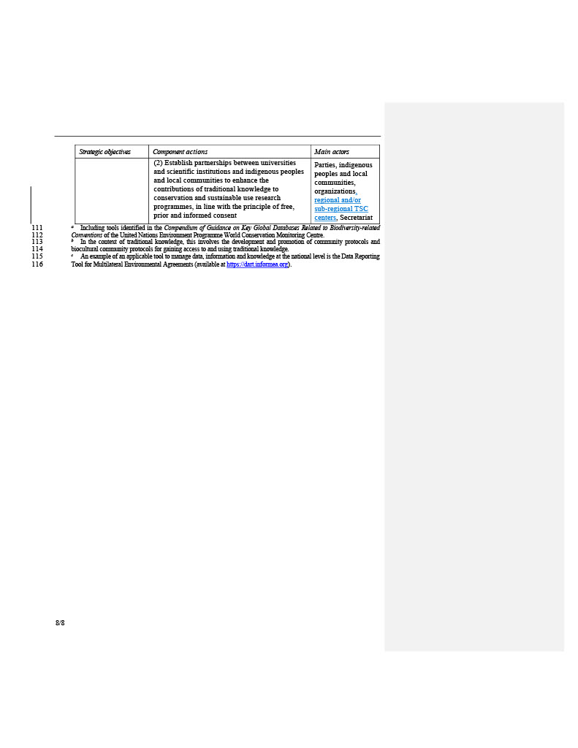

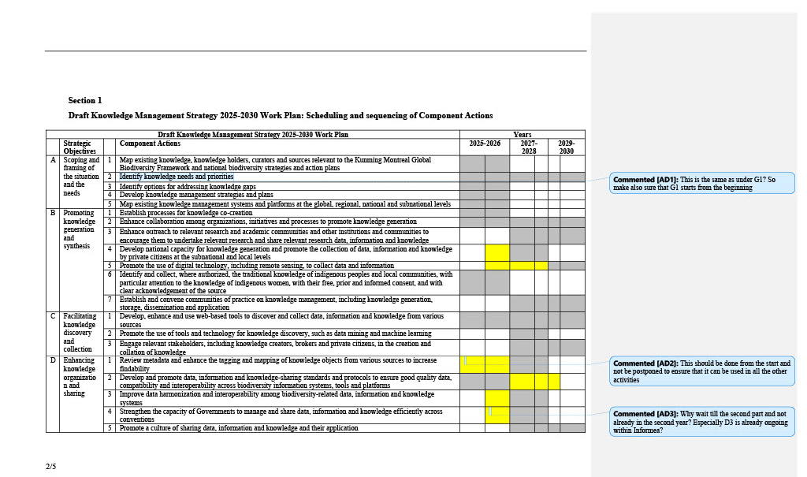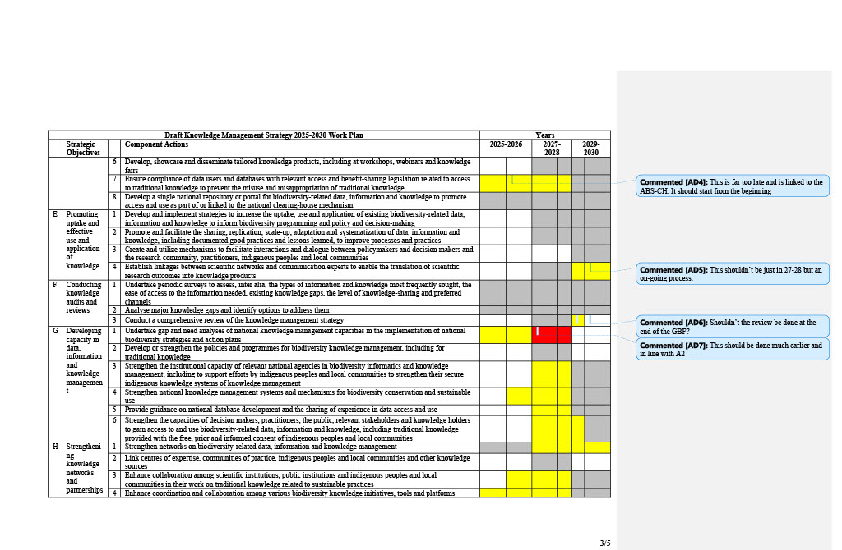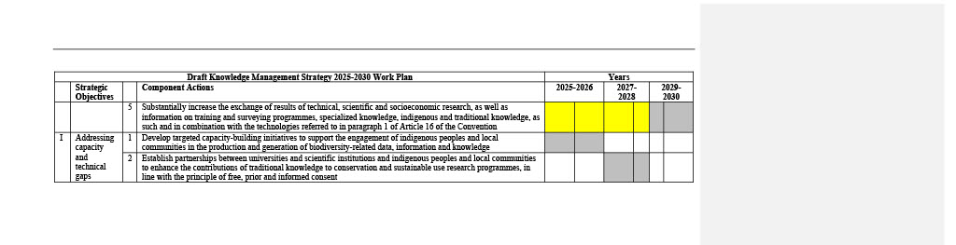

Burkina Faso
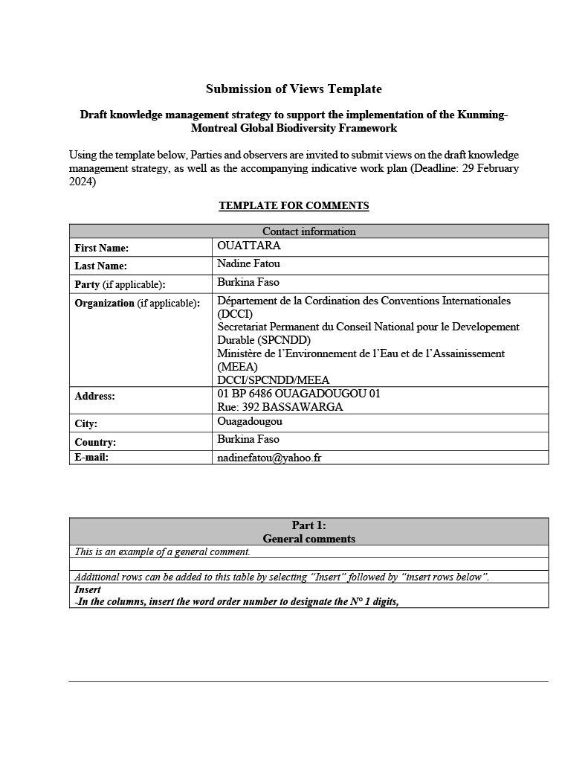

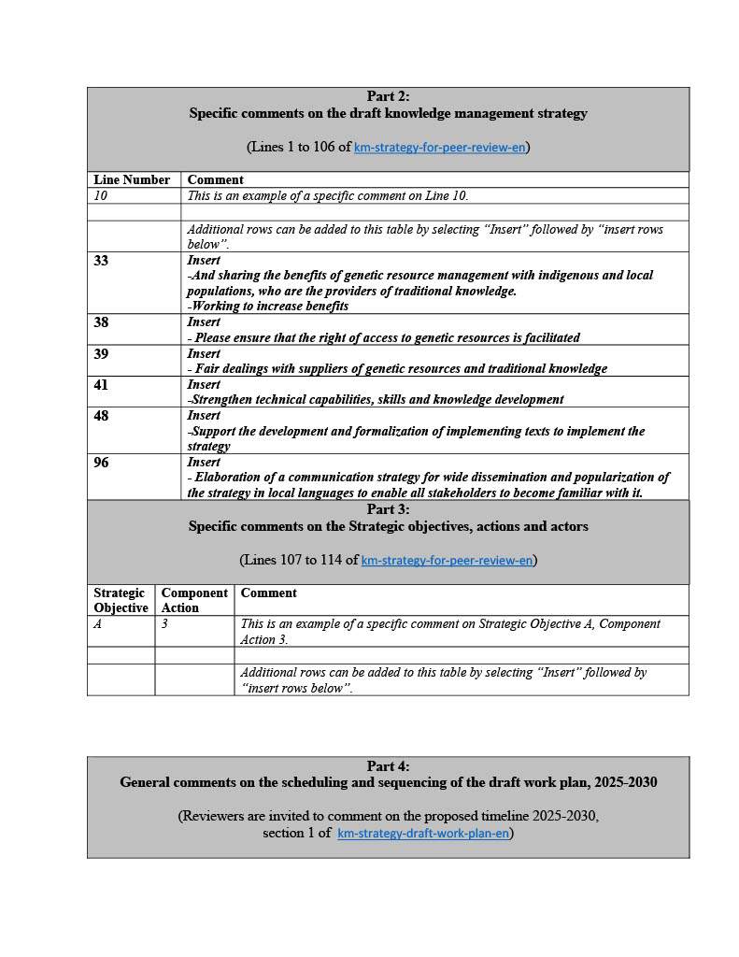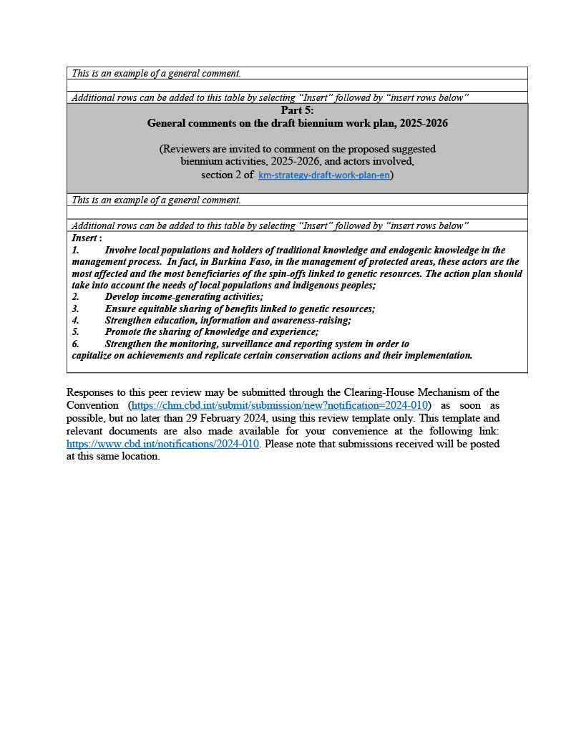

Ethiopia

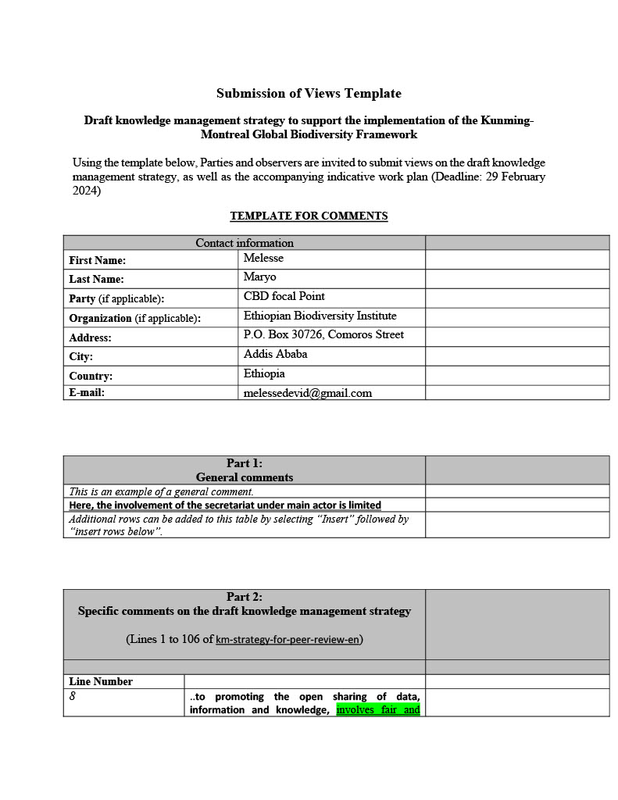
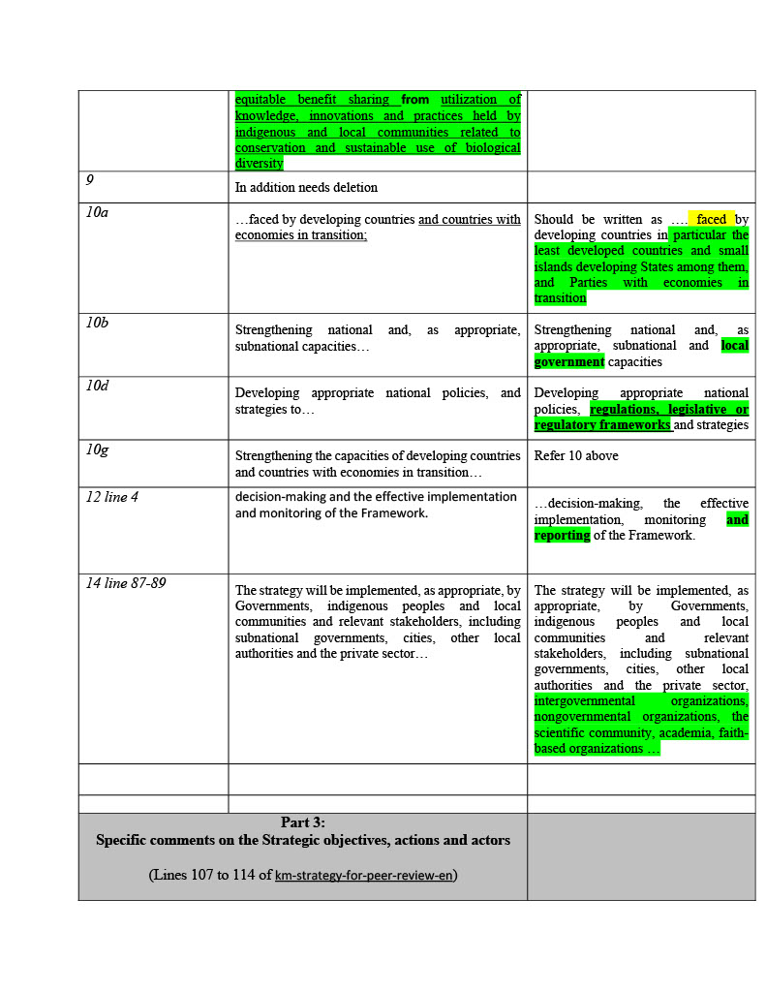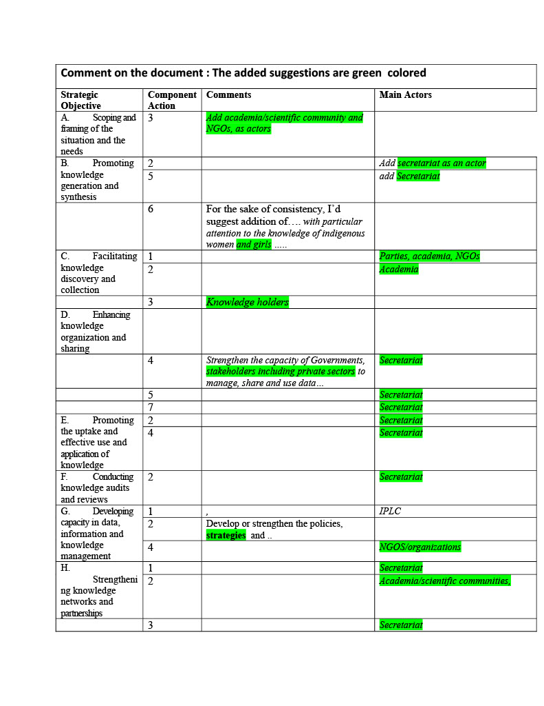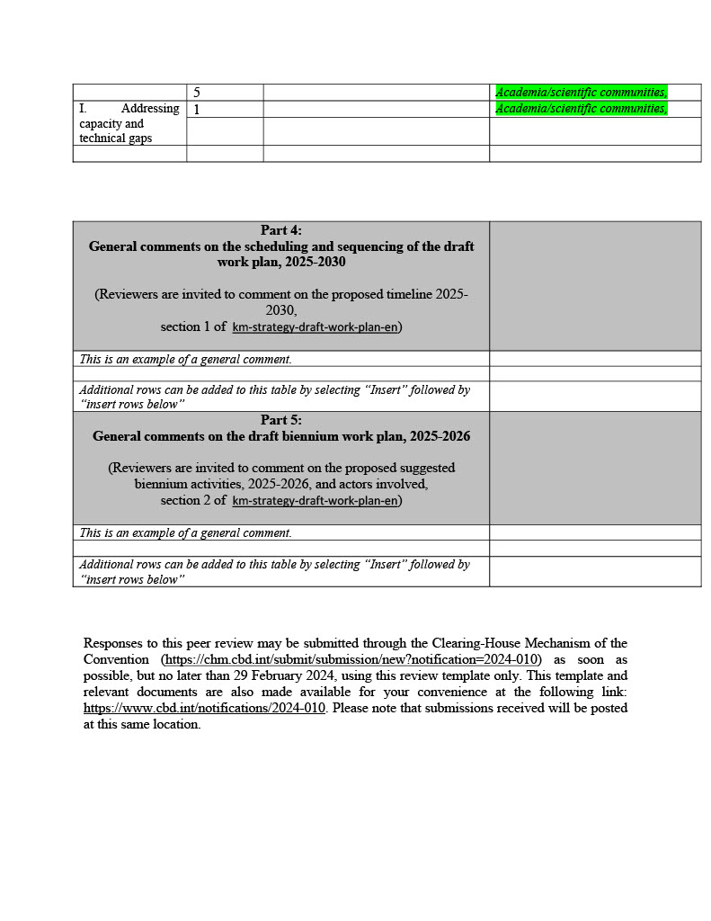

South Africa
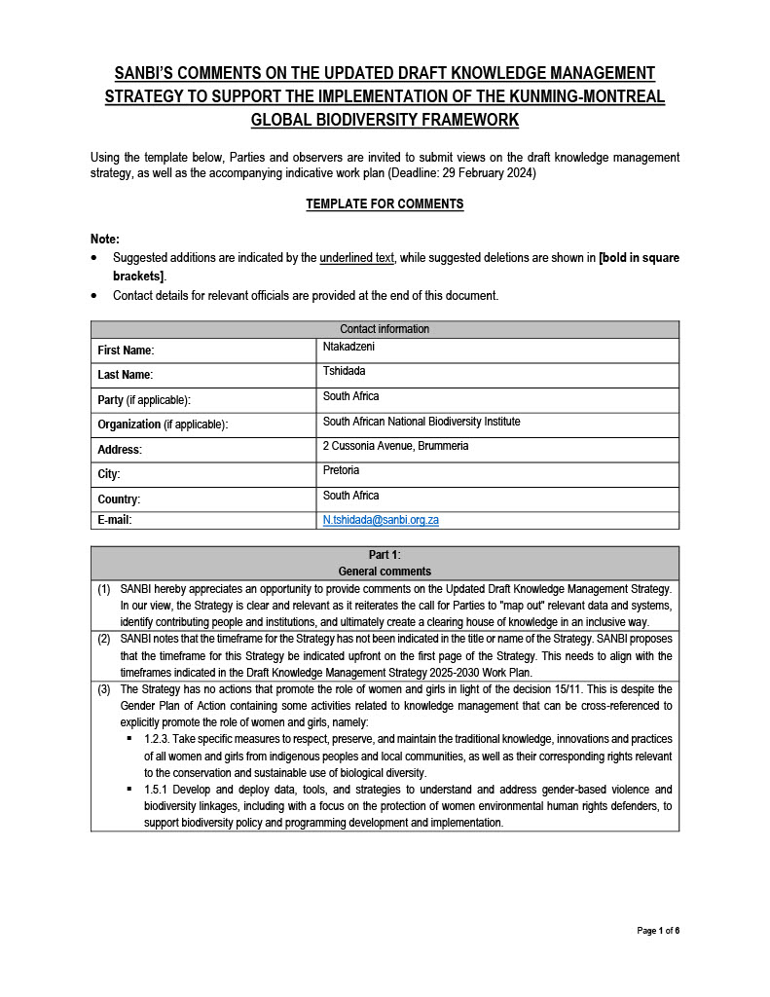
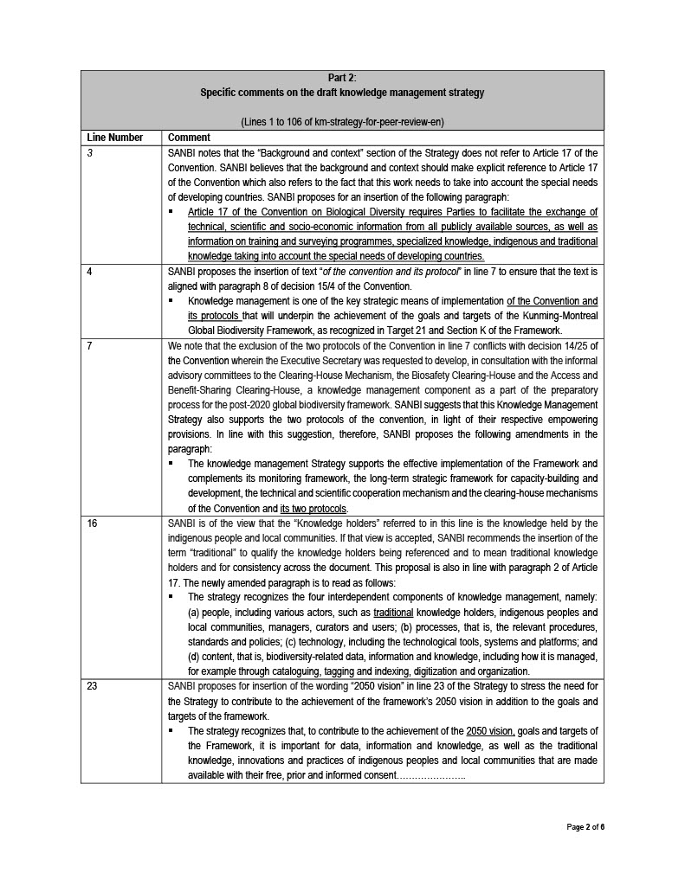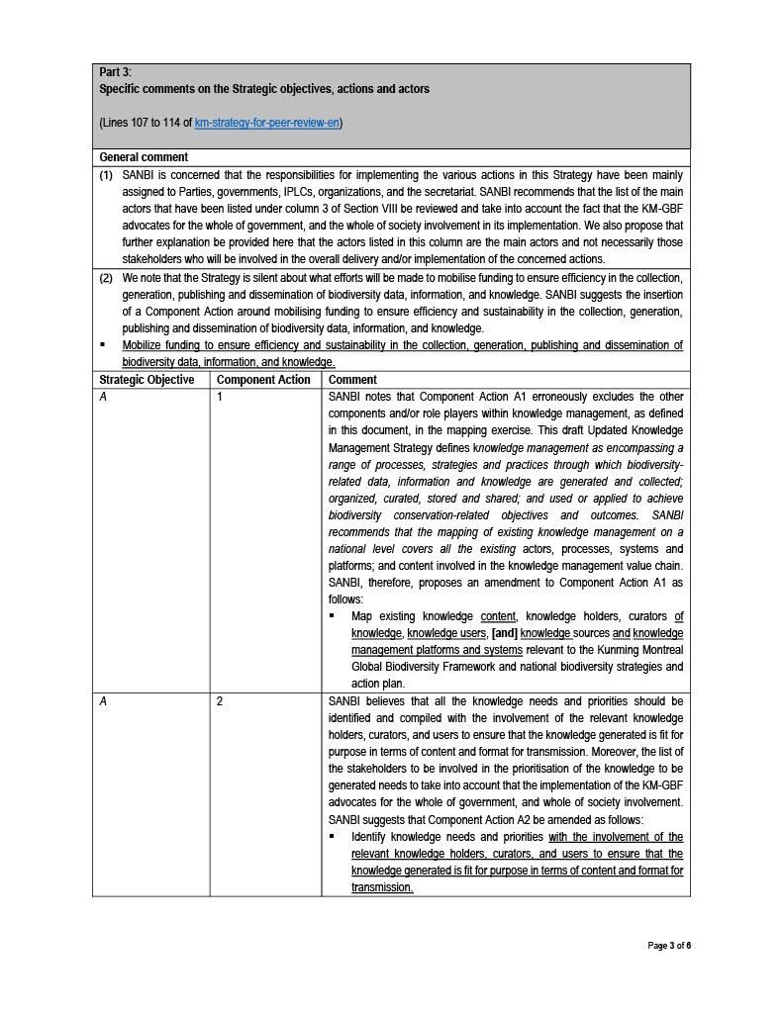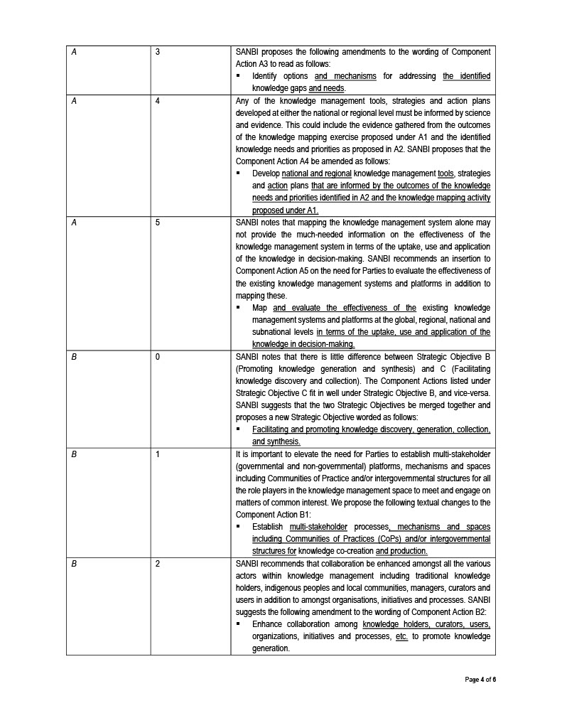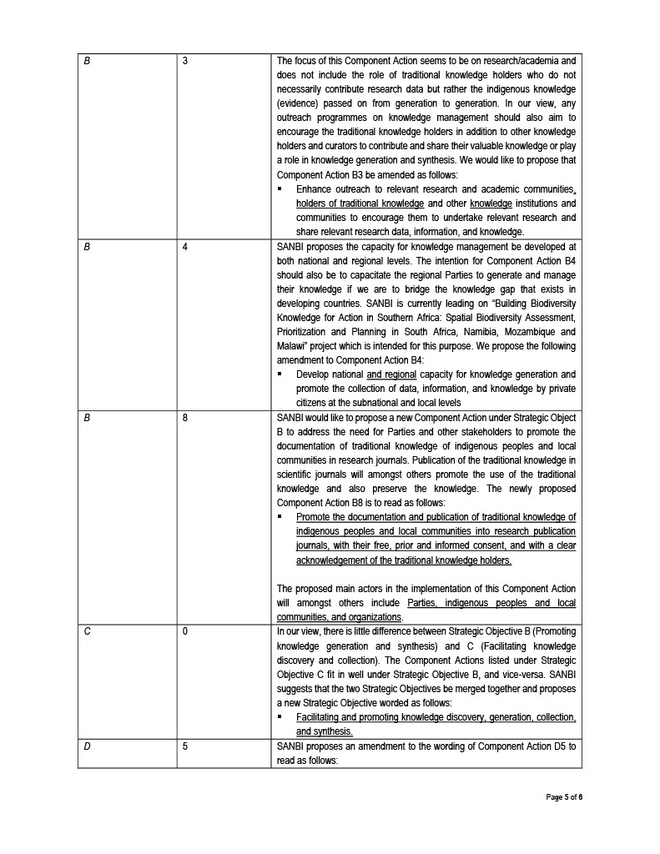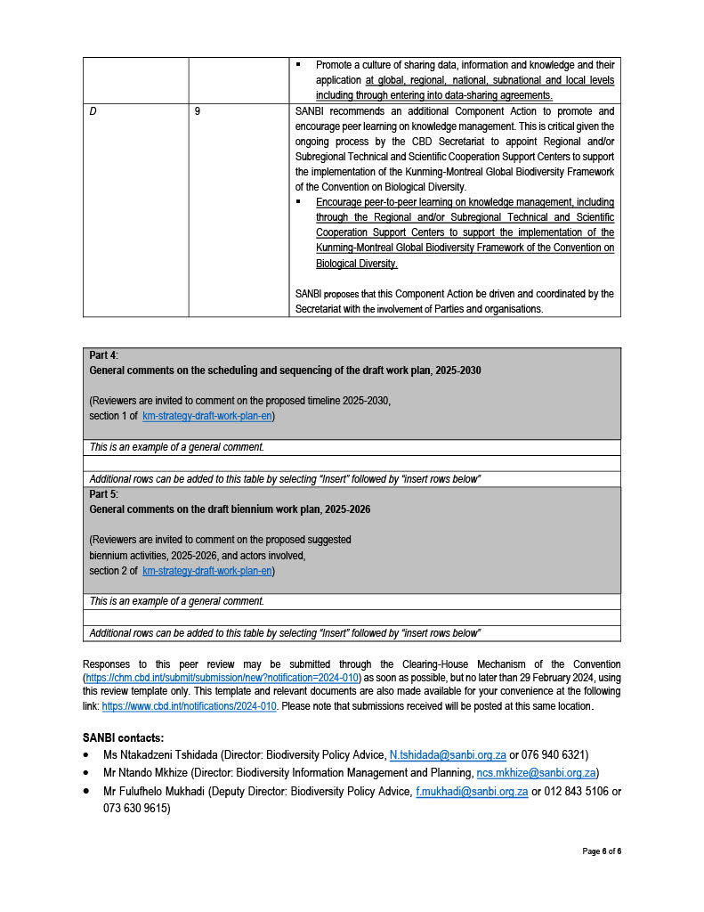

Spain
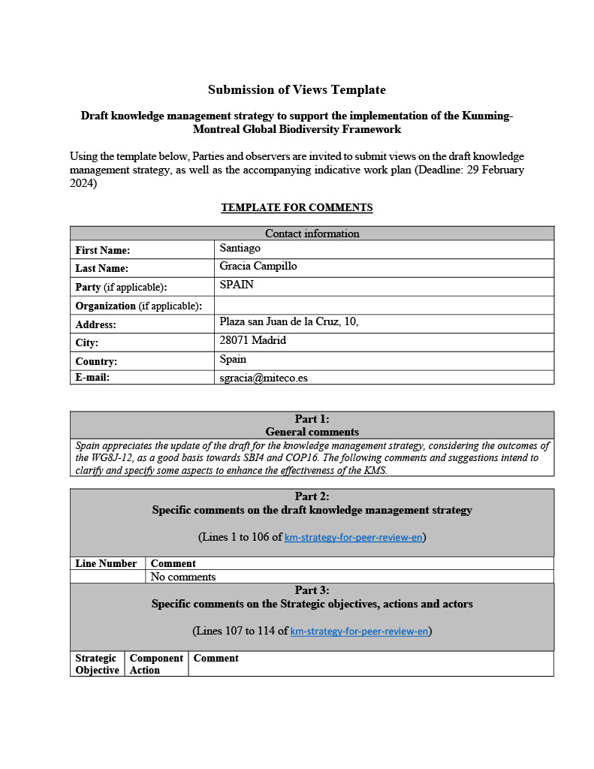
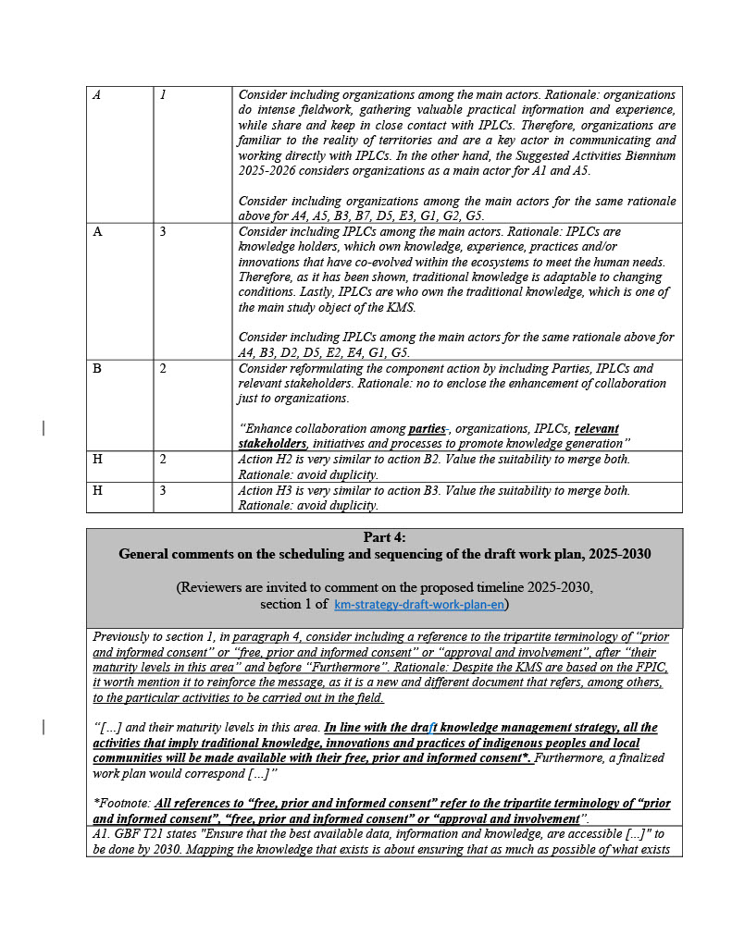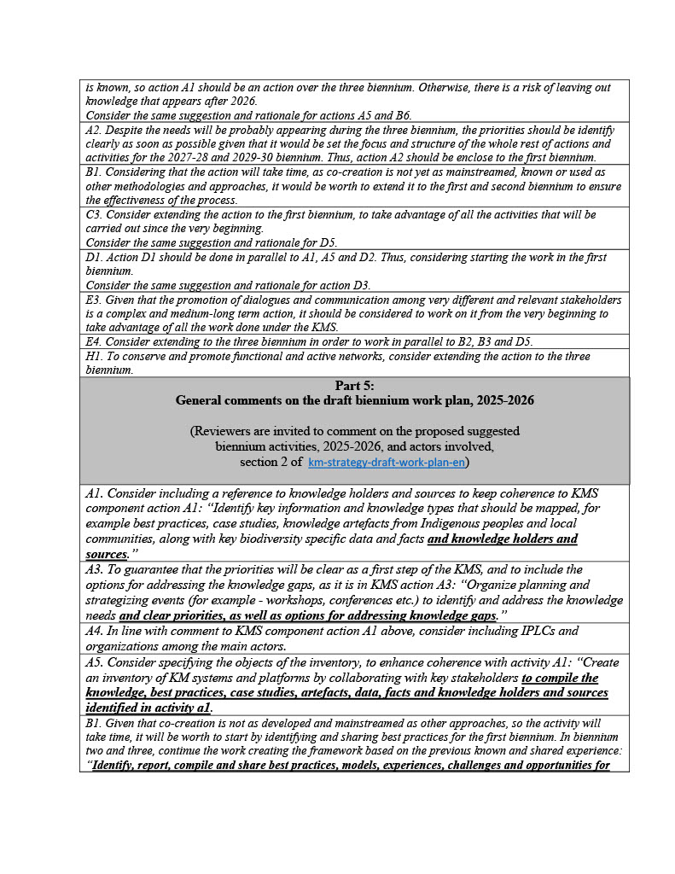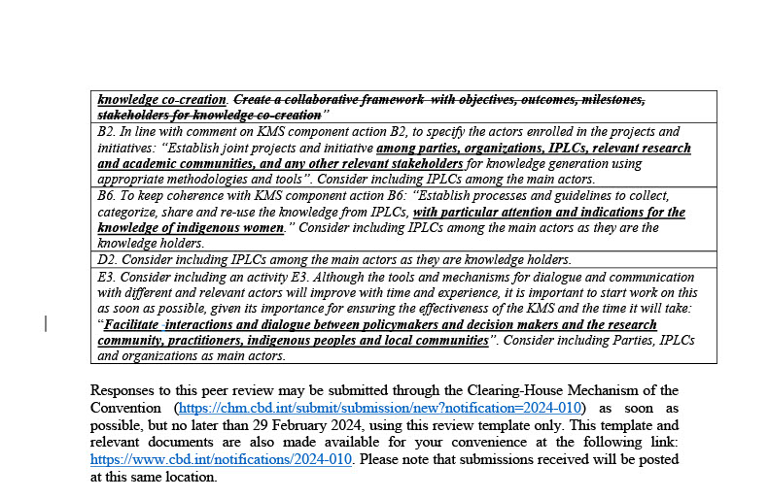

Tajikistan
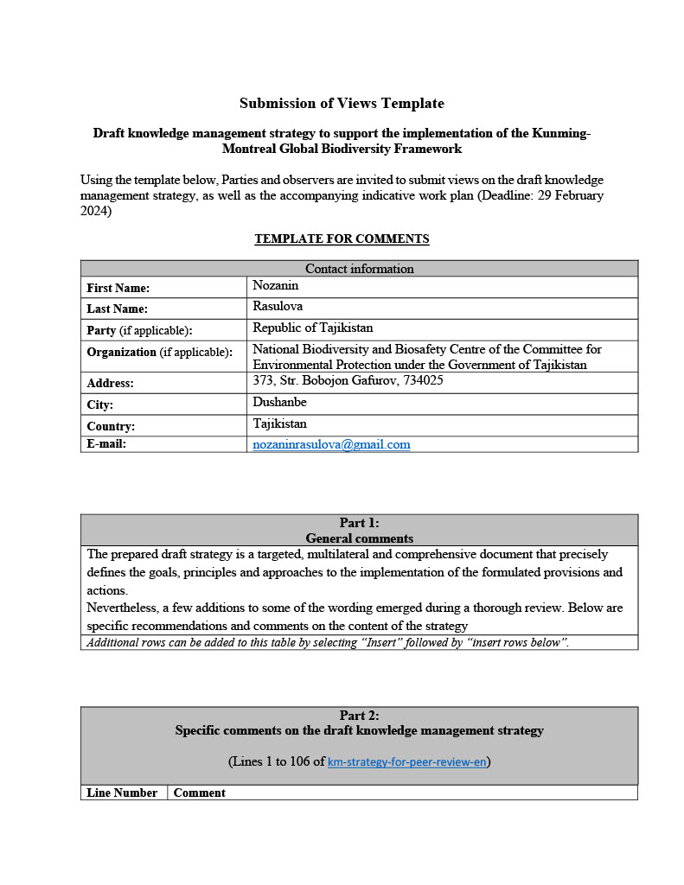
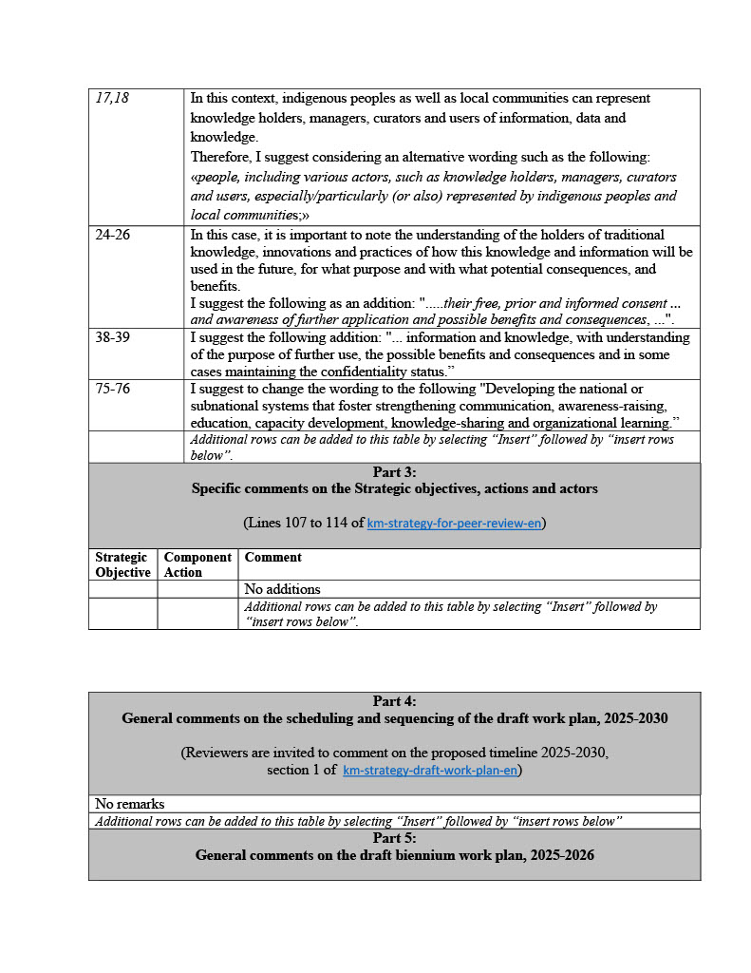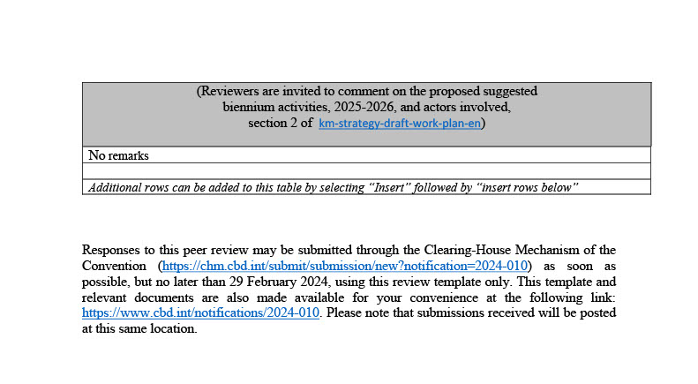

United Kingdom
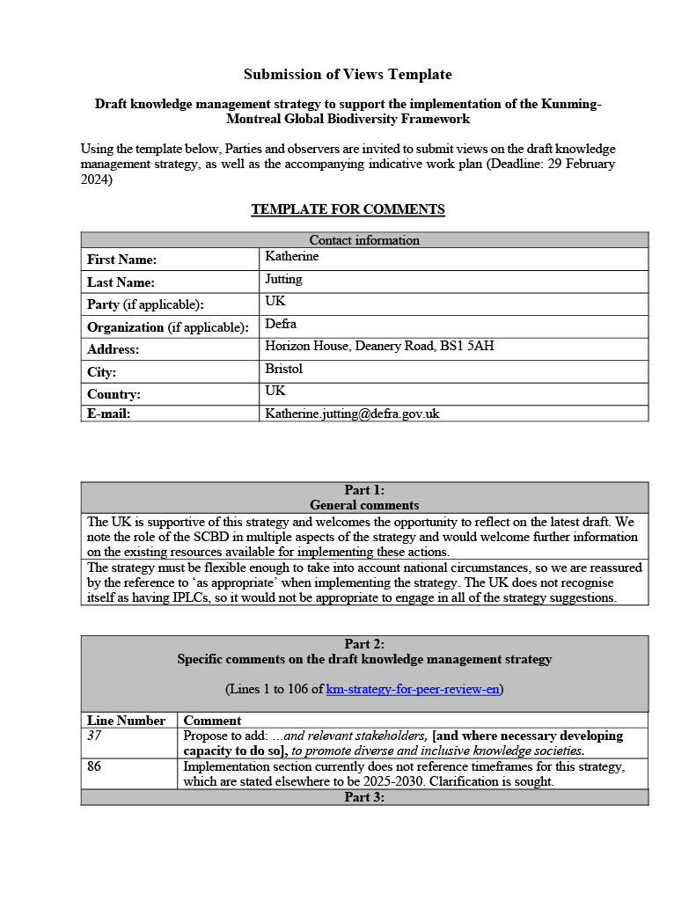
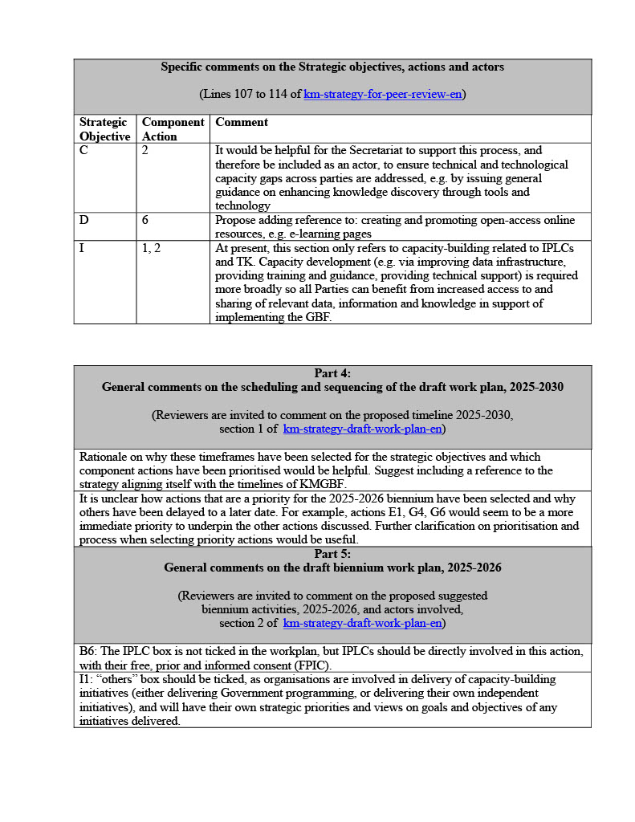

SUBMISSIONS FROM ORGANIZATIONS

CBD Women’s Caucus
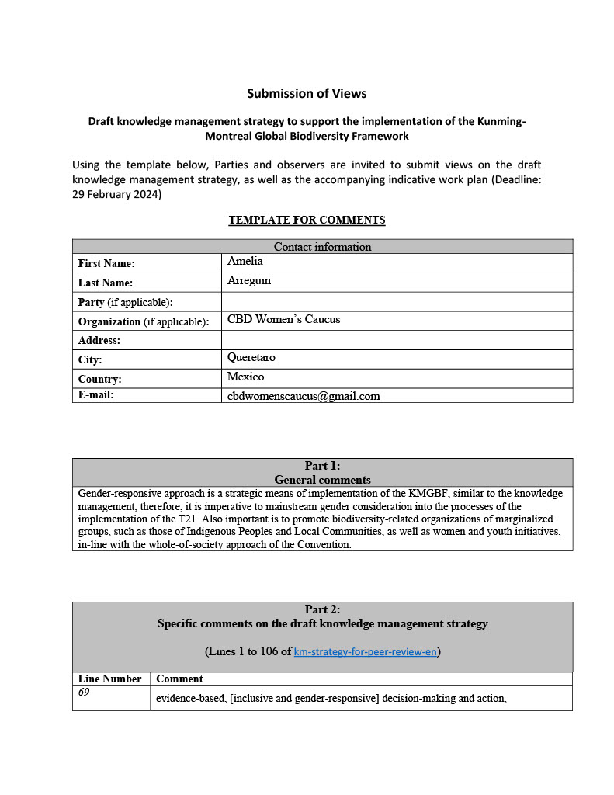
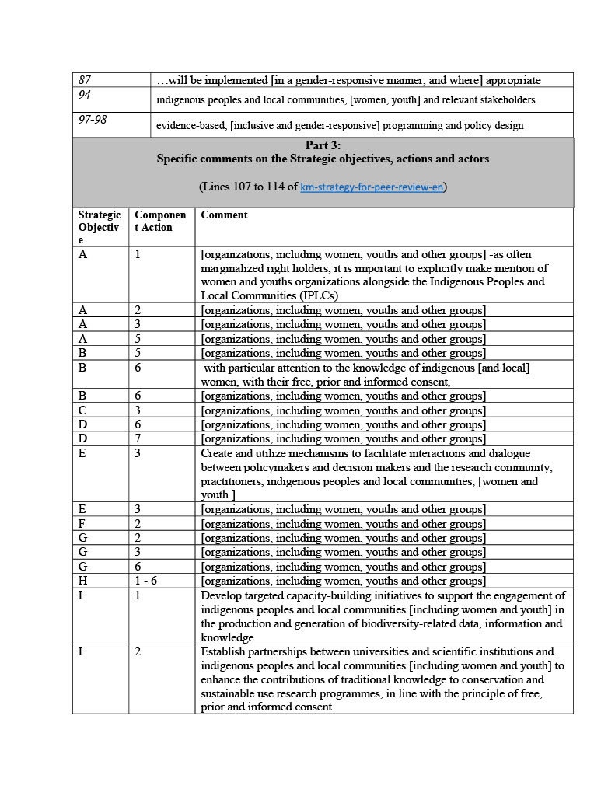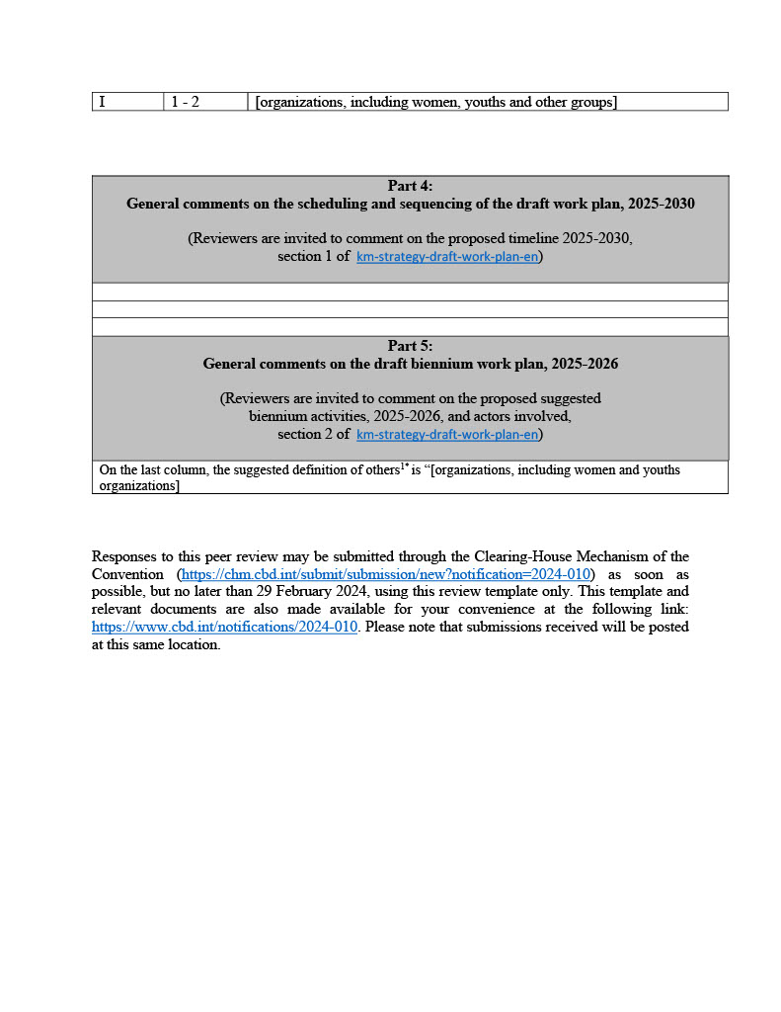

CGIAR
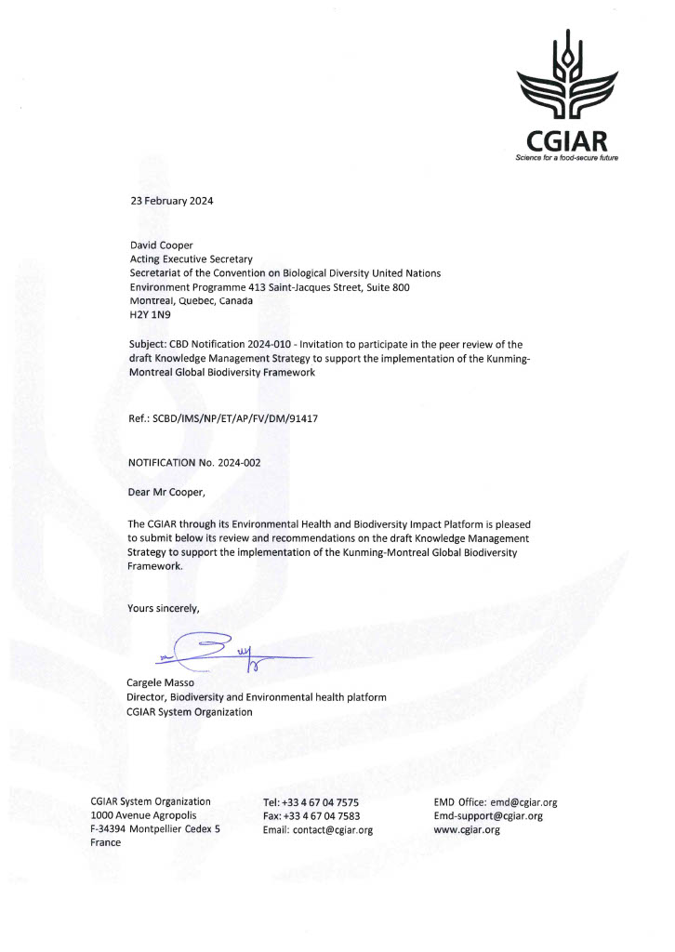
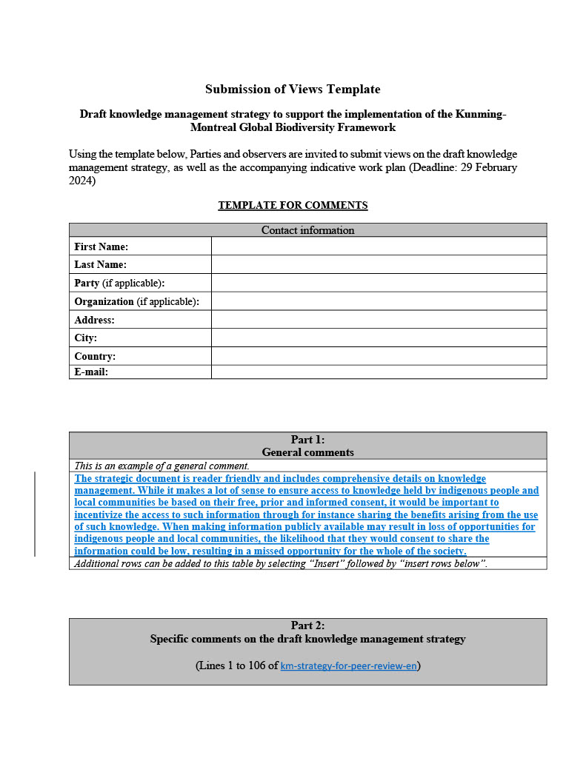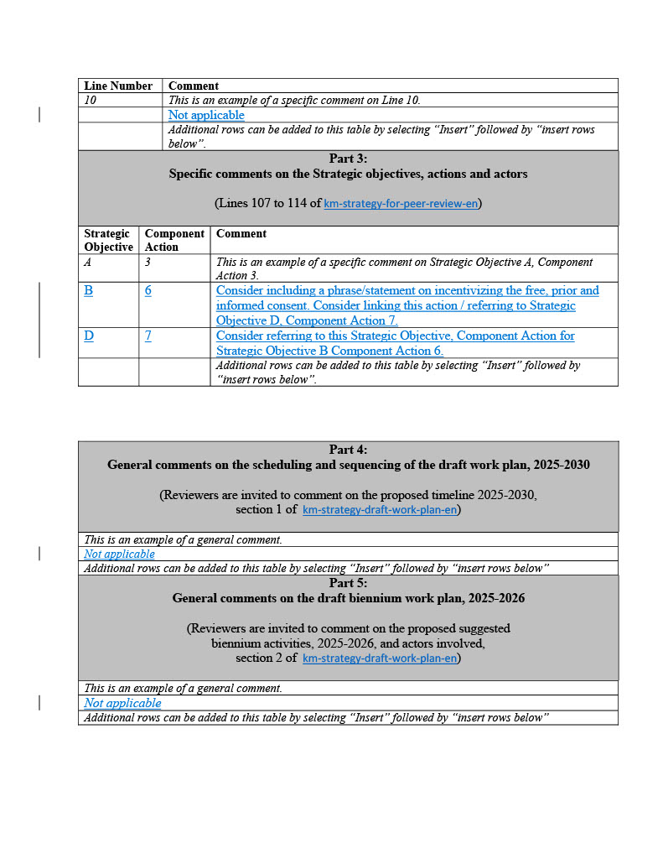

Chemichemi Foundation
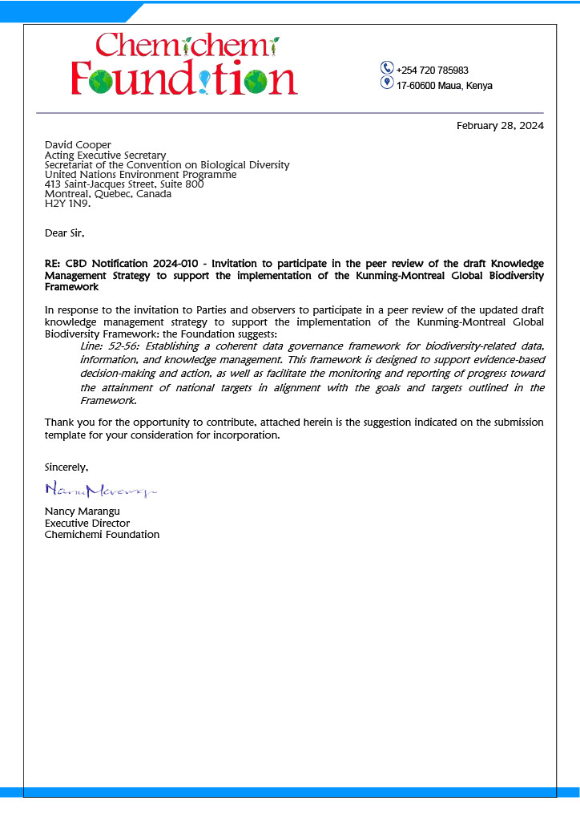
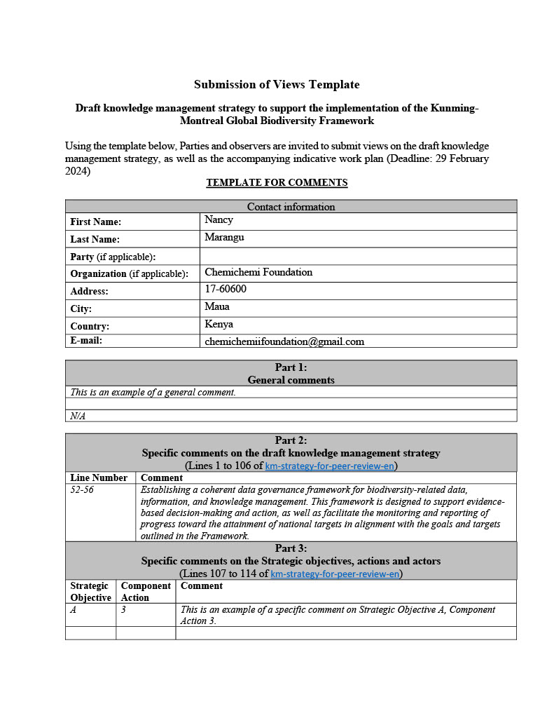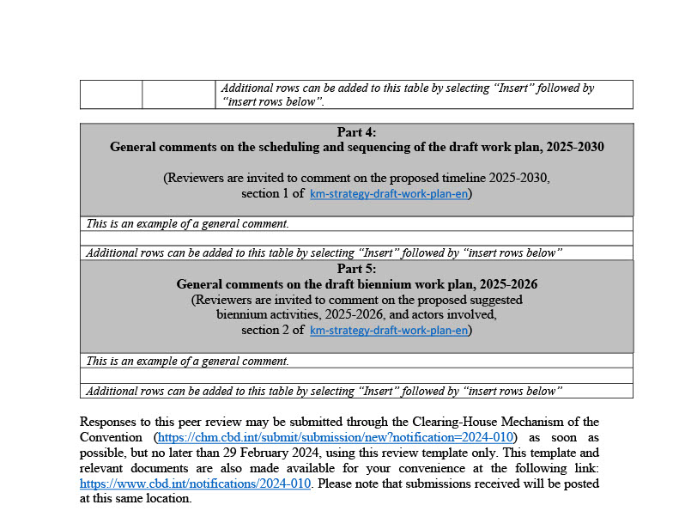

GBIF Sweden, The Swedish Museum of Natural History
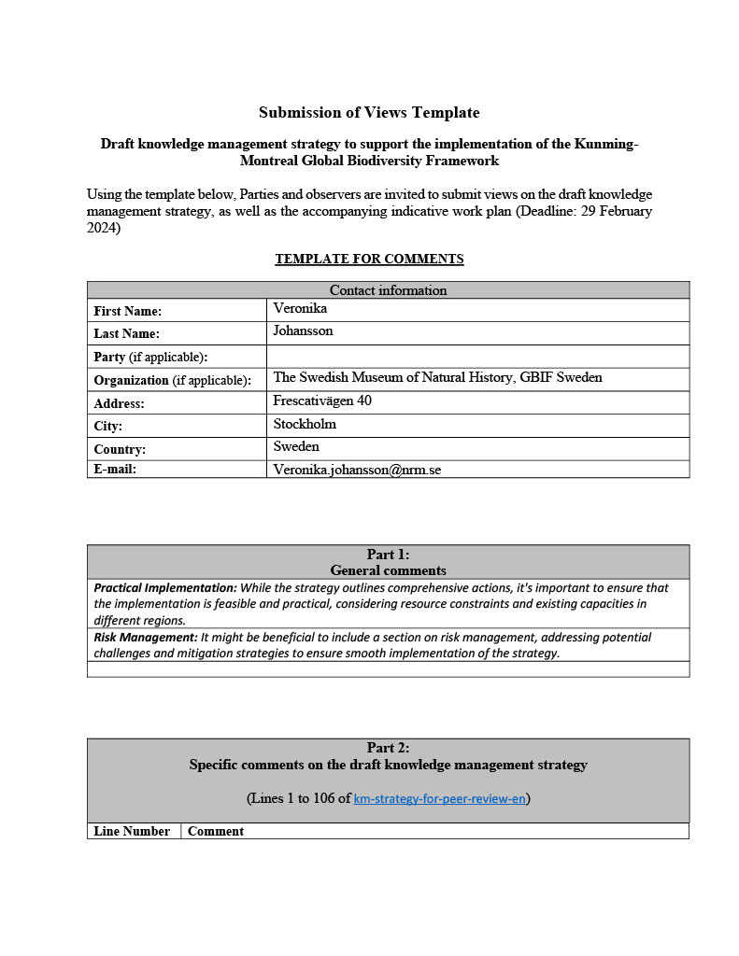
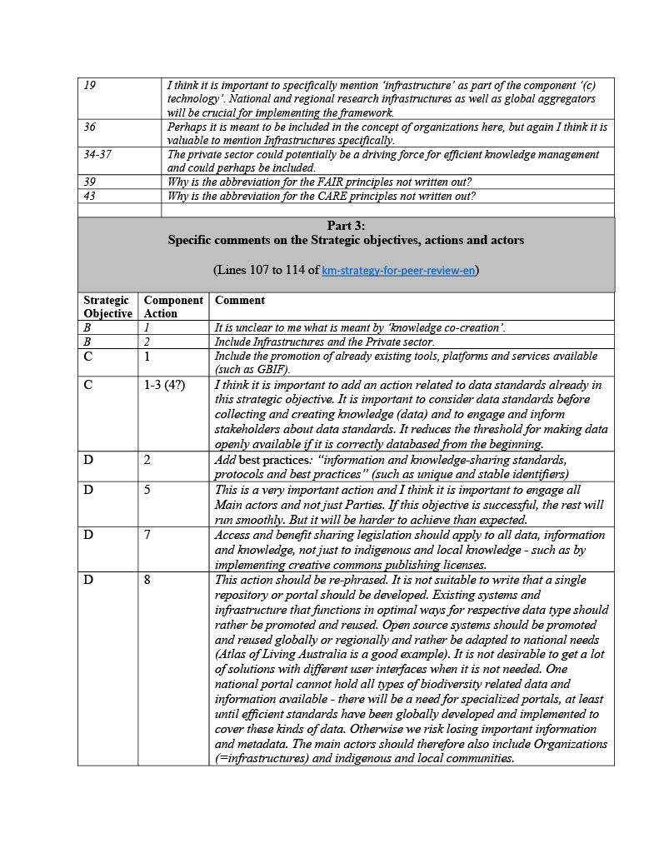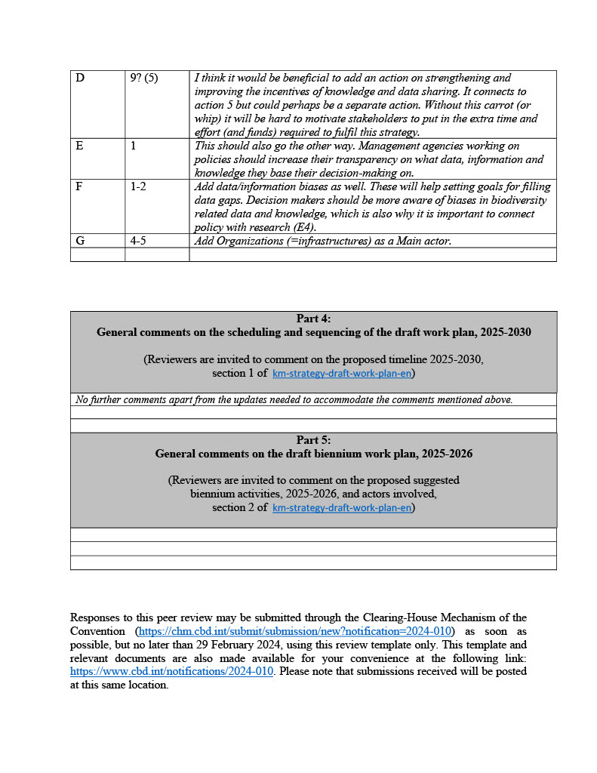

HUN-REN Centre for Ecological Research, Hungary
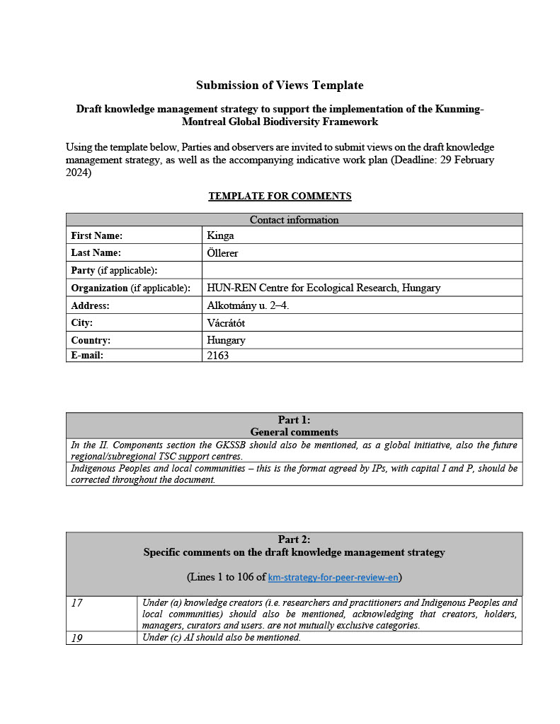
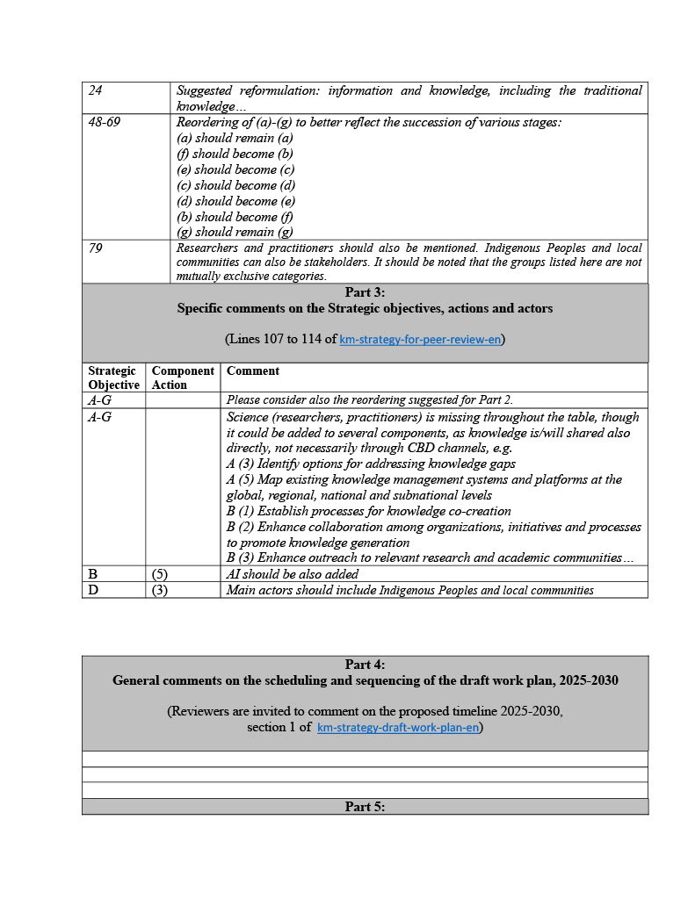

IUCN
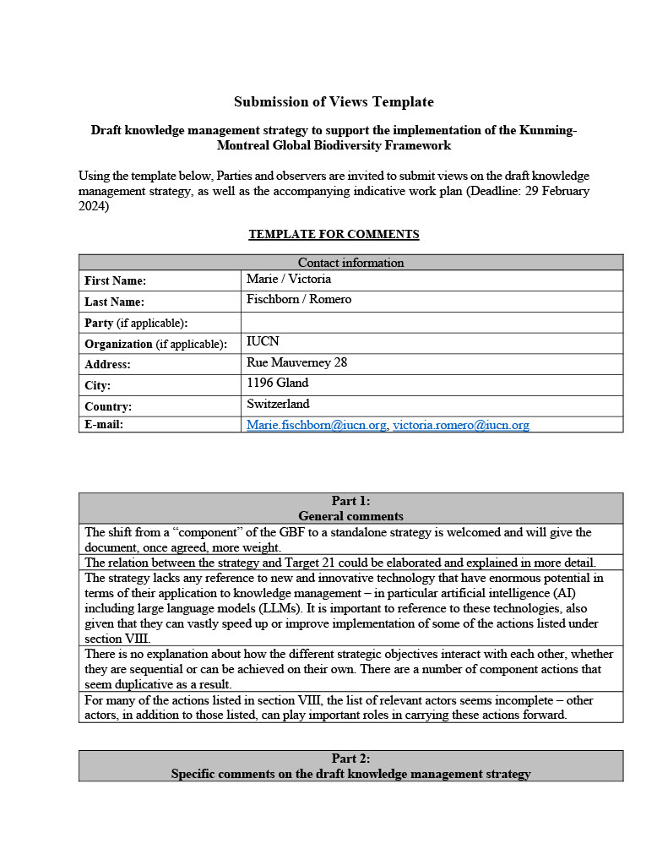
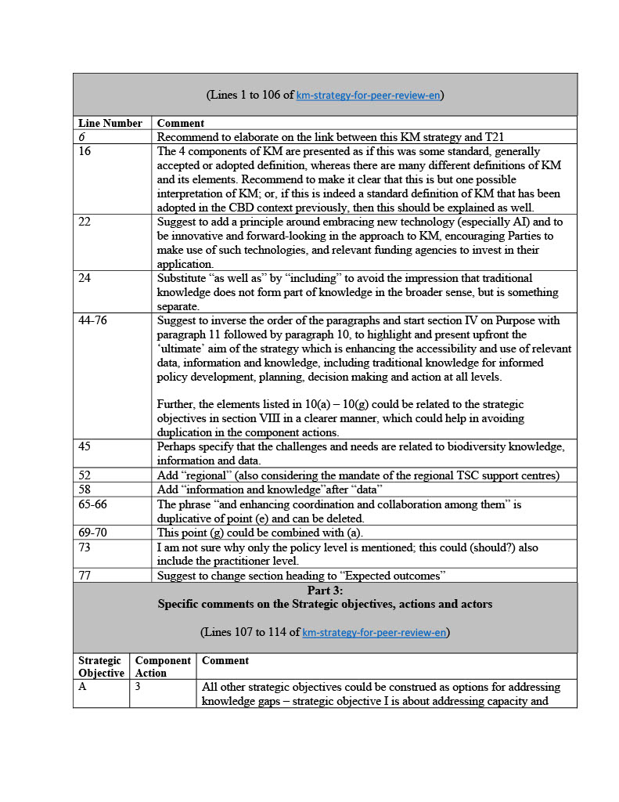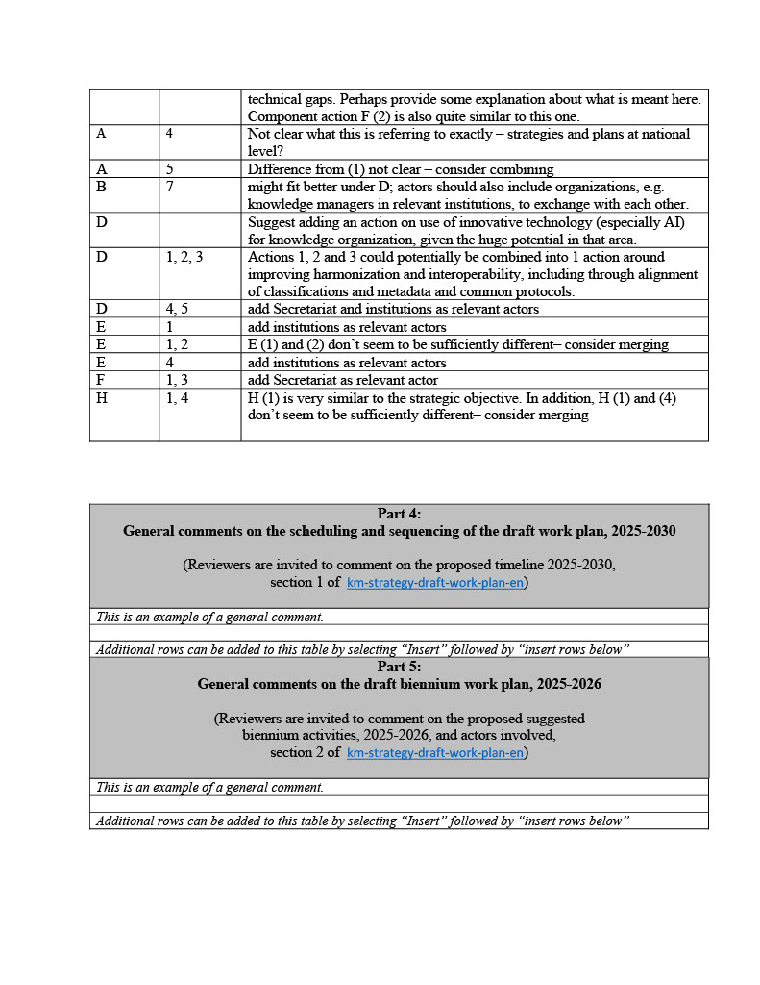

MedPAN
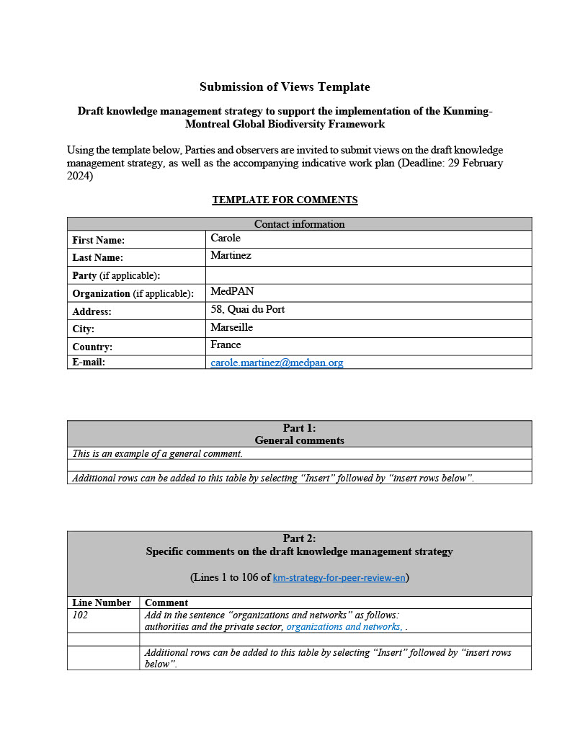
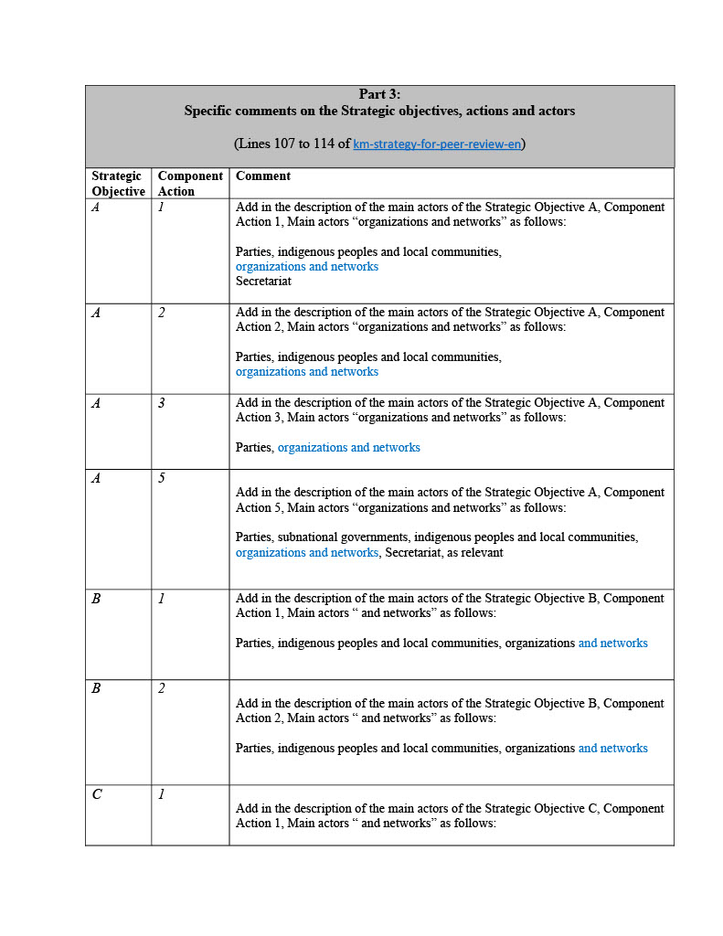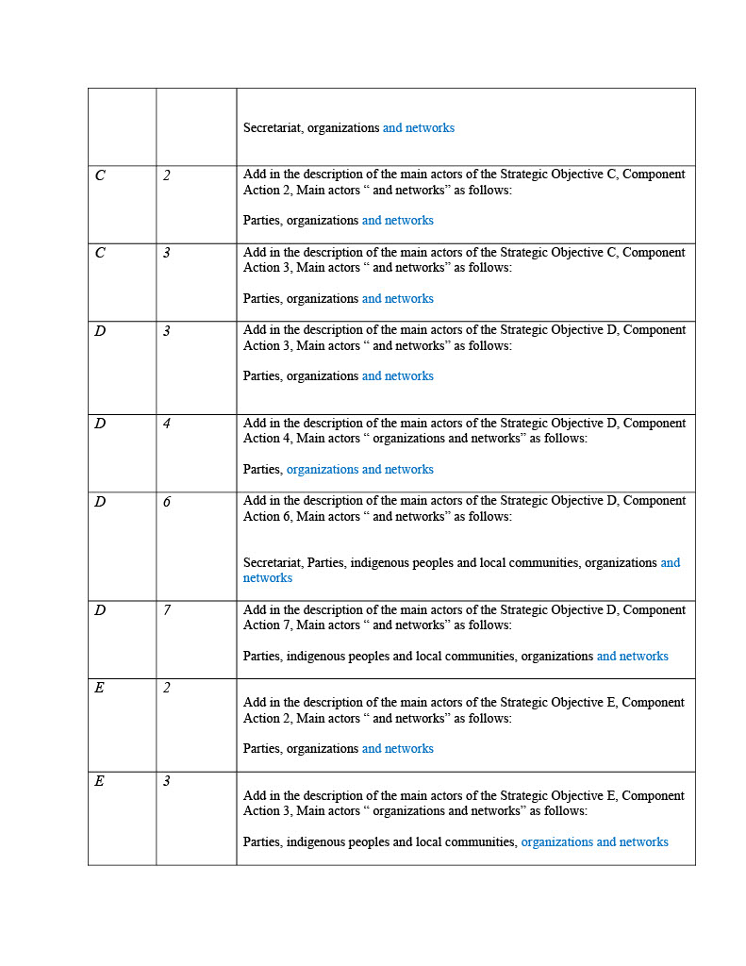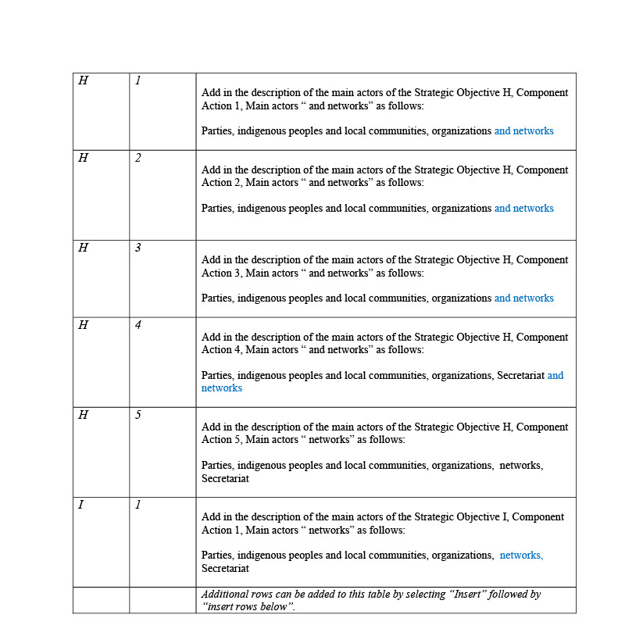

OECS Commission
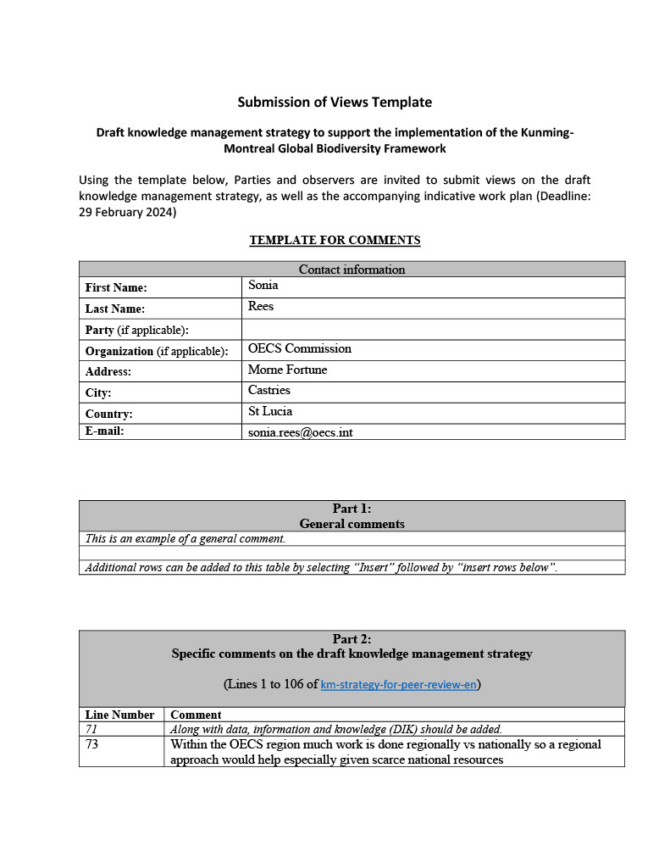

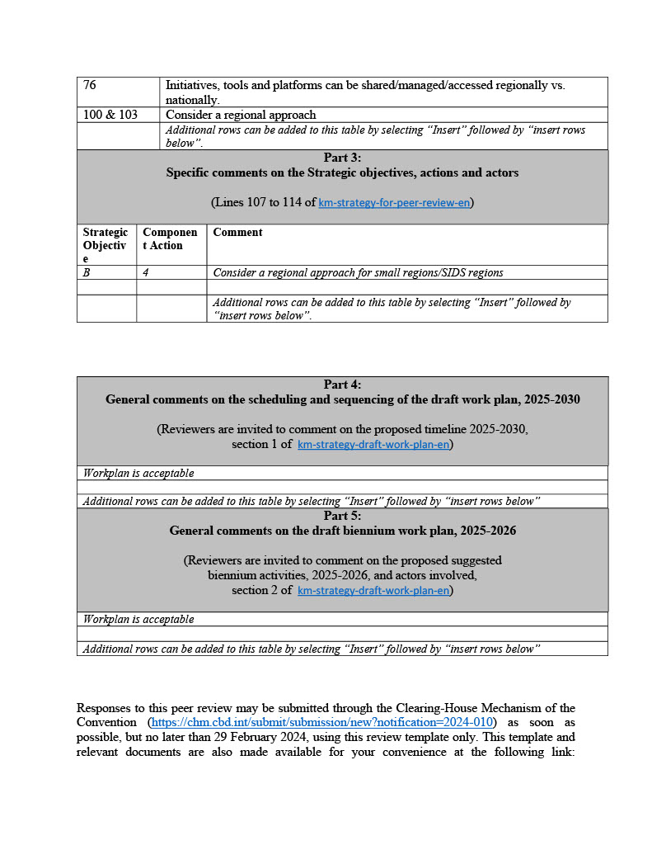

Participatory Monitoring and Management Partnership
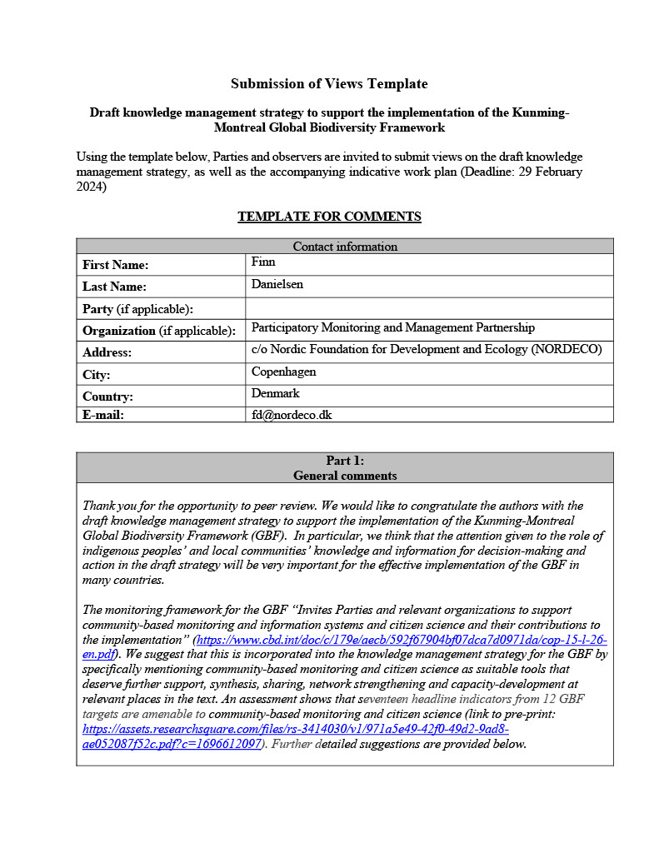
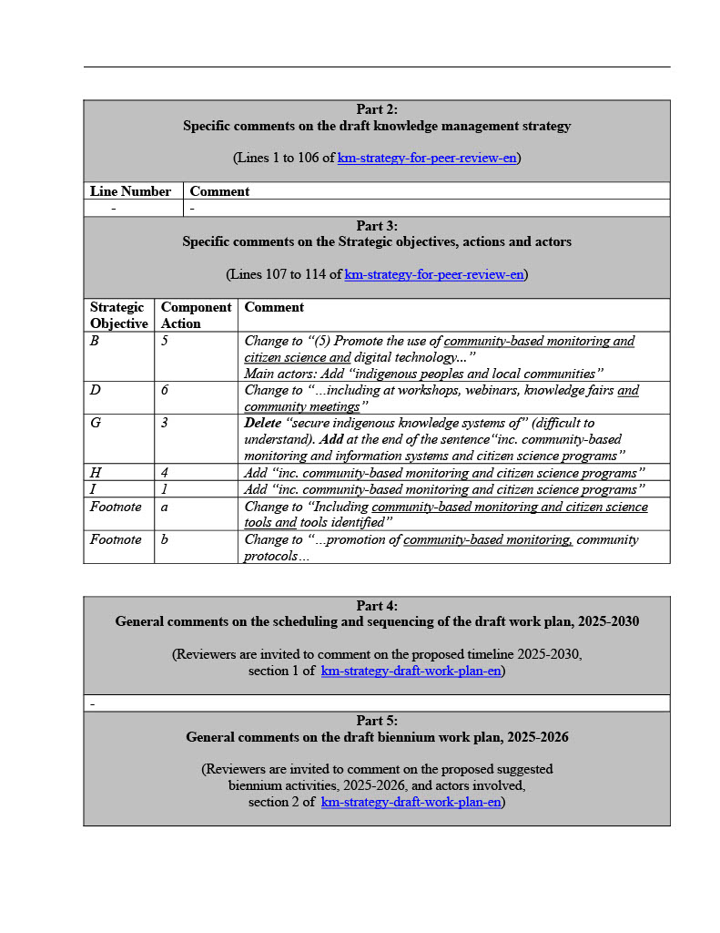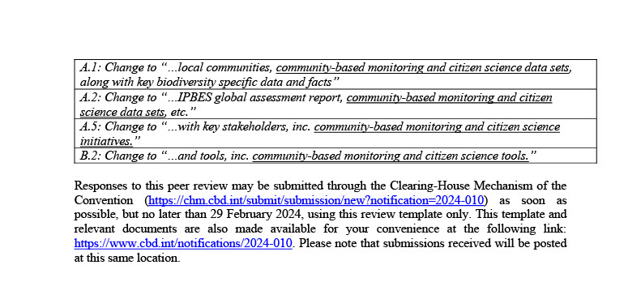

UNEP-WCMC
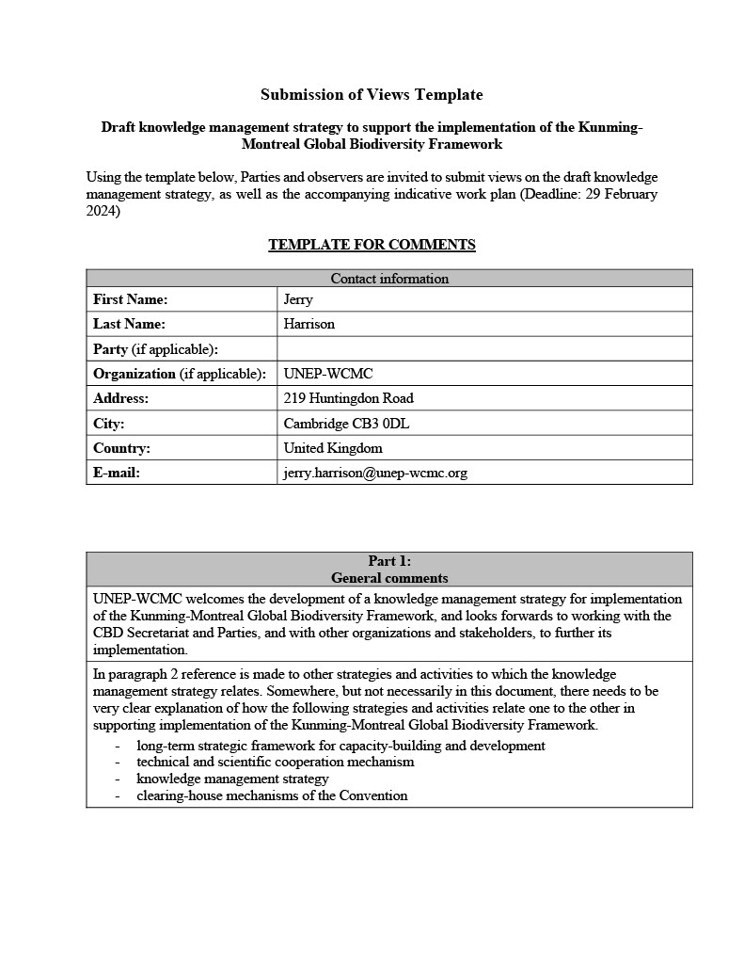
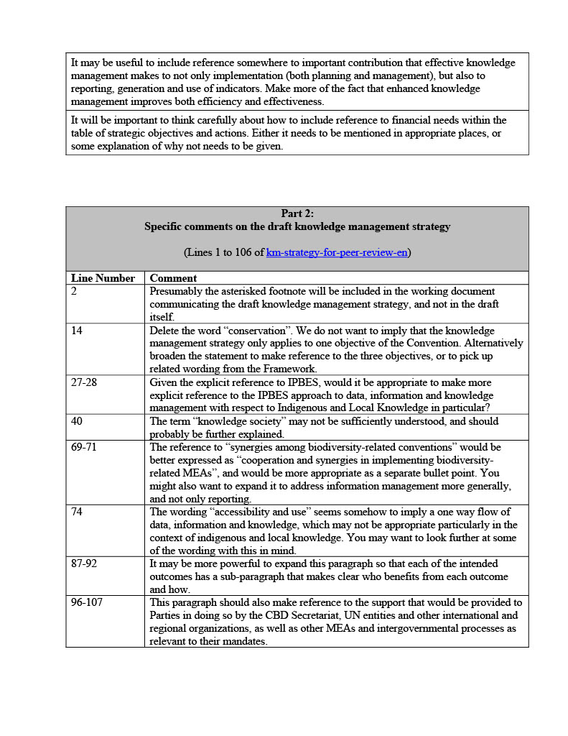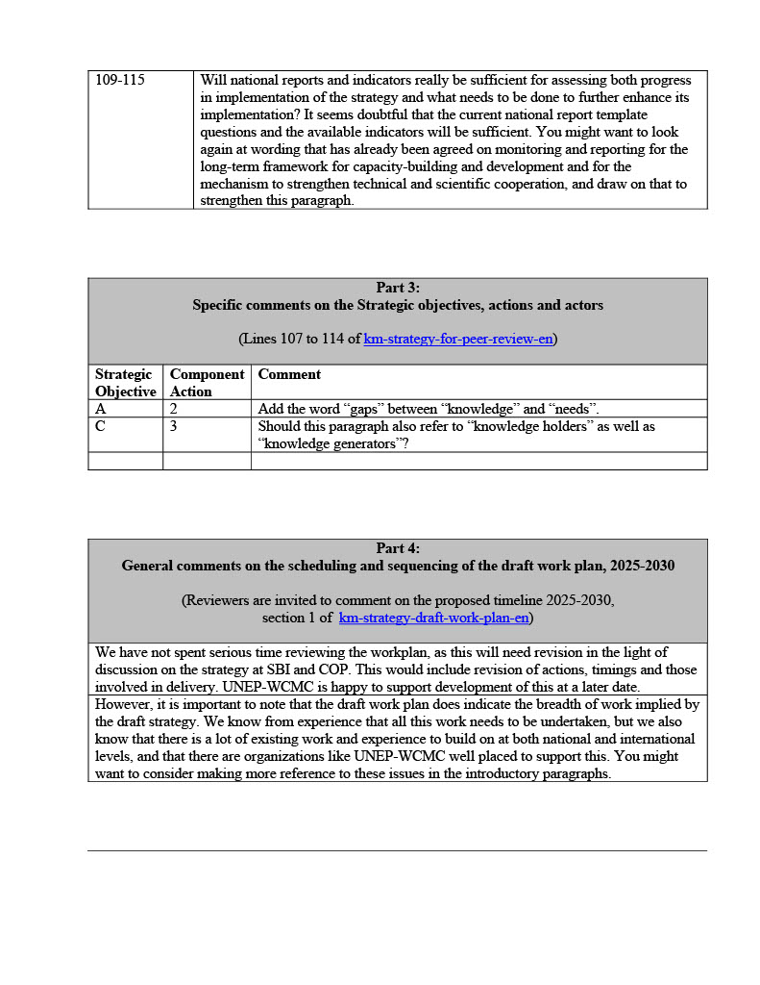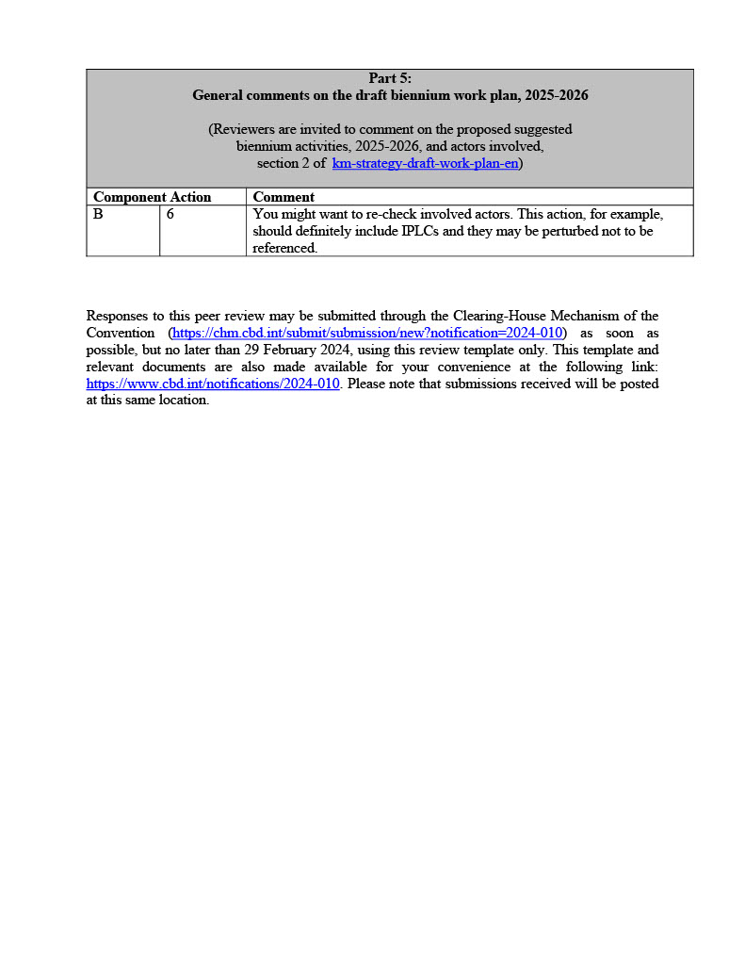

University of Siena
From Prof. Lionello F. Punzo, University of Siena, Italy.
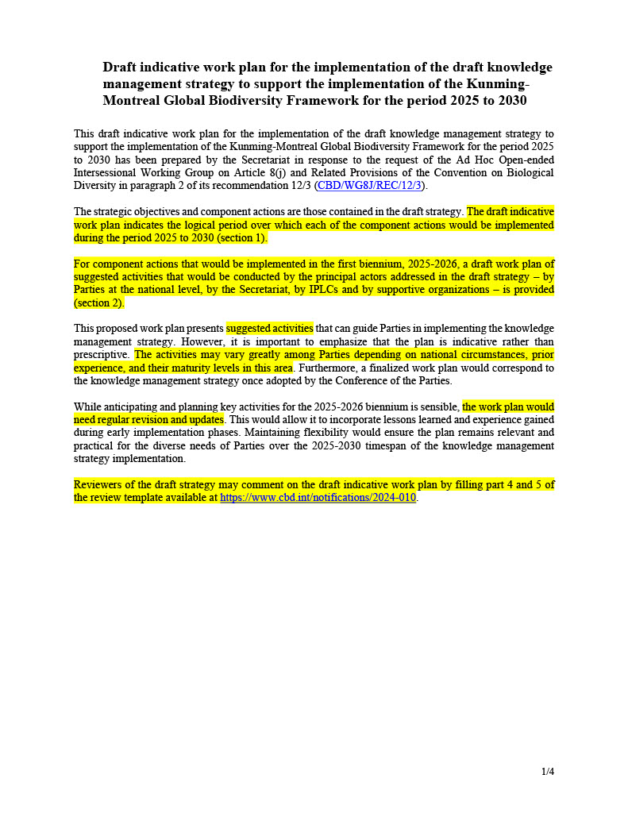
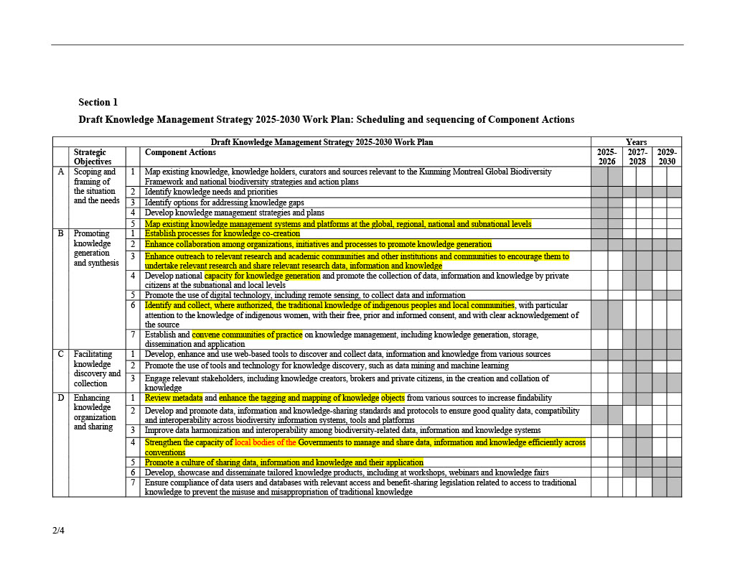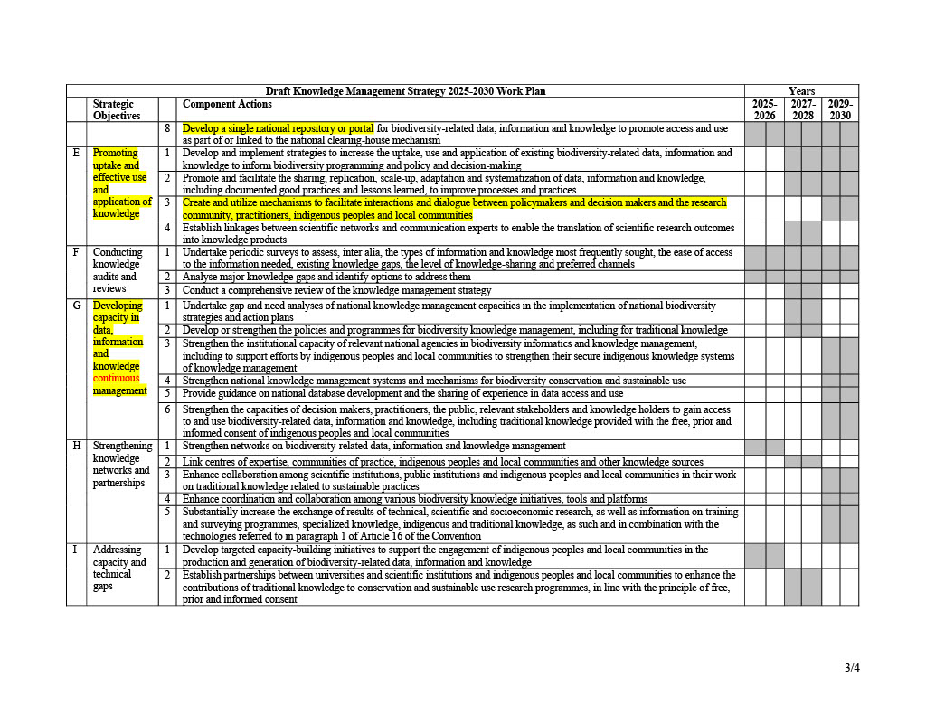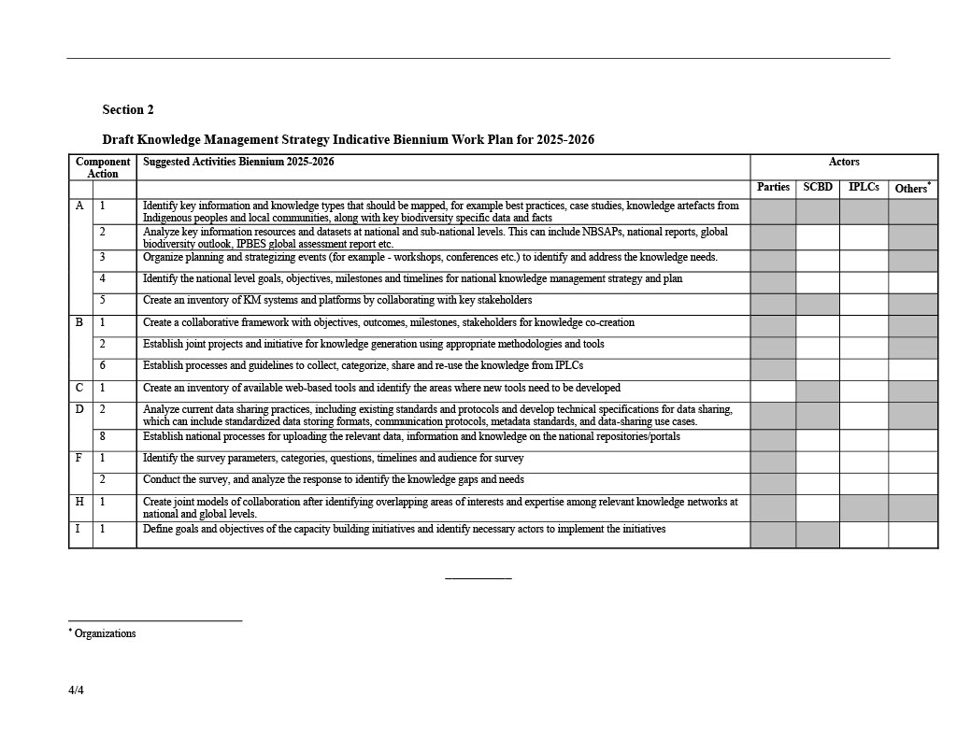

University of Aberdeen
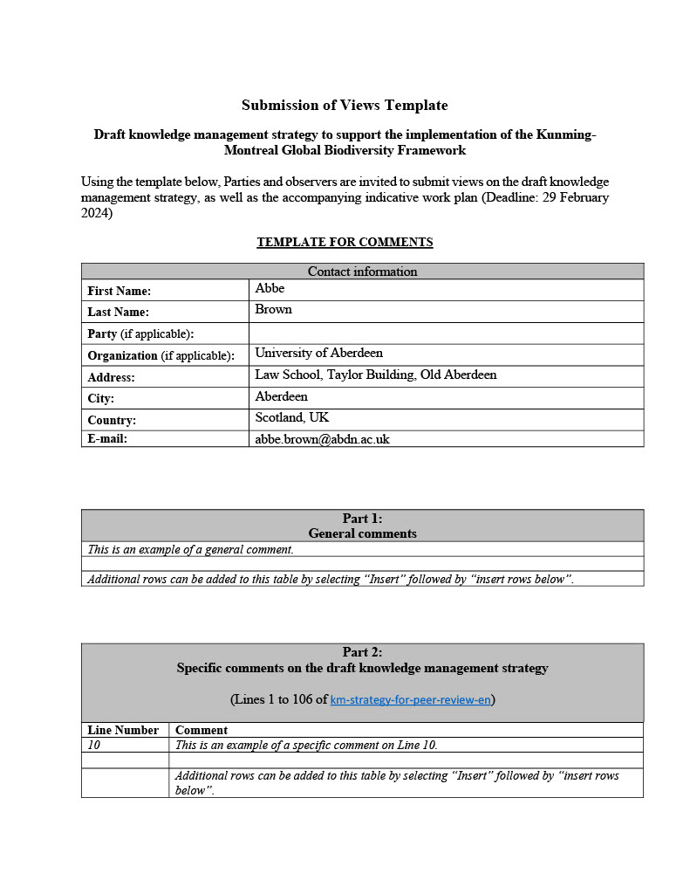
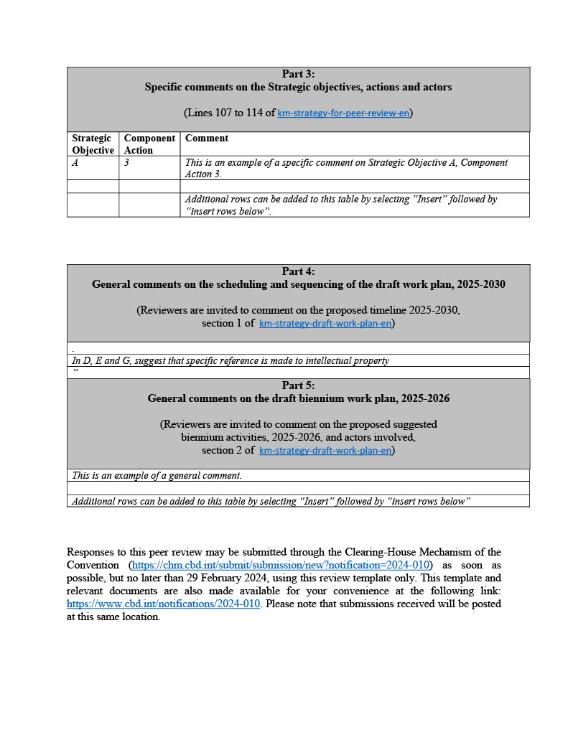

__________

* CBD/SBI/4/1.
** The present document is being issued without formal editing.
The submissions have been reproduced in the form in which they were provided to the Secretariat.

