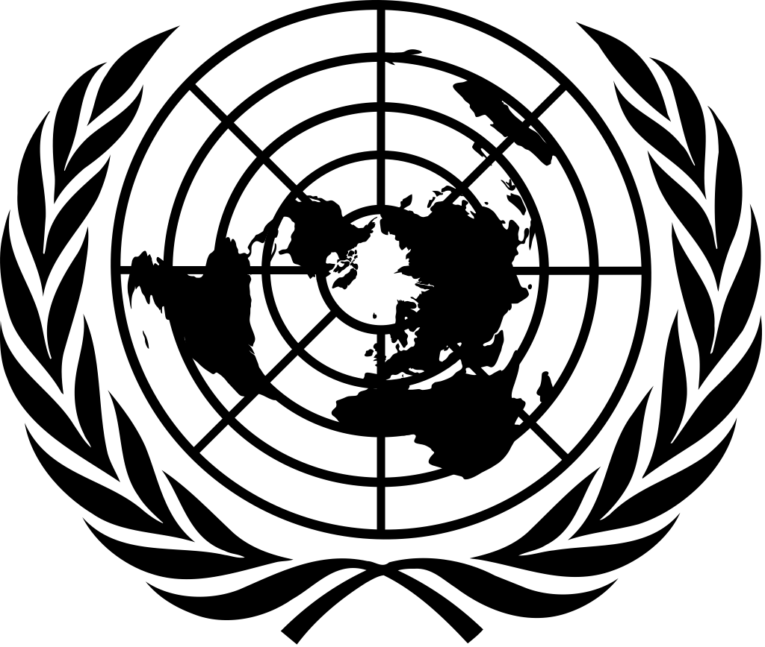 | 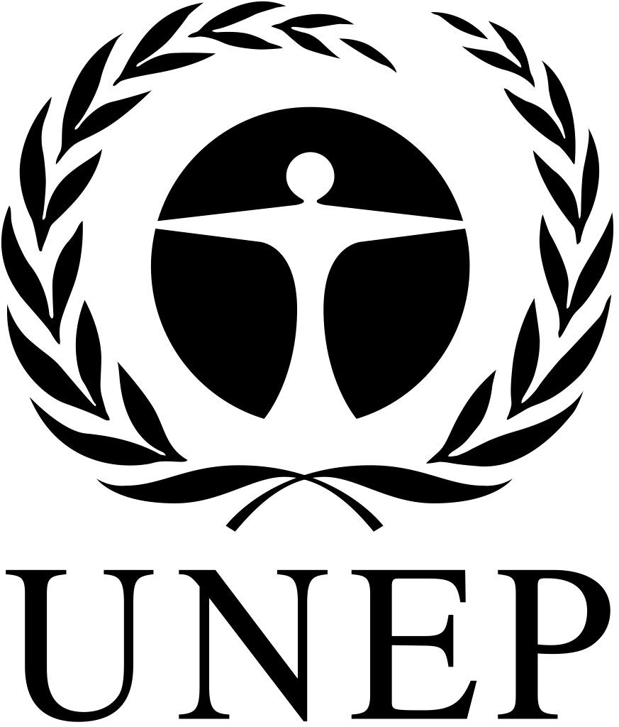 | CBD
 |  | Distr.  GENERAL  CBD/COP/14/10  25 September 2018  ORIGINAL: ENGLISH
CONFERENCE OF THE PARTIES TO THE CONVENTION ON BIOLOGICAL DIVERSITY
Fourteenth meeting
Sharm El-Sheikh, Egypt, 17-29 November 2018
Item 28 of the provisional agenda*
LIABILITY AND REDRESS (ARTICLE 14, PARAGRAPH 2)
Note by the Executive Secretary
I. INTRODUCTION
- At its twelfth meeting, the Conference of the Parties noted, in its decision XII/14, the progress made since its eighth meeting in certain areas that have relevance to liability and redress, in particular in developing guidance on ecosystem restoration, and tools for valuation of biodiversity. It invited Parties to take into account some relevant instruments and reports in their efforts to develop or adjust national policy, legislation, guidelines or administrative measures concerning liability and redress for damage to biological diversity. These include the “Guidelines for the development of domestic legislation on liability, response action and compensation for damage caused by activities dangerous to the environment”, adopted by the United Nations Environment Programme in 2010, and the Secretariat’s synthesis report on technical information relating to damage to biological diversity and approaches to valuation and restoration of damage to biological diversity, prepared for and examined by the Conference of the Parties, at its ninth meeting.
- The Conference of the Parties decided to review the item further at its fourteenth meeting on the basis of information that the Executive Secretary makes available, including information on any new developments in the adoption and implementation of response measures (including restoration and compensation) for damage to the environment in general and to biological diversity in particular.
- Accordingly, the present document contains information on some recent developments in addressing issues pertaining to damage to the environment in general and to biological diversity in particular. Section II provides an overview of some developments that are relevant to the issue of liability in the context of the Convention. The developments summarized in section II include a judgment passed by the International Court of Justice on 2 February 2018 whereby the Court, for the first time, noted that impairment and loss of the ability of the environment to provide goods and services is compensable under international law.
- Section III presents a list of brief observations derived from the review of the recent developments highlighted in section II, and section IV suggests elements for a draft decision.
II. SOME RECENT DEVELOPMENTS that are RELEVANT TO THE ISSUE OF LIABILITY AND REDRESS FOR DAMAGE TO THE ENVIRONMENT OR BIODIVERSITY

A. The entry into force of the Nagoya Kuala – Lumpur Supplementary Protocol
- The Nagoya – Kuala Lumpur Supplementary Protocol on Liability and Redress was adopted on 15 October 2010 at the fifth meeting of the Conference of the Parties serving as the meeting of the Parties to the Cartagena Protocol on Biosafety through its decision BS-V/11. The Supplementary Protocol entered into force on 5 March 2018, the ninetieth day after the date of deposit (5 December 2017) of the fortieth instrument of acceptance, by Japan.
- The Supplementary Protocol provides that Parties shall require the appropriate operator to take response measures in the event of damage resulting from living modified organisms which find their origin in a transboundary movement. Such measures must also be required of the operator where there is a sufficient likelihood that damage will result if timely response measures are not taken. The Supplementary Protocol assigns a central role to the “competent authority”. The competent authority is to identify the operator which has caused the damage, evaluate the damage and determine which response measures should be taken by the operator. Response measures are any reasonable actions to prevent, minimize, contain, mitigate or otherwise avoid damage or measures to restore biological diversity.
- The Supplementary Protocol defines damage as adverse effect on the conservation and sustainable use of biological diversity that is measurable or otherwise observable and significant, also taking into account risks to human health. Parties are required to provide, in their domestic law, for rules and procedures that address damage and that provide for response measures.
- The Supplementary Protocol addresses the issue of financial security and provides for a process. The issue of financial security involves a fundamental question of whether the operator should be obliged to guarantee adequate compensation or redress for damage by maintaining financial instruments such as insurance or other forms of financial security. The Conference of the Parties serving as the meeting of the Parties to the Cartagena Protocol is expected, at its ninth meeting, to request the Secretariat to undertake a comprehensive study concerning financial security as envisaged in Article 10 of the Supplementary Protocol.

B. Environmental Law Programme of the United Nations Environment Programme
- In September 2015, the United Nations Environment Programme convened a “meeting of senior government officials, expert in environmental law on the midterm review of the fourth Programme for the Development and Periodic Review of Environmental Law”.
- The meeting considered, among other things, developing international benchmarks for liability and damage compensation regimes associated with the extractive industries as one of the focus areas for the further development of environmental law. In its recommendations, the meeting included developing, under the provisions of relevant instruments, international standards and procedures for extractive industries, including marine mining, and to address the impact of those industries on the environment and on local communities, taking into account links with associated liability and damage compensation regimes.

C. Global Pact for the Environment
- In June 2017, the Environment Commission of the Club des juristes, a French legal think tank, in consultation with an international network of legal experts, prepared a preliminary draft of what was known as the “Global Pact on the Environment”. The draft Global Pact was formally introduced at the seventy-second session of the General Assembly of the United Nations by the Government of France with the support of some other Governments.
- The preliminary draft of the Global Pact includes article 7 on environmental damages. According to the draft article, Parties are required to take necessary measures to ensure adequate remediation of environmental damages, to immediately notify other States of any natural disasters or other emergencies that are likely to produce sudden harmful effects on the environment of those States, and to promptly cooperate to help States concerned.
- The United Nations General Assembly adopted resolution 72/277 entitled “Towards a Global Pact for the Environment”, in which, among other things, it requested the Secretary-General to prepare a report on gaps in international environmental law and environment-related instruments with a view to strengthening their implementation; and decided to establish an ad hoc open-ended working group under the auspices of the General Assembly to consider the report of the Secretary-General and discuss possible options to address possible gaps in international environmental law and environment-related instruments and, “if deemed necessary, the scope, parameters and feasibility of an international instrument, with a view to making recommendations, which may include the convening of an intergovernmental conference to adopt an international instrument, to the Assembly during the first half of 2019”.
- The organizational session of the working group met in New York from 5 to 7 September 2018 under the leadership of two Co-Chairs appointed earlier by the President of the General Assembly to lead the process. The working group decided to have the first substantive session in Nairobi from 14 to 18 January 2019, focusing on a review of the gap report of the Secretary-General, and planned for additional two subsequent sessions that would be held in the week beginning 18 March and the week beginning 20 May 2019, respectively.

D. Loss and damage associated with climate change impact
- In 2007, the Bali Action Plan, adopted by the Conference of the Parties to the United Nations Framework Convention on Climate Change at its thirteenth session, called for the consideration of risk management and strategies and means to address loss and damage associated with climate change impacts. The climate change negotiations following the Bali Action Plan consistently considered issues related to risk management, including proposals on ways to approach adverse impacts of climate change. The discussions led to a draft negotiating text at the fifteenth session of the Conference of the Parties, in Copenhagen in 2009, which included several key references to risk reduction and specific tools, such as insurance, and the consideration of loss and damage associated with climate change and extreme weather events.
- The outcomes of the Cancun meetings of 2010 recognized the need to strengthen international cooperation and expertise in order to understand and reduce loss and damage associated with the adverse effects of climate change, including impacts related to extreme weather events and slow onset events, such as sea level rise, increasing temperatures, ocean acidification, glacial retreat and related impacts, salinization, land and forest degradation, loss of biodiversity and desertification.
- At its nineteenth session, held in Warsaw, the Conference of the Parties established the Warsaw International Mechanism for Loss and Damage associated with Climate Change Impacts, to address loss and damage associated with impacts of climate change, including extreme events and slow onset events, in developing countries that are particularly vulnerable to the adverse effects of climate change.
- The functions of the Warsaw International Mechanism include: (a) enhancing knowledge and understanding of comprehensive risk management approaches to address loss and damage associated with the adverse effects of climate change, including slow onset impacts; (b), strengthening dialogue, coordination, coherence and synergies among relevant stakeholders, and (c) enhancing action and support, including finance, technology and capacity-building. The Executive Committee of the Mechanism guides the implementation of those functions through its work plan, and with the support of thematic expert groups. The Executive Committee has, among other things, launched a clearing-house for risk transfer, which serves as the repository of information on insurance and related subjects. In accordance with Article 8 of the Paris Agreement, the Warsaw International Mechanism is subject to the authority of the meeting of the Parties to the Agreement, and areas of cooperation and facilitation to enhance understanding, action and support is expected to include, among other things, risk insurance facilities, climate risk pooling and other insurance solutions.
- Climate insurance is one of the key strategies for better preparing countries for climate change. A growing number of States planned to include insurance strategies in their efforts to achieve the goals of the Paris Agreement. In this regard, the launch of the InsuResilience Global Partnership for Climate and Disaster Risk Finance and Insurance Solutions, bringing together G20 countries and V20 countries (vulnerable twenties) under German leadership, at the twenty-third session of the Conference of the Parties, was considered a major first step towards protecting the least developed countries.

E. Judgment of the International Court of Justice
- On 2 February 2018, the International Court of Justice rendered its judgment on the case which had come to be known as “Certain activities carried out by Nicaragua in the border area (Costa Rica v. Nicaragua) and Compensation owed by the Republic of Nicaragua to the Republic of Costa Rica”.
- The case had started from a territory dispute between Costa Rica and Nicaragua over a three-kilometre area of wetland. Costa Rica instituted proceedings before the Court against Nicaragua on 18 November 2010 alleging unlawful incursion, occupation and use of Costa Rican territory, including claims of serious damage to protected rainforests and wetlands. The environmental damage claim arose from Nicaragua’s activities in excavating a channel for navigational purposes, which included removal of trees and vegetation.
- Nicaragua responded by bringing, in 2011, its own legal action against Costa Rica, claiming violations of Nicaraguan sovereignty and major environmental damage arising from a road construction works by Costa Rica along the border area between the two countries.
- In 2013, the Court decided to join the two cases. During the interim the Court issued provisional order restricting both parties from any activities that aggravate or extend the dispute. Nicaragua proceeded, notwithstanding the Court’s provisional order, to excavate two more channels (canos) in the disputed territory, which led to another hearing before the Court in 2013. The Court issued a new order allowing Costa Rica to take the necessary measures to prevent irreversible damage to the environment after consultation with the Secretariat of the Ramsar Convention on Wetlands of International Importance especially Waterfoul Habitat.
- In 2015, the Court decided on the sovereignty dispute in favour of Costa Rica rendering Nicaragua’s activities unlawful under international law. Such decision gave rise to an obligation of reparation by Nicaragua. Following the parties’ failure to reach an agreement on the issue of compensation for the damage within the time period given by the Court, new proceedings for compensation were instituted. Accordingly, Costa Rica claimed compensation for two categories of damages: (a) quantifiable environmental damage caused by Nicaragua in excavation of the 2010 channel and the 2013 eastern channel, and (b) costs and expenses incurred due to Nicaragua’s unlawful activities, including expenses to monitor and remedy the environmental damage (para. 36). Nicaragua countered that Costa Rica was only entitled to “material damages”, which are damage to property or other interests of Costa Rica that can be assessed in financial terms (para. 37).
- Costa Rica argued that the ecosystem approach finds support in international and domestic practice. It noted that the UNEP Guidelines for the Development of Domestic Legislation on Liability, Response Action and Compensation for Damage Caused by Activities Dangerous to the Environment, recognize that environmental damage may be calculated on the basis of such factors as the “reduction or loss of the ability of the environment to provide goods and services”. Costa Rica also highlighted decision XII/14 of the Conference of the Parties to the Convention on Biological Diversity, which invited Parties to take into account, as appropriate, the Guidelines and a “synthesis” report” (UNEP/CBD/COP/9/20/Add.1) on technical information, which stated that liability and redress rules might also address the loss of ecosystem’s ability to provide actual or potential goods and services (para. 46).
- The Court began to address the compensation issue by identifying the legal principles of international law for the determination of compensation. The first principle of international law that the Court identified was “a breach of an obligation gives rise to an obligation to make reparation in adequate form”. The Court indicated that it had not previously adjudicated a claim for compensation for environmental damage. However, the Court stated, “it is consistent with the principles of international law governing the consequences of internationally wrongful acts, including the principle of full reparation, to hold that compensation is due for damage caused to the environment, in and of itself, in addition to expenses incurred by an injured State as a consequence of such damage” (para. 41).
- The Court noted that none of the parties contested that damage to the environment was compensable under international law. Furthermore, the Court was of the view that “the consequent impairment and loss of the ability of the environment to provide goods and services, is compensable under international law”. Such compensation according to the Court, “may include indemnification for the impairment or loss of environmental goods and services in the period prior to recovery and payment for the restoration of the damaged environment” (para. 42). The next important principle concerned causation. According to the Court, the assessment of compensation for damages requires the Court to be able to determine a causal link between the wrongful act and injury suffered (para. 32). The Court noted that environmental damage claims had their own particular issues concerning causation as damage could be the result of multiple concurrent causes or the lack of scientific certainty may make it difficult to establish the causal link (para. 34).
- In the light of Nicaragua’s wrongful acts in the disputed territory, the Court concluded that Nicaragua had an obligation to make full reparation for environmental damage caused by its wrongful acts. In determining the compensation due for environmental damage, the Court assessed the value to be assigned to the restoration of the damaged environment as well as to the impairment or loss of environmental goods and services prior to recovery. By a letter dated 22 March 2018, Nicaragua informed the Registry of the Court that, on 8 March 2018, it had transferred to Costa Rica the total amount of compensation awarded to the latter.

F. Ecological damage, insurance and national measures
- There is a growing recognition that insurance has a number of benefits as a means of environmental improvement by covering risks related to the loss of ecosystem goods and services. However, there is also a widespread understanding that there are major impediments that derive from the nature of insurance and the risks arising from biodiversity loss. It has been very difficult for the insurance market to uniformly characterize, understand and quantify ecological damage.
- Damage to biodiversity has been described as “basically intangible, although the actual underlying damage to flora and fauna are tangible”. The tangible component of ecological damage includes defined, quantifiable damage to public goods, such as water, soil, air, and flora and fauna. The intangible component includes damage to intrinsic values, such as particular scene, an area rich in biological diversity, or quality of life. Such damage is difficult to quantify and insurance for liability for loss or damage to the intangible component is much more difficult.
- A number of national Governments are increasingly probing how to address damage or losses beyond the traditional heads of damage – damage to persons or property and economic loss. Some jurisdictions address liability claims for environmental damage using environmental response funds. Perhaps inspired by the negotiations and adoption of the Nagoya Kuala – Lumpur Supplementary Protocol, some national biodiversity strategies and action plans that were introduced or updated after 2010, have included items on damage to the conservation and sustainable use of biodiversity.
- Some have enacted or amended laws. For example, France has amended its Civil Code to introduce a new compensation regime for environmental liability. Law No. 2016-1087 of 8 August 2016 for the restoration of biodiversity, nature and landscapes provided a broader description of environmental damage. It has introduced new legislation in Articles 1246-1252 and 2226-1 of the Civil Code regarding environmental liability. According to the newly introduced rules, liability may arise from significant damage to the elements or functions of ecosystems, or to the collective benefits drawn by human beings from the environment (Art. 1247). The Law became effective on the date of its publication on 9 August 2016.
- On the other hand, biodiversity itself is seen as a natural solution or insurance to preventing or mitigating the consequences of climate change and extreme weather. Some countries, such as Canada, are investing in natural infrastructure, i.e. a strategically planned and managed network of natural lands, such as forests, wetlands and other open spaces, which conserves or enhances ecosystem values and functions and provides associated benefits to human populations, as integral to the climate adaptation and disaster risk reduction commitments.
III. OBSERVATIONS
- The recent developments highlighted above show that:
(a) The issue of liability and redress for environmental/ecological damage is contentious, especially at international level. This is because environmental/ ecological or biodiversity damage does not fall within the traditional heads of damage or losses;
(b) Nevertheless, countries are still making efforts and are showing commitments to address the issue, including through a regulatory approach that ensures measures necessary to remediate the damaged environment or ecosystem are undertaken;
(c) The administrative approach whereby a competent authority is expected to be the first responder in the event of damage, and emphasis response measures that prioritize prevention and actions in the form of restoration, appear to be gaining support. The entry into force of the Nagoya – Kuala Lumpur Supplementary Protocol on Liability and Redress may corroborate such observations or conclusions;
(d) The adjudication of a claim for compensation for environmental damage by the International Court of Justice, and its recognition that consequent impairment and loss of the ability of the environment to provide goods and services as compensable under international law, represent major steps in advancing the debate as well as the legislative and judicial actions at both the national and international levels concerning liability and response actions for environmental damage, in particular damage to biodiversity;
(e) The efforts towards attaching value to ecosystems and biodiversity and establishing some form of financial security mechanism, including insurance for ecological and biodiversity damage, are still underway in different jurisdictions. Biodiversity and resilient ecosystems themselves are being recognized as natural solutions or insurance to preventing or mitigating the hazards of climate change and extreme weather.
- These developments may provide a good basis in the examination of the issue of liability and redress as envisaged in Article 14, paragraph 2, of the Convention on Biological Diversity and may encourage Parties to take more meaningful measures in their review of the issue, including restoration and compensation for damage to biological diversity.
IV. SUGGESTED ELEMENTS OF A DRAFT DECISION
- In the light of the information summarized in section II and the observations noted in section III above, the Conference of the Parties may wish:
(a) To welcome the entry into force of the Nagoya – Kuala Lumpur Supplementary Protocol on Liability and Redress;
(b) To take note of the view of the International Court of Justice stated in its Judgement of 2 February 2018 that impairment and loss of the ability of the environment to provide goods and services is compensable under international law;
(c) To invite Parties to continue to address the issue of liability and redress for damage to biological diversity through appropriate national policy, legislation, national biodiversity strategy and action plan, as well as the provision of appropriate financial security instruments, such as insurance and environmental compensation funds;
(d) To decide to review this item further at its sixteenth meeting, taking into account any new developments at the national, regional or international levels, concerning the issue of liability and redress for damage to biological diversity, including restoration and compensation.

__________

* CBD/COP/14/1.
Annex to decision SS.XI/5 B, Proceedings of the Governing Council/Global Ministerial Environment Forum at its eleventh special session, UNEP/GCSS.XI/11 (3 March 2010).
UNEP/CBD/COP/9/20/Add.1, 20 March 2008, https://www.cbd.int/doc/meetings/cop/cop-09/official/cop-09-20-add1-en.pdf
Nagoya – Kuala Lumpur Supplementary Protocol on Liability and Redress (Supplementary Protocol), Article 5, paragraph 1,
Ibid., Article 5, para. 2.
Ibid., Article 2, para. 2(d).
Ibid., Article 2, para. 2(b).
Ibid., Article 12.
For further information on financial security and other issues relevant to liability and redress, in general, and the Nagoya – Kuala Lumpur Supplementary Protocol, in particular, please see, Biosafety Technical Series No. 3: Review of Issues, Instruments and Practices Relevant to Liability and Redress for Damage Resulting from Transboundary Movements of Living Modified Organisms, Montreal: SCBD, 2012. p. 21 http://bch.cbd.int/protocol/cpb_technicalseries/cpb-ts-03-en.pdf
Item 19 of the provisional agenda of the ninth meeting of the Conference of the Parties serving as the meeting of the Parties to the Cartagena Protocol on Biosafety. See also CBD/CP/MOP/9/11, https://www.cbd.int/conferences/2018/cp-mop-09/documents
Report of the meeting of senior government officials expert in environmental law on the midterm review of the fourth Programme for the Development and Periodic Review of Environmental Law, UNEP/Env.Law/MTV4/MR/1/5, Annex, 3 (n), http://undocs.org/UNEP/Env.Law/MTV4/MR/1/5
http://pactenvironment.emediaweb.fr/wp-content/uploads/2017/07/Global-Pact-for-the-Environment-project-24-June-2017.pdf
https://www.unenvironment.org/events/conference/towards-global-pact-environment
Approaches to address loss and damage associated with climate change impacts in developing countries, https://unfccc.int/topics/adaptation-and-resilience/workstreams/approaches-to-address-loss-and-damage-associated-with-climate-change-impacts-in-developing-countries#eq-3
Giulio Corsi, COP23: A Critical Assessment of the Conference’s Outcomes, January 2018, http://climate.org/wp-content/uploads/2018/01/Corsi-COP23.pdf
International Court of Justice, Certain Activities Carried out by Nicaragua in the Border Area (Costa Rica v. Nicaragua) Compensation Owed by the Republic of Nicaragua to the Republic of Costa Rica, Year 2018, 2 February 2018, General List No. 150, https://www.icj-cij.org/files/case-related/150/150-20180202-JUD-01-00-EN.pdf
The area claimed to be affected by the activities of Nicaragua is situated in the Northeast Caribbean Wetland, which is a wetland protected under the Ramsar Convention, and, therefore, a Ramsar Advisory Mission was involved and its Report submitted to the Court.
International Court of Justice, Press Release, 23 March 2018 https://www.icj-cij.org/files/case-related/150/150-20180323-PRE-01-00-EN.pdf
Swiss Reinsurance Company, Centre for Global Dialogue, The insurability of ecological damage, 2004, p.33
ECOLEX, https://www.ecolex.org/details/legislation/loi-n-2016-1087-du-8-aout-2016-pour-la-reconquete-de-la-biodiversite-de-la-nature-et-des-paysages-lex-faoc159133/?q=France+2016+environment&type=legislation&xdate_min=&xdate_max=
Insurance Bureau of Canada et al, Combatting Canada’s Rising Flood Costs: Natural infrastructure is an underutilized option, September 2018, p.23 http://assets.ibc.ca/Documents/Resources/IBC-Natural-Infrastructure-Report-2018.pdf

