 | 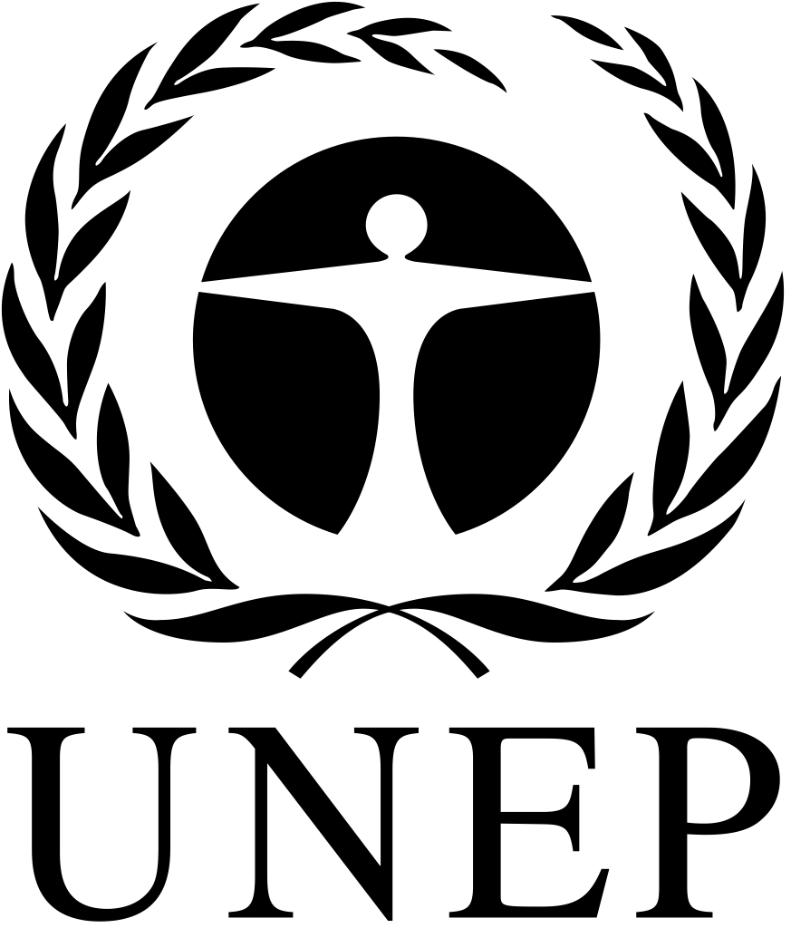 | CBD
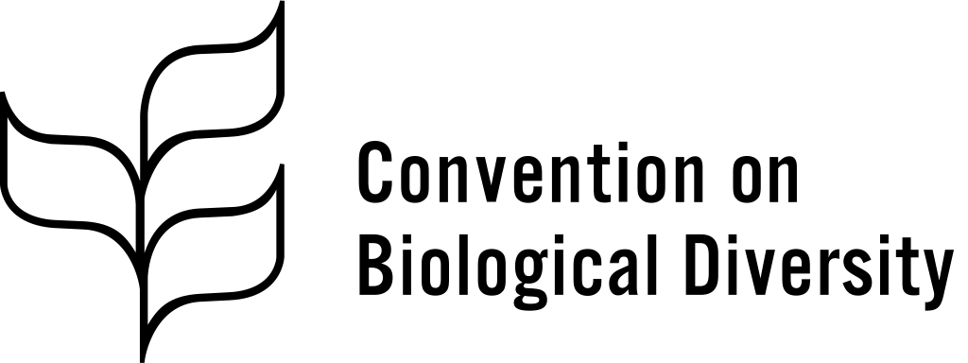 |  |  | Distr.  GENERAL  CBD/ABS/CB-IAC/2018/1/4  22 March 2018  ENGLISH ONLY
INFORMAL ADVISORY COMMITTEE ON CAPACITY-BUILDING FOR THE IMPLEMENTATION OF THE NAGOYA PROTOCOL
Third meeting
Montreal, Canada, 20-22 March 2018
Report of the Informal Advisory Committee on Capacity-building for the Implementation of the Nagoya Protocol on its third meeting

Introduction

Background
- At its first meeting, the Conference of the Parties serving as the meeting of the Parties to the Nagoya Protocol on Access to Genetic Resources and the Fair and Equitable Sharing of Benefits Arising from their Utilization adopted a strategic framework for capacity-building and development to support the effective implementation of the Nagoya Protocol (decision NP-1/8, annex I). It also established an informal advisory committee on capacity-building to provide the Executive Secretary with advice on matters of relevance to the assessment of the effectiveness of the strategic framework (decision NP-1/8, para. 2).
- The terms of reference of the Informal Advisory Committee, as stipulated in decision 1/8, annex II, include providing advice regarding the following:
  - Stocktaking of the capacity-building and development initiatives being implemented by Parties and various organizations with a view to identifying gaps in the implementation of the strategic framework;
  - The need for the development of new tools, guidelines and training materials, including e-learning modules, to facilitate capacity-building and development initiatives of Parties, other Governments, indigenous and local communities and other stakeholders;
  - Facilitation of coordination, synergy, coherence and complementarity among capacity-building and development activities, taking into account information on capacity-building and development needs and activities available in the Access and Benefit-sharing (ABS) Clearing-house and from other sources;
  - Facilitation for matching the capacity-building and development needs identified by Parties with potential opportunities and resources to support the implementation of the strategic framework.
- Two meetings of the Informal Advisory Committee were held during the biennium 2015-2016, from 15 to 17 September 2015 and from 15 to 17 June 2016, respectively. Both were held in Montreal, Canada. The reports on these meetings are available at: https://www.cbd.int/meetings/ABSCBIAC-2015-01 and https://www.cbd.int/meetings/ABSCBIAC-2016-01.
- At its second meeting, the Conference of the Parties serving as the meeting of the Parties to the Protocol decided that the Informal Advisory Committee would hold at least one meeting, and online consultations as needed, to complete its mandate and report on the outcomes of its work to the Conference of the Parties serving as the meeting of the Parties at its third meeting (decision NP-2/8, para. 4).
- The third meeting of the Informal Advisory Committee was held in Montreal, Canada, from 20 to 22 March 2018.

Attendance
- Taking into account that a number of countries have become Parties to the Nagoya Protocol since the Informal Advisory Committee was first established, there was a need to renew the composition of the Committee for this intersessional period on the basis of new nominations from Parties to the Protocol.
- A notification was issued on 3 November 2017 inviting the nomination of experts for participation in the Informal Advisory Committee. From the nominations received, 14 experts from Parties and 3 experts from indigenous peoples and local communities were selected on the basis of their experience and active engagement in ABS capacity-building, equitable geographic representation and gender balance, in accordance with the terms of reference in decision NP1/8, annex II. Due to the small number of nominations received from Parties in the Central and Eastern European group, only two members from this region could be selected instead of three.
- Representatives of international and regional organizations involved in capacity-building to support the implementation of the Nagoya Protocol were also invited to participate in the Informal Advisory Committee.
- The new composition of the Informal Advisory Committee was announced in a notification issued on 25 January 2018.
- The meeting was attended by experts from Antigua and Barbuda, Argentina, Belarus, the European Union, Germany, Malawi, Mexico, the Republic of Moldova, Mongolia, Senegal and Uganda. The experts from Belgium, Vanuatu and Viet Nam were unable to attend the meeting.
- Indigenous peoples and local communities were represented by members of the following associations and organizations: Andes Chinchasuyu, Ecuador; Indigenous Information Network (IIN), Kenya; and Centre for Indigenous Peoples’ Research and Development, Nepal.
- The meeting was also attended by representatives of the following organizations: ABS Capacity Development Initiative; ASEAN Centre for Biodiversity (ACB); Bioversity International; Commission on Genetic Resources for Food and Agriculture (CGRFA); International Development Law Organization (IDLO); International Treaty on Plant Genetic Resources for Food and Agriculture (ITPGRFA); International Union for Conservation of Nature (IUCN); United Nations Development Programme (UNDP); and United Nations Environment Programme (UNEP).
- The representatives of the Caribbean Community Secretariat (CARICOM), Commission des Forêts d’Afrique Centrale (COMIFAC), the Secretariat of the Pacific Regional Environment Programme (SPREP), the Global Environment Facility (GEF) and the United Nations Conference on Trade and Development (UNCTAD) were unable to attend the meeting.
Item 1. Opening of the meeting
- The meeting was opened by Mr. Alexander Shestakov, Director of the Science Policy and Support Division, at 9.30 a.m. on 20 March 2018.
- Mr. Shestakov welcomed Committee members to the meeting and noted that 105 Parties had ratified the Nagoya Protocol. Recalling Aichi Target 16, he informed participants that, while the first part of the target had already been achieved, efforts now needed to focus on further advancing the implementation of the Nagoya Protocol at the national level. He pointed out that the current period of fast-paced innovations in science and technology, also referred to as the Fourth Industrial Revolution, provided an unprecedented opportunity to transform the way in which researchers and the sustainable development community protected and restored the earth’s biodiversity. From discovering new drugs to optimizing microbes for industrial applications, innovation was being accelerated by learning from and using biodiversity. By harnessing nature’s biological assets, such as genetic resources, and ensuring that the benefits were shared equitably, an inclusive bio-economy could be created fostering conservation and sustainable development. He also mentioned that the international community recognized the importance and potential of the issue as expressed through target 15.6 of the Sustainable Development Goals, which aimed to “promote the fair and equitable sharing of the benefits arising from the utilization of genetic resources and promote appropriate access to such resources, as internationally agreed”.
- In highlighting the critical role of capacity-building and development in supporting the implementation of the Nagoya Protocol, he pointed out the unique position of the Committee in examining capacity-building efforts from a global perspective, to identify possible gaps in meeting the needs of Parties, as well as lessons and challenges faced by countries in order to improve future interventions. Expressing gratitude for the participation of key organizations involved in capacity-building, government representatives from all regions and representatives of indigenous peoples and local communities, he reflected on the manner in which Committee facilitated the coordination of capacity-building activities among key players, which, in turn, helped ensure a coherent and balanced approach to the implementation of the Nagoya Protocol.
- In concluding, he mentioned the evaluation of the strategic framework for capacity-building, which was to take place in 2019 and which would feed into the process of preparing a long-term strategic framework for capacity-building beyond 2020, and he encouraged the Committee members to actively contribute to the meeting by sharing their perspectives and experiences.
Item 2. Organizational matters
- Ms. Christine Echookit Akello (Uganda) was elected Chair of the meeting.
- On the basis of the provisional agenda (CBD/ABS/CB-IAC/2018/1/1) prepared by the Executive Secretary, the Committee adopted the following agenda:
1. Opening of the meeting.
2. Organizational matters:
2.1. Election of officers;
2.2. Adoption of the agenda;
2.3 Organization of work.
- Update on existing capacity-building and development initiatives and resources supporting the implementation of the Nagoya Protocol and lessons learned.
- Elements for the evaluation of the strategic framework for capacity-building and development to support the effective implementation of the Nagoya Protocol.
- Adoption of the report.
- Closure of the meeting.
- The Committee agreed on the organization of its work as proposed in the annotated provisional agenda (CBD/ABS/CB-IAC/2018/1/1/Add.1).
Item 3. Update on existing capacity-building and development initiatives and resources supporting the implementation of the Nagoya Protocol and lessons learned

Capacity-building and development initiatives and lessons learned
- The Secretariat made a presentation on the progress towards ratification and implementation of the Nagoya Protocol based on information contained in the interim national reports and the ABS Clearing-House. Capacity-building activities carried out by the Secretariat were also presented. Following a brief discussion, the Secretariat introduced the document updating existing capacity-building and development initiatives and resources supporting the implementation of the Nagoya Protocol and lessons learned (CBD/ABS/CB-IAC/2018/1/2).
- Representatives of organizations with ongoing access and benefit-sharing capacity-building and development projects were invited to present on developments since the second meeting of the Informal Advisory Committee highlighting key areas of the strategic framework, main challenges and lessons learned which could be useful for the design of future capacity-building initiatives. Representatives were also invited to inform the Committee about plans for upcoming or new capacity-building and development initiatives.
- Mr. Santiago Carrizosa, representing UNDP, provided an update on the work of UNDP to support the implementation of the Nagoya Protocol in 43 countries. He shared a number of common challenges and lessons learned. He pointed out the importance of raising awareness about the contribution of ABS to the Sustainable Development Goals in order to increase the visibility of ABS among decision makers in all relevant ministries. In addition, Mr. Carrizosa underscored the importance of including traditional knowledge and sui generis protection in the design of capacity-building projects. He highlighted the value of including simulations and role playing in ABS capacity-building and training activities, which had been particularly useful in illustrating the user-provider interplay. He also identified the growing need to provide guidance for countries developing online platforms for national permits and monitoring of ABS. He provided information on forthcoming UNDP publications related to ABS, such as a capacity-building book and another publication highlighting the contribution of ABS to the Sustainable Development Goals.
- Mr. Emmanuel Adonsou, representing UNEP, presented three GEF projects at the global, regional and national levels, respectively, which supported 30 countries in ratifying and implementing the Nagoya Protocol. The projects included capacity development workshops which focused on promoting understanding and awareness of national obligations under the Protocol related to ratification, implementation, compliance and national reporting. He highlighted common challenges and provided lessons and advice for developing future projects.
- Mr. Andreas Drews, representing the ABS Capacity Development Initiative, presented an update and general overview of the Initiative’s work providing capacity-building in African, Caribbean and Pacific countries. He shared information on the recently started project entitled “ABS Compliant Biotrade in South(ern) Africa”, which would support endogenous research capacities. He noted the importance of conducting ABS contract trainings based on real experiences and engaging with all providers of genetic resources and associated traditional knowledge, including private landowners and farmers. He mentioned the need for future capacity-building projects to demonstrate how ABS could contribute to sustainable development through, for example, conservation and sustainable use of biodiversity, the creation of jobs, and improvement of incomes. He highlighted the ABS Initiative’s work in developing capacity-building resources for negotiating ABS contracts as well as new material on the IT-based permitting and monitoring systems.
- Ms. Melesha Banhan, representing IUCN, presented an overview of the project being carried out by IUCN in eight Caribbean countries to advance the implementation of the Nagoya Protocol in the region. The project provided awareness-raising and capacity-building, including on the ABS Clearing-House, developing legal frameworks and capacity to develop ABS-related permits and contracts. Six of the eight countries were currently working on drafting ABS policy and legislative measures that would be finalized by the end of the project. She indicated that a training programme was being formalized, on the basis of the IDLO-SCBD e-learning modules but adapted to the Caribbean context, in collaboration with the University of the West Indies. In concluding, she shared a video developed by the project and indicated that a documentary film was also under development.
- Mr. Elpidio Peria, representing ACB, provided an overview of their work which included projects to support awareness raising and capacity-building for Parties as well as non-Parties to assess, develop and enforce ABS regulatory and institutional frameworks, and negotiate mutually agreed terms. In addition, he raised the importance of reviewing existing legislation to identify and build upon ABS measures already in place. Another essential element which had been challenging for the region was how to monitor the utilization of genetic resources. He informed participants that lessons were drawn for sharing with stakeholder groups and disseminated through social media. Future capacity development projects needed to be incorporated into the programming of ASEAN members and focus on different sectors and stakeholders.
- Several lessons shared by the presenters were captured in the list of common elements summarized below in paragraph 30.
- Following the presentations, other Committee members were invited to provide updates and comments on developments since the last meeting of the Committee with respect to their ABS capacity-building and development activities as well as emerging experiences. Some of the points raised are summarized below:
  - Ms. Lilian Chimphepo (nominated by Malawi) indicated that Malawi was a beneficiary of the Bio-Bridge Initiative and would be cooperating with other countries in the region;
  - Mr. Samuel Dieme (nominated by Senegal) stressed the need for courses to train the trainers and stronger commitment at the national level to replicate courses in order to increase the number of people trained;
  - Ms. Jargal Jamsranjav (nominated by Mongolia) noted that Mongolia was working under the GEF-UNDP project, and was developing a draft national law that would be adopted by the end of 2018. Mongolia was designing a traditional knowledge database and was working on bio-discovery projects. Ms. Jamsranjav added that Mongolia was setting up its national clearing-house and intended to connect it to the ABS Clearing-House;
  - Ms. Elena Makeyeva (nominated by Belarus) described the work that Belarus would be doing as a beneficiary of the Bio-Bridge Initiative;
  - Ms. Angela Lozan (nominated by the Republic of Moldova) added that, since the Nagoya Protocol had been ratified in 2016, knowledge about the Protocol in the Republic of Moldova was at a basic level. She indicated that the Republic of Moldova would be interested in participating in a regional initiative on the implementation of the Nagoya Protocol, one that engaged other Russian-speaking countries with similar economic, social and environmental contexts;
  - Ms. Julieta Sarno (nominated by Argentina) discussed initiatives in Argentina to raise awareness of ABS in different provinces and the Government’s intention to implement the Protocol in a stepwise manner. She indicated that they were developing several online modules: a general ABS module, one on scientific information, one on value chains, and one on traditional knowledge;
  - Mr. Sergio Ricardo Hernández Ordoñez (nominated by Mexico) indicated that Mexico had organized four subregional courses, training more than 200 officials and researchers. He stressed that Mexico was working closely with indigenous groups and added that national focal points should be able to leverage mutually agreed terms as an opportunity to create projects that benefit partners and indigenous groups alike;
  - Ms. Mery Ciacci (nominated by the European Union) echoed comments by various participants on the need to raise awareness among decision makers, which might be related to the lack of awareness of the potential of ABS in terms of environmental, social, and economic benefits;
  - Ms. Yolanda Teran, representing the Andes Chinchasuyu, Ecuador, highlighted the need to increase the visibility of projects dealing with indigenous peoples and local communities and, in particular, women, and to develop tools adapted to their particular needs and circumstances;
  - Ms. Lucy Mulenkei, representing the Indigenous Information Network, Kenya, indicated that strategies were needed to ensure that indigenous peoples and local communities accessed and benefited from funding to fully engage in capacity development;
  - Mr. Pasang Sherpa, representing the Centre for Indigenous Peoples’ Research and Development, Nepal, indicated that there was no policy or mechanism to ensure full and effective participation of indigenous peoples in capacity-building projects in Nepal and that it was important to continue to discuss further development of engagement mechanisms for indigenous peoples;
  - Mr. Mario Marino, representing the International Treaty on Plant Genetic Resources for Food and Agriculture (ITPGRFA), indicated that relevant resolutions dealing with capacity-building had been adopted by the Governing Body of ITPGRFA at its seventh session, held in Kigali from 30 October to 3 November 2017, with a specific reference to the implementation of the Nagoya Protocol and ITPGRFA in a mutually supportive manner.
- Although they had been unable to participate in the meeting, the representatives of Viet Nam, UNCTAD and the Secretariat of the Pacific Regional Environment Programme (SPREP) each provided a short summary of their capacity-building activities which was shared with the Committee members.
- During a general discussion on lessons learned, a number of elements were identified for consideration in developing ABS capacity-building projects:
  - The need to carry out a gap analysis at the beginning of a project;
  - Project design and capacity-building activities should be adapted to national circumstances and requirements, including the level of awareness, knowledge and existing capacities in recipient countries;
  - Stakeholder analysis should identify those directly accessing genetic resources in order to involve them in capacity-building work;
  - Gender issues and social inclusion should be mainstreamed into project design and budget;
  - Dedicated staff at the national level is needed to support the implementation of projects;
  - Given that establishing national legal ABS frameworks is a lengthy process, the development of interim measures, such as ministerial decrees, to facilitate access and benefit-sharing should be given due consideration in project design;
  - Projects should include the identification of existing value chains in order to make them ABS compliant;
  - Awareness raising should target key stakeholders, such as small businesses, tourist guides and protected area managers, which may inadvertently be sharing information on genetic resources in provider countries without knowledge of ABS;
  - Capacity-building should address both the establishment of national legal ABS frameworks and the establishment of partnerships between users and providers for the negotiation of ABS agreements;
  - Awareness raising about business models of industries that use genetic resources, and more generally strategies to bring together users and providers to build trust;
  - The importance of good and enforceable ABS contracts and the creation of annotated templates for contract clauses;
  - The need to build capacity to negotiate mutually agreed terms, including for indigenous peoples and local communities, so that the terms are enforceable and ensure benefit-sharing;
  - Consider a training-of-trainers approach to support the replication of capacity-building on ABS at the national level;
  - The need to enhance South-South cooperation;
  - The need to facilitate exchange of experiences among countries that have a similar national situation (e.g. political, geographical) as well as indigenous peoples and local communities and other stakeholders;
  - The value of integrating ABS into broader biodiversity-related capacity-building and development projects;
  - Better highlight the multidimensional aspects of ABS and how it can contribute to the Sustainable Development Goals;
  - ABS capacity-building projects should address the implementation of the Nagoya Protocol and ITPGRFA in a mutually supportive manner, where appropriate;
  - The need to build synergies between different treaties that have different focal points;
  - The need to address the interface between the Nagoya Protocol and other ABS-related treaties, such as the International Union for the Protection of New Varieties of Plants (UPOV) regarding plant breeders and the World Health Organization (WHO) with respect to issues related to access to pathogens;
  - The need to address special considerations for research in accordance with Article 8(a) of the Nagoya Protocol.
- Other issues raised during the discussion included the following:
  - The need to identify, collect and make available examples of successful ABS cases, including examples in which ABS products have been developed and how trust has been built between users and providers of genetic resources, through the development of templates that can contribute to awareness raising for decision makers and the general public;
  - Development of regional projects as a way forward to address the capacity-building gap in certain regions, such as Central and Eastern Europe;
  - ABS experiences at the community level need to be captured in order to be shared more widely;
  - Capacity-building targeting indigenous peoples and local communities and other stakeholders, such as the scientific and business communities, merits a more in-depth discussion;
  - The importance of providing support for the development of biocultural community protocols by indigenous peoples and local communities;
  - The need to discuss further including the traditional knowledge and sui generis protection of traditional knowledge within the context of developing capacity-building projects;
  - Submitting information on capacity-building projects to the ABS Clearing-House and supporting indigenous peoples and local communities in contributing to the ABS Clearing-House;
  - Value of demonstrating the environmental, economic and social benefits arising from ABS as a tool for sustainable development and attracting the attention of high-level decision makers to reflect ABS in national policy;
  - Developing strategies to incentivize research and development related to ABS both domestically and internationally.
- The Committee reviewed the information provided in the overview of capacity-building and development initiatives (CBD/ABS/CB-IAC/2018/1/2/Add.1) and suggested the following:
  - To examine with donors, including the GEF Secretariat, the possibility of incorporating in their project templates fields to specify the key strategic areas of capacity-building as well as a requirement to submit the project information to the ABS Clearing-House;
  - To send regular reminders to users of the ABS Clearing-House in order to ensure that information submitted is up to date;
  - To explore further the opportunities to make databases interoperable with the ABS Clearing-House so that information can be automatically updated.
- The Secretariat presented an overview of plans to develop a capacity-building portal as part of the revamped website. The capacity-building portal would serve as the central hub for accessing and visualizing capacity-building information for the Convention and its Protocols. The Secretariat presented mock-ups illustrating functionality to explore capacity-building information related to ABS on the ABS Clearing-House. This tool would provide a user-friendly and useful way to analyse and visualize data (through charts and maps). For example, the analyser could be used to identify how many projects were targeting indigenous peoples and local communities, where partner organizations were working, how many projects were implemented per region, and the types of tools being developed. That would provide useful insights and help identify gaps and improve coordination related to capacity-building for the Protocol.
- In that regard, the Secretariat stressed the importance for countries and capacity-building organizations to submit information on their projects and activities to the ABS Clearing-House so that the global overview provided was accurate and comprehensive.
- The Secretariat also presented the CBD Biodiversity E-Learning Platform (http://www.cbd.int/elearning) and the national report analyser available on the ABS Clearing-House (https://absch.cbd.int/reports). Following the presentation, the Committee praised the report analyser as a useful and valuable tool for accessing the information submitted through the national reports, in particular for understanding capacity-building needs. E-learning courses available on the platform would be open to the public and free to be used by national Governments and partner organizations for their capacity-building needs.
- The Secretariat also presented an initial version of a short video developed in collaboration with the ABS Initiative to explain in a simple manner the system for monitoring the utilization of genetic resources through the ABS Clearing-House. The video would soon be finalized and made available in the six official languages of the United Nations.

Capacity-building and awareness-raising resources
- The Secretariat introduced the overview of access and benefit-sharing capacity-building tools and resources (CBD/ABS/CB-IAC/2018/1/2/Add.2). Committee members were invited to verify the information in the document and to reflect on the types of capacity-building resources and tools being developed as well as the key areas of the strategic framework that they were addressing.
- It was noted that the table of capacity-building resources provided a useful overview of existing resources; however, the need for translation of existing tools and resources into local languages was highlighted. Participants also noted that more capacity-building resources needed to be developed for key areas 3 and 5. The following suggestions were made regarding the types of additional resources that would be useful:
  - Handbooks for the negotiation of mutually agreed terms along with guidance on how to access justice under mutually agreed terms;
  - Guidance material on how to draft enforceable mutually agreed terms;
  - Templates for indigenous peoples and local communities to negotiate mutually agreed terms;
  - Guidance material on how to monitor the utilization of genetic resources and associated traditional knowledge;
  - Awareness-raising material for specific groups, such as high-level officials, indigenous peoples and local communities and relevant stakeholders;
  - Audio-visual material and info graphics for governments, indigenous peoples and local communities and other stakeholders.

Facilitation for matching capacity-building and development needs
- The Secretariat delivered a presentation to introduce the Bio-Bridge Initiative, which focused on (a) catalysing and fostering technical and scientific cooperation among countries and institutions; (b) supporting the development of project proposals to articulate national needs; and (c) matching those needs with relevant technical assistance providers. An overview of the tools and resources offered by the Initiative, including a help desk, web platform, and regional round tables and regional networks to catalyse new cooperation, was also presented. In addition, the Secretariat demonstrated the workflow when requests for assistance are submitted and provided a snapshot of the future direction and priorities of the programme. Finally, out of the 10 project proposals approved to receive seed funds, two (Morocco and Belarus) were focusing on ABS.
Item 4. Elements for the evaluation of the strategic framework for capacity-building and development to support the effective implementation of the Nagoya Protocol

Elements for the evaluation of the strategic framework
- The Secretariat introduced the document on elements for the evaluation of the strategic framework (CBD/ABS/CB-IAC/2018/1/3). The Committee was invited to provide inputs and make suggestions on the proposed elements, including objectives, methodology and sources of information that would be used for the evaluation of the strategic framework.
- Committee members offered several suggestions for improving the elements for the evaluation, which included revising the objectives to better communicate the scope and focus of the evaluation. It was suggested that, in reviewing progress of the implementation of the strategic framework, it would be helpful to evaluate against the objectives of the strategic framework. It would also be useful to look at the main achievements by key area of the strategic framework and whether the measures and capacity-building activities proposed in appendix II of the strategic framework had been used in capacity-building initiatives.
- In terms of the methodology, Committee members recommended the development of detailed terms of reference for the evaluation that would specify what information would be collected and from whom and for what purpose. It was clarified that, for the most part, the evaluation exercise would consist of a document review of factual information with some qualitative input (opinions and recommendations) to be provided through a targeted online survey and interviews with representatives of key organizations involved in capacity development. Regarding the information to be used in the evaluation, participants suggested more specificity regarding the types of documents that would be used and recommended the use of project implementation reports and evaluations when available.

Renewal of mandate
- Given that the assessment of the strategic framework on which the Informal Advisory Committee had been called upon to provide advice was scheduled to take place in 2019 and the results would be reported to the Parties to the Nagoya Protocol at their fourth meeting, in 2020, the Committee considered whether its mandate should be renewed in the next biennium so that it could complete the exercise and continue supporting the implementation of the strategic framework until a decision on a subsequent framework had been made.
- The Committee agreed on the usefulness of the forum and that meetings were relevant for sharing experiences and lessons learned, identifying gaps in ongoing capacity-building activities and coordinating strategies at the national, regional and global levels. Under those circumstances, participants suggested that the mandate of the Committee should be extended until the fourth meeting of the Conference of the Parties serving as the meeting of the Parties to the Nagoya Protocol.
- It was also stressed that, at a future meeting, the Informal Advisory Committee could give special consideration to capacity-building for indigenous peoples and local communities and relevant stakeholders, such as the scientific and business community.
Item 5. Adoption of the report
- The Chair introduced the draft report on the meeting, which was adopted as orally amended.
Item 6. Closure of the meeting
- The Chair made a closing statement. Thanking the Committee members, she noted with appreciation the contribution and inputs that had been provided by all members throughout the meeting.
- The meeting closed at 11.30 a.m. on Thursday, 22 March 2018.

__________

SCBD/SPS/DC/VN/RKi/86870.
SCBD/SPS/DC/VN/RKi/86870.
General Assembly resolution 70/1 of 25 September 2015 on “Transforming our world: the 2030 Agenda for Sustainable Development”, annex.

