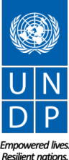

Nature for Development
Pre-SBSTTA Spatial Data Workshop

Report

Nature for Development Spatial Data Workshop

10 December, 2017
Montreal, Canada

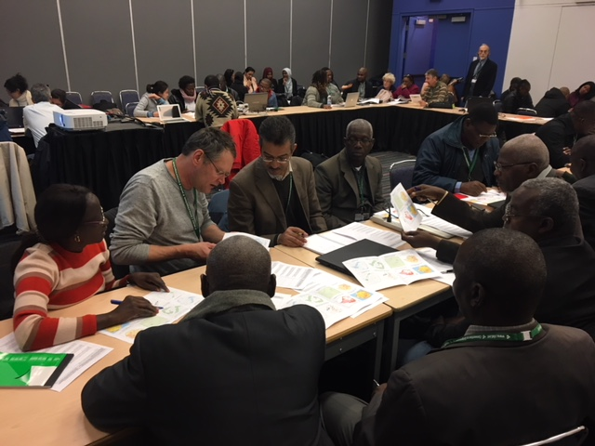

TABLE OF CONTENTS
- Introduction – Nature for Development Spatial Data Workshop
- Presentations
- Barriers and Challenges
- Spatial Data Mapping
- Key Questions for Spatial Data
- Recommendations for SBSTTA
- Annex
  - Annex I- Participant List
  - Annex II- Agenda
  - Annex III- UNDP Nature for Development Spatial Data Declaration

Introduction - Nature for Development Spatial Workshop
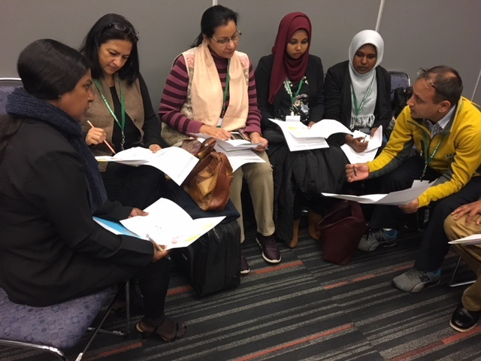

The Pre-SBSTTA Workshop on Spatial Data for the Preparation of the Sixth National Report to the Convention on Biological Diversity was organized by the United Nations Development Programme‘s (UNDP) Global Programme on Nature for Development, on 10 December, 2017, in Montreal, Canada. The Workshop brought together more than 100 participants including representatives from more than XX countries, The Convention on Biological Diversity Secretariat, and representatives from United Nations agencies including UNDP, UN Environment and FAO and related institutions (UNEP-WCMC. GEO BON, etc.). The participants discussed how spatial data can be used by national governments to inform their national biodiversity planning and reporting and support the implementation of the objectives of the Convention on Biological Diversity (CBD) to conserve and sustainably use biodiversity resources. As part of their commitment to the Convention on Biological Diversity, governments have been developing National Biodiversity Strategies and Action Plans (NBSAPs) and National Reports since the Convention was ratified in 1992. The NBSAPs are the primary instrument for implementing the Convention, and the National Reports are required for reporting on progress of implementation.

Spatial data is an essential tool for planning, implementing and reporting on biodiversity actions. Yet results from a recent UNDP study show that a very low number of countries used geospatial data in their post-2010 NBSAPs and 5th National Reports. Key findings show that 83% of countries have fewer than seven maps in both NBSAPs and National Reports, and 70% have a combined average of four maps or fewer. In short, the spatial data included in these key reports is inadequate to inform planning, implementation and reporting on biodiversity actions, and spatial data is insufficient to address the essential questions of the Aichi Biodiversity Targets. These findings are supported by a recent survey sent to countries prior to the Workshop on national spatial data barriers and needs.

Countries will report on progress in achieving global biodiversity targets including the implementation of NBSAPs and national targets in their Sixth National Report, due 31 December 2018, which will contribute to the Global Biodiversity Outlook 5 (GBO-5) and to setting biodiversity and conservation priorities for the period of 2021-2030. This Workshop provided an opportunity to review with government representatives their biodiversity and conservation priorities; to examine the national barriers and needs for the use of spatial data in biodiversity planning and reporting; to conduct spatial planning exercises in groups; to hear from governments on their current use of spatial data for biodiversity; and to provide an introduction to the Nature for Development Spatial Data Sandbox online platform which is currently under development with UN Environment MapX and will be provided to governments in 2018.

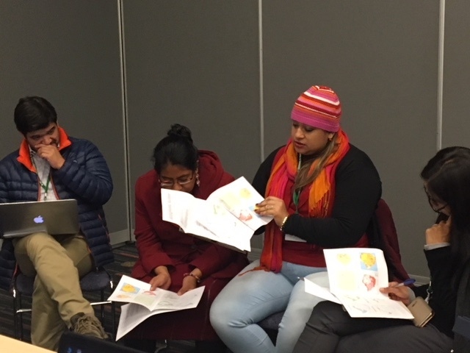
OBJECTIVES
The Pre-SBSTTA Workshop on Spatial Tools for the Preparation of the Sixth National Report to the Convention on Biological Diversity provided an opportunity for UNDP to engage with parties to the CBD to examine the lack of spatial data in NBSAPS and national reports, identify key barriers for countries in using spatial data for biodiversity planning and reporting, review the key conservation questions and related spatial data layers, and provide an overview of the Spatial Data Sandbox online platform to be launched with MapX in 2018.

Based on these objectives, the workshop took advantage of the presence of national representatives to address the following objectives:
- Bring together government representatives – as data users – to discuss what is needed to ensure that existing spatial data is used to influence national policymaking and actions on the ground;
- Identify what the key questions need to be answered in order to create actionable maps that enable informed conservation and development decision-making;
- Identify the data layers required to answer these questions;
- Provide information on the Nature for Development Spatial Data Sandbox online platform being established by UNDP and UN Environment. This platform will bring together spatial data on biodiversity and nature-related SDGs from a variety of stakeholders, including UN agencies, academic institutions, non-governmental organizations (NGOs), and governments. The objective of this data Sandbox is to enable full, open and shared access to these data sets, to better inform government planning, actions and reporting on biodiversity actions, and to gauge national and global progress on the Aichi Biodiversity Targets;

Presentations
[All presentations are available here]

Spatial Data for the 6th National Reports.
Jamison Ervin, Global Programme on Nature for Development, UNDP. Link
A primary concern with NBSAPs and National Reports is the lack of maps, especially actionable maps. This absence of spatial data and planning was examined across all post-2010 NBSAPs and the 5th National Reports and a recent report presented that the average number of maps in the 5th National Report was less than 5, 80% had no actionable maps, less than 3% of all maps focused on future, a mere 1% of maps focused on social and economic aspects, less than 4% of maps focused on ecosystem services, and no maps in all the 5th National Reports addressed all Aichi Targets fully. This failure to incorporate spatial maps is also an important opportunity to expand national capacity to use spatial data and maps. UNDP, with UN Environment, is building the Nature for Development Spatial Data Sandbox, building on a demo tool to add 60+ data layers relevant to biodiversity. This Sandbox will be crated in partnership with multiple data providers and funds have been committed to globalize the tool which will require no GIS and allow national users to add data sets and download relevant analyses.

Spatial Data and the 6NR: Country Spatial Data Needs Assessment and the Spatial Data Summit.
Christina Supples and Nicole DeSantis, Global Programme on Nature for Development, UNDP. Link
The Spatial Data Country Needs Assessment survey was sent to national contacts in November 2017 to assess country spatial data capacity, needs and barriers prior to the Pre-SBSTTA Workshop. More than 50 respondents from 42 countries provided feedback. Key takeaways from the survey included 1) an awareness that there is varying spatial data capacity across countries; 2) a broad need for all data layer types including a) basic socio-demographic data layers , b) land, resource, and human data layers, and c) land cover and bio-geographic data layers; 3) shared concerns about technical, institutional and financial barriers; and 4) a common goal among countries for data tools and platforms to engage countries in design, provide training and ease of use, and support knowledge sharing and communication.

The Spatial Data Summit in Washington D.C. in October 2017 included two events. The first was a workshop on the Forest Integrity for Sustainable Development project with the objective to utilize NASA remote-sensing data for forest cover & connectivity, and human pressure. This project engages eight pilot countries (Brazil, Ecuador, Colombia, Indonesia, Peru, Viet Nam, Costa Rica and the Democratic Republic of Congo) and the workshop engaged the countries in the identification of forest data layers for biodiversity conservation. The second event was the two-day Summit engaged more than 80+ participants across UN agencies, academia, NGOs, companies, and the pilot governments with the objective to convene stakeholders to enable full, open & shared access to spatial data. This Summit identified key biodiversity questions and associated data layers to answer those questions, convened data users & data providers, determined functionalities of the Data Sandbox Portal, strategized for a Paris moment at the 15th CBD COP in 2020, and produced a Data Declaration

Spatial Data in the Sixth National Report to the Convention on Biological Diversity
Néstor A. Acosta-Buenaño, Ministerio del Ambiente, Ecuador. Link
Ecuador’s Ministry of Environment is improving forest evaluation with spatial data. The Ministry is using maps to identify ecosystems with more than 91 ecosystems in Ecuador identified. The Ministry of Environment has also worked with the Ministry of Agriculture to define limits and priorities for the agriculture and conservation sectors. A Map of connectivity has been produced from ecosystem maps, mining information, population data, trade industries, and so forth. The government is using spatial data and information for activities such as the development of a new protected area declaration, intersection licenses system, restoration strategy, definition of conservation and agricultural limits, among other activities, but more recent data is needed for broader analyses, planning and reporting. Spatial data provides a basis to develop data-informed and impactful biodiversity and conservation plans.

MapX: A platform to map and monitor natural resources and the environment using the best available data.

Scott Atkinson, Centre for Biodiversity and Conservation Science, ARC Centre of Excellence for Environmental Decisions, University of Queensland, Australia. Link
Why use geospatial info? It helps us to make better informed conservation and management decisions. Who uses geospatial information? Many disparate users, from GIS professionals to Ministers, each with different degrees of familiarity with using, understanding, synthesizing or analyzing data. Yet there is insufficient sharing often incudes between agencies or ministries in the same government.

Challenges include how to manage multiple sources, actors and themes? Which data can be trusted and has been validated? Is correct in the GIS sense, and will allow for correct analyses to be carried out, producing valid answers? How to share data and control access when data is not meant for public eyes? How to transform information availability into impact, into actionable decisions? Taking these challenges into account, UN Environment has developed a platform to support countries in managing information and monitoring the effectiveness of interventions. This platform will be tailored with UNDP to support biodiversity conservation planning and reporting. Four ways in which MapX can help transform data into impact:
- To address issues of data reliability, bringing to bear the UN’s neutrality to act as an impartial data custodian
- Tools to help countries contextualize, visualize and analyse data
- Data dashboards that are specifically tailored to manage information as part of the NAP process
- We have developed a story mapping function to support communication, sensitization and outreach

A key outcome of the platform will be the ability for countries to create maps, and use these as inputs into reports. Making key information easily accessible, there are customized dashboards at the site and country level which displays key indicators in support of national intervention. Features to be included: systematic prioritization, optimized solutions to conservation planning targets.

GEO-BON Biodiversity Observations for Decision-Making

Mike Gill, GEO-Bon. Link
GEO BON is the biodiversity component of GEO which has 105 member states and 118 participating organizations and collectively manages and serves over 400 M data records through the GEOSS Common Infrastructure. GEO allows us to connect across disciplines and sectors to better serve biodiversity data for not only conservation but also multiple needs. GEO BON involves hundreds of partners around the world working to improve the acquisition, coordination and delivery of biodiversity observations to users to create a more coherent framework and network for biodiversity observations, including spatial data. The Global system for Earth observation has the mission to Improve the acquisition, coordination and delivery of biodiversity observations and related services to users including decision makers and the scientific community. A global biodiversity observation network that contributes to effective management policies for the world’s biodiversity and ecosystem services.

GEO-Bon is currently developing the framework for biodiversity observation by developing the Essential Biodiversity Variables or EBVs, inspired by the Essential Climate Variables. They are organized in 6 classes: genetic diversity, species populations, species traits, community composition, ecosystem function and ecosystem structure. GEO-Bon’s work is focused on producing a flexible and harmonized design process, further development of BON in a Box, the global technology transfer and capacity building toolkit for biodiversity observation tools, and on implementing the EBVs as an operational framework at national, sub-national and regional scales. All the data used and produced by the GEO BON data portal will comply with Open Data Principles and will be directly connected to GEOSS. The biodiversity Indicators Dashboard provides analysis, visualization and communication of datasets on biodiversity status and trends.

FAO Geospatial and Data Tools

Irene Hoffman, Commission on Genetic Resources for Food and Agriculture. Link
FAO has a land cover map which can highlight land use – e.g. can overlay this map with livestock production systems, such as pastoralism and livestock, and show type of land use. FAO has also produced a map on soil organic carbon, related to soil degradation, which links to UN Climate Convention. Maps provide various insights, e.g. FAO mapped trees in drylands and found that there are more trees outside of forests than in forests within drylands. Tools that can be used include openforis.org, Breed Distribution Model, and the SDG tool, for which FAO has developed clear targets and indicators as the custodian agency and has also provides metadata, trends and data that underpin the indicator. All of the data is based on reporting by countries, so it is important that countries continue to report and share this critical data, and all data is free to download. The FAO site also provides standard FAO statistics for country data which includes resources such as the FAO Yearbook on Forest Products. Further information is available in the links provided at the end of the presentation.

Barriers and Challenges
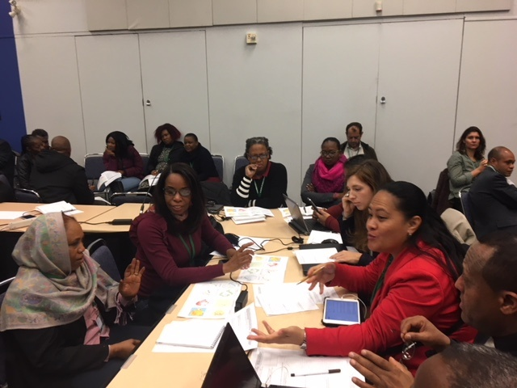

Group discussion: What barriers to using spatial data exist for government to use existing spatial data to improve national biodiversity decision making?

The main barriers identified by participants included:
- Concerns regarding the accuracy of the data
- Interpretation of the data
- Access to the data, e.g. in some jurisdictions you have to pay for the data which can prohibit access.
- Need for broader sharing of spatial data
- A centralized data source
- Ability to store data and archive it
- Data affordability. In some cases, ministries require commercial price to gain access to use their maps
- Public availability of data
- Capacity of government to use spatial data and the need for technology training for staff
- Coordination needed across different sectors
- Many maps are outdated and not of the same period and resolution

Group discussion: What is the single best thing you can do to convince decision-makers that they need spatial data for decision making on biodiversity conservation?

The main suggestions from participants included:
- Decision makers need to know how the data can impact and inform their plans, policies and programs
- Need to shape the data to meet the needs and the key questions that decision makers are asking and need
- Want to be able to develop scenarios and to know what could happen in near future as well as connect those scenarios to socio-economic factors

Spatial Data Mapping

An exercise was provided to participants and asked all participants to break into small groups of 6-8. The exercise provided eight data layers for a map of Zimbabwe including:
- protected areas
- threats (fire, poaching, invasive alien species, and wetland degradation)
- watersheds critical for water security for the capital city
- population density
- key biodiversity areas
- mining deposits, mining operations, and mines in protected areas
- drought (areas prone to drought)
- food insecurity

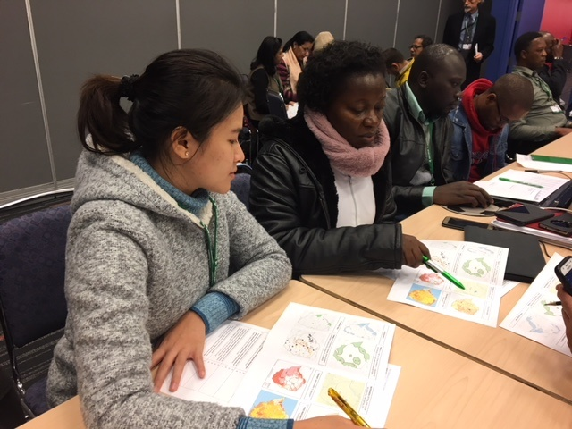
The exercise asked participant groups to review these maps and use the information provided to determine key actions such as where they would make changes to protected area coverage and/or management effectiveness and why.

Participants provided a variety of recommendations and key insights during the exercise such as:
- The need for buffer zones for isolated protected areas.
- The development of environmental restoration bonds from mining companies.
- Requiring environmental impact assessment for pollution concerns from mining and analysis on the impacts on wetlands, air and land degradation.
- The need for environments and social safeguards for mining.
- The areas with mining and high population and threats need sustainable land use plans.
- Support for sustainable community-based forest management and anti-poaching initiatives.
- Protected areas, which fall mostly along national boarders, would benefit from management measures with the neighboring countries and addressing issue of transboundary management.
- Protected area management should explore co-management with communities to improve the representation of the socio-economic needs of the community and balance with broader economic, social and environmental needs.
- Maps drive questions and hypothesis and those questions drive decisions. We also need multiple lines of evidence and types of data

Key Questions for Spatial Data

Instructions: identify the most important spatial data layers required to answer the key questions
Key questions related to the Aichi Biodiversity Targets for which geospatial data are critical, and their relationship to the Sustainable Development Goals and Targets | What are the 3 - 4 most important spatial data layers required to answer these questions?
- Where are the most important opportunities for managing biodiversity to reduce poverty? (Aichi Biodiversity Target 2; SDG 1.1; 1.2; 1.5) | - Poverty distribution  - Agricultural resources and productivity  - UN Human Development Index  - Fisheries  - Wetlands and rivers  - Forestry resources  - Economic activities  - Provision of services  - Food security  - Protected areas  - Poverty heat maps  - Maps of intuitional support  - Biodiversity and ecological resources  - Land use  - Population distribution  - Food insecurity  - Location of people in poverty  - Dependence of poor on natural resources  - Intensity of natural resource use  - Potential for ecosystem service  * to generate poverty index, map: adult literacy, water resources, survival probability to get to 40
- Where is natural resource management likely to exceed safe ecological limits and where are the areas most important to implement sustainable management? (Aichi Biodiversity Target 4; SDG 6.4, 15.1, 15.2) | - Threats layer  - Carrying capacity layers (or equivalent)  - Resource use/land use (eg mining, agriculture, pastures, over grazing)  - Land cover / land use/ change layer  - Pollution maps  - Mining  - Population density  - Forest cutting  - Ecologically and Biologically Significant Areas (EBSA) (marine)  - Areas of high restoration potential, e.g. second growth forest)  - Ecological limits  - Status of biodiversity resources and distribution  - Vegetation structure  - Harvest rates of large animals and their abundance  - Minimim accetable ecological condition  - Habitat fragmention
- Where are the highest rates of loss of natural habitats occurring, including forest ecosystems and where are the best opportunities for halving degradation and fragmentation? (Aichi Biodiversity Target 5, SDG 15.1, 15.2; 15.5) | - Land cover  - Land use  - Threats layer  - Population distribution  - Land ownership  - Roads  - Land use  - Habitat fragmentation  - Ecosystem maps  - Economic activities (development map)  - Consumption and production  - ‘original’ habitat extent / type  - rates of habitat loss  - index of fragmentation  - infrastructure and land use and management plans
- Where are the most important opportunities for promoting sustainable management of agriculture, forestry and aquaculture? (Aichi Biodiversity Target 7; SDG 15.2, 15.3) | - Land Use Planning layers (zonation)  - Protected areas/ecosystem classification layer (showing potential areas where different management level can be considered)  - Existing resource use layers (baseline data)  - Soil composition/water content  - River morphology /hydrology  - Forest Stewardship Council lands that already have sustainable management (as an example)  - Protected area buffer zones  - Areas of high poverty  - Wetlands under human use  - Land degradation maps  - Soil types and vulnerable soil types  - Agro-ecological maps  - Climate (rainfall/temperature)  - Locations of agriculture types over time  - Conversion of habitat due to agriculture land use  - Potential of land to increase production
- Where are the important point sources for pollution, including nutrients, and what are the most important opportunities for minimizing the impacts of pollution? (Aichi Biodiversity Target 8; SDG 3.9; 6.3; 14.1) | - Distribution of Industrial activities layer  - Extent of urban development  - Population density  - Waste management  - Agronomical (agriculture) layer  - Industrial development map  - Distribution of poverty  - Industry locations  - Air pollution  - Soil pollution  - Inlands water maps  - Nutrient load maps  - Nitrogen maps  - Landfill maps
- Where are the pathways for invasive alien species, and where can management interventions have the biggest impact in controlling, eradicating and preventing invasive species? (Aichi Biodiversity Target 9; SDG 15.8) | - Distribution of IAS layer and list  - Entry points (airports, seaports)  - Trade / transportation routes and infastrcutrue maps  - Activities which are potential threats (agriculture, layer)  - Regional distribution of IAS layers (esp. Transboundary relationships)  - Diseases caused by IAS  - Seed transport and trade roads  - Species distribution maps  - Habitat fragmentation maps  - Species distribution  - Ports of entry map  - Transport network map  *Needs to be for each species  * What areas are the most altered by IBS?  * What areas are most at risk of IAS damage?
- Where are the areas of coral reefs and other vulnerable ecosystems that are most vulnerable to climate change or ocean acidification, and where are the opportunities for maintaining integrity and functioning through protection, restoration and sustainable use? (Aichi Biodiversity Target 10; SDG 14.3) | - Distribution of coral reefs, mangroves and wetlands  - Protected areas/ Marine Managed Areas  - Ocean acidification layers, ocean temperature layers  - Coral reef health (using indicators such as species abundance  - Ocean pollution  - Temperate (timescale)  - Fishing pressure  - Riverine discharge  - Ocean temperature  - International / Coral Reef Initiative maps of coral reef pressure  - Ocean PH maps  - Marine ecosystem maps  - Ocean acidification map  - Marine ecosystem climate vulnerability map  - Marine biodiversity distribution
- Where are most important opportunities to create new protected areas and improve existing ones in order to improve representativeness, connectivity and management effectiveness? (Aichi Biodiversity Target 11; SDG 14.5, 15.1, 15.4, 15.7, 15.9) | - Biodiversity hotspots layers  - Kea biodiversity areas  - Threat layer  - Sensitive areas/ ecologically critical areas layer  - Current Protected area status layer  - Important bird areas  - Econets  - Ecosystem maps  - Functional biodiversity maps  - Existing Pas (WDPA)  - Unprotected wilderness areas  - Protected area maps  - Ecosystem distribution maps  - Threatened species maps  - Protected areas map  - Ecosystem distribution map  - Threatened species maps
- Where are the most important opportunities to protect, restore and sustainably manage ecosystems in order to decrease the decline of species populations and to avoid extinctions? (Aichi Biodiversity Target 12, SDG 14.2; 14.5; 15.1; 15.4; 15.7; 15.9) | - Species population density  - Species distribution  - Habitat distribution/ Bio-ecological zones layer  - Threat layer  - IUCN Classification layer (status of extinctions, etc..)  - Migration pathways  - Habitat fragmentation  - IUCN Red List Data for Endemism  - EDGE maps (Zoological Society Layer)  - Biodiversity Intactness Index Maps  - Conservation status maps  - Threatened species maps  - Species distribution maps
- Where are the most important opportunities to protect and restore ecosystems to sustain essential ecosystem services, including water, health, livelihoods and well-being, especially for women, indigenous and local communities, and the poor and vulnerable? (Aichi Biodiversity Target 14; SDG 1.1; 1.2; 1.5; 2.1; 2.4; 6.1; 6.5; 6.6) | - Ecosystems goods and services layer (e.g. Watersheds layer  - Demographics layer  - Basic services layer (health, sanitation layer  - Governance layer (levels of enforcement, quantity of investment in management of Protected areas, budget, staff)  - Water scarcity  - Food scarcity  - Flood risks  - Poverty maps  - Watersheds  - Habitat extend and condition  - Species distribution maps for disease vectors  - Ecosystem maps  - Livelihood distribution maps  - Species distribution maps
- Where are the most important opportunities to strengthen ecosystem resilience, sequester carbon through conservation and restoration, restore degraded ecosystems (Aichi Biodiversity Target 15; SDG 1.5; 6.5; 11.5; 13.1) | - Land Use Cover layer  - EEZ layer  - Layer of degraded or degrading ecosystems  - Ecosystems that sequester carbon  - Degraded land  - Functional diversity maps  - Carbon distribution maps  - Land degradation maps

Recommendations for Future Actions

More than 80 Parties and 20 other participants attended a workshop on spatial data, and its relation to the 6th National Report and the Global Biodiversity Outlook 5. In recognition of the upcoming reporting requirements for GBO-5, National Reports, and the urgency of NBSAP implementation, participants of the workshop:

- Welcome the efforts of the “Nature for Development Data Sandbox” – a partnership between UNDP, UN Environment and many related data initiatives, including GEO-Bon, FAO, NASA and universities, among others, to make key spatial data sets available to all countries as part of the 6th National Reporting process;
- Encourage SBSTTA to adopt the UNDP-UN Environment spatial data initiative as a platform for improving the availability, quality and interpretation of spatial data in national reports;
- Recognize the importance of spatial reporting on biodiversity and its contributions to the Sustainable Development Goals;
- Encourage spatial data that captures the social and economic values of biodiversity to be used in 6th National Reports, as well as for planning and policy development; and encourage the creation of maps that show the value of nature to Sustainable Development Goals, especially Goals 1, 2, 3, 6, 7, 8, 12 and 13, in addition to Goals 14 and 15;
- Request implementing agencies, to support countries on the technical capacity to create, validate and interpret spatial data; and to ensure that these efforts are available in multiple languages;
- Recommend that the Clearing House Mechanism online reporting tool be modified to allow for the inclusion of spatial data;
- Recommend to SBSTTA the development and implementation of a program that focuses on data collection, data verification/validation and a mechanism to allow for data collection on an ongoing basis at the national, sub-regional and regional levels;
- Encourage the development of spatial data planning tools that provides modelling and scenario building capability;
- Encourage all parties to fully integrate spatial data in their national reporting;
- Request the CBD secretariat to facilitate the cooperation and coordination across all the organizations that are currently producing and promoting global spatial data tools;
- Request the CBD Secretariat to prepare a document highlighting the importance of spatial data in the 6th National Report to inform the post-2020 agenda for biodiversity and to inform future reporting;
- Recommend endorsing the concept of Essential Biodiversity Variables, and establishing a formal connection with the Committee on Earth Observation Satellites to identify future requirements for remotely sensed essential biodiversity observations,
- Encourage Parties to consider endorsing the Nature for Development Data Declaration, now open for endorsement, and encourage the full, open, free sharing of data for biodiversity and development by relevant data holders

ANNEXES

Annex I- Participant List
Annex II- Agenda
Annex III- UNDP Nature for Development Spatial Data Declaration

Annex I - Participant List

 | Country / Organization | Name of participant
 | Antigua and Barbuda | Ms. Nneka Nicholas  Department of Environment
 | Argentina | Mr. Luciano Martin Donadio Linares  Secretario de Embajada  Dirección General de Asuntos Ambientales Ministerio de Relaciones Exteriores y Culto
 | Bangladesh | Mr. AKM Rafiqul Islam  AKM Rafiqul Islam  Deputy Director (Natural Resources Management)  Department of Environment
 | Barbados | Ms. Kim Downes  Environmental Officer  Ministry of Environment and Drainage
 | Belarus | Mr. S. Melnov  Director  Republican Research Unitary Enterprise "Belarusian Research Center "Ecology" (RUE “Bel RC “Ecology”)
 | Benin | Mr. Mensah Bienvenu Célestin Bossou  Directeur Exécutif  Cercle pour la Sauvegarde des Ressources Naturelles (ONG CeSaReN)
 | Bhutan | Mr. Thinley Dorji  Head, BP and ABS Program  National Biodiversity Centre  Ministry of Agriculture and Forests
 | Bolivia | Ms. Georgina Catacora-Vargas  Viceministerio de Medio Ambiente, Biodiversidad, Cambios Climáticos y de Gestión y Desarrollo Forestal  Ministerio de Medio Ambiente y Agua
 | Bolivia | Ms. Pilar Becerra-Cardona  Ministry of Environment and Water
 | Bosnia and Herzegovina | Prof. Senka Barudanovic  Faculty of Science  University of Sarajevo
 | Botswana | Ms. Sesame S. Marumo  Energy Officer  Department of Energy
 | Botswana | Ms. Kebaabetswe Keoagile  Senior Natural Resources Officer  Department of Environmental Affairs  Ministry of Environment, Natural Resources Conservation and Tourism
 | Botswana | Ms. Patience Monyek
 | Botswana | Ms. Onalenna Motlogi
 | Burkina Faso | Mr. Somanegre Nana  Ingénieur des Eaux et Forêts  Ministère de l'Environnement et du Developpement Durable
 | Cambodia | Ms. Somaly Chan  Deputy Secretary General  National Council for Sustainable Development  Ministry of Environment
 | Cambodia | Vichuta Ly  Advisor to Department of Biodiversity  National Council for Sustainable Development  Ministry of Environment
 | Cameroon | Ms. Prudence Galega  Secretary General  Ministry of Environment, Protection of Nature and Sustainable Development
 | Central African Republic | Mr. Bob Felicien Konzi Sarambo  Environnementaliste Gestionnaire  Chargé de mission en matière d'environnement  Ministère de l'Environnement, du Developpement Durable, des Eaux, Forêts, Chasse et Pêche
 | Chad | Mr. Habib Gademi  Point Focal National Biodiversité  Direction des Parc Nationaux et de la Chasse  Ministère de l'Environnement et de la Pêche
 | Chile | Sr. Diego Flores Arrate
 | China | Dr. Xu Haigen  Nanjing Institute of Environmental Sciences, Ministry of Environmental Protection
 | China | Ms. Zou Yueyu  Foreign Economic Cooperation Centre, Ministry of Environmental Protection
 | Comoros | Mr. Hachime Abdérémane
 | Convention on Biological Diversity | Kieran Mooney  Convention on Biological Diversity  Montreal, Canada
 | Convention on Biological Diversity | Monique Chiasson  Convention on Biological Diversity  Montreal, Canada
 | Convention on Biological Diversity | Lijie Cai  Convention on Biological Diversity  Montreal, Canada
 | Convention on Biological Diversity | Robert Hoft  Convention on Biological Diversity  Montreal, Canada
 | Costa Rica | Ms. Eugenia Argüedas Montezuma  Punto focal nacional CDB  (COP Bureau Member)  Sistema Nacional de Areas de Conservación  Ministerio de Ambiente y Energia
 | Cuba | Mr. Jesus Guerra Bell  Especialista Principal  Dirección de Relaciones Internacionales  Ministerio de Ciencia, Tecnología y Medio Ambiente
 | Cuba | Ms. Lourdes Coya de la Fuente  Expert, Department of Environment  Ministerio de Ciencia, Tecnología y Medio Ambiente
 | Djibouti | Mr. Houssein Rirache Robleh  Directeur de l’Environnement et du Développement Durable
 | Dominica | Ms. Kongit Haile-Gabriel  Senior Environmental Officer  Environmental Coordinating Unit  Ministry of Health and Environment
 | Dominican Republic | Ms. Marina Hernandez  Directora  Departamento de Recursos Geneticos - Direccion de Biodiversidad  Vice ministerio Áreas Protegidas y Biodiversidad, Ministerio de Medio Ambiente y Recursos Naturales
 | Ecuador | Mr. Wilson Rojas  Punto focal CDB  Coordinador Unidad de Acceso a Recursos Genéticos  Dirección Nacional de Biodiversidad  Ministerio del Ambiente
 | Ecuador | Nestor Acosta
 | Ethiopia | Mr. Genene Tefera Belihu  Director  Microbial Biodiversity Directorate  Ethiopian Institute of Biodiversity
 | Ethiopia | Dr. Misikire Tessema Lemma  Coordinator for NBSAP implementation and 6NR formulation  Ethiopian Biodiversity Institute
 | Ethiopia | Dr. Feleke Woldeyes Gamo  Deputy Director General  Ethiopian Biodiversity Institute
 | European | Ms. Anne Teller  Policy Officer for Biodiversity  DG Environment - Unit B2 Biodiversity  European Commission
 | GAMBIA | Mr. Ousainou TOURAY  Deputy Director  Department of Parks & Wildlife Management  c/o Ministry of Environment, Climate Change, Water and Wildlife
 | Ghana | Sulemana Haruna  Curriculum Development Officer  Institute of Tropical Agriculture
 | Guatemala | Mrs. Gloria M. APÉN  Técnico del Departamento de Coordinación con Pueblos Indígenas y Sociedad Civil  Consejo Nacional de Areas Protegidas (CONAP)
 | GUINEE-BISSAU | Mrs. Matilde da Conceiçao Gomes Lopes  General Direction of Environment  Ministry of Environment and Sustainable Development
 | HONDURAS | Ms. Marlé Aguilar Ponce  Analista Ambiental  Dirección de Biodiversidad  Secretaría de Energía, Recursos Naturales, Ambiente y Minas (MiAmbiente)  Tegucigalpa
 | India | Dr. Sujata Arora  Adviser  Ministry of Environment, Forest & Climate Change
 | JAMAICA | Ms. Gillian Guthrie  Senior Director  Environment and Risk Management Division  Ministry of Economic Growth and Job Creation
 | JAMAICA | Joni Jackson  Director, Natural Resources  Environment and Risk Management Division  Ministry of Economic Growth and Job Creation
 | JAMAICA | Andrea Donaldson  Manager, Project Branch  National Environment and Planning Agency
 | KIRIBATI | Ms. Marii Marae  Senior Environment Officer  Environment and Conservation Division  Ministry of Environment, Lands and Agricultural Development (MELAD)
 | LAO DPR | Ms. Sonephavanh Liemphachanh  Planning Officer  Assistant to the National Coordinator of CBD for Lao PDR  Lao National Mekong Committee Secretariat - LNMCS  Ministry of Natural Resources and Environment - MONRE
 | Madagascar | Monsieur Sahoby Yvy Randriamahaleo
 | MALAWI | Mrs. Martha MPHATSO KALEMBA  Principal Environmental Officer (Biodiversity)  Environmental Affairs Department
 | MALDIVES | Ms. Ilham Atho Mohamed  Assistant Director, Environment Department  Ministry of Environment and Energy  Malé, Maldives
 | MALDIVES | Ms. Lisama Sabry  Environment Analyst  Ministry of Environment and Energy  Malé, Maldives
 | MALI | Mr. EL HADJ SY  MSc Gestion des Ressources Naturelles/Spécialiste en Gestion des Aires Protégées  Direction Nationale des Eaux et Forêts  Ministère de l’Environnement, de l’Assainissement et du Développement
 | MALTA | Ms. Anna Gureva  Assistant Environment Protection Officer  Biodiversity and Water Unit  Environment and Resources Authority
 | Mauritania | Mr. Cheikh Mohamed El Abd  Coordinateur National des Programmes de la Convention sur la Diversité Biologique  Ministère de l’Environnement et du Développement Durable
 | Morocco | Mostafa Madbouhi  Chef de la Division de la Biodiversite  Direction de Changement Climatique, de la Diversite Biologique et de l’Economie Verte  Secretariat d’Etat charge du Developpement Durable
 | NEPAL | Mr. Maheshwar DHAKAL  Joint Secretary  Chief, Biodiversity and Environment Division  Ministry of Forests and Soil Conservation
 | NIGER | Mr. Boukar ATTARI  Conseiller  Conseil National de l'Environnement pour un Développement Durable (CNEDD)
 | PERU | Ms. Elizabeth Cardenas  Ministerio del Ambiente
 | Poland | Ms. Bozena Haczek
 | Republic of Korea | Ms. Myoung-hai Kwak  Senior Researcher  Plant Resources Division  National Institute of Biological Resources  Environmental Research Complex  mhkwak1@korea.kr
 | Republic of Korea | Mr. Byoung-Yoon Lee
 | Saint Kitts and Nevis | Mr. Sylvester Belle  Chief Conservation Officer  Department of Environment  Ministry of Agriculture, Marine Resources, Cooperatives, Environment and Human Settlement
 | Saint Lucia | Mr. Adams Toussaint  Chief Forestry Officer  Department of Forest and Lands Resources Development  Ministry of Agriculture, Fisheries, Physical Planning, Natural Resources and Co-operatives
 | Sao Tome et Principe | Mr. Aurélio de Sousa Jesus Rita  Directeur  Direcçao do Parque Natural Obô de S.Tomé  Ministério de Agricultura e Desenvolvimento Rural
 | Senegal | Mr. Samuel Dieme  Ingénieur des Eaux et Forêts  Direction des Parcs Nationaux  Ministère de l'environnement et du développement durable
 | Senegal | M. Soulèye Ndiaye
 | Serbia | Mr. Slavisa Popovic  Environmental Protection Agency (SEPA)
 | Seychelles | Ms. Marie-May Muzungaile  Director General  Biodiversity Conservation and Management Division  Ministry of Environment, Energy and Climate Change
 | Solomon Islands | Mr. Joe Horokou  Director  Environment and Conservation Division  Ministry of Environment, Climate Change, Disaster Management and Meteorology
 | Somalia | Abdirizak Mohamud  Director of Environment  Office of the Prime Minister
 | South Sudan | Mr. Paul Demetry  Deputy Director for Biodiversity  Directorate of Wetlands and Biodiversity  Ministry of Environment and Forestry
 | South Africa | Ms. Malta Qwathekana  Senior Policy Adviser; CBD Technical (Principal) Focal Point  International Biodiversity and Heritage Cooperation  Department of Environmental Affairs (DEA)
 | Sri Lanka | Ms. Hemamali Herath  Research Assistant  Biodiversity Secretariat  Ministry of Mahaweli Development and Environment
 | Sudan | Dr. EL Khitma EL Awad Mohammed  Senior Researcher  Biodiversity  Higher Council for Environment and Natural Resources (HCENR)
 | Syrian Arab Republic | Mr. (Eng.) Belal AL Hayek  Director  Directorate of Biodiversity, Lands and Natural Reserves  Ministry of Local Administration and Environment
 | Timor-Leste | Mr. Marcal Gusmao  Lecturer  Department of Agronomy, Faculty of Agriculture  National University of East Timor
 | TNC | Linda Krueger
 | Togo | M. Kotchikpa Okoumassou  Chef division des aires protégées et de la faune  Direction des ressources forestières  Ministère de l'environnement et des ressources forestières
 | Tonga | Ms. Ta'hirih Hokafonu  Principal Conservation Officer  Department of Environment, Ministry of Energy, Information, Disaster Management, Environment, Climate Change and Communications
 | Tunisia | Mr. Mohamed Ali Ben Temessek  Sous Directeur des Milieux Naturels  Direction Générale de l'Environnement et de la Qualité de la Vie  Ministère des Affaires Locales et de l’Environnement
 | Turkmenistan | Ms. Shirin Karryeva  Manager of RSPB Project on "Improvement of the Conservation Status of Birds and other Biodiversity in Turkmenistan"  State Committee on Environment Protection and the Royal Society for the Protection of Birds (RSPB) Project
 | Uganda | Ms. Sarah Naigaga  Senior Legal Officer  Legal Department  National Environment Management Authority  Ministry of Water and Environment
 | Ukraine | Sergiy Gubar  Deputy Director- Head of Division  Division of Econet Development and Biosafety, Directorate of Natural Resources Protection  Ministry of Ecology and Natural Resources of Ukraine
 | Ukraine | Yuliya Bondarenko  Chief Expert, Division of EcoNet Development and Biosafety  Directorate of Natural Resources Protection and EcoNet  Ministry of Ecology and Natural Resources
 | United Kingdom of Great Britain and Northern Ireland | Ms. Deborah Steele  Science Advisor, Wildlife and International Biodiversity Evidence Defra
 | United Republic of Tanzania | Mr. Thomas J. Chali  Division of Environment  Vice President's Office
 | ASEAN Centre for Biodiversity | Sheila G. Vergara  Director
 | ASEAN Centre for Biodiversity | C. Carida
 | Forest Peoples Programme (FPP) | Caroline de Jong  Coordinator, Environmental Governance Programme  Forest Peoples Programme (FPP)  England
 | IIFB | Mrs. Yeshing Juliana Upún yos  IIFB Expert  Latin America Region
 | UNDP | Jamison Ervin  United Nations Development Programme  New York, USA
 | UNDP | Christina Supples  United Nations Development Programme  Colorado, USA
 | UNDP | Nicole DeSantis  United Nations Development Programme  New York, USA
 | UNDP | Scott Atkinson
 | UNDP | Dr. Ruchi Pant  Programme Officer, Energy and Environment Programme, United Nations Development Programme (UNDP)
 | UN Environment | Julian Blanc
 | GEO BON/  UNEP-WCMC | Mike Gill  Co-Chair, Group on Earth Observations – Biodiversity Observation Network  Honorary Fellow, UNEP – World Conservation Monitoring Centre
 |  | Ruth Spencer

Annex II - Agenda

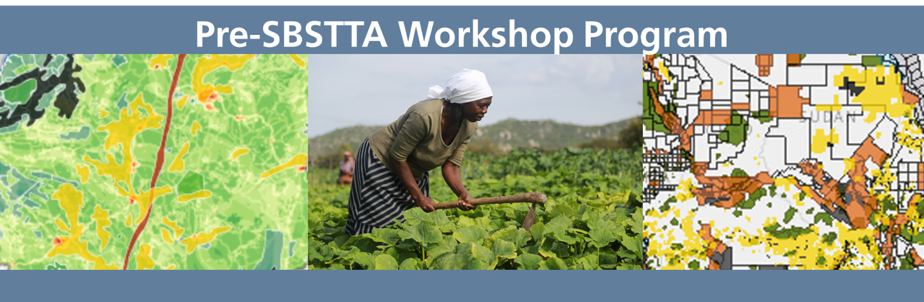

Pre-SBSTTA Workshop Program: Spatial Data in the Sixth National Report to the Convention on Biological Diversity
Jointly organized by UNDP, UN Environment and SCBD
Palais des Congrès, Montréal – Sunday, 10 December 2017, 10:00 to 17:00

Agenda

MORNING SESSION

10:00 – 10:45: Introduction and overview
- Introductions, overview of day
- Results of spatial data needs and analyses
- Participant reflections on the state of play of spatial data within countries

10:45-11:30: Value of spatial data for planning, implementation and reporting
- Overview of linkages between Sustainable Development Goals and Aichi Biodiversity Targets
- Exercise on using spatial data overlays for planning, implementation and reporting

11:30 – 12:30
- Country presentations on spatial data layers (4 presentations, with discussion)

LUNCH: 12:30 – 2:00

AFTERNOON SESSION

2:00 – 3:30: Identifying essential data sets for the Aichi Biodiversity Targets
- Key questions for which spatial data are required
- Exercise on identifying spatial data layers required to report on essential questions

3:00 – 4:00: Using spatial data for planning, implementing and reporting
- Country presentations on using spatial data for decision making, and discussion
- Proposal for developing a data sandbox and discussion

4:00 – 5:00: Possible elements on spatial data likely to be included in recommendations to SBSTTA 21
- Group discussion on possible spatial data elements likely to be included in recommendations to SBSTTA 21 and/or SBI 2

Annex III - UNDP Nature for Development Spatial Data Declaration

Nature for Development Declaration on Spatial Data

Biodiversity is in crisis. Biodiversity losses are taking place at an unprecedented scale and are often non-linear, abrupt changes that occur within complex socioeconomic systems. Over the past two decades, we have lost 10% of the planet’s wilderness¹ – an area half the size of the Amazon – and only three percent of biodiversity hotspots are still natural². Populations of 3,700 vertebrate species have declined by more than half from 1970 to 2012³. 80% of global fish stocks are fully or overexploited, or have collapsed⁴. We have surpassed 400 parts per million of CO2 in the atmosphere⁵, with nearly one degree Celsius in global average temperature rise.

These pressures on our environment will only continue to grow. The global population is expected to expand by more than 1.2 billion people over the next two decades, the global middle class is projected to more than double by 2030, consumption of animal-based foods continues to grow, and our urban footprint is expected to triple⁶. This will result in an increased demand for food by 35%, water by 40%, and energy by 50%⁷.

These pressures and losses are multiplying and inter-linked, with the potential to lead to system collapse. Unless we prioritize sharing information and data, and change how we govern and use the world’s resources, the negative impacts on our natural environment will only become more pronounced, with serious implications for our global health and economic development.

In the run-up to 2020 -- when Parties to the Convention on Biological Diversity will determine a new strategic plan and set of targets to conserve the world’s biodiversity -- spatial data are essential. The free, open, and productive flow of spatial data can help to track, plan, and deliver on the Aichi Biodiversity Targets and enable both humans and the planet to thrive.

Yet a recent UNDP study⁸ shows that a very low number of countries are using geospatial data in their post-2010 National Biodiversity Strategies and Action Plans (NBSAPs) and 5th National Reports. Key findings show that 80% of 5th National Reports, and 70% of NBSAPs contained no actionable maps, where actionable maps are defined as those that provide information that allow planners to take action such as new protected areas, coastal vulnerability, or composite maps. These findings are supported by a recent survey⁹ of national spatial data needs, where over 91% of country respondents cited their need for spatial data on land resource use and human pressure as high. Actionable maps do not explicitly lead to better decision-making; however, without this foundational information, policymakers cannot even begin to assess trade-offs between conservation and development in a spatially explicit manner. Likewise, citizens cannot hold decision-makers accountable for negative impacts on nature.

We, as governments, academic institutions, NGOs, foundations, and UN agencies, came together on the occasion of the Nature for Development Spatial Data Summit in Washington, D.C., to assess the scope and value of spatial data and planning, and to strengthen national capacities to use relevant and meaningful data.
Together, we envision by 2020 a world where biodiversity and development planning, implementation and reporting is based on reliable spatial data that facilitates achievement of the Aichi Biodiversity Targets and the 2030 Agenda for Sustainable Development.

Having met on this 26th and 27th of October 2017, we declare that the following components are important to achieving this vision:
- Nature for development: Widespread recognition that nature is essential to the achievement of the Sustainable Development Goals.
- Inclusive data generation: Knowledge from diverse social and technological systems represented, from traditional ecological knowledge to satellite remote sensing
- Robust, real-time, high-resolution, vetted data: Resources available to vet, standardize, curate, quality-assess, and update data in real time, ensuring clear information is provided about assumptions and uncertainties.
- Spatial data access: Publicly available, open source, and accessible data, software, and platforms inventoried with clear information on what is available, how it can be used, and comparative benefits of these resources for varied purposes.
- Tools that can inform biodiversity decision-making: Tools created that allow for informed decisions on biodiversity mainstreaming, maintenance of ecosystems within safe ecological limits, and improved human well-being and sustainable development.
- Empowered indigenous peoples and local communities (IPLCs): IPLCs have access and capacity to use spatial planning tools to better conserve, restore, and sustainably manage their nature resources to reduce poverty and strengthen their livelihoods.
- Future scenario planning: Governments and other key stakeholders conduct cost-benefit analyses of conservation planning focusing on future scenarios, especially under climate change scenarios, and prioritize early warning systems and forecasting.
- Communication of spatial data analysis and insights: Communication effectively engages decision-makers, scientists, media, and the general public through data-driven, targeted, clear, concise, compelling messages, stories and recommendations.

Therefore, in order to achieve this vision,
We, as a united multi-stakeholder group, strive to:
- Define key terms: Identify, define, and standardize key terms to understand how they differ across stakeholder groups.
- Improve data quality: Make data quality and assumptions transparent and agree on a standardized approach to writing metadata, especially for derived data layers.
- Inventory existing platforms: Analyze the datasets, platforms and tools that are available, their functionality and target audiences, distinguishing between static and temporal databases, mapping tools, analytical tools, open data architecture, data capture tools, and knowledge inventories in order to clearly explain what they do, and how they are resourced and maintained.
- Promote open source data and integrate platforms: Strengthen open source data availability to facilitate integration, sharing, and innovation and integrate platforms where possible, developing a dialogue between platforms to align strengths, ensure synergies, and address gaps.
- Connect data providers and data end users: Ensure that data tools and platforms are fit-for-purpose, leveraging global frameworks where appropriate.
- Develop end user-first products: Strengthen the relevance, utility, and uptake of data products by first asking end users about assets that exist – including data sources, mechanisms of reporting, and corrective action – and co-producing spatial data tools that can eliminate barriers to the integration of spatial data into conservation and development planning.
- Facilitate understanding of end-user contexts: Work to understand the contexts in which end-users apply spatial data and understand how they can make information derived from spatial data as influential as possible in a highly complex policymaking landscape.
- Integrate complementary data and scales of analysis: Facilitate the generation and integration of complementary and open source data to address evolving challenges in complex adaptive systems at different scales, including place-based knowledge from indigenous peoples and local communities, in order to ensure that data is provided at scales necessary for decision-making.
- Build capacity across sectors: Empower data end users by building local and national capacity for integration and effective use of spatial biodiversity data for into sectoral and national development planning, implementation, reporting, and decision-making, and strive toward interoperability of data and open data across all sectors.
- Facilitate long-term sustainable partnerships: Cultivate partnerships that foster data innovation, open data, responsible data sharing (including generating, collating, managing and disseminating biodiversity data holdings), and respect for data sources (including traditional knowledge and intellectual property) from the global to the local level as well as secure the resources necessary to maintain data holdings.
- Develop innovative communication channels: Share compelling stories, lessons, use cases and good practices to foster collaboration and prevent duplication of efforts.
- Foster collaboration among national institutions: Reduce bureaucratic burdens in order to facilitate maintenance, sharing, and use of already available data for reporting and decision-making, including through the recognition of the resources required by institutions to maintain these datasets.
- Support data-informed reporting & decision-making: Inform and incorporate the most relevant available spatial data in the Sixth National Report and the implementation of the NBSAPs to strengthen evidence-based decision-making for biodiversity and development.
- Connect national and global data systems: Facilitate the use of spatial data platforms to improve the collation of National Reports into global data products, while reducing the reporting burden on national agencies.

¹ Watson et al. 2016. Catastrophic Declines in Wilderness Areas Undermine Global Environment Targets. Current Biology, 26: 2929-2934.
² Venter, O., E. W. Sanderson, A. Magrach, J. R. Allan, J. Beher, K. R. Jones, H. P. Possingham, W. F. Laurance, P. Wood and B. M. Fekete. 2016. Global terrestrial Human Footprint maps for 1993 and 2009. Scientific Data.
³WWF. 2016. Living Planet Report 2016. Risk and resilience in a new era. WWF International, Gland, Switzerland.
⁴ FAO. 2010. The State of World Fisheries and Aquaculture. Available online here.
⁵ NOAA. 2017. Available online here.
⁶Seto, K. et al. (2012). Global forecasts of urban expansion to 2030 and direct impacts on biodiversity and carbon pools. Available online here.
⁷ National Intelligence Council. 2012. Global Trends 2030.
⁸ UNDP. 2017. Are We Counting On Nature? An Analysis Of Spatial Data In Post-2010 NBSAPs And 5th National Reports. Available online here.
⁹ UNDP (2017). “Country Spatial Data Needs Assessment”. UNDP Spatial Data Summit, Washington D.C.

