|  |  |  |
| --- | --- | --- |
| Macintosh HD:Users:bilodeau:Desktop:logos:template 2017:un.emf | Macintosh HD:Users:bilodeau:Desktop:logos:template 2017:unep-old.emf | **CBD** |

|  |  |  |
| --- | --- | --- |
|  |  | Distr.  GENERAL  CBD/SBI/2/16/Add.1  12 February 2018  ORIGINAL: ENGLISH |

SUBSIDIARY BODY ON IMPLEMENTATION

Second meeting

Montreal, Canada, 9-13 July 2018

Item 15 of the provisional agenda[1]*

# Review of the experience in holding concurrent meetings of the Conference of the Parties to the Convention and the meetings of the Parties to the Protocols

## *Note by the Executive Secretary*

1. **BACKGROUND**
2. In 2016, the thirteenth meeting of the Conference of the Parties to the Convention on Biological Diversity (COP 13), the eighth meeting of the Conference of the Parties serving as the meeting of the Parties to the Cartagena Protocol on Biosafety (CP-COP-MOP 8), and the second meeting of the Conference of the Parties serving as the meeting of the Parties to the Nagoya Protocol on Access to Genetic Resources and the Fair and Equitable Sharing of Benefits Arising from their Utilization (NP-COP-MOP 2)[2] were held concurrently in Cancun, Mexico. These meetings, together with the high-level segment, were collectively referred to as “The United Nations Biodiversity Conference, Cancun, Mexico, 2016” for communication purposes. In [decision XIII/26](https://www.cbd.int/doc/decisions/cop-13/cop-13-dec-26-en.pdf), the Conference of the Parties to the Convention adopted criteria for reviewing, at its fourteenth and fifteenth meetings, experience in holding meetings concurrently, and requested the Executive Secretary to prepare a preliminary review, using these criteria, for consideration by the Subsidiary Body on Implementation at its second meeting. The meetings of the Parties to the Cartagena and Nagoya Protocols decided to use similar criteria for reviewing their meetings in decisions [CP VIII/10](https://www.cbd.int/doc/decisions/mop-08/mop-08-dec-10-en.pdf) and [NP 2/12](https://www.cbd.int/doc/decisions/np-mop-02/np-mop-02-dec-12-en.pdf), respectively.
3. In response to these requests, a notification[3] was sent to Parties to the Convention and its two Protocols inviting them to provide their perspectives on concurrently convening the above mentioned meetings, using a questionnaire, focused on the criteria identified in decisions XIII/26, CP VIII/10 and NP 2/12. In addition, a survey was distributed[4] electronically to participants in the concurrent meetings. For the electronic survey, respondents participated in their personal capacity and their responses do not necessarily reflect the official view of the Parties or organizations they represent.
4. The following sections of the present document summarize the main findings of the questionnaire and survey on the experiences of convening concurrent meetings of the Conference of the Parties to the Convention, and the meetings of the Parties to the two Protocols. Observations are also provided by the Secretariat on issues related to the logistics of convening meetings of the Convention and Protocols for the information of Parties in their consideration of this issue. The note contains a section on each of the criteria identified in decisions XIII/26, CP-VIII/10 and NP-2/12 as well as a section identifying general observations and conclusion. Further, the present document is complemented by two information documents which reproduce all of the written comments received in response to the questionnaire and survey as well as provide additional analysis.[5] An earlier version of the present note was made available for peer review.[6]
5. **RESPONDENTS TO THE SURVEYS**
6. The notification issued to Parties elicited 71 responses from 64 Parties.[7] Some Parties provided separate submissions for the Convention and its Protocols, and not all respondents answered all questions in the questionnaire or provided written comments. Of the responses to the notification, 62 included information related to the Convention, 55 included information related to the Cartagena Protocol and 41 included information related to the Nagoya Protocol. This represents a response rate of approximately 32 per cent of Parties to the Convention, 32 per cent of Parties to the Cartagena Protocol and 43 per cent of Parties to the Nagoya Protocol at the time when the submissions were made. On a regional basis, 23 responses were received from Africa, 10 from Asia and the Pacific, 7 from Central and Eastern Europe, 17 from Latin American and Caribbean Countries and 14 from the Western Europe and Others Group. A total of 53 of the responses were from developing countries and 18 were from developed countries. The responses by Parties to the questionnaire are summarized in figure 1 and are further analysed in the following sections of the present document.
7. The electronic survey was distributed to 2,810 participants in COP 13, COP-MOP 8, and COP‑MOP 2.[8] This represents approximately 90 per cent of all meeting participants. Responses to the survey were received from 749 participants. This represents a response rate of approximately 27 per cent among those surveyed and 24 per cent of all participants in the concurrent meetings. Not all respondents answered all questions in the survey. Further, the number of written responses varied greatly and tended to be more critical than the situation suggested by the quantitative results. About 47 per cent of respondents had participated in the concurrent meetings as representatives of Parties, 8 per cent had participated as representatives of indigenous peoples and local communities and 38 per cent as other observers. A further 6 per cent represented non-party Governments, including subnational authorities. By comparison Parties accounted for 48 per cent of participants in the concurrent meetings, indigenous peoples and local communities represented 5 per cent of participants and observers accounted for 45 per cent of participants. On a regional basis, 17 per cent of responses were from Africa, 21 per cent from Asia and the Pacific, 8 per cent from Central and Eastern Europe, 25 per cent from Latin America and the Caribbean and 30 per cent from the Western Europe and Others Group. This distribution is similar to the regional distribution of participants in the concurrent meetings. The responses to the survey that directly address issues related to the criteria identified in decision XIII/26 are summarized in figure 2.

**Figure 1**

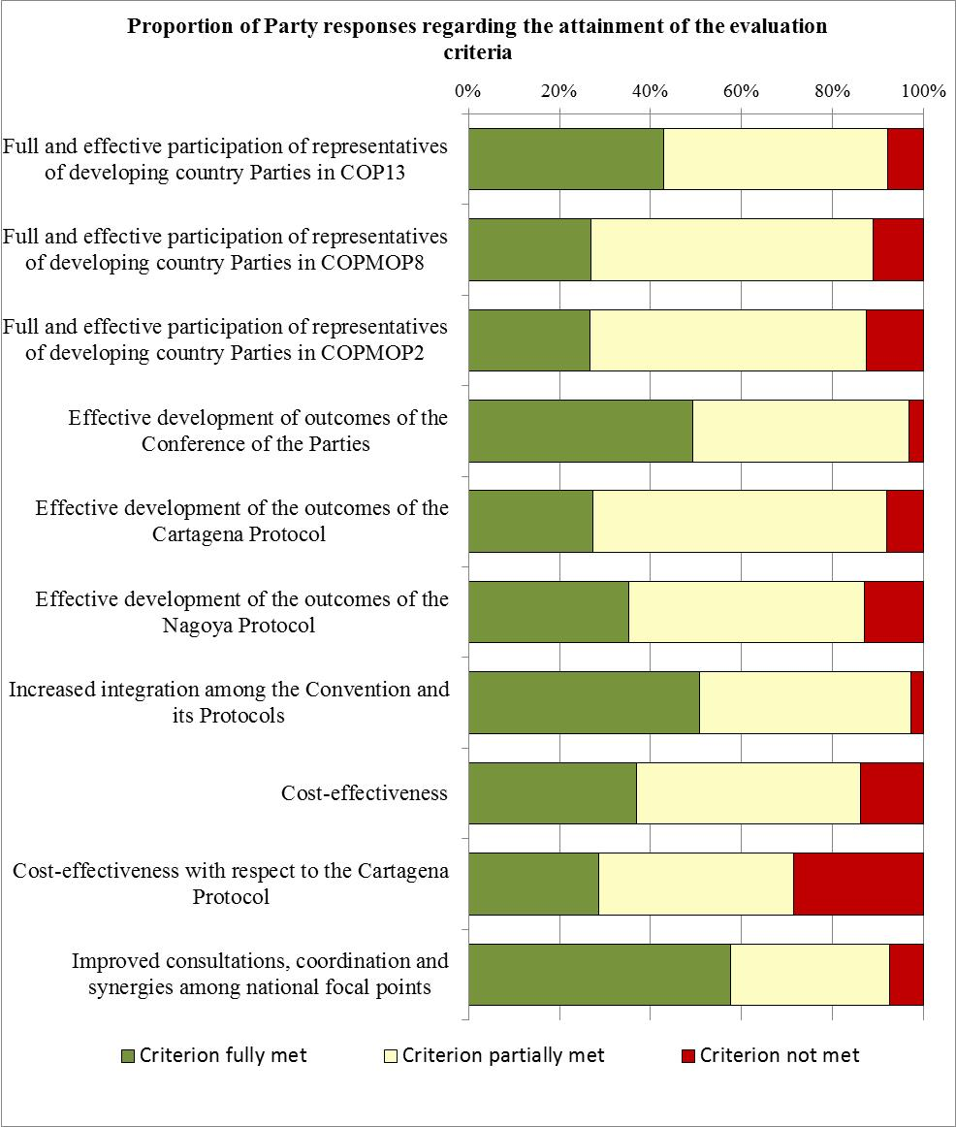

**Figure 2**

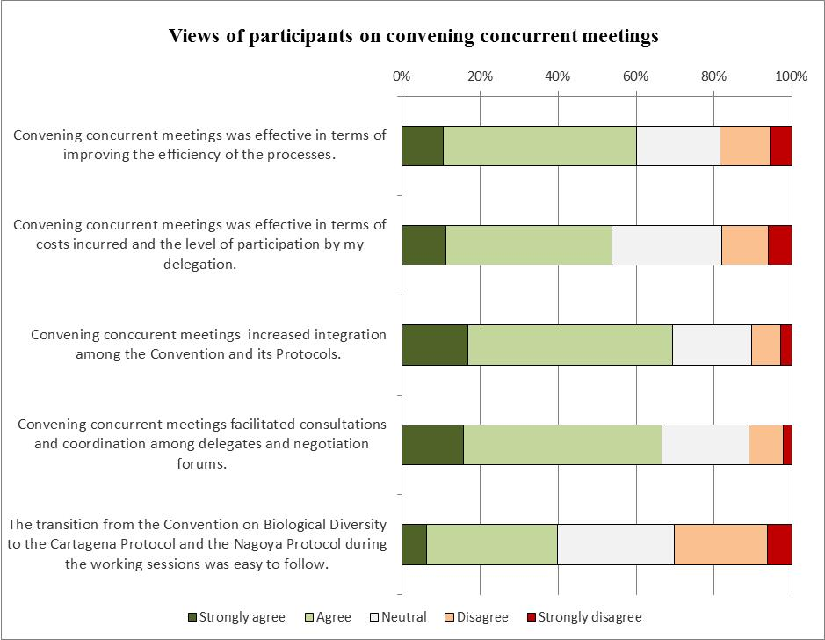

1. **FULL AND EFFECTIVE PARTICIPATION OF REPRESENTATIVES OF DEVELOPING COUNTRY PARTIES**
2. The information collected through the questionnaire distributed to Parties through the notification indicates that 43 per cent of respondents felt that the criterion of full and effective participation of representatives of developing country Parties in COP 13 had been fully met, 49 per cent of respondents felt that it had been partially met, and 8 per cent felt that the criterion had not been met. When the results are disaggregated, 43 per cent of respondents from developing country Parties felt that the criterion had been fully met, 47 per cent felt that it had been partially met, 10 per cent felt that it had not been met.
3. With regard to the participation of developing countries in CP-COP-MOP 8, 27 per cent of respondents felt that the criterion had been met, 62 per cent felt that it had been partially met, and 11 per cent felt that it had not been met. When the results are disaggregated, 25 per cent of respondents from developing country Parties felt that the criterion had been fully met, 60 per cent felt that it had been partially met, and 15 per cent felt that it had not been met.
4. For NP-COP-MOP 2, 27 per cent of respondents felt that the criterion had been met, 61 per cent felt that it had been partially met, and 13 per cent felt that it had not been met. When the results are disaggregated, 23 per cent of respondents from developing country Parties felt that the criterion had been fully met, 60 per cent felt that it had been partially met, and 16 per cent felt that it had not been met.
5. A number of issues were raised by Parties in their written comments. Several Parties noted that concurrent meetings made it difficult for some delegations to follow the proceedings. This was noted as being particularly problematic for small delegations. Furthermore, a number of Parties noted that the concurrent meetings necessitated a large number of contact group meetings as well as meetings of friends of the chair. Many Parties also noted that the limited funding available to support the participation of representatives from developing countries was problematic in terms of the full and effective participation of developing country Parties.
6. The number of developing country Parties that have received funding to participate in meetings of the COP and COP-MOPs has varied from meeting to meeting. The number of Parties and participants that can be supported is dependent on the contributions received by the Secretariat, the applicable daily subsistence rate and the cost of airfare. This makes a direct comparison of the number of Parties and participants supported to participate in meetings of the Conference of the Parties to the Convention and the meetings of the Protocols difficult as these factors have all varied between meetings. For example, the contributions received to support participation in meetings have ranged from $465,370 for COP 12 and CP-COP-MOP 7 to $1,045,102 for COP 10 and CP-COP-MOP 5. For the concurrent meetings in 2016, contributions totalling $672,000 were received.
7. The general approach the Secretariat followed at previous meetings was to provide each eligible country with the equivalent of one economy class return airline ticket and the equivalent of three weeks of daily subsistence allowance (DSA) for one person.[9] It was then up to the Party to decide how they wished to make use of the funds. For example, some Parties chose to send one participant to cover issues related to the Convention and its Protocols while other Parties chose to allocate the airfare to one participant while allocating the DSA to another. A similar approach was followed for the concurrent meetings in 2016. However, the amount of daily subsistence allowance that was made available was reduced to two weeks owing to the shorter duration of the meetings. The effect of convening concurrent meetings has been, in general, a reduction of one week of daily subsistence allowance provided by the Secretariat with contributions from donors. However, as some Parties have also received support to participate in the high-level segment of the meetings, which was convened a few days prior to the concurrent meetings, the overall reduction in DSA for some Parties was less. Further, historically it has been difficult to secure funds for the COP-MOP to the Cartagena Protocol in comparison to meetings of COP. Convening meetings concurrently has reduced this discrepancy as funds were provided for the concurrent meetings rather than a specific meeting.
8. The number of Parties receiving financial support, between COP 10 and COP 12, has ranged from 74 (COP 12) to 118 (COP 10) and has averaged 101. During the concurrent meetings in 2016, 108 Parties received support. Similarly, the number of participants receiving support has also varied. Between COP 10 and COP 12 the number of funded participants has ranged from 77 (COP 12) to 139 (COP 10) and has averaged 110. During the concurrent meetings in 2016, a total of 119 participants were funded. While both the number of Parties and participants supported to participate in the concurrent meetings in 2016 was a little higher than average, it is not clear if this can be considered a positive trend due to the other variables noted above (see figure 3). Further, it is important to note that many of the funded participants who attended the meetings of COP also participated in meetings of MOPs. This is especially true for participation in the concurrent meetings in 2016, where no distinction was made between participants in COP and COP-MOPs in the provision of support. The decision on whom to send to participate in the meetings was left to the discretion of the Parties concerned.
9. With regard to meetings of COP-MOP to the Cartagena Protocol, between COP-MOP 5 and COP-MOP 7 the number of Parties receiving support has ranged from 65 (COP-MOP 7) to 81 (COP-MOP 6) and averaged 74 and the number of funded participants has varied from 67 (COP-MOP 7) to 91 (COP-MOP 6) and average 81.[10] In the case of the concurrent meetings in 2016, all of the funded participants who registered for COP-MOP 8 were also registered to participate in COP 13. Although the overall number of Parties and funded participants in COP-MOP 8 was higher than in previous meetings of COP-MOP to the Cartagena Protocol, it is important to note that the exact number of participants who were experts in the Cartagena Protocol is not known. Furthermore, while participants attending past meetings of CP-COP‑MOP had only issues related to the Cartagena Protocol to follow, during the concurrent meetings, the participants had to follow issues related to the Convention and the other Protocol.
10. The two meetings of COP-MOP to the Nagoya Protocol have been held concurrently with meetings of COP and, therefore, it is not possible to discern any trends with regard to the funding of Parties and participants in these meetings.[11]

**Figure 3**

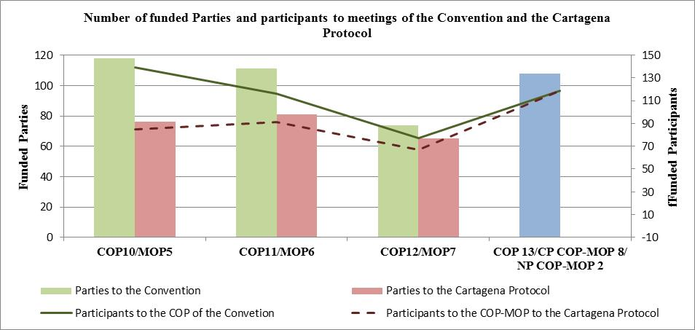

1. The number of developing country Parties participating in meetings of COP has varied over time. From COP 7 to COP 12, the number of developing country Parties participating varied from 117 (85 per cent)[12] at COP 7 to 138 (97 per cent) at COP 10 and averaged 126 Parties. During the concurrent meetings in 2016, 128 (88 per cent) developing country Parties participated. Further, the number of participants from developing country Parties has also varied. For COP 7 to COP 12, the average number of participants from developing country Parties was 892 and ranged from 578 at COP 7 to 1,168 at COP 10. During the concurrent meetings in 2016, there were 922 participants representing developing country Parties. Overall, convening concurrent meetings does not appear to have had an effect on the number of developing country Parties and participants attending the concurrent meetings (see figure 4).
2. The participation of developing countries in meetings of COP-MOP to the Cartagena Protocol has also varied over time. From COP-MOP 1 to COP-MOP 7 the number of developing country Parties participating ranged from 38 (68 per cent) at COP-MOP 1 to 93 (66 per cent) at COP-MOP 6. With regard to participants, the number of participants from developing country Parties attending the meetings of COP-MOP ranged from 123 at COP-MOP 1 to 324 at COP-MOP 6. COP-MOP 8 was attended by 104 (72 per cent) Parties and 580 participants. It appears that convening concurrent meetings has allowed for more Parties and representatives of developing countries to attend the meetings of COP-MOP (see figure 5). However, it is important to note that these figures do not provide any information on the actual number of Parties and representatives of developing countries who followed the proceedings under COP-MOP 8 or on the effectiveness of their participation. Given that some developing country Parties were represented by small delegations which had to handle multiple issues during the meeting, their ability to participate effectively in terms of having the appropriate expertise may have been limited.
3. As there have only been two meetings of COP-MOP to the Nagoya Protocol, trends are difficult to discern. As the Nagoya Protocol entered into force during COP 12, information on participation specifically for COP-MOP 1 to the Nagoya Protocol is not available. During COP-MOP 2, there were 53 (76 per cent) developing country Parties participating, represented by 320 participants. More time will be required to determine trends with regard to participation.
4. Overall, convening concurrent meetings does not appear to have had an effect on the level of participation of developing country Parties in COP. While participation of developing country Parties in COP-MOP to the Cartagena Protocol has increased, it is important to note that there is insufficient information to be able to judge the effectiveness of this participation. Further, there is insufficient information to be able to judge what the effect has been for COP-MOP to the Nagoya Protocol.

**Figure 4**

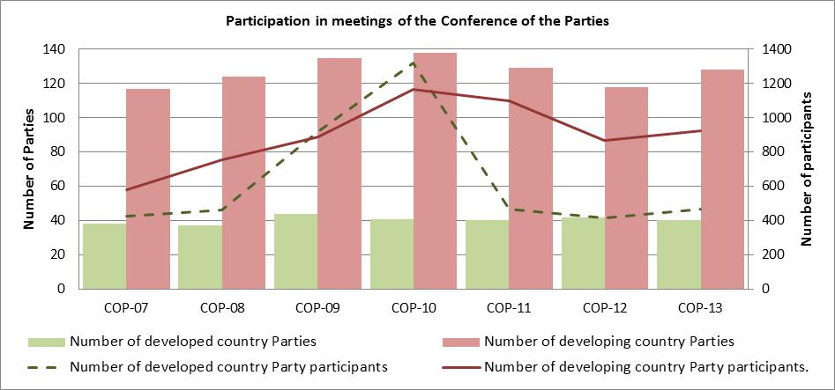

**Figure 5**

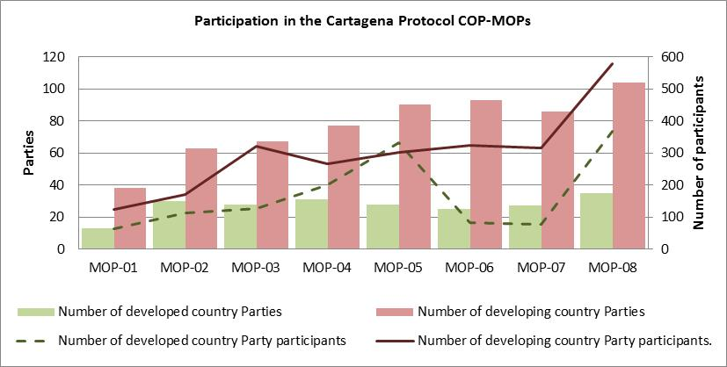

1. **EFFECTIVE DEVELOPMENT OF OUTCOMES**
2. With regard to the effective development of outcomes of COP 13, 49 per cent of the Parties responding to the notification indicated that the criterion had been fully met and 48 per cent indicated that it had been partially met, and 3 per cent of responses indicated that the criterion had not been met. When the results were disaggregated by developed and developing countries, 50 per cent of respondents from developing country Parties felt that the criterion had been met, 46 per cent felt that it had been partially met and 4 per cent felt that it had not been met. In comparison, among developed country Parties, 47 per cent of respondents felt that the criterion had been fully met, 53 per cent felt that it had been partially met and no party indicated that it had not been met.
3. With regard to COP-MOP 8 to the Cartagena Protocol, 27 per cent of responses indicated that the criterion had been fully met, 65 per cent indicated that the criterion had been partially met, and 8 per cent indicated that it had not been met. When the results were disaggregated by developed and developing countries, 33 per cent of respondents from developing country Parties felt that the criterion had been fully met, 56 per cent felt that it had been partially met and 11 per cent felt that it had not been met. By comparison, 6 per cent of respondents from developed country Parties felt that the criterion had been fully met and 94 per cent felt that it had been partially met.
4. For COP-MOP 2 to the Nagoya Protocol, 35 per cent of respondents felt that the criterion had been fully met, 52 per cent felt that it had been partially met and 13 per cent felt that it had not been met. When the results were disaggregated by developed and developing countries, 40 per cent of respondents from developing country Parties felt that the criterion had been fully met, 50 per cent felt that it had been partially met, 10 per cent felt that it had not been met. Among developed country Parties, 15 per cent felt that the criterion had been fully met, 61 per cent felt that it had been partially met, and 23 per cent felt that it had not been met.
5. The responses by Parties to the notification suggest that the process of convening concurrent meetings was perceived as being more effective for the Convention than for the Protocols. However, for both the Convention and the Protocols, the proportion of respondents indicating that the criterion had not been met was relatively small.
6. In their written comments, some Parties noted that dealing with some agenda items, such as those related to the financial mechanisms, in an integrated manner created confusion at times. However, others felt that dealing with some issues in an integrated manner, such as synthetic biology and digital sequence information, had benefits. A number of respondents noted that the limited time available for contact groups was problematic and that dealing with the Convention and the Protocols in a concurrent manner carried that risk that some instruments would be given more attention than others. It was suggested that, in the future, when the agendas for the meetings of the Convention and Protocols are prepared, these issues should be taken into account. A number of Parties also noted that the limited participation of some Parties in the concurrent meetings created challenges for the effective development of outcomes.
7. The results of the online survey of participants were similar to those of the notification. A clear majority of survey respondents felt that convening the meetings of COP to the Convention, the Cartagena Protocol and the Nagoya Protocol concurrently was effective in terms of improving the efficiency of the processes under these agreements. A total of 11 per cent of respondents strongly agreed and 50 per cent agreed that this was the case. A total of 13 per cent of respondents disagreed and 6 per cent strongly disagreed. The remaining 22 per cent of respondents had a neutral opinion on this issue. The results were similar when only responses from respondents from Parties were considered (16 per cent strongly agreed, 49 per cent agreed, 17 per cent neutral, 13 per cent disagreed and 6 per cent strongly disagreed).
8. Survey respondents, in their written comments, identified various advantages and disadvantages of convening the meetings concurrently. The advantages identified included the greater exchange of views and information and more coherent outcomes across the three agreements, shortening of the total length of the meetings and that concurrent meetings gave more visibility to the work of the Protocols and allowed for links between the three processes to be better recognized. Among the disadvantages noted were the difficulty in following three different meetings, the difficulty in coordinating, and the large number of contact groups required. These issues were noted to be particularly problematic for smaller delegations. Other challenges noted were the limited amount of time available to discuss some issues and the need for delegates to wait in plenary or working groups for their items to be addressed.
9. In total, during the concurrent meetings, there were 46 sessions held in plenary and working groups over 12 days. This means that, on average, there were 3.8 working sessions held per day. By comparison, during COP 12, COP-MOP 1 to the Nagoya Protocol and COP-MOP 7 to the Cartagena Protocol, there were 54 working sessions held over 15 days, or an average of 3.6 sessions per day. During COP 11 and COP‑MOP 6, there were a total of 51 working sessions over 15 days, or an average of 3.4 working sessions per day. Similarly, for COP 10 and COP-MOP 5, there were 56 working sessions held over 15 days, or an average of 3.7 sessions per day and for COP 9 and COP-MOP 4, there were 52 working sessions over 15 days, or an average of 3.4 sessions per day (see table 1). The effect of having concurrent meetings was a reduction in the overall length of the meeting and an overall reduction in the number of plenary and working group sessions. However, during the concurrent meetings in 2016, there were, on average, slightly more working sessions per day. However, when sessions of the high-level segment — which prior to the concurrent meetings of 2016 were convened in parallel to the official meetings — are also considered, there is no major difference in the number of working sessions.
10. The number of contact groups and friends of the chair meetings was greater during the concurrent meetings in 2016 than during most of the previous recent meetings of COP and COP-MOP, albeit lower than during COP 10. During the concurrent meetings in 2016, there were 76 meetings of contact groups and friends of the chair. There were 36 of these types of meetings during COP 12, COP-MOP 7 to the Cartagena Protocol and COP-MOP 1 to the Nagoya Protocol, while during COP 11 and COP-MOP 6 there were 42. During COP 10 and COP-MOP 5, there were 116 contact groups and friends of the chair. Part of the reason for this large number is that the negotiations at COP 10 involved the finalization and adoption of the Nagoya Protocol, the Strategic Plan for Biodiversity 2011-2020, and the Strategic Plan for the Cartagena Protocol 2011-2020 as well as discussions on the strategy for resource mobilization.

|  |  |  |  |  |  |
| --- | --- | --- | --- | --- | --- |
| **Table 1. Number of sessions per meeting** | | | |  |  |
| *Meetings* | *Length of meetings (days)* | *Number of plenary and working group sessions*[13] | *Average number of sessions per day* | *Number of contact groups and friends of the chair* | *Average number of contact groups and friends of the chair per day* |
| COP 9, COP-MOP 4 | 15 | 52 | 3.4 | NA | NA |
| COP 10, COP-MOP 5 | 15 | 56 | 3.7 | 116 | 7.7 |
| COP 11, COP-MOP 6 | 15 | 51 | 3.4 | 42 | 2.8 |
| COP 12, COP-MOP-7, COP-MOP 1 | 15 | 54 | 3.6 | 36 | 2.4 |
| COP 13, COP-MOP 7, COP-MOP 2 | 12 | 46 | 3.8 | 76 | 6.3 |

1. In summary, the effect of having the meetings concurrently has been a reduction in the length of the meetings and an overall reduction in the number of plenary and working group sessions. This appears to have also resulted in, on average, a small increase in the number of working group and plenary sessions being held each day. However, when sessions of the high-level segment (other than that of COP 13) are considered, this increase is negligible. Further, holding the meetings concurrently appears to have resulted in more contact group and friends of the chair meetings being held. Therefore, while the overall duration of the meetings has been reduced, the intensity of the negotiations appears to have increased somewhat to compensate. However, the number of plenary and working group sessions, as well as the number of contact group and friends of the chair meetings, is also influenced by the issues being discussed during the course of the meetings, as evidenced by the number of the number of contact groups and friends of the chair meetings at COP 10 and COP-MOP 5.
2. **INCREASED INTEGRATION AMONG THE CONVENTION AND ITS PROTOCOLS**
3. A total of 51 per cent of Parties responding to the notification felt that the criterion of increased integration among the Convention and its Protocols had been fully met, 46 per cent felt that it had been partially met, and 3 per cent felt that it had not been met. There were no marked differences when responses from developing and developed countries were considered separately, except that no developed country Party indicated that the criterion had not been met.
4. In their written comments, several Parties noted that the convening of the meetings concurrently was a good first step and had some positive impacts. However, a few Parties noted that more time would be required to be able to judge this issue in a meaningful way. Some Parties were of the view that more progress had been made on the integration of procedural issues under the Convention and its Protocols than on substantive matters. Others noted that the format for the concurrent meetings promoted a greater understanding of how the Convention and its Protocols relate to one another.
5. The responses from the online survey of the participants were similar to those from the questionnaire distributed to Parties. With regard to integration among the Convention and the Protocols, a majority of respondents felt that convening concurrent meetings helped in this regard. A total of 17 per cent and 52 per cent of respondents strongly agreed or agreed, respectively, that this was the case. A total of 7 per cent and 3 per cent of respondents disagreed or strongly disagreed. Further, 20 per cent of respondents had a neutral opinion on this issue. When only responses from participants who represented Parties at the concurrent meetings were considered, 22 per cent strongly agreed and 51 per cent agreed that convening concurrent meetings increased the integration among the Convention and its Protocols. A total of 7 per cent disagreed and 2 per cent strongly disagreed that this was the case. A further 18 per cent of respondents were neutral.
6. In their written comments, respondents to the online survey of participants to the concurrent meetings were generally positive regarding the effects of convening concurrent meetings on increasing the integration between the Convention and its Protocols. Among the issues highlighted were the increase in awareness of the operations of the three agreements and increased consultations. Several respondents pointed to the discussions on synthetic biology and digital sequence information as an example of increased integration among the three instruments. However, others felt that this made for complicated negotiations. Further, some respondents noted that, for small delegations, concurrent meetings did not facilitate integration and raised questions about the mandates of the Convention and the Protocols. Others felt that concurrent meetings resulted in parallel discussions and complicated negotiations rather than promoting integration. Some respondents also noted that the effects of concurrent meetings with respect to integration cannot be judged on the basis of outcomes of one meeting alone and that integration requires time.
7. The issue of integration among the Convention and its Protocols during meetings held concurrently was also considered by the Compliance Committee under the Cartagena Protocol on Biosafety at its fourteenth meeting. The members of the Committee noted that concurrent meetings allowed for better and more integrated discussions on matters common to the Convention and its Protocols, including the guidance to the Global Environment Facility.[14]
8. **COST-EFFECTIVENESS**
9. On the criterion of cost-effectiveness, 37 per cent of Parties responding to the survey felt that the criterion had been fully met, 49 per cent felt that it had been partially met and 14 per cent felt that it had not been met. When the results are disaggregated for developing and developed countries, 45 per cent of respondents from developing country Parties felt that the criterion had been fully met, 45 per cent felt that it had been partially met, and 10 per cent felt that it had not been met. Among developed country Parties, 13 per cent felt that the criterion had been met, 62 per cent felt that it had been partially met, 25 per cent felt that it had not been met.
10. Regarding the criterion on the cost-effectiveness with respect to the Cartagena Protocol, 29 per cent of responses indicated that the criterion had been fully met, 43 per cent of responses indicated that the criterion had been partially met, and 29 per cent that the criterion had not been met. In comparison to the other criteria, this was the one where the greatest proportion of respondents felt the criterion had not been met. When the responses received are disaggregated by developing and developed countries, 33 per cent of respondents from developing country Parties felt that the criterion had been met, 48 per cent felt that it had been partially met and 20 per cent believed that it had not been met. By comparison, 19 per cent of respondents from developed country Parties felt that the criterion had been fully met, 25 per cent felt that it had been partially met, 56 per cent felt that had not been met.
11. In their written comments, Parties noted that having concurrent meetings generated cost savings in relation to some elements of their participation, such as by only having two weeks of meetings rather than three weeks, but that it also generated some increased costs. Increased costs were generally noted in relation to the need to have delegates responsible for the Cartagena and Nagoya Protocols attend two weeks of meetings. Further, it was noted that the increased number of parallel sessions required larger delegations in order to ensure effective participation.
12. In addition to the costs related to funding participants, there are a variety of costs associated with convening meetings of the Convention and the Protocols. Differences in national circumstances among host countries make a direct comparison of costs impossible. However, some issues can be compared in relative terms. For example, the concurrent meetings held in 2016 required the same number of security officers from the United Nations Department of Safety and Security as for previous meetings of the COP and MOPs. However, during the concurrent meetings, officers were only required for 20 days, whereas for other meetings their presence had been required for between 26 and 28 days.
13. With regard to interpretation costs, the concurrent meetings in 2016 required more interpreters than previous meetings of COP and MOPs. However, the interpreters were required for less time. For example, the concurrent meetings required 756 interpreter days (54 interpreters for 14 days) whereas COP 12, COP‑MOP 6, COP 10, COP-MOP 5, and COP 9, COP-MOP 4 required 836 interpreter days (44 interpreters for 19 days), COP 11, COP-MOP 6 required 798 interpreter days (42 interpreters for 19 days), and COP 8, COP-MOP 3 required 722 interpreter days (38 interpreters for 19 days) (see table 2). However, it is important to note that the length of the contract for interpreters is based on a variety of factors, including the length of the meetings, the number of weekends, and the country the interpreters are travelling from to reach the meeting venue. Thus, the contracts for interpreters are not solely determined by the duration of the meeting.
14. With regard to services for document translation, for the concurrent meetings in 2016, a total of 630 translator days (45 translators for 14 days) were used. For previous meetings of COP and MOPs, the practice had been to use 840 translator days (40 translators for 21 days). However, the experience gained at the concurrent meetings suggests that, in the future, when concurrent meetings are held, the number of translators hired and/or the length of their contracts may need to be increased somewhat in order to better serve the needs of the meetings.

|  |  |  |  |
| --- | --- | --- | --- |
| **Table 2. Interpretation needs** | | | |
| *Meetings* | *Length of contract* | *No. of interpreters required* | *Interpreter days* |
| COP 8, CP-COP-MOP 3 | 19 | 38 | 722 |
| COP 9, CP-COP-MOP 4 | 19 | 44 | 836 |
| COP 10, CP-COP-MOP 5 | 19 | 44 | 836 |
| COP 11, CP-COP-MOP 6 | 19 | 42 | 798 |
| COP 12, CP-COP-MOP7, NP-COP-MOP 1 | 19 | 44 | 836 |
| COP 13, CP-COP-MOP 8, NP-COP-MOP 2 | 14 | 54 | 756 |

1. **IMPROVED CONSULTATIONS, COORDINATION AND SYNERGIES AMONG NATIONAL FOCAL POINTS**
2. The responses from Parties to the notification indicated that Parties generally felt that convening concurrent meetings of the Convention, the Cartagena Protocol and the Nagoya Protocol improved consultations, coordination and synergies among national focal points. A majority of responses indicated that this criterion had been fully met (58 per cent). Further, 35 per cent of responses indicated that this criterion had been partially met and 8 per cent of responses suggested that it had not been met. There were no marked differences when responses from developing and developed countries were considered separately.
3. In their written comments, some Parties noted that convening concurrent meetings facilitated coordination and consultation. However, some other Parties noted that they did not observe any significant change in this respect. It was also noted that, as all the issues related to the two Protocols were held in one working group, this limited consultations and coordination. A few developing country Parties noted that, as only one participant per delegation was supported to attend the meeting, this limited their ability to coordinate and consult.
4. The responses from the survey of participants to the concurrent meetings were similar to the responses by Parties to the notification. A majority of respondents felt that convening concurrent meetings facilitated consultation and coordination among delegates. A total of 16 per cent of respondents strongly agreed and 51 per cent agreed that this was the case. A total of 9 per cent of respondents disagreed and 2 per cent of respondents strongly disagreed. A total of 22 per cent of respondents had a neutral opinion on this issue. When only responses from respondents who had represented Parties at the concurrent meetings were considered, the results were similar. A total of 20 per cent of respondents strongly agreed and 51 per cent agreed that concurrent meetings facilitated consultations and coordination. A total of 8 per cent of respondents disagreed and 2 per cent strongly disagreed that this was the case. A total of 18 per cent of respondents were neutral in their opinion.
5. In their written comments, a few respondents noted that concurrent meetings created opportunities to network. However, others noted that the concurrent meetings combined with the heavy agenda reduced the amount of time available to coordinate and consult. This was noted to be the case particularly for small delegations.
6. **OTHER ISSUES**
7. Parties raised a number of additional issues in their submissions in response to the notification. A number of respondents noted that convening concurrent meetings was generally a good idea but that a number of outstanding issues needed to be resolved in order to ensure the effectiveness of the process. Among the issues identified were the need to ensure appropriate representation of developing countries, structuring the agendas for the three meetings to make them as streamlined as possible and limiting the need for meetings of contact groups and friends of the chair. It was also noted that sufficient time needed to be given to all three instruments. Some Parties suggested that, in future concurrent meetings, the discussions under the Protocols should be limited to the first week of the meetings. Some Parties also commented on the timing of the high-level segment and questioned whether it would be more effective to have the segment at the start[15] or end[16] of the concurrent meetings.
8. The high-level segment was also considered as part of the electronic survey distributed to participants in the concurrent meetings. The involvement of different sectors and ministers in the high-level segment was felt to have promoted the consideration of mainstreaming and promoted dialogue. However, a number of respondents noted that it would have been more effective if there had been greater opportunities for discussion. With regard to the timing of the high-level segment, respondents generally felt that having the segment before the official start of the concurrent meetings was effective. However, some respondents noted that this created some challenges as some high-level participants were not available to help address contentious issues that arose near the end of the concurrent meetings. Regarding the timing of future high-level segments, while the majority of respondents indicated that these should continue to be held before the official start of the concurrent meetings, respondents were more divided in their views. Further, several respondents were of the opinion that the timing of the high-level segment should be based on the goals for the high-level segment and the issues being discussed.
9. **SUMMARY**
10. Several observations arise from the review of experience in holding concurrently the meetings of the Conference of the Parties to the Convention and the meetings of the Parties to the Protocols:
    1. For almost all of the criteria identified in decisions XIII/26, CP VIII/10 and NP 2/12, the proportion of Parties that felt a criterion had been met was greater than those that felt it had not been met (see figure 1). However, for most criteria, most Parties felt that they had been partially met. Thus, while many viewed the experience of convening concurrent meetings as generally positive it is clear that further work is needed to make concurrent meetings more effective and to ensure that all of the criteria are fully met;
    2. According to the review, the most successful aspects of the experience in holding concurrent meeting are related to the following:
       1. The effective development of outcomes of the Conference of the Parties;
       2. The increased integration among the Convention and the Protocols;
       3. Improved consultations, coordination and synergies among national focal points.

About half of Parties felt that these criteria had been fully met, and most others felt they had been partially met;

* 1. According to the review the least successful aspects were related to cost-effectiveness for the Cartagena Protocol, for which the number of Parties that felt the criterion had been met was about the same as the number of Parties that felt it had not been met. Among the issues identified by Parties to improve the convening of current meetings were (i) the need to ensure appropriate representation of developing countries, (ii) the need to give sufficient time to the three instruments in negotiation sessions, (iii) the need to streamline the agendas for the meetings as much as possible in order to reduce the need for contact groups, and (iv) the need to explore ways to limit the amount of time delegates responsible for the Protocols are required to spend at the concurrent meetings;
  2. The responses from the online survey, in which participants in the concurrent meetings responded in their personal capacity, provide a similar picture to the questionnaire distributed to Parties. Overall, survey respondents generally felt that convening concurrent meetings of the Convention on Biological Diversity, the Cartagena Protocol and the Nagoya Protocol was efficient, and cost-effective. Respondents also generally felt that it increased integration and facilitated consultations. However, several respondents noted that, particularly for smaller delegations, this was not always the case and that the success of holding concurrent meetings would depend on ensuring that all Parties were appropriately represented.

1. The present review of experience in holding the meetings concurrently, in line with decision XIII/26, is expected to be supplemented and further developed in the light of the experience gained from the concurrent meetings to be held in Sharm El-Sheikh, Egypt, from 10 to 22 November 2018.

# __________

1. * [CBD/SBI/2/1](https://www.cbd.int/doc/c/6ce5/878e/5ffa49887c20c19961fe040a/sbi-02-01-en.pdf).
2. For ease of reference, these meetings are collectively referred to as the “concurrent meetings” in the present document.
3. The notification was issued on 22 February 2017 with a deadline of 24 March 2017. Subsequently, the deadline for the submission of comments was extended to 10 April 2017.
4. This survey was distributed on 22 February 2017 and was open until 10 March 2017. Reminders to complete the survey were sent on 3 March 2017 and on 9 March 2017.
5. UNEP/CBD/SBI/2/INF/1 and UNEP/CBD/SBI/2/INF/2.
6. Comments were received from Belgium, Madagascar, Mexico and the Islamic Republic of Iran as well as the Andes Chinchasuyu from Ecuador and the Indigenous Women’s Network on Biodiversity from Latin America and the Caribbean.
7. Algeria, Antigua and Barbuda, Argentina, Austria, Belarus, Belgium, Benin, Bolivia, Bosnia and Herzegovina, Bulgaria, Burundi, Cabo Verde, Canada, China, Colombia, Costa Rica, Côte d’Ivoire, Cuba, Czechia, Democratic Republic of Congo, Denmark, Ecuador, Equatorial Guinea, European Union, Finland, Germany, Ghana, Grenada, Guatemala, Guinea-Bissau, Honduras, India, Iran (Islamic Republic of), Jamaica, Kuwait, Madagascar, Malaysia, Mali, Mexico, Morocco, Mozambique, Nepal, Netherlands, Niger, Norway, Pakistan, Peru, Philippines, Republic of Korea, Sao Tome and Principe, Senegal, Seychelles, Slovakia, Slovenia, South Africa, Spain, Saint Kitts and Nevis, Sudan, Switzerland, Tunisia, Uganda, Ukraine, Yemen, and Zimbabwe. In addition, one Party (Iraq) indicated that it was unable to respond to the notification as it could not participate in the concurrent meetings for visa reasons.
8. Email addresses were collected from the list of registered participants in the United Nations Biodiversity Conference. As some participants had not provided an email address and/or registered using a generic institutional email address, it was not possible to contact all registered participants. The survey was not distributed to staff servicing the meetings, United Nations security personnel, interpreters, local staff, volunteers or those individuals who attended only a specific event taking place in the margins of the Conference.
9. However, in some cases, for example when a participant from a developing country was a member of the COP Bureau, multiple participants from the same Party were supported.
10. Note that the number Parties eligible for financial support has increased over time. At COP-MOP 5 there were 135 eligible Parties, at COP-MOP 6 there were 141, at COP-MOP 7 there were 143 and at COP MOP 8 there were 145.
11. The issue of support to developing country Parties for participation in meetings of the meetings of the Conference of the Parties and the two Protocols will be further explored during the second meeting of the Subsidiary Body on Implementation under agenda item 17 (Trust fund for facilitating participation of Parties in the Convention process: allocation of resources and possibilities of engaging the private sector). Relevant documentation prepared for that agenda item will provide further information on this issue.
12. The percent figures indicate the proportion of all developing country Parties participating in the meeting. The figures are based on the number of developing country Parties at the time of the meeting.
13. The number of sessions does not reflect the sessions held as part of the high-level segment, of which there are four for each meeting. During the concurrent meetings of 2016 the high-level segment was convened just prior to the official start of the meeting, unlike previous meetings, where it was held in parallel.
14. For further information, see [CBD/CP/CC/14/5](https://www.cbd.int/doc/meetings/bs/cpcc-14/official/cpcc-14-05-en.pdf).
15. That is, after the concurrent meetings have been formally opened and within the two-week period.
16. That is, a few days prior to the closure of the concurrent meetings.