 |  | CBD
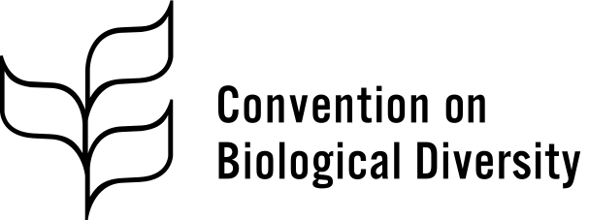 |  | Distr.  GENERAL  CBD/NP/MOP/4/INF/3  24 November 2022  ENGLISH ONLY
CONFERENCE OF THE PARTIES TO THE CONVENTION ON BIOLOGICAL DIVERSITY SERVING AS THE MEETING OF THE PARTIES TO THE NAGOYA PROTOCOL ON ACCESS TO GENETIC RESOURCES AND THE FAIR AND EQUITABLE SHARING OF BENEFITS ARISING FROM THEIR UTILIZATION
Fourth meeting – Part II
Montreal, Canada, 7–19 December 2022
Agenda item 8

Feedback on the access and benefit-sharing CEPA Toolkit and updates on awareness-raising measures

Note by the Executive Secretary

I. Introduction
- Decision NP-3/6 of the Conference of the Parties serving as the meeting of the Parties to the Nagoya Protocol called for Parties, non-Parties, relevant organizations and other actors to continue to implement awareness-raising activities, and requested the Executive Secretary to continue to seek feedback from Parties, non-Parties and other relevant actors on the access and benefit-sharing awareness-raising toolkit developed by the Secretariat and to provide an update on the implementation of the awareness-raising strategy for the consideration of the Conference of the Parties serving as the meeting of the Parties to the Nagoya Protocol at its fourth meeting.
- In response to this request, an invitation to share information on capacity development and awareness-raising related to the Nagoya Protocol, and to provide feedback on the CEPA Toolkit – Including considerations for access and benefit-sharing (CEPA Toolkit), was sent through notification 2021-037 of 17 May 2021. This document presents the responses to the survey sent to collect feedback on the CEPA Toolkit (section A) and updates on measures undertaken since 2019 to implement the awareness-raising strategy (section B). The questions used in the survey can be found in the annex. Twenty-nine responses were received. Key highlights and findings of the survey have been presented in document CBD/NP/MOP/4/5.

II. Results of the survey
- Feedback on the CEPA Toolkit
- The toolkit on communication, education, and public awareness (CEPA) including considerations for access and benefit-sharing (ABS) was developed by the Secretariat with a view to supporting the implementation of the awareness-raising strategy. The Executive Secretary was requested to seek feedback from Parties, non-Parties and other relevant actors on the awareness-raising toolkit for access and benefit-sharing. See decision NP-3/6, para. 6.

Survey questions and summary of responses on this topic:
Q1. Please indicate your institutional affiliation.
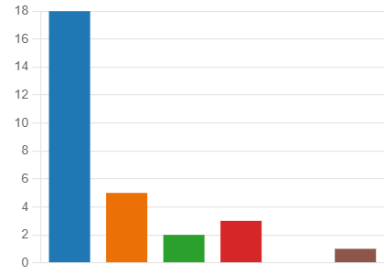
Party to the Nagoya Protocol
18
Other government
…
5
IPLCC
2
International Organization
3
Civil Society
0
Other
1
Q2. Please indicate the region you are from.

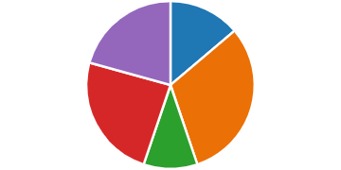
Africa
4
Asia and the Pacific
9
Central and Eastern Europe
3
Latin America and the Caribbean
7
Western Europe and Other Group
6

Q3. What is your level of satisfaction with the ABS CEPA toolkit?
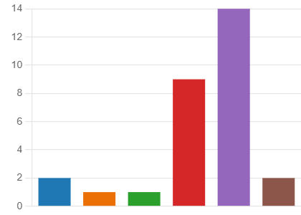
Very dissatisfied
2
Somewhat dissatisfied
1
Neither satisfied nor dissatisfied
1
Somewhat satisfied
9
Very satisfied
14
I do not know
2
Q4. Please provide additional information on the reasoning of your response regarding your level of satisfaction (examples from the 20 responses).
- The CEPA toolkit is useful in creating national awareness-raising strategies. However, situations in different parties are extremely varied. The toolkit provides guidelines and solutions that refer to almost ideal situation which is not a reality in majority of countries (lack of human, technical and financial resources)
- This is one important tool that can better improve the capacity of agencies in developing related ABS awareness raising materials wherein message can be clearly conveyed and understood in a simple and not so scientific manner.
- We need culturally appropriate tools and materials for IPLCs
- The ABS CEPA Toolkit excellently provides substantive and reliable strategies and models for effectively communicating ABS vis-à-vis biodiversity-related issues at the national level. Furthermore, it functions as a one-stop shop for wide range of education and communication interventions as it enables the national focal points and relevant stakeholders to be flexible and open to the best solutions to create bespoke communication, education and public awareness activities based on the status of ABS implementation in their own countries.
- It covers three broad areas of Communication, Education and Public Awareness very well. The language used in the toolkit is simple and understandable by various literacy levels. The toolkit also includes useful information in a form of “Recommended resources, Tips and Practical Tools”
Q5. To what extent do you agree or disagree with the following statement? The ABS CEPA toolkit is useful for my work.
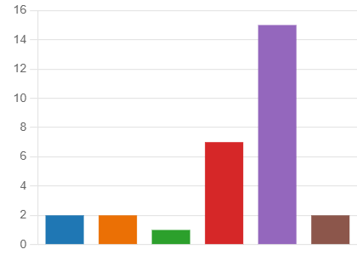
Strongly disagree
2
Somewhat disagree
2
Neither agree nor disagree
1
Somewhat agree
7
Strongly agree
15
Don't know/prefer not to answer
2

Q6. In what ways have you used the ABS CEPA toolkit? Select all that apply.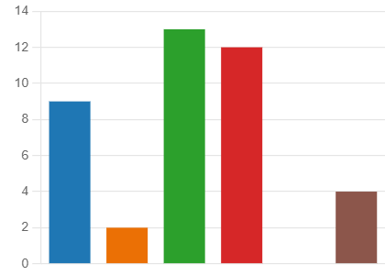
I have not used the ABS CEPA to
…
9
Used it for developing a nationa
…
2
Used it for the design of ABS aw
…
13
Used it in training and capacity
…
12
I do not know/prefer not to answer
…
0
Other
4
Q7. Have you developed any ABS awareness-raising materials that could be included in the resources section of the toolkit?
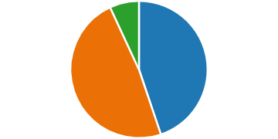
Yes
13
No
14
Don't know/prefer not to answer
2
Q8. If you answered the previous question affirmatively, have these awareness-raising materials been uploaded into the ABS-Clearing House?
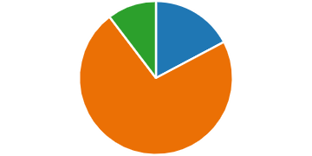
Yes
5
No
21
I don't know/prefer not to answer
3

Q9. Please provide links to all relevant awareness-raising materials where possible (list of links where resources can be found).
- https://www.youtube.com/watch?v=Ux5uNDZg_aE
- https://absch.cbd.int/database/A19A20/ABSCH-A19A20-SCBD-238868
- https://absch.cbd.int/database/A19A20/ABSCH-A19A20-SCBD-208298
- https://absch.cbd.int/countries/BT/NFP
- https://unctad.org/webflyer/guidelines-and-model-clauses-access-and-benefit-sharing-and-biotrade-lao-peoples
- https://unctad.org/system/files/official-document/ditctedinf2020d4_en.pdf
- https://unctad.org/webflyer/synthetic-biology-and-its-potential-implications-biotrade-and-access-and-benefit-sharing
- https://unctad.org/system/files/official-document/ditctedinf2018d2_en.pdf
- Update on the implementation of the awareness-raising strategy of the Nagoya Protocol

Survey questions and summary of responses on this topic:
Q10. In what stage of implementation is your country’s national awareness-raising strategy for the Nagoya Protocol?
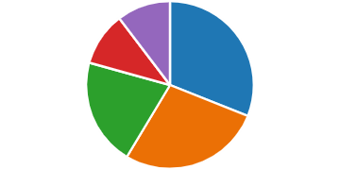
Development of an awareness-r
…
9
The awareness-raising strategy i
…
8
The awareness-raising strategy
…
6
I don't know/prefer not to answer
3
Other
3
Q11. From 2019 to date have you implemented any awareness-raising activities in your country on the Nagoya Protocol?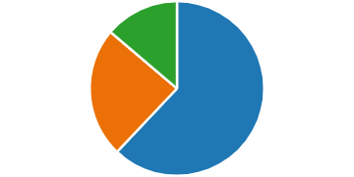
Yes
18
No
7
Don't know/prefer not to answer
4
Q12. If you answered the previous question affirmatively, please elaborate and provide relevant links if available (list of relevant links included below).
- https://www.iucn.org/news/mexico-central-america-and-caribbean/201902/caribbean-abs-week-advances-and-challenges-genetic-resources-and-traditional-knowledge
- https://vietnamabs.gov.vn/
- http://nagoya.vlir.be/events-nl/
- https://www.environment.gov.za/mediarelease/creecy_rooibosindustrywidebenefitsharing2019
Q13. What have been the main challenges in implementing your country’s awareness-raising strategy for the Nagoya Protocol? (most commonly mentioned challenges)
- The main challenges are lack of financial and human resources to implement the awareness raising strategies
- Access and benefit sharing concepts are not easy to communicate
- ABS is an emerging issue in many countries and key stakeholders have limited understanding of the issues
- Nagoya Protocol is not a priority for many authorities
Q14. Are there any recommendations or lessons you would like to share with other countries that are currently developing their awareness-raising strategies? (key lessons and recommendations)
- Develop your awareness raising strategies/materials fitted on the country's context. Be real, simple and concise. Develop it in a manner wherein you can establish an element of recall among the people especially the stakeholders.
- Put your efforts on key players (not massive or general public). When some type of regulation is achieved, the sectors begin to want to comply and commit, and then you put your efforts into the general public.
- A variety of communication, education and public awareness approaches is crucial to meet the needs of all stakeholder groupings.
- Attend the local needs, work using inclusive methodologies taking in consideration the orality and the IPs human rights.

Annex

Survey questions

Feedback on the ABS CEPA Toolkit and updates on awareness raising measures
The Secretariat has prepared the following survey for Parties, non-Parties, organizations and other relevant stakeholders to provide feedback on the access and benefit-sharing awareness raising toolkit (https://www.cbd.int/abs/awareness-raising/default.shtml#cepa-toolkit) and to provide an update on the progress of implementation of the awareness-raising strategy. The responses to the survey are anonymous and will be used for the preparation of documents for the fourth meeting of the Conference of the Parties serving as the meeting of the Parties to the Nagoya Protocol. The survey takes approximately 5 minutes to complete and should be submitted by June 12, 2021. Thank you for your participation.
* Required
1. Please indicate your institutional affiliation *
☐ Party to the Nagoya Protocol
☐ Other government (Non-Party to the Nagoya Protocol)
☐ IPLC
☐ International Organization
☐ Civil Society
☐ Other
- Please indicate the region you are from *
☐ Africa
☐ Asia and the Pacific
☐ Central and Eastern Europe
☐ Latin America and the Caribbean
☐ Western Europe and Other Group

I. Feedback on the ABS CEPA Toolkit
The toolkit on communication, education and public awareness (CEPA) including considerations for access and benefit-sharing (https://absch.cbd.int/database/resource/16B113CB-CC86-0008-4D4B4B29E846B83C) was developed by the Secretariat with a view to supporting the implementation of the awareness-raising strategy. The Executive Secretary was requested to seek feedback from Parties, non-Parties and other relevant actors on the awareness-raising toolkit for access and benefit-sharing. See decision NP-3/6, para. 6 (`).
- What is your level of satisfaction with the ABS CEPA toolkit? *
☐ Very dissatisfied
☐ Somewhat dissatisfied
☐ Neither satisfied nor dissatisfied
☐ Somewhat satisfied
☐ Very satisfied
☐ I do not know/prefer not to answer
- Please provide additional information on the reasoning of your response regarding your level of satisfaction______________________________
- To what extent do you agree or disagree with the following statement?
The ABS CEPA toolkit is useful for my work *
☐ Strongly disagree
☐ Somewhat disagree
☐ Neither agree nor disagree
☐ Somewhat agree
☐ Strongly agree
☐ Don't know/prefer not to answer
- In what ways have you used the ABS CEPA toolkit? Select all that apply *
☐ Have not used the ABS CEPA toolkit
☐ Used it for developing a national awareness-raising strategy for the Nagoya Protocol
☐ Used it for the design of ABS awareness-raising activities
☐ Used it in training and capacity building activities
☐ I do not know/prefer not to answer
☐ Other
- Have you developed any ABS awareness-raising materials that could be included in the resources section of the toolkit? *
☐ Yes
☐ No
☐ Don't know/prefer not to answer
- If you answered the previous question affirmatively, have these awareness-raising materials been uploaded into the ABS-Clearing House?
☐ Yes
☐ No
☐ Don't know/prefer not to answer
- Please provide links to all relevant awareness-raising materials where possible: _________

II. Update on the implementation of the awareness-raising strategy for the Nagoya Protocol
At its first meeting, the Conference of the Parties serving as the meeting of the Parties to the Nagoya Protocol adopted the Awareness-raising Strategy for the Nagoya Protocol on Access and Benefit-sharing (annex to decision NP-1/9 https://www.cbd.int/decisions/?id=13409) which aims at providing a systematic and coherent approach to assist Parties in the implementation of Article 21. Awareness-raising activities must respond to the specific needs and contexts of each Party. Therefore, the awareness-raising strategy is country-driven.
- In what stage of implementation is your country’s national awareness raising strategy for the Nagoya Protocol? *
☐ Development of an awareness-raising strategy has not started
☐ The awareness-raising strategy is under development
☐ The awareness-raising strategy has been elaborated and is being implemented
☐ I don't know/prefer not to answer
☐ Other
- From 2019 to date have you implemented any awareness-raising activities in your country on the Nagoya Protocol? *
☐ Yes
☐ No
☐ Don't know/prefer not to answer
- If you answered the previous question affirmatively, please elaborate and provide relevant links if available_______________________________
- What have been the main challenges in implementing your country’s awareness-raising strategy for the Nagoya Protocol?
- Are there any recommendations or lessons you would like to share with other countries that are currently developing their awareness-raising strategies? (optional)
__________

https://absch.cbd.int/api/v2013/documents/16B113CB-CC86-0008-4D4B-4B29E846B83C/attachments/CEPA-toolkit-English-F.pdf.

