 |  | CBD/COP/16/INF/26

 | Distr.: General  25 September 2024  English only

Conference of the Parties to the
Convention on Biological Diversity
Sixteenth meeting
Cali, Colombia, 21 October–1 November 2024
Item 11 of the provisional agenda*
Resource mobilization and financial mechanism
Resolution of the Standing Committee of the Convention on Migratory Species of Wild Animals with regard to elements of advice concerning the funding of national priorities for the Convention on Migratory Species for the development of the four-year outcome-oriented framework of programme priorities for the ninth replenishment period of Global Environment Facility Trust Fund
Note by the Secretariat
- In its decision 15/15, the Conference of the Parties invited the governing bodies of the various biodiversity-related conventions to provide elements of advice for the development of strategic guidance for the ninth replenishment of the Global Environment Facility Trust Fund.
- In a letter dated 22 July 2024 to the Executive Secretary of the Convention on Biological Diversity, the Executive Secretary of the Convention on Migratory Species of Wild Animals transmitted a resolution of the Standing Committee of the Convention on Migratory Species containing such elements. The full text of the resolution is reproduced in the languages in which it was provided, namely, English, French and Spanish, in annexes I, II and III, respectively, to the present note.

Annex I
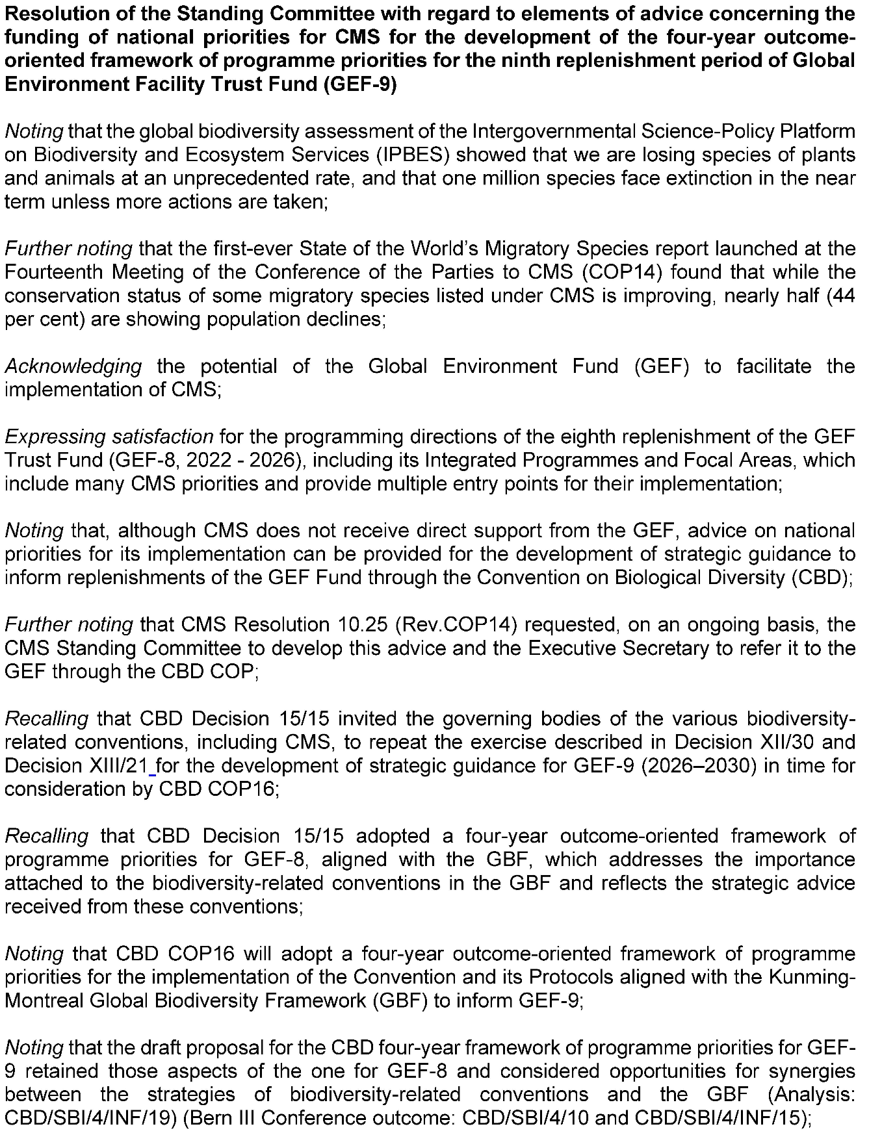

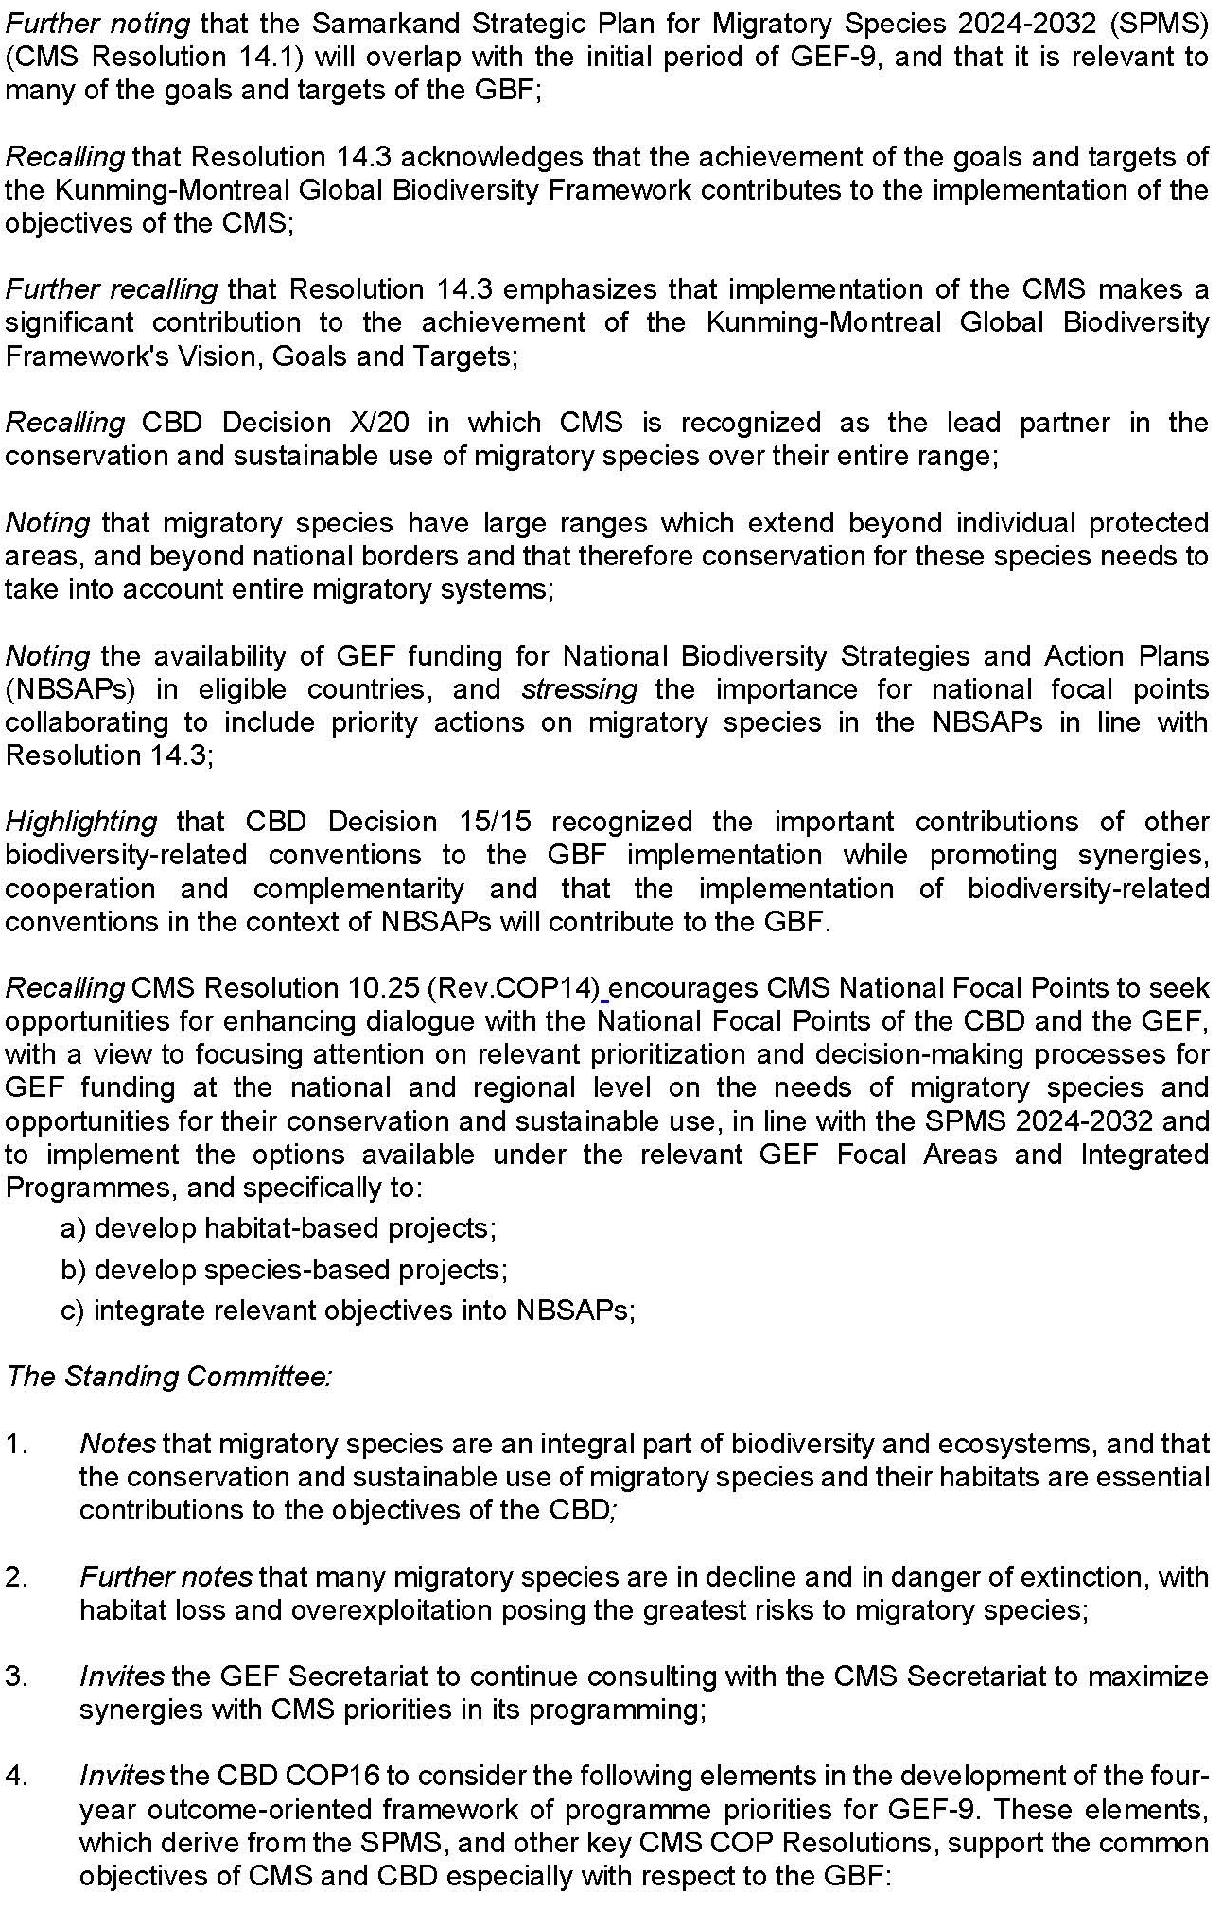
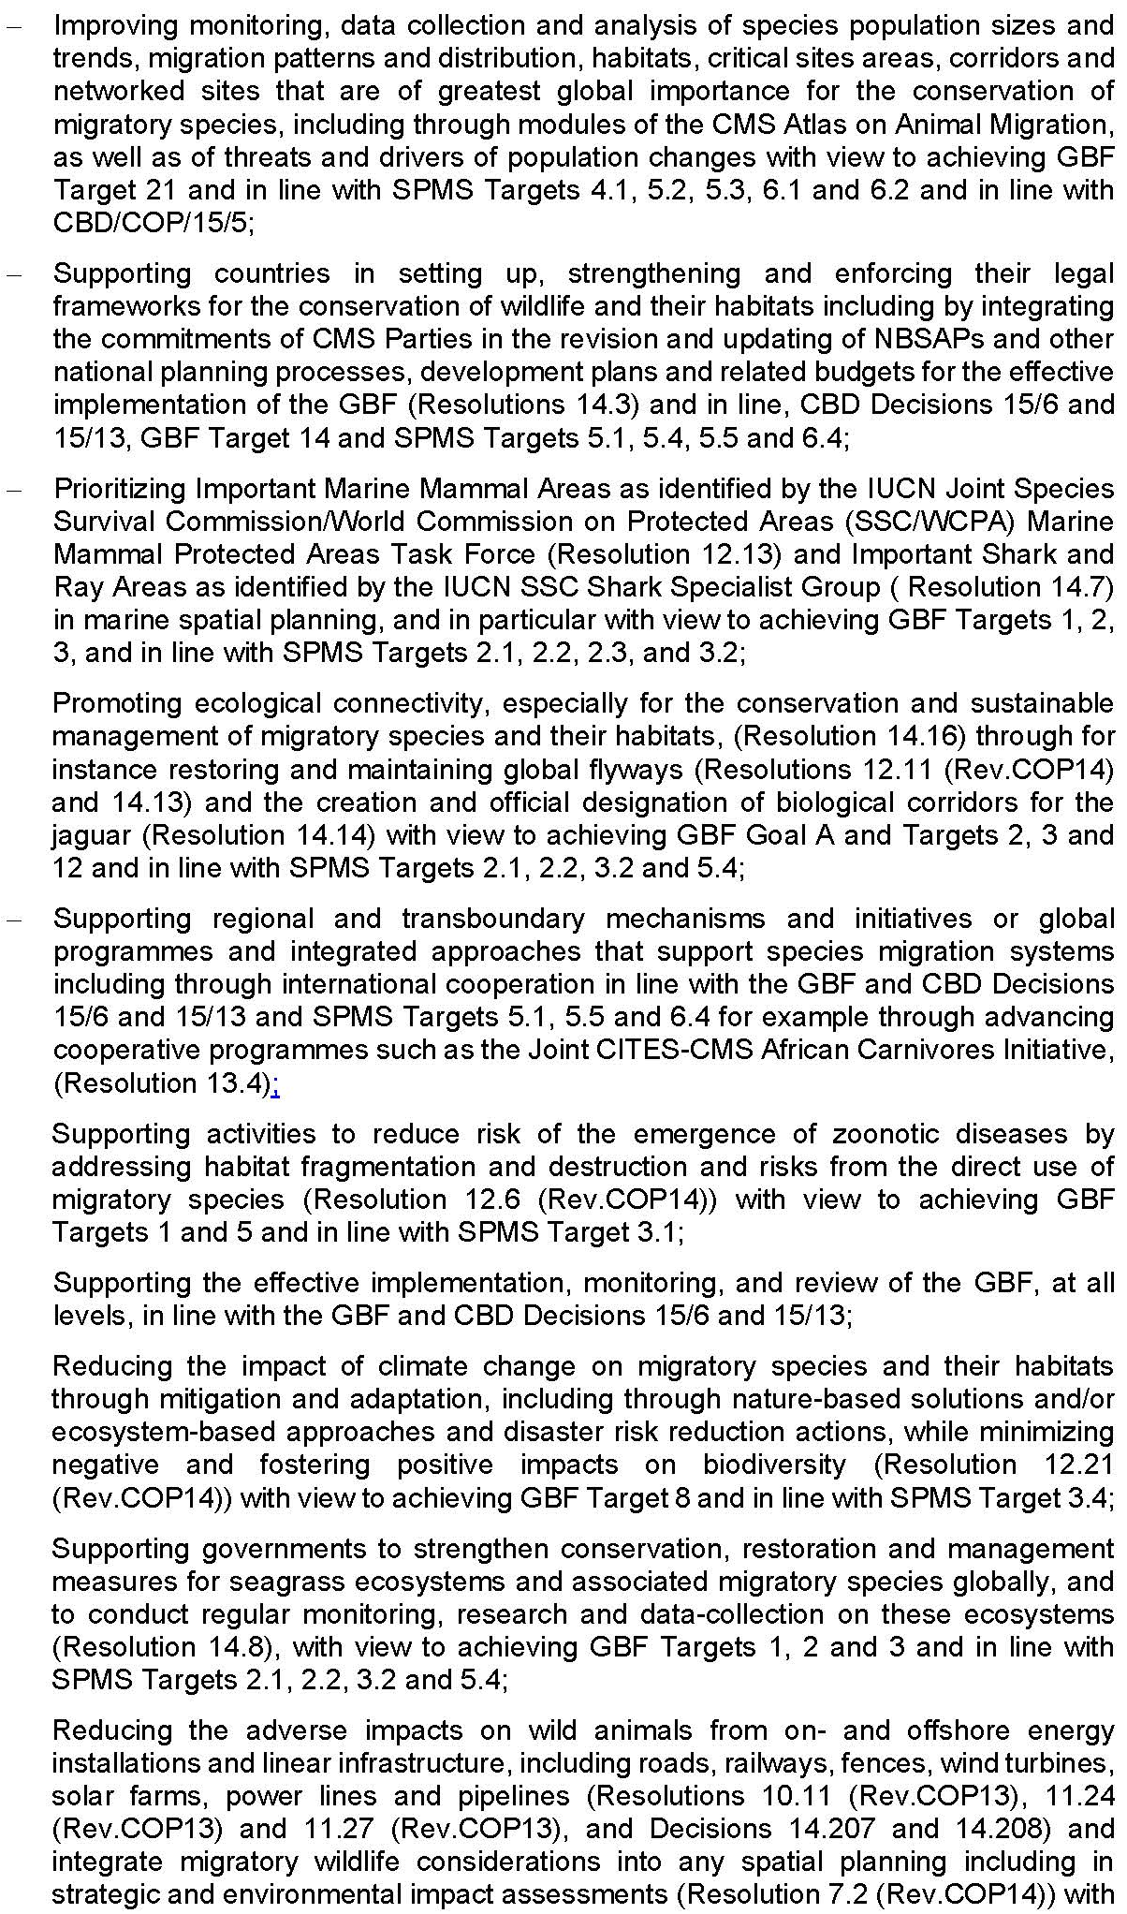
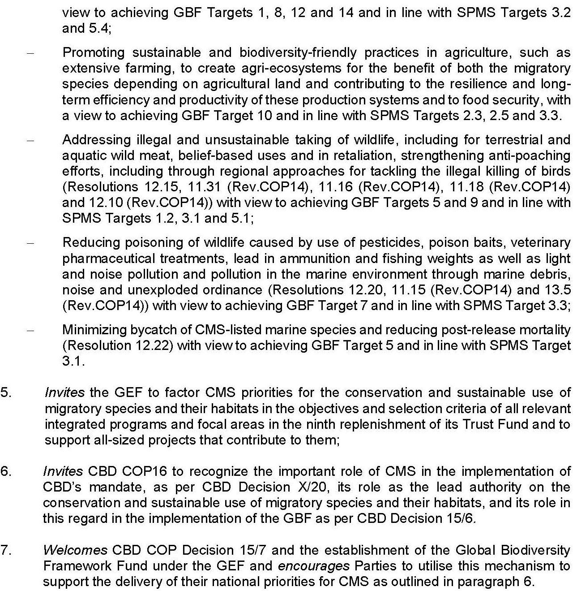

Annex II
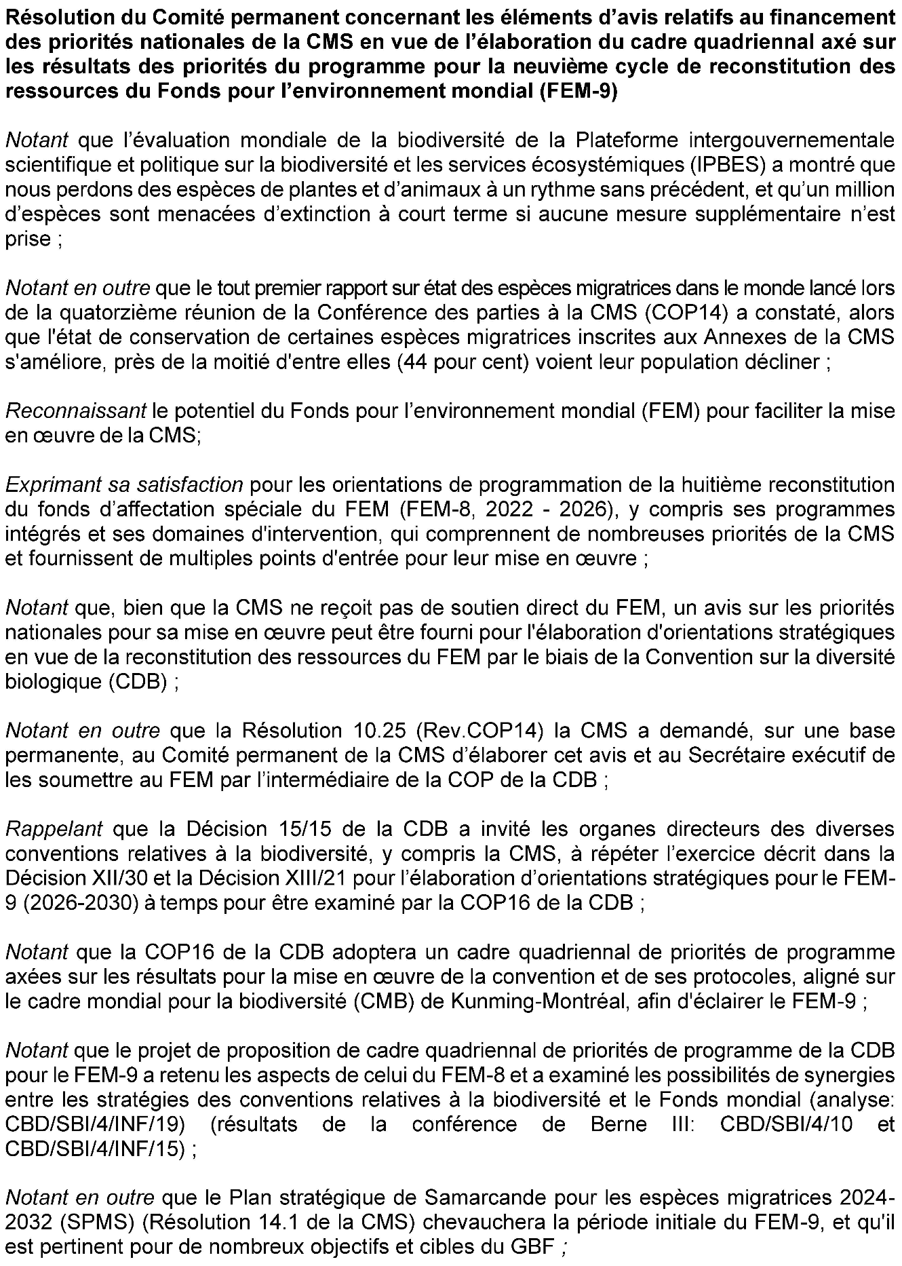

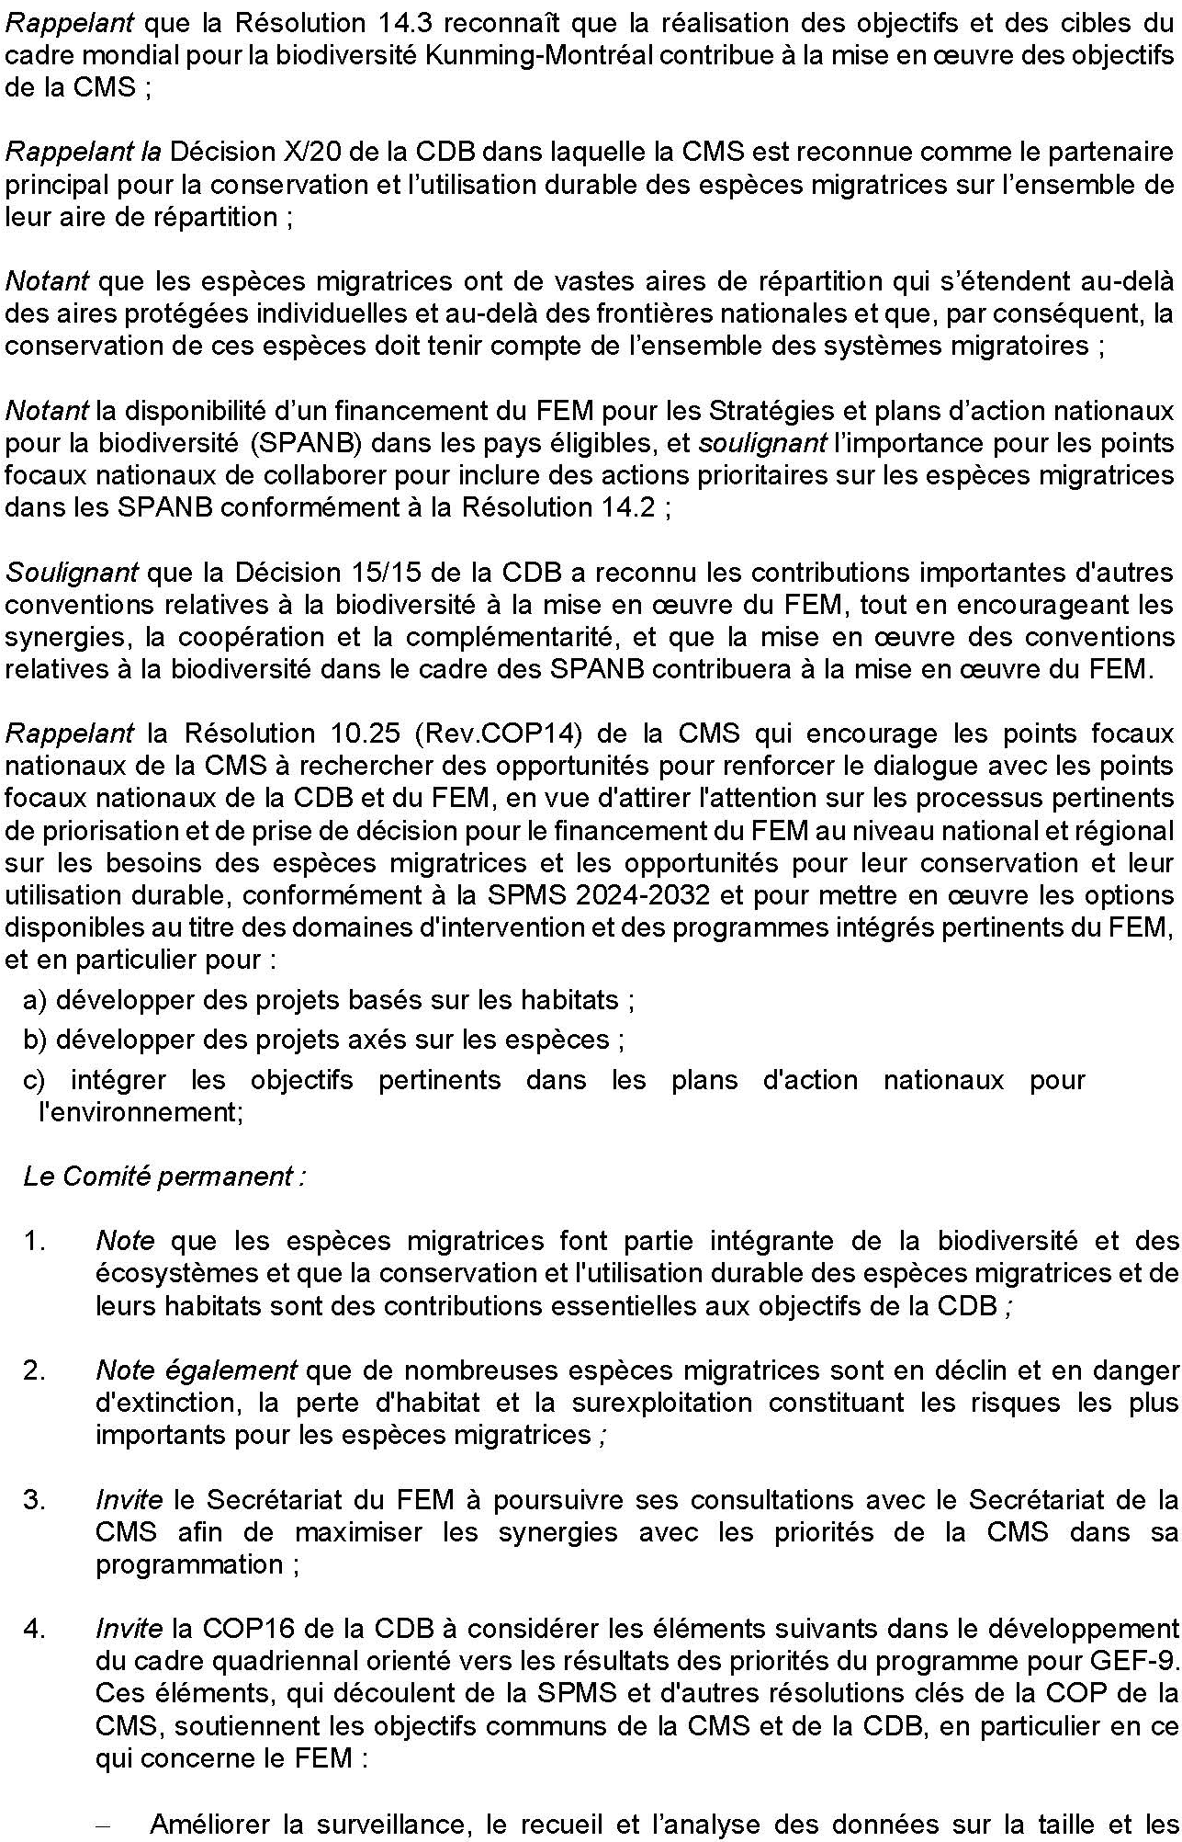
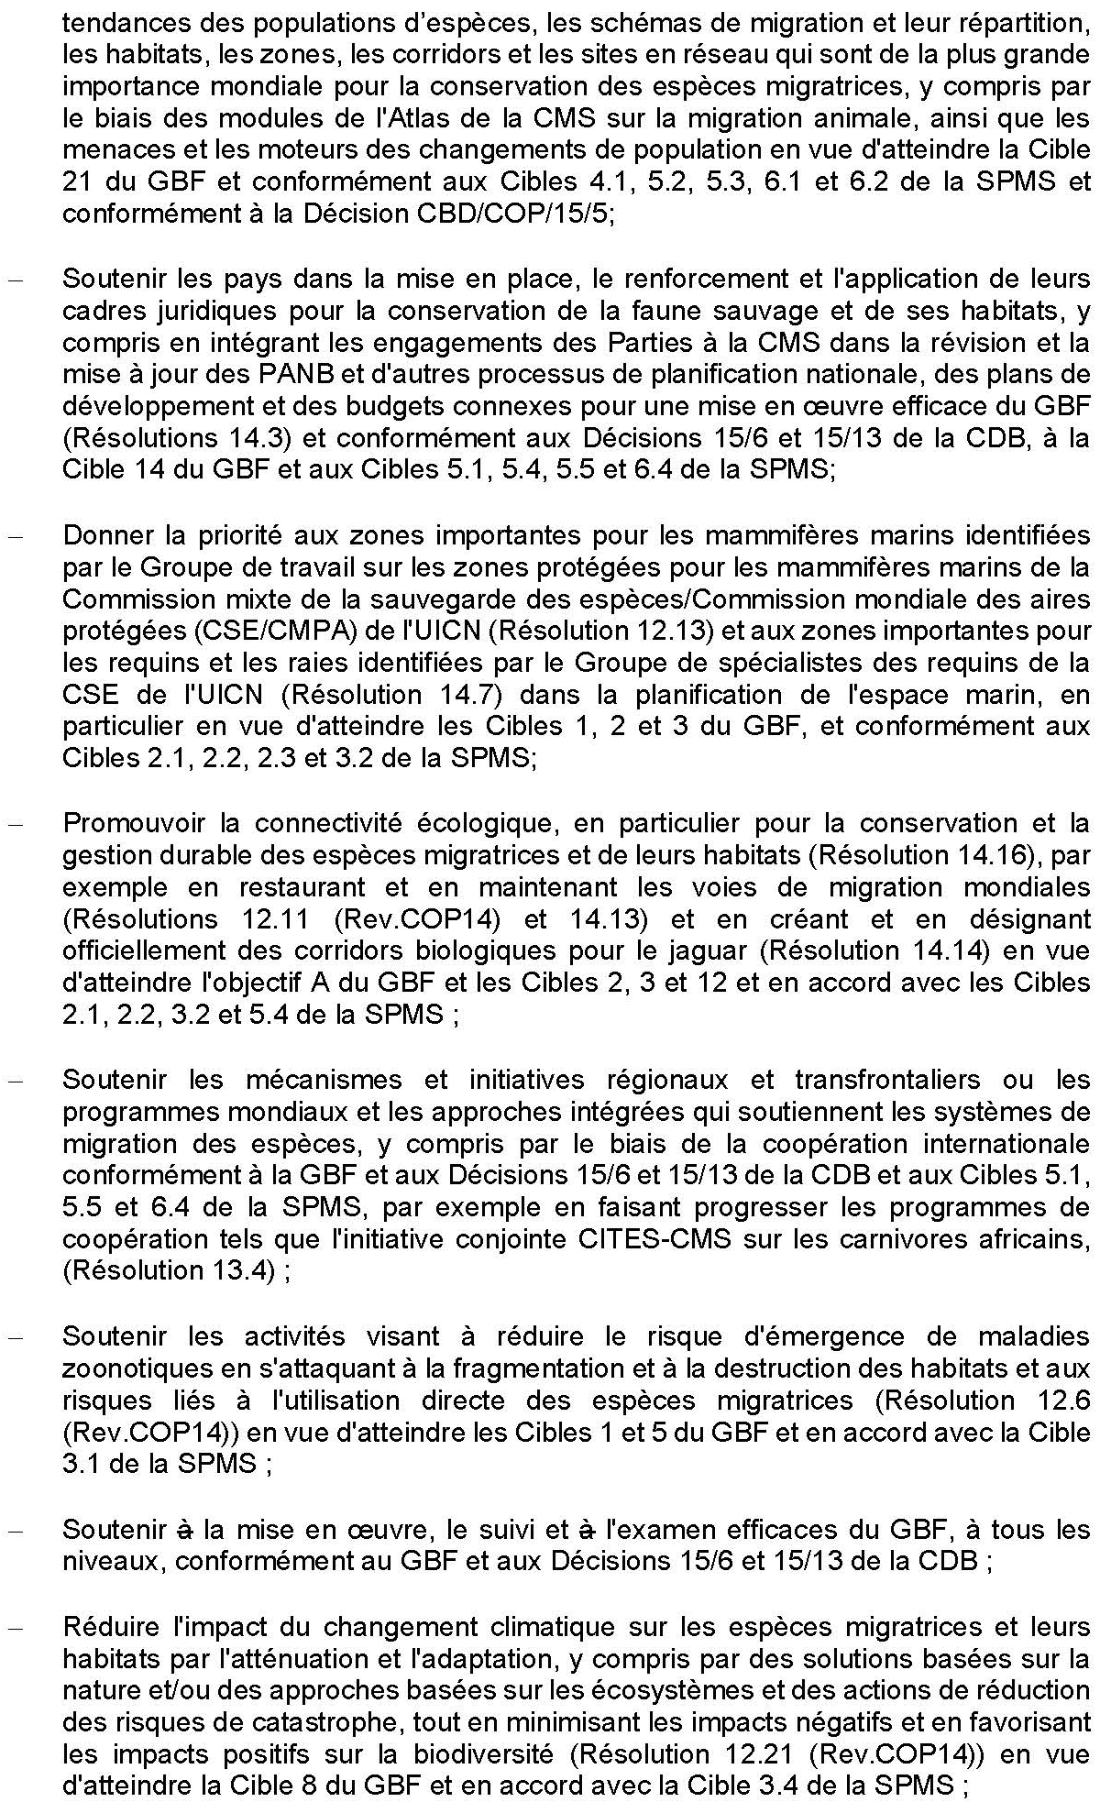
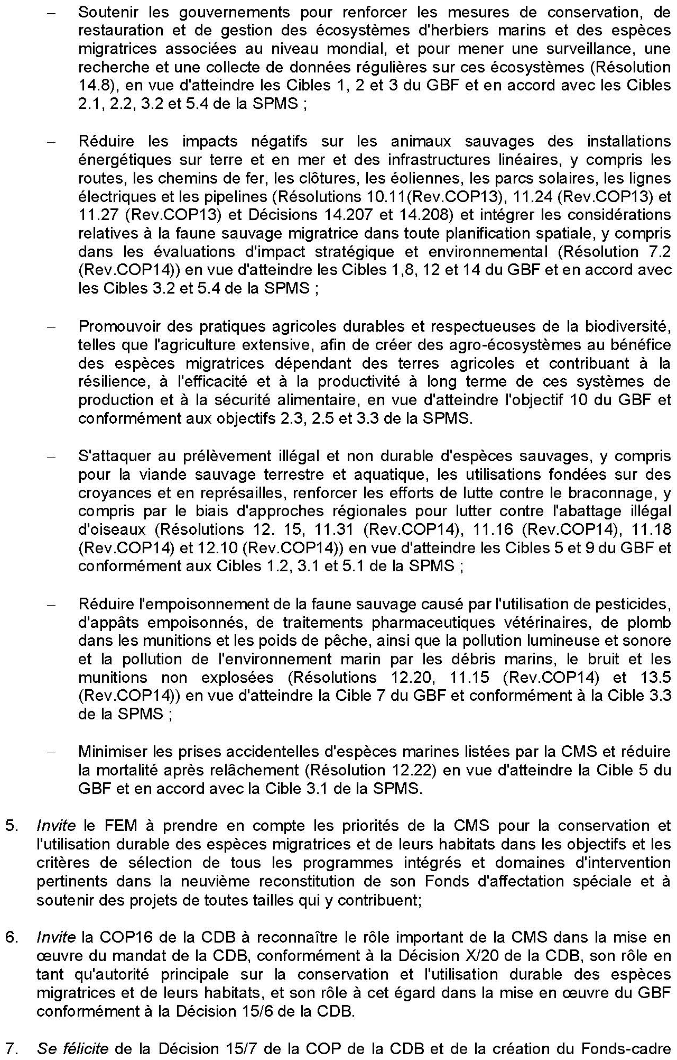

Annex III
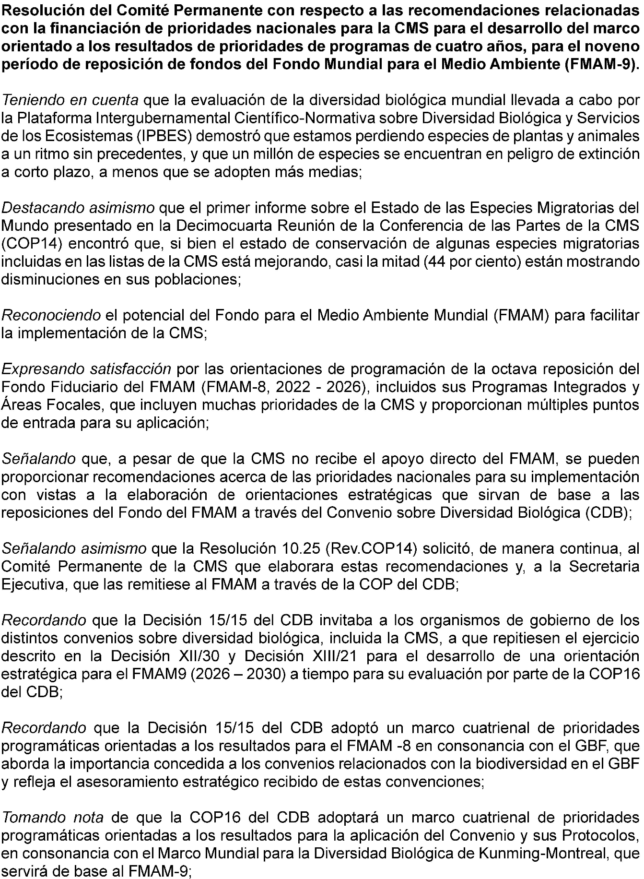

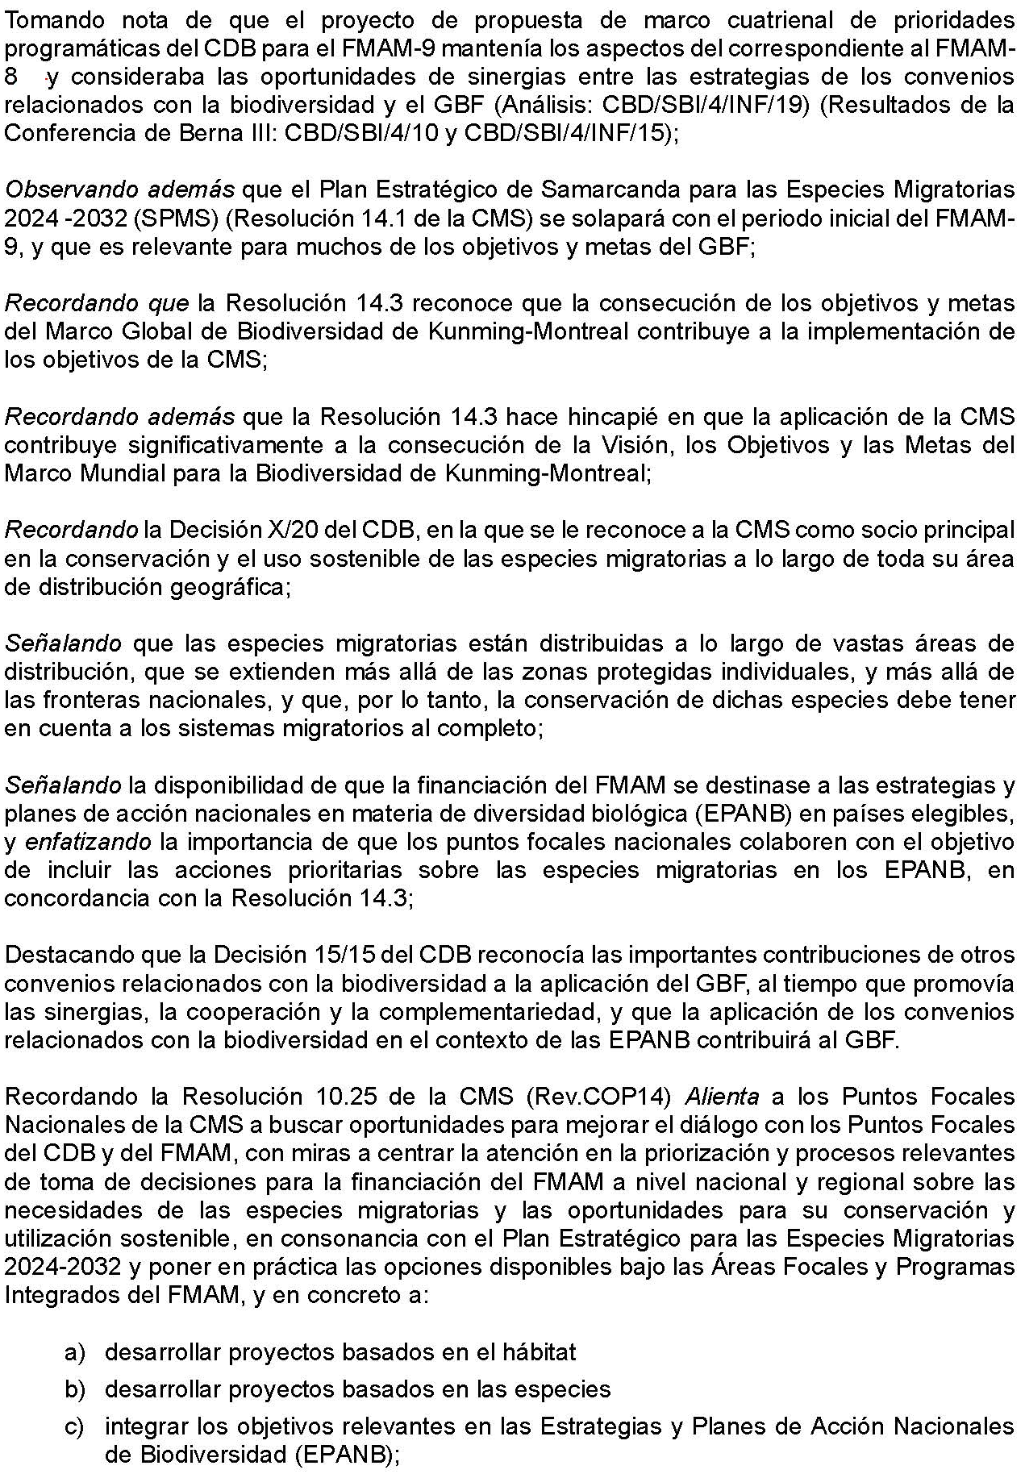

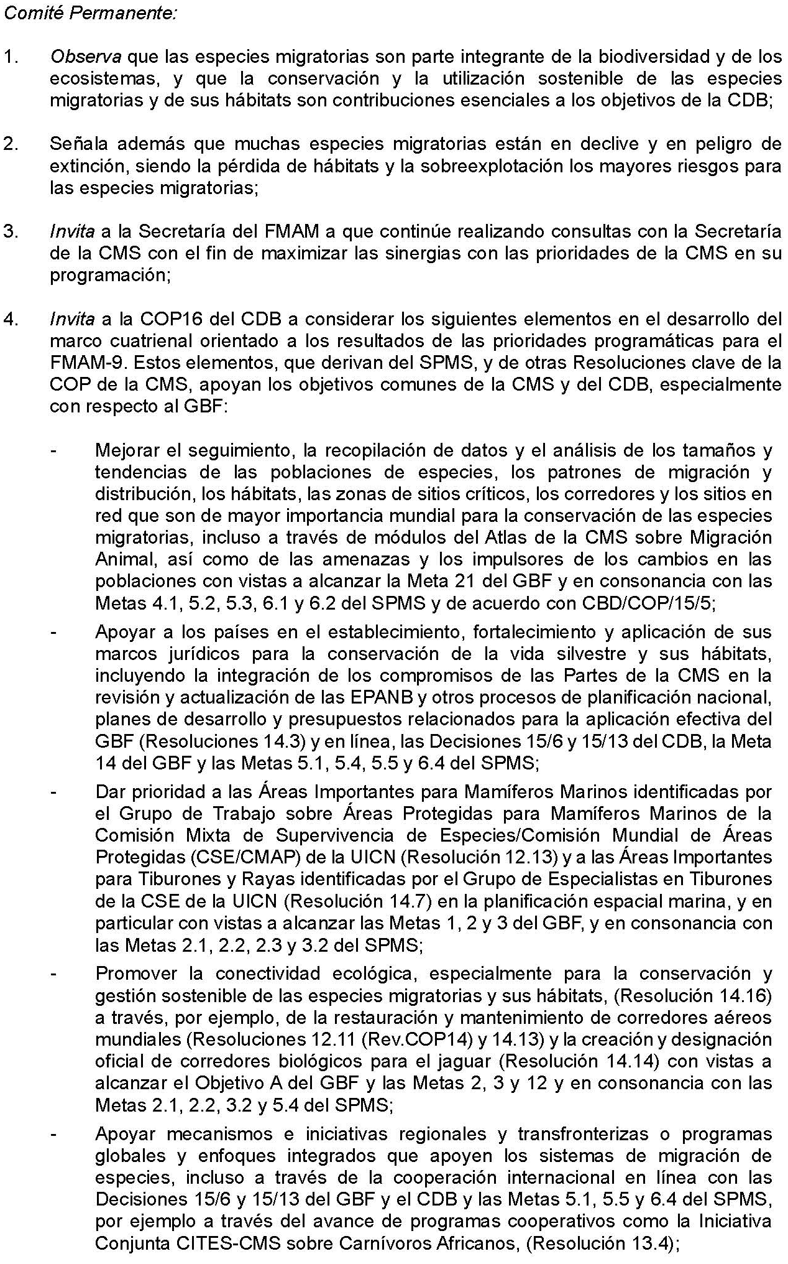
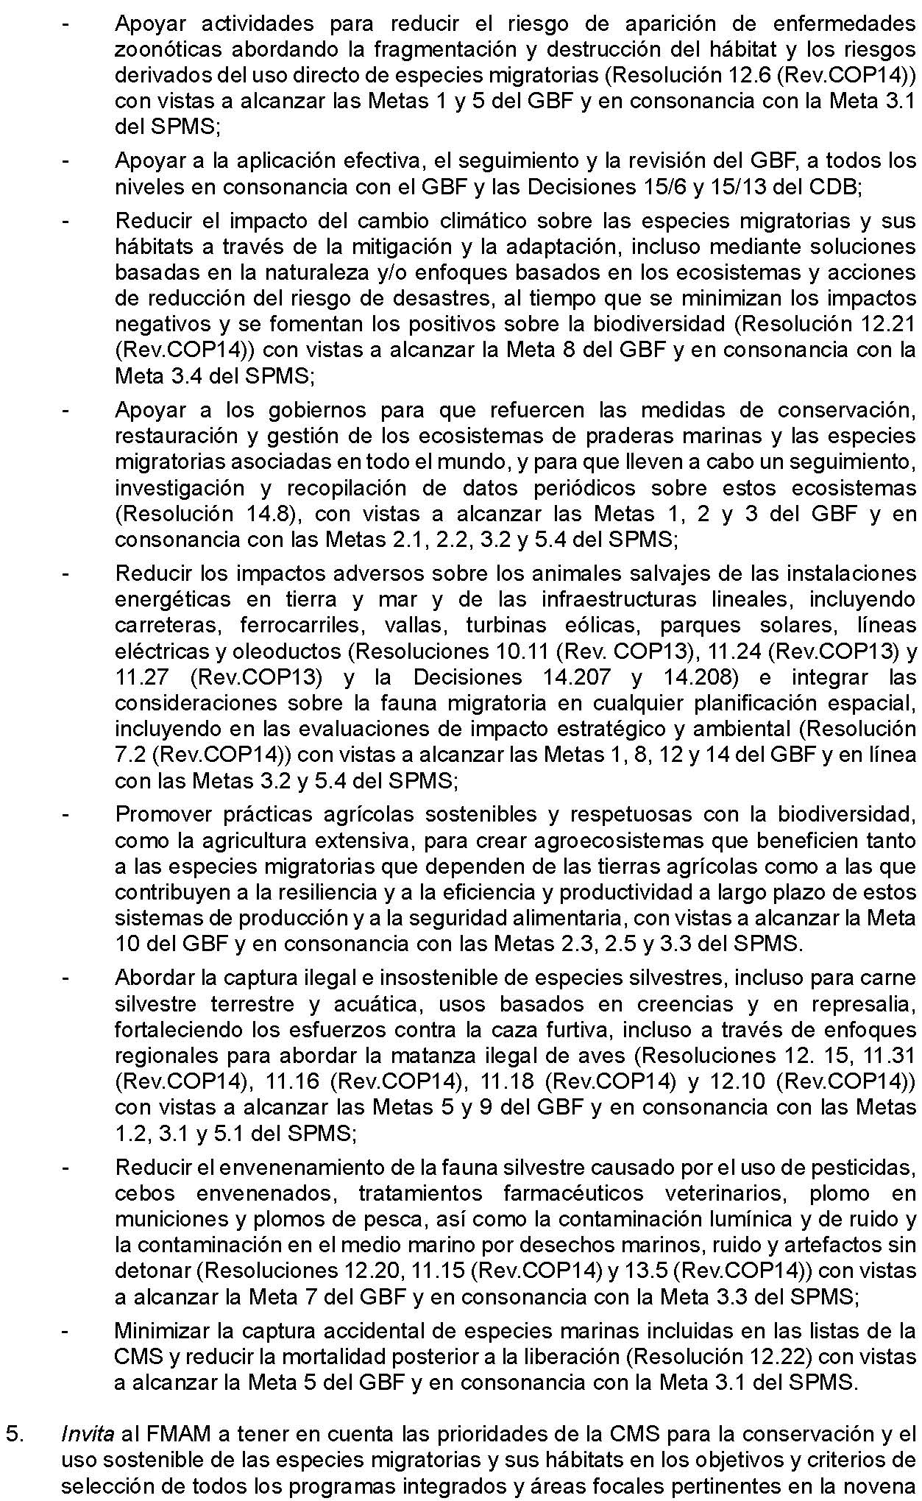
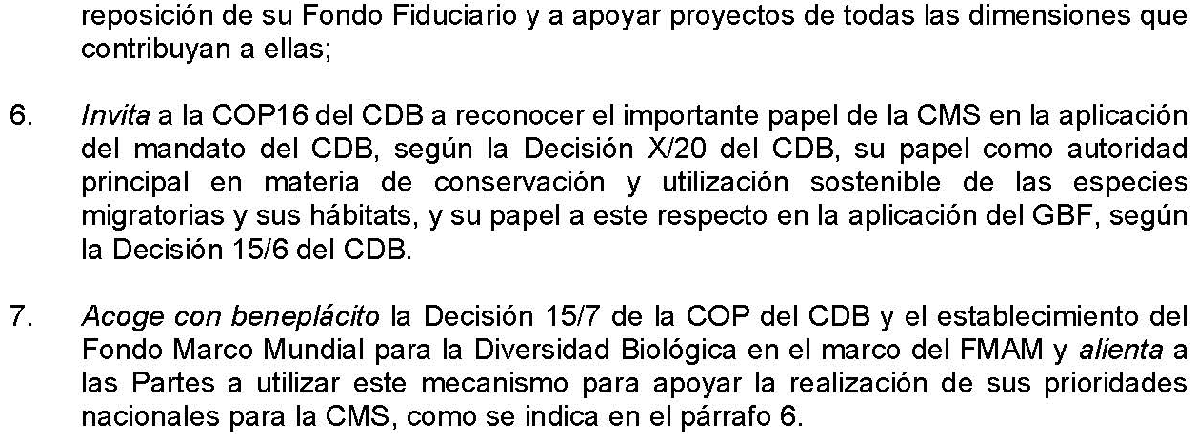

* CBD/COP/16/1.

