 |  | CBD
 |  | Distr.  GENERAL  CBD/SBI/2/INF/26  21 June 2018  ENGLISH ONLY
SUBSIDIARY BODY ON IMPLEMENTATION
Second meeting
Montreal, Canada, 9-13 July 2018
Item 16 of the provisional agenda*
Exploring elements for a transformative biodiversity agenda post-2020

I. INTRODUCTION
1. This information note introduces the concept of sustainability transitions, describes its relevance for the biodiversity community and explores its potential for governance actions that could complement existing efforts to mitigate biodiversity loss and degradation. The main premise behind the present document is that efforts to conserve biodiversity to date are being countered by negative impacts of ever increasing levels of consumption and economic growth and that new strategies are needed to achieve transformative changes.
2. In view of the process towards the post-2020 global biodiversity framework, the present document examines a complementary process (see figure 1) that mobilizes and empowers transformative actions at the national level on the basis of so called transition governance (see section 5). Section 2 presents the background on a transition perspective, before articulating the need for transition governance for biodiversity in Section 3. In sections 4 and 5, the note provides, for consideration, elements to formulate a specific process to help guide and accelerate sustainability transitions in biodiversity-relevant sectors at the national level. The proposed process for consideration could help to formulate voluntary national ambitions that are supported by national stakeholders while at the same time stimulating transformative actions and projects on the ground. Section 6 provides some conclusions for reflection.

II. BACKGROUND: THE TRANSITION PERSPECTIVE
3. The Convention on Biological Diversity and its associated Protocols have been successful in generating knowledge and actions committing to the conservation and protection of biodiversity across the globe. This has included the development of national biodiversity strategies and action plans (NBSAPs) as well as placing biodiversity considerations and the benefit of ecosystem services on political agendas. This has been carried out in different ways. For example, through the programmes of work under the Convention, regional consultations and workshops with national Government focal points, as well as through partnerships and alliances with many actors, including local authorities, city networks, indigenous peoples and local communities, and other relevant stakeholders, while also using other means. This work has also helped to stimulate environmental awareness and to further national policies countering environmental degradation and resource depletion, among other things. Despite the positive effects of these efforts and the spread of successful practices in conserving and restoring ecosystems, the state of global biodiversity has continued to deteriorate around the globe. Many positive effects of the Convention and related efforts on terrestrial ecosystems, for example, appear to have been offset by growing consumption of land and other natural resources and the use of (fossil) resources.

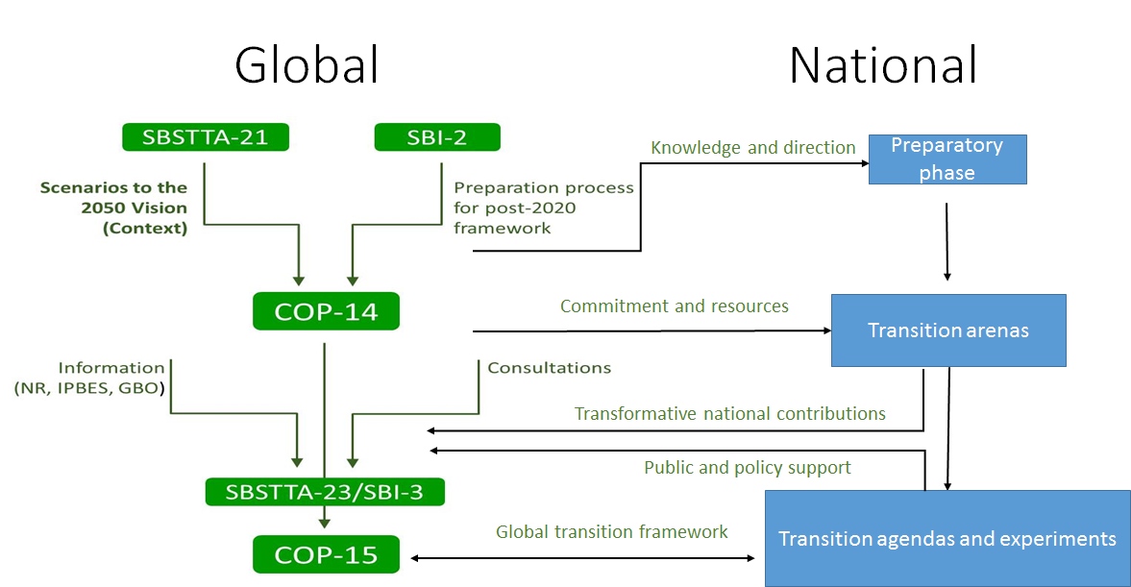
Figure 1. How transition governance complements the process towards a post-2020 global biodiversity framework
4. In view of the post-2020 period of the Convention, a timely reflection is needed with a view to examining the approaches taken in past decades to explore future pathways. The present document therefore takes a transitions research perspective to explore strategies that could help accelerate and guide the mainstreaming of sustainability transitions into economic sectors to mitigate biodiversity loss and degradation, while leveraging nature-based solutions. This is meant to complement existing work on sustainable use, conservation, benefit-sharing, and the mainstreaming of biodiversity under the Convention. This implies taking a transition perspective on persistent negative pressures upon biodiversity, and on dominant strategies to deal with these persistent problems that often lead to path-dependencies and lock-ins, and providing a framework for experimenting with new governance strategies to help guide and accelerate desired transitions.
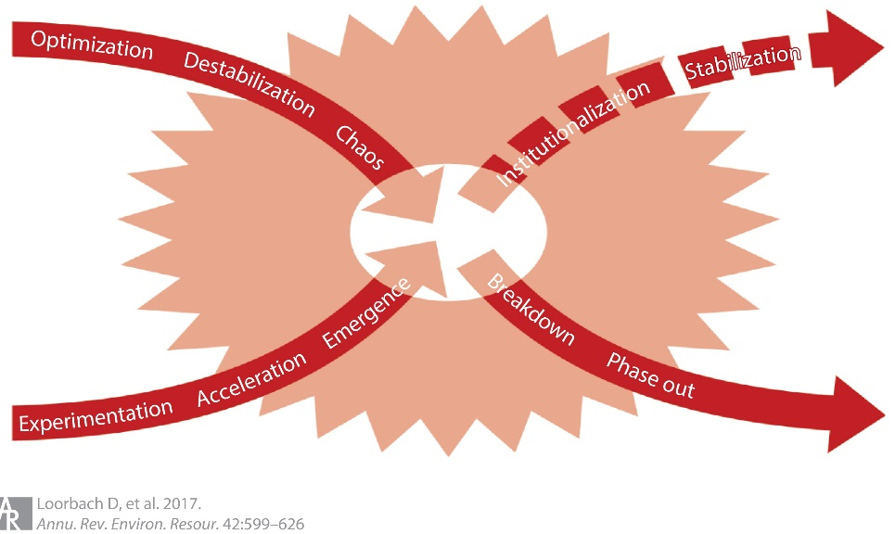
Figure 2. Transition dynamics of built-up and break-down

5. Transitions are defined as long-term processes of disruptive and non-linear systemic change in complex societal systems, such as economic sectors or regions. Historical research shows that such systems periodically go through transitions as the result of interacting patterns of build-up and break-down. Over the course of decades, three main forces co-evolve: increasing societal pressures for change; growing internal tensions within dominant institutions; and maturing or competing alternatives (technologies, lifestyles, values, business models). A core concept in transition research is the so-called “regime”: the dominant routines, structures and discourses people develop within a specific context. Such regimes are dynamic but also provide stability and predictability, often only leaving space for optimization and gradual change. A relatively rapid shift towards a new regime can only take place if external pressure is high, internal tensions lead to crises, and viable alternatives are present. This transition perspective, visualized in figure 2, helps to analyse and reflect upon the transitional dynamics in a particular societal system and identify possibilities for intervention.
6. Transitions are complex, uncertain, and cannot be managed or predicted in a traditional way since policies developed within the regime aim at sustaining and improving the existing regime. As transitions imply break-down and destabilization of the regime while, at the same time, future pathways and outcomes are still unclear, they often involve a high degree of uncertainty. Transitions can be primarily analysed in terms of destabilization, emerging pressures for transformative change and the movement away from a specific (historical) equilibrium. Transitions cannot be predicted in terms of direction and outcomes. “Transitions” in this sense could confront the process with the risks of disruptive systemic change and offer possibilities for rapid, non-linear shifts to structurally more sustainable futures.
7. The future outcomes of emerging transitions will be largely dependent upon collective actions and decisions made in the coming years. Witnessing different signals of destabilization can identify rapidly emerging and diffusing niches. Therefore, it is important to focus on desired transitions and how to increase the chances to realize them. Emerging transitions might lead to more sustainable futures should conditions be favourable, and provided that these driving forces are mobilized in an effective way:
- Global societal pressures for change are higher than ever, including global institutional pressures and commitments (e.g. the Sustainable Development Goals), civic awareness, ecological crises and climate change, and geopolitical concerns;
- Industry and sector structures associated with fossil fuel based and linear economies are showing internal tensions and crises, for example, in the energy sector, mobility/ transport sector, and agriculture;
- There is a global diffusion of alternative social and technological innovations, such as new practices and lifestyles, renewable energy technologies, platform economies, visions of sustainable futures, and cooperative models.
8. Transition governance is an approach developed to influence the speed and direction of emerging transitions. It acknowledges that business-as-usual in policy, business and science is first and foremost reproducing regimes by seeking incremental improvement rather than structural systemic change. Transition governance is therefore about developing transformative coalitions through selective participation of change agents in such a way as to empower these coalitions so that they can more strategically guide and accelerate desired sustainability transitions. To this end, transition governance processes focus on developing shared narratives about what desirable systemic change can look like. This includes developing future images, (common) goals, and long-term transition pathways as a starting point for short-term actions. Transition governance provides long-term and systemic perspectives supported by a diversity of societal actors who are, in turn, supported by a strategic socio-technical innovation approach. It enables a shift towards integrated and cross-sectoral policies that take fit-for-purpose and fit-for-context approaches.

III. THE BIODIVERSITY TRANSITION
9. Biological diversity is the foundation of life on Earth, contributing to human welfare, well-being, and health. If it is not preserved and valued, there is no perspective of future development at all. Since the 1970s, society has become aware of the negative effects of prioritizing economic growth at the expense of the environment, leading to the development of environmental policy and science, and the introduction of the concept of sustainable development at the global scale. It is in this context that the Convention on Biological Diversity was established as a global effort to commit national Governments to taking action to conserve and preserve nature and biodiversity and to address the negative effects of unsustainability as well as the root causes of destruction.
10. The past 25 years have led to a strong “biodiversity regime” with shared culture, structures and practices that address biodiversity at all levels — from ecosystems to species to genes. Such “regimes” are understood as the collective way of thinking, doing and organizing that develops over time in specific societal systems and provides stability, as well as creating path-dependencies and resistance to change. Elements in the biodiversity regime are, for example, administrative and institutional structures (Convention on Biological Diversity, United Nations Environment Assembly, national biodiversity strategies and action plans, other processes at the global and national levels), actor networks, physical infrastructures (protected areas and parks), scientific and implementation bodies (SBSTTA, SBI, IPBES), shared vocabulary (biodiversity, ecosystems, Aichi Targets, nature-based solutions, conservation, restoration, sustainable use), and financing mechanisms (Global Environment Facility, bilateral aid and funds), and growing community of practice (multiple stakeholders and partnerships). The broader societal function of this “biodiversity regime” has been to identify, discuss and decide on urgent action to deal with global concerns, primarily addressing the negative symptoms of “unsustainable” development on ecosystems and planetary health. The regime is scientifically supported by primarily qualitative ecological science that models, maps, and explores ecosystem dynamics, exposes ecological impacts, and develops policy recommendations while supporting national biodiversity strategies and action plans. The primary focus of governance efforts based on these actions is to develop regulations and build consensus.
11. The science is clear. Systemic change is necessary. Policy ambitions agreed on so far, let alone concrete commitments and actions, are not enough. Ecological and resilience research shows that there is a risk of ecological boundaries being crossed, potentially resulting in tipping points in climate and ecosystems that might lead to an acceleration of environmental disruption by 2050 and irreversible change that could lead to catastrophic consequences for life on Earth. Unmitigated economic and societal pressure on the environment makes such tipping points more likely to occur. The embedded nature of currently dominant and unsustainable cultures, structures and practices makes biodiversity conservation and sustainable use a persistent and complex global challenge. Along these lines, research suggests that merely remediating and softening the negative impacts are insufficient to fundamentally reduce the long-term and fundamental risks these impacts pose to societies, let alone actually improving the state of the environment and also creating opportunities for societal well-being in the long term.
12. To achieve broader societal transformation, more is needed than can be achieved by the biodiversity regime alone. New approaches, actors and means as well as innovative solutions need to be found to go beyond the symptoms of unsustainability to also address the root causes of biodiversity loss and degradation. This entails engaging with sectors and countries that operate in ways that produce negative impacts on different ecosystems and engage them to shift to new ways of production and consumption, to help reorient (economic) development pathways towards an economy that stays within ecological boundaries, while meeting social and ecological development goals. The question is: how can the biodiversity regime engage more directly with societal systems that determine how natural resources are used and how their use implicates biodiversity and ecosystems, for example in agriculture, fisheries, forestry, tourism, energy, mining and infrastructure, health and manufacturing, all of which are sectors in which biodiversity needs to be mainstreamed as per the decisions of the Conference of the Parties to the Convention? Additionally, how can economic, financial and ecological policies and actions be designed to place biodiversity at the centre of the development paradigm as a key natural asset?

IV. TRANSITION GOVERNANCE FOR THE BIODIVERSITY TRANSITION
13. The focus of the Convention has evolved greatly in its support to the Parties to advance implementation. Among supportive functions, work has centred on mapping biodiversity pressures and impacts, developing national biodiversity strategies and action plans and capacity-building tools, and formulating guidelines on how to alleviate and mitigate biodiversity pressures. The transition theory/governance perspective suggests that these efforts must be complemented with governance strategies that focus on accelerating desired transitions by working in a more systemic, experimental, action-oriented, and empowering approach tailored to specific transitions (in economic sectors such as agriculture, energy, mobility and construction/infrastructure) and their corresponding cultural, political, and institutional contexts. The first step of transition governance is to conduct a transition analysis to identify those actors that already pursue sustainability transitions and bring these together to develop shared transition agendas in such a way that they are empowered to become effective change agents in their own contexts and build momentum by creating diverse and transformative networks.
14. Given that, globally, there is a growing awareness of and commitment to pursuing sustainability transitions, and all sorts of alternatives are becoming available, the challenge is to connect to those dynamics, actors, ideas and solutions and to work towards a global sustainability-oriented movement with truly transformative impact at the local and regional scales. The Convention and other actors operating within the biodiversity regime could try to connect to this growing movement and bring its networks, knowledge and capacities to make biodiversity and nature a key focus point in societal transitions emerging in all sorts of economic sectors and regions. Societal transitions in general are processes of societal progress in which societies move away from (perceived) unsustainable systems towards improved futures. In this regard, an aim in working towards a new global agreement in 2020 could also be to consider ways to help other sectors and actors (such as business, citizens, other relevant stakeholders) to achieve progress in a way that values, benefits and protects nature and biodiversity.
15. Transition governance for the biodiversity transition will require an agreement in the biodiversity regime about the global, overall ambition for the long term. Mirroring the Paris Agreement’s targets under the UNFCCC this would mean a much simpler, overarching, and operational targets than the Aichi Targets and current Strategic Plan on Biodiversity 2011-2020 have in place to date. This could help to create both a broader societal urgency and confidence around a fundamental systemic change as well as providing a basis for more focused political decision-making. It could also leave more space for experimentation about fit-to-context and fit-to-problem solutions and approaches while also setting clearer and stricter boundaries within which development can take place. Moreover, operationalizing the vision could be developed in participatory and bottom-up manner, allowing for diversity as well as generating legitimacy and support.
16. For biodiversity, a rapidly diffusing narrative emerging relates to ecosystem services and natural capital. Both approaches could create the foundations for an economy within the planet’s ecological boundaries. This offers a narrative when it comes to making visible and tangible the value of preserving and investing in biodiversity and ecosystem diversity. Already, the biodiversity regime has been complementing conservation approaches with efforts to position and address biodiversity within broader contexts, as is visible in the narrative developed in the third edition of the Global Biodiversity Outlook and the conclusions of the fourth edition, and based on combining processes of conservation, restoration and transformation, in a “CRT” strategic approach.
17. Based on the concept of natural capital and related approaches, the aim could be to assist national governments in making natural capital assessments and accounts and, on that basis, formulate goals to work towards a “sustainable balance sheet” within all policy sectors. Rather than presenting a static picture one could think about a “dynamic balance sheet” in which economies in balance with nature generate as much ecological, economic and societal value as is used (but not necessarily create closed systems). For these, synergies with a range of actors active in this area (such as the Natural Capital Coalition, the accountancy, finance, and planning sectors, foundations, private equity and impact investors) are needed. Combining a conservation approach with an approach based on restoration of natural capital could lead to a vision embracing both protection and development, connecting the biodiversity community with like-minded actors, representing sustainable businesses, local initiatives, and other sectors and stakeholders embarking on sustainability pathways.
18. Drawing on existing ideas and building on emerging approaches, an ambitious agenda could include consideration to conserve, sustainably use and restore biodiversity and its many benefits to humanity. While global ambitions simplify the complex nature of the problem, they give direction and underline the transformative nature of the journey ahead, while allowing for context-specific solutions and pathways. Most importantly, this implies a different type of governance and implementation, one that, through experiment, works towards learning, adaptations, and improvement along the way. The starting point for transition governance is to achieve transformative systemic change in the long term, while acknowledging the complexities and uncertainties inherent to achieve such deep transformation. This is based on envisioning and back-casting, a philosophy of learning by doing, and social learning.
19. Among key instruments for transition governance to build capacities are transition analyses, transition arenas, using back-casting to create transition pathways, and strategic experimentation with social and technological innovation. Following the transition perspective shown in figure 3, transition analyses uncover, in societal structures, values and behaviours deeply entrenched in drivers of biodiversity loss and unsustainability, as well as the roots of institutional, organizational and socio-political limitations to overcome these drivers. They also identify niches of emergent alternatives. Transition pathways identify short-term and mid-term strategies and actions. Such pathways progressively build up the capacities to achieve the vision. Transition governance can support working towards the conditions and/or capacities that are needed to steer emerging transitions towards more desirable directions.

V. EMPOWERING NATIONAL SUSTAINABILITY TRANSITIONS FOR BIODIVERSITY
20. Transition governance is an approach for (national) governments to facilitate emerging sustainability transitions in their societies by developing a collective strategic capacity for transformation. At the same time, it empowers those involved in their daily context and activities to work more effectively towards, or contribute to, the acceleration of transitions. If this is to be associated with the work under the Convention, transition governance could help to complement global governance efforts with national and regional transition movements and explore how they could work in a co-evolutionary way towards achieving desired sustainability transitions. To this end, a framework could be envisaged to support national representatives and administrations in developing transition networks and agendas in their national contexts. To do this in such a way as to lead to the identification of transformative visions and goals that close the ambition gap while simultaneously developing the capacities and concrete actions that close the implementation gap.
21. To facilitate sustainability transitions using transition governance requires specific capacities and structures, as well as institutional space and support. Within IPBES and through the Secretariat of the Convention on Biological Diversity, multiple actors have already started to explore new types of scenarios, narratives and engagement strategies, but it remains a challenge to go beyond the biodiversity and conservation community, working across sectors on the practice of qualitative problem analysis and policy-led implementation of solutions.
22. What is needed is more effective translation between scientific and expert knowledge on biodiversity and ecosystem challenges and a direct connection to everyday practices of policymakers in other domains, business, or consumers/citizens. As long as the biodiversity agenda is seen as separate and/or perceived as an additional priority, it will be difficult to agree upon global targets that actually lead to transformative actions on the ground.
23. The urgency of better dealing with biodiversity and the opportunities of biodiversity-inclusive or natural-capital-positive strategies are starting to show. However, to mainstream biodiversity considerations into other policy domains brings a number of challenges that could be addressed through transition governance:
- To internalize biodiversity knowledge and concerns into mainstream decision-making in biodiversity-relevant sectors;
- To provide existing biodiversity-related knowledge and support for local actors in development processes;
- To accelerate the diffusion and uptake of new ideas, innovations and technologies that support sustainability transitions;
- To empower change agents to challenge incumbent interests and path-dependent unsustainable development trajectories.
24. A transition governance approach engaging a global network of transition researchers along with a global academic community on biodiversity would roughly suggest a three-phase process that includes a preparatory phase, facilitating transition arenas and implementing/diffusing transition agendas as visualized in figure 3.
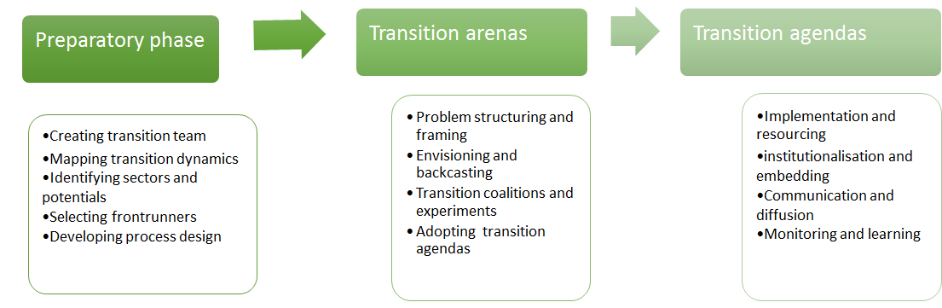
Figure 3. Phases in transition governance
25. The general process outlined in figure 3 provides the basis for developing transition governance specific to national contexts, adapting for specific socio-political, developmental, geographical, ecological, economic and institutional conditions. In general, these different phases would include:
(a) Preparatory phase:
- Representatives open to exploring ways to guide and accelerate sustainability transitions together with transition researchers identifying the most relevant sectors and transition potentials;
- An interdisciplinary team of scientists from the global, national and local contexts, maps these sectors in terms of their persistency, current regime dynamics, transition potentials, and relevant niches (at both the local and global levels);
- A local group of civil servants from relevant departments receive a week of training/capacity-building on transition management processes and start to identify potential change agents for the transition process;
- A gender-balanced transition team composed of containing transition researchers, experts and civil servants develops a process plan;
(b) Transition arenas:
- The transition team is supported by transition action researchers (either physically or by videoconferencing) to identify and engage change agents and organize open kick-off meetings informing sectors and interested actors;
- The transition team organizes a series of transition arenas, going through the process of participatory reflection on desired and potential sustainability transitions, envisioning and backcasting, and formulating experiments;
- The transition team, with support of the scientific network, synthesizes outcomes into national transition agendas, including shared ambitions, goals and intermediate targets;
(c) Transition agendas:
- These transition agendas are further enriched with ideas, knowledge and insights from other countries and examples from other regions, and are, when possible, integrated with the national biodiversity strategies and action plans and the global biodiversity transition road map;
- The outcomes are communicated and, where possible, translated into regular policy and projects either through policy or through (the support of) engaged societal actors;
- Regular reflexive monitoring and exchange is organized with the transformative networks to assess progress and adjust the course of action.

VI. CONCLUSIONS
26. The advantage of the proposed transdisciplinary governance process is that capacity-building is combined with direct knowledge of implementation and relevant change agents in national economies are empowered to take innovative actions. In this way, specific outcomes of a transition strategy document could be seen as secondary to the act of actually speeding up sustainability transitions.
27. A second strong advantage is that such national strategies could provide the building blocks for a global strategy, while at the same time offering very concrete prospects for sustainable economic development within national contexts. Rather than having the biodiversity agenda conflicting with economic growth, this strategy seeks to find sustainable economic development models for biodiversity relevant to sensitive sectors. The involvement of entrepreneurial civil servants from related departments in the process could also help to build cross-sectoral governmental support.
28. However, engaging in transition governance does also imply a new role for policymakers and policymaking and leads to outcomes that challenge existing structures and interests. If the aim is transformation, then even if such a transformation is gradual in the short term, conflict and tensions are inevitable. Engaging in transition governance thus offers an approach to help guide and accelerate desired emerging changes in sectors. It also includes engaging in enhancing institutions and examining power structures.
29. The foremost reason why transition governance is a more informal and complementary governance process is therefore that support and transformative impact will only be achieved when enough actors, in a particular sector, voluntarily want to contribute to and engage with the desired transition. In other words, this will require finding factors, such as actors, elements and examples, that already fit within desired transitions and to strengthen, connect and accelerate on those factors.

__________

* CBD/SBI/2/1.

