|  |  |  |  |  |
| --- | --- | --- | --- | --- |
|  |  | **CBD** | | |
|  | | |  | Distr.  GENERAL  CBD/SBSTTA/22/INF/23  16 May 2018[1]*  ENGLISH ONLY |

SUBSIDIARY BODY ON SCIENTIFIC, TECHNICAL AND TECHNOLOGICAL ADVICE

Twenty-second meeting

Montreal, Canada, 2-7 July 2018

Item 6 of the provisional agenda[2]**

# Options to accelerate progress towards selected Aichi Biodiversity Targets (11 and 12)

## Submission by the government of brazil and the Alliance for Zero Extinction

*Note by the Executive Secretary*

# INTRODUCTION

1. The Executive Secretary is circulating herewith, for the information of participants in the twenty‑second meeting of the Subsidiary Body on Scientific, Technical and Technological Advice, upon the request of the Government of Brazil and the Alliance for Zero Extinction, an information document on options to accelerate progress towards selected Aichi Biodiversity Targets (11 and 12). This document is relevant to the work of the Convention on Biological Diversity, in particular with regard to decision XIII/30 requesting the development of options to accelerate progress towards the achievement of those Aichi Biodiversity Targets which have been identified as the least advanced.
2. The report is being circulated in the form and language in which it was received by the Secretariat.

**OPTIONS TO ACCELERATE PROGRESS TOWARDS SELECTED AICHI BIODIVERSITY TARGETS (11 and 12) – ALLIANCE FOR ZERO EXTINCTION**

*Note*

1. **BACKGROUND AND PURPOSE**

**AZE definition and criteria**

The [Alliance for Zero Extinction (AZE)](http://www.zeroextinction.org/) is a global initiative recognized by the CBD that engages governments, multilateral institutions and non-governmental biodiversity conservation organizations to prevent species extinctions. Over 1,500 of Earth's most endangered species are restricted to just a single site, making these sites globally irreplaceable for biodiversity conservation.

Launched globally in 2005, AZE aims to identify and safeguard sites, known as AZE sites, which hold one or more Critically Endangered (CR) or Endangered (EN) species found nowhere else on Earth.

All AZE sites must meet 3 criteria:

1.    **Endangerment**. An AZE site must contain at least one Endangered (EN) or Critically Endangered (CR) species, as assessed on the IUCN Red List or on country’s national Red List.

2.    **Irreplaceability**. An AZE site should only be designated if it is the sole area where an EN or CR species occurs, contains the overwhelmingly significant known resident population (>95%) of the EN or CR species, or contains the overwhelmingly significant known population (>95%) for one life history segment (e.g. breeding or wintering) of the EN or CR species.

3.    **Discreteness**. The area must have a definable boundary within which the character of habitats, biological communities, and/or management issues have more in common with each other than they do with those in adjacent areas.

An international network of experts has so far identified 947 AZE sites that must be effectively protected to prevent the extinction of 1,536 of the world’s most threatened species (many sites have more than one AZE species confined to them) in a 2018 [global AZE update](http://birdlife.maps.arcgis.com/apps/webappviewer/index.html?id=15991d1ca7f34ec3a734efa496f644d4). This update includes sites for those taxonomic groups that have been globally assessed by the IUCN for threat level: amphibians, birds, cacti, cone snails, conifers, corals, cycads, freshwater crabs, freshwater crayfish, freshwater shrimps, mammals, mangrove plants, selected marine fish (blennies, groupers, pufferfish, wrasses), selected reptiles (chameleons, crocodiles, iguanas, tortoises, turtles), sharks and rays, and selected birches.

For the vast majority of AZE sites, habitat protection is essential. If a species' last habitat is lost, then it is very likely to become extinct in the wild.

**AZE rationale**

Humans are currently causing the greatest mass extinction of species since the extinction of the dinosaurs 65 million years ago. Given present trends, half of all living species on Earth will be extinct within 100 years, as a result of habitat destruction, pollution, invasive species and climate change. The goal of AZE is to prevent the extinction of the most threatened species on Earth.

**AZE in existing agreements**

A [Memorandum of Cooperation](http://www.zeroextinction.org/pdf/AZEMemorandumofCooperationCBDSecretariat2010.pdf) was signed by AZE and the Secretariat of the Convention on Biological Diversity in 2010. Among other items, AZE agreed to assist CBD Parties with integrating the zero extinction target into NBSAPs and other plans.

To date, nineteen (19) countries include AZE in their NBSAPs or other CBD reports (see map below).

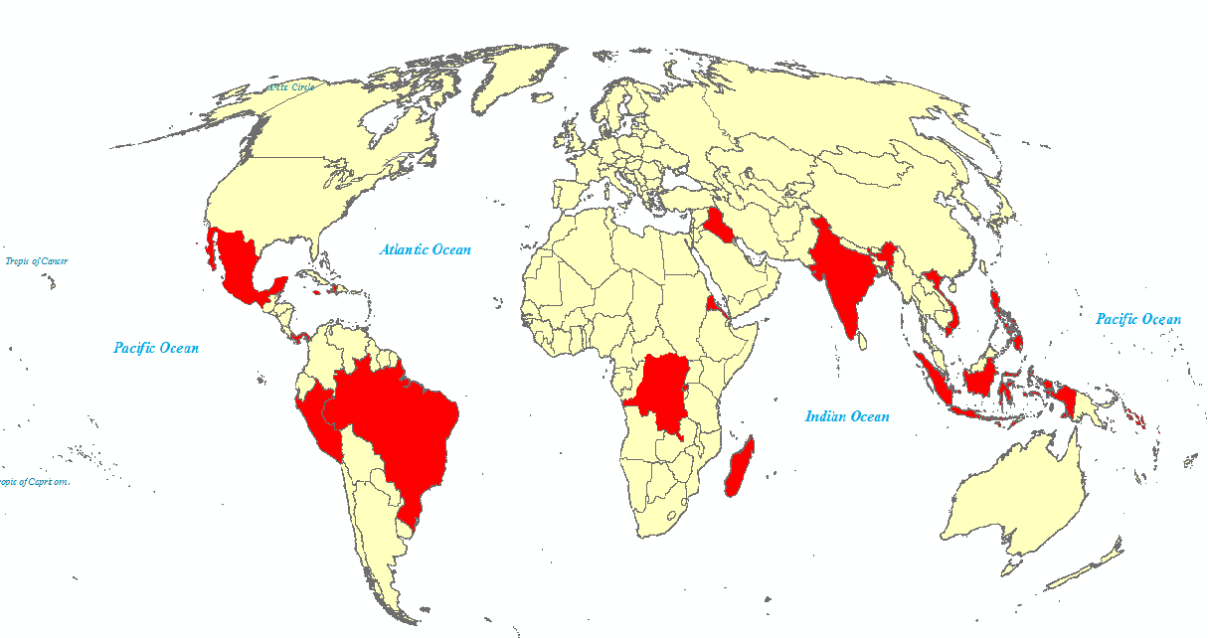

AZE sites are a recognized indicator for the CBD’s Aichi Biodiversity Targets 11 and 12. By protecting those AZE sites that are not yet included in protected areas systems, we can assure comprehensive global coverage of protected areas and guard against the loss of many of the most threatened species. Given that the loss or conversion of AZE sites would automatically cause the global extinction of the species for which they are identified, effectively conserving these areas is a fundamental to achieving Aichi Biodiversity Target 12.

As the [*Quick guide to the Aichi Biodiversity Targets*](https://www.cbd.int/doc/strategic-plan/targets/T12-quick-guide-en.pdf) explains for Target 12, “imminent extinctions of known threatened species can in many cases be prevented by protecting important habitats (such as Alliance for Zero Extinction sites).”

Moreover, AZE sites have been shown to have high value for carbon storage, ecosystem services, and cultural heritage, supporting other Aichi Biodiversity Targets.

In 2012, a [resolution](https://portals.iucn.org/library/sites/library/files/resrecfiles/WCC_2012_RES_15_EN.pdf) was passed at the IUCN World Conservation Congress to invite the world’s governments to give priority to protecting AZE sites and to request that the SSC and the WCPA encourage CBD Parties to support better protection of AZE sites.

AZE sites were also recognized in the Like-Minded Mega-Diverse Countries Carta to achieve Aichi Biodiversity Target 11, presented on the thirteenth meeting of the Conference of the Parties to the CBD, in Cancun, Mexico, on December 2016. LMMC have 61% of all identified AZE sites and, considering their relevant richness of biodiversity, this Carta calls the attention of all Parties to take concerted efforts for achieving this target.

**Links with Key Biodiversity Areas (KBAs)**

All AZE sites meet KBA criterion A1 (Threatened Species) and thus all AZE sites are KBAs. Currently, only two subsets of KBAs are globally comprehensive: Important Bird and Biodiversity Areas (IBAs) and AZE sites.

**Implementation**

There are 3 steps to implementing AZE protection:

1.    **Identify AZE sites.** AZE sites can be identified by using the IUCN Red List and a country’s national Red List to determine which CR and EN species are confined to single sites using nationally-available data and expert consultation. The current global AZE list (www.zeroextinction.org) provides a list of AZE sites.

2.    **Determine which AZE sites are currently protected.** Both national-level protected areas datasets and global datasets, such as the [World Database on Protected Areas](http://www.protectedplanet.net), can be consulted to determine which AZE sites are protected, partially protected and unprotected.

3.    **Safeguard unprotected AZE sites**. To achieve Aichi Targets 11 and 12, it is important to safeguard any unprotected AZE sites through national protected area planning or other effective area based conservation measures.

CBD supports incorporating AZE sites in the expansion of current protected area networks (Aichi Target 11), as safeguarding these sites increases the global protection of high biodiversity value sites. CBD also recommends that to implement Aichi Target 12, *“sites already identified through the Alliance for Zero Extinction could be protected, supplemented by additional work to identify, locate and protect threatened species.”* Parties can achieve Aichi Targets 11 and 12 simultaneously by linking them; governments can advantageously base the expansion of their protected area systems on the preservation of threatened species.

Parties have a great deal of flexibility in determining how best to safeguard AZE sites. As CBD explains, *“IUCN’S Guidelines for applying protected area management categories recognizes four broad types of governance of protected areas, any of which can be associated with any management objective. These categories include governance by government, shared governance, private governance, and governance by indigenous peoples and local communities.”*

One suggestion for safeguarding AZE sites is to begin by considering two levels of protection: any protection and “targeted” protection. A country’s first goal could be to achieve any level of official protection for all national AZE sites by a predetermined year, such as 2020. Since habitat destruction is the primary threat to the majority of AZE sites, providing an initial level of protection for AZE sites is the most urgently-needed step towards conserving their species.

A second and more long-term goal can be to work towards “targeted” protection for all AZE sites, with “targeted” defined on a case-by-case basis centered on the threats to and ownership of each site and the AZE species’ management needs. For example, some species may be endangered due to specific threats, such as invasive species, logging or trafficking. Working to reduce or eliminate these threats will be key to the long-term persistence of such species.

|  |  |
| --- | --- |
| **Level 1: Any protection** | **Level 2: Targeted protection** |
| Any level of official protection for unprotected or partially-protected AZE sites | Protection based on threats to the sites on a case-by-case basis centered on the threats to and ownership of each site |
| Timeframe: Enacted by a predetermined year | Timeframe: Ongoing |
| Goal: All unprotected or partially-protected AZE sites receive a basic level of official protection. | Goal: Some sites are at risk due to specific threats, such as invasive species, trafficking, or logging. Working to reduce or eliminate these threats will be key to the long-term persistence of such sites. |

A CBD Decision on AZE would encourage Parties to adopt initiatives towards the better protection of AZE sites and to promote the incorporation of AZE sites in national legislations, considering that Parties could achieve Aichi Targets 11 and 12 simultaneously by linking them and governments can advantageously base the expansion of their protected area systems on the preservation of threatened species.

1. **SUGGESTED RECOMMENDATION**

The Subsidiary Body on Scientific, Technical and Technological Advice may wish to recommend that the Conference of the Parties adopt a decision along the following lines:

*The Conference of the Parties*

*Noting* that, according to GBO-4, countries need to develop more representative and better managed protected area systems, prioritizing sites of particular importance to biodiversity, especially those containing unique populations of endangered species, in order to achieve Target 11 and 12,

*Recognizing* that Alliance for Zero Extinction is a global initiative comprising biodiversity conservation organization aiming to prevent extinctions by identifying and safeguarding key sites where species are in imminent danger of disappearing,

*Further noting* that Key Biodiversity Areas contribute to the decision XI/13 B on the identification of scientific and technical needs related to the implementation of the Strategic Plan for Biodiversity 2011-2020, as mentioned in the SBSTTA-17-INF-10, and all Alliance for Zero Extinction sites (AZE sites) meet KBA criterion A1 (Threatened Species) and therefore are KBAs,

*Further noting* that AZE sites are defined by 3 criteria: they must hold at least 1 CR or EN species, they must contain the overwhelmingly significant known resident population (>95%) of the EN or CR species OR over 95% of the population at one life history segment, and they must have definable boundaries,

*Recalling* the Memorandum of Cooperation between the Secretariat of the Convention on Biological Diversity and the Alliance for Zero Extinction, entered into effect in 2010,

Recalling the Like-Minded Mega-Diverse Countries Carta to achieve Aichi Biodiversity Target 11, presented in the thirteenth meeting of the Conference of the Parties to the Convention on Biological Diversity, in Cancun, Mexico, on December 2016, which notes that the LMMC have 61% of all identified AZE sites and urges all partners to take concerted efforts for achieving Aichi Target 11;

*Considering* the Resolution 015 – Saving the world’s most threatened species, approved by the IUCN World Conservation Congress in 2012, which invites the world’s governments to give priority to protecting sites for single-site restricted Endangered and Critically Endangered species, as a contribution to meeting their commitments under the Convention on Biological Diversity, particularly Aichi Targets 11 and 12;

*1. Welcomes* the information document provided in the Note on Alliance for Zero Extinction as an initiative that helps countries to accelerate progress toward Aichi Biodiversity Targets 11 and 12,

2. *Encourages* Parties and *invites* other Governments, as appropriate and taking into account national circumstances, to support initiatives towards the better protection of AZE sites,

3. *Requests* the Executive Secretary, subject to the availability of resources, and *invites* relevant organizations, to support the national implementation of AZE sites, as appropriate, within their competencies, through collaboration on, among other things, the following activities:

(a) Give technical support to promote the incorporation of AZE sites in national legislations, recognizing this tool as a conservation instrument,

(b) Support countries in identifying and updating their AZE sites,

(c) Compile national, subregional or regional experiences in the implementation of AZE sites, in collaboration with Parties and other Governments, and disseminate them through the clearing-house mechanism of the Convention and relevant online information-sharing mechanisms,

(d) Develop linkages with other work under the Convention or other relevant international and/or regional agreements and programmes;

(e) Explore opportunities to test guidance and best practices and to facilitate capacity development, including through capacity development workshops as well as through on‑the-ground implementation;

4. *Encourages* parties to include activities focused on improved AZE site protection in their project portfolios for potential GEF funding;

5. *Further encourages* parties to consider AZE sites in strategies of increasing protected areas systems.

__________

1. * Reissued for technical reasons on 6 June 2018.
2. ** CBD/SBSTTA/22/1.