 |  | CBD
 |  | Distr.  GENERAL  CBD/SBI/2/INF/18  22 June 2018  ENGLISH ONLY
SUBSIDIARY BODY ON IMPLEMENTATION
Second meeting
Montreal, Canada, 9-13 July 2018
Item 11 of the provisional agenda*

FOREST ECOSYSTEM RESTORATION INITIATIVE – REVIEW OF IMPLEMENTATION FOR THE PERIOD 2015-2017 AND OUTLOOK FOR 2018-2020

Note by the Executive Secretary
- INTRODUCTION AND BACKGROUND
- At its eighteenth meeting, the Subsidiary Body on Scientific, Technical and Technological Advice (SBSTTA) of the Convention on Biological Diversity (CBD) welcomed the actions being undertaken by the Republic of Korea, through the Korea Forest Service, to develop a Forest Ecosystem Restoration Initiative (FERI). The FERI was launched in October 2014 on the margins of the twelfth meeting of the Conference of the Parties to the Convention with the aim of supporting ecosystem restoration activities under the Convention in line with decisions XI/16 and XII/19 and Article 8 (f) of the Convention, and of contributing to the achievement of the Aichi Biodiversity Targets, in particular Targets 5, 14 and 15. Document UNEP/CBD/COP/12/INF/19, describing FERI, was presented to the Parties on this occasion.
- The Secretariat of the Convention on Biological Diversity and the Korea Forest Service of the Government of the Republic of Korea signed a memorandum of understanding (MOU) in March 2015, on the margins of the Bonn Challenge 2.0 meeting, in Bonn, Germany. The MOU set out the vision to 2020 for the six-year initiative and a workplan for 2015-2016. To promote collaborative engagement in the design, implementation and review of the workplan, a planning meeting was held in March 2015 with partner organizations.1 The vision of FERI for 2020 is to increase developing countries’ capacity for undertaking restoration assessments and plans, in a manner that contributes to countries’ national restoration commitments, in particular those reflected in national biodiversity strategies and action plans (NBSAPs).
- Document UNEP/CBD/COP/13/INF/10 reported on progress under the initiative for the period 2015-2016, and concluded on the need to deepen existing and develop new working relationships with technical and financing partners, including the World Resources Institute (WRI), the International Union for Conservation of Nature (IUCN), the United Nations Environment Programme’s World Conservation Monitoring Centre (UNEP-WCMC), the Society for Ecological Restoration, the International Union of Forest Research Organizations (IUFRO), the International Tropical Timber Organization (ITTO), the Food and Agriculture Organization of the United Nations (FAO), the Global Mechanism of the United Nations Convention to Combat Desertification (UNCCD), the Global Environment Facility (GEF), and private sector entities, to ensure that tools developed can best support the planning, implementation and reporting on Aichi Biodiversity Targets 5, 14 and 15.
- At its thirteenth meeting, the Conference of the Parties adopted a short-term action plan on ecosystem restoration, as a flexible framework, adaptable to national circumstances and legislation, for immediate action towards achieving Aichi Biodiversity Targets 5, 12, 14 and 15 (decision XIII/5) and welcomed, in the same decision, the progress made in the implementation of the Forest Ecosystem Restoration Initiative, supported by the Korea Forest Service of the Republic of Korea. Since its adoption, the Short-Term Action Plan on Ecosystem Restoration, has provided a framework of reference for action by the FERI in its support to countries. The structure of the Plan was reflected, for example, in that of the regional capacity-building workshop conducted in 2017 in Durban, South Africa.
- The present note provides a description, in section II, of the activities undertaken by the CBD Secretariat in implementing the FERI over the period 2015-2017 and outlook for 2018-2020. These activities fall under four main axes of implementation: (a) capacity-building activities, (b) direct support to restoration planning (c) outreach and communication activities and (d) knowledge products. Outputs from these various activities are all available on a dedicated FERI website (www.feri-biodiversity.org).
II. REVIEW OF IMPLEMENTATION FOR THE PERIOD 2015-2017 AND OUTLOOK FOR 2018-2020
- Capacity-building activities
- A key component of the FERI is the building of capacity of CBD parties on the restoration of degraded ecosystems. From 2015 to 2017, a total of 5 workshops were held in the following regions of the United Nations: Western Africa (Accra, October 2015); South America, Central America, Caribbean (only Cuba) (Bogota – April 2016); Eastern Asia, Southern Asia, Southeastern Asia (Bangkok – July 2016); Northern Africa, Southern Europe (Agadir, Morocco – March 2017); Middle Africa, Eastern Africa, Southern Africa (Durban, South Africa – September 2017).
- ‘Country dossiers’ have been prepared for each of the participant countries prior to workshops, summarizing their national targets and commitments with regards to ecosystem loss and restoration. These dossiers are then used as support for interactive sessions during the workshops, whereby participants are invited to reflect on improvements that could be made to their national targets to make them more specific and better aligned. All individual country dossiers can be accessed at: www.feri-biodiversity.org/country-data.
- In 2017, the Initiative organized its largest workshop to date, gathering participants from three regions of Africa. The Durban workshop also saw the introduction of a new format called ‘restoration clinics’, whereby a panel of restoration specialists was invited to each present their area of expertise, before leading small breakout group discussions tailored to the needs of the participants. The success of this approach is reflected in the results of the workshop evaluation by the participants, which show a clear progress in the stated knowledge gain in this area (see Figure 2).
- Capacity-building activities will continue in 2018 with a workshop in the Pacific region, with a likely focus on the restoration of coastal mangrove ecosystems and their role in climate adaptation and disaster-risk reduction. The remaining regions (Central Asia and Eastern Europe, Caribbean and other SIDS) will be covered by an additional two workshops in 2019 and 2020.
Figure 1 - Results from the post-workshop evaluation questionnaire to participants
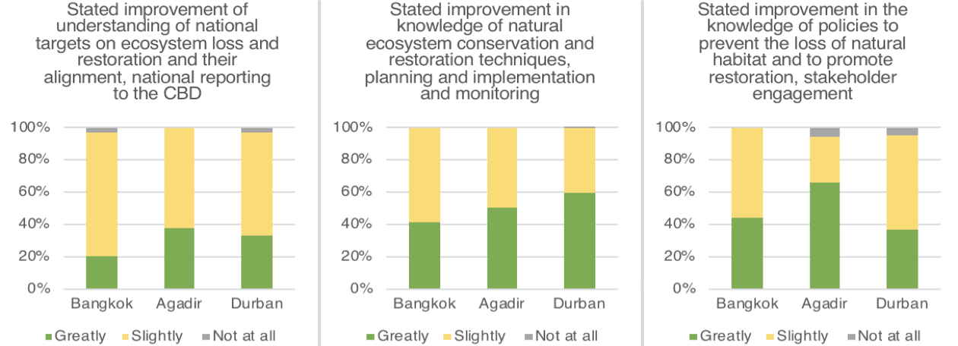

- Direct support to restoration planning
- One of the main implementation channels of the FERI is to provide direct financial and technical support to pilot restoration activities in countries parties to the CBD. These pilot projects should serve to test a variety of innovative restoration techniques and compile and disseminate lessons learned that can be used in similar restoration contexts.
- The selection of projects funded by the FERI follows a competitive process. Following the call for FERI project submissions, launched by the CBD Secretariat in February 2017, a total of 85 submissions were received from 41 countries. On July 3, 2017, the Forest Ecosystem Restoration Initiative decided on granting funding up to 100,000 US$ to six restoration projects in Bhutan, Cambodia, Kenya, Madagascar, Mexico, and Peru.
- The projects were selected by an expert committee for their strong local community involvement, long-term monitoring approach and focus on critical ecosystem services. More information about the projects can be found on the FERI website, which will be updated with new project profiles in 2018 as new funding agreements are signed).
- Implementation of the direct support projects is already well under way in Colombia and Chile and has started in Lebanon and Peru. In 2017, visits by the FERI team were given to the projects in Colombia, Chile and Peru. The visits offered an opportunity to better define the objectives of the projects and discuss the linkages with national restoration frameworks, in direct consultation with national and regional authorities.
- Further funding agreements have been signed at the beginning of 2018 with Aghrymet, for a research project on the benefits of restoration in Burkina Faso and Niger, and in Kenya with Brackenhurst botanical gardens on capacity- building of local government staff on ecological restoration. The remaining funding agreements will also be signed with Guatemala, Mexico, Madagascar and Cambodia in Q2 2018.
- Outreach and communication activities
- Over the period 2015-2017, the FERI was represented at a number of ‘outreach events’ aimed at coordinating with relevant initiatives and showcasing its impact. This includes side-events at meetings of the CBD Subsidiary Bodies and Conference of the Parties (SBSTTA 20 in Montreal, April 2016; COP 13 in Cancun, December 2016; SBSTTA 21 in Montreal, November 2017), as well as FERI representation at various events such as meetings of the Bonn Challenge (Honduras, May 2016), Global Partnership on Forest Landscape Restoration and Global Landscape Forum (Bonn, December 2017).
- In 2017, the FERI also organized its first ‘FERI Academy’, in partnership with the World Conference on Ecological Restoration organized by the Society for Ecological Restoration in Iguazu, Brazil, from August 27 to September 1. The SER 2017 conference programme featured world-renowned keynote and plenary speakers as well as numerous symposia, training workshops, concurrent sessions, and technical field trips. FERI sponsored the participation of 8 representatives from its direct support projects.
- Through five days of seminars, training sessions and participative forums, this activity aimed to further develop the knowledge of FERI project leaders on restoration science and standards of best practice, but also their capacity to disseminate the findings of their projects and promote the scaling-up of restoration activities with their national governments and other partners.
- In 2018, the results of the consultative sessions held at the conference will be used to develop an evaluation framework for monitoring the projects’ impact. Interviews with the FERI-sponsored participants during the conference have also been used to develop video communication material on each project for the website (see links below).
- For the period 2018-2020, as FERI direct support projects start to bear fruits, budget allocation for this activity will be increased to allow for the travel of implementation partners to these meetings to showcase results and share lessons learned from the restoration models tested on the ground.
- Knowledge products
- In 2017, the FERI collaborated with the SER, PARTNERS for the publication of a policy brief on Natural Regeneration. Titled ‘Partnering with Nature: The case for natural regeneration in forest and landscape restoration’. The document aims at increasing awareness of the cost-effectiveness and benefits of natural regeneration as a restoration intervention. It makes specific recommendations for policy changes that could enhance the role of natural regeneration in ecological restoration interventions and as an integral component of forest and landscape restoration. The document can be downloaded at www.feri-biodiversity.org/resources in English, Spanish and French.
- Further knowledge products are planned for 2018 such as a policy brief on biodiversity and restoration, an update to the note by the Executive Secretary on restoration of forest ecosystems and landscapes as contribution to the Aichi Biodiversity Targets (UNEP/CBD/COP/13/INF/11), produced in collaboration with IUCN, as well as a companion document to the Short-Term Action Plan for Ecosystem Restoration which will provide illustrative case studies and indications of further technical support available under the various steps of the plan.
__________

* CBD/SBI/2/1.
Workshop materials can be accessed at https://www.feri-biodiversity.org/durban

