 |  | CBD/COP/17/INF/15-CBD/CP/MOP/12/INF/7-CBD/NP/MOP/6/INF/2

 | Distr.: General  10 September 2026  English only

Conference of the Parties to the Convention on Biological Diversity  Seventeenth meeting  Yerevan, 19–30 October 2026  Item 19 of the provisional agenda*  Review of the effectiveness of processes under the Convention on Biological Diversity and its Protocols | Conference of the Parties to the Convention on Biological Diversity serving as the meeting of the Parties to the Cartagena Protocol on Biosafety  Twelfth meeting  Yerevan, 19–30 October 2026  Item 12 of the provisional agenda*  Review of the effectiveness of processes under the Convention on Biological Diversity and its Protocols | Conference of the Parties to the Convention on Biological Diversity serving as the meeting of the Parties to the Nagoya Protocol on Access to Genetic Resources and the Fair and Equitable Sharing of Benefits Arising from their Utilization  Sixth meeting  Yerevan, 19–30 October 2026  Item 14 of the provisional agenda*  Review of the effectiveness of processes under the Convention on Biological Diversity and its Protocols
Compilation of views from Parties on the modalities for a possible Party-driven process to further improve the effectiveness of the processes and meetings under the Convention on Biological Diversity and its Protocols**
Note by the Secretariat

I. Introduction
- Pursuant to subparagraph 1 (a) of recommendation 6/8 of the Subsidiary Body on Implementation, the Executive Secretary issued notification No. 2026-036 inviting Parties to submit their views on the modalities for a possible Party-driven process to further improve the effectiveness of the processes and meetings under the Convention on Biological Diversity and its Protocols.

II. Submissions
- Submissions were received from the following Parties: Brazil, Canada, European Union and its member States, Japan, Mexico, Niger, Norway and the Russian Federation. The submissions are reproduced in the annex to the present note in the form and language in which they were received by the Secretariat.
Annex
Submissions received from Parties on the modalities for a possible Party-driven process to further improve the effectiveness of the processes and meetings under the Convention on Biological Diversity and its Protocols
Brazil
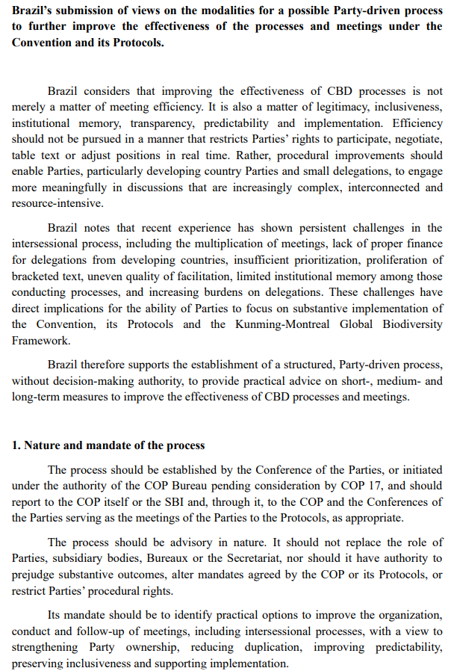
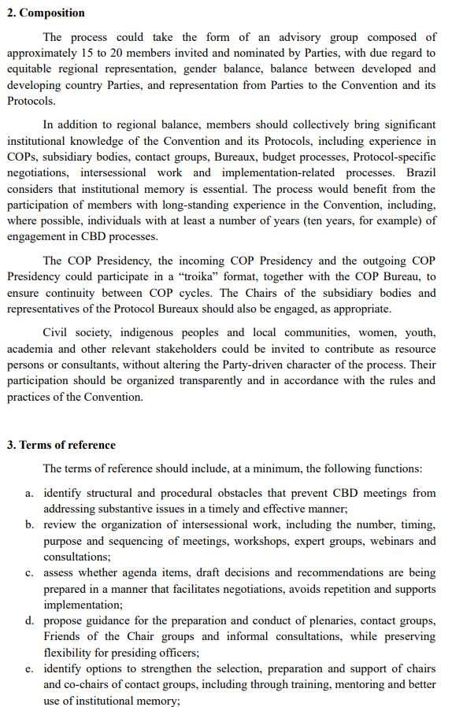
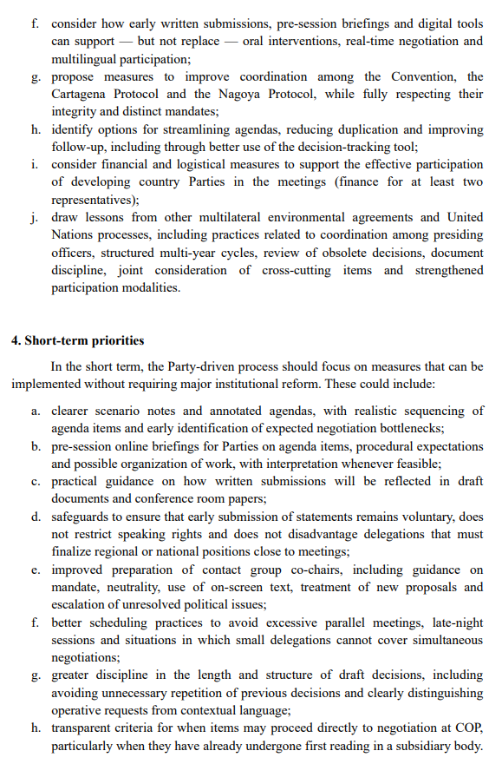
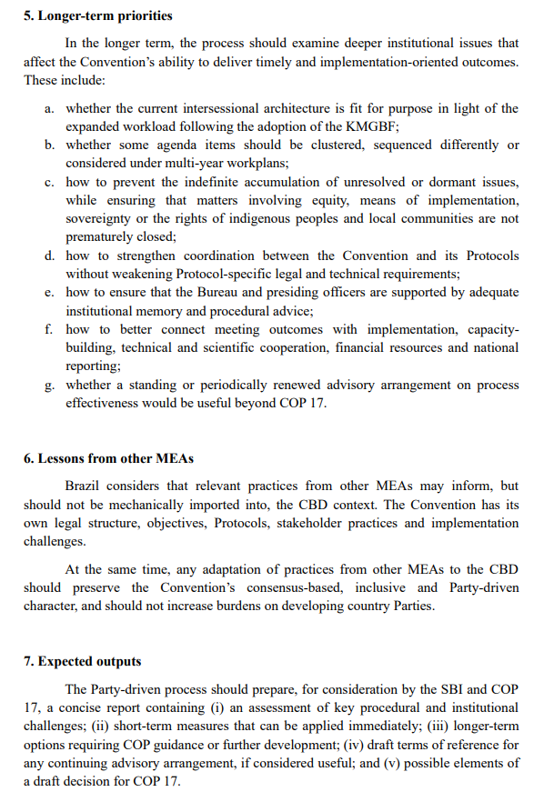
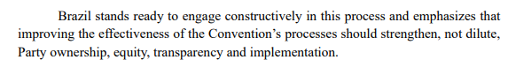

Canada

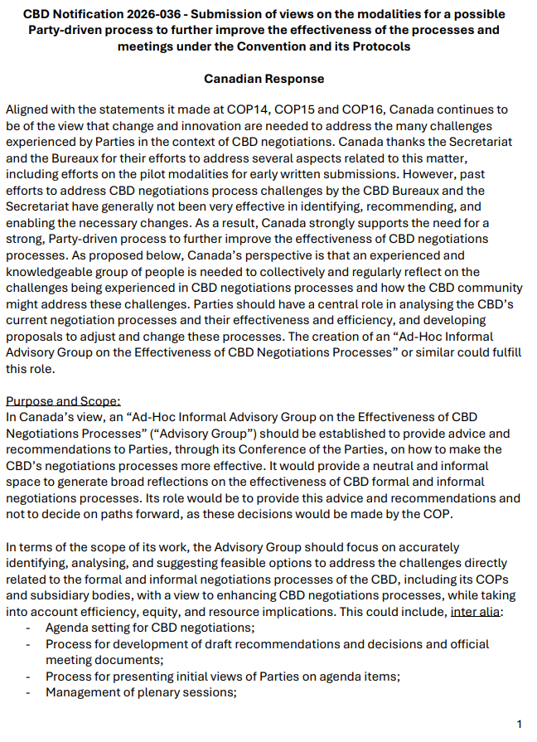
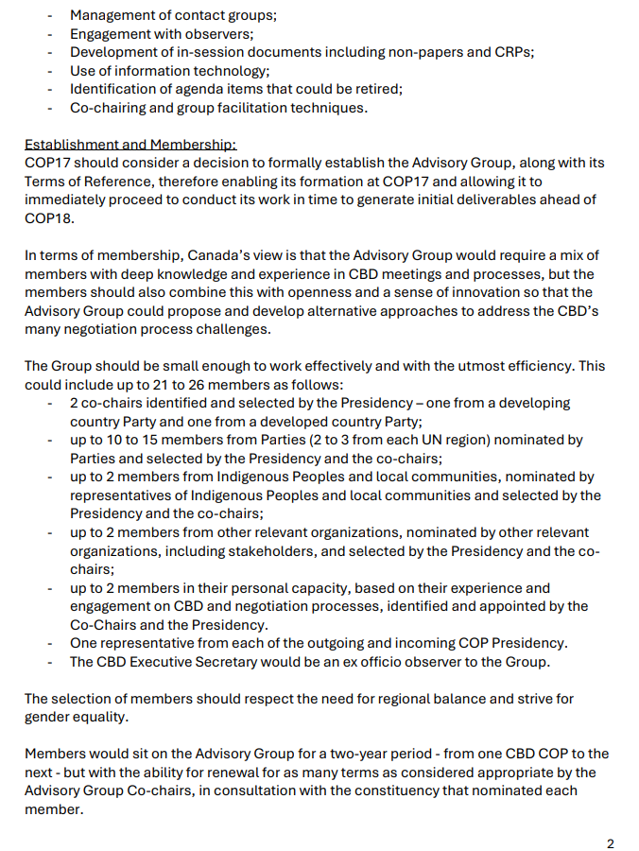

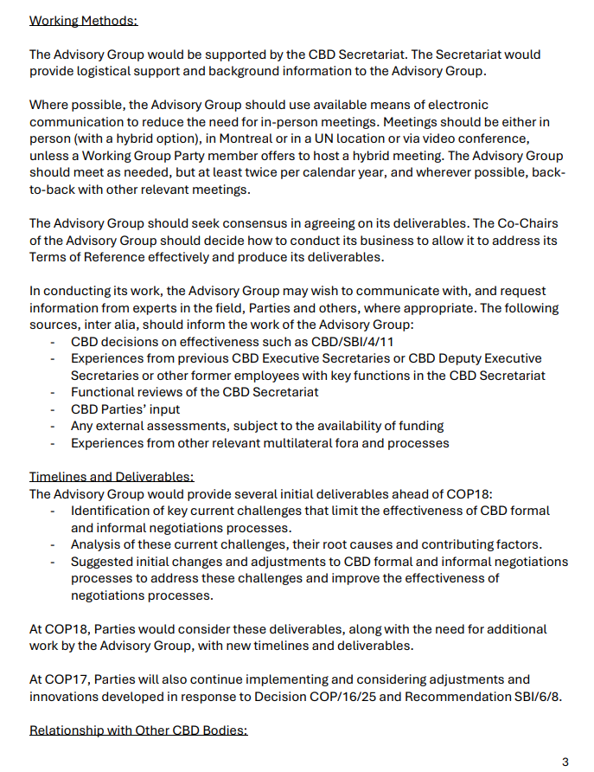
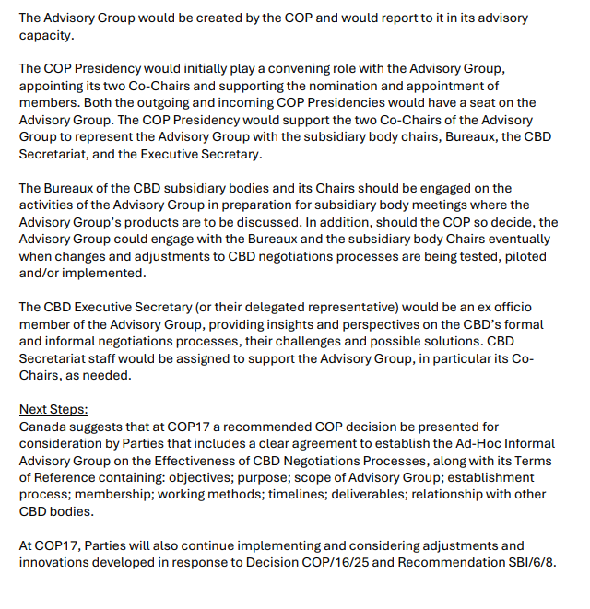

European Union and its member States
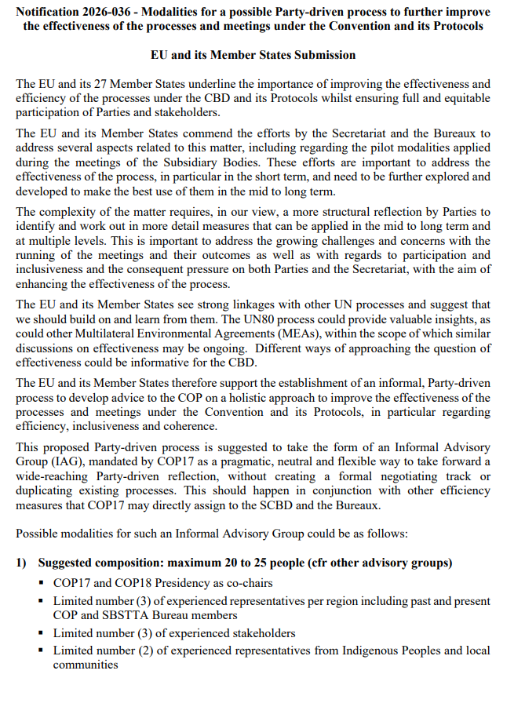
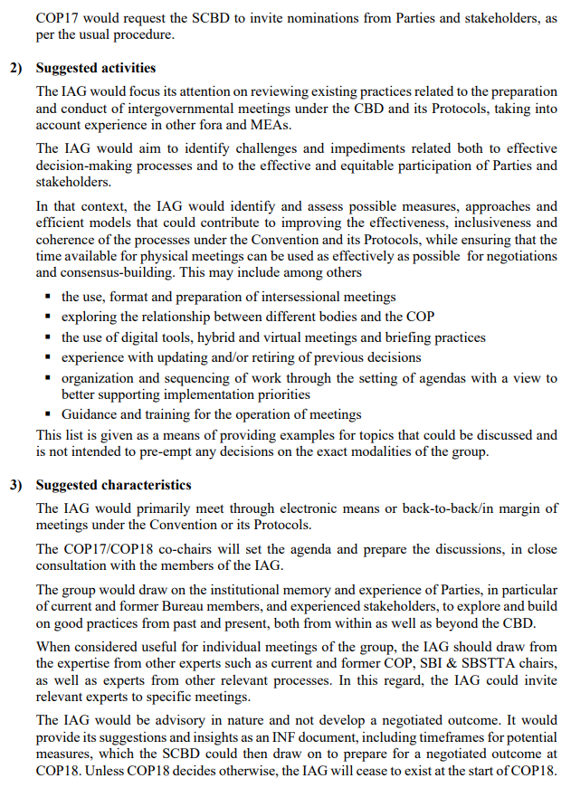
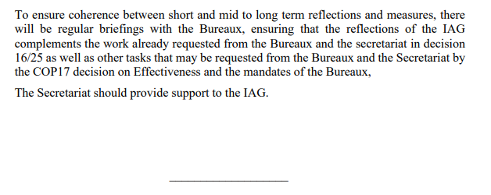

Japan

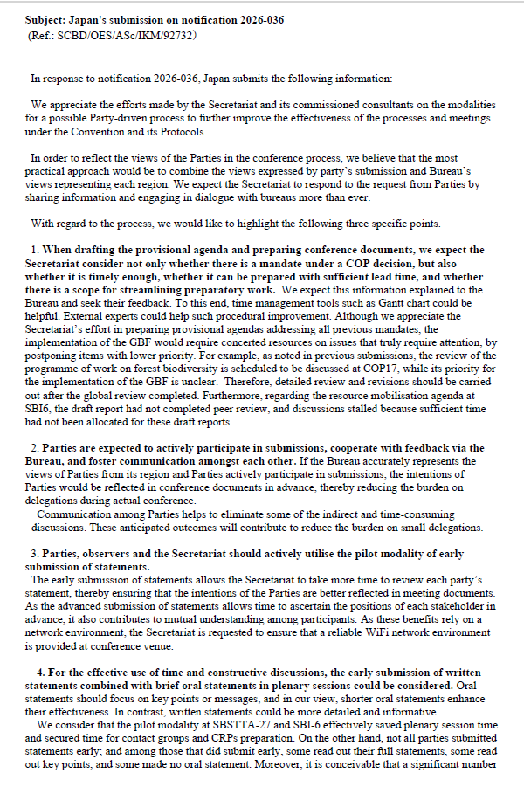

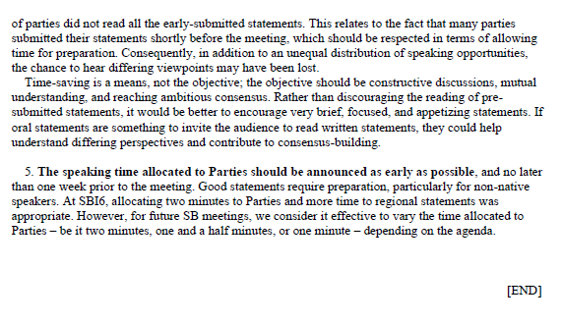

Mexico

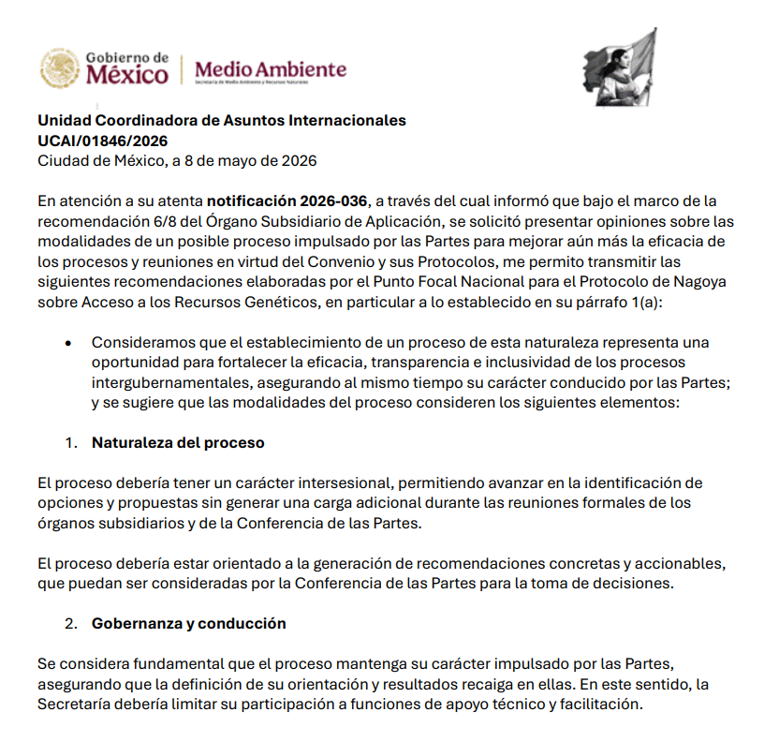

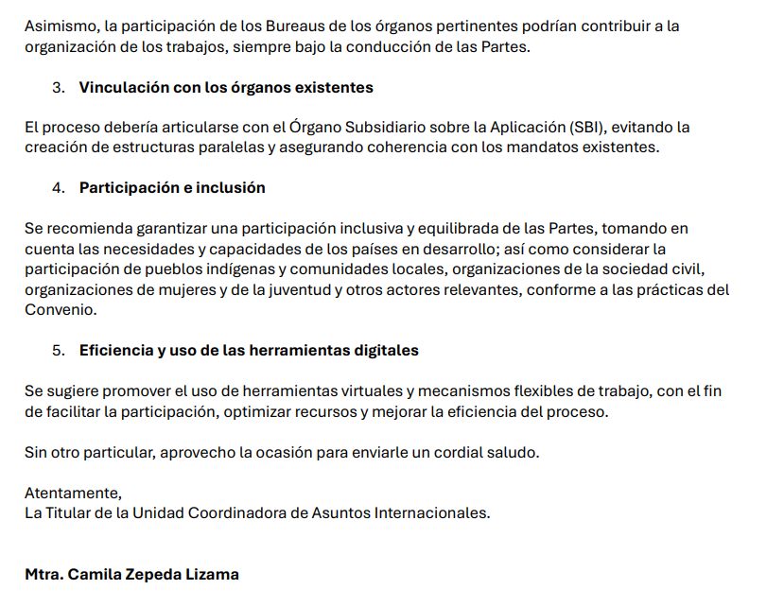

Niger

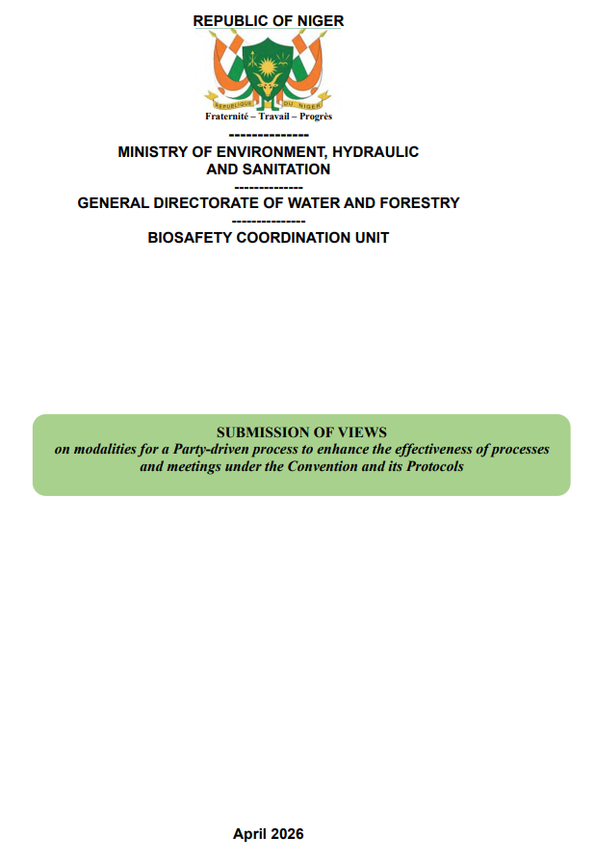
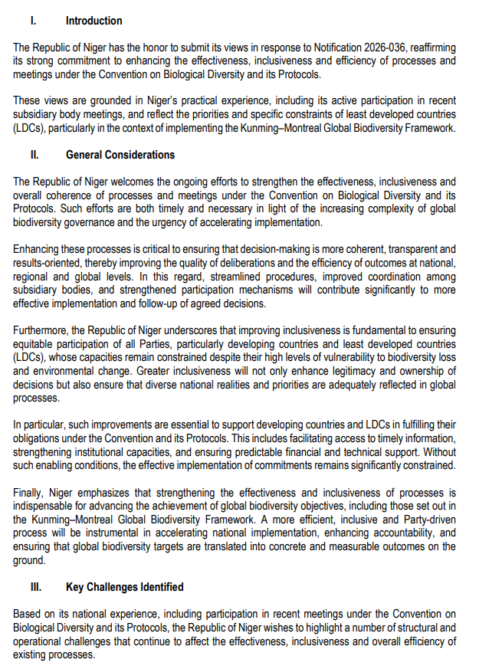
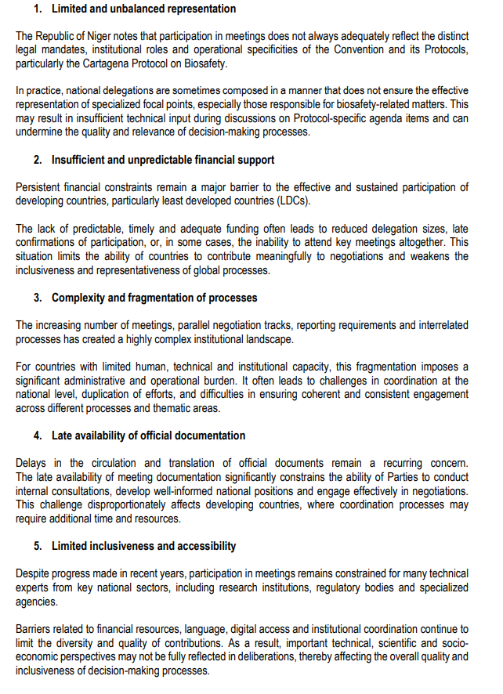
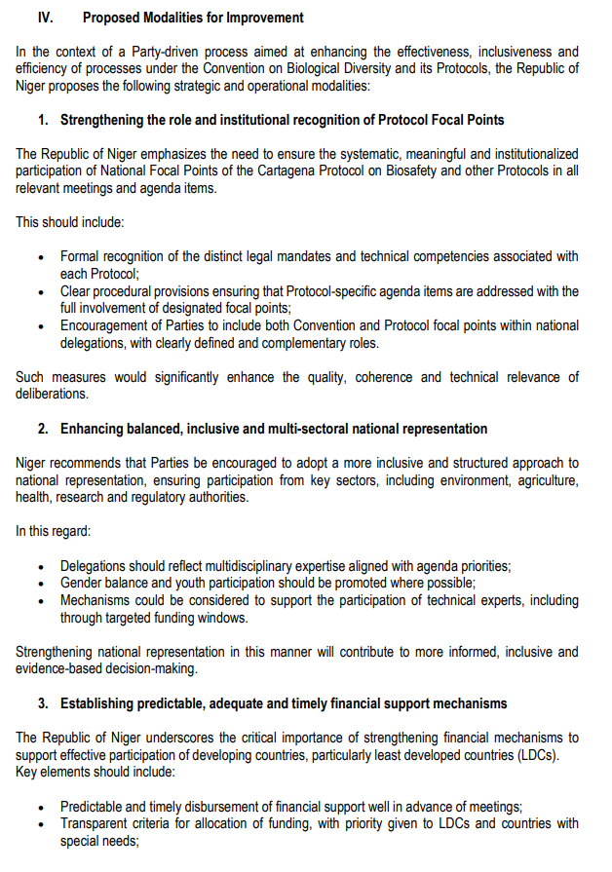
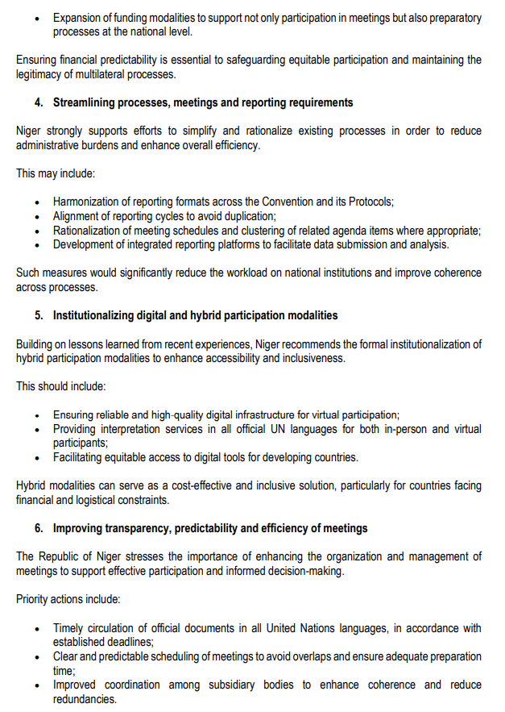
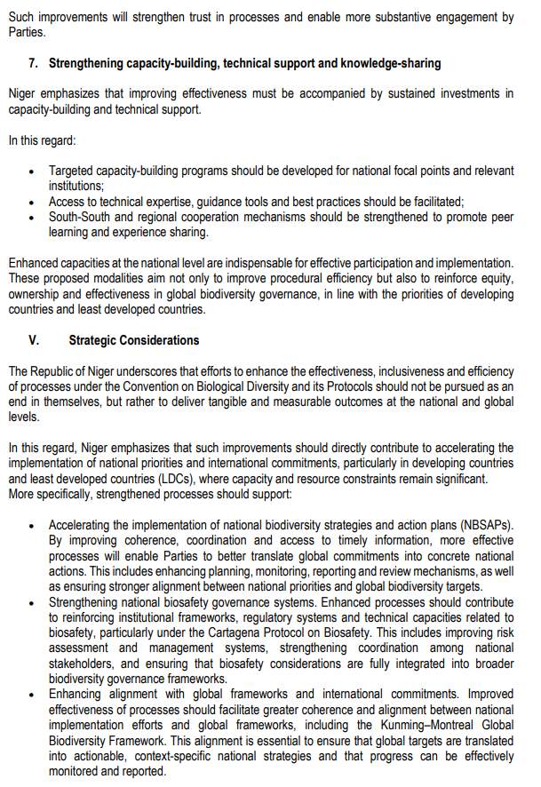
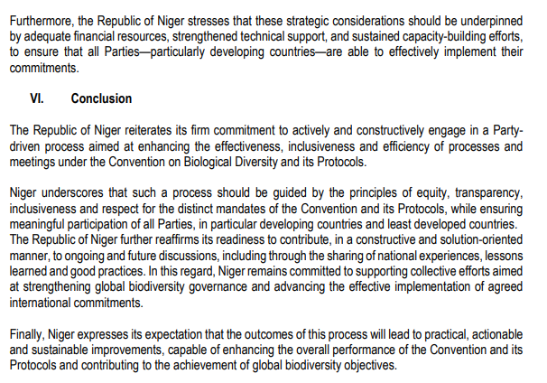
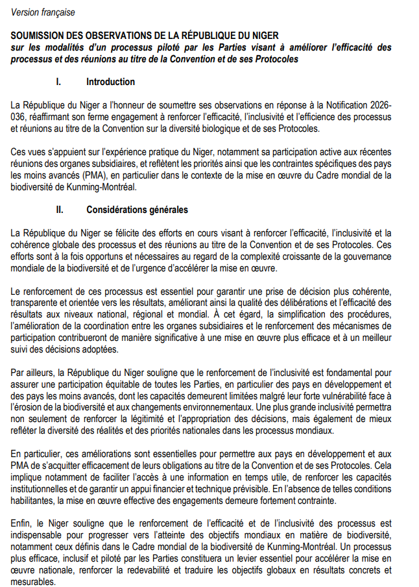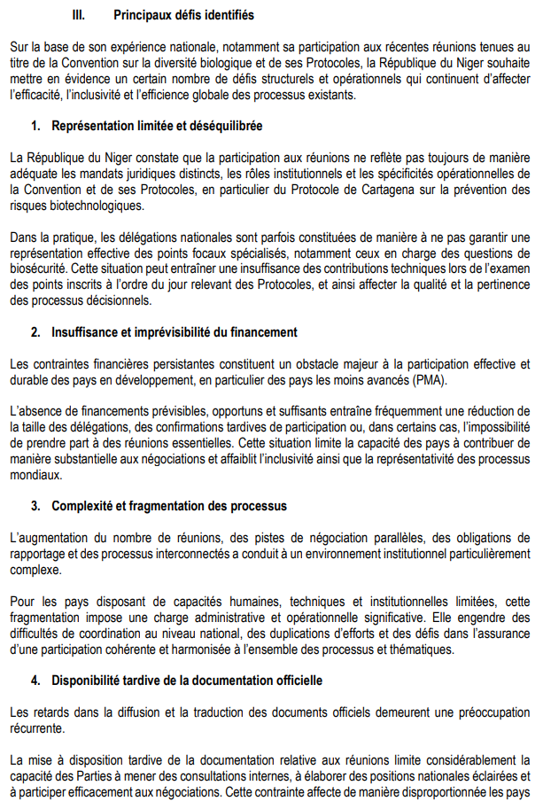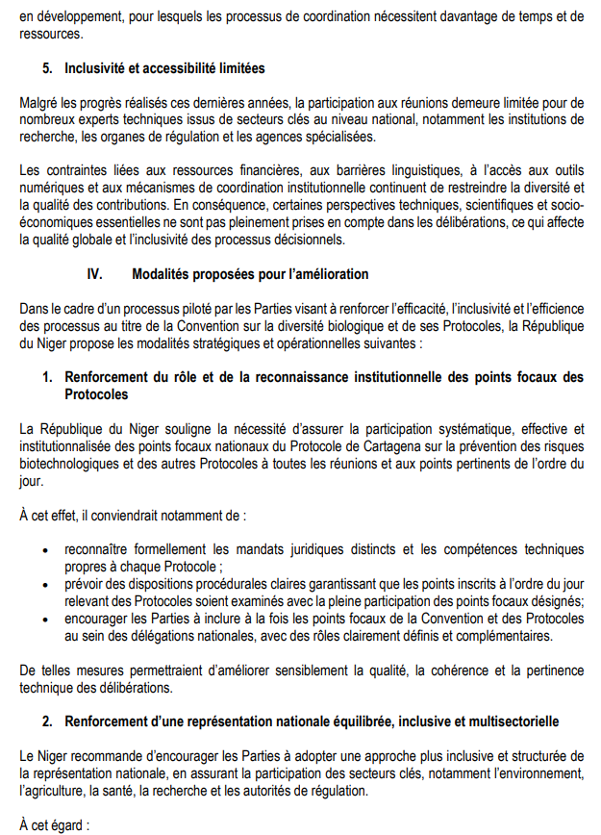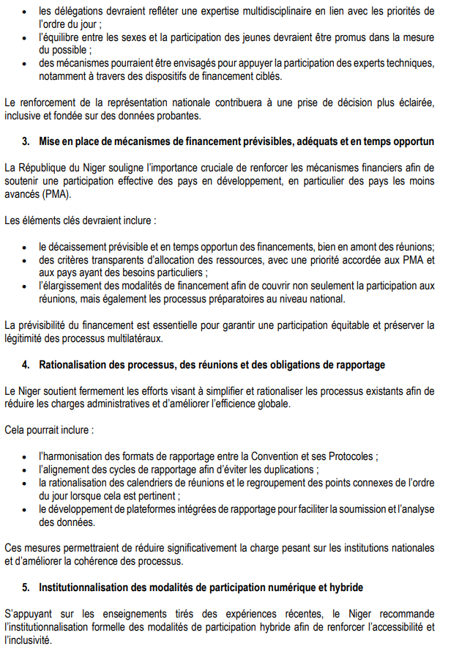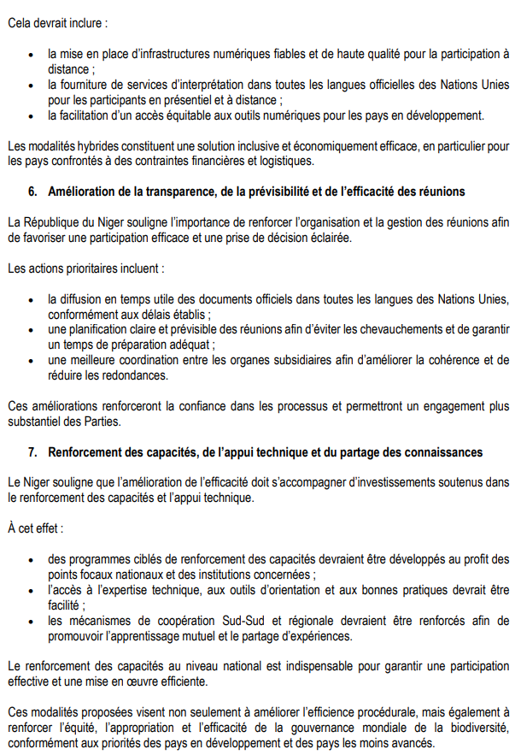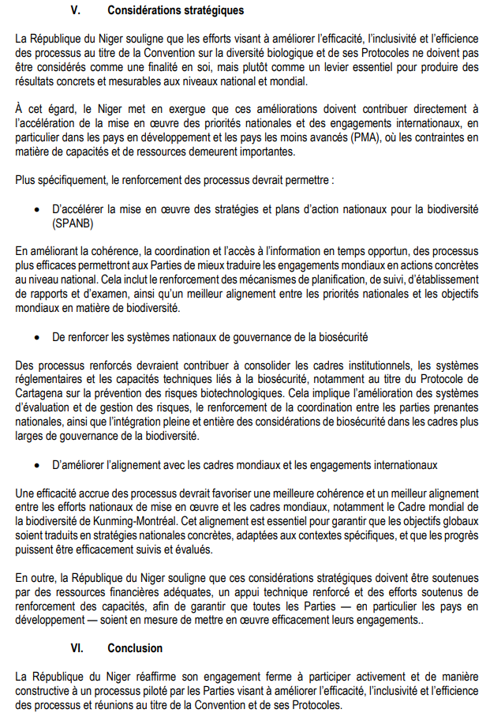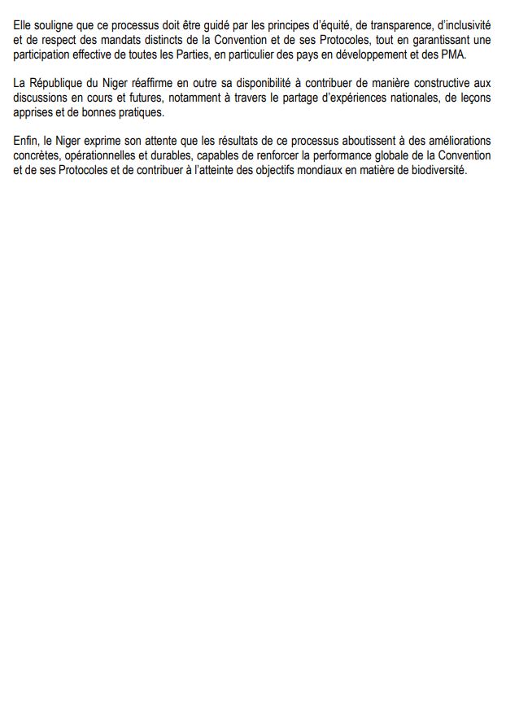

Norway
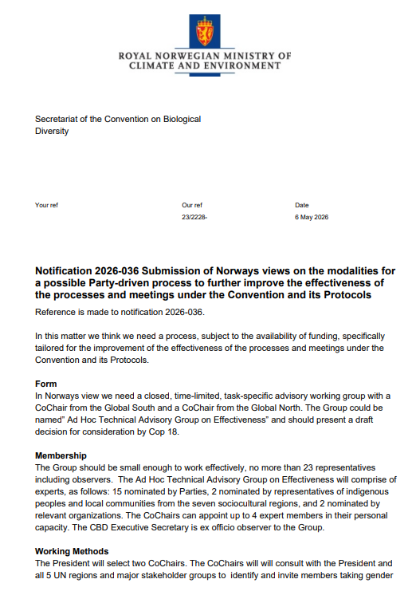

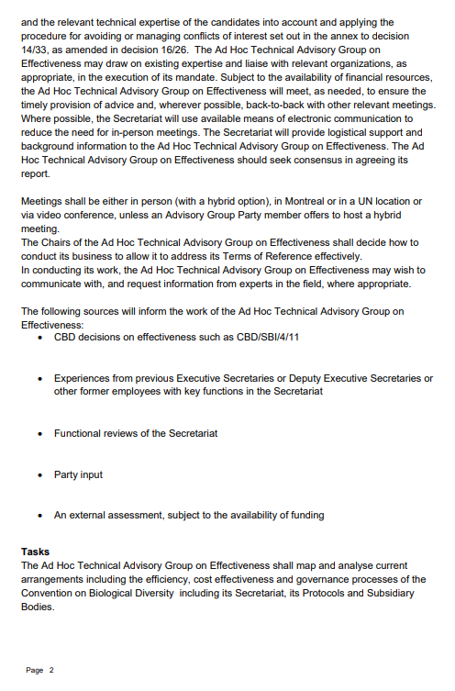

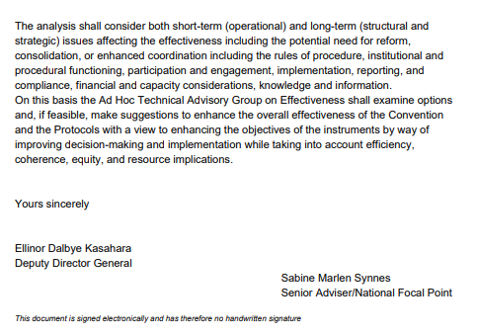

Russian Federation

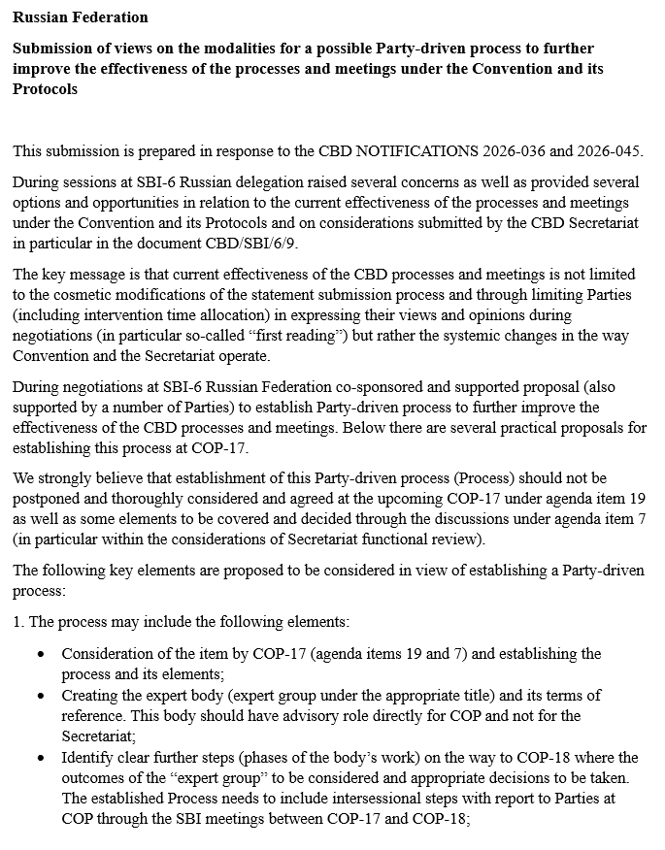
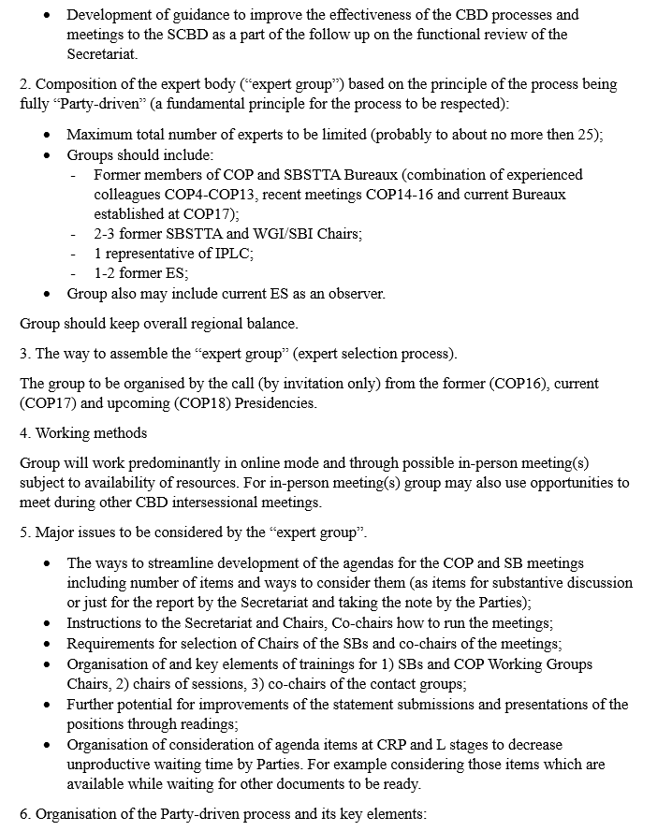
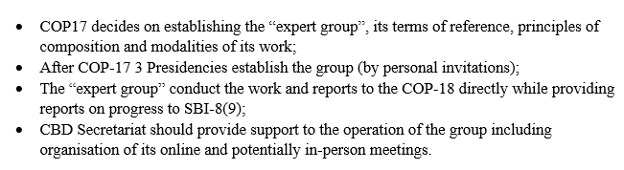
__________

* CBD/COP/17/1/Rev.1, CBD/CP/MOP/12/1 and CBD/NP/MOP/6/1, respectively.
** The present document is being issued without formal editing.
The submissions are also available on the clearing-house mechanism website at https://www.cbd.int/notifications/2026-036.

