 |  | CBD
 |  | Distr.  GENERAL  CBD/COP/15/6  2 December 2022  ORIGINAL: ENGLISH
CONFERENCE OF THE PARTIES TO THE CONVENTION ON BIOLOGICAL DIVERSITY
Fifteenth meeting – Part II
Montreal, Canada, 7-19 December 2022
Agenda item 7
REPORT OF THE EXECUTIVE SECRETARY ON THE INCOME AND BUDGET PERFORMANCE FOR THE CONVENTION ON BIOLOGICAL DIVERSITY, THE CARTAGENA PROTOCOL ON BIOSAFETY AND THE NAGOYA PROTOCOL ON ACCESS AND BENEFIT-SHARING FOR THE BIENNIUM 2019-2020, 2021 AND 2022

Introduction
- The Conference of the Parties at its fourteenth meeting (COP) and the respective meetings of the Parties of the Cartagena and Nagoya Protocols (MOP) requested Executive Secretary to report to the Conference of the Parties at its fifteenth meeting on income and budget performance, unspent balances and the status of surplus and carry-overs as well as any adjustments made to the budget for the biennium 2019-2020 (decision 14/37, para. 50).
- Due to the pandemic, the fifteenth meeting of the Conference of the Parties (COP-15) and related meetings were postponed. As the Secretariat’s funding would otherwise expire on 31 December 2020, an interim budget for 2021 was submitted and subsequently approved on 27 November 2020 by the extraordinary meeting of the Conference of the Parties to the Convention and by the meetings of the Parties to the Protocols (decisions EM-2/1, CP-EM-1/1, and NP-EM-1/1), as supplementary to decisions 14/37, CP-9/16 and NP-3/16.
- The pandemic led to further rescheduling of COP-15 and the concurrent meetings of the Parties to the Protocols. An interim budget for 2022 was submitted and subsequently approved by the Conference of the Parties at the first part of its fifteenth meeting, and by the Parties to the Protocols at the first part of respectively the tenth meeting of the Parties to Cartagena Protocol (CP-MOP-10) and of the fourth meeting of the Parties to the Nagoya Protocol (NP-MOP-4), in Kunming, China, in October 2021. In paragraph 2 of decision 15/1, Parties also confirmed the extension of parts of the 2019/2020 budget until after the end of the second part of COP-15 and the core budget for 2021, as set out in its decision EM-2/1, pending consideration and adoption of the programme budget for the biennium 2023-2024 by the Conference of the Parties, at the second part of its fifteenth meeting.
- Following a request by the Parties in decision 14/37, paragraph 22, the Secretariat has also been subject to three audits since the fourteenth meeting of the Conference of the Parties: one by the Office of Internal Oversight Services (OIOS) in 2019 and two by the United Nations Board of Auditors (BOA), in 2020 and 2021 respectively. These audit reports have been posted on the CBD website. In addition, a summary of follow-up actions taken to implement relevant recommendations of the oversight bodies has been presented as annex II to document CBD/COP/15/7.
- The present document reports on the financial and administrative performance of the Secretariat for the biennium 2019-2020 and for 2021. In addition, information is provided for fiscal year 2022 as of 31 October 2022. The document is divided into five sections. Section I provides an overview of the legislative mandates, while section II addresses the income and budget performance for the biennium 2019-2020. Sections III and IV contain information on the income and budget performance for 2021 and 2022 respectively, and section V provides information on other financial and other administrative matters.
- This document should be read in conjunction with the notes by the Executive Secretary on the proposed budget for the programme of work for the biennium 2023-2024 (CBD/COP/15/7), as well as the preliminary analysis of the structure and staffing of the Secretariat in view of the orientation of activities under the Convention and its Protocols, including the post-2020 global biodiversity framework (CBD/COP/15/7/Add.1).
- Additional information on the status of contributions to the BY, BG, BB, BE, BZ and VB trust funds as of 31 October 2022, and the financial statements for 2019, 2020 and 2021 are available on the Secretariat website.

Income and financial performance for the biennium 2019-2020

Status on Assessed Contributions
- By its decision 14/37, the Conference of the Parties adopted an integrated programme of work and a budget for the Convention on Biological Diversity, the Cartagena Protocol on Biosafety and the Nagoya Protocol on Access and Benefit-sharing. In paragraph 2 of the same decision, the Parties decided to share the costs for secretariat services among the Convention, the Cartagena Protocol, and the Nagoya Protocol on a ratio of 74:15:11 for the biennium 2019-2020. The budgets were also approved mutatis mutandis in the respective meetings of the Parties to the Protocols (CP-9/16 and NP-3/16).
- The integrated budget of $18,948,900 and $19,895,200 was approved for 2019 and 2020, respectively, amounting to $38,844,100 for the biennium 2019-2020. This is inclusive of programme support costs of 13 per cent. The individual budgets for the Convention and the Protocols, as approved by the respective governing bodies, are shown in table 1 below.

Table 1. Summary of Resources Approved, by Trust Fund
(United States Dollars)
Trust Fund | Approved Budget for 2019 | Approved Budget for 2020 | Total Approved for Biennium 2019-2020
Convention on Biological Diversity (BY Trust Fund) | 14,022,186 | 14,722,448 | 28,744,634
Cartagena Protocol on Biosafety (BG Trust Fund) | 2,842,335 | 2,984,280 | 5,826,615
Nagoya Protocol on Access and Benefit Sharing (BB Trust Fund) | 2,084,379 | 2,188,472 | 4,272,851
Total | 18,948,900 | 19,895,200 | 38,844,100

- As shown in table 2 below, after the deduction of savings from prior periods of $3,206,600 and the contribution by the host country of $2,652,800 and adding the contributions of $94,000 by the new Parties to the Protocols (15 countries ratified the Nagoya Protocol and one country became a Party to the Cartagena Protocol), the amount assessed on the Parties to the Convention in line with the scale of assessments amounted to $33,078,700 for the biennium. As of 31 October 2022, $1,345,000 remains unpaid.

Table 2. Overall Status of Assessed Contributions for the Biennium 2019-2020
(Thousands of United States Dollars)
2019-2020 Funding Sources | Amount
Approved budget | 38,844.1
Host country | (2,652.8)
Savings from prior year | (3,206.6)
Additional Parties to the Protocols | 94.0
Total assessment | 33,078.7
Amount received as of 31st October 2022 | 31,733.7
Unpaid balance | 1,345.0

Table 3 Status of Contributions to the Convention and the Protocols for the Biennium 2019-2020 as of 31 October 2022
(Thousands of United States Dollars)
 | Amount Assessed | Amount Received | Percentage | Amount Unpaid | Percentage
Convention on Biological Diversity (BY Trust Fund) | 24,408.6 | 23,641.5 | 96.86% | 767.1 | 3.14%
Cartagena Protocol on Biosafety (BG Trust Fund) | 4,948.8 | 4,615.8 | 93.27% | 333.0 | 6.73%
Nagoya Protocol on Access and Benefit Sharing (BB Trust Fund) | 3,721.3 | 3,476.4 | 93.42% | 244.9 | 6.58%
Total | 33,078.7 | 31,733.7 | 95.93% | 1,345.0 | 4.07%

- As shown in table 3 above, as at 31 October 2022, 95.93 per cent of total assessed contributions for the 2019-2020 biennium were paid by the Parties. As shown in table 4 below, as at 31 October 2022, 123 Parties to the Convention, 103 Parties to the Cartagena Protocol and 77 Parties to the Nagoya Protocol have paid their 2019 pledges in full. For 2020 pledges, 112 Parties to the Convention, 92 Parties to the Cartagena Protocol and 67 Parties to the Nagoya Protocol have paid their assessed pledges in full.

Table 4. Number of Parties that have Paid in Full their Pledges for the biennium 2019-2020 as at 31 October 2022
Trust Fund | Number of Parties | Number of Parties that have Paid 2019 Pledges in Full | Percentage | Number of Parties that have Paid 2020 Pledges in Full | Percentage
Convention on Biological Diversity (BY Trust Fund) | 196 | 123 | 62.76% | 112 | 57.14%
Cartagena Protocol on Biosafety (BG Trust Fund) | 173 | 103 | 59.54% | 92 | 53.18%
Nagoya Protocol on Access and Benefit Sharing (BB Trust Fund) | 128 | 77 | 60.16% | 67 | 52.34%
- The status of contributions to the BY, BG and BB Trust Funds is available on the Secretariat website.

2019-2020 integrated budget performance
- As shown in table 5 below (column 3), expenditures totaling $35,073,700 were incurred under the approved budget for the biennium 2019-2020. As explained in paragraphs 2 and 3 above, the COVID-19 pandemic resulted in the postponement of the Conference of the Parties and the intersessional meetings, and as such the activities initially planned for the biennium were instead carried out over a four-year period, from 2019 to 2022.

Table 5. Expenditures in 2019-2020 by object of expenditure
(Thousands of United States dollars)
Object of expenditure | Approved budget 2019-2020 | Expenditure | Variance
A. Staff costs | 23,080.50 | 20,100 | 2,981
B. Bureau meetings | 365 | 372 | (7)
C. Travel on official business | 800 | 539.80 | 260
D. Consultants/ subcontractors | 100 | 80.80 | 19
E. Public awareness material/communications | 100 | 103.60 | (4)
F. Temporary assistance/overtime | 200 | 200 | 0
G. Training | 10 | 4.60 | 5
H. Translation of CHM website/website projects | 130 | 91.70 | 38
I. Meetings | 3,688 | 3,700 | (12)
J. Expert meetings | 320 | 249.80 | 70
K. Extraordinary meetings on post-2020 | 1,310 | 1,310 | 0
L. Rent and associated costs | 2,652.90 | 2,666 | (13)
M. General operating expenses | 1,453 | 1,620.40 | (167.20)
Sub-total (I) | 34,209.6 | 31,038.7 | 3,170.9
II. Programme support costs (13%) | 4,447.2 | 4,035.0 | 412.2
Total (I + II) | 38,656.8 | 35,073.7 | 3,583.1
Staff costs
- The Conference of the Parties approved 78 posts (49 Professional posts and 29 General Service posts) for the consolidated core budget of the three Trust funds (BY, BG and BB Trust Funds) for the biennium 2019-2020 in its decision 14/37. This is also reflected, mutatis mutandis, in decisions CP-9/16 and NP-3/16. A variance of $2,980,500 was recorded under staff costs at the end of 2020, mainly due to high average vacancy rates in 2019 and 2020. The incumbency and vacancy status for all the Secretariat’s established posts for 2019 and 2022 is presented in annexes I and II below.
Bureau meetings
- During the period of 2019-2022, six COP Bureau and three SBSTTA Bureau meetings were convened and an amount of $372,000 was spent for the costs associated with these meetings. The minutes of the meetings are available on the Secretariat’s website.
Official travel
- An amount of $539,756 was spent for official travel during the biennium 2019-2020 to cover the travel of Secretariat staff to represent the Convention and its Protocols at various meetings and events. While most of the travels took place in 2019, the Secretariat staff members participated in meetings and events in video and teleconferences in 2020 due to the restriction on travel imposed during the COVID-19 pandemic. During the biennium, the Secretariat staff also attended meetings with civil society and business forums, participated in relevant technical meetings and intergovernmental processes in addition to meetings of the WG2020. It should also be noted that the participation of staff in other meetings and events was funded through voluntary funds, while some participation was paid by the various organizers.
Consultancies/subcontractors
- During the period under review, the Secretariat spent $80,853 on consultancy services covering the costs of a total of eight consultants, of which five were hired in 2019 and three in 2020 for the development of the post-2020 global biodiversity framework, development of meeting management software and the decision-tracking tool, as mandated by the Parties.
Public awareness materials
- The Secretariat spent $103,600 in 2019 and 2020 to produce information materials, for print, web, social media, audio and television dissemination, that highlight and raise awareness on the negotiation of the post-2020 global biodiversity framework and preparation of the fifth edition of the Global Biodiversity Outlook.
General temporary assistance/overtime
- During the 2019-2020 biennium, the Secretariat recruited a total of 12 individual contractors in 2019 (6) and 2020 (6) amounting to $200,000 to meet increased operational needs, mainly to provide support for the post-2020 global biodiversity framework negotiations.
Training
- While language courses and training on leadership, report writing, performance management and career coaching and a series of other trainings and courses, online and computer-based, were provided for staff members through the United Nations Office at Nairobi at no costs, an amount of $4,607 was incurred during the biennium to cover the costs of two courses at the Chartered Institute of Procurement and Supply (CIPS) for two staff members in the Administrative, Finance and Conference Services Division.
Translations of the website
- The Secretariat continued to update its website with new content, which had to be translated. As a result, the Secretariat spent $91,699 for translation in 2019-2020.
Meetings
- In its decision 14/37, the Conference of the Parties approved a budget of $3,688,000 to convene the twenty-third and twenty-fourth meetings of the Subsidiary Body on Scientific, technical and Technological Advice (SBSTTA), the tenth meeting of the Open-ended Working Group on Article 8(j) and Related Provisions (WG8J), the third meeting of the Subsidiary Body on Implementation (SBI), and the fifteenth meeting of the Conference of the Parties during the period 2019-2020. As of 31 October 2022, the conference costs for the open-ended meetings held during the period of 2019-2022 and charged to the core budget approved for 2019-2020 amounted to $3,700,000. These expenditures were incurred over a four-year period (2019-2022) due to the constraints arising from the COVID-19 pandemic.
Expert meetings
- Expenditures amounting to $149,800 were incurred in 2019 to cover the costs of the sixteenth meeting of the Compliance Committee under the Cartagena Protocol on Biosafety, one meeting of the Informal Advisory Committee to the Clearing-House Mechanism, one meeting of Informal Advisory Committee on Capacity-building for the Implementation of the Nagoya Protocol, one meeting of Informal Advisory Committee on Capacity-building for the Implementation of the Nagoya Protocol and the thirteenth meeting of the Liaison Group on the Cartagena Protocol on Biosafety, which were all in-person meetings. However, due to the COVID-19 pandemic and the related travel restrictions, the expert meetings were held online in 2020 and 2021, using Teams and therefore, the Secretariat did not incur any costs. Following a request by the Secretariat in the interim budget for 2022, the Conference of the Parties in its decision 15/1, authorized the re-allocation of $100,000 to cover the costs of the resumed sessions of the twenty-fourth meeting of SBSTTA and of the third meeting of SBI.
Extraordinary meetings on post 2020
- As of 31 December 2020, expenditures incurred for the first and second meetings of the Working Group held in person in Nairobi in August 2019 and in Rome in February 2020 respectively, amounted to $1,110,000. Due to the COVID-19 pandemic and the travel restrictions that followed, the Secretariat requested that the unspent balance of $210,000 be carried over to be used for the third meeting of the Working Group held in Geneva in March 2022, which the Parties approved in decision 15/1.
Rent and associated costs
- The rent and associated costs of the Secretariat’s existing office space in Montreal have been paid by the Government of Canada and the Government of the Province of Quebec on a 75/25 cost-sharing basis under an existing 5-year host country grant agreement that was signed on 1 October 2019 at the same time as the entry into a new 10-year lease by the Secretariat for its current office space.
General operating expenditures
- The Secretariat initiated a project to upgrade its existing space and conference rooms in July 2020, using an allocation from the landlord in the new 10-year lease agreement, voluntary contribution from the Government of Canada and general operating expenses. The Secretariat also undertook with the assistance of the Office of Information and Communications Technology at United Nations Headquarters, an assessment of the network infrastructure and systems to identify potential IT security threats and strengthen internal information security capability. This assessment led to a project to migrate the CBD.INT email to UN.ORG and the purchase of laptops for all Secretariat staff in December 2019, which when the pandemic hit in March 2020, made it possible for all staff to work remotely effectively and efficiently. The over-expenditure of $167,200 is therefore a result of the purchase of these laptops and a doubling of Umoja license costs for all Secretariat staff from 2019 to 2020,. The latter is required by the UN Controller.
Programme Support Costs
- A total of 18 posts in the Administration Division were funded from the programme support costs in 2019-2020. In addition, 50 per cent of the cost of one P-4 and of one General Service staff members, as well as 30 per cent of the office expenses of the joint liaison arrangement with the United Nations Convention to Combat Desertification (UNCCD) at United Nations Headquarters in New York is paid from programme support costs.
- Regrettably the allocation of funding provided by UNEP to the Secretariat (2/3 of total PSC income) has not been sufficient over the last four years to cover the costs of the 18 posts in the Administration Division. In an effort to contain the over-expenditures in the OTA account, one vacant Finance Assistant (G-4) position in the AFC Division was abolished and one Programme Assistant (G-6) post was moved to the core budget under the Implementation Support Division in February 2020. Due to the COVID-19 pandemic and the resultant lack of OTA income in 2021 and 2022, it was further decided to postpone until 2022 the replacement of three (3) staff members in the AFC Division who had reached mandatory retirement age that year and whose posts were funded from the OTA account. As of now, none of these posts have been filled due to funding shortage in the OTA account. This inadequate funding for operational activities unfortunately had an adverse impact on the continuity and efficiency of the support function provided by the Administration Division. The United Nations Board of Auditors has also expressed the same concern during their last audit of the Secretariat in October 2021. The Secretariat is therefore proposing that the Administrative Officer post (P-4) be transferred to the core budget since it is considered an essential function, as stated in document CBD/COP/15/7 (para. 113).

Special Voluntary Trust Fund for Additional Voluntary Contributions in Support of Approved Activities under the Convention on Biological Diversity (BE Trust Fund)
- For 2019-2020, a total of $23,291,600 was approved under the BE Trust Fund by the Conference of the Parties at its fourteenth meeting. As at 31 December 2020, the Secretariat has received contributions for additional approved activities totaling $8,895,374.
- A total expenditure of $10,075,244 was incurred from January 2019 to 31 December 2020 out of the pledges received by the Secretariat in 2019-2020. The activities carried out by the Secretariat during this period are reported in the quarterly reports which are available on the Secretariat website.

Trust Fund for Additional Voluntary Contributions to Facilitate the Participation of Parties in the Process of the Convention on Biological Diversity (BZ Trust Fund)
- A total of $3,842,000 was approved under the BZ Trust Fund by the Conference of the Parties at its fourteenth meeting and the respective meetings of the Protocols for the period 2019-2020. As at 31 December 2020, the Secretariat has received contributions totaling $1,743,080.
- The Secretariat spent $903,000 in 2019 and 2020 for the participation of 222 delegates from developing countries to attend the twenty-third meeting of SBSTTA (Montreal, December 2019), the eleventh meeting of WG8J, (Montreal, December 2019) and the first and second meetings of WG2020 in Nairobi (August 2019) and Rome (February 2020) respectively.

Special Voluntary Trust Fund for Contributions to Facilitate the Participation of Indigenous Peoples and Local Communities (VB Trust Fund)
- A budget of $565,000 was approved under the VB Trust Fund by the Conference of the Parties at its thirteenth meeting for the period 2019-2020. As at 31 December 2020, the Secretariat has received contributions totaling $411,139.
- Expenditure totaling $170,469 was incurred in 2019-2020 to cover the travel costs of 46 participants from indigenous and local communities to attend the twenty-third meeting of SBSTTA (Montreal, December 2019), the eleventh meeting of WG8J (Montreal, December 2019), and the first and second meetings of WG2020 in Nairobi (August 2019) and Rome (February 2020) respectively.

Income and financial performance for the year 2021

A. Status on Assessed Contributions for 2021
- In its decision EM-2/1, the Conference of the Parties approved on an exceptional basis, an integrated interim core budget of $16,772,626 for the year 2021. The integrated budget for the Convention and the Protocols, as approved by the Conference of the Parties and the Conference serving as the meetings of the Parties to the Cartagena and Nagoya Protocols are shown in table 6 below.

Table 6. Summary of Resources Approved for 2021 by Trust Fund
(United States Dollars)
Trust Fund | 2021
Convention on Biological Diversity (BY Trust Fund) | 12,411,743
Cartagena Protocol on Biosafety (BG Trust Fund) | 2,515,894
Nagoya Protocol on Access and Benefit Sharing (BB Trust Fund) | 1,844,989
Total | 16,772,626
- As shown in table 7 below, after the deduction of savings from prior periods of $395,500 and the contribution by the host country of $1,534,800 and after adding the contributions of $46,000 for four new Parties to the Nagoya Protocol, the amount assessed on the Parties to the Convention in line with the scale of assessments amounted to $14,888,300 for 2021. As of 31 October 2022, $1,335,000 remains unpaid.

Table 7. Overall Status of Assessed Contributions for 2021
(Thousands of United States Dollars)
2021 Funding Sources | Amount
Approved budget | 16,772.6
Host country | (1,534.8)
Savings from prior year | (395.5)
Additional Parties to the Nagoya Protocol | 46.0
Total assessment | 14,888.3
Amount received as at 31st October 2022 | 13,553.3
Unpaid balance | 1,335.0

Table 8. Status of Assessed Contributions to the Convention and the Protocols for 2021
(Thousands of United States Dollars)
 | Amount Assessed | Amount Received | Percentage | Amount Unpaid | Percentage
Convention on Biological Diversity (BY Trust Fund) | 10,983.3 | 10,107.7 | 92.03% | 875.6 | 7.97%
Cartagena Protocol on Biosafety (BG Trust Fund) | 2,226.3 | 1,979.0 | 88.89% | 247.3 | 11.11%
Nagoya Protocol on Access and Benefit Sharing (BB Trust Fund) | 1,678.7 | 1,466.6 | 87.37% | 212.1 | 12.63%
Total | 14,888.3 | 13,553.3 | 91.03% | 1,335.0 | 8.97%
- As shown in table 8 above, as of 31 October 2022, 91.03 per cent of total assessed contributions for 2021 were paid by the Parties. As shown in table 9 below, as of 31 October 2022, 100 Parties to the Convention, 83 Parties to the Cartagena Protocol and 60 Parties to the Nagoya Protocol have paid their 2021 assessed pledges in full.

Table 9 - Number of Parties that have Paid in Full their Pledges for 2021
Trust Fund | Number of Parties | Number of Parties paid 2021 pledges in full | Percentage
Convention on Biological Diversity (BY Trust Fund) | 196 | 100 | 51.02%
Cartagena Protocol on Biosafety (BG Trust Fund) | 173 | 83 | 47.98%
Nagoya Protocol on Access and Benefit Sharing (BB Trust Fund) | 132 | 60 | 45.45%

B. Budget performance for 2021
- As shown in table 10 below (column 3), a total amount of $15,242,071 was spent in 2021.

Table 10 - Expenditures in 2021 by object of expenditure
(Thousands of United States dollars)
Object of expenditure | 2021 Interim budget | Expenditure | Variance
A. Staff costs | 11,936,800 | 10,169,457 | 1,767,343
B. Bureau meetings
C. Travel on official business | 275,000 | 49,158 | 225,842
D. Consultants/subcontractors | 50,000 | 46,697 | 3,303
E. Public awareness material/communications | 50,000 | 49,965 | 35
F. Temporary assistance/overtime | 100,000 | 99,045 | 955
G. Training | 5,000 | 432 | 4,568
H. Translation of CHM website/website projects | 65,000 | 28,165 | 36,835
I. Meetings | 271,800 | 271,800 | 0
J. Expert meetings |  |  | 0
K. Extraordinary meetings on post-2020 | 350,000 | 393,000 | (43,000)
L. Rent and associated costs | 1,358,200 | 1,477,082 | (118,882)
M. General operating expenses | 726,600 | 903,758 | (177,158)
Sub-total (I) | 15,188,400 | 13,488,558 | 1,699,842
II. Programme support costs (13%) | 1,974,492 | 1,753,513 | 220,979
Total (I + II) | 17,162,892 | 15,242,071 | 1,920,821
Staff costs
- The Parties authorized a staffing table for a total of 78 posts (49 professional posts and 29 general service posts for) for the Secretariat for 2021 based on the request contained in the interim budget (COP decision EM-2/1). During the period, expenditures amounting to $ 10,169,457 were incurred under this heading, resulting in an unencumbered balance of $1,767,343. This was primarily due to the overall average vacancy rate of 12.8 percent for the year. The detailed monthly post incumbency can be found in annex III below.
Travel on official business
- With the COVID-19 pandemic disrupting global travel, and efforts to contain travel costs and thus reduce the Secretariat’s carbon dioxide emission footprint, staff members were encouraged during the period to use video teleconference or other online meeting platforms such as Teams and Zoom for meetings to the extent possible. The Executive Secretary also introduced a more rigorous policy for approving mission travel based on established priorities and quarterly travel planning, which also helped to reduce travel costs during the period. As such, travel was reduced to a minimum in 2021, and merely included trips by staff to organize and attend the first part of the fifteenth meeting of the Conference of the Parties, in Kunming, China in October 2021.
Consultancies/subcontractors
- During the period under review, the Secretariat spent an amount of $46,700 for consultancy services, covering the costs of 4 consultants in the areas of resource mobilization, communication and outreach, and the decision-tracking tool.
Public awareness materials
- The Secretariat spent $50,000 in 2021 to cover the costs for information materials and dissemination in social media and television.
Translations of the website
- Some $28,165 was spent in 2021 to translate the content of the Secretariat’s website. The underspending was due to the interoperability between the website and the Trados translation system in 2021 that prevented the Secretariat from carrying out the translation work as planned.
Meetings
- Due to the constraints arising from the COVID-19 pandemic, virtual sessions (formal and informal) of the twenty-fourth meeting of SBSTTA and of the third meeting of SBI were held in 2020 (September and December) and 2021 (February, March and May/June). As a result, the Conference of the Parties, in its decision EM-1/2 approved an additional budget of $271,800 to cover the additional costs related to the virtual sessions and authorized to carry-over the remaining unspent budget approved for 2019-2020. Costs totaling $1,835,200 were spent to organize the formal and informal sessions of the twenty-fourth meeting of SBSTTA and the third meeting of SBI.
Extraordinary meetings on the post-2020 global biodiversity framework
- In 2021, the Secretariat spent $403,000 for the first part of the third meeting of the Open-ended Working Group on the Post-2020 Global Biodiversity Fund, which was organized online in August/September 2021. Some $393,000 was incurred from the core budget and $10,000 from voluntary funds to cover the costs of the virtual meeting platform (Interactio), translation and interpretation, as well as report writers.
Rent and associated costs
- The 2021 budget for rent and associated costs of the Secretariat’s office space in Montreal was overspent due to the appreciation of the Canadian dollars against the United States dollars. A total amount of $1,477,082 was spent in 2021, thus exceeding the budget by $118,882.
General operating expenditures
- As the Secretariat continued its efforts to meet the increasing demand for virtual meetings due to the COVID-19 pandemic, it was necessary to enhance the IT infrastructure and networks. This included preparing network diagrams and heatmaps for improved Wi-Fi coverage in the office space as well as technical drawings for enhanced video teleconference infrastructure and sophisticated audio-visual equipment for the conference rooms. Considerable progress was also made to clean up the office space, write off and dispose of old and obsolete IT equipment, as well as transitioning off from desktop computers to laptops for all staff, which when the pandemic hit, made it possible for all staff to work remotely effectively and efficiently. The over-expenditure under this heading is mainly due to the office renovation, which started in 2020, and includes the purchase of new office furniture.

C. Special Voluntary Trust Fund for Additional Voluntary Contributions in Support of Approved Activities under the Convention on Biological Diversity (BE Trust Fund)
- In 2021, additional contributions amounting to $4,250,000 was received by the Secretariat for additional approved activities in the BE Trust Fund and some $3,908,000 was spent during that year. The activities carried out by the Secretariat during this period are reported in the quarterly reports which are available on the Secretariat website.

D. Trust Fund for Additional Voluntary Contributions to Facilitate the Participation of Parties in the Process of the Convention on Biological Diversity (BZ Trust Fund)
- The Secretariat received total contributions of $1,073,311 in 2021 to finance the participation of the developing countries in the Convention and its Protocols meetings. However, due to the restriction imposed on travel during the COVID-19 pandemic, no in-person meeting was held in 2021, and as such the balance was carried over to 2022.

E. Special Voluntary Trust Fund for Contributions to Facilitate the Participation of Indigenous Peoples and Local Communities (VB Trust Fund)
- Contributions totaling $156,823 were received in 2021 to facilitate the participation of the indigenous peoples and local communities in meetings under the Convention. However, due to the restriction imposed on travel during the COVID-19 pandemic, no in-person meeting was held in 2021, and as such the balance was carried over to 2022.

Income and financial performance for the year 2022

A. Status on Assessed Contributions for 2022
- In its decision 15/1, the Conference of the Parties approved, on an exceptional basis, an integrated interim core budget of $18,439,546 for the year 2022 as follows:

Table 11. Summary of Resources Approved for 2022 by Trust Fund
(United States Dollars)
Trust Fund | Approved
Convention on Biological Diversity (BY Trust Fund) | 13,645,264
Cartagena Protocol on Biosafety (BG Trust Fund) | 2,765,932
Nagoya Protocol on Access and Benefit Sharing (BB Trust Fund) | 2,028,350
Total | 18,439,546
- As shown in table 12 below, after the deduction of savings from prior periods of $1,050,000 and the contribution by the host country of $1,673,800 and adding the contributions of $4,300 for six new Parties to the Nagoya Protocol, the amount assessed on the Parties to the Convention in line with the scale of assessments amounted to $15,720,000 for 2022. As at 31 October 2022, $3,870,700 remains unpaid.

Table 12. Overall Status of Assessed Contributions for 2022
(Thousands of United States Dollars)
2022 Funding Sources | Amount
Approved budget | 18,439.5
Host country | (1,673.8)
Savings from prior year | (1,050.0)
Additional Parties to the Nagoya Protocol | 4.3
Total assessment | 15,720.0
Amount received as at 31st October 2022 | 11,849.3
Unpaid balance | 3,870.7

Table 13. Status of Contributions to the Convention and the Protocols for 2022
(Thousands of United States Dollars
Trust Fund | Amount Assessed | Amount Received | Percentage | Amount Unpaid | Percentage
Convention on Biological Diversity (BY Trust Fund) | 11,629.6 | 9,188.7 | 79.01% | 2,440.9 | 20.99%
Cartagena Protocol on Biosafety (BG Trust Fund) | 2,357.4 | 1,692.7 | 71.80% | 664.7 | 28.20%
Nagoya Protocol on Access and Benefit Sharing (BB Trust Fund) | 1,733.0 | 967.9 | 55.85% | 765.1 | 44.15%
Total | 15,720.0 | 11,849.3 | 75.38% | 3,870.7 | 24.62%
- As shown in table 13 above, as at 31 October 2022, 75.38 per cent of total assessed contributions for 2022 were paid by the Parties. As shown in table 14 below, 67 Parties to the Convention, 57 Parties to the Cartagena Protocol and 36 Parties to the Nagoya Protocol paid in full their 2022 assessed pledges.

Table 14. Number of Parties that have Paid in Full their Pledges for 2022
Trust Fund | Number of Parties | Number of Parties that have Paid 2022 Pledges in Full | Percentage
Convention on Biological Diversity (BY Trust Fund) | 196 | 67 | 34.18%
Cartagena Protocol on Biosafety (BG Trust Fund) | 173 | 57 | 32.95%
Nagoya Protocol on Access and Benefit Sharing (BB Trust Fund) | 138 | 36 | 26.09%

- As at 31 October 2022, advance payments for future years amounted to $235,018 for the Convention, $13,352 for Cartagena Protocol and $23,810 for Nagoya Protocol.
- With the introduction of the International Public Sector Accounting Standard (IPSAS) in January 2014, provision for doubtful debt is being made for pledges that are overdue for 12 months or more, thus reducing the trust fund balances and the amount available for the use by the Parties. As at 31 October 2022, 7 Parties have never paid their assessed pledges to the Convention, 12 Parties have never paid their assessed pledges to the Cartagena Protocol and 46 Parties have never paid their assessed contribution to the Nagoya Protocol, since becoming Parties. As of 31 October 2022, the outstanding arrears for the Parties that have never paid is as follows: $35,553 for the Convention, $47,679 for the Cartagena Protocol and $215,412 for the Nagoya Protocol.

B. Budget performance for 2022
- As shown in table 15 below (column 3), a total amount of $18,068,593 was spent in 2021, thus leaving an unspent amount of $204,000.

Table 15. Expenditures in 2022 by object of expenditure
(Thousands of United States dollars)
Object of expenditure | 2022 Interim budget | Actual and Projected Expenditure | Variance
A. Staff costs | 12,220,000 | 11,281,230 | 938,770
B. Bureau meetings | 0 | 0 | 0
C. Travel on official business | 275,000 | 213,538 | 61,462
D. Consultants/subcontractors | 50,000 | 51,234 | (1,234)
E. Public awareness material/communications | 50,000 | 52,939 | (2,939)
F. Temporary assistance/overtime | 100,000 | 80,879 | 19,121
G. Training | 5,000 | 3,766 | 1,234
H. Translation of CHM website/website projects | 65,000 | 62,430 | 2,570
I. Meetings | 1,198,000 | 2,068,617 | (870,61)
J. Expert meetings | 0 | 0 | 0
K. Extraordinary meetings on post-2020 |  |  | 0
L. Rent and associated costs | 1,481,220 | 1,395,595 | 85,625
M. General operating expenses | 726,600 | 779,677 | (53,077)
Sub-total (I) | 16,170,820 | 15,989,905 | 180,915
II. Programme support costs (13%) | 2,102,207 | 2,078,688 | 23,519
Total (I + II) | 18,273,027 | 18,068,593 | 204,434
Staff costs
- The Conference of the Parties approved a total of 78 posts (49 Professional posts and 29 General Service posts) for 2022, and authorized on an exceptional basis, to upgrade to the P-4 level the position of Special Assistant in the Office of the Executive Secretary, in accordance with all relevant United Nations rules and regulations (decision 15/1, paras 6 and 8). As requested by the Parties in paragraph 8 of decision 15/1, the upgrade of the post of Special Assistant to the Executive Secretary to the P-4 level was done to adjust the level of this position in accordance with all relevant United Nations rules and regulations following an error during the classification process under Functional Review carried out in 2017, whereby the post was erroneously reclassified as a P-3 instead of a P-4 position. It is anticipated that total costs of $11,281,230 will be incurred under staff costs for 2022, thus leaving an unspent balance of $938,770, which is mainly due to nine vacant posts in different stages of recruitment. The actual post incumbency for the period January to June 2022 is presented in annex IV below.
Travel on official business
- Staff members of the Secretariat travelled to various meetings and events to represent the Convention. Participations in other organizations’ events is one of the important ways of achieving synergies and integrated work programmes. The Secretariat spent $213,538 for the travel on official business of staff in 2022.
Consultancies/subcontractors
- During the period under review, the Secretariat spent $51,234 on consultancy services, covering the costs of 4 consultants, mainly for communication and outreach activities.
Public awareness materials
- The Secretariat continues disseminating information materials through social media. A total amount of $52,939 was spent in 2022.
Translations of the website
- The Secretariat spent $62,430 for website translation in 2022. The ongoing translation of the Convention website in all United Nations languages provides an important tool that supports Parties especially considering the increased use of online webinars, workshops and consultations being held virtually since the COVID-19 pandemic.
Meetings
- In its decision 15/1, the Conference of the Parties approved $1,198,000 to organize resumed sessions of the twenty-fourth meeting of SBSTTA, the third meeting of SBI and to cover further additional and unexpected costs that arose from these resumed sessions that were held in 2021. As of 31 October 2022, the Secretariat spent $1,288,107 for these resumed sessions and for the third meeting of WG2020 which were held back. The approved budget for meetings in the interim budget for 2022 will be overspent by an estimated amount of $870,000, primarily due to the costs of the fourth and fifth meetings of WG2020 held in June and December 2022, which were not foreseen and therefore not included in the interim core budgeted for 2022, and the additional costs incurred for the second part of the fifteenth meeting of COP, as a result of the change of venue and other logistics arrangements. While it was anticipated that the fourth and fifth meetings of WG2020 would be fully funded by voluntary contributions, the calls for funding did not yield the desired result, and the contributions received in the BE Trust Fund were not sufficient to cover costs of convening these two meetings. As a result, the Secretariat had no other alternative than to use the core budget to cover the gap while waiting for additional voluntary contributions funds. As of today, the Secretariat continues to receive additional pledges for the fifth meeting of WG2020, which will be used to offset the expenses recorded in the core budget.
Rent and associated costs
- The 2022 budget for rent and associated costs of the Secretariat’s office space in Montreal was under-spent due to the appreciation of the Canadian dollars against the United States dollars. A total amount of $1,395,595 was spent in 2022, thus leaving an unspent balance of $85,625.

C. Special Voluntary Trust Fund for Additional Voluntary Contributions in Support of Approved Activities under the Convention on Biological Diversity (BE Trust Fund)
- From 1 January 2022 to 31 October 2022, contributions amounting to $1,118,493 were received by the Secretariat for additional approved activities in the BE Trust Fund and some 7,591,549 was spent during this period.

D. Trust Fund for Additional Voluntary Contributions to Facilitate the Participation of Parties in the Process of the Convention on Biological Diversity (BZ Trust Fund)
- The Secretariat received total contributions of $ 2,827,849 from January 2022 to 31 October 2022 in the BZ Trust fund to finance the participation of the developing countries in the resumed sessions of the twenty-fourth meeting of SBSTTA and of the third meeting of SBI, and in the third, fourth and fifth meetings of WG2020 as well as in the second part of the fifteenth meeting of COP and its related meetings of the Cartagena and Nagoya Protocols. A total of $2,817,816 was spent to facilitate the participation of some 415 delegates to attend the above-mentioned meetings.

E. Special Voluntary Trust Fund for Contributions to Facilitate the Participation of Indigenous Peoples and Local Communities (VB Trust Fund)
- Contributions totaling $119,939 were received in 2022 (as of 31 October) to facilitate the participation of indigenous peoples and local communities (IPLCs) in meetings under the Convention. A total of $191,228 was spent facilitate the participation of 23 IPLCs to attend the resumed sessions of the twenty-fourth meeting of SBSTTA and of the third meeting of SBI, and in the third, fourth and fifth meetings of WG2020 as well as in the second part of the fifteenth meeting of the Conference of the Parties and its related meetings of the Cartagena and Nagoya Protocols.

V. Other financial and administrative matters
- The Conference of the Parties in its decision 14/37 made several different requests of financial and administrative nature to the Executive Secretary. A summary of the actions taken with respect to each of these are summarized below.

A. Financial information
- In its decision 14/37, paragraph 21, the Conference of the Parties requested the Executive Secretary to further enhance efforts to foster transparency and accountability by publishing up-to-date information relevant to the governance of the Convention. This led the Secretariat to develop a section on the website of the Convention dedicated to administrative and financial information. Information such as the status of assessed contributions and voluntary contributions, the Secretariat financial statements and audit reports are available in this section.

B. Audit of the Secretariat
- As requested by the Conference of the Parties in its decision 14/37, paragraph 22, the United Nations Office of Internal Oversight Services (OIOS) conducted an audit of the operations of the Secretariat in June and July 2019. The audit covered the period from January 2016 to May 2019 and focused on the following four areas: (a) strategic management; (b) financial management; (c) human resources management; and (d) performance management. The final report was issued on 31 October 2019 and is available on the website of the Convention. As of 31 October 2022, the Secretariat has already implemented five audit recommendations which were accepted by OIOS, and seven others, two of which are addressed to the United Nations Environment Programme, are in progress and are expected to be completed in 2023.
- Further to paragraph 22 of decision 14/37, the United Nations Board of Auditors, as part of their audit of UNEP, reviewed the operations of the Secretariat from 13 January to 5 February 2020 and from 11 October to 7 November 2021 (A/77/5/Add.7). The scope of the audit included a review of the mandate structure and functions of the Secretariat of the Convention, such as the regulatory framework and the delegation of authority, the programme of work and programmatic areas, as well as fund management and the use of consultants and individual contractors. The findings and recommendations of the Board are contained in its financial reports and audited financial statements of UNEP for the years 2019 and 2021. The reports are available on the CBD website. The implementation of the recommendations of the Board are under implementation and progress is reported quarterly.

C. Working capital reserves as of 31 December 2022
- The working capital reserve is equivalent to 15 per cent of the estimated annual expenditure, including programme support costs. The level of the working capital reserve was increased from 7.5 per cent to 15 per cent from the biennium 2019-2020 following the recommendation of the Office of the Internal Oversight Services and in accordance with decision 14/37, paragraph 4. The purpose of the working capital reserve is to ensure continuity of operations of the Secretariat of the Convention in the event of a temporary shortfall of cash. Drawdowns from the working capital reserve are restored from contributions as soon as possible. The table below provides detailed information on the working capital reserve from 2003 till present.

Table 16 Working capital reserves as of 31 December 2022
(Thousands of United States dollars)
Trust fund | 2003-14 | 2015-16 | 2017-18 | 2019-20 | 2021 | 2022 | Total
BY Trust Fund | 1 324.4 | 765.1 | 93.3 | 138.6 | (288.8) | 123.22 | 2 155.8
BG Trust Fund | 293.8 | 175.5 | 19.7 | 28.1 | (58.55) | 24.97 | 483.5
BB Trust Fund |  | 95.5 | 9.8 | 20.6 | (42.92) | 18.32 | 101.3
Total | 1 618.2 | 1 036.1 | 122.8 | 187.3 | (390.27) | 166.51 | 2 740.6

D. Cooperation with other United Nations entities
- Further to the request of the Conference of the Parties in its decision 14/37, paragraph 8, and in view of streamlining its procurement process and service delivery, the Secretariat renewed in March 2020 the Memorandum of Understanding of 2007 with the International Civil Aviation Organization (ICAO), the United Nations lead agency in Montreal. The revised Memorandum of Understanding covers areas related to conference services, language services, publications and printing. The cooperation with ICAO enabled the Secretariat to secure adequate services at a cost-effective rate and in accordance with the United Nations standards.

Annex I

ACTUAL VERSUS AUTHORIZED STAFFING LEVELS FOR THE SECRETARIAT
1 January to 31 December 2019
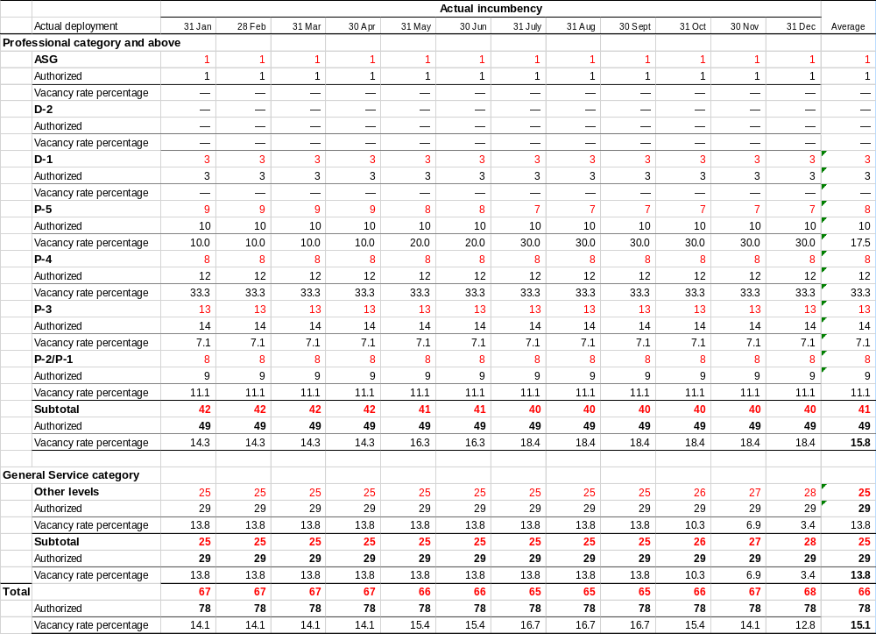

Annex II

ACTUAL VERSUS AUTHORIZED STAFFING LEVELS FOR THE SECRETARIAT
1 January to 31 December 2020
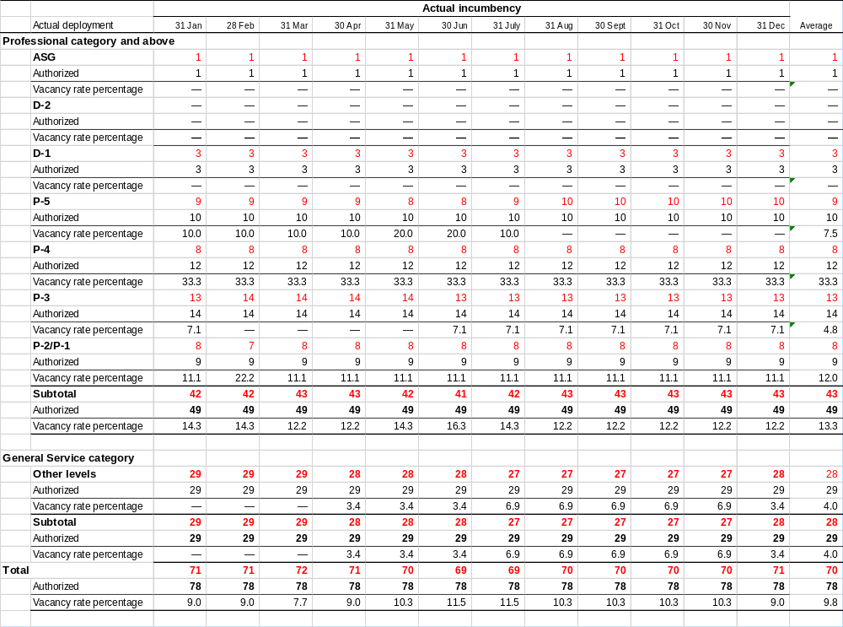

Annex III

ACTUAL VERSUS AUTHORIZED STAFFING LEVELS FOR THE SECRETARIAT
1 January to 31 December 2021
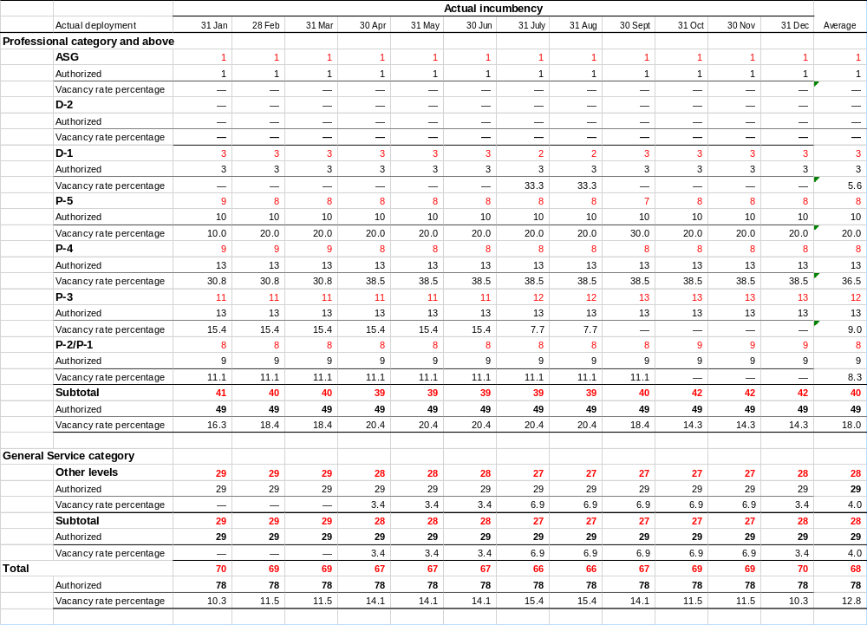

Annex IV

ACTUAL VERSUS AUTHORIZED STAFFING LEVELS FOR THE SECRETARIAT
1 January to 30 June 2022
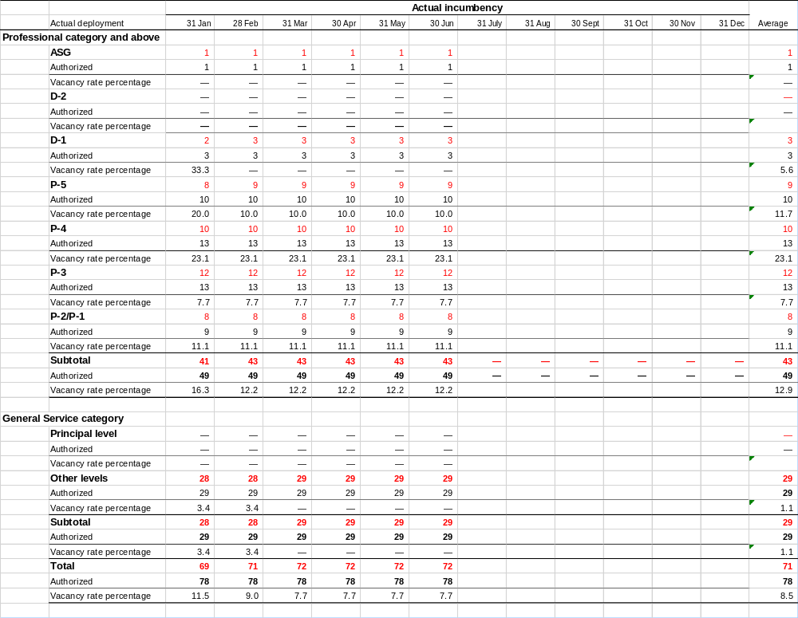
__________

Decisions 15/1; CP-10/1 and NP-4/1
2019/095
A/75/5/Add.7 and A/77/5/Add.7
https://www.cbd.int/information/adm-fin/
https://www.cbd.int/information/adm-fin/
See https://www.cbd.int/secretariat/qr/
https://www.cbd.int/information/adm-fin/

