|  |  |  |
| --- | --- | --- |
| Macintosh HD:Users:bilodeau:Desktop:logos:template 2017:un.emf |  | **CBD** |

|  |  |  |
| --- | --- | --- |
|  |  | Distr.  General  CBD/SBSTTA/24/2  20 October 2020  ORIGINAL: ENGLISH |

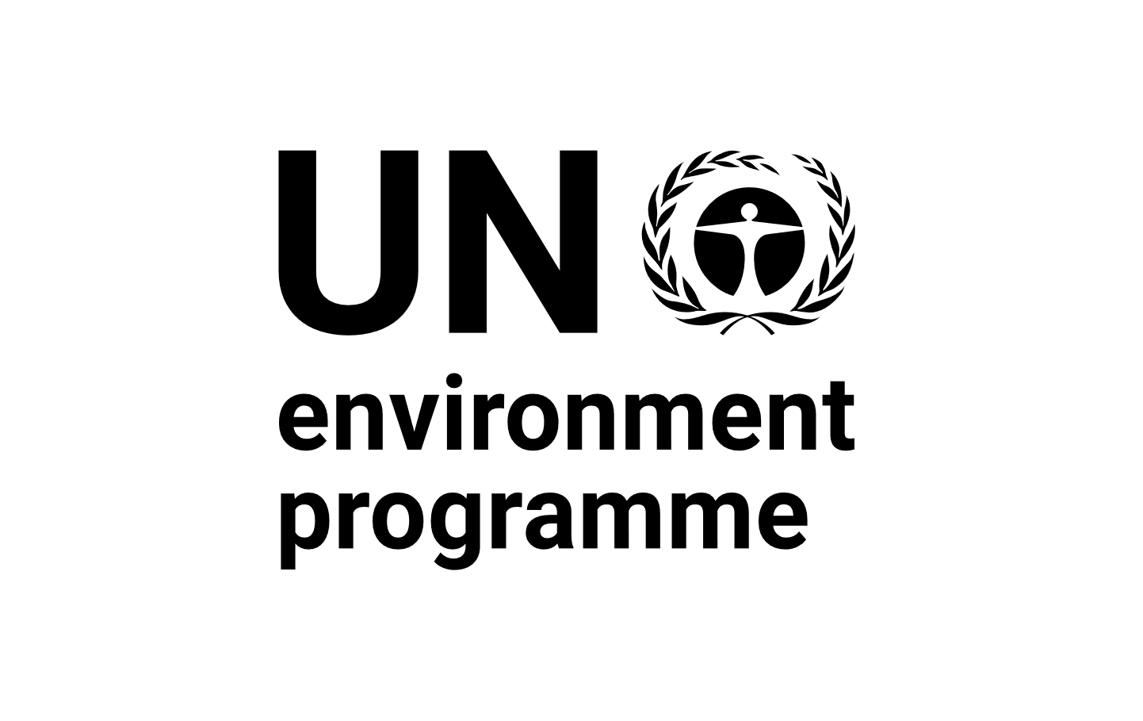SUBSIDIARY BODY ON SCIENTIFIC, TECHNICAL AND TECHNOLOGICAL ADVICE

Twenty-fourth meeting

Venue and dates to be confirmed

Item 3 of the provisional agenda[1]*

# Fifth edition of the Global Biodiversity Outlook and its summary for policymakers

*Note by the Executive Secretary*

1. **Background**
2. In decision [XIII/29](https://www.cbd.int/doc/decisions/cop-13/cop-13-dec-29-en.pdf), the Conference of the Parties decided that the fifth edition of the *Global Biodiversity Outlook* should serve as a basis for the follow-up to the Strategic Plan for Biodiversity 2011- 2020. Pursuant to decision [14/35](https://www.cbd.int/doc/decisions/cop-14/cop-14-dec-35-en.pdf), the draft summary for policymakers of the *Outlook* was made available for consideration by the Subsidiary Body on Scientific, Technical and Technological Advice at its twenty-third meeting,[2] while the complete report was made available as an information document. At the same time, the draft of the *Outlook* was made available for a public peer review from 18 November 2019 to 6 January 2020. Further, the draft text of the *Outlook* related to transitions was made available for peer review from 22 January to 7 February 2020.
3. In its recommendation [23/1](https://www.cbd.int/doc/recommendations/sbstta-23/sbstta-23-rec-01-en.pdf), the Subsidiary Body took note of the progress made in preparing the fifth edition of the *Global Biodiversity Outlook* and requested the Executive Secretary to complete the *Outlook* and to revise the draft summary for policymakers, in accordance with decisions XIII/29 and 14/35, in the light of comments made at the Subsidiary Body’s twenty-third meeting as well as the input provided through the peer-review process. In the same recommendation, the Subsidiary Body urged Parties that had not yet done so to submit their sixth national reports to the Executive Secretary, and requested the Executive Secretary to carry out a comprehensive analysis of information in the sixth national reports and to use this information when completing the *Outlook*.
4. In response to the requests above the fifth edition of the *Global Biodiversity Outlook* was launched on 15 September 2020 during a special virtual session of the Subsidiary Body of Scientific Technical and Technological Advice. The summary for policymakers of the *Outlook* is available from <https://www.cbd.int/gbo/gbo5/publication/gbo-5-spm-en.pdf>. The full *Outlook* and related materials are accessible from <https://www.cbd.int/gbo5>. Section II below provides an overview of the development of the *Outlook* following the peer-review process, and section III provides information on the media uptake of the *Outlook*. Section IV provides a draft recommendation for the consideration of the Subsidiary Body.
5. **Development of the *Outlook* following the peer-review process**
6. During the peer-review process, almost 1,000 individual comments were provided by Parties and observers. These comments raised specific technical comments as well as more general overarching observations. In response to these comments as well as Subsidiary Body recommendation 23/1, and, in addition to the more specific text modifications, the major changes to the *Outlook* were to update it as follows:
   1. Make use of information from the 167 sixth national reports and 170 national biodiversity strategies and action plans (NBSAPs) that were available by the time the fifth edition of the *Outlook* was finalized. This includes providing aggregated information on national progress towards each of the Aichi Biodiversity Targets and the Global Strategy for Plant Conservation. Specific national examples drawn from the national reports were also used to illustrate the progress that has been made in implementing the Strategic Plan for Biodiversity 2011-2020;
   2. Include in the first section of the report additional information on the links between biodiversity and the Sustainable Development Goals;
   3. Reference scientific literature and assessments which became available between January and September 2020, including information on the links between biodiversity, human health, and COVID-19. The fifth edition of the *Outlook* draws on more than 650 references and more than 50 indicators;
   4. Further elaborate the possible transitions and pathways to the 2050 Vision for Biodiversity, including the addition of a transition on a biodiversity-inclusive one health pathway.
7. **Media coverage and uptake**
8. The communication strategy for the fifth edition of the *Global Biodiversity Outlook* was implemented in two phases and with numerous partners, including the Secretariat of the Intergovernmental Science-Policy Platform on Biodiversity and Ecosystem Services. In the pre-launch phase, which began seven months prior to the release of the report, the emphasis was on raising awareness of the focus, scope and scale of the *Outlook*. Among other activities, this phase included the preparation of media primers, press materials, and the identification of partners to help publicize the *Outlook*, among other things. In the post-launch phase, the focus was on mobilizing partners to help share the findings of the *Outlook*, the organization and convening of press events and responding to requests from media outlets for interviews and information.[3]
9. The fifth edition of the *Outlook* had the highest level of media coverage and uptake of any edition.[4] As of 16 October 2020, this coverage includes:
   1. More than 3,200 references on online news sites, with a potential of 10.9 billion impressions;
   2. References to the *Outlook* in media in 107 countries and in 33 languages;
   3. Coverage in news outlets with high impact and reach, including Agence France Presse, Agencia EFE, Associated Press, CNN, *The Economist*, *The Guardian*, *Le Monde*, *National Geographic*, NBC, *The New York Times*, Reuters, *Science*, *Scientific American*, *The Times of London*, the *Washington Post*, and Xinhua;
   4. More than 10,000 tracked social media mentions, including more than 6,900 tweets and retweets.
10. **Suggested recommendation**
11. The Subsidiary Body on Scientific, Technical and Technological Advice may wish to adopt a recommendation along the following lines:

*The Subsidiary Body on Scientific, Technical and Technological Advice*

* + - 1. *Takes note* ofthe fifth edition of the *Global Biodiversity Outlook*;
      2. *Acknowledges with appreciation* the financial support provided by Canada, the European Union, Japan and the United Kingdom of Great Britain and Northern Ireland for the preparation of the fifth edition of the *Global Biodiversity Outlook*;
      3. *Takes note of* the following general conclusions from the fifth edition of the *Global Biodiversity Outlook*:
         1. Biodiversity is critical to the 2030 Agenda for Sustainable Development, and the achievement of the Sustainable Development Goals contributes to the conservation and sustainable use of biodiversity;
         2. At the global level, none of the 20 Aichi Biodiversity Targets has been fully achieved, but there are important examples in which actions in support of the goals and targets of the Strategic Plan for Biodiversity 2011-2020 have generated successful outcomes;
         3. On the current trajectory, biodiversity will continue to decline, but it is not too late to slow, halt and eventually reverse this trend;
         4. There is no single pathway towards the 2050 Vision on Biodiversity, but a significant shift away from business as usual across a broad range of human activities will be necessary;
      4. *Invites* the Open-ended Working Group to take into account the fifth edition of the *Global Biodiversity Outlook* when developing the post-2020 global biodiversity framework;
      5. *Encourages* Parties, other Governments and relevant organizations, as appropriate, to take steps to disseminate widely the fifth edition of the *Global Biodiversity Outlook* and its findings, including by translating the report into local languages and producing other appropriate communication products for different stakeholders.

__________

1. * CBD/SBSTTA/24/1.
2. CBD/SBSTTA/23/2/Add.3.
3. For further information on the launch of the fifth edition of the *Outlook*, see <https://www.cbd.int/gbo5/press>
4. For specific examples of the media coverage, see <https://www.cbd.int/gbo5/comments>.