|  |  |  |
| --- | --- | --- |
| Macintosh HD:Users:bilodeau:Desktop:logos:template 2017:un.emf |  | CBD/SYNBIO/AHTEG/2023/1/3 |
|  | | Distr.: General  14 July 2023  English only |

**Multidisciplinary Ad Hoc Technical Expert Group on Synthetic Biology to Support the Process for Broad and Regular Horizon Scanning, Monitoring and Assessment**

**First meeting**

Montreal, Canada, 11–14 July 2023

# Report of the multidisciplinary Ad Hoc Technical Expert Group on Synthetic Biology to Support the Process for Broad and Regular Horizon Scanning, Monitoring and Assessment

# Introduction

## Background

1. At its fifteenth meeting, the Conference of the Parties to the Convention on Biological Diversity adopted [decision 15/31](https://www.cbd.int/doc/decisions/cop-15/cop-15-dec-31-en.pdf), on synthetic biology, by which it established a process for broad and regular horizon scanning, monitoring and assessment of the most recent technological developments in synthetic biology. The process consists of the following steps:

(a) Information gathering;

(b) Compilation, organization and synthesis of information;

(c) Assessment;

(d) Reporting on outcomes.

1. The Conference of the Parties also established a multidisciplinary ad hoc technical expert group on synthetic biology to support the process for broad and regular horizon scanning, monitoring and assessment, in accordance with the terms of reference contained in section B of the annex to decision 15/31.
2. In the same decision, the Executive Secretary was requested to convene online discussions of the Open-ended Online Forum on Synthetic Biology to support the work of the multidisciplinary Expert Group and to synthesize the information submitted by Parties, other Governments, indigenous peoples and local communities and relevant organizations relevant to the trends in new technological developments to inform the horizon scanning, monitoring and assessment.
3. The Executive Secretary was also requested to convene at least one meeting of the Group, to prepare reports on the outcomes and operation of the horizon scanning process and to submit the reports for peer review to support the review of the effectiveness of the process by the Subsidiary Body on Scientific, Technical and Technological Advice before the sixteenth meeting of the Conference of Parties.
4. The Group was mandated to prepare a report on the outcomes of its assessment for submission to the Subsidiary Body, along with recommendations on specific issues that may require further consideration by the Conference of the Parties to the Convention or the Conference of Parties serving as the meetings of the Parties to the Cartagena Protocol and to the Nagoya Protocol on Access to Genetic Resources and the Fair and Equitable Sharing of Benefits Arising from their Utilization.
5. Pursuant to the above, and with generous financial support from the European Union, a meeting of the Group was held at the office of the Secretariat from 11 to 14 July 2023.

## Attendance

1. By notifications [2023-034](https://www.cbd.int/doc/notifications/2023/ntf-2023-034-SynBio-en.pdf) of 27 March 2023, [2023-046](https://www.cbd.int/doc/notifications/2023/ntf-2023-046-SynBio-en.pdf) of 24 April and [2023-053](https://www.cbd.int/doc/notifications/2023/ntf-2023-053-SynBio-en.pdf) of 10 May, Parties, other Governments, indigenous peoples and local communities, and relevant organizations were invited to nominate experts to the multidisciplinary Expert Group.
2. The Secretariat received a total of 58 nominations from Parties to the Convention and 48 nominations from observers, of which one was from a non-Party, 13 were from indigenous peoples and local communities and 34 from relevant organizations. The experts were selected in accordance with the consolidated modus operandi of the Subsidiary Body on Scientific, Technical and Technological Advice and through the application of [decision 14/33](https://www.cbd.int/doc/decisions/cop-14/cop-14-dec-33-en.pdf), on the procedure for avoiding or managing conflicts of interest in expert groups. The expertise and experience of the nominees and the need to ensure equitable geographical distribution and gender balance were also taken into account for the selection.
3. Following consultations with the Bureau of the Subsidiary Body on Scientific, Technical and Technological Advice, the composition of the Group was announced in notification [2023-057](https://www.cbd.int/doc/notifications/2023/ntf-2023-057-SynBio-en.pdf) of 26 May 2023.[1]
4. The meeting was attended by experts from the following 13 Parties: Antigua and Barbuda, Brazil, Canada, China, Ecuador, Egypt, European Union, Germany, Israel, Lithuania, Republic of Korea, Slovenia and Zimbabwe. The experts from Bosnia and Herzegovina, Belarus, Burkina Faso, Burundi, Colombia, Pakistan and the Philippines, who had been selected and invited, were unable to attend the meeting, including as a result of visa issues.
5. The expert from the Indigenous Genomics Institute representing indigenous peoples and local communities participated in the meeting. The expert from the International Indigenous Forum on Biodiversity was unable to attend the meeting.
6. The meeting was also attended by an expert from the United States of America and experts from the following organizations: Food and Agriculture Organization of the United Nations, Fundación Ambiente y Recursos Naturales, Global Industry Coalition, J. Craig Venter Institute, University of Melbourne, Federation of German Scientists, Third World Network, Friends of the Earth U.S., Global Youth Biodiversity Network and Foundation of Future Farming (Save Our Seeds). Experts from the World Intellectual Property Organization, the International Centre for Genetic Engineering and Biotechnology, Global Youth Online Union and SynBio Africa, who had been selected and invited, were unable to attend the meeting.

# Item 1

# Opening of the meeting

1. A representative of the Secretariat opened the meeting at 9 a.m. on 11 July 2023. The Acting Executive Secretary of the Secretariat of the Convention addressed the multidisciplinary Expert Group later in the day, welcoming the experts and highlighting the interest raised by the topic of synthetic biology, while also noting the risks to all three objectives of the Convention, as laid out in its Article 1. He encouraged the Group members to share their technical expertise and experience and to learn from one another. He also noted the linkages of the Group’s work to the Kunming-Montreal Global Biodiversity Framework and the 2030 Agenda for Sustainable Development. Lastly, he noted that the multidisciplinary nature of the Group would be a strong asset for the process for broad and regular horizon scanning, monitoring and assessment of the most recent technological developments in synthetic biology.

# Item 2

# Organizational matters

1. The multidisciplinary Expert Group elected Kishma Primus-Ormond and Florian Rabitz as Co-Chairs of the meeting.
2. On the basis of the provisional agenda prepared by the Secretariat,[2] the Group adopted the following agenda:
3. Opening of the meeting.
4. Organizational matters.
5. Implementation of the mandate.
6. Process for broad and regular horizon scanning, monitoring and assessment of the most recent technological developments in synthetic biology;
7. Steps for broad and regular horizon scanning, monitoring and assessment;
8. Trends in synthetic biology and clarification of the scope of the broad and regular horizon scanning, monitoring and assessment process.
9. Other matters.
10. Adoption of the report.
11. Closure of the meeting.
12. The Secretariat explained that two meetings of the Group had been planned during the present intersessional period, the present meeting, to decide how to perform the process for broad and regular horizon scanning, monitoring and assessment of the most recent technological developments in synthetic biology, and one in the first quarter of 2024, to finalize the work.
13. The Group approved the organization of work as outlined in annex I to the annotated provisional agenda.[3]

# Item 3

# Implementation of the mandate

1. The Secretariat introduced a note on considerations on synthetic biology pursuant to decision 15/31[4] that it had prepared to facilitate discussions, and it reminded the multidisciplinary Expert Group of its mandate under [decision 15/31](https://www.cbd.int/doc/decisions/cop-15/cop-15-dec-31-en.pdf).

# (a) Process for broad and regular horizon scanning, monitoring and assessment of the most recent technological developments in synthetic biology

1. At the invitation of the Secretariat, Luke Kemp of the Centre for the Study of Existential Risks at the University of Cambridge made a presentation, which drew on his experiences in conducting horizon scanning processes, and he provided examples of foresight exercises carried out by other organizations. The multidisciplinary Expert Group then discussed potential methodologies, options and pertinent considerations for conducting horizon scanning.

# (b) Steps for broad and regular horizon scanning, monitoring and assessment

1. The members were invited to work in four breakout groups to discuss and provide input on the four steps for broad and regular horizon scanning monitoring and assessment outlined in the annex to decision [15/31](https://www.cbd.int/doc/decisions/cop-15/cop-15-dec-31-en.pdf). They were also asked to consider how each step should be performed and how the trends should be analysed, noting that some steps might be repeated in an iterative process.
2. The members discussed the importance of the information-gathering step and noted that, while the Secretariat was the coordinating actor, it was important for the multidisciplinary Expert Group to provide specific guidance, including guiding questions, to support a structured collection of information and to include other types of knowledge, including from multidisciplinary knowledge holders, in that step. Some members also considered that, to support the broad and regular nature of information gathering, as well as monitoring, a specific recommendation could be made to establish an observatory as a component of the process. Some members highlighted that it was necessary to ensure that the monitoring component was present throughout the process. It was agreed that those topics would be further discussed at the second meeting of the Group. The members also discussed the compilation, organization and synthesis of information step and noted that a structured process would be needed to assess the large volume of literature, other publications and various other sources of information. Members were of the view that careful prioritization was needed to avoid bias and ensure that conflicts of interest were addressed. Some members were of the view that filtration criteria would be useful to facilitate the compilation, organization and synthesis of information. Furthermore, members recognized the need for an inclusive prioritization process.
3. Members also discussed the assessment step and the importance of the three objectives of the Convention, as well as socioeconomics, ethical and cultural impacts of synthetic biology. They identified other important criteria, such as time frames for the commercialization or release into the environment of synthetic biology products.
4. Members further discussed the reporting-on-outcomes step and identified the potential structure and content of the report to be prepared, bearing in mind the relevance of the trends and issues identified to policymakers. It was noted that potential positive and negative impacts of synthetic biology applications should be considered in the context of the processes under the Convention, including the programmes of work under the Nagoya Protocol, the process addressing digital sequence information on genetic resources, the Cartagena Protocol and the Kunming-Montreal Global Biodiversity Framework. Other relevant mechanisms, such as the 2030 Agenda for Sustainable Development, might also be taken into account as important elements in the report when determining relevance. Some experts also noted that the report should include additional elements to facilitate communication and outreach with a wide range of stakeholders.
5. The Co-Chairs recalled that the dual mandate of the Group was to develop an overarching process for the broad and regular horizon scanning, monitoring and assessment and to undertake an assessment for the current intersessional period. Members reviewed and agreed to the Co-Chairs’ proposal providing conceptual elements to develop the overarching process. Following an exchange of views, the Co-Chairs created a Friends of the Co-Chairs group to further develop their proposal for undertaking an assessment for the intersessional period. The small group comprised the experts from Canada, Ecuador, Egypt, Germany and the Republic of Korea. Members considered the outcomes of the work of the Friends of the Co-Chairs and agreed to a process for the intersessional period.

# (c) Trends in synthetic biology and clarification of the scope of the broad and regular horizon scanning, monitoring and assessment process

1. The multidisciplinary Expert Group discussed whether trends previously identified in the Ad Hoc Technical Expert Group on Synthetic Biology in the report on its meeting in 2019,[5] the submission of information on synthetic biology and the open-ended online forum on synthetic biology could be useful for setting the scope for the horizon scanning process.
2. The Group discussed the possible approach to identify and prioritize trends and issues regarding developments in synthetic biology that should be considered vis-à-vis the three objectives of the Convention. Following some discussions, the Co-Chairs created a Friends of the Co-Chairs group comprising the experts from China, Ecuador, Germany, Slovenia and Zimbabwe to develop a conceptual framework for categorizing the list of trends and issues. Members considered the provisional analysis prepared by the small group and requested the Secretariat to create an updated preliminary list of trends.
3. The outcomes of the meeting are contained in annex I.

# Item 4

# Other matters

1. A member of the multidisciplinary Expert Group noted the importance of ensuring the full and effective participation of all stakeholder groups to ensure an inclusive process, noting that resources would be necessary to support their participation.
2. Another member raised concerns regarding difficulties experienced by some participants in obtaining a Canadian visa to attend the meeting. She explained that several members from developing country Parties from the African Group, the Asia-Pacific Group and the Latin America and Caribbean Group had been unable to participate in the meeting owing to delays in visa processing, despite submitting all relevant documentation, including proof of financial support from the Secretariat, in due form and in a timely manner. She suggested that the Secretariat take up the matter with the Government of Canada to facilitate full participation of members in future meetings of the Group. Several members noted that the underrepresentation of some regions in the meeting could compromise overall participation and contributions to the multidisciplinary nature of the Group.
3. Some members raised the issue of ensuring a coordinated approach between the Convention and the Protocols, noting that, in paragraph 7 of decision 14/19, the Conference of the Parties had emphasized the need for a coordinated, complementary and non-duplicative approach on issues related to synthetic biology under the Convention and its Protocols. It was also noted that recommendations from the Group to other relevant processes under the Convention and the Protocols should be included in the compilation of its recommendations.
4. Members noted the linkages between synthetic biology applications and the digital sequence information processes under way and suggested that recommendations highlighting those linkages be made, as appropriate.
5. The Group was of the view that its discussions had been fruitful and that important lessons of relevance to the wider processes under the Convention had been learned. Some members noted, however, that the multidisciplinary process could be further enhanced by providing interpretation during the Group meetings and translation of documentation, to allow for a wider and more inclusive participation in the process.
6. Several members recognized the importance of ensuring capacity-building on and common understanding of the issues under discussion by the Group. They acknowledged that members faced specific national circumstances and challenges. At its second meeting, the Group would consider the issues of capacity-building, technology transfer and knowledge‑sharing needs in greater detail.

# Item 5

# Adoption of the report

1. The Co-Chairs introduced the draft report of the meeting, which was adopted, as orally amended.

# Item 6

# Closure of the meeting

1. Following the customary exchange of courtesies, the meeting was closed at 9.55 p.m. on 14 July 2023.

# Annex I

# Outcomes of the first meeting of the multidisciplinary Ad Hoc Technical Expert Group on Synthetic Biology

## A. Overarching process for the broad and regular horizon scanning, monitoring and assessment

1. The overall elements for the broad and regular horizon scanning, monitoring and assessment of the most recent technological developments in synthetic biology are shown in figure I.

Figure I

**Elements of the process for** **the broad and regular horizon scanning, monitoring and assessment**

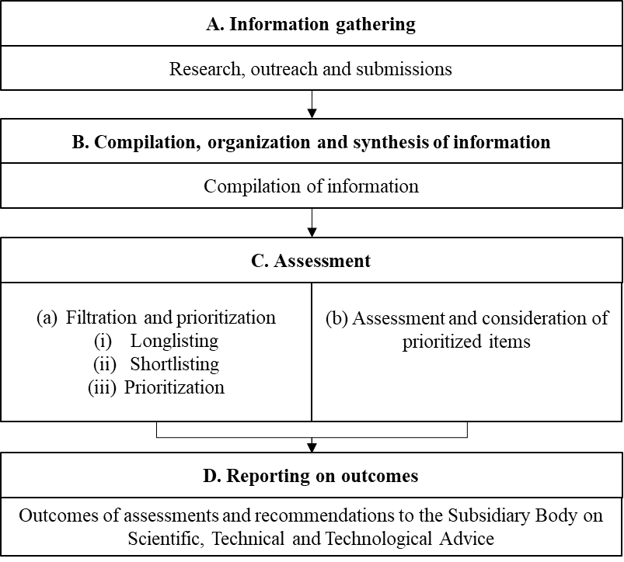

**Explanatory notes**

* Steps A to C may be repeated in an iterative manner.
* The process for the broad and regular horizon scanning, monitoring and assessment of the most recent technological developments in synthetic biology will consist of the four steps (information gathering; compilation, organization and synthesis of information; assessment; and reporting of outcomes) specified by the Conference of Parties to the Convention on Biological Diversity in its [decision 15/31](https://www.cbd.int/doc/decisions/cop-15/cop-15-dec-31-en.pdf).
* A multidisciplinary expert group advises on the guiding questions for information gathering.
* The Secretariat of the Convention is the coordinating actor for the information gathering and compilation, organization and synthesis of information steps. The members of the aforementioned multidisciplinary expert group are the coordinating actors for the assessment and reporting-on-outcomes steps.
* Each step, as defined in decision 15/31 regarding the broad and regular horizon scanning, monitoring and assessment of the most recent technological developments in synthetic biology consists of conceptual elements, as laid out in figure I.
* For the information-gathering step, it was recognized that both multidisciplinary expert-driven and research-based approaches were necessary. As a result, the conceptual elements are research, outreach and submissions.
* It was recommended that the research element include literature reviews and other sources, such as patent databases, regulatory applications and grant approvals, depending on the case and subject to the availability of resources, also bearing in mind the multidisciplinary nature of this element.
* The information-gathering step may also incorporate other types of knowledge, knowledge systems and knowledge holders in a complementary manner, inter alia, through the use of workshops, forums and other methods of communication in line with established procedures and approaches.
* The outreach element would involve a broad range of stakeholders and right holders in multiple sectors, including Parties, other Governments, industry, scientific community, civil society, indigenous peoples and local communities, women and young people, and could include the use of side events, workshops, forums and other methods of communication. It would also be important to understand the research priorities of the Parties and other Governments, also bearing in mind the multidisciplinary nature of this element.
* The submissions element would consist of a submission of information (e.g. through the use of a structured form) on the Open-ended Online Forum on Synthetic Biology and other forums.
* Additional considerations for the information-gathering step include the use of multilingual and multi-format knowledge collection, research, data and information. It may be necessary to consider making a specific recommendation to establish an observatory to support the ongoing information gathering process.
* Information gathered during the iterative process will be compiled, organized and synthesized.
* For the assessment step, the conceptual elements will be divided into two parts. First, the filtration and prioritization part will contain three subprocesses to be carried out in a sequential manner, namely, longlisting, shortlisting and prioritization. For the second part, there will be an assessment and consideration of the prioritized items. The instruments of information gathering, such as literature searches and online forums, could be used to assist with the assessment of the prioritized items with respect to the potential positive and negative impacts vis-à-vis the three objectives of the Convention.
* For the reporting-on-outcomes step, the conceptual element would be the outcomes of assessments and recommendations to the Subsidiary Body on Scientific, Technical and Technological Advice, in line with the request of the Conference of Parties.
* Considerations of further conceptual elements related to the compilation, organization and synthesis of information, assessment, and reporting-on-outcomes steps would be addressed in the light of the outcomes of the cycle of the broad and regular horizon scanning, monitoring and assessment.

# B. Process for the 2023 to 2024 intersessional period

1. The process of broad and regular horizon scanning, monitoring and assessment of the most recent technological developments in synthetic biology for the 2023–2024 intersessional period are shown in figure II.

Figure II

**Process for the 2023–2024 intersessional period**

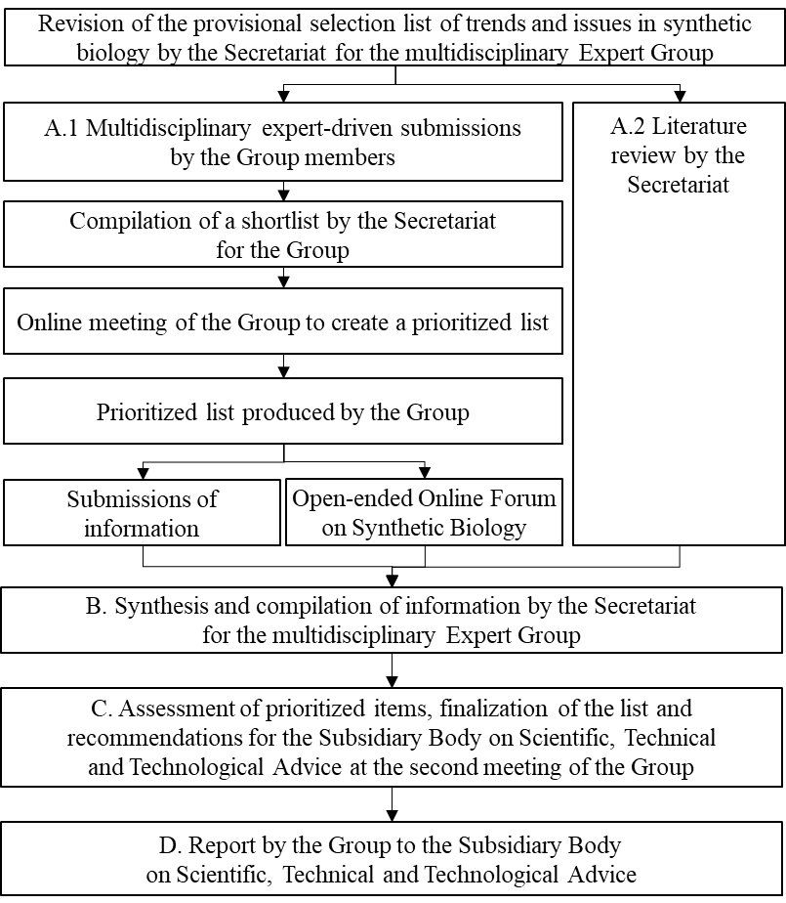

**Explanatory notes**

* An updated timeline will be provided by the Secretariat following the first meeting of the multidisciplinary Expert Group, taking into account the dates and timing of the twenty-sixth meeting of the Subsidiary Body on Scientific, Technical and Technological Advice.
* The process will follow a multidisciplinary expert-driven approach. It was acknowledged that the submissions of information, the Open-ended Online Forum, the publication *Technical Series No. 100: Synthetic Biology* and the report of the Ad Hoc Technical Expert Group on Synthetic Biology on its meeting in 2019[6] formed a basis for informing the process. However, it would be helpful to complement the process with a literature review.
* For the intersessional period, it was agreed that the process would consist of the following steps:

1. Revision of the provisional selection list of trends and issues in synthetic biology by the Secretariat;

2. Parallel multidisciplinary expert-driven submissions by the Group and literature review by the Secretariat;

3. Compilation of a shortlist by the Secretariat;

4. Online meeting of the Group to create a prioritized list;

5. Prioritized list produced by the Group;

6. Submissions of information;

7. Open-ended Online Forum on Synthetic Biology;

8. Synthesis and compilation of information by the Secretariat;

9. Assessment of prioritized items, finalization of the list and recommendations for the Subsidiary Body on Scientific, Technical and Technological Advice at the second meeting of the Group;

10. Report by the Group to the Subsidiary Body.

* With regard to the revision of the provisional selection list, the multidisciplinary Expert Group requested the Secretariat to reorganize, compile and synthesize the list of trends identified in 2019 by the Ad Hoc Technical Expert Group on Synthetic Biology and information provided in the documentation for and in the course of the first multidisciplinary Expert Group meeting, the submissions of information, the Open-ended Online Forum and the publication *Technical Series No. 100: Synthetic Biology*.
* Once the provisional selection list is developed, a multidisciplinary expert-driven submissions process by the Group members begins. A complementary literature review would also be undertaken by the Secretariat.
* The literature review would be conducted on the basis of the provisional selection list compiled by the Secretariat and serve to validate and confirm the list and identify whether there are new trends and issues for consideration. The outcomes of the literature review would be provided to the Group before its second meeting or as soon as available.
* For the multidisciplinary expert-driven submissions process, the Group members will be asked to select from the provisional selection list and/or submit items not identified therein. A maximum of five items should be selected or submitted. When providing input in a structured manner, the members will be asked to provide preliminary information on potential positive and negative impacts vis-à-vis the three objectives of the Convention, including socioeconomic, ethical and cultural considerations, timelines (if possible) and other considerations that could be deemed relevant by the members, as well as any supporting documentation. The Secretariat will develop a submission form to allow for the automated collection of responses and aggregation of duplicates.
* The shortlist will then be compiled by the Secretariat and the responses will be provided to the Group members for further deliberation, at an online meeting, in order to exchange views and information, with a view to informing the prioritization step. The members will then organize the items to create the prioritized list. They will also provide guiding questions for the online forum.
* An additional submission-of-information step will be conducted, on the basis of the prioritized list and through a call for submissions of information, to gather further information on the prioritized items to support the next stage of the assessment process, which will be undertaken at the second meeting of the Group.
* The results of the prioritized list will also be the basis for convening an additional meeting of the Open-ended Online Forum on Synthetic Biology. The discussions will focus on information related to the potential positive and negative impacts vis-à-vis the three objectives of the Convention, as well as relevant technical issues, including capacity‑building, technology transfer and knowledge‑sharing needs.
* The information gathered from the submissions and the Open-ended Online Forum on Synthetic Biology will be compiled, organized and synthesized before the second meeting of the Group. The outcomes of the literature review will also be provided for consideration by the Group.

1. At its second meeting, the multidisciplinary Expert Group will:

(a) Assess the prioritized items and new trends and issues from the literature review;

(b) Consider potential positive and negative impacts vis-à-vis the three objectives of the Convention;

(c) Finalize the list of items and prepare recommendations for the Subsidiary Body on Scientific, Technical and Technological Advice;

(d) Identify capacity-building, technology transfer and knowledge-sharing needs in the light of the outcomes of the process.

1. The report to the Subsidiary Body on Scientific, Technical and Technological Advice will include the prioritized items, containing information and recommendations from the assessment, in particular in the context of processes under the Convention, including programmes of work under the Nagoya Protocol, the process addressing digital sequence information on genetic resources, the Cartagena Protocol, the Kunming-Montreal Global Biodiversity Framework and other multilateral agreements, as well as further recommendations for consideration by the Subsidiary Body. The report will contain the longlist and shortlist of items in an annex.

**Annex II**

# List of participants

## A. Experts nominated by Parties

**Antigua and Barbuda**

Kishma Primus-Ormond

Senior Plant Protection Officer

Department of Plant Protection

Ministry of Foreign Affairs, Agriculture, Trade and Barbuda Affairs

**Brazil**

Isaque Medeiros Siqueira

Environmental Analyst

Environmental Protection Directorate

Instituto Brasileiro do Meio Ambiente e dos Recursos Naturais Renováveis

**Canada**

Ian Siboo

Unit Head, Emerging Priorities Division

Science and Risk Assessment, Science and Technology Branch

Environment and Climate Change Canada

**China**

Weiwen Zhang

Professor at Tianjin University

**Ecuador**

Francisco Javier Flores

Professor

Universidad de las Fuerzas Armadas

**Egypt**

Ossama Abdel-Kawy

Conseiller / Scientist

Egyptian Environmental Affairs Agency

**European Union**

Kathleen Lehmann

Policy Officer

Directorate General Sante E.3

European Commission

**Germany**

Margret Engelhard

Federal Agency for Nature Conservation

**Israel**

Ronit Justo-Hanani

Assistant Professor, Department of Public Policy, Faculty of Social Sciences

The Steinhardt Museum of Natural History

**Lithuania**

Florian Rabitz

Chief Researcher

Research Group Civil Society and Sustainability

Kaunas University of Technology

Faculty of Social Sciences, Arts and Humanities

**Republic of Korea**

Bong Hyun Sung

Principal Researcher

Korea Research Institute of Bioscience and Biotechnology

**Slovenia**

Martin Batič

Head of Biotechnology Section

Ministry of Environment, Climate Change and Energy

**Zimbabwe**

Natasha Robertha Mavengere

Senior Lecturer

Harare Institute of Technology

School of Industrial Science and Technology

Department of Biotechnology

## B. Experts nominated by other Governments

**United States of America**

Jennifer Shinen

Office of Conservation and Water, Bureau of Oceans

International Environmental and Scientific Affairs

United States Department of State

## C. Experts nominated by indigenous peoples and local communities

**Indigenous Genomics Institute**

Karaitiana Taiuru

Māori Cultural Ethicist

Taiuru and Associates Indigenous Genomics Institute

## D. Experts nominated by organizations

**Food and Agriculture Organization of the United Nations**

Chikelu Mba

Senior Officer, Plant Genetic Resources and Seeds

Plant Production and Protection Division

**Foundation of Future Farming (Save Our Seeds)**

Barbara Pilz

Policy Coordinator Campaigns

**Friends of the Earth U.S.**

Jim Thomas

Emerging Technologies Advisor

**Fundación Ambiente y Recursos Naturales**

Cicilia Wangari Githaiga

Lawyer/Legal Advisor

Women Caucus

**Third World Network**

Eva Sirinathsinghji

Research Associate

**Global Industry Coalition**

Felicity Keiper

Global Regulatory Policy Manager, Seeds and Traits

BASF Australia Ltd

**Federation of German Scientists**

Ricarda Steinbrecher

Working Group on Agriculture and Biodiversity, including Biotechnology

**J. Craig Venter Institute**

Robert M. Friedman

Adjunct Faculty

**University of Melbourne**

Tiffany Kosch

Research Fellow

One Health Research Group

**Global Youth Biodiversity Network**

Joel Andrés Rojas González

**E. Invited speakers**

Luke Kemp  
Centre for the Study of Existential Risks

University of Cambridge

**F. Secretariat of the Convention on Biological Diversity**

Wadzanayi Mandivenyi

Senior Programme Management Officer

Head, Biosafety Unit

Austein McLoughlin

Associate Programme Management Officer

Biosafety Unit

Melissa Willey

Programme Management Assistant

Biosafety Unit

Anastasia Beliaeva

Programme Management Assistant (Biosafety Clearing-House)

Biosafety Unit

Paola Scarone

Senior Programme Management Assistant

Biosafety Unit

__________________

1.
2. [CBD/SYNBIO/AHTEG/2023/1/1](https://www.cbd.int/doc/c/1067/ae4b/374ea0bb2d6958ea4209706a/synbio-ahteg-2023-01-01-en.pdf).
3. [CBD/SYNBIO/AHTEG/2023/1/1/Add.1](https://www.cbd.int/doc/c/cb35/d059/0699994369dfa44f85f492d9/synbio-ahteg-2023-01-01-add1-en.pdf).
4. [CBD/SYNBIO/AHTEG/2023/1/2](https://www.cbd.int/doc/c/c057/b885/0bfc95a708747e5b2be5305e/synbio-ahteg-2023-01-02-en.pdf).
5. CBD/SYNBIO/AHTEG/2019/1/3.
6. CBD/SYNBIO/AHTEG/2019/1/3.