USER GUIDE AND INFORMATION FOR SPECIAL VIRTUAL SESSIONS

This user guide is divided into five sections: (i) Technical and hardware requirements; (ii) training sessions schedule, (iii) official meeting sessions and virtual meeting links for viewers and speakers; (iv) platform user guide, (v) statement submission.

- TECHNICAL AND HARDWARE REQUIREMENTS

- A computer or laptop is preferred.
- Reliable internet connection, preferably using wired connection and that you close all other programs running on your computer to dedicate more resources to the virtual meeting session and sit as close as possible to your WIFI router to maximize your signal strength.
- For optimal sound quality and to avoid noise and feedbacks, a hard-wired headset, with noise cancellation and microphone a is highly recommended.
- There two types of connections for each of the meetings, both links will be posted on the meeting home page: https://www.cbd.int/conferences/sbstta24-sbi3-prep-02
- First connection as Speaker, for which each accredited speaker will receive a login and password.
- Second connection as a Viewer will connect to live webcast.
- You can test your connectivity in advance of training and meeting sessions through this link: https://troubleshooter.interactio.io/
- Please note that the Interactio system will be available 1 hour prior to the start of each Special Virtual Session to familiarize yourself with the system.

- TRAINING SESSIONS SCHEDULE

The training will be available one hour before the start of each session on the use of the updated version of the Interactio platform is as follow:

- 15 and 16 December 6:00 A.M. (Montreal Time)

Sessions links can be found on the meeting home page shown above. We Strongly recommend that you connect 10 minutes before each session.

- Official Meeting Sessions:

The meetings sessions are schedule on 15 and 16 December, daily from 7:00-9:00 AM (Montreal time), however, the platform will be activated one hour earlier as of 6:00 AM Montreal Time. We encourage you to join and test your connection early to ensure your participation sound and voice is of the highest quality.

Links to the meetings will be posted on the meeting home page and provide you two ways to connect:

- As Viewer through live webcasting, with options of the 6 UN languages.
Or As Speaker with active participation for accredited official speaker, and this link will require the Login and Password that you have received by email from the CBD.

- PLATFORM USER GUIDE - PARTICIPANT GUIDE FOR SPEAKERS

Joining the meeting

- Open a New Incognito window on Google Chrome (Recommended) (Ctrl+Shift+N), or Microsoft Edge (version 79 and up) (Ctrl+ Shift+N), then copy and paste the meeting link to the browser URL field and press ENTER key to go to the meeting page to sign in. Please test with your preferred browser to make sure it works in advance

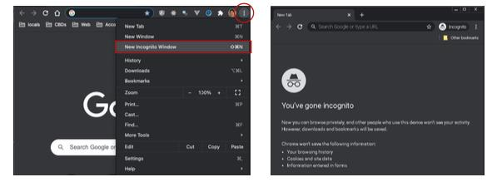

- When prompted by the browser, you must turn on your microphone and camera to activate it on the Interactio system (1). And press Join to join the meeting (2).
Note: Before Joining the meeting, it is strongly recommended to RUN TEST (3) to make sure your internet, camera and microphone all work well.

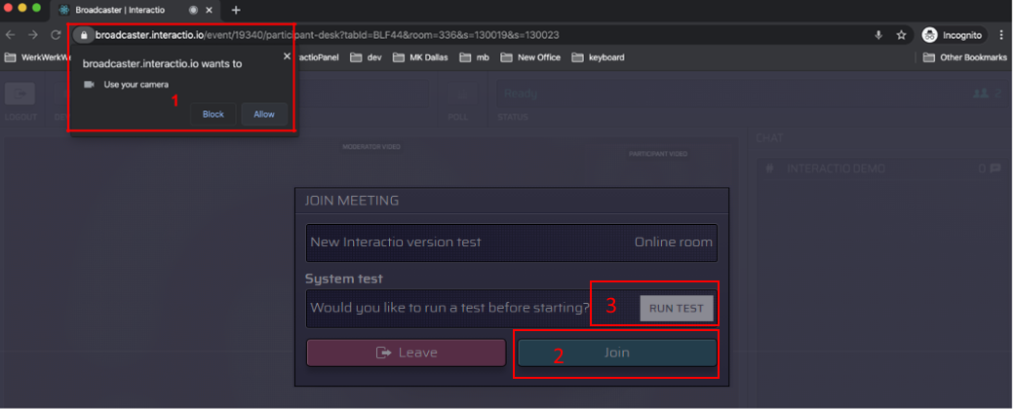

3. Select the devices you want to use for the meeting:
(1) camera – select your camera
(2) microphone - select your audio input device
(3) speaker/headset – select your audio output device

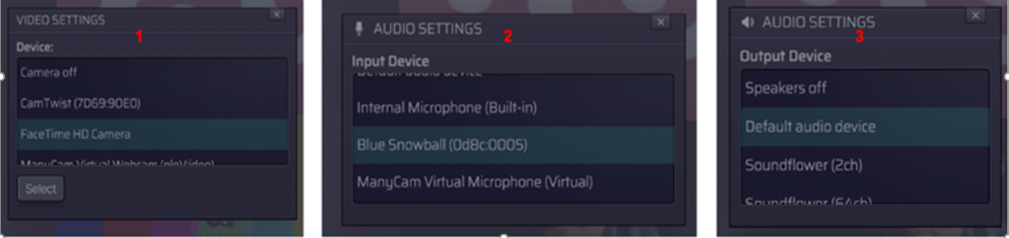

During the session

- Select the preferred audio language

Click the AUDIO CHANNEL SELECTOR (1) and choose the preferred language (All 6 UN languages will be available) or the floor channel.
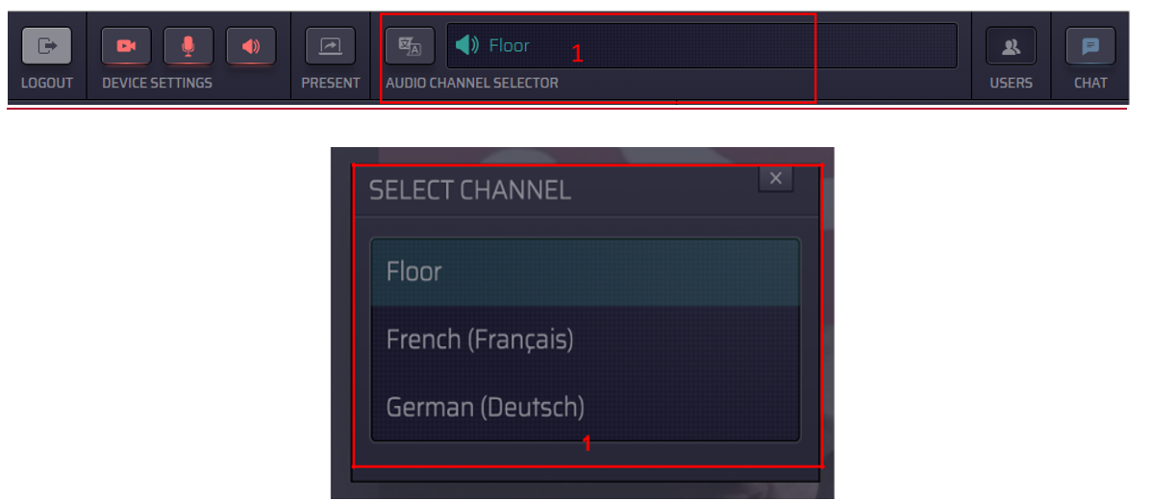

Note: If your MICROPHONE is red, you are listening to the floor channel only. Interpretation is NOT available when the MICROPHONE is red.

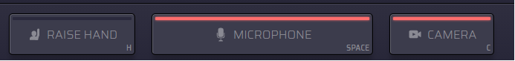
- Display video

Note: If your webcam is on, you will always see your own webcam, but it will only be visible to everyone once you have the floor and start to speak live.

- Click 1 to change video display mode:
Options: Asterisk * will show person speaking on main screen; and others small
Push Pin: will show pinned person on main screen
4 squares: will show 4 people on main screen
- Click 2 to view video in full screen mode
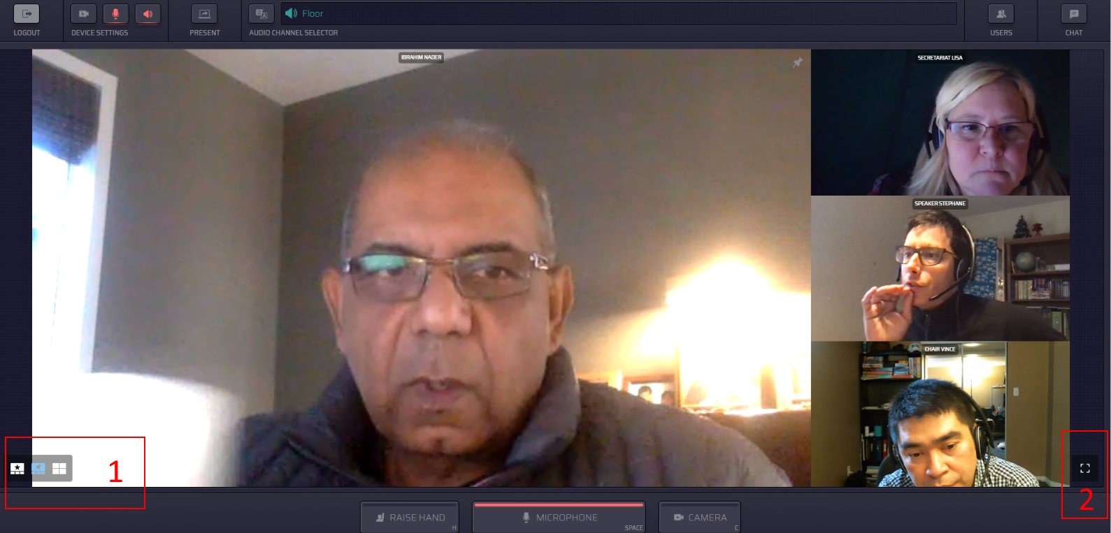

- Requesting the Floor

- When you first join the meeting, the MICROPHONE button and CAMERA button are marked in blue, which means they are in ready to use mode.
You could turn off your MICROPHONE and CAMERA by pressing the buttons (become no color).
After you raise hand to request the floor, please make sure your MICROPHONE and CAMERA are in blue (ready to use mode).
Please note that interpretation is available when MICROPHONE is blue or grey.

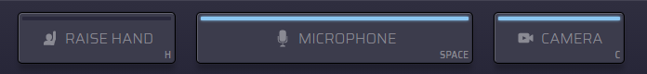

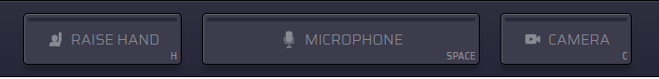

- Press the button RAISE HAND at the bottom to indicate your wish to speak (color becomes yellow). Your name will be added to the queue. Please note that the raise hand requests are automatically seen by the Chair and moderators. Your raise hand keeps your place in the queue. You will be informed by the Chair when you are given the floor to speak. Please pay close attention to the proceedings to hear when you are given the floor to speak. The list you see on your screen is in alphabetical order and is not the queue that the Chair and moderators have on their monitors which is in chronological order of the requests for interventions from the floor as per usual procedure of CBD meetings.

Note: Please ensure that your MICROPHONE and CAMERA are in ready to use mode (color blue) after you raise your hand.
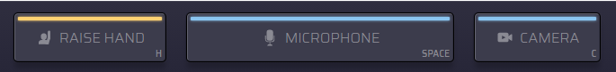
- When you are given the floor, the MICROPHONE button and the CAMERA button will automatically become red, which means you are live, you can speak and be seen.
Note: If needed to improve connectivity, you could turn off your camera by pressing CAMERA button (red to no color).
Please note that interpretation is not available when MICROPHONE is red.

- To share your screen for presentations, etc., press the PRESENT button in the red selection below. Please note that you must be live to use the present button.

- Your presentation should already be open on your computer and ready to show on your screen.
- Select present and chose window where presentation is located.
- Click on presentation and it will replace your picture on screen.

- End speaking on the Floor

When finished speaking:
  - Press the MICROPHONE button to turn the microphone off (red to no color);
  - Press the CAMERA button to turn the camera off (red to no color).

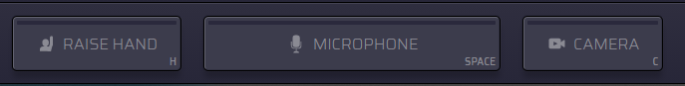
- Other useful options

- USERS: see the list of attendees
- POLLS: participate in the live poll or simply view all previous polls’ results if any.
- CHAT: view chat history and chat with others, if you have any technical problems, please use technical support information below and not on the Interactio system.
- FILES: download files available to you

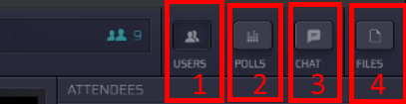

For Technical Support:

The Secretariat is providing help before and during the meetings and support can be reached from the meeting home page by clicking on the “green question mark” at the bottom right: https://www.cbd.int/conferences/sbstta24-sbi3-prep-02 between 15-16 December from 6:00AM – 9:00AM Montreal time.

- Statement Submission

Parties and organizations are requested to email their statements in advance of the sessions to statements@cbd.int so they can be shared with interpreters. Kindly include your country/organization in the subject line and the related session/topic.

-----

