Co-Chairs’ text
contact group on item 6

Draft elements on resource mobilization in relation to the post-2020 global biodiversity framework

I. Introduction
1. The present document has been prepared by the co-chairs of the contact group on item 6, Ms. Teona Karchava (Georgia) and Ms. Ines Verleye (Belgium), based on the input received from the delegates. It is a synthesis of the views on resource mobilization, expressed during the plenary session of the Subsidiary Body on Implementation on 17 May 2021, the informal sessions of the Subsidiary Body on 9 March 2021 and the contact group sessions under agenda item 6 of the Subsidiary Body’s agenda (19 May to 9 June 2021). With a view to streamlining the advice to the Co-Chairs of the Open-ended Working Group on the Post-2020 Global Biodiversity Framework, an effort has also been made to capture elements relevant to resource mobilization raised under other agenda items.
2. Bearing in mind the specific mandate of the Open-ended Working Group, the content of this note has not been negotiated by Parties and does not imply that agreement or consensus has been reached on any part of this text. This document is not intended to replace the interventions made by Parties and observers during the above-mentioned meetings, which will also be at the disposal of the Co-Chairs of the Working Group as well as the recommendations of the Panel of Experts. Rather, it presents a structure that reflects the different threads and elements that Parties consider important for integrating resource mobilization in the post-2020 global biodiversity framework. The purpose of the document is to provide advice to the Co-chairs of the Open-Ended Working Group on the key elements and their interdependencies when developing the first draft of the post-2020 global biodiversity framework. It does not suggest a choice between these elements in order not to prejudge any negotiations among the Parties during the third meeting of the Open-ended Working Group.
3. The current draft of the post-2020 global biodiversity framework provides a number of potential entry points for reflecting the issue of resource mobilization, notwithstanding the future evolution of the post-2020 global biodiversity framework and the prerogative of Parties at the third meeting of the Working Group on the Post-2020 Global Biodiversity Framework to govern this evolution. For instance, in the current draft of the global biodiversity framework, elements related to resource mobilization could be covered in: the 2050 goals; the 2030 milestone goals; the 2030 action targets, in particular the tools and solutions section; section F on implementation support mechanisms; and the indicators and monitoring framework. Resource mobilization could also be addressed, or emphasized, in the COP-15 decision adopting the post-2020 global biodiversity framework, as well as in a complementary decision on resource mobilization or a possible new strategy for resource mobilization. Furthermore, resource mobilization is also referenced in relation to several other cross-cutting items, including mainstreaming, capacity-building, technology transfer, knowledge management, benefit-sharing, national planning and reporting.
4. The advice below aims to provide an overview of those elements that were considered important to address in relation to how resource mobilization is treated in the development and implementation of the global biodiversity framework, without specifying where these individual elements should be reflected, as this will be for the Parties to decide at third meeting of the Working Group on the Post-2020 Global Biodiversity Framework or the fifteenth meeting of the Conference of the Parties.
5. The text is structured as follows. After this introductory section, section II distils, from the views expressed by Parties, a number of broad principles that may guide the reflections on resource mobilization for the coming decade. Section III identifies a range of elements that may reflect the ambition as well as possible pathways to achieve the required results. Finally, section IV reflects some of the key instruments that may be available to Parties and other actors to address resource mobilization as a cross-cutting issue.

II. Principles related to resource mobilization
6. Closing the global biodiversity finance gap will require addressing the issue from different angles and through several mechanisms simultaneously. Action along different pathways in parallel is necessary to ensure that an increased mobilization of resources results in concrete progress at the national level to support Parties in implementing their national biodiversity objectives and achieve the global targets of the global biodiversity framework.
7. It will be important to reflect the multidimensional and cross-cutting character of resource mobilization in the outcomes of the fifteenth meeting of the Conference of the Parties. In order to facilitate those discussions in a balanced way, several principles have been mentioned by the delegates. These are captured in the following list, which, however, does not imply any endorsement of their relevance for the resource mobilization discussions under the Convention, nor does it imply a hierarchy, a selection or an order of importance:
- To be an integral part of the post-2020 global biodiversity framework and commensurate with its ambition;
- To support all three objectives of the Convention and its protocols;
- To be consistent and in harmony with the Convention, and other relevant international obligations;
- To be in line with Articles 20 and 21 of the Convention;
- Encouraging contributions from other countries and sources on a voluntary basis;
- To come from all sources: international and domestic, public and private, traditional and innovative;
- To widen burden sharing for resources from all sources among all constituents, reflecting evolving global socio-economic circumstances, including large non-State actors and philanthropic organizations;
- Maintaining the eligibility of all developing countries for biodiversity financial support;
- To take into account different national circumstances, priorities and capacities;
- To be in line with Article 11 of the Convention;
- To be timely, efficient, effective and transparent, bringing resources where they are needed;
- To aim at tangible, sustainable and durable results for enhancing biodiversity;
- To reflect three pathways to delivery: (i) eliminate, reduce or redirect resources being spent on activities with negative impacts on the global biodiversity objectives, (ii) increase resources being spent on activities in support of the global biodiversity objectives, and (iii) improve the effective, efficient and transparent use of resources;
- To be inclusive, involving both public and private actors, including all Parties, all groups (e.g. indigenous peoples and local communities, women and youth) and all sectors;
- To apply the ecosystem approach as defined within the Convention on Biological Diversity and contribute to achieving the Sustainable Development Goals;
- To promote synergies and partnerships across different international agreements and processes, bearing in mind their respective mandates, as well as with their financial mechanisms;
- To take into account the Rio Principles, in particular Principle 7.

III. Possible elements related to resource mobilization
8. In order to capture the complex nature of resource mobilization for the post-2020 global biodiversity framework, keeping in mind the different possible entry points identified in paragraph 3 above, and within the context of the principles identified in paragraph 7, this section brings together different suggestions for reflecting (a) the global ambition on resource mobilization in the post-2020 global biodiversity framework (para. 9) and (b) possible elements that could contribute to that ambition (para. 10).
9. As the global ambition on resource mobilization needs to be commensurate with the ambition of the post-2020 global biodiversity framework, the former needs to be reflected prominently in the framework in a qualitative and/or a quantitative way. This could take the form, for instance, of a goal or an overarching target, or a combination of both, which could include, for example, closing the global biodiversity finance gap, aligning financial flows with biodiversity positive outcomes, increased mobilization of means of implementation, etc.
10. The global ambition could further be composed of several elements that may be captured either in the global biodiversity framework or elsewhere, for example, in the form of specific targets, sub-targets, indicators, the monitoring or reporting framework, or national commitments. The following clusters provide an overview of possible elements as raised by delegates, organized along the three pathways mentioned in the principles above.
11. As noted in paragraph 3, there are various entry points for such elements, and, in order not to pre-empt this discussion, the list below does not attempt to indicate how these should be reflected. Moreover, the listing of these possible elements here does not endorse their relevance for the resource mobilization discussions, nor does it imply a hierarchy, a selection or an order of importance.

Eliminating, reducing or redirecting resources causing harm to biodiversity
- Mainstreaming of biodiversity into the policies, programmes and expenditure plans of governments and public bodies, including through the long-term approach to mainstreaming.
- Identifying, eliminating, phasing out, redirecting, repurposing of activities, budgets and incentives, including subsidies, harmful to biodiversity and increasing positive activities and/or incentives by public and private actors (e.g. through the use of OECD tools, the UNDP/BIOFIN methodology).
- Transition of economic sectors towards biodiversity-positive practices, for example, through policy/legal/strategy reforms, internalizing/managing of biodiversity impacts and risks, including along supply chains, increasing activities and investments with positive impacts on biodiversity and its sustainable use.
- Transition of financial sector, public and private, towards alignment of financial flows with biodiversity-positive practices, for example for financial institutions to measure, assess, disclose, account for and address risks, dependencies and impacts associated with biodiversity loss among others by reflecting assessed risks and opportunities in their investment decisions, to decrease the negative impacts of financing on biodiversity and increase financing of positive impacts on biodiversity; and addressing challenges faced by developing countries to access such financial flows.

Generating additional resources from all sources
- Significant increase in resources from all sources, including international and domestic resources, public and private finance, innovative finance, and philanthropy:
  - Increased mobilization of international financial flows (e.g. to developing countries, from developed countries, bilateral, multilateral, North-South, South-South), possibly with a quantitative element (e.g. a global biodiversity fund with X amount of dollars per year, X% of GDP/budget towards biodiversity related activities, X% of ODA from developed countries as a percentage of GDP, X% increase to developing countries over existing international flows, X% reduction of the global funding gap);
  - Increased mobilization of domestic resources in support of the national goals and targets (elements could include a nationally determined target (e.g. X% of GDP, X% reduction of the national financing gap, etc), or the development and implementation of national finance plans);
  - Increased mobilization of resources from the public and private financial sector, including through innovative finance solutions, such as green financing, nature performance bonds, taxes, large public funds, blended finance, small- and large-scale nature-based solutions, payments for environmental services schemes or voluntary mechanisms, taking into account the importance of robust social and environmental safeguards;
- Widening the donor base from traditional and non-traditional sources, reflecting the most recent global economic realities and capacities;
- Monetary and non-monetary benefit sharing, aligned with discussions taking place under other agenda items and/or CBD bodies (e.g. a global multilateral benefit-sharing mechanism,), possibly with a quantitative element (e.g. X% of benefits being shared);
- Recognizing the role of the Nagoya Protocol as a resource mobilization mechanism.

Enhancing the efficiency, effectiveness and transparency of resource use
- Aligning financial flows and optimizing co-benefits, in particular with climate finance, post-COVID recovery and poverty alleviation;
- Addressing resource mobilization in national planning, strategies and action plans throughout the government, across sectors, including regulatory measures, fiscal, budgetary, and financial mainstreaming by governments (e.g. Parties to develop national biodiversity finance plans, percentage of Parties that received support to implement the financial solutions);
- Enabling activities to support resource mobilization, such as capacity-building/development, technical and scientific cooperation, technology transfer, economic education (elements could include capacity development for government at all levels, businesses, the financial sector, applying the UNDP/BIOFIN methodology, etc.);
- Including biodiversity in business and financial decision-making and investment, for instance through the development of standardized frameworks, methodologies and metrics, tools and guidance, or mandatory and internationally comparable disclosure requirements for nature-related risks and dependencies, such as in the framework of the Task Force on Nature-related Disclosure;
- Enhance aid effectiveness, in particular by focusing on recipient ownership and results;
- Promote resource use in an open, competitive, project-based manner, to support on ground activities aimed at the conservation of biological diversity and the sustainable use of its components, for example in pursuit of the spending priorities identified by the Intergovernmental Science-Policy Platform on Biodiversity and Ecosystem Services through scientific assessments;
- Explore the development of a single methodology to measure the commitments of Parties regarding increased financial flows, to compare the amounts in the financial reports (e.g. Rio markers or alternatives);
- Promote the role of multilateral development banks to support efficient, effective and transparent use of resources across processes;
- Clear thematic focus of resources for biodiversity conservation, biological safety, access and benefit-sharing, and maintaining species-balanced ecosystems;
- Prioritize provision of resources to areas with more demonstrable needs, and taking into account the most recent IBRD/DAC guidelines, in due consideration of the positive changes in income improvements in certain parts of the world.

IV. Instruments under the Convention on Biological Diversity related to resource mobilization
12. The elements mentioned in paragraph 11 above will contribute to mobilizing resources from all sources, at both the international and domestic levels. However, it was also stated by many that there is a direct relationship between the resource mobilization aspects and several cross-cutting issues currently discussed in preparation for the post-2020 global biodiversity framework and the fifteenth meeting of the Conference of the Parties. This section therefore draws attention to those instruments and/or means of implementation that have been mentioned by delegates as key mechanisms or instruments to support the effectiveness and efficiency of domestic resource mobilization.
These could include the following:
- National planning and reporting: National biodiversity strategies and action plans, including national goals and targets, or other national planning instruments;
- National biodiversity finance plans as a mechanism for identifying and supporting international and domestic resource mobilization, including possible financing solutions that address the three pathways above in support of the NBSAPs (e.g. assessments and fiscal reforms, ecological fiscal transfers (EFTs), and the use of economic instruments, such as the polluter pays principle, environment levies, and payment for ecosystem services;
- Technical and scientific cooperation, technology transfer, knowledge management and communication: Strategic Framework for Capacity Building (CBD, NP, CP), Capacity-building plan of action, long-term strategic framework for capacity development;
- The Long-Term Approach to Mainstreaming could provide a structure to help Parties operationalize this complex issue of integrating biodiversity throughout society in support of the three pathways above;
- The Global Environment Facility, as the current financial mechanism of the Convention, in supporting structural and institutional changes as appropriate.
13. Finally, the figure below is provided purely for illustrative purposes to visualize the complexity of elements related to resource mobilization as well as to highlight their interaction. The priority and relevance of each of them will vary according to national priorities, but, in order to achieve real progress towards closing the global finance gap, efforts will be needed to address all three pathways in a coherent way. This will also require joint efforts, partnerships and collaboration with a broad range of public and private actors, including governments, international organizations (e.g. UNDP/BIOFIN), businesses and financial institutions, indigenous peoples and local communities, stakeholders and civil society.
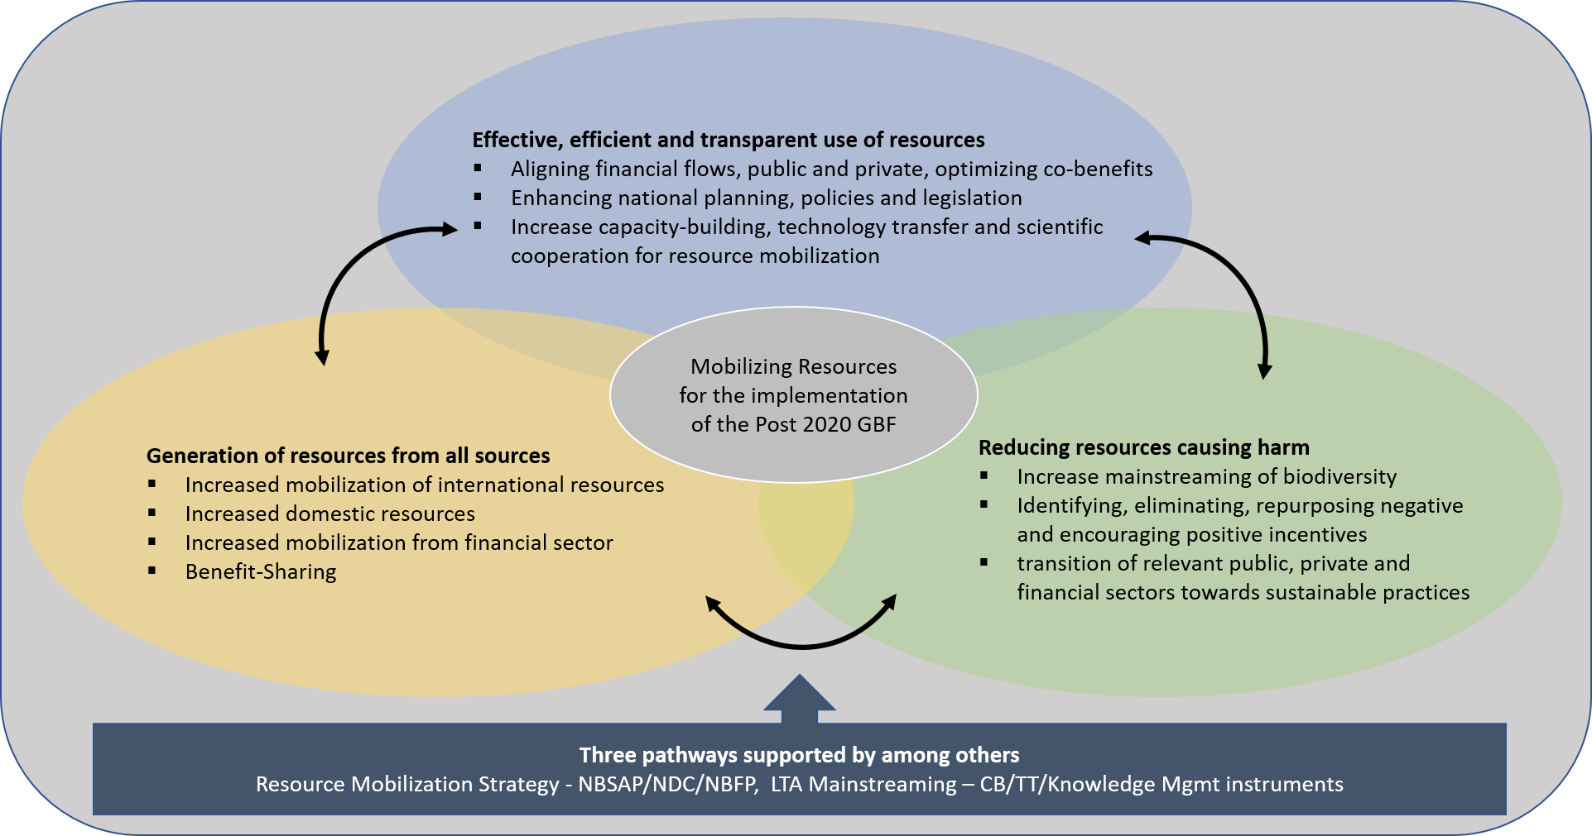__________

Decisions V/6 and VII/11.
e.g. 1 per cent of the retail price of all commercial income resulting from all utilization of genetic resources, traditional knowledge associated with genetic resources or digital sequence information on genetic resources.

