 |  | CBD/NP/CB/WS/2024/1/1/Add.1
 |  | Distr.: General  14 July 2024  English only
Global capacity-building workshop on operationalizing access and benefit-sharing national frameworks under the Nagoya Protocol
Bonn, 30 September–3 October 2024

Annotated provisional agenda

Introduction
- At its fifteenth meeting, the Conference of the Parties adopted the Kunming-Montreal Global Biodiversity Framework and through its Goal C and Target 13, Parties have placed access and benefit-sharing as a key component central to its achievement and success. Goal C calls for an increase of the monetary and non-monetary benefits from the utilization of genetic resources and digital sequence information on genetic resources, and of traditional knowledge associated with genetic resources, as applicable, are shared fairly and equitably by 2050.
- By decision 15/5, Parties also adopted a monitoring framework which includes different sets of indicators. The headline indicators to measure progress on Goal C and Target 13 rely on having information available on monetary and non-monetary benefits received. Many of the component and complementary indicators are also linked to information being published in the Access and Benefit-sharing (ABS) Clearing-House, such as the number of internationally recognized certificates of compliance and checkpoint communiqués published.
- With a view to achieving Goal C and increasing the benefits received, Parties first must establish the necessary ABS measures and institutional structures. These measures and structures must then be operationalized into functioning, practical and efficient procedures and information systems that can be clearly understood and easily followed by authorities and users of genetic resources and associated traditional knowledge. It is only then that Parties are able to begin to efficiently publish their certificates and checkpoint communiqués on the ABS Clearing-House and to receive the benefits, as agreed in mutually agreed terms.
- This workshop aims to help Parties achieve Goal C and Target 13, as well as to develop systems to monitor their progress. It will bring together ABS experts, partners and relevant stakeholders from around the world and provide an opportunity to showcase the progress made, share experiences and foster peer-to-peer cooperation and learning with regard to addressing ABS operationalization challenges and with a particular focus on practical issues related to:
  - Developing efficient user-friendly ABS procedures;
  - Managing ABS information;
  - Monitoring the utilization of genetic resources and compliance;
- The workshop is being organized by the Secretariat of the Convention on Biological Diversity, in collaboration with partners, including the ABS Capacity Development Initiative, the German Nagoya Protocol HuB and the Union for Ethical Biotrade. The workshop will be hosted by the German Federal Ministry for the Environment, Nature Conservation, Nuclear Safety and Consumer Protection, and will be financially supported by the Government of Japan through its Japan Biodiversity Fund, the Government of Denmark, the Government of the Federal Republic of Germany and the ABS Capacity Development Initiative.
- Please note that participants are required to prepare for the workshop by completing a country presentation template, available at: www.cbd.int/meetings/NP-CB-WS-2024-01. The template should be completed and sent to the Secretariat at: gisela.talamas@un.org by 30 July 2024. Participants representing partner organizations (and not representing any single country), are strongly encouraged to complete the sections of the country presentation template relevant to their own perspective and work experience related to supporting the implementation and operationalization of the Protocol.
- The workshop will be conducted in English. No translation will be provided.
- More information on the tentative workshop programme is available in the annex.

Item 1
Opening of the workshop
- Registration of participants will begin at 8 a.m. on Monday, 30 September 2024. A representative of the Government of Germany will open the workshop at 9 a.m. A representative of the Secretariat will also make opening remarks on behalf of the Executive Secretary.

Item 2
Workshop background, methodology and expectations
- Representatives of the Secretariat will give an overview of the background, objectives, methodology and expected outputs and outcomes of the workshop and relevant logistical arrangements.
- Participants will be invited to briefly introduce themselves through an ice-breaker activity.

Item 3
Sharing practical experiences operationalizing the Nagoya Protocol
- The country presentation templates provided by workshop participants will provide the content and basis for discussion during the workshop. It is therefore essential that participants complete their country presentation template and provide it to the Secretariat prior to the workshop.
- The format of the workshop will be organized in both plenary and breakout group sessions and will include thematic presentations followed by question-and-answer sessions, interactive group exercises and discussions. The Secretariat and its partners will introduce and present various sections of the “ABS workflow” (see the figure below), outlining the processes, steps and concepts related to access, benefit-sharing and compliance from the perspectives of all relevant stakeholders, as well as a summary and analysis of the country presentation templates.
- Participants will have the opportunity to present their experiences in operationalizing the “ABS workflow” and participate in the discussions on the various approaches taken, challenges faced, solutions and lessons learned. When preparing their country templates participants are asked to draw on actual practical experience paying particular attention to describing the processes and how relevant information is made available, organized, stored and managed.
Figure
General access and benefit-sharing workflow
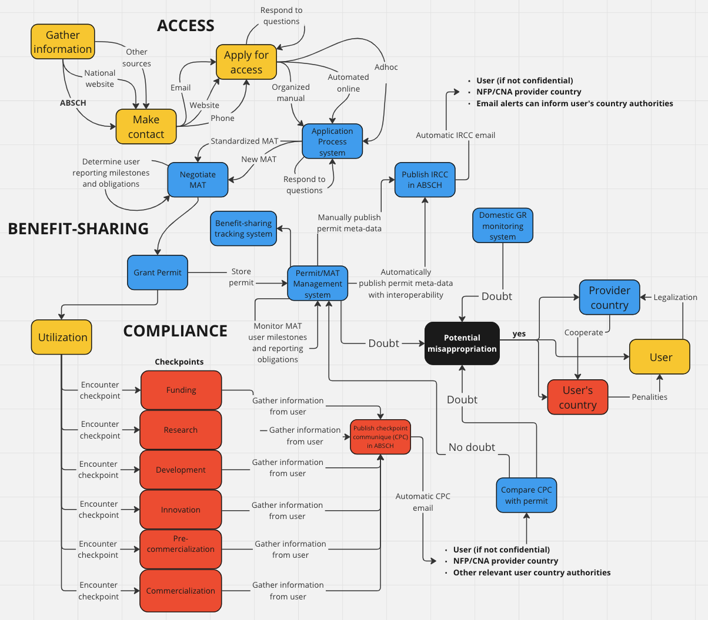

Item 4
Developing project proposals and elaborating case studies
- The fourth and final day of the workshop will be dedicated to catalyzing action to operationalize ABS frameworks focusing on simple, practical and appropriate solutions that can improve their ABS capacity, procedures and information systems and result in an increase in the benefits received and in the quality and number of national records published on the ABS Clearing-House, in particular ABS procedures, certificates and checkpoint communiqués. In groups or on their own, participants will have an opportunity to develop new projects and plans or elaborate and improve existing ones. Participants can also support each other by elaborating on case studies, lessons learned, best practices and solutions that can be made available and shared through the ABS Clearing-House. The preliminary projects and case studies developed will be shared with the workshop participants for feedback and questions.

Item 5
Conclusion and summary
- Participants will discuss key conclusions and observations that have emerged during the workshop, as well as opportunities for future collaboration building on the workshop discussions and output.
- Lastly, participants will also provide their views and be asked to complete a short survey to evaluate the effectiveness of the workshop itself, to be considered in future capacity development activities.
- The conclusions of the workshop will contribute to identifying progress, challenges and successes to inform future capacity-building, implementation and policy.

Item 6
Closure of the workshop
- The workshop is scheduled to conclude at 4 p.m. on 3 October 2024, with closing remarks by representatives of the Government of Germany and the Secretariat.

Annex

Provisional programme
Time | Agenda item
Monday 30 September
8–9 a.m. | Registration of participants
9–9.45 a.m. | Item 1. Opening of the workshop  - Welcoming remarks  - Introduction to the workshop, methodology and icebreaker
9.45–10 a.m. | Coffee break
10–10.30 a.m. | Item 2. Workshop background, methodology and expectations  Overview and key concepts  - Goal C and Target 13  - ABS workflow, steps and objectives
10.30 a.m.–12.30 p.m. | Item 3. Sharing practical experiences operationalizing the Nagoya Protocol  Access: from access requests to permits  - Country experiences  - Question-and-answer period/discussion
12.30–1.30 p.m. | Lunch break
1.30–2.45 p.m. | Item 3 (continued)  Access: from access requests to permits (continued)  - Short presentations  - Question-and-answer period/discussion
2.30–3.15 p.m. | Access: communicating access and benefit-sharing procedures  - Country experiences  - Question-and-answer period/discussion
3.15–3.30 p.m. | Coffee break
3.30–4.30 p.m. | Access: communicating access and benefit-sharing procedures (continued)  - Short presentations  - Question-and-answer period/discussion
4.30–5.30 p.m. | Daily wrap-up
To be announced | Evening activity
Tuesday, 1 October
9–9.30 a.m. | Recap of the previous day and introduction to today’s activities
9.30–10.30 a.m. | Item 3 (continued)  Access: issuing permits and internationally recognized certificates of compliance  - Country experiences  - Question-and-answer period/discussion
10.30–10.45 a.m. | Coffee break
10.45 a.m.–12.30 p.m. | Access: issuing permits and internationally recognized certificates of compliance (continued)  - Short presentations  - Question-and-answer period/discussion
12.30–1.30 p.m. | Lunch break
1.30–3 p.m. | Item 3 (continued)  Benefit-sharing  - Country experiences  - Short presentations  - Question-and-answer period/discussion
3–3.15 p.m. | Coffee break
3.15–4.30 p.m. | Activity
4.30–5.30 p.m. | Daily wrap-up
To be announced | Evening activity
Wednesday, 2 October
9–9.30 a.m. | Recap of the previous day and introduction to today’s activities
9.30–10.45 a.m. | Item 3 (continued)  Compliance (Articles 15 and 16)  - Country experiences  - Short presentations  - Question-and-answer period/discussion
10.45–11 a.m. | Coffee break
11 a.m.–12.30 p.m. | Monitoring utilization of foreign genetic resources under the Nagoya Protocol - Checkpoint and checkpoint communiqués  - Country experiences  - Question-and-answer period/discussion
12.30–1.30 p.m. | Lunch break
1.30–2.30 p.m. | Item 3 (continued)  Other systems for monitoring the utilization of genetic resources  - Country experiences  - Question-and-answer period/discussion
2.30–3 p.m. | Addressing non-compliance  - Country experiences  - Question-and-answer period/discussion
3–3.15 p.m. | Coffee break
3.15–4.30 p.m. | Activity
4.30–5.30 p.m. | Daily wrap-up
To be announced | Evening activity
Thursday, 3 October
9–9.30 a.m. | Recap and introduction to today’s activities
9.30–10 a.m. | Item 3 (continued)  Challenges and national priorities  - Country experiences  - Short presentations  - Question-and-answer period/discussion
10–10.15 a.m. | Coffee break
10.15–11.30 a.m. | Support available and cooperation  - Country experiences  - Short presentations  - Question-and-answer period/discussion
11.30 a.m.–12.30 p.m. | Item 4. Developing project proposals and elaborating case studies  Taking action  Activity on commitments, solutions, discussion
12.30–1.30 p.m. | Lunch break
1.30–3.15 p.m. | Item 4 (continued)  Taking action (continued)  - Group work: Preparation of case studies and proposals  - Presentation of group work
3.15–3.30 p.m. | Coffee break
3.30–3.45 p.m. | Item 5. Conclusion and summary  Wrap-up and evaluation
3.45–4 p.m. | Item 6. Closure of the workshop  Closing remarks
__________

More information on Goal C, Target 13 and ABS relevant indicators can be found at: www.cbd.int/abs/gbf.shtml#tab=5.
www.cbd.int/meetings/NP-CB-WS-2024-01.

