Arab Republic of Egypt
Ministry of State for Environmental Affairs
Egyptian Environmental Affairs Agency
Nature Conservation Sector
June 2009

International Expert Workshop on the Removal and Mitigation of Perverse and
The Promotion of Positive and Incentive Measures
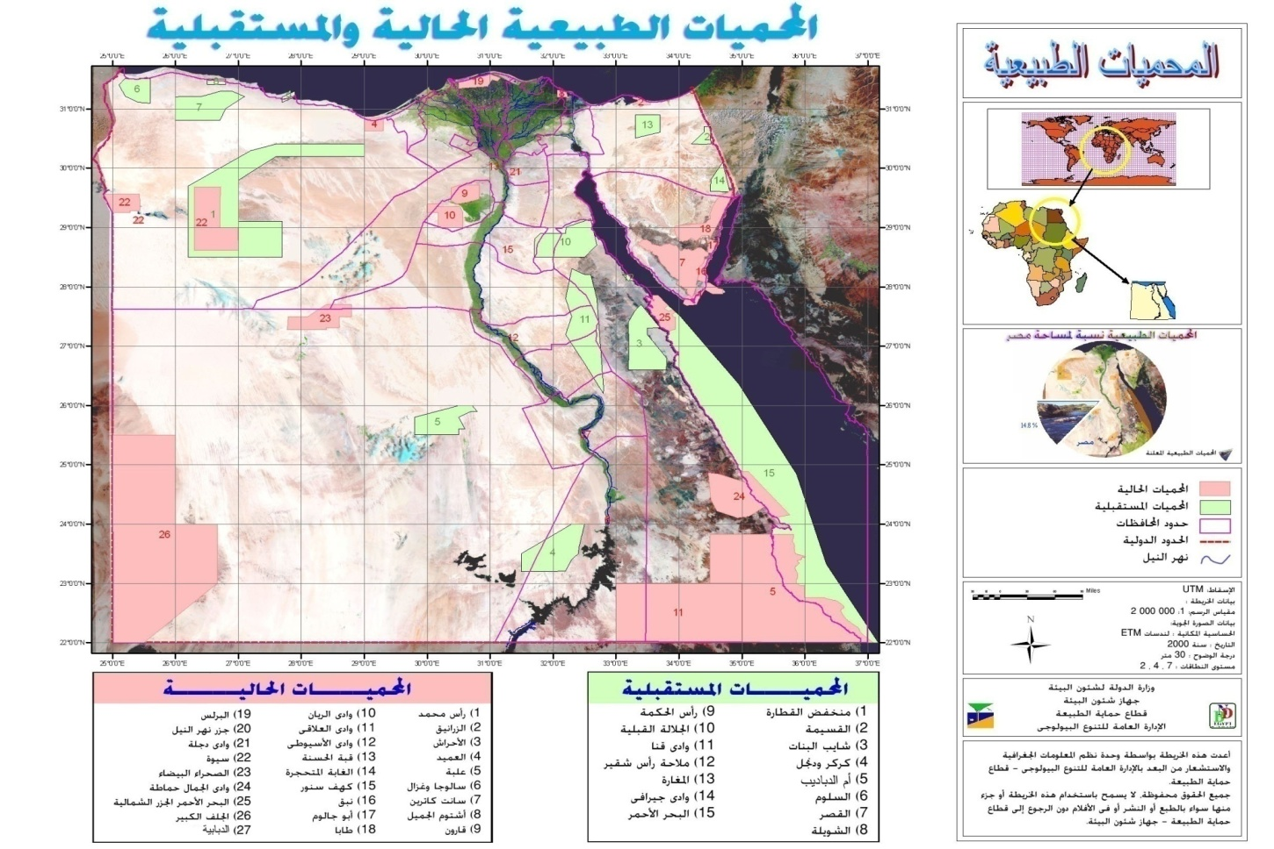
Introduction:
- Concrete cultural heritage such as monuments and popular traditions and habits are the bases of human beings development along different ages.
- Man used available natural resources surrounding him and has changed their nature according to his needs. Cultural and natural heritage are linked closely as biological diversity was mentioned in all religions, beliefs, common laws, languages, folklores and music. Accordingly, loss of biological diversity is a loss of cultural heritage of different nations.
- Egypt is considered to be one of the richest countries with its cultural heritage that reflected in civilizations and different human traditions where their heritages and knowledge transferred across different generations .These natural and cultural wealth were exposed to huge pressures emerged from human beings , in addition to new technologies that contributed in loosing great amount of them . For that reason, taking decisions about suitable technologies to be used must arise from needs of nations especially in local communities.
- Protected areas contributed in the protection of cultural heritage, natural landscape and traditional knowledge. It also encouraged participation of local communities in conservation of their different cultures, as there are prehistoric drawings in protectorates of El-Gulf El-kabeer, Wadi El-Gemal and Elba mountain; roman and
- pharaonic monuments in protectorates of Qaroun, Sewa, Wadi El-Gemal and El- Zaranik; Christian monuments in protectorate of Saint Catherine and Islamic monuments in protectorate of El-Zaranik. They were also encouraged in protection of cultural diversity of languages, local dialects, handicrafts, folklore, dancing and
traditional tools in local communities as in Bedouins and tribes of El- Ababda and El-Basharia, in addition to green buildings that reflect local raw materials and different natural scenes.
- The development of any new protected area in Egypt is based upon the local communities as partnership to implement its main programs. On the same stream, the support of the local communities is a major program that should be implemented side by side with the conservation programs where the benefits and incentives to the locals is the base motive to believe the importance and valuation of the natural resources.
- Following are some major case studies within the Egyptian Protected Areas that are considered now mile stone for conservation in the country.

CASE STUDY1:

SAINT KATHERINE PROTECTORATE / SOUTH SINAI / EGYPT
- Background The case study reported here is an attempt to institute an integrated approach to the development and diversification of sustainable tourism in the St. Katherine Protectorate that will help conserve the natural and cultural resources of the area and at the same provide tangible benefits to local communities. The programme has incorporated a number of linked initiatives including the construction of a model community ecolodge, establishing interpretative nature trails, revitalizing traditional craft skills, constructing a visitor interpretative centre, establishing satellite centers on tourist routes, publishing tourist maps, nature guidebooks and an interactive CD ROM and launching a web page for the Protectorate. For this case study only the Bedouin ecolodge and the women’s craft and income generation project are described. It is important to note that both enterprises are in the early stages of development.
The promotion of sustainable tourism is one element of the establishment and development of the St. Katherine Protectorate by the Egyptian Environmental Affairs Agency. From the inception a participatory management approach with the communities has been adopted to accomplish the Protectorate’s conservation objectives and the underlying management principle is that local people must be primary beneficiaries in the Protectorate’s development. To this end a Bedouin Support Programme was instituted that includes a primary health service for local communities, veterinary support, employment of Community Guards, establishing a Bedouin owned company for the production and marketing of women's traditional crafts, Protectorate sign making by local artisans, vocational training, infrastructure development such as roads and dams etc. The Protectorate gives local people priority for employment and 60% of the Protectorate Area Management staff are local Bedouins.
Ecolodge – ‘Al karm’: Craft – ‘Fansina’ : in Saint Katherine City/ South Sinai Governorate- Egypt
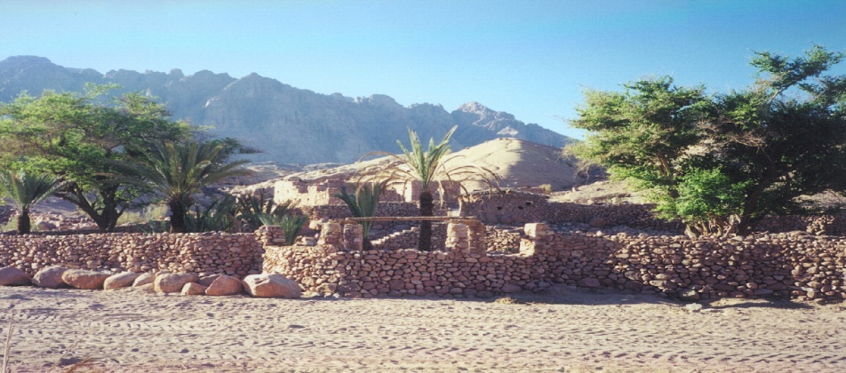
Shakh Awawd Ecolodge
In partnership with local people, the Protectorate has constructed a model Bedouin owned and managed ecolodge (Al Karm) by refurbishing some abandoned traditional houses and garden where visitors will have Bedouin-mediated experiences. This is considered to be the first genuine ecolodge in Egypt. The ecolodge is situated close to the traditional route to St. Katherine Monastery in an area of great scenic beauty, which also contains rare wildlife species such as hyena, wolf and ibex and several archaeological sites some dating back to 7,000 years BP.

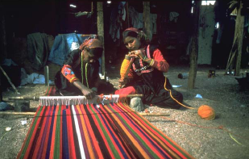
Crafts. The conservation of traditions, and the application of indigenous knowledge and customary skills of local people, have become central to the development and management of the St. Katherine Protectorate. One significant Protectorate initiative is the Bedouin Craft programme, started in 1997 to assist women particularly, in preserving, developing and marketing their traditional skills and in generating additional income. In 2002 a Bedouin owned company (Fansina) was established and officially registered to produce and market craft items. Currently over 400 Bedouin women are involved in this enterprise.
Bedouins Handicrafts
Contact Fansina@sinainet.com.eg

B. Initiation :
Early on in the development of the Protectorate it was concluded that one of the most effective ways to direct benefits to local people would be to link sustainable tourism with local community development, thereby making conservation and attractive option to rural people.
A study of the tourism sector in south Sinai, commissioned in 1997 by the Protectorate indicated that there were significant opportunities for enhancing the quality of tourism and the revenue stream by promoting Bedouin managed tourism enterprises in the premium wilderness areas inside the Protectorates. A number of interconnected trekking routes and various itineraries were proposed along with suggestions for local administrative arrangements based on orfi (customary law) tradition to implement the programme.
The craft programme was implemented with the assistance of consultants whose periodic input has been sustained over 4 years.

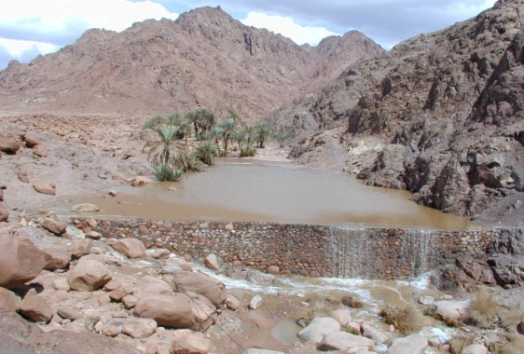
water capture dam at Bedouin setllement
C.Finance and funding:
Ecolodge. The build and fitting-out cost of the lodge was approximately $40,000 (excluding fees of supervising architect), nearly 60% of this was for local wages. As a model to be replicated elsewhere it was essential that the cost of the ecolodge be kept as low as possible.
Room rates are modest (approximately $10/person/night) but additional income is generated by provisioning and related services (food supply, guided recreational trips, sales of handicrafts….).
The comprehensive feasibility study by EQI (Environmental Quality International) consultants determined the area’s natural and cultural heritage along with the social, legal/institutional, the marketing potential and the financial viability of the project. The study was positive on all these aspect and indicated the financial viability of the enterprise with a ‘full return on investment’ within 3 years (if necessary) at an average 50% occupancy, On reality now the occupancy comes to 90% beside the rate change from US$ 5 to 10 to 15.
Fansina. The protectorate subsidized the craft programme from its inception until January 2002 since when the enterprise has become self-sustaining with the exception of consultant and trainer’s fees. Total investment in the craft project to date amounts to approximately $60,000 excluding consultants’ fees.
Monthly sales are growing as outlets expand and marketing improves e.g. through the ecolodge, the new Visitor Interpretative Centre and satellite centers. Sales in 2008 currently generate around $10000/month up from $1,200/month in 2001 and export orders are now being received.

D. Environmental sustainability of the ecotourism project business
1). Contribution to the conservation of natural areas.
The ecolodge site is within the St. Katherine Protectorate. The local community understand the natural attractions of the area to visitors and have demonstrated their interest and capacity to maintain them by reporting on violations and using peer pressure to prevent deleterious activities etc. The major opinion leader in the stakeholder community is also a Protectorate Community Guard who helps enforce regulations and is a conduit between the Protectorate and the community.

2). Education and interpretation features.
Local environmental awareness has been raised in the destination area directly and through related protectorate activities such as primary health, child development and nutrition surveys and veterinary services.

A specific interpretative guide to the area and the lodge is to be produced for visitors. The Visitor Interpretative in St. Katherine is orientating visitors to the opportunities for sustainable tourism and the Protectorate’s natural and cultural values. The lodge is situated on the traditional route to the St. Katherine Monastery and an existing interpretative trail is to be extended to the site.

3). Environmental practices.
The lodge was designed in the vernacular style and 25 local Bedouin artisans built and fitted out of the lodge in three and a half months. It was built using local materials and has a capacity of 20 persons; it operates on the principle of minimal environmental impact and offers very basic facilities - it has waterless composting toilets and the showers are water efficient and solar heated. A dam has been built upstream to recharge groundwater supplies. Waste grey water is filtered through a ‘fat’ trap and then used to irrigate Bedouin gardens. Guests will bring their own bedding, so no laundry is done on site, and firewood comes from a sustainable source.

The craft programme was initiated in the belief that the maintenance of cultural diversity and the conservation of biological diversity are interconnected and that biodiversity can be conserved through a broader effort to promote and sustain human welfare and culture.

The conservation of traditions, and the application of indigenous knowledge and customary skills of local people, has become central to the development and management of the St. Katherine Protectorate. The stylised motifs of their decorative embroidery and beadwork reflect local plants and animals.

E. Social sustainability:
Community Involvement and benefits.
This model ecolodges seeks to bring about a broad involvement of the local community in the enterprise and spread the benefits and awareness of conservation. The local community will manage the lodge and individuals from the community have had vocational training as part of the project.
Twenty-four families have traditional rights to the property so future benefits will be shared between these families. The ecolodge will catalyse related employment and income generation activities within the communities e.g. by creating a market for fresh produce, supply of services, guide fees and the sale of traditional crafts etc. The soft furnishings of the ecolodge e.g floor and sleeping mats are made by local people.

Many of the younger children from the stakeholder communities are significantly malnourished though a significant proportion of agricultural activity is devoted to the production of tobacco rather than food crops. It is hoped that the demand for fresh produce created by visitors to the ecolodge will encourage the production of more food crops, which could contribute to raising the community’s general nutritional status.

The ecolodge is a small-scale enterprise and its impact both on nature conservation and on income generation and employment will be necessarily limited and localized. However it is anticipated that in the future the ecolodge experience will be replicated to form a network situated on interconnecting mountain trails throughout the Protectorate, and thereby creating a wider impact with mutually supportive linkages

F. Economic sustainability :
1). Marketing and Promotion:
General. The obvious target is the growing adventure-tourism market and the culturally curious travelers, which operates at lower capacities but has higher margins than the mass-tourism market and are usually ‘loyal to locations’. This would have the advantages of attracting a new market to Sinai, rather than simply diversifying the present client base, and maximize economic benefits to local communities. In spite of the prevailing global tourism situation locally exacerbated by the present Palestine/Israel conflict it is anticipated that the ecolodge could survive on internal tourism by attracting nationals and foreign residents.
The Protectorate and its ecotourism opportunities have been publicized at the 2001 Mediterranean and London Tourism Fairs.
Ecolodge. A marketing brochure is in preparation. The Protectorate will continue to support the marketing of this enterprise for the foreseeable future. The destination has been registered with the major tourist web page for south Sinai i.e www.goredsea.com A beach-based ecotourism enterprise (Basata), established for over 15 years, is cooperating in promoting and marketing the destination to guests and through its web page.

Fansina. The company has been extensively promoted at bazaars and trade fairs, and by commissioned posters, stickers, bags etc and on the Protectorate’s web page.
2). Profitability.
The ecolodge direct revenue is presently distributed among over 26 owner family members beside over 20 other from the locals that provide adventure trips to the tourists. Fansina is in 8th year of financial independence but it appears to be a financially viable enterprise. 5 years ago the Governor of South Sinai provided LE 20,000 ($4,000) as a soft loan to Fansina to help extend its activities to other communities, The company is permanently requested to represent the South Sinai traditions in the international fairs
G. Cooperation in ecotourism business operation
The commissioning of the ecolodge has been supported by a privately owned beach-based ecotourism enterprise in Sinai (Basata). This cooperation involves orientation and training of the Bedouin owners in lodge, location and visitor management practices. Currently we are testing the promotion of the ecolodge with a small number of European based companies specialising in premium adventure tourism in Sinai..

H. Regulation of ecotourism activities:
In Egypt mass tourism is a mainstay for the national economy and the strategic approach is to increase the throughput of visitors by efficiently marketing and catering to the package holiday industry. Until recently there has been little recognition of the role and added value of ecotourism and subsequently there has been little promotion of the nature based tourism potential i.e. the oases and other attractions of the western and eastern deserts or the mountains and deserts of Sinai or Egypt’s system of protected areas. Consequently there is little regulation of ecotourism activities though guidelines for ecotourism and ecolodge development have been produced by the Tourism Development Agency in co-operation with USAID.
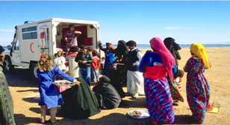
Health car at Bedouin setellement

I. Results achieved
Though both enterprises show positive results achieved.
Ecolodge:
A functioning ecolodge has been built, owned and managed by the Bedouin themselves, 8 of whom have received vocational training. Visitor numbers are increased.
Fansina.
- An independent Bedouin owned craft company established, managed by 4 local people and contributing to household incomes for over 400 local women.
- Over 20 local women trained in quality control, finishing, stock inventory and marketing.
- A permanent craft production centre has been established in St. Katherine with materials store, finishing workshop and retail outlet.
- Income generation average about 1000 LE for each women and girl.
- Will expand this year for 100 women more (under training).
- Potential to expand to the south protectorate in NBQ this summer to starte establish a craft center to support over 100 family in the protectorate and surrounding.

J. Lessons learned:
The primary lesson learnt from collaborative management with the locals within St. Katherine Protectorate is the absolute imperative to involve and benefit local people at an early stage in the process and to win their active support for conservation activities
Other significant lessons are::
- Community participation is a long-term commitment; it needs to be established early in the process and often cannot be successfully accomplished in the relatively short period of most conservation processes.
- Inputs have to be sustained to gain the trust and confidence of local people and this should extend to the long-term involvement and accountability of individual rangers & Manager.
- Investments should be explicitly tailored and appropriately scaled.
- Tangible benefits to local communities must be sustained at any time of the development or normal conservation process.
- Traditional responsibility of local people as the resource managers in the area should be acknowledged and exploited.
- Effective integration between tourism, local economic development and protected area management the expansion of nature-based tourism can direct economic benefits to remote rural areas and increased incentives for conservation in state protected lands.
- Conservation projects can help to catalyze associated rural development activities by other agencies.
K. Repaeted activities that have good effect on conservation and incentives:
Due to the benefits and incentives come out of the Saint Katherine Bedouin crafts, It becomes one of the main activities within local support program for any protectorate development, This program is in function now for Zaraneek, Elba, Omayed and Wadi El Gemal PAs
El-Zaranik Protectorate ( North Sinai): Setting up non governmental society, providing health and veterinary services, providing houses with natural gas stoves, and training of 56 women and girls on handicrafts and methods of marketing their products through environmental exhibitions.

El-Omayed Protectorate ( Matrouh Governorate): Issuing birth certificates and national number identity cards for about 600 women and girls, providing some families with sewing machines and natural gas stoves.

Elba Protectorate ( South Red Sea Governorate): Setting up Red Sea Development Society for Supporting local Community, providing health support for inhabitants and vaccination of children, building of a class to eliminate illiteracy and educate 30 child in the area of the protectorate, training of about 40 women and girls on handicrafts and marketing their products through environmental exhibitions, presenting a proposal for Environmental Protection Fund of EEAA to train about 300 women and girls with about 30.000 L.E.

LIFE project in the Red Sea: Forming a folkloric show troupe in Shalatean, develop Hamatta School, setting up Vocational Training Center, develop handicrafts in Hamatta , Shallatean and Elba Mountain for about 30 families , employing 3 women in separation station of solid wastes to earn about 1500 pounds for each .

El-Alaky Protectorate: Setting up Society of Developing Women and Local Community to raise incomes for about 40 women and girls, establishing some small projects such as distributing sewing machines and eliminate illiteracy, implementing agricultural projects, raise inhabitants health awareness, in addition to initiate implementing some of handicrafts projects.

CASE STUDY2: Samadi
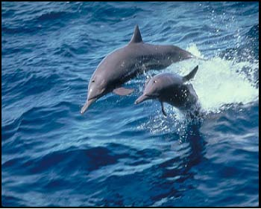
Samadi Dolphins
- Background:
Few years ago, divers discovered Samadi area, where spinner dolphins exist . It is located south of Marsa Alam city , in the Red Sea where divers, snorkelers, and vessels have increased dramatically in this area. This has led to unacceptable behavior by individuals such as chasing dolphins, making noise in the water, and in some cases, vessels were set on fire, resulted in dolphins deserted Samadi for about two weeks.

- Action taking:
- Red Sea protectorates in coordination with the Red Sea governorate interfered to solve this problem.
- Developing of a management plan for the area .
- Ecotourism activity regulations and permits were produced.
- Monitoring team was established to report any difficulty to the management board.
- Team work was established to study dolphins behavior & tourists capacity on the basis of number of visitors does not exceed 200 per day,
- It was agreed to start the implementation of his plan on 2004.

- Results achieved:
After one year of implementing the management plan:
- The monitoring programme has shown remarkable increase in coral reefs growth..
- In 2008, fees collected amounted 5 million LE.
- Improving tourism in Marsa Alam area during 2006, 2007.
- Establishing Abu Salama association for dolphins with participation of beneficiaries.
- Dolphins Protection in this area and surrounding, that reached 120 dolphins / day during summer.
- Studies succeeded in determining the breeding season of dolphins, along with identifying dolphins food which included fish, mollusks and crustacean.

- Beneficiaries & Benefits:
- Stable income generation for 90 local employment, average income over 750 LE/ month.
- Providing part of the operational cost of Red Sea three protectorates.
- Incentives provided to the Environmental employers of the Governorate.
- Conservation of rare and endangered species.
- Dolphins habitat is well managed.
- Increasing of numbers of tourists and income for the area.

- Lessons learned:
The primary lesson learnt from collaborative management with the locals within Red Sea Protectorates is the absolute imperative to involve and benefit local people at an early stage in the process and to win their active support for conservation activities
Other significant lessons are:
- Collaborative Management plan can be implemented for the sack of all stockholders.
- Investments should be explicitly tailored and appropriately scaled.
- Tangible benefits to local communities must be sustained during normal conservation process.
- Effective integration between tourism, local authorities, and protected area management the expansion of nature-based tourism can direct economic benefits to remote areas and increased incentives for conservation in state protected lands.
- Conservation management can help to catalyze associated nature based recreational activities by local authorities.

CASE STUDY3: Medicinal plants
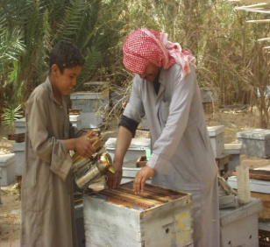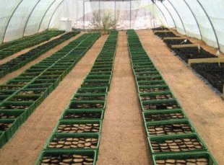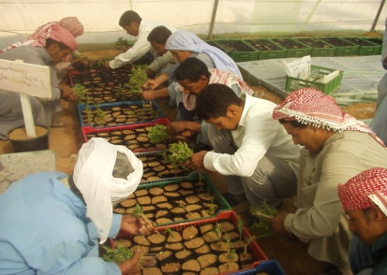
Medicinal Plants Activities
- Background:
- The UNDP funded project to sustain and develop a community based Management Natural Resources within Saint Katherine PA is now working in the city of Saint Katherine, this way of management similar in a way the collaborative management of the natural resources where the local community and the stake holders sit together to find the right way to rehabilitate, cultivate, collect and proper marketing the medicinal plant as a health product , It is a proper and solid way for the locals for income generation , Conservation of the natural resources, Economic valuation of part flora species.
- The Egypt Medicinal Plants Conservation Project (MPCP) is implemented through the UNDP, The UNDP-GEF PDF-B (Preparatory Assistance Document EGY/99/G43/A/1G/99) was signed in February 1999 and a Project Document was prepared. The PDF-B Project Brief developed the concept for the MPCP. The resulting Project Document (EGY/00/G31/A/1G/99), developed the rationale for the MPCP, produced the log frame matrix for the projects implementation and set out the modalities for project execution.
- In February 2007 the project developed a revised log frame matrix (LFM) was produced. The strategy to achieve the conservation of MAP resources in SKP that resulted from this
- LFM revision can be summarized as:
- Protecting the wild MAP resources in SKP
- Increasing the motivation for sustainable management.
- Replacing critically endangered resources with alternatives and providing alternatives.
- Creating a supporting legal and policy framework for sustainable utilization, protection and access to well-regulated markets for MAPs in SKP.
- Conservation and sustainable use of globally significant medicinal plant biodiversity in St Katherine’s Protectorate.

The local community
- The management plan define the local community as the seven Bedouin Tribes who live within SKP.
- No description of who, how or where MAPs were collected.
- Democratic arrangements for distributing the benefits from tourism that are associated with the Monastery and guiding tourists up Gebel Musa (Mount Moses).
- The Bedouin are quite capable of developing sophisticated arrangements in order to equitably share a common property.
- The investigation failed to define the wild collection of MAPs and “local community” or “Bedouin” are defined as “local people” and settled expediently on the traditional system of Helf without realizing that this was a sophisticated common property agreement that was only ever relevant when resources such as grazing were abundant.

The Medicinal Plants Association "MPA"
The purpose of the MPA :
- Play important focal roles institution (sic) for training and extension and for marketing of medical plants”.
- Develop a marketing association for medicinal plants to provide an interface between producers and wholesalers/retailers.
- For instance, a processing and marketing association for the Bedouin farmers and collectors does not necessarily require a building.
- Strengthening informal arrangements and legitimising user rights through the SKP without the need for establishing a formal Medicinal Plants Centre.
- Sustainable collection of medicinal plants as part of the conservation and management of these resources.
- Provide tangible benefit from the M.P. resource.
- Development of cultivation, processing and marketing and little interaction with the majority of collectors who are mostly women, children and the local traditional healers (Hakim).”

- Activities:
- A settled agreement with 60 of collectors and marketing merchants, within a determined collecting system.
- IUCN regulation to collect the Medicinal plants translated and distributed.
- Contracting three Bedouin women as communicating and public awareness officers.
- Develop and design 70 products ( Medicinal plants- wild honey- Bedouin crafts & customs- ornaments - ….) for the MPA.
- Training of 62 Bedouin women on the handicrafts.
- Produce a catalogue for the MPA products.
- Training course on fair trading attended by 10 from MPA and other 10 from the local community.
- Guidelines for the production of Medicinal plants for MPA are produced.
- An agreement is been signed to guarantee an equitable share of the profits out of the fair trade of the products of MPA for the local community.
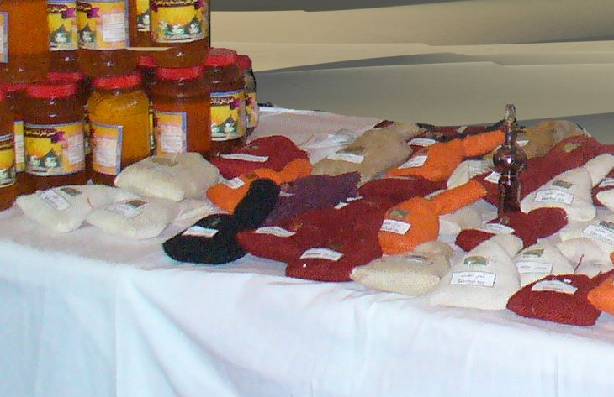
MPA products
- Benefits:
Number of the MPA member ships comes to 265 person represents 230 families are the main beneficiaries from the MPA services which are:
- Revolving loans: for Gas stoves, Gas home tank, Fuel wood, Bees farm, MP cultivation,...)
- Develop a MP Pharmacy to be managed by the MPA to serve 2500 Saint Katherine residents and surroundings.
- Support the reoperation of the only bakery in Saint Katherine city that produce the bread for the city.
- Provide 108 permanent jobs.
- 35 Jobs for the implementation of subprogram for conservation of the natural resources (Rehabilitations, Gene bank, seedlings, ….. .)
- 6 Jobs for the Peace Park in Sharm El Shakh.
- 20 Jobs Support the Saint Katherine Protectorate.
- 7 Jobs for the support of Community Based Natural Resources Management program.
- 10 Jobs for the support of the MPA.
- 30 Jobs for the support of Herbariums school and traditional knowledge.

