Moldova’s experience with positive incentive measures

Ala Rotaru, Principal consultant in the Natural Resources and Biodiversity Division, Ministry of Ecology and Natural Resources, Republic of Moldova

The Republic of Moldova is a small, land-locked country situated between Ukraine and Romania. Covering an area of 33,843 square kilometers Moldova is slightly larger than the State of Maryland and contains forest, steppe, and forest/steppe landscapes. The natural and semi-natural ecosystems (forests, forest belts, hayfields, pastures, wetlands, water bodies) account for only 17% of the Moldovan territory. Today, agricultural activities cover 75% of the landscape and farmers produce world-famous wines along with cereal grains, corn, fruits, vegetables, nuts and other products. The rich Chernozem soils, good climate, and adequate water resources contribute to the rich agricultural tradition of Moldova.
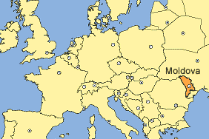

Strategically located in southeastern Europe, Moldova plays an important role in maintaining regional biodiversity. It lies at the intersection of three bio-geographic zones: 1) Central-European, oak forests; 2) Euro-Asiatic, semi-arid steppe; and 3) Mediterranean, Black Sea. The overlap of these zones results in high-level of genetic diversity in plants and animals. However, many species live at the borders of their natural ranges and therefore regional meta-populations may be more vulnerable to extinction.
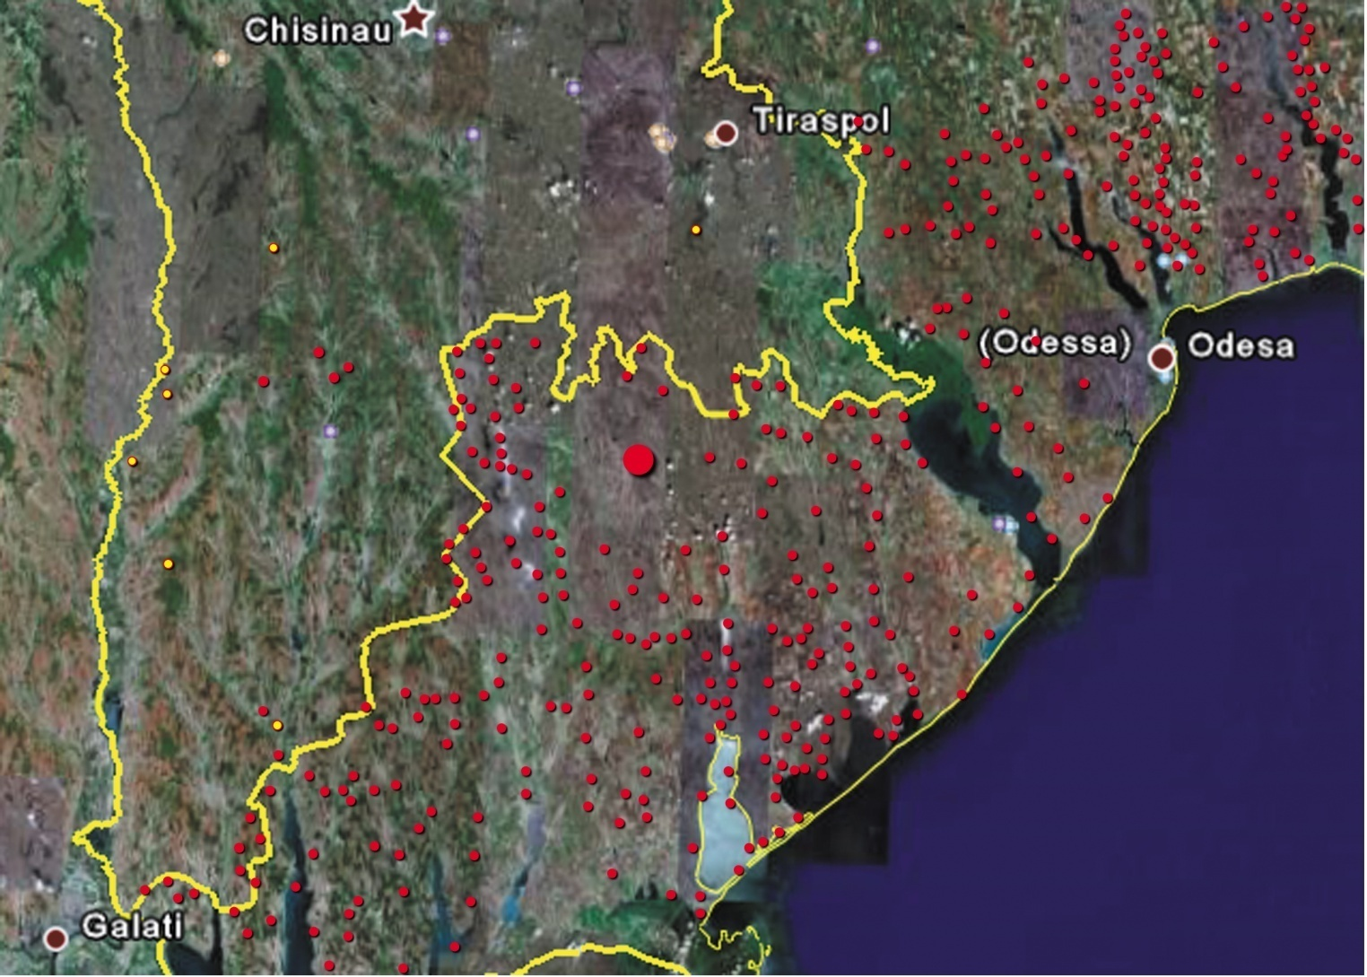
Despite their current economic hardships, the Moldovan people have a national identity based on respect for the natural environment. A healthy environment and stable biological diversity is essential for a nation built on an agricultural economy. The correlation between compromised ecosystem services and the eventual effect on an agricultural economy are very clear.
The expansion of the agricultural sector and other previous economic development plans severely compromised natural habitats in forest, steppe, and aquatic areas. Agricultural expansion in the semi-arid regions of southern Moldova eliminated over 90% of natural steppe habitats, including grasslands, marshes, and meadows.

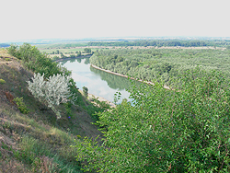
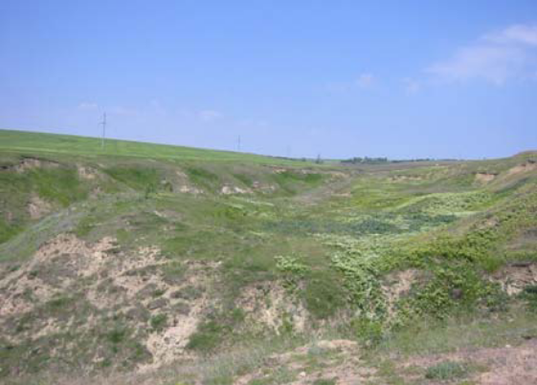

Moldovan forests were mostly cleared three times in the 20th century and the majority of current stands grew from plantations or from stump or root sprouts. The majority of mature forest stands lack the genetic and species composition of healthy forest ecosystems. Today, the Republic of Moldova has 362,700 ha of forests covering 10.7% from the country’s territory, which is a very low figure as compared to the European average (29%) .
Moldova has 30,500 ha of forest protection belts and 18,500 ha of bushes planted to combat soil erosion, to protect field crops and water bodies. Reportedly, the quality of these areas have declined due to illegal cutting for firewood, lack of proper maintenance or competition from more advantageous invasive species such as box elder (Acer negundo).
The biodiversity in the Republic of Moldova is affected at all levels by series of natural and anthropogenic facts. It is established the increasing of air temperature in different zones of the Republic of Moldova. At the same time, there exists a natural tendency to habitats humidity diminution, which is aggravating thanks to antropic impact as well (meadow zones draining and destruction of small rivers meadows).
Today’s Global Economic Crisis increases the necessity of taking into account the biodiversity, its economic value and potential values and the factors conducting to avoid the perverse incentives.

CASE STUDY1: Political incentives
Republic of Moldova acknowledge the importance of adopting economically and socially sound measures that act as incentives for the conservation and sustainable use of components of biological diversity. Moldova have a few positive measures adopted. With some imperfections in their use, they are important part of the environmental policy in the economic field.
These measures cover a large field of instruments like political, social and monetary incentives (laws, education, research, governance, subsidies, tax incentives etc.).
The National Strategy and Action Plan in Biological Diversity Conservation provide the integration of local potential and promotion of politics in the field of biodiversity. Local Action Plans in the field of environmental protection are elaborated in every district (rayon) of the Republic of Moldova. In the major part this documents contain chapters on biodiversity conservation. But these plans are less implemented because of lack of financial sources. The best activities for implementation of these plans are realized in the districts: Ştefan Vodă, Ungheni, Cahul, Orhei and Bălţi municipality.
Other documents having as subject the consolidation of local potential are the following:
- The Strategy for Economic Growth and Poverty Reduction (2004 - 2006) (2004);
- National Action Plan in the field of human rights for 2004-2008 (2003);
- Strategy for sustainable development of tourism in the Republic of Moldova in period of 2003 -2015 (2003);
- Program of activity of the Government for the years 2001-2005 “Renaissance of economy - renaissance of the country ” (2001);
- Program of activity of the Government for the years 2005-2009 “Modernization of the country - welfare of nation” (2005);
- Strategy for socio-economic development of the Republic of Moldova for medium term (until 2005) (2001);
- National Program for assurance of ecological security (2003)

The state policy reflected in some documents (conceptions, strategies, action plans) stipulates this kind of measures. For example, in NSAPBDC at the compartment III. is stipulated: encouraging the farmers to conserve the biodiversity components (rare species habitats, reproduction sites, migration routes etc.) by offering respective incentives. Some legislative acts in the field of silviculture (Forest Code and Law on Improving the Degraded Lands Through Afforestation) offer stimulation for private forests creation, but economical mechanisms for stimulating the population to this kind of activities are not yet elaborated.
In the Republic of Moldova only a few elements of the economical mechanism that belong to his domain are applied, as the ones from:
Annex nr. 1 to Animal Kingdom Law stipulates:
- that persons who traced out offenders of hunting regulations and terms beside receiving money and remuneration in nature - up till 100% from birds and hare meat that was confiscated, also have priority at buying the meat of illicitly captured hoofed animals;
- that persons who traced out directly offenders are offered rewards, and the person that traced out an offence in which the judicial and investigation organs discovered criminal actions, is offered a reward the size of 10 minimal wages;
- that the remained resources at the special account after remuneration are used to remunerate the persons that actively participate at the hinting development;
Annex nr.2 to Animal Kingdom Law stipulates that the remained amounts at the Piscatorial Service account may be used till 50% to stimulate the workers of Piscatorial Service and public inspectors;
Law on environment protection stipulates: the use of ecological fund resources (national, local) for staff remuneration - regardless of departmental provenience - that brought a real contribution to environment protection. The amounts for remuneration will not exceed 1% from National Ecological Fund, and 5% from Local Ecological Funds.
Law on Vegetal Kingdom has special articles: economic mechanism and economic stimulation:
(1) economic stimulation of rational using, restore and preserve of objects of vegetal kingdom aims to increase interest and responsibility of owners and beneficiaries of land for their conservation and rational development.
(2) economic stimulation of rational using, restore and preserve of objects of vegetal kingdom provides:
a) stimulating activities on rational use development programs, the restoration and preservation of plants at the expense allowances provided in the state budget, local budgets, special funds and other sources of legal provenance;
b) field of instruments to holders of land territories for improve the activities in protection of biodiversity in this;
c) promotion of material incentives for individuals and legal entities to take effective measures to guard and protect the plants that have found violations of the relevant legislation and ensured the collection of fines and compensation for material damage caused to objects of the vegetal kingdom.

CASE STUDY2: Reforestation and Afforestation
Soil erosion and landslides are major environmental problems that adversely affect land productivity in several regions of the Republic of Moldova. These problems if allowed to continue could result in long term adverse impacts on the land productivity in several parts of the country.
Towards that goal, The Moldova Soil Conservation project, initiated in 2002 with support from the WB Prototype Carbon Fund, is reforesting 19,768 hectares of degraded and eroded state-owned and communal agricultural lands spread over throughout the country. The reforestation proposes to achieve multiple objectives, and in particular to restore degraded lands through improvement in the vegetative cover and sustainably enhance supplies of forest products to local communities. The Project is financing and implementing by the Forest State Agency Moldsilva. Moldsilva is establishing all plantations and maintaining plantations on state-owned land. On communal land, the new forests it`s planning to l be returned to the municipalities under long-term management contracts.

In the years 1990 - 1998 was created a comprehensive legislative framework axed on forestry reports and their interconnection with environmental protection, economic, social and cultural interests of the country.
Circumstances causing a low contribution of the forest sector in solving the social-economical problems are:
- insufficient level of forestation of country’s territory, and thus the less possibilities for ingathering and processing of timber mass and accessory forest products;
- insufficient use of the stationed potential, that leads to a low productivity of forests;
- insufficient use of timber mass reserves (current growing), which could be gotten in without damaging the state of forests;
- low level of assurance of forest sector with modern equipment for efficient processing of timber mass, what negatively reflects on variety, quality and competitiveness of final product made of it, as well as on ingathering of accessory forest products;
- insufficient development of some auxiliary activities, as nurseries, growing of snails and pheasants to be commercialized, hunting tourism, ecotourism etc., that could bring profit to be used for supplementary financing of basic activities.
Moldsilva and local councils traditionally lacked financial resources to restore the degraded lands. Due to the lack of investments, public and community lands have shown significant productivity declines and have become susceptible to erosion and land slides. In the absence of restorative action, these lands are expected to degrade further and continue to be the major sources of GHG emissions.
The incentive in the form of revenue from sale of certified emission reduction credits (CERs) from afforestation/reforestation activities under the CDM assumes significance and has served as catalyst in establishing legally binding institutional arrangements and stakeholder relationships involving Moldsilva and 384 local councils that represent the rural communities in the country.
Out of total project area of 20,289.8 ha, Moldsilva and local councils own about 40% and 60% of the land, respectively. As per the contractual arrangement, Moldsilva is authorized to undertake afforestation/reforestation (A/R) activities on lands owned by local councils and to manage these lands until after the establishment of forest and later to transfer them to the local councils for subsequent management.
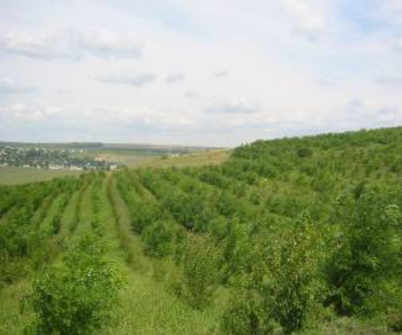
The project design incorporated measures to enhance the socioeconomic status of communities and to ensure that their livelihoods are not affected and the pre-project economic activities are not displaced to areas outside project. The socioeconomic measures and programs implemented based on the feedback from public consultations at the level of local council, mayoralty, forest enterprise, judet, and national government contribute to the prevention of economic activity displacement.
The project adopts renewable 20-year crediting period, which is expected to be extended for further two consecutive 20-year crediting periods, for a total project implementation period of 60 years. The project is expected to generate revenue from the sale of timber from thinning and final harvest of short rotation species, and from the sale of Certified Emission Reduction (CER) credits over the first 20-year crediting period.

CASE STUDY2: Regional experience in protection of steppe ecosystems
The Project “Sustainable Integrated Land Use of Eurasian Steppe” is implemented in the territories of steppe ecosystems of the three countries – Ukraine, Russian Federation and Moldova, which embraces Lugansk and Odessa oblast in Ukraine, Manych valley in Russia, steppe plots in Cahul rayon and on the west bank of Dnester in Moldova. The Project is operating since December 2007 and will be elongated till the end of 2009.

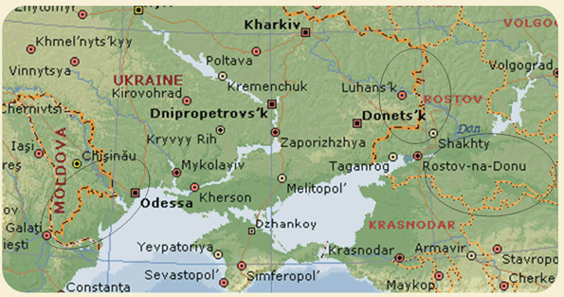

Main project task is to test in practice and implement such mechanisms of steppe area management, which would facilitate the development of rural areas on one hand and conservation of steppe ecosystem areas on the other hand.
- Promotion among the farmers and agricultural structures of sustainable, environmentally sound land use of steppe areas for the conservation of steppe biodiversity;
- Restoration of abandoned and degraded steppe territories; increase of steppe grasslands productivity;
- Development and implementation of market mechanisms, which aim at conservation and restoration of steppe, and also agriculture development;
- Lobbying and promotion of the issues of sustainable steppe land use management at legislative level.
Within the project "Identifying agricultural lands of a natural high value: supporting countries that do not adhere to the European Union" was determined the share of steppe ecosystems, that maintains natural high value (only 5%) and those who have the biologic ability to restore spontaneously (30%), in case of grazing reduction.
In order to protect effectively steppe ecosystem, the territory of Moldova was evaluated and there have been highlighted 16 areas of interest for being taken under state protection.
The objective of ensuring of impartial regional development includes the prevention of environmental pollution and efficient use of natural resources in line with improvement of life quality. The fulfillment of these objectives envisages that environmental policy will be implemented with active involvement of local public authorities in the system of management of natural resources. In this context measures related to clear division of tasks among local and central authorities shall be taken in order to strengthen the capacities of responsible public authorities as well for increase of public awareness regarding negative impact of some activities upon the quality of environment.

RESULTS AND OBSTACLES
I. Normative-legislative framework in the Republic of Moldova has been developed and it ensures the realization of strategies and plans for the conservation of biological diversity, but requires improvements in order to be adjusted to the recent international acts, such as:
- compensation procedure for natural persons and legal entities - victims of environmental pollution;
- increase responsibilities at all levels and increase the level of incentive mechanisms implementation for CBD;
- improve normative regulations related to sustainable use of biological resources and the enforcement of adopted legislation;

II. In the legislation of the Republic of Moldova the aspects for stimulating the economic agents and landowners with regard to biodiversity protection and conservation are weakly developed. In the future it is necessary to design special programmers in this domain. It is also necessary to design and approve the mechanisms and ways of promoting national programmers for stimulating the economic agents, instruction and improvement of personnel. Elaboration of sectoral programmers as indispensable parts of state policy in the respective domain is also important.

III. Inadequate financial motivation of the market economy in the Republic of Moldova respect of sustainable forestry, lack of budget funding for forest management with functional purpose, such as those from Republic of Moldova, cause:
- a continuous decrease in biodiversity of forest ecosystems;
- issues’ accumulation, that lead to the instability of forest ecosystems;
IV. Poorly developed system of administration and finance of biological diversity conservation activities led to:
- under-development of the differentiated tax system and economic stimulation in the field of biodiversity conservation and sustainable use of natural resources;
- decrease of administrative possibilities and other measures of the central environmental body, including the staff reducing by about 4 times.

V. Local authorities are not always well informed regarding current legal acts and programs that’s why it is very important to initiate a dialogue with population regarding administration of lands and territorial arrangement. An important objective of consultancy services is the promotion of positive agricultural practice which contribute to decrease of soil degradation, or safety and more efficient use of pesticides and fertilizers. In order to success it is necessary to have a solid scientific basis, educational capacity and adequate financing. Applied scientific research in agriculture require improvement. Best agricultural practices must be in the center of consultancy service. It is necessary to support the positive tendency of MENR to provide financial support in the future for solution of issues related to land consolidation, especially on the initiative of local authorities.

References:
    - Web: www.mediu.gov.md
    - Strategy for Sustainable Development of the Forestry Fund of the Republic of Moldova (2001).
    - Republic of Moldova. National Report on the implementation of AGENDA 21.(2002). Ministry of Ecology and Natural Resources. Chisinau.
    - The Ecological Network: A way to the nature conservation in Moldova. (2002). Biotica. Chisinau.
    - Republic of Moldova. State of the Environment Report (2004). National Ecological Fund. Chisinau.
    - National Biodiversity Conservation Strategy and Action Plan (2002), Stiinta. Chisinau.
    - National Environmental Legislation (3 editions: 1996, 1998. 2001)

