 | 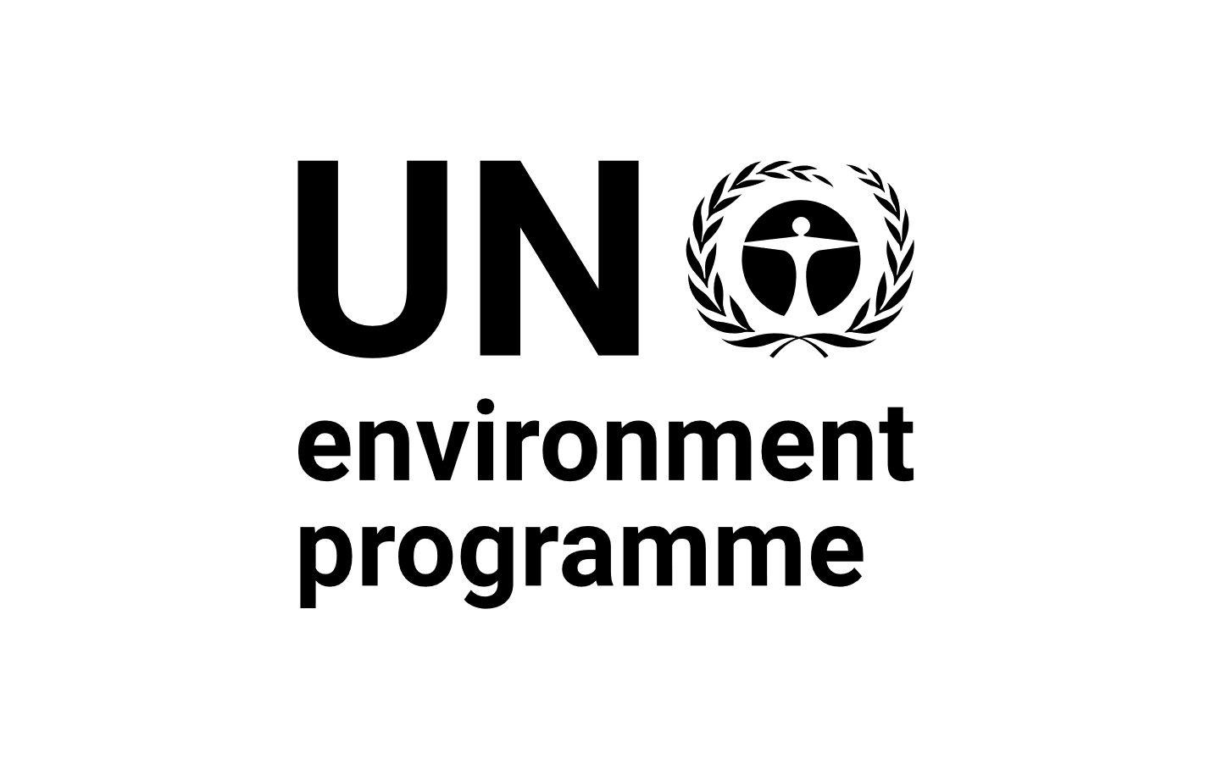 |  | CBD
Distr.
GENERAL

CBD/DEC/NP-EM/1/1
27 November 2020

ORIGINAL: ENGLISH

CONFERENCE OF THE PARTIES TO THE CONVENTION ON BIOLOGICAL DIVERSITY SERVING AS THE MEETING OF THE PARTIES TO THE NAGOYA PROTOCOL ON ACCESS TO GENETIC RESOURCES AND THE FAIR AND EQUITABLE SHARING OF BENEFITS ARISING FROM THEIR UTILIZATION

First extraordinary meeting

Montreal (Online), 16-19 November 2020 and 25-27 November 2020 (resumed session)

Decision adopted by the Conference of the parties serving as the meeting of the Parties to the Nagoya Protocol on Access and Benefi-sharing AT ITS FIRST EXTRAORDINARY MEETING

NP-EM-1/1. Interim Budget for the programme of work of the Nagoya Protocol on Access to Genetic Resources and the Fair and Equitable Sharing of Benefits Arising from Their Utilization, for the year 2021
The Conference of the Parties serving as the meeting of the Parties to the Nagoya Protocol on Access Benefit-sharing,
Recalling its decision 3/16, in which it approved the budget for the biennium 2019-2020,
Considering that the fourth meeting of the Conference of the Parties serving as the meeting of the Parties to the Nagoya Protocol has been postponed until 2021 due to constraints arising from the COVID-19 pandemic,
Noting the need, therefore, to make arrangements to allow the continued functioning of the organs of the Protocol, including its Secretariat and the meetings of its Parties and its subsidiary bodies,
Taking note of the proposal of the Bureau of the Conference of the Parties that, on an exceptional basis, the Parties consider and approve an interim budget for 2021 through agreed modalities,
Taking note of the note by the Executive Secretary,
Recognizing the exceptional nature of the circumstances arising from the pandemic and expressing solidarity among all Parties as they face its human and economic impacts,
1. Confirms that the present decision is supplementary to decision 3/16, which remains in effect until the next ordinary meeting of the Conference of the Parties serving as the meeting of the Parties to the Nagoya Protocol and whose provisions will apply also for the year 2021, unless otherwise provided for in the present decision;
2. Decides to extend, up to 31 December 2021, or, in the case that the fourth meeting of the Conference of the Parties serving as the meeting of the Parties to the Nagoya Protocol is not held during 2021, until the end of the month following the closure of the fourth meeting of the Conference of the Parties serving as the meeting of the Parties to the Nagoya Protocol, the validity of the funds allocated in the 2019-2020 budget and associated with the costs of the meetings of the Conference of the Parties serving as the meeting of the Parties to the Nagoya Protocol and its subsidiary bodies that are postponed from the biennium 2019-2020; and authorizes the carry-over of these funds, estimated at 418,543 United States dollars, to be spent in 2021 for the purposes listed in table 1 below;
3. Approves, on an exceptional basis, an interim core programme budget for the Nagoya Protocol on Access and Benefit-sharing of 1,844,989 United States dollars for the year 2021, representing 11 per cent of the integrated interim budget of 16,772,626 United States dollars for the year 2021, for the purposes listed in tables 2a and 2b below;
4. Adopts the scale of assessments for the apportionment of expenses for 2021, in accordance with the current scale of assessments of the United Nations, as contained in table 4 of the present decision;
5. Decides to apply, mutatis mutandis, paragraphs 4 and 5 and paragraphs 7 to 18 of the decision of the Conference of the Parties at its second extraordinary meeting.
Table 1
Integrated budget for the trust funds of the Convention on Biological Diversity and its Protocols for 2019-2020
(Thousands of United States dollars)
Object of expenditure | Total approved budget | Total estimated expenditure  (1 January 2019-31 December 2020) | Estimated Carry-over | Variance
A. Staff costs | 23 080.5 | 20 100.0 |  | 2 980.5
B. Bureau meetings | 365.0 | 200.0 | 165.0
C. Travel on official business | 800.0 | 559.6 |  | 240.4
D. Consultants/subcontractors | 100.0 | 100.0
E. Public awareness material/communications | 100.0 | 100.0
F. Temporary assistance/overtime | 200.0 | 200.0
G. Training | 10.0 | 10.0
H. Translation of CHM website/website projects | 130.0 | 130.0
I. Meetings¹ | 3 688.0 | 845.8 | 2 842.2
J. Expert meetings | 320.0 | 83.7 | 150.0 | 86.3
K. Extraordinary meetings on post-2020² | 1 310.0 | 1 100.0 | 210.0
L. Rent and associated costs | 2 652.9 | 2 652.9
M. General operating expenses | 1 453.2 | 1 453.2
Sub-total (I) | 34 209.6 | 27 532.2 | 3 367.2 | 3 307.2
II. Programme support costs (13%) | 4 447.2 | 3 579.6 | 437.7 | 429.9
Sub-Total (I + II) | 38 656.8 | 31 114.8 | 3 804.9 | 3 737.1
III. Working Capital Reserve | 187.3 | 187.3
Grand-Total (I + II + II) | 38 844.1 | 31 302.1 | 3 804.9 | 3 737.1
Nagoya Protocol share (11%) |  |  | 418.54
1 Meetings to be funded from carry-over:
- Twenty-fourth meetings of the Subsidiary Body on Scientific, Technical and Technological Advice
- Third meeting of the Subsidiary Body on Implementation
- Fifteenth meeting of the Conference of the Parties to the Convention / Tenth meeting of the Parties to the Cartagena Protocol / Fourth meeting of the Parties to the Nagoya Protocol, held concurrently.
- Special virtual sessions for SBSTTA 24 and SBI-3 (September 2020)
-Two-day informal virtual pre-session meeting
- 6-day virtual pre-session meeting for SBSTTA-24
- 6-day virtual pre-session meeting for SBI-3
- And any additional pre-session meetings for SBSTTA and SBI that might be decided

2 One extraordinary meeting on the post-2020 global biodiversity framework to be funded from the carry-over in line K

Table 2a
Integrated interim budget for the trust funds of the Convention on Biological Diversity and its Protocols for 2021
Object of expenditure | 2021  (Thousands of United States dollars)
A. Staff costs | 11 936.80
B. Bureau meetings | 0.00
C. Travel on official business | 275.00
D. Consultants/subcontractors | 50.00
E. Public awareness material/communications | 50.00
F. Temporary assistance/overtime | 100.00
G. Training | 5.00
H. Translation of CHM website/website projects | 65.00
I. Meetings¹ | 271.80
J. Expert meetings | 0.00
K. Extraordinary meetings on post-2020² | 350.00
L. Rent and associated costs | 1 358.20
M. General operating expenses | 726.60
Sub-total (I) | 15 188.40
II. Programme support costs (13%) | 1 974.49
Sub-total (I + II) | 17 162.89
III. Working Capital Reserve | -390.27
Grand Total (II + III) | 16 772.63
Nagoya Protocol share of the interim budget (11%) | 1 844.99
Less: Contribution from host country | (168.83)
Less: Use of reserves for extraordinary meetings | (43.51)
Net total (amount to be shared by Parties) | 1 632.65
1 Meetings to be funded from the interim budget for 2021 in complement to the carry-over as per table 1 above
- Twenty-fourth meetings of the Subsidiary Body on Scientific, Technical and Technological Advice
- Third meeting of the Subsidiary Body on Implementation
- Fifteenth meeting of the Conference of the Parties to the Convention / Tenth meeting of the Parties to the Cartagena Protocol / Fourth meeting of the Parties to the Nagoya Protocol, held concurrently.
- Special virtual sessions for SBSTTA 24 and SBI-3 (September 2020)
- Two-day informal virtual pre-session meeting
- 6-day virtual pre-session meeting for SBSTTA-24
- 6-day virtual pre-session meeting for SBI-3
- And any additional pre-session meetings for SBSTTA and SBI that might be decided

2 One extraordinary meeting on the post-2020 global biodiversity framework

Table 2b
Resource requirements by Division from the integrated core budgets for the year 2021
(Thousands of United States dollars)
 | 2021
I. Programmes:
Office of the Executive Secretary | 2 404.4
ABS and BS Protocols | 2 283.4
Science, Society and Sustainable Futures Division | 3 316.75
Implementation Support Division | 4 262.15
II. Administration, Finance and Conference Services | 2 921.7
Subtotal | 15 188.40
Programme support costs | 1 974.49
III. Working capital reserve | (390.27)
Total | 16 772.63
Nagoya Protocol share of the integrated budget (11%) | 1 844.99
Less: contribution from host country | (168.83)
Less: Use of reserve for Extraordinary meeting | (43.51)
Net amount to be shared by Parties | 1 632.65

Table 3
Secretariat staffing requirements from the core budgets of the Convention and its Protocols 2021

Category and level | Proposed 2021
Professional and higher
ASG | 1
D-1 | 3
P-5 | 10
P-4 | 12
P-3 | 14
P-2/1 | 9
Subtotal | 49
General Service | 29
Total | 78

Table 4
Contributions to the Trust Fund for the Nagoya Protocol on Access and Benefit-sharing for 2021
Member country | Scale of assessments | Scale with 22% ceiling, no LDC paying more than 0.01% | Contributions per 1 January 2021
Afghanistan | 0.007 | 0.012 | 193
Albania | 0.008 | 0.014 | 221
Angola | 0.010 | 0.010 | 163
Antigua and Barbuda | 0.002 | 0.003 | 55
Argentina | 0.915 | 1.546 | 25 248
Austria | 0.677 | 1.144 | 18 681
Belarus | 0.049 | 0.083 | 1 352
Belgium | 0.821 | 1.388 | 22 654
Benin | 0.003 | 0.005 | 83
Bhutan | 0.001 | 0.002 | 28
Bolivia (Plurinational State of) | 0.016 | 0.027 | 442
Botswana | 0.014 | 0.024 | 386
Bulgaria | 0.046 | 0.078 | 1 269
Burkina Faso | 0.003 | 0.005 | 83
Burundi | 0.001 | 0.002 | 28
Cambodia | 0.006 | 0.010 | 166
Cameroon | 0.013 | 0.022 | 359
Central African Republic | 0.001 | 0.002 | 28
Chad | 0.004 | 0.007 | 110
China | 12.005 | 20.290 | 331 263
Comoros | 0.001 | 0.002 | 28
Congo | 0.006 | 0.010 | 166
Côte d’Ivoire | 0.013 | 0.022 | 359
Croatia | 0.077 | 0.130 | 2 125
Cuba | 0.080 | 0.135 | 2 208
Czechia | 0.311 | 0.526 | 8 582
Democratic People’s Republic of Korea | 0.006 | 0.010 | 166
Democratic Republic of the Congo | 0.010 | 0.010 | 163

Member country | Scale of assessments | Scale with 22% ceiling, no LDC paying more than 0.01% | Contributions per 1 January 2021
Denmark | 0.554 | 0.936 | 15 287
Djibouti | 0.001 | 0.002 | 28
Dominican Republic | 0.053 | 0.090 | 1 462
Ecuador | 0.080 | 0.135 | 2 208
Egypt | 0.186 | 0.314 | 5 132
Eritrea | 0.001 | 0.002 | 28
Estonia | 0.039 | 0.066 | 1 076
Eswatini | 0.002 | 0.003 | 55
Ethiopia | 0.010 | 0.010 | 163
European Union |  | 2.500 | 40 816
Fiji | 0.003 | 0.005 | 83
Finland | 0.421 | 0.712 | 11 617
France | 4.427 | 7.482 | 122 158
Gabon | 0.015 | 0.025 | 414
Gambia | 0.001 | 0.002 | 28
Germany | 6.090 | 10.293 | 168 046
Ghana | 0.015 | 0.025 | 414
Greece | 0.366 | 0.619 | 10 099
Guatemala | 0.036 | 0.061 | 993
Guinea | 0.003 | 0.005 | 83
Guinea-Bissau | 0.001 | 0.002 | 28
Guyana | 0.002 | 0.003 | 55
Honduras | 0.009 | 0.015 | 248
Hungary | 0.206 | 0.348 | 5 684
India | 0.834 | 1.410 | 23 013
Indonesia | 0.543 | 0.918 | 14 983
Japan | 8.564 | 14.474 | 236 313
Jordan | 0.021 | 0.035 | 579

Member country | Scale of assessments | Scale with 22% ceiling, no LDC paying more than 0.01% | Contributions per 1 January 2021
Kazakhstan | 0.178 | 0.301 | 4,912
Kenya | 0.024 | 0.041 | 662
Kuwait | 0.252 | 0.426 | 6 954
Kyrgyzstan | 0.002 | 0.003 | 55
Lao People’s Democratic Republic | 0.005 | 0.008 | 138
Lebanon | 0.047 | 0.079 | 1 297
Lesotho | 0.001 | 0.002 | 28
Liberia | 0.001 | 0.002 | 28
Luxembourg | 0.067 | 0.113 | 1 849
Madagascar | 0.004 | 0.007 | 110
Malawi | 0.002 | 0.003 | 55
Malaysia | 0.341 | 0.576 | 9 409
Maldives | 0.004 | 0.007 | 110
Mali | 0.004 | 0.007 | 110
Malta | 0.017 | 0.029 | 469
Marshall Islands | 0.001 | 0.002 | 28
Mauritania | 0.002 | 0.003 | 55
Mauritius | 0.011 | 0.019 | 304
Mexico | 1.292 | 2.184 | 35 651
Micronesia (Federated States of) | 0.001 | 0.002 | 28
Mongolia | 0.005 | 0.008 | 138
Montenegro | 0.004 | 0.007 | 110
Mozambique | 0.004 | 0.007 | 110
Myanmar | 0.010 | 0.010 | 163
Namibia | 0.009 | 0.015 | 248
Nepal | 0.007 | 0.012 | 193
Netherlands | 1.356 | 2.292 | 37 417
Nicaragua | 0.005 | 0.008 | 138

Member country | Scale of assessments | Scale with 22% ceiling, no LDC paying more than 0.01% | Contributions per 1 January 2021
Niger | 0.002 | 0.003 | 55
Norway | 0.754 | 1.274 | 20 806
Oman | 0.115 | 0.194 | 3 173
Pakistan | 0.115 | 0.194 | 3 173
Palau | 0.001 | 0.002 | 28
Panama | 0.045 | 0.076 | 1 242
Peru | 0.152 | 0.257 | 4 194
Philippines | 0.205 | 0.346 | 5 657
Portugal | 0.350 | 0.592 | 9 658
Qatar | 0.282 | 0.477 | 7 781
Republic of Korea | 2.267 | 3.831 | 62 555
Republic of Moldova | 0.003 | 0.005 | 83
Romania | 0.198 | 0.335 | 5 464
Rwanda | 0.003 | 0.005 | 83
Saint Kitts and Nevis | 0.001 | 0.002 | 28
Samoa | 0.001 | 0.002 | 28
Sao Tome and Principe | 0.001 | 0.002 | 28
Saudi Arabia | 1.172 | 1.981 | 32 340
Senegal | 0.007 | 0.010 | 163
Serbia | 0.028 | 0.047 | 773
Seychelles | 0.002 | 0.003 | 55
Sierra Leone | 0.001 | 0.002 | 28
Slovakia | 0.153 | 0.259 | 4 222
Solomon Islands | 0.001 | 0.002 | 28
South Africa | 0.272 | 0.460 | 7 506
Spain | 2.146 | 3.627 | 59 216
Sudan | 0.010 | 0.010 | 163
Sweden | 0.906 | 1.531 | 25 000

Member country | Scale of assessments | Scale with 22% ceiling, no LDC paying more than 0.01% | Contributions per 1 January 2021
Switzerland | 1.151 | 1.945 | 31 760
Syrian Arab Republic | 0.011 | 0.019 | 304
Tajikistan | 0.004 | 0.007 | 110
Togo | 0.002 | 0.003 | 55
Tonga | 0.001 | 0.002 | 28
Tuvalu | 0.001 | 0.002 | 28
Uganda | 0.008 | 0.010 | 163
United Arab Emirates | 0.616 | 1.041 | 16 998
United Kingdom of Great Britain and Northern Ireland | 4.567 | 7.719 | 126 021
United Republic of Tanzania | 0.010 | 0.010 | 163
Uruguay | 0.087 | 0.147 | 2 401
Vanuatu | 0.001 | 0.002 | 28
Venezuela (Bolivarian Republic of) | 0.728 | 1.230 | 20 088
Viet Nam | 0.077 | 0.130 | 2 125
Zambia | 0.009 | 0.015 | 248
Zimbabwe | 0.005 | 0.008 | 138
Total | 57.716 | 100.000 | 1 632 656

__________

CBD/NP/ExMOP/1/2.

