 |  | CBD
 |  |  |  | Distr.  GENERAL  UNEP/CBD/BS/CC/5/2  7 October 2008  ORIGINAL: ENGLISH
COMPLIANCE COMMITTEE UNDER THE CARTAGENA PROTOCOL ON BIOSAFETY
Fifth meeting
Kuala Lumpur, 19-21 November 2008
Item 4 of the provisional agenda*

MONITORING AND REPORTING UNDER THE PROTOCOL (ARTICLE 33)

Revised analysis of information contained in the first national reports /

Note by the Executive Secretary

I. INTRODUCTION
- As specified in Article 33 of the Protocol, each Party is required to monitor the implementation of its obligations under the Protocol and to report to the Conference of the Parties serving as the meeting of the Parties to the Protocol (COP-MOP) on measures taken to implement the Protocol.
- At the third meeting of the Conference of the Parties serving as the meeting of the Parties to the Protocol, held from 13 to 17 March 2006 in Curitiba, Brazil, the Parties to the Protocol adopted a format for the first regular national report on the implementation of the Cartagena Protocol on Biosafety (decision BS-III/14) and agreed to consider the first national reports at their fourth meeting, on the basis of an analysis that the Executive Secretary was requested to prepare.
- At the fourth meeting of the Conference of the Parties serving as the meeting of the Parties to the Protocol, held from 12 to 16 May 2008, in Bonn, the Parties took note of the analysis of information contained in the first national reports and expressed their concern regarding the low number of reports that had been submitted (decision BS-IV/14). In the same decision, Parties were urged to observe relevant decisions on reporting, especially with regards to timeframes for the submission of national reports. The Executive Secretary was requested to repeat the analysis of the first national reports submitted after the deadline within three months after the Conference of the Parties serving as the meeting of the Parties to the Protocol and make the analysis available through the Biosafety Clearing-House.
- This document presents the requested second analysis of information contained in the first national reports received by the Secretariat prior to 18 August 2008. Section II describes the methodology used in the preparation of the analysis, the regional distribution of responses, presentation of information, as well as the limitations that need to be taken into account in reviewing the analysis. Section III contains the analysis itself, which is presented following the structure of the reporting format, which in turn, follows the structure of the provisions of the Protocol and section IV provides some general conclusions for consideration by the Parties. The list of respondents whose national reports have been included in the analysis can be found in annex I and a summary of the responses for questions providing multiple-choice answers is provided in annex II. The complete text of the responses to all questions provided in the national reports submitted to the Secretariat can be accessed through the Biosafety Clearing-House of the Convention on Biological Diversity (CBD). / A National Reports Analyzer, intended to assist users to aggregate and analyse data according to selected Parties, geographic area, economic groups and other criteria is also available on the website.

II. METHODOLOGY OF THE ANALYSIS

A. Regional breakdown
- As of 20 August 2008, 78 Parties to the Cartagena Protocol on Biosafety and two non-Parties had submitted their national reports. / Of these 78 Parties, two are countries that were not Parties to the Protocol on 11 September 2007 and therefore had no obligation to submit a first national report. Thus, reports were received from 76 (about 54 per cent) of the 141 Parties who had an obligation to report. The distribution of these reports among the United Nations regional groups is as follows:
- Africa: 22 reports equal to 28 per cent of the total number of reports received and 42 per cent of the members in the regional group;
- Asia and Pacific: 18 reports, equal to 22 per cent of the total number of reports received and 32 per cent of the members in the regional group;
- Latin America and the Caribbean (GRULAC): 9 reports, equal to 11 per cent of the total reports received and 27 per cent of the members in the regional group;
- Central and Eastern Europe (CEE): 14 reports, equal to 18 per cent of the total number of reports received and 61 per cent of the members in that regional group;
- Western Europe and Others Group (WEOG): 17 reports, equal to 21 per cent of the total number of reports received and 55 per cent of the members in that group.

Limitations
- The results presented in this paper should be interpreted within the limitations of the analysis. Technical limitations only allowed the statistical analysis of national reports written in United Nations’ languages that use the Roman alphabet (i.e. English, French and Spanish.) For this reason, two national reports are not included in the statistical analysis below which is therefore based on 76 reports from Parties and two from non-Parties.
- From a statistical point of view, it should be stressed that the analysis and some conclusions drawn here are based on information received from only just over half the Parties to the Protocol, and for certain regional or economic groupings this proportion is much lower.
- It is also important to note that reporting Parties or countries were self-selecting, i.e., results were analysed only from those Parties that submitted reports. Therefore, results may be biased towards Parties or countries that were in a position to submit their reports for any reason, such as stronger monitoring and reporting capacities, language accessibility or determination to comply with the reporting requirement. Finally, the reports vary in the amount of information they provided.

III. INFORMATION IN THE FIRST REGULAR NATIONAL REPORT ON THE IMPLEMENTATION OF THE CARTAGENA PROTOCOL ON BIOSAFETY
- Prior to completing the report, countries were asked to provide summary information on the process by which their reports had been prepared. Many countries listed the stakeholders who were actively involved in the preparation of the report. These included national focal points, Government bodies (e.g. Ministry of Environment, etc.) biosafety experts, legal consultants, relevant industries, competent authorities, research institutions and the general public. Materials used in the preparation of the reports included the text of the Protocol, decisions of the Conference of the Parties serving as the meeting of the Parties to the Protocol, legislative frameworks, regulation and information documents, outreach materials circulated by the Secretariat, the 2005 interim national reports, questionnaires, public consultation, materials that were made available through the UNEP-GEF capacity-building project on the development of national biosafety frameworks, and materials registered in the Biosafety Clearing-House.

Obligations for provision of information to the Biosafety Clearing-House
- Several articles of the Protocol require that information be provided to the Biosafety Clearing-House. In cases where relevant information exists but has not been provided to the Biosafety Clearing-House, question 1 of the report asks Parties to describe any obstacles or impediments they may have encountered in making the information available. Several African countries reported that they were still developing their national biosafety frameworks, biosafety databases or websites and that, upon completion of those projects, all information required under the Protocol will be provided to the Biosafety Clearing-House. One African Party stated that although it “has submitted some information to the BCH, there is still information which is to be submitted, with special reference to information pertaining to risk assessments of Living Modified Organisms (LMOs) that have been approved in accordance with the Advanced Informed Agreement (AIA) procedure before the Protocol became effective for” that country. Another reported that “generating such information requires existence of an implementation mechanism and a structure as well as considerable coordination among stakeholders which involves cost that can be provided only upon approval of the biosafety law and its administrative structure”. Parties from the Asia and Pacific region generally did not report major obstacles or impediments. One reported that “In respect of domestic use of LMOs, Bt cotton is the only transgenic crop approved for commercial cultivation”. However one country reported about the lack of an information exchange mechanism among different government departments while another pointed to “problems with updating BCH are limitation of computers, internet connection and difficulties in linking the national database to the BCH”. A Party from GRULAC stated: “The provision of information to the BCH was impeded by the lack of understanding of the full range of information that a Party is required to make available to the BCH.” A Party from the Central and Eastern European (CEE) region also reported the lack of human and financial resources as major impediments (a problem also echoed by other African countries), as well as the existence of intensive work which overstretched resources, to develop relevant national laws and regulations harmonized with the legislation of the European Union. Another reported that, the roster of experts is in need of an extensive updating but “there is no agreed process how to select those experts and who should adopt this list, what are the criteria for experts etc.” A CEE Party also stated: it “encounters some difficulties because of the lack of English translation possibilities. The national legal acts and decisions related to biosafety are available only in” that county’s language. A majority of the WEOG countries reported having submitted comprehensive information through the Biosafety Clearing-House. However, one WEOG Party reported that its “biosafety clearing-house is in place… but we have experienced difficulties with respect to regular updates...”
- In question 2, Parties are asked to provide an overview of the information required to be provided to the Biosafety Clearing-House. In particular, they are asked to indicate whether the information: (a) exists and is being provided to the Biosafety Clearing-House; (b) exists but is not yet provided to the Biosafety Clearing-House; or (c) does not exist or the question is not applicable. The purpose of the question is to establish an understanding of the current situation on the implementation of obligations related to making information available through the Biosafety Clearing-House.
- At the global level, only 20 per cent of the information required under the Protocol is reported to exist and to have been provided to the Biosafety Clearing-House. Furthermore, 63 per cent of the responses indicated that the information either does not exist or that the question is inapplicable. However, only 8 per cent of the respondents indicated that the information exists but has not yet been provided. The results at the regional level are consistent with those at the global level with the exception of the WEOG, where 46 per cent of the information required is reported to exist and to have been provided to the Biosafety Clearing-House.
- The groups reporting the highest percentage of information that exists but has not yet been submitted are Asia-Pacific (13 per cent) and GRULAC (12 per cent). The group reporting the highest percentage of information which does not exist or the question is inapplicable is Africa (79 per cent) while the percentage of answers from the other regions ranges between 50 and 65 per cent.
- A detailed analysis of the 17 different categories of information listed under question 2, which highlights some gaps and problems in the implementation of the obligations related to making information available to the Biosafety Clearing-House, is set out below in three groups.
- In the first group, the percentages of information reported as not existing or to which the question was not applicable are very high. One reason for these high numbers may be the simple fact that these categories of information were either not recorded or not present at all in the early stages of national implementation of the Protocol. Such categories of information include:
- Bilateral, multilateral and regional agreements and arrangements (where 83 per cent of respondents reported this information as either not existing or not applicable);
- Occurrence of unintentional transboundary movements of living modified organisms (LMOs) (96 per cent);
- Illegal transboundary movements of LMOs (84 per cent);
- Declarations regarding the framework to be used for LMOs intended for direct use as food or feed, or for processing (FFP) under Article 11.6 (76 per cent);
- Review and change of decisions (88 per cent);
- LMOs granted exemption status (95 per cent); and
- Cases where intentional transboundary movement may take place at the same time as the movement is notified to the Party of import as for Article 13.1 (97 per cent).
- In the second group, the percentages of information reported as not existing or for which the question was not applicable are relatively high. This information is mainly related to the decision-making procedures which are central to the Protocol and, had the information been available, it could have highlighted important trends in the implementation of the Protocol:
- In cases of multiple competent national authorities, responsibilities for each (Articles 19.2 and 19.3) (55 per cent of respondents reported this information as either not existing or not applicable);
- Reports submitted by the Parties on the operations of the Protocol (38 per cent);
- Final decisions regarding the importation or release of LMOs under Articles 10.3 and 20.3(d) (62 per cent);
- Information on the application of domestic regulations to specific imports of LMOs as for Article 14.4 (68 per cent);
- Final decisions regarding the domestic use of LMOs that may be subject to transboundary movement for direct use as food or feed, or for processing as for Article 11.1 (67 per cent);
- Final decisions regarding the import of LMOs intended for direct use as food or feed, or for processing that are taken under domestic regulatory frameworks as for Article 11.4 or in accordance with annex III as for Article 11.6 (63 per cent);
- Summaries of risk assessments or environmental reviews of LMOs generated by regulatory processes and relevant information regarding products thereof as for Article 20.3(c) (59 per cent).
- In the third group, the percentages of respondents reporting that the information exists and is being provided to the BCH is much higher than the previous two groups although it still indicates that a large fraction is still missing:
- Existing national legislation (56 per cent of respondents reported that the information exists and is being reported to the BCH);
- National laws, regulations and guidelines applicable to the import of LMOs intended for direct use as food or feed, or for processing (39 per cent);
- Contact details for competent national authorities (Articles 19.2 and 19.3), national focal points (Articles 19.1 and 19.3), and emergency contacts (Article 17.2 and 17.3(e)) (63 per cent)
- Question 36 complements question 1 by asking countries to describe any further details regarding their experiences and progress in implementing Article 20 (Information Sharing and the Biosafety Clearing-House), including any obstacles or impediments encountered. The responses were similar from all of the regional groups. For example, many countries described implementing a national Biosafety Clearing-House, often with the assistance of UNEP-GEF, which is interoperable with the Biosafety Clearing-House administered by the Secretariat (BCH Central Portal). One African country reported experiencing challenges in synchronizing its national database with the Biosafety Clearing-House. Obstacles reported by one Party from GRULAC in implementing Article 20 include: (i) the identification of persons and institutions involved; (ii) lack of a capacity-building strategy (and the tools to develop one); (iii) the characterization of relevant information related to decisions; and (iv) maintaining the interest and the commitment of the main actors involved. Some Parties from CEE and WEOG reported that training on the Biosafety Clearing-House had been conducted. Impediments reported include: poor Internet connectivity, slow response time from certain stakeholders and officials, insufficient financial and technical/human resources assistance, biosafety information scattered throughout different departments, inadequate public participation, lack of media exposure, absence of a binding national law/administrative structure, information resources not maximally used and “the high level of technical expertise needed to comply with the technical choices made by the Secretariat”. One WEOG country reported that “another limiting factor was the very slow implementation of a network of interoperable BCH nodes at EU level” (this problem was echoed by two other Parties from Asia-Pacific) and that it experienced difficulties in providing translations into one of the six official United Nations languages. In that respect, another WEOG country reported the following: “In our opinion, the Management Center of the BCH website is functional and easy to use. We would, however, appreciate even better functionality with respect to being able to enter and retrieve the information on the BCH both in English and in our national language.”

Article 2 – General provisions
- Questions 3 and 4 of the report ask countries to indicate if they have introduced the necessary legal, administrative and other measures required to implement the Protocol and to provide a description of their experiences and progress in this regard, including any obstacles or impediments they have encountered.
- A majority of the respondents (51 per cent) have indicated that they have a full domestic regulatory framework in place. Of the remaining 49 per cent of respondents, 35 per cent reported that only some measures had been introduced, while 13 per cent reported that no measures had been taken yet.
- With the exception of WEOG, in which 100 per cent of respondents reported having a full domestic regulatory framework in place, all the other groups acknowledged significant gaps regarding the introduction of necessary legal, administrative and other measures required to implement the Protocol. In particular, no respondents from the GRULAC region reported having a full domestic regulatory framework in place. In all of the developing country groups, the percentages of respondents indicating that no measures have been taken yet range between 11-21 per cent.
- Several countries from Africa and Asia-Pacific reported on draft national biosafety legislation emerging under their national biosafety frameworks supported by the UNEP-GEF projects. Of these, most countries reported that their frameworks are currently administrative and voluntary in nature pending enactment of binding legislation. One African country reported the following impediments: “(i) low level of public awareness; (ii) the country is under-equipped in terms of capacity-building (human and physical infrastructure); (iii) untimely release of project funds”. Some Parties from Asia-Pacific reported the establishment of a national biosafety council/committee or the establishment of “specialized working groups in all related ministries/organizations for implementation of biosafety standards”. Another reported that a “key impediment is the inadequacy of technical capacity”. Similarly, A GRULAC Party reported that “the existing human, technical and financial resources are some of the key challenges to fully establish and operate the required National Administrative and Regulatory regimes”. One African Party reported that “the major challenge thus far has been public debate on LMOs and ensuring public understanding of biotechnology.” A Party from Asia-Pacific stated that it “is very challenged for all national competent authorities due to infrastructure, personnel and mandated high-level policy to commit its implementation continuously. The public still does not have sufficient information and understanding in order to effectively participate in the implementation of the Protocol.” Several Parties from the European Union set out the details of their national legislation and the nature of its relationship to both the Protocol and the overarching legislation of the European Union.

Articles 7 to 10 and 12: The advance informed agreement procedure
- The AIA procedure applies to the first intentional transboundary movement of a specific LMO into the jurisdiction of a Party of import for intentional introduction into the environment. The procedure allows for the Party of import to decide whether or not it will authorize the import or impose any conditions. Questions 5 to 11 address this procedure.
- Under question 5, approximately 34 per cent of the respondents identified themselves to be Parties of import while, under question 6, only 8 per cent of the respondents considered themselves to be Parties of export. The major importing groups are: WEOG (53 per cent) GRULAC (40 per cent) and Asia-Pacific (35 per cent),. The major exporting groups are: GRULAC (20 per cent) and Asia-Pacific (12 per cent) .
- Under question 7, the majority of respondents (53 per cent) reported that there is a legal requirement for the accuracy of information provided by exporters in their jurisdictions. The regional breakdown is as follows: Africa 32 per cent, Asia Pacific 39 per cent, GRULAC 18 per cent, CEE 77 per cent and WEOG 100 per cent.
- Under question 8, no Party of export reported having requested any Party of import to review a decision it had made under Article 10 on the grounds specified in Article 12.2.
- Question 9 asks if Parties took any decisions regarding import under domestic regulatory frameworks as allowed by Article 9.2(c). The majority of the respondents reported that this was either not applicable (60 per cent) or that no decisions were taken during the reporting period (19 per cent). / Twenty-one per cent of respondents reported that they have taken decisions regarding import under domestic regulatory frameworks as allowed by Article 9.2(c). In particular, 41 per cent of WEOG respondents, 18 per cent of the Asia-Pacific, 20 per cent of GRULAC, 15 per cent of CEE and 10 per cent of the Africa group indicated that they have taken decision regarding import under domestic regulatory frameworks as allowed by Article 9.2(c).
- Question 10 asks Parties if they have been a Party of export of LMOs intended for release into the environment and to describe their experiences and progress in implementing Articles 7 to10 and 12 of the Protocol, including any obstacles or impediments encountered. None of the countries reporting from Asia-Pacific, and CEE were Parties of export. One Party from Africa reported exporting LMOs for environmental release. However, this was done only to Parties of Import where those LMOs had already been approved and therefore “did not require Advanced Informed Agreement procedures before consenting to the importation”. One Party from GRULAC reported exporting to a non-Party. One Party from WEOG indicated that difficulties arose “in the semantic interpretation of some requirements of the Protocol”, particularly with respect to Annex I which specifies information required in notifications under Articles 8, 10 and 13. Another WEOG country reported that consent for import and release into the environment for the purpose of field trials has been granted for six notifications (and that no obstacles were reported in the process).
- Question 11 focuses on decisions taken on the import of LMOs intended for release into the environment and asks Parties to describe their experiences and progress in implementing Articles 7 to 10 and 12, including any obstacles or impediments encountered. No African countries reported having taken decisions on import and one Party reported having received “several requests for confined field trials of LMOs”, but in all occasions they “had to request for more information from the applicant as the first submissions were deemed insufficient”. As a result, two confined field trials were approved with conditions, one rejected and the other is still under review. Some Parties from GRULAC reported having gone through decision processes consistent with both the objective of the Protocol and their national legislation for importation from non-Parties. There were no decisions reported from Asia-Pacific but one Party reported that obstacles faced “include inadequate information sharing of imported LMOs, shortage of testing technical standards, reference standards and reference materials”. Most Parties from Europe within WEOG, as well as most Parties from the CEE, reported that decisions on the import of LMOs intended for release into the environment are taken at the European Union (EU) level (i.e. under the EU’s domestic regulatory framework and in place of the advance informed agreement procedure) and that only decisions relating to LMOs that are for other purposes (i.e. for field trials) are taken at the national level. One of the Parties from the CEE reported that between 2004 and 2007, “14 written authorizations have been issued by the national competent authority for import of GM maize, barley and tobacco seeds for experimental release”. Another CEE Party declared that, during the years 2005-2006, it had imported Roundup Ready soybean from the United States through a procedure set out in a national law, “partially transposing” an EC Directive and that imports “haven’t been notified to BCH, yet”.

Article 11 – Procedure for living modified organisms intended for direct use as food or feed, or for processing (LMOs-FFP)
- Article 11 of the Protocol establishes a specific procedure for the transboundary movement of LMOs-FFP whereby a Party must inform other Parties through the Biosafety Clearing-House, within fifteen days, of its decision regarding domestic use of LMOs-FFP that may be subject to transboundary movement. Questions 12 to 16 address this procedure.
- Under question 12, the majority of respondents (59 per cent) reported that there is a legal requirement for the accuracy of information provided by the applicant with respect to the domestic use of a LMO that may be subject to transboundary movement for direct use as food or feed, or for processing (Article 11.2). Approximately 10 per cent of respondents reported that no legal requirements are in place. Finally, 31 per cent of respondents reported that legal requirements are not yet in place, but under development. The regional breakdown for this last answer is as follows: Africa 59 per cent, Asia-Pacific 41 per cent and GRULAC 45 per cent.
- Under question 13, with the exception of WEOG, some respondents in all groups reported having indicated their needs for financial and technical assistance and capacity-building in respect of LMOs-FFP (Article 11.9). The regional breakdown is as follows: in Africa 38 per cent of respondents stated that their country has indicated its needs for financial and technical assistance and capacity-building in respect of LMOs-FFP, Asia-Pacific 71 per cent, GRULAC 60 per cent, and CEE 38 per cent. Thirty-one percent of respondents from the CEE region reported that the question was not relevant.
- Under question 14, approximately 24 per cent of the respondents reported having taken decisions regarding import under domestic regulatory frameworks (Article 11.4). Among the regional groups, WEOG had the highest percentage (47 per cent) of respondents from its group who indicated that they had taken decisions regarding import under their domestic regulatory frameworks. Another 23 per cent of respondents reported that they had not taken decisions regarding import under domestic regulatory frameworks with 56 per cent of respondents from the GRULAC region providing this answer, the highest percentage amongst the regional groups. Finally, a significant group of respondents (53 per cent) reported that the question was not applicable or that no decisions were taken during the reporting period. Sixty-eight percent of respondents from the African region provided this answer, the highest percentage amongst the regional groups.
- Question 15 asks countries if they have been a Party of export of LMOs intended for direct use for FFP and to describe their experiences and progress in implementing Article 11, including any obstacles or impediments encountered. Only one country from the African region reported having been such a Party of export, stating it “exported LMOs intended for food or feed or for processing but only of LMOs that already have similar approval status in the Party of Import.” The same country reported that no obstacles or impediments were encountered in the implementation of Article 11.
- Question 16 focuses on the import of LMOs intended for direct use as food or feed, or for processing and asks countries to describe their experiences and progress in implementing Article 11, including any obstacles or impediments encountered. Most reporting countries from Africa reported that they were not Parties of import. One African country highlighted the following obstacles: “(i) information/documents accompanying import contradictory (LMO and not LMO); (ii) non-compliance by importers of the existing regulations due to ignorance; (iii) decision-taking on the matter across at least two ministries delays work; (iv) payment for laboratory analysis delayed due to lack of funding; and (v) confidentiality of opinions by officials was not guaranteed”. Another reported that LMOs-FFP were being imported in violation of Article 11 of the Protocol because that provision has not yet been implemented. A third African Party stated: “Some of the constraints experienced included certification of the LMOs which are commercially available in the exporting country. When consulting the BCH concerns arise as to the status of the information (when last it was updated). Documentation provided by the importers also needs to be verified. Our experience has indicated that importers present certification documentation (detailing which LMOs have been approved in the country of export) from various authorities. It has been difficult to establish the legal status of these certification bodies from the competent authorities.” Two Parties in GRULAC reported having imported LMOs-FFP and one stated that the mechanism for enforcing and monitoring the implementation of the national legislation for this type of import is still under development and not yet in force. One Party from Asia-Pacific reported it had imported “annually scores of million tons of genetically modified soybean and corn for processing and for animal feed” in accordance with regulations and statutes requiring “detailed and accurate information”. The same country identified technical problems related to “risk assessment, defining threshold for limit, effective identification and traceability”. Another reported “Only those regulated articles or LMOs for direct use as for food and feed or processing which have passed a satisfactory risk assessment conducted in accordance to domestic rules and regulations and are listed in the approval registry, are allowed entry. We have ensured that all importations allowed into the country are approved LMOs.” One other Party from Asia-Pacific stated: “The country prohibits an import of LMOs intended for direct use for food or feed or processing. However, two important commodities for food consumption and food industry are exempted; including corn (only for feed) and soybean (for food and processing) for industrial and processing purpose. Ministry of Public Health requires a labelling of LMOs food which will be placed into the market. The obstacles regarding to an exemption of LMO-FFPs include a segregation, traceability of original sources, inspection and surveillance of LMO-FFPs distribution and transport in a safe manner.” One Party from CEE that acceded to the EU reported it had “imported approximately 8 million tonnes of soybeans as a feed component that may have contained GMOs.” Another stated it “imported only LMOs authorized in the European Community for direct use for food or feed, or for processing. The operators must hold the information for each transaction and be able to identify the operator by whom and to whom the products are made available.”

Article 13 – Simplified procedure
- Question 17 asks Parties if they have applied the simplified procedure whereby a Party of import may specify in advance: (a) cases in which the intentional transboundary movement to it of an LMO may take place at the same time as the movement is notified to the Party of import; and (b) imports of living modified organisms to it to be exempted from the advance informed agreement procedure. Question 18 asks for a description of experiences in implementing Article 13, including any obstacles or impediments encountered.
- One Party, from the Asia-Pacific region, reported having applied an “ecological area-based approval procedure and simplified procedure for processing applications for the Biosafety Certificate (for commercialization) of genetically modified pest-resistant cotton.” One Party from the African region also reported that “transboundary movement of LMOs approved previously (where a full AIA was applied) is subject to the Simplified Procedure”. It also stated that “this is a very useful Article and prevents unnecessary delays in trade”.

Article 14 – Bilateral, regional and multilateral agreements and arrangements
- Questions 19 and 20 ask if Parties have entered into any bilateral, regional or multilateral agreements or arrangements and to describe experiences in implementing Article 14, including any obstacles or impediments encountered.
- Approximately 14 per cent of respondents (from one to three respondents per region) reported having entered into a bilateral, regional or multilateral agreement or arrangement.
- One country from Africa reported that divergent political alignments concerning LMOs constitute the biggest difficulty with respect to this issue. Another stated that it “is participating in the ECOWAS [Economic Community of West African States] subregional mechanism for management of biotechnology agreement and African Union deliberations on Biotechnology and Biosafety.” While no agreement was reported from the GRULAC countries, two of them stated that bilateral/regional treaties are in the process of being elaborated. One Party from Asia-Pacific reported that the ASEAN treaty / is “preparing the ASEAN Guideline for Handling GMOs Transboundary Movement.” Another mentioned the issuing of a document regarding the application of biotechnology in animal health and production which was in line with the OIE (World Organisation for Animal Health) directives. Most Parties from CEE and WEOG reported that they had not entered into any agreements and made reference to the national report from the European Community. The European Community likewise reported that it had not entered into any agreements and that the “EC has determined as per Article 14(4) and 9 (2) (c) that it relies on its existing legislative framework for intentional movements of GMOs within the Community and for imports of GMOs into the EC. This decision has been communicated to other Parties through the Biosafety Clearing-House.” One Party from WEOG made reference to ‘Food Standards Australia New Zealand’ (FSANZ) / which is not a bilateral, regional or multilateral agreement or arrangement per se.

Articles 15 and 16 – Risk assessment and risk management
- Under Article 15, the Protocol requires Parties to make decisions on the import of LMOs for intentional introduction into the environment in accordance with scientifically sound risk assessments and, under Article 16, the Protocol requires Parties to adopt measures and strategies for preventing adverse effects and for managing and controlling risks identified by risk assessments. Under the section on general provisions, most countries highlighted the importance of capacity-building in the field of risk assessment and risk management. Questions 21 to 28 address these issues more specifically.
- Eleven respondents to question 21 (14 per cent) reported having carried out risk assessments for all decisions taken under Article 10. By region, 4 per cent of respondents from Africa, 12 per cent of respondents from Asia-Pacific, 38 per cent of respondents from GRULAC, 15 per cent of respondents from CEE and 18 per cent of respondents from WEOG reported having carried out risk assessments for all decisions taken under Article 10. A large majority of the respondents (74 per cent) reported either that they were not a Party of import or that no decisions were taken under Article 10. The percentage of the latter answer was minimal in the GRULAC region (38 per cent), while the other groups ranged between 71 and 85 per cent.
- Of the eleven respondents who indicated that they carried out risk assessments for all decisions taken under Article 10, eight (72 per cent or 12 per cent of all respondents to question 22) reported having required the exporter to carry out the risk assessment. Under question 23, 15 per cent of respondents reported that they had required the notifier to bear the cost of the risk assessment for decisions taken under Article 10. This includes eight of the eleven respondents (72 per cent) who indicated that they had carried out risk assessments for all decisions taken under Article 10.
- Of all the respondents answering question 24, approximately 49 per cent reported having established and maintained appropriate mechanisms, measures and strategies to regulate, manage and control risks identified in the risk-assessment provisions of the Protocol. When broken down by regional group, the percentages of respondents answering question 24 in this way are much more variable: Africa 24 per cent, Asia-Pacific 29 per cent, GRULAC 30 per cent, CEE 64 per cent and WEOG 100 per cent. In WEOG, no Party indicated that there is no mechanism in place. In the other groups, the percentage of respondents stating that no mechanism is in place ranged from 7 per cent (CEE) to 19 per cent (Africa).
- On question 25, approximately 48 per cent of the respondents reported having adopted appropriate measures to prevent unintentional transboundary movements of LMOs. Significant differences, however, result from the regional breakdown: in Africa, 23 per cent of respondents stated that they had adopted appropriate measures to prevent unintentional transboundary movements, Asia-Pacific 29 per cent, GRULAC 20 per cent, CEE 71 per cent and WEOG 94 per cent.
- More than half of respondents (59 per cent) reported that in all cases, they endeavoured to ensure that any LMO undergoes an appropriate period of observation commensurate with its life-cycle or generation time before it is put to its intended use (Question 26). Differences are also present in the regional breakdown where 41 per cent of respondents from Africa, 41 per cent of respondents from Asia-Pacific, 33 per cent of respondents from GRULAC, 86 per cent of respondents from CEE and 89 per cent of respondents from WEOG responded to this question in this way.
- Approximately one third of the respondents reported cooperating with others for the purposes specified in Article 16.5 (identification of LMOs or specific traits that may have adverse effects and appropriate measures regarding the treatment of these LMOs or traits – Question 27). Significant differences, however, result from the regional breakdown: in Africa, 10 per cent of respondents reported cooperation with others, Asia-Pacific 31 per cent, GRULAC 11 per cent, CEE 46 per cent and WEOG 71 per cent.
- Question 28 asks Parties to provide further details about their responses to the above questions, as well as a description of their experiences and progress in implementing Articles 15 and 16, including any obstacles or impediments encountered. Most African countries reported that they were not a Party of import but indicated that procedures for risk assessments will appear in their biosafety laws (which are at various stages of development). One African country indicated that consultations are under way with the Member States of the East African Community and the Common Market for Eastern and Southern Africa (COMESA) / regarding risk assessment and risk management. Another stated that the absence of a binding national law impedes a risk assessment and risk management regime. A third African country reported that “All applicants (notifiers) are required to conduct risk assessments at their own cost and submit this with any application for contained use, release into the environment or food, feed and processing. This information is reviewed through an extensive process, which includes public participation, before authorization is approved.” One Party from GRULAC reported having established risk assessment guidelines while another from the same region stated that the main obstacle for an acceptable application of these requirements was the limited institutional capacity within the competent national authorities. Most Parties from Asia-Pacific reported that they have procedures in place for risk assessment and risk management although they reported the need for financial support and training. The same is generally true for CEE and WEOG Parties that are EU members with most pointing to the comprehensive regime outlined in the EU legislation which governs its Member States. In general, risk assessments contained in notifications are evaluated by the European Food Safety Authority and the competent authorities of the Member States. One Party from the CEE reported that it has “established a bank of reference materials and samples of GM material approved” (import and field trials). One Party from WEOG reported being “in favour of a scientific committee being appointed with the task of providing scientific and technical guidance on risk assessment guidelines… for the fulfilment of the objectives of the Protocol”. A second reported that its legislative framework concerning risk assessment and risk management “are made and notified in a manner that meets or exceeds the requirements of the Protocol”. A third reported that it “has objected to nearly all applications of marketing or cultivating genetically modified plants as the undertaken environmental and health risk assessments seem incomplete so far.” A WEOG non-Party stated that legislation requires “a comprehensive Risk Assessment and Risk Management Plan (RARMP) for every licence application for intentional release of a GMO into the environment. The development of the RARMP is informed by extensive consultation with the public and a wide range of experts, agencies and authorities, and forms the basis of the Regulator’s decision of whether or not to issue a licence and what, if any, conditions will be imposed if a licence is issued.”

Article 17 - Unintentional transboundary movements and emergency measures
- When a Party knows of an unintentional transboundary movement of an LMO that is likely to have significant adverse effects on biodiversity and human health, it must notify affected or potentially affected States, the Biosafety Clearing-House and relevant international organizations regarding information on the unintentional release. Furthermore, Parties must initiate immediate consultation with the affected or potentially affected States to enable them to determine response and emergency measures. Question 29 asks Parties if they have undergone any unintentional transboundary movements of LMOs and if they consulted the affected or potentially affected States for the purposes specified in Article 17.4.
- Approximately 95 per cent of the respondents reported no such occurrences. Only four cases were reported (three in Africa and one in GRULAC).
- Question 30 asks Parties to provide further details about their responses to the above question, as well as a description of their experiences and progress in implementing Article 17, including any obstacles or impediments encountered. One African country reported that LMO seeds may have been smuggled into the country but “without any testing processes we could not consult the country of export as there is no accompanying proof”. One Party from GRULAC reported that communications with potentially affected States took place (although delayed) and focused primarily on the probability that such movements had, in fact, occurred. One Party from Asia-Pacific reported that it “has set up a series of laws and regulation in a great effort to eliminate illegal and unintentional transboundary movement of LMOs”. Another stated that their “regulations are being finalized with expected completion date of October 2008”. However, two others reported that without a legal framework in place during the reporting period, unintentional transboundary movement was not monitored. Similarly, several Parties noted that, in the absence of a binding national law, the implementation of the Protocol, and in particular of this article, is extremely difficult.

Article 18 - Handling, transport, packaging and identification
- Amongst other things, Article 18 of the Protocol specifies requirements on identification by setting out what information must be provided in documentation that accompanies transboundary shipments of LMOs. Questions 31 to 35 address this issue.
- A majority of respondents (62 per cent) to question 31 reported having taken measures requiring that LMOs that are subject to transboundary movement within the scope of the Protocol are handled, packaged and transported under conditions of safety, taking into account relevant international rules and standards (Article 18.1). The regional breakdown is as follows: Africa 43 per cent, Asia-Pacific 47 per cent, GRULAC 36 per cent, CEE 92 per cent and WEOG 94 per cent. An additional 32 per cent of the respondents reported that the implementation of such measures is under development.
- Similarly, 59 per cent of the respondents to question 32 reported having taken measures requiring that documentation accompanying LMOs intended for direct use as FFP clearly identifies that they “may contain” LMOs and are not intended for intentional introduction into the environment, as well as a contact point for information (Article 18.2(a)). The regional breakdown is as follows: Africa 41 per cent, Asia-Pacific 47 per cent, GRULAC 20 per cent, CEE 92 per cent and WEOG 94 per cent. An additional 33 per cent of the respondents reported that the implementation of such measures is under development.
- A majority of respondents (62 per cent) to question 33 reported having taken measures to require that documentation accompanying LMOs that are destined for contained use clearly identifies them as LMOs and specifies any requirements for the safe handling, storage, transport and use, the contact point for further information, including the name and address of the individual and institution to whom the LMOs are consigned (Article 18.2(b)). The regional breakdown is as follows: Africa 45 per cent, Asia-Pacific 47 per cent, GRULAC 30 per cent, CEE 92 per cent and WEOG 94 per cent. An additional 32 per cent of the respondents reported that the implementation of such measures is under development.
- Finally, the same majority of respondents (62 per cent) to question 34 reported having adopted measures to require that documentation accompanying LMOs that are intended for intentional introduction into the environment of the Party of import and any other LMO within the scope of the Protocol, clearly identifies them as LMOs; specifies the identity and relevant traits and/or characteristics, any requirements for the safe handling, storage, transport and use, the contact point for further information and, as appropriate, the name and address of the importer and exporter; and contains a declaration that the movement is in conformity with the requirements of the Protocol applicable to the exporter (Article 18.2(c)). The regional breakdown is as follows: Africa 41 per cent, Asia-Pacific 47 per cent, GRULAC 40 per cent, CEE 92 per cent and WEOG 94 per cent. An additional 32 per cent of the respondents reported that the implementation of such measures is under development.
- Question 35 asks Parties to provide further details about their responses to the above questions, as well as a description of their experiences and progress in implementing Article 18, including any obstacles or impediments encountered. One African country reported that “All requirements pertaining to this Article have been incorporated into export permits”. However, most African countries, some Asia-Pacific countries and a GRULAC country indicated that measures addressing handling, transport, packaging and identification will appear in their biosafety laws (which are at various stages of development). Most Parties from the other regions reported that they have regulations in place, or under development but in an advanced phase, requiring that LMOs entering their jurisdictions be accompanied with documentation and appropriate labelling. For example, one Party from CEE reported that “it is obligatory that the words ‘This product contains genetically modified organisms’ appear on both the label and the accompanying documents”. Most Parties from CEE and WEOG pointed to the comprehensive regime outlined in the EU legislation which governs its Member States. However, one Party from WEOG stated that “a standardized format for documentation and identification requirements for inclusion in a standalone document, should be developed in order to secure clearest possible identification and avoid the difficulties for traders that would result from different countries requiring different formats and documents”. Another reported it had a “Prohibition Order” in place which “applies equally to Parties and non-Parties, and provides that the export of LMOs is prohibited unless the Minister for the Environment has consented to the export”. A third WEOG Party stated that “information is often confusing for the stakeholders importing or exporting LMOs destined for contained use only. Another point of confusion is the documentation and /or packaging requirements which vary greatly upon the carrier type”. A WEOG non-Party stated that its “regulation of genetically modified organisms generally meets the provisions for national implementation of the Protocol”. A Party from Asia-Pacific reported that it “has neither been an importer nor exporter of LMOs except for pharmaceutical products such as human Insulin and Hepatitis B Vaccine”. A Party from CEE reported that the “main problem in implementing Article 18 is sharing of responsibilities of different institutions”.

Article 19 – Competent national authorities and national focal points
- The Protocol requires that each Party designate one national focal point to be responsible on its behalf for liaison with the Secretariat and one or more competent national authorities to be responsible for performing the administrative functions required by the Protocol. This requirement is addressed in question 2 (d) regarding the provision of information to the Biosafety Clearing-House (see section III A above).

Article 20 – Information sharing and the Biosafety Clearing-House
- See section III A above.

Article 21 - Confidential information
- Primarily in the context of the advance informed agreement, the provider of information (the notifier) is required to submit information to the Party of import so as to allow the latter to decide whether or not to authorize the import of the LMO in question. In return, the Party of import has an obligation to permit the notifier to identify information that is to be treated as confidential. Questions 37 to 40 ask Parties of import and Parties of export about their experiences regarding confidential information.
- Approximately 59 per cent of respondents reported having procedures to protect confidential information received under the Protocol and 33 per cent reported that the implementation of such procedures is under development (question 37). At the regional level, 92 per cent of respondents from the CEE group and all respondents from the WEOG group indicated that they had procedures in place. Fourty-one per cent of respondents from Asia-Pacific reported having these procedures in place while 47 per cent reported that procedures are under development. Similarly, 40 per cent of respondents from GRULAC reported having these procedures in place while 50 per cent reported that procedures are under development. Finally, 32 per cent of respondents from the African region reported having procedures in place and 59 per cent reported that procedures are under development. In the following groups, a limited number of respondents reported that no procedures are in place: Africa 9 per cent, Asia-Pacific 12 per cent, GRULAC 10 per cent and CEE 8 per cent.
- In question 38, 11 per cent of the respondents reported having permitted a notifier to identify information submitted under the procedures of the Protocol or required by the Party of import as part of the Advance Informed Agreement procedure that was to be treated as confidential (Article 21.1). The regional breakdown is as follows: Africa 5 per cent, Asia-Pacific 13 per cent, GRULAC 29 per cent and WEOG 19 per cent. No such measure has been taken or occurred in the CEE region for reasons that include the non-applicability of the situation. Furthermore, approximately 12 per cent of the respondents reported that they did not permit any notifier to identify information to be treated as confidential, and a large majority (77 per cent) reported either that the question was not applicable or that they had not received such a request.
- Question 39 asks Parties that answered “yes” to question 38 to provide information on their experience including a description of any impediments or difficulties encountered. One Party from GRULAC reported that, in accordance with their national legislation, all technical and scientific information provided by private individuals or legal identities for the respective registers will be considered confidential. Three Parties from Asia-Pacific reported that they have confidentiality provisions in their national biosafety laws. Another stated “Our rules and regulations provide that “If there are portions of the applications for field test, commercial propagation and direct use for food and feed or processing, which contain trade secrets or confidential business information, each page of the application containing such information shall be marked “Commercial-in-Confidence” (CIC) by the applicant”. Two Parties, one from Asia-Pacific and one from Africa, stated that applicants can submit two copies of documentation, one of which is a copy where all confidential information has been deleted. “In this way applicants are afforded the opportunity to indicate which information should be treated as confidential”. Several Parties from CEE and European WEOG pointed to the comprehensive regime outlined in the EU legislation which governs its Member States. The European Community legislation stipulates that confidentiality should be applied equally to domestic and foreign producers. Whether or not information will be treated as confidential is decided by the competent authority. Information that may not be kept confidential includes: the general description of the LMO, the contact details of the notifier, the reason for the release, the location of the release and intended uses, the method(s) and plan(s) for monitoring the LMO and for emergency response and risk assessments.
- Question 40 asks Parties that are Parties of export, to describe any impediments or difficulties they encountered, or encountered by exporters under their jurisdiction, if information is available, in the implementation of the requirements of Article 21. Only a few Parties reported on this question. One from GRULAC reported no obstacles because the importing country was not a Party to the Protocol and one WEOG Party stated that it “has approved a number of LMOs for export from registered containment research facilities to indoor contained-use facilities overseas, pursuant to the requirements of” its relevant legislation. Two exporter countries (one from WEOG and one from Africa) declared that no difficulties were identified with regard to Article 21 for exports.

Article 22 - Capacity-building
- In order to implement the Protocol, many developing countries and countries with economies in transition require support to build adequate capacities in terms of human, technical and financial resources. For example, they required capacity to undertake risk assessment and risk management of LMOs, and/or to monitor LMOs once released into the environment. In Questions 41 to 48 both developed and developing country Parties were asked to report about their capacity-building initiatives, if any.
- In response to question 41, approximately 43 per cent of respondents reported that they were developed country Parties or had provided assistance to other countries. Among these, 75 per cent (equivalent to 32 per cent of all respondents) reported having cooperated in the development and/or strengthening of human resources and institutional capacities in biosafety for the purposes of the effective implementation of the Protocol in developing country Parties or Parties with economies in transition.
- Regarding question 42 on how cooperation took place, one African Party reported hosting regional workshops, organized by the Regional Agricultural and Environment Initiatives Network-Africa (RAEIN Africa), for delegations from Member States of the Southern African Development Community (SADC) and other African countries, and various engagements with other government agencies such as the National Corn Growers Association and US Grains Council. One Party from Asia-Pacific reported having supported capacity-building projects by contributing financial resources through the GEF and FAO. A WEOG non-Party provided support for and participated in APEC meetings, conferences and workshops. A different Party from the same group offered free access to developing countries to its clearing-house database system. One CEE Party reported having organized a training course on the analysis of food samples for LMOs. Many initiatives were reported by Parties from WEOG. Examples included the following:
- Biosafety Clearing-House training courses;
- Twinning projects;
- Joint Manual on Analysis of Food Samples for the Presence of GMOs;
- Training courses on the analysis of food and feed samples for the presence of GMOs;
- Network of Genetically Modified Organisms (GMO) Laboratories;
- Research funding;
- Project on consumer organizations and the Cartagena Protocol on Biosafety;
- Global Conference on GMO Analysis;
- Nordic-Baltic capacity-building project;
- Training of trainers course;
- Regional workshop on risk assessment and risk management;
- Financial support through UNEP-GEF;
- UNEP-GEF training courses and workshops;
- Active participation in the capacity-building programme developed by the UNEP-GEF (Building Capacity for Effective Participation in the Biosafety Clearing House (BCH) of the Cartagena Protocol)
- Bilateral initiatives with CEE countries;
- National biosafety workshops, technical workshops, awareness campaigns and training courses in biosafety, including risk assessments and risk management;
- Collaboration in the MATRA project in the CEE region (a Social Transition Programme for Central and Eastern Europe funded by the Netherlands Ministry of Foreign Affairs);
- GTZ workshop on GMOs in Beijing/China;
- participation at the International Forum for countries of the Great Mekong Subregion (GMS) countries on sharing experiences on implementing biotechnology and biosafety policies and regulations;
- East African Regional Programme and Research Network for Biotechnology, Biosafety and Biotechnology Policy Development (BIOEARN); and
- Masters Programme in Management of Biological Diversity.
- On the other hand, approximately 76 per cent reported question 43 to be applicable. This question asked developing country Parties and Parties with an economy in transition whether, during the reporting period, they had contributed to the development and/or strengthening of human resources and institutional capacities in biosafety for the purposes of the effective implementation of the Protocol in another developing country Party or Party with an economy in transition. Among those indicating that the question was applicable, 48 per cent (equivalent to 37 per cent of all respondents) reported having contributed to the development and/or strengthening of human resources and institutional capacities in biosafety for the purposes of the effective implementation of the Protocol in another developing country Party or Party with an economy in transition.
- Question 44 asks countries that answered yes to question 43, how such cooperation has taken place. From the African region, one Party reported that “three institutions of Government with relevant functions in Biosafety were provided with internet equipment and their key personnel trained in the use of the Biosafety Clearing-House”. Three other African countries reported having conducted biosafety-related training initiatives and a fourth reported having provided technical assistance to other developing countries in the region. Two Parties from GRULAC reported having contributed to capacity-building initiatives through the participation of national experts or the organization of biosafety training courses. Another GRULAC Party reported having assisted another country in the region in the identification of a legal consultant. Six Parties from the Asia-Pacific region also reported conducting biosafety-related training initiatives. One country from the CEE reported that it has “actively participated in the cooperation within the region of Central and Eastern European (CEE) countries”. Another stated “With the expertise accumulated in course of the UNEP/GEF projects on developing and implementation of NBFs, the German-Austrian PHARE project and the PSO project (Netherlands-Bulgaria) [it] is now on a position to play more active role in the field of capacity-building in biosafety in the Balkan and Black Sea region”.
- Question 45 asked developing countries or countries with an economy in transition whether they had benefited from cooperation for technical and scientific training in the proper and safe management of biotechnology to the extent that it is required for biosafety. Approximately 46 per cent of the respondents, reported that capacity-building needs were partially met (Africa 64 per cent, Asia-Pacific 50 per cent, GRULAC 80 per cent and CEE 46 per cent. Another 17 per cent reported that capacity-building needs remained unmet (Africa 23 per cent, Asia-Pacific 38 per cent, GRULAC 20 per cent). Three respondents (4 per cent), two from Africa and one from the CEE region, reported that capacity-building needs were fully met and four Parties (5 per cent), one from Africa and three from the CEE region, reported having no unmet capacity-building needs.
- Question 46 asked developing countries or countries with an economy in transition whether they had benefited from cooperation for technical and scientific training in the use of risk assessment and risk management for biosafety. Approximately 46 per cent of the respondents reported that capacity-building needs in this regard were partially met (Africa 59 per cent, Asia-Pacific 47 per cent, GRULAC 90 per cent and CEE 46 per cent). Another 18 per cent reported that capacity-building needs for risk assessment and management remained unmet (Africa 32 per cent, Asia-Pacific 35 per cent, and CEE 8 per cent). Only two countries (3 per cent), one from Africa and one from the CEE region, reported that capacity-building needs were fully met. Five respondents (6 per cent), one from each of the African region, Asia-Pacific and GRULAC and two from CEE also reported that they had no unmet capacity-building needs.
- Question 47 focused on cooperation for technical and scientific training for enhancement of technological and institutional capacities in biosafety. Approximately 47 per cent of the respondents reported that capacity-building needs in this regard were partially met (Africa 50 per cent, Asia-Pacific 53 per cent, GRULAC 90 per cent and CEE 62 per cent) while 18 per cent reported that capacity-building needs for enhancement of technological and institutional capacities remained unmet (Africa 32 per cent, Asia-Pacific 35 per cent, GRULAC 10 per cent). Only two respondents (3 per cent), one from Africa and one from the CEE region, reported that capacity-building needs were fully met. Four respondents (5 per cent), three from Africa and one from the CEE region also reported that they had no unmet capacity-building needs.
- Question 48 asks countries to provide a description of their experiences and progress in implementing Article 22, including any obstacles or impediments encountered. A number of countries made reference to having benefited from the UNEP-GEF project on developing national biosafety frameworks. Many GRULAC countries also reported their need for more financial support in this area. Two African countries emphasized the need for trained scientists in risk assessment and risk management. Another stated biosafety courses had been followed at ICGEB. A third African country reported benefitting from the Collaborative Agricultural Biotechnology Initiative (CABIO) that is supported by the U.S. Agency for International Development (USAID). One CEE Party stated that it had benefited from the PHARE Twinning Project which address the contained use, deliberate release and placing on the market of GMOs. Seven countries from Asia-Pacific expressed inadequacies in capacity-building, especially with regard to risk assessment and risk management. One Asia-Pacific Party, as well as one African and one GRULAC Party, stated that they had benefited from the GEF-World Bank Capacity Building Project on Biosafety. Another Party from the Asia-Pacific region reported having participated in the International Biosafety Course “Holistic Foundations for Assessment and Regulation of Genetic Engineering and Genetically Modified Organisms” in collaboration with Genok (Norway) and Third World Network.

Article 23 - Public awareness and participation
- Under Article 23, Parties undertake to promote and facilitate public awareness, education and participation concerning the safe transfer, handling and use of LMOs, to consult the public in the decision-making processes and to provide information to the public about access to the Biosafety Clearing-House. Questions 49 to 54 address these obligations.
- In question 49, approximately 40 per cent of the respondents, reported promoting and facilitating, to a significant extent, public awareness, education and participation concerning the safe transfer, handling and use of LMOs (Article 23.1(a)). The regional breakdown is as follows: Africa 27 per cent, Asia-Pacific 29 per cent, GRULAC 10 per cent, CEE 46 per cent and WEOG 81 per cent. In addition, 56 per cent of the respondents reported having implemented Article 23.1(a) to a limited extent.
- In question 50, approximately 25 per cent of the respondents reported having cooperated with other States and international bodies to a significant extent while 53 per cent of them reported cooperation to a limited extent. Approximately 22 per cent of the respondents, from Africa, Asia-Pacific and GRULAC, reported that there had been no such cooperation.
- In question 51, approximately 45 per cent of the respondents reported endeavouring to ensure, to a significant extent, that public awareness and education encompass access to information on LMOs (Article 23.1(b)). The regional breakdown is as follows: Africa 23 per cent, Asia-Pacific 47 per cent, GRULAC 22 per cent, CEE 62 per cent and WEOG 75 per cent. In addition, 45 per cent reported having implemented Article 23.1(b) to a limited extent.
- In question 52, approximately 52 per cent of the respondents reported to have fully consulted, in accordance with their respective laws and regulations, the public in the decision-making process regarding LMOs and to have made the results of such decisions available to the public (Article 23.2). Significant variability in the answers is reflected in the regional breakdown: Africa 29 per cent, Asia-Pacific 41 per cent, GRULAC 10 per cent, CEE 77 per cent and WEOG 100 per cent. An additional 27 per cent of the respondents reported having implemented Article 23.2 to a limited extent and eight of them (16 per cent) reported that no consultations with the public took place.
- In question 53, only 26 per cent of the respondents reported having fully informed the public about the means of public access to the Biosafety Clearing-House. Approximately 61 per cent of respondents reported to having done so to a limited extent. Ten respondents (13 per cent), from Africa, Asia-Pacific and GRULAC, reported having not informed the public about the Biosafety Clearing-House.
- Question 54 asks countries to provide a description of their experiences and progress in implementing Article 23, including any obstacles or impediments encountered. A number of respondents from Africa reported wide-spread public-awareness initiatives including through the Biosafety Clearing-House and the UNEP-GEF project on developing national biosafety frameworks. One African country listed the following impediments: “(1) The country has diverse languages and to fully involve the public, there is need to translate most of the concepts into the various national languages, (2) Limited funding for public awareness, (3) Insufficient human resources.” Three Parties from Asia-Pacific reported on their public-awareness initiatives. These were mainly conducted via the Internet as well as through news releases and press conferences. Parties from GRULAC reported different levels of the implementation of Article 23 and they all indicated that much more needs to be done with respect to public participation. One GRULAC Party stated “some national debate on Biosafety issues has occurred through the execution of stakeholders’ consultations and workshops under the NBF Development Project”. One Party from Asia-Pacific reported that “600 university students have been invited to participate in live debate in TV” regarding the safe handling of LMOs. Another stated that “With the release of Bt cotton, the first LMO, extensive efforts have been made to create awareness amongst all stakeholders such as scientists, industry, government departments, NGOs, farmers, etc.” Another Asia-Pacific Party reported the following as obstacles: (i) different level of awareness and education of target groups; (ii) limited budget; (iii) characterization of the country as an archipelago; and (iv) determined appropriate media for public awareness and participation. A fourth Asia-Pacific Party stated “Public awareness and participation is one of the topmost identified constrain in Biosafety issue in the country. Lack of public awareness brings to confusion of what will be their final decision/choice. Lack of participation gradually create the public concern and controversial.” A number of developing country Parties stated that public participation processes will be included in upcoming National Biosafety Laws. Several respondents from CEE and WEOG reported national websites (sometimes operating in collaboration with the UNEP-GEF projects) as the primary means of implementing public awareness and participation. Reference was also consistently made to being a Party to the Aarhus Convention on Access to Information. / One Party from WEOG reported having convened two “citizens fora” and another reported that “consultation with the public is an integral component both of the process leading to the development of laws and regulatory mechanisms”. Another non-Party from WEOG reported the requirement “to consult with a range of experts and authorities and the public before finalising risk assessments”.

Article 24 - Non-Parties
- Article 24 states that the transboundary movements of LMOs between Parties and non-Parties must be consistent with the objective of the Protocol and that Parties shall encourage non-Parties to adhere to the Protocol and to contribute appropriate information to the Biosafety Clearing-House on LMOs. Questions 55 and 56 ask Parties if there have been any Party/non-Party transboundary movements of LMOs and if so, to describe their experiences, including any obstacles or impediments encountered.
- Transboundary movements of LMOs with non-Parties were reported by 23 per cent of respondents. This was especially the case in Asia-Pacific (25 per cent), GRULAC (22 per cent) and WEOG (47 per cent). A lower percentage of respondents reported such transboundary movements in Africa and the CEE regions – 6 per cent and 15 per cent, respectively.
- Question 56 asks Parties that have experienced transboundary movements of LMOs between their country and a non-Party to provide information on their experiences, including a description of any impediments or difficulties encountered. One African Party reported that “the documents accompanying the import were contradictory” and that “the Exporting Party did not feel obliged to contact the national competent authority of the importing country”. Another reported that “applications for confined field trial have been received from one non-Party, and it was subjected to the same process as would have applied to a Party (risk assessment was required and the application is still under review)”. A third African Party stated “As an exporter to non-parties during this reporting period, we experienced that the non-parties prefer not to follow the provisions of the Protocol and are very reluctant to adhere to national requirements that are beyond the requirements provided for by the Protocol.” One Party from GRULAC reported problems in the implementation of Article 24, and in particular it highlighted the difficulty of recognizing the presence of LMOs in material traded with non-Parties. One Party from Asia-Pacific reported an import of genetically modified corn from a non-Party and that “measures have been taken to prevent their distribution”. Another reported that “pre-market risk assessment and an informed consent through a permit issued by our regulatory agencies” are requested in all cases. Some Parties from CEE and WEOG reported transboundary movements (import and export) of LMOs for contained use (i.e. for scientific purposes). One WEOG Party reported that LMOs had been imported “to a very large extent from non-Parties of the Protocol” and that, once authorized, no impediments or difficulties were encountered regarding the import of these LMOs.

Article 25 - Illegal transboundary movements
- Questions 57 to 59 address the situation whereby the transboundary movement of an LMO takes place in contravention of national regulations implementing the Protocol.
- In question 57, the adoption of appropriate domestic measures in order to prevent and penalize, as appropriate, transboundary movements of LMOs carried out in contravention of their domestic measures was reported by 68 per cent of respondents. An absence of measures in place was reported by respondents in three groups: Africa 45 per cent, Asia-Pacific 53 per cent and GRULAC 67 per cent.
- In question 58, illegal transboundary movements of LMOs were reported by 19 per cent of the respondents in accordance with the following regional breakdown: Africa 6 per cent, Asia-Pacific 6 per cent, GRULAC 11 per cent, CEE 31 per cent and WEOG 44 per cent.
- Question 59 asks Parties to provide further details about any illegal transboundary movements as well as a description of their experiences and progress in implementing Article 25, including any obstacles or impediments encountered. A number of countries, particularly from the African region, reported that legal measures, including liability and redress measures, are going to be put into place on this issue once their national biosafety legal frameworks come into force and are implemented. One African country stated that it “makes use of inspectors to monitor all imports into [the country] and the GMO Act makes provision for penalties in cases of illegal transboundary movements.” One respondent from GRULAC reported illegal transboundary movements of LMOs from a non-Party. The primary obstacles reported in those circumstances were: (i) the absence of notifications for potential transboundary movements; (ii) the absence of information on the specific LMO; and (iii) the lack of coordination among national competent authorities. No sanctions were applied against the country responsible for the illegal movement. One respondent from Asia-Pacific reported illegal transboundary movement of Bt10 corn into its jurisdiction and stated that “measures have been taken to prevent their distribution”. Many European countries from WEOG and CEE reported that their legislation is harmonized with that of the EU. In this regard, several respondents reported on the illegal transboundary movement of “Glofishes” (Zebra fishes, Brachydanio rerio). One respondent from WEOG reported that emergency measures had been taken regarding the unauthorized presence of LL RICE 601 in several rice products on the EU market. Another respondent from WEOG reported on the illegal transboundary movement of genetically modified rice as well as genetically modified papaya. Another reported “Some incidents of illegal or unintended t.m. (Bt 10 maize, LL 601 rice)”. Finally, a Party from WEOG reported that sanctions are in place regarding the “import, keeping, use and release of any LMO which does not have an approval under the EU regulatory regime”.

Article 26 - Socio-economic considerations
- In reaching decisions on imports, the Protocol states that Parties may take into account socio-economic considerations arising from the impact of LMOs on the conservation and sustainable use of biological diversity. Questions 60 to 62 address this issue.
- In question 60, approximately 44 per cent of the respondents reported having taken decisions on import. Of these, one country (approximately 1 per cent of the respondents), reported having taken socio-economic considerations into account to a significant extent. Thirty-five per cent (or 16 per cent of the respondents) reported having taken them into account to a limited extent and 62 per cent (or 27 per cent of the respondents) reported that no socio-economic considerations were taken into account in their decisions.
- In question 61, one country (approximately 1 per cent of the respondents) reported having cooperated with other Parties to a significant extent on research and information exchange on any socio-economic impacts of LMOs. Eighteen percent of the respondents reported limited cooperation. The regional breakdown of this answer was as follows: Africa 9 per cent, Asia-Pacific 24 per cent, GRULAC 22 per cent, CEE 15 per cent and WEOG 24 per cent. Approximately 81 per cent of the respondents reported that there was no cooperation regarding socio-economic impacts of LMOs.
- Question 62 asks countries to provide further details about socio-economic considerations as well as a description of their experiences and progress in implementing Article 25, including any obstacles or impediments encountered. A number of developing country Parties reported that socio-economic impacts are covered in their draft biosafety bills. Another reported that “socio-economic considerations are part and parcel of our risk assessment/review process”. A third Party from Africa pointed to “a need for an international framework with regard to the socio-economic factors that should be taken into account during decision-making.” One Party from Asia-Pacific reported that it had undertaken research “on the socio-economic impacts by GM-cotton, GM- rice and GM-poplar trees”. The same country reported that it “has relatively inadequate research on the socio-economic impacts of LMOs and is facing many obstacles and impediments”, especially with regard to inadequate research staff and financial support. Another country from Asia-Pacific stated the following: “Socio economic has become a consideration for decision making. In the case of Bt cotton, government requested the importer to appoint independent institution to conduct socioeconomic studies. These studies have been conducted twice (2001 & 2002). But it is a not a part of risk assessment”. Another Party reported that it “still lacks experts of socio-economic aspects related to biosafety”. Other countries reported that socio-economic considerations are reflected in their national legislation. For example, one CEE country stated that its “GMO Act stipulates that socio-economic impact (s) must be taken into account before each placing on the market/import of LMOs.” European countries from WEOG and CEE referred to the EU which, in 2003, issued a non-binding recommendation that “aims at ensuring that no form of agriculture be excluded in the EU and that consumers and producers are given a choice with regard to agricultural produce”. However, Member States are encouraged to develop measures for coexistence of LMO and non-LMO products, based on the guidelines provided by the EU.

Article 28 - Financial mechanism and resources
- Article 28 calls for financial assistance to be provided to developing country Parties and Parties with economies in transition that have limited capacity and need assistance in order to comply with the obligations set out in the Protocol. Questions 63 and 64 ask Parties if they gave or received financial assistance and, in either case, to describe their experiences, including any obstacles or impediments encountered.
- In question 63, approximately 15 per cent of respondents reported having made financial resources available to other Parties for the purposes of implementation of the Protocol; 49 per cent reported having received financial resources from other Parties or financial institutions and 33 per cent reported that no financial resources were provided or received.
- The regional breakdown of donor countries is as follows: 6 per cent of respondents from Asia-Pacific indicated that they had made financial resources available to other Parties, CEE 8 per cent, and WEOG 59 per cent. The percentage of countries, in each region, which received financial assistance were as follows: 50 per cent of respondents from Africa indicated that they had received financial resources, Asia-Pacific 65 per cent, GRULAC 70 per cent and CEE 75 per cent. Question 64 asks countries to provide further details about the financial mechanism and resources as well as a description of their experiences, including any obstacles or impediments encountered. Many African countries, as well as some from the GRULAC, Asia-Pacific and CEE regions, referred to financial support provided by the UNEP-GEF projects, particularly with respect to developing national biosafety frameworks and national biosafety websites. One African Party stated that “There is also a need for institutional support to enable the implementation of the national biosafety framework.” Another reported that, as well as UNEP-GEF support, further support came from the International Institute of Tropical Agriculture (IITA) and USAID. One GRULAC Party stated that “Considering the substantive amount of financial resources required to meet our capacity-building needs as identified in Section 48 of this report, the issue of funding remains a challenge particularly as the indicative RAF allocation per country stands at US$ 1 million to cover Biodiversity and Biosafety over the four (4) year GEF 4 cycle.” Many European countries reported having provided financial resources./

Other information
- Question 65 invited respondents to provide any other information related to articles of the Protocol, questions in the reporting format, or other issues related to national implementation of the Protocol. One African country reported “the national implementation of the Protocol is likely to be negatively impacted on by the new financing arrangements (resource allocation framework - RAF) by the GEF, since biosafety is not regarded a priority at national level”. Another stated “Once the national law is enacted most problems met will be overcome”. One Party from Asia-Pacific suggested that information on LMOs that are at the field trial stage should be made available through the Biosafety Clearing-House. Another stated that more regional training is required. Some respondents from CEE set out the competencies and details of their national focal points, competent authorities and ministers. A number of respondents from WEOG described in greater detail their regulatory regimes regarding LMOs. One WEOG Party reported “there is currently a five-year moratorium banning the dissemination of LMOs in agriculture which started in November 2005 and will end in November 2010. This moratorium does not concern the deliberate release of LMOs for research purposes, which is allowed after approval of the application from the competent authorities.” One non-Party from WEOG stated that although it is “not a signatory to the Protocol, [it] has some of the most rigorous regulation in the world concerning gene technology” and that its regulatory framework generally meets the provisions for national implementation of the Protocol.

Comments on reporting format
- A final box in the reporting format invited respondents to provide information on any difficulties encountered in interpreting the wording of the questions. No difficulties were reported by respondents from GRULAC or CEE countries regarding the reporting format. Most African countries reported satisfaction. However, one reported that: “Many questions are too long (…) Some questions are noncommittal (…) The numbering was not consistent.” Another stated “Some of the questions are a little confusing and seem repetitive. This is due to the nature of the format following the articles of the Protocol”. One GRULAC Party stated: “The reporting format was taken straight from the protocol. As a developing country awaiting passage of its legislation and establishment of its biosafety system, difficulty was found in answering many of the questions which bore no relevance to activities by the country at present”. The same country suggested that issues of liability and redress should be addressed in the reporting format. Another Party suggested detailed questions should only be addressed to those countries that have developed activities in the specific area concerned in the reporting section. One Party from Asia-Pacific did not find the reporting format flexible enough to accurately reflect its situation on biosafety issues. Another stated “there should be more options such as ‘yes’, ‘to a large extent’ in addition to ‘a full extent’ and ‘a limited extent’ in questions 49 to 53.” One Party from WEOG reported “some minor confusion related to the use of the term BCH since there is a Secretariat BCH and a National BCH.” Another stated “some difficulty was encountered in interpreting the appropriate level of detail required for this report.”
- The Compliance Committee reviewed general issues of compliance on the basis of the initial analysis of information communicated through the first national reports (i.e., the analysis in document UNEP/CBD/BS/COP-MOP/4/13). In so doing, it identified some gaps in the existing reporting format and made suggestions to include, in the future reporting format: (i) a question about the possible origin of living modified organisms deemed to be illegal transboundary movements and the nature of the living modified organism, where known; (ii) a requirement for explanations, where available, as to why such movements occurred or were illegal; and (iii) a question in relation to Article 14 on “Bilateral, regional and multilateral agreements and arrangements”, seeking specific information on the nature and scope of any such arrangements and agreements. /

IV. conclusions
- The following conclusions are made within the inherent limitations of this report as described in paragraphs 6 and 7 above:
- Capacity-building (human, financial and institutional), socio-economic considerations and public participation in biosafety-related processes, remain the most pressing concerns that Parties to Protocol need to address;
- Countries are cooperating and assisting each other at the regional level in terms of building capacities for the effective implementation of the Protocol;
- Training initiatives, particularly in the areas of: (i) risk assessment and risk management; and (ii) exchange of available existing national information through the Biosafety Clearing-House, are reported to be still particularly important for the implementation of the Protocol;
- Several respondents believe that it is imperative that information made available through the Biosafety Clearing-House be translated into all six United Nations languages. Furthermore, there must be greater facility for countries to register information in the Biosafety Clearing-House in any language;
- Several developing country Party respondents are increasingly realizing the need for comprehensive biosafety regulatory regimes, and are taking action in finalizing and in implementing their national biosafety frameworks – mostly with support through the UNEP-GEF Biosafety Projects. However, there are still serious limitations and gaps in this respect;
- A number of countries have not yet provided information to the Biosafety Clearing-House, as required under Article 20 of the Protocol. Many countries involved in the UNEP-GEF Biosafety Projects reported that the primary reason for not providing the information to the Biosafety Clearing-House is that the draft legislation set out in their national biosafety frameworks has not yet been implemented;
- The transboundary movement of LMOs not being fully monitored partly because many countries have not yet enacted biosafety legislation. The legislation of many countries is only in draft format;
- Confidentiality provisions are included in the national biosafety laws of many countries, especially developed countries;
- Public participation processes will be included in the upcoming national biosafety laws of a number of developing country Parties;
- Experience in the implementation of the advanced informed agreement procedure is generally low and full application of this procedure has not yet been fully realized;
- The slow pace of implementation of the requirements relating to Article 18 (“Handling, Transport, Packaging and Identification”) continues to be of utmost concern to Parties of import of living modified organisms;
- Several respondents reported transboundary movements of LMOs, both legal and illegal, into their jurisdictions and stressed the need for enforcing or strengthening their decision-making and monitoring processes;
- There is a need for better adoption and/or application of more comprehensive and detailed risk assessment criteria and risk management procedures in biosafety legislation;
- Socio-economic considerations are reflected in the national legislation, both enacted and in draft form, in many countries;
- Taking into account that only slightly more than 50 per cent of Parties have submitted their first national reports and in considering the recommendation contained in paragraph 6 of decision BS-I/9, Parties may also wish to review the current reporting interval.

Annex I
SUMMARY OF RESPONSES
- Below is a summary of the responses to the multiple choice questions provided by Parties in the First Regular National Report on the Implementation of the Cartagena Protocol on Biosafety. This summary includes all reports received by 20 August 2008 that were in Word format and written in Roman alphabet.
- Note that where explanatory text was provided directly within a multiple-choice question, it is reflected below as a footnote next to the country name.

Reports received by regional groups
Groups / | Parties | Number of members of the regional groups | Reports received | Percentage of Groups submitting reports | Percentage of Group members submitting reports
AFR | 41 | 53 | 22 | 28% | 42%
AP | 34 | 56 | 17 | 22% | 37%
GRULAC | 27 | 33 | 9 | 12% | 27%
CEE | 22 | 23 | 13 | 17% | 52%
WEOG | 23 | 31 | 17 | 22% | 46%
Tot | 147 | 196 | 78 | 100%

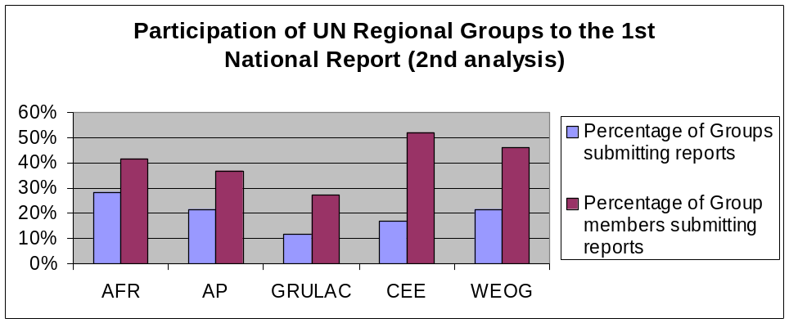

Obligations for provision of information to the Biosafety Clearing-House
- Question 2. Please provide an overview of information that is required to be provided to the Biosafety Clearing-House:
- For this question, the type of information categorized in the A B C columns appearing in the tables below is as follows:
A = Information exists and is being provided to the Biosafety Clearing-House;
B = Information exists but is not yet provided to the Biosafety Clearing-House; and
C = Information does not exist /not applicable

Sums and percentages of all answers under Question 2 (a-p):

 | A | B | C | (A+B+C) |  | Percentages
AFR: | 41 | 27 | 254 | 322 |  |  | Tot | AFR | AP | GRULAC | CEE | WEOG
AP | 64 | 39 | 188 | 291 |  | A | 20% | 13% | 22% | 37% | 33% | 46%
GRULAC | 62 | 20 | 86 | 168 |  | B | 8% | 8% | 13% | 12% | 4% | 4%
CEE | 73 | 10 | 141 | 224 |  | C | 63% | 79% | 65% | 51% | 63% | 50%
WEOG | 133 | 12 | 145 | 290
Tot | 260 | 108 | 814 | 1295

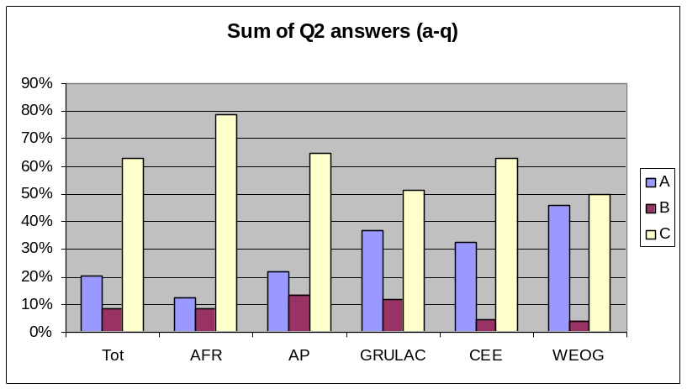

- Existing national legislation, regulations and guidelines for implementing the Protocol, as well as information required by Parties for the advance informed agreement procedure (Article 20.3(a)):

 | A | B | C | (A+B+C) |  | Percentages
AFR: | 4 | 6 | 12 | 22 |  |  | Tot | AFR | AP | GRULAC | CEE | WEOG
AP | 12 | 5 | 3 | 20 |  | A | 56% | 18% | 60% | 43% | 79% | 94%
GRULAC | 6 | 3 | 5 | 14 |  | B | 18% | 27% | 25% | 21% | 14% | 0%
CEE | 11 | 2 | 1 | 14 |  | C | 25% | 55% | 15% | 36% | 7% | 6%
WEOG | 16 | 0 | 1 | 17
Tot | 49 | 16 | 22 | 87

Question 2(a)
0%
10%
20%
30%
40%
50%
60%
70%
80%
90%
100%
Tot
AFR
AP
GRULAC
CEE
WEOG
A
B
C
- National laws, regulations and guidelines applicable to the import of LMOs intended for direct use as food or feed, or for processing (Article 11.5):

 | A | B | C | (A+B+C) |  |  | Percen Percentages tages
AFR: | 4 | 4 | 11 | 19 |  |  | Tot | AFR | AP | GRULAC | CEE | WEOG
AP | 9 | 6 | 4 | 19 |  | A | 39% | 21% | 47% | 55% | 71% | 100%
GRULAC | 6 | 1 | 4 | 11 |  | B | 18% | 21% | 32% | 9% | 21% | 0%
CEE | 10 | 3 | 1 | 14 |  | C | 25% | 58% | 21% | 36% | 7% | 0%
WEOG | 17 | 0 | 0 | 17
Tot | 31 | 14 | 20 | 80

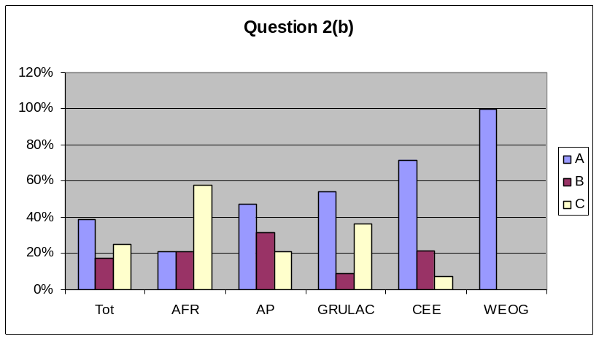

- Bilateral, multilateral and regional agreements and arrangements (Articles 14.2, 20.3(b), and 24.1):

 | A | B | C | (A+B+C) |  |  | Percentages
AFR: | 0 | 1 | 17 | 18 |  |  | Tot | AFR | AP | GRULAC | CEE | WEOG
AP | 1 | 1 | 14 | 16 |  | A | 9% | 0% | 6% | 23% | 15% | 18%
GRULAC | 3 | 2 | 8 | 13 |  | B | 5% | 6% | 6% | 15% | 0% | 0%
CEE | 2 | 0 | 11 | 13 |  | C | 83% | 94% | 88% | 62% | 85% | 82%
WEOG | 3 | 0 | 14 | 17
Tot | 7 | 4 | 64 | 77

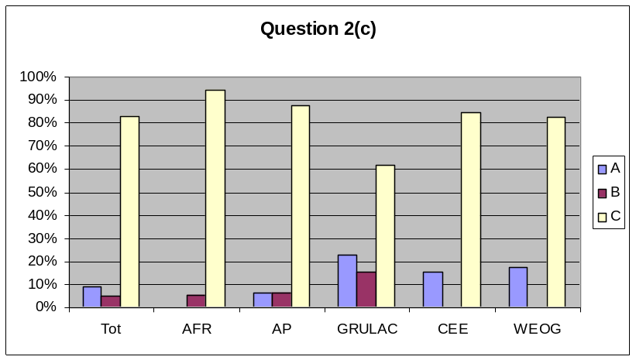

- Contact details for competent national authorities (Articles 19.2 and 19.3), national focal points (Articles 19.1 and 19.3), and emergency contacts (Article 17.2 and 17.3(e)):

 | A | B | C | (A+B+C) |  |  | Percentages
AFR: | 18 | 2 | 0 | 20 |  |  | Tot | AFR | AP | GRULAC | CEE | WEOG
AP | 15 | 2 | 0 | 17 |  | A | 63% | 90% | 88% | 83% | 93% | 100%
GRULAC | 10 | 1 | 1 | 12 |  | B | 8% | 10% | 12% | 8% | 7% | 0%
CEE | 13 | 1 | 0 | 14 |  | C | 1% | 0% | 0% | 8% | 0% | 0%
WEOG | 17 | 0 | 0 | 17
Tot | 50 | 6 | 1 | 80

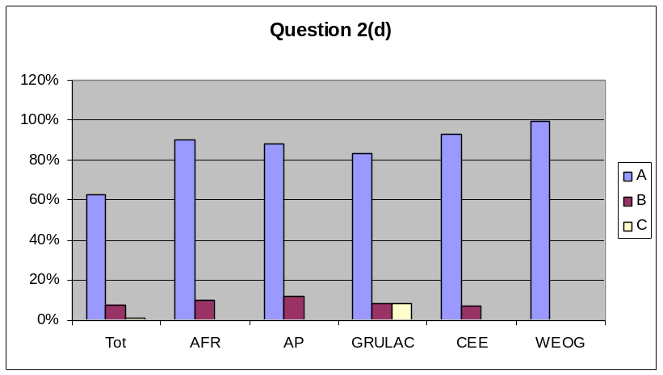

- In cases of multiple competent national authorities, responsibilities for each (Articles 19.2 and 19.3):

 | A | B | C | (A+B+C) |  |  | Percentages
AFR: | 1 | 1 | 16 | 18 |  |  | Tot | AFR | AP | GRULAC | CEE | WEOG
AP | 5 | 2 | 9 | 16 |  | A | 26% | 6% | 31% | 60% | 54% | 59%
GRULAC | 6 | 1 | 3 | 10 |  | B | 5% | 6% | 13% | 10% | 0% | 0%
CEE | 7 | 0 | 6 | 13 |  | C | 55% | 89% | 56% | 30% | 46% | 41%
WEOG | 10 | 0 | 7 | 17
Tot | 19 | 4 | 41 | 74

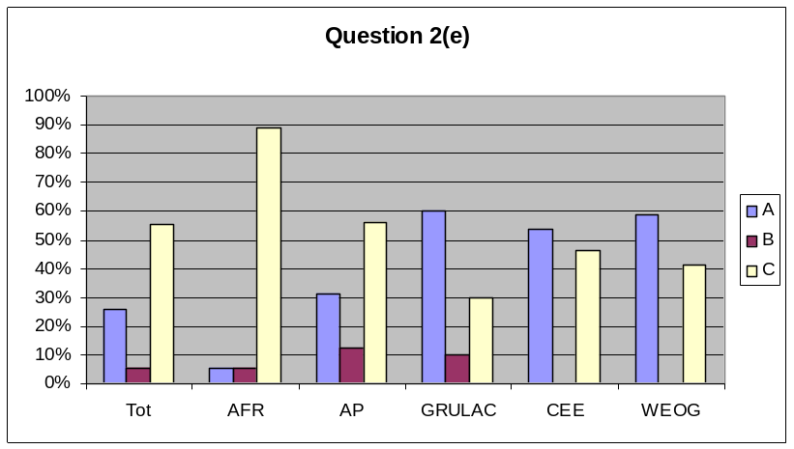

- Reports submitted by the Parties on the operation of the Protocol (Article 20.3(e)):

 | A | B | C | (A+B+C) |  |  | Percentages
AFR: | 5 | 3 | 11 | 19 |  |  | Tot | AFR | AP | GRULAC | CEE | WEOG
AP | 4 | 4 | 8 | 16 |  | A | 34% | 26% | 25% | 56% | 54% | 76%
GRULAC | 5 | 2 | 2 | 9 |  | B | 16% | 16% | 25% | 22% | 0% | 18%
CEE | 7 | 0 | 6 | 13 |  | C | 38% | 58% | 50% | 22% | 46% | 6%
WEOG | 13 | 3 | 1 | 17
Tot | 25 | 12 | 28 | 74

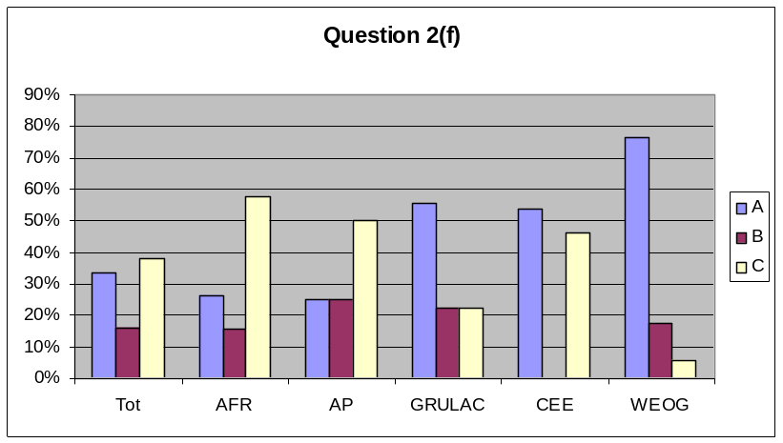

- Occurrence of unintentional transboundary movements that are likely to have significant adverse effects on biological diversity (Article 17.1):

 | A | B | C | (A+B+C) |  |  | Percentages
AFR: | 0 | 0 | 18 | 18 |  |  | Tot | AFR | AP | GRULAC | CEE | WEOG
AP | 0 | 0 | 17 | 17 |  | A | 0% | 0% | 0% | 22% | 0% | 0%
GRULAC | 2 | 1 | 6 | 9 |  | B | 1% | 0% | 0% | 11% | 0% | 0%
CEE | 0 | 0 | 13 | 13 |  | C | 96% | 100% | 100% | 67% | 100% | 100%
WEOG | 0 | 0 | 17 | 17
Tot | 0 | 1 | 71 | 74

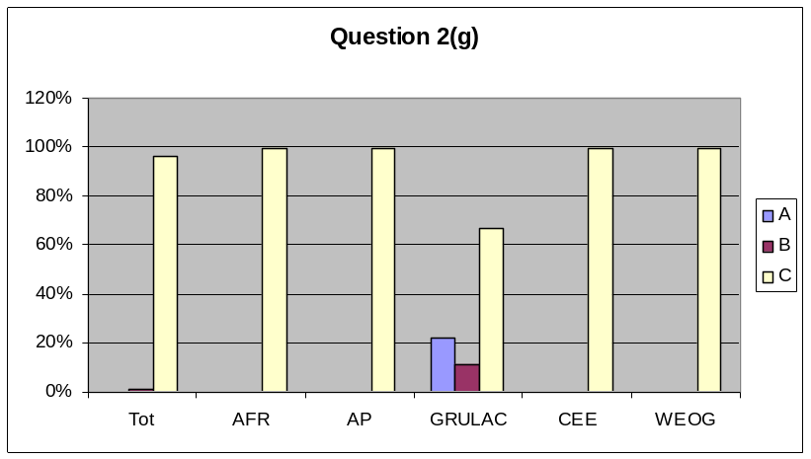

- Illegal transboundary movements of LMOs (Article 25.3):

 | A | B | C | (A+B+C) |  |  | Percentages
AFR: | 0 | 1 | 18 | 19 |  |  | Tot | AFR | AP | GRULAC | CEE | WEOG
AP | 1 | 1 | 15 | 17 |  | A | 3% | 0% | 6% | 22% | 0% | 6%
GRULAC | 2 | 1 | 6 | 9 |  | B | 11% | 5% | 6% | 11% | 8% | 24%
CEE | 0 | 1 | 12 | 13 |  | C | 84% | 95% | 88% | 67% | 92% | 71%
WEOG | 1 | 4 | 12 | 17
Tot | 2 | 8 | 63 | 75

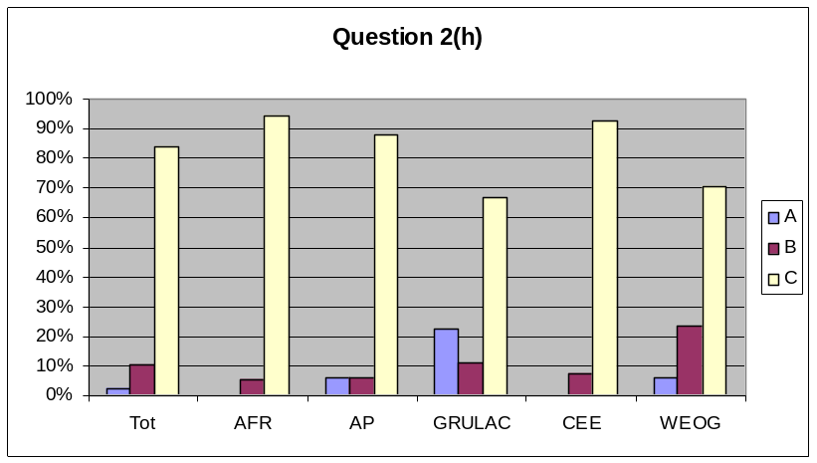

- Final decisions regarding the importation or release of LMOs (i.e. approval or prohibition, any conditions, requests for further information, extensions granted, reasons for decision) (Articles 10.3 and 20.3(d)):

 | A | B | C | (A+B+C) |  |  | Percentages
AFR: | 1 | 1 | 16 | 18 |  |  | Tot | AFR | AP | GRULAC | CEE | WEOG
AP | 2 | 3 | 12 | 17 |  | A | 19% | 6% | 12% | 22% | 46% | 59%
GRULAC | 2 | 2 | 5 | 9 |  | B | 9% | 6% | 18% | 22% | 0% | 6%
CEE | 6 | 0 | 7 | 13 |  | C | 62% | 89% | 71% | 56% | 54% | 35%
WEOG | 10 | 1 | 6 | 17
Tot | 14 | 7 | 46 | 74

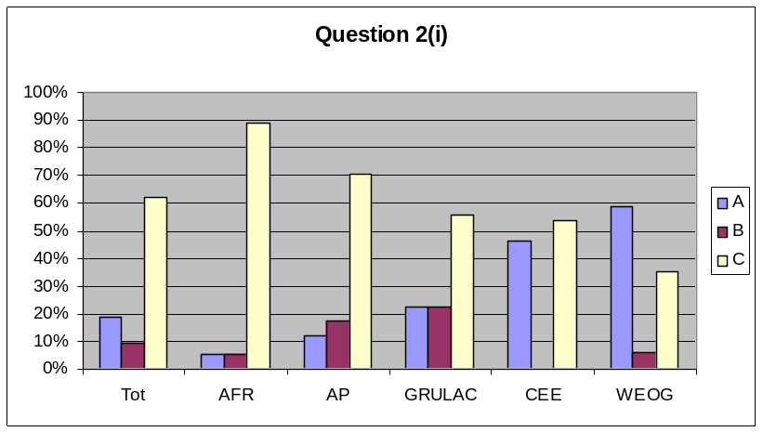

- Information on the application of domestic regulations to specific imports of LMOs (Article 14.4):

 | A | B | C | (A+B+C) |  |  | Percentages
AFR: | 1 | 1 | 17 | 19 |  |  | Tot | AFR | AP | GRULAC | CEE | WEOG
AP | 2 | 4 | 11 | 17 |  | A | 13% | 5% | 12% | 33% | 31% | 41%
GRULAC | 3 | 1 | 5 | 9 |  | B | 9% | 5% | 24% | 11% | 8% | 0%
CEE | 4 | 1 | 8 | 13 |  | C | 68% | 89% | 65% | 56% | 62% | 59%
WEOG | 7 | 0 | 10 | 17
Tot | 10 | 7 | 51 | 75

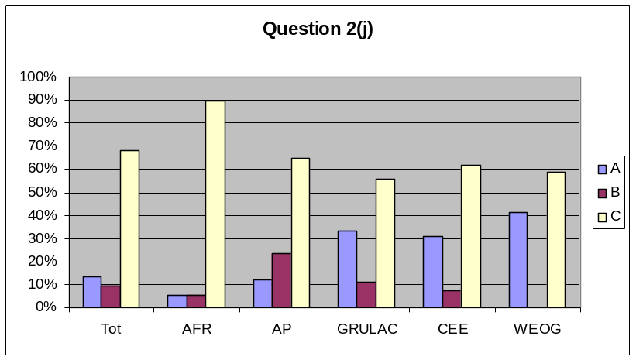

- Final decisions regarding the domestic use of LMOs that may be subject to transboundary movement for direct use as food or feed, or for processing (Article 11.1):

 | A | B | C | (A+B+C) |  |  | Percentages
AFR: | 1 | 2 | 16 | 19 |  |  | Tot | AFR | AP | GRULAC | CEE | WEOG
AP | 3 | 3 | 11 | 17 |  | A | 15% | 5% | 18% | 22% | 23% | 53%
GRULAC | 2 | 1 | 6 | 9 |  | B | 9% | 11% | 18% | 11% | 0% | 6%
CEE | 3 | 0 | 10 | 13 |  | C | 67% | 84% | 65% | 67% | 77% | 41%
WEOG | 9 | 1 | 7 | 17
Tot | 11 | 7 | 50 | 75

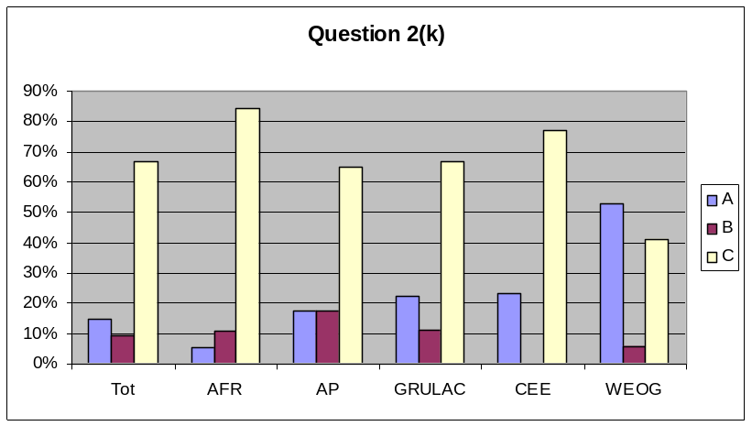

- Final decisions regarding the import of LMOs intended for direct use as food or feed, or for processing that are taken under domestic regulatory frameworks (Article 11.4) or in accordance with annex III (Article 11.6) (requirement of Article 20.3(d)):

 | A | B | C | (A+B+C) |  |  | Percentages
AFR: | 1 | 2 | 16 | 19 |  |  | Tot | AFR | AP | GRULAC | CEE | WEOG
AP | 2 | 3 | 12 | 17 |  | A | 20% | 5% | 12% | 22% | 31% | 71%
GRULAC | 2 | 1 | 6 | 9 |  | B | 9% | 11% | 18% | 11% | 8% | 0%
CEE | 4 | 1 | 8 | 13 |  | C | 63% | 84% | 71% | 67% | 62% | 29%
WEOG | 12 | 0 | 5 | 17
Tot | 15 | 7 | 47 | 75

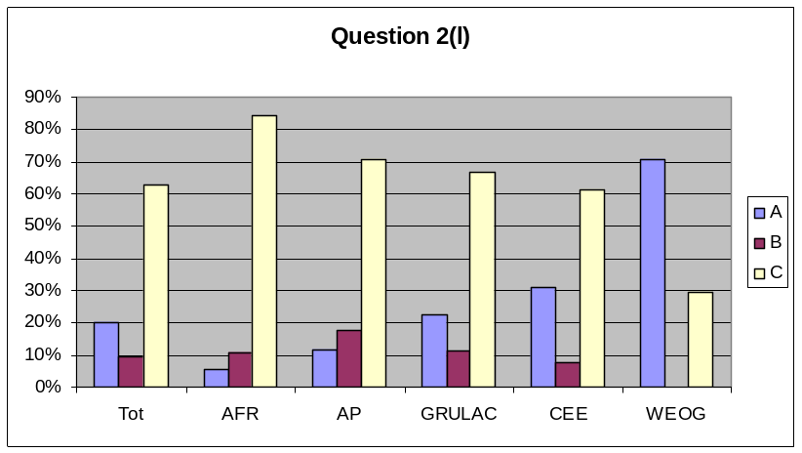

- Declarations regarding the framework to be used for LMOs intended for direct use as food or feed, or for processing (Article 11.6):

 | A | B | C | (A+B+C) |  |  | Percentages
AFR: | 2 | 0 | 17 | 19 |  |  | Tot | AFR | AP | GRULAC | CEE | WEOG
AP | 5 | 2 | 10 | 17 |  | A | 11% | 11% | 29% | 44% | 8% | 24%
GRULAC | 4 | 0 | 5 | 9 |  | B | 3% | 0% | 12% | 0% | 0% | 0%
CEE | 1 | 0 | 12 | 13 |  | C | 76% | 89% | 59% | 56% | 92% | 76%
WEOG | 4 | 0 | 13 | 17
Tot | 8 | 2 | 57 | 75

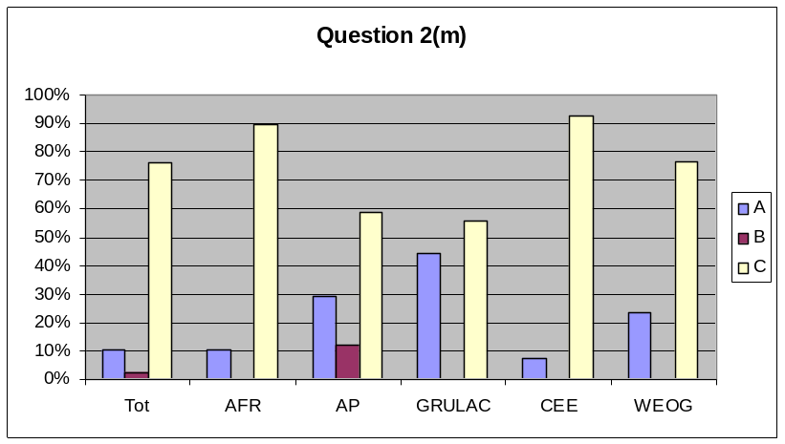

- Review and change of decisions regarding intentional transboundary movements of LMOs (Article 12.1):

 | A | B | C | (A+B+C) |  |  | Percentages
AFR: | 1 | 0 | 18 | 19 |  |  | Tot | AFR | AP | GRULAC | CEE | WEOG
AP | 0 | 0 | 16 | 16 |  | A | 5% | 5% | 0% | 22% | 8% | 24%
GRULAC | 2 | 1 | 6 | 9 |  | B | 1% | 0% | 0% | 11% | 0% | 0%
CEE | 1 | 0 | 12 | 13 |  | C | 88% | 95% | 100% | 67% | 92% | 76%
WEOG | 4 | 0 | 13 | 17
Tot | 4 | 1 | 65 | 74

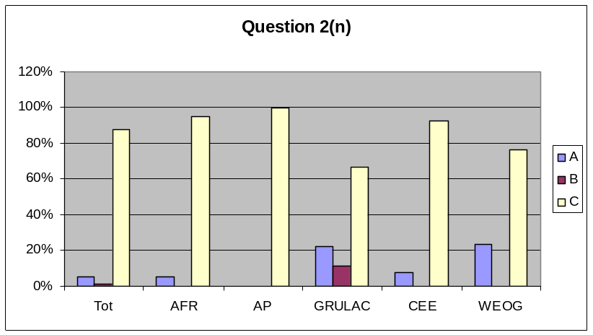

- LMOs granted exemption status by each Party (Article 13.1):

 | A | B | C | (A+B+C) |  |  | Percentages
AFR: | 1 | 0 | 17 | 18 |  |  | Tot | AFR | AP | GRULAC | CEE | WEOG
AP | 0 | 1 | 16 | 17 |  | A | 0% | 6% | 0% | 22% | 0% | 0%
GRULAC | 2 | 0 | 7 | 9 |  | B | 1% | 0% | 6% | 0% | 0% | 0%
CEE | 0 | 0 | 13 | 13 |  | C | 95% | 94% | 94% | 78% | 100% | 100%
WEOG | 0 | 0 | 17 | 17
Tot | 0 | 1 | 70 | 74

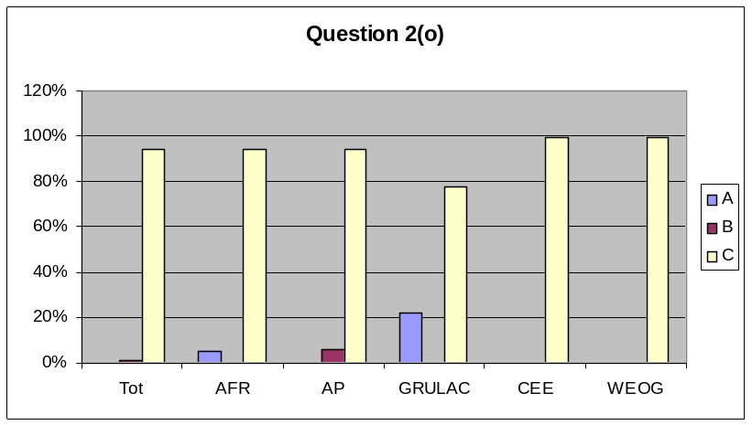

- Cases where intentional transboundary movement may take place at the same time as the movement is notified to the Party of import (Article 13.1):

 | A | B | C | (A+B+C) |  |  | Percentages
AFR: | 0 | 0 | 18 | 18 |  |  | Tot | AFR | AP | GRULAC | CEE | WEOG
AP | 0 | 0 | 17 | 17 |  | A | 0% | 0% | 0% | 22% | 0% | 0%
GRULAC | 2 | 0 | 7 | 9 |  | B | 0% | 0% | 0% | 0% | 0% | 0%
CEE | 0 | 0 | 13 | 13 |  | C | 97% | 100% | 100% | 78% | 100% | 100%
WEOG | 0 | 0 | 17 | 17
Tot | 0 | 0 | 72 | 74

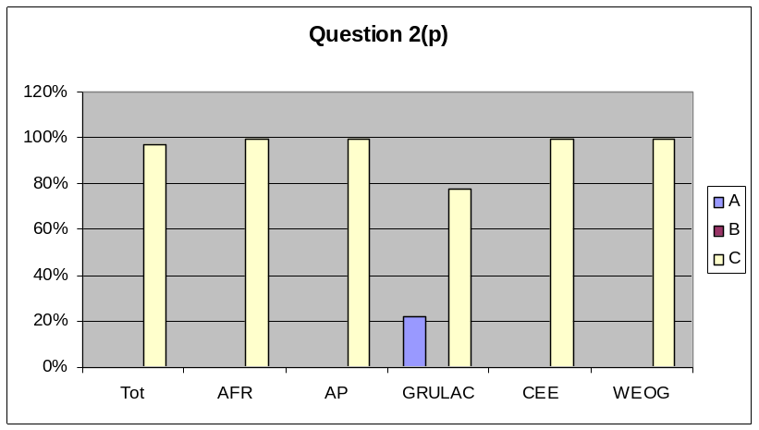

- Summaries of risk assessments or environmental reviews of LMOs generated by regulatory processes and relevant information regarding products thereof (Article 20.3(c)):

 | A | B | C | (A+B+C) |  |  | Percentages
AFR: | 1 | 3 | 16 | 20 |  |  | Tot | AFR | AP | GRULAC | CEE | WEOG
AP | 3 | 2 | 13 | 18 |  | A | 19% | 5% | 17% | 33% | 31% | 56%
GRULAC | 3 | 2 | 4 | 9 |  | B | 14% | 15% | 11% | 22% | 8% | 17%
CEE | 4 | 1 | 8 | 13 |  | C | 59% | 80% | 72% | 44% | 62% | 28%
WEOG | 10 | 3 | 5 | 18
Tot | 15 | 11 | 46 | 78

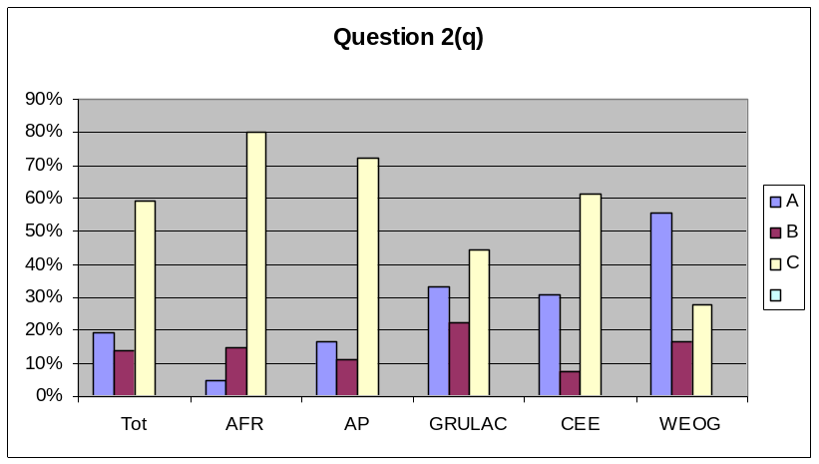

Article 2 - General provisions
- Question 3. Has your country introduced the necessary legal, administrative and other measures for implementation of the Protocol? (Article 2.1)
- full domestic regulatory framework in place
- some measures introduced
- no measures yet taken

 | a) | b) | c) |  | Percentages
AFR: | 9 | 10 | 5 |  |  | Tot | AFR | AP | GRULAC | CEE | WEOG
AP | 7 | 9 | 2 |  | a) | 51% | 38% | 39% | 0% | 69% | 100%
GRULAC | 0 | 8 | 2 |  | b) | 35% | 42% | 50% | 80% | 15% | 0%
CEE | 9 | 2 | 2 |  | c) | 13% | 21% | 11% | 20% | 15% | 0%
WEOG | 17 | 0 | 0
Tot | 42 | 29 | 11

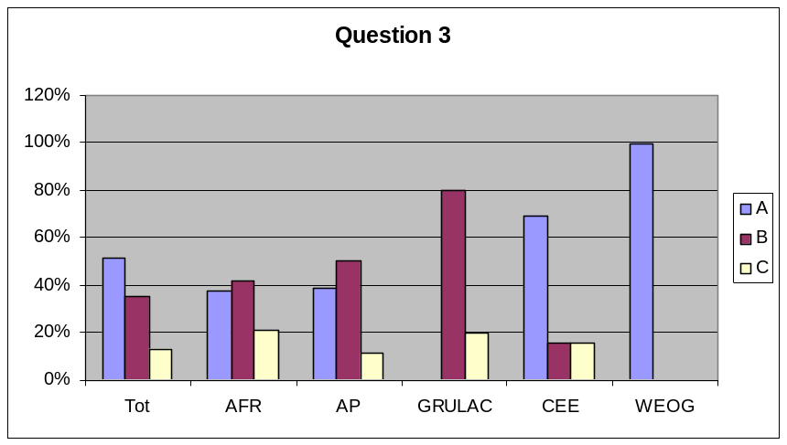

Articles 7 to 10 and 12: The advance informed agreement procedure
- Question 5. Were you a Party of import during this reporting period?
- yes
- no

 | a) | b) |  | Percentages
AFR | 4 | 15 |  |  | Tot | AFR | AP | GRULAC | CEE | WEOG
AP | 6 | 11 |  | a) | 34% | 21% | 35% | 40% | 23% | 53%
GRULAC | 4 | 6 |  | b) | 66% | 79% | 65% | 60% | 77% | 47%
CEE | 3 | 10
WEOG | 9 | 8
Tot | 26 | 50

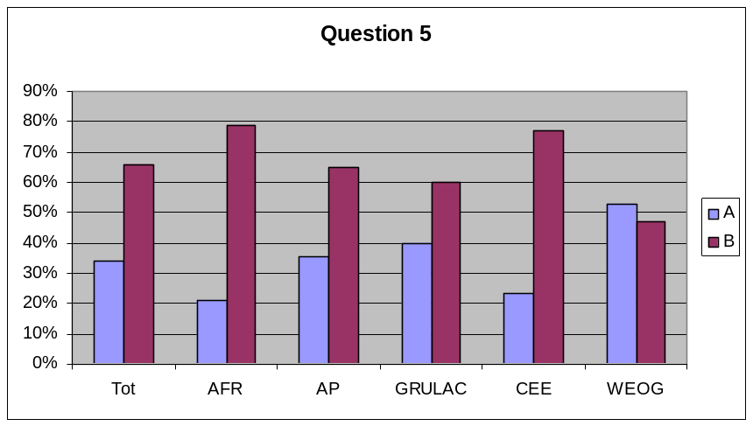

Article 13 - Simplified procedure
- Question 6. Were you a Party of export during this reporting period?
- yes
- no

 | a) | b) |  | Percentages
AFR | 0 | 19 |  |  | Tot | AFR | AP | GRULAC | CEE | WEOG
AP | 2 | 15 |  | a) | 8% | 0% | 12% | 20% | 0% | 13%
GRULAC | 2 | 8 |  | b) | 92% | 100% | 88% | 80% | 100% | 88%
CEE | 0 | 13
WEOG | 2 | 14
Tot | 6 | 69

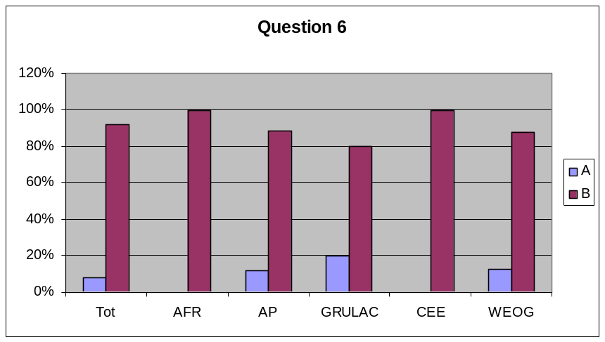

- Question 7. Is there a legal requirement for the accuracy of information provided by exporters / under the jurisdiction of your country? (Article 8.2)
- yes
- not yet, but under development
- no
- not applicable - not a Party of export

 | a) | b) | c) | d) | Percentages
AFR: | 7 | 9 | 0 | 6 |  |  | Tot | AFR | AP | GRULAC | CEE | WEOG
AP | 7 | 9 | 0 | 2 |  | a) | 53% | 32% | 39% | 18% | 77% | 100%
GRULAC | 2 | 6 | 2 | 1 |  | b) | 30% | 41% | 50% | 55% | 0% | 0%
CEE | 10 | 0 | 0 | 3 |  | c) | 2% | 0% | 0% | 18% | 0% | 0%
WEOG | 17 | 0 | 0 | 0 |  | d) | 15% | 27% | 11% | 9% | 23% | 0%
Tot | 43 | 24 | 2 | 12

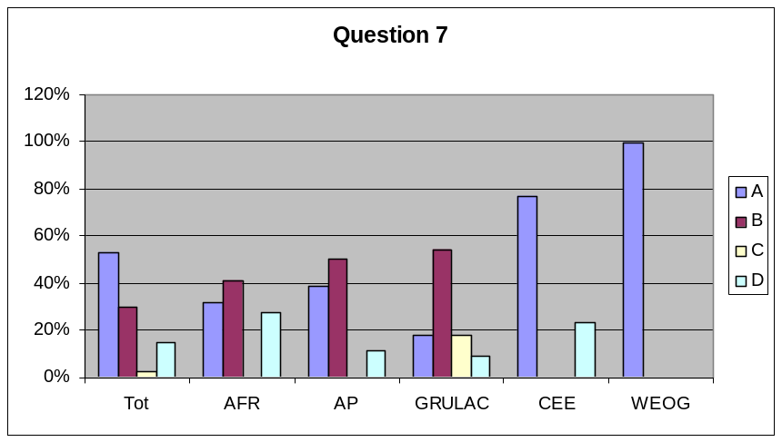

- Question 8. If you were a Party of export during this reporting period, did you request any Party of import to review a decision it had made under Article 10 on the grounds specified in Article 12.2?
- yes
- not yet, but under development
- no
- not applicable - not a Party of export

 | a) | b) | c) | d) | Percentages
AFR: | 0 | 2 | 2 | 18 |  |  | Tot | AFR | AP | GRULAC | CEE | WEOG
AP | 0 | 0 | 3 | 14 |  | a) | 0% | 0% | 0% | 0% | 0% | 0%
GRULAC | 0 | 0 | 2 | 7 |  | b) | 3% | 9% | 0% | 0% | 0% | 0%
CEE | 0 | 0 | 0 | 13 |  | c) | 15% | 9% | 18% | 22% | 0% | 29%
WEOG | 0 | 0 | 5 | 12 |  | d) | 82% | 82% | 82% | 78% | 100% | 71%
Tot | 0 | 2 | 12 | 64

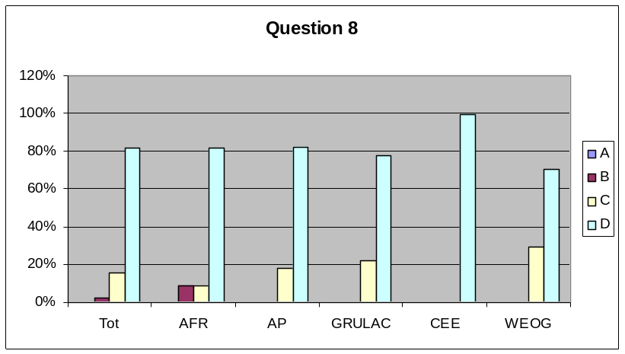

- Question 9. Did your country take decisions regarding import under domestic regulatory frameworks as allowed by Article 9.2(c)?
- yes
- no
- not applicable - no decisions taken during the reporting period

 | a) | b) | c) |  | Percentages
AFR: | 2 | 5 | 14 |  |  | Tot | AFR | AP | GRULAC | CEE | WEOG
AP | 3 | 2 | 12 |  | a) | 21% | 10% | 18% | 20% | 15% | 41%
GRULAC | 2 | 3 | 5 |  | b) | 19% | 24% | 12% | 30% | 31% | 6%
CEE | 2 | 4 | 7 |  | c) | 60% | 67% | 71% | 50% | 54% | 53%
WEOG | 7 | 1 | 9
Tot | 16 | 15 | 47

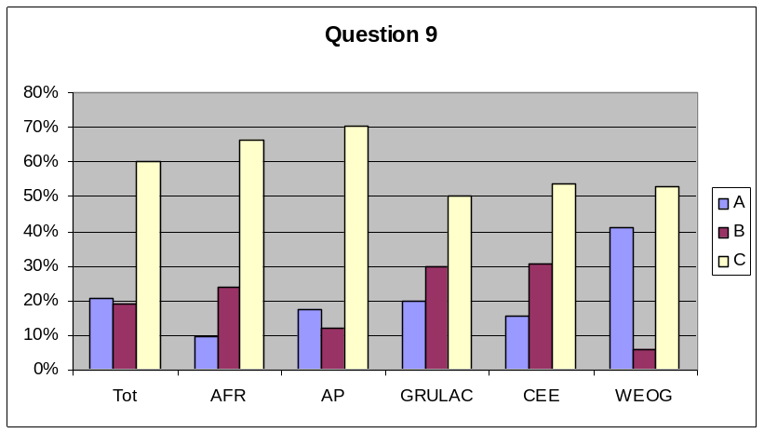

Article 11 - Procedure for living modified organisms intended for direct use as food or feed, or for processing
- Question 12. Is there a legal requirement for the accuracy of information provided by the applicant with respect to the domestic use of a living modified organism that may be subject to transboundary movement for direct use as food or feed, or for processing? (Article 11.2)
- yes
- not yet, but under development
- no
- not applicable

 | a) | b) | c) | d) | Percentages
AFR: | 6 | 13 | 3 | 0 |  |  | Tot | AFR | AP | GRULAC | CEE | WEOG
AP | 9 | 7 | 1 | 0 |  | a) | 59% | 27% | 53% | 27% | 92% | 100%
GRULAC | 3 | 5 | 3 | 0 |  | b) | 31% | 59% | 41% | 45% | 0% | 0%
CEE | 12 | 0 | 1 | 0 |  | c) | 10% | 14% | 6% | 27% | 8% | 0%
WEOG | 17 | 0 | 0 | 0 |  | d) | 0% | 0% | 0% | 0% | 0% | 0%
Tot | 47 | 25 | 8 | 0

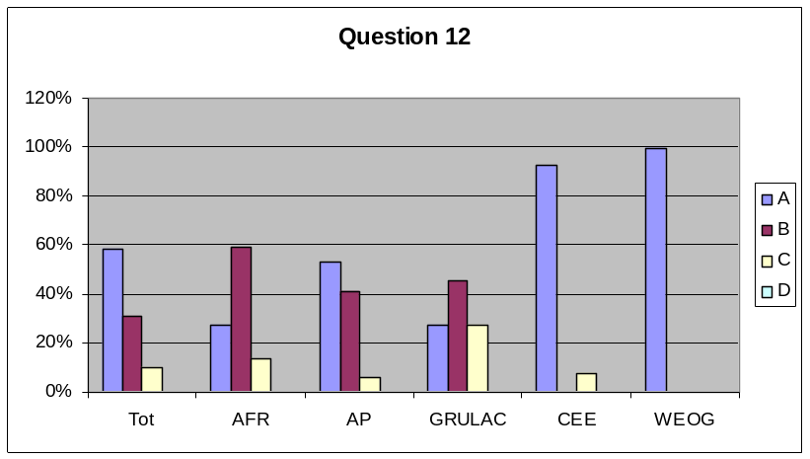

- Question 13. Has your country indicated its needs for financial and technical assistance and capacity-building in respect of living modified organisms intended for direct use as food or feed, or for processing? (Article 11.9)
- yes
- no
- not relevant

 | a) | b) | c) |  | Percentages
AFR: | 8 | 12 | 1 |  |  | Tot | AFR | AP | GRULAC | CEE | WEOG
AP | 12 | 5 | 0 |  | a) | 40% | 38% | 71% | 60% | 38% | 0%
GRULAC | 6 | 4 | 0 |  | b) | 33% | 57% | 29% | 40% | 31% | 6%
CEE | 5 | 4 | 4 |  | c) | 27% | 5% | 0% | 0% | 31% | 94%
WEOG | 0 | 1 | 16
Tot | 31 | 26 | 21

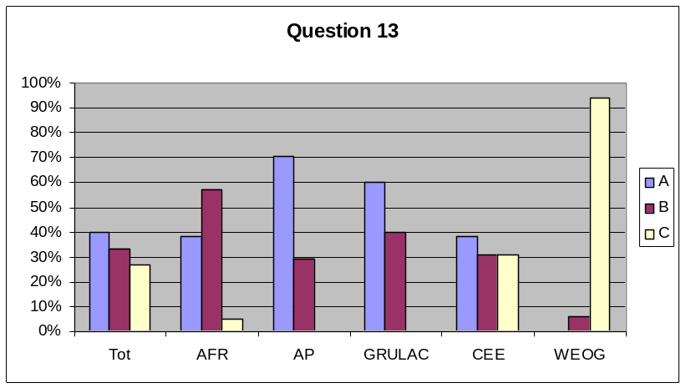

- Question 14. Did your country take decisions regarding import under domestic regulatory frameworks as allowed by Article 11.4?
- yes
- no
- not applicable - no decisions taken during the reporting period

 | a) | b) | c) |  | Percentages
AFR: | 1 | 6 | 15 |  |  | Tot | AFR | AP | GRULAC | CEE | WEOG
AP | 5 | 2 | 10 |  | a) | 24% | 5% | 29% | 22% | 23% | 47%
GRULAC | 2 | 5 | 2 |  | b) | 23% | 27% | 12% | 56% | 23% | 12%
CEE | 3 | 3 | 7 |  | c) | 53% | 68% | 59% | 22% | 54% | 41%
WEOG | 8 | 2 | 7
Tot | 19 | 18 | 41

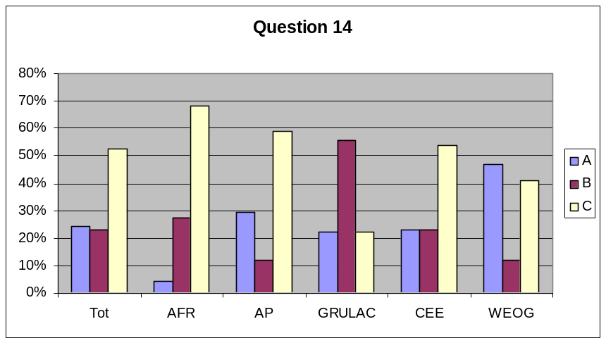

Article 13 - Simplified procedure
- Question 17. Have you applied the simplified procedure during the reporting period?
  - yes
  - no

 | a) | b) |  | Percentages
AFR | 0 | 19 |  |  | Tot | AFR | AP | GRULAC | CEE | WEOG
AP | 1 | 15 |  | a) | 1% | 0% | 6% | 0% | 0% | 0%
GRULAC | 0 | 9 |  | b) | 99% | 100% | 94% | 100% | 100% | 100%
CEE | 0 | 13
WEOG | 0 | 17
Tot | 1 | 73

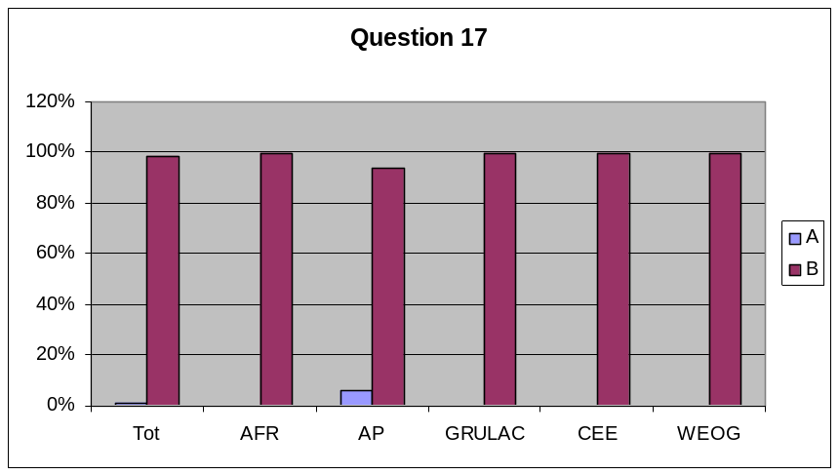

Article 14 - Bilateral, regional and multilateral agreements and arrangements
- Question 19. Has your country entered into any bilateral, regional or multilateral agreements or arrangements?
a) yes
b) no

 | a) | b) |  | Percentages
AFR | 2 | 16 |  |  | Tot | AFR | AP | GRULAC | CEE | WEOG
AP | 3 | 13 |  | a) | 14% | 11% | 19% | 11% | 8% | 18%
GRULAC | 1 | 8 |  | b) | 86% | 89% | 81% | 89% | 92% | 82%
CEE | 1 | 12
WEOG | 3 | 14
Tot | 10 | 63
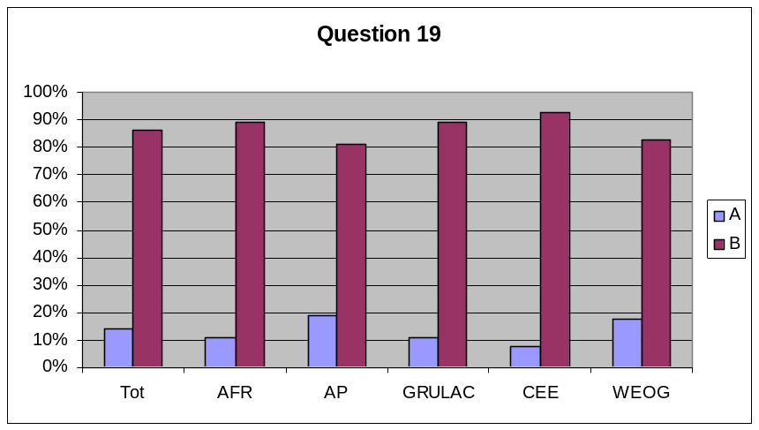

Articles 15 and 16 - Risk assessment and risk management
- Question 21. If you were a Party of import during this reporting period, were risk assessments carried out for all decisions taken under Article 10? (Article 15.2)
- yes
- no
- not a Party of import / no decisions taken under Article 10

 | a) | b) | c) |  | Percentages
AFR: | 1 | 4 | 18 |  |  | Tot | AFR | AP | GRULAC | CEE | WEOG
AP | 2 | 3 | 12 |  | a) | 14% | 4% | 12% | 38% | 15% | 18%
GRULAC | 3 | 2 | 3 |  | b) | 12% | 17% | 18% | 25% | 0% | 0%
CEE | 2 | 0 | 11 |  | c) | 74% | 78% | 71% | 38% | 85% | 82%
WEOG | 3 | 0 | 14
Tot | 11 | 9 | 58

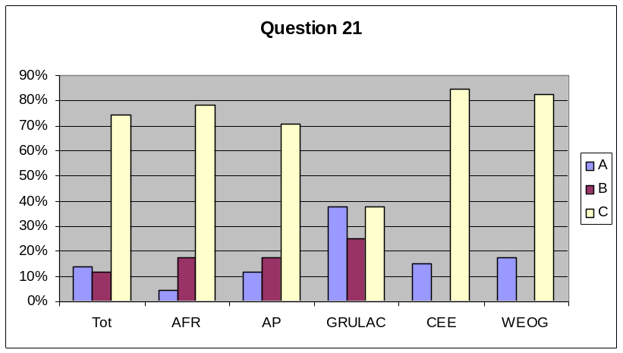

- Question 22. If yes to question 21, did you require the exporter to carry out the risk assessment?
- yes - in all cases
- yes – in some cases
- no
- not a Party of import / no decisions taken under Article 10

 | a) | b) | c) | d) | Percentages
AFR: | 1 | 0 | 0 | 15 |  |  | Tot | AFR | AP | GRULAC | CEE | WEOG
AP | 2 | 0 | 1 | 10 |  | a) | 12% | 6% | 15% | 13% | 15% | 12%
GRULAC | 1 | 1 | 3 | 3 |  | b) | 1% | 0% | 0% | 13% | 0% | 0%
CEE | 2 | 0 | 0 | 11 |  | c) | 7% | 0% | 8% | 38% | 0% | 6%
WEOG | 2 | 0 | 1 | 14 |  | d) | 79% | 94% | 77% | 38% | 85% | 82%
Tot | 8 | 1 | 5 | 53

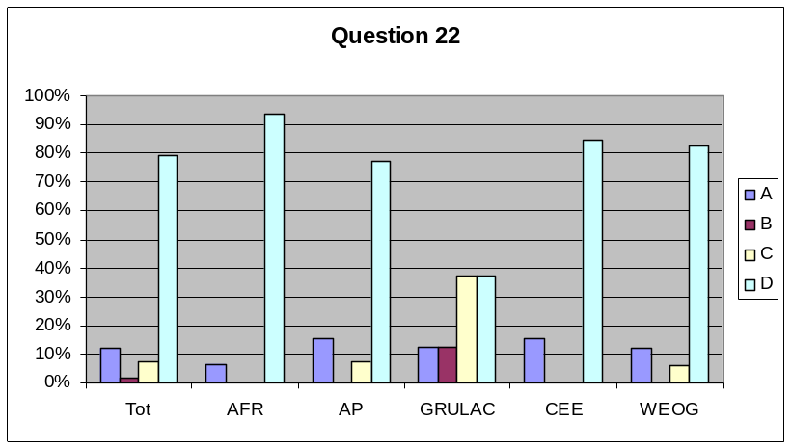

- Question 23. If you took a decision under Article 10 during the reporting period, did you require the notifier to bear the cost of the risk assessment? (Article 15.3)
- yes – in all cases
- yes – in some cases
- no
- not a Party of import / no decisions taken under Article 10

 | a) | b) | c) | d) | Percentages
AFR: | 2 | 0 | 1 | 18 |  |  | Tot | AFR | AP | GRULAC | CEE | WEOG
AP | 4 | 0 | 0 | 12 |  | a) | 15% | 10% | 25% | 13% | 15% | 12%
GRULAC | 1 | 0 | 3 | 4 |  | b) | 0% | 0% | 0% | 0% | 0% | 0%
CEE | 2 | 0 | 0 | 11 |  | c) | 7% | 5% | 0% | 38% | 0% | 6%
WEOG | 2 | 0 | 1 | 14 |  | d) | 79% | 86% | 75% | 50% | 85% | 82%
Tot | 11 | 0 | 5 | 59
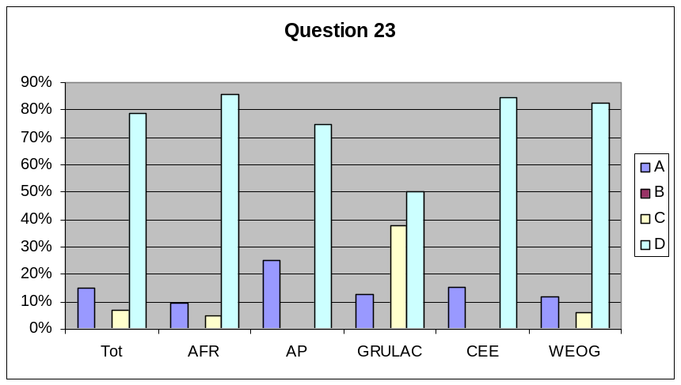

- Question 24. Has your country established and maintained appropriate mechanisms, measures and strategies to regulate, manage and control risks identified in the risk assessment provisions of the Protocol? (Article 16.1)
- yes - fully established
- not yet, but under development or partially established
- no

 | a) | b) | c) |  | Percentages
AFR: | 5 | 12 | 4 |  |  | Tot | AFR | AP | GRULAC | CEE | WEOG
AP | 5 | 10 | 2 |  | a) | 49% | 24% | 29% | 30% | 64% | 100%
GRULAC | 3 | 5 | 2 |  | b) | 39% | 57% | 59% | 50% | 29% | 0%
CEE | 9 | 4 | 1 |  | c) | 11% | 19% | 12% | 20% | 7% | 0%
WEOG | 17 | 0 | 0
Tot | 39 | 31 | 9

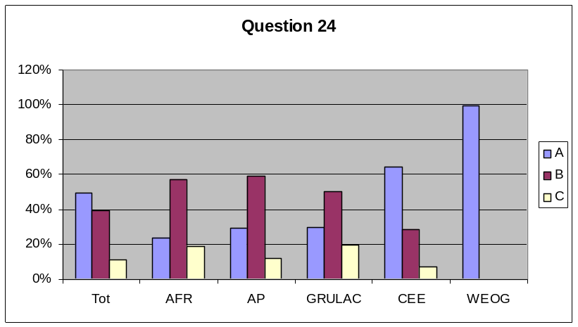

- Question 25. Has your country adopted appropriate measures to prevent unintentional transboundary movements of living modified organisms? (Article 16.3)
- yes - fully established
- not yet, but under development or partially established
- no

 | a) | b) | c) |  | Percentages
AFR: | 5 | 12 | 5 |  |  | Tot | AFR | AP | GRULAC | CEE | WEOG
AP | 5 | 9 | 3 |  | a) | 48% | 23% | 29% | 20% | 71% | 94%
GRULAC | 2 | 5 | 3 |  | b) | 38% | 55% | 53% | 50% | 21% | 6%
CEE | 10 | 3 | 1 |  | c) | 15% | 23% | 18% | 30% | 7% | 0%
WEOG | 16 | 1 | 0
Tot | 38 | 30 | 12

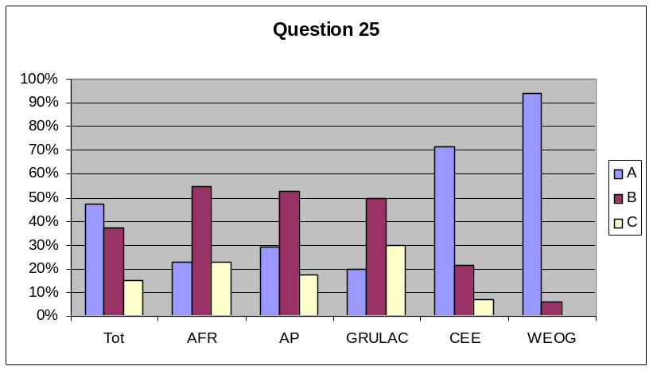

- Question 26. Does your country endeavour to ensure that any living modified organism, whether imported or locally developed, undergoes an appropriate period of observation commensurate with its life-cycle or generation time before it is put to its intended use? (Article 16.4)
- yes - in all cases
- yes – in some cases
- no
- not applicable

 | a) | b) | c) | d) | Percentages
3 | 9 | 3 | 3 | 7 |  |  | Tot | AFR | AP | GRULAC | CEE | WEOG
AP | 7 | 3 | 1 | 6 |  | a) | 59% | 41% | 41% | 33% | 86% | 89%
GRULAC | 3 | 1 | 1 | 4 |  | b) | 9% | 14% | 18% | 11% | 0% | 0%
CEE | 12 | 0 | 2 | 0 |  | c) | 10% | 14% | 6% | 11% | 14% | 6%
WEOG | 16 | 0 | 1 | 1 |  | d) | 23% | 32% | 35% | 44% | 0% | 6%
Tot | 47 | 7 | 8 | 18

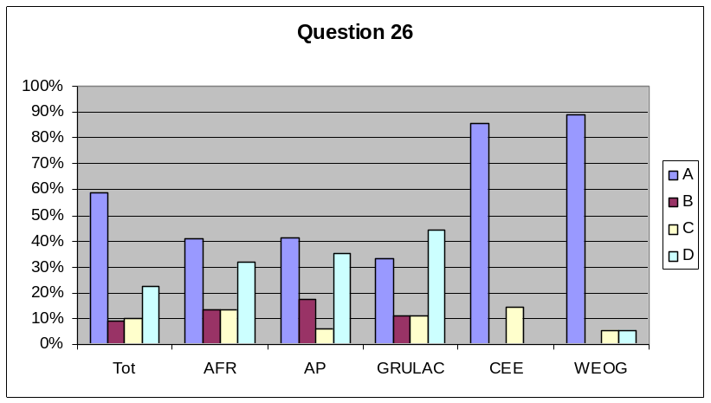

- Question 27. Has your country cooperated with others for the purposes specified in Article 16.5?
a) yes
b) no

 | a) | b) |  | Percentages
AFR | 2 | 19 |  |  | Tot | AFR | AP | GRULAC | CEE | WEOG
AP | 5 | 11 |  | a) | 34% | 10% | 31% | 11% | 46% | 71%
GRULAC | 1 | 8 |  | b) | 66% | 90% | 69% | 89% | 54% | 29%
CEE | 6 | 7
WEOG | 12 | 5
Tot | 26 | 50

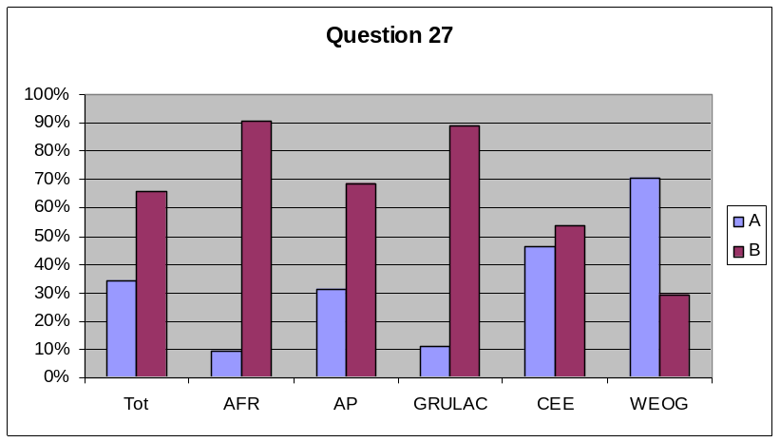

Article 17 - Unintentional transboundary movements and emergency measures
- Question 29. During the reporting period, if there were any occurrences under your jurisdiction that led, or could have led, to an unintentional transboundary movement of a living modified organism that had, or could have had, significant adverse effects on the conservation and sustainable use of biological diversity, taking also into account risks to human health in such States, did you immediately consult the affected or potentially affected States for the purposes specified in Article 17.4?
- yes - all relevant States immediately
- yes - partially consulted, or consultations were delayed
- no - did not consult immediately
- not applicable (no such occurrences)

 | a) | b) | c) | d) | Percentages
AFR: | 0 | 0 | 3 | 18 |  |  | Tot | AFR | AP | GRULAC | CEE | WEOG
AP | 0 | 0 | 0 | 17 |  | a) | 0% | 0% | 0% | 0% | 0% | 0%
GRULAC | 0 | 1 | 0 | 7 |  | b) | 1% | 0% | 0% | 13% | 0% | 0%
CEE | 0 | 0 | 0 | 13 |  | c) | 4% | 14% | 0% | 0% | 0% | 0%
WEOG | 0 | 0 | 0 | 17 |  | d) | 95% | 86% | 100% | 88% | 100% | 100%
Tot | 0 | 1 | 3 | 72

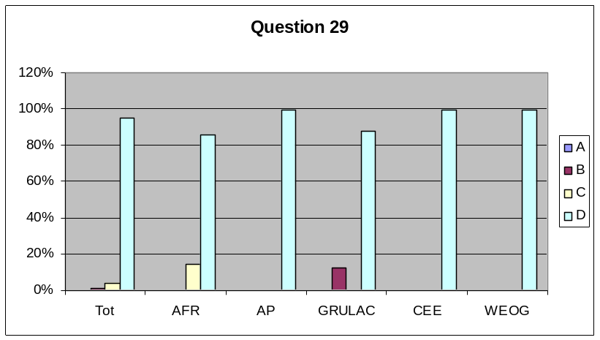

Article 18 - Handling, transport, packaging and identification
- Question 31. Has your country taken measures to require that living modified organisms that are subject to transboundary movement within the scope of the Protocol are handled, packaged and transported under conditions of safety, taking into account relevant international rules and standards? (Article 18.1)
- yes
- not yet, but under development
- no
- not applicable

 | a) | b) | c) | d) | Percentages
AFR: | 9 | 11 | 0 | 1 |  |  | Tot | AFR | AP | GRULAC | CEE | WEOG
AP | 8 | 9 | 0 | 0 |  | a) | 62% | 43% | 47% | 36% | 92% | 94%
GRULAC | 4 | 5 | 1 | 1 |  | b) | 32% | 52% | 53% | 45% | 0% | 0%
CEE | 12 | 0 | 1 | 0 |  | c) | 3% | 0% | 0% | 9% | 8% | 0%
WEOG | 16 | 0 | 0 | 1 |  | d) | 4% | 5% | 0% | 9% | 0% | 6%
Tot | 49 | 25 | 2 | 3

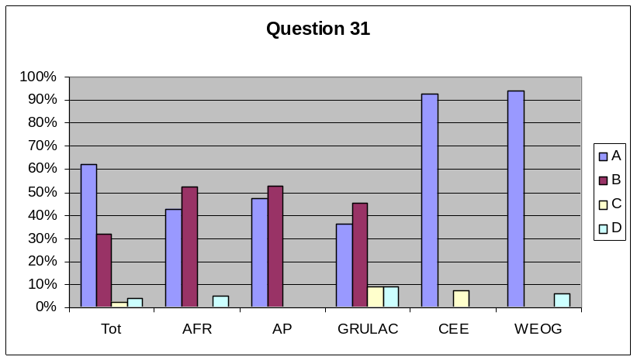

- Question 32. Has your country taken measures to require that documentation accompanying living modified organisms for direct use as food or feed, or for processing, clearly identifies that they ‘may contain’ living modified organisms and are not intended for intentional introduction into the environment, as well as a contact point for information? (Article 18.2(a))
- yes
- not yet, but under development
- no

 | a) | b) | c) |  | Percentages
AFR: | 9 | 12 | 1 |  |  | Tot | AFR | AP | GRULAC | CEE | WEOG
AP | 8 | 8 | 1 |  | a) | 59% | 41% | 47% | 20% | 92% | 94%
GRULAC | 2 | 6 | 2 |  | b) | 33% | 55% | 47% | 60% | 0% | 0%
CEE | 12 | 0 | 1 |  | c) | 8% | 5% | 6% | 20% | 8% | 6%
WEOG | 16 | 0 | 1
Tot | 47 | 26 | 6

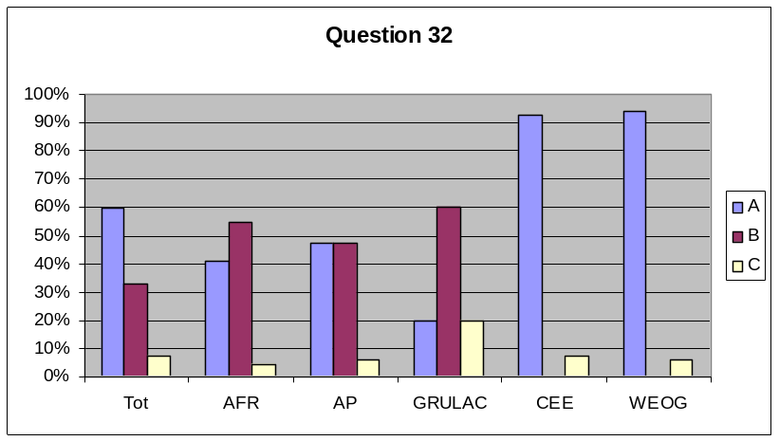

- Question 33. Has your country taken measures to require that documentation accompanying living modified organisms that are destined for contained use clearly identifies them as living modified organisms and specifies any requirements for the safe handling, storage, transport and use, the contact point for further information, including the name and address of the individual and institution to whom the living modified organisms are consigned? (Article 18.2(b))
- yes
- not yet, but under development
- no

 | a) | b) | c) |  | Percentages
AFR: | 10 | 11 | 1 |  |  | Tot | AFR | AP | GRULAC | CEE | WEOG
AP | 8 | 9 | 0 |  | a) | 62% | 45% | 47% | 30% | 92% | 94%
GRULAC | 3 | 5 | 2 |  | b) | 32% | 50% | 53% | 50% | 0% | 0%
CEE | 12 | 0 | 1 |  | c) | 6% | 5% | 0% | 20% | 8% | 6%
WEOG | 16 | 0 | 1
Tot | 49 | 25 | 5

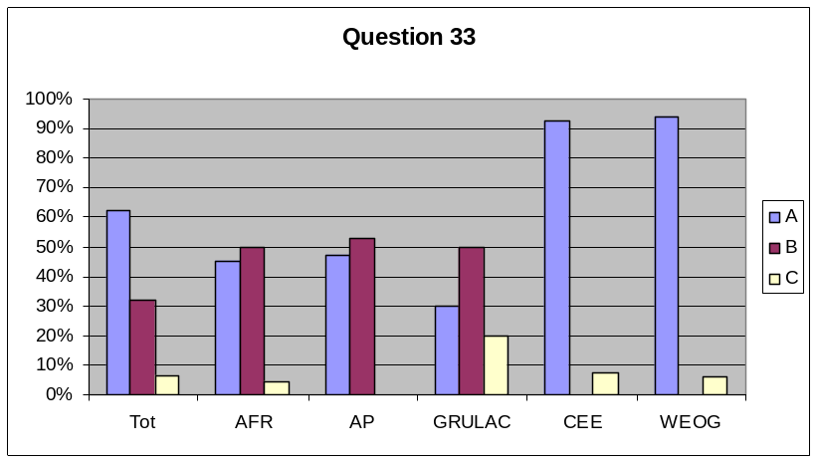

- Question 34. Has your country adopted measures to require that documentation accompanying living modified organisms that are intended for intentional introduction into the environment of the Party of import and any other living modified organisms within the scope of the Protocol, clearly identifies them as living modified organisms; specifies the identity and relevant traits and/or characteristics, any requirements for the safe handling, storage, transport and use, the contact point for further information and, as appropriate, the name and address of the importer and exporter; and contains a declaration that the movement is in conformity with the requirements of this Protocol applicable to the exporter? (Article 18.2(c))
- yes
- not yet, but under development
- no

 | a) | b) | c) |  | Percentages
AFR: | 9 | 12 | 1 |  |  | Tot | AFR | AP | GRULAC | CEE | WEOG
AP | 8 | 8 | 1 |  | a) | 62% | 41% | 47% | 40% | 92% | 94%
GRULAC | 4 | 5 | 1 |  | b) | 32% | 55% | 47% | 50% | 0% | 0%
CEE | 12 | 0 | 1 |  | c) | 6% | 5% | 6% | 10% | 8% | 6%
WEOG | 16 | 0 | 1
Tot | 49 | 25 | 5

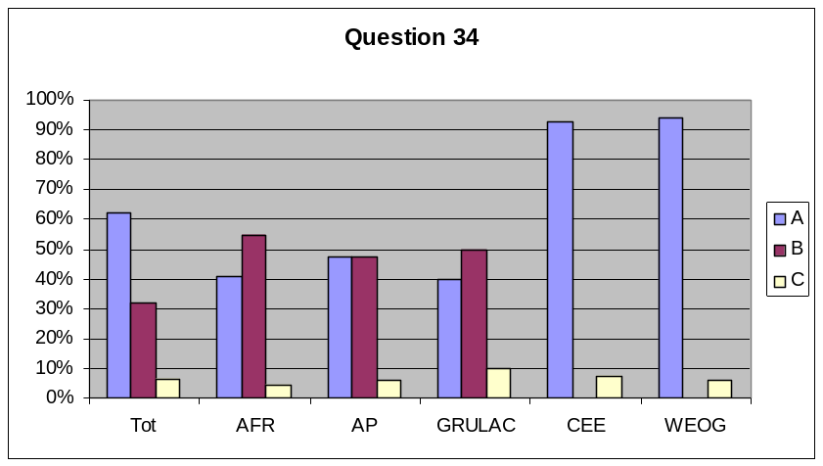

Article 21 - Confidential information
- Question 37. Does your country have procedures to protect confidential information received under the Protocol and that protect the confidentiality of such information in a manner no less favourable than its treatment of confidential information in connection with domestically produced living modified organisms? (Article 21.3)
- yes
- not yet, but under development
- no

 | a) | b) | c) |  | Percentages
AFR: | 7 | 13 | 2 |  |  | Tot | AFR | AP | GRULAC | CEE | WEOG
AP | 7 | 8 | 2 |  | a) | 59% | 32% | 41% | 40% | 92% | 100%
GRULAC | 4 | 5 | 1 |  | b) | 33% | 59% | 47% | 50% | 0% | 0%
CEE | 12 | 0 | 1 |  | c) | 8% | 9% | 12% | 10% | 8% | 0%
WEOG | 17 | 0 | 0
Tot | 47 | 26 | 6

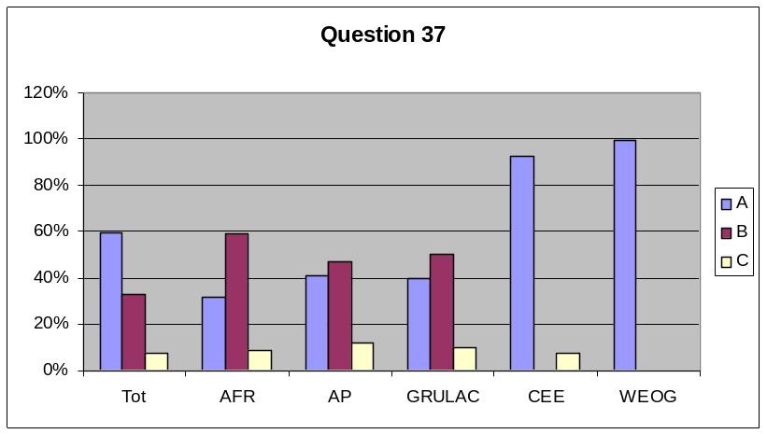

- Question 38. If you were a Party of import during this reporting period, did you permit any notifier to identify information submitted under the procedures of the Protocol or required by the Party of import as part of the advance informed agreement procedure that was to be treated as confidential? (Article 21.1)
- yes
- no
- not applicable - not a Party of import / no such requests received

 | a) | b) | c) |  | Percentages
AFR: | 1 | 4 | 16 |  |  | Tot | AFR | AP | GRULAC | CEE | WEOG
AP | 2 | 1 | 13 |  | a) | 11% | 5% | 13% | 29% | 0% | 19%
GRULAC | 2 | 2 | 3 |  | b) | 12% | 19% | 6% | 29% | 15% | 0%
CEE | 0 | 2 | 11 |  | c) | 77% | 76% | 81% | 43% | 85% | 81%
WEOG | 3 | 0 | 13
Tot | 8 | 9 | 56

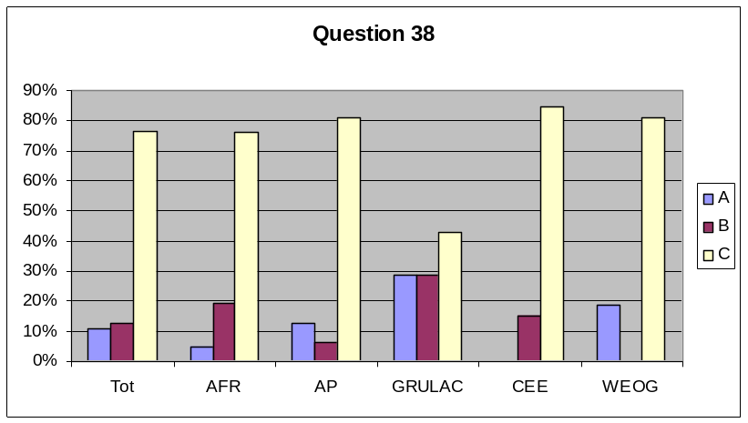

Article 22 - Capacity-building
- Question 41. If a developed country Party, during this reporting period has your country cooperated in the development and/or strengthening of human resources and institutional capacities in biosafety for the purposes of the effective implementation of the Protocol in developing country Parties, in particular the least developed and small island developing States among them, and in Parties with economies in transition?
- yes
- no
- not applicable - not a developed country Party

 | a) | b) | c) |  | Percentages
AFR: | 2 | 1 | 15 |  |  | Tot | AFR | AP | GRULAC | CEE | WEOG
AP | 3 | 1 | 13 |  | a) | 32% | 11% | 18% | 0% | 36% | 88%
GRULAC | 0 | 1 | 8 |  | b) | 11% | 6% | 6% | 11% | 21% | 13%
CEE | 5 | 3 | 6 |  | c) | 57% | 83% | 76% | 89% | 43% | 0%
WEOG | 14 | 2 | 0
Tot | 24 | 8 | 42

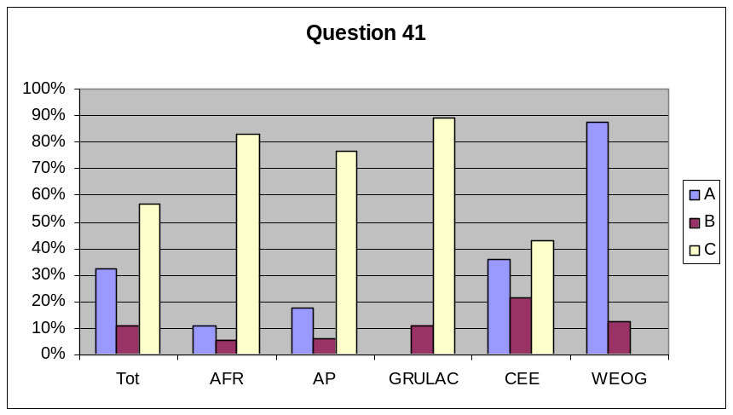

- Question 43. If a developing country Party, or Party with an economy in transition, during this reporting period has your country contributed to the development and/or strengthening of human resources and institutional capacities in biosafety for the purposes of the effective implementation of the Protocol in another developing country Party or Party with an economy in transition?
- yes
- no
- not applicable - not a developing country Party

 | a) | b) | c) |  | Percentages
AFR: | 8 | 11 | 0 |  |  | Tot | AFR | AP | GRULAC | CEE | WEOG
AP | 8 | 7 | 2 |  | a) | 37% | 42% | 47% | 60% | 31% | 12%
GRULAC | 6 | 4 | 0 |  | b) | 39% | 58% | 41% | 40% | 54% | 6%
CEE | 4 | 7 | 2 |  | c) | 24% | 0% | 12% | 0% | 15% | 82%
WEOG | 2 | 1 | 14
Tot | 28 | 30 | 18

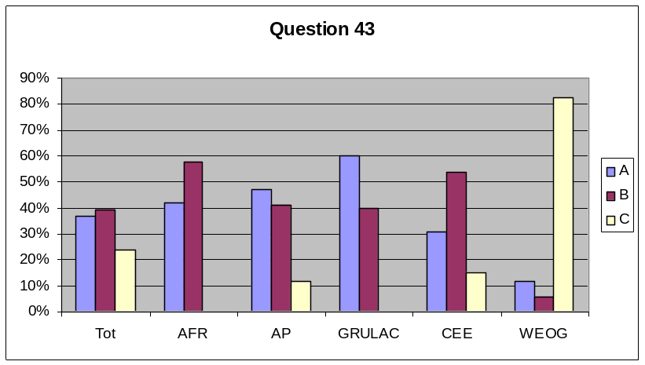

- Question 45. If a developing country Party or a Party with an economy in transition, have you benefited from cooperation for technical and scientific training in the proper and safe management of biotechnology to the extent that it is required for biosafety?
- yes - capacity-building needs fully met
- yes - capacity-building needs partially met
- no - capacity-building needs remain unmet
- no - we have no unmet capacity-building needs in this area
- not applicable - not a developing country Party or a Party with an economy in transition

 | a) | b) | c) | d) | e) | Percentages
AFR: | 2 | 14 | 5 | 1 | 0 |  |  | Tot | AFR | AP | GRULAC | CEE | WEOG
AP | 0 | 8 | 6 | 0 | 2 |  | a) | 4% | 9% | 0% | 0% | 8% | 0%
GRULAC | 0 | 8 | 2 | 0 | 0 |  | b) | 46% | 64% | 50% | 80% | 46% | 0%
CEE | 1 | 6 | 0 | 3 | 3 |  | c) | 17% | 23% | 38% | 20% | 0% | 0%
WEOG | 0 | 0 | 0 | 0 | 17 |  | d) | 5% | 5% | 0% | 0% | 23% | 0%
Tot | 3 | 36 | 13 | 4 | 22 |  | e) | 28% | 0% | 13% | 0% | 23% | 100%

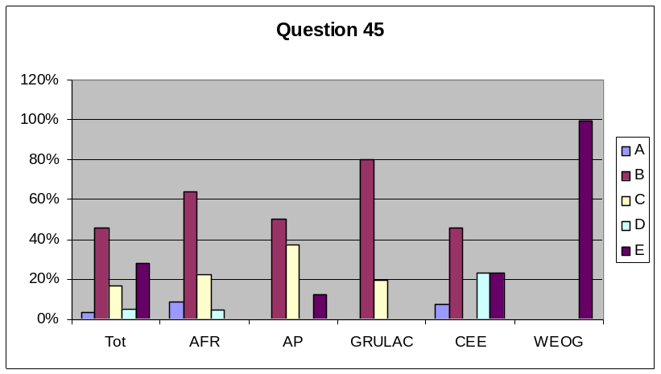

- Question 46. If a developing country Party or a Party with an economy in transition, have you benefited from cooperation for technical and scientific training in the use of risk assessment and risk management for biosafety?
- yes - capacity-building needs fully met
- yes - capacity-building needs partially met
- no - capacity-building needs remain unmet
- no - we have no unmet capacity-building needs in this area
- not applicable - not a developing country Party or a Party with an economy in transition

 | a) | b) | c) | d) | e) | Percentages
AFR: | 1 | 13 | 7 | 1 | 0 |  |  | Tot | AFR | AP | GRULAC | CEE | WEOG
AP | 0 | 8 | 6 | 1 | 2 |  | a) | 3% | 5% | 0% | 0% | 8% | 0%
GRULAC | 0 | 9 | 0 | 1 | 0 |  | b) | 46% | 59% | 47% | 90% | 46% | 0%
CEE | 1 | 6 | 1 | 2 | 3 |  | c) | 18% | 32% | 35% | 0% | 8% | 0%
WEOG | 0 | 0 | 0 | 0 | 17 |  | d) | 6% | 5% | 6% | 10% | 15% | 0%
Tot | 2 | 36 | 14 | 5 | 22 |  | e) | 28% | 0% | 12% | 0% | 23% | 100%

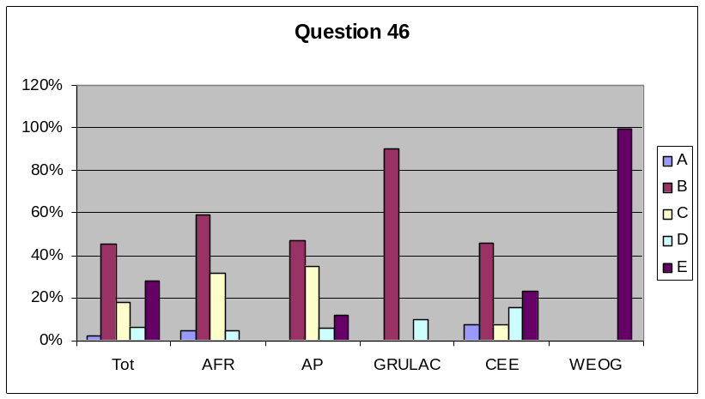

- Question 47. If a developing country Party or a Party with an economy in transition, have you benefited from cooperation for technical and scientific training for enhancement of technological and institutional capacities in biosafety?
- yes - capacity-building needs fully met
- yes - capacity-building needs partially met
- no - capacity-building needs remain unmet
- no - we have no unmet capacity-building needs in this area
- not applicable - not a developing country Party or a Party with an economy in transition

 | a) | b) | c) | d) | e) | Percentages
AFR: | 1 | 11 | 7 | 3 | 0 |  |  | Tot | AFR | AP | GRULAC | CEE | WEOG
AP | 0 | 9 | 6 | 0 | 2 |  | a) | 3% | 5% | 0% | 0% | 8% | 0%
GRULAC | 0 | 9 | 1 | 0 | 0 |  | b) | 47% | 50% | 53% | 90% | 62% | 0%
CEE | 1 | 8 | 0 | 1 | 3 |  | c) | 18% | 32% | 35% | 10% | 0% | 0%
WEOG | 0 | 0 | 0 | 0 | 17 |  | d) | 5% | 14% | 0% | 0% | 8% | 0%
Tot | 2 | 37 | 14 | 4 | 22 |  | e) | 28% | 0% | 12% | 0% | 23% | 100%

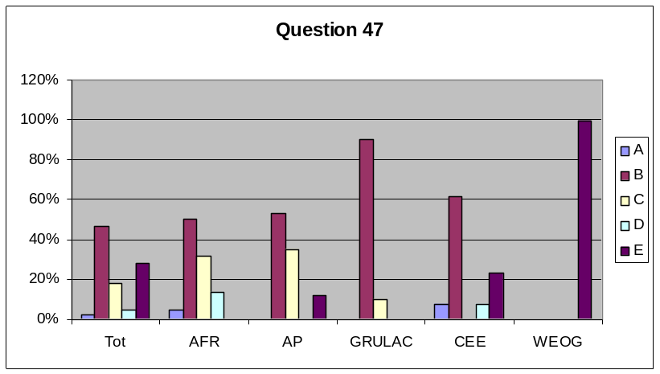

Article 23 - Public awareness and participation
- Question 49. Does your country promote and facilitate public awareness, education and participation concerning the safe transfer, handling and use of living modified organisms in relation to the conservation and sustainable use of biological diversity, taking also into account risks to human health? (Article 23.1(a))
- yes - significant extent
- yes - limited extent
- no

 | a) | b) | c) |  | Percentages
AFR: | 6 | 15 | 1 |  |  | Tot | AFR | AP | GRULAC | CEE | WEOG
AP | 5 | 11 | 1 |  | a) | 40% | 27% | 29% | 10% | 46% | 81%
GRULAC | 1 | 8 | 1 |  | b) | 56% | 68% | 65% | 80% | 54% | 19%
CEE | 6 | 7 | 0 |  | c) | 4% | 5% | 6% | 10% | 0% | 0%
WEOG | 13 | 3 | 0
Tot | 31 | 44 | 3

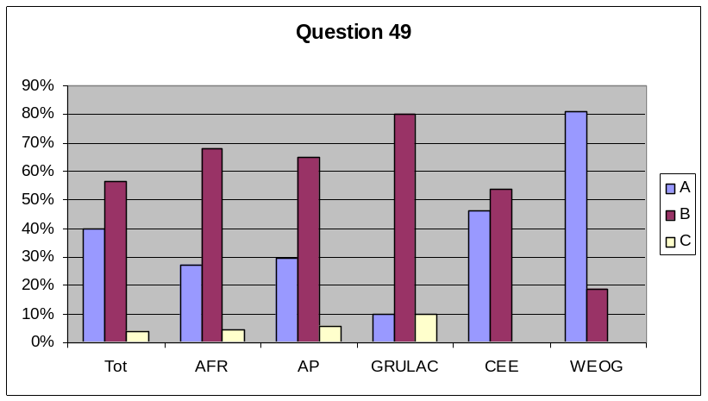

- Question 50. If yes, do you cooperate with other States and international bodies?
- yes - significant extent
- yes - limited extent
- no

 | a) | b) | c) |  | Percentages
AFR: | 2 | 11 | 8 |  |  | Tot | AFR | AP | GRULAC | CEE | WEOG
AP | 3 | 10 | 3 |  | a) | 25% | 10% | 19% | 10% | 23% | 63%
GRULAC | 1 | 3 | 6 |  | b) | 53% | 52% | 63% | 30% | 77% | 38%
CEE | 3 | 10 | 0 |  | c) | 22% | 38% | 19% | 60% | 0% | 0%
WEOG | 10 | 6 | 0
Tot | 19 | 40 | 17

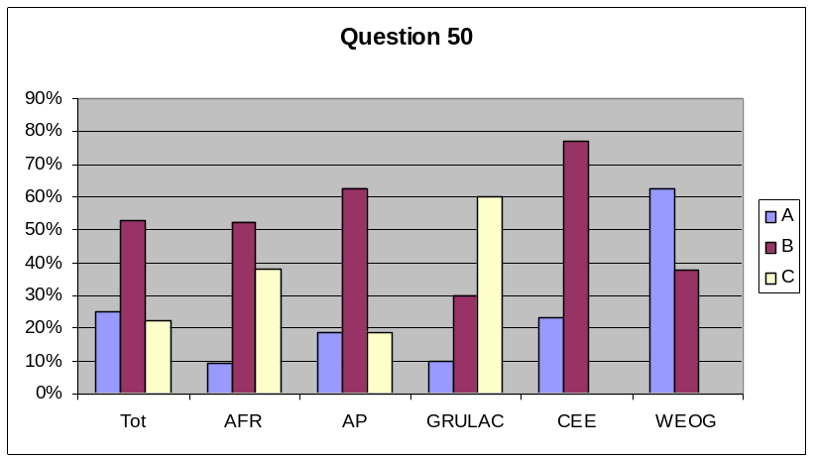

- Question 51. Does your country endeavour to ensure that public awareness and education encompass access to information on living modified organisms identified in accordance with the Protocol that may be imported? (Article 23.1(b))
- yes - fully
- yes - limited extent
- no

 | a) | b) | c) |  | Percentages
AFR: | 5 | 16 | 1 |  |  | Tot | AFR | AP | GRULAC | CEE | WEOG
AP | 8 | 7 | 2 |  | a) | 45% | 23% | 47% | 22% | 62% | 75%
GRULAC | 2 | 3 | 4 |  | b) | 45% | 73% | 41% | 33% | 38% | 25%
CEE | 8 | 5 | 0 |  | c) | 9% | 5% | 12% | 44% | 0% | 0%
WEOG | 12 | 4 | 0
Tot | 35 | 35 | 7

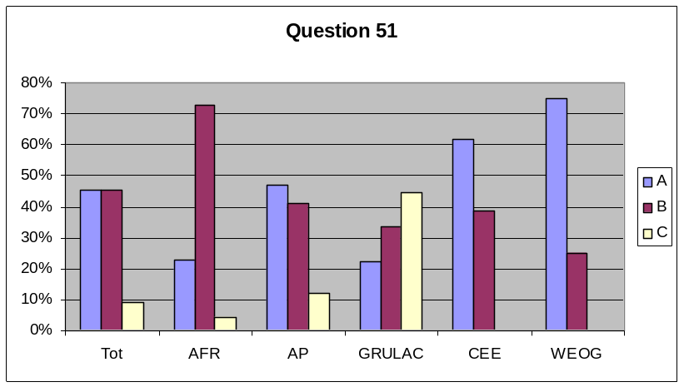

- Question 52. Does your country, in accordance with its respective laws and regulations, consult the public in the decision-making process regarding living modified organisms and make the results of such decisions available to the public? (Article 23.2)
- yes - fully
- yes - limited extent
- no

 | a) | b) | c) |  | Percentages
AFR: | 6 | 10 | 5 |  |  | Tot | AFR | AP | GRULAC | CEE | WEOG
AP | 7 | 6 | 4 |  | a) | 52% | 29% | 41% | 10% | 77% | 100%
GRULAC | 1 | 3 | 6 |  | b) | 27% | 48% | 35% | 30% | 15% | 0%
CEE | 10 | 2 | 1 |  | c) | 21% | 24% | 24% | 60% | 8% | 0%
WEOG | 16 | 0 | 0
Tot | 40 | 21 | 16

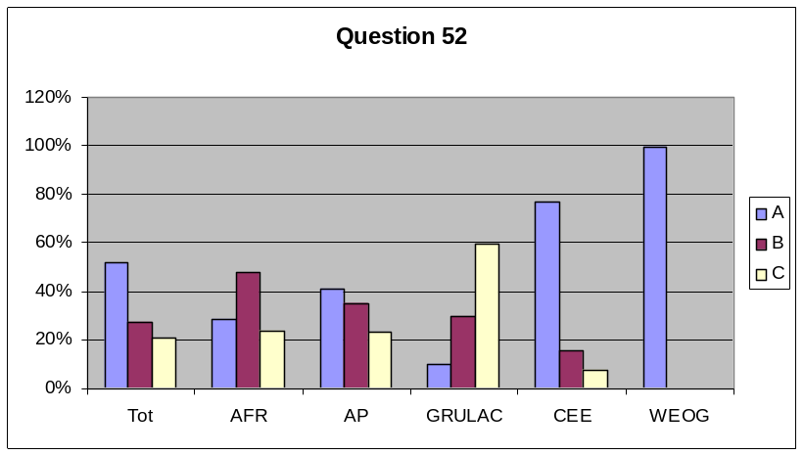

- Question 53. Has your country informed its public about the means of public access to the Biosafety Clearing-House? (Article 23.3)
- yes - fully
- yes - limited extent
- no

 | a) | b) | c) |  | Percentages
AFR: | 0 | 18 | 2 |  |  | Tot | AFR | AP | GRULAC | CEE | WEOG
AP | 4 | 9 | 4 |  | a) | 26% | 0% | 24% | 0% | 46% | 63%
GRULAC | 0 | 6 | 4 |  | b) | 61% | 90% | 53% | 60% | 54% | 38%
CEE | 6 | 7 | 0 |  | c) | 13% | 10% | 24% | 40% | 0% | 0%
WEOG | 10 | 6 | 0
Tot | 20 | 46 | 10

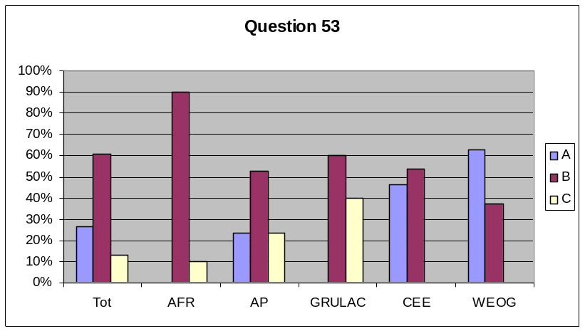

Article 24 - Non-Parties
- Question 55. Have there been any transboundary movements of living modified organisms between your country and a non-Party during the reporting period?
- yes
- no

 | a) | b) |  | Percentages
AFR | 1 | 17 |  |  | Tot | AFR | AP | GRULAC | CEE | WEOG
AP | 4 | 12 |  | a) | 23% | 6% | 25% | 22% | 15% | 47%
GRULAC | 2 | 7 |  | b) | 77% | 94% | 75% | 78% | 85% | 53%
CEE | 2 | 11
WEOG | 7 | 8
Tot | 16 | 55

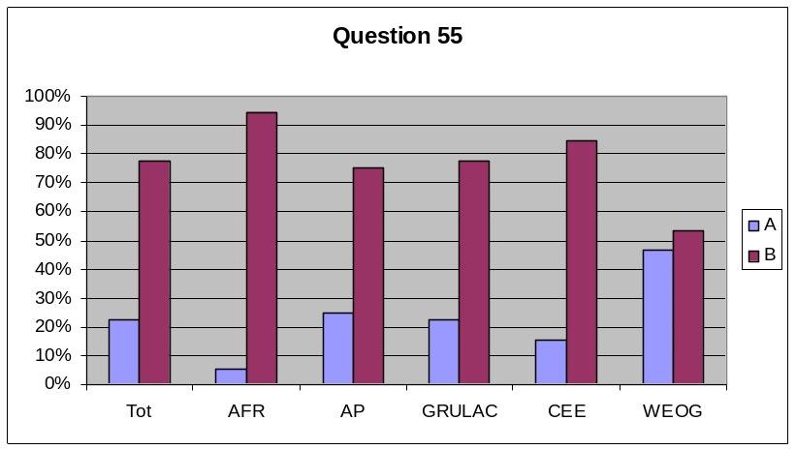

Article 25 - Illegal transboundary movements
- Question 57. Has your country adopted appropriate domestic measures to prevent and penalize, as appropriate, transboundary movements of living modified organisms carried out in contravention of its domestic measures? (Article 25.1)
- yes
b) no

 | a) | b) |  | Percentages
AFR | 12 | 10 |  |  | Tot | AFR | AP | GRULAC | CEE | WEOG
AP | 8 | 9 |  | a) | 68% | 55% | 47% | 33% | 100% | 100%
GRULAC | 3 | 6 |  | b) | 32% | 45% | 53% | 67% | 0% | 0%
CEE | 13 | 0
WEOG | 17 | 0
Tot | 53 | 25

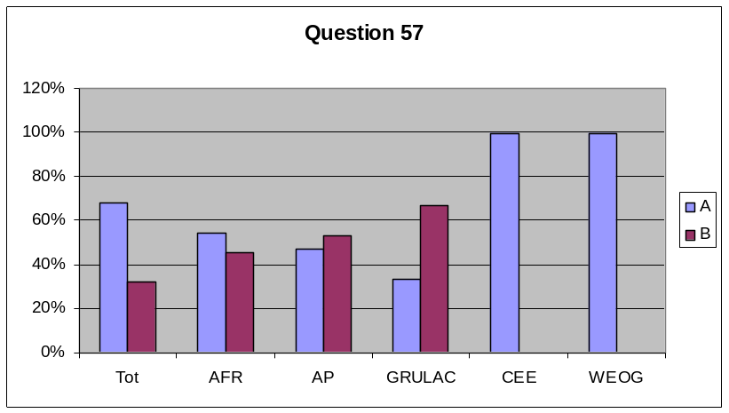

- Question 58. Have there been any illegal transboundary movements of living modified organisms into your country during the reporting period?
- yes
- no

 | a) | b) |  | Percentages
AFR | 1 | 16 |  |  | Tot | AFR | AP | GRULAC | CEE | WEOG
AP | 1 | 16 |  | a) | 19% | 6% | 6% | 11% | 31% | 44%
GRULAC | 1 | 8 |  | b) | 81% | 94% | 94% | 89% | 69% | 56%
CEE | 4 | 9
WEOG | 7 | 9
Tot | 14 | 58

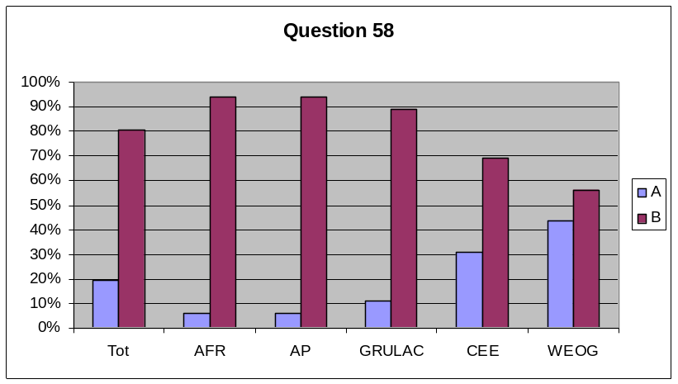

Article 26 - Socio-economic considerations
- Question 60. If during this reporting period your country has taken a decision on import, did it take into account socio-economic considerations arising from the impact of living modified organisms on the conservation and sustainable use of biological diversity, especially with regard to the value of biological diversity to indigenous and local communities? (Article 26.1)
- yes - significant extent
- yes - limited extent
- no
- not a Party of import

 | a) | b) | c) | d) | Percentages
AFR: | 0 | 3 | 4 | 15 |  |  | Tot | AFR | AP | GRULAC | CEE | WEOG
AP | 1 | 3 | 4 | 9 |  | a) | 1% | 0% | 6% | 0% | 0% | 0%
GRULAC | 0 | 1 | 4 | 3 |  | b) | 16% | 14% | 18% | 13% | 8% | 24%
CEE | 0 | 1 | 2 | 10 |  | c) | 27% | 18% | 24% | 50% | 15% | 41%
WEOG | 0 | 4 | 7 | 6 |  | d) | 56% | 68% | 53% | 38% | 77% | 35%
Tot | 1 | 12 | 21 | 43

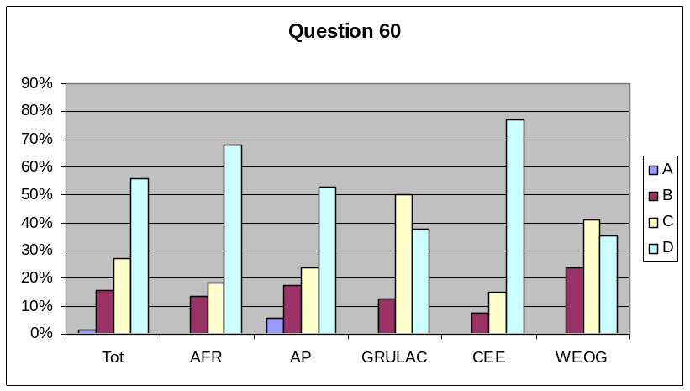

- Question 61. Has your country cooperated with other Parties on research and information exchange on any socio-economic impacts of living modified organisms, especially on indigenous and local communities? (Article 26.2)
- yes - significant extent
- yes - limited extent
- no

 | a) | b) | c) |  | Percentages
AFR: | 0 | 2 | 20 |  |  | Tot | AFR | AP | GRULAC | CEE | WEOG
AP | 0 | 4 | 13 |  | a) | 1% | 0% | 0% | 0% | 8% | 0%
GRULAC | 0 | 2 | 7 |  | b) | 18% | 9% | 24% | 22% | 15% | 24%
CEE | 1 | 2 | 10 |  | c) | 81% | 91% | 76% | 78% | 77% | 76%
WEOG | 0 | 4 | 13
Tot | 1 | 14 | 63

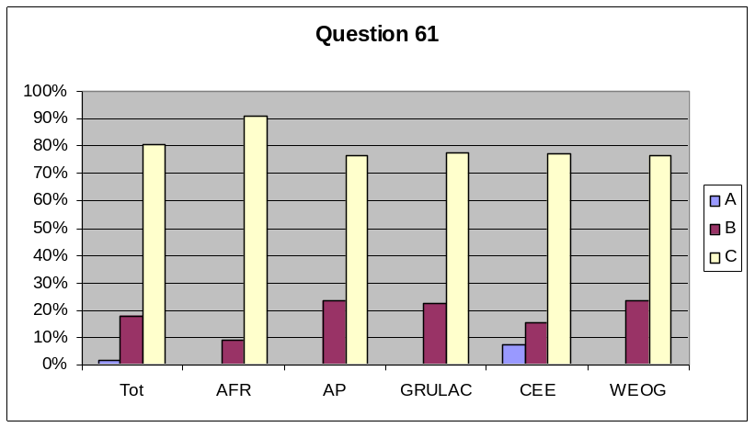

Article 28 - Financial mechanism and resources
- Question 63. Please indicate if, during the reporting period, your Government made financial resources available to other Parties or received financial resources from other Parties or financial institutions, for the purposes of implementation of the Protocol.
- yes - made financial resources available to other Parties
- yes - received financial resources from other Parties or financial institutions
- both
- neither

 | a) | b) | c) | d) | Percentages
AFR: | 0 | 11 | 1 | 10 |  |  | Tot | AFR | AP | GRULAC | CEE | WEOG
AP | 1 | 11 | 0 | 5 |  | a) | 15% | 0% | 6% | 0% | 8% | 59%
GRULAC | 0 | 7 | 0 | 3 |  | b) | 49% | 50% | 65% | 70% | 75% | 0%
CEE | 1 | 9 | 1 | 1 |  | c) | 3% | 5% | 0% | 0% | 8% | 0%
WEOG | 10 | 0 | 0 | 7 |  | d) | 33% | 45% | 29% | 30% | 8% | 41%
Tot | 12 | 38 | 2 | 26

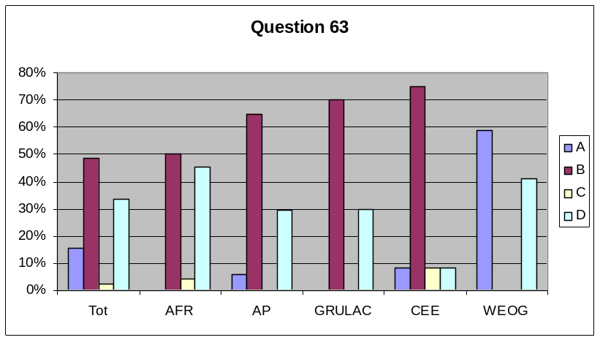

Annex II
- List of countries having reported by 20 August 2008

Parties:

- Armenia  - Austria*  - Barbados*  - Belgium  - Bhutan*  - Bulgaria*  - Cambodia  - Cameroon  - China  - Colombia*  - Costa Rica  - Croatia  - Cuba  - Czech Republic  - Democratic Republic of the Congo  - Dominican Republic  - Egypt*  - Estonia  - Ethiopia  - European Union  - Finland  - France  - Germany  - Ghana  - Guinea /  - Hungary  - India* | - Indonesia*  - Iran  (Islamic Republic of)*  - Ireland  - Italy  - Japan  - Jordan* /  - Kenya  - Latvia  - Liberia  - Lithuania  - Madagascar  - Malaysia*  - Maldives*  - Mauritius*  - Mexico  - Mozambique*  - Myanmar* /  - Netherlands  - New Zealand  - Nigeria*  - Norway  - Palau*  - Peru  - Philippines*  - Poland  - Portugal  - Qatar | - Republic of Moldova  - Romania*  - Rwanda  - Saint Lucia*  - Senegal  - Seychelles  - Slovakia  - Slovenia  - South Africa*  - Spain  - Sri Lanka*  - Sudan  - Swaziland  - Sweden  - Switzerland*  - Syrian Arab Republic  - Thailand*  - Togo  - Uganda  - Ukraine* /  - United Kingdom of Great Britain and Northern Ireland  - United Republic of Tanzania  - Venezuela*  - Viet Nam*
Non-Parties:
- Australia* | - Côte d'Ivoire
- List of countries having reported between 21 August 2008 and 17 September 2008
- Brazil | - Papua New Guinea | - Samoa
These reports are not included in the present analysis as they were received after 20 August 2008.
* Reports from countries marked with an asterisk were not included in the first analysis submitted to COP-MOP in document UNEP/CBD/BS/COP-MOP/4/13 because the reports were submitted after 16 October 2007.
-----

* UNEP/CBD/BS/CC/5/1. ?/ The first analysis (UNEP/CBD/BS/COP-MOP/4/13) is also available at http://www.cbd.int/doc/meetings/bs/mop-04/official/mop-04-13-en.pdf ) and the summary of responses (UNEP/CBD/BS/COP-MOP/4/INF/11) at https://www.cbd.int/doc/meetings/bs/mop-04/information/mop-04-inf-11-en.pdf ).
/ Available at http://bch.cbd.int/protocol/reporting/ .
/ At the time of finalizing this document, the Secretariat has received 83 national reports as listed in annex II.
/ The formulation of the question may have induced some confusion because answers (b) and (c) might be seen as overlapping (i.e. no decisions were taken).
/ See http://www.aseansec.org/.
/ See http://www.foodstandards.gov.au .
/ See http://www.comesa.int/index_html/view.
/ See http://www.unece.org/env/pp/
/ These include contributions to: (a) The BI Trust Fund to facilitate participation of developing country Parties and Parties with economies in transition; (b) The OETEG on Art. 18.2(a); (c) The 2nd - 4th OEWG meetings on Liability and Redress; (d) The MOP-2 and MOP-3 meetings; (e) The BH Trust Fund for the organization of the first OEWG meeting on Liability and Redress; (f) The African Union; (g) The General Trust Fund for the Core Programme Budget of the Protocol (BG Trust Fund); (h) The Special Voluntary Trust Fund for Additional Voluntary Contributions in Support of Approved Activities of the Cartagena Protocol on Biosafety (BH Trust Fund); (i) The Special Voluntary Trust Fund for Additional Voluntary Contributions to Facilitate the Participation of Parties in the Cartagena Protocol on Biosafety (BI Trust Fund); (j) The Ad-Hoc Technical Expert Group on Risk Assessment in November 2006; (k) Academically-accredited courses; (l) Various regional Biosafety projects; (m) Various training initiatives; and (n) Various NGOs.
/ See paragraphs 19 and 20 the “Report of the Compliance Committee under the Cartagena Protocol on Biosafety”, UNEP/CBD/BS/COP-MOP/4/2.
/ AFR: Africa, AP: Asia and the Pacific, GRULAC: Latin America and the Caribbean, CEE: Central and Eastern Europe, WEOG: Western Europe and Others.
/ Guinea did not have an obligation to submit a first national report as it was not a Party to the Protocol during the reporting period.
/ Not included in the present analysis and not loaded into the CBD Analyzer because report submitted in Arabic only.
/ Myanmar did not have an obligation to submit a first national report as it was not a Party to the Protocol during the reporting period.
/ Not included in the present analysis and not loaded into the CBD Analyzer because report submitted in Russian only.

