 |  | CBD
 |  |  |  | Distr.  GENERAL  UNEP/CBD/BS/CC/9/2  16 April 2012  ORIGINAL: ENGLISH
COMPLIANCE COMMITTEE UNDER THE CARTAGENA PROTOCOL ON BIOSAFETY
Ninth meeting
Montreal, 31 May - 1 June 2012

Item 3 of the provisional agenda

State of compliance with national reporting obligation

I. INTRODUCTION
- At its last meeting, the Compliance Committee agreed, in the context of the organization of work it adopted, to review at the present meeting the compliance of Parties with their obligation to submit national reports. The review is intended to focus on three aspects of national reporting: (a) consideration of the rate of reporting; (b) completeness of the reports (the number of reports that are not complete); and (c) information on Parties that have not submitted any national report (i.e. interim, first and second national reports) by the end of 2011.
- Accordingly, this document presents, in section II, the data and information compiled pertaining to the three aspects of the review as requested by the Committee. The compilation is preceded by a brief recap of some of the basic information on the obligation to monitor implementation and to report, the frequency of reporting and the timelines for national report submissions to date. Finally, section III outlines a few suggestions for the consideration of the Committee.

II. The Obligation to monitor implementation of obligations under the Protocol and to report
- Article 33 of the Protocol requires each Party to monitor the implementation of its obligations under the Protocol and to report, at intervals, to the Conference of the Parties serving as the meeting of the Parties to the Protocol (COP-MOP) on measures taken to implement the Protocol.
- At their first meeting, the Parties to the Protocol decided that national reports must be submitted every four years from the date of the entry into force of the Protocol, i.e. 11 September 2003. Within this general frequency, it is also required that national reports be submitted 12 months prior to the COP-MOP at which the reports are going to be considered. It was further agreed that during the initial four-year period, an interim report would be submitted two years after the entry into force of the Protocol.
- Accordingly, the interim national reports were due on 11 September 2005; first national reports on 11 September 2007; and the latest, the second national reports, by the end of September 2011.
(a) Rate of reporting
- By 11 October 2005, a month after the deadline for submitting interim national reports, the Secretariat had received and analyzed 44 national reports, representing only 36 percent of the Parties to the Protocol. By that date, the number of Parties to the Protocol was 121.
- By 16 October 2007, first national reports were received from 50 Parties to the Protocol and analyzed by the Secretariat. The number of Parties to the Protocol by that date was 141. Again, the rate of reporting stood at only 35 percent of the Parties that had an obligation to submit a first national report. The rate improved following COP-MOP 4 when the Parties expressed their concern regarding the low number of reports submitted (decision BS-IV/14). The decision was adopted based on, inter alia, the recommendations of the Compliance Committee. Parties were urged to observe the relevant decisions on reporting and the Executive Secretary was requested to repeat the analysis of the first national reports by including reports submitted subsequently. By 20 August 2008, 76 Parties had submitted their first national report representing a reporting rate of 54 percent.
- By 31 December 2011, 143 of 161 Parties had submitted their second national reports, representing a rate of 89 percent. This represents a high rate of submission, particularly as compared to the previous two reporting cycles,
- Such a high rate of reporting was made possible in part by: (i) the funds that were made available by the Global Environment Facility (GEF); and (ii) the discussions held and the information conveyed through four regional workshops that the Secretariat conducted from June to December last year.
- The GEF extended an expedited financial support to 86 eligible Parties through three medium-size projects helping them to prepare and submit their national reports. The financial support finally became reality after the persistence of the Compliance Committee in its recommendations to the COP-MOP to invite or urge the GEF, through the appropriate guidance to the financial mechanism, to make funding available for the preparation of national reports. Also, at the last meeting of the Parties to the Protocol, Parties were encouraged to give priority to national reporting when seeking funding from the GEF.
- Last year, the Secretariat conducted regional workshops in Central and Eastern Europe, Africa, Asia and the Pacific and Latin America and the Caribbean with a view, primarily, to promote signature and ratification of the Nagoya – Kuala Lumpur Supplementary Protocol on Liability and Redress. The Secretariat structured the regional workshops to also include an item on national reporting where participants were reminded of their obligation and informed of the opportunities available to them to facilitate submission of second national reports. The Secretariat has, in effect, implemented paragraph 8(c) of decision BS-V/14 where the Executive Secretary was requested to organize regional or sub-regional workshops on national reporting with a view to assist Parties. This specific decision has, in turn, its root in the recommendations of the Compliance Committee submitted to the fifth meeting of the Parties to the Protocol.
- All these efforts seem to have come to fruition during this reporting cycle where 143 Parties (almost 90 percent) of the Parties to the Protocol have submitted their second national report and 86 of them were able to do so after receiving funding from the GEF.
- The figures and the table below provide a comparative overview and update on the number of Parties that have fulfilled their reporting obligation, including the interim, first and second national reports.
Fig.1: Comparative overview of rate of reporting by reporting cycle 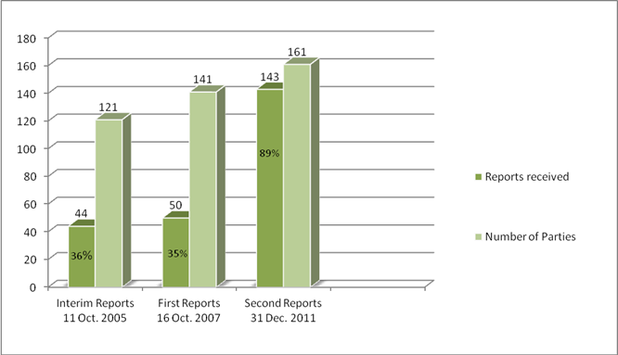

Fig.2: Comparative overview of submission of national reports by region and reporting cycle
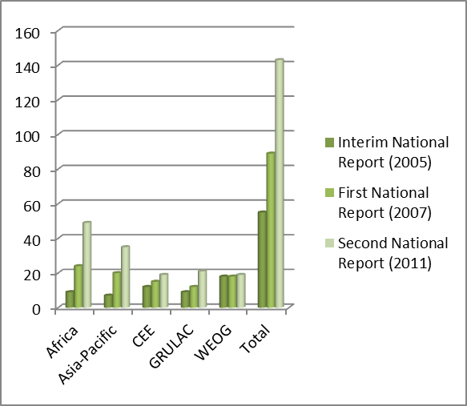

Table 1: Status of national reporting as of 13 January 2012
Report | Africa | Asia -  Pacific | CEE | GRULAC | WEOG | Total  (by 13 January 2012)
Interim | 9 (27%) | 7 (24%) | 12 (71%) | 9 (41%) | 18 (90%) | 55 (45%)
First | 21 (52%) | 19 (55%) | 16 (80%) | 12 (48%) | 17 (81%) | 85 (60%)
Second | 49 (100%) | 35 (85%) | 19 (86%) | 21 (75%) | 19 (90%) | 143 (89%)

(b) Completeness of the reports
- As indicated at different places in the analysis in document UNEP/CBD/BS/COP-MOP/6/16 and as can be observed from each national report concerned, some information is missing from some of the reports.
- The reports received from 49 Parties are incomplete. They do not respond to one or more of the questions from the reporting format. Depending on the nature of the missing information, the incompleteness of these national reports has created some important gaps which made it difficult to piece together the overall picture of implementation of obligations under the Protocol, both at the level of the individual Parties concerned and at the level of all Parties collectively.
- Some reports also contain responses which do not correspond with the information and data that is available in the Biosafety Clearing-House. The Committee is expected to review, in the future, issues of consistency between the information in national reports and the Biosafety Clearing-House at step 7 of the organization of work agreed to at its last meeting.
(c) Parties that have not submitted interim, first and second national reports
- According to decision BS-V/1, the Compliance Committee has the responsibility to consider taking compliance measures if, inter alia, a Party fails to submit its national report. In order to commence taking steps towards the fulfilment of such a responsibility and with a view to developing experience and testing the application of decision BS-V/1 in this regard, the Committee, at its last meeting, requested the Secretariat to compile information about Parties that had the obligation to submit the interim, first, and second national reports but have not done so.
- Accordingly, from the records, there are seven Parties to the Cartagena Protocol on Biosafety that have not submitted any of the three national reports despite their obligation to do so. These are: (i) Bahamas, (ii) Luxembourg, (iii) Marshall Islands, (iv) Nicaragua, (v) Nauru, (vi) Oman, and (vii) Paraguay. In addition to the general notifications reminding Parties to submit their second national reports that the Secretariat issued several times before and after the deadline for second national reporting, specific reminder e–mail messages were sent to these Parties individually between 6 and 8 March 2012. The messages reminded the concerned Parties that no national reports had been received from them to date and asked each of them to inform the Secretariat of any difficulties they might have encountered so as to identify means to overcome them. To date, only one Party, Paraguay, has responded promising that they will immediately initiate a process.
- Furthermore, the Secretariat looked into the records in the Biosafety Clearing-House and other databases maintained by the Secretariat in order to gather information regarding the extent of involvement and participation of the seven Parties in activities and processes under the Biosafety Protocol.
- With the exception of Luxembourg, where no activity has been found in the records, it appears that all the concerned Parties have been represented at COP-MOP meetings and have taken part in some inter-sessional activities sometime in the last several years. Each has also made some amount of information available through the Biosafety Clearing-House.
- The table below summarizes the information compiled. The Compliance Committee may wish to use it as case studies, as requested at its eighth meeting.
Table 2: Parties that have submitted no national reports (interim, first and second national reports)
Party | Region | Entry into force of the Protocol for the Party | Participation in  Protocol processes | Response to  Secretariat’s  reminder
Marshall Islands | Asia & Pacific | 11-Sep-2003 | Yes, to some extent | None
Nauru | Asia & Pacific | 11-Sep-2003 | Yes, to some extent | None
Oman | Asia & Pacific | 11-Sep-2003 | Yes, to some extent | None
Bahamas | Latin America and Caribbean | 14-Apr-2004 | Yes, to some extent | None
Nicaragua | Latin America and Caribbean | 11-Sep-2003 | Yes, to some extent | None
Paraguay | Latin America and Caribbean | 8-Jun-2004 | Yes, active | Yes, promised to initiate process
Luxembourg | Western Europe and Others | 11-Sep-2003 | None | None

III. Suggestions for the consideration of the Committee

22. The Committee may wish to:

(a) Make recommendations to the COP-MOP for it to:

(i) Welcome the high rate of reporting;
(ii) Welcome the funds that were made available by the GEF to a number of eligible Parties to support the preparation of their second national reports;

(iii) Urge the Parties that have not yet submitted their national report to do so as soon as possible;

(iv) Urge the Parties to respond to all questions in the reporting format and submit complete reports;

(b) Welcome the efforts made by the Secretariat, including through the regional workshops, in reminding Parties of the need to submit their national reports and informing them of the available opportunities to assist them in fulfilling this obligation;

(c) Request the Secretariat to contact the Parties that submitted incomplete reports, draw their attention to the information gap in their reports, and to seek the necessary information;

(d) Agree to approach, through a letter to be written by the Chair of the Committee, the six Parties that submitted no national reports to date and did not respond to any reminder, with a view to seeking an explanation of the situation that might have prevented them from submitting national reports and offering them the availability of the Committee to provide, as appropriate, advice or assistance that they may wish to receive.

------

UNEP/CBD/BS/CC/9/1.
Step 4 of figure 2 and paragraph 20, Report of the Compliance Committee under the Cartagena Protocol on Biosafety on the Work of its Eighth Meeting (UNEP/CBD/BS/CC/8/3), 14 October 2011.
The Secretariat understands that the scope of information required by the Committee as regards rate of reporting seems to be limited to the rate of submission of the second national reports. However, this section also includes the rate of reporting under the previous reporting cycles, namely the interim and first national reports so that the Committee may easily see the trends in compliance of Parties with their reporting obligation.
See document UNEP/CBD/BS/COP-MOP/3/12.
See document UNEP/CBD/BS/COP-MOP/4/13.
The Secretariat carried out the analysis as requested and submitted it to the fifth meeting of the Compliance Committee. See document UNEP/CBD/BS/CC/5/2. All first national reports received by 20 August 2008 were included in the revised analysis.
See document UNEP/CBD/BS/COP-MOP/6/16. Normally, the due date for the submission of second national reports should have been 11 September 2011. However, upon request from Parties, the deadline was set initially for 30 September 2011 and later extended further to 31 December 2011, following the announcement by the Global Environment Facility of the availability of funding for national report preparation, in order to allow eligible Parties sufficient time to access the funds, prepare their report and submit it.
See the following recommendations of the Committee: paragraph 8, annex, UNEP/CBD/BS/COP-MOP/3/2; paragraph 2, annex, UNEP/CBD/BS/COP-MOP/4/2; and paragraph 7, annex UNEP/CBD/BS/COP-MOP/5/2.
The purpose of compiling such information was to see whether there is any correlation between the extent of involvement and participation in Protocol processes and the non-submission of national reports. That relationship seems to be applicable to Luxembourg only, which does not appear to have had any participation in the processes under the Protocol and did not submit any report to date.
Paragraph 21 of the report of the Committee’s eighth meeting.

