 |  | CBD
 |  |  | Distr.  GENERAL  UNEP/CBD/BS/CC/13/3  3 February 2016  ENGLISH ONLY
COMPLIANCE COMMITTEE UNDER THE CARTAGENA PROTOCOL ON BIOSAFETY
Thirteenth meeting
Montreal, Canada, 24-26 February 2016
Item 4 of the provisional agenda

evaluation of the status of implementation of the Protocol in meeting its objectives: input to the third assessment and review and mid-term evaluation of the strategic plan
Note by the Executive Secretary

introduction
- The Conference of the Parties serving as the meeting of the Parties to the Cartagena Protocol on Biosafety (COP-MOP) is required, under Article 35 of the Protocol, to undertake an evaluation of the effectiveness of the Protocol, including an assessment of its procedures and annexes, at least every five years. In accordance with this requirement, the first and second assessment and review were carried out by COP-MOP at its fourth meeting, in 2008, and at its sixth meeting, in 2012, respectively.
- At its fifth meeting, held in 2010, COP-MOP adopted the Strategic Plan for the Cartagena Protocol on Biosafety for the Period 2011-2020. COP-MOP decided that a mid-term evaluation of the Strategic Plan should be conducted five years after its adoption, in conjunction with the third assessment and review (see decision BS-V/16).
- At its sixth meeting, COP-MOP decided that the data and information provided for the second assessment and review would form the baseline for measuring progress in implementing the Protocol, in particular the subsequent evaluation of the effectiveness of the Protocol and the mid-term evaluation of the implementation of the Strategic Plan.
- In its decision BS-VII/3, COP-MOP decided that the third assessment and review be combined with the mid-term evaluation of the Strategic Plan at the eighth meeting of the COP-MOP. It also requested the Executive Secretary to collect, compile and analyse information on the implementation of the Protocol using the third national reports as a primary source. COP-MOP requested the Subsidiary Body on Implementation to review the information gathered and analysed by the Executive Secretary, including contributions from the Liaison Group on Capacity-building, and to submit its findings and recommendations to COP-MOP at its eighth meeting. COP-MOP requested that the assessment and review be undertaken, using the core set of identified information needs shown in the annex to decision BS-VII/3.
- In decision BS-VII/3, COP-MOP requested the Compliance Committee to provide an input to the third assessment and review of the Protocol and the mid-term evaluation of the Strategic Plan in the form of an evaluation of the status of implementation of the Protocol in meeting its objectives.
- The Compliance Committee at its twelfth meeting held in 2015, considered a document prepared by the Secretariat (UNEP/CBD/BS/CC/12/4) that was aimed at highlighting some of the elements that the Compliance Committee might consider in providing its input into the third assessment and review of the Protocol and the mid-term evaluation of the Strategic Plan in response to the request of COP-MOP.
- After considering the document, the Committee decided to focus its input on the review of matters relevant to compliance that can add value to the third assessment and review and mid-term evaluation of the Strategic Plan. In that regard, it decided that the scope of the Committee’s input would include:
- Evaluation of progress with respect to operational objective 3.1 of the Strategic Plan that refers to the strengthening of the mechanisms for achieving compliance;
- Element 15(c) of the core set of identified information needs for the third assessment and review contained in the annex to decision BS-VII/3 regarding the extent to which information in the BCH is reliable and up to date;
- The experience gained by the Committee in implementing its supportive role as specified in decision BS-V/1.
- The present document is intended to support the deliberations of the Committee in relation to its input to the third assessment and review of effectiveness of the Protocol and mid-term evaluation of the Strategic Plan. The document is structured following the three topics that constitute the focus of the Committee’s input.

EValuation of progress with respect to operational objective 3.1 of the Strategic plan
- Methodology
- Operational objective 3.1 of the Strategic Plan is related to Compliance with the Protocol. Under Operational Objective 3.1, a number of outcomes are provided, as well as indicators to measure the extent to which the outcomes have been achieved.
- For the preparation of the present document, an analysis of information available in the third national reports has been carried out for each indicator of operational objective 3.1. Where needed and possible, additional sources of information have been used, including the Biosafety Clearing-House (BCH).
- The information provided in the second assessment and review has served as a baseline for measuring progress, pursuant to decision BS VI/15. Where the second national reporting format did not include a similar question, information provided through the dedicated survey to gather information corresponding to indicators in the Strategic Plan that could not be obtained from the second national reports or through other existing mechanisms has been used.
- In addition, the “possible elements and corresponding core set of identified information needs for the third assessment and review in conjunction with the mid-term evaluation of the strategic plan” have been used to identify information needs to measure progress and have been linked to the indicators of operational objective 3.1.
- Only those third national reports that were received by 31 December 2015 have been included in the analysis. Furthermore, for the purpose of measuring progress against the baseline, only responses from those Parties that answered the specific question or its equivalent in both the third and second national reports, have been taken into account. References to increases or decreases at the regional level are based on the aggregate regional result. The wording of the indicator (percentage of Parties/number of Parties) determines whether information is presented as a percentage or as the number of Parties.
- The analysis per indicator is presented in the annex to the present document. A summary of the analysis is provided below.
B. Summary of evaluation of progress
- As of 31 December 2015, 105 Parties had submitted their third national report out of the 170 Parties to the Protocol that had the obligation to do so (62 per cent). At a comparable point in time after the submission deadline for the second national reports, the submission rate was higher (89 per cent). Due to setbacks in the release of funding to Parties to support the completion of their third national report, however, it is difficult to compare these figures.
- Only 52 Parties (51 per cent) indicate that the necessary legal, administrative and other measures are fully in place, despite overall progress (8 Parties more, or +8 per cent). Considerable regional differences are noted. Some Parties indicate that further instruments are under development or that their adoption is pending, although other Parties report that the instruments have been awaiting adoption for many years. In this respect, some Parties indicate that awareness at the political and decision-making level is insufficient and that this results in a lack of priority being accorded to the strengthening of national biosafety frameworks. A considerable number of Parties that indicate that legislation, regulations and administrative measures are not yet fully in place, report that to some extent such measures have been adopted (38 Parties). Almost all Parties report having at least indirect instruments that apply to biosafety (101 Parties, or 98 per cent).
- Many parties indicate that the slow rate of adoption of legal, administrative and other measures continues to be one of the main obstacles to implementing the obligations under the Protocol, despite the progress reported in the third national report. Some Parties report that further instruments are under development. Some Parties that report having specific instruments in place indicate that these instruments are still to be adopted.
- In relation to administrative structures, many Parties report that insufficient human and financial resources are available and note a considerable decrease (-11 per cent) in the establishment of mechanisms that ensure budgetary allocations for the operation of their national biosafety framework, with just over half of the Parties (53 Parties) reporting that such a mechanism have been established. Some progress is reported in the establishment of institutional capacity and having available permanent staff.
- In relation to administrative structures, some Parties report that institutional changes are being implemented or are about to be implemented. Some Parties that report having permanent staff dedicated to biosafety specify that staff work on a part-time basis on biosafety.
- About two thirds of Parties report having put in place legislation, administrative measures and mechanisms for the operation of the AIA procedure (71 per cent) or for taking decisions regarding domestic use of LMOs-FFP (67 per cent). The figures have remained largely the same as those provided in the second national report. Some Parties that indicated not having such legislation, measures and mechanisms, indicate in free text submissions that despite the absence of specific instruments on AIA, their general national biosafety framework addresses this issue. Those Parties that indicate having taken decisions regarding the transboundary movement of an LMO for intentional introduction into the environment also report having legislation and, in almost all cases, mechanisms in place to take such decisions. However, in relation to decisions regarding LMOs-FFPs, a number of Parties indicate having neither specific legislation nor mechanisms.
- All but two Parties have notified the Secretariat of their national focal point, in accordance with Article 19 of the Protocol (99 per cent). All but one Party have notified the Secretariat of their BCH national focal point, in accordance with decision BS-I/3 and decision BS-II/2 (99 per cent). Out of 170 Parties 100 (59 per cent) have made available to the BCH the relevant details regarding the national point of contact, in accordance with Article 17, related to unintentional transboundary movements.
- In relation to the submission to the BCH of mandatory information, Parties have reported progress on most types of information. The overall number of Parties that report having submitted information on national legislation, regulations and guidelines to the BCH increased (+12 per cent), although the percentage of Parties that report having submitted complete information on their frameworks remains just below two thirds (65 per cent). Almost all Parties (96 per cent) report having submitted at least some information on their frameworks.
- Despite reported progress on submitting to the BCH summaries of risk assessments, only about a third of Parties (38 per cent) indicate having done so in all cases. In one region, none of the Parties report having submitted such summaries in all cases. When considering the number of Parties that indicate having submitted summaries in some cases only, overall figures rise to just over two thirds (70 per cent), which is a considerable increase in respect of the second national report (16 per cent).
- About two thirds of Parties (64 per cent) report having submitted information on final decisions regarding LMOs for intentional introduction into the environment, which constitutes a considerable increase (+21 per cent). Overall figures are similar in relation to submission of information regarding final decisions on import of LMOs-FFP (65 per cent), but lower in relation to final decisions on domestic use of LMOs-FFP (48 per cent). Only 14 Parties provided information on decisions relating to LMOs for intentional introduction into the environment, and 23 Parties in relation to LMOs-FFP. Information provided in response to different questions relating to submission of decisions on LMOs-FFP was found to be inconsistent.
- Parties continue to show low rates of submission of information on bilateral, regional or multilateral agreements or arrangements into which they have entered and which have relevance for biosafety. Less than half of the 11 Parties reporting on this matter (45 per cent) indicated having always submitted to the BCH information on such agreements and arrangements. This figure rises to just over half, when taking into consideration those Parties that have submitted such information in some cases only.
- Parties continue to report a low rate (4 per cent) of submission to the BCH of complete information on illegal transboundary movements, which is the same result as in the second national report. Only nine Parties report that such information is available. Discrepancies are noted between information provided under different questions related to this matter.
- Parties report that human capacities and financial resources are insufficient for keeping the information in the BCH up to date. Some Parties report on the beneficial effect of capacity-building activities offered through the UNEP/GEF in this respect. Parties report a number of challenges in relation to making information available in full to the BCH, including: lack of permanent and full-time staff, rotation of staff, insufficient coordination in the collection of information at the national level, and insufficient awareness on need to submit certain types of information to the BCH. Some Parties indicate that information has not been submitted because it is not available.
- About two thirds of Parties (71 Parties or 68 per cent) report having a monitoring system in place. A slightly higher percentage of Parties (75 Parties or 71 per cent) report having an enforcement system in place. Regional differences are considerable in relation to enforcement systems. In one region, less than a fifth (19 per cent) of Parties report having established an enforcement system. In comparison with the information provided in the Survey, Parties report some progress on the establishment of both monitoring and enforcement systems, although regional differences are considerable. Bearing in mind that the financial and human resources available for biosafety are reported to be insufficient by many Parties, it is unlikely that, even where systems are in place, monitoring and enforcement can effectively be carried out by all Parties.
- Only about a third of Parties (36 Parties or 34 per cent) indicate that they dispose of predictable and reliable funding for capacity-building for the effective implementation of the Protocol, with the lowest results reported in GRULAC and Africa. The situation seems having deteriorated somewhat in respect of the information provided in the Survey. About two thirds of Parties (68 Parties or 65 per cent) indicate that they have received additional funding for implementation of the Protocol, which is similar to what was reported in the Survey, although larger amounts (more than US$ 50,000) are reported than previously. The Global Environment Facility has continued to make available funding to support the implementation of the Protocol; yet, regional differences show that these figures are lowest in GRULAC and Africa. On 31 December 2015, 17 national and 1 regional projects were under implementation. In addition, GEF/UNEP has made available funding for 82 Parties for completing their third national reports. Despite the availability of the additional resources, many Parties indicate that the lack of sufficient funding is one of the main obstacles to full implementation of the Protocol at the national level.

extent to which information In the biosafety clearing-house is reliable and up to date
- The second element of the scope of the Committee’s input in the third assessment and review and mid-term evaluation of the Strategic Plan is related to element 15(c) of the possible elements. This element is formulated as follows: extent to which information on the biosafety clearing-house is reliable and up to date.
- Question 131 of the reporting framework for the third national reports relates to this issue. A total of 57 Parties (or 57 per cent) indicate that the information submitted to the BCH is complete and up to date, which is an increase of 5 Parties (or 5 per cent) in comparison with the second national report. At the regional level, 38 per cent of the Parties in Africa report that data is up to date and complete, followed by GRULAC (47 per cent). At the regional level, an increase is reported in Africa and WEOG, and a decrease in Asia and the Pacific (-11 per cent). Some Parties indicate that, due to technical difficulties, information is not submitted to the BCH, while others report human capacity problems as obstacles to ensuring that data on the BCH is up-to-date and complete. For more detailed information on submission of particular types of information, see paragraphs 22 to 27 above.
- In line with the approach and work plan agreed at the Committee’s eighth meeting, the Committee is expected to consider the compliance of Parties with their obligations under the Protocol by reviewing the consistency of information that Parties provide through their national reports and through the BCH every four years. At its eleventh meeting, the Committee reviewed the consistency between information in national reports and the biosafety clearing-house on the basis of a document issued by the Secretariat (UNEP/CBD/BS/CC/11/3) in which information from 151 out of 161 second national reports was compared with information available in the BCH. Several discrepancies were noted between information contained in second national reports and that made available to the BCH. The Secretariat contacted the focal points of the Parties concerned by e-mail in the period from February to March 2014 to request them to clarify the inconsistencies identified and/or provide supplementary information.
- Pursuant to the approach and work plan agreed at the Committee’s eighth meeting, the Committee will consider the consistency of information provided in the third national reports with information in the BCH prior to COP-MOP 9. By that time, it is expected that a more complete set of third national reports will have been submitted and will be available for analysis by the Secretariat.
- In addition to the periodic review of consistency of information provided in national reports and in the BCH, the Secretariat routinely reviews national records in the BCH for completeness, including a comparison of data provided in the BCH with the data reported through other channels and in other databases. The comparison of data is related to final decisions taken regarding the importation or release of an LMO and those regarding the domestic use of LMOs that may be subject to transboundary movement for direct use as food or feed or for processing.
- In this context, the Secretariat compared information present in the database of the International Service for the Acquisition of Agri-biotech Applications (ISAAA) with the information available in the BCH. Where discrepancies were found, the Secretariat contacted the Party concerned.
- A total of 28 Parties were found to have submitted data to the ISAAA that were inconsistent with the data submitted to the BCH. These inconsistencies can be broken down regionally as follows: Africa, 4; Asia-Pacific, 10; GRULAC, 10; and WEOG, 4. For 11 Parties, the inconsistencies were related to one or two entries only. For three Parties, the inconsistencies were related to more than 50 entries.
- In addition, a verification was carried out to ensure that a corresponding risk assessment report is available in the BCH for all decisions requiring a risk assessment. For decisions made available by a total of eight Parties in all regions, risk assessment reports were missing. Three of these Parties had not submitted one risk assessment report, one Party had not submitted four risk assessment reports and four Parties had not submitted several risk assessment reports (between 8 and 32). In the context of the development of documentation for the Ad Hoc Technical Expert Group Meeting on the Second Assessment and Review of the Cartagena Protocol on Biosafety, held in June 2012, the rate of completeness of risk assessment reports in the BCH was reported to be 83 per cent. At the moment, the ratio is 95 per cent. The Secretariat has contacted the Parties found not to have submitted risk assessment reports.
- Parties were in the process of providing clarifications and/or taking action with regard to gaps and inconsistencies in their national records at the time of writing of the present document.

EXPERIENCE GAINED BY THE COMMITTEE IN IMPLEMENTING ITS SUPPORTIVE ROLE
- The third element of the scope of the Committee’s input in the third assessment and review and mid-term evaluation of the Strategic Plan is related to the experience gained by the Committee in implementing its supportive role as specified in decision BS-V/1. The role of the Committee is described in more detail in UNEP/CBD/BS/CC/13/INF/1.
- In the current reporting period, Parties have continued to refrain from submitting information on compliance issues to the Compliance Committee. However, the Committee has started the substantive implementation of its extended mandate, as given in decision BS-V/1. In this context, the Committee has taken action in relation to the submission and completeness of the second national reports and in relation to issues identified from a review of information provided in the second national reports and the BCH. Further information has been provided in the section above and is available in greater detail in UNEP/CBD/BS/CC/13/INF/1. The supportive role of the Committee is likely to have contributed to the high submission rates and completeness of the second national reports and to the consistency of information provided in the second national reports and in the BCH. In this respect, Parties have made progress in addressing compliance issues.

Suggestions for the consideration of the Committee
- The Compliance Committee may wish to:
        - Request the Secretariat to integrate the analysis and findings presented in the present document, including the recommendations, as required, into the report on Assessment and Review of the Implementation of the Cartagena Protocol on Biosafety and the Mid-term Evaluation of the Strategic Plan for the Cartagena Protocol for the consideration of the Subsidiary Body on Implementation;
        - Agree that a member of the Committee should be present at the eleventh meeting of the Liaison Group on Capacity-Building and at the first meeting of the Subsidiary Body on Implementation to inform the Liaison Group and Subsidiary Body on Implementation respectively, where required, on the Committee’s input to the third assessment and review and mid-term evaluation of the Strategic Plan;
        - Consider submitting a recommendation to COP-MOP to:
- Welcome progress made by Parties in complying with their obligations under the Protocol, yet note with concern that in relation to most obligations under the Protocol a number of Parties are not in full compliance;
- Urge Parties that have not yet completely done so, to put in place legal, administrative and other measures to implement their obligations under the Protocol, paying particular attention to the importance of putting in place monitoring systems as a prerequisite for effective reporting;
- Urge Parties that have not yet completely done so to make information available to the BCH, where they are required to do so;
- Urge Parties that have not yet done so to submit their complete third national report as soon as possible;
- Welcome the Committee’s input to the assessment and review and mid-term evaluation, and to request the Committee to continue providing inputs to the final evaluation of the Strategic Plan;
- Welcome the Committee’s supportive role, carried out pursuant to decision BS-V/1, as a contribution to the progress reported and request the Committee to continue carrying out its mandate, in particular in relation to the issues identified above;
- Request the Secretariat, as appropriate and following guidance provided by the Committee, to continue following up with Parties that have not yet fully applied with their obligations under the Protocol, and to request Parties to collaborate fully in this regard.

Annex
ANALYSIS OF INFORMATION PRESENTED PER INDICATOR OF OPERATIONAL OBJECTIVE 3.1 OF THE STRATEGIC PLAN
- Operational Objective 3.1 of the Strategic Plan provides a number of outcomes, as well as indicators to measure the extent to which the outcomes have been achieved, as reproduced in the table below.
Strategic Plan of the Cartagena Protocol on Biosafety for the period 2011-2020
Operational Objective 3.1: Compliance with the Protocol to strengthen the mechanisms for achieving compliance
Outcomes | Indicators
- Each Party fully implements its obligations and regularly monitors the implementation of its obligations under the Protocol  - Improved reporting by Parties including by submitting complete and timely national reports  - All Parties able to enforce their regulatory frameworks and decisions  - Sufficient financial resources are allocated to compliance  - The Compliance Committee is able to thoroughly review the implementation of obligations by Parties and to propose appropriate measures  - Supportive role of the Compliance Committee is improved | - Number of Parties that have identified and addressed their non-compliance issues  - Number of Parties having approved and functional national legal, administrative and other measures to implement the Protocol  - Percentage of Parties that designated all National Focal Points  - Number of Parties having in place a system for handling requests including for Advance Informed Agreement  - Percentage of Parties that published all mandatory information via the BCH  - Number of Parties having in place a monitoring and enforcement system  - Number of national reports received under each reporting cycle  - Number of Parties able to access financial resources to fulfil their obligations under the Protocol
- For the preparation of the analysis presented herein, an analysis of available information has been carried out for each indicator of operational objective 3.1, following the methodology described in paragraphs 9 to 14 of the main document.
Number of Parties that have identified and addressed their non-compliance issues
- The reporting format does not include a specific question related to identifying and addressing issues of non-compliance. The proceedings of the Compliance Committee, which reviews compliance by the Parties with their obligations, constitute an alternative source of information for identifying cases of non-compliance.
- Pursuant to the Procedures and Mechanisms on Compliance (decision BS-I/7, annex), the Compliance Committee may carry out functions in relation to promoting compliance and addressing cases of non-compliance. Parties may submit to the Committee issues relating to compliance with respect to the Party itself, and with respect to another Party.
- To date, Parties have not made submissions to the Committee concerning issues of compliance. Parties have also refrained from requesting assistance from the Compliance Committee.
- Following the adoption of decision BS-V/1, the Committee has taken a more active role in approaching individual Parties at its own initiative. In this context, the Committee has taken action in relation to the submission and completeness of the second national reports and in relation to issues identified from a review of information provided in the second national reports and the BCH. In the context of the submission of third national reports, the Committee has not yet taken action.
- Element 14 of the possible elements (“Compliance Committee is functioning”) is related to this indicator. Element 14 identifies the following information needs: (a) Parties raise issues with the Compliance Committee concerning their own compliance; (b) Compliance Committee has decision-making rules of procedure in place.
- As set out above, Parties have refrained from submitting compliance issues with respect to themselves and others, yet the Committee has taken the initiative in approaching individual Parties facing difficulties with their compliance, following the adoption of decision BS-V/1.
Number of Parties having approved and functional national legal, administrative and other measures to implement the Protocol
- Questions 14, 15 and 16 of the format for the third national report are related to this indicator. Under Element 2 and 3 of the possible elements, a number of information needs relate to the issue of biosafety frameworks, which is closely related to this indicator.
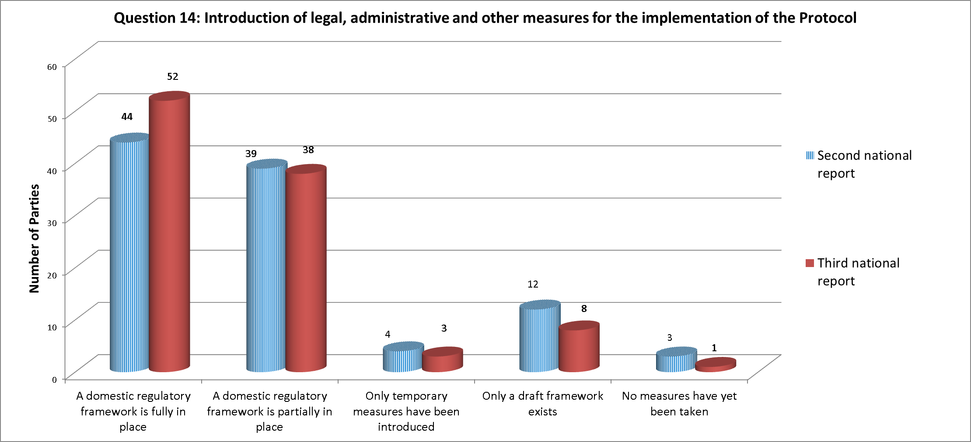
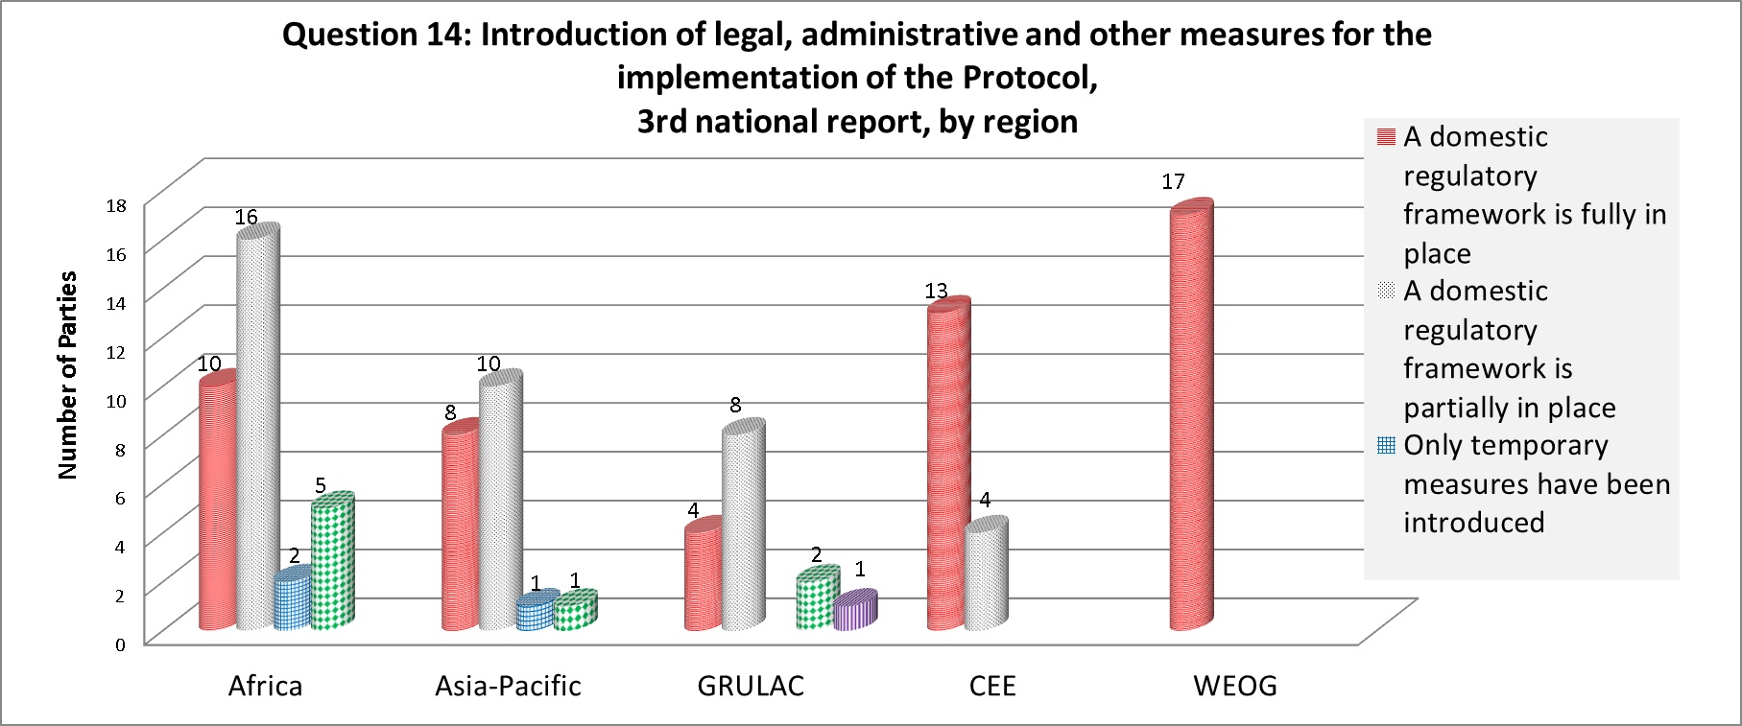

- A total of 52 Parties (51 per cent) report that they have fully introduced the necessary legal, administrative and other measures for the implementation of the Protocol, which represents an increase of eight Parties (+8 per cent). Most growth is reported in Africa followed by GRULAC, which are the regions where the vast majority of Parties report not having fully introduced the necessary legal, administrative and other measures, despite progress made by some Parties. A total of 38 Parties (37 per cent) report that these measures are partially in place, which is a reduction of one Party (-1 per cent) in comparison to the results of the second national report. The number of countries reporting that their biosafety framework has become operational within the current reporting period has continued to increase (with 9 Parties), yet more slowly than during the last reporting period, when the increase was more pronounced (26 Parties). Parties report progress in adopting biosafety-specific and non-specific instruments, with 101 Parties (98 per cent) reporting that at least some kind of instrument is in place, which represents an increase of 3 Parties.
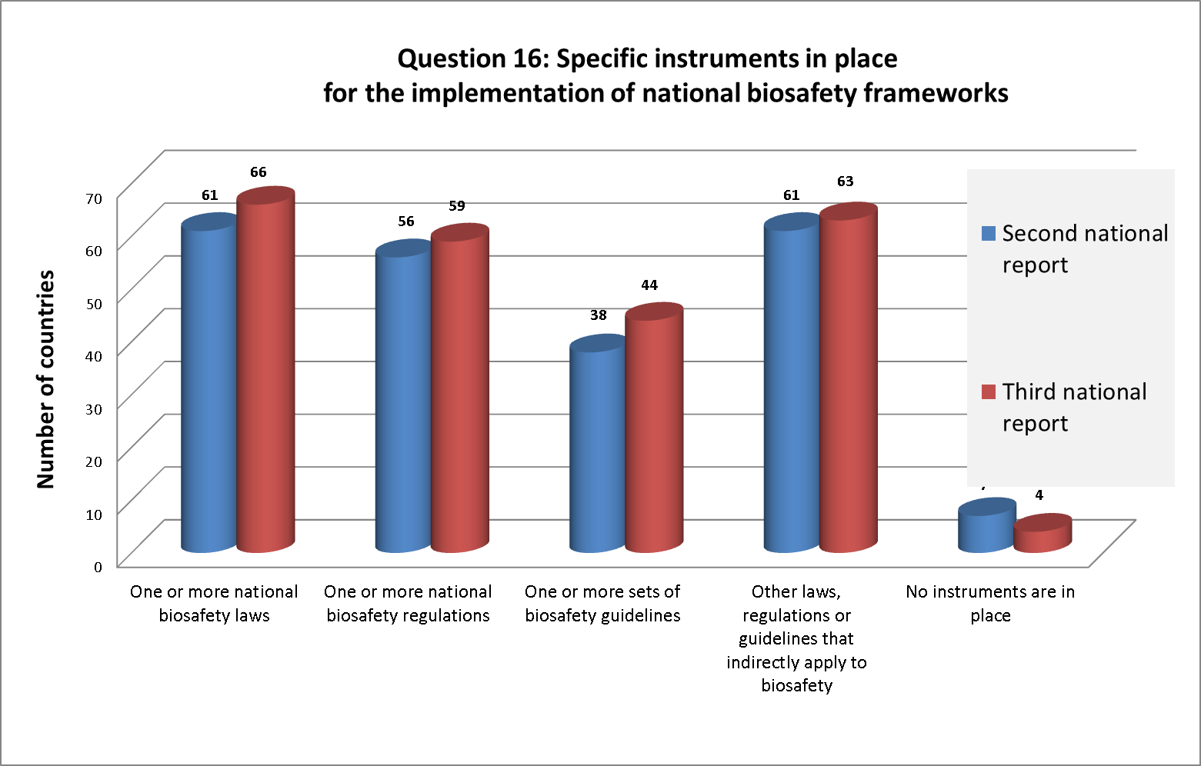
- Parties report a significant decrease (11 Parties or -11 per cent) in having established mechanisms for budgetary allocations of funds for the operation of national biosafety frameworks, with just over half of the responding Parties (53 Parties, or 52 per cent) indicating that they had established such mechanisms. A slight increase (+2 Parties, or +2 per cent) reports having permanent staff to administer functions directly related to the national biosafety framework, with a global total of 87 Parties (85 per cent), indicating accordingly.
- Many parties indicate that the slow rate of adoption of legal, administrative and other measures continues to be one of the main obstacles to implementing the obligations under the Protocol, despite the progress reported in the third national report. Some Parties report that further instruments are under development. Some Parties that report having specific instruments in place, indicate that these instruments are still to be adopted. In relation to administrative structures, some Parties report that institutional changes are being implemented or about to be implemented. Some Parties that report having permanent staff dedicated to biosafety specify that staff work on biosafety on a part-time basis.
Percentage of Parties that designated all national focal points
- Article 19 of the Protocol requires each Party to designate one national focal point to be responsible on its behalf for liaison with the Secretariat. In addition, COP-MOP called upon Parties to designate an appropriate national focal point for the Biosafety Clearing-House. Furthermore, Article 17 of the Protocol requires that Parties make available to the BCH the relevant details setting out its point of contact for purposes of receiving notifications related to unintentional transboundary movements. Strictly speaking, Article 17 does not refer to a “national focal point”, and information provided on national points of contact therefore does not necessarily need to be included in the analysis of this indicator. Given the binding character of the provision related to points of contact under Article 17 and considering that the information provided in relation to this matter is similar in nature to the information provided in relation to national focal points, the information provided on points of contact has been taken into consideration in this section.
- All but two Parties have notified the Secretariat of their national focal point, in accordance with Article 19 of the Protocol (99 per cent). All but one Party have notified the Secretariat of their BCH national focal point, in accordance with decision BS-I/3 and decision BS-II/2 (99 per cent). Out of 170 Parties, 100 (59 per cent) have made available to the BCH the relevant details regarding the national point of contact in accordance with Article 17, related to unintentional transboundary movements.
Number of Parties having in place a system for handling requests including for Advance Informed Agreement
- A number of questions in the third national reporting format relate to this indicator. Systems for handling requests may be related to the AIA procedure in case of the first intentional introduction into the environment (Cartagena Protocol, Article 7). Requests can also be related to final decisions regarding domestic use of a living modified organism that may be subject to transboundary movement for direct use as food or feed or for processing (Cartagena Protocol, Article 11). Finally, the provisions related to the designation of a national competent authority may be regarded as a requirement for a functioning system for handling requests. An overview of the responses to questions related to these issues and an analysis of differences in reporting rates between the second and third national reports is provided below. Under Element 2 and 3 of the possible elements, a number of information needs relate to the issue of biosafety frameworks, which is closely related to this indicator.
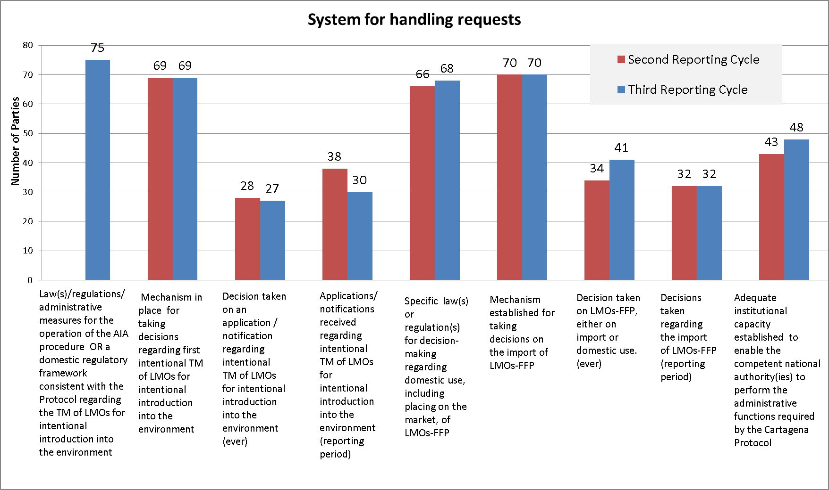
- A total of 75 Parties (71 per cent) report having adopted laws, regulations or administrative measures for the operation of the AIA procedure, or have a domestic regulatory framework that is consistent with the Protocol. A total of 69 Parties report that a mechanism for taking decisions regarding first intentional introduction into the environment has been established, which is the same result as in the second national report. Regional differences are noted, with the proportion of Parties within each region reporting that mechanisms are fully in place varying between 47 per cent (GRULAC) and 100 per cent (WEOG). Most Parties that report having laws, regulations or administrative measures also report having mechanisms in place (or in place to some extent) for taking decisions regarding first intentional introduction into the environment.
- The number of Parties that report having taken a decision on an application/notification regarding intentional transboundary movements of LMOs for intentional introduction into the environment has remained stable with 27 Parties indicating that they had taken such decisions (31 per cent), which is one Party less than in the second national report, on a total of 30 applications/notifications. All Parties that indicate having taken a decision report having legislation in place for taking such decisions. Most of these Parties also report having mechanisms in place, although one Party reports not having such a mechanism in place, and two report having such mechanisms in place to some extent.
- Some Parties indicate that reviews of applications are currently being carried out. Others indicate that, pending the entry into force of legislation, applications cannot be processed.
- Most Parties that indicate having laws, regulations and administrative measures related to decision-making for intentional introduction into the environment also indicate having such laws and regulations for decision-making regarding domestic use, including placement on the market of LMOs-FFP. A total of 70 Parties, (67 per cent) report having such laws and regulations for LMOs-FFP, which constitutes an increase of 2 Parties (or 2 per cent) in respect of the second national report. A similar number of Parties (72) report having a mechanism in place for taking decisions on the import of LMOs-FFP. Despite regional differences, the global figures remain the same as that reported in the second national report in relation to the establishment of mechanisms for taking decisions on LMOs-FFP. Regional differences show that a majority of Parties in GRULAC and Africa report having neither instruments nor mechanisms.
- Some Parties indicate that, despite the absence of specific legal instruments related to AIA and LMOs-FFP, the general biosafety framework addresses these issues. Some Parties that report the existence of a legal framework indicate that the legislation has not yet been adopted or that informal procedures are being applied.
- A total of 41 Parties indicate having taken a decision on LMOs-FFP, which represents an increase of 8 Parties (+7 per cent), and 32 Parties report having taken a decision on the import of LMOs-FFP in the current reporting period. No data are available from the second national report. A total of 28 Parties report having taken a decision on domestic use, including placement on the market of LMOs-FFP. Most Parties that indicate having taken a decision report having legislation and a mechanism in place for taking such decisions. However, five Parties report having neither a mechanism nor specific legislation in place, although one of them clarifies that informal arrangements have been established and another indicates that, on the occasion when a decision was taken, the imports were rejected.
- Progress is reported, especially in Africa, in the establishment of institutional capacity to enable competent national authorities to perform the administrative functions required under the Protocol, with 48 Parties (48 per cent) reporting having done so, which represents an increase of 5 Parties (5 per cent). Despite making progress in establishing institutional capacities to some extent, in the GRULAC region, the number of Parties reporting that they had fully established adequate institutional capacities has decreased (1 Party) and remains low 2 out of 15 Parties responding in GRULAC.
- Some Parties, including some of those that indicate that capacities have been established to some extent, report that more capacity-building is required, while others report that the legal framework providing the basis for the establishment and functioning of the competent national authorities has not been adopted.
Percentage of Parties that published all mandatory information via the BCH
- The data show that Parties, overall, have made progress in submitting information to the BCH. The third national reporting format contains a number of questions that are at least partly duplicative. For such questions, results are presented in an aggregate form, where possible.
- A total of 65 per cent of Parties report having submitted their biosafety frameworks, legislation, regulations and guidelines, which is an increase of 12 per cent, with the largest regional increases reported in Africa (+19 per cent) and GRULAC (+14 per cent). A total of 31 per cent of Parties report that this information has been submitted partly. In addition, 65 per cent of Parties report the existence of legislation, regulations and guidelines and that the information required for the AIA procedure has been submitted in full to the BCH, which represents an increase of 14 per cent. A total of 67 per cent of Parties report having adopted specific legislation for decision-making regarding domestic use, including placement on the market of LMOs-FFP. A total of 54 per cent of Parties report that national laws, regulations and guidelines applicable to the import of LMOs-FFP have been submitted in full, which is an increase of 8 per cent. This lower rate is largely due to lower availability of such instruments, in comparison with similar instruments on AIA, in especially GRULAC and, to a lesser extent, Africa, despite reported progress in these regions (respectively +7 per cent and +9 per cent).
- Parties report progress (+8 per cent) in submitting contact details for competent national authorities, focal points and emergency contacts, whereby most Parties (85 per cent) report having submitted such information fully, with notable progress in Africa (+16 per cent) and WEOG (+18 per cent).
- Despite reported progress (+10 per cent) on the submission of summaries of risk assessments in all cases, global overall rates remain low with 38 per cent of Parties indicating that they had submitted them in all cases. In one region, Africa, none of the Parties reports having submitted such summaries in all cases. Considerable regional progress is reported in Asia and the Pacific (+27 per cent) and GRULAC (+28 per cent). When taking into consideration Parties that indicate having submitted such risk assessments in some cases only, overall figures rise to 70 per cent, which constitutes an increase of 16 per cent. A total of 30 per cent of Parties reports having submitted summaries of risk assessments or environmental reviews of LMOs generated by regulatory processes and relevant information of products thereof to the BCH in all cases, which is an increase of 11 per cent.
- Of the 14 Parties that provided such information in both the second and third national reports, 64 per cent report having informed the BCH or the notifier of decisions taken in relation to transboundary movements of LMOs for intentional introduction into the environment, which is a considerable increase (+21 per cent). Progress is attributable to GRULAC (+50 per cent) and WEOG (+34 per cent). Of those Parties that approved an import with conditions, 83 per cent of Parties indicates having submitted the reasons on which the decision was based to the BCH, which is an 8 per cent increase. In relation to the broader formulated question whether final decisions regarding importation or release of LMOs were submitted fully to the BCH, 31 per cent of Parties indicate having done so, which represents a 7 per cent increase. At the regional level increases are reported in the CEE region (+17 per cent), GRULAC (+14 per cent), WEOG (+11 per cent) and Africa (+6 per cent), while Asia and the Pacific reports a decrease (-11 per cent).
- A total of 68 per cent of Parties report having established a mechanism to ensure that decisions regarding LMOs-FFP that may be subject to transboundary movement are communicated to the Parties through the BCH, which constitutes a 5 per cent increase, with regional increases reported in GRULAC (14 per cent) and Africa (9 per cent).
- Of the 23 Parties having provided such information in their second and third national reports, 65 per cent indicate having always informed Parties through the BCH of decisions regarding the import of LMOs-FFP, which constitutes a 13 per cent increase, with notable regional increases in Asia and the Pacific and GRULAC (both +40 per cent), while a decrease is reported in Africa (-25 per cent).
- Of the 23 Parties having provided such information in their second and third national reports, 48 per cent report having always informed Parties through the BCH of decisions regarding domestic use of LMOs-FFP within 15 days, which represents a 9 per cent decrease, with decreases reported in Africa (-25 per cent) and WEOG (-13 per cent). A total of 26 per cent of Parties reports having submitted such information beyond the delay of 15 days, which represents an increase of (+17 per cent).
- On the closely related question whether final decisions regarding domestic use of LMOs-FFP that may be subject to transboundary movements are made available to the BCH, an important discrepancy is noted: 31 per cent of the Parties indicate that such information was made available to the BCH, which represents an increase of 7 per cent.
- Parties report limited progress (+1 per cent) on fully making available to the BCH declarations regarding the framework to be used for LMOs-FFP, with increases reported in GRULAC (+7 per cent), Asia and the Pacific (+6 per cent) and a decrease reported in Africa (-4 per cent). A total of 26 per cent of Parties made such information fully available to the BCH.
- Of the Parties having entered bilateral, regional or multilateral agreements or arrangements, out of the 11 Parties that provided such information in the second and third national reports, 45 per cent indicate having submitted related information to the BCH, and 9 per cent indicate having submitted such information in some cases only. Information provided on the same matter provided under different questions slightly varies. In the context of bilateral, regional and multilateral agreements and arrangements, 25 per cent of Parties indicate that information on the application of domestic regulations to specific imports of LMOs is made available to the BCH, which represents a slight increase (+1 per cent).
- A total of 4 per cent of Parties report that information on illegal transboundary movements is submitted to the BCH, which is the same result as in the second national report. Only nine Parties report that such information is available. Of the 15 Parties that indicate having received information on illegal transboundary movements, 3 Parties indicate having informed either the BCH only, or the BCH and the other Parties involved. Discrepancies are noted in the answers to the related questions.
- Some Parties report that the human and institutional capacities are insufficient and that awareness is limited for keeping up to date the information in the BCH. Several Parties report on the beneficial effect of UNEP-GEF support provided in this reporting period in relation to the establishment of national BCH mechanisms and related training. Some Parties indicate that there is a continuing need for training of officers in the use of the BCH. Some Parties indicate that, due to changes in personnel, acquired skills have been lost.
- Other Parties report that, at the national level, information on trials is not made available and therefore cannot be submitted. Some Parties indicate that information is available but not centrally stored and, therefore, not all information is made available through the BCH. Some Parties report that agencies, policymakers and legislators need to be made aware of the BCH and its functioning. Many Parties indicate that they lack the information and data altogether, although often the same Parties indicate that, where data exist, they are not always made available due to lack of capacity.
Number of Parties having in place a monitoring and enforcement system
- Question 204 of the third national reporting format is related to this indicator. This question was included as question 35 of the Survey. An additional question of the reporting format related to the adoption of measures aimed at preventing and/or penalizing transboundary movements in contravention of domestic frameworks to implement the Protocol, which is included on the basis of the possible elements. Compared to the survey, progress is reported in the establishment of both monitoring and enforcement systems; yet, regional differences remain more pronounced in relation to enforcement systems.
- A total of 71 Parties (68 per cent) report having a monitoring system in place. In the survey, out of 107 responding Parties, 61 reported having a monitoring system. Within the regions, differences are noted: within GRULAC, fewer Parties report having monitoring systems (31 per cent) than in WEOG and Africa (82 per cent and 76 per cent, respectively). A total of 75 Parties (71 per cent) report having an enforcement system in place, with similar but slightly more pronounced regional difference (CEE 94 per cent; WEOG 88 per cent; Africa 76 per cent; Asia and the Pacific 73 per cent; GRULAC 19 per cent). In the survey, out of 107 responding Parties, 58 reported having an enforcement system, with high results for WEOG and CEE, and low results for GRULAC and Africa.
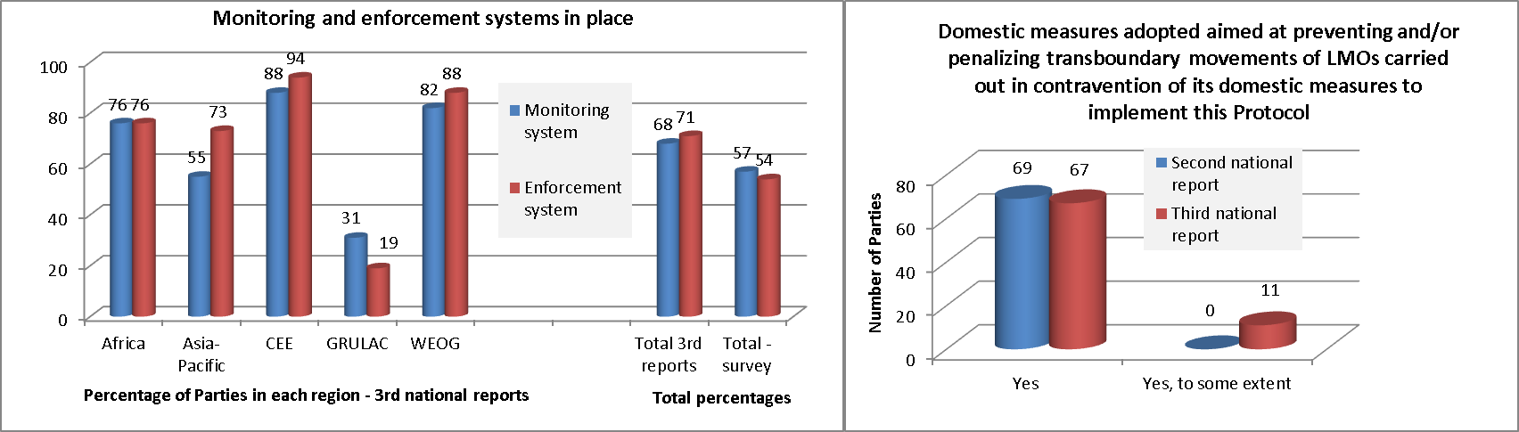
- A total of 67 Parties (66 per cent) report having adopted domestic measures aimed at preventing and/or penalizing transboundary movements of LMOs carried out in contravention of the domestic framework to implement the Protocol, which represents a decrease of 2 per cent. Regional differences are noted. GRULAC, despite progress, reports lowest on the adoption of such measures (47 per cent), followed by Africa (52 per cent), which reports a decrease. In Asia and the Pacific, a higher percentage of Parties report having adopted such measures (60 per cent), as is the case in CEE (82 per cent) and WEOG (100 per cent). When taking into consideration those Parties indicating that such measures have at least been adopted to some extent, the overall figure rises to 78 Parties, which constitutes an increase of 9 per cent.
Number of national reports received under each reporting cycle
- As of 31 December 2015, 105 national reports had been submitted out of 170 national reports due (62 per cent). The document on review of compliance with the obligation to submit national reports (UNEP/CBD/BS/CC/13/2) provides an overview of the status of submission of national reports, including a comparison with the submission rates of previous national reports. The document shows that reporting rates, measured as at the date on which the analysis of the reports was carried out, have increased as follows: 36 per cent for interim national reports; 35 per cent for first national reports; and 89 per cent for second national reports.
- Questions 205 and 206 of the reporting format for the third national report are related to this issue. Those Parties that have not submitted one or more national reports are requested to indicate the reason for not having done so. Out of the 13 Parties responding, six Parties (46 per cent) indicate a lack of financial resources. At the regional level, in Africa, lack of financial resources is reported as the reason in 83 per cent of the cases, and in GRULAC in 25 per cent of the cases. Lack of relevant information at the national level is reported as the reason by two Parties (15 per cent), both within GRULAC. One Party (8 per cent) from GRULAC reports difficulty in compiling information from different sectors as the reason for not having submitted one or more national reports. Four Parties, from Africa, Asia and the Pacific and CEE, report the absence of an obligation to submit such reports as the reason for not having submitted previous reports.
- For the completion of third national reports, UNEP/GEF made available funding for 82 Parties. Challenges with the implementation of the new Enterprise Resource Planning system (Umoja) by UNEP, however, resulted in a delay in the disbursement of GEF funds for the completion of third national reports. The deadline for submission was therefore postponed. A number of reports were nevertheless submitted after the extended due date.
Number of Parties able to access financial resources to fulfil their obligations under the Protocol
- Question 139, related to funding for capacity building for implementation of the Protocol, and 203, related to funding for implementation of the Protocol in general, are related to this indicator. Question 7 of the Survey corresponds to this question.
- A total of 36 Parties (34 per cent) report having predictable and reliable funding for capacity building for the effective implementation of the Protocol. Considerable regional differences are noted. Within the Africa and GRULAC, 7 (21 per cent) and 2 (13 per cent) Parties respectively report having such resources. In Asia and the Pacific, CEE and WEOG respectively 11 (50 per cent), 9 (53 per cent) and 7 (41 per cent) Parties report having such funding. In the Survey, 43 out of 109 Parties indicated having predictable and reliable funding for capacity building for the implementation of the Protocol. Both overall and regional scores were better in the Survey.
- A total of 68 Parties (65 per cent) report having received general funding for the implementation of the Protocol. In the survey, results were similar with 67 out of 109 responding Parties indicating having received funding. In relation to the quantity of funding received by Parties, more Parties report having received larger amounts of funding (more than US$ 50,000) in comparison to what was reported in the Survey.
- In the reporting period for the third national report, GEF approved 1 global, 1 regional and 10 national projects. In addition, UNEP/GEF made available funding for 82 Parties for the completion of their third national reports. A number of additional projects that were approved prior to the current reporting period, both at the national (17) and regional (1) levels, are currently under implementation.
- Despite the availability of additional resources and some project funding, many Parties indicate that a lack of sufficient funding is one of the major obstacles to the implementation of the Protocol.
__________

See UNEP/CBD/BS/CC/12/5, para. 29.
The Survey results were made available as UNEP/CBD/BS/COP-MOP/7/INF/10 and online at: http://bch.cbd.int/database/reports/surveyonindicators.shtml.
See decision BS-VII/3, annex.
Where, for example, an increase in respect of the second national report is reported by four Parties within one region, and a decrease by one Party within the same region, the overall regional difference is three. Where national differences are reported, explicit reference to the national level is made.
For more information on the rate of submission of third national reports, see UNEP/CBD/BS/CC/13/2, made available for the current meeting.
The relationship between the different questions pertaining to biosafety frameworks may need to be clarified in the reporting format to be used for future national reports.
Based on data available in the BCH on 31 December 2015.
Information drawn from question 126(h) of the third national report format. Only nine Parties reported having such information in both their second and third national reports.
In this case, Parties should have indicated that the information is not available in question 126.
As of 19 January 2016, 16 of those Parties had not yet submitted their third national report.
UNEP/CBD/BS/CC/8/3 para. 17.
For further information on the discussions and conclusions under this item, see UNEP/CBD/BS/CC/11/4 paras. 21 to 27.
UNEP/CBD/BS/A&R/1/INF/1, page 15. 536 risk assessment reports were available on a total of 647 decisions on LMOs.
Currently, for 85 decisions a risk assessment is not available. The current number of decisions on LMOs available in the BCH is 1787. The ratio of decisions for which a risk assessment report is available is 1702/1787 = 95 per cent.
Decisions BS-VII/1, paragraph 4; decision BS-V/1, paragraph 3, and document UNEP/CBD/BS/CC/13/INF/1.
For an overview of the role of the Committee, see UNEP/CBD/BS/CC/13/INF/1.
The issue related to the decision-making rules of the Committee was discussed in document UNEP/CBD/BS/A&R/1/2, paragraph 79. “The rules of procedure of the Committee concerning decision-making have not been finalized, and rule 18 of the Committee’s rules of procedure remains in square brackets. Nonetheless, the Committee has been able to function and adopt decisions on the basis of consensus to date.”
Elements 2(c), 3(b) and 3(c), for which respectively questions 124, 17 and 18 of the third national report format are relevant. Question 124 is presented below.
Information drawn from question 14 of the third national report format.
Ibid., question 15.
Ibid., question 16.
Ibid., question 17.
Ibid., question 18.
BS-I/3, BS-II/2.
Questions 29, 30, 47, 50, 124 of the third national report format.
Elements 2(a), 2(b), for which question 29 of the third national report format is relevant and Elements 3(a) and 3(d) related to respectively questions 30 and 35, 38. In addition, Element 4(a) is related to questions 52 and 54, and Element 4(b) to question 50.
Information drawn from question 29 of the third national reporting format. The question in the second national report format was formulated as follows: Has your country adopted law(s)/regulations/administrative measures for the operation of the AIA procedure of the Protocol? Because of the different formulation of the question in the second and third reports, the analytical tool does not allow for a comparison between the responses of only those countries that have submitted their third national report. The second national report shows that 86 countries responded positively and 67 responded negatively to the question.
Information drawn from question 30 of the third national report format.
Ibid., question 35.
Ibid., question 47.
Ibid., question 50.
Ibid., question 54.
Ibid., question 55.
Ibid., question 124.
Questions that elicited responses in both the second and third national reports by 10 Parties or fewer, together with associated questions, have not been considered in this summary (in particular, questions 63, 64, 65, 126(n), 69, 126(o), 126(p), 102 and 126(g)).
Question 126 consists of a number of sub-questions that appear in a similar form in other questions of the reporting format.
Information drawn from questions 20, 47, 126(a), 126(b) of the third national report format.
Ibid., question 126(d).
Ibid., questions 91 and 126(q). Taking into consideration the answers of those Parties that indicated that information has partially been submitted to the BCH, the information provided under both questions largely corresponds.
Ibid., question 43.
Ibid., question 45. The second national report did not contain a similar a question. Only 12 Parties could provide such information in both the second and third national report.
Ibid., question 126(i). The question specifies final decisions as “approval or prohibition, any conditions, requests for further information, extensions granted, reasons for decision”.
Ibid., question 49.
Ibid., question 56.
Ibid., question 57. If the responses of Parties reporting that information has been made available with delays of more than 15 days are taken into consideration, the absolute numbers for questions 56 and 57 are similar.
Especially when comparing at the individual response level, rather than at the regional aggregate level.
Information drawn from question 126(k) of the third national report format.
Ibid., question 126(m).
Ibid., question 74.
Information drawn from question 126(c) of the third national reporting format varies in respect of the information provided under question 74.
Information drawn from question 126(h) of the third national report format. Only nine Parties reported having such information in both their second and third national reports.
Ibid., question 187.
Element 7(a) of the possible elements relates to this issue.
Information drawn from question 184 of the third national report format.
As of 19 January 2016, 16 of these Parties, had not yet submitted their third national report.
Information drawn from question 139 of the third national report format.
See para. 43 above.

