 |  | CBD
 |  |  |  | Distr.  GENERAL  UNEP/CBD/BS/CM-CB/6/INF/2  31 January 2010  ORIGINAL: ENGLISH
SIXTH COORDINATION MEETING FOR GOVERNMENTS AND ORGANIZATIONS IMPLEMENTING OR FUNDING BIOSAFETY CAPACITY-BUILDING ACTIVITIES
Siem Reap, Cambodia, 1-3 February 2010
Item 4.1 of the provisional agenda*

summary of results of the survey on the application of and experience in the use of socio-economic considerations in decision-making on living modified organisms
- INTRODUCTION
- Paragraph 1 of Article 26 of the Cartagena Protocol on Biosafety allows Parties, in reaching a decision on import under the Protocol or under their domestic measures implementing the Protocol, to take into account, consistent with their international obligations, socio-economic considerations arising from the impact of living modified organisms (LMOs) on the conservation and sustainable use of biological diversity, especially with regard to the value of biological diversity to indigenous and local communities. There is currently a lack of information on the extent to which Parties have implemented this provision of the Protocol.
- The fourth coordination meeting for Governments and organizations implementing or funding capacity-building activities (New Delhi, 11-13 February 2008) offered recommendations on capacity-building and socio-economic considerations. In its decision BS-IV/16, the fourth meeting of the Conference of the Parties serving as the meeting of the Parties to the Protocol (COP-MOP) took note of the recommendations from the fourth coordination meeting and invited the next coordination meeting to further consider possibilities for cooperation in identifying needs for capacity-building among Parties for research and information exchange on socio-economic impacts of living modified organisms and to submit any recommendations to the fifth meeting of the Parties to the Protocol, to be held in Nagoya, Japan, in October 2010.
- This document has been prepared to assist the Coordination Meeting in this task. Section II of the document describes the background to the survey as well as the survey design and implementation. Section III summarizes the results from the survey focusing in particular on the aspects related to capacity-building. Section IV offers a conclusion. Figures illustrating the results of the survey are contained in the annex hereto.

II. SURVEY PROJECT, DESIGN and IMPLEMENTATION
- Since 2001, the United Nations Environment Programme Division of Global Environment Facility Coordination (UNEP DGEF) has been managing a global project on the development of national biosafety frameworks. In 2007, UNEP DGEF received funding from the United Kingdom Department for International Development to undertake a scoping exercise on socio-economic considerations in biosafety decision-making. The exercise is to include a questionnaire to gather information on countries’ progress with socio-economic considerations and the preparation of a draft outline for a toolkit module on socio-economic considerations.
- As part of the scoping exercise, a workshop on socio-economic considerations was held in Mexico City in July 2008 to bring together a group of experts to consider the work done on the project. Amongst other things, the group of experts reviewed a draft questionnaire, making suggestions and changes to it.
- In July 2009, a consultant was hired to carry out the survey and conduct an analysis of the results. A web page for the survey was created in the Biosafety Clearing-House (http://bch.cbd.int/onlineconferences/socioeconomics.shtml) and the Convention Secretariat issued a notification inviting people to register to participate in the survey. A contact list was compiled consisting of names and e-mail addresses of people who had previously participated in biosafety meetings and workshops (drawn from the ANUBIS database); the National Focal Points for the Biosafety Protocol; those who registered for the survey; and the organizations database maintained by the Secretariat of the Convention on Biological Diversity. The sampling frame size was 6,612 e-mail addresses.
- An introductory e-mail was sent out on 6 October 2009 that informed the population of the objectives of the survey. The survey was launched on 14 October 2009 with individuals and organizations given a web link that included their password for the survey. Reminder e-mails with the link to the survey were sent out on 26 October, 4 November and 10 November 2009 to those who had not completed the survey. The survey was closed on 13 November 2009. A total of 578 completed surveys had been received by this date. The number of completed surveys surpassed the minimum number required to meet the sample criteria.
- The survey was designed to be implemented on the web. Each individual or organization was given a password and individuals could only complete one survey questionnaire. The survey contained 46 questions, however no individual would have to answer all of the questions. The survey was divided into four parts.
- The first part of the survey asked general questions about the organization that the individual worked with. This included the type of organization (e.g. government, educational) and the type of work undertaken (e.g. regulatory, research). Respondents were also asked to choose, based on their experience, a country that they would use as a point of reference for the rest of the survey. The second part of the survey asked respondents about their experience with socio-economic considerations being taken into account in decision-making on LMOs. There were three different pathways through this part of the survey depending upon the respondents’ experience. Respondents whose countries had well defined systems for incorporating socio-economic considerations into the decision-making concerning LMOs answered questions through one pathway. Respondents who had some experience with socio-economic considerations being taken into account in the decision-making process concerning LMOs answered questions through another pathway. Finally, respondents whose countries had not incorporated socio-economic decision-making into the decision-making framework for LMOs answered questions through a third pathway. The third part of the survey asked respondents their opinions on various aspects of including socio-economic considerations in the decision-making framework concerning LMOs. The last part of the survey was a general assessment that asked respondents to provide some indication of the level of agreement to various statements concerning socio-economic considerations being taken into account in the decision-making process for LMOs.
III. RESULTS FROM THE SURVEY

A. Characteristics of the respondents
- Respondents were asked to identify the type of organization they worked for. The largest number of respondents was from governments, non-governmental organizations (NGOs) and educational institutions. Only 34 respondents identified their organization as being in the private sector (see figure 1 in the annex hereto).
- Question 2 asked the respondents what type of work they undertake. The largest number of respondents was involved in government and regulatory work. This was followed by respondents who worked in research for public institutions and public information or education. This was followed by academics and consultants. The “other” category included 94 responses. These responses included: advocates for aboriginal groups, research not for public institutions, research coordination, policy formation and capacity-building.
- The third question asked whether respondents answered the survey after consulting with colleagues or others. The majority of the respondents answered as individuals, however 177 respondents consulted other individuals in their organization or across organizations before completing the survey. Communications with respondents concerning the ability to respond as a group suggest that some respondents coordinated responses across organizations. Thus, a larger number of individuals and organizations are represented by the results of the survey. This would suggest that the 587 responses include a larger number of individuals and organizations.
- Question 4 asked respondents to identify a country that would be used as their point of reference for the rest of the survey. A total of 154 different countries were identified by the respondents. The country used most often as the reference point was the United States with 20 responses. This was followed by Mexico with 17 responses, India with 16 responses and Kenya and the Philippines each with 12 responses. A total of ten countries were chosen by ten or more respondents as their reference point (figure 2). Twenty-five countries had between five and nine responses as the reference country. This included South Africa and Ghana with nine responses as the reference country and Argentina, China, Chile, Grenada, Honduras and the Ukraine each with five responses (figure 3). Thirty-four countries received only one response to use them as a reference country.

B. Summary of capacity-building related aspects
- Further to the mandate given to this meeting, it is useful to examine in more detail the questions and responses related to capacity-building and socio-economic considerations. A number of questions in the survey related to capacity-building, in particular question 29 and questions 36 through 42.
- In question 11 of the survey, respondents were asked whether socio-economic considerations have been taken into account in decisions that have been taken on LMOs in their country. Respondents who answered that their country had not taken socio-economic considerations into account in their decisions on LMO were asked to identify how important five possible reasons were for why this was not done. The respondents could rank each of the five possible reasons for why socio-economic considerations were not taken into account on a scale from “Not at All Important” to “Very Important” to answer the question. Two methods were used to evaluate the responses. The first counted the number of times “Very Important” was selected for each possible reason. The second approach used a scoring method with weights of 1 through 5. Using the scoring method, a response of “Not at All Important” was given a weight of 1 while a response of “Very Important” was given a weight of 5. Weights of 2, 3, and 4 were given to “Not Very Important”, “Neutral”, and “Somewhat Important” respectively.
- Figure 4 provides the ranking of possible reasons why socio-economic considerations were not taken into account in the decisions concerning LMOs. The reason that received the greatest number of “Very Important” selections was that there was “not a mechanism in place” to take them into account. This reason was identified 131 times as being “Very Important” out of a possible 260 selections. This was followed by a “lack of capacity” and a “lack of institutional coordination”. These possible reasons received 102 and 95 selections each. The possible reason that the “regulation does not require it” was selected 90 times. The reason that received the lowest number of “Very Important” selections was “political reasons.” This reason was selected as “Very Important” only 78 times.
- The scoring approach provided a similar ranking of the possible reasons why socio-economic considerations were not taken into account in the decisions concerning LMOs as counts of “Very Important” selections. Of a possible score of 1,300; i.e. 260 times five, the “mechanism not in place” reason received a score of 956. This was followed by “lack of capacity” and “lack of institutional coordination.” These two possible reasons scored much closer than when the “Very Important” selection was taken into account. These two reasons scored 876 and 875 respectively. These were followed by “regulation does not require it” and “political reasons” as possible reasons for not taking socio-economic considerations into account when making decisions concerning LMOs. These latter possible reasons received scores of 825 and 786, respectively (figure 5).
- Respondents were also given the opportunity to indicate other important reasons why their country did not take socioeconomic considerations into account in its decisions on LMOs. There were a total 117 responses to this question. Some of the “other” reasons that were identified were: framework is in a draft form, no applications, costly to implement, and these considerations are factored into the country’s general policy.
- Question 36 asked all respondents the importance of a number of challenges that could have been faced by their country in including socio-economic considerations in its decisions on LMOs. Respondents were asked to identify on a scale whether the challenge was “Not at all important” ranging up to “Very important”. This question was analysed using two methods: (i) by the number of times respondents identified the challenge as “Very important”; and (ii) with a scoring method where each possible answer was given a specific weight. The weights were: 1 for “Not at all important”, 2 for “Not very important”, 3 to “Neutral”, a weight of 4 for “Somewhat Important”, and a weight of 5 for “Very important”.
- The results using the two methods to evaluate the challenges were very similar. In both cases, the challenge that had the largest number of “Very important” and the largest score was the financial challenges. Financial challenges were identified 366 times as being “Very important” and received a score of 2,433 out of a possible 2,885 points. The next important challenge identified by both methods was informational challenges. This challenge was identified 334 times as being “Very important” and received a score of 2,390. The final two challenges received very similar evaluations. Using the number of “Very important” selections, institutional challenges received five more selections than the human resource challenge. That is, the institutional challenge received 329 selections, while human resource challenges received 324 selections. The scoring method estimated the same scores for each method, 2,367 (figures 6 and 7).
- Question 36 also asked respondents what other important challenges their countries faced when trying to include socio-economic considerations in decisions on LMOs. One hundred and forty-four comments were received including: political challenges, political will, inconsistency between organizations, coordination between government departments, public concern about the environment, World Trade Organization regulations and distributional challenges.
- All respondents were asked whether their country had adequate capacity for the performance of socio-economic assessment. Of the 577 responses, 238 indicated that they had the capacity to undertake the socio-economic assessment, while 282 respondents stated that did not have the capacity.
- Respondents were asked to rank from 1 to 10, with the highest priority being given a ranking of 1, the top ten areas that were in need of capacity-building in the field of socio-economic assessment in their country. In total, there were 21 areas that were identified that were available to be ranked. Two methods were used to analyse the results to identify the top priorities. The first method used the number of times a number one ranking was given. The more often an area received a number one ranking, the stronger the case that the area needed capacity-building. The second approach was a scoring approach that weighed a number one ranking by 10 and decreased the weight by 1 for every decrease in rank until a number ten ranking had a weight of 1.
- Using the first method to assign priority for capacity-building, the food security area was in the highest need for capacity-building. This area was identified 54 times as a number one priority. This was followed by impacts on market access and trade, macroeconomic impacts, and impacts on conservation and sustainable use of biodiversity. These areas received 48, 35 and 35 number one rankings respectively. The next two areas of priority were coexistence of LMOs and compliance with biosafety measures. These two areas received 31 and 26 number one rankings respectively. The lowest ranked areas, in terms of priority, were land tenure, rural-urban migration and gender impacts (figure 8).
- The second method of scoring the priorities provided a different ranking of the areas that needed to be addressed. The most important priority area was food security. This priority was similar to the first method and received a score of 1,818. The next three priorities were: health-related impacts, impacts on market access and trade, and the impact on the conservation and sustainable use of biodiversity. These three areas had scores of 1,531, 1,397, and 1,340 respectively. The next two priority areas were coexistence of LMOs and macroeconomic impacts. These two areas received scores of 1,292 and 1,291. The lowest ranked priorities using the scoring approach were land tenure, rural-urban migration and gender impacts.
- Both of the methods used to evaluate priority areas for capacity-building identified food security as the number one priority. The top ten priority areas were the same with both methods of ranking the areas with only the relative priority within the top ten areas changing. In addition, both methods identified the same three areas as having the lowest priorities for capacity-building, namely land tenure, rural-urban migration and gender impacts.
- Question 39 asked all respondents whether a methodological guide (toolkit) would be a useful document to assist the inclusion of socio-economic considerations in a country’s decision-making framework concerning LMOs. Eighty-four per cent of the responses felt that such a methodological guide would be a useful document (figure 9).
- The next question asked the importance of various elements for the methodological guide or toolkit. Seven different assessment mechanisms were presented and respondents were asked to rank these on a scale from “Not at all important” to “Very important”. Two methods were used to evaluate the importance of each element. The first was to count the number of times respondents identified “Very important” for each element and to rank them based on the counts. The second was to use a scoring approach from 1 to 5, where a weight of 1 was given to “Not at all important” through to a weight of 5 for “Very important”.
- Using the first approach to rank the importance of the elements resulted in cost effectiveness as being the most important with a count of 136. This was followed by macroeconomic impacts and cultural, ethical assessment, both of which received 127 counts. This was followed by property right assessment and community analysis, which obtained 125 and 119 counts respectively (figure 10).
- Using the scoring approach, the ranking of importance changed. The most important element using this approach was the property right assessment, which scored 1,034. This was followed by macroeconomic impacts, cultural, ethical assessment and cost effectiveness. These three elements scored 971, 962, and 882 respectively (figure 11). It should be noted that respondents found this a difficult question to respond to and between 50 and 70 percent of respondents answered “do not know” for some elements.
- Question 41 asked all respondents who the target audience for the methodological toolkit should be. Three groups of individuals were clearly identified as a potential target audience. These were: individuals responsible for evaluating assessments, individuals responsible for carrying out assessments and the decision-making authority. These three groups were identified 409, 404, and 401 times respectively. Groups to be targeted after these were policy makers, civil society organizations, and industry (figure 12).
- Question 44 also asked respondents to indicate their level of agreement with nine statements. Respondents had a scale that could be used to identify their agreement from strongly disagree to strongly agree. A scoring method was used to estimate the overall level of agreement for each statement and also to compare the level of agreement between statements. The scoring method used a weight of -2 for “Strongly disagree”, a weight of -1 for “Somewhat disagree”, a weight of “0” for a “Neutral” response, a +1 for a “Somewhat agree” response, and a +2 for a “Strongly agree” response. Figure 13 presents the nine statements and their scores. The two strongest statements that the respondents could agree to was that there was a need to build countries’ socio-economic assessment capability (statement 7) and that a methodological toolkit would be a good starting point to build that capacity (statement 9). These statements scored 906 and 869 respectively out of a possible total of 1,156. Respondents also indicated that their country would be interested in building its socio-economic capacity (statement 8).
IV. CONCLUSION
- Based on this information, the Coordination Meeting may wish to make recommendations for consideration at the fifth meeting of the Conference of the Parties to the Convention on Biological Diversity serving as the meeting of the Parties to the Cartagena Protocol.
Annex. FIGURES

Figure 1. Types of organizations survey respondents were from
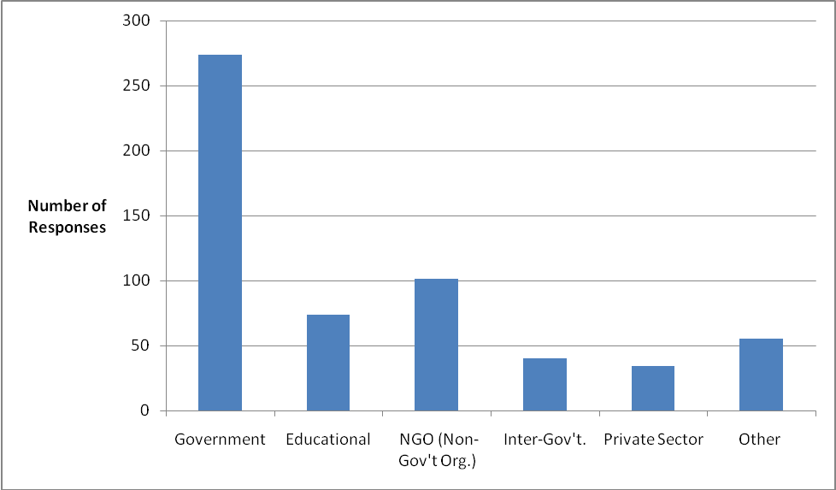

Figure 2. Number of responses for countries chosen as a reference point (10 or more responses)
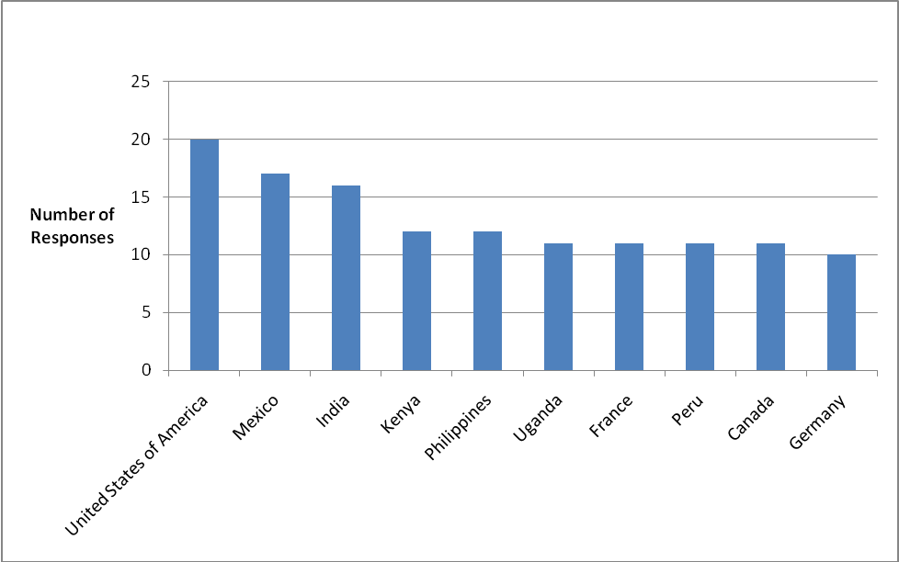

Figure 3. Number of responses for countries chosen as a reference point (between 5 and 9 responses)
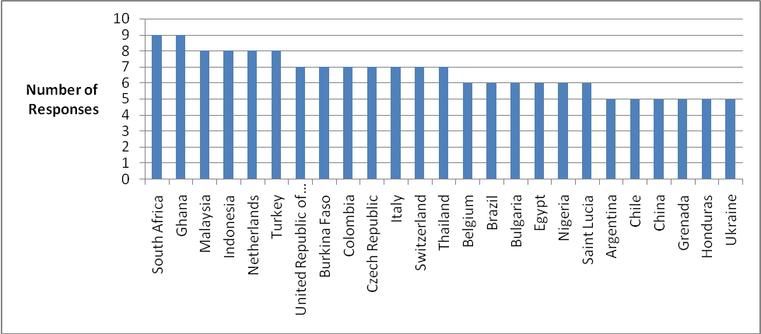

Figure 4. Number of times “very important” was identified with possible reasons why socio-economic considerations were not taken into account in decisions concerning LMOs.
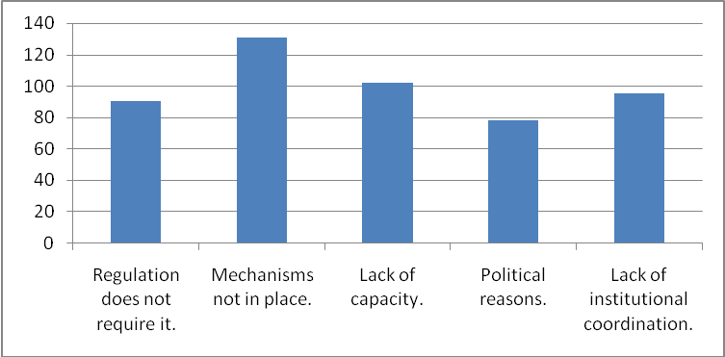

Figure 5. Scoring of possible reasons why socio-economic considerations were not taken into account in decisions concerning LMOs
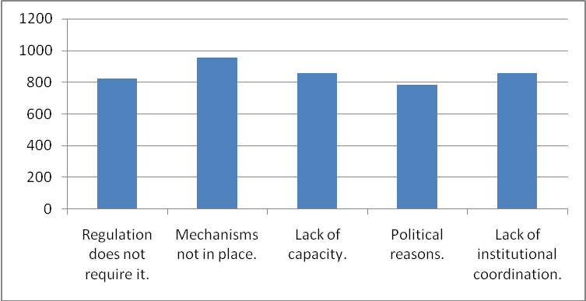

Figure 6. The importance of the various challenges to a country in including socio-economic considerations in it decisions on LMOs based on the number of times “very important” was selected
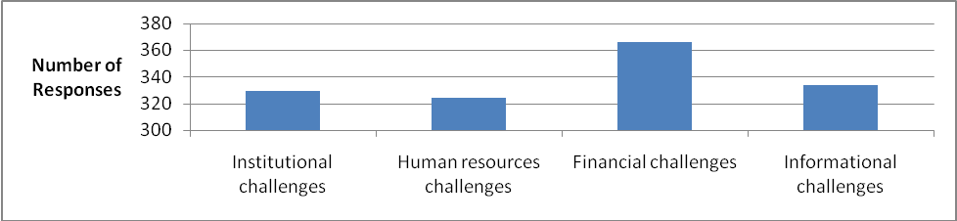

Figure 7. The importance of the various challenges to a country in including socio-economic considerations in it decisions on LMOs based on a scoring system
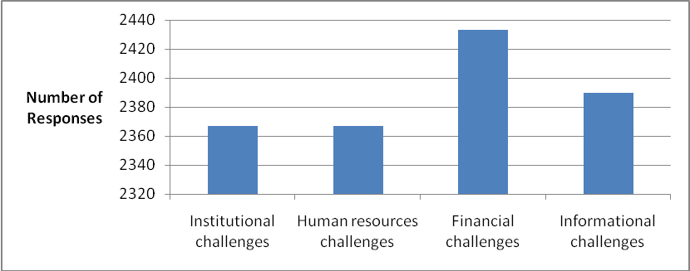

Figure 8. Ranking the priority areas for capacity-building in the area of socio-economic assessment using the number of times an area was ranked as the number 1 priority
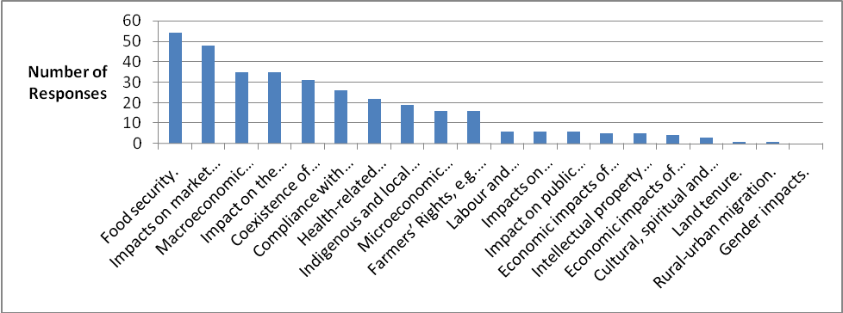

Figure 9. Responses to whether or not a methodological toolkit would be a useful document to assist in the inclusion of socio-economic considerations in decision-making on LMOs
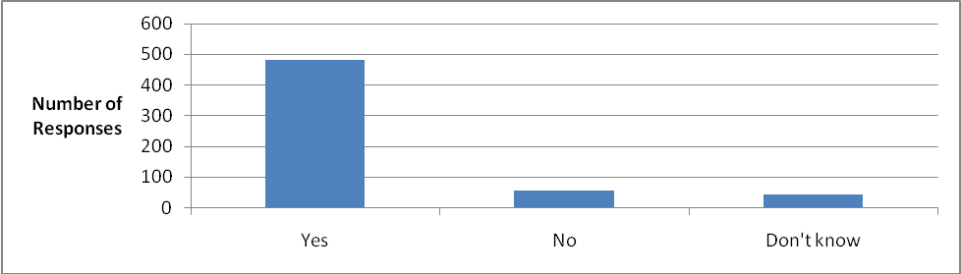

Figure 10. Identifying the importance of information for the methodological guide using the number of times respondents selected “very important”
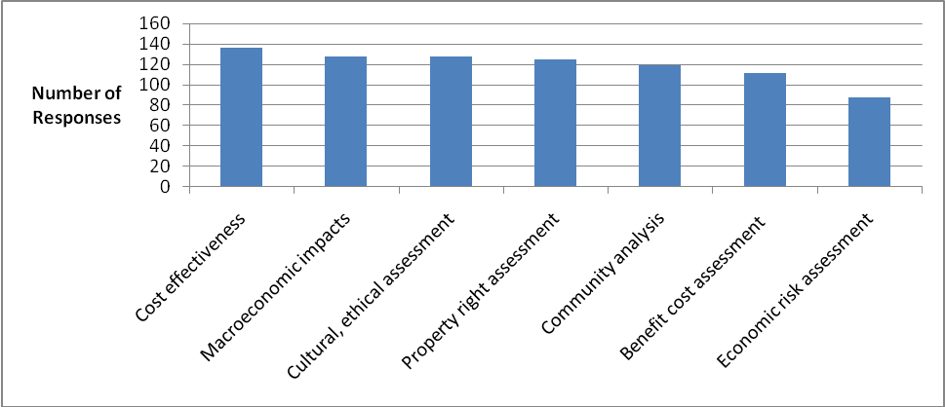

Figure 11. Identifying the importance of information for the methodological guide using a scoring method
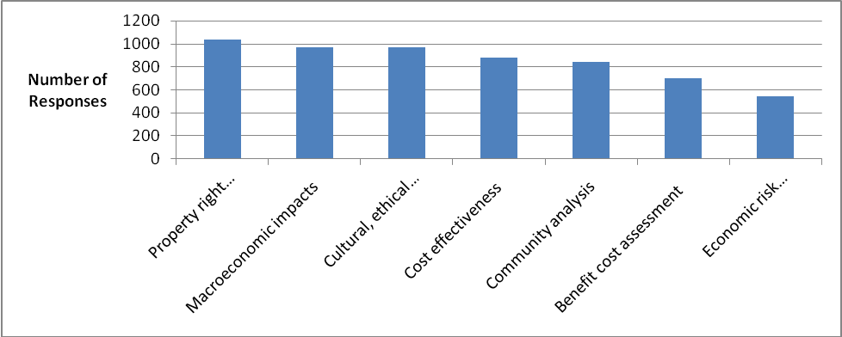

Figure 12. Identifying who the target audience for the toolkit should be
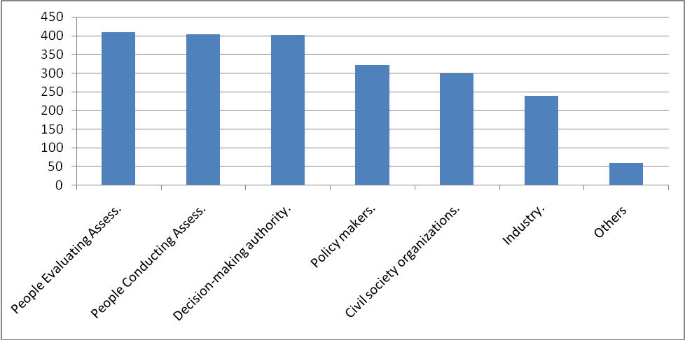

Figure 13. Respondents’ level of agreement with nine statements
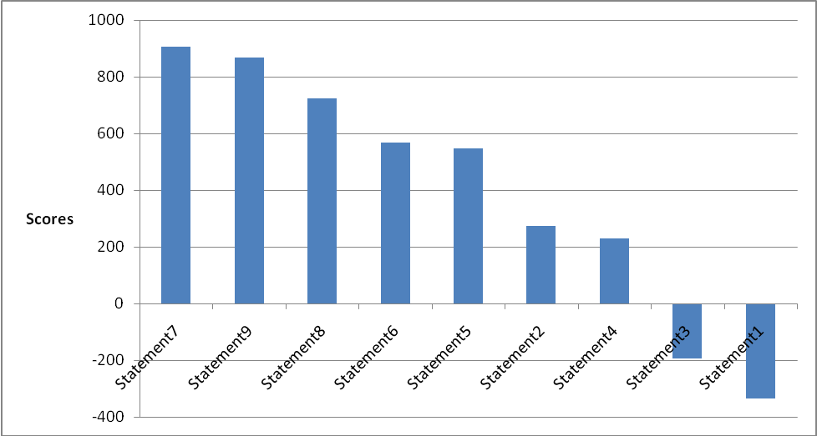

Statement 1 | Socio-economic information should be given more weight than scientific risk assessment information.
Statement 2 | Socio-economic information should be given equal weight as scientific risk assessment information.
Statement 3 | Socio-economic information should be given less weight than scientific risk assessment information.
Statement 4 | Socio-economic assessment should be undertaken at each stage of the scientific risk assessment.
Statement 5 | Specific items or elements should be included in each socio-economic assessment.
Statement 6 | Socio-economic assessments should be designed around the LMO being considered and thus would have different elements included in them.
Statement 7 | Countries need to build their socio-economic assessment capacity.
Statement 8 | My country would be interested in building its socio-economic assessment capacity.
Statement 9 | A methodological toolkit on how to undertake a socio-economic assessment is a good starting point for capacity- building in this area.

-----

* UNEP/CBD/BS/CM-CB/6/1.
It should be noted that the sampling frame size is not equivalent to 6,612 individuals/organizations as some contacts in the list had more than one e-mail address associated with their name. Efforts were made, however, to ensure that individuals and organizations only received one password for accessing and completing the survey.
The full text of the survey is available here: http://bch.cbd.int/forum/socioecsurvey/s-e_survey_en.pdf.

