 | 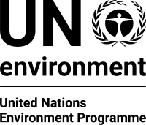 | CBD
Distr.
GENERAL

CBD/CP/CC/14/1
16 February 2017

ENGLISH ONLY
COMPLIANCE COMMITTEE UNDER THE CARTAGENA PROTOCOL ON BIOSAFETY
Fourteenth meeting
Montreal, Canada, 16-18 May 2017

Provisional agenda
- Opening of the meeting.
- Organizational matters:
2.1 Election of officers;
2.2 Adoption of the agenda;
2.3 Organization of work.
- Assessment of the outcomes of the eighth meeting of the Conference of the Parties serving as the meeting of the Parties to the Cartagena Protocol on Biosafety with regard to items relevant to compliance.
- Review of compliance on the basis of the third national reports, with a focus on the priority issues identified by the Conference of the Parties serving as the meeting of the Parties to the Cartagena Protocol on Biosafety at its eighth meeting.
- Review of general issues of compliance.
- Other matters.
- Adoption of the report.
- Closure of the meeting.
__________

