 |  | CBD
 |  |  | Distr.  GENERAL  UNEP/CBD/BS/COP-MOP/7/INF/2  7 August 2014  ORIGINAL: ENGLISH and SPANISH
CONFERENCE OF THE PARTIES TO THE CONVENTION
ON BIOLOGICAL DIVERSITY SERVING AS THE
MEETING OF THE PARTIES TO THE CARTAGENA
PROTOCOL ON BIOSAFETY
Seventh meeting
Pyeongchang, Republic of Korea, 29 September - 3 October 2014
Item 10 of the provisional agenda*
COMPILATION OF SUBMISSIONS ON EXPERIENCE GAINED WITH THE IMPLEMENTATION OF PARAGRAPH 4 OF DECISION BS-III/10 AS WELL AS THE IMPLEMENTATION OF DECISION BS-V/8
Note by the Executive Secretary
INTRODUCTION
- In paragraph 7 of decision BS-V/8 (Handling, transport, packaging and identification of living modified organisms: paragraph 2(a) of Article 18), the Conference of the Parties serving as the meeting of the Parties to the Cartagena Protocol on Biosafety requested Parties, and invited other Governments and relevant organizations to submit to the Executive Secretary, no later than six months prior to its seventh meeting, further information on experience gained with the implementation of paragraph 4 of decision BS-III/10 as well as the implementation of decision BS-V/8, including any information on obstacles that are encountered in the implementation of these decisions as well as capacity-building needs to implement these decisions. The Parties to the Protocol also requested the Executive Secretary to compile the information and prepare a synthesis report for consideration at their seventh meeting.
- The Executive Secretary had received thirteen submissions by the extended deadline of 2 May 2014. These consisted of eight submissions from the following Parties: Brazil, China, European Union, Malaysia, Mexico, Norway, Republic of Korea and South Africa; two submissions from other Governments, namely Australia and the United States of America; and three submissions from non-governmental organizations, namely the Global Industry Coalition (GIC), the International Grain Trade Coalition and No! GMO Campaign.
- Accordingly, this document presents a compilation of the submissions received. It supplements document UNEP/CBD/BS/COP-MOP/7/8, which contains a synthesis of the views provided. The submissions are reproduced in the form and language in which they were provided to the Secretariat.

CONTENTS
SUBMISSIONS FROM PARTIES AND OTHER GOVERNMENTS
BRAZIL..............................................................................................................................2
CHINA................................................................................................................................2
EUROPEAN UNION………………………………………….........................................3
MALAYSIA.......................................................................................................................5
MEXICO.............................................................................................................................6
NORWAY.........................................................................................................................33
REPUBLIC OF KOREA ..................................................................................................33
SOUTH AFRICA .............................................................................................................34
AUSTRALIA....................................................................................................................34
UNITED STATES OF AMERICA..................................................................................35
SUBMISSIONS FROM ORGANIZATIONS
GLOBAL INDUSTRY COALITION (GIC)...................................................................36
INTERNATIONAL GRAIN TRADE COALITION......................................................38
NO! GMO CAMPAIGN..................................................................................................40

SUBMISSIONS FROM PARTIES AND OTHER GOVERNMENTS

BRAZIL [1 APRIL 2014]
[SUBMISSION: ENGLISH]

Brazil considers that Decision BS III/10, especially its paragraph 4, provides a balanced guidance on how to implement Article 18 2(a) of the Protocol. It is important that Parties continue to adopt, in accordance to their needs and in line with the objectives of the Protocol, appropriate domestic measures for the implementation of both Article 18 2(a) and Decision BS III/4. It is also important that Parties keep providing the BCH, in due course, the list of LMOs which are allowed in their jurisdiction for use in food, feed and processing (FFP-Food, Feed and Processing). Finally, Parties and other organizations should continue to support countries in need of capacity-building support.

In Brazil, the activities of handling, transport, packaging and identification of LMOs must follow the National Biosafety Law (law nr. 11.105, 24 March 2005). Its article 29 establishes that "the non-authorized production, storage, transportation, marketing, import or export of LMOs and their by-products, breaching the norms provided by the National Technical Biosafety Commission (CTNBio) and by registration and inspection agencies and entities" may be punished by confinement up to two years. In addition to that, the transport of LMOs is ruled by Regulatory Instruction nr. 4, 19.12.1996; while the import, marketing, transport, storage, handling, use, and disposal of LMO products are ruled by Regulatory Instruction nr. 17, 17.11.1998, both from CTNBio.

CHINA [4 APRIL 2014]
[SUBMISSION: ENGLISH]
- About Paragraph 2(a) of Article 18
The authorities related to the LMOs that are intended for direct use as food or feed or for processing in China are the Ministry of Agriculture and the State Forestry Administration. The transport, packaging and labeling of LMOs is regulated and a series of inspection standards are developed in line with related laws and regulations, including the Regulations on Administration of Agricultural Genetically Modified Organisms Safety, the Measures for Management of the Agricultural Genetically Modified Organisms Safety Labels, the Procedures for Review and Accreditation of Agricultural Genetically Modified Organisms and the Measures for Accreditation of Forestry Genetic Engineering Activities.
The authorities related to LMO import and export administration in China are the General Administration of Quality Supervision, Inspection and Quarantine and the General Administration of Customs. The two agencies inspect imported and exported LMOs in accordance with the Regulations on Regulations on Administration of Agricultural Genetically Modified Organisms Safety and related measures.
China proposes that the CBD Secretariat suggests parties take the following measures,
- Provide detailed information and identify labels for exported LMOs that are intended for direct use as food or feed or for processing;
- Undertake gene tests before export and provide test certificates and reports for exported LMOs that are intended for direct use as food or feed or for processing;
- Share information of Identity Protection System through the Biosafety Clearing House so that import countries can have access to accurate information of LMOs.

EUROPEAN UNION [1 APRIL 2014]
[SUBMISSION: ENGLISH]

Further to notification 2012-149 of 6 December 2012, regarding the decisions of the COP-MOP/6 that require specific action, and particularly to Decisions BS -V/8 (handling, transport, packaging and identification) and BS-VI-16 (Unintentional transboundary movements), the European Union and its Member States would like to notify:
In its decision BS -V/8 on handling, transport, packaging and identification of living modified organisms: paragraph 2(a) of Article 18, the Conference of the Parties serving as the meeting of the Parties to the Cartagena Protocol on Biosafety requested Parties to submit information on experience gained with the implementation of paragraph 4 of decision BS-III/10 as well as the present decision.
The EU set up a comprehensive legal framework which addresses the topic of handling, transport, packaging and identification of living modified organisms (art. 18 of Cartagena Protocol):
- Council Directive 94/55/EC of 21 November 1994 on the approximation of the laws of the Member States with regard to the transport of dangerous goods by road (last amended by Commission Directive 2003/28/EC);
- Council Directive 96/49/EC of 23 July 1996 on the approximation of the laws of the Member States with regard to the transport of dangerous goods by rail (last amended by Commission Directive 2003/29/EC);
- Regulation (EC) No 1829/2003 of 22 September 2003 on genetically modified food and feed; and its implementing Regulation (EC) No 641/2004 of 6 April 2004 on detailed rules for the implementation of Regulation (EC) No 1829/2003;
- Regulation (EC) No 1830/2003 of 22 September 2003 concerning the traceability and labeling of genetically modified organisms and the traceability of food and feed products produced from genetically modified organisms;
- Regulation (EC) No 1946/2003 of 15 July 2003 on transboundary movements of genetically modified organisms;
- Regulation (EC) No 65/2004 of 14 January 2004 establishing a system for the development and assignment of unique identifiers for genetically modified organisms
As regards Article 18(1) of Cartagena Protocol, the existing EU legislation, mainly Directive 94/55/EC and Directive 96/49/EC, contains appropriate rules on the safe transport, handling and packaging.
As regards Article 18(2)(a) of Cartagena Protocol, the EU wishes to recall that:
- Regulation (EC) No 1829/2003 lays down rules on labeling of all GM food and feed. GM food and feed has to be labeled as GM, except if they contain GM material in a proportion no higher than 0.9% and if this presence is adventitious or technically unavoidable.
- Regulation (EC) No 1830/2003 provides that business operators must transmit and retain information about products that contain or are produced from GMOs at each stage of the placing on the market. In particular, the Regulation requires that:
  - operators are to have systems and standardized procedures in place to identify to whom and from whom products are made available;
  - At the first stage of the placing on the market of a product consisting of or containing GMOs, including bulk quantities, operators shall ensure that the following information is transmitted in writing to the operator receiving the product: (a) that it contains or consists of GMOs; (b) the unique identifier(s) assigned to those GMOs; and
  - in the case of products consisting of or containing mixtures of GMOs to be used only and directly as food or feed or for processing, written information on the unique identifier(s) assigned to the GMOs of which the product consists or which are contained in it, may be replaced by a declaration of use by the operator, accompanied by a list of the unique identifiers for all those GMOs that have been used to constitute the mixture.

- Regulation (EC) No 65/2004 established a system for the development and assignment of unique identifiers for genetically modified organisms. The Regulation adopts the format developed by the OECD for Unique Identifiers for Transgenic Plants, which in mid-April 2004 became mandatory for the EC’s domestic regulatory framework for GMOs. Moreover, the EU has extended use of this format to unique identifiers for genetically modified micro-organisms and animals pending the development and adoption of any other specific format at an international level. The EU considers the use of the unique identifier as a key to access information available on the Biosafety Clearing-House.

- Regulation (EC) No 1946/2003, under Article 12, provides that exporters are required to state in a document accompanying the GMO, which is to be transmitted to the importer receiving the GMO:
  - that it contains or consists of GMOs; and
  - the unique identification code(s) assigned to those GMOs if such codes exist.

Article 12 further stipulates that for GMOs intended for direct use as food or feed, or for processing, the above information must be supplemented by a declaration by the exporter:
  - stating that the GMOs are intended for direct use as food or feed, or for processing and indicating clearly that they are not intended for deliberate release into the environment; and
  - giving details of the contact point for further information.
In the case of products consisting of or containing mixtures of GMOs to be used only and directly as food or feed, or for processing, the above identification requirements may be replaced by a list of unique identifiers used to constitute the mixture.
In relation to Article 18(2)(b) of Cartagena Protocol, the EU wishes to recall that EU legislation contains rules on identification of GMOs that are destined for contained use, in line with the Protocol:
- Regulation (EC) No 1946/2003, under Article 12, provides that exporters are required to state in a document accompanying the GMO, which is to be transmitted to the importer receiving the GMO:
  - that it contains or consists of GMOs; and
  - the unique identification code(s) assigned to those GMOs if such codes exist.

Article 12 further stipulates that for GMOs intended for contained use, the information referred to in paragraph 1 shall be supplemented by a declaration by the exporter which shall specify:
  - any requirements for the safe handling, storage, transport and use of these GMOs;
  - the contact point for further information, including the name and address of the individual or institution to whom or which the GMOs are consigned.

Finally, as regards Article 18(2)(c) of Cartagena Protocol, Regulation No (EC) 1946/2003 requires exporters of GMOs destined for deliberate release into the environment to ensure that documentation accompanying the GMO states:
  - that it contains or consists of GMOs; and
  - the unique identification code(s) assigned to those GMOs if such codes exist;

In addition, this information shall be supplemented by a declaration by the exporter which shall specify:
  - the identity and relevant traits and characteristics of the GMOs;
  - any requirements for the safe handling, storage, transport and use of these GMOs;
  - the contact points for further information and, as appropriate, the name and address of the importer and exporter; and
  - a declaration that the movement is in conformity with the requirements of the Protocol applicable to the exporter.

The above requirements regarding identification and documentation of GMOs are in line with Article 18 of the Protocol and without prejudice to further specific requirements imposed by EU legislation.
Decision BS -V/8 also requested Parties to submit information regarding specific capacity-building need to implement its decisions. The EU wishes to notify that the EU has not specific capacity-building needs.

MALAYSIA [28 MARCH 2014]
[SUBMISSION: ENGLISH]

The domestic legal framework for handling of LMOs is already in place in Malaysia. However, before this can be fully operationalized, more interagency coordination, capacity building and awareness activities need to be done. Engagement with several agencies which are directly involved with trade activities are currently ongoing in the development of a mechanism to require all consignments for import that contain products which have been subjected to genetic modification carry a declaration stating that the product is "genetically modified”.

For LMOs destined for contained used activities, the transportation must be carried out in compliance with national and international regulations and guidelines. For instance the LMOs being transferred should be packaged in secure containers capable of preventing material loss during transportation. The LMOs should also be kept separate from other materials. Additionally, the regulatory authorities, which are the Institutional Biosafety Committee (IBC) and the National Biosafety Board (NBB), must be notified through the appropriate form. Detailed explanation on the procedures for packaging and transport of LMOs are tabulated according to the type of LMOs in the Biosafety guidelines for the Contained Use Activity of LMOs. It is essential that a national biosafety regulatory system clearly articulate a safety standard in its laws and regulations. In a functional, transparent, and protective system, all interested parties know and understand the standard beforehand and government decisions apply that standard in a uniform and fair manner. Thus priority should be given more to build capacity in this aspect especially among the developing country Parties and Parties with economies in transition with appropriate financial support in place.

MEXICO [1APRIL 2014]
[SUBMISSION: SPANISH]

En México existen elementos de experiencia que deseamos manifestar en respuesta a la solicitud del Secretariado con relación a la importación de OGMs destinados al uso directo como alimento, piensos o derivados procesados (FFP). Como antecedente se debe precisar que la Ley de Bioseguridad de Organismos Genéticamente Modificados (LBOGM) prevee la expedición de autorizaciones por parte de la Secretaría de Salud para este fin en el caso de que los OGMs de que se traten tengan por objeto lo siguiente (art. 91 LBOGM):
I. Los que se destinen a su uso o consumo humano, incluyendo granos;
II. Los que se destinen al procesamiento de alimentos para consumo humano;
III. Los que tengan finalidades de salud pública, y
IV. Los que se destinen a la biorremediación.
También se consideran OGMs para uso o consumo humano aquellos que sean para consumo animal y que puedan ser consumidos directamente por el ser humano.
Por su parte, el artículo 97 de la LBOGM dispone que los OGMs autorizados por la Secretaría de Salud podrán ser libremente comercializados e importados para su comercialización, al igual que los productos que contengan dichos organismos y los productos derivados de los mismos, por lo que esta Secretaría es la autoridad competente dentro del ámbito de autorizaciones para la comercialización e importación para su comercialización. En tanto se lleva a cabo la expedición de la Norma Oficial Mexicana correspondiente, la Secretaría de Salud tiene previstos los requisitos de identificación de OGMs de importación y que a continuación se enlistan:
- Título: Autorización Sanitaria para Comercialización e Importación para su comercialización de Organismos Genéticamente Modificados.
- El número de autorización emitida por parte de la Secretaría de Salud, que ampara la importación de los OGMs sujetos a movimiento transfronterizo;
- Fundamento Legal
- Nombre, denominación o razón social del primer importador quien lleva a cabo el movimiento transfronterizo o la importación del OGM autorizado y, en su caso, nombre del representante legal
- Domicilio para oír y recibir notificaciones, así como el nombre de la persona o personas autorizadas para recibirlas;
- Información mínima del OGM: especie (nombre científico y común de la especie receptora), clave de identificación única de la OECD; tipo de OGM u OGMs sujetos al movimiento transfronterizo;
- Tipo de evento
- Función
- Estabilidad de la modificación genética
- Equivalencia sustancial
- Uso
- Destino del producto
- Presentación
- Alergenicidad
- Toxicidad
- País de Origen
- País de Procedencia
- Proteínas expresadas
- Fecha de expedición
- Firma del Comisionado de Autorización Sanitaria de la Secretaría de Salud.

Referente a la experiencia que se ha tenido en el país, es de resaltar también la iniciativa adoptada en un esquema de Programa Piloto para la documentación que acompaña a las importaciones de maíz amarillo destinado al uso directo como consumo humano, animal o para procesamiento, implementado por la Secretaría de Economía, de conformidad con lo señalado por el artículo 102 de la LBOGM, del cual se acompaña el reporte como Anexo 1 al presente documento.

En dicho reporte se refleja la información obtenida a partir de este Programa Piloto en años recientes, la complejidad experimentada en su aplicación, así como algunas propuestas para dar continuidad al procedimiento. Los resultados de este Piloto serán considerados al momento de la elaboración de la norma respectiva dentro de los grupos de trabajo que faciliten la coordinación interinstitucional para abordar el tema.

Anexo 1.
Reporte sobre la situación del Programa Piloto para la documentación que acompaña a las importaciones de maíz amarillo destinado para uso directo como consumo humano, animal o para procesamiento que presenta la Secretaría de Economía.

Presentación del Reporte.

El presente consta de los siguientes elementos:

I. Antecedentes.
II. Arreglo Trilateral entre Canadá, Estados Unidos de Norteamérica y México.
III. Programa Piloto para la documentación que acompaña a las importaciones de maíz amarillo destinado para uso directo como consumo humano, animal o para procesamiento.
i. Contexto de México.
ii. Primera Etapa.
iii. Segunda Etapa.
iv. Pasos a seguir y perspectiva.

I. - Antecedentes

El artículo 18 del Protocolo de Cartagena sobre Seguridad de la Biotecnología (PCB) aborda lo relativo a la manipulación, transporte, envasado e identificación de Organismos Vivos Modificados (OVM), y establece que las Partes adoptarán las medidas para el tipo de documentación que acompañe a estos, dependiendo de su destino.

En el tema que nos ocupa, nos enfocamos a documentar la experiencia con relación a la fracción (a) del párrafo 2 del artículo en comento, es decir, los OVM destinados a uso directo como alimento humano o animal o para procesamiento.

Cabe recordar la letra del inciso en comento:

(a) Living modified organisms that are intended for direct use as food or feed, or for processing, clearly identifies that they “may contain” living modified organisms and are not intended for intentional introduction into the environment, as well as a contactpoint for further information. The Conference of the Parties serving as the meeting of the Parties to this Protocol shall take a decision on the detailed requirements for this purpose, including specification of their identity and any unique identification, no later than two years after the date of entry into force of this Protocol;

Ahora bien, con la entrada en vigor del PCB, todos los países Parte, incluido México, quedaron obligados a exigir que todas las importaciones de alimento humano o animal o para procesamiento, incluidas las provenientes de cualquier país (Parte o no del PCB), contengan la leyenda “may contain” en los casos en que haya evidencia o suposición de contenido de OVM en los cargamentos de que se trate.

Para el particular del caso mexicano, cabe destacar que, el despacho de Aduanas, que opera al amparo de la Secretaría de Hacienda y Crédito Público (SHCP), está migrando, con la asistencia técnica de la Secretaría de Economía y demás instancias involucradas, a un sistema de ventanilla única, que operará, llegado el momento, de manera electrónica y unificada.

Asimismo, el Gobierno Federal analizó los alcances y efectos del citado artículo, encontrando que la implementación del ordenamiento debe ser cautelosa, especialmente en el contexto de un comercio globalizado, y dado que en el caso de México, somos un país deficitario en algunos de los cultivos que ya se modifican genéticamente, debemos ser especialmente cuidadosos en garantizar el abasto alimentario, a precios razonables y al alcance de nuestra población.

II. Arreglo Trilateral entre Canadá, Estados Unidos de Norteamérica y México.
Con el objeto de dar cumplimiento al artículo 18. 2 (a) del Protocolo de Cartagena, el Gobierno de México negoció y suscribió un Arreglo Trilateral con Canadá y los Estados Unidos de América (el Arreglo), para ello, se generó un proceso riguroso de intercambio de información y consultas entre las autoridades mexicanas correspondientes al comercio internacional de productos agrícolas, con un enfoque a los graneles de básicos, y con miras al establecimiento de las condiciones mínimas aceptables para no obstaculizar el comercio, así como para garantizar el cumplimiento de los lineamientos que establece el Protocolo de Cartagena a sus países Parte en su intercambio comercial con países no Parte.
En este sentido, en la negociación del Arreglo se acordó la inclusión de los siguientes términos:
- Incorporar en la factura comercial la leyenda "puede contener OVMs destinados para su uso directo como alimento humano o animal o para procesamiento y que no están destinados para su introducción intencional en el medio ambiente",
- Identificando al último exportador y primer importador del embarque y eximiendo de estos requisitos los embarques de productos en cuyas especies no se han desarrollado OVMs (p. ej. trigo y sorgo) o explícita o implícitamente referidos como libres de OVMs (frijol soya o maíz libre de OVMs).
- El umbral para determinar la ausencia de OVMs es con un 5% máximo contenido, basado en tolerancias establecidas bajo un gran número y tiempo de experiencias sobre correlación de costos y viabilidades de control y verificación en los diversos parámetros comerciales.

Este Arreglo Trilateral fue signado de común acuerdo por los Ministros de Agricultura de los tres países, titulado: "Requisitos de documentación para OVMs destinados a alimento humano o animal o para procesamiento". El Arreglo amparado bajo el artículo 24 del Protocolo de Cartagena y firmado por México con países No Parte del mismo, tuvo originalmente vigencia hasta octubre del 2005, y posteriormente se prorrogó indefinidamente, mediante una adenda refrendada por los mismos Ministerios de Agricultura.

III. Programa Piloto para la documentación que acompaña a las importaciones de maíz amarillo destinado para uso directo como consumo humano, animal o para procesamiento
Derivado del Arreglo Trilateral, la Secretaría de Economía, la Secretaría de Agricultura, Ganadería, Desarrollo Rural, Pesca y Alimentación (SAGARPA), el Servicio Nacional de Sanidad, Inocuidad y Calidad Agroalimentaria de esa Secretaría (SENASICA-SAGARPA) y la Administración General de Aduanas bajo las instrucciones del titular de la Secretaría de Hacienda y Crédito Público (SHCP), elaboraron un esquema voluntario de cumplimiento de ese Acuerdo, adoptando el llamado Programa Piloto para la documentación que acompaña a las importaciones de maíz amarillo destinado para uso directo como consumo humano, animal o para procesamiento (Programa Piloto), implementando simultáneamente los términos del Arreglo descrito para maíz amarillo proveniente de los E.U.A., y los lineamientos relativos del Protocolo, anunciándolo en la COP-MOP 3, en marzo de 2006, y agregando procedimientos sencillos de seguimiento.
El Programa Piloto tiene como objetivo “Implementar un Programa que permita identificar las importaciones que pudieran contener OVM’s y darles seguimiento a partir de su entrada al país y hasta su destino final.”
Dicho Programa permite cumplir con los requisitos del Protocolo de Cartagena, pues facilita a las autoridades competentes el seguimiento de los insumos que se importan, a través de un mecanismo sencillo que no genera obstáculos técnicos al comercio de maíz amarillo.

i. Contexto de México

México: Deficitario en maíz amarillo.

Antes de entrar de lleno en la información de fondo del tema, es necesario presentar un diagnóstico de la situación respecto al maíz amarillo en nuestro país.

México, como es bien conocido, es Centro de Origen y Diversidad Genética del Maíz, sin embargo y a pesar de que existe mucha producción de dicho cultivo, la demanda del producto por parte de la población rebasa a aquella, por lo que nos vemos en la apremiante necesidad de importar; ésta situación tiene una tendencia creciente, como se muestra a continuación: Consumo Nacional Aparente en México de Maíz Amarillo (Fracción Arancelaria 10059003)
Producción* |  | Importaciones* |  | Exportaciones* |  | Consumo Nacional Aparente*
2003 | 632 |  | 5,401 |  | 0.102 |  | 6,033
2004 | 1,061 |  | 5,096 |  | 0.107 |  | 6,157
2005 | 1,330 |  | 5,615 |  | 0.011 |  | 6,945
2006 | 1,718 |  | 7,278 |  | 0.036 |  | 8,997
2007 | 1,575 |  | 7,562 |  | 0.055 |  | 9,136
2008 | 1,574 |  | 8,612 |  | 0.012 |  | 10,186
2009 | 1,713 |  | 7,045 |  | 0.056 |  | 8,758
2010 | 2,018 |  | 7,276 |  | 0.041 |  | 9,294
2011 | 1,692 |  | 8,092 |  | 0.051 |  | 9,785
2012 | 1,766 |  | 9,454 |  | 0.021 |  | 11,220
2013**
* Miles de toneladas
** A la fecha no se cuenta con el resumen que realizan las áreas competentes, pero las cifras estarán disponibles a finales del mes de abril de 2014, por lo que la Secretaría de Economía compartirá con la COP-MOP 7 los datos.

Fuente: Datos de comercio: SIAVI (2003-2011); SIAP (2011 - 2012).
Datos de producción: SIAP.

Cabe destacar que en el caso de maíz amarillo, el destino va mayormente al consumo animal y a la industrialización.

ii. Primera Etapa.

En virtud de lo anterior, y toda vez que nuestro principal proveedor de dicho insumo es nuestro vecino país, Estados Unidos de Norteamérica (EUA), la Secretaría de Economía, de manera conjunta con la SAGARPA y la SHCP, sostuvo numerosas reuniones con representantes de la industria nacional, incluyendo a las empresas desarrolladoras de la tecnología con presencia en México y a las empresas comercializadoras de productos agropecuarios a granel en el país, para discutir el diseño y aplicación de un esquema de carácter voluntario (Programa Piloto), con objeto de definir los requisitos de la documentación que debiera acompañar los embarques de maíz amarillo (fracción 10059003) destinados para uso directo como alimento humano o animal o para procesamiento.

Derivado de dichas reuniones, se alcanzó un acuerdo definitivo entre las partes interesadas y en 2005 se definió un instrumento de carácter voluntario, lo que permitió alcanzar compromisos de acciones coordinadas, que no involucraron la creación de nuevas Leyes, ni Reglamentos ni otras disposiciones legales como Normas Oficiales Mexicanas.

El Programa Piloto instrumentó un mecanismo sencillo para documentar las importaciones, utilizando la factura comercial que acompaña a los cargamentos de maíz amarillo procedentes de Canadá y EE.UU., en donde se incluye la siguiente leyenda:

“Este embarque puede contener organismos vivos modificados para uso directo como alimento humano o animal o para su procesamiento y que no están destinados para su introducción intencional en el medio ambiente”.

El Programa Piloto funcionaba de la siguiente manera:
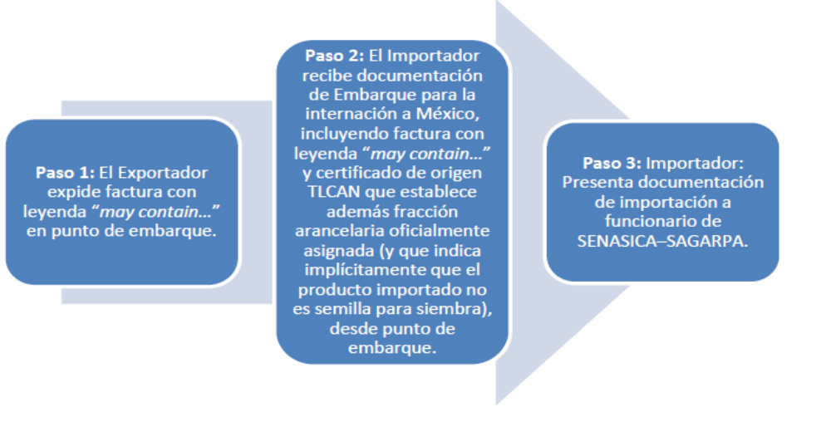

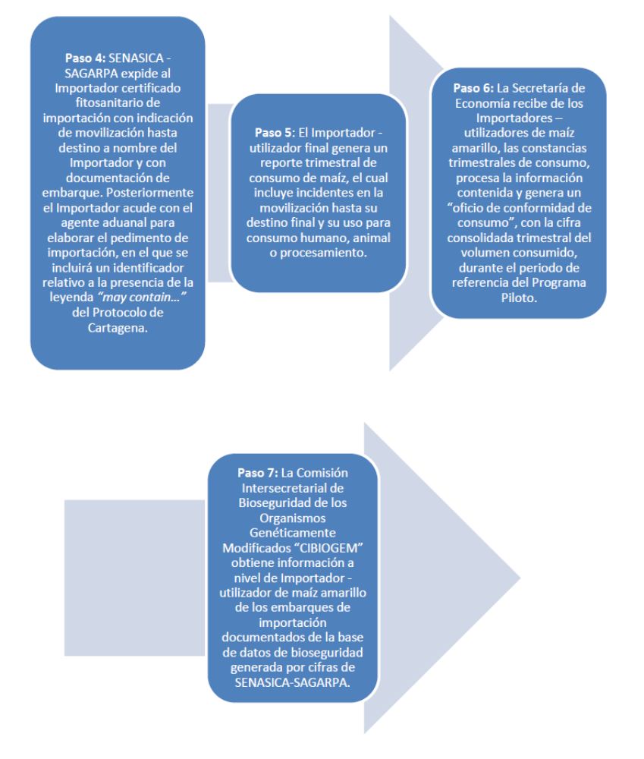

Cuando estuvo definido el mecanismo referido con antelación, y a fin de obtener información de los cargamentos que contienen esta leyenda, la SHCP publicó en el Diario Oficial de la Federación (DOF) el 15 de octubre de 2005, información sobre el identificador SB como una marca estadística, dentro de un programa voluntario, lo que permitió al agente aduanal, o bien, al funcionario de aduanas asentar el registro en el punto de entrada al país.

La Secretaría de Economía recibió y recabó la información que envió la industria nacional, a través de asociaciones, organizaciones y empresas, respecto a sus importaciones de maíz amarillo de conformidad con el formato que aparece como Anexo 1.

En esta primera etapa de la implementación del Programa Piloto, del análisis de la información proporcionada por la industria nacional a la Secretaría de Economía sobre las importaciones de maíz amarillo del 15 de octubre de 2005 y el 30 de septiembre de 2007, conforme al citado Formato, se obtuvieron los siguientes datos:

- 53 empresas presentaron información a través de los Formatos por un volumen de importación de maíz amarillo de 6,160,251.64 toneladas, de los cuales 5,179,522 toneladas (84.08%) registraron que en factura se indicó la leyenda “puede contener” para cumplir con el Programa Piloto.
- La información reportada indica 1032 pedimentos, de los cuales 653 pedimentos (63.3%) registraron que en factura se indicó la leyenda “puede contener”.
- Se cotejó la información obtenida a través de los Formatos con la proporcionada por la Administración Central de Operación Aduanera (SAT), y se conoce que las importaciones totales (6,160,251.64 toneladas) reportadas por la industria ascendió a 43% de las importaciones totales registradas por Aduanas (14,332,407.47 tons).
- Aduanas reportó que ingresaron al país 3,326,496.37 toneladass con identificador SB, mientras que la industria reporta 5,179,522 toneladas. Las causas podrían ser diversas:
- Algunas empresas reportaron pedimentos que no corresponden al periodo 15 de octubre de 2005 al 30 de septiembre de 2007, por lo que exista una sobreestimación.
- Al considerarse el identificador SB como una marca estadística, dentro de un programa voluntario y no representar obligación alguna, podría darse el caso que el agente aduanal o bien el funcionario de aduanas NO asentó dicho registro en el pedimento.
- Con información de Aduanas se conoce que sólo 10, de las 53 empresas que presentaron el Formato, tienen por lo menos un registro sobre pedimentos que contenían el identificador “SB” por un volumen de importación de maíz amarillo de 2,918,143.97 toneladas.
- El Programa Piloto ha permitido obtener información relativa a las importaciones de maíz amarillo a México que puede contener OGMs, durante el periodo ya señalado, que de otro modo no se podría haber obtenido: importadores, puntos de entrada, usos o incidencias en el transporte.

iii. Segunda Etapa.

En el año 2005 se tenían las condiciones estructurales adecuadas en el comercio agrícola en la región de Norteamérica, para dar cumplimiento al Programa Piloto, en los términos referidos anteriormente, ya que se podía dar un seguimiento más preciso a los movimientos transfronterizos, esto fue posible al haber un régimen libre de arancel con condiciones que permitieron localizar y cuantificar los flujos del maíz importado, en el caso que nos ocupa, maíz amarillo, facilitando la identificación de los operadores involucrados. Esto debido a que los cupos se asignaban individualmente a los importadores interesados, y los aranceles vigentes con desgravación anual, tenían por efecto que las importaciones que se realizaban fuera de los cupos fueran marginales.

Sin embargo, a partir del año del 2008 cambiaron las condiciones del régimen de importaciones de maíz, al ejercerse plenamente el Tratado de Libre Comercio de América del Norte, liberándose de restricciones arancelarias. Esto derivó, poco después, en una transformación de la estructura comercial, al surgir actores intermedios entre la importación y el consumo, haciendo más complejo e inadaptado el esquema original del Programa Piloto.

Desde del año 2008 y hasta 2009 se dio seguimiento al Programa en su formato original, empezando a arrojar resultados parciales respecto a los movimientos reales del comercio de maíz amarillo, por lo que a partir del 2009 y para la COP MOP 5, se intentó relanzar el mismo con algunas adaptaciones organizativas y de procedimiento, pero fue hasta 2010 que se realizó un diagnóstico más amplio sobre la participación y modificación de las estructuras comerciales y las actividades que desempeñaban los diversos operadores y su correspondencia con los flujos en el comercio de este grano, así como de las características internas de las organizaciones gremiales.

Durante 2011 y 2012 que se determinó con mayor precisión una diversificación de operadores intermedios entre el último exportador y el último utilizador del maíz en el país, en mayor medida para el consumo pecuario, aunque también en algún grado para las industrias procesadoras de este cereal, para alimento humano o como ingredientes químicos. Estas últimas en especial, históricamente han participado con las mayores cantidades importadas, concentradas en un número sustancialmente menor de empresas. Por otra parte, los utilizadores del sector pecuario constituyen un alto número de unidades, con toda la gama de tamaños y una gran dispersión territorial, lo cual propició la ramificación distributiva que se presentó en este sector en particular. Al igual que con las industrias procesadoras, las empresas de mayor talla en el sector pecuario han mantenido las cadenas de suministro con menos operadores intermedios.

Aunado a lo anterior, estas mismas características de número, talla y dispersión de unidades productivas afiliadas, provocaron diversas problemáticas no previstas en la gestión del programa al interior de las organizaciones gremiales participantes, que complicaron su pleno cumplimiento. Cabe señalar, que dentro de los más importantes se detectaron dificultades de comunicación y seguimiento del programa al interior de las mismas, en forma correlativa a esas características.

Desde fines de 2012 y durante 2013, con el objeto de consolidar esta experiencia rumbo a la COP MOP 7, la entidad coordinadora, con participación y apoyo de las organizaciones gremiales participantes en el Programa, se dio a la tarea de formular un proceso de ajuste o reingeniería del Programa, con adaptaciones mayores en los puntos críticos de cumplimiento y control, dentro del esquema voluntario de participación. En este proceso se ha intensificado la interacción entre la Secretaría de Economía, como la entidad coordinadora, y las organizaciones, tanto en forma conjunta como bipartita en reuniones con cada una de ellas, con el fin de ir detectando los puntos sensibles y decisivos que logren un mayor conocimiento del ámbito de bioseguridad de los OGMs y retroalimentación con la coordinadora, y por lo tanto, promover su proactividad mutua. En especial se realizaron adecuaciones en las formas de información y procesos para su recopilación, que cada operador potencialmente activo en las evolutivas estructuras de distribución pueda aportar, respetando sus condiciones empresariales básicas y sin menoscabo de la competencia desempeñada en los ámbitos y mercados correspondientes. Todo lo anterior fortalece las capacidades en común de nuestro país, para el mejor cumplimiento posible del propósito fundamental del Protocolo de Bioseguridad, en la preservación de la diversidad biológica.

Para lo anterior, se identificaron los distintos operadores que pueden existir, desde el momento en que se importa, hasta la desnaturalización del insumo, y se ubicaron los siguientes:

1. Importador y utilizador. Operador que importa y desnaturaliza el producto como la misma persona física o moral.
2. Importador. Persona física o persona moral que recibe directamente del exportador y se ostenta como comprador en la factura de exportación, redistribuyendo el grano, ya sea conociendo o no a los compradores y utilizadores al realizar la importación.
3. Redistribuidor. Persona física o persona moral que compradel importadory vende grano en los mercados internos sin identificar si es o no de importación.
4. Utilizador. Persona física o moral consumidora agroindustrial o procesadora del maíz amarillo genéticamente modificado de importación.

Cabe precisar que debido a las actividades tan diferenciadas que tienen estos operadores, se elaboró necesariamente un formato específico a cada uno, pues como se dijo líneas arriba, con el formato anterior (Anexo 1), la respuesta seguiría siendo limitada y la identificación de las importaciones casi nula.

Es así, que se asignaron para cada uno los siguientes:
- Anexo 2. Importador y utilizador
- Anexo 3. Importador
- Anexo 4. Redistribuidor
- Anexo 5. Utilizador

La entrega de los formatos, obedece al siguiente flujograma:
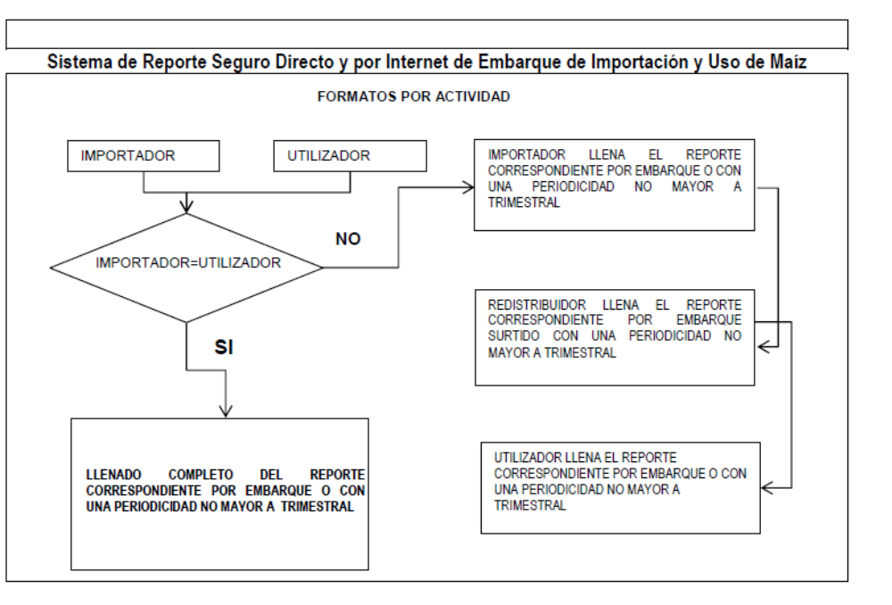

Desde abril de 2013 se enviaron los primeros borradores de los nuevos formatos, a todos los identificados como operadores, para que hicieran sus observaciones y adecuaciones; fue en octubre del mismo año que se circularon para su llenado (de manera retroactiva por todo el año), en el entendido de que en el lapso comprendido de abril a octubre, se estuvo recibiendo retroalimentación, así como capacitando a los actores en el llenado de los formatos.

A la fecha, contamos con los siguientes resultados preliminares: en el año 2013 se importaron 6,343,179.78 toneladas de maíz amarillo procedente de Estados Unidos y Canadá de las cuales se reportaron 2,894,798.51 toneladas con la leyenda puede contener OVMs, equivalente al 45.64% del volumen total de importación (Anexo 6).

iv. Pasos a seguir y perspectiva.

Como se desprende del apartado anterior, todo el año 2013 se reportó con los nuevos formatos, pero cabe reiterar que los mismos fueron circulados y conocidos por los operadores hasta octubre de dicho año, por lo que su llenado fue de manera retroactiva, y como es evidente, apenas se estaban familiarizando para poder adaptar a sus sistemas internos y reglas particulares, el “nuevo” mecanismo de compartir información.

Es por ello, y no obstante la imposibilidad material de enviar en este momento el reporte del primer trimestre del año que corre (2014), que nos encontramos trabajando junto con la industria, para presentar ésta información, así como la del segundo trimestre de 2014 durante la COP-MOP 7.

Con esto llevaremos también un análisis más completo y realista del cumplimiento que puede darse a la letra del artículo 18.2.a, sin generar gastos extra que repercutirían en el consumidor final y en la seguridad alimentaria.

Asimismo, se espera involucrar más directamente al resto de instancias que conforman a la CIBIOGEM, de ser el caso.

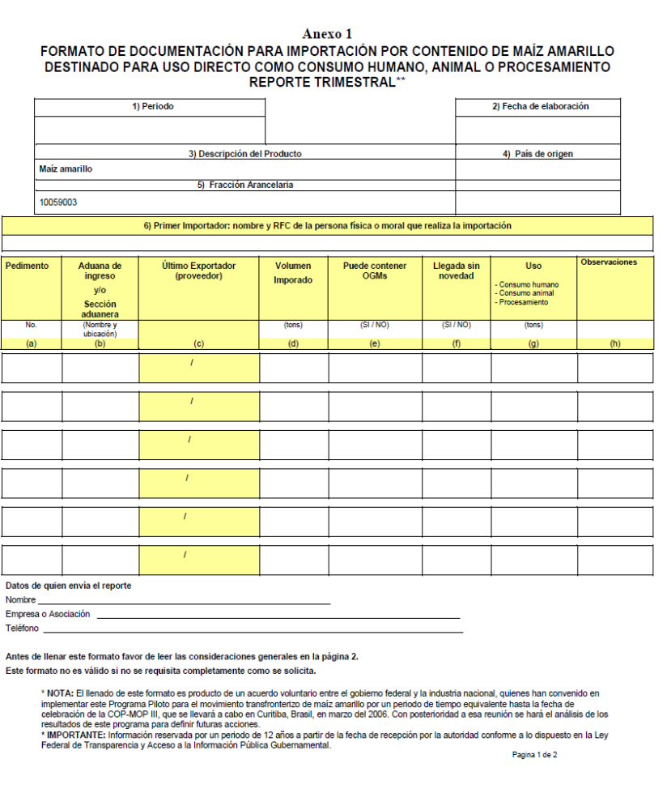
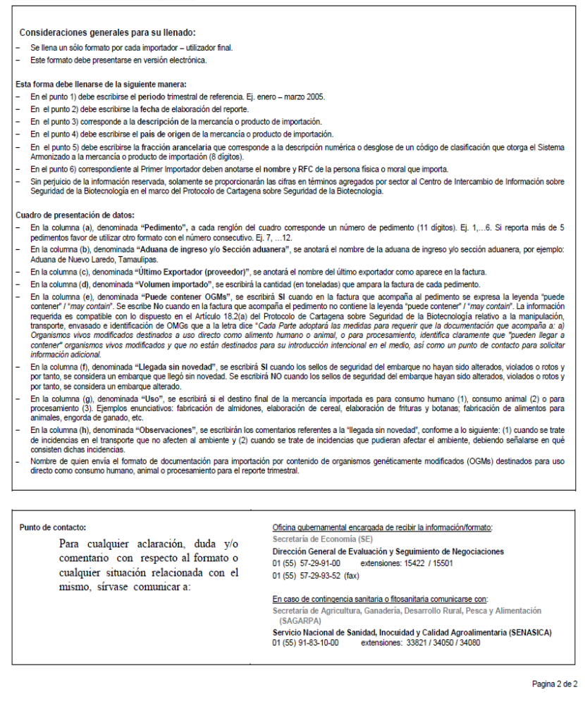

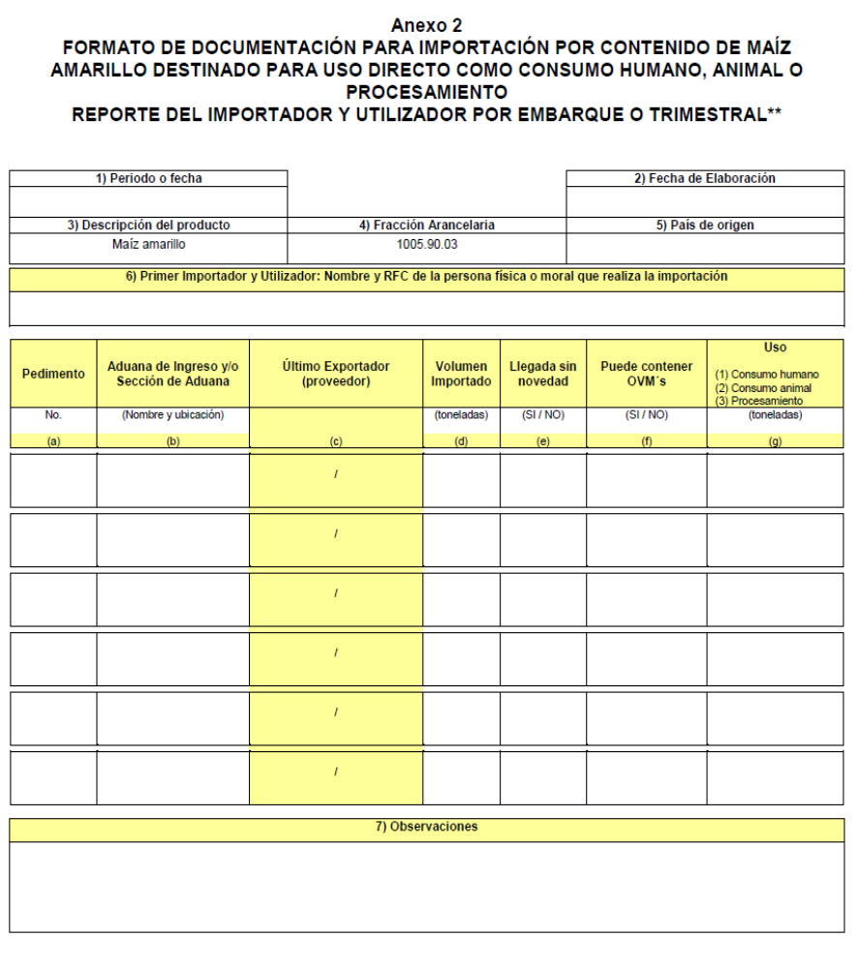
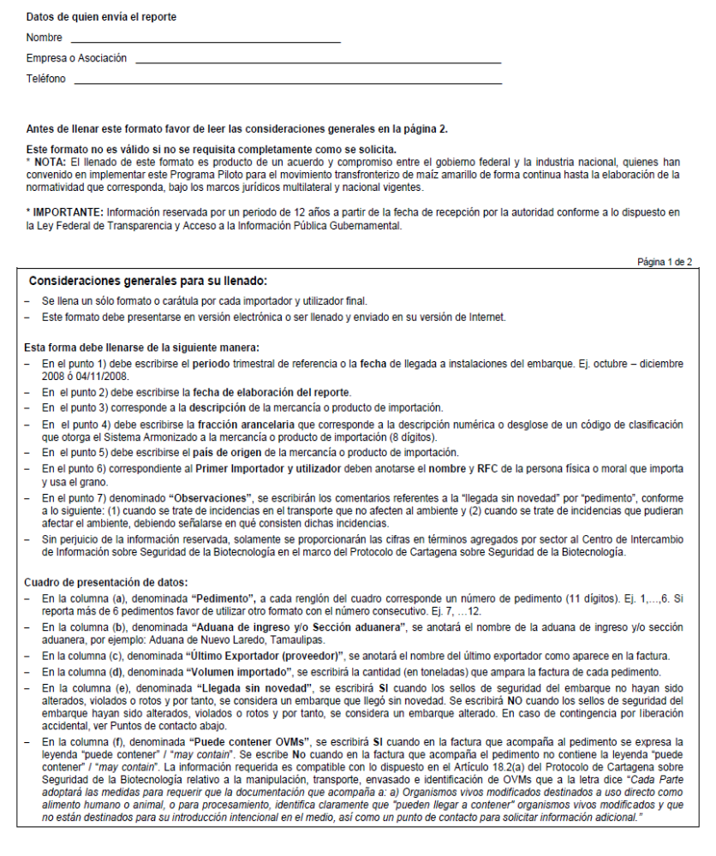

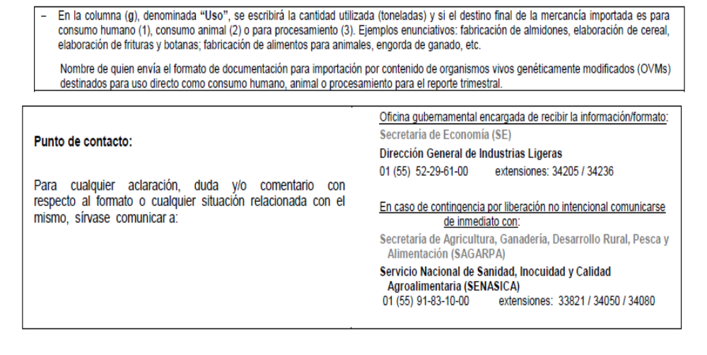

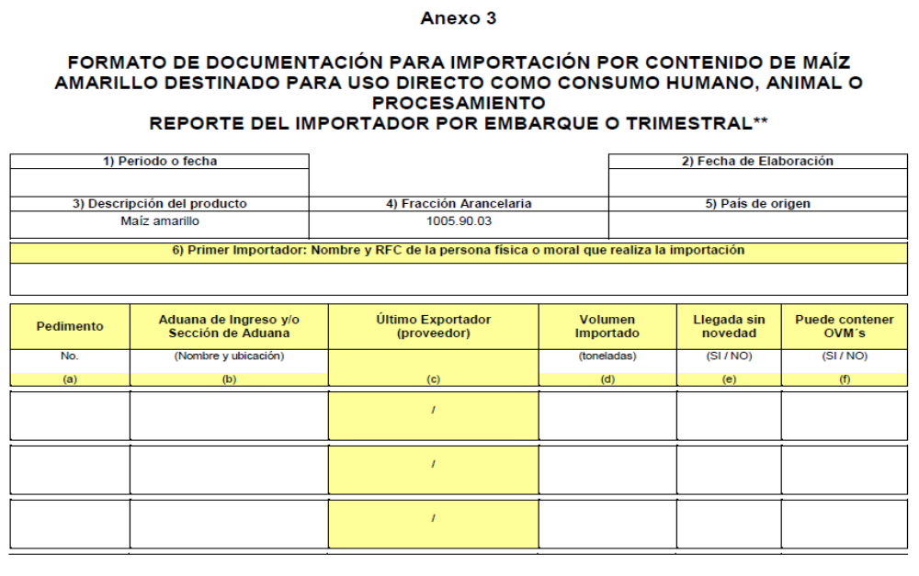
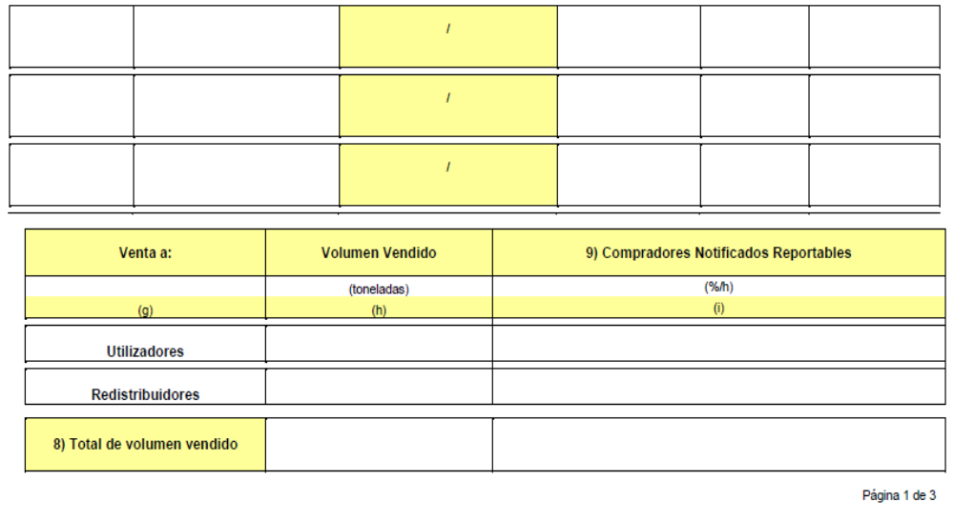
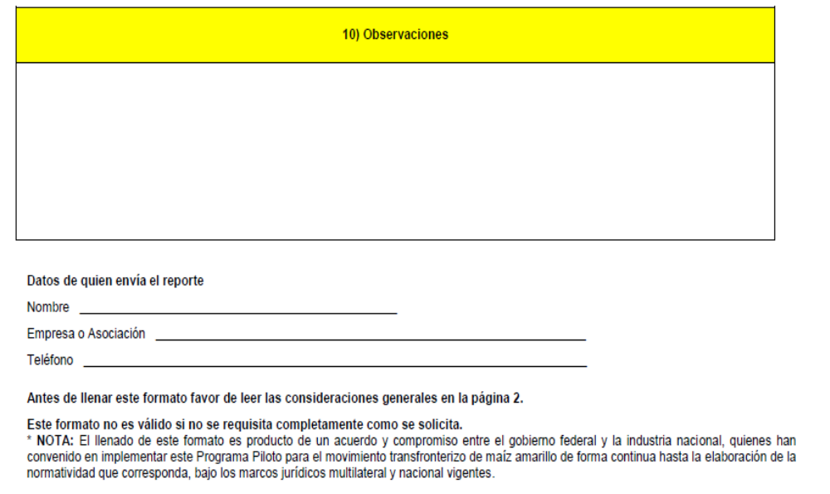
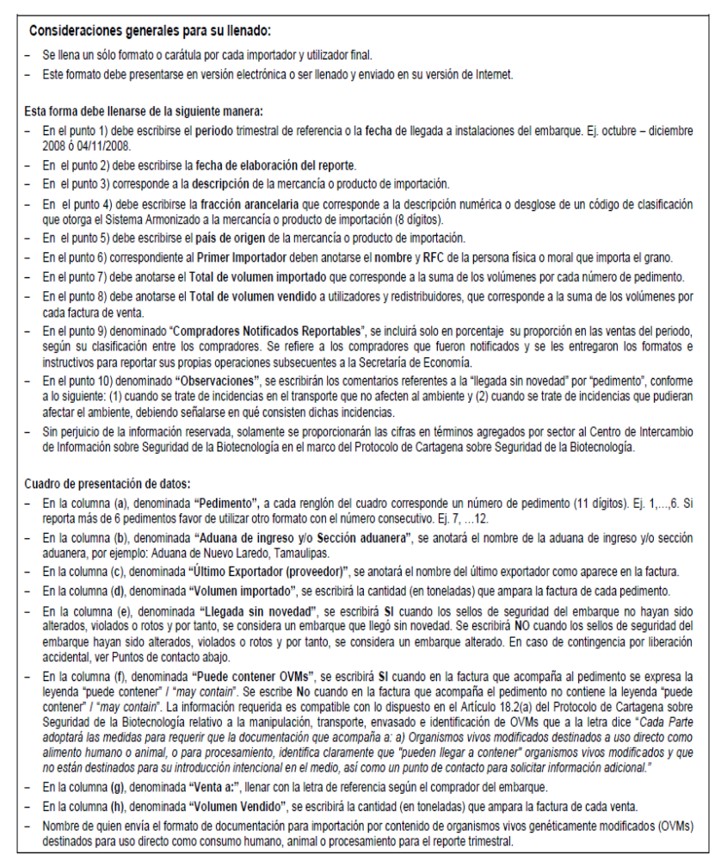

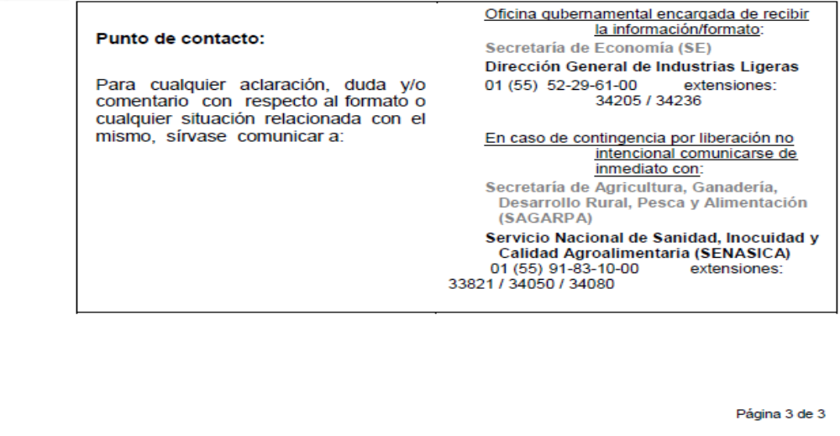
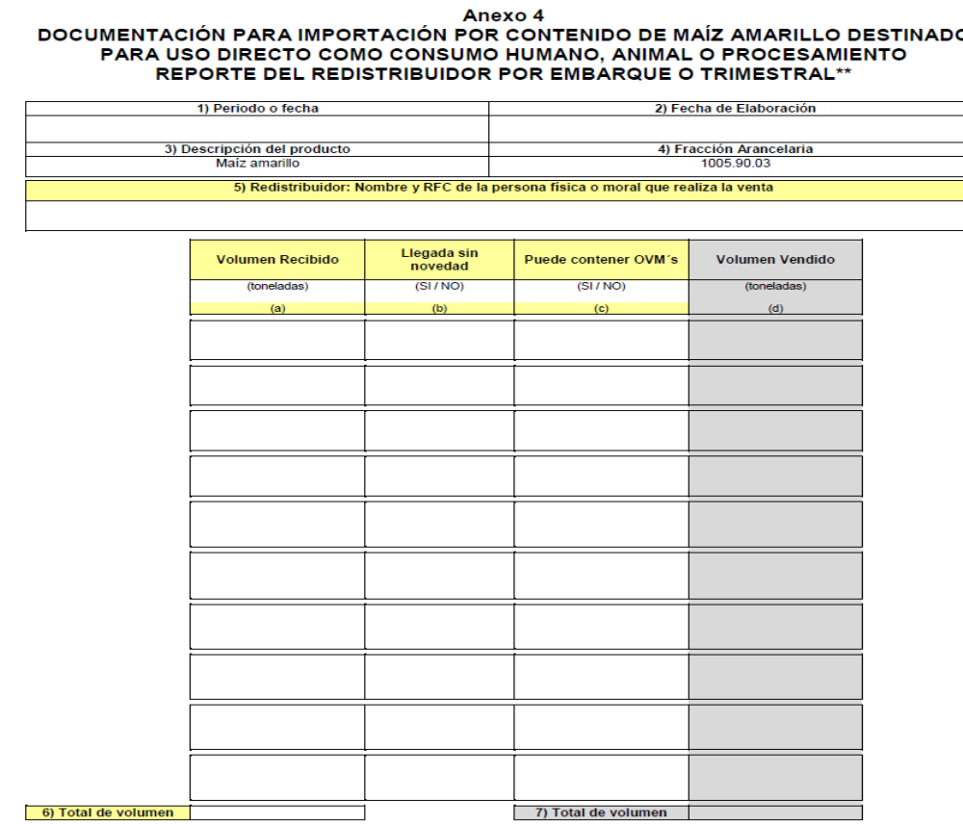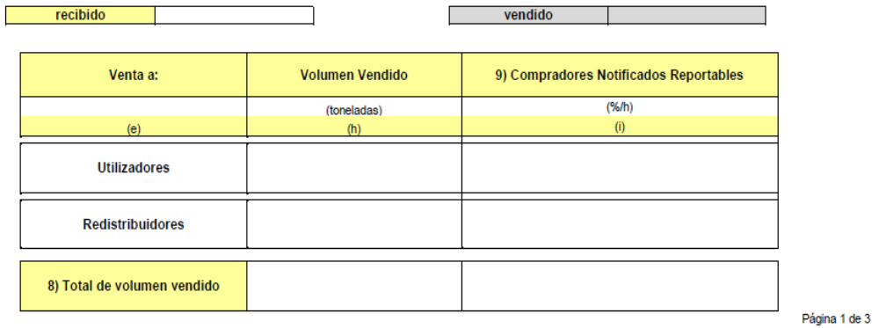

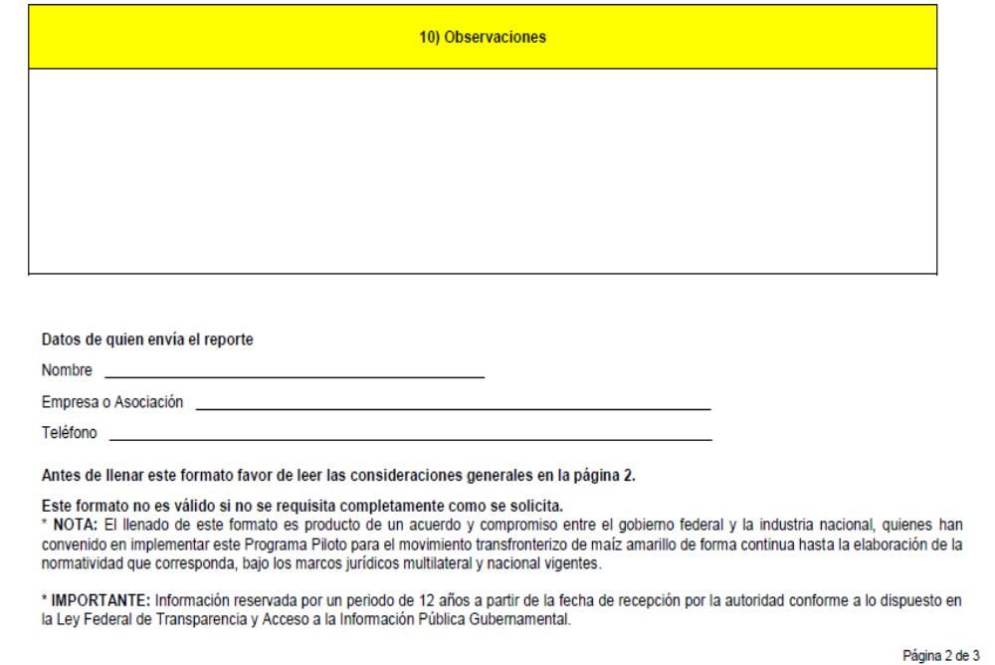
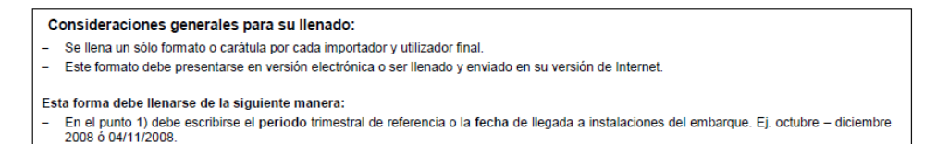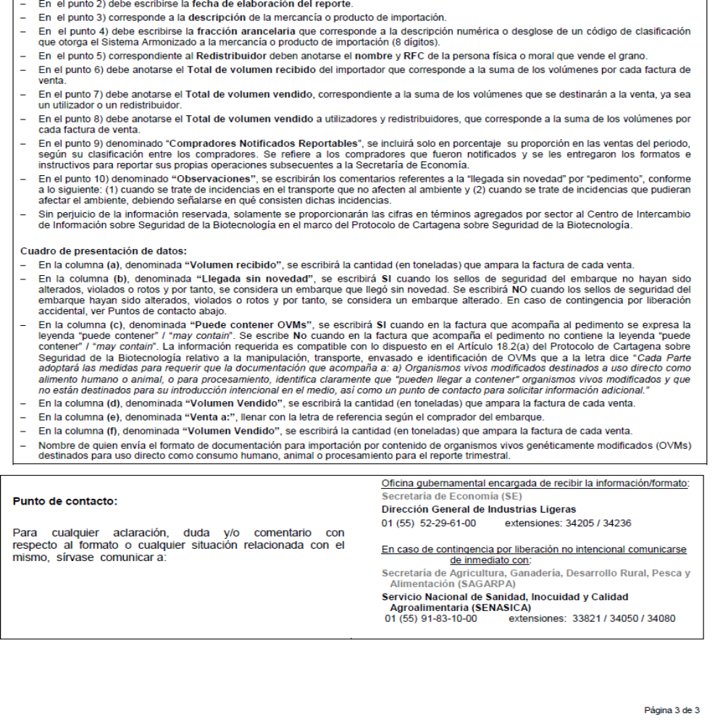
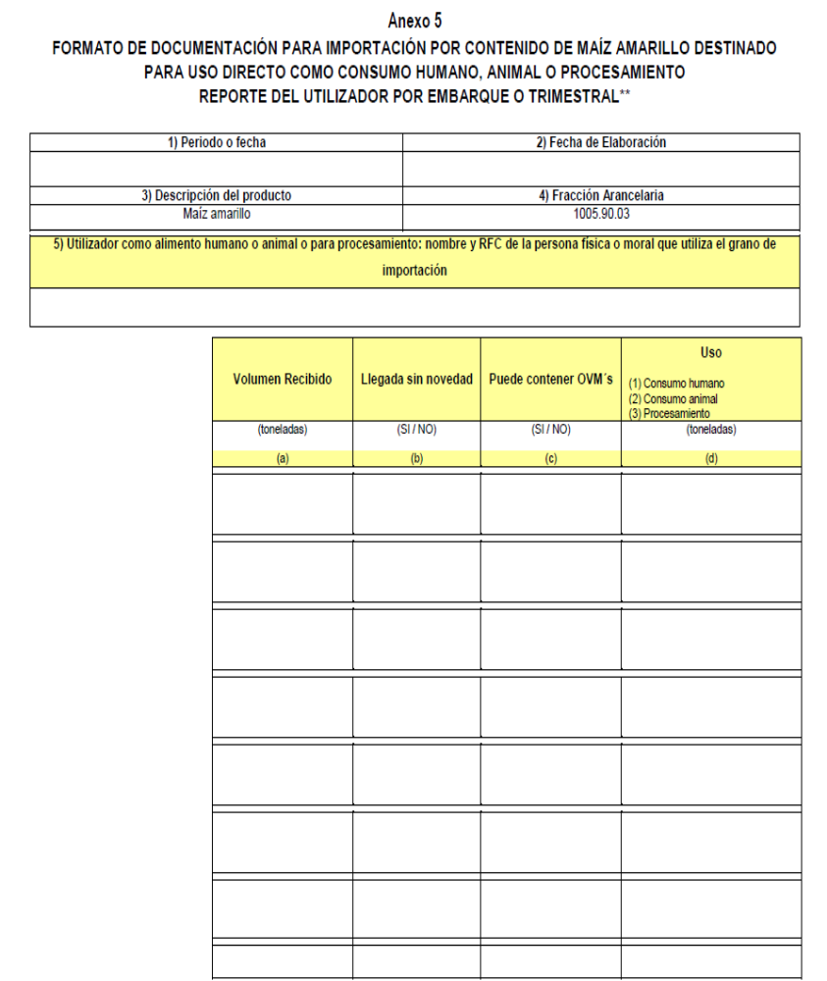
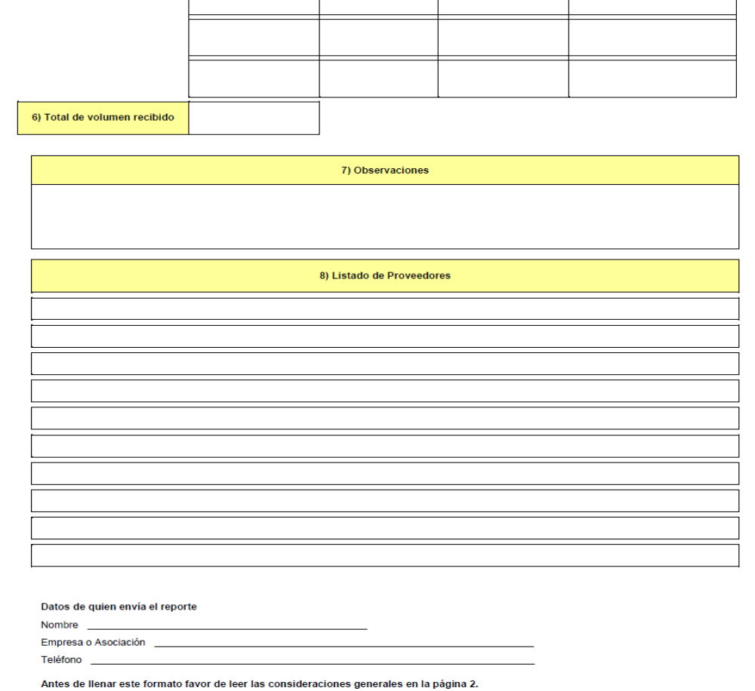

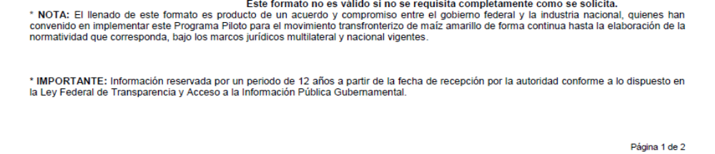
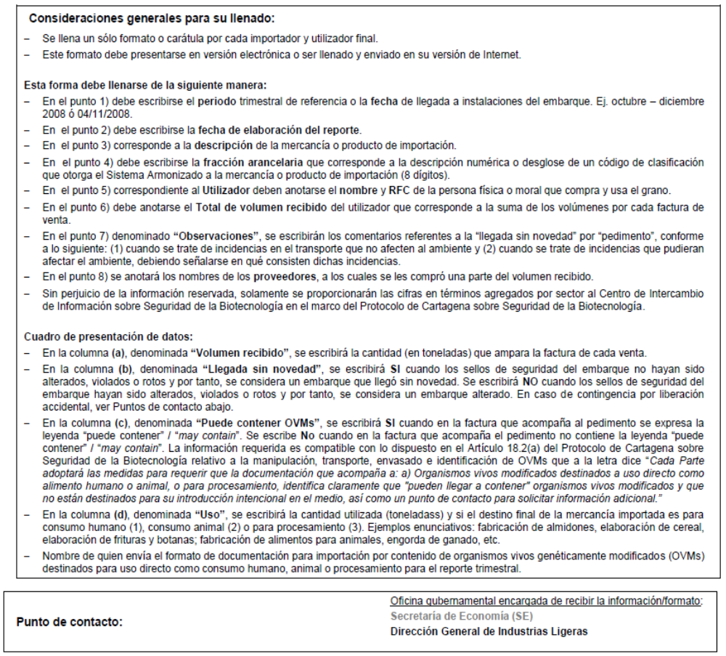
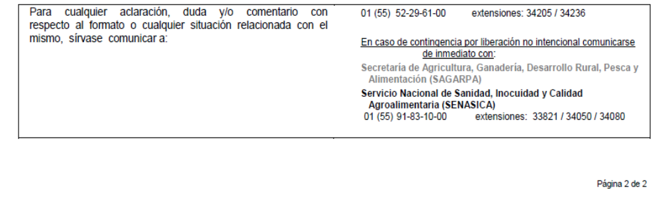
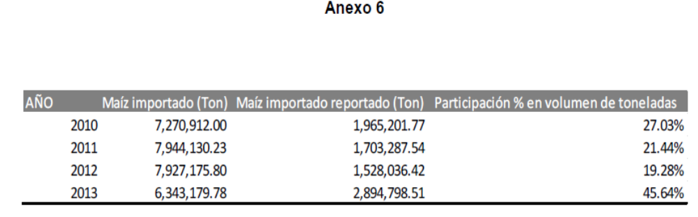

NORWAY [1 APRIL 2014]
[SUBMISSION: ENGLISH]

Paragraph 4 of decision BS-III/10 is implemented through Regulations regarding labelling, transport, import and export of genetically modified organisms (FOR-2005-09-02-1009).
Norway has thus far not had any transboundary movement of LMO-FFPs, and consequently has not gained any experience related to the implementation of the paragraph relevant to the notification.

THE REPUBLIC OF KOREA [2 MAY 2014]
[SUBMISSION: ENGLISH]

According to Article 8 Clause 1 of the “Act on Transboundary Movement of Living Modified Organisms” (hereafter referred to as the “LMO Act”), effective since January 1, 2008, those that want to import LMOs-FFP into Korea must acquire approvals from the related central administrative authorities.

Subsequently, in order to receive import approval, the one must submit an “application for LMO import approval” according to the format of Appendix No. 5 of the Enforcement Ordinance of the same Act, to the related central administrative authority. The application must clearly indicate the (common and scientific) name of the LMOs-FFP to be imported, as well as the transformation event code. It must also include the import quality and (monetary) amount of the respective items.

However, in cases when one does not know accurately the quantity and monetary amount of each event of the imported shipment, codes of transformation events that are likely to be included in the import shipments must be recorded, and instead of data on respective events the whole quantity of and payment for the shipment must be recorded. In addition, a separate document must be attached that indicates the safety management plan and transportation plan necessary for treatment and storage of the LMOs-FFP. As a result, when making a contact on import-export of LMOs-FFP, the importer demands information mentioned above to be included in accompanying documents like commercial invoices. Relating to this, Article 24 Clause 1 of the LMO Act and Article 24 of the Enforcement Decree of the same Act stipulate that the commercial invoice must include the name, type, purpose, and trait of the LMOs-FFP, as well as the contact information of the exporter, and the sentence that the living modified organisms are not intended for intentional introduction into the environment.

At present, exporters actually indicate that their LMOs-FFP shipments “may contain one or more living modified organisms that are intended for direct use as food or feed, or for processing”, and write all codes of transformation events that may be included. They also declare in the commercial invoices that the LMOs are “not intended for intentional introduction into the environment”.

As such, the Republic of Korea is faithfully implementing the procedure for import/export of LMOs-FFP in accordance with the decision (BS-III/10) of the COP-MOP 3, while about 8 million tons of LMOs-FFP has been imported into the Republic of Korea every year since January 2008. We have not experienced any special difficulties regarding implementation of the relevant decision, BS-III/10.

The need for a stand-alone document
As stated above, the Republic of Korea government demands all importers to go through import approval procedure pursuant to the LMO Act. Through import contracts, importers demand exporters to indicate information necessary for such import approval in commercial invoices. Exporters are now providing information adhering to the decision (BS-III/10) of the COP-MOP 3 without special difficulties.
Therefore, to date it has been felt that we do not need another type of accompanying document. Through domestic regulation such as import approval procedure, we have been able to make up for any deficiencies. However, we should agree that we may need additional review of accompanying document and identification factors as types or characteristics of LMOs-FFP are becoming more diversified in the future.

SOUTH AFRICA [18 MARCH 2014]
[SUBMISSION: ENGLISH]

South Africa support the use of relevant standards with regard to handling, transport, packaging and identification of living modified organisms in line with existing standard-setting bodies such as Codex, OIE, etc. South Africa has a well-developed regulatory system in the form of the Genetically Modified Organisms Act, 1997), as amended by Genetically Modified Organisms Act, 2006 (Act No. 23 of 2006). The Act provides for an administrative system through which authorizations for any activity involving GMOs are granted through the issuance of the relevant permit. Consequently, SA supports the use of existing documentation in the form of an export permit issued under national legislation. This eliminates the need for additional stand alone documents to accompany LMO-FFP consignments, which could be perceived as additional trade barriers. SA has incorporated the information requirements in the export permit and currently uses the “may contain” language accompanied by the list of LMO events commercially approved in South Africa.

AUSTRALIA [1 APRIL 2014]
[SUBMISSION: ENGLISH]

Australia provides the following information and experience gained with respect to documentation accompanying living modified organisms (LMOs) intended for direct use as food or feed, or for processing.

Australia’s view is that the ‘may contain’ documentation regime using commercial invoices provides sufficient information about the potential presence of LMOs in import cargoes to importing countries so that they can make appropriate arrangements to manage any risks that the LMOs pose to biodiversity. This approach is practical and in line with current commercial practices and allows industry to meet market needs. It is also a low cost regime.

Any additional documentation requirements would increase the cost of trading grains. The ‘may contain’ approach avoids these costs and the problems associated with unintended presence of approved LMOs in non-LMO cargoes.

Any documentation regime that raises transaction costs is likely to distort world markets for grains and raise the cost of food to consumers by more than the ‘may contain’ regime.

UNITED STATES OF AMERICA [1 APRIL 2014]
[SUBMISSION: ENGLISH]

In response to the request in Decision BS-V8 paragraph 7 to submit further information on experiences gained with the implementation of paragraph 4 of decision BS-III/10, the United States would like to share its experience as a major exporter of living modified organisms (LMOs) intended for food, feed and processing (FFP).

As a non-party to the Protocol, the United States has noted Article 24 in facilitating the transboundary movements of LMO to Parties. In October 2003, Canada, Mexico, and the United States signed a Trilateral Arrangement in providing practical guidance to North America grain and oilseed trade on the implementation of the Article 18.2(a). Although this Agreement predates BS-III/10 by three years, the documentation guidance is consistent between the two. In brief, the Agreement specifies that the “may contain” language should appear on commercial invoices, and the specific “may contain” language is stated as:

“Cartagena Biosafety Protocol Provision: This shipment may contain living modified organism intended for direct use as food or feed, or for processing, that are not intended for intentional introduction into the environment.”

The Trilateral Agreement and the BS-III/10 paragraph 4 are consistent with both commercial trade practices and the Protocol’s environmental objectives with regards to the transboundary movement of LMOs for FFP. The United States is one of the largest exporters of LMOs for FFP. Many of our trading partners who are Parties to the Protocol have implemented documentation requirements as per Decision BS-III/10. In practice and in our experience, the information provided and the mechanism of documentation used by our commercial partners are satisfactory in meeting the needs of importers and Parties. Therefore, it is our opinion that there is no need for guidance and additional work to amend Decision BS-III/10.

SUBMISSIONS FROM ORGANIZATIONS

GLOBAL INDUSTRY COALITION (GIC) [31 MARCH 2014]
[SUBMISSION: ENGLISH]

The Global Industry Coalition (GIC) respectfully submits the view that Parties can implement, and in several cases have implemented, the requirements of paragraph 2(a) of Article 18 as outlined in Decision BS-III/10 in a way that achieves the objectives of the Cartagena Protocol on Biosafety (Protocol), is minimally disruptive to trade and will not be unduly burdensome or costly for Parties. Implementation is already occurring with existing documentation in a way that provides the importing country customs officials with the information they require to make an informed decision to allow import of the material. Making changes to the guidance Parties already provided will disrupt a process that is working and would require new training of customs officials and negate the progress made by Parties and other Governments in implementing Decision BS-III/10 to date. The GIC therefore supports continued use of the language in Decision BS-III/10 to ensure continuity for those Parties and other Governments that have already implemented the decision and encourages Parties to implement the decision if they have not done so already.
The GIC is pleased to submit its views on the implementation of paragraph 2(a) of Article 18 of the Cartagena Protocol on Biosafety in response to the request for information from the Secretariat in accordance with Decision BS-V/8.
Paragraph 7 of BS-V/8 states:
7. Requests Parties and invites other Governments and relevant organizations to submit to the Executive Secretary, no later than six months prior to the seventh meeting of the Parties to the Protocol, further information on experience gained with the implementation of paragraph 4 of decision BS-III/10, as well as the present decision, including any information on obstacles that are encountered in the implementation of these decisions as well as specific capacity-building needs to implement these decisions, and requests the Executive Secretary to compile the information and prepare a synthesis report for consideration by the Parties at their seventh meeting.
In Paragraph 4 of Decision BS-III/10, the Parties provide detailed instructions to identify LMOs where the identity of the material is known, for example by identity preservation, or not known and identified as “may contain”. All the required information from this decision can be and has been adequately conveyed using existing documentation for the past eight years of implementation of Decision BS-III/10.
There are three key sections of this decision:
- Paragraph 4(a) which notes, “In cases where the identity of the living modified organisms is known through means such as identity preservation systems, that the shipment contains living modified organisms that are intended for direct use as food or feed, or for processing;”.
- As this paragraph applies to shipments where the identity of the LMO is known through “means such as identity preservation systems”, the GIC continues to support the use of “contains” in these instances. The LMO is known and purposefully segregated to maintain its integrity so it is possible to identify the LMO(s) in the shipment.
- Paragraph 4(b) which states, “In cases where the identity of the living modified organisms is not known through means such as identity preservation systems, that the shipment may contain one or more living modified organisms that are intended for direct use as food or feed, or for processing;”
- In cases where the identity of the LMOs is not known through means such as identity preservation systems, this section requests that the documentation should state that the commodity in the shipment “may contain” one or more LMOs that are intended for direct use as food or feed, or for processing in commercial production and authorized in accordance with domestic regulatory frameworks, in compliance with the requirements of the country of import.
- This is an appropriate requirement for bulk commodity shipments, as requiring a list of all events that may be in a bulk shipment would require extensive and costly testing and traceability measures to determine what LMOs are in the shipment, and potential associated problems due to ‘false positives’ from sampling errors. Such additional costs would then be passed on to consumers in the form of higher commodity prices. Additionally, with shipments of commodities where there are many commercialized events in the marketplace, it will be meaningless to provide a detailed list of all possible events. Invoices would have to list every possible event approved in the exporting market, resulting in lengthy and confusing shipping documentation if Parties were to make changes to this implementation guidance.
- It is also relevant to highlight that paragraph 5 of Decision BS-III/10 invites Parties to make available through the Biosafety Clearing-House (BCH) “the transformation events that are commercially produced for each planting cycle in the exporting country”. This must be read together with paragraph 4(c), containing the information Parties should provide through the BCH about the events approved for direct use as food or feed, or for processing. In line with those provisions, Parties already have reliable information about the LMOs approved in the exporting country. Additionally, the six largest technology providers share information about commercial status for all products authorized for use by a national authority on a public database available at www.biotradestatus.org.
- Paragraph 6 which states, “[a]cknowledges that the expression “may contain” does not require a listing of living modified organisms of species other than those that constitute the shipment”.
- This is an important section of the decision to highlight as it emphasizes the Parties’ recognition that the “may contain” language only applies to products of the same species as the LMOs intended to be contained in the shipment.

Conclusions

Numerous Parties and other Governments have implemented the provisions contained in Decision BS-III/10 and experience demonstrates that this decision can be implemented in a manner that provides sufficient information to customs officials and Parties to adopt measures aiming to implement paragraph 2(a) of Article 18 with minimal trade disruption. Changing the decision at this time has the potential to create significant trade disruptions by confusing customs officials, generating huge testing and sampling costs with no accuracy guarantee, and undermining the progress made by Parties and Governments in implementation to date. The GIC therefore supports a draft decision for MOP-7 that:

- Requests Parties to the Protocol and urges other Governments to continue to use existing documentation, in most instances a commercial invoice, to list the information required by paragraph 2 (a) of Article 18 and paragraph 4 of decision BS-III/10 to identify LMOs intended for direct use as food or feed, or for processing, as specified in paragraph 1 of decision BS-III/10; and
- Requests Parties and urges other Governments to continue to take measures, including domestic regulatory and/or administrative frameworks that facilitate further implementation of decision BS-III/10, in particular paragraph 4.

INTERNATIONAL GRAIN TRADE COALITION (IGTC) [31 MARCH 2014]
[SUBMISSION: ENGLISH]

Based on our history and experience we offer our comments, as follows:

According to the International Service for the Acquisition of Agri-biotech Applications, global biotech acreage reached 175 million hectares in 2013 and a significant percentage of the global grain trade now involves products produced through modern biotechnology. Therefore it is critically important that Article 18.2(a) which defines the documentation requirements for the transboundary movement of LMOs for food, or feed, or for processing, is implemented in a commercially acceptable manner.

The current widespread practice of documenting the possible presence of Living Modified Organisms on existing commercial documents with a simple “May Contain” clause has been shown to be practical and cost effective for commercial grain trade parties.

As nations have managed the handling, transport, packaging and identification of living modified organisms with the Cartagena Protocol as it has been implemented thus far, exporters and importers have often been able to trade commodities containing living modified organisms in international commerce in accord with the requirements invoked by most countries. In the event policy is not acceptable to the exporters or importers they have the freedom to avoid the trade or inflate their transaction costs to cover the additional or unusual costs that are associated with conformance with the unique requirements in that particular country. In these cases the beneficiaries of trade, including – consumers and the economies in the importing countries that restrict imports, risk insufficient supply, reduced sustainability and higher costs for essential food and energy needs.

The recently released FAO survey on levels of GM crops in international food and animal feed trade showed that 25 countries have blocked imports after finding traces of GMO’s. The incidents have led to trade disruptions between countries with shipments of grain, cereal and other crops being blocked by importing countries and destroyed or returned to the country of origin. The 25 reported incidents are small in the context of the total number of global grain shipments which would be out of a total of more than 10,000 shipments or a very minor percentage of the total.

When regulatory interventions have occurred for reasons that are related to documentation and LMO content, they have been extremely expensive and disruptive to commercial activity. If the 25 instances of shipment rejection identified earlier were an average 50,000 mt cargo of soybeans or maize and the reason for rejection was improper documentation for commodities that have already gone through a CODEX compliant risk assessment process, then more than $100 million and possibly as much as $250 million USD worth of safe food or feed was possibly denied to the food chain.

International trade of grains, oilseeds, pulses, and derived products occurs at low cost margins due to the extremely competitive nature of the business with multiple origins and competitors vying for a finite volume of business. Highly efficient and low margin international trade is only possible when exporters and importers are able to define and manage their trade risks including those due to Living Modified Organisms. The current practice of allowing documentation on existing commercial documents and with the “May Contain” clause comports with the needs of the trade for transparency, simplicity and clarity and minimizes introduction of unknown documentation risks, which translated means lower costs.

Sampling of grain, oilseeds, pulses and derived products is often key to trade facilitation and verification of regulatory compliance. IGTC members believe that existing standards and procedures for sampling grains and oilseeds for other analytical needs including quality and safety are sufficient to sample grains for LMO’s. Sound commercially viable and sufficiently representative sampling methods have been used successfully for decades. There is no need for a separate or unique sampling plan system for GMO analysis.

With regard to sampling, please note that past efforts to develop sampling methods for detection of genetically modified organisms in foodstuffs were considered to be in conflict with work conducted by CODEX Alimentarius; unnecessary. In 2006, similar unnecessary efforts were removed from the program of work of the International Standards Organization (ISO) committee that was addressing the provision. In the ISO Committee deliberations, it was argued that grain is already sampled for many factors and an additional sampling regime as proposed in the foodstuffs standard was and is not practicable in the real world. A separate ISO workshop in 2008 considered the issue of sampling of bulk grains including for the presence of GMO’s in conjunction with a review of ISO 24333 for cereals and cereal products. The experts present at the workshop specifically stated that sampling for the presence of GMO’s should not be addressed separately from the existing sampling practices. The European Technical Specification CEN/TS 15568 includes provisions of ISO standard 21568 for foodstuffs, but it is reportedly seldom, if ever, used. Experts in the field in several different venues have indicated that a separate and unique sampling plan for the presence of GMO’s is not different than sampling plans for other characteristics.
Importers and exporters conducting business among and between the United States of America, Canada and Mexico have found the so-called “Trilateral Accord” covering the commodities traded among the three countries which may contain Living Modified Organisms to be extremely useful and favorable to efficient trade thus far. More details on the practical implications and effectiveness of the ”Trilateral Accord” are recorded in the attached presentation entitled “The Mexican Experience for Documentation Accompanying Food/Feed/Processing Shipments of Living Modified Organisms”.

In summary, the “may contain” language approach on existing documents provides parties the necessary information to use the BCH and their domestic regulatory frameworks to assure that the environment remains protected, while not imposing extra costs on consumers of food and feed which would accompany unnecessary event specific listing and testing requirements. For these reasons it is important that the implementation language continue to allow for “may contain” language on the existing commercial documents.

If additional actions are taken to require extraordinary, additional handling, testing and segregation requirements for the predominant bulk commodity trading system, the global grain trading and food systems will incur increased costs; experience unnecessary delivery delays, and major supply-chain interruptions, which would severely and adversely cripple efforts to address the growing global food security challenge.

NO! GMO CAMPAIGN [2 MAY 2014]
[SUBMISSION: ENGLISH]
We respectfully offer the following comments in preparation for the seventh meeting of the COP-MOP7 regarding decisions BS-V/8 and BS-VI/16.

We are a coalition of civic society organizations and non-governmental organizations that are actively investigating and educating the public as well as discussing with the Japanese government the negative influence that living modified organisms (LMOs), such as genetically modified organisms, are having on biodiversity here in Japan.

During the seventh meeting of the Convention on Biological Diversity and the Cartagena Protocol Conference of the Parties (COP/MOP7) in South Korea later this year, the main themes are the 17th article of the Cartagena Protocol, "Unintentional transboundary movements of living modified organisms" and the 18th article, "Handling, transport, packaging, and identification [labeling] of living modified organisms."

We strongly request strict international rules to be put in place in order to prevent contamination by LMOs, and to avoid the bad influence on biodiversity that this will cause.

Specifically, we have investigated the spontaneous generation of genetically modified canola for ten years. Each year, some 1500 people participate in our investigation campaigns all over the country. We have carefully tested and reported about the findings of wild-growing GM canola growing near the main roads from import harbours leading directly to food oil companies. Also, we have found that the contamination of such GM canola is spreading to other areas including residential areas.

Moreover, we have found a number of cases of complications as the wild-growing GM canola creates hybrids with local varieties of mustard, broccoli and weeds. This indicates clearly the danger of introducing genetically modified organisms into ecosystems which have plants from the same or similar origin. Also, as our experience shows, decontamination is difficult unless massive efforts are made to locate, pick up, test, and destroy wild-growing GM plants.

Based on that, we have the following requests:

Regarding the 18th article, "Handling, transport, packaging, and identification [labeling] of living modified organisms," we ask for measures to be put into practice so that contamination by GM seeds during transport and loading/unloading is prevented. Similarly, measures are needed for labeling to make it possible to access correct and detailed information regarding the contamination cases. Beyond that, we ask for measures to ensure that the current cases of wild-growing GM canola in Japan and the further contamination of local crop varieties and weeds will not spread to the rest of the world.

__________

The Global Industry Coalition (GIC) for the Cartagena Protocol on Biosafety receives input and direction from trade associations representing thousands of companies from all over the world. Participants include associations representing and companies engaged in a variety of industrial sectors such as plant science, seeds, agricultural biotechnology, food production, animal agriculture, human and animal health care, and the environment.

