 |  | CBD
 |  |  |  | Distr.  GENERAL  UNEP/CBD/BS/COP-MOP/7/INF/5  10 June 2014  ENGLISH ONLY
CONFERENCE OF THE PARTIES TO THE CONVENTION ON BIOLOGICAL DIVERSITY SERVING AS THE MEETING OF THE PARTIES TO THE CARTAGENA PROTOCOL ON BIOSAFETY
Seventh meeting
Pyeongchang, Republic of Korea, 29 September-3 October 2014
Item 12 of the provisional agenda∗
OVERVIEW OF THE STATUS OF IMPLEMENTATION OF
OPERATIONAL OBJECTIVES 1.3, 1.4 AND 2.2 OF THE STRATEGIC PLAN FOR THE CARTAGENA PROTOCOL ON BIOSAFETY
Note by the Executive Secretary
- BACKGROUND
- In its decision BS-VI/12, paragraph 13, the Conference of the Parties serving as the meeting of the Parties to the Cartagena Protocol on Biosafety (COP-MOP) requested the Executive Secretary to conduct an online survey on the status of the implementation of operational objectives 1.3, 1.4 and 2.2 of the Strategic Plan for the Cartagena Protocol on Biosafety for the period 2011-2020, where data is missing and cannot be retrieved through existing sources of information available to the Secretariat, with a view to establishing baselines for, and collecting data on, the indicators concerned.
- In its decision BS-V1/15, paragraph 3, the COP-MOP requested the Executive Secretary to undertake a similar survey referred to in paragraph 1 above with a view to gathering information corresponding to all indicators in the Strategic Plan that could not be obtained from the second national reports or through other existing mechanisms and to review the information gathered through the survey and make the results available to the Parties before their seventh meeting.
- Accordingly, on 27 May 2013, the Executive Secretary launched a survey through the Biosafety Clearing-House (BCH) to generate the necessary information to augment the baseline as established in paragraph 2 of decision BS-VI/15 for measuring progress in the implementation of the Protocol.
- The complete set of data gathered through the dedicated survey is available on the BCH at https://bch.cbd.int/database/reports/surveyonindicators.shtml.

- This document provides an analysis of the status of implementation of operational objectives 1.3, 1.4 and 2.2 on the basis of the responses to the survey referred to in paragraph 3 above and previously available information, in response to decision BS-VI/12, paragraph 13, on risk assessment and risk management.
- STATUS OF IMPLEMENTATION OF Operational ObjectiveS 1.3, 1.4 And 2.2
Operational Objective 1.3 (Risk assessment and risk management):
To further develop and support implementation of scientific tools on common approaches to risk assessment and risk management for Parties
Outcomes | Indicators
- Guidance on risk assessment and risk management including guidance on new developments in modern biotechnology  - Common approaches to risk assessment and risk management established and adopted by Parties and other Governments, as appropriate | 1.3.1 Percentage of Parties adopting and using guidance documents on risk assessment and risk management for the purpose of:  - Performing their own risk assessment and risk management;  - Evaluating risk assessment reports submitted by notifiers.  1.3.2 Percentage of Parties adopting common approaches to risk assessment and risk management  1.3.3 Percentage of Parties that undertake actual risk assessment pursuant to the Protocol.
Indicator 1.3.1.1: Percentage of Parties adopting and using guidance documents on risk assessment and risk management for the purpose of performing their own risk assessment and risk management
- In response to the survey question as to whether any guidance documents had been adopted or used for the purpose of conducting risk assessment, 58% of the Parties answered “yes” and 42% answered “no”. Among the developing country Parties, 44% of the respondents answered “yes” and 56% answered “no” to this question (Figure 1a).
- To the question if any guidance documents had been adopted or used for the purpose of conducting risk management, 51% of the Parties answered “yes” and 49% answered “no”. Among the developing country Parties, 36% of the respondents answered “yes” and 64% answered “no” to this question (Figure 1b).

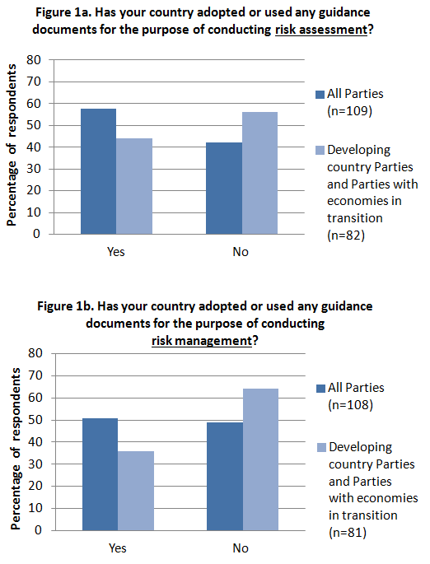
- Sixty four Parties provided comments to these questions. Among these, seven Parties reported that they are using the “Guidance on Risk Assessment of Living Modified Organisms” (LMOs) developed by the Open-ended Online Forum and the Ad Hoc Technical Expert Group (AHTEG) on Risk Assessment and Risk Management. Two other Parties are using the Manual for Risk Assessment of LMOs developed by the CBD Secretariat. Several other Parties reported developing and using their own guidance for risk assessment and risk management, typically based on international standards such as those developed by the Codex Alimentarius Commission and the Organisation for Economic Co-operation and Development. Among the Parties that have not yet adopted any guidance on risk assessment or risk management, some are in the process of developing their own guidance, whereas others indicated that they need capacity building in this regard.
Indicator 1.3.1.2: Percentage of Parties adopting and using guidance documents on risk assessment and risk management for the purpose of evaluating risk assessment reports submitted by notifiers
- In response to the survey question if any guidance documents had been adopted or used for the purpose of evaluating risk assessment reports submitted by notifiers, 47% of the Parties answered “yes” and 53% answered “no”. Among the developing country Parties, 32% of the respondents answered “yes” and 68% answered “no” to this question (Figure 2).
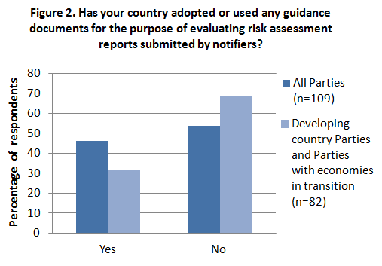
- In their comments to this question, some Parties indicated that they use the same guidance as for indicator 1.3.1.1 above. Other Parties indicated that they do not have any guidance in place to assist in the evaluation of risk assessment reports submitted by notifiers. One Party among those that do not have guidance in place noted that establishing a mechanism for reviewing risk assessment reports submitted by notifiers is a priority for the country.
Indicator 1.3.2: Percentage of Parties adopting common approaches to risk assessment and risk management
- In response to the survey question as to whether a Party had adopted any common approaches to risk assessment with other countries, 37% of the Parties responded “yes”, and 63% responded “no”. Among the developing country Parties, 23% of the respondents answered “yes” and 77% answered “no” to this question (Figure 3).
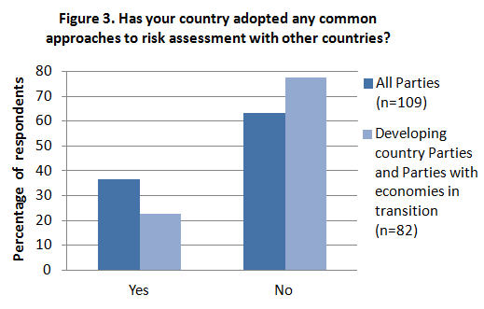
- Among the common approaches to risk assessment listed in the comments to this question are those led by the Common Market for Eastern and Southern Africa (COMESA), Southern Africa Development Community (SADC), Secretariat of the Pacific Regional Environment Programme (SPREP), European Food Safety Authority (EFSA), Codex Alimentarius Commission, Organisation for Economic Co-operation and Development (OECD). Moreover, regional initiatives for developing common approaches to risk assessment are under way among countries of the West African Economic and Monetary Union (WAEMU) and among Caribbean countries.
Indicator 1.3.3: Percentage of Parties that undertake actual risk assessment pursuant to the Protocol
- In response to the survey question if they had ever conducted a risk assessment of an LMO, 39% of the Parties answered “yes”, and 61% answered “no”. Among the developing country Parties, 27% of the respondents answered “yes” and 73% answered “no” to this question (Figure 4).
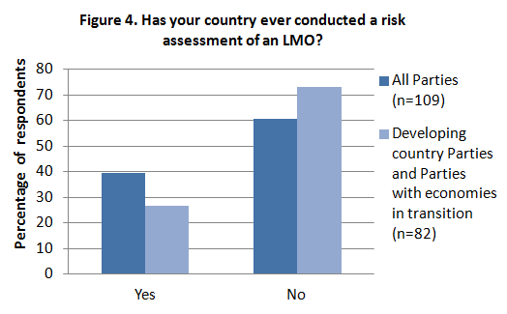
- In their comments to this question, several Parties that answered “no” indicated that they have not yet received any request that triggered the need for a risk assessment. However, among the Parties that answered “no”, there were also several Parties that indicated that they have conducted risk assessments for contained use, direct use as feed, as well as for introductions into the environment for field trials and propagation.
- Among the Parties that answered “yes” to this question, the scopes of their risk assessments included contained use, direct use as food, feed, or for processing, and releases into the environment for various purposes such as field trials, seed propagation and commercial production.

Operational Objective 1.4 (LMOs or traits that may have adverse effects):
To develop modalities for cooperation and guidance in identifying LMOs or specific traits that may have adverse effects on the conservation and sustainable use of biological diversity, taking also into account risks to human health
Outcomes | Indicators
- Modalities developed and put in place  - Parties enabled to identify, assess, and monitor LMOs or specific traits that may have adverse effects | 1.4.1 Guidance on living modified organisms or specific traits that may have adverse effects on the conservation and sustainable use of biological diversity, taking also into account risks to human health, developed by Parties and available  1.4.2 Number of Parties that have the capacity to identify, assess and monitor living modified organisms or specific traits that may have adverse effects on the conservation and sustainable use of biological diversity, taking into account risks to human health.
Indicator 1.4.1: Guidance on living modified organisms or specific traits that may have adverse effects on the conservation and sustainable use of biological diversity, taking also into account risks to human health, developed by Parties and available
- This indicator is meant to measure progress towards the outcome of modalities for cooperation in identifying LMOs or specific traits that may have adverse effects on the conservation and sustainable use of biodiversity, taking also into account risks to human health being developed and put in place. Because, to date, such modalities for cooperation have yet to be developed and put in place, indicator 1.4.1 cannot be measured.
Indicator 1.4.2: Number of Parties that have the capacity to identify, assess and monitor living modified organisms or specific traits that may have adverse effects on the conservation and sustainable use of biological diversity, taking into account risks to human health.
- In response to the survey questions as to whether they have the capacity to identify, assess and/or monitor LMOs or specific traits that may have adverse effects on the conservation and sustainable use of biological diversity, taking into account risks to human health, Parties, and among them developing countries and countries with economies in transition, answered as follows (Figure 5a-c).
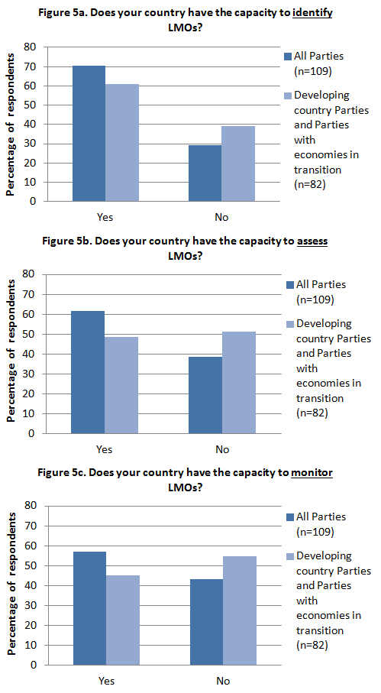
- The comments provided in the form of free-text to these questions varied extensively and were often contradictory of the close-ended responses to the same question. For example, many of the respondents who reported having capacity to identify, assess and monitor LMOs or specific traits that may have adverse effects have noted that their capacity is only limited and still inadequate. Among these, some Parties noted that they lack trained personnel or laboratory facilities or both. One Party also noted that it has the capacity to identify, assess and monitor LMOs and their potential effects on biodiversity, but not to take into account human health.
- An emerging consensus among most Parties that are developing countries or countries with economies in transition is the need for further capacity development, regardless of their responses.

Operational Objective 2.2 (Risk assessment and risk management):
To enable Parties to evaluate, apply, share and carry out risk assessments and establish local science-based capacities to regulate, manage, monitor and control risks of LMOs
Outcomes | Indicators
- Resources, including human resources required to assess risks of living modified organisms are available and administrative mechanisms are in place  - Training materials and technical guidance on risk assessment and risk management developed and used by Parties  - Infrastructure and administrative mechanisms established for the management of risks of living modified organisms at national, subregional or regional level | 2.2.1 Ratio of risk assessment summary reports as against number of decisions on LMOs on the BCH  2.2.2 Number of risk assessment summary reports in the BCH that are in compliance with the Protocol  2.2.3 Number of people trained on risk assessment, as well as in monitoring, management and control of LMOs  2.2.4 Number of Parties that have infrastructure, including laboratories for monitoring, management and control  2.2.5 Number of Parties that are using the developed training materials and technical guidance  2.2.6 Number of Parties that are of the opinion that the training materials and technical guidance are sufficient and effective

Indicator 2.2.1: Ratio of risk assessment summary reports as against number of decisions on LMOs on the BCH
- According to the information provided in document UNEP/CBD/BS/COP-MOP/6/INF/22, 83% of the decisions on “LMOs for intentional introduction into the environment” and/or on “LMOs for direct use as food or feed, or for processing” contain at least one assessment summary attached.
Indicator 2.2.2: Number of risk assessment summary reports in the BCH that are in compliance with the Protocol
- According to the information provided in document UNEP/CBD/BS/COP-MOP/6/3, the number of risk assessment reports submitted to the BCH increased by 56.5%, from 416 in March 2010 to 651 in May 2012.
- However, as noted in document UNEP/CBD/BS/COP-MOP/6/INF/22, it is understood that for a risk assessment summary to be “in compliance with the Protocol”, it must summarize a risk assessment that was carried out in a scientifically sound and transparent basis and on a case-by-case manner for each LMO, its intended use and the likely potential receiving environment. Information related to the number of risk assessment summaries in the BCH that comply with these principles is not available.
Indicator 2.2.3: Number of people trained on risk assessment, as well as in monitoring, management and control of LMOs
- In response to the survey questions on the number of people at the national level that had been trained in risk assessment, monitoring, management and control of LMOs, Parties, and among them developing countries and countries with economies in transition, the answers are as follows (Figure 6a-c):
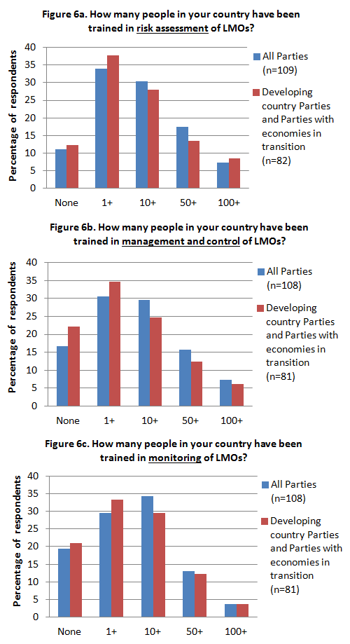
- In their comments to these questions, many Parties, and in particular those that are developing countries or countries with economies in transition, indicated that although they have trained personnel, the training was of short duration and/or at an introductory level and limited to a small number of recipients. Many Parties indicated a need for training and capacity building activities on risk assessment and risk management of LMOs that are more in-depth and specifically designed for their needs.
Indicator 2.2.4: Number of Parties that have infrastructure, including laboratories for monitoring, management and control
- In response to the question as to whether they have the infrastructure (e.g. laboratory facilities) for monitoring or managing LMOs, 73% of the Parties answered “yes” and 27% answered “no”. Among the Parties that are developing countries or countries with economies in transition, 65% answered “yes” and 35% answered “no” (Figure 7).
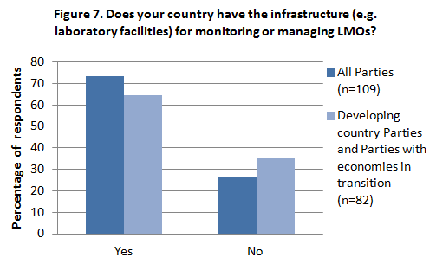
- Among the respondents that provided comments to this question, some indicated that they have some laboratory facilities but that these are not specifically designed for monitoring or managing LMOs. Some Parties noted that their existing laboratories have very limited capacity for detection and monitoring of LMOs and requested financial support to enhance their capacities.
Indicator 2.2.5: Number of Parties that are using the developed training materials and technical guidance
- In response to the survey question as to whether they were using training material and/or technical guidance for training in risk assessment and risk management of LMOs, 61% of the Parties answered “yes” and 39% answered “no”. Among the Parties that are developing countries or countries with economies in transition, 51% answered “yes” and 49% answered “no” (Figure 8).
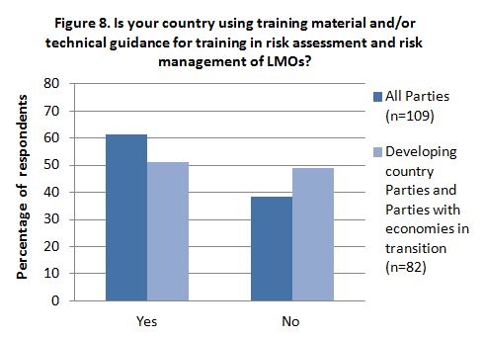
- Among the 51 Parties that provided comments to this question, some referred to training material and/or technical guidance for training in risk assessment and risk management of LMOs during the preparation of their National Biosafety Frameworks under the UNEP-GEF project. A number of other Parties answered that they are using the Guidance on Risk Assessment of Living Modified Organisms developed through the CBD’s "Open-ended Online Forum" and the Ad Hoc Technical Expert Group (AHTEG). Some Parties reported using guidance developed by the Codex Alimentarius Commission and the Organization for Economic Co-operation Development. Some Parties that are members of the European Union reported the use of guidance developed by the Joint Research Centre of the European Commission and by the European Food Safety Authority. An African Party also cited the African Model Law as a source.
Indicator 2.2.6: Number of Parties that are of the opinion that the training materials and technical guidance are sufficient and effective
- In response to the question as to whether the available training materials and technical guidance on risk assessment and risk management of LMOs are sufficient, 45% of the Parties responded “yes” and 55% “no”. From among the Parties that are developing countries, 31% answered that the materials are sufficient and 69% that they are insufficient (Figure 9a).
- In response to the question as to whether the available training materials and technical guidance on risk assessment and risk management of LMOs are efficient, 49% of the Parties answered “yes” and 51% answered “no”. From among the Parties that are developing countries, 33% answered that the materials are efficient and 67% that they are inefficient (Figure 9b).
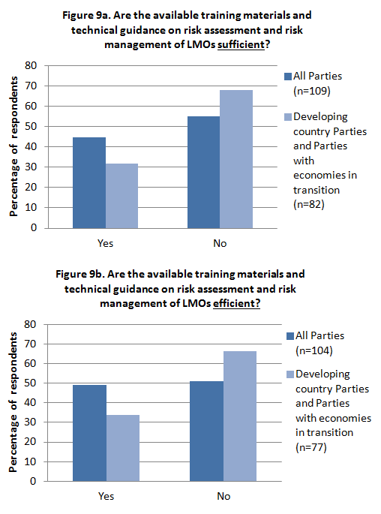
- In their comments to this question, Parties identified a number of needs and gaps including, for example, that (i) further training materials and technical guidance documents on risk assessment and risk management of LMOs are necessary, particularly for countries that lack the capacity to develop their own materials; (ii) materials and guidance need to be adjusted to the local conditions when conducting training on risk assessment and risk management at the national level; (iii) technical guides need more details on a “case by case” basis; and (iv) training is needed even in cases where guidance is already available.
- Several Parties noted that new guidance on specific topics of risk assessment and risk management is needed to keep abreast with fast expansion in modern biotechnology. They identified the following gaps and needs for further guidance:
- Risk assessment of local LM crops
- Risk assessment of LMOs containing iRNA
- Risk assessment of LM animals
- Risk assessment of LM fish
- Risk assessment of LM insects
- Risk assessment for introduction of LMOs in centres of origin
- Risk assessment for introduction of LMOs in megadiverse environments
- Risk assessment of LMOs taking into account socio-economic considerations
- Risk assessment of LMOs taking into account human health and food

- EMERGING TRENDS AND CONCLUDING REMARKS
Guidance and training material
- The results of the survey indicate a significant difference in how developed country Parties and developing country Parties or Parties with economies in transition evaluate the availability and efficiency of the available training materials and technical guidance on risk assessment and risk management.
- The majority (69%) of Parties that are developing countries or countries with economies in transition, consider that the existing guidance on risk assessment and risk management are not sufficient. Several gaps and needs related to guidance on risk assessment were identified as per paragraph 29 above.
- The gaps and needs identified by the Parties may be taken into account by the AHTEG on Risk Assessment and Risk Management and the COP-MOP when considering how to proceed with respect to the development of further guidance on specific topics of risk assessment as per paragraph 3(c) of the annex to decision BS-VI/12.
Capacity building
- The number of people trained in risk assessment, risk management or monitoring of LMOs is higher among Parties that are developed countries than among those that are developing countries or countries with economies in transition.
- Among all the Parties, the number of people trained in risk assessment of LMOs is higher than the number of people trained in risk management or monitoring. Approximately 20% of all Parties do not have any personnel trained in monitoring of LMOs.
- Over 20% of the Parties that are developing countries or countries with economies in transition do not have any personnel trained in risk management.
- The need for more in-depth capacity building activities on risk assessment, risk management and monitoring was identified by many Parties.

Experience in conducting actual risk assessments
- Less than 40% of the Parties to the Protocol indicated that they have carried out risk assessments of LMOs in their answers to the survey. In contract, during a recent survey conducted by the FAO, more than 70% of the 75 respondents indicated that they have conducted environmental assessments of LM crops.
- The discrepancy between the results of the CBD and FAO surveys may be due, at least in part, to the fact that, in the CBD survey, several Parties that indicated that they had not conducted actual risk assessments of LMOs have in fact, as indicated in their comments, conducted risk assessments of LMOs for contained use, field trials, propagation or for direct use as food, feed, or for processing.
- Based on these observations, the total number of Parties that have conducted actual risk assessments of LMO is expected to be considerably higher than that indicated in paragraph 13 above.
- A different approach is needed, e.g. a revised question in the format for the Third National Report on the implementation of the Protocol, to establish a meaningful baseline and for measuring progress in the percentage of Parties that undertake actual risk assessments pursuant to the Protocol.
LMOs or traits that may have adverse effects
- Challenges were encountered in measuring progress towards the operational objective on LMOs or traits that may have adverse effects. Firstly, modalities for cooperation for the identification of such LMOs or traits have not yet been put in place. Secondly, the answers to the survey questions related to indicator 1.4.2 were ambiguous in that the closed- and open-answers were not consistent.
- The only emerging trend that could be drawn from the responses related to the status of implementation towards the outcomes related to LMOs or traits that may have adverse effects is that many Parties, in particular those that are developing countries and countries with economies in transition identified a need for more capacity building in this area.
-----

This document was previously published as UNEP/CBD/BS/AHTEG-RA&RM/5/5 on 23 May 2014.
 UNEP/CBD/BS/COP-MOP/7/1.
The online survey is available at https://bch.cbd.int/managementcentre/register/2ndNatRepAddendum.shtml.
Most of the data presented in this analysis originate from the survey referred to in paragraph 3 above. The only exception are the data presented in paragraphs 20 to 22 below, which originate from previously published documents based on information contained in the BCH.
Available at http://bch.cbd.int/protocol/meetings/documents.shtml?eventid=4715.
Available at http://bch.cbd.int/protocol/meetings/documents.shtml?eventid=4715.
The results of the FAO survey on “Technical Consultation on Low Levels of Genetically Modified (GM) Crops in International Food and Feed Trade” are available at http://www.fao.org/fileadmin/user_upload/agns/topics/LLP/AGD803_4_Final_En.pdf.

