 |  |  | CBD
 |  | CONVENTION ON  BIOLOGICAL DIVERSITY |  |  | Distr.  GENERAL  UNEP/CBD/COP/7/INF/33  20 January 2004  ENGLISH ONLY
CONFERENCE OF THE PARTIES TO THE CONVENTION ON BIOLOGICAL DIVERSITY
Seventh meeting
Kuala Lumpur, 9-20 and 27 February 2004
Item 26 of the provisional agenda*

Provisional Global Indicators for assessing progress
towards the 2010 Biodiversity target

Note by the Executive Secretary

I. INTRODUCTION
- The Inter-Sessional Meeting on the Multi-Year Programme of Work of the Conference of the Parties up to 2010 recommended that the Conference of the Parties at its seventh meeting requests the Executive Secretary to develop a framework for evaluation of progress, including indicators (recommendation 2, paragraph 3 (a)). At its ninth meeting the Subsidiary Body on Scientific, Technical and Technological Advice (SBSTTA) made recommendations to the Conference of the Parties (COP) concerning the design of national-level monitoring programmes and indicators (recommendation IX/10). SBSTTA also recommended to the Conference of the Parties that a limited number of trial indicators be developed, tested and reviewed by SBSTTA prior to the eighth meeting of the Conference of the Parties. These global-level indicators should be selected to effectively communicate trends in the status of biodiversity and the impacts on ecosystem goods and services and human well-being during the present decade. They would be adapted or derived from the report of the London meeting (UNEP/CBD/SBSTTA/9/INF/9), the note by the Executive Secretary on proposed biodiversity indicators relevant to the 2010 target (UNEP/CBD/SBSTTA/9/INF/26) and the note by the Executive Secretary on using existing processes as building blocks in reporting on the 2010 target (UNEP/CBD/SBSTTA/9/INF/27), for which data are available from existing sources.
- In its recommendation IX/13, SBSTTA suggested that the following five indicators should be tested immediately:
    - Trends in extent of selected biomes, ecosystems and habitats;
    - Trends in abundance and distribution of selected species;
    - Change in status of threatened species;
    - Trends in genetic diversity of domesticated animals, cultivated plants, and fish species of major socioeconomic importance;
    - Coverage of protected areas;
and that indicators for the following should be developed:
(f) Threats to biodiversity;
(g) Ecosystem goods and services; and
(h) Equitable sharing of benefits arising from the use of genetic resources.
- On the basis of this guidance, the note by the Executive Secretary on the implementation of the Strategic Plan: Evaluation of progress towards the 2010 biodiversity target: development of specific targets, indicators and a reporting framework (UNEP/CBD/COP/7/20/Add.3) proposes a set of global indicators, which would allow the assessment of progress towards the achievement of the goals and targets suggested in the same document. In addition to the five indicators to be tested immediately, the following six indicators are proposed for developing and testing:
- Criteria and indicators for sustainable management of ecosystems;
- Biodiversity used in food and medicine; and
- Trophic integrity of ecosystems;
- Water quality in aquatic ecosystems;
- Nitrogen deposition;
- Numbers and cost of alien invasions.
- These indicators of threats to biodiversity and of goods and services are intended to complement the five more conservation-oriented indicators. Additionally, as proposed in document UNEP/CBD/COP/7/20/Add.3, indicators for the equitable sharing of benefits arising from the use of genetic resources and on the state of traditional knowledge might be developed respectively by the Ad Hoc Open-ended Working Group on Access and Benefit-Sharing and the Ad Hoc Open-ended Working Group on Article 8(j) and related provisions.
- The present note has been prepared by the Executive Secretary to provide additional technical background information on the provisional set of global indicators for assessing progress towards the 2010 biodiversity target contained in annex III of document UNEP/CBD/COP/7/20/Add.3. It illustrates the possible application of the indicators and the types of data available, and complements the document on Proposed biodiversity indicators relevant to the 2010 target (UNEP/CBD/SBSTTA/9/INF/26). The annex to this document summarizes the status of development or implementation and data availability for these indicators.
II. Rationale for the proposed set of global indicators and their limitations
- The proposed indicators have been selected on the basis of data availability and relevance to the objectives of the Convention in general, and in areas that have been identified as central to monitoring progress towards the 2010 biodiversity target. They would also contribute to measuring progress towards the Millennium Development Goals, in particular goal 7 (“Ensure environmental sustainability”).
- The eleven proposed indicators are complementary and allow monitoring of progress towards the 2010 target within the scope of the first two objectives of the Convention. As a set, they attempt to provide sufficient and reliable information on biodiversity trends without a proliferation of indicators. The indicators should be considered as a means of evaluating progress towards an end, not as goals in themselves.
- The indicators have been strategically selected to address key issues relevant to the Convention without duplicating efforts already undertaken or planned elsewhere. They should be seen as complementary to global indicators evolving within other environmental and/or development efforts such as those by UNDP and UNFCCC.
- While attempting the widest possible coverage of the range of issues covered by the Convention, it is recognized that the set of eleven proposed indicators cannot comprehensively address all aspects of biodiversity. The focus has therefore been placed on indicators, which can effectively communicate trends in the status of biodiversity, pressures on or threats to biodiversity, and the impacts on ecosystem goods and services and human well-being.
- Some of the major threats to biodiversity listed in SBSTTA recommendation IX/13 (para 2 (a) (ii)) are not assessed through separate indicators. Climate change, for example, will be assessed using the UNFCCC process. Other conventions, processes, international assessments, agencies, networks and initiatives also provide valuable information in assessing progress towards achievement of the 2010 target and efforts need to be made to make full use of this information. / Habitat change can be assessed through the indicators on trends in extent of selected biomes, ecosystems and habitats combined with indicators on the quality of habitats (e.g. trends in abundance and distribution of selected species and trophic integrity).
- In some cases, measures of abiotic factors are considered to be helpful, particularly as data are easier to obtain and their influence on habitats and species composition is well understood. For this reason, water quality and nitrogen deposition are proposed both as indicators of habitat quality and of the pressures on biodiversity.
- The following section provides information on the proposed indicators.
III. Data availability for the Proposed global Indicators
Global Indicator 1: Trends in extent of selected biomes, ecosystems and habitats
- The indicator for Trends in extent of selected biomes, ecosystems and habitats provides a direct measure of changes in ecosystem quantity. Data are available systematically for selected biomes, ecosystems and habitats such as natural and semi-natural forests, selected wetlands and coral reefs. Aggregated indices of “natural ecosystems” are available for some countries only and face definitional problems.
- Fact sheets relating to the size of ecosystem type, including for some specific ecosystem types such as forests, coral reefs, mangroves and sea grass beds, were presented in documents UNEP/CBD/SBSTTA/9/INF/7 and UNEP/CBD/SBSTTA/9/INF/26.
- Over millennia, human societies have modified natural habitats through a variety of land and water-use practices. The world’s major biomes have been affected to different degrees by large scale conversion of natural habitats into production or waste lands resulting in the reduction and fragmentation of natural habitat leading to the reduction of ecosystem diversity, loss of species and ecosystem services.
- Over time, changes in land cover and extent of habitats can be measured by comparing satellite images and other remote sensing information. This method makes it possible to generate, at comparatively low cost, a detailed picture of habitat change across large areas.
- Estimates of changes in forest cover are already being assessed globally by the Food and Agriculture Organization of the United Nations (FAO), based primarily on information provided by countries in response to a questionnaire. The Global Forest Resources Assessments (FRA) / are carried out at ten-year intervals allowing a direct comparison of forest area (Figure 1). An update on this assessment has been made available to SBSTTA (UNEP/CBD/SBSTTA/9/INF/37). The next assessment will be published in 2010.
- The Global Forest Resources Assessment 2000 (FRA2000) provides little information about ecosystem quality. It is envisaged that the forthcoming assessment FRA2010 will include more information on biodiversity in forests. Information on “ecosystem extent” needs to be considered in conjunction with information on ecosystem quality provided through other indictors (such as species abundance, sustainable management and trophic integrity) to give a more complete picture. Alternatively, indictors of forest extent, such as that provided through FRA could be supplemented by indicators of forest degradation and fragmentation. Such indicators might be derived from road density (include that of temporary logging roads), canopy cover class, biomass index or an index on vulnerability to fire.

Figure 1. Estimated change in natural forest area in the tropical and non-tropical region 1990-2000
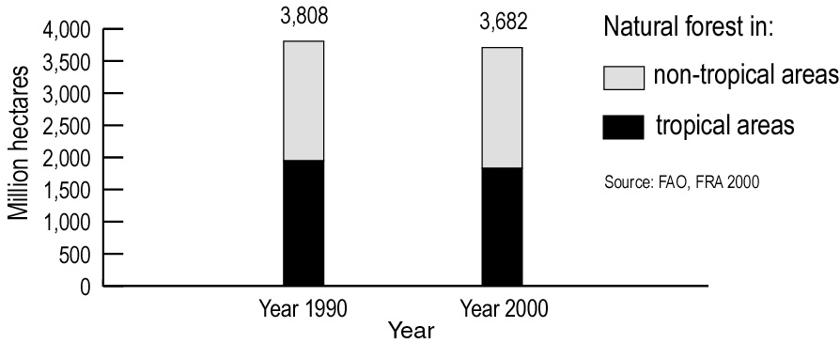

- Other assessments of specific ecosystem types include:
- An assessment of the Global Peat Resources / provides a compilation of available information on the total worldwide peatland area, which provides a reference to the 1990s of the extent of peatlands. The Global Peatlands Initiative, led by Wetlands International, prepared a 2002 map of approximate global peatland distribution. / The Guidelines for Global Action on Peatlands (GAP), adopted in Resolution VIII.17 of the Ramsar Convention foresee the establishment of a global database of peatlands which should be compiled in the first instance from sources of existing information, brought into line with the agreed standardized terminology and classification systems for peatlands, and should include baseline information on the distribution, size, quality, ecological characteristics and biological diversity of the resource;
- A world mangrove atlas prepared by UNEP-WCMC. / Mangrove forests are among the world's most biologically diverse and productive systems. They occupy about 17 million hectares of tropical coast worldwide and line about 25 per cent of tropical coastlines. / Mangroves are being lost at an estimated 100,000 hectares a year worldwide (ITTO 2003); /
- A world atlas of coral reefs, also prepared by UNEP-WCMC, / and the biannual country-by-country assessments on the status of coral reefs of the world prepared by the Global Coral Reef Monitoring Network. / According to UNEP-WCMC, 10% of the world's reefs are seriously degraded and many more are threatened; /
- A world atlas of seagrasses, also just published by UNEP-WCMC, / which summarizes the global status of seagrass beds. Seagrasses are valuable structural, functional and economic components of coastal ecosystems. Documented losses indicate that 900 km² of seagrass habitat have been lost over the last ten years (ICRI 2000); /
- The Global Marine Assessment (GMA), which, in accordance with the WSSD Plan of Implementation, / is being established as a regular process under the United Nations for global reporting and assessment of the state of the marine environment, including socio-economic aspects, both current and foreseeable, building on existing regional assessments;
- The Millennium Coral Reef Mapping Project / uses a consistent data set of high-resolution (30 metre) multispectral Landsat 7 images acquired between 1999 and 2003. Based on these data sets, the Institute for Marine Remote Sensing at the University of South Florida is developing the first global uniform map of shallow coral reef ecosystems.
- The regular repetition of such assessments will provide monitoring information for ecosystem types of critical importance.
- In addition to the above-mentioned biome- or ecosystem-specific monitoring programmes focusing on selected key ecosystems, global surveys have been carried out. Trends in the extent of terrestrial, and in some cases marine, ecosystems more generally can be monitored by comparison of remotely sensed data sets from different years. Both optical and radar sensors have been used to map land use and a number of global maps have been prepared using different sensors and operating at different resolutions.
- The Global Land Cover Characteristics database / is based on the International Geosphere Biosphere Programme (IGBP) 1-km AVHRR 10-day composites for April 1992 through March 1993 and distinguishes 94 ecosystem classes that are based on their land cover mosaic, floristic properties, climate, and physiognomy;
- The Global Land Cover 2000 project (GLC 2000) / was based on daily observations of the planet's land surface between 1 November 1999 and 31 December 2000 with the “VEGETATION” sensor of the SPOT-4 satellite producing imagery at 1-km resolution. It has been anticipated that such a global environmental assessment should be done every 5 years;
- A number of continuous field land cover products using MODIS 500 metre data; /
- The Sea-viewing Wide Field-of-view Sensor (SeaWiFS) project / collects, since mid 1997, quantitative data on global ocean bio-optical properties, which provide information on the various types and quantities of marine phytoplankton. Ocean colour data are considered critical for the study of ocean primary production and global biogeochemistry.
- Although these projects provide environmental information over very large regions or inaccessible areas, it is uncertain whether they will be repeated or, in the case of SeaWiFS continued, to provide comparable data, which would allow the detection of change over time.
- Orthorectified Landsat images (resolution 30 metre) for the 1990s and 2000 have been recently made available by NASA to UNEP. UNEP is in process of distributing these data sets to every developing country in the world. Potentially this offers a solution to monitoring changes in distribution and extent of habitats. However, there is currently no operational programme to use these data sets to derive information for biodiversity assessment.
Global Indicator 2: Trends in abundance and distribution of selected species
- The indicator on Trends in abundance and distribution of selected species provides a direct measure of changes of species’ status for well-monitored taxonomic groups. Biome-specific data also provide an indicator of ecosystem quality, complementing Global Indicator 1. Species assemblage population indices are available for marine, freshwater and forest systems (aggregated as the Living Planet Index). Bird population indices also cover agricultural ecosystems. Data are more complete for developed country regions
- A fact sheet on trends in species abundance and a species assemblage trends index was included in the report of the Expert meeting on indicators of biological diversity including indicators for rapid assessment of inland water ecosystems (UNEP/CBD/SBSTTA/9/INF/7) and the proposed biodiversity indicators relevant to the 2010 target (UNEP/CBD/SBSTTA/9/INF/26). A document prepared for SBSTTA-9 by a group of NGOs also provided additional information on an indicator of species population trends. /
- Habitat degradation and loss are the main causes of changes in population sizes of species and of shifts in species composition. This indicator therefore complements the indicator on trends in extent of selected biomes, ecosystems and habitats (Global Indicator 1). However, in some instances shrinking habitat size leads temporarily to the compression of a population and an increase in population density rather than a reduction in size (number of individuals). For this reason the data on trends in population size should, wherever possible, be supplemented by a spatial component and be considered together with the distribution of the species, i.e. the range it occupies.
- Trends in population size and geographic range are also the key criteria for assessing the protection status of a species. / This indicator therefore also complements the indicator on the change in status of threatened species (Global Indicator 3) by supplementing information on trends of non- threatened species and on groups of ecologically related species. It also potentially provides information on subtle changes below the threshold that qualifies for a change in threat status.
- The indicator is based on population trends and distribution of species in well-monitored taxonomic groups but ideally should cover a broader range than at present. Taxonomic groups for which changes in distribution can be monitored include selected plants, birds, mammals, fish, amphibians and possibly butterflies. It will be important to use a large number of species to ensure adequate representation.
- Species assemblage population indices are available for marine, freshwater and forest systems aggregated as the Living Planet Index, / which uses data on 730 separate populations of species from forest, freshwater and marine ecosystems (Figure 2). The Pan-European Common Birds Index / (BirdLife International and European Bird Census Council) combines counts across Europe of 24 farmland and 24 woodland bird species. A representative set of species or a group of sensitive habitat-specific (indicator) species with narrow ecological amplitude can also provide a measure of ecosystem quality.
- The Census of Marine Life, / which is a growing global network of researchers engaged in a ten-year initiative to assess and explain the diversity, distribution, and abundance of marine life in the oceans, is expected to provide data on trends in abundance and distribution of selected marine taxa.
Figure 2. Living planet index for species groups
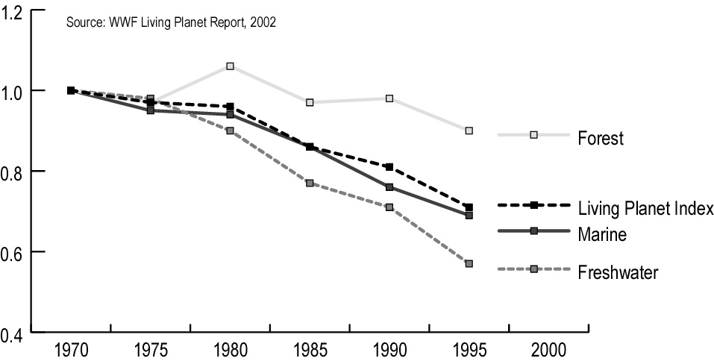
- Global Indicator 3: Change in status of threatened species
- Red Lists indicate threatened species according to globally-agreed criteria. For well-assessed groups of species changes in status of a species between categories can be assessed. A Red List Indicator based on such data is under development. For other groups of species, changes in threat category reflect improvement of knowledge rather than a change in status of the species itself.
- Under the Global Strategy for Plant Conservation, all higher plants will be assessed on a preliminary basis by 2010. Target 8 of the Strategy (60% of threatened plant species conserved in situ) provides an outcome-oriented approach, which calls for conservation measures to be carried out for listed species (for example, inclusion in an effectively protected area or management system). A complementary indicator can be constructed on the basis of this information.
- A fact sheet on this indicator was included in the report of the Expert meeting on indicators of biological diversity including indicators for rapid assessment of inland water ecosystems (UNEP/CBD/SBSTTA/9/INF/7) and the proposed biodiversity indicators relevant to the 2010 target (UNEP/CBD/SBSTTA/9/INF/26). The document prepared for SBSTTA-9 by a group of NGOs / included a detailed description of the status of development of this indicator.
- The IUCN Red List / is being developed into a global programme to monitor the extent and rate of biodiversity degradation, both through documentation of risk of extinction for individual taxa as well as through development of indicators. The 2003 Red List includes assessments and re-assessments for more than 23,000 taxa of mammals, birds, trees and representatives of other taxonomic groups.
- A strategy is in place to assess a larger, more representative set of species with an emphasis on improving the balance of marine, freshwater and terrestrial species in the future. In addition to the individual taxa assessment process, there are regular analyses of global trends undertaken at approximately four-year intervals to coincide with the World Conservation Congress.
- A sub-group of the IUCN Red List Committee is working to develop a Red List indicator based on the Red List assessments, and the prototypes are now being tested on some well-documented taxa. This indicator will be based on two broad classes of data. One (non-sampled) is based on the Red List assessments of all taxa for groups, such as birds, in which all species have been assessed more than once. The strength of this indicator is that data for one group (birds) extend back to 1988. However, the number of completely assessed groups is currently limited: by 2010, data will be available only for birds, mammals, and possibly amphibians.
- The IUCN Red List indicator uses the Red List data to measure the frequency with which species move across the threat categories. Changes in this indicator reflect step-wise changes in the number of species in the different categories; a species moving from Least Concern to Near Threatened contributes just as much to the changing score as a species moving from Endangered to Critically Endangered. Because the number of described species (Figure 3a) and those assessed for their conservation status is constantly increasing this increase in knowledge has to be accounted for in the indicator. Figure 3b shows a significant increase over the past three years in the number of threatened species in some taxonomic groups. However, some of this increase may be due to the larger number of species assessed, rather than a larger proportion of threatened species within the taxonomic group.
Figure 3a. Number of described species
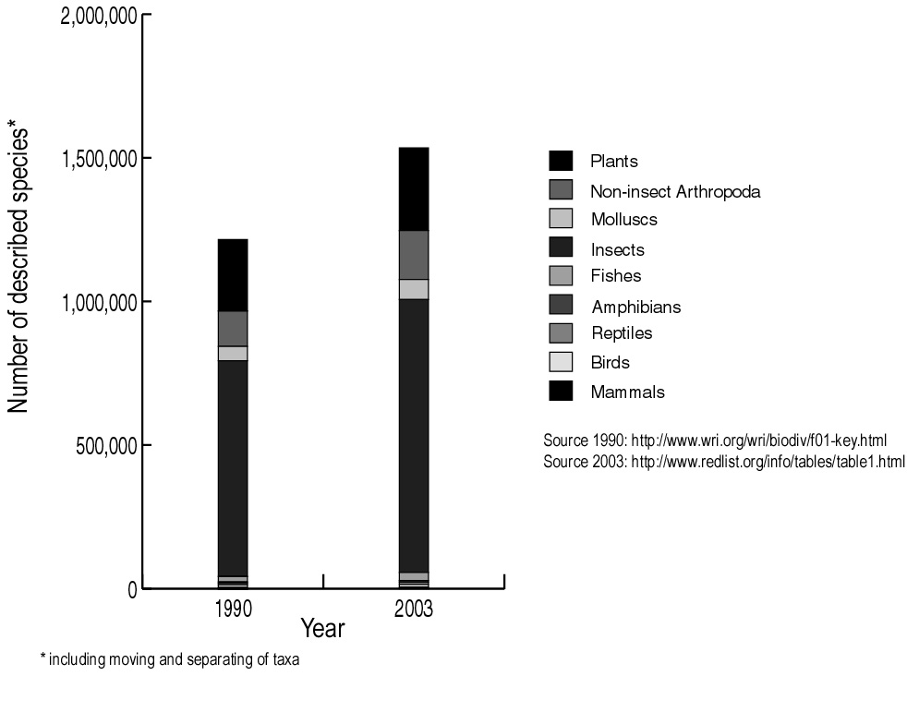
Figure 3b. Number of threatened species
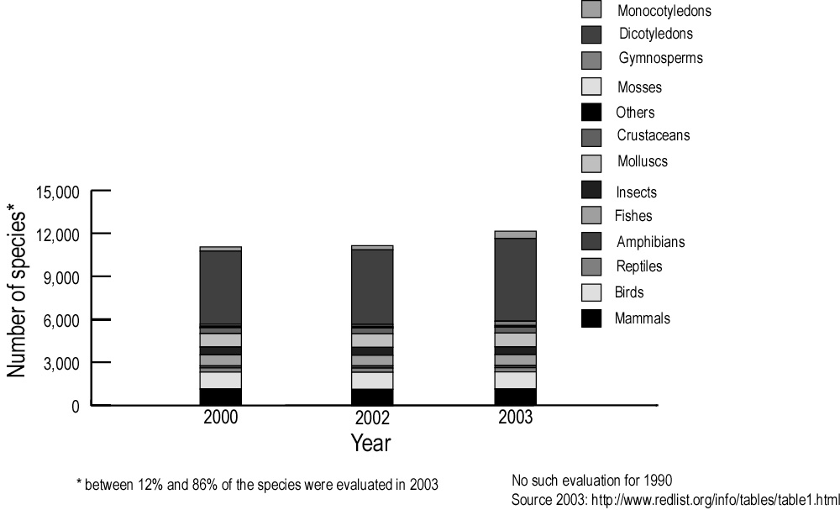

Global Indicator 4: Trends in genetic diversity of domesticated animals, cultivated plants, and fish species of major socioeconomic importance
- Genetic diversity comprises the total genetic variation present in a population or species, in any given location. It can be manifested in different phenotypes and their different uses. It can be characterized by three different facets: (1) number of different entities (e.g.: the number of varieties used per crop; the number of alleles at a given locus); (2) evenness of the distribution of these entities, and/or (3) the extent of the difference between the entities (as in the case of pedigree date, for example). With crop varieties or livestock it is possible that the overall genetic diversity decreases while the number of varieties or breeds increases in a region. Diversity within varieties or breeds could be gauged by taking into account the population size of the various breeds. The three facets could be combined to result in an indicator analogous to the Species Assemblage Trend Index for wild species (see Global Indicator 2 on Trends in abundance and distribution of selected species.)
- Comprehensive data on the genetic diversity of domesticated animals and many cultivated plants, and their genepools, as well as a few tree and fish species are available, and can be used to provide a direct indicator of genetic diversity for these species.
- Fact sheets on the number and share of crop varieties and on the number of livestock breeds were presented in documents UNEP/CBD/SBSTTA/9/INF/7 and UNEP/CBD/SBSTTA/9/INF/26. Information on indicators of genetic diversity of plant genetic resources has been provided by FAO and IPGRI. /
- The indicator provides direct information on biodiversity trends within agro-ecosystems and aquaculture, e.g. a decrease in abundance of many (such as traditional varieties, landraces, breeds) and increase of a few others (such as high external input/high productive varieties, living modified organisms). An analysis of farm units with respect to the ratio between registered/certified varieties and locally known crop types in use is an indicator of the type of agricultural system. The share of major varieties in the total production for individual crops describes the evenness of biodiversity in use. It also relates to Global Indicator 7 on biodiversity used in food and medicine. Table 1 provides some examples

Table 1. The extent of genetic uniformity in selected crops after UNEP-WCMC ,
Crop | Country | Number of varieties
Rice | Sri Lanka | From 2000 varieties in 1959 to less than 100 today; 75% descend from a common stock
Rice | Bangladesh | 62% of varieties descend from a common stock
Rice | Indonesia | 74% of varieties descend from a common stock
Wheat | USA | 50% of crop in 9 varieties
Wheat | China | About 1000 of 10000 varieties used in 1949 remained in 1970
Maize | Mexico | Only 20% of maize varieties planted in the 1930s remain
Potato | USA | 75% of crop in 4 varieties
Soybeans | USA | 50% of crop in 6 varieties
Garden landraces | Korea (Rep.) | About 25% of landraces of 14 crops grown in home gardens in 1985 remained in 1993
- In fisheries, the situation is more complex. For example, mixed-stock harvest of wild and enhanced salmon stocks greatly complicates the conservation of salmon diversity. Unless it is possible to selectively harvest different populations, the overall harvest rate must be reduced to ensure the conservation of the vulnerable stocks in a mixed-stock harvest.
- FAO, the International Livestock Research Institute (ILRI), the International Plant Genetic Resources Institute (IPGRI) and various regional and national institutes hold data on specific domesticated resources. Data are particularly good for registered varieties and for some heritage varieties. Reasonable data exist for land races of major crops and are held by specialized institutions, e.g. the International Rice Research Institute (IRRI), International Potato Center (IPC), the International Maize and Wheat Improvement Center (CIMMYT). Information on locally important crops, e.g. tef, various millets, are limited although a substantive body of traditional knowledge exists on these taxa.
- The FAO World Watch List for domestic animal diversity provides information on their current state and recent trends (Figure 4). Nine of the 14 most important species (cattle, horse, ass, pig, sheep, buffalo, goat, chicken, duck) may account for as many as 4,000 breeds worldwide. Of 5,300 breeds, representing 35 species, 30% face extinction. Extinction risk for mammalian breeds is 35%, for bird breeds 63%. Information on 1,671 breeds from eight domesticated species indicates that 448 of these are at risk of extinction.
Figure 4. Risk status of the world’s mammalian and avian breeds. Comparison of status of breeds recorded up to May 1995 and December 1999 respectively within 16 species of mammals (alpaca, ass, Bactrian camel, buffalo, cattle, deer, dromedary, goat, guanaco, horse, llama, pig, rabbit, sheep, vicuña, yak) and 14 species of birds (cassowary, chicken, duck, emu, goose, Guinea fowl, Muscovy duck, nandu, ostrich, partridge, pheasant, pigeon, quail, turkey).
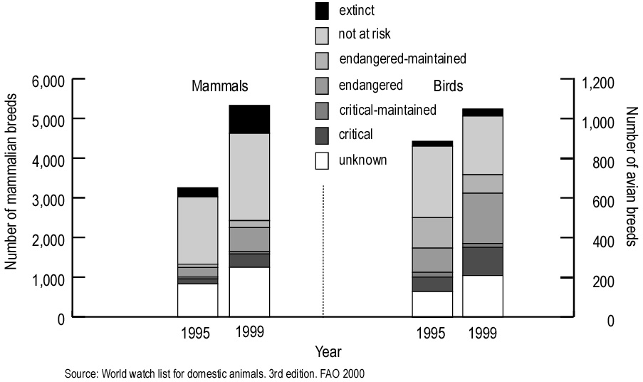

Global Indicator 5: Coverage of protected area
- The surface area of protected areas reflects measures taken to safeguard biodiversity. Comprehensive data on officially recognized protected areas are regularly compiled. By using geographical information systems these data can be assigned approximately to different biomes or ecological regions, allowing analysis of coverage and gaps. The data would also allow analysis of the protection of specific sites important for particular species and habitats. Better data and further methodological development are needed to include criteria of protected area effectiveness and protected area distribution in relationship to biodiversity features. /
- A fact sheet on this indicator was included in documents UNEP/CBD/SBSTTA/9/INF/7 and UNEP/CBD/SBSTTA/9/INF/26. Its strengths and limitations were also discussed in the document prepared for SBSTTA-9 by a group of NGOs on scaleable biodiversity indicators. 20/
- A World Database on Protected Areas (WDPA) has been compiled since 1981 by IUCN and UNEP-WCMC and the latest version (2003) including comprehensive geo-referenced information is available on CD-Rom. UNEP-WCMC, WWF and the University of British Columbia are currently collaborating to improve the WDPA coverage of marine protected areas. Institutions such as the World Commission on Protected Areas (WCPA), UNEP-WCMC, BirdLife International, the Conservation Biology Institute, Conservation International, The Nature Conservancy, the World Resources Institute, Fauna and Flora International, the Wildlife Conservation Society and WWF work together to monitor status and trends in the designation of protected areas, according to IUCN protected areas’ categories. In conjunction with Global Indicator 1, this indicator shows the extent to which major biomes (e.g. number of examples, size and functionality) are represented in protected areas.
- Figure 5a shows the increase in protected area coverage since 1872 resulting in 11.5 percent of land surface and 0.5 percent of marine area being under protection. Figure 5b analyses the protected area coverage by biome and shows the important contribution of mixed island systems and tropical humid forest to the overall protected area coverage while other biomes, in particular temperate grasslands, are under-represented.
Figure 5a. Cumulative growth in protected areas by 5 year increment 1872-2003 (area and number of marine protected areas in white). Modified after 2003 United Nations list of protected areas.
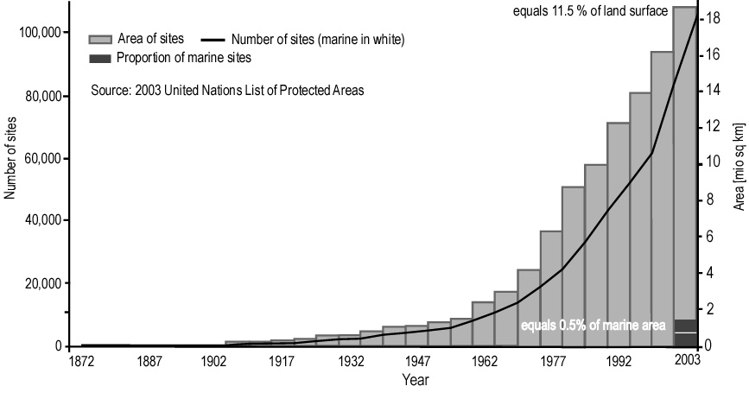
Figure 5b. Extent of protection of the world’s major terrestrial biomes. After 2003 United Nations list of protected areas.
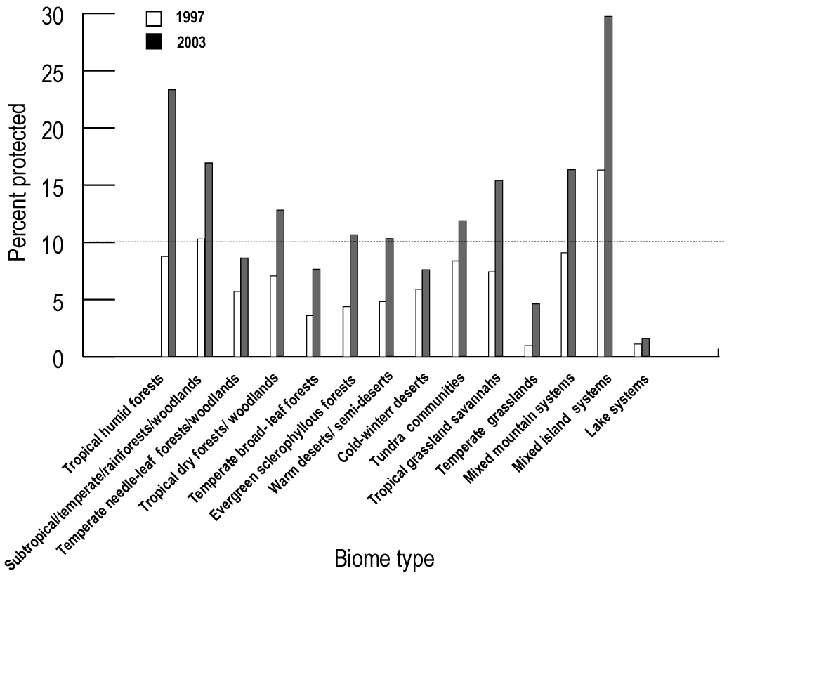Global Indicator 6: Criteria and indicators for sustainable management of ecosystems
- This indicator includes both the sustainable harvesting of wild species, and the sustainable management of production systems. The sustainable use of the components of biological diversity is one of the three objectives of the Convention. The indicator might include the percentage of production land, which is sustainably managed, or the share of products and resources stemming from sustainable production systems.
- The indicator on the sustainable management of ecosystems will provide information relevant to targets 6 (30% of production lands managed consistent with the conservation of plant diversity) and 12 (30% of plant-base products derived from sources that are sustainably managed) of the Global Strategy for Plant Conservation (decision VI/9). The document on the technical and scientific rationale of the targets / provides detailed information on scope, terminology and available baseline information.
- Various systems for criteria and indicators have been developed and are in use, including for agriculture, aquaculture, fisheries, forest management and horticulture. These can be area or product based. Increasingly, they are complemented by more stringent certification and labelling schemes. Ecolabels, including for organic foods and fibres, non-wood forest products, eco-forestry and eco-tourism, provide market-based incentives that reward producers for environmentally sound practices. Driven by consumer demand and trade regulations, the share of certified management systems and products has significantly increased over the past years. However, third-party certification is usually difficult to obtain, particularly for small-scale producers, and can be of limited interest to producers relying on domestic markets. Nevertheless, many of these may take considerations of sustainable management into account.
- The following systems of criteria and indicators are particularly noteworthy:
- Under the OECD substantial progress has been made in developing agri-environmental indicators. / These cover inter alia the use of pesticides and fertilizers, and impacts on soil, water and biodiversity at genetic, species and habitat levels. /,/ The global area of certified croplands has been estimated at 2% in 2000. / In the same year, between 1 and 3% of the managed pasture lands, which are estimated to be about 50% of total pasture lands, have been certified; /
- Criteria and indicators for sustainable forest management have been developed on a regional or biome-specific basis. / FAO (2001) has compiled the nine systems of criteria and indicators for sustainable forest management. / More recently, an International Conference on the contribution of criteria and indicators for Sustainable Forest Management / has analyzed and compared the status of implementation of international criteria and indicator processes. The area of certified forest has risen from about 2% in 2000 to almost 4% in 2003 (Figure 6a);
- In recent years, a number of certification and labelling systems have been introduced for fisheries. For example, about 160 products certified under the Marine Stewardship Council are now on sale (Figure 6b). The Aquaculture Certification Council (ACC) certifies aquaculture facilities that apply best management practices to ensure social and environmental responsibility, food safety and traceability throughout the production chain. / ACC was launched in 2002. At the end of 2003 less than 10 shrimp farms (all located in Central America) and one US-based buyer had been certified. The demand for certified aquaculture products, however, is increasing and other labels are being launched. Such initiatives are mostly private sector driven.
- FAO / has analyzed the global trends in fisheries stocks since the early 1970s. Figure 6c shows the results of increasingly intense exploitation and continuing depletion of marine fisheries stocks with the number of overexploited, depleted or recovering stocks having nearly tripled over the past 30 years. The number of stocks for which information was available has also increased (from 120 to 454).
- There is also increasing awareness about the risk that the growing herbal market might pose a threat to biodiversity through the over harvesting of the raw material for herbal medicines and other natural health care products including culinary herbs, food supplement applications, essential oils and pharmaceuticals. These practices may lead to the extinction of endangered species and the destruction of natural habitats and resources. For example, of 880 medicinal plants traded in India, 104 are Red Listed. /
Figure 6a. Global area of forest certified under the Forest Stewardship Council, the Pan European Forest Certification, the Sustainable Forest Initiative, the Canadian Standard Association, the American Tree Farm System and the Malaysian Timber Certification Scheme
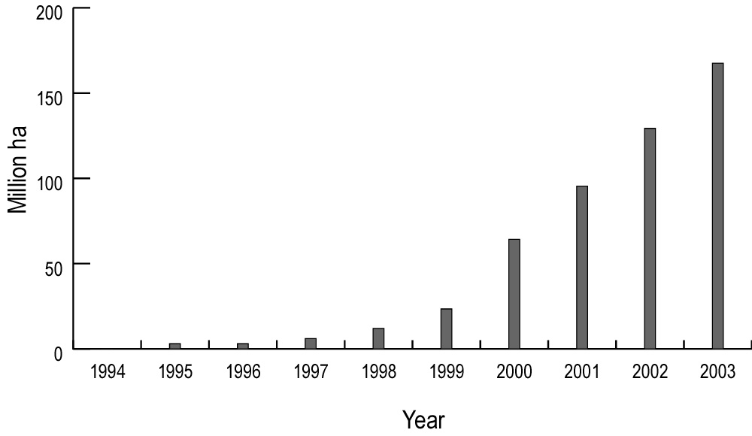
Figure 6b. Number of products certified under the Marine Stewardship Council
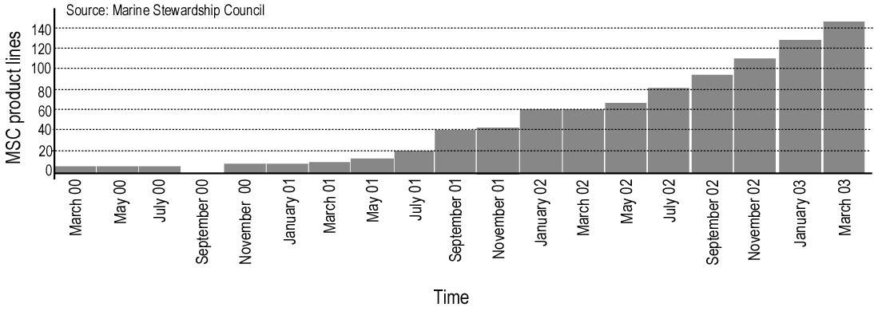
Figure 6c. Global trends in marine fisheries stocks (after FAO, State of World Fisheries and Aquaculture 2000)
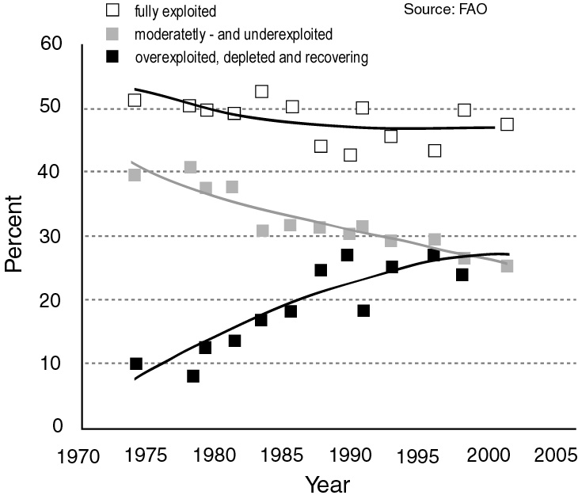
Global Indicator 7: Biodiversity used in food and medicine
- One direct measure of biodiversity in use is the variability and degree of balance of human nutrition as well as the availability of, and access to, biodiversity-based medicines. In some areas, it may also be used as a proxy for extent of recognition of indigenous and traditional knowledge. Coarse global and national indicators can be derived from food balance data, which are available periodically for most countries. More detailed time-series data are available for selected cases, including breakdown by varieties as well as species used.
- Food and medicine represent two of the most obvious uses of biodiversity, and ones that affect people most directly. Recently, there has been renewed attention to the value of a diverse diet for human nutrition and health, ,,, which is seen as an important element in countering the global trend towards obesity and other diet-related diseases in urbanized populations. , In addition, the rural poor still largely depend on a diverse range of cultivated and harvested wild food sources. , Most people in developing countries still rely predominantly on traditional medicines, mostly derived from plants, for their primary health care, and recently, there has been increased demand for herbal medicines in developed countries. /
- About 30,000 of the roughly 250,000 identified plant species are edible and about 7,000 have been cultivated or collected by humans for food at one time or another. /,/ However, when data are aggregated to the global level, only 30 crops account for 95% of dietary energy (calories) or protein. Just three species: wheat, rice and maize alone provide more than half of the global plant-derived energy intake. On the other hand, analysis of food energy supplies on a country-by-country basis shows that 90% of the per caput food plant supplies of all nation states are provided by only 103 plant crops. Additionally, wild species are important, both nutritionally and culturally, to many people. Many other species that are important to large numbers of people at sub-national levels fall outside the national lists. / In addition, a large number of crops are important as suppliers of other dietary factors (protein, fats, vitamins and minerals, etc.). The traditional diets of indigenous communities are often highly diverse, typically composing around 100 species (of plants and animals), and sometimes over 200. /
- While the number of plant species which supply most of the world’s energy and protein is relatively small, the diversity within such species is often immense. Estimates of the number of distinct varieties of the rice species, Oryza sativa, for example, range from tens of thousands to more than 100,000.
- As the foregoing discussion illustrates, developing an indicator on biodiversity used for food is essentially a question of scale and level of aggregation. Possible indicators might include:
- The total number of species typically used by a community or nation; and/or
- The number of species providing, for example, 90% or 95% of energy, fat, protein and/or total mass of the food intake of a particular community or nation.
- Globally consistent data are available only for option (b) and are held by the FAO. Such information could be complemented by samples surveyed according to option (a). In each case the absolute number could be complemented by an index of the evenness of the distribution of species making up total foods. With such data, changes over time could be monitored. The data could also be aggregated regionally and globally. Finally, the diversity between communities and nations could be assessed. Figure 7a / shows the convergence of diets (assessed at a rather coarse level of resolution).
- Approximately 20% of all plants have medicinal values and, on average, over 10% are recognized as medicinal plants in national pharmacopoeias (Table 2). Over 1,000 species are traded globally.
- Microorganisms are a resource with a large potential for use, including in the pharmaceutical industry. In the early 1990s, only just over 1% of the estimated total number of algae, fungi, prokaryotes and viruses was held in service culture collections (Table 3).
Figure 7a. Food consumption convergence in OECD countries based on FAO food balance sheets
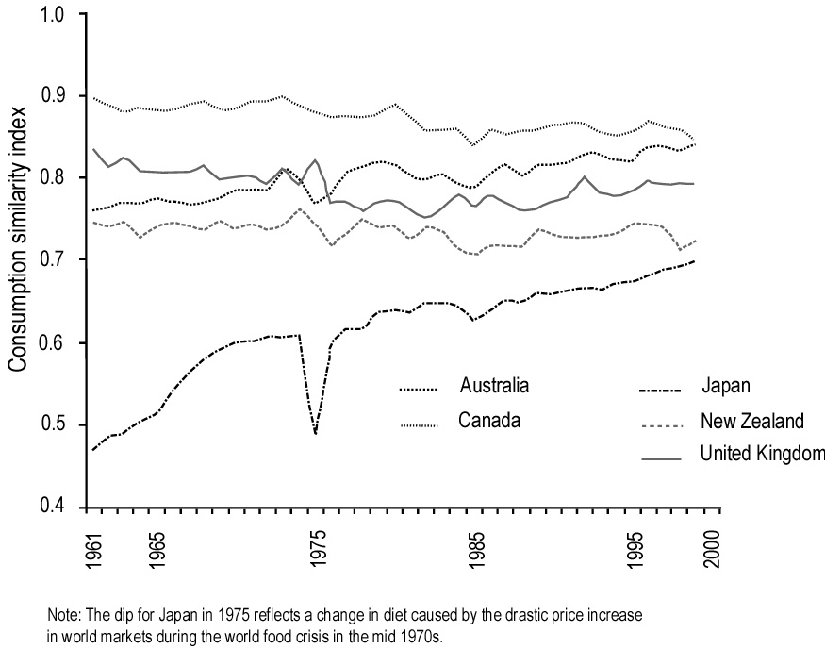
Table 2. Medicinal plants in use in selected countries
Country | Plant species | Medical plant species | %
China | 26 092 | 4 941 | 18.9
India | 15 000 | 3 000 | 20.0
Indonesia | 22 500 | 1 000 | 4.4
Malaysia | 15 500 | 1 200 | 7.7
Nepal | 6 973 | 700 | 10.0
Pakistan | 4 950 | 300 | 6.1
Philippines | 8 931 | 850 | 9.5
Sri Lanka | 3 314 | 550 | 16.6
Thailand | 11 625 | 1 800 | 15.5
USA | 21 641 | 2 564 | 11.8
Viet Nam | 10 500 | 1 800 | 17.1
Average | 13 366 | 1 700 | 12.5

Table 3. Number of known and estimated microbial species in relation to material held in service culture collections
Group | Number of species |  | Material held in culture collection
 | known | estimated | total | % of known species | % of estimated species
Algae | 40 000 | 60 000 | 1600 | 4.0 | 2.6
Fungi | 69 000 | 1 500 000 | 11 500 | 16.7 | 0.8
Prokaryotes | 4204 | 40 000-3.5million | 2300 | 54.7 | 0.07-5.8
Viruses | 5000 | 130 000 | 2200 | 44.0 | 1.7
Global Indicator 8: Water quality in aquatic ecosystems.
- This is an indicator of the quality of inland water and marine and coastal ecosystems. It is also a measure of the capacity of aquatic ecosystems to sustain life and, in terms of pollution, indicates a pressure on biodiversity. Increasing loads of suspended solids (sediments) in rivers stem from erosion due to the opening of the natural vegetation cover from inter alia conversion of natural ecosystems into agricultural land, deforestation, degradation of ecosystems by other human activities and fire. Data on natural or pre-agricultural load of suspended solids are available for some major river basins. However, as a result of damming, loads can decrease below natural levels.
- Water quality data are routinely available for major waterways in a large number of countries. Pesticides, fungicides, herbicides, toxic compounds and heavy metals originating from industrial processes, common pollutants, POPs, and nitrogen deposition threaten life sustaining processes in rivers, streams and coastal areas.
- Intensification of agricultural production, including the increase in irrigated area, which has almost doubled between 1970 and 2000, has led to increased water consumption and pollution. The percentage of water treated before discharge, while increasing, is still low, particularly for water used in agricultural processes. The increase in global water consumption (Figure 8a) indicates the pressure on water quality. It is also an indicator of sustainable use.
- Biological oxygen demand (BOD) is an indicator of the organic pollution of freshwater. In comparing the past two decades, rivers in Europe and Australasia show a statistically significant reduction in BOD concentrations. Although the reduction is not particularly large, it is indicative of positive trends (Figure 8b).
- The natural sediment load discharged through river systems is correlated with runoff volumes. Data for the early 1990s are available on a region-by-region basis (Figure 8c). / Significant increases in sediment load are indicative of soil loss, mostly from unsustainable land use practices.
- Additional data are available from UNESCO-IOC Global Nutrient Export from Watersheds project, UNEP Global Environment Monitoring System (GEMS), WRI, USGS; EEA; as well as national and regional institutes.
Figure 8a. Global water consumption (after World Water Council) and irrigated area (after FAO AQUASTAT)
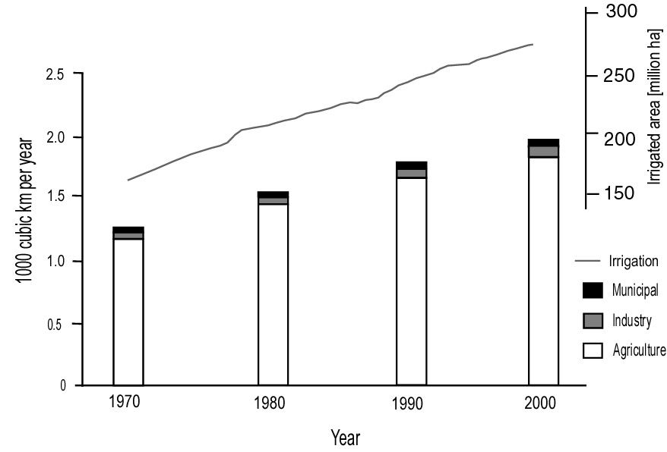
Figure 8b. Changes in biological oxygen demand (BOD) of major water bodies on a regional basis
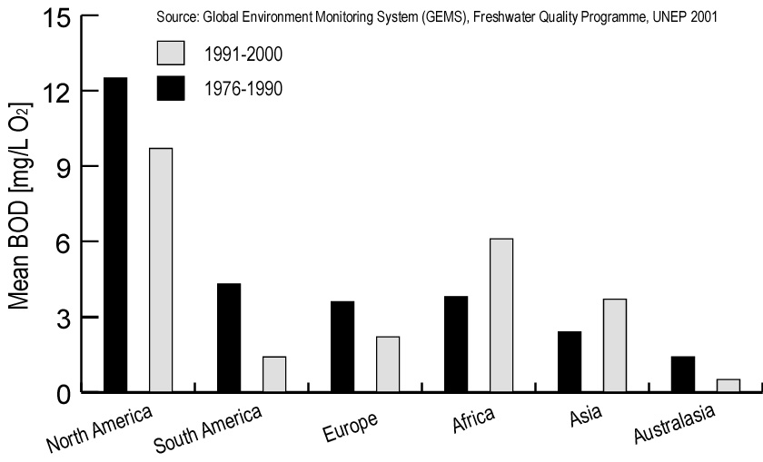
Figure 8c. Suspended sediment discharge per region (in million tonnes per year)
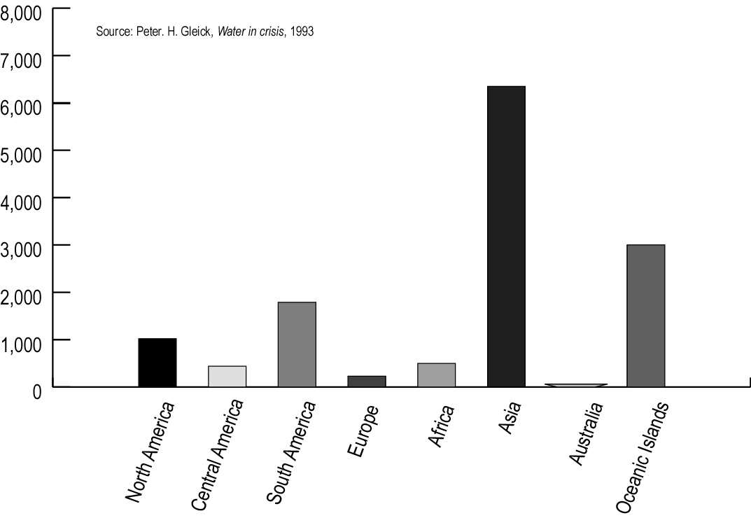

Global Indicator 9: Trophic integrity of ecosystems
- Several studies have confirmed that the mean trophic level of selected species groups provides a reliable indicator of the integrity of an ecosystem. While this has been demonstrated for soil fauna, / and postulated as a key objective of ecosystem management. / It is considered a particularly effective indicator to assess the integrity of marine ecosystems. /,/ It is also an indictor of the sustainability of fisheries. Trophic integrity can be calculated, globally and regionally, from fisheries data. Excessive N- and P-loads, however, may also alter trophic structures, particularly in inland water ecosystems. /
- Many fisheries tend to target the largest and most valuable species. Unsustainable fisheries lead to a depletion of large bodied and higher trophic level species (particularly carnivorous and piscivorous fish) eventually leading to rarity or absence of such species and dominance of small-bodied species with high rates of population turnover, usually from lower trophic levels. It is estimated that large predatory fish biomass worldwide has been reduced by 90% since pre-industrial times. / The impacts on intra-specific genetic diversity are unknown.
- The intensification of fishing has led to a process of the effective removal of species from marine food webs. Based on FAO world catch statistics the reduction in mean trophic level has been quantified (Figure 9). The relevant data concern time series of landings of fish taken by fisheries in defined areas from all major aquatic ecosystem types. Based on their diet composition, 220 trophic levels have been assigned to fishes and invertebrates which constitute the catch. The analysis showed a reduction from 3.3 in the early 1950s to less than 3.1 in 1994 from marine areas and a decrease from just over 3 to 2.8 in inland water fisheries.
Figure 9. Global trends of mean trophic level of fisheries landings 1950-1994 (marine areas in black, inland water areas in grey). 65/
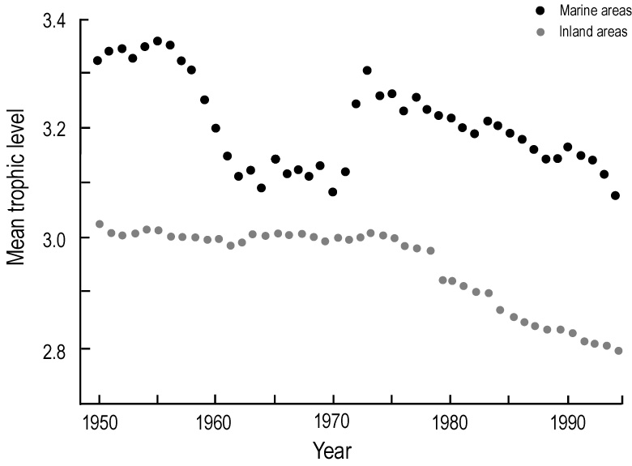
Global Indicator 10. Nitrogen deposition
- Nitrogen has a direct effect on biodiversity as it affects species composition. Human activities are greatly increasing the amount of nitrogen cycled between the soil, water and atmosphere. Fixed nitrogen in global ecosystems has more than doubled due to anthropogenic additions with consequences for biodiversity and the integrity of terrestrial, aquatic and marine ecosystems. N additions can be calculated on a global basis, and can be estimated also for some countries and watersheds. Some data are also available for N loads in aquatic ecosystems (see under Global Indicator 8).
- Fossil fuel burning, fertilizer production, legume growing, livestock farming and biomass burning are now releasing more reactive nitrogen into the global environment than pre-industrial natural processes. / Reactive nitrogen is accumulating in the biosphere, oceans and atmosphere and is having powerful interlinked effects - some positive (faster forest growth) others negative (acidification, eutrophication). The actual impacts of acidification and eutrophication are medium to long-term processes with time lags beyond 2010.
- Increasing population densities, conversion of natural ecosystems and intensification of agricultural production result in increasing riverine nitrogen fluxes, due to nitrogen-leaching from the soils. For example, riverine nitrogen fluxes from most of the temperate regions surrounding the North Atlantic Ocean have increased from 2- to 20-fold since industrialization started. / Some authors predict a 2.5 fold increase in nitrogen- and phosphoros-driven eutrophication of terrestrial, inland water and near-shore marine ecosystems by 2050. /
- The nitrogen load in selected river systems has doubled in the last 50 years. It is estimated that pre-industrial nitrogen-loading was around 110 Tg/year / while industrial loading amounts to 227 Tg/year of potentially mobilizable nitrogen-fluxes in river networks. / Global fertilizer use increased from less than 14 million tonnes in 1950 to 145 million tonnes in 1988; by 1996 it had amounted to about 135 million tonnes. / Since the residence time of water in the groundwater system may be very long, nitrogen that infiltrated groundwater decades ago may cause pollution of surface water much later. Large-scale abatement measures may therefore not immediately show effects, which are directly correlated to the reduction of N-release.
- In estuaries and coastal seas eutrophication may cause hypoxia and anoxia. Low oxygen conditions have led to significant losses of fish and shellfish resources. In estuaries and coastal seas eutrophication is often associated with a loss of diversity, both in the benthic community and among planktonic organisms, as manifested by algae blooms.
- The concentration of research on the consequences of nitrogen deposition into north-temperate forests made sense until recently, since most nitrogen deposition occurred there. Now, however, 40% of global applications of industrial nitrogenous fertilizer take place in the tropics and subtropics, and over two-thirds are expected to occur in developing regions by 2020.
- Within the UN/ECE Convention on Long-range Transboundary Air Pollution, empirical procedures have been developed to set critical loads for atmospheric nitrogen deposition. Worldwide, critical loads have not been established, but they have been estimated on the basis of ecosystem and soil information. / For deposition, only very fragmented measurements are available. Output data from atmospheric chemistry models and emission data can be used instead. /
- Data are available from UNESCO-IOC; USGS; EEA; national and regional institutes, UNEP’s Global Environment Outlook-2 and UNEP’s Global assessment of acidification and eutrophication of natural ecosystems (1999). UNESCO-IOC Global Nutrient Export from Watersheds project; SCOPE studies on nitrogen in Atlantic; UNEP’s Global Environment Outlook 3.
- The industrial fixation of nitrogen for use as fertilizer represents by far the largest human contribution of new nitrogen to the global cycle, exceeding by a factor of two the amount fixed by leguminous crops and forages (soybean, peas, alfalfa etc.) and by a factor of four that released by fossil fuel burning. / Global fertilizer production and consumption, which is well documented since the 1960s, provides an indication of the most important source of new nitrogen (Figure 10a). Figure 10b shows that the nitrogen efficiency from inorganic fertilizers has decreased during this period. /
Figure 10a. Global fertilizer consumption 1961-2001
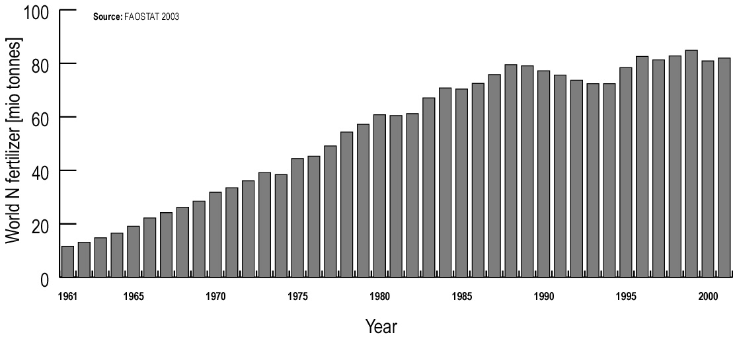
Figure 10b. Agricultural intensification and nitrogen efficiency of cereal production (from FAOSTAT)
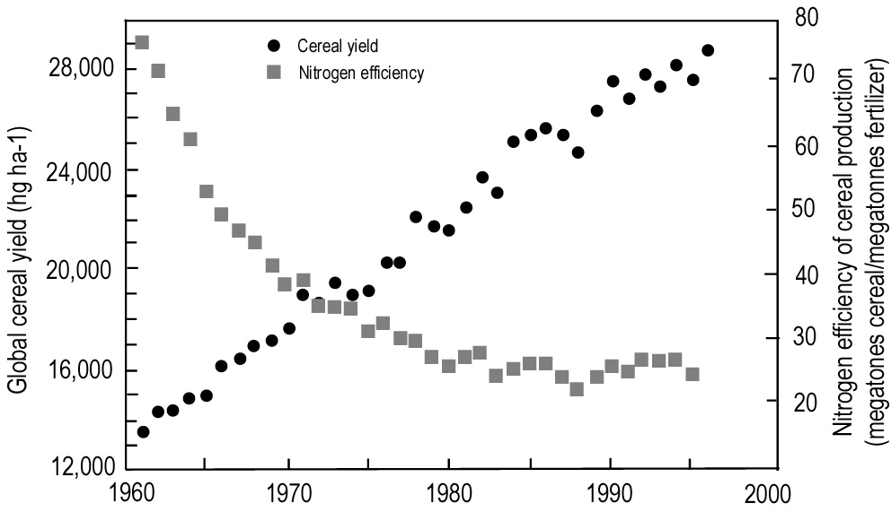
Global Indicator 11: Numbers and cost of alien invasions
- This is an indicator of one of the major pressures on biodiversity. Data on the number and severity of alien invasions are available for some countries, but very sporadic for others. The economic cost of the impacts of invasive alien species, or the cost of control measures can be calculated in some cases.
- Invasive alien species are considered to be one of the main causes of biodiversity loss. For example in the USA there has been a 4000% increase in the number of alien insects that have established themselves since 1800. In some of Australia’s diverse marine environments, more than 200 alien species can be found - some of them are known marine pests. / There are numerous similar examples from around the world. /
- In terms of costs losses to agriculture, forestry and fisheries are best documented: about a quarter of the US agricultural gross national product is lost each year to foreign plant pests and the costs of controlling them, although a large portion does not concern native biota. In eastern forests, losses to European gypsy moths in 1981 were valued at US$764 million, while the Asian strain that has invaded the Pacific Northwest has already necessitated a US$20 million eradication campaign. To keep US waterways clear of such plants as the Sri Lankan hydrilla and water hyacinth, about US$100 million is spent annually. / The European zebra mussel has infested over 40% of internal waterways in the USA and may have required between US$750 million and US$1 billion in expenditure on control measures between 1989 and 2000.
- Data on invasive species are available from IUCN Invasive Species Specialist Group, the Global Invasive Species Programme (GISP) and CABI. The GEF/UNDP/IMO Global Ballast Water Management Programme (GloBallast) / maintains links to national, regional and global databases relevant to aquatic invasions. The FAO database on introductions of aquatic species (DIAS) / was established in the early 1980s. It initially included mainly freshwater species of fish and has been expanded to include additional taxa, such as more molluscs and crustaceans, and marine species. In the mid-1990s a questionnaire was sent to national experts to gather additional information on introductions and transfers of aquatic species in their countries. The database, which contains now about 3,150 records, can be queried through the Search Form. Figure 11 shows the number of new introductions of species in inland water and marine ecosystems compiled from data of FAO-DIAS and Welcomme presented in GEO-3.

Figure 11: Number of new introductions of species into freshwater and marine environments

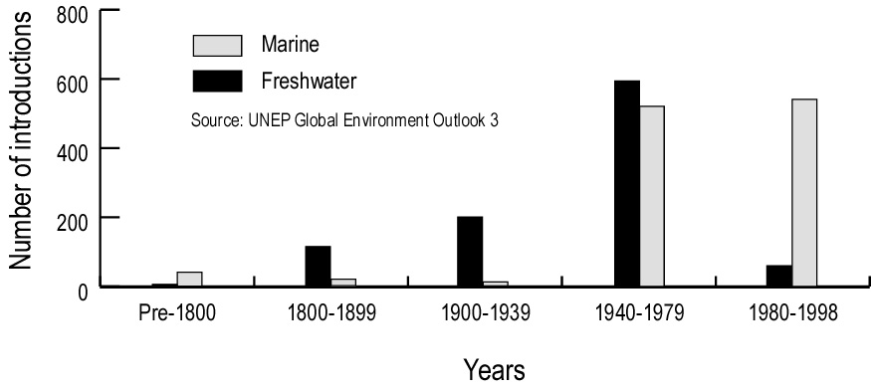

Annex
Based on the section on data availability, the following table summarizes the status of development or implementation for each of the proposed global indicators.

Proposed global indicator | Status of development/implementation and data availability
1. Trends in extent of selected biomes, ecosystems and habitats | Indicator ready for use for selected biomes, ecosystems and habitats. Accuracy of data to be improved. Follow-up to ecosystem-specific surveys to be ensured.
2. Trends in abundance and distribution of selected species | Indicator (Species Assemblage Trend Index) in use for selected taxonomic groups and habitats based on population size. Distribution data to be integrated.
3. Change in status of threatened species | Indicator (Red List indicator) under development. Data generally available for mammals, birds, amphibians, fishes and higher plants.
4. Trends in genetic diversity of domesticated animals, cultivated plants, and fish species of major socioeconomic importance | Indicator to be developed. Data for major crops and livestock generally available.
5. Coverage of protected areas | Indicator (Percentage of protected area per biome) ready for use. Data generally available and being improved. Measure of protection effectiveness to be developed.
6. Criteria and indicators for sustainable management of ecosystems | Indicator to be developed/selected. Data available for selected commodities.
7. Biodiversity used in food and medicine | Indicator to be developed. Selected data available.
8. Trophic integrity of ecosystems | Indicator ready for use for marine and inland water ecosystems. Data available globally for marine ecosystems and for selected inland waters.
9. Water quality in aquatic ecosystems | Indicator ready for use. Number of sampling points to be increased in some areas.
10. Nitrogen deposition | Indicator ready for use. Data generally available.
11. Numbers and cost of alien invasions | Indicator to be developed. Data availability varies between countries and regions. No global compilation readily available.

-----

* UNEP/CBD/COP/7/1 and Corr.1.
/ see UNEP/CBD/SBSTTA/9/INF/27.
/ http://www.fao.org/forestry/foris/webview/forestry2/index.jsp?siteId=101&langId=1
/ Lappalainen, E. (editor). 1996. Global Peat Resources. International Peat Society and Geological Survey of Finland.
/ http://www.wetlands.org/projects/GPI/gpi0.htm
/ http://www.ramsar.org/key_res_viii_17_e.htm
/ http://www.wcmc.org.uk/aboutWCMC/ann_rpt/1997/mangrove.htm
/ http://www.unep.org/GEO/geo3/english/179.htm
/ http://www.itto.or.jp/inside/mangrove/download/Mangrove_brochure_english.pdf
/ Spalding, M.D., Ravilious, C. & Green, E.P. 2001. World Atlas of Coral Reefs. Prepared at the UNEP World Conservation Monitoring Centre. University of California Press, Berkeley, USA
/ Wilkinson, C. (ed.) 2002. Status of coral reefs of the world: 2002. Australian Institute of Marine Science
/ http://www.wcmc.org.uk/marine/data/coral_mangrove/coral.mangrove.text.html
/ http://www.unep-wcmc.org/marine/seagrassatlas/
/ International Coral Reef Initiative (ICRI). CPC Meeting, Noumea, May 2000; Document 18.
/ Paragraph 36 (b) of document A/CONF.199/20
/ http://earth.jsc.nasa.gov/Reefs/Overview2003/mill.htm
/ http://edcdaac.usgs.gov/glcc/glcc.html
/ http://www.vgt.vito.be/news/glc2000%20information%20note.doc
/ http://modis.umiacs.umd.edu/vcf.htm
/ http://seawifs.gsfc.nasa.gov/SEAWIFS.html
/ Reducing the rate of biodiversity loss: towards a set of scaleable indicators. Paper presented to SBSTTA-9
/ http://www.redlist.org/info/categories_criteria2001.html
/ Loh, J., et.al. (2000, 2001, 2002) Living Planet Report, WWF International
/ http://www.birdlife.net/action/science/indicators/
/ http://www.coml.org/coml.htm
/ Reducing the rate of biodiversity loss: towards a set of scaleable indicators. Paper presented to SBSTTA-9
/ http://www.redlist.org/
/ Review and development of indicators for genetic diversity, genetic erosion and genetic vulnerability (GDEV): summary report of a joint FAO/IPGRI workshop (Rome, 11-14 September, 2002)
/ UNEP-WCMC. 1992. Global biodiversity. Status of the earth’s living resources. Chapman and Hall.
/ Groombridge, B. and Jenkins, M.D. 2002. World Atlas of Biodiversity. Prepared by the UNEP World Conservation Monitoring Centre. University of California Press, Berkely, USA.
/ http://dad.fao.org/cgi-dad/$cgi_dad.dll/Reference?Eng#World%20Watch%20List%20for%20Domestic%20Animal %20Diversity
/ See, for example, UNEP/CBD/SBSTTA/8/INF/7 and UNEP/CBD/SBSTTA/9/INF/3
/ http://www.biodiversity.org/wcpa/ev.php
/ The 2003 UN list of protected areas tends to underestimate the coverage of lake systems because several protected areas which include lake areas are listed under other categories. According to a more recent analysis, 12.7% of inland wetlands area is under protection. Mulongoy, K.J., Chape, S.P. (Eds) 2004. Protected Areas and Biodiversity: An overview of key issues. CBD Secretariat, Montreal, Canada and UNEP-WCMC, Cambridge, UK.
/ UNEP/CBD/COP/6/INF/21/Add.1
/ http://www.oecd.org/topic/0,2686,en_2649_33795_1_1_1_1_37401,00.html
/ OECD. 2001. Environmental Indicators for Agriculture, Volume 3: Methods and Results. OECD, Paris.
/ OECD. 2002. Report of the OECD expert meeting on Agri-Biodiversity Indicators, Zürich 5-8 November, 2001. OECD, Paris.
/ Willer, Hella and Minou Yussefi (2001) Organic Agriculture Worldwide 2001: Statistics and Future Prospects. BIOFACH/IFOAM/Stiftung Ökologie & Landbau, Germany (http://www.soel.de/)
/ Batello, pers. 14omm.. Cited in UNEP/CBD/COP/6/INF/21/Add.1
More than 150 countries are participating in nine eco-regional processes to develop and implement criteria and indicators for sustainable forest management, all of which include conservation of biodiversity. As most of these processes have begun only in the last few years, it is anticipated that much more information will be available on sustainable forest management in future. Currently there are no globally agreed criteria and indicators, but FAO is facilitating a process to harmonize the various sets.
/ Castañeda, F., C. Palmberg-Lerche, & P. Vuorinen. 2001. Criteria and Indicators for Sustainable Forest Management: A Compendium. Forest Management Working Paper 5. FAO Forestry Department.
/ International Conference on the Contribution of Criteria and Indicators for Sustainable Forest Management: The Way Forward (CICI-2003) Volume 2, CICI - 2003, 3 - 7 February 2003, Guatemala City, Guatemala (http://www.fao.org/DOCREP/005/J0077E/J0077E00.htm#TopOfPage)
/ http://www.msc.org/assets/docs/news_and_reports/Annual_report03_English.pdf
/ http://www.aquaculturecertification.org/accprocp.html
/ FAO. 2001. The State of World Fisheries and Aquaculture 2000. Rome.
/ Database at http://envis.frlht.org.in/
/ Kennedy, G; Nantel G; Shetty P 2003. The scourge of “hidden hunger”: global dimensions of micronutrient deficiencies. FAO, Rome.
/ Johns, T. Plant genetic diverstiy and malnutrition. Practical Steps in the Development and Implementation of a Global Strategy Linking Plant Genetic Resource Conservation and Nutrition. Afr. J. Food & Nnutr. Sci. (AJFNS - online version) 2 (2). http://www.ajfand.net/issueIIIfiles/timothyjohns.htm
/ Popkin BM, Horton S and S Kim. 2000. The nutrition transition and prevention of diet-related diseases in Asia and the Pacific. Food Nutr. Bull. 22(suppl): 58.
/ Burlingame, B. 2001 What is a Nutrient? J. Food Comp. Anal. 14: 1.
/ http://www.unu.edu/env/plec/cbd/Montreal/papers/Johns.pdf
/ WHO/FAO. 2002. Diet, nutrition and the prevention of chronic diseases. Report of a joint WHO/FAO expert consultation, Geneva 28 January - 1 February 2002. WHO technical report series 916.
/ Hladik, C.M. et al. 1993. Tropical forests, people and food. Biocultural interactions and applications to development. Man and the Biosphere Series. Volume 13. UNESCO and Parthenon Publishing, Paris and Carnforth.
/ FAO 1988 The State of the World’s Plant Genetic Resoruces for Food and Agriculture.
/ http://www.who.int/mediacentre/factsheets/2003/fs134/en/
/ http://www.ipgri.cgiar.org/nus/docs/UOCFramework.doc
/ FAO1998. The state of the world’s plant genetic resources for food and agriculture. FAO, Rome.
/ See for example: Lost Crops of Africa, volume I: Grains. Board on Science and Technology for International Development, National Research Council, National Academy Press, Washington, D.C. 1996
/ Kuhnlein, H 2003 Micronutrient nutrition and traditional food systems of indigenous peoples. Food, Nutrition and Agriculture no 32, 2003, FAO, Rome.
/ FAO. 2003. World Agriculture: towards 2015/2030. Edited by Jelle Bruinsma, Earthscan Publications Ltd.
/ Schippmann, U., J. Leaman, D.J. and A.B. Cunningham 2002. Impact of cultivation and gathering of medicinal plants on biodiversity: Global trends and issues. In: Biodiversity and the Ecosystem Approach in Agriculture, Forestry and Fisheries. Satellite event on the occasion of the Ninth Regular Session of the Commission on Genetic Resources for Food and Agriculture. Rome, 12-13 October 2002. Inter-Departmental Working Group on Biological Diversity for Food and Agriculture. FAO, Rome. http://www.fao.org/DOCREP/005/AA010E/AA010e00.htm#TopOfPage
/ Ten Kate, K. and S.A. Laird. 1999. The commercial use of biodiversity. Earthscan
/ P.H. Gleick. 1993. Water in crisis. Oxford University Press, New York
/ Stork, N. E., & P. Eggleton. 1992. Invertebrates as determinants and indicators of soil quality. Am. J. Altern. Agric.7: 38-47.
/ Grumbine, R.E. 1994. What is ecosystem management? Conservation Biology 8(1): 27-38.
/ Pauly, D., Christensen, V., Dalsgaard, J., Froese, R. & Torres Jr., F. 1998. Fishing Down Marine Food Webs. Science 279: 860-863.
/ Measuring biodiversity for conservation. The Royal Society Policy document 11/03, August 2003.
/ Salas HJ & Martino P 1991, 'A simplified phosphorus trophic state model for warm -water tropical lakes', Water Research, vol. 25, pp. 341-350
/ Myers, R.A. & B. Worm.2003. Rapid worldwide depletion of predatory fish communities. Nature 423: 280-283.
/ Vitousek, P.M., J. Aber, R. Howarth, G.E. Likens, P. Matson, D. Schindler, W. Schlesinger and G.D. Tilman. 1997. Human alteration of the global nitrogen cycle: causes and consequences. Ecological Applications 7(3): 737-750.
/ Seitzinger, S.P. and C. Kroeze. 1998. Global distribution of nitrous oxide production and N inputs in freshwater and coastal marine ecosystems. Global Biogeochemical Cycles 12(1): 93-113.
/ Tilman, D., Fargione, J., Wolff, B., D'Antonio, C., Dobson, A., Howarth, R., Schindler, D., Schlesinger, W.H., Simberloff, D., Swackhamer, D. 2001. Forecasting agriculturally driven global environmental change. Science 292: 281-284.
/ 1 Tg = teragram = 1 million metric tons (tonnes)
/ Geophysical Research Abstracts, Vol. 5, 11438, 2003, c European Geophysical Society 2003, Fluxes of organic and inorganic nitrogen through rivers: a global assessment based on typology Pamela Green (1), Charles J. Vörösmarty (1,2), Michel Meybeck (3), James Galloway (4), Bruce Peterson (5)
/ FAOSTAT, 2003
/ Bouwman and Van Vuuren 1999. IPPC Special Report on Emission Scenarios.
/ JRC; Met Office; Data on deposition of sulphur and nitrogen deposition are available from global atmospheric chemistry models.
/ Vitousek, P.M., J. Aber, R. Howarth, G.E. Likens, P. Matson, D. Schindler, W. Schlesinger and G.D. Tilman. 1997. Human alteration of the global nitrogen cycle: causes and consequences. Ecological Applications 7(3): 737-750.
/ Tilman, D., K.G. Cassman, P.A. Matson, R. Naylor, and S. Polasky. 2002. Agricultural sustainability and intensive production practices. Nature 418, 671 - 677.
/ Dr Keith Hayes, Risk Analyst, Division of Marine Research, Commonwealth Science & Research Organisation (CSIRO), Tasmania, Australia
/ Pimentel, D.; Lach, L.; Zuniga, R.; Morrison, D. (1999) Environmental and economic costs associated with non-indigenous species in the United States
/ Simberloff, D. (1996) Impacts of Introduced Species in the United States Consequences 2(2), 13-23. The Congressional Office of Technology Assessment "Harmful Non-Indigenous Species in the United States"
/ http://globallast.imo.org/index.asp
/ http://www.fao.org/waicent/faoinfo/fishery/statist/fisoft/dias/mainpage.htm
/ Welcomme, R.L. 1998. International introductions of inland aquatic species. Fisheries Technical Paper 294. FAO, Rome.

