 |  |  | CBD
 |  | CONVENTION ON  BIOLOGICAL DIVERSITY |  |  | Distr.  GENERAL  UNEP/CBD/COP/8/INF/17  6 February 2006  ORIGINAL: ENGLISH
CONFERENCE OF THE PARTIES TO THE CONVENTION ON BIOLOGICAL DIVERSITY
Eighth meeting
Curitiba, Brazil, 20-31 March 2006
Items 20 and 23 of the provisional agenda*

monitoring implementation of the Convention and achievement of the 2010 target: status and application of, and relationship between Goals, targets and indicators
Note by the Executive Secretary

i. INTRODUCTION
- In its eleventh meeting, the Subsidiary Body on Scientific, Technical and Technological Advice (SBSTTA) requested the Executive Secretary to prepare an information document for consideration by the eighth meeting of the Conference of the Parties, on the status and application and relationship between: (a) Goals and targets (VI/26 and VII/30); (b) Headline global indicators established in decision VII/30; (c) Indicators proposed for assessing progress in implementing goals and objectives of the strategic plan; (d) Indicators proposed for programmes of work of the Convention; and (e) any national indicators; and specified that this document should refer to the means of development, implementation, reporting and review of the indicators including timescales and data flows.
- The present note has been prepared by the Executive Secretary to respond to this request. It is based on the decisions VI/26 and VII/30 as well as SBSTTA recommendations X/4, X/5, X/6, XI/3, XI/7, XI/15 and recommendation I/8 of the Ad Hoc Open-ended Working Group on Review of Implementation of the Convention. The relationship between goals, targets and indicators is described in Section II and summarized in the Figure contained in Annex I to this note. Means of development, and status of implementation, reporting and review of the indicators are presented in the table attached as annex II.

ii. Relationship between Goals, targets and indicators
- Biodiversity management and monitoring systems at any level – site, (sub-)national, (sub-)regional, global - typically consist of a set of goals and targets that are to be achieved through implementation of a number of activities. Monitoring may focus on the extent to which activities have been carried out and/or the degree to which the desired results have been achieved. In an adaptive management system monitoring serves to adjust activities in order to maximize their effectiveness.
- Monitoring based on indicators facilitates assessing progress made towards the established goals and targets. Results from monitoring are typically communicated to managers, decision makers and relevant stakeholders and serve as a basis for review and refinement of the goals and targets and relevant activities.
- At the national level, most countries have had ongoing monitoring programmes on biodiversity-relevant issues, even before the Convention was negotiated and entered into force. They may include forest management systems guided by periodical forest inventories and national state of forest reporting, monitoring of water and air quality, or the monitoring of rare and endangered species.
- Through Article 6, the Convention requires Parties to develop national strategies, plans and programmes for the conservation and sustainable use of biological diversity or adapt for this purpose existing strategies, plans or programmes. National biodiversity strategies and action plans define the national goals and targets to be achieved and include a plan for implementation.
- Annex I shows the relationship between goals, targets and indicators in a generic way and how these relate to the different components and mechanisms established under the Convention and at the national level.
- The Strategic Plan for the Convention, adopted through decision VI/26, includes four strategic goals and 19 objectives as well as the 2010 biodiversity target as the mission. These are to be achieved through a combination of activities at the national, (sub-)regional and global levels.
- To facilitate the evaluation of progress towards the implementation of the Convention and the Strategic Plan, the Ad Hoc Open-ended Working Group on Review of Implementation of the Convention (recommendation I/8) recommended that the framework for monitoring implementation of the Convention and achievement of the 2010 target be comprised of the following five components:
- The four goals and 19 objectives of the Strategic Plan adopted by the Conference of the Parties in decision VI/26;
- Indicators to measure progress in the implementation of the Strategic Plan, to be developed on the basis of the proposed indicators in annex I of recommendation I/8 of the Ad Hoc Open-ended Working Group on Review of Implementation of the Convention;
- The provisional framework for goals and targets, consisting of seven focal areas, 11 goals and 21 targets, adopted in decision VII/30;
- Outcome-oriented indicators to measure progress towards the 2010 target (as adopted by decision VII/30 with amendments recommended by SBSTTA in recommendation X/5); and
- Reporting mechanisms, including the Global Biodiversity Outlook and the national reports.
- It is useful to note that:
- The Strategic Plan includes global and regional objectives (Goal 1), objectives to be achieved through bilateral and multilateral collaboration (Goal 2), objectives to be achieved at the national level (Goal 3) and objectives for national, regional and global actors (Goal 4);
- Indicators to measure progress in the implementation of the Strategic Plan would therefore rely on global and regional assessments (Goal 1), reports from donor/recipient countries (Goal 2) and national reports (Goals 3 and 4);
- The provisional framework for goals and targets of decision VII/30 has been developed to clarify the 2010 global biodiversity target, and to assess progress towards this target. The provisional global indicators contained in annex 1 to decision VII/30 with refinements recommended by SBSTTA (recommendation X/5) serve as a means to assess and communicate progress at the global level towards the 2010 target. Indicators have been identified taking into account the availability of global data. On the basis their ability to collect, manage and analyse data globally, SBSTTA, in recommendation X/5, identified possible lead organizations to deliver these headline indicators. Parties are encouraged to use the same indicators at the regional, national and local levels as tools for the implementation of the Convention and of national biodiversity strategies and action plans. However, recognizing the existence of national monitoring systems and indicators, this may not be applicable in all countries;
- The programmes of work are developed for guidance and implementation at the global, regional and national levels. Decision VII/30 requires integrating outcome-oriented targets into programmes of work by using the provisional framework as a means of promoting coherence among the programmes of work of the Convention. Because most programmes of work had been adopted prior to the development of this framework, a complete match between targets and activities in the programmes of work would not be expected when integrating the goals and targets into the programmes of work. In accordance with decision VII/30 the goals and targets - and the way in which these are integrated into the programmes of work - should be viewed as a flexible framework within which national and/or regional targets may be developed. There is no agreed provision to report on progress in the implementation of programmes of work on the basis of the goals and targets of the provisional framework, either by the Executive Secretary or by contracting Parties;
- Indicators are communication tools requiring adequate reporting mechanisms. A key mechanism to communicate progress towards the 2010 biodiversity target is the Global Biodiversity Outlook, to be prepared by the Executive Secretary in collaboration with UNEP/WCMC and other relevant partners. There is no provision to request data on parameters or specific measures relevant to these headline indicators through national reports to the Convention. However, where processes that generate relevant information are already established (e.g. the FAO Global Forest Resources Assessment, the World Database on Protected Areas process, the UNEP/GEMS-Water programme) or where they could be used to extract relevant information, this information derived from national sources is used for reporting progress towards the 2010 target. Where such processes could be better utilized to generate relevant information, the Convention should collaborate with the relevant governing bodies of these processes to identify opportunities for synergy. Information provided by Parties and other Governments through such processes should not be requested again through the national reports to the Convention;
- Annex II specifies the status, application, means of development, implementation, reporting and review of the indicators including timescales and data flows.

Annex I

Relationship of goals, targets and indicators for evaluating progress in the implementation of the Convention and the Strategic Plan
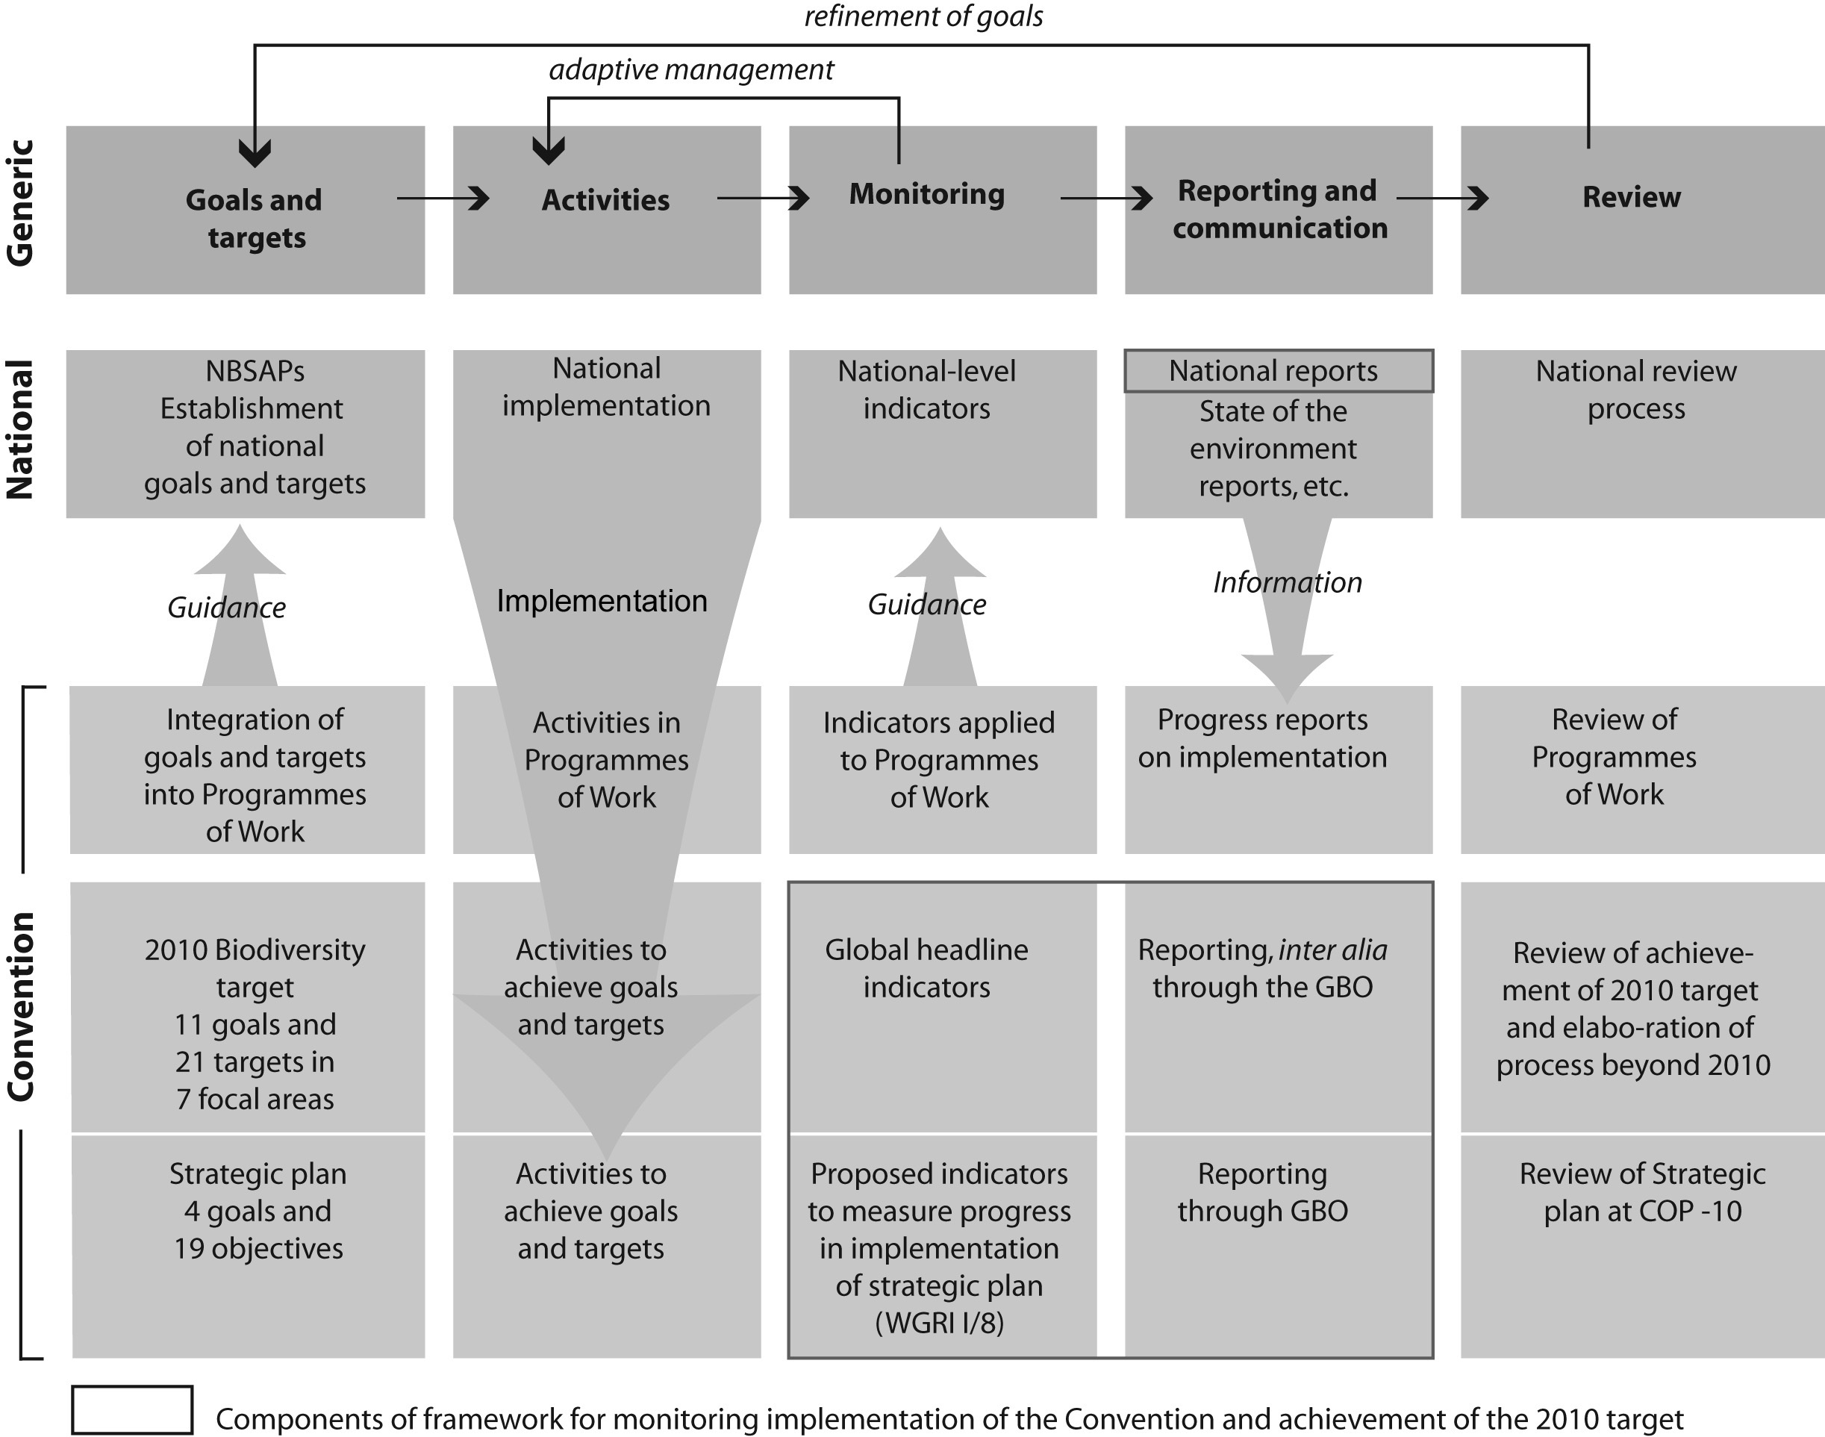
Annex II

means of development, implementation, reporting and review of the indicators including timescales and data flows
Indicators | Status | Application | Means of development, implementation, reporting and review | Timescales | Data flows
Global headline indicators VII/30 annex 1 | Adopted in 2004 to be tested, identified or developed (VII/30 para 4); SBSTTA recommended addition and refinements (SBSTTA Recommendation X/5) | Assessment of progress at the global level towards the 2010 target and effective communication of trends in biodiversity related to the three objectives of the Convention (VII/30 para 3) | SBSTTA to review use of the indicators (VII/30 para 6(a)) and to identify or develop indicators (VII/30 para 6(b))  SBSTTA identified organizations to coordinate delivery of indicators (SBSTTA Recommendation X/5)  Indicators to be used in the second Global Biodiversity Outlook (VII/30 para 3 and 6(a)) | Indicators are at different stages of development and implementation. Coverage and resolution of indicators will gradually improve as research continues until 2010.  The review of the Strategic Plan at COP-10 would also entail a review of the indicators. | Information generated by organizations identified by SBSTTA (rec. X/5) as coordinating implementation of indicators. Data are generated from a variety of compatible sources, with a strong emphasis on existing global databases, global surveys and global review undertaken by various actors
Indicators for assessing progress in implementing goals and objectives of the strategic plan | To be developed on the basis of proposed indicators in annex I of recommendation WGRI I/8 (WGRI I/8 para 1(a)(ii)) | Evaluation of progress in the implementation of the Convention and the Strategic Plan (VI/26 para 4) | To be determined once indicators are agreed  Review in accordance with the process to be decided by COP-8 on the basis of recommendation WFRI I/8 para 1(d) | Indicators are yet to be agreed.  The review of the Strategic Plan at COP-10 would also entail a review of the indicators. | Data will rely both on information compiled by the Secretariat and on national reports
Indicators proposed for programmes of work of the Convention | Agricultural biodiversity: review of programme of work at SBSTTA-13 and COP-9 | To be determined | To be determined | Review of programmes of work in accordance with the schedule provided in the multi-year programme of work | Indicators serve as guidance for development of national indicators. For some indicators information can be generated through existing mechanisms (e.g. Forest Resources Assessment, National reports to the Ramsar Convention etc.). Efforts are underway to maximize synergy.
Indicators proposed for programmes of work of the Convention | Inland waters biological diversity: SBSTTA-10 notes progress made by Ramsar STRP on indicators and invites STRP to link these indicators to the targets contained in the annex to this recommendation (Recommendation X/4, para 3) | Not specified | Further develop the targets as applied to the programme of work on inland waters biodiversity (annex to Recommendation X/4) and link the indicators to the targets
Indicators proposed for programmes of work of the Convention | Marine and coastal biological diversity: SBSTTA makes no reference to indicators (Recommendation X/4) | Not specified | Not determined
Indicators proposed for programmes of work of the Convention | Forest biological diversity | Not specified | COP to recognize that proposed global indicators for further development proposed by Expert Group (UNEP/CBD/SBSTTA/ 11/INF/3) needs refinement, and existing global data sources should be used whenever reporting on any indicators in order to minimize the reporting burden (SBSTTA XI/7 para 4 (d))  COP to invite CPF members to take note of … proposed global indicators (SBSTTA XI/7 para 4 (e))  COP to invite FAO to explore options to include reporting related to forest targets and indicators … in its Global Forest Resources Assessment process (SBSTTA XI/7 para 4 (f))  Establishment of a liaison group to assess suitability of proposed global forest-related indicators (SBSTTA XI/7 para 4 (g))  Parties to share their experiences … in the development and application of national indicators (SBSTTA XI/7 para 4 (i))
Indicators proposed for programmes of work of the Convention | Dry and sub-humid lands biological diversity | Not specified | COP to consider proposed global indicators (SBSTTA XI/7 para 3(b)) and to urge Parties and invite other Governments to develop … national indicators … and to incorporate them into relevant plans, programmes and initiatives, including NBSAPs (SBSTTA XI/7 para 3(b))  Facilitation of the application of global headline indicators in ongoing and planned assessments of DSHL (SBSTTA XI/1 para 18)  SBSTTA to determine ways of facilitating the application within relevant assessments of biodiversity indicators adopted in decision VII/30 (SBSTTA XI/1 para 18(b))
Indicators proposed for programmes of work of the Convention | Mountain biological diversity | Not specified | COP to consider the technical rationale and proposed global indicators contained in the note by the Executive Secretary (UNEP/CBD/SBSTTA/11/10) (SBSTTA XI/7 para 5(b))  COP to urges Parties … to develop national and/or regional goals and targets and related national indicators (SBSTTA XI/7 para 5(e))
Indicators proposed for programmes of work of the Convention | Island biological diversity | Indicators used to assess progress and report in the context of national reports of the CBD | COP-8 to request Parties to use the agreed indicators to assess progress and report in the context of national reports of the CBD (SBSTTA X/1 para 5(h))

National indicators | Status ranging from early stages of development to existing operational (sub-)national and (sub-)regional biodiversity monitoring programmes and indicators | Application in accordance with  (sub-)national and  (sub-)regional requirements | COP- considered the guidance for the development of national-level biodiversity indicators and monitoring (UNEP/CBD/SBSTTA/9/10) useful and encouraged cooperation and information sharing among Parties and the promotion, where useful, of harmonized procedures and formats for data acquisition, computation and reporting, especially at subregional and regional levels  Parties and Governemnts invited to use existing national indicators or to establish national indicators using existing tools (UNEP/CBD/SBSTTA/9/10), and according to national needs and priorities to assess progress towards national and/or regional targets (VII/30 para 16); need for capacity-building to enable developing countries to implement activities to achieve and monitor progress towards the goals and targets (VII/30 para 17);  Parties, Governments, international and funding organizations to provide support for the implementation of activities to achieve and monitor progress towards the goals and targets (VII/30 para 18);  Developed country Parties to support developing countries in development of national-level indicators (VII/30 para 21);  NBSAPs should be developed or reviewed in view of the goals of the Strategic Plan and those of the provisional framework and incorporated into NBSAPs when these are revised (VII/30 para 20); | Not determined | National indicators are implemented for national purposes. The use of national indicators will be encouraged in national reporting to facilitate a more reliable review of national implementation.
-----

* UNEP/CBD/COP/8/1.
/ See UNEP/CBD/SBSTTA/11/INF/24 and UNEP/CBD/COP/8/INF/18 (Global outcome oriented targets for the implementation of the programme of work on dry and sub-humid lands - Relationships between the framework goals and targets and activities of the programme of work)

