 |  | CBD
 |  |  |  | Distr.  GENERAL  UNEP/CBD/COP/9/INF/6  10 March 2008  ENGLISH ONLY
CONFERENCE OF THE PARTIES TO THE CONVENTION ON BIOLOGICAL DIVERSITY
Ninth meeting
Bonn, 19–30 May 2008

Item 4.10 of the provisional agenda*
Island biodiversity: report of the STRATEGY meeting of
the Global Island Partnership
Note by the Executive Secretary
introduction
- In decision VIII/1, the Conference of the Parties adopted a work programme on island biodiversity. In his progress report on the thematic programmes of work (UNEP/CBD/COP/9/19), the Executive Secretary reports on the achievements of Parties and their partners in implementing the work programme, and on the main issues raised in several events related to islands, including the GLISPA Strategy Meeting, which took place in Rome, from 25 to 27 September, 2007.
- The GLISPA Strategy Meeting was co-chaired by Rolph Payet, Special Advisor to the Seychelles President, and Jo Mulongoy, Principal Officer of the Division of Scientific, Technical and Technological Matters, Secretariat of the Convention on Biological Diversity. Its 29 participants included representatives of the Partnership’s most active Government and organization members and/or champions of existing or developing initiatives that are interested in greater involvement with the Partnership.
- The GLISPA Draft Strategic Plan: 2008-2010, one of the outcomes of the GLISPA Strategy Meeting, outlines GLISPA’s first strategic plan and a global consultation process and is attached to the present note for the information of participants in the ninth meeting of the Conference of the Parties to the Convention on Biological Diversity. The draft Strategic Plan will guide the Partnership and provide the necessary support structure, as GLISPA continues to evolve over the next three years. More information on GLISPA can be found at http://www.cbd.int/island/glispa.shtml.
- The draft Strategic Plan is being circulated in the form and language in which it was received by the Secretariat.

Global Island Partnership
Draft Strategic Plan: 2008-2010

A better future for all our islands and a solid foundation to build a sustainable future for the world
- HE Seychelles President James A. Michel, Rome, Italy - September 26, 2007

Background
The Global Island Partnership (GLISPA) assists islands in addressing one of the world’s greatest challenges — to conserve and sustainably utilize the invaluable island natural resources that support people, cultures, and livelihoods in their island homes around the world. It brings together island nations and nations with islands — small and large, developing and developed — to mobilize leadership, increase resources and share solutions in a cost-effective and sustainable way that will catalyze action for conservation and sustainable livelihoods on islands.
GLISPA is recognised by the Convention on Biological Diversity (CBD) as a partnership to advance the implementation of the CBD 2010 target to reduce the rate of biodiversity loss and the Programmes of Work on Island Biodiversity and Protected Areas. GLISPA was created to help bridge local and global initiatives and build upon existing networks and programmes.

Since it was first called for at the Mauritius International Meeting in January 2005 and launched at the 8th Conference of the Parties (COP8) for the Convention on Biological Diversity in Brazil in March 2006, the Global Island Partnership has grown rapidly. To date, GLISPA has engaged more than 20 countries and 20 implementing and donor organisations in commitments to significant action and funding for conservation and sustainable livelihoods on islands (Figure 1, p. 3).

The GLISPA group spans all the regions of the world and includes leaders from small islands states, large island nations, overseas territories, and donor countries as well as local, national, regional and international organizations (current GLISPA partners, membership criteria and expectations of partners are provided in Annex 1). Remarkably, the Partnership has achieved this without formal structure or dedicated staffing.

In September 2007, a group of active partners met in Rome to outline GLISPA’s first strategic plan and a global consultation process (Annex 6). This GLISPA 2008-2010 Strategy will guide the Partnership and provide the necessary support structure, as GLISPA continues to evolve over the next three years.

Box 1: GLISPA: Global potential for island partnerships and collaboration
Island Biodiversity: Unique & Threatened
- 1/6 of the Earth’s surface  - Over half of its marine biodiversity  - 7 of the 10 coral reef hotspots surround islands  - 25% of the terrestrial Global 200 Ecoregions  - 12 of the 18 centers of marine endemism  - More than 30% of the World’s Biodiversity hotspots  - Half of the Endemic Bird Areas  - 37% of the Critically Threatened Species | 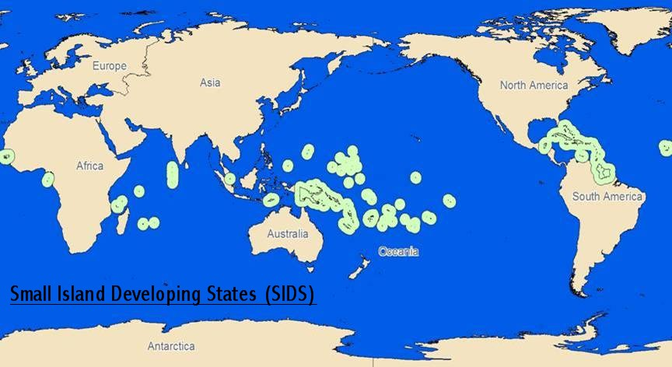
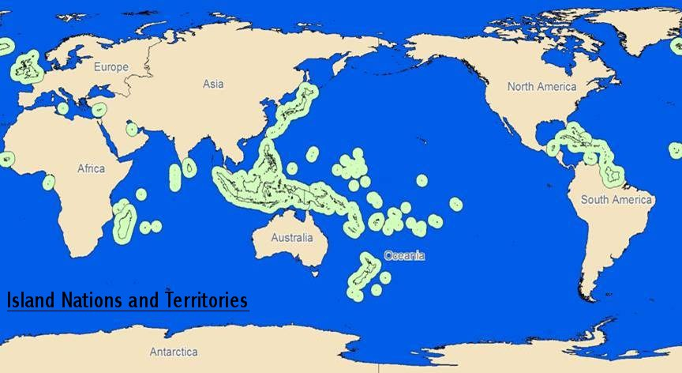
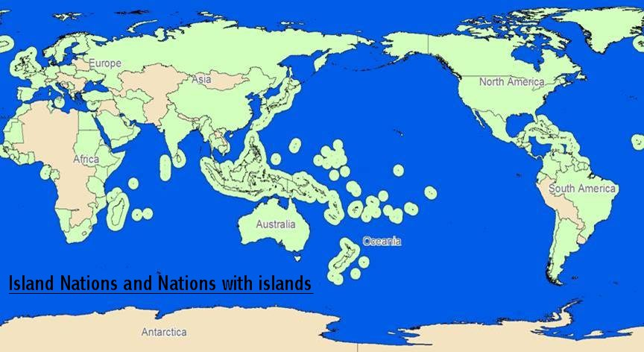 |  |  | A global partnership on islands. Who Benefits?  - 500 million inhabitants  - 47 of the World’s nations  - 60+ island nations & territories  - ca 60-70% of countries have islands  - Extraordinary cultural diversity

GLISPA Commitments
The Micronesia Challenge was one of the earliest GLISPA commitments and is an outstanding example of how the Partnership is working. Following Fiji’s bold announcement in Mauritius, / the President of Palau led five Micronesian Chief Executives – three Heads of State and two Governors of U.S. Territories – to a shared commitment to “effectively conserve at least 30% of their near-shore marine resources and 20% of their terrestrial resources by the year 2020.”
The Micronesia Challenge subsequently inspired the government of Grenada to announce its intention to "protect 25% of its marine and terrestrial area by 2020". Grenada was immediately joined by the Bahamas, thereby initiating the Caribbean Challenge Marine Initiative. To date, all nine members in the Organization of Eastern Caribbean States (OECS) have adopted the Caribbean Initiative in principle, and much work is underway. At the same time, Indonesia’s President Yudhoyono initiated discussions with five neighbouring countries to work together to protect the heart of coral diversity in the world, the Coral Triangle, and Seychelles’ President Michel launched the Western Indian Ocean Marine Protected Area Initiative.
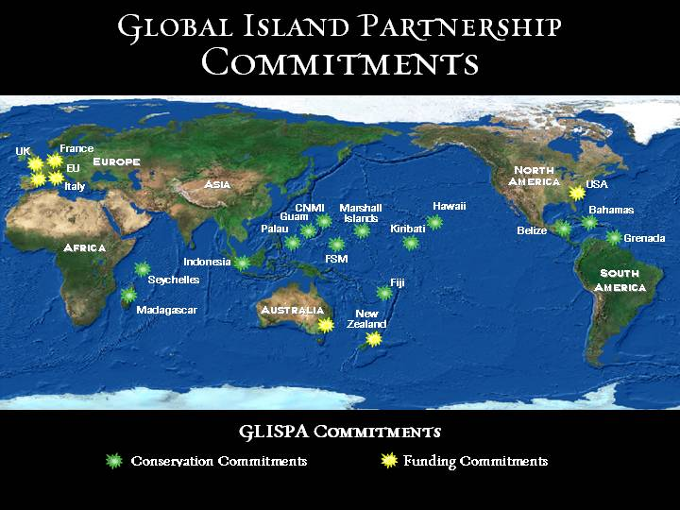
Figure 1 - GLISPA Conservation and Funding Commitments -- More than 20 countries and 20 organisations have made significant commitments to island conservation and funding, including more than US$ 33 million in support for island priorities (Annex 2.)

GLISPA Mission
GLISPA promotes actions for island conservation and sustainable livelihoods by inspiring leadership, catalyzing commitments, and facilitating collaboration among all islands.

GLISPA Principles
- GLISPA is an open partnership, available to any country or organization who shares its mission and values
- GLISPA commitments are based on national and/or organisational priorities, including helping countries accelerate action on key international policies (e.g. CBD Programmes of Work, Millennium Development Goals and related policies)
- Partners are responsible for implementing and funding their commitments; the Partnership assists through its global network and visibility
- Collaboration is encouraged but voluntary
- GLISPA adds value to existing networks and initiatives
- GLISPA does not engage in policy advocacy; this is a role for individual countries, organizations or coalitions

GLISPA Goals

Each government and organisation active in the Global Island Partnership share goals articulated in the CBD Programmes of Work and other international, regional and national plans. However, each partner brings their own priorities, and these determine the GLISPA commitments that they make. GLISPA’s role is to provide a mechanism for advancing, accelerating and leveraging its partners’ efforts and achievements in their chosen priorities. Hence, GLISPA has three simple overarching goals and uses seven strategies to define its unique niche in working with Partners.

Goal 1: Support successful implementation of Partner commitments
Goal 2: Catalyze new commitments to address critical island issues
Goal 3: Establish and maintain a flexible and efficient Partnership responsive to its partners

GLISPA Strategies
Strategy 1: Inspire and recognize leadership and commitments to action for island conservation and sustainable livelihoods
Strategy 2: Strengthen partnerships to support implementation of commitments and to build local long-term conservation capacity.
Strategy 3: Facilitate increased public and private funding for island priorities
Strategy 4: Promote targeted and cost-effective collaboration and exchanges among islands
Strategy 5: Engage in effective communication strategies on island issues
Strategy 6: Build linkages between all islands, regardless of political status
Strategy 7: Track progress on GLISPA commitments

GLISPA Objectives 2008-2010
The leaders and partners implementing and planning major GLISPA commitments identified specific ways the Partnership can help advance their initiatives, and specific ways they can help advance the Partnership. A partial list of these GLISPA 2010 key actions for each commitment is provided in Table 1, p.11 at the end of this Strategy. Other GLISPA partners will add their key actions over time.
Since GLISPA’s purpose is to promote island leadership and encourage collaborative action and as the Partnership is actively growing, the following GLISPA 2010 objectives reflect the current active membership and will undoubtedly change with time. This will be accommodated with regular updates of Table 1 and the GLISPA 2010 plan. Critical milestones to track the Partnership’s effectiveness are provided in the last section of this document, p. 10.

GLISPA’s focus on leadership and synergy are key success factors. The proposed governance structure will maintain the Partnership’ strategic agility, high leverage and low overhead while providing the leadership, continuity and professional support essential for the Partnership to function effectively and respond to its growing membership.

Objective I: Leadership and Decision-making
Establish a representative and effective “Steering Committee” of 10-20 GLISPA partners to provide leadership and decision-making for the Partnership.

Steering Committee Key Functions
- Ensure GLISPA core coordination functions are maintained (e.g. events, conference calls, exchanges, information/expertise sharing, partner engagement & recruitment, fundraising)
- Facilitate new or existing commitments for action with a focus on leveraging support and resources
- Recruit, support and supervise the GLISPA Coordination Team and an extended network of in-kind staff contributions
- Oversee GLISPA management, including review and approval of membership, budgets, and administrative arrangements
- Approve and oversee GLISPA high level communications decisions, including GLISPA Communications Strategy
- Ensure regular communication and consultation with GLISPA membership and key stakeholders, including a short annual report
- Track progress on GLISPA 2010 Strategy and update it annually.
- Recommend improvements to GLISPA governance structure, including possibly instituting a high level board or patrons group for CEO/Head of State engagement
- Review and update Steering Committee membership every year.

Steering Committee Membership Criteria
One or more of the following:
- Financial and/or significant in-kind contributions to GLISPA core coordination functions
- Lead role in implementation of a major GLISPA commitment
- In-kind contribution of committed staff to provide timely review of materials and regular participation on conference calls and meetings (20% time or more highly recommended)

Box 5 – Proposed GLISPA Steering Committee Members for 2008-2010
Representatives from each of the following active GLISPA partners have agreed to serve on the GLISPA Steering Committee. Additional members may be added.
- Caribbean Challenge Marine Initiative (CCMI)  - CBD Secretariat  - Conservation International (CI)  - Coral Triangle Initiative (CTI)  - GLISPA Communications  - GLISPA Coordination  - Invasives Initiative  - Italy | - World Conservation Union (IUCN)  - Micronesia Challenge  - Palau  - Secretariat of the Pacific Regional Environment Programme (SPREP)  - Seychelles  - The Nature Conservancy (TNC)  - UNEP/WCMC
Lead representatives and their alternates are provided in Annex 5.

Objective II - GLISPA Staffing
Hire and support a GLISPA Coordination Team to provide professional support for three critical partnership functions – facilitation and strategy with partners; communications; and GLISPA event coordination.

Since 2005, GLISPA has grown without dedicated staffing or funding. All activities have been organized and executed by Partner staff on a volunteer basis. This experience has demonstrated the need for a Coordination Team formed by three dedicated GLISPA staff positions or contracts to ensure continuity of critical coordination functions as well as maximum leverage for GLISPA partners.
- GLISPA Facilitator – works closely with the Steering Committee to develop and implement GLISPA’s strategic direction, including assistance with recruiting new members and leveraging initiatives
- Communications Coordinator – works closely with the Communications Team (comprised of communication staff of GLISPA partners) to raise the visibility of island issues, commitments and achievements, including joint communication campaigns
- Events Coordinator – works with the other GLISPA staff and ad hoc teams of GLISPA partners to develop and implement up to two major GLISPA events each year. Typically, these will be held in conjunction with a relevant global event (e.g. the CBD COP.) In addition, the Event Coordinator will advise and coach GLISPA teams organizing regional and other events (e.g. Pacific Island Leaders Forum.)

Objective III – GLISPA Finance
By June 2008, secure commitments for at least U.S. $2 million to support the GLISPA coordination functions through 2010.

GLISPA’s coordination costs will be financed by partner contributions. For the first three years, at least 4 partners will contribute approximately U.S. $500,000 each to establish the GLISPA Coordination Team and provide base funding for essential network activities. All GLISPA commitments and most GLISPA events will be jointly funded by sponsoring partners.

GLISPA Coordination - Estimated Expense Budget
(U.S. $ 000)
 | 2008 | 2009 | 2010 | TOTAL
Personnel (3) | 270 | 350 | 365 | 985
Office expenses | 15 | 16 | 17 | 48
Equipment | 20 |  |  | 20
Staff travel | 60 | 63 | 66 | 189
Meeting & event support* | 100 | 105 | 110 | 315
Communication products | 20 | 40 | 40 | 100
Steering Committee meetings | 25 | 27 | 28 | 80
Measures & review** | 50 | 50 | 150 | 250
Administration (20%) | 112 | 130 | 154 | 396
TOTAL | 672 | 781 | 930 | 2,383

*assumes 2-3 core events each year; additional events will require partner sponsorship
** annual monitoring and 2010 review of achievements

GLISPA Milestones 2008 – 2010
2008
- At least 5 countries report high-impact results on their island conservation commitments, and these are publicized/shared widely
- At least 10 countries or organizations make new commitments to major island conservation initiatives that implement priority actions within the CBD Islands Programme of Work or related policies.
- Island exchanges facilitated to accelerate conservation progress on priority island issues, as requested
- Global Island Partnership structure established, funding secured and staff hired
- At least U.S.$15? million in new funds pledged to support Partner commitments [$10M GEF GLISPA; $6M for MC; ?? for Fiji, Kiribati, Caribbean, Coral Triangle, Indian Ocean, Sea Level Rise]

2010
- At least 10 countries report high-impact results on their island conservation commitments, and these are publicized/shared widely
- Sustainable funding targets met by at least two initiatives, with significant GLISPA assistance
- Regional or global programmes, and information exchanges mechanisms, in place to help islands rapidly share solutions, technology, capacity and practices to address invasive species and sea level rise.
- More than 50% of active GLISPA partners report significant benefits from participating in the Partnership.
- At least one partnership with the private sector announced to address a major island challenge, such as sustainable tourism, fisheries, forestry, agriculture, waste management, coastal development or invasive species management.

Table 1 – Major Commitments & Key GLISPA 2010 Actions
The leaders and partners implementing and planning the following major GLISPA commitments identified the specific ways the Partnership can help advance their initiatives, and ways they can help advance the Partnership. Brief action plans drafted in Rome are currently included in Annex 4.

Goal 1: Support Successful Implementation of Partner Commitments

- Micronesia Challenge (MC) – Bill Raynor (TNC & Acting MC Coordinator)
By 2020, effectively conserve at least 30% of the near-shore marine resources and 20% of the terrestrial resources in five Micronesian countries and territories -- Federated States of Micronesia (FSM), Palau, Republic of the Marshall Islands (RMI), U.S. Territory of Guam, and the U.S. Commonwealth of the Northern Mariana Islands (CNMI)
- Assist in securing U.S. $18 million for the first phase of the Micronesia Challenge endowment
- Build stronger linkages with U.S. island initiatives, especially the new Papahanaumokuakea Marine National Monument in the Northwestern Hawaiian Islands
- Facilitate collaboration with Kiribati’s new Phoenix Islands Marine Protected Area.
- Connect the Micronesia Challenge with other islands to share lessons learned in planning and implementing a regional “challenge” or initiative.

- Phoenix Islands Protected Area (PIPA) – Tekabu Teroroko (Kiribati), Sue Taei (CI)
  - Assist with disseminating lessons learned from PIPA, including reverse-fishing license endowment after documented in 2008
  - Share expertise and examples to assist with development of PIPA sustainable financing plan in 2008
  - Promote PIPA’s leadership in developing a model trans-boundary surveillance and enforcement partnership
  - Assist in securing PIPA endowment of U.S. $15-20 million.
  - Foster collaboration and engagement of Kiribati with the larger Micronesia Challenge
  - Assist in developing a joint communication strategy for shared target audiences focused on the small islands of the central and north Pacific

- Coral Triangle Initiative (CTI) – Sian Owen (WWF) & Sheldon Cohen (TNC)
- Work with the six Coral Triangle governments to launch the CTI with majority funding secured at the World Ocean Summit in Manado, North Sulawesi in May 2009
- Share expertise and examples to assist with development of MPA sustainable financing plan(s) for the six CTI countries.
- Promote the Coral Triangle Initiative with regional and international stakeholders
- Connect the CTI with other islands to share lessons in developing a regional framework for sustainable fisheries
- Explore feasibility and interest in a joint communications strategy for Coral Triangle and other island initiatives

- Fiji Marine Initiative - Kesa Tabunakawai (WWF-Fiji)
  - By 2008, assist Fiji partners in securing strong support from the new Government for the national commitment to establish 30% of their marine area as MPAs.
[NOTE: The Fiji government was the first to make this kind of large scale commitment in 2005, but action has been suspended since the coup in 2006. Elections for a new government are scheduled for the first quarter of 2009.

- Western Indian Ocean MPA Initiative – Rolph Payet (Seychelles)
Seychelles, Mauritius, Comoros, Madagascar, (La Reunion)
- Facilitate exchanges to strengthen or initiate marine protected area networks in at least four countries/territories
- Share expertise and examples for sustainable financing plans in at least ## countries/territories, and assist in securing at least $?? In GEF funding
- Connect with other islands to share lessons in effective management of MPAs using radar technology

Goal 2: Catalyze New Commitments to Address Critical Island Issues
- Caribbean Challenge Marine Initiative – Spencer Thomas (Grenada) & Rob Weary, (TNC)
- Work with Caribbean leaders and partners to launch the Caribbean Initiative at CBD COP9 in May 2008, including at least 10 Caribbean countries and a focus on sustainable financing of protected areas and implementation of national systems of protected areas.
- Help increase international attention and funding for long-term financing of protected area systems in the Caribbean and elsewhere.
- Assist the Caribbean in developing a regional multi-sector approach to preventing and managing alien invasive species

- Invasive Species on Islands – Stas Burgiel (GISP/TNC) & Greg Sherley (New Zealand)
- Recruit one or more global leaders in invasive species management to champion this issue and make a GLISPA commitment for invasives at COP9
- Strengthen, coordinate and expand the partnership initiatives addressing invasive species in the Pacific – SPREP, SPC, Pacific Invasives Learning Network, Pacific Invasives Initiative and key bilateral efforts by New Zealand, Australia, USA and others.
- Assist two island regions to adapt the Pacific partnership approach to building national and regional capacity for invasive species management
- Work with GEF to develop a programme and secure matching funds to support global leadership in island invasive species management
- Develop a joint communications strategy to highlight the global threat posed by invasive species and the high cost of delayed action [to be discussed with the Communications Team]
- Help recruit and recognize at least one private sector industry taking leadership on invasive species prevention and management.

- Sea Level Rise Foundation – Rolph Payet (Seychelles)
The Sea Level Rise Foundation will bring resources and expertise together to support small island states, islands and other low-lying areas in adapting to the growing threat of sea level rise and avoiding the first climate refugees.
- Identify early champions to join the Seychelles in developing the Sea Level Rise Foundation
  - Help recruit support from the World Economic Forum and build public-private partnerships to develop technologies and guidance for addressing sea-level rise
  - Explore feasibility and interest in a joint communications strategy to highlight the global impact of sea level rise on island communities.

- Global islands database and information portal – Kristian Teleki (UNEP-WCMC) with other partners including CBD Secretariat, Global Islands Network (GIN), IUCN Task Force on Island Conservation and Protected Areas (TAFICOPA) and TNC
The development of an island database that will feed future biodiversity assessments, support international action for islands and lead to development of several products, including an islands web portal and a World Atlas of Island Biodiversity to communicate key issues in island conservation.
- Consolidate existing sources of data and information to create a central and up to date information portal. Conduct initial review to identify data gaps and areas for future work required to make the database fully consistent.
- Conduct an expert workshop to plan the database merger and to consider how it should be developed and used in the future, and in particular how island stakeholders can be involved in this process.
- Distribute the database to key stakeholders to gauge interest and seek feedback on accuracy and utility of the database.
- Review other readily available datasets that could be combined with the data in the new islands database to create more powerful tools and analysis.
- Potential future uses of the database
- Biodiversity assessment: The database would support systematic global assessment of the status of island biodiversity, support assessment of progress in achieving the targets identified in the CBD Programme of Work on Island Biodiversity, and facilitate review of the extent to which island biodiversity is included in protected area networks.
- Islands indicators: The database would allow regular and informed monitoring of the status of islands through a series of simple and easily definable common island related indicators. This would serve as a tool for national reporting and the prioritization of donor resources.
- Input to other assessment processes: The database would facilitate the objective assessment of the status of island biodiversity and environments within existing assessment processes and products relevant to islands. Relevant assessment processes include the UNEP Global Environmental Outlook and the CBD Global Biodiversity Outlook.
- Online database: In the future, the database could be made available online to support the work of other organizations and networks, allowing the data to be used, and allowing others to link information to the database. This increases access to information for a wide range of stakeholders, including island residents.
- World atlas of islands: The database will provide major inputs to the proposed World Atlas of Islands, which is being designed to communicate the importance of islands to a wide audience.
- Private sector engagement: The database would serve as a basis for engaging the private sector and establishing the business benefits associated with maintaining the ‘living capital’ of islands.

- New commitments currently being explored
- Sustainable Tourism on Islands – Oliver Hillel (CBD Secretariat) & Rolph Payet, (Seychelles and World Economic Forum)
- Mediterranean Partnership – Margarita Astralaga (IUCN) & Isabella Pratesi (WWF Italy)
- Ecosystem-Based Management of Fisheries and Large Marine Ecosystems – Rob Weary (TNC) & others

Annex 1 – GLISPA Partners, Membership Criteria
GLISPA Partners
More than 20 countries and territories and 20 agencies and organizations worldwide are currently engaged in high level commitments and on the ground action for island conservation and sustainable use of natural resources.
Countries and Territories include | Agencies and organizations include
- Australia  - Bahamas  - Belize  - Commonwealth of the Northern Mariana Islands  - European Union  - Federated States of Micronesia  - Fiji  - France  - Grenada  - Guam  - Indonesia  - Italy  - Kiribati  - Madagascar  - New Zealand  - Palau  - Republic of the Marshall Islands  - Seychelles  - United Kingdom  - United States of America | AOSIS - Alliance of Small Island States  Birdlife International  CI - Conservation International  CII – Cooperative Islands Initiative  CSP - Conservation Society of Pohnpei  ForSec - Pacific Forum Secretariat  GIN - Global Islands Network  ICRAN - International Coral Reef Action Network  ICRI - International Coral Reef Initiative  IRF - Island Resources Foundation  ISSG – Invasive Species Specialist Group  IUCN - World Conservation Union  MCT - Micronesia Conservation Trust  Nature Seychelles  PCS - Palau Conservation Society  PII – Pacific Invasives Initiative  PILN – Pacific Invasives Learning Network  RARE  RSPB - Royal Society for the Protection of Birds  SPREP - Secretariat of the Pacific Regional Environment Programme  TNC - The Nature Conservancy  UNDP-GEF - United Nations Development Programme - Global Environment Facility  UNEP/CBD - United Nations Environment Programme - Convention on Biological Diversity  UNEP/CMS - United Nations Environment Programme Convention on Migratory Species  UNESCO - United Nations Educational, Scientific and Cultural Organization  WCS - Wildlife Conservation Society  WWF - World Wide Fund for Nature
GLISPA Membership Criteria
- GLISPA membership is open to any entity – government, agencies, organizations, but also individuals – committed to taking significant action to ensure sustainable livelihoods, conserve nature or address global changes on islands (Note: commitments are usually announced at GLISPA-sponsored events, although this is not a requirement.)
- Partners implement their commitments in accordance with the Partnership’s principles (listed on p. 4 of the Draft Strategy)
- Membership lapses in three years, unless the partner reports progress on its commitment(s).
The GLISPA Steering Committee decides any membership related issues.

Annex 2: GLISPA Commitments 2005 – 2007
Country, Organization or Initiative | Commitment | Leads∗
Asia Pacific
- Micronesia Challenge | - 30% marine; 20% terrestrial under effective conservation by 2020 in Palau, FSM, RMI, CNMI, Guam  - US$6 million challenge to leverage $12 million more to sustainably finance protected areas in the Micronesia Challenge.  - US $6M GEF funds pledged toward match | Palau –Youlsau Bells  FSM – Marion Henry  RMI – Yumi Crisostomo  Guam – Vangie Lujan  CNMI – Fran Castro  TNC – Bill Raynor  CI – Francois Martel
- Kiribati | Phoenix Islands MPA – 3rd largest MPA in the world | Kiribati – Tukabu Teroroko  CI – Sue Taei
- Fiji PA Network | 30% of Fiji’s inshore & offshore marine areas in MPA network by 2020 | Fiji  WWF-Fiji – Kesa Tabunakawai  WCS – Etikia Rupeni
- Indonesia Coral Triangle | Leading collaboration among Coral Triangle countries to conserve coral mega diversity in the Coral Triangle (Malaysia, Philippines, Solomon Islands, Timor Leste, Papua New Guinea, Palau and FSM) | Indonesia -  TNC – Rili Djohani & Sheldon Cohen  WWF – Sian Owen
- Australia | - AU$500,000 to support freshwater management on islands, a critical ecosystem that is often not included in protected area systems. (Mauritius)  - continuation of Regional Natural Heritage Program (RNHP) | Australia – Zena Armstrong  CI – Francois Martel  TNC – Peter Thomas
- New Zealand | - Supporting the Pacific programme of the Cooperative Islands Initiative to reduce the impacts of Invasive Alien Species on island biodiversity and livelihoods in the Pacific Islands  - US$600,000 to match UNDP/GEF for the GEF Small Grants Programme across the Pacific, bringing the total to US$1.2 million. | NZ – Greg Sherley  TNC – Krista Singleton  PII – Souad Boudjelas
- Hawai’i | See USA – Papahanaumokuakea (Northwestern Hawaiian Islands) Marine National Monument

Latin America Caribbean
- Grenada | - Grenada - 25% marine & 25% terrestrial areas under effective conservation by 2020  - Official launch of Caribbean Challenge Marine Initiative at COP9 | Grenada – Spence Thomas  Bahamas – Donald Cooper  TNC – Ruth Blyther & Rob Weary
- Belize | Comprehensive National Protected Areas Policy and System Plan by 2005
- Bahamas | - Development of a network of fully protected Marine Reserves  - Studies of potential ways to enhance fish biomass in areas outside of proposed reserve boundaries.
Indian Ocean, Africa
- Madagascar | Protected Areas | WWF – Sian Owen
- Seychelles | - Western Indian Ocean MPA Initiative  - Sea Level Rise Foundation | Seychelles – Rolph Payet  WWF – Sian Owen
Europe & North America
- EU | Funding in Mauritius (get details) | EU –  TNC – G. Miles, R Weary
- France | - EU 9 million for reef conservation (2005 – 2007) – IFRECOR & CRISP  - Hosting EU/OCT meeting on islands and climate change in Reunion in collaboration with IUCN | France -  CI – Francois Martel
- Italy | - Expand Island Initiative (with IUCN)  - Host GLISPA 2010 Strategy meeting in Rome, September 2007 | Italy – Alfredo Guillet  IUCN – Giorgio Grussu  TNC – Susi Olmsted
- UK | - Co-sponsor & active partner in all GLISPA events  - Developing island initiative focused on climate change | UK – Chris Tompkins, Robert Baldi  TNC – Gerald Miles
- USA | - Papahanaumokuakea (NWHI) Marine National Monument, largest MPA in world  - $460,000 for protected areas in FSM, regional invasives and RMI waste mgmt  - NOAA/UNESCO meeting to increase collaboration by NWHI and the Pacific | USA – Joe Murphy (Pacific); Christine Dawson  TNC – Emily Tibbott & Audrey Newman
International Organizations
- CI | - $3 million for Micronesia Challenge  - Lead partner working with Kiribati; co-lead on Coral Triangle & Madagascar  - Co-sponsor of all GLISPA events | CI – Francois Martel
- IUCN | - Co-sponsor & organizer for GLISPA 2010 Strategy meeting in Rome  - Lead on EU/OCT meeting on islands & climate change in Reunion | IUCN – Giorgio Grussu, Margarita Astralaga, Yves de Soye & Jean Philippe Palasi
- RARE/TNC | $3 million for social marketing campaigns (not just islands) | RARE – Paul Butler
- TNC | - $2 million for Early Action Grants for MPA networks in island states  - $3 million for Micronesia Challenge  - Lead partner working with Micronesia & Caribbean; co-lead on Coral Triangle & Western Indian Ocean  - Co-sponsor of all GLISPA events  - Co-sponsor & organizer for GLISPA 2010 Strategy meeting in Rome | TNC – Gerald Miles & Audrey Newman
- UNDP/GEF | - $1.2 million for GEF Small Grants Program across Micronesia ($600K matched 1:1 by NZ)  - $6 million pledged to Micronesia Challenge (from $100M GEF Pacific Alliance for Sustainability) | GEF – Nicole Glineur  TNC – Yabanex Batista
- UNEP/CBD | - Support to all CBD Parties on Island Biodiversity Programme of Work  - Host of GLISPA website  - Co-sponsor of GLISPA events at COP8 & COP9 | CBD – Oliver Hillel & Jo Mulongoy
- USP | 10%f graduates trained for successful implementation of GLISPA by 2010 | USP – Randy Thaman
- WWF | - Lead partner working with Fiji & Western Indian Ocean; co-lead on Coral Triangle & Madagascar  - Co-sponsor of all GLISPA events | WWF – Sian Owen
- GLISPA | More than 25 organizations are working together to highlight the importance of island biodiversity; hold GLISPA events; assist with implementation of major island commitments and strengthen the Global Island Partnership’s ability to help islands around the world. | AOSIS, Birdlife Int’l, CEP, CI, CSP, DEFRA, ForSec, GIN, ICRAN, ICRI, Italian Dev’t Corp, IRF, IUCN, MCT, Nature Seychelles, PCS, RARE, RSPB, SPREP, TAFICOPA, TNC, UNEP/CBD, UNEP/CMS, UNESCO, WCS, WWF

Annex 3 – Calendar of Major Island Events 2008-2010
These are potential venues for meetings of GLISPA members and/or for major GLISPA events.

DATE | EVENT | LOCATION
2008
January | International Coral Reef Initiative (ICRI) Meeting & International Year of the Reef Launch | Washington DC, USA
February | 2nd Working Group on Protected Areas (WGPA2) | Rome, Italy
February | SBSTTA13 for the CBD | Rome, Italy
April | 4th Global Conference on Oceans, Coasts, and Islands | Hanoi, Viet Nam
April | GEF Council meeting (Coral Triangle) | Washington DC, USA
May | Coral Triangle Initiative (CTI) 2nd Senior Officials Meeting (SOM2) | Philippines
May | 9th Conference of the Parties for the CBD (COP9) | Bonn, Germany
June | G8 Summit | Tokyo, Japan
July | European Union and islands: strategies for biodiversity conservation in the face of climate change | La Reunion, Indian Ocean
July | International Coral Reef Society Meeting - | Fort Lauderdale, Florida, USA
August | Pacific Island Forum Meeting | Niue
October | IUCN World Conservation Congress | Barcelona, Spain
October | First ministerial meeting (MM1). Review of draft Joint Declaration (containing CTI Plan of Action). Finalization of Joint Declaration | To be determined
2009
May | World Ocean Summit | Manado, Indonesia
June | G8 Summit | La Maddalena, Italy
2010
To be determined | 10th Conference of the Parties for the CBD (COP10) | Japan

Annex 5: GLISPA Steering Committee Members – November 2007

Country, Organisation or Initiative | Lead Contact | Alternate Contact
- Caribbean Challenge Marine Initiative | Spencer Thomas (Grenada) | Rob Weary (TNC)
- CBD Secretariat | Oliver Hillel (CBD Secr) | Jo Mulongoy (CBD Secr)
- Conservation International (CI) | Francois Martel (CI)
- Coral Triangle Initiative (CTI) | Sian Owen (WWF) | Sheldon Cohen (TNC)
- GLISPA Communications | Cathryn Treasure (GLISPA) | Chrissy Schwinn (TNC)
- GLISPA Coordination | Susi Olmsted (TNC) | Audrey Newman (TNC)
- Invasives | Stas Burgiel (GISP-TNC) | Greg Sherley (New Zealand)
- Italy | Alfredo Guillet (Italy) | Giorgio Grussu (Italy)
- World Conservation Union (IUCN) | Jean Philippe Palasi (IUCN) | Margarita Astralaga (IUCN)
- Micronesia Challenge | Bill Raynor (TNC)
- Palau | Larry Goddard (Palau) | Youlsau Bells (Palau)
- Secretariat of the Pacific Regional Environment Programme (SPREP) | Kate Brown (SPREP)
- Seychelles | Rolph Payet (Seychelles)
- The Nature Conservancy (TNC) | Gerald Miles (TNC) | Audrey Newman (TNC)
- UNEP/WCMC | Kristian Teleki (UNEP-WCMC)

Annex 5: GLISPA 2010 Strategy - Rome Meeting participants
Meeting participants included representatives of the Partnership’s most active government and organization members and/or champions of existing or developing initiatives that are interested in greater involvement with the Partnership.
- Keynote speech and opening by H.E. Seychelles President James A. Michel
- Strategy Meeting Co-Chairs
  - Rolph Payet, Special Advisor to the Seychelles President
  - Jo Mulongoy, Principal Officer of the Division of Scientific, Technical and Technological Matters, CBD Secretariat

Name | Position | Country or Organization | Contact information
Roland ALCINDOR | Economist / Program Manager, Head of Environment Unit | UNDP – Mauritius / Seychelles  Http://un.intnet.mu | roland.alcindor@undp.org
Margarita ASTRALAGA | Director, IUCN Centre for Mediterranean Cooperation | IUCN  www.uicnmed.org | margarita.astralaga@iucn.org
Stas BURGIEL | Senior Policy Analyst, Global Invasive Species Program (GISP) and TNC | Global Invasive Species Program (GISP) www.gisp.org  The Nature Conservancy (TNC)  www.nature.org | s.burgiel@gisp.org  sburgiel@tnc.org
Piero GENOVESI | Deputy Chair IUCN ISSG | INFS .- Italian Wildlife Institute | piero.genovesi@infs.it
Nicole GLINEUR | Program Manager, Biodiversity & Private Sector | Global Environment Facility (GEF) | nglineur@TheGEF.org
Giorgio GRUSSU | IUCN-DGCS (Direzione Generale Cooperazione allo Sviluppo) SIDS Program Officer | IUCN - Ministry of Foreign Affairs, Italy | giorgio.grussu@esteri.it
Alfredo GUILLET | Focal Point for Environment, Direzione Generale Cooperazione allo Sviluppo | Ministry of Foreign Affairs, Italy | alfredo.guillet@esteri.it
Abdul  HALIM | Policy and Technical Manager, TNC Coral Triangle Center, Indonesia | The Nature Conservancy (TNC)  www.nature.org  www.coraltrianglecenter.org | ahalim@tnc.org
Oliver  HILLEL | Programme Officer | CDB Secretariat  www.cbd.int | oliver.hillel@cbd.int
Paolo LOMBARDI | Director | WWF Mediterranean | plombardi@wwfmedpo.org
Francois MARTEL | Executive Director, Pacific Islands Program | Conservation International (CI)  www.conservation.org | fmartel@conservation.org

Susi MENAZZA OLMSTED | Meeting Coordinator | GLISPA | solmsted@tnc.org
Gerald  MILES | Regional Director, External Affairs Asia Pacific | The Nature Conservancy (TNC)  www.nature.org | gmiles@tnc.org
Oliviero MONTANARO | Head of Unit, Directorate for Nature Protection | Ministry of Environment, Italy | montanaro.oliviero@minambiente.it
Kalemani Jo MULONGOY | Principal Officer of the Division of Scientific, Technical and Technological Matters | CBD Secretariat  www.cbd.int | jo.mulongoy@cbd.int
Audrey NEWMAN | Senior Conservation Advisor, Asia Pacific | The Nature Conservancy (TNC)  www.nature.org | anewman@tnc.org
Sian  OWEN | Head, Policy & External Relations, Coral Triangle Program | WWF International  www.panda.org/coral | sowen@wwf.nl
Jean-Philippe PALASI | Program Coordinator, European overseas Regions and Territories | IUCN  www.iucneurope.org | jean-philippe.palasi@iucn.org
Rolph  PAYET | Special Advisor to the President | Seychelles | rolph@statehouse.gov.sc
Tara PELEMBE | Overseas Territories Officer | Joint Nature Conservation Committee (JNCC), UK  www.jncc.gov.uk | tara.pelembe@jncc.gov.uk
Bruce POTTER | President | Island Resource Foundation (IRF)  www.irf.org | bpotter@irf.org
Bill  RAYNOR | Director, Micronesia Program | The Nature Conservancy (TNC)  www.nature.org | braynor@tnc.org
Geraldine SAURER | First Secretary of Seychelles Embassy in Italy | Seychelles | geraldinembassyrome@seyrep.com
Loring SCHWARZ | Deputy State Director, Massachusetts Chapter | The Nature Conservancy (TNC)  www.nature.org | lschwarz@tnc.org
Jason SPENSLEY | Senior Biodiversity Policy Specialist | The Nature Conservancy (TNC)  www.nature.org | jspensley@tnc.org
Kristian TELEKI | Head, One Ocean Programme | UNEP-WCMC | kristian.teleki@unep-wcmc.org
Spencer THOMAS | Focal Point, CBD | Grenada | sthomas@ectel.int
Cathryn TREASURE | Communications and Media Consultant | GLISPA | mouse@netconnect.co.za
Robert WEARY | Senior Policy Advisor, Caribbean | The Nature Conservancy (TNC)  www.nature.org | rweary@tnc.org

* UNEP/CBD/COP/9/1.
/ Fiji announced “by 2020, at least 30% of Fijis inshore & offshore marine areas… will come under a comprehensive, ecologically, representative networks of marine protected areas, which are effectively managed and financed.”


