 |  | CBD
 |  |  |  | Distr.  GENERAL  UNEP/CBD/COP/9/INF/30  30 April 2008  ENGLISH ONLY
CONFERENCE OF THE PARTIES TO THE CONVENTION ON BIOLOGICAL DIVERSITY
Ninth meeting
Bonn, 19-30 May 2008
Item 4.4 of the provisional agenda*
Use and Impact of the Sub-global Assessments (SGAs) in the Millennium Ecosystem Assessment (MA)

Note by the Executive Secretary
1. The Executive Secretary is please to circulate herewith, for the information of participants in the ninth meeting of the Conference of the Parties, an information a document on the use and impact of the Sub-Global Assessments (SGAS) in the Millennium Ecosystem Assessment (MA)” submitted by the Institute of Advanced Studies of United Nations University (UNU-IAS).
2. The document is reproduced in the form and language in which it was provided to the Secretariat.

Use and Impact of the Sub-global Assessments (SGAs) in the Millennium Ecosystem Assessment (MA)

Report to the Convention on Biological Diversity (CBD)

1.0 BACKGROUND
1.1 Objectives of this Report
This report to the Convention on Biological Diversity synthesizes the ways in which the findings and experience of the Sub-global Assessments of the Millennium Ecosystem Assessment (MA SGAs) have been used, and have had an impact at their relevant scales. It is submitted by the Secretariat for Sub-global Follow-up at the United Nations University Institute of Advanced Studies (UNU-IAS) for incorporation into the document UNEP/CBD/COP/9/13 ‘Follow-up to the Millennium Ecosystem Assessment’.

1.2 Current Status of SGAs
During the course of the MA, a total of thirty-four (34) SGAs were initiated with the primary goal of meeting the needs of decision-makers at the scale at which the assessments were conducted, and building capacity to undertake integrated assessments. Of the 34 SGAs, eighteen (18) were ‘Approved’ assessments which fully satisfied the established selection criteria and were formally approved by the MA Board, and sixteen (16) were ‘Associated’ assessments which were affiliated with the MA and met a subset of the established criteria (see map below).

MAP SHOWING THE SUB-GLOBAL ASSESSMENTS OF THE MILLENNIUM ECOSYSTEM ASSESSMENT
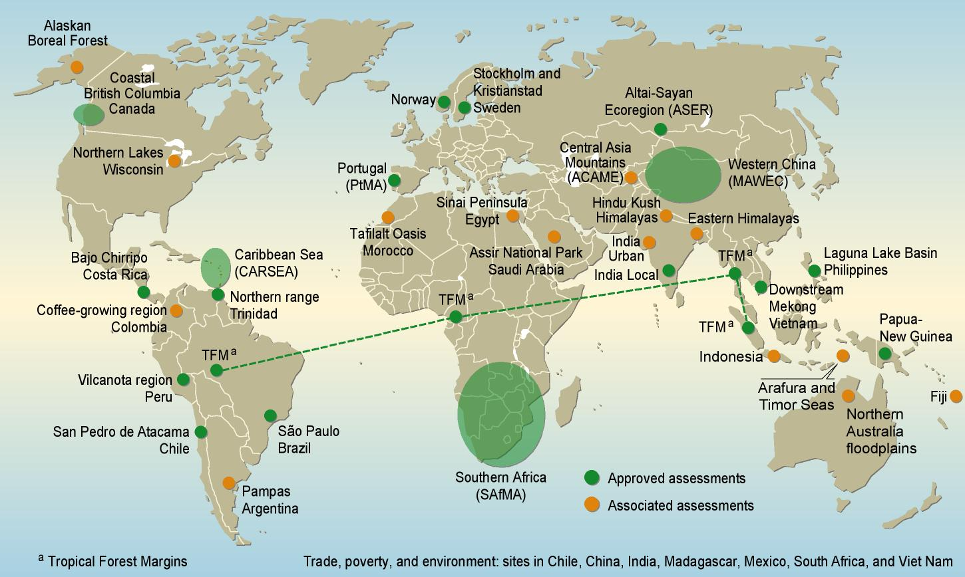

The global MA was completed in early 2005, and at this time, with notable exceptions such as SAfMA, Western China, and the Local Assessment in India, most of the MA SGAs were still in the process of undertaking their assessment work.

In January 2007, on the basis of a questionnaire survey, it was found that almost two years after completion of the MA, most SGAs remained incomplete, with the assessments at varying stages of completion (the figure below shows the results of this survey undertaken in January 2007). In addition, it was also discovered that new assessment initiatives began to take root in places such as North Carolina and Japan, and there was an expressed interest from other countries and regions (such as Europe, Canada, Germany, Trinidad and Tobago, Brazil, Mexico, Malaysia) to initiate some form of MA-type activity/ follow-up.
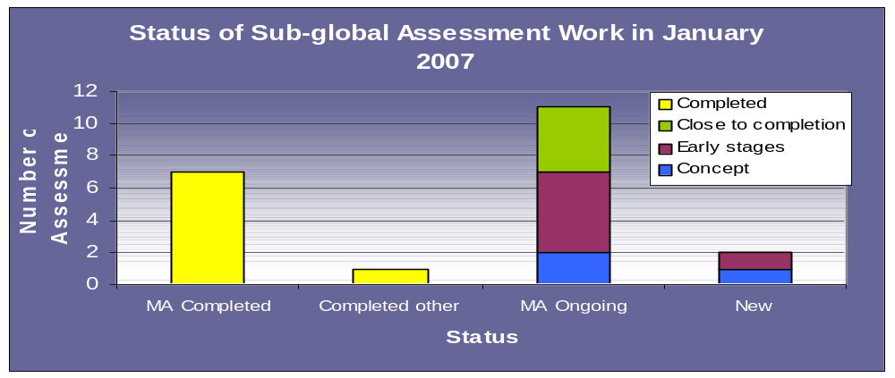
Information collected from the most recent of survey of SGAs (February 2008), indicates that at least seventeen SGAs have now completed their assessment work and have advanced to the stage of outreach and follow-up (Annex 1). Among the more recently-completed assessments are the Northern Floodplains in Australia, the Caribbean Sea (CARSEA), the San Pedro de Atacama in Chile, the Northern Range of Trinidad, the Philippines Laguna Lake Basin, the Kristianstad Wetlands in Sweden, the Downstream Mekong River Wetlands in Vietnam, the Argentine Pampas, the Coffee-growing region in Colombia, the Indian Urban Assessment, the Portugal Assessment, the first phase of the Jakarta Bay Indonesian Assessment, the Trade Poverty and Environment Initiative in eastern India, and the Saudi Arabian Assessment. At least half of the MA SGAs, however, remain incomplete, and along with these incomplete MA SGAs are the new assessments that have emerged/ continue to emerge in the wake of the MA.

1.3 Background to MA SGA follow-up
Since the MA’s completion in 2005, a variety of initiatives have been underway to follow-up on the findings and achievements of the MA. A global Strategy on MA Follow-up has been developed by a consortium of partners, with overall coordination provided by UNEP. This strategy consists of four main components: (1) advancing the knowledge base on ecosystem services and human well-being; (2) strengthening policy implementation at the country level based on the MA approach; and (3) outreach to disseminate the MA findings and framework to relevant stakeholders; and (4) establishing a process to explore needs, options and modalities for a second global ecosystem assessment in the future.

Within the knowledge base component, the sub-global assessments’ part of this follow-up strategy is being supported by United Nations University Institute of Advanced Studies (UNU-IAS), the Cropper Foundation, UNEP, and the UNEP World Conservation Monitoring Centre (WCMC). Activities being developed as a part of the sub-global follow-up programme include the establishment of an intranet/internet site to encourage and support networking among SGAs; annual meetings of sub-global coordinators, the first of which was held in April 2008 in Kuala Lumpur, Malaysia; the provision of technical expertise for SGAs; and the publication and dissemination of relevant documents. Funding to support activities related to the follow-up strategy has been provided by the government of Sweden through the Swedish International Biodiversity Programme (SwedBio), and efforts to raise further funding from other sources are continuing.

2.0 RESULTS OF THE SURVEY
2.1 Overview of the Survey on the Use and Impact of SGAs
Information for this report was compiled from several sources:
- The primary instrument used was a questionnaire circulated to SGAs in late 2007/ early 2008, to which 21 responses have been received to date (Annex 2). Of the 21 responses, two are from new assessments (England and Malaysia) that are not yet able to provide information on the use and impact of their work given the very early stage at which their work now stands. However, 19 responses from original MA SGAs have been incorporated into the report.
- Several of the SGAs proving responses to the questionnaires were subsequently contacted by phone in order to further discuss some of the issues raised, but not elaborated on, in their questionnaires.
- Because responses to the 2008 questionnaire have not been received from some SGAs who provided information in a previous survey conducted in early 2007 by UNEP-WCMC, supplementary information from this older survey was also included.
- Sections of text have been drawn from other documents previously prepared by the Sub-global Secretariat for various purposes.
- The first Annual Meeting for the MA Sub-global Follow-up Programme that was organized on 10-12 April 2008 in Kuala Lumpur included the group discussion on the links between assessment findings and policy making & implementation. The results and outcome of the discussion among some of the SGA coordinators were incorporated into the analysis.

In keeping with the needs of the CBD Secretariat, this report focuses on the impact and use of the MA SGAs on the following major groups of stakeholders/ users:
- policy makers—primarily governments, intergovernmental organizations and other regional/ national and local decision-makers;
- the private sector—business and industries;
- science and education;
- civil society and community outreach.

As a starting point, and as a contextual, general observation, the survey of SGAs conducted in early 2007 found that academic and research institutions are the stakeholder group most heavily involved in the assessment work, while policy makers seem to be the group most often included in the use and implementation of findings. In the more recent survey conducted by UNU-IAS (2008), this observation seems to hold. The figure below shows the main users included in the use of SGA findings, and although it appears that research and academic institutions are the largest group, ‘policy-makers’, for the purpose of this survey, were disaggregated into regional, national, and local-level authorities. The sum of these three bars indicates that policy makers are in fact the most important group of users for the SGA findings.

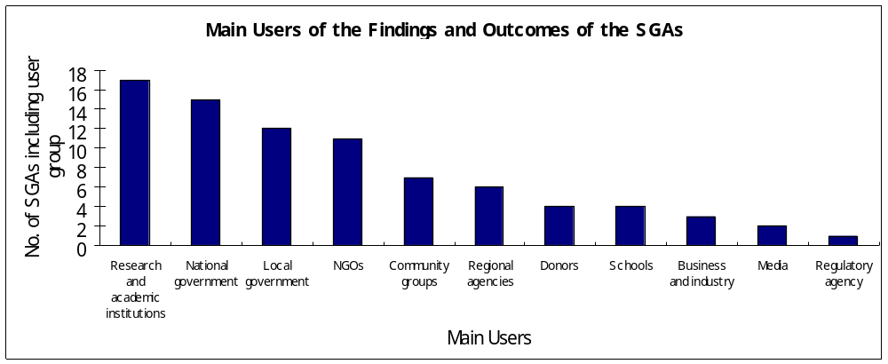

While being aware that policy makers should be a key group, the discussion at the first Annual Meeting of SGA coordinators identified that the assessments need to not only target policy makers but also attach importance to civil society as a pressure group to influence policy. Nonetheless, there is a caution that MA process does not become a lobbying process, as the MA is an objective assessment and should be policy relevant but not policy prescriptive. In addition, the Meeting discussion recognized the SGAs’ process as a social learning process and urged the development of “networks” of stakeholders to increase the use and impacts for decision making in various and wider areas.

2.2 Impact on Policy Making
Although many of the SGAs are including policy makers in their outreach and follow-up, for many SGAs, it is still quite early to measure significant impacts on policy making. However, improved access to data and information has certainly seemed to have had a positive influence on decision makers. The use of various assessment tools in policy planning have also been reported by SGAs: the MA conceptual framework, including concepts, seems to be the most popular, and has been found useful by 70% of the SGAs. The assessment of policy responses produced by the SGAs as well as the development of indicators (including those related biodiversity, ecosystem conditions, ecosystem services and human well-being) have also been reported as useful to policy makers. Other tools, however, such as scenario analysis, valuation of ecosystem services, GIS analysis, modeling, and the development of indicators, remain underutilized.

Despite a lack of major impacts on policy-making at SGA scales, there are some tangible and very promising developments from several SGA regions which do in fact indicate a level of impact on policy and decision-making:
- In the wake of the Caribbean Sea Assessment, a Commission for the Caribbean Sea was formed by the Association of Caribbean States (ACS—an intergovernmental body in the Caribbean Region that includes both English and non-English speaking countries). The establishment of such a Commission was one of the recommendations put forward in the Caribbean Sea Report in an effort to help overcome the disjointed approach to managing the Caribbean Sea, and thereby promote intra-regional cooperation for improving governance and institutional structures.
- The Ministry of Science and Technology of the People’s Republic of China (MOST) and State Environmental Protection Administration of China (SEPA), for example, have paid attention to the integrated ecosystem assessment completed in Western China. Jiangxi province and Qingyang municipality of Gansu province have cooperated with research group of integrated ecosystem assessment in using the findings or the outcomes of the sub-global assessment since 2002.
- In the Philippines, The Laguna Lake Development Authority (LLDA, which is the main agency of the government overseeing the management of the lake) has used the MA report notably in its publication on the state of the lake (Laguna de Bay Monitor).
- National and local government activities have been influenced by the findings of SAfMA e.g. State of the Environment Reporting in South Africa incorporates findings of SAfMA. UNEP and DEFRA are funding a workshop in March 2008 which focused on integrating MA findings into sustainable development policy.
- Several policy makers in Vietnam have been using the Downstream Mekong River Wetlands Assessment—the Ministry of Aquaculture; Provincial Peoples Committees in Mekong Delta; the Institute of Aquaculture Planning, and the Institute of Land-Use Planning.
- In Alaska, The Fairbanks county planning board and the US Fish and Wildlife Service have begun using the SGA’s modelling of future fire regime as a basis development and conservation planning.
- The Strategic Environmental Assessment for the Rural Development Programme 2007-2013 in Portugal which was conducted by a scientific team at the Instituto Superior Technico—that was also involved in the Portugal MA—by request of the Ministry of Agriculture, Rural Development and Fisheries, used data on the assessment of the condition and trends, in particular those related to the agricultural and forest ecosystems.

Two very specific examples of the impact on biodiversity planning were provided:
- In Sweden, the Kristianstad Wetlands was finally accepted as a biosphere reserve in 2005 and is now called Kristianstads Vattenrike Biosphere Reserve (KVBR).
- The methodology developed for preparing People’s Biodiversity Registers (PBRs) has been accepted by the Central Government in India. It has been circulated through the website. Many state governments in India are adopting the methodology for developing model PBRs.

In addition, the discussion at the first Annual Meeting of SGAs specified the tools and methodologies to strengthen the policy implementation of the findings of SGAs.
- Given a need to mainstream Strategic Environmental Assessments (SEAs) into national planning policies, the spatial mapping where possibly the land tenure including ownership and governance issues can be also mapped, should be developed for the use in SEAs.
- In addition to the spatial planning, the social mapping and the sectoral planning should be incorporated into the SGAs in order to coordinate the efforts for the integrated ecosystem management.
- The tools and methodologies which can provide better options for decision making and also can well convince policy makers include valuation tools, scenarios, trade-off analyses, and other qualitative analyses in the absence of qualitative data and information.

2.3 Impact on Business and Industries
As can been seen from the chart on the previous page, the corporate sector has not been as well included as other user groups at the SGA level, with most SGAs not having any business/ industry involvement at all. There are, however, a few demonstrated examples of inclusion:
- In China, the Trade and Tourism Department in the provinces of the Mekong Delta used the findings for ecosystem assessment and their service for eco-tourism development especially in tourism to orchards and river tourism.
- The main stakeholder in the Colombian Assessment (the National Coffee Federation) and Humboldt Institute have jointly formulated a project (Conservation and sustainable use of mountain ecosystems for the benefit of the people in three coffee producing areas of Colombia.) with the support of UNDP Colombia. The project follows (partly the MA framework) with funding from Germany (KFW) and seeking GEF support. This project will have support to address some issued at the very local level, thing that was not possible to achieve with the SG (partly due to resources limitation) and has all the support of the coffee federation and local coffee committees.
- Arising from the Indian Urban Assessment there are several impacts on industries/ business: Kirloskar Oil Engine Industries group with US 1 billion annual turnover has supported business development program to develop biogas & CNG from maize than tree oilseeds. The group won the state govt. energy award in 2008 for clean energy practices. Sahara city business group, owning a prime biodiversity sites on Pune-Mumbai highway, has asked RANWA to prepare a consolidated environmental management plan focusing on energy, waste, organic farming & herbal healthcare. Tata Trust, the biggest business firm charity in India supported expansion agro-biodiversity marketing business in Tamilnadu, Maharashtra, Madhya Pradesh & Orissa states.
- In Portugal, CONFAGRI, a paper industry association, has applied the MA concepts to the follow-up to its agri-enviornmental policies and also published a set of documents on the MA findings on its website as well as on its magazine that especially targets the agriculture sector.

2.4 Impact on Science and Education
The MA SGAs have collectively resulted in the production of a large number of scientific publications and journal and newspaper articles. In addition, the findings of the SGAs have been used quite extensively in science and education. Some examples provided by the SGAs are as follows:
- Workshops for teachers have been held on the Caribbean Sea, and the CARSEA case study materials made available as supporting material for the teaching of aspects of the secondary school science curricula
- The findings or the outcomes of the sub-global assessment have been used as Course materials of Graduate University of Chinese Academy of Sciences. In addition, Sino-German workshops on Integrated Ecosystem Assessment and Comprehensive Watershed Namagement of Poyang Lake Basin were respectively held in October 11-14, 2006, Nanchang, China, and in May 11-12, Munich, Germany.
- Course materials for a training of trainers course: ‘Strengthen Environmental policy ad Management Capacity at the National and Local levels as a contribution to Poverty Alleviation and Sustainable Development in Africa’ were developed by members of SAfMA for UNEP in 2005. The course materials were used in a training of trainers course run by members of SAfMA in South Africa and attended by trainees from seven African countries. The aim of the course was to build capacity to undertake and use integrated ecosystem assessments in Kenya, Mali, Mauritania, Mozambique, Rwanda, Tanzania and Uganda. The training materials were translated into French and Portuguese. The training materials were subsequently used by UNEP to run a training course in Rwanda.
- The findings from Kristianstad Wetlands have furthered basic research in the field “adaptive governance of social-ecological systems.” The Resilience Alliance (RA) has been inspired and conducted several comparative studies (e.g. Olsson et al. 2006). The RA has also developed a hand-book and a manual on how to manage social-ecological systems and in these products the experiences from Kristianstad Wetlands are used.
- In Vietnam, the results from the SGA have been used as the scientific base for some other projects: Appropriate resource use and intergrated management of water, soil and biodiversiy in the Mekong delta and some other coastal zone provinces (Institute of Geography); Project building for preservation of typical ecosystem in Dong Thap muoi (Dong Thap muoi provinces); Planning for shrimp aquaculture in the coastal zone (Ministry of Aquaculture and Coastal Provinces of the Mekong Delta).

2.5 Civil Society and Community Outreach
There has been a fair amount of community outreach and civil society engagement across the SGAs. Some assessments were designed primarily to meet the needs of local communities, for example in the case of the Vilcanota Assessment in Peru, the Alaskan Assessment, the Atacama region in Chile, the Northern Australian floodplains, the Sanai region in Egypt, the Kristianstad wetlands in Sweden, the local villages in India, the work in Fiji, and in the regions covered by the Alternative to Slash and Burn project (ASB). Other assessments included communities as an important aspect of their work, for example in the Sao Paulo Greenbelt Region of Brazil, in the Northern Range of Trinidad, in the coffee-growing regions of Colombia, in Portugal, in Eastern India (as a part of the Trade, Poverty and Environment project), and in Japan.

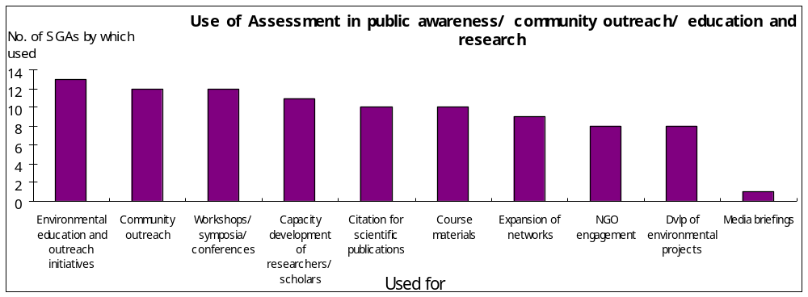

As can be seen from the diagram above, the findings and experience of the SGAs have been used to a limited extent in civil society engagement per se, although it is fair to assume that through engagement with other stakeholder groups such as NGOs, communities, school, public sector entities and researchers, the assessments would have some impact on civil society.

Some of the demonstrated examples of civil society and community engagement across the SGAs are as follows:
- In Alaska, the assessment team has worked with the Alaskan native village of Huslia to plan for climate change. This work led to the following outcomes: (1) acquiring funds to pay local villagers to clear flammable fuels near the village, which reduced fire hazard, provided income and job experience to local youths who had no previous job experience, and increased local awareness about climate change; (2) initiation of interviews by high-school students of village elders, which increased awareness of youth of their cultural heritage and reduced the sense of alienation between community leaders and youth; these interviews were broadcast on Alaska Public Radio throughout Alaska; (3) initiation of a community conservation plan to plan for climate plan. This plan was initiated entirely by the community, but draws on information and concepts that were developed through jointly organized workshops; and (4) development of an alternative energy plan to reduce dependence of the village on imported diesel fuel.
- During the course of undertaking the Northern Range Assessment, three Northern Range communities were consulted as one way of gathering information to help ground-truth the findings of the overall assessment. On the basis of this initial community-based work, follow-up projects focusing on Northern Range communities have developed:
      - in May 2004, follow-up work with one Northern Range community consulted during the course of the assessment was initiated. This two-year pilot project, funded by the local GEF Small Grants Project Programme, ended in May 2006 and was successful in helping the community to develop its governance arrangements, in part to better manage its natural resources, such that the UNDP National Office has made a grant directly to this community for follow-up effort in this area
      - an expanded programme on sustainable hillside agriculture for the Northern Range has been initiated, and focuses on supporting a process to reorient agricultural practices in selected watersheds of the Northern Range, with a view to protecting/ maintaining/enhancing the services of the ecosystem, while at the same time improving the livelihood base of Northern Range farmers, especially given the projections for the impacts of climate change. This project hopes to create models for hillside agriculture, using a watershed approach, which might then be extended beyond the Northern Range to other regions in the Caribbean.
      - In Fiji, it has been recorded that community groups are now undertaking resource management because they are convinced of its importance.
      - The work in Indonesia has had an impact of the fishing community as they are now pushing government to better enforce environmental law and to ensure better control of industrial activities that are leading to marine pollution.
      - The first results of the Portugal MA—“The State of the Assessment Report” —were released nationwide at a press conference in March 2005 where the State Secretary for the Environment was present, and reached to a large spectra of people from all over the country, as the press conference had a broad coverage by media including newspapers, internet news sites, radios, and television.

The discussion at the first Annual Meeting reiterated the importance of the outreach, and identified the dialogues and communications as an area to be improved for the increase in making impacts on policy making and implementation. While there has been the limitation in the outreach of the global MA in the public, some terms and concepts used in the MA have been misread on the ground. For instance, the term of ecosystem services was thought to mean the services always capitalised for markets in some cases including Brazil. Furthermore, there was a lack of communication between / among different stakeholders, particularly between scientists and the public, which could limit the use and impact of SGAs in the wider scope.

3.0 LESSONS LEARNED
3.1 Practical Constraints and Challenges
The most recent survey of SGAs did not explore constraints and challenges across the SGAs. Yet, on the basis of the survey conducted in January 2007, it was found that the SGAs have faced many challenges—both in undertaking their assessment work, and in moving to the stage of dissemination and implementation of their findings—and this largely accounts for the fact that many of the MA SGAs have not been able to complete their assessment work. As the diagram below shows, most of the SGAs have had to deal with between 1 and 3 challenges, most facing a combination of two constraining factors.
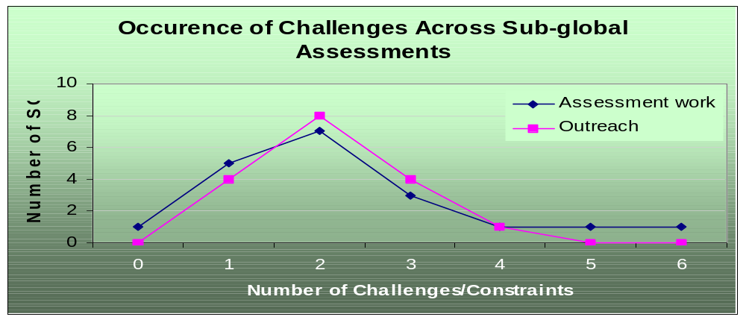
Funding was the most common constraint across the SGAs (both in undertaking assessment and outreach work) and was also the most pressing one within many of the SGAs. However, it is evident that assessment work was also hampered by the lack of data and information tools, the right type of capacity to undertake the work (relating to expertise and the required man power), and even by institutional and governance arrangements (whether at the local, national or regional levels). Outreach and follow-up constraints generally follow the same pattern, but the issue of time seems to be significantly more important at this stage for the assessments, while data and information tools are noted as less significant (see diagram that follows).
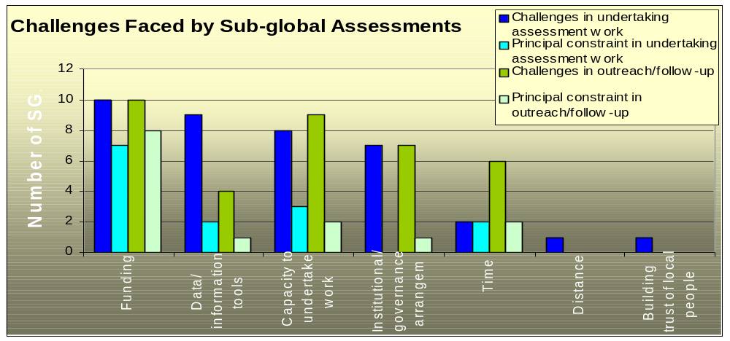
3.2 Learning, networking and capacity building
Of the 19 responses received from the MA SGAs, it is evident that SGA work has had an impact on capacity building especially for the lead organization involved in the work. Eighty-four per cent (84%) of the SGAs reported an increase in capacity for undertaking assessment work; seventy-four per cent (74%) reported an increase in coordinating different users; and about half of the SGAs reported that their work has lead to an increased capacity for using assessment work. Some case examples include:
- In China, for example, capacity built as a result of the Western China Assessment has led to the development of a project on " Key Technologies for Integrated Assessment and Monitoring of Ecological Renovation and Restoration in China " which has been funded for 25 million RMB (about 2.5 million EURO) by Ministry of Science and Technology of the People’s Republic of China (MOST). This project has started in October 2006 and will be completed in October 2010.
- On the basis of the work done in the Indian Local Villages Assessment, it has been noted that he assessment has helped to build the capacities of various agencies and stakeholders such as Central and State Governments and NGOs such that they are now better able to undertake assessments of ecosystem goods and services in terms of the MA conceptual framework and methodology.
- In the case of the Laguna Lake Basin Assessment in the Philippines, it was recorded that there was increased coordination between scientists working in different disciplines and from various organizations. Their involvement in the MA work enabled them to interact in a unique way.
- Members of the SAfMA Assessment team have been able to extend their knowledge and learning, and are currently involved in a project on assessment of ecosystem services and poverty alleviation in sub-Saharan Africa (ESPA).
- The Northern Range and Caribbean Sea Assessments have lead to the development of several other assessment ideas in Trinidad and Tobago.

3.3 Lessons for SGAs
On the basis of all information collected from the SGAs, there is one thing that is certain—the SGAs span a wide breadth in terms of scope, experience, and challenges. No doubt, the lessons learned from individual processes would therefore vary. While it was beyond the scope of this survey to collect information necessary to compile a comprehensive list of specific lessons learned from each SGA, there are some common lessons which have crystallized during engagement with the SGAs:
      - It is not easy to undertake assessment work—successful completion and implementation of assessments require a good understanding of the need for the assessment, and the methodology required both for undertaking assessment work, and then using the findings. Without a good appreciation of these, many SGAs have not been able to advance beyond a concept or very early stages of their work.
      - Following on from the point above, it is clear that there is no one recipe for undertaking an assessment. The purpose and scope of an assessment will vary depending on several factors (including need, funding, available resources, and capacity). Knowing how to adapt prescribed methodologies rests very heavily on the experience of assessment practitioners and the ability to mobilise the right type of expertise and support. Few assessments were able to successfully do this.
      - The importance of a champion/ strong leadership: many of the SGAs who have completed their work and have moved on to undertake successful outreach and follow-up initiatives have had the benefit of strong leadership, often in one person, or in a small group of individuals working as a team.
      - Although the SGAs were not able to fully benefit from the global MA process in the way that was originally envisaged (see section 3.4), involvement of SGA practitioners in global MA activities led to significant capacity building which proved extremely beneficial for the SGAs as a whole.
      - Earlier involvement of users in the process, more possibility to improve ownership and buy-in of users for the assessments. This can help identifying the needs of an assessment, incorporating those needs into the design of the assessment, providing feedbacks on the progress of the assessment work, and then finally use the findings in each area.
      - As funding is essential for conducting an assessment, a strategic approach to the authorities / agencies must be critical to allocate the budget for the relevant issues. Given that the concept of ecosystem services has not been mainstreamed, there is a need to find a way to bring this concept into the mid-term budgetary decision-making framework for allocation of funds. For this purpose, it is important to target all the relevant Ministries including the Ministry of Finance.
      - The governmental restructuring/change can affect negatively the assessment processes through transferring of the officers to other sections/departments but also can positively work to influence policy making by using the timing of changes in the issues the governments focus on. Understanding the political climate of the country may lead to making right interventions.

3.4 Lessons for overall design of the MA
Among the lessons learned in relation to the sub-global assessments, which are of relevance to any ongoing and future sub-global assessment work, are the following:
- The MA project design which provided for the global and sub-global assessments to be undertaken simultaneously did not allow for the full benefits of the sub-global assessments to be realized within the project timeframe, or for effective connection with the global assessment.
- The community of assessment practitioners that developed through the working group of MA sub-global assessments was highly valuable for exchanging information on methodologies and lessons learned, but even by the end of the MA, the required capacity among some sub-global assessment teams was still not sufficiently developed.
- The basic ‘bottom-up’ approach taken in developing sub-global assessments resulted in a wide and varied set of assessments driven by user-demand, but did not provide comprehensive global coverage of all ecosystem types and geographical areas.
- Funding for sub-global assessments proved difficult to raise, and not surprisingly, those assessments which were able to secure significant funding were more likely to be completed in a timely manner – the quality of many sub-global assessment products has thus been variable.
- Enhancing the buy-in of national governments through the SGA processes may stand a better chance of setting up a mechanism such as an intergovernmental panel, while the process may tend to become top-down in the intergovernmental panel mechanism (e.g. IPCC) although the bottom-up process is the unique characteristic of the MA SGAs. Nevertheless, it is critical to have a permanent interface between decision makers and practitioners/ researchers to reinforce the impact on policy making and implementation.
- In order to build on the process and the outcome of the MA SGAs that have been taking the bottom-up approach, the global MA follow-up process can help to target regional level decision-making so that they can make impacts on policy making at the regional level in the integrated manner.
- Since some of the tools and methodologies are new for many of the assessment coordinators and even for the scientists, there should be continuing efforts of capacity development for the use of the key assessment components—including valuation tools, scenarios building, and trade-off analyses. In particular, the preparation for a synthesis document on valuation tools for use by SGAs is urged, while the MA Methods Manual whose extended outline has received the inputs from the SGA coordinators at the 1st Annual Meeting of SGAs is expected to be available around the end of 2008.
4.0 CONCLUSIONS
In general, many of the findings related to the status and scope of SGAs have not changed significantly since the last survey of SGAs was conducted in late 2006/early 2007. Also it seems to be too early to evaluate the use and impact of SGAs and the impact will be better captured after the most of the outcome and outputs of the assessments become available. However, a few points are worth noting:
- More SGAs can now report on having completed their assessment work. In the 2006/2007 survey, 8 assessments were reported as completed. The 2008 survey shows that 17 MA SGAs have now wrapped up their assessment work.
- Policy makers continue to be the user group most heavily targeted in use and implementation of SGA findings. However, it is also important to attach more importance to the publics and the networks to enhance the links between the assessment findings and policy making & implementation. Furthermore, a permanent interface between decision makers and scientists may need to be formulated to move beyond being a policy-relevant assessment and make more contributions to policy implementation.
- The development and improvement in the tools and methodologies (e.g. valuation tools, scenario building, and trade-off analyses) should be also a window on the policy implementation of the assessment findings. In addition to the publications such as synthesis report and manuals, more capacity development opportunities on the tools and methodologies are encouraged.
- The SGAs remain very interested in, and motivated to continue their assessment work (ongoing and new assessments), and use assessment findings in outreach and follow-up. The SGA network could thus potentially serve as a good platform for ongoing CBD efforts to integrate MA thinking into biodiversity planning. The mechanism to realize this will however have to be developed.

In terms of specific impacts of MA SGAs on national-level biodiversity planning, there are a few observations:
      - Firstly, relatively few SGAs seemed aware of either the efforts of the CBD to mainstream the MA framework and methodology into national-level biodiversity planning, or of the request to national focal points to submit information on use and impacts of the MA. Notable exceptions are Australia, Sweden, and Trinidad and Tobago where MA SGAs were undertaken; as well as the United Kingdom and Japan, where assessment work has been initiated in the wake of the MA. In some cases, where for example the focus of the SGA was principally at a community level, this is understandable. However, it is clear that there needs to be greater emphasis placed on creating the necessary links between SGAs (especially those with relevance for national-level decision-making) and national governments; and vice versa.
      - Following on from the point above, it is apparent that, as a whole, the impact of SGAs on policy planning remains relatively low, although SGAs reported policy-makers, especially at the national level, as the most important users of the assessments. The reason(s) for this disjuncture is not yet clear, but it is hoped that through further interactions with the SGAs, this would be better understood.
- From the responses received to the 2008 questionnaire, there are only two explicit examples of where SGA work has had an impact on national-level biodiversity planning: in Sweden where the Kristianstad Wetlands was accepted as a biosphere reserve in 2005; and in India where the methodology developed for preparing People’s Biodiversity Registers (PBRs) has been accepted by the Central Government.

Prepared by: Maiko Nishi and Keisha Garcia
Date: 01 May 2008

Annex 1: Summary of Status of SGAs

Assessment Short Name | Current Status unknown | Completed | Close to completion | Underway but early stages | Concept stage
MA Approved Assessments

Altai-Sayan | √ | - | - | - | -
Alternatives to Slash and Burn (ASB) | - | - | √ | - | -
Brazil (Sao Paulo Greenbelt) | - | - | - | √ | -
Canada (Coastal British Columbia) | √ | - | - | - | -
Caribbean Sea (CARSEA) | - | √ | - | - | -
Chile (Atacama) | - | √ | - | - | -
China (Western) | - | √ | - | - | -
Costa Rica (Chirripo) | √ | - | - | - | -
India (Local Villages) | - | √ | - | - | -
Norway (Glomma River Basin) | - | - | - | - | √
Papua New Guinea (PNG) | - | - | - | - | √
Peru (Vilcanota) | √ | - | - | - | -
Philippines (Laguna Lake Basin) | - | √ | - | - | -
Portugal | - | √ | - | - | -
Southern Africa (SAfMA) | - | √ | - | - | -
Sweden (Kristianstad) | - | √ | - | - | -
Sweden (Stockholm urban) | - | - | √ | - | -
Trinidad (Northern Range) | - | √ | - | - | -
Vietnam (Downstream Mekong River Wet) | - | √ | - | - | -
Total | 4 | 10 | 2 | 1 | 2
MA Associated Assessments

Arab Region | √ | - | - | - | -
Arafura and Timor Seas | - | - | - | - | √
Australia (Northern Australia Floodplains) | - | √ | - | - | -
Argentina (Pampas) | - | √ | - | - | -
Central Asia Mountain Ecosystem | √ | - | - | - | -
China (Great Rivers) | √ | - | - | - | -
Colombia (Andean Coffee Growing Region) | - | √ | - | - | -
Egypt (Sinai) | - | - | √ | - | -
Fiji | - | - | - | √ | -
Great Asian Mountains (GAMA) | √ | - | - | - | -
Himalayas (Eastern) | √ | - | - | - | -
Himalayas (Hindu-Kush) | √ | - | - | - | -
India Urban | - | √ | - | - | -
Indonesia (Jakarta Bay and Bunaken) | - | √ | - | - | -
Saudi Arabia | - | √ | - | - | -
Trade, Poverty and Environment | - | √ | - | - | -
United States (Alaska) | - | - | √ | - | -
United States (Wisconsin) | - | - | - | √ | -
Total | 6 | 7 | 2 | 2 | 1
Assessment Short Name | Current Status unknown | Completed | Close to completion | Underway but early stages | Concept stage
New Assessments

England | - | - | - | - | √
Europe (EURECA) | - | - | - | - | √
Germany | - | - | - | - | √
Japan | - | - | - | √ | -
Malaysia | - | - | - | - | √
Mexico | √ | - | - | - | -
North Carolina | - | - | - | - | √
Aboriginal People | - | - | - | - | √
Total | 1 | 0 | 0 | 1 | 6
GRAND TOTAL | 11 | 17 | 4 | 4 | 9

Annex 2: List of Sub-global Assessments with Current Contact Status:

Assessment Short Name | 2006/2007 Questionnaire Received | 2008 Questionnaire Received | Phone contact established | 2008 E-mail contact established | 2008 1st Meeting participated
MA Approved Assessments

Altai-Sayan | No | No | No | Yes | No
Alternatives to Slash and Burn (ASB) | Yes | Pending | No | Yes | No
Brazil (Sao Paulo Greenbelt) | Yes | Yes | No | Yes | Yes
Canada (Coastal British Columbia) | No | No | No | No | No
Caribbean Sea (CARSEA) | Yes | Yes | Yes | Yes | Yes
Chile (Atacama) | Yes | Yes | No | Yes | Yes
China (Western) | Yes | Yes | Yes | Yes | Yes
Costa Rica (Chirripo) | No | No | No | Yes | Yes
India (Local Villages) | No | Yes | No | Yes | Yes
Norway (Glomma River Basin) | No | No | No | Yes | No
Papua New Guinea (PNG) | No | No | Yes | Yes | Yes
Peru (Vilcanota) | Yes | Pending | No | Yes | Yes
Philippines (Laguna Lake Basin) | No | Yes | No | Yes | Yes
Portugal | Yes | Yes | No | Yes | Yes
Southern Africa (SafMA) | Yes | Yes | Yes | Yes | Yes
Sweden (Kristianstad) | Yes | Yes | No | Yes | No
Sweden (Stockholm urban) | No | Yes | No | Yes | No
Trinidad (Northern Range) | Yes | Yes | Yes | Yes | Yes
Vietnam (Downstream Mekong River Wet) | No | Yes | No | Yes | Yes
MA Associated Assessments

Arab Region | Yes | No | No | Yes | Yes
Arafura and Timor Seas | No | No | No | Yes | Yes
Australia (Northern Australia Floodplains) | Yes | No | No | Yes | No
Argentina (Pampas) | No | Yes | No | Yes | Yes
Central Asia Mountain Ecosystem | Yes | No | No | No | No
China (Great Rivers) | No | No | No | No | No
Colombia (Andean Coffee Growing Region) | Yes | Yes | Yes | Yes | Yes
Egypt (Sinai) | Yes | Yes | Yes | Yes | Yes
Fiji | Yes | Yes | No | Yes | Yes
Great Asian Mountains (GAMA) | No | No | No | No | No
Himalayas (Eastern) | No | No | No | Yes | Yes
Himalayas (Hindu-Kush) | No | No | No | No | No
India Urban | No | Yes | No | Yes | Yes
Indonesia (Jakarta Bay and Bunaken) | No | Yes | No | Yes | Yes
Saudi Arabia | No | Yes | No | Yes | No
Trade, Poverty and Environment | Yes | Pending | No | Yes | No
United States (Alaska) | No | Yes | No | Yes | No
United States (Wisconsin) | Yes | Pending | No | Yes | No
Total positive | 18 | 20 | 7 | 32 | 22
Assessment Short Name | 2006/2007 Questionnaire Received | 2008 Questionnaire Received | Phone contact established | E-mail contact established | 2008 1st Meeting participated
New Assessments

England | No | Yes | Yes | Yes | No
Europe (EURECA) | No | No | No | Yes | No
Germany | No | No | No | Yes | Yes
Japan | Yes | Yes | Yes | Yes | Yes
Malaysia | No | Yes | Yes | Yes | Yes
Mexico | No | No | No | Yes | No
North Carolina | Yes | No | Yes | Yes | No
Aboriginal People | No | Yes | No | Yes | No
Total positive | 2 | 4 | 4 | 8 | 3

* UNEP/CBD/COP/9/1.
UNEP and its partners are now addressing this problem through the development of manuals which focus on the purpose of assessments, and how they are conducted.

