 |  | CBD
 |  |  |  | Distr.  GENERAL  UNEP/CBD/COP/9/27/Add.2  5 May 2008  ORIGINAL: ENGLISH
CONFERENCE OF THE PARTIES TO THE CONVENTION ON BIOLOGICAL DIVERSITY
Ninth meeting

Bonn, 19-30 May 2008
Item 5.1 of the provisional agenda*
PROPOSED BUDGET FOR THE PROGRAMME OF WORK OF THE CONVENTION ON BIOLOGICAL DIVERSITY FOR THE BIENNIUM 2009-2010

Note by the Executive Secretary

Addendum
- Subsequent to the receipt of the audited accounts of the Convention from the United Nations Environment Programme on 15 April 2008, the Secretariat has prepared a projection of expenditures to the end of 2008. The projection indicates that, should all factors remain unchanged, there will be a deficit of approximately US$ 800,000 at the end of 2008 (see table 1 below).
- The projected deficit is the result of the negative effect that the depreciation of the United States dollar has had on the budget of the Convention for the period 2006-2007 and which is continuing in 2008 (see UNEP/CBD/COP/9/27, para.30). There are large expenditures over which the Secretariat has no control, such as the rent and maintenance costs, which are denominated in Canadian dollars and which therefore cost more in terms of the United States dollar every time the United States dollar depreciates. The Executive Secretary in his letter of 16 October 2007 (copy attached), brought this matter to the attention of Parties and requested additional voluntary contributions to enable the Secretariat to offset some of the losses foreseen as a result of the exchange rate fluctuations; however, no positive responses were received to this request.
- A total of US$ 4,000,000 was taken from the surplus and savings of the Convention in order to reduce the assessed contributions of Parties for the 2007-2008 biennium. This has contributed to the projected shortfall, given that at the time the decision was made the exchange rate of the United States dollar was much more favourable.
- In view of the projected shortfall in the 2007-2008 budget it is proposed that additional funding be identified during the ninth meeting of the Conference of the Parties from voluntary funds or adjustments to the assessed contributions for 2008, or alternatively that the Conference of the Parties authorizes the Secretariat to use the working capital reserve to offset these projected losses. The Secretariat has already made efforts to minimize the expenses in 2008 with the suspension of recruitment of all short term staff, and consultants and the cancellation of all staff travel on missions not directly related to activities under the Convention on Biological Diversity, however given that the Secretariat is now fully staffed this effort will be unlikely to be able to cover all the projected losses.
- The Executive Secretary has also brought the situation to the attention of the Executive Director of the United Nations Environment Programme (UNEP), who responded that: “The exchange rate loss issue is not specific to UNEP but applies to the entire UN…”, and that “…the UN Secretariat has not provided guidelines to alleviate the burden of such situations.”
- In view of the circumstances the Conference of the Parties may wish to consider adopting a draft decision along the following lines:
The Conference of the Parties,
Noting the projected shortfall in the Secretariat budget for the 2007-2008 biennium,
- Approves a supplementary budget of US$ xxx,xxx in 2008 to cover projected shortfalls in 2008 due to exchange rate losses in 2007-2008;
- Adopts the scale of assessments for the apportionment of additional expenses for 2008 as contained in the table annexed to the present decision.*

Table 1. Trust Funds for the Convention on Biological Diversity
 |  | 2000 | 2001 | 2002 | 2003 | 2004 | 2005 | 2006 | 2007 | 2008
 |  |  |  |  |  |  |  |  |  | Projection
COP approved budget |  | 8,998,600 | 8,594,000 | 10,049,900 | 10,742,500 | 11,214,300 | 10,497,800 | 10,918,500 | 10,957,000 | 11,390,600
Pledges (includes additional contributions) |  | 7,110,013 | 7,357,985 | 8,089,404 | 8,432,349 | 8,041,394 | 9,397,807 | 8,333,489 | 9,647,542 | 8,755,458
Collections during the year |  | 8,043,145 | 7,800,145 | 8,780,762 | 8,133,102 | 7,598,551 | 9,900,213 | 7,925,080 | 7,279,822 | 11,123,178
Interest |  | 293,914 | 594,585 | 335,191 | 248,767 | 121,235 | 142,341 | 263,662 | 167,747 | 150,000
Miscellaneous income |  | 3,220 | 1,668 | 38,105 | 190,192 | 110 | - | 5,135 | 0 | 0
TOTAL INCOME |  | 7,407,147 | 7,954,238 | 8,462,700 | 8,871,308 | 8,162,739 | 9,540,148 | 8,602,286 | 9,815,289 | 8,905,458
EXPENDITURE
Direct Expenditures |  | 7,087,133 | 8,378,744 | 8,073,538 | 9,198,047 | 8,328,315 | 8,536,723 | 9,636,401 | 9,391,853 | 10,080,200
Programme support costs |  | 921,327 | 1,089,237 | 1,049,560 | 1,195,746 | 1,082,681 | 1,109,774 | 1,252,732 | 1,220,941 | 1,310,426
Loss/Gain on exchange/ Bank charges |  |  | 23,757 | 28,374 | (28,674) | 65,605 | 75,699 | 163,780 | (20,888) | 80,000
Prior period's adjustments |  | 22,952 | (57,492) | (285,887) | 137,621 | 91,700 | (44,944) | 5379 | 0
TOTAL EXPENDITURES |  | 8,065,419 | 9,434,246 | 8,865,585 | 10,502,740 | 9,568,301 | 9,677,252 | \11,058,292 | 10,591,906 | 11,470,626
BALANCE |  | (658,272) | (1,480,008) | (402,885) | 1,631,432) | (1,405,562) | (137,104) | (2,456,006) | (776,617) | (2,565,168)
Working capital reserve |  |  |  |  | 878,272 |  | 183,400 |  | 55,700

SURPLUS (Cumulative) | 11,176,509 | 9,696,501 | 9,293,617 | 6,783,912 | 5,378,350 | 5,057,846 | 2,601,840 | 1,769,523 | (795,645)

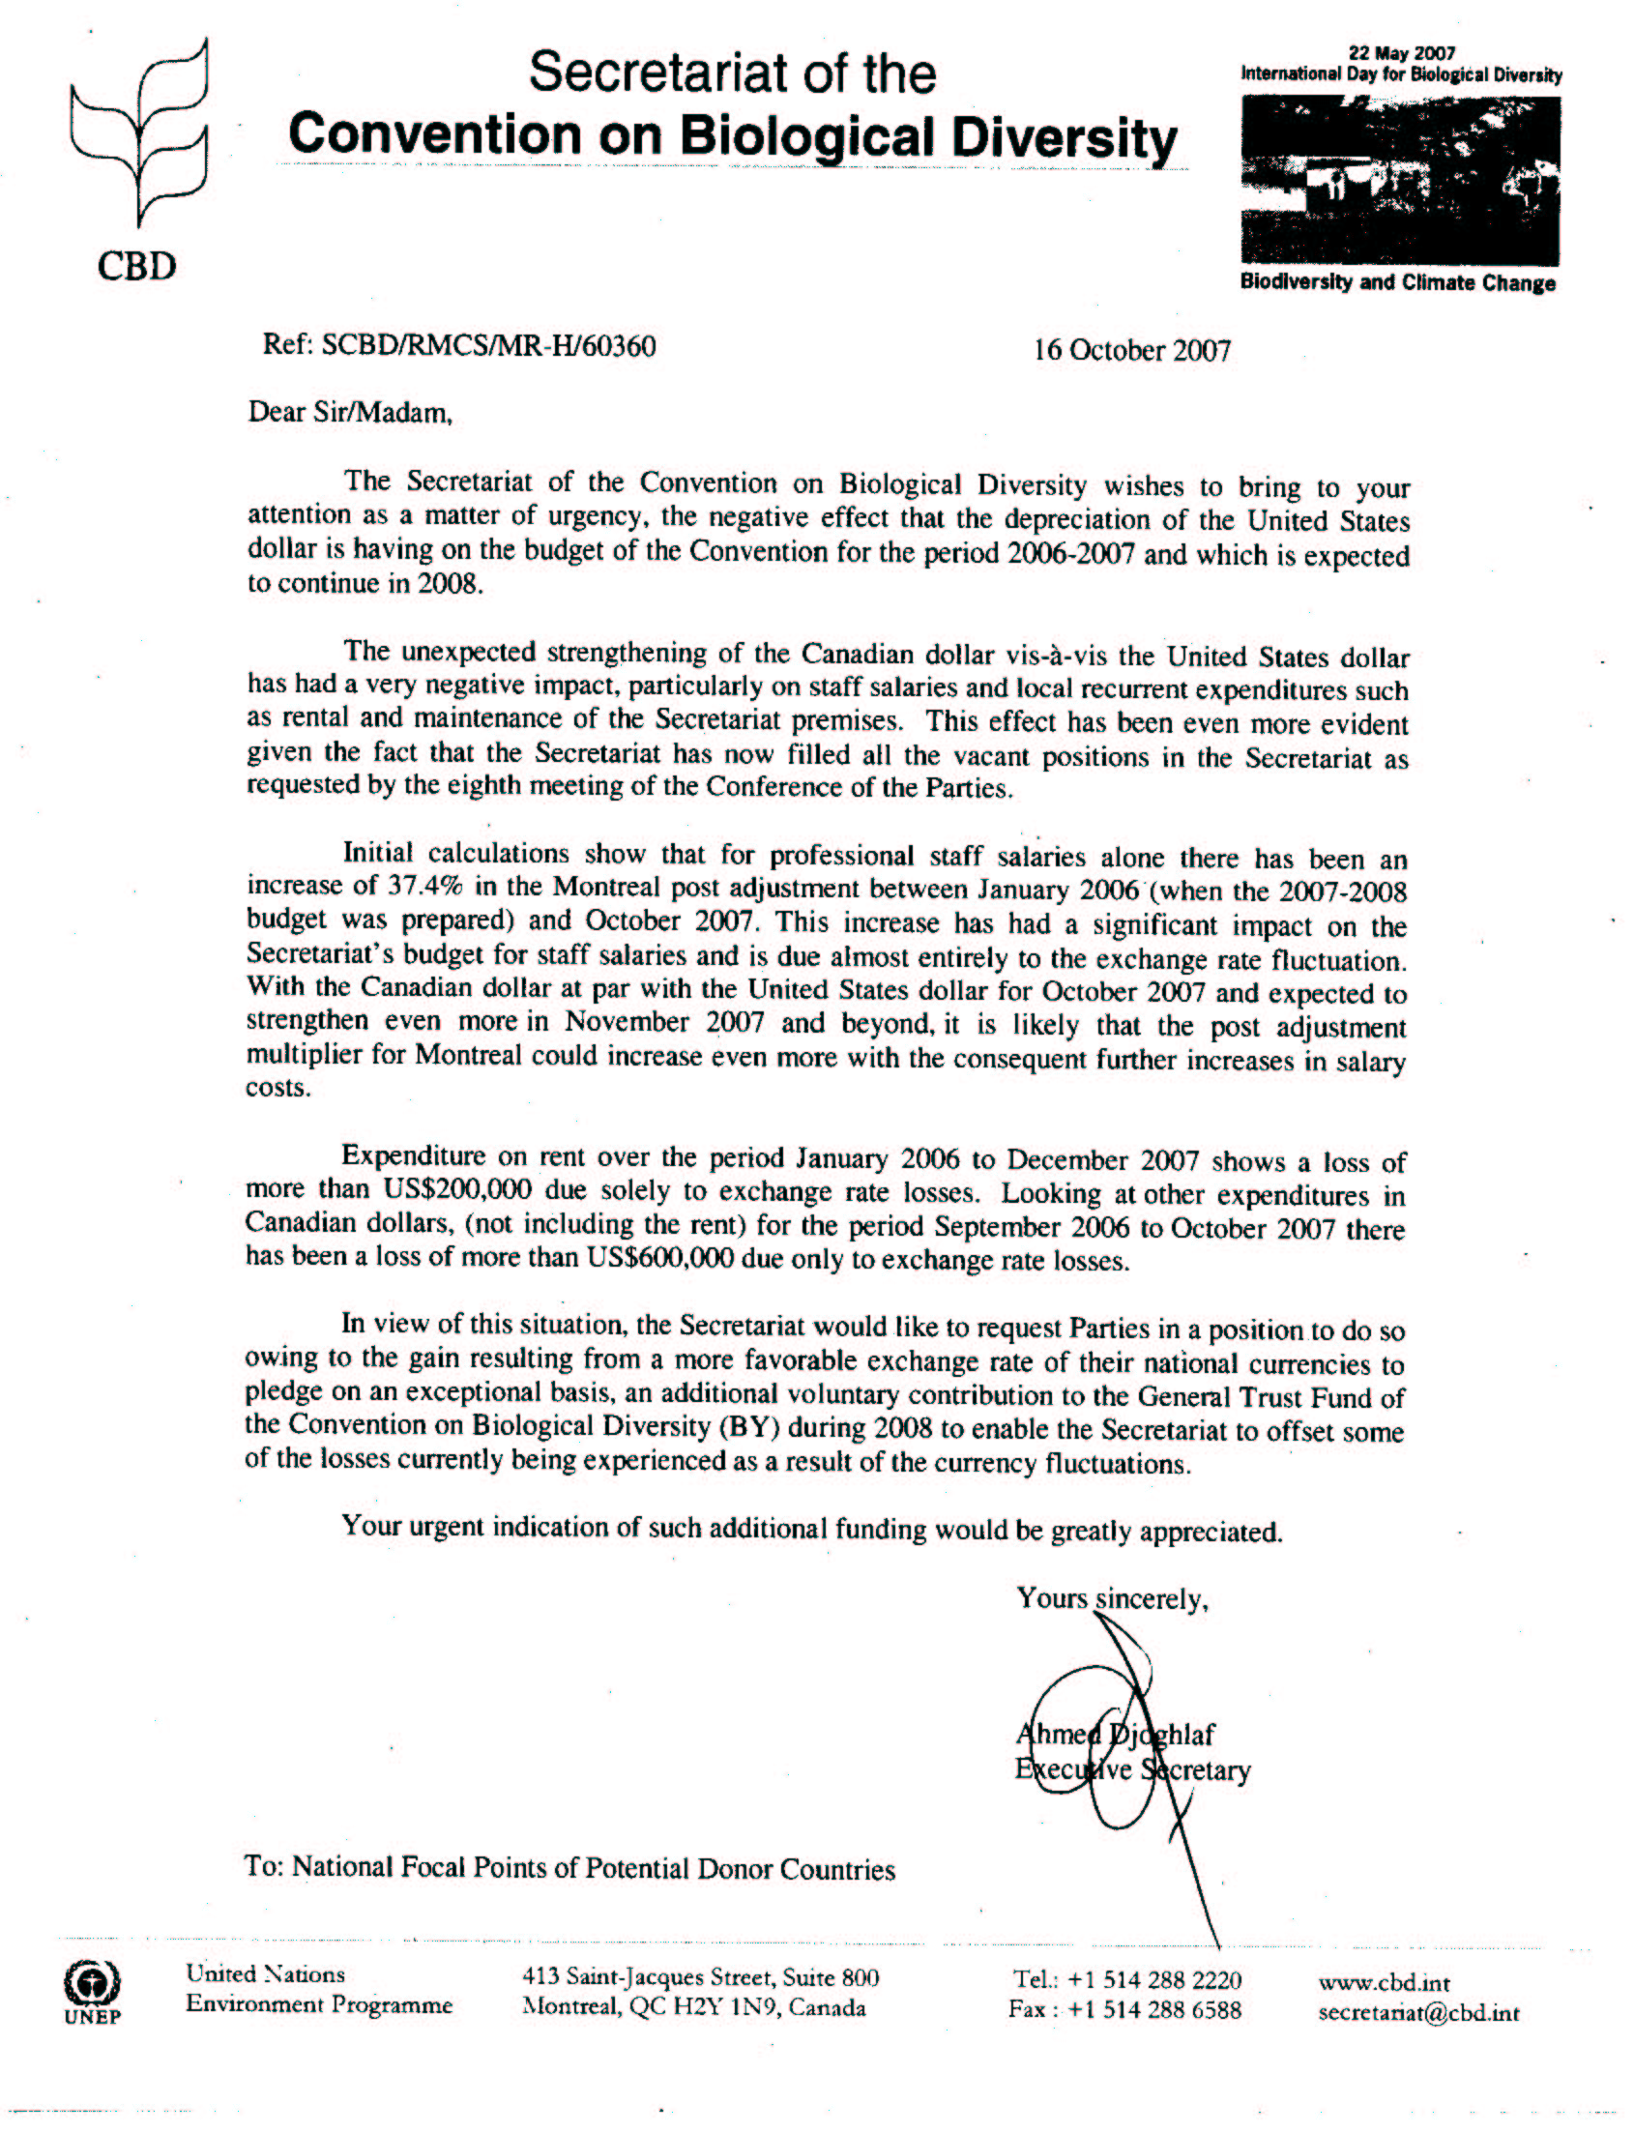
-----

* UNEP/CBD/COP/9/1.
* The table will be prepared on the basis of the outcome of the discussions at the ninth meeting of the Conference of the Parties.

