 |  | CBD
 |  |  |  | Distr.  GENERAL  UNEP/CBD/COP/11/INF/16  3 October 2012  ORIGINAL: ENGLISH
CONFERENCE OF THE PARTIES TO THE CONVENTION ON BIOLOGICAL DIVERSITY
Eleventh meeting
Hyderabad, India, 8-19 October 2012

Item 4.1 of the provisional agenda*
State of Financing for Biodiversity: Draft Global Monitoring Report 2012 on the Strategy for Resource Mobilization under the Convention
Note by the Executive Secretary
Summary
The present draft version of the global monitoring report has been prepared by the Secretariat in pursuance of decision IX/11 B requesting a regular global monitoring report on the implementation of the strategy for resource mobilization under the Convention, as well as decision X/3 A requiring that the global monitoring reports on the implementation of the strategy for resource mobilization should be prepared in time for consideration by the Conference of the Parties at its ordinary meetings, with national and regional participation, and should provide essential information on the status and trends in biodiversity financing and help to disseminate funding knowledge and know-how as related to biodiversity.
The report covers all issues identified in the strategy for resource mobilization, as well as the indicators added by the tenth meeting of the Conference of the Parties. Three questions are raised on each funding issue: what has materialized in the past, particularly in the base year 2010; what will likely happen in the near future; and what funding action the global community may take to influence the future course of financial development. For easy reference, the relevant strategic objectives and indicators of the strategy for resource mobilization are footnoted on each issue page, and diagrams are offered to help visualize the funding issue under discussion. Data sources and technical notes are available at the end of the report.

Table of Contents
Introduction 3
Table: Goals, objectives and indicators for resource mobilization 4
I. Information Base on Funding Needs, Gaps and Priorities (Goal 1) 8
1.1 Identification and Reporting of Funding Needs, Gaps and Priorities 9
1.2 Assessment of Values of Biodiversity and Ecosystem Services 10
II. National Capacity for Resource Mobilization (Goal 2) 11
2.1 Domestic Expenditure for the Environment Including Biodiversity 12
2.2 Development of National Financial Plans for Biodiversity 13
2.3 Sectoral mobilization 14
2.4 Economic Incentives 15
2.5 Domestic Funds and Funding Programmes through Voluntary Contributions 16
2.6 Enabling Conditions for Private Sector Involvement 17
III. Mobilization of External Resources (Goal 3) 18
3.1 Co-Financing and Other Modes of Project Financing for GEF Projects 19
3.2 Official Development Assistance (ODA) 20
3.3 Implementation of Monterrey Consensus 21
3.4 New and Additional Funding Programmes through Voluntary Contributions 22
3.5 Public Sector Investments in Biodiversity 23
3.6 Private Sector Investments in Biodiversity 24
3.7 Domestic Environmental Funds 25
3.8 Debt Relief and Conversion Initiatives, Including Debt-For-Nature Swaps 26
IV. Innovative Financial Mechanisms (Goal 4) 27
4.1 Schemes for Payment for Ecosystem Services 28
4.2 Biodiversity Offset Mechanisms 29
4.3 Environmental Fiscal Reform 30
4.4.1 Markets for Green Products 31
4.4.2 Business-Biodiversity Partnerships 32
4.4.3 Charity 33
4.5 New and Innovative Sources of International Development Finance 34
4.6 Funding Mechanisms for Climate Change 35
V. Biodiversity Mainstreaming In Development Cooperation Plans and Priorities (Goal 5) 36
5.1 Policy integration at financial institutions and development agencies 37
5.2 National Development Plans, Strategies and Budgets 38
5.3 Funding by United Nations development system, as well as international financial institutions and development banks 39
5.4 Regional, Subregional and Inter-Regional Cooperation and Coordination 40
5.5 International Organizations and Non-Governmental Organizations 41
VI. Capacity-Building and South-South Cooperation (Goal 6) 42
6.1 Technical Cooperation and Capacity Building Initiatives 43
6.2 South-South Cooperation Initiatives 44
VII. Access and Benefit-Sharing (Goal 7) 45
7 Access and Benefit Sharing Initiatives and Mechanisms 46
VIII. Global Engagement for Resource Mobilization (Goal 8) 47
8 Global Awareness Initiatives 48
Data Sources, Technical Notes and References 49
Acronyms 70

Introduction

This report has been prepared by the Secretariat in response to the request, by the ninth meeting of the Conference of the Parties, for a regular global monitoring report on the implementation of the strategy for resource mobilization under the Convention. The tenth meeting of the Conference of the Parties further decided that the global monitoring reports on the implementation of the strategy for resource mobilization should be prepared in time for consideration by the Conference of the Parties at its ordinary meetings, with national and regional participation, and should provide essential information on the status and trends in biodiversity financing and help to disseminate funding knowledge and know-how as related to biodiversity. A series of subregional workshops on biodiversity and finance were thus organized in collaboration with the Global Environment Facility in advance of the preparation of this report.
The report covers all issues identified in the strategy for resource mobilization, as well as the indicators added by the tenth meeting of the Conference of the Parties. Chapter I deals with goal 1 of the strategy for resource mobilization, but the indicator on financial support to needs assessment is taken up together with national financial planning under goal 2.
Chapter II is focused on national resourcing capacity. Due to information constraints, the report does not investigate relevant sectoral budgets to a desirable extent, and this area of monitoring will be enhanced for the next edition of the global monitoring report.
Chapter III presents information on eight funding issues, taken from the strategic objectives under goal 3. It does not attempt to distinguish between the indicator on amount of financial resources from all sources from developed countries to developing countries to contribute to achieving the Convention’s objectives and the indicator on amount of financial resources from all sources from developed countries to developing countries towards the implementation of the Strategic Plan for Biodiversity 2011-2020. Given considerable interest in subsidy-related issues, harmful subsidies are considered together with economic incentives.
Chapter IV discusses eight issues under innovative financial mechanisms, all from the original strategic objectives under goal 4. As innovative financial mechanisms are an emerging area of resource mobilization, Governments expressed a keen interest in further exploration of innovative financial mechanisms by requesting the Executive Secretary to conduct a global synthesis of information on innovative financial mechanisms. A more detailed analysis of innovative financial mechanisms is presented in a companion to this report.
Chapters V to VIII contain information on funding issues identified under goals 5 to 8 of the strategy for resource mobilization.
Three questions are raised on each funding issue: what has materialized in the past, particularly in the base year 2010; what will likely happen in the near future; and what funding action the global community may take to influence the future course of financial development. For easy reference, the relevant strategic objectives and indicators of the strategy for resource mobilization are footnoted on each issue page, and diagrams are offered to help visualize the funding issue under discussion.
Data sources and technical notes are available at the end of the report.
By this new way of presentation, it is hoped that the report will inform all those participating in the eleventh meeting of the Conference of the Parties and help advance the agenda to mobilize more, faster and better financing for biodiversity.

Goals, objectives and indicators for resource mobilization
GOALS AND OBJECTIVES  From the Strategy for Resource Mobilization (decision IX/11) |  | INDICATORS FOR MONITORING PROGRESS  From decision X/3

Mission
1. The target of the strategy for resource mobilization is to substantially enhance international financial flows and domestic funding for biological diversity in order to achieve a substantial reduction of the current funding gaps in support of the effective implementation of the Convention’s three objectives and the 2010 target. This target for global resource mobilization should be viewed as a flexible framework for the development of measurable targets and/or indicators addressing all relevant funding sources, according to national priorities and capacities, and taking into account the special situation and needs of developing countries. |  | Aggregated financial flows, in the amount and where relevant percentage, of biodiversity-related funding, per annum, for achieving the Convention’s three objectives, in a manner that avoids double counting, both in total and in, inter alia, the following categories:  (a) Official Development Assistance (ODA);  (b) Domestic budgets at all levels;  (c) Private sector;  (d) Non-governmental organizations, foundations, and academia;  (e) International financial institutions;  (f) United Nations organizations, funds and programmes;  (g) Non-ODA public funding;  (h) South-South cooperation initiatives;  (i) Technical cooperation
Goal 1: Improve information base on funding needs, gaps and priorities
1.1. To improve the existing financial information base through enhancing accuracy, consistency and delivery of existing data and improved reporting on funding needs and shortfalls for the Convention’s three objectives. Funding trends could be measured through the following indicators:  (a) OECD/DAC Rio markers on biodiversity;  (b) National reports of Parties;  (c) Trends in funding to GEF;  (d) Funding flows through a selected number of the large international NGOs.  1.2. To assess economic costs of the loss of biodiversity and its associated ecosystem services, of the failure to take measures to fulfill the three objectives of the Convention, and benefits of early action to reduce loss of biological diversity and its associated ecosystem services.  1.3. To improve priority-setting for guiding resource allocation to biological diversity and its associated ecosystem services. |  | 1A. Number of countries that have: (a) Assessed values of biodiversity, in accordance with the Convention;  1B. Number of countries that have: (b) Identified and reported funding needs, gaps and priorities;
Goal 2: Strengthen national capacity for resource utilization and mobilize domestic financial resources for the Convention’s three objectives
2.1. To strengthen institutional capacities for effective resource mobilization and utilization, including strengthening capacities of relevant ministries and agencies to make the case for including biodiversity and its associated ecosystem services in discussions with donors and relevant financial institutions.  2.2. To prepare national financial plans in the context of national biodiversity strategies and action plans that can be implemented by local, national, regional and international stakeholders.  2.3. To strengthen capacity for integration of biodiversity issues and its associated ecosystem services into national and sectoral planning, and promote budgetary allocations for biological diversity and its associated ecosystem services in national and relevant sectoral budgets.  2.4. To develop and implement economic incentives that are supportive of the Convention’s three objectives at local and national levels, consistent and in harmony with the other relevant international obligations.  2.5. To consider the enhancement of existing, or the establishment of new, domestic funds and funding programmes through voluntary contributions, including for official development assistance, where biodiversity is identified as a priority by developing country Parties in poverty reduction strategies, national development strategies, United Nations development assistance frameworks and other development assistance strategies, that include innovative financing instruments to achieve the Convention’s three objectives.  2.6. To establish enabling conditions for private sector involvement in supporting the Convention’s three objectives, including the financial sector. |  | 2A. Amount of domestic financial support, per annum, in respect of those domestic activities which are intended to achieve the objectives of this Convention;  2B. Number of countries that have: (c) Developed national financial plans for biodiversity;  2C. Number of countries that have: (d) Been provided with the necessary funding and capacity building to undertake the above activities  2D. Resources mobilized from the removal, reform or phase-out of incentives, including subsidies, harmful to biodiversity, which could be used for the promotion of positive incentives, including but not limited to innovative financial mechanisms, that are consistent and in harmony with the Convention and other international obligations, taking into account national social and economic conditions;
Goal 3: Strengthen existing financial institutions and, promote replication and scaling-up of successful financial mechanisms and instruments
3.1. To enhance efforts in mobilizing co-financing and other modes of project financing for biological diversity.  3.2. To strive to increase official development assistance associated with biological diversity, where biodiversity is identified as a priority by developing country Parties in poverty reduction strategies, national development strategies, United Nations development assistance frameworks and other development assistance strategies and in accordance with priorities identified in national biodiversity strategies and action plans.  3.3. To mobilize public sector investments in biological diversity and its associated ecosystem services.  3.4. To mobilize private sector investments in biological diversity and its associated ecosystem services.  3.5. To establish, as appropriate, new and additional funding programmes through voluntary contributions to support the three objectives of the Convention.  3.6. To fulfil the implementation of the provisions of the Monterrey Consensus on mobilizing international and domestic funding as related to biodiversity.  3.7. To continue to support, as appropriate, domestic environmental funds as essential complements to the national biodiversity resource base.  3.8. To promote biological diversity in debt relief and conversion initiatives, including debt-for-nature swaps. |  | 3A. Amount of funding provided through the Global Environment Facility and allocated to biodiversity focal area  3B. Level of CBD and Parties’ support to other financial institutions that promote replication and scaling-up of relevant successful financial mechanisms and instruments  3C. Amount of financial resources from all sources from developed countries to developing countries to contribute to achieving the Convention’s objectives  3D. Amount of financial resources from all sources from developed countries to developing countries towards the implementation of the Strategic Plan for Biodiversity 2011-2020
Goal 4: Explore new and innovative financial mechanisms at all levels with a view to increasing funding to support the three objectives of the Convention
4.1. To promote, where applicable, schemes for payment for ecosystem services, consistent and in harmony with the Convention and other relevant international obligations.  4.2. To consider biodiversity offset mechanisms where relevant and appropriate while ensuring that they are not used to undermine unique components of biodiversity.  4.3. To explore opportunities presented by environmental fiscal reforms including innovative taxation models and fiscal incentives for achieving the three objectives of the Convention.  4.4. To explore opportunities presented by promising innovative financial mechanisms such as markets for green products, business-biodiversity partnerships and new forms of charity.  4.5. To integrate biological diversity and its associated ecosystem services in the development of new and innovative sources of international development finance, taking into account conservation costs.  4.6. To encourage the Parties to United Nations Framework Convention on Climate Change and its Kyoto Protocol to take into account biodiversity when developing any funding mechanisms for climate change. |  | 4. Number of initiatives, and respective amounts, supplementary to the financial mechanism established under Article 21, that engage Parties and relevant organizations in new and innovative financial mechanisms, which consider intrinsic values and all other values of biodiversity, in accordance with the objectives of the Convention and the Nagoya Protocol on Access to Genetic Resources and the Fair and Equitable Sharing of the Benefits Arising from their Utilization
Goal 5: Mainstream biological diversity and its associated ecosystem services in development cooperation plans and priorities including the linkage between Convention’s work programmes and Millennium Development Goals
5.1. To integrate considerations on biological diversity and its associated ecosystem services into the priorities, strategies and programmes of multilateral and bilateral donor organizations, including sectoral and regional priorities, taking into account the Paris Declaration on Aid Effectiveness.  5.2. To integrate considerations on biological diversity and its associated ecosystem services in economic and development plans, strategies and budgets of developing country Parties.  5.3. To integrate effectively the three objectives of the Convention into the United Nations development system, as well as international financial institutions and development banks.  5.4. To strengthen cooperation and coordination among funding partners at the regional and subregional levels, taking into account the Paris Declaration on Aid Effectiveness.  5.5. To enhance financial, scientific, technical and technological cooperation with international organizations, non-governmental organizations, indigenous peoples’ organizations and public institutions for biological diversity and its associated ecosystem services. |  | 5A. Number of international financing institutions, United Nations organizations, funds and programmes, and the development agencies that report to the Development Assistance Committee of Organisation for Economic Co-operation and Development (OECD/DAC), with biodiversity and associated ecosystem services as a cross-cutting policy  5B. Number of Parties that integrate considerations on biological diversity and its associated ecosystem services in development plans, strategies and budgets
Goal 6: Build capacity for resource mobilization and utilization and promote South-South cooperation as a complement to necessary North-South cooperation
6.1. To build local, national and regional capacities on resource mobilization skills, financial planning and effective resource utilization and management, and support awareness raising activities.  6.2. To identify, engage and increase South-South cooperation as complement to North-South cooperation to enhance technical, technological, scientific and financial cooperation.  6.3. To promote exchange of experience and good practice in financing for biological diversity. |  | 6A. Number of South-South cooperation initiatives conducted by developing country Parties and those that may be supported by other Parties and relevant partners, as a complement to necessary North-South cooperation;  6B. Amount and number of South-South and North-South technical cooperation and capacity-building initiatives that support biodiversity;
Goal 7: Enhancing implementation of access and benefit-sharing initiatives and mechanisms in support of resource mobilization
7.1. To raise awareness and build the capacity of different stakeholders to implement access and benefit-sharing initiatives and mechanisms.  7.2. To promote exchange of experiences and good practices in access and benefit sharing. |  | 7. Number of access and benefit-sharing initiatives and mechanisms, consistent with the Convention and, when in effect, with the Nagoya Protocol on Access to Genetic Resources and the Fair and Equitable Sharing of the Benefits Arising from their Utilization, including awareness-raising, that enhance resource mobilization;
Goal 8: Enhance the global engagement for resource mobilization in support of the achievement of the Convention’s three objectives
8.1. To raise public awareness of the importance of biological diversity and the goods and services that it provides at all levels in support of resource mobilization. |  | 8. Number of global initiatives that heighten awareness on the need for resource mobilization for biodiversity;

I. Information base on funding needs, gaps and priorities
Goal 1 of the strategy for resource mobilization seeks to improve information base on funding needs, gaps and priorities. It recommends three strategic objectives: improving the financial information base, assessing economic costs and benefits of biodiversity and ecosystem services, and improving priority setting.
Complete information of biodiversity financing is essential for celebrating financial accomplishments, understanding gaps and envisaging future actions. It offers an early sign for predicting the progress made in achieving nationally approved goals and targets that contribute to globally agreed targets, and enables the global community to consider corrective measures.
Economic valuation and financial costing provide economic justifications for financial flows and investments into biodiversity activities through conventional cost-benefit analyses. A participatory financial planning process can bring all interested stakeholders together periodically in reviewing progress and status, debating funding needs, gaps and priorities and developing scale-up funding measures. External funders are increasingly interested in receiving national information related to economic values, funding needs, gaps and priorities as well as national financial plans for biodiversity. A global sense of economic values, funding needs, gaps and priorities is believed to contribute to informed decisions on resource mobilization by the Conference of the Parties.
The availability of funding information has been improved considerably at the global level, particularly through OECD/DAC Rio markers on biodiversity and fourth national reports under the Convention, but accuracy, consistency and delivery of national funding data remains to be a major challenge. While a global system of biodiversity funding data should provide data standards and reporting guidance, corresponding national systems must be in place to enable proper functioning of a global funding data system, including both costs and benefits.

1.1 Unit cost of conservation and sustainable use tends to converge across countries and increase over time
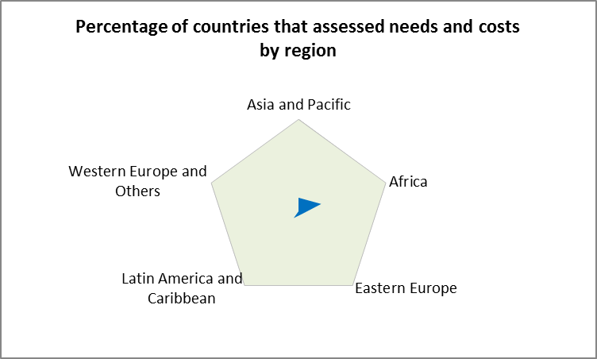
Status: Only 14 % of countries are known to have assessed funding needs and gaps in quantitative terms in the first round of national biodiversity strategies and action plans, mostly in Africa and Asia, and these assessments have applied different methodologies, mostly by presenting a list of project proposals/ideas/concepts. National submissions on funding needs and costs of implementing the Strategic Plan for Biodiversity 2011-2020 are also limited in number, and have followed different methodologies of estimation, making global aggregation an impossible task.
Trend: The assessment of funding needs, gaps and priorities may take place twice, the first for new round of national biodiversity strategies and action plans, and the second coinciding with the seventh replenishment negotiation for the Global Environment Facility Trust Fund. Based on the average unit costs of conservation and sustainable use from 25 countries and adjusted for level of development, funding opportunities of developing countries in the current decade are estimated to be around $60 billion per annum in 2010 and can go up to $150 billion per annum in 2020.
Options: The baseline on the number of countries that have identified and reported funding needs, gaps and priorities for the new decade may be set at zero since the existing efforts have diminishing relevance to the year 2010. Together with the on-going progress in financial planning, the target can be that by 2014, all countries will have identified and reported funding needs, gaps and priorities, and this target should be renewed for 2018. Some countries have already started the estimation process. Bangladesh estimated that the total resource requirements for implementation of biodiversity programme of actions 2020 amount to US$0.3 billion, and has sporadic financial arrangements through its mid-term budgetary framework to support project based biodiversity conservation efforts. At the global level, technical references on assessing funding needs and gaps and identifying priorities and close monitoring of development of financing elements of new national biodiversity strategies and action plans can be helpful. Timely regional and subregional workshops for joint learning and peer reviews on funding needs, gaps and priorities can be held in order to improve the overall quality in the next two years. As funding needs, gaps and priorities are essential for financial planning and can be sensitive to changing political and economic circumstances, the same exercise needs to be renewed periodically, for instance, every two to four years.

1.2 Unaccounted values of biodiversity and ecosystem services are greater than combined gross domestic products globally
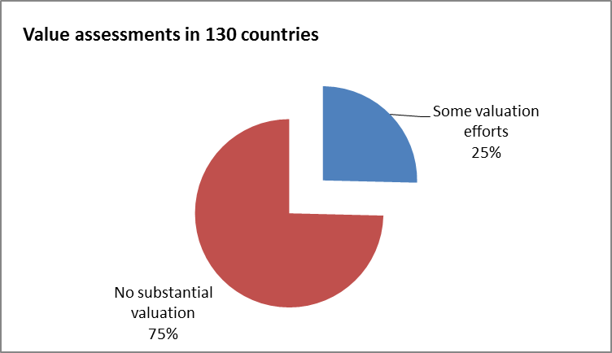
Status: Only a quarter of countries have undertaken valuation exercise, and the drivers for valuation include promotion of biodiversity-based goods and services (green markets/biotrade, agriculture, fisheries, forest products, medicinal plants, tourism, wildlife), use of labels/ certificates, application of market mechanisms such as transferable rights or quota, liability and insurance, polluter-pays-principle, environmental impact assessment procedures. Lack of human and technical capacity in conducting such valuation studies was identified as a constraint.
The rough order-of-magnitude estimates of values of biodiversity and ecosystem services are available at the global level, and several countries have started to implement the economics of ecosystems and biodiversity at the national level. Most existing valuation exercises have been done at project level and incomprehensive in nature, and national-level aggregations of biodiversity values generally are not available. In the late 1980s, Costa Rica and Mexico implemented national environmental accounting through pilot projects, and subsequently Chile, Argentina, Peru, Colombia, Brazil, Bolivia, Dominican Republic, Venezuela, Panama, Guatemala all have experimented with environmental accounts, though not including data on ecosystem services outside of land use and land cover.
Trend: The interest in value assessment of biodiversity and ecosystem services continues to grow, and the valuation exercise needs to be renewed periodically, preferably into national statistical system. The Global Partnership for Ecosystem Valuation and Wealth Accounting provides new impetus to value ecosystems services in terms of national income and wealth accounts, and incorporate natural wealth accounting in macroeconomic and sectoral development planning.
Options: The baseline for the indicator on the number of countries that have assessed values of biodiversity in 2010 may be set as zero, though many countries planned to undertake comprehensive economic assessments. The valuation target for 2020 is that all countries will have conducted a comprehensive valuation exercise for biodiversity and ecosystem services. Enabling financial support and capacity can be critical towards realizing such a target.

II. National Capacity for Resource Mobilization
Goal 2 aims to strengthen national capacity for resource utilization and mobilize domestic financial resources for the Convention’s three objectives. The stewardship of biodiversity and ecosystem services has been traditionally provided by domestic users, particularly by indigenous peoples and local communities. The associated financial contributions, however, have never been counted appropriately. Although the loss of biodiversity and ecosystem services has been recognized as a common concern, domestic financial contributions have been largely ignored or not duly recognized globally. This has led to further problems in considering the linkage and synergies between domestic and foreign financial support. Global discussions of biodiversity financing cannot proceed appropriately without the information concerning domestic financial support to domestic biodiversity activities.
Goal 2 recommends six strategic objectives, namely, national budgetary capacity, national financial plan, sectoral consideration, financial incentives, domestic funds and funding programmes, and enabling conditions for private sector involvement. The starting point for considering national resource mobilization is the national institutional structure dedicated to biodiversity – a biodiversity unit or biodiversity office mostly located in the Ministry of the Environment. As most national biodiversity offices have only a normative policy mandate, their budgets are relatively very small in size. The principal budgetary resources for biodiversity are from sectoral ministries, as well as newly established funds and funding programmes. Although the expectation for private sector involvement remains high, private resources can only be induced through economic incentives and enabling conditions that can be established and improved by governments. One way to track private financing is to examine the extent to which economic incentives and enabling conditions have been used.

2.1 National budgets for the environment including biodiversity have not improved visibly relative to economic growth over time
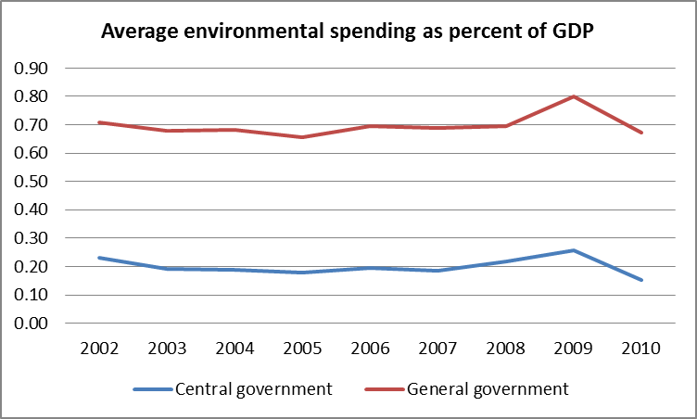
Status: The average percentage of environmental expenditure of central governments in gross domestic products of some 40 countries has stayed around 0.2 per cent over the period between 2002 and 2010, and the average percentage of general governments including lower levels of governments has been around 0.7 percent, implying that a difference of 0.5 percent of gross domestic products for environmental protection has come from provincial and local governments. Several countries registered higher than 1 percentage of general government environmental protection spending in their national domestic products in 2009.
Trend: Although the overall trend in environmental spending is rather stable, many countries reported quantum jump in national budgets for biodiversity and ecosystem services. The two diagrams from Namibia provide a snapshot of the story that can also be found in South Africa, Vietnam, and Antigua and Barbuda, where ten-fold increase in biodiversity funding was reported. Globally speaking, national budgetary support to biodiversity and ecosystem services is estimated to be in the range between US$15 billion - $45 billion in 2010. If one per mille of gross domestic products can be allocated for biodiversity and ecosystem services, some US$63 billion may be expected in 2010.
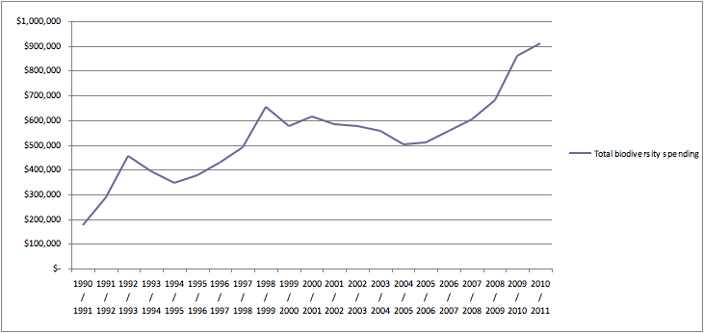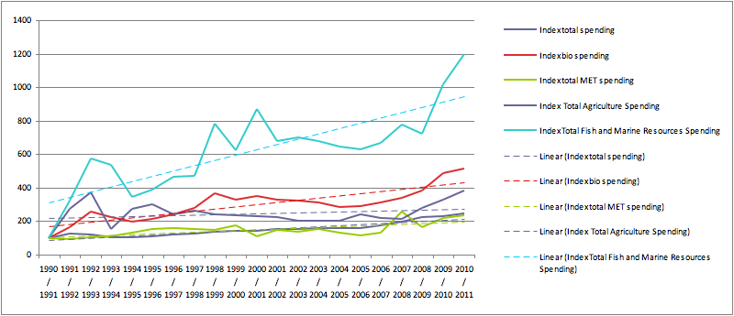
Options: The baseline for national biodiversity budgets in 2010 may be 0.02% -0.07% of gross domestic products, and the target by 2020 can be set at 0.1% of gross domestic products for conservation and sustainable use of biodiversity. Clear definition of biodiversity and ecosystem services in funding statistics, and building of national financing teams for improving financial monitoring and project planning are prerequisite for making progress towards such targets.

2.2 National financial plans for biodiversity may become a primary tool to give effect to national biodiversity strategies and action plans
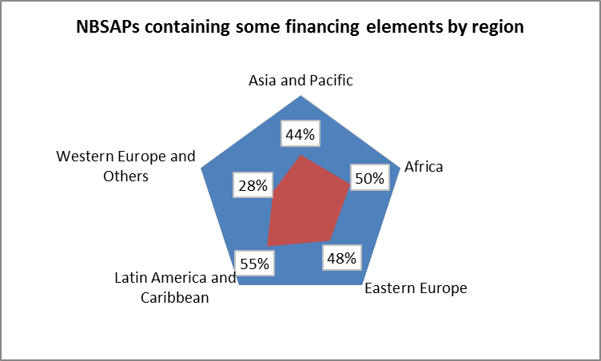
Status: Country-specific resource mobilization strategies are needed to support national biodiversity strategies, and national financial plans to realize national biodiversity action plans. In broad sense, nearly 90 countries have some elements of funding strategies in their existing national biodiversity strategies, and only several countries have developed detailed, though one-time, national financial plans for biodiversity. In general, national financial plans for biodiversity are not synchronized with national budgetary cycles or with international funding processes.
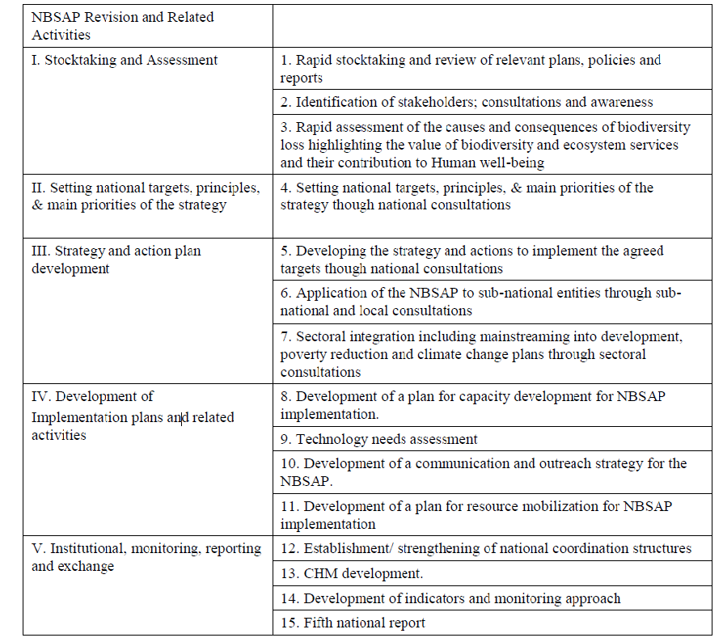A total of 148 countries received financial support of over $36.6 million from the financial mechanism of the Convention for the formulation of their national biodiversity strategies and action plans at a cost of $41.9 million in the past two decades, mostly in 1997-1998. The Global Environment Facility also developed a capacity development initiative in advancing capacity needs assessments and capacity building projects.
Trend: GEF makes available funding for 145 countries to undertake national planning processes, and about 70% of GEF-eligible countries have received financial support to revise their national biodiversity strategies and action plans. The Japan Biodiversity Fund executed by the Convention Secretariat supports sharing and transfer of knowledge and know-how on financial planning.
Options: The baseline in 2010 for the number of counties that have developed national financial plans and received funding and capacity building should be set at zero as all countries should develop new national financial plans in response to the strategic plan for biodiversity 2011-2020. The desirable target can be that by 2014, all countries will have developed and implemented national financial plans for biodiversity, and received necessary funding and capacity building. International support may include development of a consolidated financial planning process as a consolidated platform through which Parties can present annual national financial plans for biodiversity and demonstrate information on funding needs and priorities broadly, in order to promote clear elaboration of national funding needs and priorities for biodiversity and ecosystem services regularly, keep under annual review national funding status, gaps and options for biodiversity and ecosystem services, mobilize broad attention to project proposals, success stories and lessons learned, and foster a coordinated response.

2.3 A wide range of sectoral budgets provide support to biodiversity and ecosystem services
Status: The bulk of biodiversity funding has come from various sectoral ministries, most frequently ministries of agriculture, forestry and fisheries, despite the varied relative importance of different ministries in different countries. In Colombia, electricity sector was transferred to regional environment authorities and city and municipal administrations in the area of river basins, dams and steam generating plants, and has resulted resources to programs for the protection and conservation of basins, environmental improvement and basic sanitation. But contributions to the environmental sector from the National Mineral Royalties Fund were reduced because of the prioritization of basic hygiene, health and education. In Cameroon, the Ministry of Transport decided to include an environmental unit to take care of the environmental aspect in the course of their road infrastructure. Algeria links biodiversity funding with its food security and physical and biological balance, and progressively mobilizes oil profits for national biological development.
Trend: Biodiversity and ecosystem services are seen as an emerging opportunity for new investments at the interface between economic sectors and biodiversity in order to feed the increasing human population with increasing demand for higher calories, better health, energy and transportation. If all countries achieve 25% of their agricultural lands under sustainable use during 2011-2020, particularly those proximate to protected areas, there can be a funding and investing opportunity of US$21 billion –US$32 billion annually for the international community, public and private alike. A 10% of territorial waters under conservation as marine protected areas can provide a funding and investing opportunity of US$14 billion. The mitigation opportunities (excluding emissions) of the transport sector may mean a business of US$12 billion – US$64 billion for the biodiversity community.
Options: Sectoral integration of biodiversity has been explored extensively at the national level, and requires more in-depth consideration at the global level. In agriculture, for instance, discussions can be initiated on transfer of green technology, payment for agricultural services, market for green products through green public procurements, partnerships between biodiversity and agribusinesses, agricultural development banks, public funding realignment, emerging cross-border agricultural development etc.

2.4 The potential of correcting incentives including subsidies harmful to biodiversity remains largely unexploited
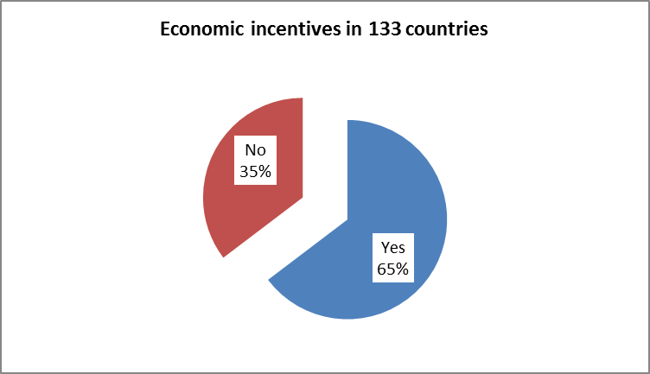
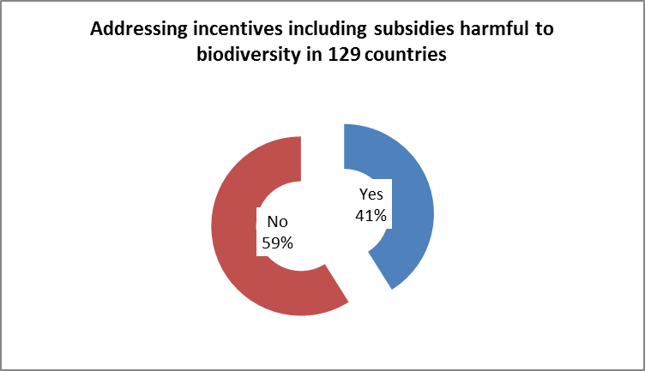
Status: Economic incentives take many forms, including subsidies. Subsidies are deliberate governmental fiscal actions to influence market condition for production and consumption in order to achieve public objectives, often through direct transfer of funds (grants), credit-related subsidies (interest rate subsidies, preferential loans, debt foregiveness, export insurance, loan guarantees and insurance programmes), government equity participation, revenue foregone or not collected (accelerated depreciation and other tax deferrals, credits, refunds and exemptions from income tax, exemptions and relief from indirect taxes), government provision or purchase, and income or price support. 86 reports from 133 countries examined have certain economic incentives for conservation and sustainable use of components of biodiversity and 47 has not adopted any incentive measures. Among 129 reports examined, some 53 countries made some progress in removing or mitigating policies or practices that generate perverse incentives for the conservation and sustainable use of biological diversity, and 76 countries did not.
Trend: The international call for removal, reform or phase-out of incentives, including subsidies, harmful to biodiversity has become stronger in the recent years. The subsidy estimation has demonstrated that agricultural subsidies in OECD countries averaged US$261 billion/year in 2006-8, global fisheries subsidies at US$15-35 billion, energy subsidies around US$500 billion per year worldwide, transport subsidies US$238-306 billion/year, and water subsidies US$67 billion. A portion of these subsidies re-directed can be significant for biodiversity objectives.
Options: The baseline for the indicator on resources mobilized from subsidy reform can be assumed to be nil in 2010, because although a number of countries have started to reform subsidies, the resultant resources remain largely insignificant up to now. The target by 2020 could be two-folded: all countries will have participated in subsidy reform in favour of biodiversity objectives, and one third or even higher of the subsidies harmful to biodiversity will be eliminated. An international levy could be imposed on perverse subsidies in a way that countries must pay for introducing or maintaining these subsidies harmful to biodiversity, and this levy could be used to reward the countries that reform subsides proactively. Countries need to build better understanding of the adverse impact of their subsidies on biodiversity, and a vigorous reporting system on subsidy also needs to be established.

2.5 Financial deepening is essential to domestic funds and funding programmes through voluntary contributions
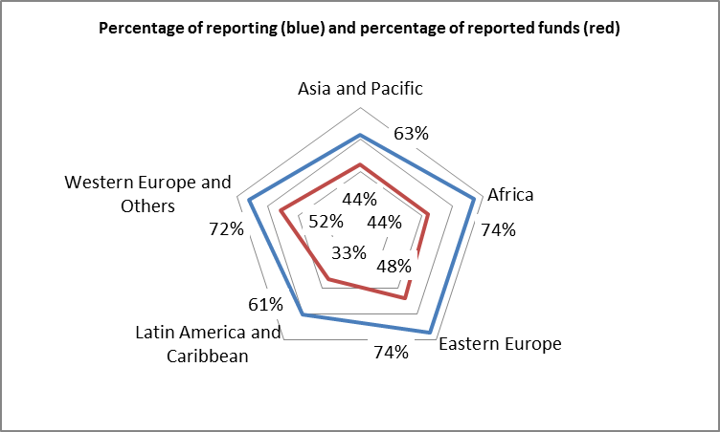
Status: Domestic funds and funding programmes enhance the visibility of funding availability to biodiversity, and about 64% of Parties reported the establishment of new domestic funds and funding programmes or the enhancement of existing ones. Domestic budgetary allocations are among the drivers of creating and enhancing domestic funds and funding programmes, and external voluntary contributions appear to be the principal driver in most developing countries. In United Kingdom, the Heritage Lottery Fund distributes a share of the money raised by the National Lottery for Good Causes, and raised over £125 million for biodiversity projects in the past ten years. Bangladesh and US government have established Tropical Forest Conservation Fund (TFCF) for conservation, restoration and afforestation of tropical forest. In Chile, Agricultural Research Fund (FIA), National Fund for Technology and Production (FONTEC), Fisheries Research Fund (FIP), CONAMA Environmental Fund (FAC), Fund of the Americas, SAG Fund, National Fund for Regional Development (FNDR), all provide financial support to biodiversity projects.
Trend: The number of domestic funds and funding programmes tend to increase during fiscal expansionary periods, but decline during fiscal consolidation periods. Many countries continue to explore opportunities through domestic funds and funding programmes. While the interest of biodiversity and ecosystem services will be further extended into new funds and funding programmes, enhancing biodiversity components within existing domestic funds and funding programmes can become increasingly important. There will likely be more financial deepening for biodiversity in existing funds and funding programmes in the coming decade.
Options: A challenge for mobilizing resources through domestic funds and funding programmes is to maximize resources by bringing projects that have the same objectives together to coordinate and synchronize their activities and objectives as pursued in Antigua and Barbuda. Domestic funds and funding programmes with no specific biodiversity mandates offer greater potential for resourcing than domestic funds and funding programmes with specific biodiversity mandates, but can be more difficult in terms of coordination with biodiversity objectives. Official development assistance, particularly those grants from the financial mechanism, may help leverage resources from domestic funds and funding programmes with no specific biodiversity mandates. Safeguard policy on biodiversity and ecosystem services needs to be introduced and implemented to provide assurance that domestic funds and funding programmes with no specific biodiversity mandates do not run counter to the objectives of biodiversity. Greater sharing of information and experiences on domestic funds and funding programmes, such as the practice of earmarking for biodiversity, can help build stronger case for biodiversity.

2.6 Enabling conditions for private sector involvement require a systematic approach
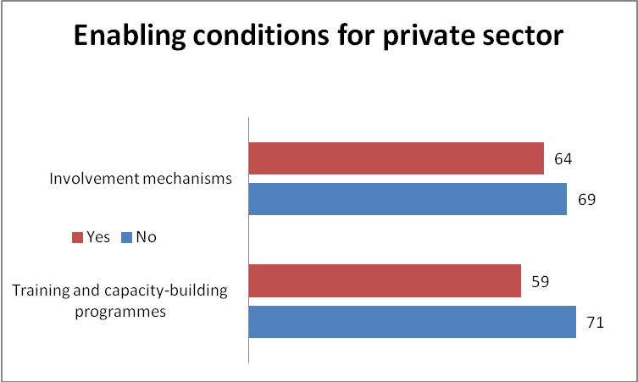
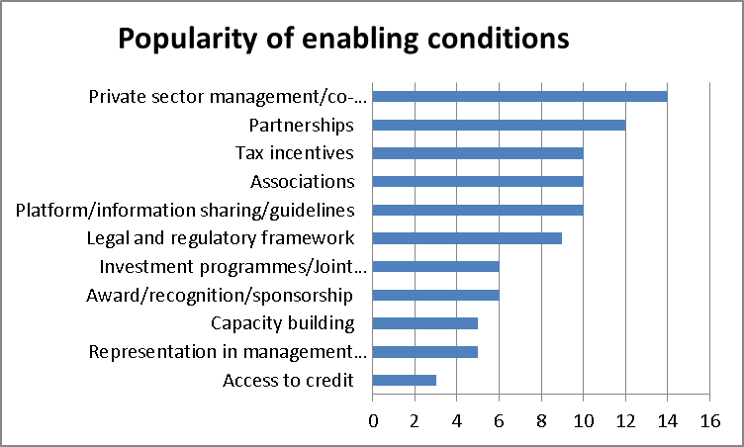
Status: 45% of the examined countries have reported training and capacity-building programmes to implement incentive measures and promote private-sector initiatives, and 48% of the 133 countries examined have developed or explored mechanisms to involve the private sector in initiatives on the sustainable use of biodiversity. In addition, countries have applied many other forms of enabling conditions to involve the private sector. The most popular form of enabling condition is to introduce private sector management or co-management of biodiversity. When annual funding of its parks system was slashed by 20% since 2009, California concluded its first corporate agreement with American Land & Leisure Co. that would take over operations of three state parks for five years. The decentralization policy in Burkina Faso, Cambodia, Uganda, Vietnam and Zambia ensures increased private sector participation and decision making in environmental and natural resources management. Zimbabwe transformed some of its departments or parastatals to for subsidiary companies in order to mobilize financial resources from their business transactions.
Trend: Private sector involvement, although increasingly regarded as an effective way to sustain biodiversity objectives during a period of budgetary difficulties, have helped broaden management perspectives on biodiversity and ecosystem services, by introducing private sector provision of public good. The initial measures of engagement, such as capacity building, recognition awards and sponsorship, investment programme and joint venture, participation in management decision-making and access to credit will continue to expand in many countries, particularly in developing countries. The private sector will increasingly seek to provide their expertise and resources in managing biodiversity and ecosystem services through management contracts, voluntary covenants, public-private partnerships and trade associations.
Options: Governments can be more proactive in promoting private sector involvement in supporting the Convention by providing tax privileges and incentives, legal, regulatory and administrative certainty and information sharing platforms. Australia promotes voluntary conservation covenants on private land with taxation concessions. Kyrgyz Republic and the Gambia work on legal and regulatory framework for engaging the private sector. European Community has set up the EU Business and Biodiversity Platform, which brings together businesses from six different sectors (agriculture, extractive industries, finance, food supply, forestry and tourism) to share their experiences and best practices.

III. Mobilization of External REsources
Goal 3 of the strategy for resource mobilization intends to strengthen existing financial institutions and, promote replication and scaling-up of successful financial mechanisms and instruments. The extent to which developing countries and countries with economies in transition effectively achieve global biodiversity objectives depends on the effective utilization of financial resources made available by developed countries as economic and social development and eradication of poverty are the first and overriding priorities of the developing countries. The resources from the Global Environment Facility thus far have considerably contributed to the policy, regulatory, administrative and budgetary changes for biodiversity in many developing countries and countries with economies in transition. External finances continue to be critical for sustaining biodiversity achievements and in aiming for further and rapid advancement towards the 2020 global targets for resources-constraining countries, particularly the least developed countries and Small Island Developing States.

3.1 Larger co-financing ratio appears to have slightly better chance of attracting increased GEF grants
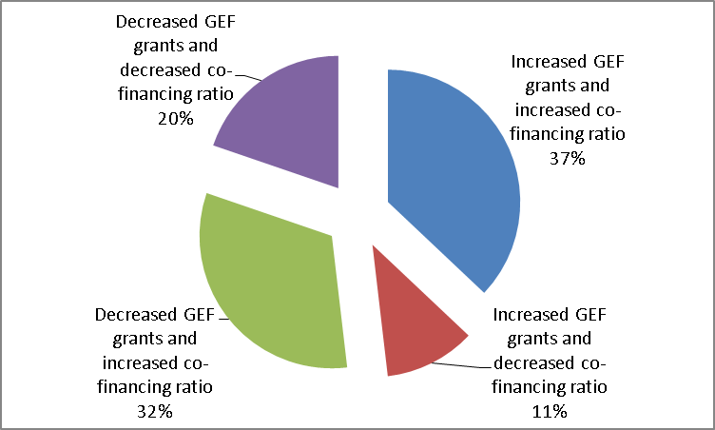
Status: The overall co-financing ratio for GEF grants has been increased by 14 per cent, from 3.19 in GEF-3 to 3.65 in GEF-4. Increased co-financing ratio appears to have slightly better chance of receiving larger GEF grants (increase in 30 cases of 80 samples but decrease in 26 cases), and decreased co-financing ratio can lead to higher chance of receiving decreased GEF grants (decrease in 15 cases and increase in 9 cases). Co-financing ratios may not be necessarily correlated to the level of development of a recipient country.
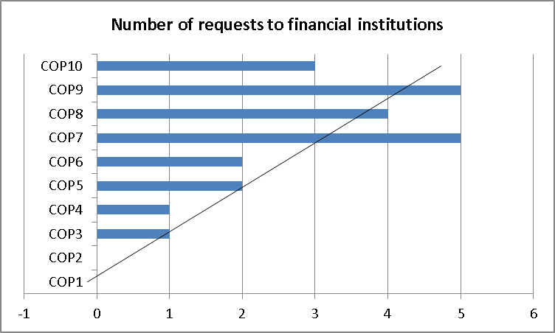
The interest in financial institutions, other than the Global Environment Facility is manifest in the decisions adopted by the Conference of the Parties. There have been three to five requests to other financial institutions from the Conference of the Parties in its recent decisions. These decisions call to other financial institutions for financial support to protected areas, forests, coral reefs, indigenous and local communities, island biodiversity, management of invasive alien species, strategic plan, but most requests to other financial institutions have been observed in the decisions on financial resources, which directly demonstrates the increased level of CBD and Parties’ support to other financial institutions that promote replication and scaling-up of relevant successful financial mechanisms and instruments.
Trends: The average annual amount of biodiversity funding from the Global Environment Facility was US$240 million in the GEF-3 replenishment period (2002-2006) and US$257 million in the GEF-4 replenishment period (2006-2010). The nominal annual increase was close to 2 per cent, and to a large extent, helped offset the impact of inflation during the same period. Some 56 per cent of 138 recipient countries (77) saw certain increase in average annual funding for biodiversity from the Global Environment Facility over the two periods.
Options: The baseline for the financial mechanism in 2010 may be set at US$257 million - an annual average of the GEF-4 replenishment period 2006-2010, and the baseline number of support to other financial institutions in 2010 is 3 requests. As the financial mechanism is centered on the global financial architecture for biodiversity, the target for annual funding average from the financial mechanism in 2020 could be set as 10%-20% of official development assistance marked for biodiversity (annual average for the period 2018-2022), and the target requests to other financial institutions can be doubled by 2020. The resource allocation system needs to reconcile and realign national priorities with global guidance in order to maximize the impacts of resource allocation and utilization.

3.2 Marked bilateral official development assistance has entered a growing phase
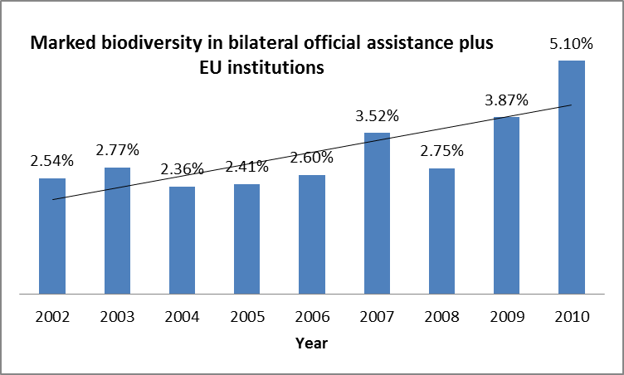
Status: EU Institutions and the 23 countries that are member of the Development Assistance Committee (DAC) marked US$6.57 billion biodiversity assistance from their development cooperation data in 2010, three times higher than the same measurement (US$1.35 billion in current price and US$1.99 billion in 2010 price) in 2002. The percentage of marked biodiversity in bilateral official development assistance has also increased from 2.54% in 2002 to 5.1% in 2010, with the average point of 3.1%. The top ten donors are as follows (in descending order in terms of total amounts): Japan, EU Institutions, Germany, Netherlands, France, United Kingdom, Norway, Spain, Denmark, and United States. Eleven donors have higher than the annual ratio average of marked biodiversity assistance in official development assistance over the nine year period, including Denmark, Japan, Netherlands, Finland, Norway, Spain, Belgium, Ireland, Germany, Canada, and Australia.
Trend: The considerable increase in marked official development assistance for biodiversity can be attributed to many factors. In addition to improved reporting, the global increase in available official development assistance and the percentage increase of biodiversity in official development assistance have also been observed. This has occurred, maybe coincidentally, after the adoption of the strategy for resource mobilization when official development assistance marked for biodiversity dipped in 2008. As the potential increase from improved reporting will likely be exhausted soon, the future trend in biodiversity assistance will depend upon the extent to which overall official development assistance and their biodiversity components can be further increased.
Options: The baseline for the indicator on financial flows in terms official development assistance to developing countries in 2010 is 5% of official development assistance marked for biodiversity. The effective consideration of future official development assistance should take place within the overall financial architecture for biodiversity, in particularly in terms of effective allocations of available global resources. If Parties are committed to provide 0.1% of global gross domestic products for biodiversity and ecosystem services, it makes sense to set the target by 2020 that one third of biodiversity funding available in developed countries will have been transferred to developing countries. This proportional approach gives full consideration to all prevailing economic and financial circumstances. Appropriate reporting framework, particularly reference handbook on marking biodiversity projects in official development assistance will have to be developed, discussed and implemented.

3.3 Greater momentum is needed to implement the Monterrey Consensus
Status: The Monterrey Consensus provides an international framework of resource mobilization for broad development purposes, within which the strategy for resource mobilization for biodiversity should be considered. Recognizing its importance, the ninth meeting of the Conference of the Parties adopted the Bonn message on finance and biological diversity, as an input of the Convention on Biological Diversity to the Follow-up International Conference on Financing for Development to Review the Implementation of the Monterrey Consensus held in Doha from 29 November to 2 December 2008. The Bonn message was posted on the website of the Follow-up International Conference, but was not referred to in the Doha Declaration on Financing for Development. Nevertheless, the Monterrey Consensus and the Doha Declaration outline a balanced approach to considering all the elements of financing for biodiversity, including mobilizing domestic financial resources for development, mobilizing foreign direct investment and other private flows, international trade as an engine for development, increasing international financial and technical cooperation for development, external debt, and enhancing the coherence and consistency of the international monetary, financial and trading systems in support of development
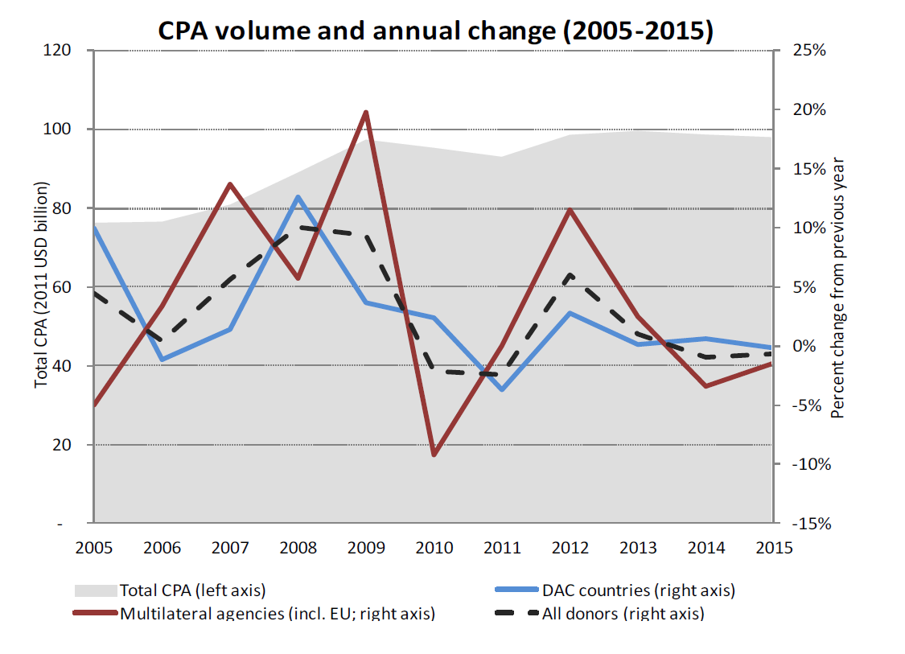
Trend: Global Country Programmable Aid (CPA) in 2011 is estimated at US$ 93.1 billion, representing a decline 2.4% compared to 2010. In real terms, the decline represents nearly US$ 2.3 billion, and countries in Central America and in East Asia (e.g. Indonesia and the Philippines) are mainly affected. Global CPA is estimated to increase by 6% in real terms in 2012, mainly due to expected increases in soft loans from multilateral agencies. From 2013, global CPA is expected to stagnate, reflecting delayed full impacts of a great recession on aid flows. In general, few changes are expected for Africa, but some decrease for Latin America. South and Central Asian countries (e.g. Bangladesh, Myanmar and Nepal) can still experience some increases in CPA.
Options: The prevailing international development cooperation architecture has been built on market interdependence and diplomatic necessity, and may require rethinking in terms of its relevance to addressing global common concerns, such as biodiversity and ecosystem services, and climate change. Further research needs to be advanced on the effective and efficient provision of global public goods, including possible new financial arrangements. Development of a new development cooperation order for addressing common concerns requires collective wisdom and visionary courage of all countries and may not be avoidable eventually. The negotiation for post-2015 development goals and targets can be the first chance to promote international rethinking on financing arrangements for biodiversity and climate change. Parties and the Secretariat of the Convention need to avail themselves of new and innovative ideas, thinking and knowledge on financing global commons, and proactively participate in the debates on financial innovations and the need for a new development cooperation order.

3.4 Donors mainly use trust funds to fill gaps in the system of multilateral aid
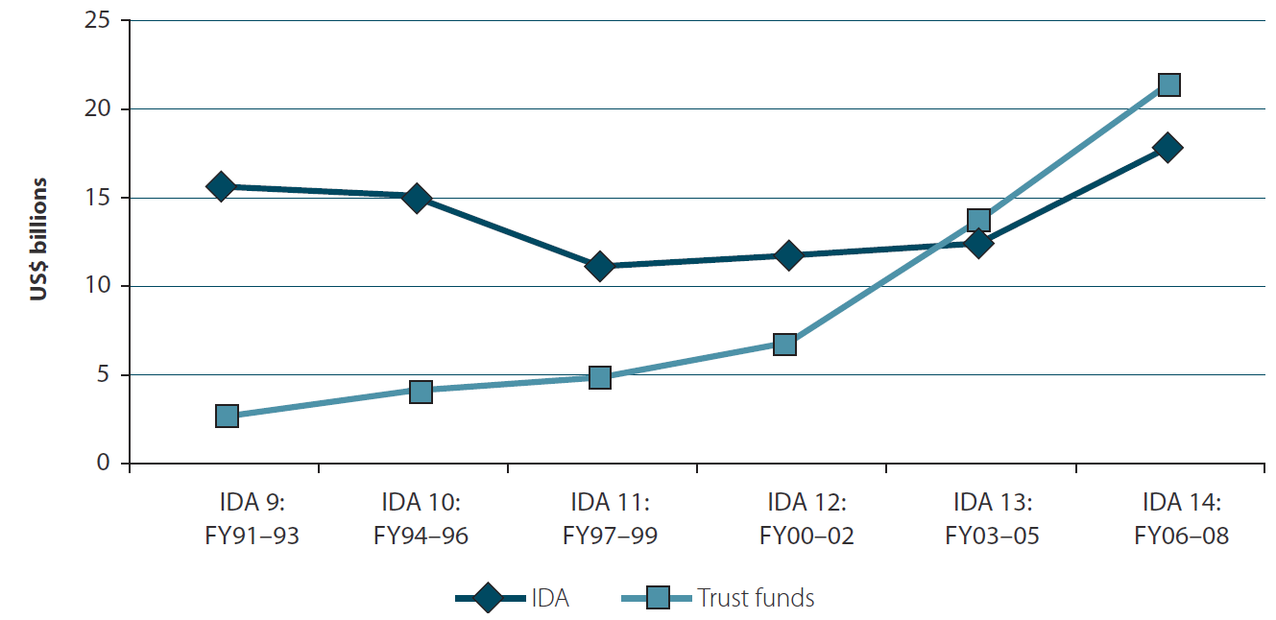
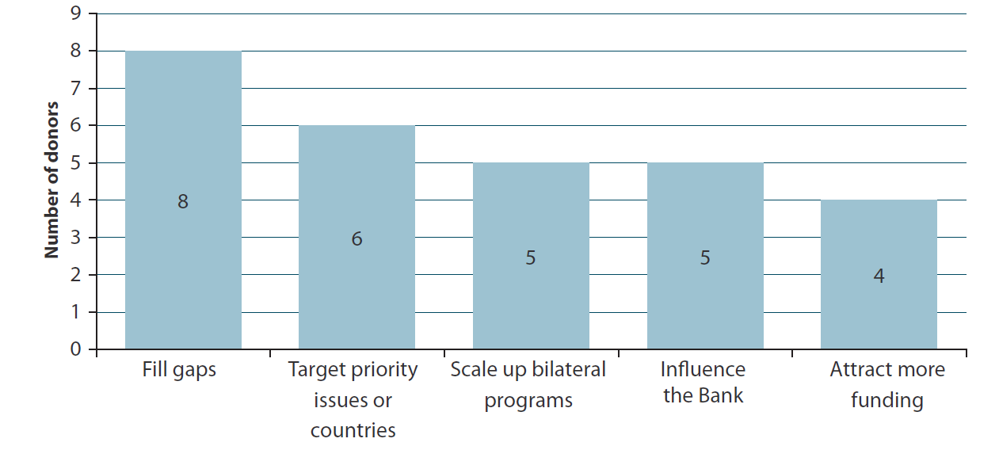
Status: The idea of establishing new and additional funding programmes through voluntary contributions has gained increasing traction under the Convention process. The Nagoya Protocol Implementation Fund became operational at the Global Environment Facility in 2011, and the Japan Biodiversity Fund, though not a separate trust fund, has been used by the Convention Secretariat to promote the revision of national biodiversity strategies and action plans. The tenth meeting of the Conference of the Parties invited the Global Environment Facility to consider establishing a South-South biodiversity cooperation trust fund for the implementation of the Strategic Plan for Biodiversity 2011-2020 based on voluntary contributions. Further ideas for biosafety trust fund and other special-purpose funds also emerged in several official working documents in the past few years. This new phenomenon of fund creation has triggered the debate on comparative merits of trust funds.

Trend: Globally speaking, trust funds accounted for about 11 percent of total official development assistance in 2007-2008, and donors’ trust fund contributions exceeded their International Development Association (IDA) contributions in the past three IDA replenishment periods. In fiscal year 2010, the World Bank administered about 1,075 active trust funds entrusted to it by just over 200 donors. The global average indicates that trust funds for biodiversity may go up to US$600 -$800 million annually, including through the Global Environment Facility Trust Fund, and there is considerable space for the current level of biodiversity allocation through trust funds to grow. Even when funding is available, according to Botswana, it is often difficult to get donors to invest in some biodiversity priorities.
Options: Trust funds do not necessarily provide additional financial resources at the global level, but can add value by providing coordinated financing and grant resources on targeted issues for individual countries, particularly considering the relatively low priority status of biodiversity and ecosystem services, and the even lower priority status of certain biodiversity issues within the established biodiversity assistance system. Despite considerable overlapping interests of various stakeholders in the concept of trust funds, views still diverge on specific issues such as how trust fund allocation decisions are made and how trust funds are governed and managed. Trust funds need to at least ensure sufficient recipient participation and clear outcome objectives.

3.5 Global stimulus packages were largely a missed opportunity for investing in biodiversity and ecosystem services
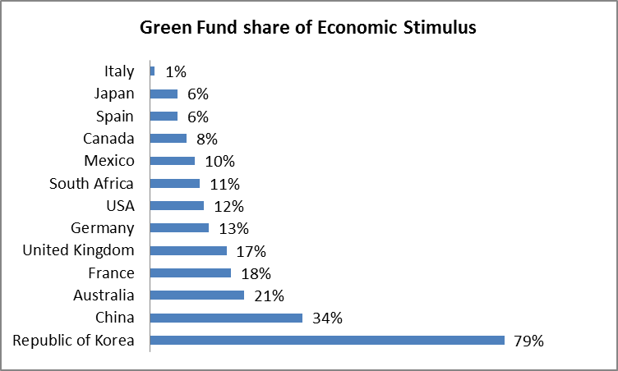
Status: Public sector investment in nature conservation can provide solutions to severe economic crises. The Civilian Conservation Corps (CCC), a public work relief program that operated from 1933 to 1942 in the United States, provided employment for 2.5 million young men in implementing a general natural resource conservation program in rural lands owned by federal, state and local governments. The global economic stimulus packages, introduced after the 2008 great recession, contained green investments in rail, grid, water/waste, building energy efficiency, renewable energy, and low carbon vehicles, and only very limited consideration was given to biodiversity and ecosystem services. France’s stimulus package financed the priority areas identified within the “Grenelle de l’Environnement” that support ecology, sustainable development and land use management. Mexico invested in forest fire prevention measures, and Republic of Korea promoted the restoration of its four major rivers to enhance adaptation to climate change.
Trend: The public sector varies by country, but many countries have established public sector investment programmes, offering an entry point for promoting public sector investment in biodiversity and ecosystem services. The surprisingly low level of overall public sector investments, other than budgetary allocations, indicates that public sector investments have not been used effectively as a policy instrument option, and that public sector investment can be a promising area for future exploration. In Comoros, the offer of banking products remains relatively small, both in terms of savings and loans, for targeted actions.
Options: Conservation and sustainable use of biodiversity largely remain within the remit of public sector investment as about 90 percent of land and water for conservation is owned by governments themselves. China introduced environmental criteria including biodiversity in credit policies of its state-owned banks, and the practice may be replicated for all national development banks and agricultural banks. In Belgium, export credit agencies have begun to consider biodiversity and ecosystem services. Uganda incorporated biodiversity in its Sector Wide Investment Plans (SWIPs). Zimbabwe’s Public Sector Investment Programme (PSIP) contains provisions to relevant departments and institutions. In Antigua and Barbuda where government programs and projects make up over 50% of development, the public sector investment programme (PSIP) process offers a focus on achieving predetermined goals including biodiversity targets. In Brazil, Petrobras developed a biodiversity management system through its corporate standard for managing potential impacts on biodiversity. Mexico incorporated environmental criteria into investment projects financed by development banks. More comprehensive understanding of public sector investment into biodiversity and ecosystem services and its dynamics is needed. With nearly $5 trillion in assets under management at the end of 2011, sovereign wealth funds possess significant potential for further investment in biodiversity and ecosystem services.

3.6 The avenues for private sector investments in biodiversity and ecosystem services remain limited
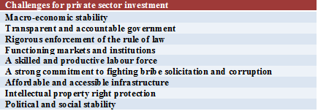
Status: Private sector investment refers to investing activities by for-profit business entities, and can be a driver for turning perceived global values of biodiversity and ecosystem services into multi-billion dollar business operations. The diversity of private sector investors – domestic or foreign, large or small, formal or informal – offers different challenges and opportunities for realizing values of biodiversity. A very large number of private sector investors in the field of biodiversity and ecosystem services are small and medium-sized enterprises, often women-owned businesses. They need expanded access to financial services, greater access to associations and larger firms, support to participation in national forums and capacity building. Microcredit and microfinance, as pioneered by the Grameen Bank in Bangladesh, have emerged as new tools for promoting small-scale entrepreneurial activity. Over 60 major private banks in developing countries have adopted the Equator Principles, launched in 2003, committing themselves to financing only projects that meet basic environmental and social standards, or where necessary, have social and environmental management systems to mitigate, manage and monitor the impacts and risks. Georgia and Kyrgyz Republic advocated for ecological insurance systems - a way of integrating risk, including environmental risk, into economic decision-making, giving an indication of which risks are worth taking and which are not.
Trend: Global foreign direct investment inflows to developing countries and countries with economies in transition reached over US$ 600 billion in 2010, mainly in green-field investments, and grew by 21% in 2011. The flows to Latin America and the Caribbean rose most since foreign investors continued to find appeal in South America’s natural resources. Nevertheless, it is rare that foreign direct investments participate in the provision of biodiversity and ecosystem services. As the global market for green products and ecosystem services expands in size, credit and security market can emerge for their producers, market operators and other providers of associated services. Corporations offering green products and ecosystem services may even be able to raise funds through share offering at domestic and international stock markets, and merge and acquisition activities will also emerge to optimize management structure and force out inefficiencies in the global system for biodiversity and ecosystem services.
Options: The baseline for the indicator on private sector financial flows to biodiversity in 2010 can be significant in specific location, but globally may be deemed as nil in terms of billions of dollars. The target finance from private sector for 2020 can be set as 10% of global biodiversity financing that comes from the private sector. The statistical system for counting private sector investment needs to be designed carefully, on which the future market for biodiversity and ecosystem services depends.

3.7 National environmental funds
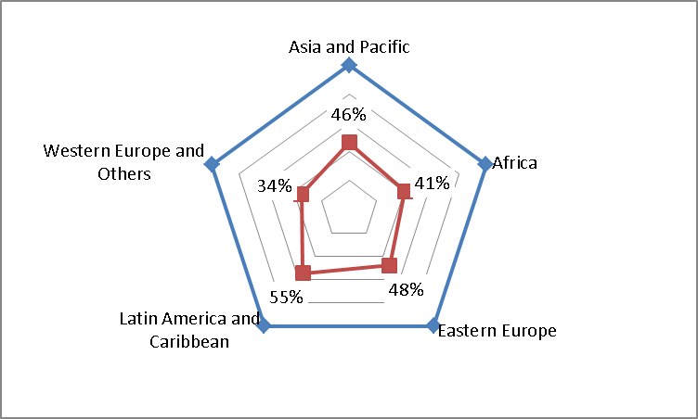
Status: National environmental funds make a considerable share of its resources to conservation and sustainable use of biodiversity, and in some cases, the entire environmental funds are designed for pursuing biodiversity objectives. Some 87 Parties have reported the existence or planned introduction of national environmental funds used for biodiversity purposes, implying that less than half the Parties have adopted the idea of a special fund for biodiversity. The established environmental funds differ in terms of sources of revenue, governance and institutional structure, scope of function, legislative base, relation to national biodiversity finance structure, as well as other aspects. A review of 50 conservation trust funds has observed that some US $810 million have been raised for biodiversity conservation worldwide, including 74% in Latin America, 10% in Asia, 9% in Africa, and 7% in Europe. The contribution from United States, Global Environment Facility and Germany accounts for 70%, and resources from national governments and other donors cover the remaining 30%.
Trend: Unlike many biodiversity-specific funds and funding programmes, national environmental funds normally have nationally designated stable sources of revenues, domestic and external alike. Despite the competition by different environmental priorities for allocations from national environmental funds, many countries, in particular in Africa and Asia, which do not yet have national environmental funds, continue to advocate for new environmental funds in their national biodiversity strategies and action plans. The Arab Environment Facility is already ready to grow. Zambia undertook the feasibility study to develop an environmental fund with Norwegian funding. Zimbabwe’s environmental management policy and act provides for the establishment of an environment fund. Bolivia’s National Environmental Fund (FONAMA) had to be restructured to resolve institutional difficulties in terms of changes in mandate, autonomy, hierarchy within the state apparatus, political problems that led to constant changes in personnel, and delays in processing applications for financial support.
Options: The level of allocations to biodiversity from national environmental funds can be boosted by the availability of international co-financing arrangements, and introduction of revenue streams arising out of conservation and sustainable use of biodiversity as well as benefit sharing.

3.8 Debt relief and conversion initiatives, including debt-for-nature swaps
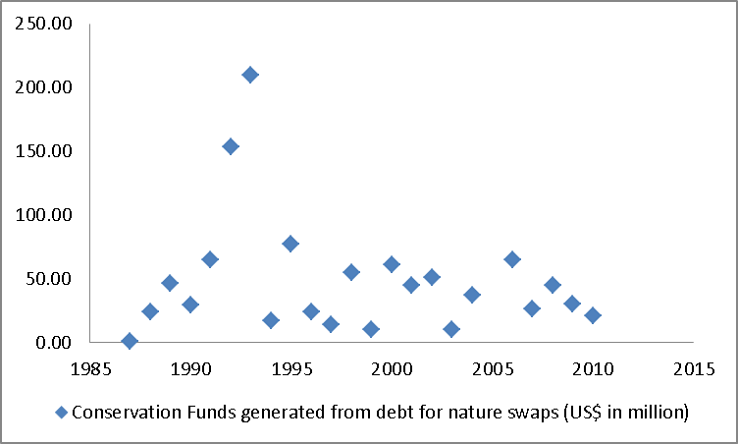
Status: Servicing of external debts may exert a devastating impact on biodiversity and ecosystem services because the pressured need to generate hard currency through export can magnify unsustainable exploitation pattern in relation to biodiversity and ecosystem services. A debt crisis can wipe out virtually all financial gains in sustaining biodiversity and ecosystem services, and debt conversion, on the other hand, can provide additional resources for conservation. 13 creditor countries and 31 debtor countries have been involved in debt for nature swaps. Non-governmental organizations also collaborated with official and private creditors, including Conservation International, The Nature Conservancy, the World Wildlife Fund, Smithsonian Institution, Rainforest Alliance, Missouri Botanical Garden, etc. Conservation funds generated from debt-for-nature swaps peaked in 1992 and 1993, and have since then stabilized in terms of generated funds and number of transactions.
Trend: Among the seven developing countries with the highest external debt stock in 2010, five countries are listed by Conservation International as mega-diverse countries, including China, Brazil, India, Mexico and Indonesia. Half of the twenty-two developing countries with the highest external debt stock in 2010 are members of the Like-Minded Mega-diverse Countries. Although these countries have managed their debt services well by increasing international reserves, any surprise debt shock can lead to unprecedented adverse impacts on achieving biodiversity objectives on the global scale. Debt-for-nature swaps have moved away from forcing a reactive solution for debtors in distress, to seeking a proactive outcome of debt solution for debtors not so much deep in debt problems. For instance, the latest debt-for-nature agreement signed between the United States of America and Brazil in August, 2010 aimed to reduce Brazil’s debt payments to the United States by close to $21 million through 2015. There is still considerable interest from creditor countries in debt swap, and the Global Fund to fight Aids, tuberculosis and malaria received considerable amounts from Australia and Germany. France planned debt reduction contract for development up to 1.5 billion € for ten countries between 2000 and 2015. Through the debt relief initiatives, eligible countries have increased markedly their expenditures on health, education, and other social services. On average, such spending is about five times the amount of debt-service payments. However, poverty reduction strategy papers provide little evidence that support mainstreaming biodiversity and ecosystem services in these countries.
Options: Global consideration needs to be on the chronic problem for addressing the potential adverse impacts of external debts on biodiversity and ecosystem services. One option is to allow an automatic reduction of 1% of all external debts of developing countries and countries with economies in transition, and use the resultant funds to support biodiversity and ecosystem services. Using the data of total external debt outstanding in 2010, the nature in lieu of debt option can generate some US$40.76 billion per year. Several developing countries have demonstrated continued interest in exploring the opportunity of debt-for-nature swap, including Colombia, Central African Republic, Bhutan, Democratic Republic of Congo, Gambia and Indonesia, with present and potential donors.

IV. Innovative Financial Mechanisms
Goal 4 of the strategy for resource mobilization explores new and innovative financial mechanisms at all levels with a view to increasing funding to support the three objectives of the Convention. Innovative financial mechanisms have the potential to generate substantial financial resources and also bring new perspectives on biodiversity financing. Removal, reform or phase-out of perverse incentives can considerably reduce the financial needs of addressing the adverse impacts of these incentives, even when the freed resources are returned to general budgetary accounts, not to biodiversity allocations per se. Regulated by appropriate safeguards, markets for green products and ecosystem services provide a new avenue of generating financial resources by market creation and trade expansion. The market and trade opportunities for biodiversity and ecosystem services can bring effective transformation to the prevailing economic and financial analysis of unsustainable development projects.
Further development of innovative financial mechanisms can benefit from the following four core principles:
Principle 1: Innovative financial mechanisms should be consistent and in harmony with the Convention on Biological Diversity and its protocols and ensure that they are not used to undermine unique components of biodiversity
Principle 2: Innovative financial mechanisms should not replace the financial mechanism established under the provisions of Article 21 of the Convention, and the resultant resources are complementary to the commitment and obligations of Parties under the provisions of Article 20 of the Convention
Principle 3: Innovative financial mechanisms should respect, preserve and maintain knowledge, innovations and practices of indigenous and local communities, and bring added benefits to indigenous and local communities
Principle 4: Innovative financial mechanisms should be consistent and in harmony with the relevant international obligations, and should not be used as a disguised restriction on international trade

4.1 European Union’s agri-environment model has the potential for wider replication
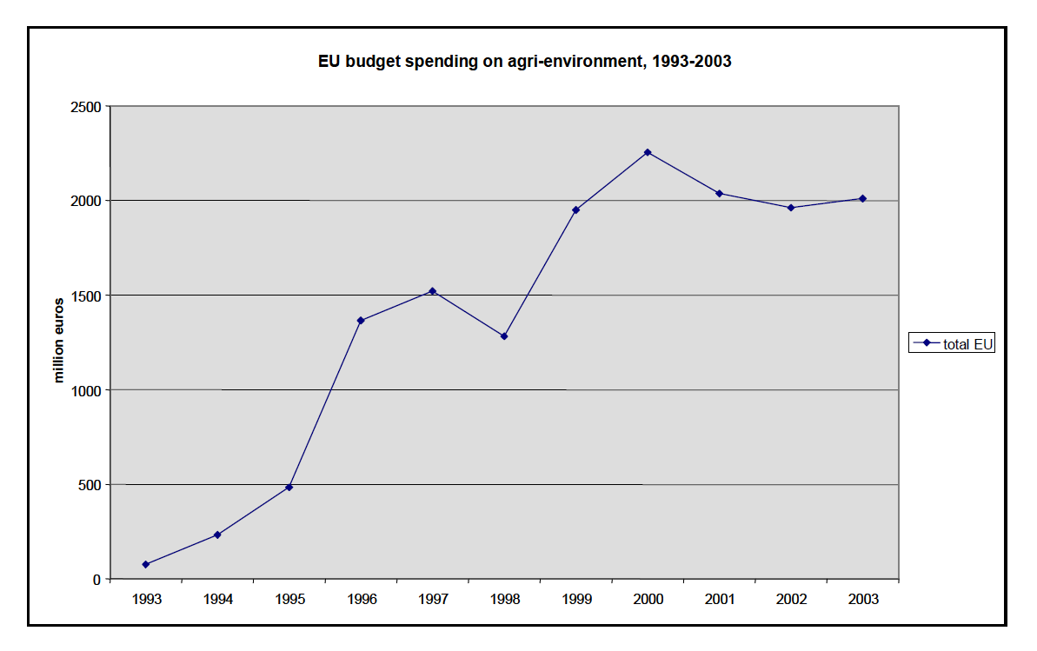
Status: Payment for ecosystem services, an infant form of market for ecosystem services, refers to financial transactions through which the provision of specific ecosystem services is either not adversely affected by projected development activities or enhanced by proactive project activities. Most large-scale schemes of payment for ecosystem services have been sponsored by governments.
Agri-environmental measures provide payments to farmers in return for carrying out commitments that go beyond legal obligations and provide environment services such as reducing environmental risks associated with intensive farming, and/or preserving nature and cultivated landscapes in more extensive farming areas. The measures are designed at national, regional or local level and pay for additional costs and income foregone due to the commitments stipulated in contracts between farmers and respective administration. EU spending on agri-environment has progressed rapidly after agri-environment measures were introduced to the Common Agricultural Policy (CAP) in 1992, and amounts to nearly 20 billion € or 22% of the expenditure for rural development for 2007-2013.
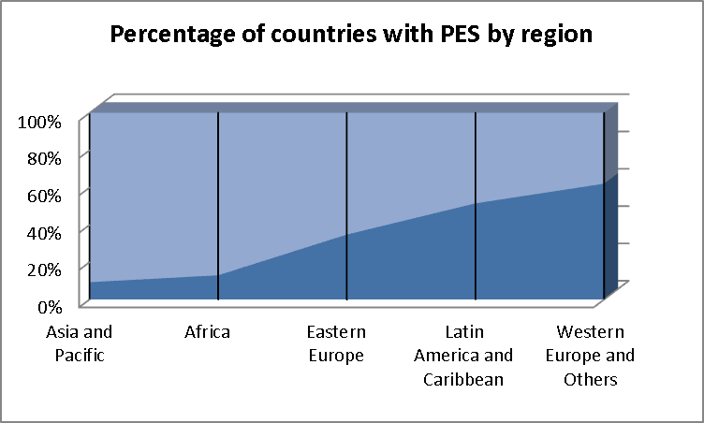
Trend: The concept of payment for ecosystem services has been spread steadily from developed countries to less developed countries over the past two decades. Latin America is accumulating more interests and experiences than other developing regions, but other regions will likely catch up rapidly.
Options: The baseline for the indicator on the number of initiatives on payment for ecosystem services in 2010 is 28.5% of countries with or interested in payment for ecosystem services. The target for 2020 can be that all countries will develop an interest in and design and implement payment for ecosystem services schemes. The exact magnitude of resultant funding in 2010 will be available over time when appropriate statistical system is in place, but such funding can be tripled if the scheme is replicated successfully worldwide due to the current low base of relevant activities.

4.2 In the United States, the number of wetland banks have grown phenomenally over the past two decades
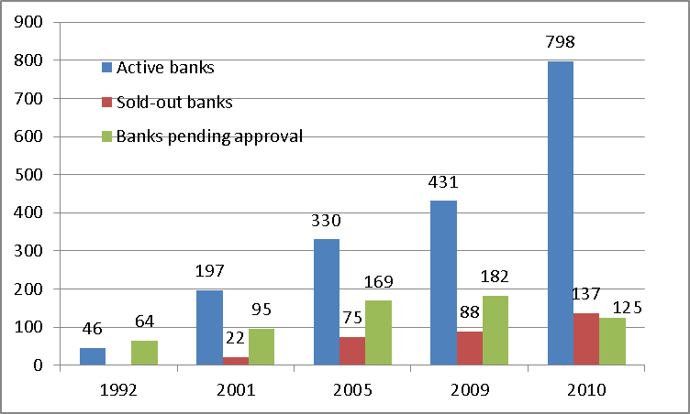
Status: Biodiversity offset mechanisms are well advanced in North America and Australia, and increasingly developed in a number of European countries, such as United Kingdom, France and Sweden. Private and public expenditures for ecological compensation under key federal programs are estimated to be approximately $3.8 billion annually in 2005 in the United States. Mitigation banking mechanisms can reduce uncertainty over whether the compensatory mitigation will be successful in offsetting project impacts; assemble and apply extensive financial resources, planning, and scientific expertise not always available to many permittee-responsible compensatory mitigation proposals; reduce permit processing times and provide more cost-effective compensatory mitigation opportunities; and enable the efficient use of limited agency resources in the review and compliance monitoring of compensatory mitigation projects because of consolidation.
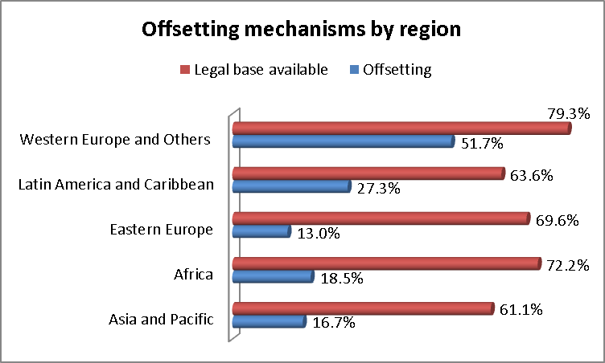
Trend: Over two thirds of countries have legal requirements through environmental impact assessment legislations, policies and procedures for compensations for environmental damages, and nearly a quarter of them have already implemented or tested various forms of biodiversity offset mechanisms. As 9 percent of global ecosystems need to be restored under the Strategic Plan for Biodiversity 2011-2020, the potential for biodiversity offsets can amount up to $45 billion through ecosystems restoration.
Options: The baseline for the indicator on the number of initiatives on biodiversity offset mechanisms in 2010 is 23.8% of countries with some form of biodiversity offset mechanisms. The target for 2020 can be that all countries will benefit from biodiversity offset mechanisms. The approximate magnitude of resultant funding in 2010 is around US$5 billion and this estimate will be more precise over time when appropriate statistical system is in place. Such funding can be more than tripled if international protocols and best practice guidelines accompanied by capacity building and technical assistance are available.

4.3 Environmental Fiscal Reform
Status: Environmental fiscal reform refers to a wide range of structural adjustments to a country’s fiscal system, particularly taxation models and fiscal incentives, which can reflect true values and importance of biodiversity and ecosystem services in national economies. Over 70 countries indicated that certain fiscal measures have been undertaken or planned. Sri Lank introduced environmental tax system into the 2008 budget proposals. Georgia tried to bring the budget law and tax law in line with environmental legislation. In the Netherlands, revenues from green taxes over the past 23 years quadrupled from 4.8 billion euros in 1987 to nearly 20 billion euros in 2010. In Philippines, the Gilutongan Island Marine Sanctuary (GIMS) in the Municipality of Cordova in Cebu generated about PhP 3.0 million in user fee income in 2008 compared to about PhP 550,000 in 2001. Tax exemptions for biodiversity-related objects and activities are observed in a large number of countries including Kenya and Myanmar. Norway undertook to reduce the environmental pressure caused by the consumption of goods and services by giving greater weight to environmental considerations in public procurement processes. In Brazil and Portugal, biodiversity has been introduced into their indexes for calculating intergovernmental transfer to subnational governments.
Trend: 37% of countries have some experience of mobilizing resources from reforming fiscal systems. There is still considerable fiscal space available for introducing fiscal measures in many countries and deepening existing environmental fiscal reforms that have proved successful.
Options: The baseline for the indicator on the number of initiatives on environmental fiscal reform in 2010 is that 37% of countries undertook such reform. The target for 2020 can be that all countries will benefit financially from environmental fiscal reforms. The precise amount of resultant funding is reflected in new national budgets for biodiversity and ecosystem services. Parties need to first undertake a review of fiscal system from the perspectives of biodiversity and ecosystem services, identify potential opportunities for reform, mobilize public support and international financial support for smoothing the transition, and address associated effects.

4.4.1 Markets for green products can be boosted by green purchases
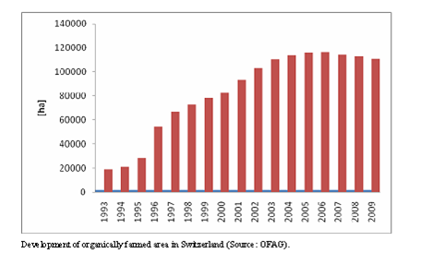
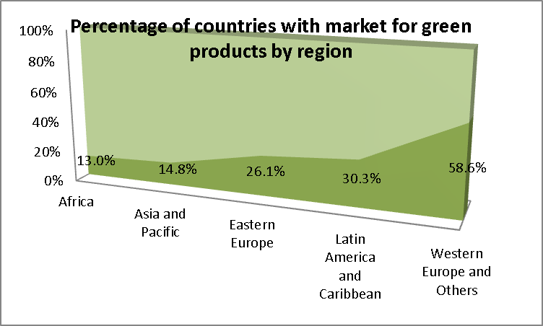
Status: Market for green products refers to the trade mechanism for products certified using criteria that support the three objectives of the Convention. Such products are either natural products including wild plant and animal products used as food sources or used for biochemicals, new pharmaceuticals, cosmetics, personal care, bioremediation, biomonitoring, and ecological restoration, or nature-based products involving many industries, such as agriculture, fisheries, forestry, biotechnology based on genetic resources, recreation and ecotourism. Nearly 50 countries reported national measures to promote certification and organic products, and nearly forty certification schemes and standards are available internationally for agriculture, finance, fisheries, forestry, mining, tourism, carbon and biotrade. Some countries committed themselves to create specific products brands, and part of the revenues from the sale of these products are reallocated to finance programmes to sustain biodiversity and ecosystem services. American Express, Apple, Beats by Dr. Dre, Belvedere Vodka, Bugaboo, Converse, Dell, Gap, Nike, Penfolds, and Starbucks contributed, through branding, US$161 million to the Global Fund to fight Aids, tuberculosis and malaria since 2006.
Trend: The market for green products is driven by green producers, and can be scaled up by green purchasers. Many governments, influenced by the directives and Action Plan for Green Public Procurement in the EU, have established green procurement policies that stimulate markets which might otherwise be slow to develop. Standards and criteria can well inform green private procurements. In 2009, goods and services expense of governments were US$2,221 billion - 12 per cent of their total expenses, and 3.8 per cent of global gross domestic products. Any percentage of this amount means a significant market for green products.
Options: The baseline for the indicator on the number of initiatives on market for green products in 2010 is that 25% of countries have taken measures related to market for green products. The target for 2020 can be that all countries will benefit from the growing market for green products. The accurate estimates of resultant funding for biodiversity in 2010 can be defined when necessary data becomes available, and may be deemed as nil in terms of billions of dollars. The target amount can be derived from a target of a quarter of global government purchases that come from market for green products.

4.4.2 Business-biodiversity partnerships call for business approaches
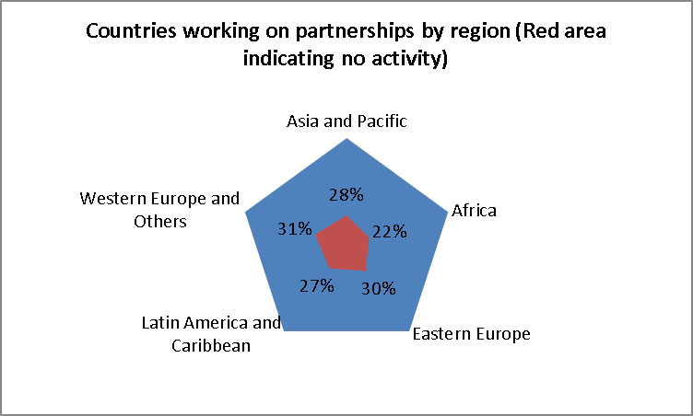
Status: Business-biodiversity partnerships offer operational arrangements that take advantage of enabling conditions and deliver private resources for biodiversity objectives. There are higher percentages of developing countries in Africa, Latin America and Caribbean, Asia and Pacific that work on partnering with the business sector than that of developed countries. Many developing countries are focused on inducement measures that may attract business engagement, while in developed countries, business-biodiversity partnerships are already providing business solutions to biodiversity problems. Austrian Development Co-operation promotes public private partnerships in development activities including the environment.
Trend: Despite the widespread interest in private funding, the global progress on business and biodiversity partnerships remains slow in pace and limited in scope. While business and biodiversity partnerships will continue to spread out to all sectors and all countries, how to enhance resourcing contents of such partnerships will also need to be explored. Developing countries have an additional challenge of reconciling biodiversity objectives and the need to attract foreign investments, including by multinational corporations.
Options: The baseline for the indicator on the number of initiatives on business-biodiversity partnerships in 2010 is that 73% of countries work on partnerships with the business sector. The target for 2020 can be that all countries will benefit financially from business and biodiversity partnerships. The accurate estimates of resultant funding for biodiversity in 2010 can be significant for specific sites and countries, but globally may be deemed as nil in terms of billions of dollars. The target amount for 2020 can be set as 10% of global biodiversity financing that will come from business-biodiversity partnerships.

4.4.3 Charitable giving remains largely untapped for biodiversity and ecosystem services
Status: Philanthropy is rooted in all cultures and all religions that promote philanthropic behaviour in one way or another. Care for animals and the environment is part of this tradition, but has not benefited equally from philanthropic giving worldwide. Globally speaking, philanthropic giving may mount up to over US$600 billion per year, half of them in U.S.A and one fourth in European countries in recent years. Very limited proportion of this funding has been channelled to biodiversity and ecosystem services. This estimate does not include workers’ remittances from host countries to home countries. According to the World Bank, officially recorded remittance flows to developing countries are estimated to have reached US$372 billion in 2011, and are expected to reach US$467 billion by 2014 (US$615 billion if flows to high-income countries are included). Any small portion of this massive flow can be financially significant for biodiversity and ecosystem services.
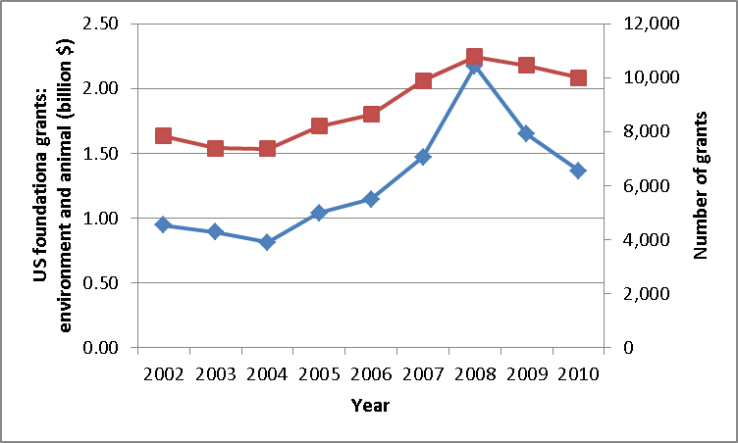
Trend: Religious and cultural activities, education and health have been most successful in attracting philanthropic contributions. Many factors may contribute to their success, but the global presence of institutionalized micro-foundation, such as churches, schools, cultural and health centres, is instrumental in resource mobilization from individual donors or givers. Similar success stories for biodiversity can be found from non-government organizations and grant-making foundations in U.S. Some 6 percent of grants from U.S. grant-making foundations were devoted to the environment and animals, which was US$1.36 billion in 2010. If 5 per cent of global philanthropic giving can be mobilized, some US$30 billion can be available for sustaining biodiversity and ecosystem services.
Options: The baseline for the indicator on the number of initiatives on charity for biodiversity in 2010 is nil and the global amount of charitable resources for biodiversity in 2010 is around US$1.5 billion. The target for 2020 can be that at least two global initiatives on charity will be introduced, and some US$3 billion will be generated for biodiversity objectives. Some harmonization of tax standards for ecosystem management institutions needs to be encouraged, considering that nearly all national regulations require tax-deductible donations to be made to domestically-based organizations, even if it is to be used overseas, but a donation with same objectives cannot have same tax benefits if made to foreign organizations. In Armenia, a funding plan focusing on Armenian Diasporas, particularly in Europe and the Americas was developed to promote investments from Diaspora for financing of environmental activities. Workers’ remittances have never benefited from income tax deductions in host countries. If tax incentives can be provided to workers’ remittances that will be used by ecosystem management institutions, a single-point percentage of the current remittances re-directed would bring nearly US$4 billion to ecosystem institutions for biodiversity purposes.

4.5 New and innovative sources of international development finance remain to be tapped
March 2002 | Publication of the Landau reports and the Declaration on Action against Hunger and Poverty | France announced that air-ticket solidarity levy was to be implemented in France, which entered into force on 1 July 2006 | International Finance Facility for Immunization (IFFIm) set up to borrow €4 billion on capital markets to finance vaccination programmes via the GAVI Fund | Italy announced that it was to establish an Advanced Market Commitment (AMC) for a new pneumococcal vaccine | 29 November – 2 December 2008 | Launching of the Taskforce on International Financial Transactions and Development in Paris | 22 September 2010
2002 | 2004 | 2005 | 2006 | 2007 | 2008 | 2009 | 2010
Monterrey Conference in Mexico: the idea of “innovative financing mechanisms” was introduced in international debate | September 2004 | 29 August 2005 | UNITAID officially launched (co-sponsors: Brazil, Chile, France, Norway, United Kingdom). | February 2007 | Follow-up International Conference on Financing for Development in Doha | 22 October 2009 | UN Declaration recognizing the role of innovative financing to achieve the MDGs

Status: About twenty countries already set up one or more innovative financings so far, and raised nearly US$6 billion since 2006. Advanced Market Commitments leveraged US$1.45 billion to guarantee the price of vaccines once they have been developed. International Finance Facility for Immunization uses long-term donor pledges from donor governments to issue bonds on financial markets, and levied some US$3.4 billion between 2006 and 2011 for the GAVI Alliance (formerly the Global Alliance for Vaccines and Immunisation). Solidarity levy on air ticket generated US$1.22 billion. Belgian Fund for Food Security received 20% of the revenues of the national lottery each year. The Currency Exchange Fund has mobilized US$ 50 million in the Netherlands and US$40 million in Germany.
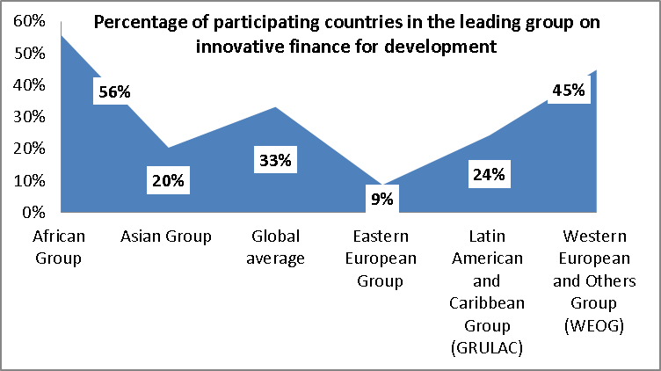
Trend: Innovative development financing mechanisms have evolved considerably over the past decade, with growing interests from both developed and developing countries. African Group and Western Europe and Others Group have demonstrated the highest interest in those mechanisms, while the interest from Eastern Europe Group, Asia Group and Latin America is developing.
Options: The baseline for the indicator on the number of initiatives on innovative development financing for biodiversity and the global amount of resultant resources in 2010 is nil. The target for 2020 can be that similar innovative mechanisms will be introduced for biodiversity, and mobilize a symbolic amount of US$1 billion for biodiversity objectives. For instance, the concept of advanced market commitment can easily be replicated to the market for green products where certain price guarantee for green products can effectively transform production decisions for green products. International finance facility can be introduced to enable the Global Environment Facility Trust Fund to frontload the replenishment resources for immediate project commitments.

4.6 Climate funding can contribute to biodiversity objectives tremendously
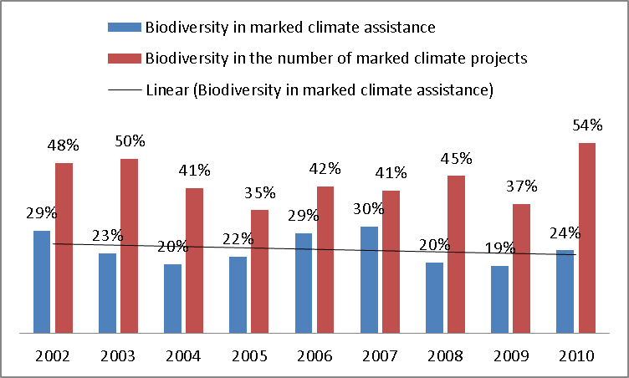
Status: Climate change has been identified as an emerging major cause of biodiversity loss, and any funding action that combats climate change is thus also considered to address biodiversity objectives. Some climate interventions have explicit relevance to conservation and sustainable use of biodiversity. On average, about 23% of development assistance projects marked for climate change are also marked for biodiversity. This ratio may go up when climate adaptation marker is to be introduced. The percentage of biodiversity-related climate change projects in all climate projects is relatively high, signifying that biodiversity contents can help spread out the impacts of climate investments.
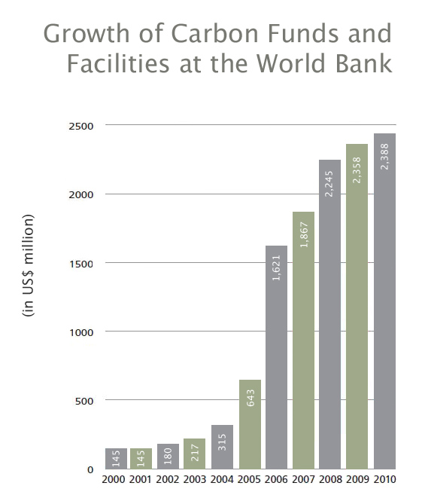
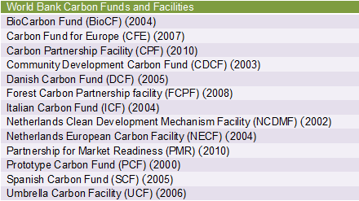
Trend: If the Copenhagen Accord is to be followed, some US$100 billion climate funding will be mobilized annually, and based on the historic trend, direct benefits to biodiversity conservation and sustainable use are on the order of US$20-25 billion per year. World Bank Carbon Finance Unit has reported an increasing number of climate projects that also meet biodiversity objectives.
Options: The baseline for the indicator on the number of initiatives to integrate biodiversity into climate funding schemes in 2010 is 2, and about 24% of official development assistance for climate change is also marked for biodiversity. The target for 2020 can be that all climate funding schemes will have been integrated with the consideration of biodiversity and ecosystem services, and 20%-25% will be mobilized from these schemes for biodiversity objectives. Projects addressing climate and biodiversity objectives need to be preferred to single-purposed projects, in order to achieve savings and environmental impacts. Key biodiversity players need to seek and play a proactive role in advocating biodiversity objectives in the existing Climate Investment Fund, and the emerging green climate fund. Countries need to incorporate the double benefits of co-interventions in country-specific resource mobilization strategies and financial plans for biodiversity.

V. Mainstreaming in development cooperation plans and priorities
Goal 5 of the strategy for resource mobilization undertakes to mainstream biological diversity and its associated ecosystem services in development cooperation plans and priorities including the linkage between Convention’s work programmes and Millennium Development Goals. Policy statements provide a guide and reference in developing budgetary prioritization, and policy changes eventually result in budgetary re-allocations. Although biodiversity and ecosystem services are increasingly referred to as a cross-cutting policy and in development plans, strategies and budgets, frequent re-adjustments of national polices and agency priorities require persistent advocacy for the importance of biodiversity and ecosystem services and regular re-emphasis of biodiversity and ecosystem services in the framework of national policies and agency priorities.

5.1 Biodiversity as a cross-cutting policy must be renewed periodically
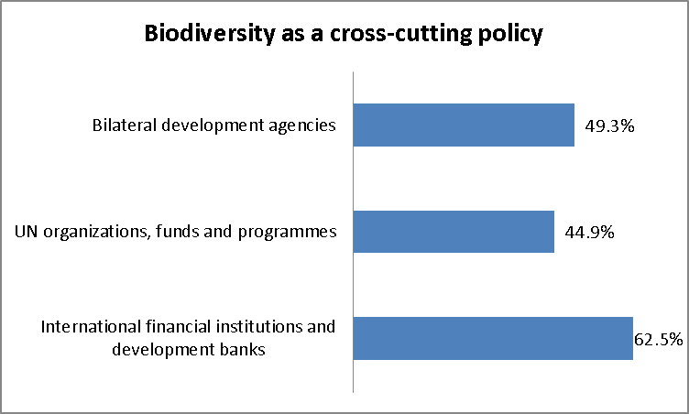
Status: United Nations organizations, funds and programmes scored relatively low among all the development cooperation entities, due to the lack of consideration at regional economic commissions and several special purpose funds. Biodiversity is sustained as a priority issue at a number of bilateral development agencies, but it has become more invisible in several bilateral agencies. International Development Association does not have a specific theme on biodiversity, and African Development Bank only addresses biodiversity in its environmental safeguard policy. But both institutions have financed biodiversity projects, and African Development Bank is an agency for the financial mechanism.
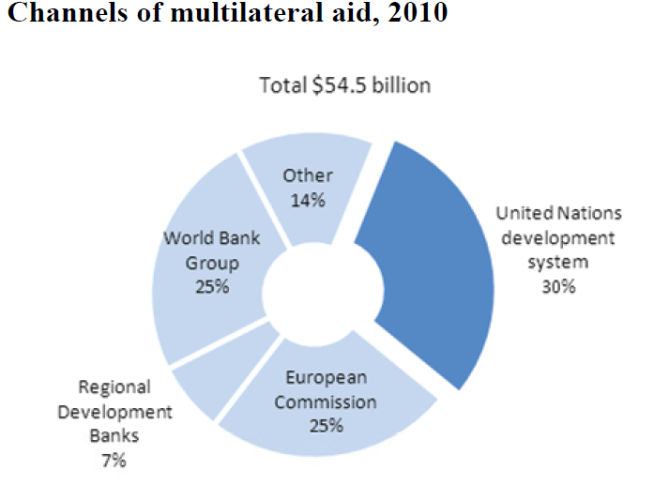
Trend: International momentum and changes in leadership and policy reviews can lead to re-prioritization, and the outcome of the United Nations Conference on Sustainable Development is expected to have positive impacts.
Options: The baseline for the indicator on the number of international financing institutions, United Nations organizations, funds and programmes and the development agencies in 2010 is less than half of these organizations take biodiversity and ecosystem services as a priority. The target for 2020 may be that all these organizations have biodiversity and ecosystem services as a priority issue or a cross-cutting policy. France offers principal stakeholders an opportunity to subscribe to its national biodiversity strategies and action plans by signing a letter of engagement. Similarly, a Commitment to Funding Action (CFA) Process may be established as a coherent framework through which international donors and donor agencies can demonstrate their contribution to biodiversity and ecosystem services. Participating organizations can establish and update voluntary funding targets for biodiversity and ecosystem services at organizational level, and report publicly and annually on the achievement of those targets; mainstream consideration of biodiversity and ecosystem services into relevant priorities, plans, programmes and strategies; develop and enhance, where appropriate, funds and funding programmes for biodiversity and ecosystem services, including through innovative financial mechanisms; collaborate with funding partners with a view to scaling up financial support to biodiversity and ecosystem services, and become an active champion for rapid and extensive biodiversity action; build significant organizational capacity to understand fully the implications of loss of biodiversity and ecosystem services and enhance effectiveness of funding action in support of biodiversity and ecosystem services.

5.2 Integration into national development plans, strategies and budgets calls for more operational consideration
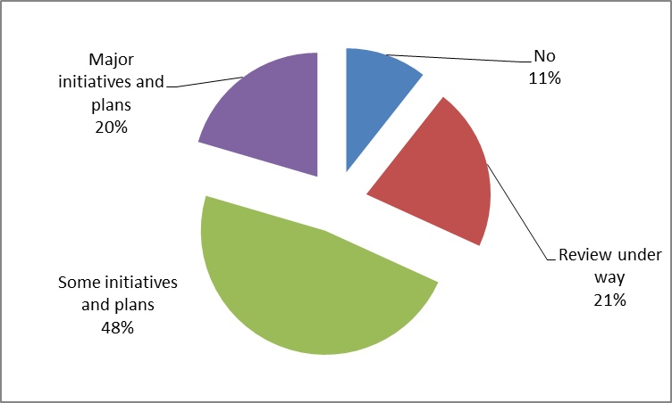
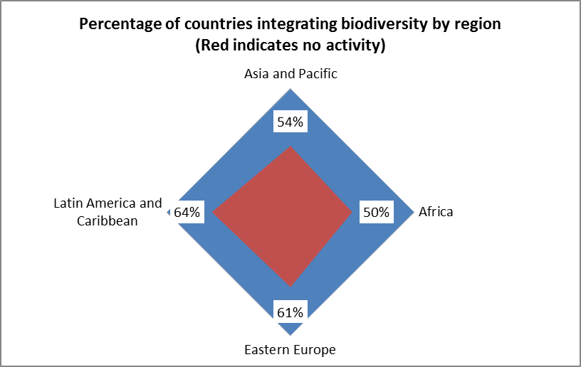
Status: Two thirds of countries have reported concrete actions to review and further integrate biodiversity considerations in the development and implementation of major international development initiatives, as well as in national sustainable development plans and relevant sectoral policies and plans. Africa Group has the highest percentage of countries that have integrated biodiversity into development plans and strategies. In Latin America and Caribbean, about two thirds of countries have not featured biodiversity in their development planning processes. Croatia indicated that the integration of biological diversity has been achieved at the legislative level (it has been integrated into strategic documents) and in sectors of agriculture, forestry, hunting, fisheries, environmental protection, nature protection, marine, etc. However, in most of the sectors, no operational mechanisms for implementation have been established. Similarly in Zambia, the poverty reduction strategy paper and national development plan have stand-alone sections on the environment or natural resources (which include biodiversity), but with no real demonstrated linkages to other sectors. These government documents are generally not influencing the main forces affecting degradation because they mostly fail to establish systems and processes that engage the dominant sectors of society and government. Algeria left funding needs of biodiversity to be taken care of in national socioeconomic development plans.
Trend: Burkina Faso noted that biodiversity conservation and sustainable use must go harmony with other national strategies and plans and sectoral development plans that exist or are being developed or planned. Belgium promotes integration of biodiversity into development plans of partner countries. France undertakes to turn biodiversity into a driver for development. Developing countries and development partners of developed countries need to redouble efforts to integrate biodiversity and ecosystem services into development plans and strategies, particularly whenever they are updated.

Options: The baseline for the indicator on the number of Parties that integrate consideration of biodiversity and ecosystem services in development plans, strategies and budgets in 2010 is two thirds of all Parties. The target for 2020 is that all Parties will have integrated biodiversity and ecosystem services in development plans, strategies and budgets.

5.3 Biodiversity makes up less than a tenth of one percent of lending at the World Bank
Status: All eight international financial institutions and development banks have either included biodiversity in their environmental strategy document or in their safeguard notes, partly because of their status as a GEF agency. In 2012, World Bank adopted new Environment Strategy for the next decade, replaced the one adopted in 2001. Under its green agenda, World Bank focuses on how to nurture sustainable growth and poverty reduction while protecting biodiversity and ecosystems, that is, how growth can become more sustainable and how investing in the environment can stimulate growth. The new Strategy outlines four areas of actions: support countries on valuation of ecosystem services and wealth accounting, including health of oceans and marine biodiversity; leverage work on oceans, fisheries, marine ecosystems, and coastal resources; expand financial and policy reform support for natural resource management and biodiversity; strengthen capacity in strategic environmental assessment and country environmental analysis, including analysis on ecosystem services; revitalize program focusing on pricing biases, subsidies, and market and trade barriers to environmental goods and services; promotion of sustainable supply chains, etc. Inter-American Development Bank is developing a Biodiversity Platform around mainstreaming biodiversity in economic sectors and accounting for the value of ecosystems, maintaining the biodiversity endowment, promoting private sector investment in biodiversity, and strengthening governance and the policy framework.
Trend: Despite the strategic importance attached to biodiversity and ecosystem services, international financial institutions and development banks still face several internal and external challenges. Biodiversity is at most a secondary concern for these banks, and the work on biodiversity can be undermined by more central pursuits with neutral or negative impacts on ecosystems, particularly at European Bank for Reconstruction and Development and African Development Bank. There is little incentive to work on “small” biodiversity projects when greater rewards come from working on the much bigger loans for agriculture, industry, or infrastructure, both requiring similar time, energy, and approval steps. The integration of biodiversity concerns into non-environmental lending can create win-win situations, but may also involve both private costs and added bureaucracy, and encourage borrowers to go for competing lenders.
Options: The baseline for the indicator on the financial flows from international financial institutions, United Nations organizations, funds and programmes in 2010 is approximately US$ 0.45 billion. The target for 2020 can be twice the amount from the Global Environment Facility. This target may be affected by the pace of introducing agencies that will have direct access to the financial mechanism.

5.4 Project approaches to promoting regional, subregional and inter-regional cooperation and coordination
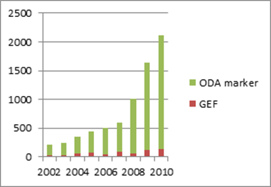
Status: The existing regional and subregional political establishments (UN regional commissions, and regional and subregional community organizations) have been active in becoming partners at the regional and subregional levels, but their involvement has been rather limited in terms of number of projects. The majority of regional and subregional biodiversity projects are initiated and executed by international development organizations and financial institutions, non-governmental organizations as well as governments and key stakeholders of donor and recipient countries. Regional and subregional projects have grown considerably over the past decade, passing the mark of US$ 2 billion in 2010, roughly corresponding to the level of co-financing for GEF regional, subregional and interregional biodiversity projects amounted to US$1.89 billion in the same year.
Trend: The growing trend of regional, subregional and inter-regional cooperation is expected to continue, and by 2020, regional (subregional and interregional) projects may surpass US$3 billion. Regional and subregional environmental cooperation arrangements will play a catalytic role in mobilizing within-region partnerships, such as the African Ministerial Conference on the Environment (AMCEN) (organized by UNEP and UN Economic Commission for Africa every two years), the Ministerial Conference on Environment and Development in Asia and the Pacific (MCED) (organized by UN Economic and Social Commission for Asia and the Pacific every five years), the Forum of Ministers of the Environment of Latin America and the Caribbean (supported by the Inter-Agency Technical Committee (ITC)). The Joint Annual Meetings of the AU Conference of Ministers of Economy and Finance and ECA Conference of Ministers of Finance, Planning and Economic Development offers a promising occasions for developing linkages between biodiversity and ecosystem services and finance, planning and economic development.
Options: Cooperation and coordination among funding partners at the regional and subregional levels needs to build on the existing regional and subregional political establishments. Without involving substantial negotiations at the highest level of governance, a pragmatic mobilization option is to advance a project-based approach to regional and subregional cooperation and coordination. GEF Expanded Constituency Workshops (US$10 million) bring regional and subregional groups of countries (GEF focal points and convention focal points) together, and thus can be used as an effective and efficient platform for incubating regional and subregional project ideas and concepts. Meantime, a longer-term vision for the project-based approach needs to be developed by utilizing the existing arrangements, such as the United Nations Regional Coordination Mechanism, United Nations Development Group, and regional and subregional ministerial forums (environmental as well as development and finance), and enriching them with biodiversity and ecosystem services as a thematic area.

5.5 Funding through international organizations and non-governmental organizations has fluctuated with economic cycles
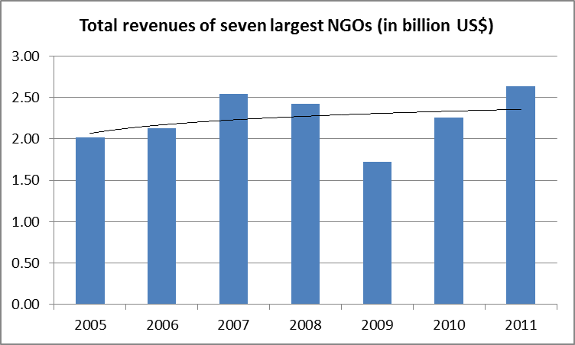
Status: Large international non-government organizations, including BirdLife International, Conservation International, Flora and Fauna International, The Nature Conservancy, Wildlife Conservation Society, World Wildlife Fund, and World Resources Institute, are only a small drop of the ocean of non-governmental organizations, but have demonstrated unparalleled capabilities of resource mobilization. The financial health of these large international non-governmental organizations also serves as a bellwether for the entire community of non-governmental environmental organizations. After a sharp decline in revenues following the financial crisis in 2008, the seven largest nongovernmental organizations have recovered to their pre-crisis level, jumping over the US$2.5 billion mark, though still lower than the historic high. As the large non-governmental organizations spend roughly 80 percent of their funding on conservation programs, policies, awareness and education, some US$2 billion may have been extended from these organizations in 2011.
Trend: Countries have become increasingly receptive to nature-based international organizations and non-governmental organizations. Conservation organizations, such as WWF International, The Nature Conservancy and Conservation International sometimes have an Australian arm, or are regionally headquartered in Australia, with a focus on activities specifically in Australia’s regions. The mobilizing capability of nongovernmental organizations is strongly correlated with economic and business environments in respective countries. But in many cases, non-governmental organizations are much more effective in mobilizing private resources from corporations and individuals. This trend will likely continue in the coming decade.
Options: The baseline for the indicator on the amount from non-governmental organizations, foundations, and academia in 2010 is approximately US$4 billion. The target for 2020 can be set at US$6 billion based on the historic trends. Governments can play a proactive role in helping non-governmental organizations on fund-raising. The Netherlands invested 4.37 million € to scale up the ICCO (the Netherlands-based interchurch organization for development cooperation) Fair Climate Fund with commercial loans of 4.3 million € from ING., and United Kingdom contributed 50 million € and Gates Foundation US$50 million to the GAVI matching fund approach to resource mobilization through non-government organizations. The matching practice already exists for many other purposes in many countries. Its conscientious use in resource mobilization for biodiversity can be an effective way to bring coherence to resources from non-governmental organizations, foundations, and academia in overall biodiversity funding plan in support of national biodiversity strategies and action plans.

VI. Capacity building and South-South Cooperation
Goal 6 of the strategy for resource mobilization is focused on building capacity for resource mobilization and utilization and promoting South-South cooperation as a complement to necessary North-South cooperation. Resource mobilization capacities are the prerequisites for successful resource mobilization campaigns, but the field of biodiversity and ecosystem services has not been able to attract and retain a critical mass of financial experts, particularly in developing countries and countries with economies in transition. South-South cooperation, technical cooperation and capacity building are effective tools to expedite the process of generating necessary financial capacities.

6.1 Amount and number of technical cooperation and capacity building initiatives have increased steadily
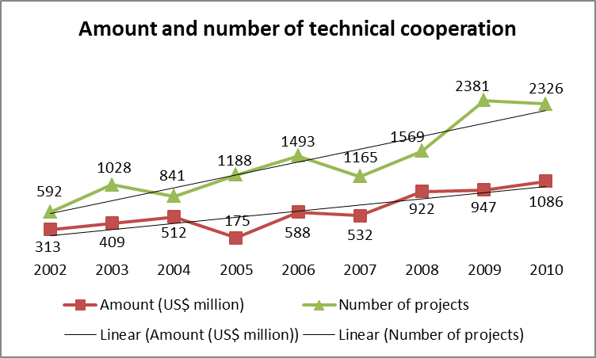
Status: There are two basic types of technical cooperation: (1) free-standing technical cooperation, which is the provision of resources aimed at the transfer of technical and managerial skills or of technology for the purpose of building up general national capacity without reference to the implementation of any specific investment projects; and (2) investment-related technical cooperation, which denotes the provision of technical services required for the implementation of specific investment projects. About 19.7% of all official development assistance marked for biodiversity from 2002 to 2010 belongs to free-standing technical cooperation projects. The amount of technical cooperation increased by 1.2 times from 2002 to 2010 using the constant price, and the number of technical cooperation projects were four times higher in 2010 than in 2002.
Trend: Stand-alone technical cooperation accounts for around 10% of South-South cooperation. Many South-South cooperation contributors (for example Brazil, Argentina, Chile, Cuba, Egypt, Indonesia, Malaysia, Mexico, Nigeria, Singapore and Tunisia) focus mainly on technical cooperation, and a number of developing countries have dedicated technical cooperation departments or agencies which are in charge of most of their South-South cooperation. The technical cooperation include sending experts to advise in-country, peer learning through study tours, training (technical and academic) and capacity building.
Options: The baseline for the indicator on technical cooperation in 2010 is 20% of official development assistance. As technical cooperation is considered as part of official development assistance, future changes in technical cooperation will fluctuate with the overall trends in official development assistance. The target for 2020 can still be that technical cooperation will account for 20% of official development assistance marked for biodiversity. As South-South technical cooperation is still a growing area, the total amount and number of technical cooperation and capacity building initiatives can be doubled by 2020. In order to access to technical cooperation, Parties need to improve the capacity for designing and elaborating project proposals and applying for funding from all donors through training for key ministry employees and non-governmental organizations in project development and grants applications suitable for national and international donors. Various departments need to have trained personnel to ensure implementation of actions identified within the plans and programs.

6.2 The number of South-South cooperation initiatives continue to grow
Status: South-South cooperation in the context of resource mobilization is defined as concessional loans and grants and technical cooperation provided by a developing country for biodiversity purposes. Globally speaking, South-South Cooperation is estimated to be US$15 billion –US$20 billion a year, and 22 per cent is channeled via multilateral organizations including the United Nations and World Bank. Using the OECD Rio marker for biodiversity as reference, some US$200 million of annual South-South cooperation may be of high relevance to biodiversity purpose. Cuba implemented a total of 23 projects relating to the subject of biodiversity are positive experiences for efficient use of resources. Cuba carried out training and joint projects with Colombia, Venezuela, Dominican Republic, and Mexico. The bilateral Agreements for Sustainable Development signed between the Netherlands, Bhutan, Costa Rica, and Benin have fostered technical and policy exchange with Costa Rica for Bhutan and Benin.
Trend: Between 1990 and 2008, world trade expanded fourfold, while South-South trade multiplied by more than 20 times its initial levels over the same period of time. As of 2008, developing countries accounted for around 37 per cent of global trade and nearly three quarters of global growth, with South-South flows making up about half of that total. Economists have predicted that by 2030 South-South cooperation will be one of the main engines of growth, accounting for 57 per cent of the world’s gross domestic product (GDP). Several developing countries agree formal programmes with Finance and Planning Ministries, but most developing countries agree to South-South assistance at Head of State or Government level, and provide technical cooperation via line ministers, other public sector agencies or non-governmental organizations.
Options: The baseline in 2010 for the indicator on the number of South-South cooperation initiatives conducted by developing country Parties is that 30% of countries are involved in South-South cooperation initiatives. The target for 2020 can be that all countries will have participated in South-South cooperation initiatives on biodiversity. Despite the tremendous flows of South-South cooperation, the baseline in 2010 for the indicator on the amount of South-South cooperation initiatives for achieving the Convention’s three objectives is still nil in terms of billions of dollars. The target for 2020 could be established at an annual scale of up to US$1 billion by 2020, in order to effectively promote positive link between South-South economic activities and biodiversity and ecosystem services. This message may help attract necessary attention at the highest level of global governance, and triangular or hybrid cooperation needs to be instrumental in seeding such a global target since developing countries need clear reaffirmation of the commitments under paragraph 4, Article 20 of the Convention.

VII. Access and benefit sharing
Goal 7 of the strategy for resource mobilization seeks to enhance implementation of access and benefit-sharing initiatives and mechanisms in support of resource mobilization. Genetic resources are widely used in several important industries with considerable financial benefits. In accordance with the Nagoya Protocol on Access to Genetic Resources and the Fair and Equitable Sharing of the Benefits Arising from their Utilization, countries have committed to encourage users and providers to direct benefits arising from the utilization of genetic resources towards the conservation of biological diversity and the sustainable use of its components. Access and benefit sharing initiatives and mechanisms thus will emerge as a new source of funding for biodiversity objectives.

7. In INBio, revenues from access and benefit sharing agreements are firmly embedded in its income statements
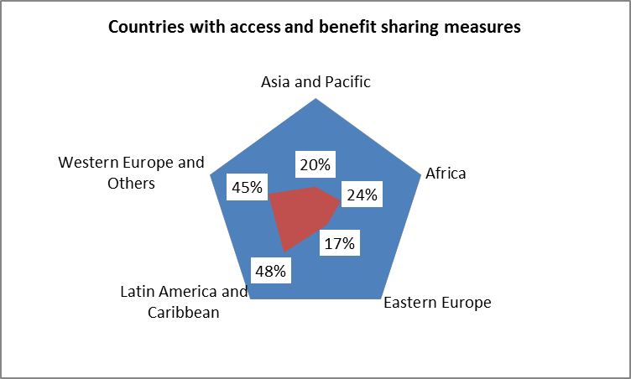
Status: Access and benefit sharing measures, including initiatives and mechanisms, have been developed unevenly across regions. Latin America and the Caribbean as well as Western Europe and Others are far more advanced, with nearly half of their countries undertaking access and benefit sharing measures, than Eastern Europe and Asia and the Pacific where less than one fifth have some access and benefit sharing measures in place. Only a quarter of African countries have undertaken similar measures. The known number of access and benefit sharing agreements involving financing are relatively low and concentrated in a selected group of countries. Their associated financial contributions to biodiversity conservation are relatively small.
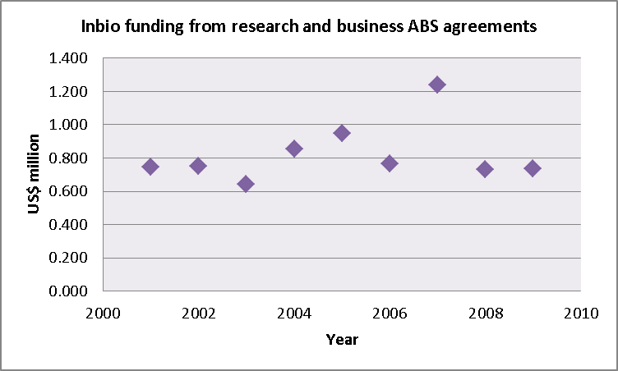
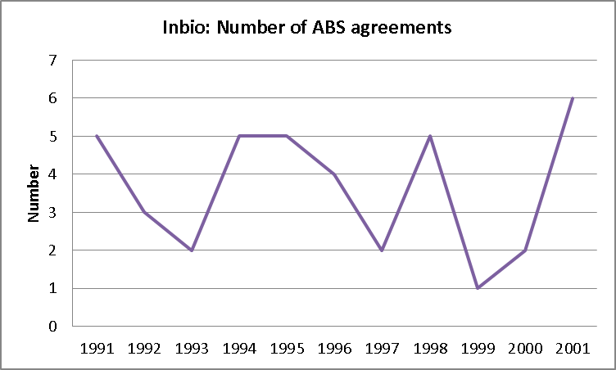
Trend: Global investment in research and development is expected to grow over the next decades, and with necessary time lags, some access agreements may lead to benefits that can be shared. Some US$500 million may be mobilized from regulatory allocations and access contracts. The Nagoya Protocol Implementation Fund will play a catalytic role in advancing the development of access and benefit-sharing agreements and a global multilateral benefit-sharing mechanism could play an important role as mechanism for mobilizing resources for achieving the Convention’s objectives.
Options: The baseline for the indicator on the number of access and benefit sharing agreements involving financial transactions in 2010, measured by countries covered, is less than 10% of the total number of the Parties to the Convention. The target for 2020 can be that every country will have benefited financially from at least one access and benefit sharing contractual agreement, which can be observed through the number of internationally recognized certificates of compliance available on the access and benefit sharing clearing-house and the countries of issuance.

VIII. Global Engagement for Resource Mobilization
Goal 8 of the strategy for resource mobilization is targeted at enhancing the global engagement for resource mobilization in support of the achievement of the Convention’s three objectives. Global awareness initiatives on funding needs provide a platform for all stakeholders to join their efforts to mobilize resources. Such initiatives can attract better media coverage and reach more audience, including high-level politicians, with more powerful political messages and more convincing evidences worldwide.

8. The strategy for resource mobilization was reflected in some high-profile outcome documents, but the momentum is at risk
Status: Global awareness-raising initiatives extend influence over more than one geographical region of the United Nations, which can be effectively pursued through the international high-profile political and economic processes by making explicit statements on the need for resource mobilization for biodiversity. The strategy for resource mobilization was part of the resolutions of United Nations General Assembly in 2010 and 2011 and of G8 Declaration in 2011, but not taken up by Group of 77, United Nations Economic and Social Council Annual Ministerial Reviews and Development Cooperation Forums, annual meetings of governing boards of International Monetary Fund and the World Bank, United Nations Financing for Development process, Group of Twenty.
T1 |  |  | GA(64) | GA(65); G8 | UNCSD
T2 | AMR; OECD ministerial; FfD | GA(63); OECD ministerial; FfD
T3 | GA(62); G77; G8; | G77; G8 | G77; G8 | G77 | GA(66)
T4 |  |  |  |  | OECD ministerial
T5 | DCF; IMF/WB annuals; G20 | AMR; IMF/WB annuals; G20 | AMR; DCF; FfD; IMF/WB annuals; G20 | AMR; IMF/WB annuals; G20 | DCF; IMF/WB annuals; G8; G20
Year | 2008 | 2009 | 2010 | 2011 | 2012

Trends: United Nations Conference on Sustainable Development or Rio +20 points to a positive trend in further exploring financial solutions in the coming years, by stating “We welcome the Strategy for Resource Mobilization in support of the achievement of the Convention on Biological Diversity’s three objectives, including the commitment to substantially increasing resources from all sources in support of biodiversity, in accordance with decisions taken at the Tenth Conference of the Parties.” But the strategy for resource mobilization has not been able to sustain traction at the United Nations General Assembly or at Group of Eight, and financing for biodiversity will likely continue with no attention from other major international processes related to finance.
Options: The baseline for the indicator on the number of global awareness initiatives in 2010 is that the strategy for resource mobilization was incorporated in two outcome documents. The target for 2020 could be that all nine major international processes will consider the strategy for resource mobilization or its goals and strategic objectives in their outcome documents. This requires Parties to influence the preparatory processes of nine international processes through respective organizing secretariats and key negotiation groups. Parties and the convention secretariat need to proactively elaborate headline messages for world leaders, and organize dialogue workshops, seminars and similar events with key stakeholders on the margin of the nine international processes. The Conference of the Parties needs to deliver consensual messages on financing for biodiversity through its high-level segments, to the major international processes, as well as to financial institutions and development agencies.

Data Sources, Technical Notes and references
1.1. Information base on funding needs, gaps and priorities (Goal 1)
National information is taken from national reports, national biodiversity strategies and action plans and submissions which are available on the website of the Convention Secretariat. The data on protected areas, land and water surface areas, and agricultural areas are taken from the World Bank Global Monitoring Report dataset.
For the indicative order of magnitude estimation of funding needs for conservation and sustainable use of biodiversity, a simple method is used: (land and water under protection * unit cost of conservation) + (agricultural land under sustainable use * unit cost of sustainable use) + (number of species threatened * unit cost of improved status for species threatened).
If a country has exceeded 17 per cent of their terrestrial areas and 10 per cent of their costal and marine areas under effective protection, the known figures of surface areas of land and water under protection are used. Otherwise, the targeted level of protection is used. Based on the experience of European Union, 25 per cent of agricultural lands are assumed to be under sustainable use by 2020. Two average unit costs are used: the average expenses of 63 euros per hectare for 25 European Union member countries in 2010, which incurred in Europe’s Natura 2000 system, and average subsidy of 16.2 euro per hectare to sustainable agriculture from the European Union which is co-financed with an estimated equal amount of support from respective national governments. Unit cost of improved status for species threatened is based on the experience of the United Kingdom where conservation action plans have been prepared and implemented for over 250 threatened species at a cost of around 400,000 pounds per plan, but only $200,000 per threatened species per annum is assumed here for developing countries. The unit cost of conservation and sustainable use is then examined on the basis of level of development.
References:
Bangladesh (2010). Fourth National Report (Biodiversity National Assessment and Programme of Action 2020), Department of Environment, Ministry of Environment and Forests, January 2010
Braat, L. & P. ten Brink (eds.) (2008). The Cost of Policy Inaction: the case of not meeting the 2010 biodiversity target, Wageningen, Brussels, May 2008
European Commission (2002). IRENA ((Indicator Reporting on the integration of Environmental concerns into Agricultural policy) Indicator Fact Sheet, IRENA 1 – Area under agri-environment support, Brussels
Gantioler S., Rayment M., Bassi S., Kettunen M., McConville A., Landgrebe R., Gerdes H., ten Brink P. (2010). Costs and Socio-Economic Benefits associated with the Natura 2000 Network. Final report to the European Commission, DG Environment on Contract, ENV.B.2/SER/2008/0038. Institute for European Environmental Policy / GHK / Ecologic, Brussels
United Kingdom (2009). Fourth National Report to the United Nations Convention on Biological Diversity, 18 May 2009
World Bank (2012). Global Monitoring Report 2012: Food Prices, Nutrition, and the Millennium Development Goals, Washington DC
1.2. Assessment of Values of Biodiversity and Ecosystem Services (Goal 1)
National information is taken from national reports, national biodiversity strategies and action plans and submissions which are available on the website of the Convention Secretariat.
References:
South Africa (2009). South Africa’s Fourth National Report to the Convention on Biological Diversity, Department of Environmental Affairs and Tourism, March 2009
Inter-American Development Bank (2012). Leveraging Opportunities for Sustaining Growth: IDB Biodiversity Platform for Latin America and the Caribbean, Department of Infrastructure and Environment (INE), June 2012
Lange, Glenn-Marie, Arati Belle and Sunanda Kishore (2010). Valuation of Ecosystem Services in World Bank Group Work, the World Bank Group 2010 Environment Strategy Analytical Background Papers, 15 December 2010
World Bank (2010). World Bank Launches New Global Partnership to “Green” National Accounts - Global Partnership for Ecosystems and Ecosystem Services Valuation and Wealth Accounting, Press Release No: 2011/155/SDN, Nagoya, Japan, October 28, 2010
2.1. Domestic Expenditure for the Environment Including Biodiversity (Goal 2)
National data on environmental spending are taken from IMF – Government Finance Statistics Yearbook database, accessed on 12 June 2012. The data on gross domestic products are taken from the World Bank Global Monitoring Report dataset. Other national information is taken from national reports, and national biodiversity strategies and action plans.
The combined global domestic products were estimated at US$ 63 trillion in 2010. As national biodiversity spending ranges from 3% -10% of national environmental expenditures, national biodiversity spending is between just above 0.02% and 0.07% of gross domestic products. This estimation is subject to changes in definition of biodiversity and ecosystem services in national financial statistics. Countries registered higher than 1 percentage of general government environmental protection spending in their national domestic products in 2009 include Netherlands (1.86%), Malta (1.775%), Japan (1.42%), Ireland (1.34%), Lithuania (1.18%), United Kingdom (1.08%), France (1.06%) and Estonia (1.01%).
References:
International Monetary Fund (2012). Government Finance Statistics Yearbook, online version
Namibia (2010). Namibia’s Draft Fourth National Report to the United Nations Convention on Biological Diversity (UNCBD), Compiled by the Namibian Ministry of Environment and Tourism, August 2010
2.2. Development of National Financial Plans for Biodiversity (Goal 2)
National information is taken from national reports, and national biodiversity strategies and action plans. The data on financial support in the past decade are taken from the project database of the Global Environment Facility, which may be slightly different from those contained in the previous reports of the Global Environment Facility.
Reference:
GEF (2012). Report to the eleventh meeting of the Conference of the Parties to the Convention on Biological Diversity, Washington DC
2.3. Sectoral mobilization (Goal 2)
National information is taken from national reports, and national biodiversity strategies and action plans.
The same methodology as provided under chapter 1.1 is used to estimate funding and investing opportunities for sustainable agriculture and territorial waters under protection.
The estimation of funding and investing opportunities in transport is based on the World Bank study showing that environmental assessments accounted for 0.06% to 0.45% of the total project cost, and the costs of mitigation actions often required two to five per cent of project construction costs (could be higher in urban areas or sensitive locations). The latest update of annual transport infrastructure investment and maintenance data collected by the International Transport Forum at the OECD shows that GDP share of investment in inland transport infrastructure has remained almost constant in Western Europe (0.8%), which declined from an average 1.5% in 1975 to 1.2% in 1980, and North America (0.6%) over the past decade. A range of 0.8% - 1% GDP invested in transport means that the world’s investment in transport may be around US$505 billion – US$630 billion, and some US$12 billion – US$32 billion should have been spent on biodiversity and mitigation actions. As global investment in transport is expected to increase and probably be doubled by 2020, the estimated mitigation costs of transport projects will likely be doubled as well.
References:
Algeria (1997). Stratégie algérienne et plan d’action nationale d’utilisation durable de la diversité biologique, Tome VIII, Ministère de l’Aménagement du Territoire et de l’Environnement, FEM/PNUD Project ALG/97/G31
Cameroon (1997). National Report, Ministry of the Environment and Forestry
Chile (2003). Primer Informe Nacional a la Conferencia de las Partes del Convenio Sobre Diversidad Biologica, Comisión Nacional de Medio Ambiente, Diciembre 2003
Colombia (1998). First National Report, April 1998
Estonia (1999). Estonian Biodiversity Strategy and Action Plan, Estonian Ministry of the Environment, Tallinn, 1999
European Commission (2002). IRENA ((Indicator Reporting on the integration of Environmental concerns into Agricultural policy) Indicator Fact Sheet, IRENA 1 – Area under agri-environment support, Brussels
France (1995). Circulaire n° 96-19 du 12 décembre 1995. Relative à la politique “1 p. 100 paysage et développement” sur les autoroutes et les grands itinéraires interrégionaux
Gantioler S., Rayment M., Bassi S., Kettunen M., McConville A., Landgrebe R., Gerdes H., ten Brink P. (2010). Costs and Socio-Economic Benefits associated with the Natura 2000 Network. Final report to the European Commission, DG Environment on Contract, ENV.B.2/SER/2008/0038. Institute for European Environmental Policy / GHK / Ecologic, Brussels
International Transport forum (2011a). Transport Outlook – Meeting the Needs of 9 Billion People
International Transport forum (2011b). Trends in Transport Infrastructure Investment 1995-2009, Statistics Brief, July 2011
World Bank (1996). The Impact of Environmental Assessment: Second Environmental Assessment Review of Projects Financed by the World Bank (July 1992 – June 1995). Washington, DC: World Bank, Environment Department
2.4. Economic Incentives (Goal 2)
National information is taken from national reports, and national biodiversity strategies and action plans. The indicative order of magnitude estimates for subsidies are taken from ten Brink, Patrick (ed.) (2011). No separate estimation is done in this regard.
References:
Centre d’Analyse Stratégique (2011). Les aides publiques dommageables à la biodiversité, October 2011
Jones, Darryl and Ronald Steenblik (ed.) (2010). Subsidy Estimation: a survey of current practice, the Global Subsidies Initiative (GSI), International Institute for Sustainable Development, Geneva, Switzerland, June 2010
Loh, Jonathan (ed.) (2005). 2010 and beyond: rising to the biodiversity challenge, Global Footprint Network
SCBD (2008). In-Depth Review of the Work on Incentive Measures: Synthesis report of information on incentive measures provided by Parties in the third national reports, Note by the Executive Secretary, UNEP/CBD/COP/9/12/Add.1, 28 April 2008
ten Brink, Patrick (ed.) (2011). The Economics of Ecosystem and Biodiversity in National and International Policy Making, Earthscan, London
2.5. Domestic Funds and Funding Programmes through Voluntary Contributions (Goal 2)
National information is taken from national reports, and national biodiversity strategies and action plans.
References:
Antigua and Barbuda (2001). Biodiversity Strategy and Action Plan for Antigua and Barbuda, Draft, Office of the Prime Minister, Government of Antigua and Barbuda, April 2001, UNDP Project #ANT/97/1G/99
Bangladesh (2005). Third National Report, Ministry of Environment and Forests, 15 May 2005
Chile (2003). Primer Informe Nacional a la Conferencia de las Partes del Convenio Sobre Diversidad Biologica, Comisión Nacional de Medio Ambiente, Diciembre 2003
United Kingdom (2005). United Kingdom and its Overseas Territories and Crown Dependencies: Third National Report to the Convention on Biological Diversity
2.6. Enabling Conditions for Private Sector Involvement (Goal 2)
National information is taken from national reports, and national biodiversity strategies and action plans. The popularity of enabling conditions is based on manual counting of measures or planned measures contained in national information.
References:
Australia (2005). Third National Report, Department of Environment and Heritage
Burkina Faso (2010). Quatrieme Rapport National a la Conference des Parties, Ministère de l’Environnement et du Cadre de Vie / Secrétariat Permanent du Conseil National pour l’Environnement et le Développement Durable, Juillet 2010
Cambodia (2006). Third National Report, Phnom Penh, May 2006
European Union (2011). Communication from the Commission to the European Parliament, the Council, the Economic and Social Committee and the Committee of the Regions: our life insurance, our natural capital: an EU biodiversity strategy to 2020, Brussels, 3 May 2011, COM(2011) 244 final
Kyrgyz Republic (1998). Biodiversity Strategy and Action Plan, Ministry of Environmental Plan, Bishkek, November 1998
Taves, Max (2012). Private Fix for Public Parks: Companies will Manage Six California Sites to Limit Closures under Budget Cuts, Wall Street Journal, 17 June 2012
Uganda (2009). Fourth National Report to the Convention on Biological Diversity - National Environment Management Authority, Ministry of Water and Environment, 11 May 2009
Vietnam (2007). National Action Plan on Biodiversity up to 2010 and Orientations towards 2020 for Implementation of the Convention on Biological Diversity and the Cartagena Protocol on Biosafety, Decision No. 79/2007/Qd-Ttg, 31 May 2007
Zimbabwe (2003). Third National Report, Ministry of Environment and Tourism
3.1. Co-Financing and Other Modes of Project Financing for GEF Projects (Goal 3)
The data are taken from the GEF Secretariat project database in June 2011. Both projects in biodiversity focal area and those that have biodiversity components in multi-focal area of the Global Environment Facility are included. Co-financing ratio is based on planned amount, not actually realized amount. The annual average of GEF funding in a country is computed by dividing the sum of all GEF-approved biodiversity projects by 4.
Requests to other financial institutions are manually counted after conducting a key word search through all the decisions from the Conference of the Parties.
The GEF reported a cofinancing ratio of 1 (GEF) to 4 (cofinancing) from the biodiversity focal area, thus assuming 20% of total project costs for GEF-related biodiversity projects. The share of the GEF in total official development assistance marked for biodiversity has declined over time from just over 10% to less than 4%.
References:
GEF (2009). Co-Financing Data Related to GEF Operations, Second Meeting for the Fifth Replenishment of the GEF Trust Fund, GEF/R.5/Inf.9, 17 June 17 2009
GEF (2010). GEF Report to the Tenth Meeting of the Conference of the Parties to the Convention on Biological Diversity, 21 June 2010, Washington DC
GEF (2012). Report to the eleventh meeting of the Conference of the Parties to the Convention on Biological Diversity, Washington DC
3.2. Official Development Assistance (ODA) (Goal 3)
The data are taken from the spread-sheets which are kindly provided by the OECD Secretariat.
References:
OECD (2007). Directives for reporting to the aid activity database (Creditor Reporting System), Development Co-Operation Directorate Development Assistance Committee, DCD/DAC(2007)39/FINAL, 4 September 2007, Paris
OECD (2011). Development Co-operation Report 2011 - 50th Anniversary Edition, 4 October 2011, Paris
SCBD (2010). Global Monitoring Report 2010: Innovative Financing for Biodiversity, Montreal
3.3. Implementation of Monterrey Consensus (Goal 3)
The diagram on CPA volume and annual change (2005-2015) is reproduced from OECD (2012).
References:
CBD (2008). Message on biological diversity and finance to the Follow-up International Conference on Financing for Development to Review the Implementation of the Monterrey Consensus, annex C to decision IX/11, UNEP/CBD/COP/DEC/IX/11, 9 October 2008
OECD (2009). 2009 DAC Report on Aid Predictability: Survey on Donors’ Forward Spending Plans 2009-2011, Paris
OECD (2011). 2011 OECD Report On Aid Predictability: Survey On Donors’ Forward Spending Plans, 2011 – 2013, Paris
OECD (2012). Outlook on Aid: Survey on Donors’ Forward Spending Plans 2012-2015, Paris
United Nations (2003). Monterrey Consensus of the International Conference on Financing for Development, the final text of agreements and commitments adopted at the International Conference on Financing for Development Monterrey, Mexico, 18-22 March 2002
United Nations (2009). Doha Declaration on Financing for Development: outcome document of the Follow-up International Conference on Financing for Development to Review the Implementation of the Monterrey Consensus, the final text of agreements and commitments adopted at the Follow-up International Conference on Financing for Development to Review the Implementation of the Monterrey Consensus, Doha, Qatar, 29 November - 2 December 2008
United Nations (2012). The future we want: draft resolution submitted by the President of the General Assembly, A/66/L.56, 24 July 2012
3.4. New and Additional Funding Programmes through Voluntary Contributions (Goal 3)
The data are taken, and the two diagrams are reproduced, from IEG (2011).
The potential of US$600-$800 million for biodiversity trust funds is estimated on the basis of two factors: 0.1% of global gross domestic products may be available for biodiversity and ecosystem services, and about 11% of total official development assistance is channelled through trust funds historically.
References:
Botswana (2009). Fourth National Report to the Convention on Biological Diversity, Department of Environmental Affairs, 19 May 2009
CBD (2010). Additional guidance to the financial mechanism, decision X/25
GEF (2012). Report to the eleventh meeting of the Conference of the Parties to the Convention on Biological Diversity, Washington DC
IEG (Independent Evaluation Group) (2011). Trust Fund Support for Development: An Evaluation of the World Bank’s Trust Fund Portfolio. Washington, DC: Independent Evaluation Group, the World Bank Group
3.5. Public Sector Investments in Biodiversity (Goal 3)
The data on economic stimulus are taken, and the diagram is reproduced, from UNEP (2009). The data on sovereign wealth funds are taken from UNCTAD (2012).
References:
Antigua and Barbuda (2010). Fourth National Report to the Convention on Biological Diversity, prepared by Dr. Janil Gore Francis, March 2010
Belgium (2006). Belgium’s National Biodiversity Strategy 2006-2016, Environment Directorate-General of the Federal Public Service of Health, Food Chain Safety and Environment, November 2006
Brazil (2010). Fourth National Report to the Convention on Biological Diversity, Office of the National Program for Biodiversity Conservation, Secretariat of Biodiversity and Forests, Ministry of the Environment, COP-10 Special Edition, October 2010
China (1997). China’s National Report on Implementation of the Convention on Biological Diversity, National Environment Protection Agency, December 1997
Maher, Neil M. (2008), Nature’s New Deal: The Civilian Conservation Corps and the Roots of the American Environmental Movement. New York: Oxford University Press
Mexico (2009). Cuarto Informe Nacional de México al Convenio sobre Diversidad Biológica (CDB), Secretaría de Medio Ambiente y Recursos Naturales, Junio 2009
Salmond, John A. (1967). The Civilian Conservation Corps, 1933-1942: a New Deal Case Study
Uganda (2002). National Biodiversity Strategy and Action Plan, National Environment Management Authority (NEMA), April 2002
Zimbabwe (2005). Third National Report, Ministry of Environment and Tourism, September 2005
UNEP (2009). Global Green New Deal: An Update for the G20 Pittsburgh Summit, September 2009
UNCTAD (2012). World Investment Report: Towards a New Generation of Investment Policies, Geneva
3.6. Private Sector Investments in Biodiversity (Goal 3)
The data are taken, and the diagram is reproduced, from UNCTAD (2012)
References:
Bruck, Nicholas (2005). Future Role of National Development Banks in the Twenty First Century, Ad Hoc Expert Group Meeting “Rethinking the Role of National Development Banks”, New York, 1-2 December 2005
Equator Principles (EP) Association Secretariat (2006). The Equator Principles: A financial industry benchmark for determining, assessing and managing social and environmental risk in project financing, June 2006
Georgia (2010). Second National Report, Ministry of Environmental Protection and Natural Resources, 6 May 2010
Kyrgyz Republic (1998). Biodiversity Strategy and Action Plan, Ministry of Environmental Plan, Bishkek, November 1998
UNCTAD (2012). World Investment Report: Towards a New Generation of Investment Policies, Geneva
3.7. Domestic Environmental Funds (Goal 3)
The national information is taken from national reports and national biodiversity strategies and action plans. The two diagrams are reproduced from the website of Poland’s national environmental fund.
References:
Boliva (1997). Implementacion del Convenio sobre Diversidad Biologica: Primer Informe Nacional de Bolivia, Direccion General de Biodiversidad, Viceministerio de Desarrollo Sostenible y Medio Ambienté, Ministerio de Desarrollo Sostenible y Planificación, La Paz-Bolivia, enero de 1997
CBD (2010). Global Monitoring Report: Innovative financing for biodiversity, Montreal
Lebanon (2005). Third National Report, Ministry of Environment
Poland (2001). Second National Report, 15 May 2001
Zambia (2006). Third National Report on the Implementation of the Convention on Biological Diversity in Zambia, Ministry of Tourism Environment and Natural Resources, December 2006
Zimbabwe (2010). Zimbabwe’s Fourth National Report to the Convention on Biological Diversity, Ministry of Environment & Natural Resources Management, December 2010
3.8. Debt Relief and Conversion Initiatives, Including Debt-For-Nature Swaps (Goal 3)
The diagram on debt for nature swaps is based on the data contained in Sheikh (2006, and 2010), and the data on external debts are from IMF and World Bank.
The potential for the nature in lieu of debt option is estimated on the basis of two factors: outstanding external debt data from IMF and World Bank, and a 1% automatic reduction.
The national information is from relevant national reports and national biodiversity strategies and action plans.
References:
Funbio (2010). Brasil e EUA convertem dívida em fundo ambiental, news on 25 August 2010
IMF (2011). Factsheet: Debt Relief under the Heavily Indebted Poor Countries (HIPC) Initiative, December 15, 2011, available at: http://www.imf.org/external/np/exr/facts/hipc.htm
IMF (2012). Factsheet: The Multilateral Debt Relief Initiative, April 16, 2012, available at: http://www.imf.org/external/np/exr/facts/mdri.htm
Leading Group (2012). Peer review of existing innovative financings for development, Permanent Secretariat 2012, Paris
Loh, Jonathan (ed.) (2005). 2010 and beyond: rising to the biodiversity challenge, Global Footprint Network
Sheikh, P. (2006). Debt-for-Nature Initiatives and the Tropical Forest Conservation Act: Status and Implementation. Congressional Research Service Report. October 11, 2006
Sheikh, P. (2010). Debt-for-Nature Initiatives and the Tropical Forest Conservation Act: Status and Implementation. Congressional Research Service Report. March 30, 2010
United Nations (2011a). External Debt Sustainability and Development: Report of the Secretary-General, A/66/164, 20 July 2011
United Nations (2011b). The Global Partnership for Development: Time to Deliver, MDG Gap Task Force Report 2011
United Nations (2012). World Economic Situation and Prospects 2012, New York: United Nations
World Bank (2012). Global Development Finance 2012: External Debt of Developing Countries, World Bank Publications
4.1. Schemes for Payment for Ecosystem Services (Goal 4)
The national information is from relevant national reports and national biodiversity strategies and action plans. The diagram on EU budget spending on agri-environment is reproduced from European Commission (2005a).
References:
CBD (2010). Global Monitoring Report: Innovative Financing for Biodiversity, Montreal
European Commission (2005a). Agri-environment measures: overview on general principles, types of measures, and application, Directorate General for Agriculture and Rural Development, Unit G-4 – Evaluation of Measures applied to Agriculture, Studies, March 2005
European Commission (2005b). Council Regulation (EC) on support for rural development by the European Agricultural Fund for Rural Development (EAFRD), No 1698/2005, 20 September 2005
4.2. Biodiversity Offset Mechanisms (Goal 4)
The national information is from relevant national reports, national biodiversity strategies and action plans. The diagram on active banks in USA is compiled from ELI (2007) and Madsen etc. (2011).
Target 15 states: “by 2020, ecosystem resilience and the contribution of biodiversity to carbon stocks has been enhanced, through conservation and restoration, including restoration of at least 15 per cent of degraded ecosystems, thereby contributing to climate change mitigation and adaptation and to combating desertification.” According to the Millennium Ecosystems Assessment, approximately 60% of the Earth’s ecosystem services that have been examined have been degraded in the last 50 years, with human impacts being the root causes. 15 per cent of degraded ecosystems can thus be translated as 9 per cent of global ecosystems.
Lester (2009) compiled additional annual funding needed to restore the Earth in the amount of US$ 110 billion, including $9 billion for restoring rangelands, $13 billion for restoring fisheries, $23 billion for planting trees to reduce flooding and conserve soil and sequester carbon.
References:
Environmental Law Institute (ELI) (2007). Mitigation of Impacts to Fish and Wildlife Habitat: Estimating Costs and Identifying Opportunities, October 2007
Brown, Lester R. (2009). Plan B 4.0: Mobilizing to Save Civilization, Earth Policy Institute, New York: W • W • Norton & Company
Madsen, Becca, Nathaniel Carroll, Daniel Kandy, and Genevieve Bennett (2011). 2011 Update: State of Biodiversity Markets – Offset and Compensation Programs Worldwide, Washington, DC: Forest Trends
Wilkinson, Jessica and Jared Thompson (2006). 2005 Status Report on Compensatory Mitigation in the United States, Environmental Law Institute, April 2006
U.S. Environmental Protection Agency. Mitigation Banking Factsheet: Compensating for Impacts to Wetlands and Streams, Washington DC
4.3. Environmental Fiscal Reform (Goal 4)
The national information is taken from relevant national reports, national biodiversity strategies and action plans. The two diagrams are reproduced from the sources identified therein.
References:
Centre d’Analyse Stratégique (2011). Les aides publiques dommageables à la biodiversité, October 2011
Georgia (2005). National Biodiversity Strategy and Action Plan (2005), Tbilisi
Hungary (2011). Workshop Report on Innovative Financial Mechanisms, 22 - 23 March 2011, Budapest
Kenya (2005). Third National Report to the Conference of Parties to the Convention on Biological Diversity, National Environment Management Authority, December 2005
Mumbunan, Sonny, Irene Ring and Thomas Lenk (2012). Ecological fiscal transfers at the provincial level in Indonesia, Helmholtz-Zentrum für Umweltforschung GmbH – UFZ Discussion Papers, Department of Economics, June 2012
Myanmar (2005). Third National Report, 15 August 2005
Netherlands (2010). Fourth National Report, Department of Nature, Landscape and Rural Affairs, Ministry of Agriculture, Nature and Food Quality, The Hague, the Netherlands, April 2010
Norway (2004). Summary in English: Report No. 21 (2004–2005) to the Storting : The Government’s Environmental Policy and the State of the Environment in Norway
OECD (2001). Environmentally Related Taxes in OECD Countries: Issues and Strategies, Paris
Philippines (2009). Assessing Progress towards The 2010 Biodiversity Target: The 4th National Report to the Convention on Biological Diversity, 2009
Ring, I. (2008). Integrating local ecological services into intergovernmental fiscal transfers: the case of the ecological ICMS in Brazil, Land Use Policy 25(4): 485-497
South Africa (2006). Draft Policy Paper: a Framework for Considering Market-Based Instruments to Support Environmental Fiscal Reform in South Africa, National Treasury, Tax Policy Chief Directorate, April 2006
Sri Lanka (2007). Third National Report, Ministry of Environment & Natural Resources, 31 October 2007
World Bank (2005). Environmental Fiscal Reform: What should be Done and How to Achieve it, May 2005, Washington DC
4.4.1. Markets for Green Products (Goal 4)
The national information is taken from relevant national reports, national biodiversity strategies and action plans. The data on government purchases are from IMF (2012) and World Bank (2012).
References:
European Commission (2004a). Directive 2004/17/EC of the European Parliament and of the Council of 31 March 2004 coordinating the procurement procedures of entities operating in the water, energy, transport and postal services sectors (30.04.2004)
European Commission (2004b). Directive 2004/18/EC of the European Parliament and of the Council of 31 March 2004 on the coordination of procedures for the award of public works contracts, public supply contracts and public service contracts (30.04.2004)
European Union (2012). National GPP action plans - the state of affairs in the 27 EU Member States (last updated in January 2012)
International Monetary Fund (2012). Government Finance Statistics Yearbook, online version
Leading Group (2012). Peer review of existing innovative financings for development, Permanent Secretariat 2012, Paris
Switzerland (2010). Switzerland's Fourth National Report under the Convention on Biological Diversity, Federal Office for the Environment (FOEN), Bern
UNEP-WCMC 2011. Review of the Biodiversity Requirements of Standards and Certification Schemes: A snapshot of current practices. Secretariat of the Convention on Biological Diversity, Montréal, Canada. Technical Series No. 63
World Bank (2012). Global Monitoring Report 2012: Food Prices, Nutrition, and the Millennium Development Goals, Washington DC
4.4.2. Business-Biodiversity Partnerships (Goal 4)
The national information is taken from relevant national reports, national biodiversity strategies and action plans.
References:
Austria (2005). Third National Report to the Convention on Biological Diversity, Federal Ministry for Agriculture, Forestry, Environment and Water Management, 7 November 2005
CBD (2012). Global Platform on Business and Biodiversity, online version
4.4.3 Charity (Goal 4)
The data on global giving are mainly from Charities Aid Foundation, the data on remittances from World Bank, and the data on US foundations from the Foundation Center.
References:
Armenia (1999). Biodiversity Strategy and Action Plan for the Republic of Armenia: GEF Project Implemented by UNDP, Ministry for Nature Protection, Yerevan, July 1999
Armenia (2006). Third National Report on Biodiversity, Ministry on Nature Protection of the Republic of Armenia, Yeravan, 3 April 2006
Charities Aid Foundation (2006). “International comparisons of charitable giving,” CAF briefing paper, November 2006, available from: http://www.cafonline.org/pdf/International%20Comparisons%20of%20Charitable%20Giving.pdf
Charities Aid Foundation (2011). “World Giving Index 2011: a Global View of Giving Trends,” available at: http://www.cafonline.org/pdf/World_Giving_Index_2011_191211.pdf
Foundation Center (2010). International Grant-making Update: A Snapshot of U.S. Foundation Trends, December 2010
Foundation Center (2012). Foundation Growth and Giving Estimates (2012 Edition), June 2012
Grupo de Fundaciones (GDF) (2005). Fundaciones donantes en la Argentina: Analisis y Directorio del Sector, Junio de 2005
Johnson, Paula D. (2010). Global Institutional Philanthropy: a Preliminary Status Report, Worldwide Initiatives for Grantmaker Support (WINGS), Philanthropic Initiative, Inc.
Slack, Adrian and Jason Leung-Wai (2012). Giving New Zealand: Philanthropic Funding 2011, Report to Philanthropy New Zealand, January 2012
Spero, Joan E. (2010). The Global Role of U.S. Foundations, New York: The Foundation Center
World Bank (2003). Remittances: development impact and future prospects, proceedings of a 2003 conference organized by the Department for International Development, IMF, and World Bank, edited by Samuel Munzele Maimbo and Dilip Ratha
World Bank (2011). Outlook for Remittance Flows 2012-2014: Remittance flows to developing countries exceed $350 billion in 2011, Migration and Remittances Brief 17, 1 December 2011
4.5. New and Innovative Sources of International Development Finance (Goal 4)
The data are from the Leading Group Secretariat and the United Nations Financing for Development Office.
References:
Leading Group (2012a). Peer review of existing innovative financings for development, Permanent Secretariat 2012, Paris
Leading Group (2012b). The Leading Group: some key dates, online version
United Nations (2004). Innovative sources of financing for development: note by the Secretary-General, A/59/272, 17 August 2004
United Nations (2009). Progress report on innovative sources of development finance: report of the Secretary-General, A/64/189, 29 July 2009
United Nations (2010). Innovative mechanisms of financing for development, GA resolution 65/146, 20 December 2010
United Nations (2011). Innovative mechanisms of financing for development: report of the Secretary-General, A/66/334, 1 September 2011
4.6. Funding Mechanisms for Climate Change (Goal 4)
The data on climate change funding are taken from the OECD Creditor Reporting System and Rio Markers. The diagram on carbon funds and facilities is reproduced, and the data for the table are, from the World Bank website.
References:
UNFCCC (2009). Report of the Conference of the Parties on its fifteenth session, held in Copenhagen from 7 to 19 December 2009. Addendum. Part Two: Action taken by the Conference of the Parties at its fifteenth session, FCCC/CP/2009/11/Add.1
UNFCCC (2010). Report of the Conference of the Parties on its sixteenth session, held in Cancun from 29 November to 10 December 2010. Addendum. Part Two: Action taken by the Conference of the Parties at its sixteenth session, FCCC/CP/2010/7/Add.1, 15 March 2011
World Bank (2012). List of World Bank Carbon Funds and Facilities, and Summary of Funds and Facilities, online version
5.1. Policy integration at financial institutions and development agencies (Goal 5)
International financial institutions and development banks examined include: International Bank for Reconstruction and Development, International Development Association, International Finance Corporation, African Development Bank, Asian Development Bank, Inter-American Development Bank, European Bank for Reconstruction and Development, International Fund for Agricultural Development.
United Nations organizations, funds and programmes examined include: United Nations Department of Economic and Social Affairs, Economic Commission for Africa, Economic Commission for Europe, Economic Commission for Latin America and the Caribbean, Economic and Social Commission for Asia and the Pacific, Economic and Social Commission for Western Asia, United Nations Environment Programme, United Nations Development Programme, United Nations Children’s Fund, United Nations Conference on Trade and Development, United Nations Human Settlements Programme, United Nations Population Fund, United Nations World Food Programme, United Nations Office for Project Services, United Nations University, Food and Agriculture Organization of the United Nations, International Maritime Organization, International Monetary Fund, United Nations Educational, Scientific and Cultural Organization, United Nations Industrial Development Organization, World Health Organization, World Intellectual Property Organization, World Meteorological Organization, World Tourism Organization, World Trade Organization, United Nations Fund for International Partnerships.
Development agencies examined include: Australian Agency for International Development, Austrian Development Agency, Directorate General for Cooperation and Development (Belgium), Canadian International Development Agency and International Development Research Centre, Danish International Development Agency, Ministry of Foreign Affairs (Finland), French Development Agency, Kreditanstalt für Wiederaufbau, Deutsche Gesellschaft für Technische Zusammenarbeit and Bundesministerium für Wirtschaftliche Zusammenarbeit und Entwicklung, Ministry of Foreign Affairs (Greece), Department of Foreign Affairs (Ireland), Direzione Generale per la Cooperazione allo Sviluppo (Italy), Japan Bank for International Cooperation and Japanese International Cooperation Agency, Korea International Cooperation Agency, Ministry of Foreign Affairs (DGIS/Netherlands), International Aid & Development Agency (New Zealand), Norwegian Agency for Development Cooperation, Instituto Português de Apoio ao Desenvolvimento, I.P., Ministry of Foreign Affairs (Spain), Swedish International Development Authority, Swiss Agency for Development and Co-operation, Department for International Development, Agency for International Development (USA), European Development Fund.
Each organization is assigned with a score (0, 1, 2, and 3) based on whether biodiversity is taken as a policy issue (0 is assigned for no consideration at all, 1 for some consideration in safeguard, 2 for consideration in environmental policy or as a visible policy theme, and 3 for consideration at the corporate level. Each category of organizations thus has a total score, and the actual score is then divided by the total score that may be assumed when all organizations fully consider biodiversity as a cross-cutting policy.
The diagram on channels of multilateral aid is reproduced from United Nations (2012).
References:
France (2011). National Biodiversity Strategy 2011-2020, Ministère de l’Écologie, du Développement durable, des Transports et du Logement
United Nations (2012). Analysis of funding of operational activities for development of the United Nations system for 2010, Report of the Secretary-General, A/67/94–E/2012/80, 13 June 2012
5.2. National Development Plans, Strategies and Budgets (Goal 5)
The national information is taken from relevant national reports, national biodiversity strategies and action plans.
References:
Algeria (1997). Stratégie algérienne et plan d’action nationale d’utilisation durable de la diversité biologique, Tome VIII, Ministère de l’Aménagement du Territoire et de l’Environnement, FEM/PNUD Project ALG/97/G31
Belgium (2006). Belgium’s National Biodiversity Strategy 2006-2016, Environment Directorate-General of the Federal Public Service of Health, Food Chain Safety and Environment, November 2006
Burkina Faso (1999). Stratégie nationale et plan d’action du Burkina Faso en matière de diversité biologique, Secrétariat permanent du conseil national pour la gestion de l’environnement, December 1999
Croatia (2007). Third National Report, Nature Protection Directorate, Ministry of Culture, 7 February 2007
France (2011). National Biodiversity Strategy 2011-2020, Ministère de l’Écologie, du Développement durable, des Transports et du Logement
Zambia (2006). Third National Report on the Implementation of the Convention on Biological Diversity in Zambia, Ministry of Tourism Environment and Natural Resources, December 2006
5.3. Funding by United Nations development system, as well as international financial institutions and development banks (Goal 5)
The data used for the diagram are taken from the World Bank project database, which appear to be different from other sources of the World Bank.
For every dollar of GEF grants, GEF agencies have mobilized an average of two dollars from their own sources as co-financing. As most international financial institutions and development banks as well as United Nations system organizations are GEF agencies, a conservative estimation of biodiversity funding contributed by these organizations is to use the GEF grants as reference.
References:
GEF (2009). Co-Financing Data Related to GEF Operations, Second Meeting for the Fifth Replenishment of the GEF Trust Fund, GEF/R.5/Inf.9, 17 June 17 2009
GEF (2010). GEF Report to the Tenth Meeting of the Conference of the Parties to the Convention on Biological Diversity, 21 June 2010, Washington DC
IFAD (2011). IFAD’s Strategic Framework 2011-2015, Rome
Independent Evaluation Group (2009). Annual Review of Development Effectiveness: Achieving Sustainable Development. World Bank, Washington, DC
Independent Evaluation Group (2010). Cost-Benefit Analysis in World Bank Projects, World Bank, Washington, DC
Inter-American Development Bank (2010). Report on the Ninth General Increase in the Resources of the Inter-American Development Bank, AB-2764, 21 May 2010
Tlaiye, Laura and Yewande Awe (2010). Lessons from Environmental Mainstreaming: Towards Environmental Sustainability, the World Bank Group 2010 Environment Strategy, Analytical Background Papers, 9 December 2010
World Bank (2001). Making Sustainable Commitments: An Environment Strategy for the World Bank, endorsed by the World Bank Group's Board of Directors on 17 July 2001, Washington DC
World Bank (2010). The Role of Biodiversity and Ecosystems in Sustainable Development, the World Bank Group 2010 Environment Strategy, Analytical Background Papers, 23 November 2010
World Bank (2012). Toward a Green, Clean, and Resilient World for All: A World Bank Group Environment Strategy 2012 – 2022, May 2012
5.4. Regional, Subregional and Inter-Regional Cooperation and Coordination (Goal 5)
The data used for the diagram are from the OECD Creditor Reporting System and Rio Markers, and taken into account all projects that are not assigned to specific recipient countries.
References:
AMCEN Secretariat (2006). History of the African Ministerial Conference on the Environment: 1985 – 2005, Nairobi
GEF (2012). Report to the eleventh meeting of the Conference of the Parties to the Convention on Biological Diversity, Washington DC
Economic and Social Commission for Asia and the Pacific (2010). Ministerial declaration on environment and development in Asia and the Pacific, 2010, as adopted by the sixth Ministerial Conference on Environment and Development in Asia and the Pacific on 2 October 2010, E/ESCAP/MCED(6)/11, 20 October 2010
UN Regional Commissions (2010). System-wide Coherence at the Regional Level: Regional Coordination Mechanism (RCM) and Regional Directors’ Teams (RDTs) Functions and Complementarities, 1 April 2010
United Nations (2010). Development Cooperation for the MDGs: Maximizing Results, ST/ESA/326, Department of Economic and Social Affairs, United Nations, 2010
United Nations (2011). Regional cooperation in the economic, social and related fields, Report of the Secretary-General, E/2011/15, 3 May 2011
United Nations (2012). Regional cooperation in the economic, social and related fields, Report of the Secretary-General, E/2012/15, 16 April 2012
5.5. International Organizations and Non-Governmental Organizations (Goal 5)
The estimates of total revenues of seven largest non-governmental international organizations are based on financial documents of individual organizations. The exchange rates between American dollars, British pounds, Euro and Swiss francs are taken from the European Central Bank.
The total amount from non-governmental organizations, foundations, and academia is based on the known amounts of these sources. Grant-making foundations provide financial support to both non-governmental organizations and academia. In some cases, an establishment can be classified into all the three sub-categories. Considering the potential overlapping, the estimated amount is less than the combined total of non-governmental organizations under this chapter and charitable giving under chapter 4.4.
References:
Australia (2005). Third National Report, Department of Environment and Heritage
Birdlife International (various years). Secretariat finances
Conservation International (various years). Audited financial statements
Flora and Fauna International (various years). Reports and financial statements
Leading Group (2012). Peer review of existing innovative financings for development, Permanent Secretariat 2012, Paris
The Nature Conservancy (various years). Annual reports - financial summary
World Resources Institute (various years). Financial Summary
World Wildlife Fund (various years). Annual report
Wildlife Conservation Society (various years). Financial documents
6.1. Technical Cooperation and Capacity Building Initiatives (Goal 6)
The data used for the diagram are taken from the OECD Creditor Reporting System and Rio markers.
References:
IMF (2003). External Debt Statistics: Guide for Compilers and Users – Appendix III, Glossary, IMF, Washington DC
Task Team on South-South Cooperation (TTSSC, of DAC Working Party on Aid Effectiveness) (2010). Case Stories accessed at http://www.impactalliance.org/ev_en.php?ID=48706_201&ID2=DO_COMMUNITY
UNDP (1994). Buenos Aires Plan of Action for Promoting and Implementing Technical Cooperation among Developing Countries, November 1994
United Nations (2009). Nairobi outcome document, General Assembly resolution 64/222, annex
United Nations (2010). Development Cooperation for the MDGs: Maximizing Results, ST/ESA/326, Department of Economic and Social Affairs, United Nations, 2010
United Nations (2011). South-South and Triangular Cooperation in the United Nations System, prepared by M. Mounir Zahran, Enrique Roman-Morey, Tadanori Inomata, Joint Inspection Unit, JIU/REP/2011/3, Geneva 2011
6.2. South-South Cooperation Initiatives (Goal 6)
The data on South-South cooperation are taken from United Nations (2010). The data used in the table are from www.aiddata.org. The data on South-South trade and future developments are from OECD (2010) and World Bank (2011).
References:
Argentina (2010). South-south and Triangular Cooperation of Argentina, Ministry of Foreign Affairs, International Trade and worship, Secretariat of Coordination and International Cooperation, General Directorate of International Cooperation, Argentine Fund for Horizontal Cooperation (FO.AR), Journal Nr. 10-2010, Special Bicentenary Edition
Bhutan (1997). Biodiversity Action Plan for Bhutan, Thimphu, Bhutan, December 1997
China (2011). China’s white paper on foreign aid, is available from http://news.xinhuanet.com/english2010/china/2011-04/21/c_13839683.htm
Cuba (2009). IV Informe de País Implementación al Convenio Sobre la Diversidad Biológica, 19 March 2009
OECD (2010). Perspectives on Global Development 2010: Shifting wealth, chapter 3, pp. 70-90
The Economist (2010). Brazil's foreign-aid programme: Speak softly and carry a blank cheque - In search of soft power, Brazil is turning itself into one of the world's biggest aid donors. But is it going too far, too fast? 15 July 2010
United Nations (2001). Report of the Secretary-General – State of South-South Cooperation (A/56/465), 12 October 2001
United Nations (2003). Report of the Secretary-General – State of South-South Cooperation (A/58/319), 25 August 2003
United Nations (2005). Report of the Secretary-General – The State of South-South Cooperation (A/60/257), 16 August 2005
United Nations (2007). Report of the Secretary-General – The State of South-South Cooperation (A/62/295), 23 August 2007
UNDP (2009). Enhancing South-South and Triangular Cooperation: Study of the Current Situation and Existing Good Practices in Policy, Institutions and Operations of South-South and Triangular Cooperation, United Nations Development Programme Special Unit for South-South Cooperation, 2009
United Nations (2009a). Report of the Secretary-General – The promotion of South-South cooperation for development, a thirty-year perspective (A/64/504), 27 October 2009
United Nations (2009b). Report of the Secretary-General – The State of South-South Cooperation (A/64/321), 24 August 2009
United Nations (2010). Development Cooperation for the Millennium Development Goals: Maximizing Results (ST/ESA/326), Department for Economic and Social Affairs, New York, 2010
United Nations (2011a). South-South and Triangular Cooperation in the United Nations System, prepared by M. Mounir Zahran, Enrique Roman-Morey, Tadanori Inomata, Joint Inspection Unit, JIU/REP/2011/3, Geneva 2011
United Nations (2011b). Report of the Secretary-General – The state of South-South cooperation (A/66/229), 3 August 2011
United Nations (2012). Letter dated 11 January 2012 from the Permanent Representative of the United Arab Emirates to the United Nations addressed to the Secretary-General (A/66/663)
World Bank (2011). Global Economic Prospects 2011: Navigating Strong Currents, January 2011
7. Access and Benefit Sharing Initiatives and Mechanisms (Goal 7)
The data on Inbio Instituto Nacional de Biodiversidad (INBio) are from its website. The data on global investment in research and development are taken from OECD Biotechnology Statistics Database (December 2011) and UNESCO Institute for Statistics research and development expenditure.
Globally speaking, annual biotechnology research and development expenditure is about US$45 billion, including US$33 billion from the private sector, and US$12 billion from the public sector and governmental expenditure. If the public sector allocates 0.5% of their biotechnology research and development expenditure to governance and regulatory needs, some US$60 million can be expected for developing and implementing necessary national, regional and global regulatory frameworks related to Nagoya and Cartagena protocols. An annual investment of US$60 million can establish a sound financial base for the two protocols. Not all biotechnology research and development expenditures are used to tap the potential of genetic resources. A conservative approach is to assume that only 10 percent of all biodiversity research and development activities are spent on bio-prospecting based on foreign genetic resources and traditional knowledge, which leads to an estimated annual investment of US$4.5 billion. Some of the expenses, say 10%, can be expected as benefits to local communities and research institutions, and also to contribute to conservation and sustainable use of biotechnology (US$450 million approximately). This will likely be doubled or even tripled over the next one or two decades.
References:
Iwu, Maurice M. and Sarah A. Laird (1998). The International Cooperative Biodiversity Group Drug Development and Biodiversity Conservation in Africa: Case Study of a Benefit-Sharing Plan, Case Study submitted in response to the Call for Benefit Sharing Case Studies by the Secretariat of the Convention on Biological Diversity, February 1998
Rausser, G. C. and A. A. Small (2000). Valuing research leads: bioprospecting and the conservation of genetic resources, UC Berkeley: Berkeley Program in Law and Economics
Rosales, K. (2004). Roadmap to Commercialization: Costa Rica. In Sharing Innovative Experiences, Examples of the Development of Phamaceutical Products from Medical Plants, Vol. 10
CBD (2008). Access and Benefit-Sharing in Practice: Trends in Partnerships Across Sectors, Technical Series No. 38, Montreal
CBD (2012). Access and benefit sharing measures database, online version
Tamayo, G; Guevara, L; and Gámez, R. 2004. Biodiversity Prospecting: The INBio Experience. Microbial Diversity and Bioprospecting. 2004, Chapter 41
Tamayo, G., A. L. Guevara & A. Huertas. S. Bhatti, S. Carrizosa & P. & Young T. Mcguire (eds.) (2009). Bioprospecting in Costa Rica: Scientific, technological and legal impacts. Contracting for ABS: The Legal and Scientific Implications of Bioprospecting Contracts, Gland: IUCN
UNEP (1998). Benefit-Sharing Case Studies: Aristocladus korupensis and Prunus africana, Submission by the United Nations Environment Programme, UNEP/CBD/COP/4/Inf.25, 20 April 1998
8. Global Awareness Initiatives (Goal 8)
The global initiatives cover the high-profile international events such as the General Assembly and the Economic and Social Council of the United Nations, meetings of the governing bodies of the Bretton Wood Institutions, ministerial meetings of the Organization for Economic Cooperation and Development, Group of Eight, Group of Twenty Finance Ministers and Central Bank Governors, and Group of 77. The relevance of awareness raising to biodiversity finance is classified into five tiers. The first tier describes the full consideration of the strategy for resource mobilization and related biodiversity funding in an outcome document of relevant major processes. The second tier indicates general consideration of funding issues in natural resources and environmental management that may lead to increasing financial support to biodiversity and ecosystem services. The third tier refers to the situation in which biodiversity is discussed but with little attention to funding needs. The fourth tier only touches on general issues of natural resources and environmental management without addressing financial matters. The fifth tier deals with broad economic and social challenges with no specific attention to biodiversity and ecosystem services.
References:
United Nations General Assembly resolutions 62/194 (19 February 2008), 63/219 (25 February 2009), 64/203 (2 March 2010), 65/159 (4 March 2011) and 66/202 (13 March 2012), High-level Plenary Meeting of the General Assembly on the Millennium Development Goals (20-22 September 2010), United Nations Conference on Sustainable Development (UNCSD) (20-22 June 2012)
United Nations Economic and Social Council annual ministerial reviews (2008, 2009, 2010, 2011)
United Nations Economic and Social Council Development Cooperation Forum (2008, 2010, 2012)
United Nations Financing for Development: Doha Declaration (29 November – 2 December 2008), Outcome of the Conference on the World Financial and Economic Crisis and Its Impact on Development (24-30 June 2009), Fourth High-level Dialogue on Financing for Development (23-24 March 2010)
Communiqués of annual meetings of International Monetary and Financial Committee of the Board of Governors of the International Monetary Fund and Joint Ministerial Committee of the Boards of Governors of the Bank and the Fund (12 April 2008, 11 October 2008, 25 April 2009, 4 October 2009, 24 April 2010, 25 April 2010, 9 October 2010, 16 April 2011, 16 April 2011, 24 September 2011, 21 April 2012)
Ministerial declarations adopted by Annual Meeting of Ministers for Foreign Affairs of the Group of 77 (26 September 2008, 25 September 2009, 28 September 2010, 23 September 2011)
OECD Meeting of the Environment Policy Committee at Ministerial Level: Making Green Growth Deliver (29-30 March 2012), Joint High-Level Meeting of the Development Assistance Committee (DAC) and the OECD Environment Policy Committee (EPOC) (28-29 May 2009), Meeting of the Environment Policy Committee at Ministerial Level (28-29 April 2008)
G8 Hokkaido Toyako Summit Leaders Declaration (8 July 2008), G8 on Responsible Leadership for a Sustainable Future (8 July 2009), G8 Muskoka Declaration on Recovery and New Beginnings (25-26 June 2010), Deauville G8 Declaration on Renewed Commitment for Freedom and Democracy (26-27 May 2011), Camp David Declaration (18-19 May 2012)
G20 Declaration of the Summit on Financial Markets and the World Economy (15 November 2008), G20 Leaders Statement: the Pittsburgh Summit (24-25 September 2009), London Summit – Leaders’ Statement (2 April 2009), the G-20 Toronto Summit Declaration (26-27 June 2010), the G20 Seoul Summit Leaders’ Declaration (11-12 November 2010), Cannes Summit Final Declaration – Building our Common Future: Renewed Collective Action for the Benefit of All (4 November 2011), G20 Leaders Declaration (18-19 June 2012)

Acronyms
AfDB | African Development Bank
AMC | Advanced Market Commitment
AMCEN | African Ministerial Conference on the Environment
AMR | ECOSOC Annual Ministerial Reviews
AsDB | Asian Development Bank
CBD | Convention on Biological Diversity
CAP | Common Agricultural Policy
COP | Conference of the Parties
CPA | Country Programmable Aid
DAC | Development Assistance Committee
DCF | ECOSOC Development Cooperation Forum (biennial)
EBRD | European Bank for Reconstruction and Development
ECA | Economic Commission for Africa
ECE | Economic Commission for Europe
ECLAC | Economic Commission for Latin America and the Caribbean
ECOSOC | Economic and Social Council of the United Nations
ESCAP | Economic and Social Commission for Asia and the Pacific
ESCWA | Economic and Social Commission for Western Asia
EU | European Union
FAO | Food and Agriculture Organization of the United Nations
FfD | Financing for Development of the United Nations Department of Economic and Social Affairs
FTC | Free-standing technical cooperation
G20 | Group of Twenty Finance Ministers and Central Bank Governors
G77 | Group of 77
G8 | Group of Eight (Canada, France, Germany, Italy, Japan, Russia, United Kingdom, and United States)
GA | General Assembly of the United Nations
GDP | Gross Domestic Products
GEF | Global Environment Facility
IADB | Inter-American Development Bank
IDA | International Development Association
IFAD | International Fund for Agricultural Development
IFFIm | International Finance Facility for Immunization
IMF | International Monetary Fund
IMO | International Maritime Organization
INBio | Instituto Nacional de Biodiversidad
IRTC | Investment-related technical cooperation
MCED | Ministerial Conference on Environment and Development in Asia and the Pacific
ODA | Official development assistance
OECD | Organization for Economic Cooperation and Development
PES | Payment for ecosystem services
PSIP | Public Sector Investment Programme
REDD | Reducing Emissions from Deforestation and Forest Degradation
SWIP | Sector Wide Investment Plan
TCX | Currency Exchange Fund
TFCF | Tropical Forest Conservation Fund
UNCDF | United Nations Capital Development Fund
UNCTAD | United Nations Conference on Trade and Development
UNDP | United Nations Development Programme
UNEP | United Nations Environment Programme
UNESCO | United Nations Educational, Scientific and Cultural Organization
UNFPA | United Nations Population Fund
UN-Habitat | United Nations Human Settlements Programme
UNICEF | United Nations Children’s Fund
UNIDO | United Nations Industrial Development Organization
UNIFEM | United Nations Development Fund for Women
UNWTO | World Tourism Organization
WB | World Bank
WFP | World Food Programme
WHO | World Health Organization
WIPO | World Intellectual Property Organization
WMO | World Meteorological Organization
-----

* UNEP/CBD/COP/11/1.
Strategic objective 1.1: To improve the existing financial information base through enhancing accuracy, consistency and delivery of existing data and improved reporting on funding needs and shortfalls for the Convention's three objectives Strategic objective 1.3: To improve priority-setting for guiding resource allocation to biological diversity and its associated ecosystem services Indicator: Number of countries that have identified and reported funding needs, gaps and priorities
Strategic objective 1.2: To assess economic costs of the loss of biodiversity and its associated ecosystem services, of the failure to take measures to fulfill the three objectives of the Convention, and benefits of early action to reduce loss of biological diversity and its associated ecosystem services Indicator: Number of countries that have assessed values of biodiversity, in accordance with the Convention
Strategic objective 2.1: To strengthen institutional capacities for effective resource mobilization and utilization, including strengthening capacities of relevant ministries and agencies to make the case for including biodiversity and its associated ecosystem services in discussions with donors and relevant financial institutions Indicator: Amount of domestic financial support, per annum, in respect of those domestic activities which are intended to achieve the objectives of this Convention Indicator: Aggregated financial flows, in the amount and where relevant percentage, of biodiversity-related funding, per annum, for achieving the Convention’s three objectives, in domestic budgets at all levels
Strategic objective 2.2: To prepare national financial plans in the context of national biodiversity strategies and action plans that can be implemented by local, national, regional and international stakeholders Indicator: Number of countries that have developed national financial plans for biodiversity Indicator: Number of countries that have been provided with the necessary funding and capacity building to undertake the valuation and planning activities
Strategic objective 2.3: To strengthen capacity for integration of biodiversity issues and its associated ecosystem services into national and sectoral planning, and promote budgetary allocations for biological diversity and its associated ecosystem services in national and relevant sectoral budgets
Strategic objective 2.4: To develop and implement economic incentives that are supportive of the Convention’s three objectives at local and national levels, consistent and in harmony with the other relevant international obligations Indicator: Resources mobilized from the removal, reform or phase-out of incentives, including subsidies, harmful to biodiversity, which could be used for the promotion of positive incentives, including but not limited to innovative financial mechanisms, that are consistent and in harmony with the Convention and other international obligations, taking into account national social and economic conditions
Strategic objective 2.5: To consider the enhancement of existing, or the establishment of new, domestic funds and funding programmes through voluntary contributions, including for official development assistance, where biodiversity is identified as a priority by developing country Parties in poverty reduction strategies, national development strategies, United Nations development assistance frameworks and other development assistance strategies, that include innovative financing instruments to achieve the Convention’s three objectives
Strategic objective 2.6: To establish enabling conditions for private sector involvement in supporting the Convention’s three objectives, including the financial sector
Strategic objective 3.1: To enhance efforts in mobilizing co-financing and other modes of project financing for biological diversity Indicator: Amount of funding provided through the Global Environment Facility and allocated to biodiversity focal area Indicator: Level of CBD and Parties’ support to other financial institutions that promote replication and scaling-up of relevant successful financial mechanisms and instruments
Strategic objective 3.2: To strive to increase official development assistance associated with biological diversity, where biodiversity is identified as a priority by developing country Parties in poverty reduction strategies, national development strategies, United Nations development assistance frameworks and other development assistance strategies and in accordance with priorities identified in national biodiversity strategies and action plans Indicator: Amount of financial resources from all sources from developed countries to developing countries to contribute to achieving the Convention’s objectives Indicator: Amount of financial resources from all sources from developed countries to developing countries towards the implementation of the Strategic Plan for Biodiversity 2011-2020 Indicator: Aggregated financial flows, in the amount and where relevant percentage, of biodiversity-related funding, per annum, for achieving the Convention’s three objectives, in official Development Assistance (ODA)
Strategic objective 3.6: To fulfil the implementation of the provisions of the Monterrey Consensus on mobilizing international and domestic funding as related to biodiversity
Strategic objective 3.5: To establish, as appropriate, new and additional funding programmes through voluntary contributions to support the three objectives of the Convention
Strategic objective 3.3: To mobilize public sector investments in biological diversity and its associated ecosystem services
Strategic objective 3.4: To mobilize private sector investments in biological diversity and its associated ecosystem services. Indicator: Aggregated financial flows, in the amount and where relevant percentage, of biodiversity-related funding, per annum, for achieving the Convention’s three objectives, in private sector
Strategic objective 3.7. To continue to support, as appropriate, domestic environmental funds as essential complements to the national biodiversity resource base
Strategic objective 3.8: To promote biological diversity in debt relief and conversion initiatives, including debt-for-nature swaps
Strategic objective 4.1: To promote, where applicable, schemes for payment for ecosystem services, consistent and in harmony with the Convention and other relevant international obligations Indicator: Number of initiatives, and respective amounts, supplementary to the financial mechanism established under Article 21, that engage Parties and relevant organizations in new and innovative financial mechanisms, which consider intrinsic values and all other values of biodiversity, in accordance with the objectives of the Convention and the Nagoya Protocol on Access to Genetic Resources and the Fair and Equitable Sharing of the Benefits Arising out of Their Utilization
Strategic objective 4.2: To consider biodiversity offset mechanisms where relevant and appropriate while ensuring that they are not used to undermine unique components of biodiversity Indicator: Number of initiatives, and respective amounts, supplementary to the financial mechanism established under Article 21, that engage Parties and relevant organizations in new and innovative financial mechanisms, which consider intrinsic values and all other values of biodiversity, in accordance with the objectives of the Convention and the Nagoya Protocol on Access to Genetic Resources and the Fair and Equitable Sharing of the Benefits Arising out of Their Utilization
Strategic objective 4.3: To explore opportunities presented by environmental fiscal reforms including innovative taxation models and fiscal incentives for achieving the three objectives of the Convention Indicator: Number of initiatives, and respective amounts, supplementary to the financial mechanism established under Article 21, that engage Parties and relevant organizations in new and innovative financial mechanisms, which consider intrinsic values and all other values of biodiversity, in accordance with the objectives of the Convention and the Nagoya Protocol on Access to Genetic Resources and the Fair and Equitable Sharing of the Benefits Arising out of Their Utilization
Strategic objective 4.4: To explore opportunities presented by promising innovative financial mechanisms such as markets for green products, business-biodiversity partnerships and new forms of charity Indicator: Number of initiatives, and respective amounts, supplementary to the financial mechanism established under Article 21, that engage Parties and relevant organizations in new and innovative financial mechanisms, which consider intrinsic values and all other values of biodiversity, in accordance with the objectives of the Convention and the Nagoya Protocol on Access to Genetic Resources and the Fair and Equitable Sharing of the Benefits Arising out of Their Utilization
Strategic objective 4.4: To explore opportunities presented by promising innovative financial mechanisms such as markets for green products, business-biodiversity partnerships and new forms of charity Indicator: Number of initiatives, and respective amounts, supplementary to the financial mechanism established under Article 21, that engage Parties and relevant organizations in new and innovative financial mechanisms, which consider intrinsic values and all other values of biodiversity, in accordance with the objectives of the Convention and the Nagoya Protocol on Access to Genetic Resources and the Fair and Equitable Sharing of the Benefits Arising out of Their Utilization
Strategic objective 4.4: To explore opportunities presented by promising innovative financial mechanisms such as markets for green products, business-biodiversity partnerships and new forms of charity Indicator: Number of initiatives, and respective amounts, supplementary to the financial mechanism established under Article 21, that engage Parties and relevant organizations in new and innovative financial mechanisms, which consider intrinsic values and all other values of biodiversity, in accordance with the objectives of the Convention and the Nagoya Protocol on Access to Genetic Resources and the Fair and Equitable Sharing of the Benefits Arising out of Their Utilization
Strategic objective 4.5: To integrate biological diversity and its associated ecosystem services in the development of new and innovative sources of international development finance, taking into account conservation costs Indicator: Number of initiatives, and respective amounts, supplementary to the financial mechanism established under Article 21, that engage Parties and relevant organizations in new and innovative financial mechanisms, which consider intrinsic values and all other values of biodiversity, in accordance with the objectives of the Convention and the Nagoya Protocol on Access to Genetic Resources and the Fair and Equitable Sharing of the Benefits Arising out of Their Utilization
Strategic objective 4.6: To encourage the Parties to United Nations Framework Convention on Climate Change and its Kyoto Protocol to take into account biodiversity when developing any funding mechanisms for climate change Indicator: Number of initiatives, and respective amounts, supplementary to the financial mechanism established under Article 21, that engage Parties and relevant organizations in new and innovative financial mechanisms, which consider intrinsic values and all other values of biodiversity, in accordance with the objectives of the Convention and the Nagoya Protocol on Access to Genetic Resources and the Fair and Equitable Sharing of the Benefits Arising out of Their Utilization
Strategic objective 5.1: To integrate considerations on biological diversity and its associated ecosystem services into the priorities, strategies and programmes of multilateral and bilateral donor organizations, including sectoral and regional priorities, taking into account the Paris Declaration on Aid Effectiveness Indicator: Number of international financing institutions, United Nations organizations, funds and programmes, and the development agencies that report to the Development Assistance Committee of Organisation for Economic Co-operation and Development (OECD/DAC), with biodiversity and associated ecosystem services as a cross-cutting policy
Strategic objective 5.2: To integrate considerations on biological diversity and its associated ecosystem services in economic and development plans, strategies and budgets of developing country Parties Indicator: Number of Parties that integrate considerations on biological diversity and its associated ecosystem services in development plans, strategies and budgets
Strategic objective 5.3: To integrate effectively the three objectives of the Convention into the United Nations development system, as well as international financial institutions and development banks Indicator: Aggregated financial flows, in the amount and where relevant percentage, of biodiversity-related funding, per annum, for achieving the Convention’s three objectives, in international financial institutions Indicator: Aggregated financial flows, in the amount and where relevant percentage, of biodiversity-related funding, per annum, for achieving the Convention’s three objectives, in United Nations organizations, funds and programmes
Strategic objective 5.4: To strengthen cooperation and coordination among funding partners at the regional and subregional levels, taking into account the Paris Declaration on Aid Effectiveness
Strategic objective 5.5: To enhance financial, scientific, technical and technological cooperation with international organizations, non-governmental organizations, indigenous peoples’ organizations and public institutions for biological diversity and its associated ecosystem services Indicator: Aggregated financial flows, in the amount and where relevant percentage, of biodiversity-related funding, per annum, for achieving the Convention’s three objectives, in non-governmental organizations, foundations, and academia
Strategic objective 6.1: To build local, national and regional capacities on resource mobilization skills, financial planning and effective resource utilization and management, and support awareness raising activities Strategic objective 6.3: To promote exchange of experience and good practice in financing for biological diversity Indicator: Amount and number of South-South and North-South technical cooperation and capacity-building initiatives that support biodiversity Indicator: Aggregated financial flows, in the amount and where relevant percentage, of biodiversity-related funding, per annum, for achieving the Convention’s three objectives, in technical cooperation
Strategic objective 6.2: To identify, engage and increase South-South cooperation as complement to North-South cooperation to enhance technical, technological, scientific and financial cooperation Indicator: Number of South-South cooperation initiatives conducted by developing country Parties and those that may be supported by other Parties and relevant partners, as a complement to necessary North-South cooperation Indicator: Aggregated financial flows, in the amount and where relevant percentage, of biodiversity-related funding, per annum, for achieving the Convention’s three objectives, in South-South cooperation initiatives
Strategic objective 7.1: To raise awareness and build the capacity of different stakeholders to implement access and benefit-sharing initiatives and mechanisms Strategic objective 7.2: To promote exchange of experiences and good practices in access and benefit sharing Indicator: Number of access and benefit sharing initiatives and mechanisms, consistent with the Convention and, when in effect, with the Nagoya Protocol on Access to Genetic Resources and the Fair and Equitable Sharing of the Benefits Arising out of Their Utilization, including awareness-raising, that enhance resource mobilization
Strategic objective 8.1: To raise public awareness of the importance of biological diversity and the goods and services that it provides at all levels in support of resource mobilization Indicator: Number of global initiatives that heighten awareness on the need for resource mobilization for biodiversity

