 |  | CBD
 |  |  |  | Distr.  GENERAL  UNEP/CBD/COP/12/13/Add.5/Rev.1  30 September 2014  ORIGINAL: ENGLISH
CONFERENCE OF THE PARTIES TO THE CONVENTION ON BIOLOGICAL DIVERSITY
Twelfth meeting
Pyeongchang, Republic of Korea, 6-17 October 2014
Item 14 of the annotated agenda*

Report on activities on collective actions and non-market-based
approaches for resource mobilization
Note by the Executive Secretary

Introduction
- In decision XI/4, paragraph 23, the Conference of the Parties requested the Ad Hoc Open-ended Working Group on Review of Implementation of the Convention, at its fifth meeting, to further review the preliminary reporting framework and baseline information for each of the targets, including the role of collective action, including by indigenous and local communities, and non-market-based approaches to achieving the objectives of the Convention; and requested the Executive Secretary to prepare for this review, based on information received from Parties on the application of the preliminary reporting framework and on funding needs, gaps and priorities.
- Accordingly, the Executive Secretary sent notification 2013-050 (Ref. No. SCBD/TSI/RS/ML/lz/82040), dated 25 June 2013, inviting submissions from Parties and other Governments on several aspects related to financial reporting as referred to in decision XI/4. As of 1 May 2014, submissions were received from 31 Parties. 29 submissions included the preliminary reporting framework, in varying stages of completion. A total of eight submissions provided statements or comments, including on the role of collective action, including by indigenous and local communities, and non-market-based approaches to achieving the objectives of the Convention, as well as on successes and barriers encountered in reporting on and monitoring resources mobilized for biodiversity.
- The information received through the submissions was made available to the Ad Hoc Open-ended Working Group on Review of Implementation of the Convention in the note by the Executive Secretary on review of implementation of the strategy for resource mobilization. As noted in that document, Bolivia, in its submission, reported on the preparation of a study on recognizing the role of indigenous and local populations’ collective action in conservation and sustainable use of biodiversity, and announced that the results of this study would be made available as a regional contribution of Member Countries of the Amazon Cooperation Treaty Organization to the consideration of matters under decision XI/4 by the Conference of the Parties at its twelfth meeting.
- The Ad Hoc Open-ended Working Group on Review of Implementation of the Convention, at its fifth meeting, reviewed the preliminary reporting framework and baseline information for each of the targets on the basis of the note from the Executive Secretary, prepared a draft decision for consideration by the Conference of the Parties, at its twelfth meeting, and requested the Executive Secretary to develop, for consideration by the Conference of the Parties at its twelfth meeting, proposals for concrete and effective actions for implementing Aichi Biodiversity Target 20, and include activities that encourage and support collective action, including by indigenous and local communities, and non-market-based approaches for mobilizing resources for achieving the objectives of the Convention, including such approaches as community-based natural resource management, shared governance or joint management of protected areas, or through indigenous and community conserved territories and areas (paragraph 1 (e) of recommendation 5/10).
- Following the international workshop on financing for biodiversity held in August 2014 in Kartause Ittingen, Switzerland, the Executive Secretary has developed proposals for concrete and effective actions for implementing Aichi Biodiversity Target 20, which are contained in the annex to document UNEP/CBD/COP/12/13 on resource mobilization.
- The present note contains a conceptual and methodological framework for evaluating the contribution of collective action to biodiversity conservation for the consideration of the Conference of Parties. The conceptual and methodological framework including a course of further actions was developed through an initiative of the Bolivian government with the support of the Amazon Cooperation Treaty Organization (OTCA) through the Amazon Regional Programme (ARP)-GIZ, and the IUCN South (International Union for Conservation of Nature) – Resilience and Development Programme (SWEDBIO). However, this document is still under consideration by the Member Countries of OTCA. The full report “Conceptual and Methodological Framework for Evaluating the Contribution of Collective Action to Biodiversity Conservation” is available in an information document.
SUGGESTED ADDITIONAL ELEMENTS FOR A DRAFT DECISION
- In the light of the present report, the Conference of the Parties may wish to take into account the following possible additional elements, when considering the draft decision contained in recommendation 5/10:
Takes note of the report “Conceptual and Methodological Framework for Evaluating the Contribution of Collective Action to Biodiversity Conservation” and its summary;
Invites Parties and relevant stakeholder organizations to consider, as appropriate, the use of the conceptual and methodological framework for evaluating the contribution of collective action to biodiversity conservation and resource mobilization;
Invites Parties and relevant stakeholder organizations to provide information on the contribution of collective action to biodiversity conservation through the Financial Reporting Framework, and requests the Executive Secretary to make such information available through the clearing house mechanism of the Convention.
Annex

Conceptual and methodological framework for evaluating the
contribution of collective action to biodiversity conservation
- This summary is divided into three main sections: (1) Policy Relevance; (2) Theoretical Rationale, and (3) Proposed Methodology.
Policy Relevance
- The policy relevance of the framework proposed here rests on decision XI/4, paragraph 23 which requested the development of an approach to assess the contribution of indigenous peoples and local communities’ collective action to the conservation of biodiversity.
- The proposed conceptual framework and methodology aims at supporting countries to assess and report the contribution of collection action for biodiversity for the implementation of the Strategic Plan for Biodiversity for 2011-2020, including the development of country-specific frameworks for mobilization of financial resources that consider the contribution of indigenous people and local communities to the national strategy for biodiversity conservation. Figure 1 presents an overview of the various components of the proposed framework.
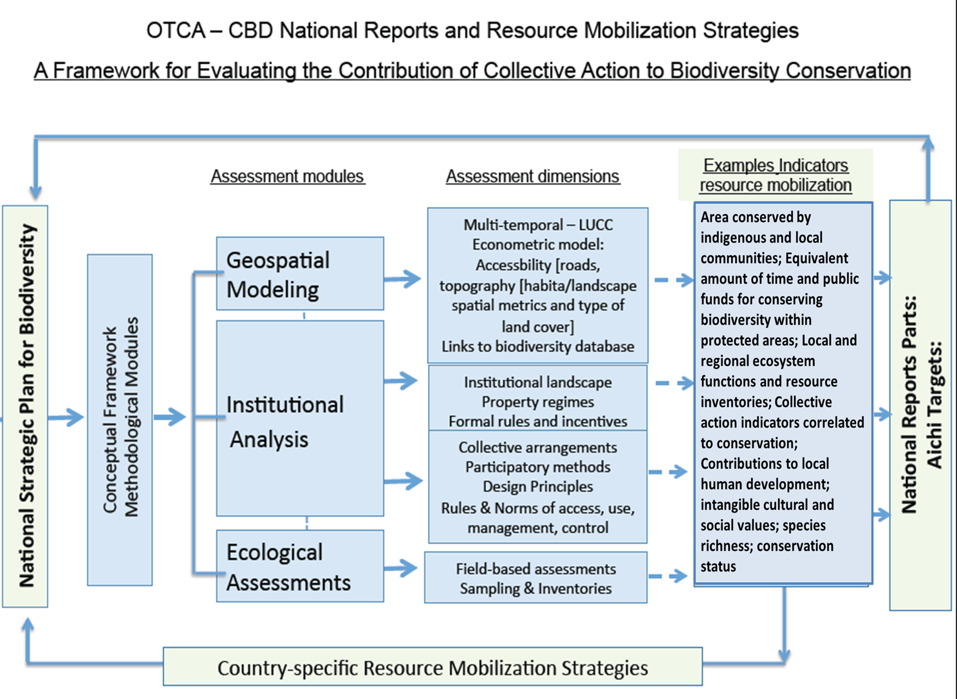
Figure 1. Overall approach and methodology for the assessment of the contribution of collective action to the conservation of biodiversity

Theoretical Rationale
- One of the most successful efforts to halt biodiversity loss has been the promotion and creation of conservation units and protected areas of different types. Several CBD Parties, in collaboration with governmental, non-governmental organizations, indigenous peoples and local communities, have been instrumental in developing this approach. Much of this effort has been done directly or indirectly in collaboration with local populations and communities involved in the use and management of natural resources. In tropical areas such as the Amazon, these areas, and particularly areas managed by indigenous and local communities, have been recognized as significant buffers against deforestation and the degradation of ecosystems and biodiversity. There is now significant evidence that indigenous peoples, local communities and resource user groups are central to the effectiveness of protecting biodiversity within and outside of these areas.
- In many cases, however, these communities are overwhelmed by pressures and transformations occurring around them, such as the consequences of extractive and agro-industrial expansion. In this context, it is important to understand the ways in which local resource users organize themselves to respond to external pressures in maintaining biodiversity ecosystem functions. In some cases, these local actions are aimed at protecting a given area or territory, while in others they are organized to protect specific resources or environmental functions (e.g., water quality). In other cases, the socioeconomic realities of local populations can also limit the efforts to conserve biodiversity. It is therefore important to recognize the limitations of complete self-regulation and consider how institutions developed at higher levels can contribute, create incentives, and facilitate or undermine local efforts of conservation.
- The methodology proposed here brings together advances in land change sciences that link – through geospatial analysis – the analysis of environmental change at different scales with the analysis of institutional arrangements that examine the underlying mechanisms of local individual and collective action to protect biodiversity and ecosystems. Figure 2 below illustrates how modules of the proposed methodology could feed into the national reporting system and contribute to the generation of new indicators that are directly relevant for several of the Aichi Biodiversity Targets. From this combination of modules different indicators can be generated to evaluate the relationship between collective action and biodiversity conservation, with respect to resource mobilization.
Proposed Methodology: Collective Action in Socio-Ecological Systems [CASES]
- The proposed methodology will enable member countries to evaluate and quantify the contribution of local people to biodiversity conservation (see Figure 2 in the main report). These modules could also be adapted for use by local communities and user groups. It consists of three modules: (a) a geospatial modelling approach to estimate the area of terrestrial ecosystems protected by local people; (b) an institutional analysis module that complements the geospatial analysis, and (c) an ecological-assessment module that outlines field-based protocols and sampling to validate the geospatial model.

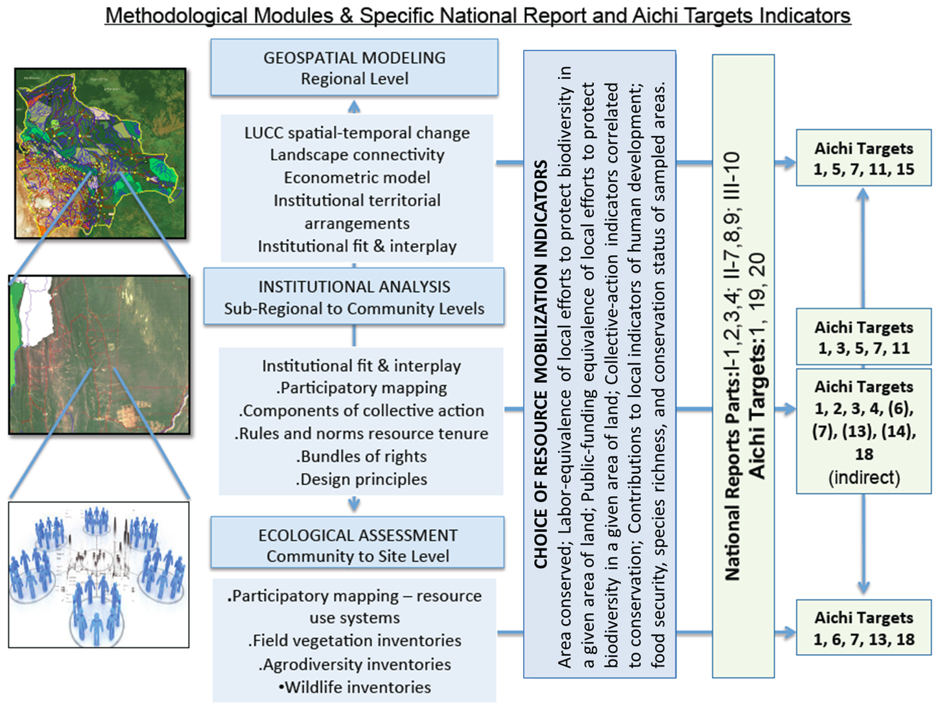
Figure 2. Analytical results linked to possible resource mobilization indicators, National Report questions and specific Aichi targets

- The methodological approach discusses one example of the role of collective action in biodiversity conservation and sustainable use of its components, such as forest areas conserved by local communities through collective action. Further work is needed for assessing the role of collective action in other aspects such as water and biodiversity conservation, protection of environmental functions, food security, among others.
- The implementation of these modules allow for the generation of ten indicators of resource mobilization, as summarized in Table 1 below, and the methodology relates to 14 of the 20 (see Figure 3 in the main report) Targets. As mentioned previously, this document takes as an example of the forest area conserved by local people through collective action, and some proxy indicators (labor and public funding equivalents) can be developed as necessary. The remaining indicators are indirectly relevant to resource mobilization in that they can help explain why some indigenous and local communities are more successful in protecting biodiversity—indicators that can help create more effective conservation policies.

Table 1: The proposed metrics for quantifying local people’s contribution to the conservation of biological diversity.
Module | Criteria | Examples of indicators for resource mobilization
Geospatial Modelling Module | Local resource users are able to conserve natural resources under increasing pressures from growing population and market opportunities | Example of collective action: Forest area conserved by local communities (km²).  Regional environmental functions and resource inventories
Institutional Analysis Module | The active involvement of local resource users in the creation, monitoring and enforcement of rules associated with natural resource use and environmental functions improves the cost-effectiveness of conservation efforts both inside and outside protected areas. | Labour and public-funding equivalents to forest conserved areas.  Collective action indicators correlated to conservation  Contributions to local Living-well/human wellbeing  Intangible cultural and social values  Local environmental functions and resource inventories
Ecological Assessment Module | Local protection efforts, individual or collective, improve the condition of the natural resource base. | Resource provisioning and food security  Species richness, presence of vulnerable indicator species

A Geospatial Modelling Approach
- The proposed modelling approach for the example of forest areas conserved through collective action assumes that there are three basic reasons that biodiversity may be protected. It is protected because (1) it has been given a formal protected status by a government agency; (2) it is difficult to access and extract resources from, and (3) local resource users take actions to protect the natural resources. The last category of local action can be individually driven (i.e. a landowner who maintains native forest cover for personal reasons), or collectively driven (i.e. a community that communally manages forest for subsistence needs). The goal of the methodology is to carry out analysis at national and subnational levels to identify which of the three mechanisms are at work in any given area where natural resources appear to be in good, stable condition. The modelling approach relies on data that are publicly available in most countries. How is this done in practice?
- The modelling starts by calculating the probability that a given area on the map has natural resources in a relatively stable condition (see Table 3 in the main report). We use a statistical model that uses several causal variables (slope, population, distance to roads, etc.) to predict the main outcome variable (land cover change) (see Figure 4 in the main report for illustration). The model will, in other words, predict whether a given area on the map is likely to be conserved in the absence of action by local people. Having these model predictions for all pixels on the map, we will then be able to compare the model’s prediction with the actual state of the ecosystem (according to the actual land-cover map). The model for the example, indicator of forest conserved areas by local communities through collective action is likely to find that most areas that are close to major roads, near large human settlements, and are relatively flat have a greater likelihood of being degraded (not conserved). But we might also find that the model predicts some areas to be degraded while they are actually conserved. Such anomalies may reveal local people’s actions because they suggest that although known drivers of environmental degradation are present—making conservation unlikely—the natural resources have somehow been protected. We add up all pixels that fall within the “anomaly” areas within the country—areas that are actually conserved despite being exposed to major outside pressure and this number represents local people’s contribution to biodiversity conservation at the national level.
Institutional Analysis: geospatial and field-based
- The institutional analysis module is applied at two subnational levels: Regional and Local (see Figure 5 in the main report). At a regional level, institutional analysis is carried out as part of the geospatial analysis module to understand how land cover change associate with layers containing types of institutional arrangement and property regimes. At this level, layers designating institutional arrangements and property regimes are associated with attribute tables containing data about property systems, population characteristics, and rules of resource access, management, and use. This type of analysis can be extended to sub-regional levels, through a sampling approach, to allow closer examination of rates of land cover change associated with different types of institutional arrangements, property regimes, and populations. At the local level, institutional analysis is carried out through the use a systematic protocol in sampled locations to understand the institutional arrangements associated with specific areas, social and resource user groups, and/or communities. These areas are identified through a sampling process and the sample size should be adjusted to the availability of available resources and desired level of precision of the data. And it is in these areas that regional and subregional analysis will be carried out for more in-depth investigation of why some areas are better conserved than others. At this level, institutional analysis is applied to understand the interaction of two dimensions of collective action, i.e., at the level of a given area or territory and at the level of a specific natural resource. This level of work involves a combination of participatory mapping and community level questionnaires with the goal of understanding how different forms of institutional arrangement and collective action relate to the management and use of different areas/territories and resources (see Figure 6 in the main report). The institutional analysis protocol involves eight structuring dimensions or components of collective action, which are used to examine the underlying elements of collective action at both the level of a given territory and at the level of a user group and/or community. These eight components include: 1.1 Physical/geographic boundaries; 1.2 Social boundaries; 2. Legitimacy of institutions and right to organize; 3. Congruency between rules of resource appropriation and local conditions; 4. Collective choice arrangements; 5. Control and monitoring of resource and territory; 6. Sanctions; 7. Mechanisms of conflict resolution; 8. Degree of nesting to higher-level institutions. The institutional analysis will allow for field-based adjustments (validation) of the estimates of areas conserved by local people produced by the geospatial model in the previous stage.
Ecological Assessment
- While the modules presented above build understanding of the drivers of land cover, landscape structure, habitat (e.g., integrity and connectivity) and biodiversity change, the ecological assessment module measures these changes themselves. Although satellite imagery is used as a basis for identifying potential areas conserved by collective action, it is necessary to engage in more detailed assessments to determine whether lands are truly protected, or are ‘empty forests’, selectively logged of valuable trees and hunted free of large animals. Assessments can be made across ecosystems, or target particular species of interest, including plants and wildlife important to the local economy. As mentioned, participatory mapping allows for spatial understanding of institutional arrangements associated with collective action at the level of landscapes and communities. It also serves as a basis for defining resource use areas and, thus the selection of sites for ecological assessments and inventories. Ecological assessments of plant and animal resources can be developed at different levels of detail, from systematic inventories providing specific information about density, frequency, and dominance of key species in a given area, to general conditions of the vegetation and fauna. This module presents field protocols for three types of assessments: (1) systematic surveys; (2) rapid assessments, and (3) targeted interviews. The choice of level of detail will influence the types of indicators (monetary and non-monetary) that can be calculated. We outline the operational and analytical trade-offs associated with different choices of methods and their implications for the development of different indicators.
______

* UNEP/CBD/COP/12/1/Rev.1.
UNEP/CBD/WGRI/5/4. Detailed information on the submissions is contained in document UNEP/CBD/WGRI/5/INF/5, entitled “review of preliminary reporting framework”.
UNEP/CBD/WGRI/5/4.
Reproduced in the compilation contained in document UNEP/CBD/COP/12/1/Add.2.
In this context, it is relevant to note that the Subsidiary Body on Scientific, Technical and Technological Advice, at its seventeenth meeting, in recommendation XVII/1, identified among the key scientific and technical needs related to the implementation of the Strategic Plan for Biodiversity 2011-2020: the need for better ways to include relevant indigenous and traditional knowledge systems and the collective actions of indigenous and local communities to complement scientific knowledge in support of the effective implementation of the Strategic Plan for Biodiversity 2011-2020, with the approval and involvement of the holders of such knowledge, innovations and practices; as well as the need strengthen non–monetary valuation tools and methodologies for the maintenance of ecosystem functions
UNEP/CBD/COP/12/INF/7.
Reproduced in the compilation contained in document UNEP/CBD/COP/12/1/Add.2.
UNEP/CBD/COP/12/INF/7.
Annex to UNEP/CBD/COP/12/13/Add.5.
UNEP/CBD/COP/12/13/Add.3.
Ricketts TH, Soares-Filho B, da Fonseca GAB, Nepstad D, Pfaff A, et al. (2010), Indigenous Lands, Protected Areas, and Slowing Climate Change, PLoS Biol 8(3): e1000331 and Soares-Filho B, da Fonseca G A B, Nepstad D, Pfaff A, Petsonk A, Anderson A, Boucher D, Cattaneo A, Conte M, et al., Indigenous Lands, Protected Areas, and Slowing Climate Change, PLoS Biol 2010, 8(3): e1000331.
Cox, M., G. Arnold, and S.V. Tomas (2010), A review and reassessment of design principles for community-based natural resource management, Ecology and Society; Castro, F. and McGrath, D., Community-Based Management of Lakes and Sustainability of Floodplain Resources in the Lower Amazon, Human Organization (2003), 62(2):123-133; Brondizio, E. S. (2008), The Amazonian Caboclo and the Açaí palm: Forest Farmers in the Global Market.” New York: New York Botanical Garden Press; and Andersson, K. Benavides, J.P. León, R., Institutional Diversity and Local Forest Governance, Environmental Science and Policy 2014, 36: 61-72.
Andersson, K. and Gibson, C. (2007), Decentralized Governance and Environmental Change: Local Institutional Moderation of Deforestation in Bolivia, Journal of Policy Analysis and Management 26(1): 99-123.
(Andersson and Ostrom, 2008; Brondizio et al 2009) Andersson, K. and Ostrom, E. 2008. Analyzing Decentralized Natural Resource Governance from a Polycentric Perspective. Policy Sciences 41(1):1-23; and Brondizio E S, Ostrom E, Young O. (2009), Connectivity and the Governance of Multilevel Socio-ecological Systems: The Role of Social Capital, Annual Review of Environment and Resources 2009, 34:253–78.

