 |  | CBD
 |  |  |  | Distr.  GENERAL  17 May 2011  ENGLISH ONLY
AD HOC TECHNICAL EXPERT GROUP MEETING ON
INDICATORS FOR THE STRATEGIC PLAN
FOR BIODIVERSITY 2011-2020
High Wycombe, United Kingdom of Great Britain
and Northern Ireland, 20-24 June 2011

Information Note for Participants


Visa Information (page 6)


Meeting Documents (page 8)


Hotel Information (page 5)

Weather Information (page 8)

Currency Information (page 7)

INFORMATION HIGHLIGHTS

1. Opening and registration 3
2. Venue and accommodation 3
3. Visa Information 4
4. Transportation 4
7. Documents 6
8. Displays and publications 6
9. Weather 6
10. Contact information 6

 | 

International Expert Workshop in support of the AHTEG on Indicators for the Strategic Plan for Biodiversity 2011-2020

A workshop convened by the UNEP World Conservation Monitoring Centre (UNEP-WCMC)

In cooperation with the Convention on Biological Diversity (CBD)

Hosted by the UK Department for Environment, Food and Rural Affairs (Defra), with funding provided by the European Commission (EC), the UK Joint Nature Conservation Committee (JNCC), and the United Nations Environment Programme (UNEP)

Uplands House, High Wycombe, United Kingdom of Great Britain and Northern Ireland
20-22 June 2011

Support for the workshop provided by the following:

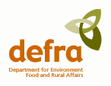 |  | 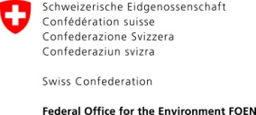 |  | 

- Opening and registration

The Ad Hoc Technical Expert Group (AHTEG) meeting will be held in High Wycombe, United Kingdom from Monday, 20 June to Friday, 24 June 2011. The International Expert Workshop in support of the AHTEG will be held at the same location from Monday, 20 June to Wednesday, 22 June 2011.

The AHTEG will start at 8:30 on the morning of 20 June 2011 and registration will take place from 8:00 a.m. The AHTEG will close on 24 June 2011 at 17:00.

The International Expert Workshop will start at 9:30 on the morning of 20 June 2011 and registration will take place from 8:30. The meeting will finish at 17:00 on 22 June 2011.

The working language of both meetings will be English.

- Venue and accommodation

Both the AHTEG and the International Expert Workshop will be held at Uplands House.

Uplands House
Four Ashes Road
High Wycombe
Buckinghamshire
HP15 6LB
U.K.

Tel: +44 (0)870 6091159
URL: http://www.devere.co.uk/our-locations/uplands-house

Onsite accommodation will also be provided at Uplands House. Wireless internet access is available throughout the workshop venue. The cost for a single room is approximately £80. Below is a map of High Wycombe showing the location of the workshop venue and transport hubs. An interactive version is available on Google Maps
. 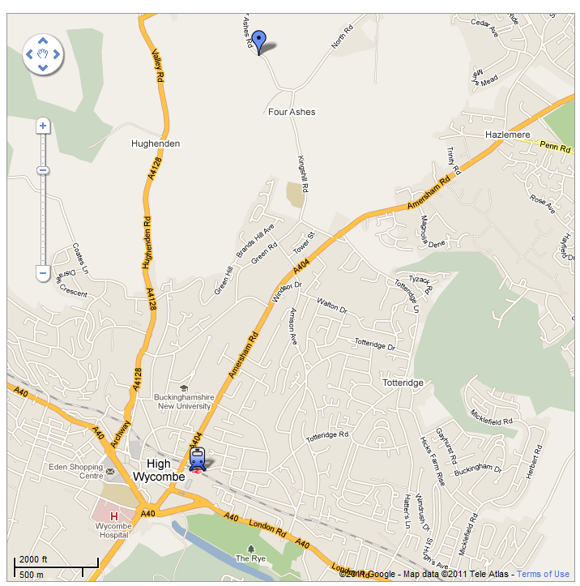
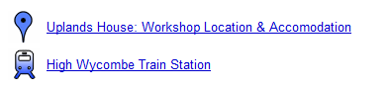

- Visa Information

Information on visa procedures, including a list of relevant U.K. diplomatic/consular missions abroad, is available on the web site of the U.K. border Agency at www.ukvisas.gov.uk/. Please make sure that you fulfil the necessary visa requirements for entering the U.K. The http://www.ukvisas.gov.uk/en/howtoapply/wheretoapply/

If you require an official letter of invitation for the International Expert Workshop please contact Ms. Anna Chenery: anna.chenery@unep-wcmc.org.

- Transportation

From Heathrow Airport

Heathrow Airport (www.heathrowairport.com/) is just 37 kilometres from Uplands House. A taxi between Heathrow Airport and Uplands House is the simplest way of reaching the workshop venue and the trip will take approximately 30 minutes. Arrangements have been made with a local taxi company to transport participants to and from the meeting venue. In order to arrange for a taxi you are requested to contact anna.chenery@unep-wcmc.org with your flight information. Alternatively Black cab taxis are available from the airport however they are the most expensive option costing approximately £80 for the journey.

From other London airports

If arriving at an alternative London airport the best option is to use regular train services between the airports and central London:
- Gatwick Airport
Web site: www.gatwickexpress.com. Approximate cost for a return ticket £27.50.
- Stansted Airport
Web site: https://www.stanstedexpress.com. Approximate cost for a return ticket £27.70.
- Luton Airport
Web site: http://www.nationalrail.co.uk/. Approximate cost for a return ticket £15.50.

The London underground (Map: http://www.tfl.gov.uk/assets/downloads/standard-tube-map.pdf) can then be used to travel to London Marylebone station, which has regular train services to High Wycombe train station (http://www.nationalrail.co.uk/). Approximate cost of a return train ticket from London Marylebone to High Wycombe is £16.50. Uplands House is 3 kilometres from High Wycombe station and taxis can be booked from the taxi rank or by calling a local taxi company ++44 (0)1494522555.

From London

Uplands House is 3 kilometres from High Wycombe station with railway connections direct to/from London Marylebone (http://www.nationalrail.co.uk/). Approximate cost of a return train ticket from London Marylebone to High Wycombe is £16.50. Taxis can be booked from the taxi rank or by calling a local taxi company ++44 (0)1494522555.

- Electricity

The electricity supply voltage in the UK is 240 V AC (RMS) at 50 Hz, using a three-rectangular-pronged plug as shown below (en.wikipedia.org/wiki/File:G_plug.png).



- Currency & Daily Subsistence Allowance (DSA)

The currency in the UK is the Pound Sterling (£ or GBP). The current exchange rate as of 17 May 2011 is approximately £1 = $1.62 or €1.14. Exact rates are available via www.oanda.com/convert/classic.
While some businesses, including hotels, restaurants and shops, may accept Euros or US Dollars, this is a rare occurrence and should not be relied upon. All major credit and debit cards are widely accepted.

Funded participants to the AHTEG will receive their daily subsistence allowance in accordance with the official funding letters. Participants to the international expert workshop receiving financial support will receive their allowance in GBP on the first day of the meeting.

- Documents

The same documents are available for the AHTEG and the International Expert Workshop and are made available on the CBD Secretariat’s web site at: http://www.cbd.int/doc/?meeting=AHTEG-SP-IND-01. Participants are kindly reminded to bring their own copies of the documents for the meeting as there will be no extra copies made available on site during the meeting. Meeting documents will also be made available, via the International Expert Workshop webpage on the 2010 BIP website at www.bipindicator.net/expertworkshop.

- Displays and publications

It may be possible to display a limited number of information items (e.g., posters, brief publications, leaflets, etc.) during the International Expert Workshop. Please contact anna.chenery@unep-wcmc.org if you wish to display materials.

- Weather

In June, temperatures usually range between a maximum of 20°C and a minimum of 11°C. Current weather conditions can be found at: http://www.worldweather.org/010/c00032.htm.

- Contact information

For all questions regarding the AHTEG, please contact Mr. Kieran Noonan-Mooney at: kieran.mooney@cbd.int. For all questions regarding the workshop, please contact Ms. Anna Chenery at: anna.chenery@unep-wcmc.org, telephone: +44 223 277314.

- Disclaimer

The CBD Secretariat and the organizers of the International Expert Workshop disclaim all responsibility for medical, accident and travel insurance, for compensation for death or disability compensation, for loss of or damage to personal property and for any other loss that may be incurred during travel time or the period of participation. In this context, it is strongly recommended to secure international medical insurance for the period of participation prior to departure.
-----

