 |  |  | CBD
 |  | CONVENTION ON  BIOLOGICAL DIVERSITY |  |  | Distr.  GENERAL  UNEP/CBD/AHTEG-2010-Ind/1/INF/3  7 October 2004  ORIGINAL: ENGLISH
AD HOC TECHNICAL EXPERT GROUP ON INDICATORS FOR ASSESSING PROGRESS TOWARDS THE 2010 BIODIVERSITY TARGET
Montreal, 19-22 October 2004
Item 3.1 from the provisional agenda*

Indicators for assessing progress towards the 2010 target:
Coverage of protected areas
Note by the Executive Secretary

I. Summary
- 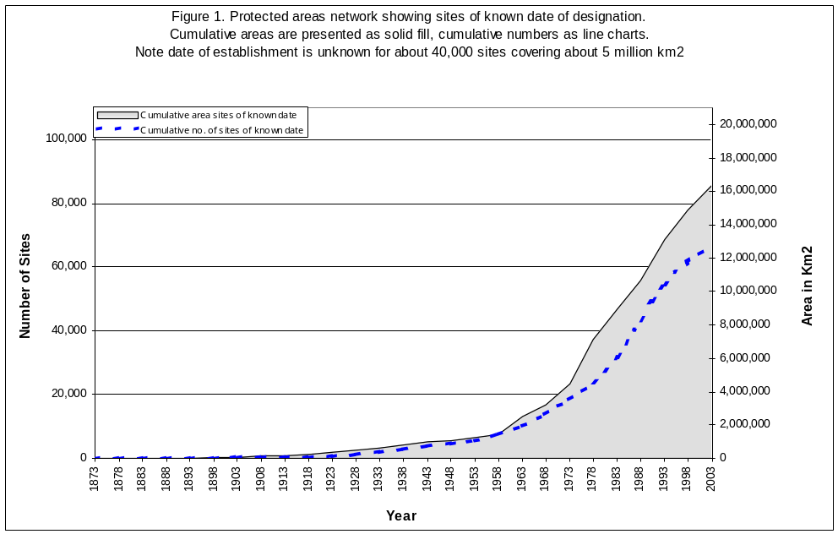The establishment of protected areas reflects measures taken to safeguard biodiversity. Globally, the number of protected areas has been increasing significantly over the past few decades and is now more than 100,000 sites. The total area has also increased continuously from less than 3 million km² in 1970 to more than 20 million km² in 2004 (figure 1). However, ecoregional and habitat representation remains uneven, and coastal and marine ecosystems are particularly under-represented.

- Comprehensive data on officially recognized protected areas are regularly compiled. The data include information on all nationally designated sites, ranging from national parks to forest reserves and from strict nature reserves to resource reserves. By using geographical information systems, these data can be assigned approximately to different biomes or ecological regions, allowing analysis of coverage and gaps.

II. Relation of indicator to focal area
- Protected areas have been the cornerstones of biodiversity conservation strategies and plans for more than a century, and the majority of Parties to the Convention on Biological Diversity have identified protected areas as the most obvious contribution towards achievement of the first principal objective of the convention. / All countries have systems of protected areas, and there are many other regional and global agreements and programmes that both promote the establishment of protected areas and give international recognition to specific sites.
- Protected areas now cover about 12 per cent of the Earth’s land surface, and as such constitute one of the largest conscious changes of land use. In most cases, protected areas are created to ensure the long term conservation of the biota, habitats, and landscapes contained within their boundaries. Establishment and management of effective protected area systems thus constitutes an important indicator of man’s response to biodiversity loss, serving as an indicator of the efforts made at national, regional, global or biogeographic/bioregional levels to maintain biodiversity.
- Protected area coverage has several advantages as an indicator: data are regularly compiled and stored; the surface area can be calculated and analysed at various scales and in relation to different political or biogeographic features and to different categories of protected area; and the concept of protected area coverage as a means towards biodiversity conservation can be effectively communicated. /
- This indicator has clear potential linkages with other indicators, including in particular: (a) trends in extent of selected biomes, ecosystems and habitats; (b) trends in abundance and distribution of selected species; (c) sustainable use; and (d) connectivity and fragmentation of ecosystems. Combining information on the distribution and status of species and ecosystems can provide valuable insight into the effectiveness of protected area networks, and the status of conservation response to pressures on species and ecosystems.

III. General description
- The number of protected areas has been increasing globally for the past few decades and is now around 105,000 sites. The total area has also increased continuously from less than 3 million km2 in 1970 to more than 20 million km2 in 2004. However, ecoregional and habitat representation remains uneven and coastal and marine ecosystems are particularly under-represented. While protected areas cover around 3.5 per cent of the planet’s surface, in reality most of these areas are on land and the total terrestrial surface covered by protected areas is around 12 per cent of the total land surface. Less than 2 million km2 of world’s ocean surface falls within protected areas, 0.5 per cent of the total ocean surface.
- Article 8 (a) of the Convention on Biological Diversity enjoins Parties to establish a system of protected areas or areas where special measures need to be taken to conserve biological diversity. Establishment and management of protected areas, together with conservation, sustainable use and restoration initiatives in the adjacent land and seascape, are therefore central to implementation of Article 8 on in situ conservation. It is hoped that these sites are likely to between them cover the full range of biodiversity within any given geographical region, and that the protected areas will meet a number of different conservation-related objectives (decision VII/28).
- The most comprehensive dataset on protected areas world-wide is the World Database on Protected Areas (WDPA) managed by the UNEP World Conservation Monitoring Centre working in partnership with the IUCN World Commission on Protected Areas and a consortium of internationally active organizations and networks. This is described further in section 5.
- Protected areas are established for many purposes, and can be classified by management objective. IUCN has developed a system of six categories of protected area defined by primary management objective (see below), and about two thirds of the sites in the WDPA have an assigned IUCN management category. Of these sites the most numerous are categories III and IV, while in terms of area occupied, categories II and VI predominate. The categories offering the strictest protection from outside influence (categories Ia and Ib) make up a much smaller proportion of both the number and area of the sites. The cumulative growth rate of protected areas as per IUCN management categories is given in figure 2, demonstrating that those categories concerned with landscape (category V) and with resource management (category VI) have increased more rapidly in recent years.

Figure 2. Cumulative rate of protected area coverage by IUCN management category (data from UNEP-WCMC)

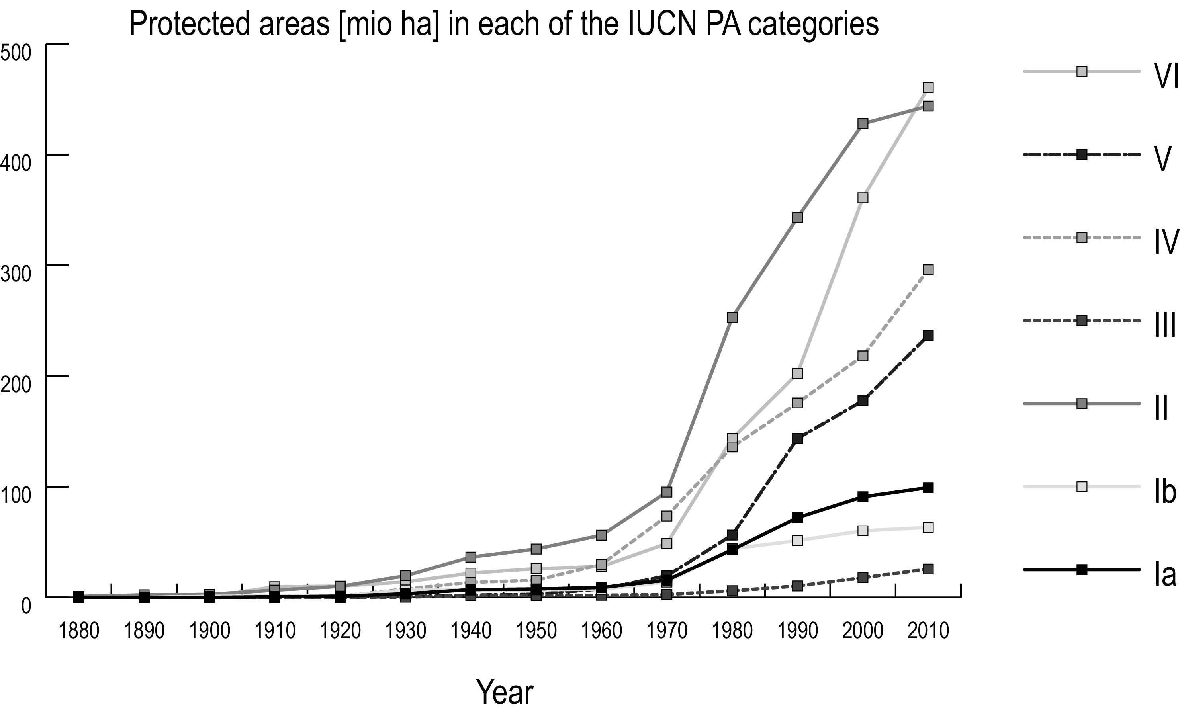

- UNEP-WCMC has analysed global protected areas data as far as possible by biome type to give a first indication of protection in different regions and different ecosystems. Initial comparisons were made using the framework developed by Udvardy in 1975 which classifies the world into 14 terrestrial biomes. In this assessment it has been shown that nine of the 14 terrestrial biomes in the Udvardy system have now met or exceeded the target of 10 per cent representativeness. By contrast, the biomes falling well behind the global average include temperate grasslands and lake systems, while temperate needleleaf forests and temperate broadleaf forests are also both below 10 per cent coverage using the Udvardy system. Similar analyses can be made using other maps, such as those for the WWF Global 200 Ecoregions, / Conservation International’s Biodiversity Hotspots, / BirdLife International’s Endemic Bird Areas, / etc. Ideally, a biome or ecoregion map should be chosen that is consistent across all the 2010 indicators, and used in other programmes of the Convention on Biological Diversity, where ecoregional mapping is required (for example in the Global Strategy for Plant Conservation, target iv).
Figure 3. Cumulative rate of protected area coverage by major biome (data from UNEP-WCMC)

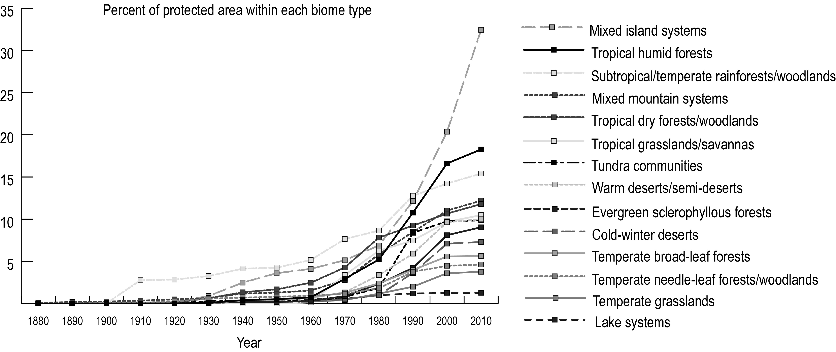

- Many countries have designated protected areas under the various international agreements and programmes that recognize specific sites. These include the World Heritage Sites (World Heritage Convention), Ramsar Sites (the Convention on wetlands of International Importance especially as Waterfowl Habitat) and Biosphere Reserves (UNESCO Man and Biosphere Programme). Compilation of time series data on these international designations in different ecoregions would be useful to illustrate the impact of international site-related agreements on protection of different biomes. There are already reviews of coverage at single points in time which could also provide a baseline for future assessment of change, for example the review of natural World Heritage carried out by UNEP-WCMC. /
Figure 4: Annual history of Ramsar site designations /
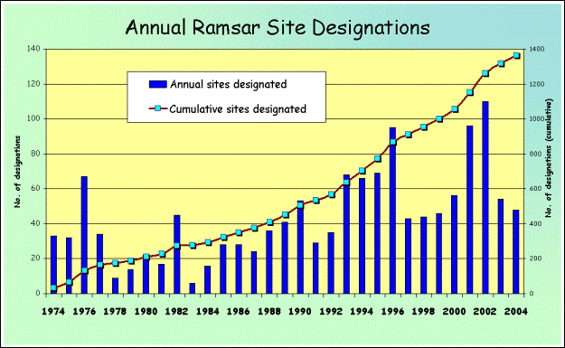
Limitations
- The number and surface area of protected areas is a reflection of measures taken to safeguard biodiversity, but it must be understood that the statistical measurement of protected area numbers and extent does not tell us how effective those protected areas are in actually conserving biodiversity and reducing its rate of loss. This requires two additional pieces of information, an understanding of how well biodiversity is covered by these sites, and an understanding of the effectiveness of site management.
- There are therefore two sorts of limitations in using the protected area indicators suggested so far: limitations of data and limitations of the indicator. Limitations of the data are discussed below within the section on technical information, as these are already being addressed. Other limitations of the indicator itself include the following:
    - It is possible to have a good protected areas system on paper which does not include most key biodiversity sites (hence the need for gap analysis); and
    - It is possible to have a good protected areas system on paper, but not to be managing sites effectively (hence the need for assessment of management effectiveness).
- In the previous section, analysis and development of an indicator for biome or ecoregion was proposed, to demonstrate coverage of biodiversity. It is important to realise, however, that analysis using biome and ecoregion maps provides only a crude measure of ‘potential’ natural vegetation or habitat at a coarse level. These maps do not take account of the fact that vast areas of land have now been altered by human activity, and they do not provide sufficiently detailed resolution to pick up fine-scale variation in habitat. Increasingly, new, global level land-cover maps are enabling a more detailed analysis of the actual habitats protected. UNEP-WCMC has recently carried out a preliminary analysis using these maps, which shows similar, but perhaps slightly higher, levels of protection for the remaining areas of natural habitats. Work is currently under way to rework this study using a more recent and reliable land-cover map, however at this stage it will be difficult to use this as an indicator (although it could provide a potential baseline for analysis of future change). /
- Recently, several analyses have demonstrated that current protected area systems do not adequately cover key biodiversity features. For example, gap analyses carried out for the World Parks Congress in 2003 demonstrated that at least 300 critically endangered species, and at least 237 endangered and 267 vulnerable species of bird, mammal, turtle and amphibian have no protection in any part of their ranges. /,/ Considering this, participants at a recent workshop at the Royal Society in London have proposed an additional sub-indicator for protected areas and biodiversity. This would be based on the percentage of species whose ranges (by grid cell) are overlapped by protected areas. Further details on the proposed indicator, including both strengths and weaknesses, can be found in the summary report of this workshop. /
- Another approach would be to consider the protected area coverage of key biodiversity areas such as the Important Bird Areas identified by BirdLife International, or the Important Plant Areas identified by PlantLife International. These are sites identified according to agreed international criteria based on threat and geographical concentration. Again, overlay of mapped information on these sites and on protected areas will give percentage protection which could provide a baseline for a future indicator. Further details on the proposed indicator, including both strengths and weaknesses, can again be found in the summary report of the Royal Society workshop. /
- Assessment of protected area management effectiveness is a far more difficult process, but one that is being actively developed in a number of countries to help in improving protected area systems. This is an area in which the IUCN World Commission on Protected Areas has been very active, as have the World Bank and several conservation NGOs including WWF and The Nature Conservancy. It is likely that data will improve significantly over the coming years based on national-level reviews, but at present time series do not exist, and a baseline is only possible for a sample of sites (perhaps 2-3,000 out of more than 100,000 protected areas). On the other hand the information does exist and could be compiled for demonstrating investment in protected areas in terms of finance and staffing, and change over time could be demonstrated. Both approaches were discussed at the recent Royal Society workshop in London. /

Baseline data
- No baseline is necessary for the basic data on protected areas is necessary, as for each protected area the date and history of establishment is known (even though it may not currently be included in the database. There are inconsistencies as each protected area only has one date in the database, but we assume these inconsistencies are ironed out when all data are considered. It may be sensible in the future to test this assumption. Baselines for additional sub-indicators have been discussed in the text.

IV. Policy relevance
- Protected area coverage is an indicator to assess the achievement of targets 1.1 (at least 10 per cent of each of the world’s ecological regions effectively conserved) and 1.2 (areas of particular importance to biodiversity protected) set out in the framework of goals and sub-targets adopted in decision VII/30. Since, habitat degradation and loss are the main causes of changes in population sizes of species and of shifts in species composition, this indicator is also relevant to targets 2.1 (restore, maintain, or reduce the decline of populations of species of selected taxonomic groups) and 2.2 (status of threatened species improved). Protected areas coverage is also directly relevant to several of the outcome-oriented targets in the Global Strategy for Plant Conservation (decision VI/9).

A. Relevance to other regional or global processes
- As one of the major natural resource use allocations on the planet, international commitment to protected areas has become a key indicator for environmental monitoring. Within the framework of significantly reducing the current rate of biodiversity loss at global, regional and national levels the WSSD Plan of Implementation has the following specific directives and implications that underline the relevance of this indicator:
    - Establishment of a representative system of marine protected areas by 2012;
    - Promotion and support for conservation 'hot spot' initiatives, and ecological networks;
    - Promotion of transboundary conservation areas.
- The eight Millennium Development Goals agreed on at the Millennium Summit in September 2000 set the agenda for reducing poverty and improving lives. For each goal one or more targets has been set, most for 2015, using 1990 as the benchmark year. This indicator has direct relevance to goal 7 (Ensuring Environmental Sustainability) and target 9 (Integrate the principles of sustainable development into country policies and programmes and reverse the loss of environmental resources). Importantly, one of the key indicators for target 9 is Indicator 26: the ratio of area protected to maintain biological diversity to surface area at national and global levels.

B. Relation to existing targets (national, regional, international)
- The WSSD Plan of Implementation calls on States to establish representative systems of marine protected areas by 2012. In the programme of work programme on protected areas (decision VII/28) the Conference of the Parties put forward some specific time-bound targets to guide Parties. There are also time-bound targets in the Global Strategy for Plant Conservation (decision VI/9), and targets are being considered for other programmes of work of the Convention on Biological Diversity. There are also relevant targets identified within the recommendations of the World Parks Congress and the Durban Action Plan (Durban, 2003). /

V. Technical information

A. Definitions
- IUCN defines a protected area as “An area of land and/or sea especially dedicated to the protection and maintenance of biological diversity, and of natural and associated cultural resources, and managed through legal or other effective means”. IUCN further recognizes six categories of protected area defined by primary management objective (see box 1), with management objectives ranging from strict protection to sustainable use of natural ecosystems.
Box 1 - IUCN Protected Areas Management Categories (1994) /
CATEGORY Ia – Strict Nature Reserve: Protected area managed mainly for science. Area of land and/or sea possessing some outstanding or representative ecosystems, geological or physiological features and/or species, available primarily for scientific research and/or environmental monitoring.
CATEGORY Ib – Wilderness Area: Protected area managed mainly for wilderness protection.?Large area of unmodified or slightly modified land, and/or sea, retaining its natural character and influence, without permanent or significant habitation, which is protected and managed so as to preserve its natural condition.
CATEGORY II – National Park: Protected area managed mainly for ecosystem protection and recreation. Natural area of land and/or sea, designated to (a) protect the ecological integrity of one or more ecosystems for present and future generations, (b) exclude exploitation or occupation inimical to the purposes of designation of the area and (c) provide a foundation for spiritual, scientific, educational, recreational and visitor opportunities, all of which must be environmentally and culturally compatible.
CATEGORY III – Natural Monument: Protected area managed mainly for conservation of specific natural features: Area containing one or more specific natural or natural/cultural features which are of outstanding or unique value because of their inherent rarity, representative or aesthetic qualities or cultural significance.
CATEGORY IV – Habitat/Species Management Area: Protected area managed mainly for conservation through management intervention. Area of land and/or sea subject to active intervention for management purposes so as to ensure the maintenance of habitats and/or to meet the requirements of specific species.
CATEGORY V – Protected Landscape/Seascape: Protected area managed mainly for landscape/seascape conservation and recreation: Area of land, with coast and sea as appropriate, where the interaction of people and nature over time has produced an area of distinct character with significant aesthetic, ecological and/or cultural value, and often with high biological diversity. Safeguarding the integrity of this traditional interaction is vital to the protection, maintenance and evolution of such an area.
CATEGORY VI – Managed Resource Protected Area: Protected area managed mainly for the sustainable use of natural ecosystems: Area containing predominantly unmodified natural systems, managed to ensure long term protection and maintenance of biological diversity, while providing at the same time a sustainable flow of natural products and services to meet community needs.

B. Data availability, quality and sustainability / continuity
- The World Database on Protected Areas (WDPA) has been maintained since 1981 by UNEP-WCMC and IUCN, building on earlier work by IUCN on compilation of the United Nations List of National Parks and Equivalent Reserves. The WDPA aims to record all areas meeting the IUCN definition of a protected area, and to maintain basic information on each including its IUCN management category. Part of the database is available online, and the latest version of the United Nations List was published in 2003 on CD-Rom, including comprehensive geo-referenced information. / The World Database on Protected Areas is also periocially released on CD-Rom. / Information is derived from national sources, usually those agencies responsible for protected areas establishment and management.
- UNEP-WCMC, who are the managers of the database and the data custodians, and IUCN have helped to establish a “WDPA Consortium” which aims to collaborate in improvement of the database and access to it. Members of the WDPA Consortium include BirdLife International, the Conservation Biology Institute, Conservation International, The Nature Conservancy, the World Resources Institute, Fauna and Flora International, the Wildlife Conservation Society and WWF. Part of the purpose of the consortium is to reduce duplication of effort, and to ensure that all international organizations are contributing to and using one database. With this in mind, UNEP-WCMC is also working closely with the European Environment Agency and the Council of Euope within the European region, with IUCN and the Comisión Centroamericana de Ambiente y Desarrollo in Central America, and the ASEAN Regional Centre for Biodiversity Conservation in the South East Asian region.
- There are know inadequacies in the database, mainly arising from an inadequate level of resources for such a global effort. For example the IUCN Management Category and year of establishment is each missing for many sites, and there is need for greater quality control. In the 2003 edition of the United Nations List, more than two-thirds of the over 100,000 protected areas are fully geo-referenced. As this work continues the accuracy and precision of the information increases. Over the coming years, data gaps arising from the lack or inaccuracy of polygon data for a significant number of protected areas and errors in the attribute data are expected to be removed. In many cases, this will allow the correction of protected area coverage information for the recent past, and increased accuracy in analyses.
- Maintenance of the WDPA by UNEP-WCMC and the WDPA Consortium is a dynamic process requiring continuous updating to record changes to the world's protected areas estate. Already, global numbers in the WDPA have changed and more changes are expected, especially when countries follow through with the implementation of the programme of work on protected areas. The aim is to gradually move from a centralised approach to information collection and management, to a more distributed information management approach involving protected area management agencies at the national level. Concurrent with this will be improvements in database structure and management, and development of improved quality assurance methods.

VI. Application of the indicator at national/regional level
- The indicator is widely used at the national regional and international levels, in part because it is such a simple statistic to generate, calculate and use. Two examples are given, while noting that the definition of a protected area used at the national level may differ from that of IUCN given earlier.
- Percentage of the Province of British Colombia in Protected Area Status; /
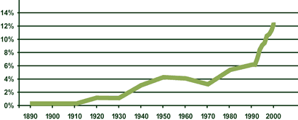
- Proportion of protected area per total area of Thailand: 1990-2001 /
1990 | 1991 | 1992 | 1993 | 1994 | 1995 | 1996 | 1997 | 1998 | 1999 | 2000 | 2001
12.4% | 12.8% | 14.0% | 13.9% | 14.2% | 14.6% | 15.1% | 15.3% | 15.8% | 16.9% | 17.8% | 17.6%

- Also there are numerous analyses of protected areas coverage for specific aspects of biodiversity (such as the recent series of studies presented during the World Parks Congress), although most of these are for one specific point in time providing the basis for future analysis rather than providing an analysis of current trends.

VII. Suggestions for the improvement of the indicator
- The data on protected areas provide a simple and cost effective overview of the efforts made at national, regional, global or biogeographic/bioregional levels to maintain biodiversity. There are also some shortcomings in this indicator. The fact that global coverage of protected areas exceeds 12 per cent of land cover is an historic achievement. Unfortunately, protection is not proportionately representative and some ecosystems and some species remain largely outside the protected areas network. There are also wider questions about the effectiveness of the system. The proclamation of an area as protected does not automatically guarantee the conservation of the biodiversity it contains. The protected area coverage indicator needs to be complemented by measures of protected area management effectiveness and protected area distribution in relationship to biodiversity features.

A. Core database
- There are concerns over the inconsistent quality and frequency of data reporting on protected areas worldwide, and thus over the quality of data in the World Database on Protected Areas which is based on the data. Efforts are underway to address this, but national authorities may require additional support and encouragement to allow them contribute to the updating of information on protected areas under their jurisdiction. The increased collaboration between organizations working internationally on protected areas data is welcomed and encouraged, particularly where this reduces duplication of effort, and reduces the burden on national agencies.

B. Coverage of biodiversity features
- Protected area systems are only effective in conserving biodiversity if they actually include all appropriate biodiversity elements. As demonstrated earlier, analysis of coverage shows that there are still gaps in these networks. The programme of work on protected areas of the Convention on Biological Diversity places emphasis on planning protected areas as part of a network and within the broader land- and seascape context. Major advances have been made on protected area planning to ensure that important ecosystems and hotspots are covered and that protected areas are planned as a network of connected sites which facilitate migrations and exchange of genepools. It is imperative to regularly assess coverage of biodiversity by protected areas, and not just to present data on number and area. This will require the further development of the analyses and indicators discussed earlier in the section on limitations.

C. Management effectiveness
- Protected areas are also only effective in helping to ensure the conservation and sustainable use of biological diversity if they are effectively managed. Various national and international organizations are working on this issue, with the aim of helping individual sites and systems to develop more effective management. Much of this work is based on guidelines for evaluating effectiveness published by the IUCN World Commission on Protected areas. / Information based on such assessment would be valuable in complementing the information on protected areas number, extent and coverage, but there may well be concerns about using this data in global or even regional databases. One way of approaching this in a more politically sensitive manner may be to include data on the financial and staffing resources available for protected areas. A study carried out by UNEP-WCMC in the 1990s demonstrated wide variation in resources available, and it may be valuable to carry out this study again a decade later. Meanwhile, WCPA and UNEP-WCMC are also considering finding common effectiveness indicators linked to the WCPA framework and compiling them from the existing assessments using the framework (about 2,000).

Viii. summary of comments received on this document

A. Marine protected areas
- Given the global targets in place for marine and coastal protected areas set by both WSSD and in the Programme of Work of the Convention on Biological Diversity, it is important to ensure that whatever indicators are established the marine and coastal elements of these can be easily extracted. This is perhaps also important because of the far lower proportion of marine and coastal habitats lying in protected areas.

B. Indigenous peoples and local communities
- The Programme of Work on Protected Areas adopted at the seventh meeting of the Parties to the Convention on Biological Diversity (decision VII/28) recognises that indigenous peoples and local communities play a central role. Given this, it has been suggested that the protected areas indicator should also include social aspects, to reflect the need not just for more protected areas, but also the need for protected areas that respect the rights of and ensure the involvement of indigenous peoples and local communities. The following “sub-indicators” were proposed for consideration:
- Changes in management approach over time, addressing the extent of involvement of indigenous peoples and local communities (managed by, co-managed with, not involved).
- Reduction over time in the proportion of protected areas that have caused displacements of local peoples on lands that have outstanding land claims and disputes over land rights.
- Information necessary for delivery of the first of the proposed sub-indicators is not compiled at present, but could be added in future to information compiled by UNEP-WCMC as part of the WDPA. It is considered that the second would be a rather more difficult matter, and may require significant initial research to establish a baseline.

C. Natura 2000 and the Emerald Network
- Reference was made to both the Natura 2000 network of protected areas in Europe developed in response to the provisions of the EU Birds and Habitats Directives, and to the Emerald Network developed in response to the provisions of the Bern Convention. These are not explicitly referred to in the paper, but are considered similar in nature to World Heritage sites of Ramsar sites. As both of these networks are explicitly established to protect listed species and habitats, there is potential to very effectively link information on these regional protected area networks to species and habitat trend indicators.

D. Mean size of protected areas
- The data seem to suggest that the average size of protected areas is on the increase, and one reviewer suggested that this point should be made as it is a positive trend. In fact it is almost certainly an artifact of one or two very large sites being established in recent years.

E. Cross comparison of biomes and categories
- Cross-comparison of biomes and categories could well be interesting. Previous analysis by region has suggested strong regional differences in use of protected area categories, and this will also be reflected in biome figures. This is of interest as it reflects the extent to which different management tools are being applied in different parts of the world, and therefore the potential for future development of protected area systems. It might be best to present this as a comparison of two groups of categories, I-IV and IV-VI, rather than try to present data on all biomes and all categories.

F. Protected areas and habitat fragmentation
- One reviewer suggested that there was urgent need to relate information on protected areas to information on the status of habitat and habitat loss, implying the need for an analysis of protected areas against habitat “patch size” and distribution. This could be considered through linking the protected areas information to any indicator developed for connectivity and fragmentation.

G. Combining use of indicators
- The protected areas indicators is a response indicator, while the others so far under development are indicators of the state of biodiversity. It was suggested by one reviewer that if state indicators are collected inside and outside protected areas as separate datasets, then the effectiveness of protected areas can be evaluated. This would necessarily be something for implementation at the national level.

H. Benefits of protected areas
- An indicator to demonstrate the benefits of protected areas to people has not been discussed except in one reviewer comment. The indicator with the most immediate potential is analysis of visitor numbers, which in many cases are also available over time.

-----

* UNEP/CBD/AHTEG-2010-Ind/1/1.
/ Mulongoy, K.J., Chape,S.P.(Eds) 2004. Protected Areas and Biodiversity: An overview of key issues. Secretariat of the Convention on Biological Diversity, Montreal, Canada and UNEP-WCMC, Cambridge, UK.
/ Robert Höft. 2004. Protected Area Coverage – A biodiversity indicator, Secretariat of the Convention on Biological Diversity, Montreal. CBD Technical Series no. 15.
/ http://www.panda.org/about_wwf/where_we_work/ecoregions/global200/pages/home.htm
/ http://www.biodiversityhotspots.org/xp/Hotspots
/ http://www.birdlife.net/action/science/endemic_bird_areas/
/ Magin, C., Chape, S. 2004. Review of the World Heritage Network: Biogeography, habitats, biodiversity. UNEP World Conservation Monitoring Centre and World Conservation Union. http://www.unep-wcmc.org/protected_areas/world_heritage/wh_review.htm
/ http://www.wetlands.org/RSDB/default.htm
/ Chape, S., Harrison, J., Spalding, M., Lysenko, I. In press. Measuring the extent and effectiveness of protected areas as an indicator for meeting global biodiversity targets. Paper presented at The Royal Society Discussion Meeting “Beyond extinction rates: Monitoring wild nature for the 2010 targets”, 19-20 July 2004.
/ Rodrigues, A.S.L., et al. 2003. Global Gap Analysis: Towards a representative network of protected areas. Advances in Applied Biodiversity Science, No.5. Centre for Applied Biodiversity Science, Washington. D.C.
/ Rodrigues, A.S.L., et al. 2004. Effectiveness of the global protected areas network in representing species diversity. Nature 428, 8 April 2004.
/ http://www.twentyten.net
/ http://www.twentyten.net
/ http://www.twentyten.net
/ http://www.iucn.org/themes/wcpa/wpc2003/english/outputs/intro.htm
/ Anon (1994); Guidelines for Protected Area Management Categories , IUCN and the World Conservation Monitoring Centre, Gland, Switzerland and Cambridge, UK.
/ Chape, S., Blyth, S., Fish, L., Fox, P., Spalding, M. (Compilers) 2003. 2003 United Nations List of Protected Areas. IUCN, Gland, Switzerland and Cambridge, UK and UNEP-WCMC, Cambridge, UK.
/ http://sea.unep-wcmc.org/wdbpa/download/wdpa2004/index.html
/ source Government of British Colombia - http://wlapwww.gov.bc.ca/soerpt/1protectedareas/percent.html - permission being sought
/ Source : Forestry Statistics of Thailand 2001, Royal Forest Department, Ministry of Agriculture and Cooperative
/ Hocking, M., Stolton, S., Dudley, N. 2000. Evaluating effectiveness: A Framework for Assessing the Mangement of Protected Areas. IUCN, Gland, Switzerland and Cambridge, UK.

