 |  |  | CBD
 |  | CONVENTION ON  BIOLOGICAL DIVERSITY |  |  | Distr.  GENERAL  UNEP/CBD/AHTEG-2010-Ind/1/INF/4  4 October 2004  ORIGINAL: ENGLISH
AD HOC TECHNICAL EXPERT GROUP ON INDICATORS FOR ASSESSING PROGRESS TOWARDS THE 2010 BIODIVERSITY TARGET
Montreal, 19 - 22 October 2004
Item 3.1 of the provisional agenda*

Indicators for assessing progress towards the 2010 target:
Nitrogen deposition
Note by the Executive Secretary

I. Summary
- Nitrogen in reactive forms is essential for life. Use of nitrogen fertilizers is necessary to produce sufficient food for a growing human population. However, excessive levels of reactive nitrogen in the biosphere and atmosphere constitute a major threat to biodiversity in terrestrial, aquatic and coastal ecosystems. Reactive nitrogen from anthropogenic sources (mainly fertilizer production, fossil-fuel use, and widespread cultivation of legume crops, and crops such as rice which stimulate biological nitrogen fixation) has increased markedly following the discovery of the Haber-Bosch process for fertilizer manufacture (figure 1). Anthropogenic sources now exceed natural terrestrial sources and hence more than half of all reactive nitrogen in ecosystems globally is from human sources.

Figure 1: Anthropogenic production of reactive nitrogen
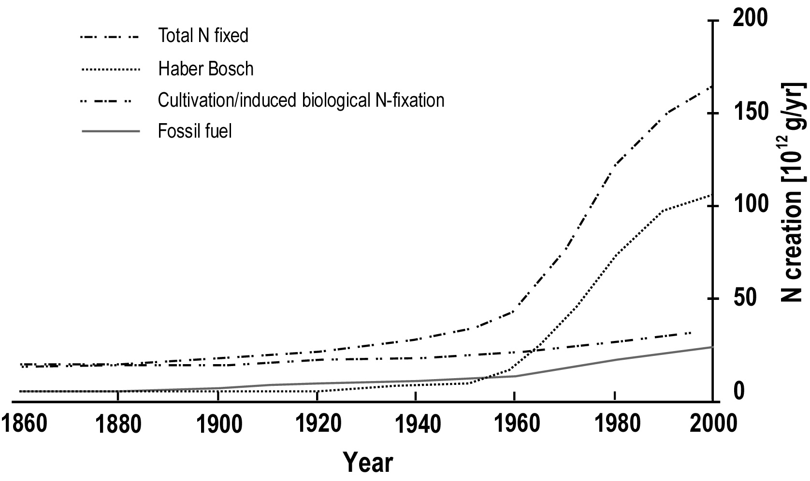

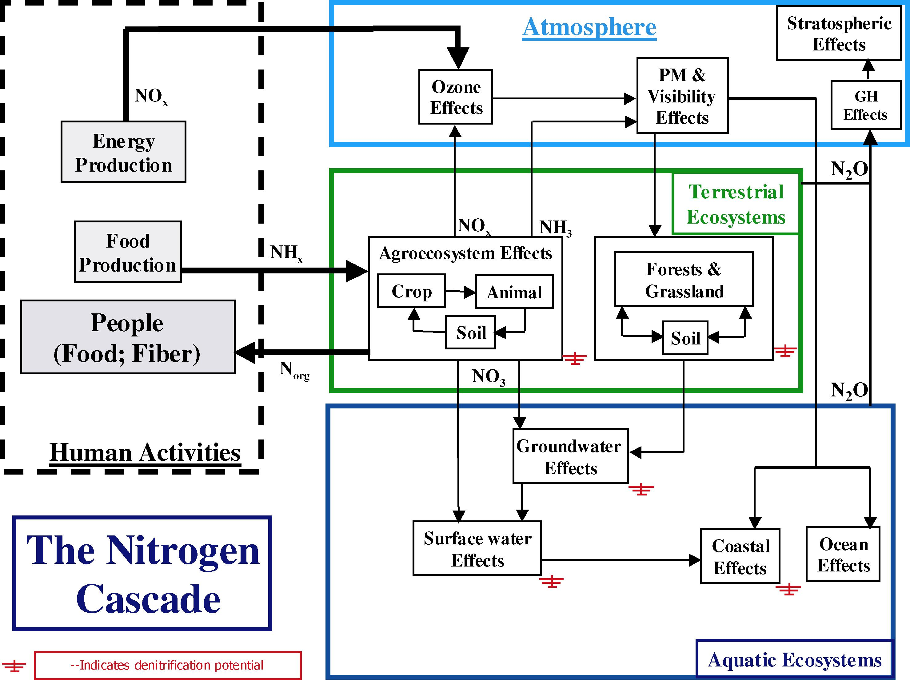
- Higher than natural levels of reactive nitrogen in natural terrestrial ecosystems, especially temperate grasslands, shrublands and forests leads directly to lower plant diversity, as slow-growing species are out-competed by a small number of faster-growing species. The major source of reactive nitrogen affecting terrestrial ecosystems is fuel combustion, industrial processes and the use of fertilizers, which release nitrogen compounds into the atmosphere, which are subsequently deposited onto the biosphere (see figures 2 and 3). Excessive levels of reactive nitrogen in water bodies, including rivers, coastal zones and other wetlands frequently leads to algal blooms and eutrophication, including low-oxygen conditions which causes major damage to biodiversity including fisheries. The main source is run-off of nitrates and other nitrogenous compounds from agricultural lands and atmospheric deposition (see figure 3). In addition to the above effects nitrous oxide is considered to be a potent greenhouse gas, and in the upper atmosphere can damage the ozone layer.

II. Relevance of the indicator to the focal area
- The indicator relates to focal area (c) of the Convention on Biological Diversity: Addressing the major threats to biodiversity, including those arising from invasive species, climate change, pollution, and habitat change.
- The indicator is useful because:
- Excess reactive nitrogen is the pollutant that has the most significant effects, globally and regionally, / and
- Globally consistent data sets are available.
- The indicator complements indicators of climate change (e.g. greenhouse gas emissions; mean global temperature).
- The species abundance indicator is a complementary indicator that can show direct effects from this pressure.
- Nitrogen loading in aquatic systems could also be viewed as a component of indicator 6: Water quality in aquatic systems, / contributing to focal area (d) ecosystem goods and services.
- Derivatives of the indicator – nitrogen use efficiency – would be relevant to focal area (b) sustainable use (in agricultural systems).

iii. General description
- This indicator represents trends of the increases in reactive nitrogen, globally, and in specific ecosystems. Reactive nitrogen (Nr) is defined as all biologically active, photochemically reactive, and radiatively active N compounds in the biosphere and atmosphere. In practice this means all nitrogen except N₂ gas, for example nitrates, organic nitrogen compounds, nitrous oxides and ammonium. While nitrogen, in biologically available forms is essential for life and use of nitrogen fertilizers is necessary to produce sufficient food for a growing human population, excess reactive nitrogen constitutes a major threat to biodiversity in terrestrial, aquatic and coastal ecosystems.
- Figure 1 shows global trends in generation of anthropogenic reactive nitrogen. Reactive nitrogen is generated from Haber-Bosch production (mostly for nitrogen fertilizers); fossil fuel use; and widespread cultivation of legume crops and of crops such as rice, which stimulate biological nitrogen fixation in the soil. Anthropogenic sources now exceed natural terrestrial sources to the extent that more than half of all reactive nitrogen created annually on a global basis is from human sources.
- Higher than natural levels of reactive nitrogen in natural terrestrial ecosystems, especially temperate grasslands, shrublands and forests leads an increase in biomass, but also a direct decrease in plant diversity, as slow-growing species are out-competed by a small number of faster-growing species. This can potentially lead to breeding failure of grassland breeding birds. / The major source of reactive nitrogen affecting terrestrial ecosystems is fuel combustion, industrial processes and the use of fertilizers, which release nitrogen compounds into the atmosphere, which are subsequently deposited onto the biosphere (see figure 2).
- Nitrogen deposition on forestry has been shown to increase the risk of nutrient imbalances in trees and to increase susceptibility to parasites and frost and drought damage.
- However the effects of nitrogen-deposition depends not only on the duration and total amount of the deposition but also on ecosystem properties like abiotic conditions and sensitivity of plant and animal species. Some ecosystems are very sensitive, while in others negative effects only occur at inputs far above the natural background. Based on empirical data the sensitivity-levels has been described for many ecosystems. / Experiments and ecosystem-models show that exceedance of this level is directly related to changes in biodiversity. Exceedance of this level (i.e. the critical load) by the deposition is used as an effect-indicator by the World Health Organization (WHO), the United Nations Economic Commission for Europe (UN-ECE), the European Union and many individual countries.

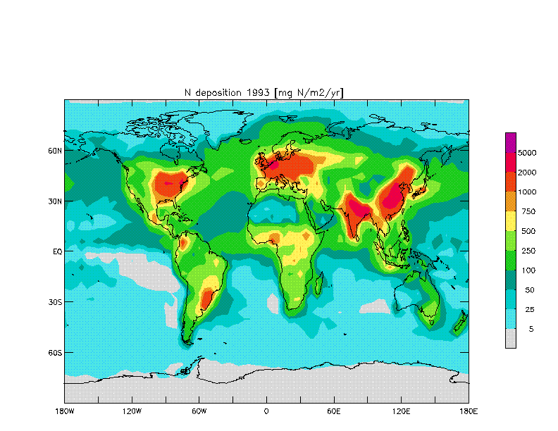
Figure 2: Global atmospheric deposition of reactive nitrogen (Nr) onto the oceans and continents of the Earth in 1993 (mg N m⁻² yr ⁻¹): The largest values exceeding 5000 mg N m⁻² yr ⁻¹ are reached in SE China, N India, Benelux and N-US. Deposition in the North Atlantic, northern Indian Ocean and West Pacific (Chinese Sea) are between 100 and 250 mg N m⁻² yr ⁻¹. Personal communication from F. J. Dentener, as published in Galloway and Cowling (2002).

- Excessive levels of reactive nitrogen in water bodies, including rivers, coastal zones and other wetlands frequently leads to algal blooms and eutrophication, including low-oxygen conditions which causes major damage to biodiversity including fisheries. The main source is run-off of nitrates and other nitrogenous compounds from agricultural lands (see figure 3) but aquaculture and mariculture are also significant sources of nitrogen. For many developing countries, the major source of nitrogen to water bodies is untreated domestic sewage and wastewaters but municipal wastewater also contributes to eutrophication in developed countries.

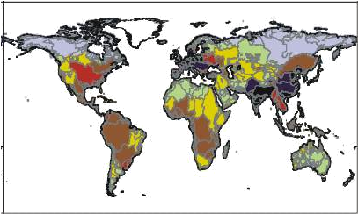
Figure 3: Nitrogen loading in major water basins (Green et al 2004)

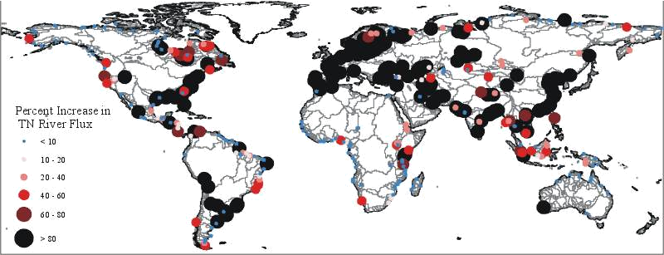
Figure 4: Nitrogen flux in to coasts: percent change in total river flux from pre-industrial to contemporary state (Green et al 2004)
- In addition to the above effects nitrous oxide is a potent greenhouse gases, and in the upper atmosphere can damage the ozone layer.
- The same atom of reactive nitrogen can cause multiple effects as it “cascades” through terrestrial and aquatic ecosystems and the atmosphere (the “Nitrogen Cascade”).
- Impacts of reactive nitrogen on terrestrial and aquatic ecosystems are essentially regional in scale, the most affected areas being North America, Europe, South Asia, East Asia and some industrial centres in Latin America – downwind and downstream of the major sites of reactive nitrogen use in agriculture (primarily) and fuel combustion. While North America and Europe have been the most affected regions in the past, Asia will be the most affected region this century.
- Nitrogen-containing discharges can also have toxic effects leading to fish kills and toxic algal blooms.
- The only ways to remove Nr from circulation in ecosystems are (i) by promoting denitrification to N₂ gas; and (ii) by storage in long-term reservoirs. In this context, a number of ecosystems, including soils systems, inland water systems, and the continental shelf provide important services in denitrifying and sequestering reactive nitrogen. Wetlands are particularly important and it is important to find the right balance between the needs of some aspects of biodiversity in oligotrophic systems and the potential of eutrophic systems to sequester nitrogen in highly productive processes.
- Mitigation strategies within the agricultural context, for example through the provision of incentives for organic-farming practices with low use of nitrogen fertilizers could help to reduce the production of Nr.
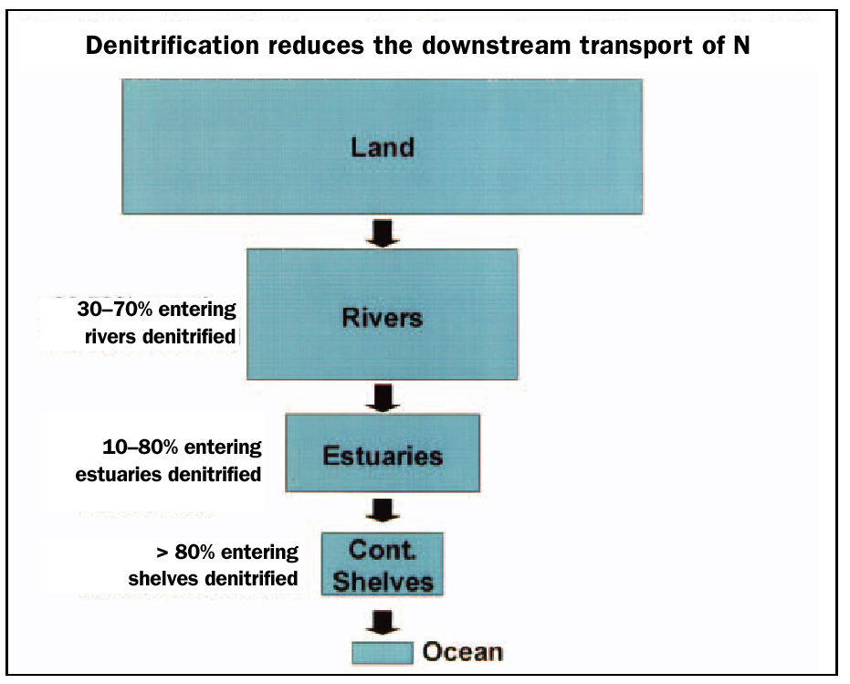
Figure 5. The transport of reactive nitrogen from terrestrial to oceanic systems decreases at each step along the river–estuarine–continental shelf system./

Status and trends
- Nitrogen budgets for the nitrogen cycle in 1860, the 1990s and a projection for 2050 have been calculated by Galloway et al 2004 (table 1). It may, however, not be easy to calculate a figure for 2010.

Table 1. Nitrogen budgets for the nitrogen cycle in 1860, the 1990s and a projection for 2050 (from Galloway et al. 2004)
Tg N/yr | 1860 | early 1990s | 2050
Lightning | 5 | 5 | 5
Biological fixation in terrestrial natural systems* | 120 | 107 | 98
Total natural sources | 125 | 112 | 103
Haber-Bosch process | 0 | 100 | 165
Cultivation induced | 15 | 32 | 50
Fuel consumption | 0 | 25 | 52
Total anthropogenic | 15 | 157 | 267
Total terrestrial production | 140 | 269 | 370
Aerial depositions to land | 17 | 64 | 125
Aerial depositions to marine | 14 | 39 | 69
Transfer to coastal zone by rivers | 27 | 48 | 63
Data from Galloway et al 2004

IV. Policy Relevance

Placement in the 2010 framework of the Convention on Biological Diversity
- Pollution from excessive fertilization and use of pesticides and other toxic chemicals directly impacts biodiversity. In the 2010 framework this is being addressed in goal 7 and target 7.2.
Goal 7. Address challenges to biodiversity from climate change, and pollution
Target 7.2: Reduce pollution and its impacts on biodiversity
- While excessive fertilization and eutrophication may initially increase the biomass of a given ecosystem they reduce diversity and resilience leading to changes and eventually decreases in the goods and services an ecosystem can deliver. Therefore, the indicator is also related to goal 8 and target 8.1 of the framework.

Goal 8. Maintain capacity of ecosystems to deliver goods and services and support livelihoods
Target 8.1: Capacity of ecosystems to deliver goods and services maintained.
Relevance to other processes (MDG, WSSD, CSD etc.)
- The indicator is also relevant to target 9 of the Millennium Development Goals (“Ensure environmental sustainability”) and to the Global Plan of Action for the Protection of the Marine Environment from Land-Based Activities (GPA).

V. Technical information

A. Description and data sources

- The total nitrogen fixed from atmospheric N₂ is the sum of reactive nitrogen created via the Haber-Bosch process (this includes production of NH₃ for non-fertilizer purposes), is cultivation-induced biological N fixation from cultivation of legumes, rice and sugar cane and fossil fuel combustion.

Limitations and qualifications.
- Of the amount of reactive nitrogen created each year through anthroprogenic sources it is not known how much accumulates and how much is denitrified to N₂ gas, or otherwise made essentially unavailable in long term reservoirs. Natural rates of biological nitrogen fixation are also not known with accuracy.
- The total amount of reactive nitrogen created each year through anthroprogenic sources can be calculated accurately at the global level, and at smaller spatial scales. However, relating this to impacts is complicated by trade in fertilizers, food, feed and fibre, as well as by aerial and aqueous movement.
- The main uncertainties in the modeling of nitrogen deposition fluxes are: Emission inventories; Chemical transformations; Wet and dry removal processes; Atmospheric transport and resolution of the model. The emission inventories for NO and NH₃ used in this study are based on the widely used EDGAR2.0 database for NO and the Bouwman et al. [1997] compilation for NH₃. The inventories provide data on 1x1 degree, which were aggregated in the model resolution. The inaccuracies of the NO emissions are of the order of 30% in the industrialized regions of nitrogen. America, Europe and Japan. In other regions a subjective estimate is of the order 50%. Due to cancellation of errors the uncertainties are smallest for larger regions, and become larger on smaller temporal and spatial scales. (Galloway et al 2004).

Data availability
Data compiled by scientists participating in the International Nitrogen Initiative, using data from various sources. Data required for calculation of the indicator in figure 1 (fertilizer production; crops areas, energy use) is routinely available. / Spatial data obtained by modeling. Inaccuracies, discussed above, tend to cancel out at larger geographical scales.

B. Key References

Boesch, D.F. 2002. Challenges and opportunities for science in reducing nutrient over-enrichment of coastal ecosystems. Estuaries 25, 886-900
Galloway J.N., E.B. Cowling. 2002. Reactive nitrogen and the world: Two hundred years of change. Ambio 31, 64-77
Galloway J.N., J.D. Aber, J.W. Erisman, S.P. Seitzinger, R.W. Howarth, E.B. Cowling & B.J. Cosby. 2003. The nitrogen cascade. BioScience 53, 341-356.
Galloway J.N.; F. Dentener; D. Capone; E. Boyer, R.W. Howarth; S. Seitzinger; G. Asner; C. Cleveland; P. Green, E. Holland; D. Karl; A. Michaels; J. Porter; A. Townsend (2004), Nitrogen Cycles: Past, Present and Future. Biogeochemistry (in press)
Green P.A., C.J. Vorosmarty, M. Meybeck, J.N. Galloway, B.J. Peterson & E.W. Boyer (2004, inpress) Pre-industrial and contemporary fluxes of nitrogen through rivers: a global assessment based on typology. Biogeochemistry 68: 71-105.
Seitzinger, S.P., C. Kroeze, A.F. Bouwman, N. Caraco, F. Dentener and R.V. Styles. 2002. Global patterns of dissolved inorganic and particulate nitrogen inputs to coastal systems: Recent conditions and future projections. Estuaries 25:640.
Tilman, D. et al. 2001. Forecasting agriculturally driven global environmental change. Science 292, 281–284.

VI. Application of the indicator at national/regional level
- While it may be possible to apply the indicator at the national level this may not be desirable because of the movement of reactive nitrogen through air and water. Regional application, such as by river basin, may be more suitable. Because of the limited range of transportation of reactive nitrogen (i.e. much of the deposition occurs where the reactive nitrogen is produced) the indicator is suitable for regional monitoring and regional efforts to reduce the threat.

VII. Suggestions for the improvement of the indicator
- The main uncertainties in the modeling of nitrogen deposition fluxes are: Emission inventories; chemical transformations; wet and dry removal processes; atmospheric transport and resolution of the model (see section 5). Improvements in each of these areas can reduce the error margins.
- It is not clear how the nitrogen-production indicator will be interpreted with regard to the 2010 target. Nitrogen production would have to fall in absolute terms to reduce the pressure on biodiversity, but this seems unlikely. Fertilizer inputs are needed to increase the yields from agricultural land as an alternative to further increasing agricultural land take. A more useful indicator might be the efficiency of nitrogen usage in terms of crop yields or reductions in atmospheric deposition and diffuse pollution in sensitive ecosystems.
- This type of analysis needs to be expanded to include phosphorus and also to examine how river flows of nitrogen and phosphorus are modified by the presence or increasing absence of wetlands and marshes (ref. to water quality indicator). It needs to be integrated with data on numbers and sizes of HABs (Harmful Algal Blooms) and ‘dead zones’, particularly with respect to areas of high nitrogen and P outflow into the oceans.
-----

* UNEP/CBD/AHTEG-2010-Ind/1/1.
/ Nitrogen deposition contributes to vegetation changes and accelerates mineralization in soils, which again accelerates effects on vegetation, ecosystems and leads to even more release of N and carbon fixed in organic soils
/ UNEP GEMS Water has developed an N0₃ indicator for the World Water Development Report-II (WWDR-II) to capture one important issue for water quality.
/ Steven et al. (2004): Impact of nitrogen deposition on the species richness of grasslands. Science 303: 1876-1879. demonstrated the recent impact of nitrogen deposition on the British flora and showed direct correlation of increased N and the loss of plant species.
/ UN-ECE, 2002. Empirical Critical loads for Nitrogen. Expert Workshop. See also references therein.
Galloway J.N., J.D. Aber, J.W. Erisman, S.P. Seitzinger, R.W. Howarth, E.B. Cowling & B.J. Cosby. 2003. The nitrogen cascade. BioScience 53, 341-356.
/ This may need to be better explained.
/ See for example Galloway J.N.; F. Dentener; D. Capone; E. Boyer, R.W. Howarth; S. Seitzinger; G. Asner; C. Cleveland; P. Green, E. Holland; D. Karl; A. Michaels; J. Porter; A. Townsend (2004), Nitrogen Cycles: Past, Present and Future. Biogeochemistry (in press)

