Template for Submission of Scientific Information
to Describe Ecologically or Biologically Significant Marine Areas

Title/Name of the area: Referent Monitoring System of Polygons for Russian Far-East Seas.
Presented by Dr. Boris V. Preobrazhensky, Principal Scientist, Pacific Institute of Geography, FEB RAS, 7, Radio str., 690041, Vladivostok, Russian Federation,
E-mail prbzmail@gmail.com
Abstract
The most representative and easily controlled means of monitoring of ecological state of ecosystems is, time- attributed and accurately GPS- pinpointed, underwater landscape mapping. Preserved in hard copy and electronic form, easily accessible reference data will serve as a reliable base for making conclusion about changes in state of marine ecosystems and areas in marine offshore environment. The initiate network of reference polygons is proposed.

Introduction
Underwater landscape mapping of habitats were undertaken by the Laboratory of Underwater Landscape Studies of Pacific Institute of Geography of Russian Academy of Sciences using a complex routine of recognising, simulating and mapping of sea floor geosystems. Landscaping methodology was developed during 1986 - 1996. The use of the bentheme map allows to develop the theoretically based approach to localization of objects of industrial activity in the marine environment; planning and allocation of sites for aquaculture requires adequate knowledge of spatially distributed trophodynamic elements of habitats. According to our terminology, the habitats are named benthemes which is equivalent to the benthic geosystems. There is a whole discussion targeted on this subject published by present authors elsewhere (1987, 1990, 1999). Selected areas of offshore underwater landscape fields in upper sublittoral were mapped using SCUBA technology. Geomorphological, ecological and hydrobiological data converted in special encoding, a special landscape nomenclature and legends designed, mapping routine standardized within the Laboratory of Underwater Landscape Studies of Pacific Institute of Geography, FEB RAS.

Location
Russian sectors of Japan Sea, Sea of Okhotsk and Bering seas. Network of Monitoring reference areas (red squares)
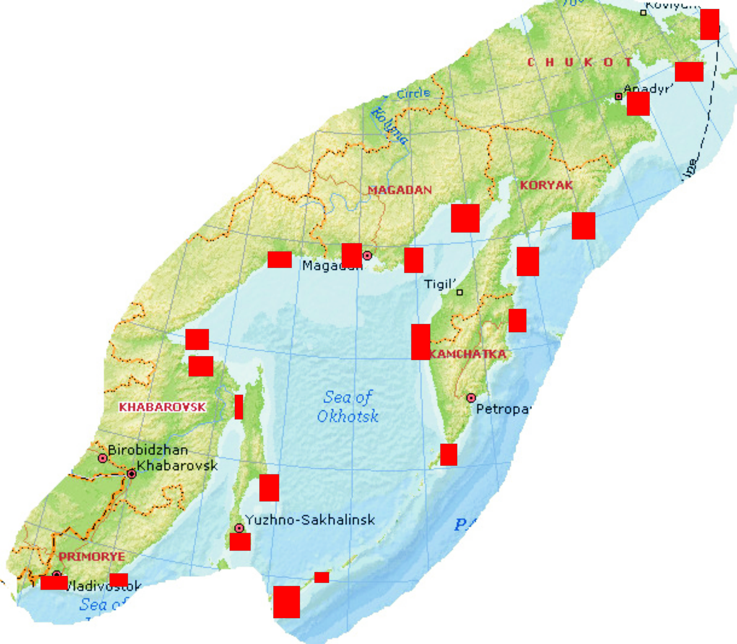

Feature description of the proposed areas
Russian Primorye is being closely investigated during last four decades. Underwater landscape routine encompassing certain selected areas was designed, tested and mapped. Spatial static and dynamic graphical models serve as base for determining the ecological loss caused by severe dredging. Ecological passportization of aquatories serves the base for our proposals of introduction of cadasters of underwater estates for the purposes of development of aquaculture and fishing. The practices of such developments should be supported on Federal and International level. The scrupulously selected testing areas should be preserved, accurately mapped, described; data will serve as further reference sites for ecological monitoring. Areas of close attention are located in the following areas of Russian jurisdiction; South Primorye, Tatar Straight, Aniva Bay of Sakhalin, Habomai group, Kuril Shallows between Kunashir Island and Habomai, The cape Krai Sveta of Shikotan Island, Southern point of Kunashir Island, L’vinaya Past’ caldera of Iturup island, Shantar Archipelago, Tugur Bay with its high velocity benthic communities, Taui Lip with its residuary population of herring, Koni Peninsula of Magadan shores, Western shores of Central Kamchatka Peninsula with its hatching areas of crabs and salmons, The Marine sanctuary of Commander’s Islands in Bering sea, Anadyr Bay of Chukchi Peninsula with its population of walruses and whales. Most of those scantly studied areas are highly vulnerable. The threat comes from increasing press of private and state-owned companies developing either energy installations or prospecting gas and oil. Special Program of organizing the Reference Monitoring Network of Underwater Polygons has to be initiated and financed by responsible agencies.

Feature condition and future outlook of the proposed area
Overfishing and poaching destruction of most vulnerable marine benthic organisms such as Apostychopus japonicas (“trepang”), sea scallop Mizuchopecten, Sea urchins Strongylocentrotus intermedius in vast areas of South Primorye lead to devastation of sometime fabulous marine biotopes. Underwater landscape mapping and broad publication of information about essentially important areas could attract attention of International scientific society and to some extent diminish the speed of degradation of ecosystems. Scantly studied, areas of Okhotsk and Bering seas should alert attention of those decision makers to the dangers of losing the key ecosystems as result of rushing to exploiting the mineral and energy resources at the cost of biological stability of entire basins.

The examples of previously published and well-known underwater landscape (bentheme) maps from two selected bays in South Primorye are attached here. The legends may be presented in color palette or in cryptic signs corresponding to accurate detailed descriptive diagnoses of landscape units.
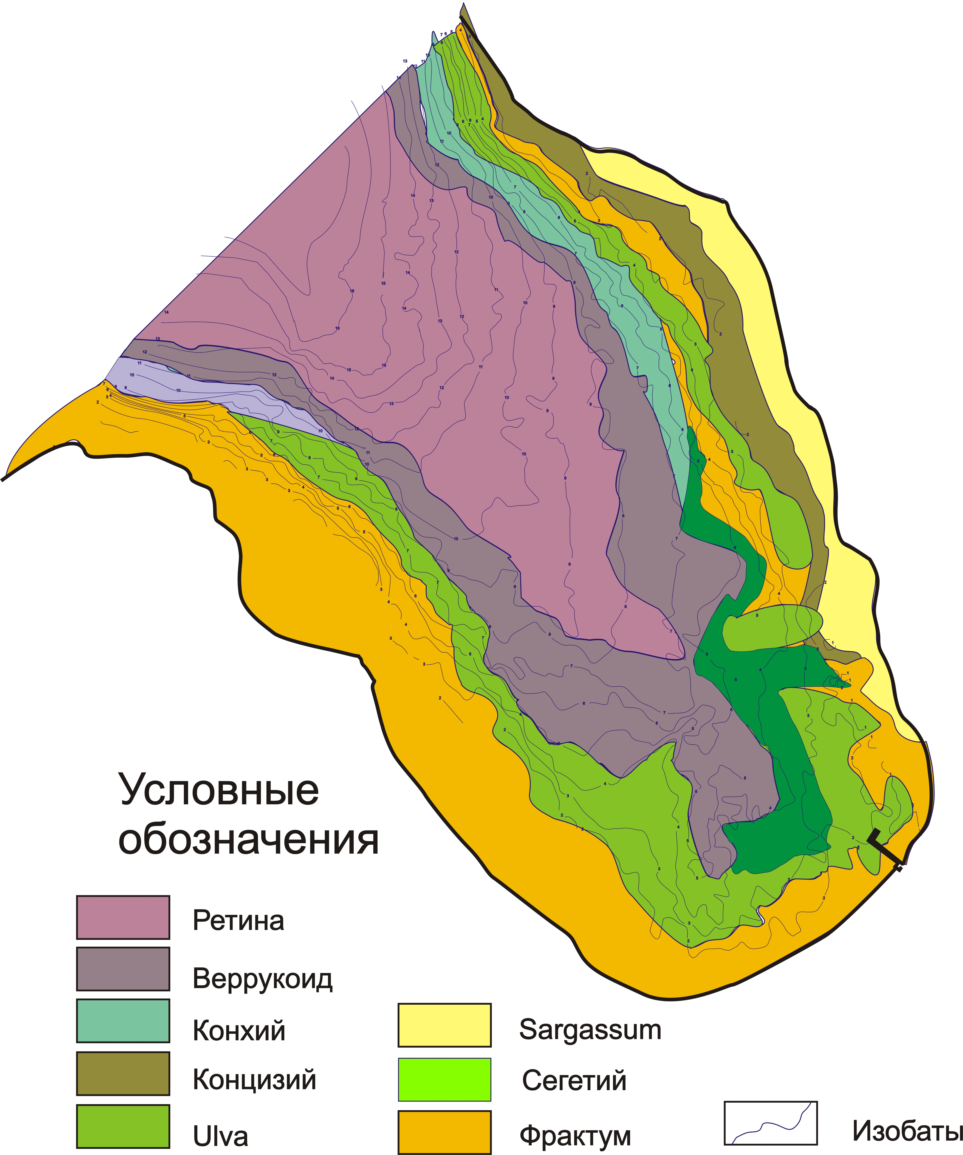
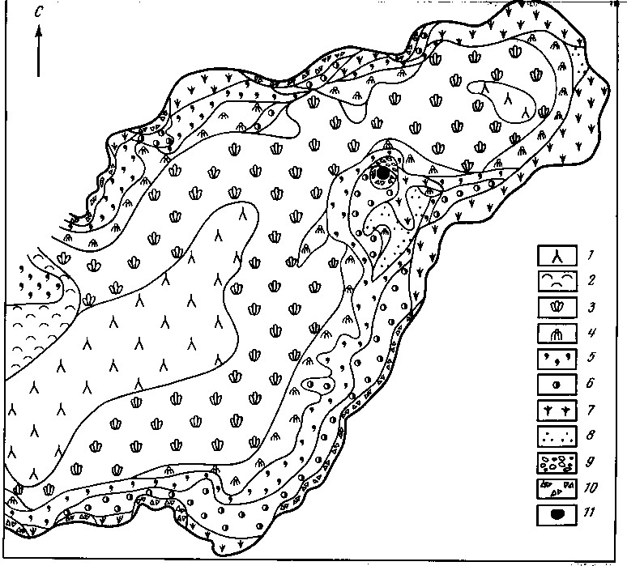
Assessment of the area against CBD EBSA Criteria
Areas of above mentioned polygons are not the ready subjects for such detailed studies and modeling. They are even not sites of preparatory readiness for it.

CBD EBSA Criteria  (Annex I to decision IX/20) | Description  (Annex I to decision IX/20) | Ranking of criterion relevance  (please mark one column with an X)
CBD EBSA Criteria  (Annex I to decision IX/20) | Description  (Annex I to decision IX/20) | Don’t Know |  | Low |  |  | Some |  | High
Uniqueness or rarity | Area contains either (i) unique (“the only one of its kind”), rare (occurs only in few locations) or endemic species, populations or communities, and/or (ii) unique, rare or distinct, habitats or ecosystems; and/or (iii) unique or unusual geomorphological or oceanographic features.
Explanation for ranking

Special importance for life-history stages of species | Areas that are required for a population to survive and thrive.
Explanation for ranking

Importance for threatened, endangered or declining species and/or habitats | Area containing habitat for the survival and recovery of endangered, threatened, declining species or area with significant assemblages of such species.
Explanation for ranking

Vulnerability, fragility, sensitivity, or slow recovery | Areas that contain a relatively high proportion of sensitive habitats, biotopes or species that are functionally fragile (highly susceptible to degradation or depletion by human activity or by natural events) or with slow recovery.
Explanation for ranking

Biological productivity | Area containing species, populations or communities with comparatively higher natural biological productivity.
Explanation for ranking

Biological diversity | Area contains comparatively higher diversity of ecosystems, habitats, communities, or species, or has higher genetic diversity.
Explanation for ranking

Naturalness | Area with a comparatively higher degree of naturalness as a result of the lack of or low level of human-induced disturbance or degradation.
Explanation for ranking

Sharing experiences and information applying other criteria (Optional)

Other Criteria | Description | Ranking of criterion relevance  (please mark one column with an X)
Other Criteria | Description | Don’t Know | Low | Some | High
Add relevant criteria

Explanation for ranking

References
(e.g. relevant documents and publications, including URL where available; relevant data sets, including where these are located; information pertaining to relevant audio/visual material, video, models, etc.)

Maps and Figures

Rights and permissions
(Indicate if there are any known issues with giving permission to share or publish these data and what any conditions of publication might be; provide contact details for a contact person for this issue)

